Step 1: Clone the repository you have created in GitHub.

Step 2: Create a new branch using the command.



Step 3: Switch to the new branch.



Step 4: Make some changes to the code in your local copy of the repository.

Step 5: Commit changes to the new branch.

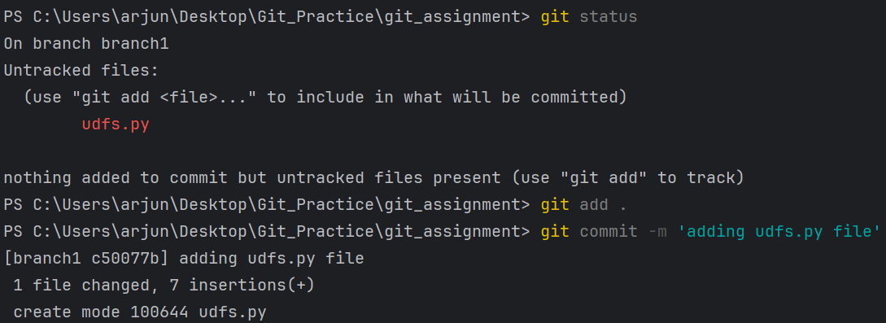

Step 6: Switch back to the original branch



Step 7: Merge the new branch

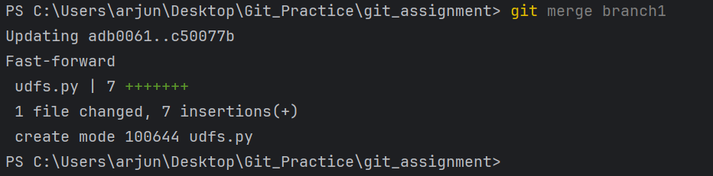

Step 8: Push changes to the original branch

