Step 1: Create a feature branch.



Step 2: Switch to the new branch.



Step 3: open the file and make some changes to it.

Step 4: Add and commit the changes to the new branch.

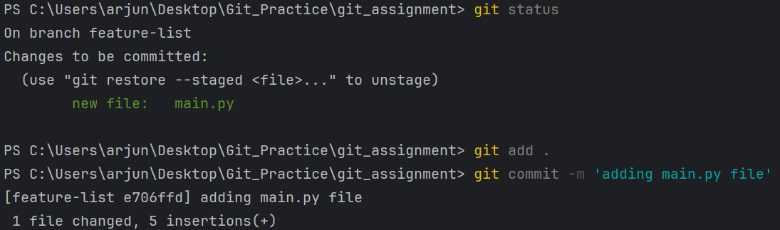

Step 5: Push the changes to the new feature branch.

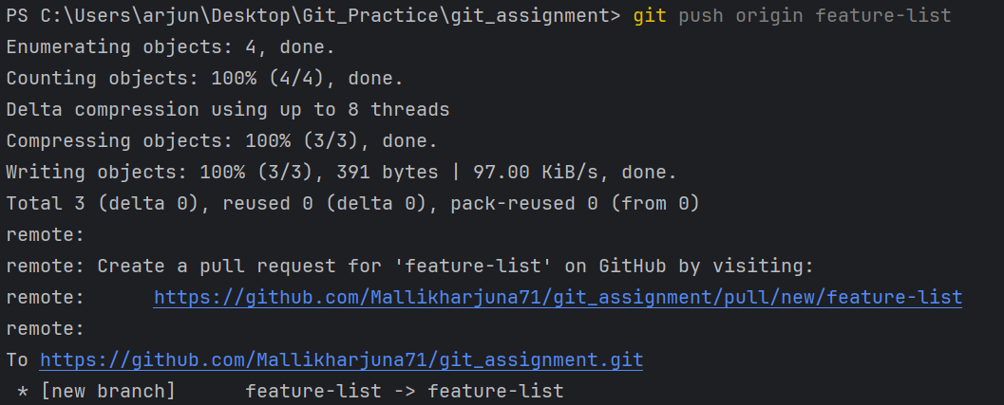

Step 6: Create a pull request.

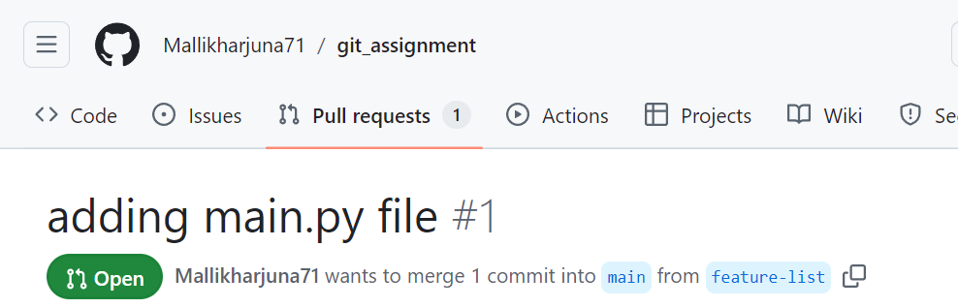

Step 8: As another user in the master branch make some changes to the same file and add and commit the changes to the master branch.

