Step 1 : Create a feature branch



Step 2: Switch to the new branch.

open the file and make some changes to it.

Add and commit the changes to the new branch.

open the same file and make some changes to it.

Add and commit the changes to the new branch.

open the same file and make some changes to it.

Add and commit the changes to the new branch

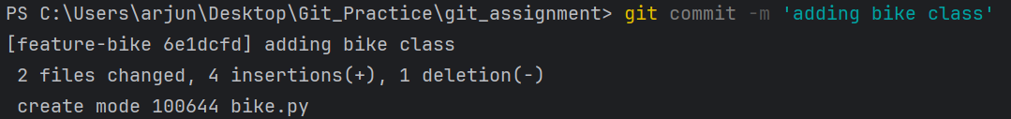





Step 3: Identify the commit or commits that you want to "cherry-pick"(Note the hash of the commit or commits that you want to "cherry-pick")

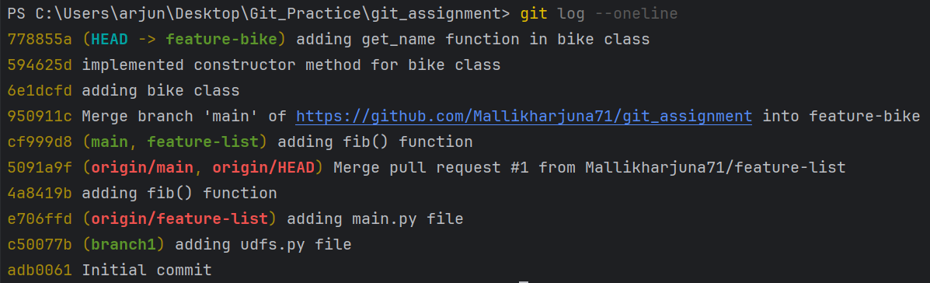

Step 4: Use the "git checkout" command to switch to the branch where you want to apply the changes.



Step 5: Use the "git cherry-pick" command followed by the commit hash(es) that you want to apply.

