SOLID PRINCIPLES

- SOLID principles are the design principles that enable us manage most of the software design problems.
- The term SOLID is an acronym for five design principles intended to make software designs more understandable, flexible and maintainable.
- The five design principles are:
  - S : Single Responsibility Principle (SRP) - “Every module or class should have responsibility over a single part of the functionality provided by the software, and that responsibility should be entirely encapsulated by that class.”
  - O : Open closed Principle (OSP) - “Software entities should be open for extension, but closed for modification.”
  - L : Liskov Substitution Principle (LSP) - “Objects in a program should be replaceable with instances of their subtypes without altering the correctness of that program.”
  - I : Interface Segregation Principle (ISP) - “Many client-specific interfaces are better than one general-purpose interface.”
  - D : Dependency Inversion Principle (DIP) - “One should depend upon abstractions, not concretions.”

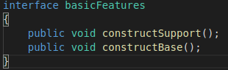
To illustrate the above five principles, let us consider the chair.java which is used for manufacturing a chair.
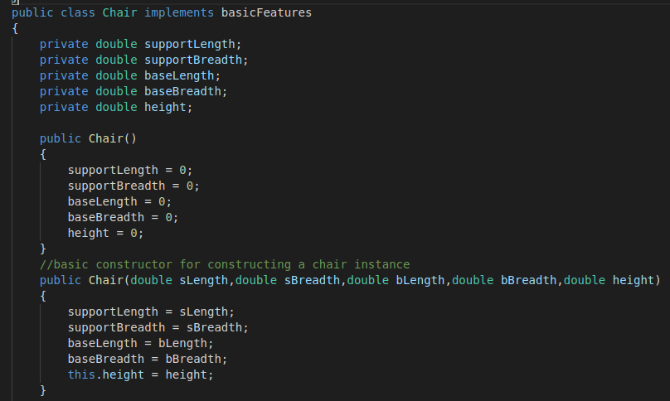

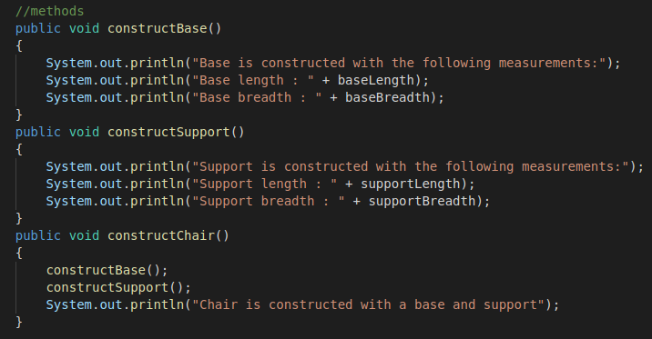

The above chair.java class has some basic functions like constructSupport(), constructBase() and implements an interface named basicFeatures.

We will try and make the above class more simple and cleaner by applying the SOLID principles.

Scenario – 1: We want to add some additional features like handles, rotating wheels and height adjustability to the chair.

Solution : We often tend to make changes to the existing chair.java class by adding methods like addHandles(), addWheels() and addAdjustability(). This approach violates one of the SOLID principles – Open closed Principle (OSP).
We can make the following changes without violating the OSP, by creating an another class namely “Chairv1” which extends the Chair.java and implementing a separate interface namely “advanceFeatures”.

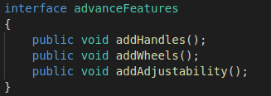
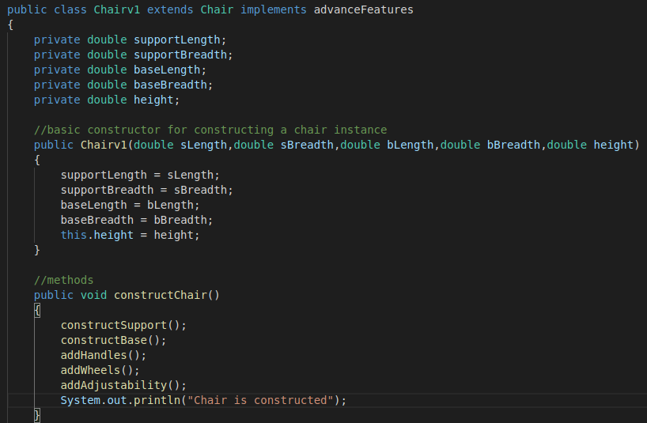
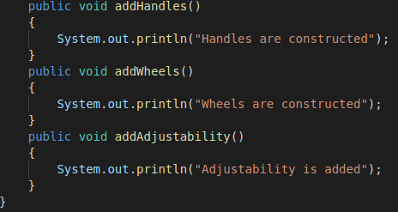
As shown above the class Chair.java is closed for modification and opened for extension by making Chairv1.java to extend the Chair.java class. Thus making sure that Chair.java adheres to the Open closed Principle (OSP).

Senario – 2: What if we want to add only one of the advance features ?

Solution : One possible solution is to create another class Chairv2.java and implement the interface advanceFeatures. This approach forces the client to override the unnecessary functions, if he wants to add only one of the feature.

The above requirement can be acheived by segregating the interface “advanceFeatures” into three different interfaces as shown below.
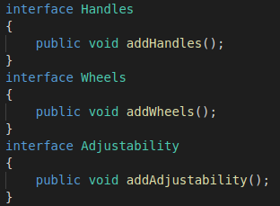

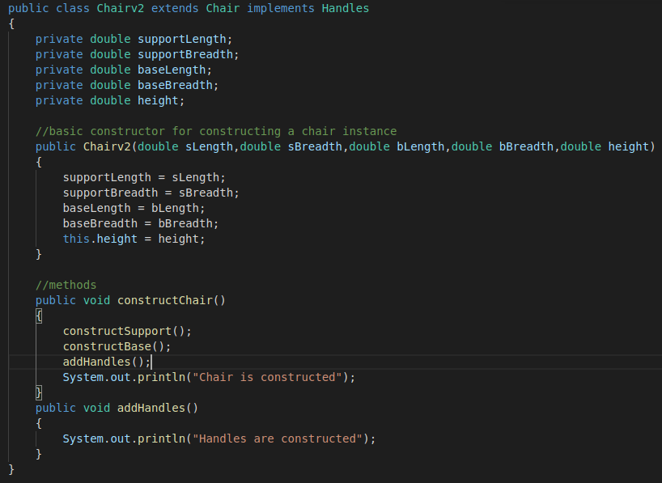
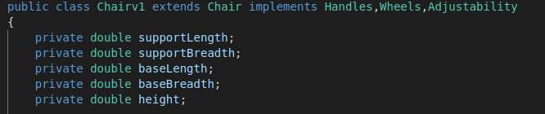

The above approach is much simpler and cleaner. It adheres to Interface Segregation Principle (ISP).
By dividing the interface into meaningful parts, we limited the responsibility of each class.

Scenario – 3:

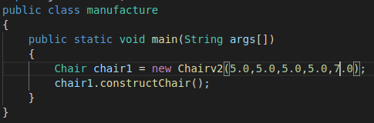

When the above class is executed we get the following output:

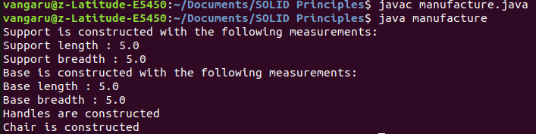
From the above, we can say that the derived type ( Chairv2.java ) is completely substitutable for its base type ( Chair.java ). This can be acheived by making the Chair class abstract or by using the interfaces. Here, we used the second approach i.e interfaces. Thus, we can say that our Chair.java adheres to Liskov Substitution Principle (LSP).

Scenario – 4: From the above example, we can observe that one class performs various functions like constructSupport(), constructBase() etc. which violates the Single Responsibility Principle (SRP). We can modify the example to support SRP as shown below.

Solution:

- Create an interface named “Connection”.

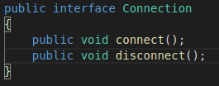

- Create a class named Chair.java with basic features like support and base.

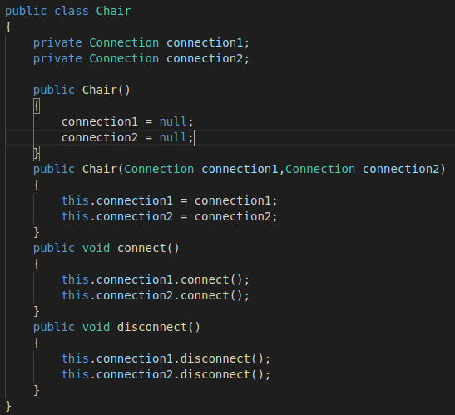

- Create a separate class for every feature and implements the interface “Connection”.

- Support.java ( For constructing support )
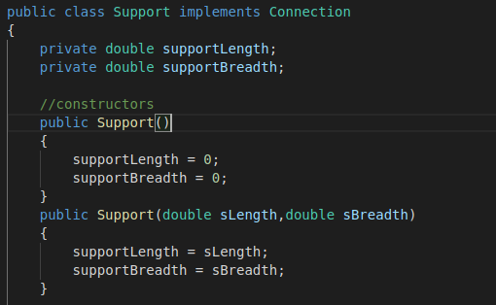
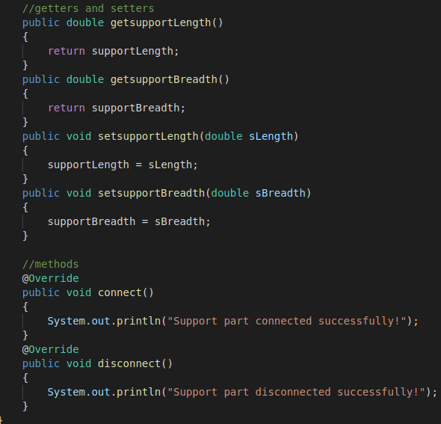

- Base.java ( For constructing the base )
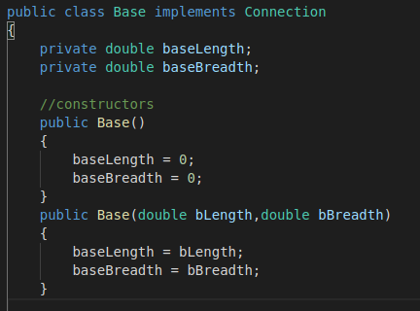

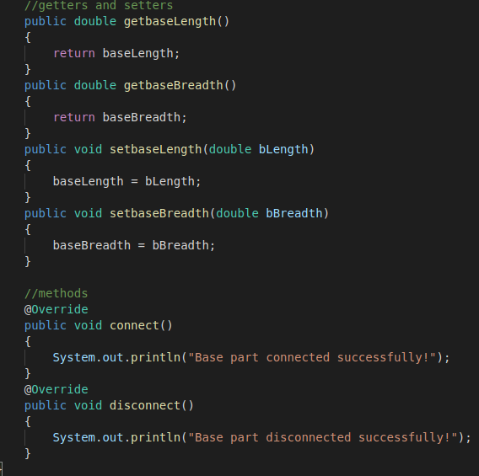
Similarly for all the other features. The above classes support Single Responsibility Principle (SRP) and Dependency Inversion Principle (DIP).

Execution:
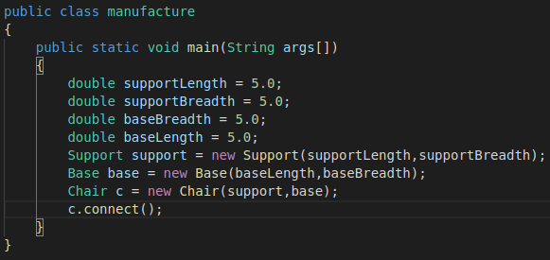
When the above code is executed we get the following output:
Scenario – 5 : If we want to add new features, we simply create a class for that feature and implement the Connection interface. Then we create another class named Chairv1.java to create another chair with the new features.

For example, let us consider the addition of handles to the chair as a new feature. Then we do the following :

1. Create a class named Handle.java and implement Connection interface.

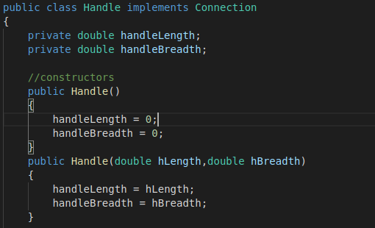

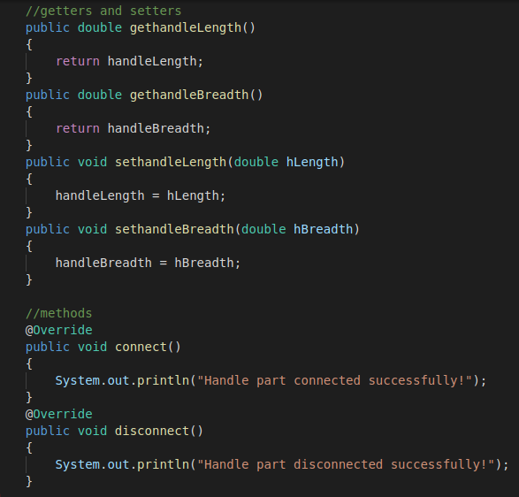
2. Create a class Chairv1.java extends Chair.java
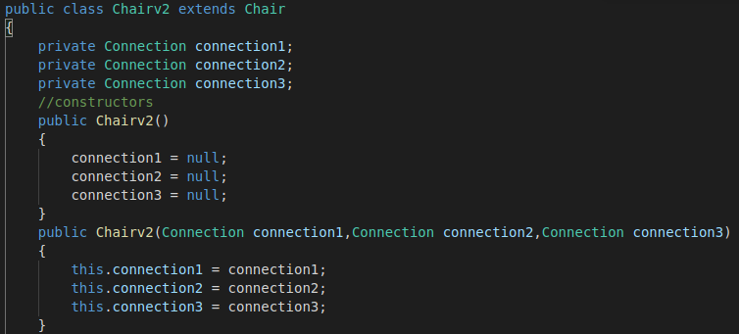

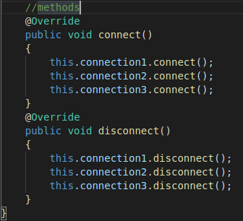

Execution:

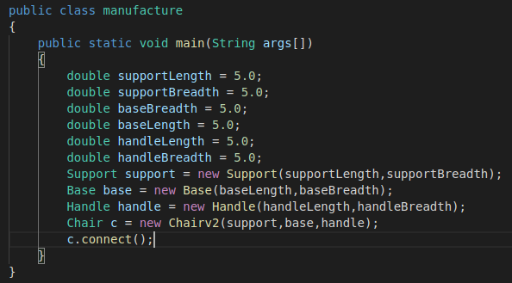
When the above code is executed we get the following output:
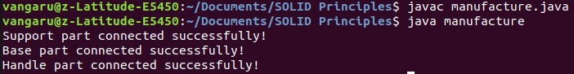
Finally, we can say that the above example adhere to SOLID Principles.

