CAASP: BDD tests GINKO integration

1) Past
2) Simple Present
3) Simple Future

Preambule: This is an highlevel demo.

( I don’t show all details)

1) Some of past/current problems about (E2E):

a) * Reasoning about the testrunner is/was not simple.

(real static analysis of testrunner)
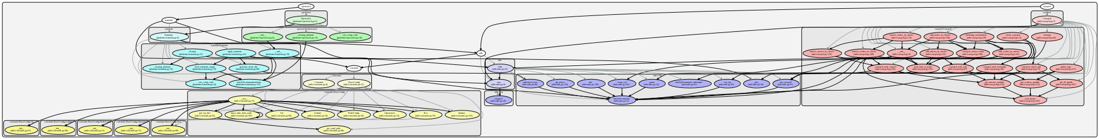

b)* Remote!= local behaviour in intuitive way

Something fail in CI, people don’t know how to reproduce it locally, in a simple way. ( without spending 3H reading docs)

Simple Present: (regarding e2e).

REMOTE == LOCAL

This was the past
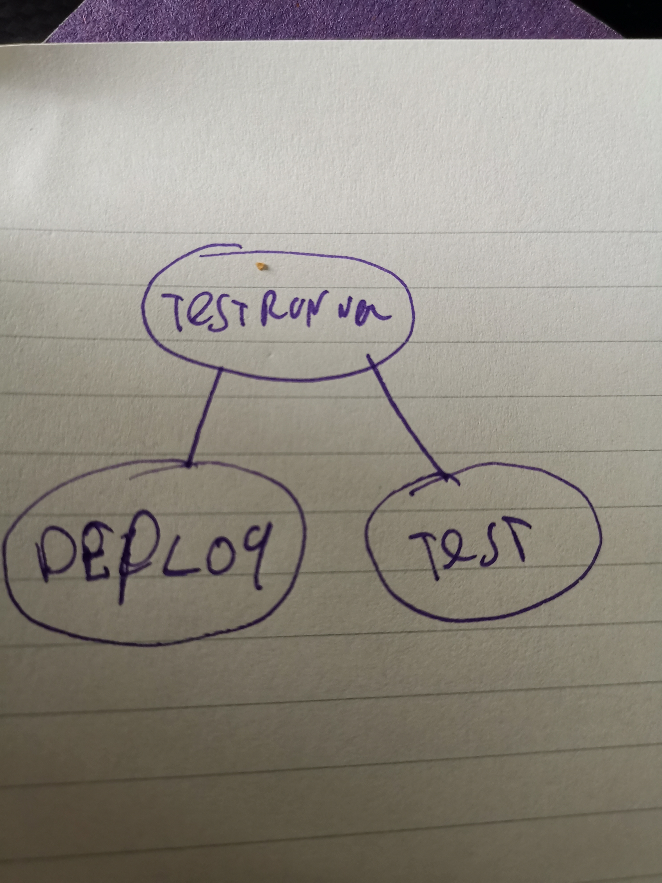

Present:
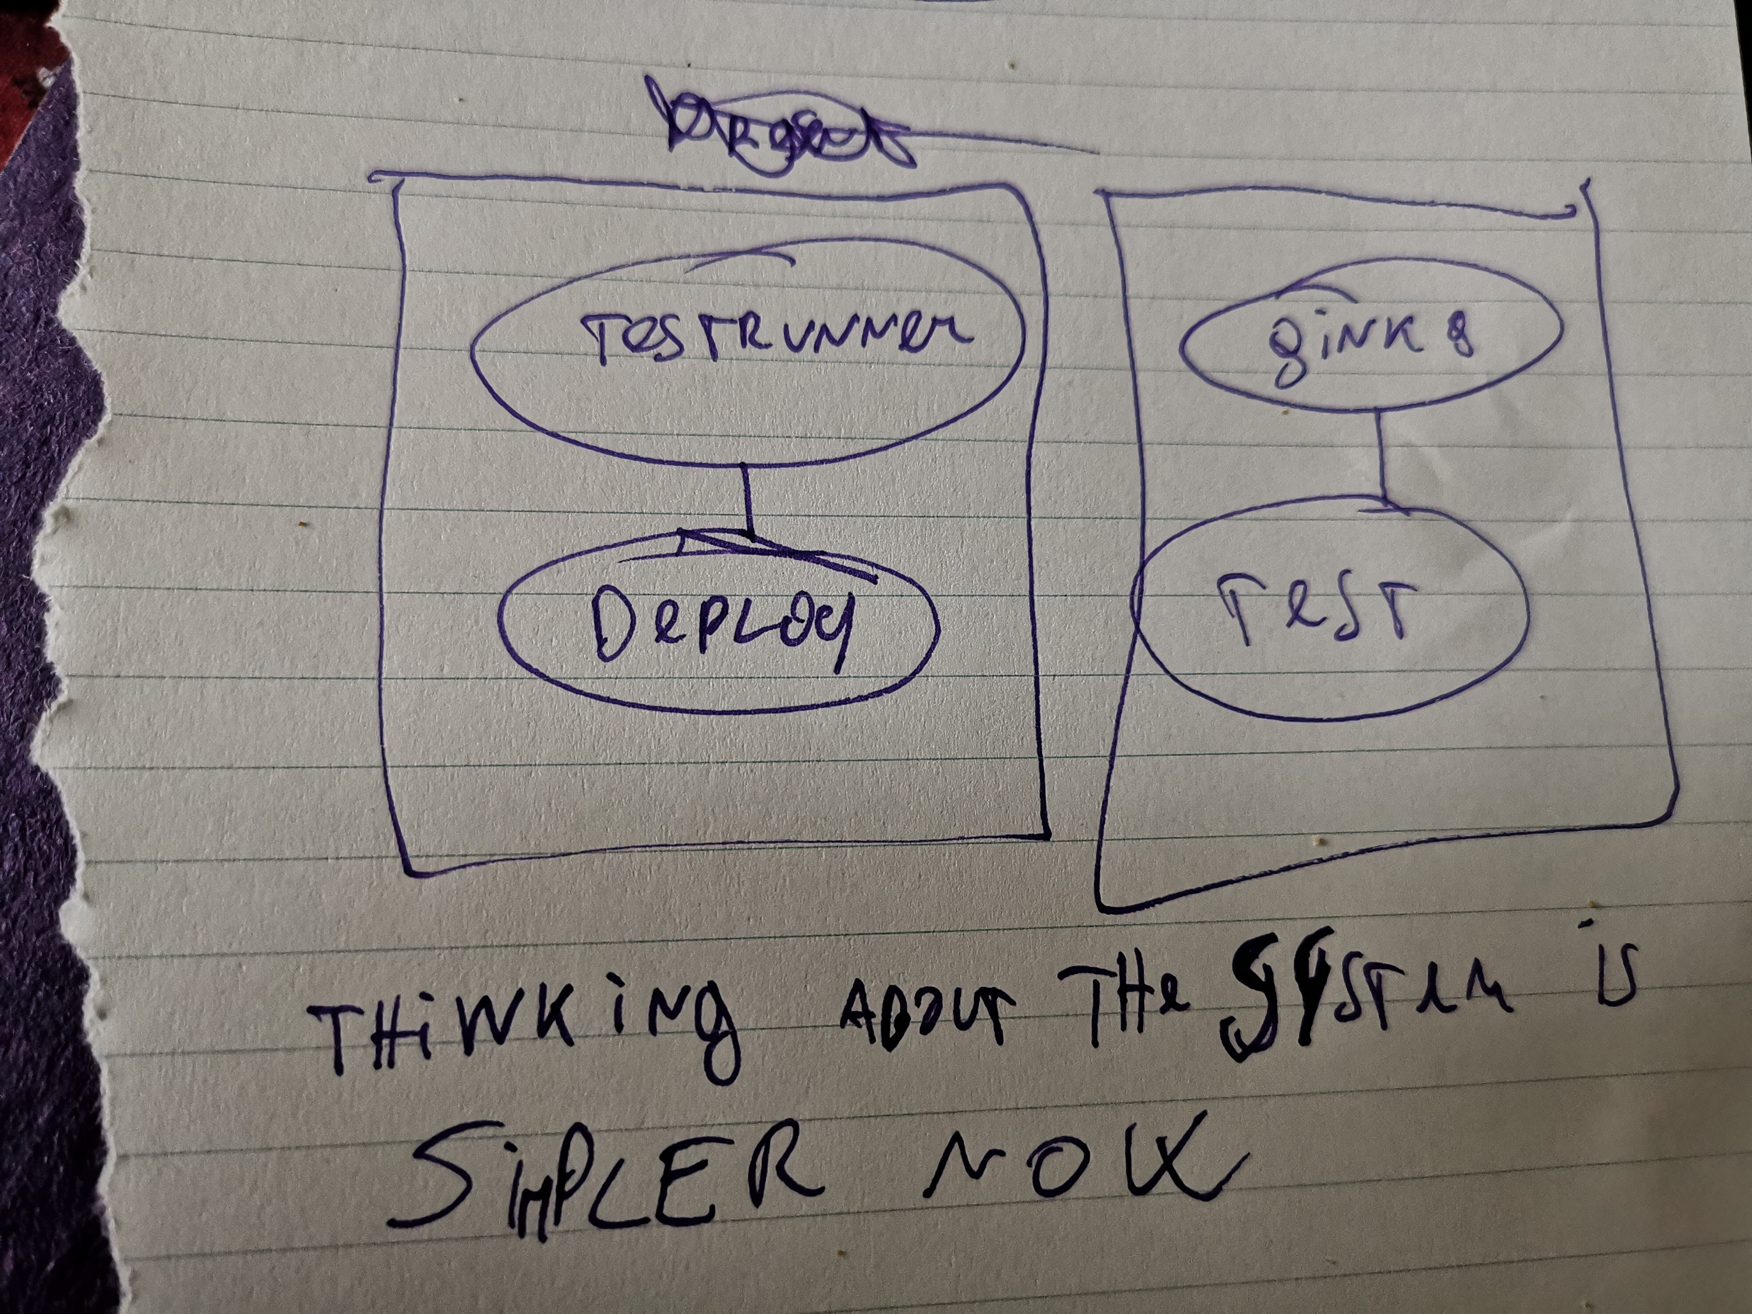
- separate components
- separate design and scope.

Pragmatic Present:

Utilisations:

1) As user don’t use terraform as deploy method for infrastructure

(https://asciinema.org/a/L2WSBwGj1n1rlQLG3uCLvpiFv)

2) An user use terraform (https://asciinema.org/a/gjiJ3LhgaQ9C3AjgrrkqqKrId)

a) Testing different Releases of caaspctl (beta1/beta2/..)
Near future:

Adding new tests, and other tasks tracked on this issue:

https://github.com/SUSE/avant-garde/issues/322

acknowledgement

Thx to reviewers:
Pablos, Alvaro,Nirmoy, Sascha, Markos.

