Mallory Burr

Due September 17, 2019

CSC 3750- Online

Homework 2

Pacific Trails Website

Table of Contents

Code for Index.html 2

Code for Yurts.html 3

Code for Activities.html 5

Code for Reservations.html 6

Screenshot for Index.html 7

Screenshot for Yurts.html 8

Screenshot for Activities.html 9

Screenshot for Reservations.html 10

# Code for Index.html

<!DOCTYPE html>

<html lang="en">

<head>

<title>Pacific Trails Resort</title>

<meta charset="utf-8">

</head>

<body>

<h1>Pacific Trails Resort</h1>

<nav>

<b><a href="index.html">Home</a></b>&nbsp;

<b><a href="yurts.html">Yurts</a></b>&nbsp;

<b><a href="activities.html">Activities</a></b>&nbsp;

<b><a href="reservations.html">Reservations</a></b>&nbsp;

</nav>

<main>

<h2>Enjoy Nature in Luxury</h2>

<p>

Pacific Trails Resort offers a special lodging experience on the California North

Coast. Relax in serenity with panoramic views of the Pacific Ocean.

</p>

<ul>

<li>Private yurts with decks overlooking the ocean</li>

<li>Activities lodge with fireplace and gift shop</li>

<li>Nightly fine dating at the Overlook Cafe</li>

<li>Heated outdoor pool and whirlpool</li>

<li>Guided hiking tours of the redwoods</li>

</ul>

<div>

Pacific Trails Resort</br>

12010 Pacific Trails Road</br>

Zephyr, CA 95555</br></br>

888-555-5555</br></br>

</div>

</main>

<footer>

<small><i>

Copyright &copy; 2016 Pacific Trails Resort</br>

<a href="mailto:fz3821@wayne.edu">Mallory Burr

[fz3821@wayne.edu</a](mailto:fz3821@wayne.edu%3c/a)>

</i></small>

</footer>

</body>

</html>

# Code for Yurts.html

<!DOCTYPE html>

<html lang="en">

<head>

<title>Pacific Trails Resort :: Yurts</title>

<meta charset="utf-8">

</head>

<body>

<h1>Pacific Trails Resort</h1>

<nav>

<b><a href="index.html">Home</a></b>&nbsp;

<b><a href="yurts.html">Yurts</a></b>&nbsp;

<b><a href="activities.html">Activities</a></b>&nbsp;

<b><a href="reservations.html">Reservations</a></b>&nbsp;

</nav>

<main>

<h2>The Yurts at Pacific Trails</h2>

<dl>

<dt><strong>What is a yurt?</strong></dt>

<dd>

Our luxury yurts are permanent structures

four feet off the ground. Each yurt has

canvas walls, a wooden floor, and a roof

dome that can be opened.

</dd>

<dt><strong>How are the yurts furnished?</strong></dt>

<dd>

Each yurt is furnished with a queen-size

bed with down quilt and gas-fired stove.

The luxury camping experience also includes

electricity and a sink with hot and cold

running water. Shower and restroom

facilities are located in the lodge.

</dd>

<dt><strong>What should I bring?</strong></dt>

<dd>

Bring a sense of adventure and some time to

relax! Most guests also pack comfortable

walking shoes and plan to dress for

changing weather with layers of clothing.

</dd>

</dl>

</main>

<footer>

<small><i>

Copyright &copy; 2016 Pacific Trails Resort</br>

<a href="mailto:fz3821@wayne.edu">Mallory Burr

[fz3821@wayne.edu</a](mailto:fz3821@wayne.edu%3c/a)>

</i></small>

</footer>

</body>

</html>

# Code for Activities.html

<!DOCTYPE html>

<html lang="en">

<head>

<title>Pacific Trails Resort :: Activities</title>

<meta charset="utf-8">

</head>

<body>

<h1>Pacific Trails Resort</h1>

<nav>

<b><a href="index.html">Home</a></b>&nbsp;

<b><a href="yurts.html">Yurts</a></b>&nbsp;

<b><a href="activities.html">Activities</a></b>&nbsp;

<b><a href="reservations.html">Reservations</a></b>&nbsp;

</nav>

<main>

<h2>The Activities at Pacific Trails</h2>

</main>

<footer>

<small><i>

Copyright &copy; 2016 Pacific Trails Resort</br>

<a href="mailto:fz3821@wayne.edu">Mallory Burr

[fz3821@wayne.edu</a](mailto:fz3821@wayne.edu%3c/a)>

</i></small>

</footer>

</body>

</html>

# Code for Reservations.html

<!DOCTYPE html>

<html lang="en">

<head>

<title>Pacific Trails Resort :: Reservations</title>

<meta charset="utf-8">

</head>

<body>

<h1>Pacific Trails Resort</h1>

<nav>

<b><a href="index.html">Home</a></b>&nbsp;

<b><a href="yurts.html">Yurts</a></b>&nbsp;

<b><a href="activities.html">Activities</a></b>&nbsp;

<b><a href="reservations.html">Reservations</a></b>&nbsp;

</nav>

<main>

<h2>The Reservations at Pacific Trails</h2>

</main>

<footer>

<small><i>

Copyright &copy; 2016 Pacific Trails Resort</br>

<a href="mailto:fz3821@wayne.edu">Mallory Burr

[fz3821@wayne.edu</a](mailto:fz3821@wayne.edu%3c/a)>

</i></small>

</footer>

</body>

</html>

# Screenshot for Index.html

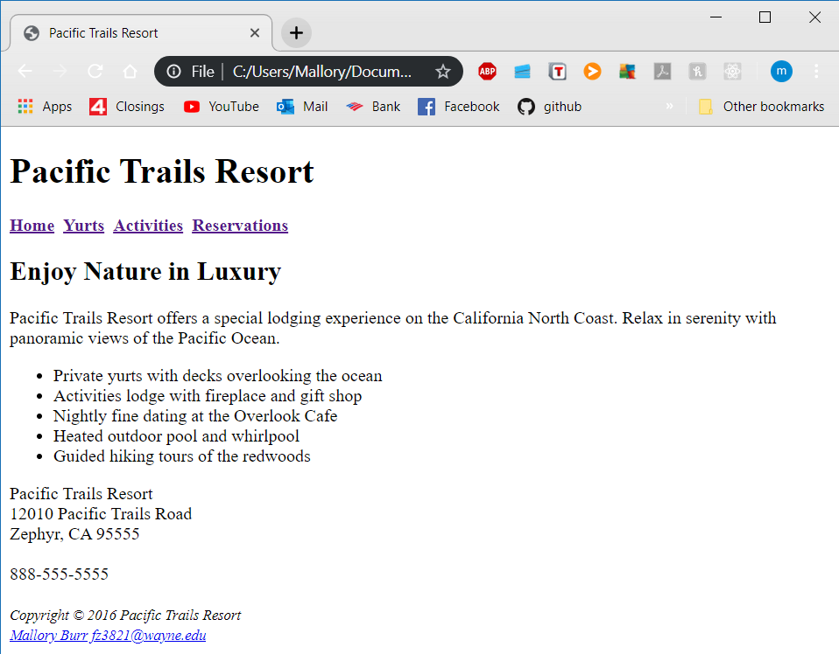

# Screenshot for Yurts.html

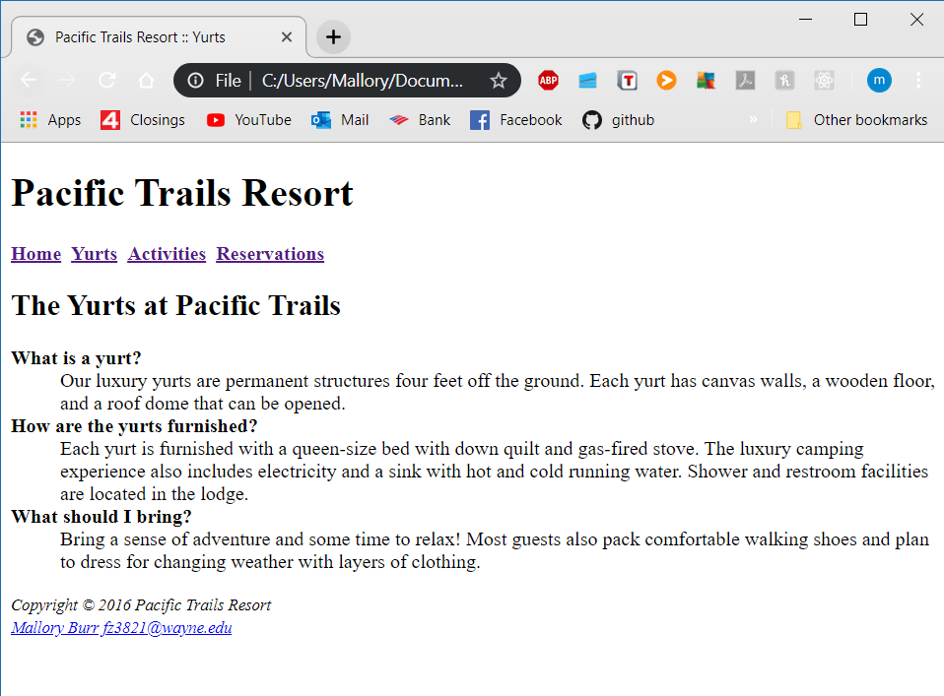

# Screenshot for Activities.html

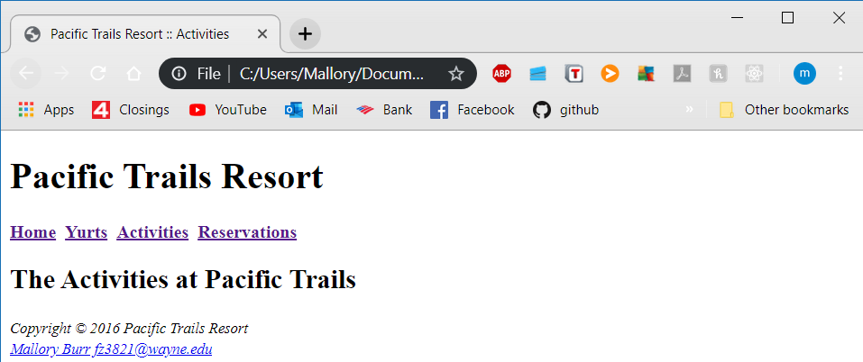

# Screenshot for Reservations.html

