Mallory Burr

Due September 24, 2019

CSC 3750- Online

Homework 3

Pacific Trails Website CSS

Table of Contents

Code for Index.html 2

Code for Yurts.html 4

Code for Pacific.css 6

Screenshot for Index.html 8

Screenshot for Yurts.html 9

# Code for Index.html

<!DOCTYPE html>

<html lang="en">

<head>

<title>Pacific Trails Resort</title>

<link href="pacific.css" rel="stylesheet">

<meta name="viewport" content="width=device-width, initial-

scale=1.0">

<meta charset="utf-8">

</head>

<body>

<div id="wrapper">

<header>

<h1>Pacific Trails Resort</h1>

</header>

<nav>

<a href="index.html">Home</a>&nbsp;

<a href="yurts.html">Yurts</a>&nbsp;

<a href="activities.html">Activities</a>&nbsp;

<a href="reservations.html">Reservations</a>&nbsp;

</nav>

<main>

<h2>Enjoy Nature in Luxury</h2>

<p>

<span class="resort">Pacific Trails Resort</span>

offers a special lodging experience on the

California North

Coast. Relax in serenity with panoramic views of

the Pacific Ocean.

</p>

<ul>

<li>Private yurts with decks overlooking the

ocean</li>

<li>Activities lodge with fireplace and gift

shop</li>

<li>Nightly fine dating at the Overlook Cafe</li>

<li>Heated outdoor pool and whirlpool</li>

<li>Guided hiking tours of the redwoods</li>

</ul>

<div>

<span class="resort">Pacific Trails Resort</span>

</br>

12010 Pacific Trails Road</br>

Zephyr, CA 95555</br></br>

888-555-5555</br></br>

</div>

</main>

<footer>

Copyright &copy; 2016 Pacific Trails Resort</br>

<a href="mailto:fz3821@wayne.edu">Mallory Burr

fz3821@wayne.edu</a>

</footer>

</div>

</body>

</html>

# Code for Yurts.html

<!DOCTYPE html>

<html lang="en">

<head>

<title>Pacific Trails Resort :: Yurts</title>

<link href="pacific.css" rel="stylesheet">

<meta name="viewport" content="width=device-width, initial-

scale=1.0">

<meta charset="utf-8">

</head>

<body>

<div id="wrapper">

<header>

<h1>Pacific Trails Resort</h1>

</header>

<nav>

<a href="index.html">Home</a>&nbsp;

<a href="yurts.html">Yurts</a>&nbsp;

<a href="activities.html">Activities</a>&nbsp;

<a href="reservations.html">Reservations</a>&nbsp;

</nav>

<main>

<h2>The Yurts at Pacific Trails</h2>

<dl>

<dt>What is a yurt?</dt>

<dd>

Our luxury yurts are permanent

structures four feet off the ground.

Each yurt has

canvas walls, a wooden floor, and a

roof dome that can be opened.

</dd>

<dt>How are the yurts furnished?</dt>

<dd>

Each yurt is furnished with a queen-

size bed with down quilt and gas-fired

stove.

The luxury camping experience also

includes electricity and a sink with hot and cold

running water. Shower and restroom facilities are located in the lodge.

</dd>

<dt>What should I bring?</dt>

<dd>

Bring a sense of adventure and some

time to relax! Most guests also pack

comfortable walking shoes and plan to dress for changing weather with layers of clothing.

</dd>

</dl>

</main>

<footer>

Copyright &copy; 2016 Pacific Trails Resort</br>

<a href="mailto:fz3821@wayne.edu">Mallory Burr

fz3821@wayne.edu</a>

</footer>

</div>

</body>

</html>

# Code for Pacific.css

body

{

background-color: #FFFFFF;

font-family: Arial, Verdana, Sans-Serif;

color: #666666;

}

header

{

background-color: #000033;

color: #FFFFFF;

font-family: Georgia, Serif;

}

h1

{

line-height: 200%;

}

nav

{

font-weight: bold;

background-color: #90C7E3;

}

h2

{

color: #3399CC;

font-family: Georgia, Serif;

}

dt

{

color: #000033;

font-weight: bold;

}

.resort

{

color: #000033;

font-size: 1.2em;

}

footer

{

font-size: .70em;

font-style: italic;

text-align: center;

}

#wrapper

{

width: 80%;

margin-right: auto;

margin-left: auto;

}

# Screenshot for Index.html

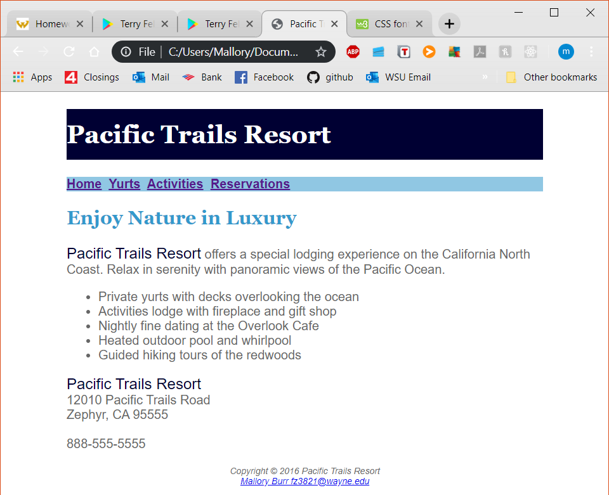

# Screenshot for Yurts.html

