Mallory Burr

Due November 7, 2019

CSC 3750- Online

Homework 6

Pacific Trails Website with Mobile and Tablet Capabilities

Table of Contents

Code for Index.html 2

Code for Yurts.html 4

Code for Activities.html 6

Code for pacific.css 8

Screenshot for Index.html 13

Screenshot for Yurts.html 14

Screenshot for Activities.html 15

# Code for Index.html

<!DOCTYPE html>

<html lang="en">

<head>

<title>CSC 3750 Home</title>

<link href="css/styles.css" rel="stylesheet">

<meta name="viewport" content="width=device-width, initial-scale=1.0">

<meta charset="utf-8">

</head>

<body>

<div id="wrapper">

<header>

<h1>Intro to Web Development Homeworks</h1>

<h3>Mallory Burr - Fall 2019</h3>

</header>

</br></br>

<main>

<div class="card">

<a href="Homework2/pacific/index.html">

<div class="container">

<h4><b>Homework One</b></h4>

<p>Basic Website</p>

</div>

</div>

<div class="card">

<a href="Homework3/pacificcss/index.html">

<div class="container">

<h4><b>Homework Two</b></h4>

<p>Website with CSS</p>

</div>

</div>

<div class="card">

<a href="Homework4/pacific4/index.html">

<div class="container">

<h4><b>Homework Three</b></h4>

<p>Website with CSS and images</p>

</div>

</div>

<div class="card">

<a href="Homework5/pacific6/index.html">

<div class="container">

<h4><b>Homework Four</b></h4>

<p>Website with columns</p>

</div>

</div>

<div class="card">

<a href="Homework6/pacific7/index.html">

<div class="container">

<h4><b>Homework Five</b></h4>

<p>Website with mobile</p>

</div>

</div>

</main>

</br></br>

</div>

</body>

</html>

# Code for Yurts.html

<!DOCTYPE html>

<html lang="en">

<head>

<title>Pacific Trails Resort :: Yurts</title>

<link href="pacific.css" rel="stylesheet">

<meta name="viewport" content="width=device-width, initial-

scale=1.0">

<meta charset="utf-8">

<!--[if lt IE 9]>

<script src="http://html5shim.googlecode.com/svn/trunk/html5.js">

</script>

<![endif]-->

</head>

<body>

<div id="wrapper">

<header>

<h1>Pacific Trails Resort</h1>

</header>

<nav>

<ul>

<li><a href="index.html">Home</a></li>

<li><a href="yurts.html">Yurts</a></li>

<li><a href="activities.html">Activities</a></li>

<li><a href = "reservations.html">

Reservations</a></li>

</ul>

</nav>

<div id="yurthero">

</div>

<main>

<h2>The Yurts at Pacific Trails</h2>

<dl>

<dt>What is a yurt?</dt>

<dd>

Our luxury yurts are permanent

structures four feet off the ground.

Each yurt has canvas walls, a wooden

floor, and a roof dome that can be opened.

</dd>

<dt>How are the yurts furnished?</dt>

<dd>

Each yurt is furnished with a queen-

size bed with down quilt and gas-fired

stove.

The luxury camping experience also

includes electricity and a sink with

hot and cold running water. Shower and restroom facilities are located in the lodge.

</dd>

<dt>What should I bring?</dt>

<dd>

Bring a sense of adventure and some

time to relax! Most guests also pack comfortable walking shoes and plan to dress for changing weather with layers of clothing.

</dd>

</dl>

</main>

<footer>

Copyright &copy; 2016 Pacific Trails Resort</br>

<a href="mailto:fz3821@wayne.edu">Mallory Burr

fz3821@wayne.edu</a>

</footer>

</div>

</body>

</html>

# Code for Activities.html

<!DOCTYPE html>

<html lang="en">

<head>

<title>Pacific Trails Resort :: Activities</title>

<link href="pacific.css" rel="stylesheet">

<meta name="viewport" content="width=device-width, initial-

scale=1.0">

<meta charset="utf-8">

<!--[if lt IE 9]>

<script src="http://html5shim.googlecode.com/svn/trunk/html5.js">

</script>

<![endif]-->

</head>

<body>

<div id="wrapper">

<header>

<h1>Pacific Trails Resort</h1>

</header>

<nav>

<ul>

<li><a href="index.html">Home</a></li>

<li><a href="yurts.html">Yurts</a></li>

<li><a href="activities.html">Activities</a></li>

<li><a href = "reservations.html">

Reservations</a></li>

</ul>

</nav>

<div id="trailhero">

</div>

<main>

<h2>Activities At Pacific Trails</h2>

<h3>Hiking</h3>

<p>

<span class="resort">Pacific Trails Resort</span>

has 5 miles of hiking trails and is adjacent to a state park.

Go it alone or join one of our guided hikes.

</p>

<h3>Kayaking</h3>

<p>

Ocean kayaks are available for guest use.

</p>

<h3>Bird Watching</h3>

<p>

While anytime is a good time for bird watching at

Pacific Trails, we offer

guided bird-watching trips at sunrise several

times a week.

</p>

</main>

<footer>

Copyright &copy; 2016 Pacific Trails Resort</br>

<a href="mailto:fz3821@wayne.edu">Mallory Burr

fz3821@wayne.edu</a>

</footer>

</div>

</body>

</html>

# Code for pacific.css

@media only screen and (max-width: 1024px) {

body {

padding: 0;

background-image: none;

}

#wrapper

{

width: auto;

min-width: 0;

margin: 0;

box-shadow: none;

}

h1 {

margin: 0;

}

nav {

float: none;

width: auto;

padding: 0.5em;

}

nav li {

display: inline-block;

}

nav a {

padding: 1em;

}

main {

padding: 1em;

margin-left: 0;

font-size: 90%;

}

footer {

margin: 0;

}

#homehero, #yurthero, #trailhero {

margin-left: 0;

}

}

@media only all and (max-width: 768px) {

h1 {

height: 100%;

font-size: 1.5em;

padding-left: 0.3em;

}

nav {

padding: 0;

}

nav a {

display: block;

padding: 0.2em;

font-size: 1.3em;

border-bottom: 1px #330000;

}

nav ul {

margin: 0;

padding: 0;

}

nav li {

display: block;

margin: 0;

padding: 0;

}

main {

padding-top: 0.1em;

padding-right: 0.6em;

padding-bottom: 0.1em;

padding-left: 0.4em;

}

#homehero, #yurthero, #trailhero {

display: none;

}

footer {

padding: 0;

}

#mobile { display: inline; }

#desktop { display: none; }

}

body

{

background-color: #FFFFFF;

background-image: url("images/background.jpg");

font-family: Arial, Verdana, Sans-Serif;

color: #666666;

}

* { box-sizing: border-box; }

header, nav, main, footer { display: block; }

#wrapper

{

width: 80%;

margin-right: auto;

margin-left: auto;

background-color: #90C7E3;

min-width: 700px;

max-width: 1024px;

box-shadow: 3px 3px 3px #333;

}

nav a:link {

color: #000033;

}

nav a:visited {

color: #344873;

}

nav a:hover {

color: #FFFFFF;

}

nav ul

{

list-style-type: none;

padding-left: 0;

margin: 0;

}

header

{

background-color: #000033;

color: #FFFFFF;

font-family: Georgia, Serif;

}

nav

{

font-weight: bold;

float: left;

width: 160px;

padding-top: 20px;

padding-right: 5px;

padding-bottom: 0px;

padding-left: 20px;

}

nav a

{

text-decoration: none;

}

#homehero

{

height: 200px;

background-image: url("images/coast.jpg");

background-size: 100% 100%;

background-repeat: no-repeat;

margin-left: 170px;

}

#yurthero

{

height: 200px;

background-image: url("images/yurt.jpg");

background-size: 100% 100%;

background-repeat: no-repeat;

margin-left: 170px;

}

#trailhero

{

height: 200px;

background-image: url("images/trail.jpg");

background-size: 100% 100%;

background-repeat: no-repeat;

margin-left: 170px;

}

.resort

{

color: #000033;

font-size: 1.2em;

}

h1

{

line-height: 200%;

background-image: url("images/sunset.jpg");

background-position: right;

background-repeat: no-repeat;

padding-left: 20px;

height: 72px;

margin-bottom: 0;

}

h2

{

color: #3399CC;

font-family: Georgia, Serif;

}

h3

{

color: #000033;

}

main

{

padding-left: 20px;

padding-right: 20px;

display: block;

background-color: #FFFFFF;

margin-left: 170px;

padding-top: 1px;

padding-bottom: 1px;

}

dt

{

color: #000033;

font-weight: bold;

}

footer

{

font-size: .70em;

font-style: italic;

text-align: center;

padding: 10px;

background-color: #FFFFFF;

margin-left: 170px;

}

# Screenshot for Index.html

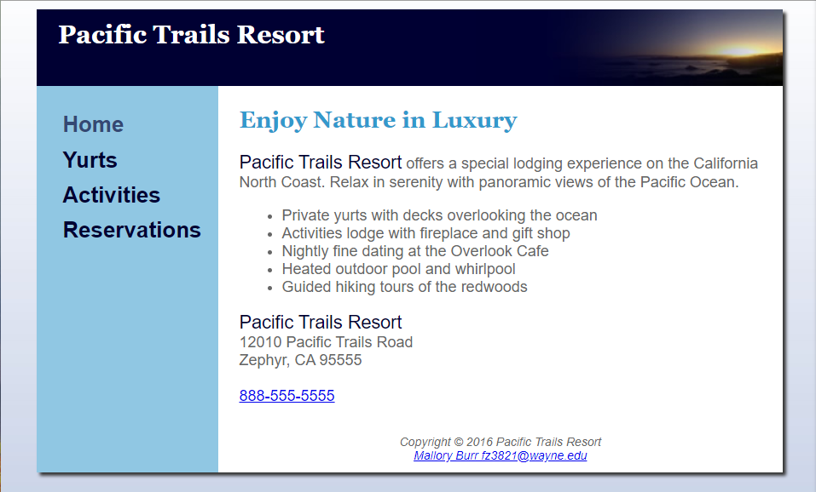

# Screenshot for Yurts.html

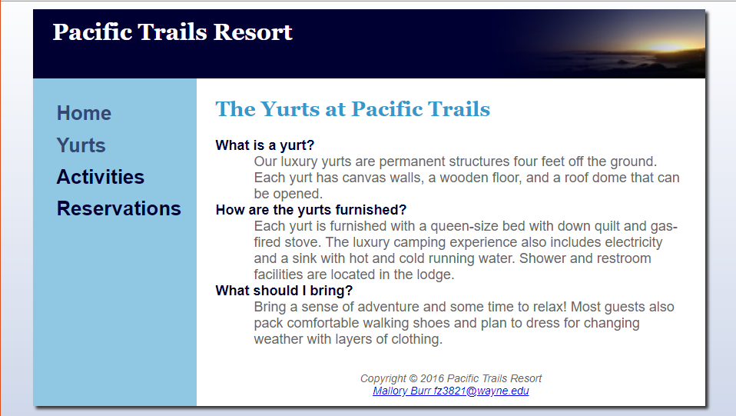

# Screenshot for Activities.html

