Design

Development

I broke the software development stage into four parts: creating the initial version of the feature in question, finding any bugs that existed in the initial version, fixing those bugs to perfect the feature, and then giving that version to my end users to provide feedback on the specific feature in question that would then go into refining the feature. This cycle would then repeat until the end users were happy with the feature.

The first feature I had to develop was the system used to initialise the tank and the tank’s interior. Originally this was done by using Panda3d’s inbuilt rendering commands inside the main program itself, as shown below:

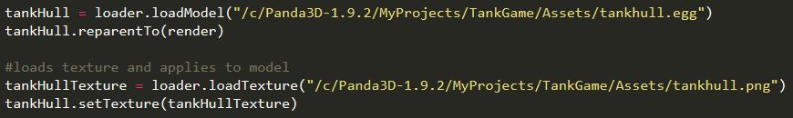

However, after a few models, this would have swollen the size of the program significantly, especially when my single vehicle is made up of 20+ components. So, I decided to create a function inside my external utility library that would allow me to just supply a function with all the necessary information to create the component.

Shown below is the function inside the utility library:

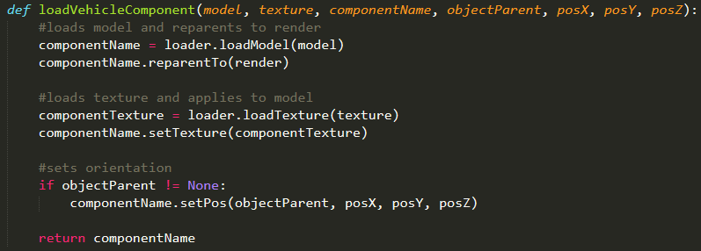

The function takes the model filepath of the component, the texture filepath of the component, the name of the component (this is just used for external referencing), the model that the component’s position will be set relative to, and the X, Y and Z coordinates of the component relative to the parent object. The function loads the model and parents it to panda3d’s render node, bringing it ingame. The function then loads the texture and applies it to the model. After that, it checks if the component has a parent object, and if that evaluates to anything other than true, then the model is positioned relative to the object

This function is used inside the main body of the program to initialise all the components that the tank the player is in uses. The model and texture filepaths are held inside arrays for each component, shown below:

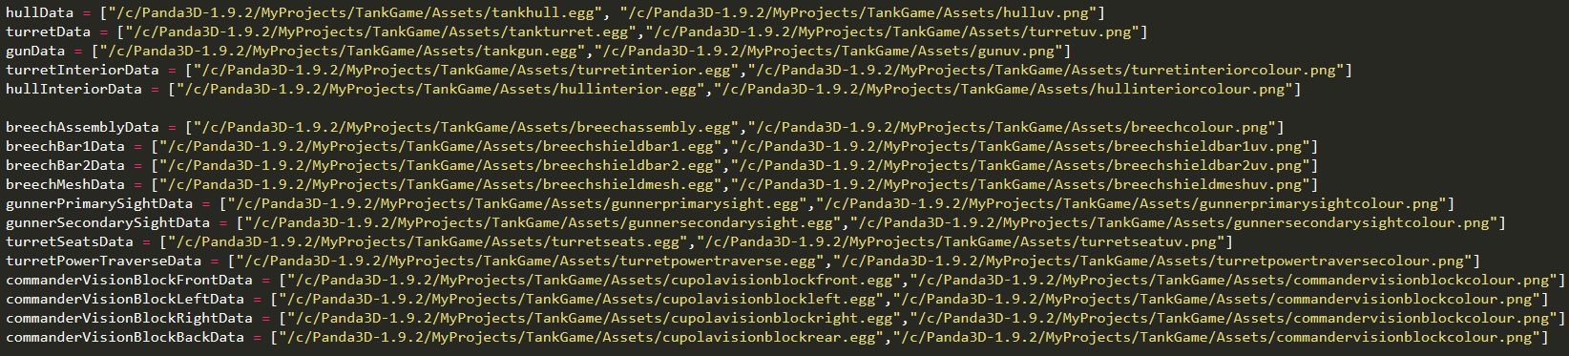

And the function from the external utility library is shown below:

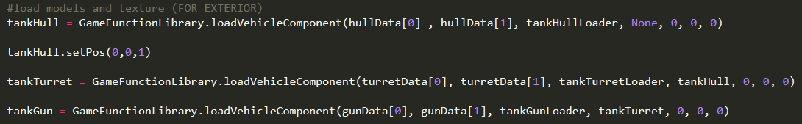

(this is not all the functions