Integrating the Lightware Lw20/C over the CAN

Objective:
We need to make sure that the Lightware LW20C Serial can be connected to CAN port using the mro CAN Node V1
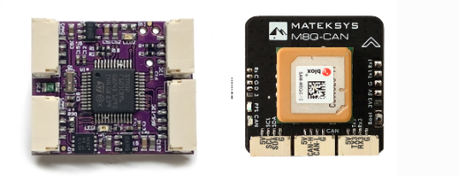
This is to remove the issues we are facing with the I2C connector.

Important Links:
- Peripheral Page for the Ardupilot wiki
- mRobotics DroneCAN Adapter Node
- Ardupilot Peripheral Code
- Mro CAN Node V1 page
- Porting Code

Observation of an issue:

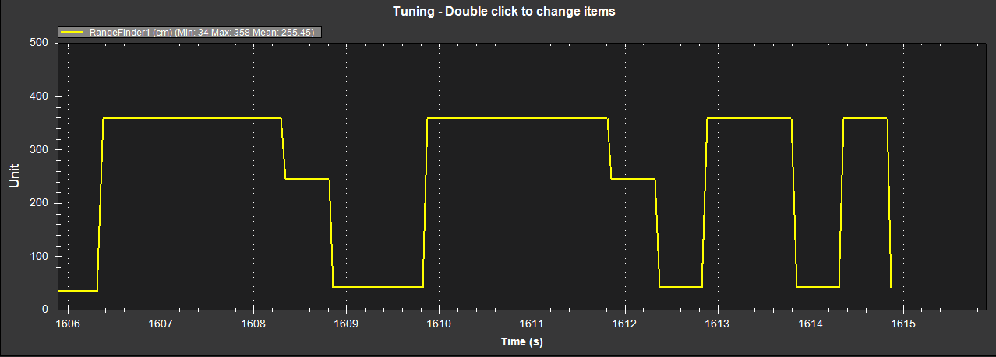

Compilation of Code:
Issue with compiling the code for f303-Universal board
Important commands:
Build Commands:
./waf configure --board f303-Universal
./waf distclean
./waf AP_Periph
Git commands used:
git fetch --tags
git tag | grep -E "^AP_Periph" | tail -5
git checkout AP_Periph-stable
git submodule update --init --recursive --force

Updating the hwdef.dat file for f303-Universal
I also updated the hardware file for the f303-Universal to only look for Rangefinder:
Location: libraries/AP_HAL_ChibiOS/hwdef/f303-Universal/hwdef.dat

include ../f303-periph/hwdef.inc
# ==================== DISABLE ALL FEATURES ====================
# GPS
define AP_PERIPH_GPS_ENABLED 0
define GPS_MOVING_BASELINE 0
# Compass/Magnetometer
define AP_PERIPH_MAG_ENABLED 0
# Barometer
define AP_PERIPH_BARO_ENABLED 0
# Airspeed - NEW API NAME
define AP_PERIPH_AIRSPEED_ENABLED 0
# ADSB
define AP_PERIPH_ADSB_ENABLED 0
# LEDs
define AP_PERIPH_NCP5623_LED_WITHOUT_NOTIFY_ENABLED 0
define AP_PERIPH_NOTIFY_NEOPIXEL_ENABLED 0
# MSP
define HAL_MSP_ENABLED 0
# Camera
define AP_RUNCAM_ENABLED 0
# PiccoloCAN
define HAL_PICCOLO_CAN_ENABLE 0
# Battery - NEW API NAME
define AP_PERIPH_BATTERY_ENABLED 0
# RC - NEW API NAMES
define AP_PERIPH_RC_OUT_ENABLED 0
define AP_PERIPH_RCIN_ENABLED 0
# RPM - NEW API NAME
define AP_PERIPH_RPM_ENABLED 0
# ==================== ENABLE RANGEFINDER ====================
define AP_PERIPH_RANGEFINDER_ENABLED 1
define RANGEFINDER_MAX_INSTANCES 1

Go into: Setup->Optional Hardware->DroneCAN/UAVCAN-> SLCAN Direct
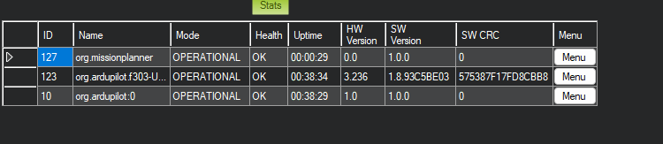

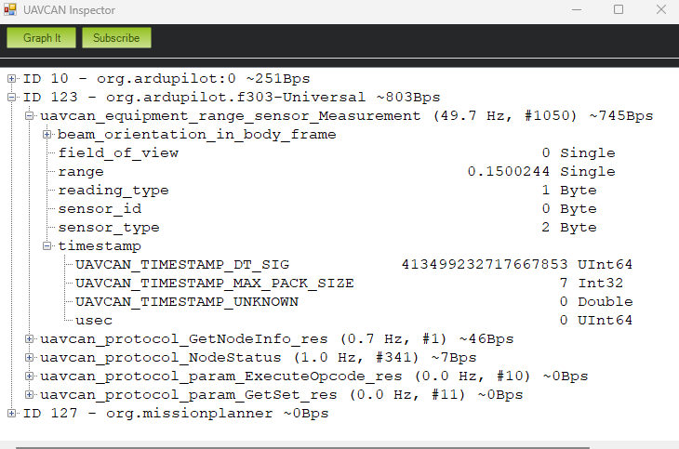

BRD_SERIAL_NUM,0
CAN_BAUDRATE,500000
CAN_NODE,0
DEBUG,0
FLASH_BOOTLOADER,0
FORMAT_VERSION,2
OPTIONS,0
Params for the F303:
RNGFND_BAUDRATE,115200
RNGFND_MAX_RATE,50
RNGFND_PORT,3
RNGFND1_ADDR,0
RNGFND1_FUNCTION,0
RNGFND1_GNDCLR,0.1
RNGFND1_LW20MODE,2
RNGFND1_MAX,95
RNGFND1_MIN,0.05
RNGFND1_OFFSET,0
RNGFND1_ORIENT,0
RNGFND1_PIN,-1
RNGFND1_POS_X,0
RNGFND1_POS_Y,0
RNGFND1_POS_Z,0
RNGFND1_PWRRNG,0
RNGFND1_RMETRIC,1
RNGFND1_SCALING,3
RNGFND1_STOP_PIN,-1
RNGFND1_TYPE,8

FC Drone Can:
RNGFND1_TYPE,24

F103 Integratoin:
Using the commands:
./waf configure --board f103-RangeFinder
./waf AP_Periph
Using the branch: AP_Periph-stable on ardupilot

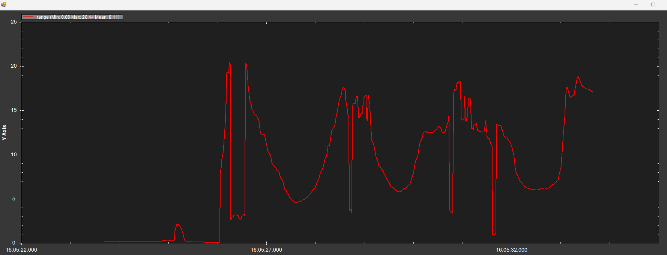
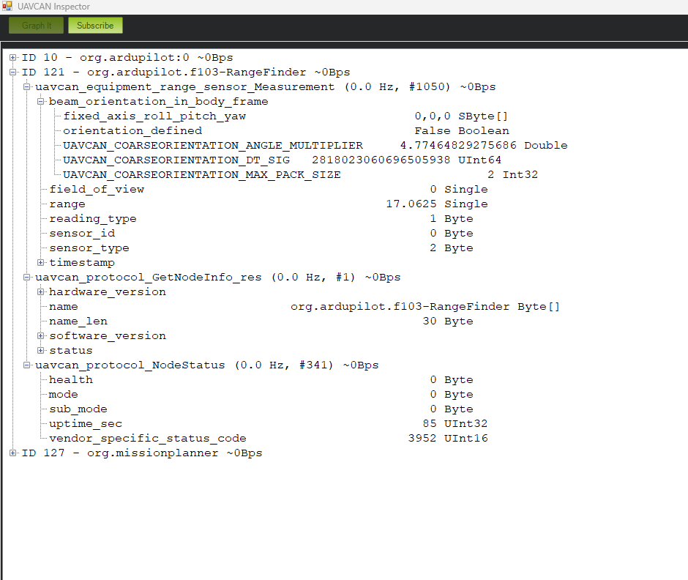

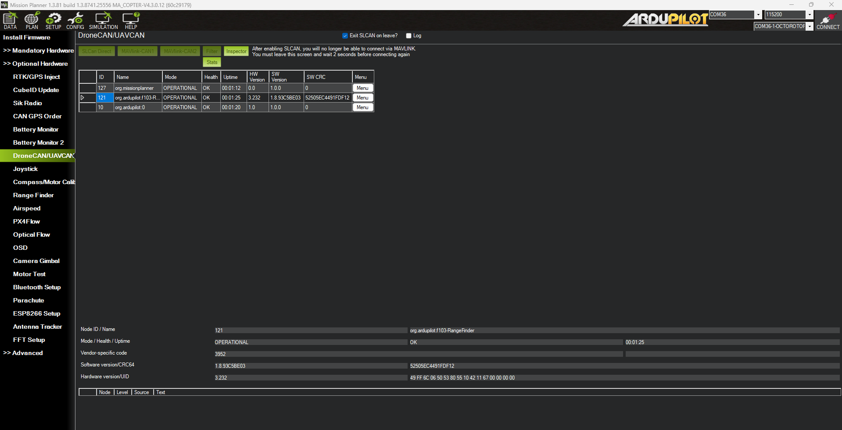

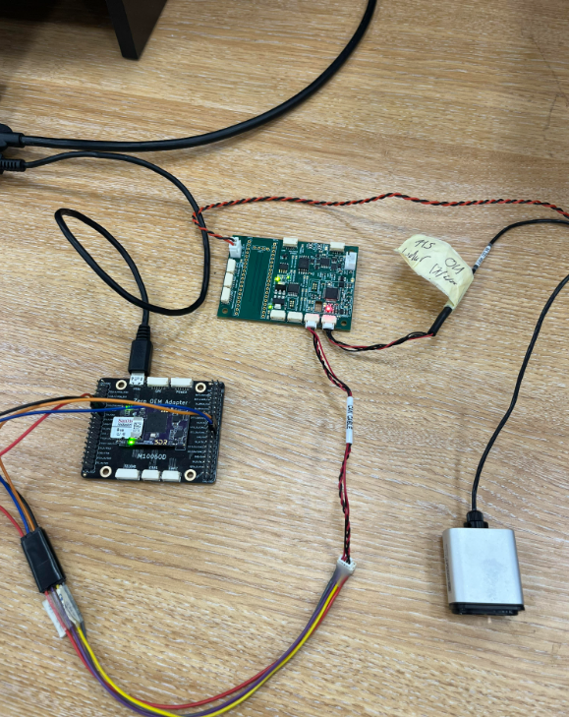

Issue Observed on F103:
We observed on the custom board we are getting on CN17 can node :
t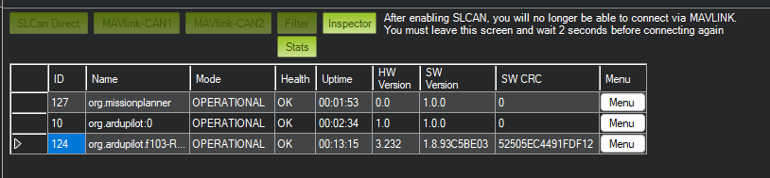
But not on CN16:
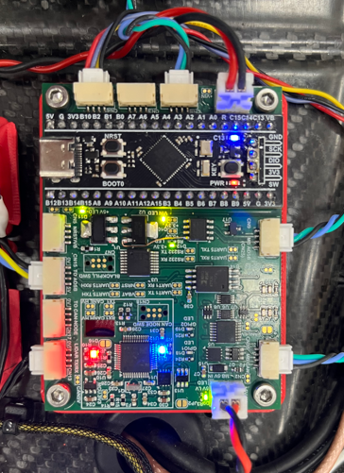

Parameters:
- CAN_P1_DRIVER = 1 (assuming its on the first CAN bus of the autopilot and will be using the first driver)
- CAN_D1_PROTOCOL = 1 (DroneCAN)(assuming its the first driver)
- RNGFND1_TYPE = 24 (DroneCAN)
Fix for the Above issue:
120ohm resistor on the high voltage side

CAN Messages observed:
Can ID | Count | Source ID | Description
0001557Fh | 308 | 7Fh – 127 mission planner | 155h – 341 Node Status
1001550Ah | 330 | 0A- 10 Ardupilot | 155h- 341 Node Status
1801557Ch | 309 | 7Ch-124 from the f103 | 155h- 341 Node Status
18041A7Ch | 46341 | 7Ch-124 from the f103 | 041Ah- 1050 range sensor measurement
1E044C0Ah | 617 | 0A- 10 Ardupilot | 044Ch-1100 Arming Status
1E4E200Ah | 617 | 0A- 10 Ardupilot | 4E20h -20000 Safety State
1E4E270Ah | 12324 | 0A- 10 Ardupilot | 4E27-20007 Notify State
