**Hungry Shark’s Deployment Plan**

**Team Shake Shark**

December 1, 2019

**Team Members**

Qingyang Dong

Jialei Zhou

Ziwen Wang

Feishian Tzeng

# Introduction to Hungry Shark

Hungry Shark is a 2D casual game which is written in Python 3. The background of this game is the marine debris had been released in a sea or ocean. There are one million seabirds killed by marine litter every year. More than a hundred thousand turtles and marine mammals, such as dolphins, whales and seals, are killed by plastic marine litter every year around the world. Our main goal is bringing the awareness of protecting ocean environment. The main audience of this game is for 4-9 years old children. Therefore, our product is a Non-Commercial game.

# Introduction to Publisher

Due to the nature of product, the main purpose of this game is for entertainment. There are many video game publishers and digital distribution company in the world. Below are the largest publishers in general according to their revenue in billions of dollars as of 2017 (TAKAHASHI).

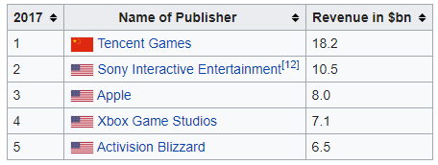

However, none of those top five companies can deploy our game. For Tencent Games, Sony Interactive Entertainment, and Activision Blizzard, they most likely won’t allow individual developer to release their game. On the other hand, Apple and Xbox Game Studios are not working either, because the current status of our game only supports on Windows and Mac OS X.

# Publish Plan on App Store and other publishers

* Publish on Apple App Store and Google Play Store

In order to be published on app store, the most important thing is to make our game running on iOS and android system. It would take about one month to finish the cross-platform product if we are in a group of 5 people. After our game is ready to be published, Apple App Store will charge an annual developer fee of $99 and Google Play Store will charge a one-time developer fee of $25.

* Publish on Steam

Steam is a video game digital distribution service developed by Valve. It was launched as a standalone software client in September 2003 as a way for Valve to provide automatic updates for their games and expanded to include games from third-party publishers.

According to Pavel Drotár, there are five steps to release a game on Steam:

1. Register a legal entity (company) as a developer, complete with bank account information so that Steam can send you your earnings.
2. Pay the 100$ fee for publishing your game on Steam Direct.
3. Agree on price, provide promotional videos and images, description of the game for the store page, register moderator accounts for Steam game forums, decide on the structure of the forums for the game.
4. Deliver the game files to Steam (as per instructions which you will receive).
5. Set the release date.

For the first requirement, we have to fill out the requirements below:

* + Business name
  + Business location
  + Ownership, management structure, or directors
  + Registered agent information
  + Number and value of shares (if you’re a corporation)

On the other hand, we also need the documents below:

(Administration)

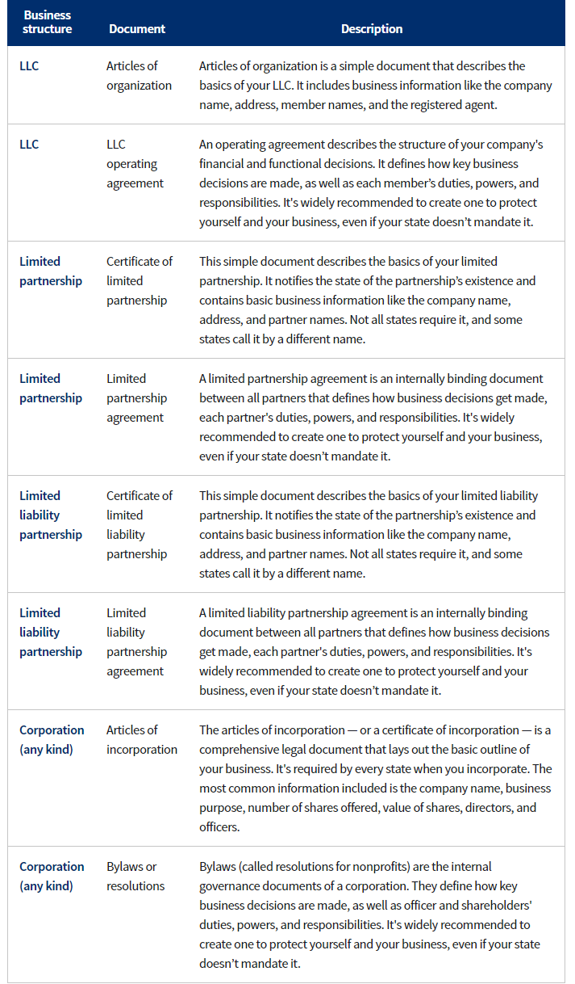

After we successfully register a legal entity, Steam charges $100 fee for publishing our game on Steam Direct. The rest of the process require us approximately three month to finally set the release date.

# Summary

The game, Hungry Shark, is not designed commercially. The main purposes of the product are for the education and the environmental awareness instead of the profit. The most effective way to release our game is publishing on Steam because the earlier our product is released, the greater number of audiences we will have. When it comes to cross-platform development, we need to decide which part of code can be used on multiple platforms and implement those codes in different languages.

# Works Cited

Administration, U.S. Small Business. "Register your business." 1 Nov 2018. *https://www.sba.gov/.* 29 Nov 2019.

TAKAHASHI, DEAN. "Newzoo: Top 25 game companies captured 77% of $121.7 billion market." 09 May 2018. *venturebeat.* 29 Nov 2019.