**Hungry Shark’s Bug list**

**Team Shake Shark**

December 1, 2019

**Team Members**

Qingyang Dong

Jialei Zhou

Ziwen Wang

Feishian Tzeng

1. The image’s center is not the ‘real’ center

Due to our product involves images, which results there exists a center coordinate for image itself and a center coordinate for the displayed image. In general, display an image will automatically use the center as the placement coordinate. As the following screenshot shown, the ‘+’ is the placement coordinate. So, we need to manually adjust the coordinate until it matches the center of our shark. In this kind of scenario, touch detection requires a more accurate location. This bug will cause measurement error for touching detection.

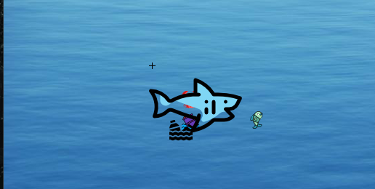

1. Different shape of object using same method to detect distance

Our touch detection involves origin point and radius, which assume object is a circle. Object will react if the distance between shark and itself is too close. However, there are many different types of shapes. Such as our shark, the shape can be assuming as rectangle. In other words, the length of longer side is larger than the smaller side, which can result shark will be accidently eliminate if an obstacle is getting too close on the top or bottom side of shark.

1. Did not limit the boundary for objects

We only limit the boundary for shark but not the obstacles and food. This might cause memory overflow as gaming progressing.

1. For the special mode, sometimes the ship will be stuck in the same position instead of moving horizontally.
2. For the sound effect part, there is delay between shark scores points and sound shows up due to the refresh rate for game loop and system is not sync.
3. Mac OS X user can only use Fullscreen mode to play. Otherwise, the game will become 30 fps due to the display refresh rate on mac is locked at 30Hz.