EXP NO: 7
Servlet Program to Store and Retrieve User Preferences Using Cookies

Aim:
Write a Servlet program to store a user's preferences (like theme or language) using cookies. Retrieve and display these preferences on subsequent visits.

Code:
Cookie.jsp

<%@ page language="java" contentType="text/html; charset=ISO-8859-1"
pageEncoding="ISO-8859-1"%>
<!DOCTYPE html>
<html>
<head>
<meta charset="ISO-8859-1">
<title>Set Preferences</title>
</head>
<body>
<form method="post">
<p>
<label>Theme: </label>
<select name="theme">
<option value="light">Light</option>
<option value="dark">Dark</option>
</select>
</p>
<p>
<label>Language: </label>
<select name="language">
<option value="English">English</option>
<option value="Tamil">Tamil</option>
<option value="Hindi">Hindi</option>
</select>
</p>
<button type="submit">Save Preferences</button>
</form>

<%
if ("POST".equals(request.getMethod())) {
String theme = request.getParameter("theme");
String language = request.getParameter("language");

Cookie themeCookie = new Cookie("theme", theme);
Cookie langCookie = new Cookie("language", language);

themeCookie.setMaxAge(60 * 60 * 24 * 7); // 7 days
langCookie.setMaxAge(60 * 60 * 24 * 7); // 7 days

themeCookie.setPath("/");
langCookie.setPath("/");

response.addCookie(themeCookie);
response.addCookie(langCookie);

response.sendRedirect("getCookie.jsp");
}
%>
</body>
</html>

Getcookie.jsp
<%@ page language="java" contentType="text/html; charset=ISO-8859-1"
pageEncoding="ISO-8859-1"%>
<!DOCTYPE html>
<html>
<head>
<meta charset="ISO-8859-1">
<title>Your Preferences</title>
</head>
<body>
<%
String theme = "Not set";
String language = "Not set";

Cookie[] cookies = request.getCookies();
if (cookies != null) {
for (Cookie cookie : cookies) {
if ("theme".equals(cookie.getName())) {
theme = cookie.getValue();
} else if ("language".equals(cookie.getName())) {
language = cookie.getValue();
}
}
}
%>
<h2>Your Saved Preferences</h2>
<p>Theme: <%= theme %></p>
<p>Language: <%= language %></p>
</body>
</html>

OUTPUT:
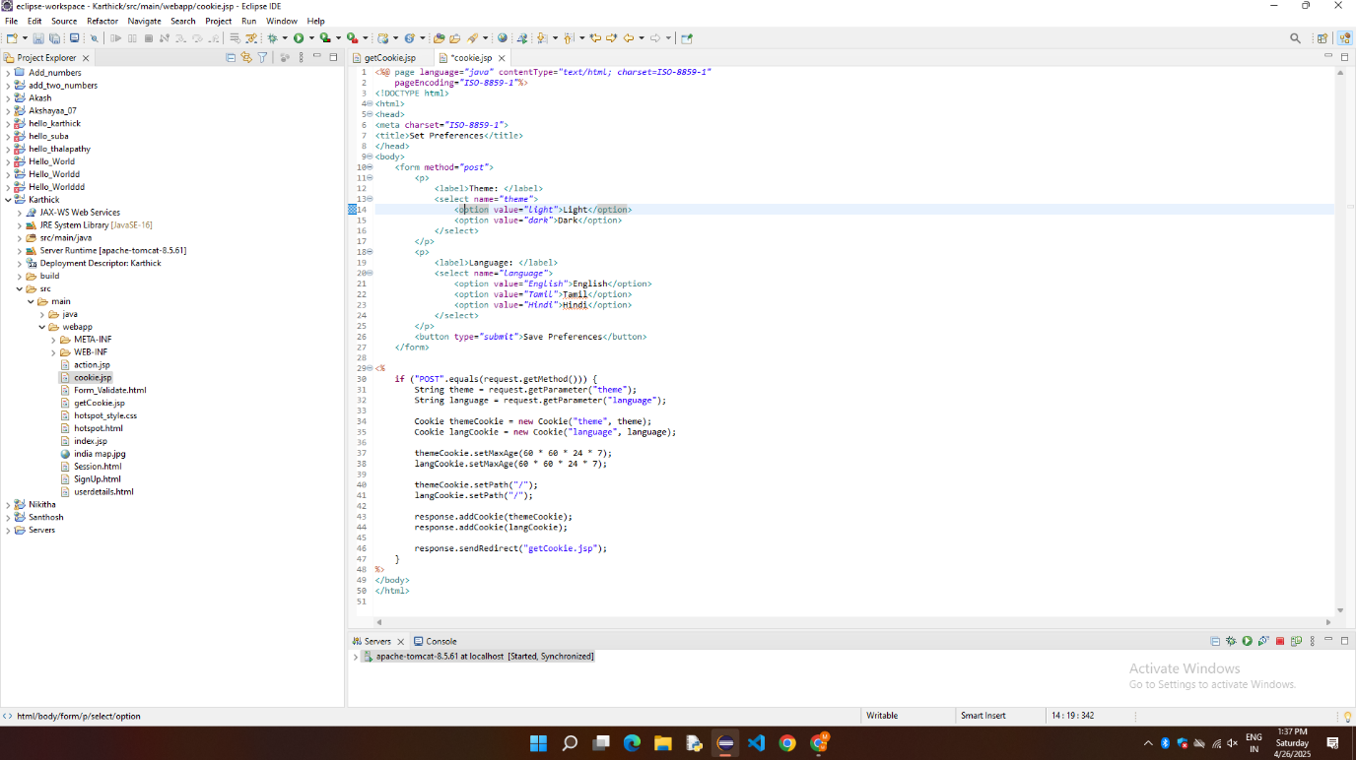

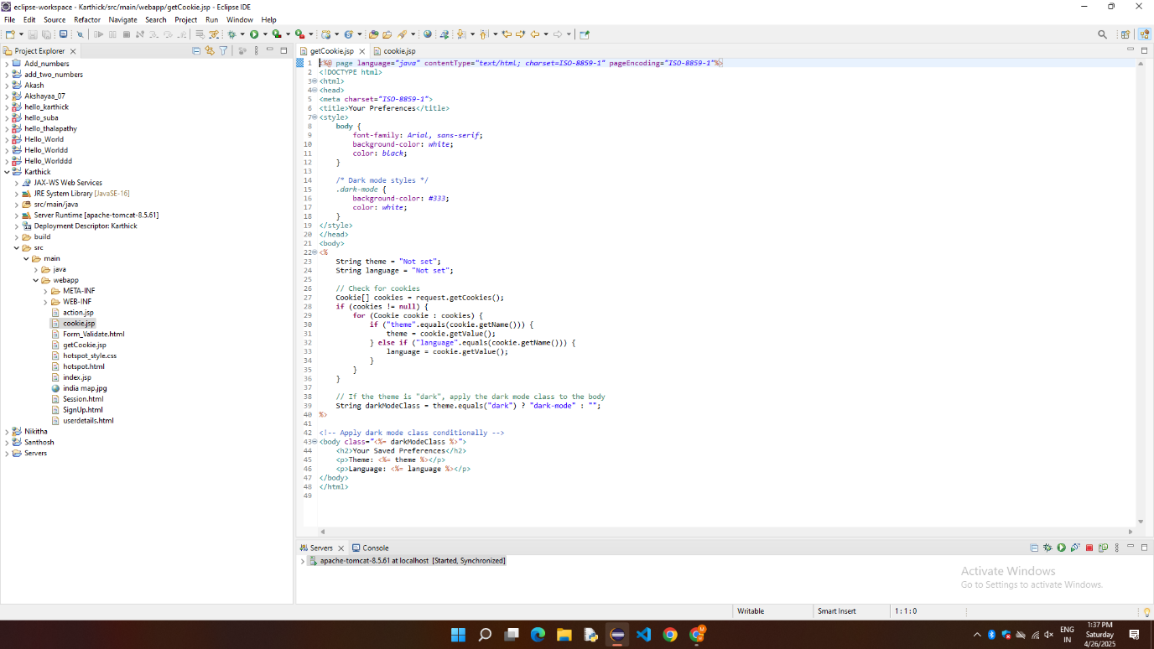
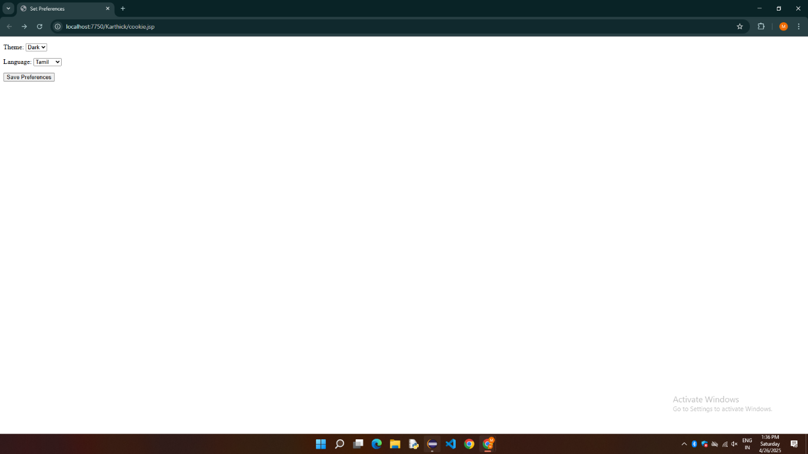

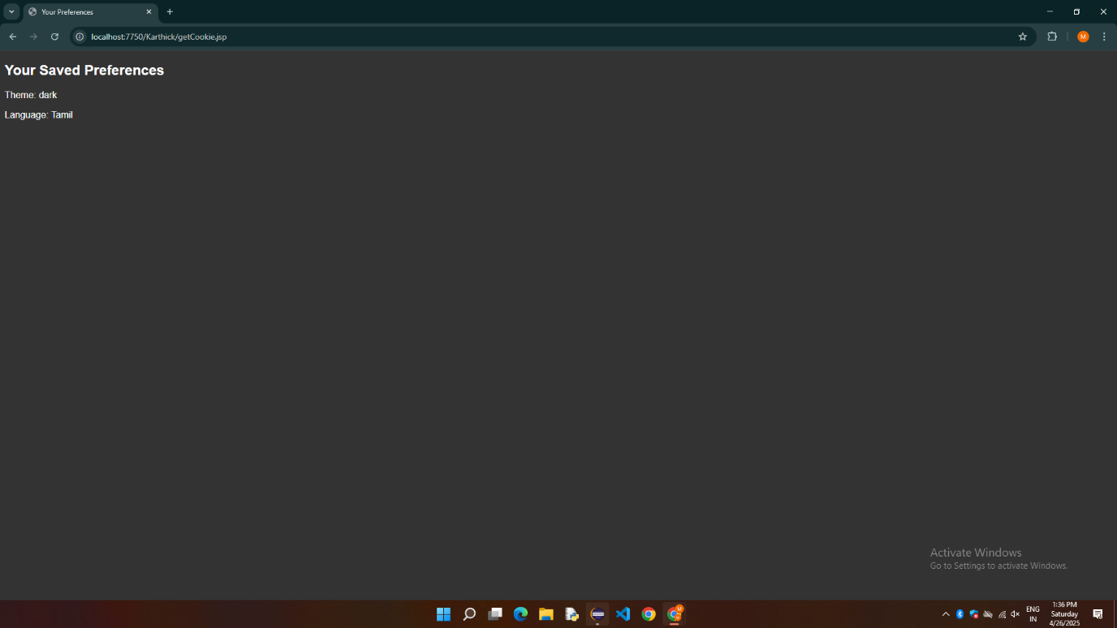

RESULT:
Thus, the Cookies is demonstrated Successfully.

