Question 1 (AA1, AA2):

1. Unity & Construct 2

The game engine chosen was Unity.

* Free for personal Use.
* Use of C# makes, allows you to do more with your game
* Allows for 3D games not just limited to platform
* Highly optimized system even for weak devices.

1. C# & Python

The chosen programming language is C#

* Large variety of Libraries, Plugins and Imports
* IDE for Debugging, Compiling etc.
* Cross Platform (When installed vie .NET framework
* Easy Development and implementation with unity due to Libraries.

Question 2 (SE1):

Ongoing

Ongoing

Ongoing

End

Level 3

Level 2

Level 1

Start

Load Next Level

Load Next Level

Load Next Level

Load Next Level

Quit

Application.Quit

Load Next Level

Check Points

Check Points

Win

Next Level

GameStart

Opponent Points

Points

Start

5 Points First

5 Points First

Question 3 (KU 4):

Compression is when you make media files smaller which creates more storage space and makes transfer of data faster, thus distributing is easier. This is because compression removes repetitive or redundant data, this gives you the same amount of content without the unnecessary data which consumes device storage. There are two types of compression: Lossless and Lossy. Lossless compression allows you to recreate the original file to its original state with no data loss during compression. Lossy is used mainly for multiple types of media (ie. video and audio), This decreases the quality of the files but are typically undetectable to the human senses. An example of this could be to compress a file to upload to the cloud. It takes less time to upload and saves storage on your cloud devices.

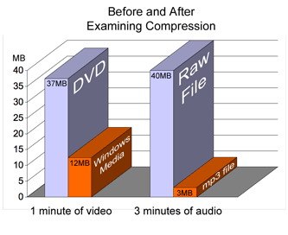

References;

**STATE DIAGRAMS - EVERYTHING TO KNOW ABOUT STATE CHARTS**

**In-text:**(Smartdraw.com, 2017)

**Your Bibliography:**Smartdraw.com. (2017). *State Diagrams - Everything to Know about State Charts*. [online] Available at: https://www.smartdraw.com/state-diagram/ [Accessed 17 Dec. 2017].

### COMPRESSION DEFINITION

**In-text:**(Techterms.com, 2017)

**Your Bibliography:**Techterms.com. (2017). *Compression Definition*. [online] Available at: https://techterms.com/definition/compression [Accessed 17 Dec. 2017].