Yield-Constrained Agrivoltaic Potential of India Under Current and Mid-Century Climate
M. Al-Mandhari¹ and A. Ghosh^{1*}
¹[Affiliation of each author: department, institution, city, country.]
*Corresponding author: Aritra Ghosh ([email address])

Key Points:
• If crops must keep 80% of their yield, Indian farmland could host 22.6 to 39.2 terawatts peak of elevated solar
• Allowed panel density is about twice as high for cereals as for legumes, and low fertiliser use makes crops look more shade tolerant
• Mid-century climate barely changes this capacity, but raised frames need a tariff top-up that crop income cannot cover

Abstract
Growing crops under solar panels could ease the competition between food and energy for land, but national estimates of agrivoltaic potential assume fixed power densities and do not test whether crops keep their yield. To our knowledge, this is the first yield-constrained national potential for India. A strip-resolved light model for three array layouts drives crop models of wheat, chickpea, pearl millet and groundnut on 2977 grid cells, under five downscaled climate models for 1995–2014 and 2041–2060 and with nitrogen calibrated to observed state yields. For each cell we found the largest ground coverage ratio (GCR) that keeps relative yield at or above 0.66, 0.80 or 0.90, the thresholds of German, Japanese and French rules. With the lower of calibrated and recommended nitrogen, cropland with slopes up to 5% could host 39.2 terawatts peak (TWp) of east-west elevated arrays at 80% relative yield on 39.7 million hectares (60.9 petawatt-hours per year). The crop models were more shade-tolerant than field observations; rescaled to them, capacity is 22.6 TWp, so we report 22.6–39.2 TWp as a technical potential, not a forecast. Feasible GCR averaged 0.52 for cereals but 0.29 for legumes, and low nitrogen hid part of the shade loss. Under the high-emission pathway SSP5-8.5, capacity changed by −1% and energy by −5%, through lower irradiance. Screening costs show that elevated frames need a tariff adder of Indian rupees (Rs) 0.49–0.85 per kWh, far above the crop value protected, so support should be tied to a yield threshold.

Plain Language Summary
Solar farms compete with food crops for land. Panels can be raised above a field so that both share the sunlight, but a crop only does well if enough light gets through. We built a computer model of the light under three panel layouts and linked it to crop models for wheat, chickpea, pearl millet and groundnut across India. For each place we asked how many panels fit if the crop must still give at least 80% of its normal harvest. Under that rule, Indian cropland could host between 22.6 and 39.2 terawatts of solar capacity, a technical figure that ignores grid, finance and land ownership. Wheat and pearl millet tolerate about twice as many panels as chickpea and groundnut, and crops grown with little fertiliser seem to cope with shade better than they really would. Climate change by mid-century barely changes how many panels fit, but it slightly reduces the electricity they produce. Raised frames cost more than ground-mounted panels, so farmers would need a higher electricity price, a gap that the value of the crop cannot cover. Linking any support to a yield rule would keep the land in food production.

1 Introduction
India has committed to drawing half of its installed electricity capacity from non-fossil sources by 2030 (Government of India, 2022). Solar power carries most of that growth, with more than 160 gigawatts (GW) installed by mid-2026 (Ministry of New and Renewable Energy, 2026b), and utility-scale photovoltaics (PV) need flat, sunny and accessible land. In India that land is mostly farmland. Agriculture still employs about 46% of the country's workers (National Statistics Office, 2024), so every hectare converted to PV trades food and rural income for power, and croplands happen to be among the most productive places for PV anywhere (Adeh et al., 2019). Globally, 13–16% of ground-mounted PV is already associated with a loss of cropland (Curioni et al., 2025). Agrivoltaics (APV), which grows crops under the panels, offers a way out of that choice.
Early field and modelling work showed that one field producing both food and electricity can outperform two separate ones (Dupraz et al., 2011; Valle et al., 2017), and in drylands the shade can even relieve plant water stress (Barron-Gafford et al., 2019). Crops do not all respond alike, however. In a meta-analysis of shading experiments, some crops lost little yield under moderate shade, whereas grain legumes lost yield almost in proportion to the light removed (Laub et al., 2022). Indian evidence remains thin. It covers grape farms (Malu et al., 2017), the experimental plant at Jodhpur in the hot arid zone (Santra et al., 2021; Poonia et al., 2022) and wheat under arrays of different density (Prakash et al., 2023). What suits one crop can fail another, so APV potential cannot be judged without the crop below the panels.
Regulators have drawn the same conclusion and set a minimum crop yield. Germany requires at least 66% of the reference yield (DIN, 2021). In Japan, a permit for PV over farmland is in doubt once yields fall by about 20% against the local average (Ministry of Agriculture, Forestry and Fisheries of Japan, 2024), and France asks for more than 90% of a reference area (Décret n° 2024-318, 2024). When systems are designed under such rules, it is often the yield limit, not the energy target, that fixes the panel density (Ademollo et al., 2026). A meaningful estimate of APV potential should therefore count only land where the yield condition holds, and only at a density that meets it.
Few potential estimates apply such a condition (Table 1). For India, a study for the Indo-German Energy Forum combined threshold screening with a crop suitability matrix and reported 3.2 to 13.8 terawatts (TW) (Fraunhofer ISE et al., 2024). The Energy and Resources Institute (TERI) found 1.2 to 2.1 TW on the 2.8 million hectares of cropland it judged highly suitable for shade-compatible crops (Yadav et al., 2026), and a geospatial multi-criteria study mapped more than 200,000 km² of highly suitable land (Mehta & Betz, 2026). None of them simulates crop yield under the panels. Studies elsewhere have the same gap: suitability for Great Britain was mapped without a crop model (Neesham-McTiernan et al., 2025), while a global agro-hydrological study cut light uniformly for rainfed crops and found that 22–35% of their harvested area could keep its yield (Curioni et al., 2025). The tenfold spread of the Indian figures thus reflects assumptions about which crops tolerate shade and what power density is acceptable. It does not come from modelling how a given array affects a given crop.
Table 1. Studies that estimate agrivoltaic potential at regional to global scale.
Study | Region and resolution | Crop yield under PV | PV geometry | Irrigation and nitrogen | Climate | Yield rule
Fraunhofer ISE et al. (2024) | India, district | Crop suitability matrix | Three configurations | No | Current | None
Yadav et al. (2026) | India, 250 m | Suitability matrix; 2.8 of 47 million hectares used | Fixed 0.42–0.75 megawatts (MW) per hectare | No | Current | None
Mehta and Betz (2026) | India, 1 km | Not modelled (multi-criteria index) | Not modelled | No | Current | None
Xia et al. (2024) | China, PV sites | Shading-response curve per crop | Two densities | No | Current | None
Willockx et al. (2022) | Europe, 25 km | Assumed unchanged; GCR from crop light need | Elevated, fixed | No | Current | Light requirement
Curioni et al. (2025) | Global, ~10 km | Agro-hydrological model, rainfed crops | Uniform light reduction | Rainfed only | Historical | None
Jia et al. (2026) | US Midwest, county | Process-based model, maize and soybean | GCR 0.33 | Not specified | Current and projected, high-emission | None
Arendarczyk et al. (2026) | Global, gridded | LandSyMM (LPJ-GUESS with PLUM) | Fixed GCR 0.25 | Nitrogen and irrigation simulated | Land-use scenarios to 2060 | None
This study | India, 0.25°, 2977 cells | Process-based, 4 crops, calibrated to state yields | 3 layouts × GCR 0.05–0.7, strip-resolved light | Irrigated and rainfed; calibrated and recommended nitrogen | 1995–2014; 2041–2060 under two emission pathways, 5 climate models | Relative yield ≥ 0.66, 0.80, 0.90
GCR is the ground coverage ratio, the share of land covered by modules.
At field scale, coupled light and crop models already exist. Ground irradiance below PV rows has been computed with ray tracing (Dupraz et al., 2011) and view factors (Nassar et al., 2022) and passed to crop and water-balance models. These couplings predict yield and irrigation demand under specific arrays (Amaducci et al., 2018; Elamri et al., 2018), optimise layouts at single sites (Mazzeo et al., 2025; Ademollo et al., 2026) and rank designs against a minimum crop ratio (Bellone et al., 2024). None has been scaled to a national map, which would need weather, soil, calendar and management data for every location and many crop-model runs per layout. Climate change adds a further reason to try. Shade removes light, which costs yield where light limits growth, but it also cools the canopy and lowers water demand, which helps where heat and drought dominate. In the United States Midwest, for example, one array design reduced maize and soybean yields in the humid east and raised soybean yields in the semi-arid west (Jia et al., 2026). Warming and shifting rainfall could likewise move the land where APV meets a yield rule, something correlative suitability maps cannot capture. To our knowledge, no national APV potential has yet been tested with crop models, explicit array layouts and a yield threshold under future climate.
India makes a demanding test case. Its cropland spans arid, semi-arid and humid climates. Four major field crops with contrasting shade responses cover about 51 million hectares (Mha) of harvested area: wheat (28 Mha), pearl millet (9 Mha), chickpea (8 Mha) and groundnut (5 Mha) (Yu et al., 2020). Policy, meanwhile, is already moving PV onto farms through the Pradhan Mantri Kisan Urja Suraksha evam Utthaan Mahabhiyaan (PM-KUSUM) scheme, which supports ground-mounted or stilt-mounted solar plants on farmers' own land (Ministry of New and Renewable Energy, 2024). Whether such plants can keep yields within accepted limits, and at what density, remains open.
Here we ask how much solar capacity India's cropland can host if its crops must keep a set share of their yield. We couple a strip-resolved light model for three array layouts with Decision Support System for Agrotechnology Transfer (DSSAT) crop models for the four crops, on a 0.25° grid driven by five climate models. Three questions follow. How dense can arrays be while the cropland keeps 66%, 80% or 90% of its yield? How do crop, layout and nitrogen management change that density and the resulting capacity? And how do both shift by 2041–2060 under two Shared Socioeconomic Pathways (SSPs), SSP2-4.5 and SSP5-8.5? Finally, we estimate how much crop the rule gives up and screen what keeping the crop costs in tariff terms.

2 Materials and Methods
We estimated the potential by coupling a two-dimensional light model of the ground below the PV rows with process-based crop models. The coupling was run for every 0.25° cell where the four crops are grown, under the current climate and two mid-century scenarios. As outlined in Fig. 1, the light model (A) feeds the crop model (B), whose relative yields are tested against a threshold (C) and then converted to capacity, energy, crop given up and cost (D). The Supporting Information gives further detail (Text S1–S14).
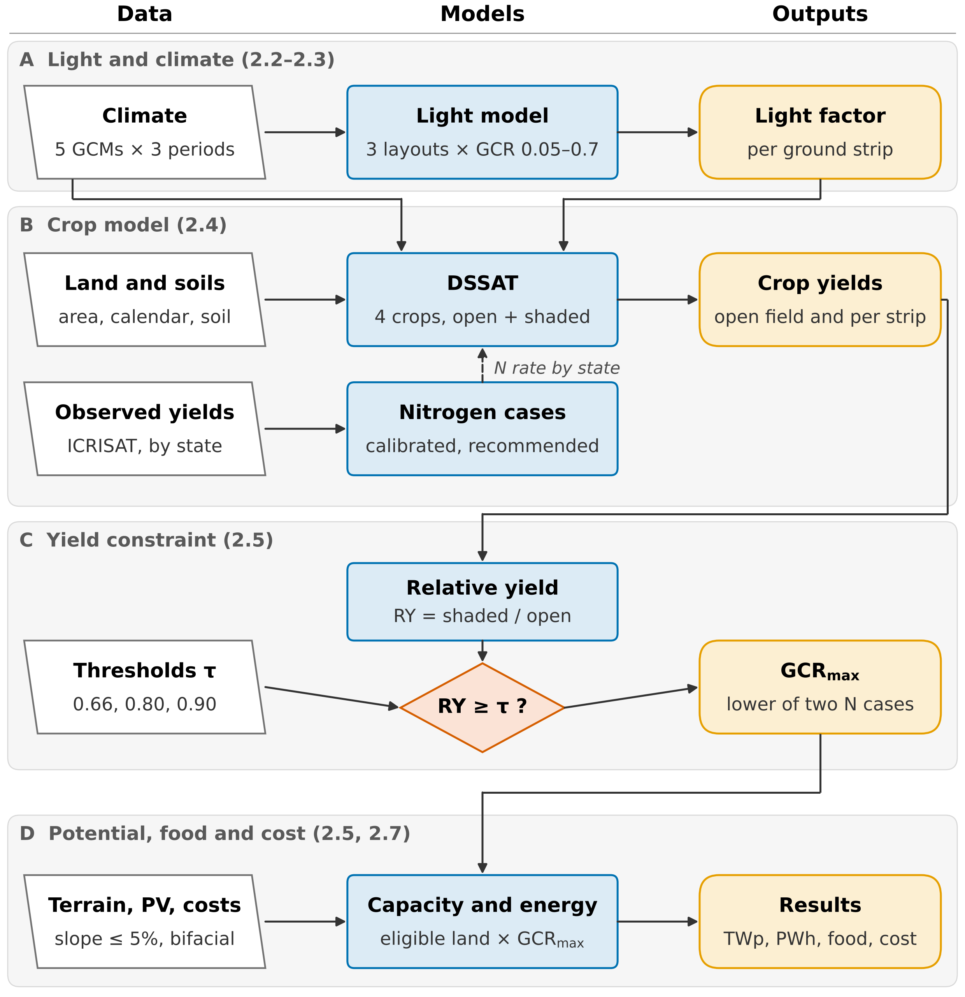
Fig. 1. Workflow. (A) A light model gives the daily light factor of five ground strips for each layout and ground coverage ratio (GCR), under five global climate models (GCMs). (B) The Decision Support System for Agrotechnology Transfer (DSSAT) simulates open-field and shaded yields with nitrogen (N) calibrated by state against observed yields (ICRISAT, International Crops Research Institute for the Semi-Arid Tropics) and at the recommended rate. (C) Relative yield (RY) is tested against each threshold τ to find the largest feasible GCR (GCR_{max}); the robust case takes the lower of the two N cases. (D) GCR_{max} and the eligible land give photovoltaic (PV) capacity and energy, the crop given up and the cost. Numbers in brackets are sections of the text.

2.1 Study domain and crop systems
The four crops span both cropping seasons and the main contrasts in shade response: wheat (rabi, a C₃ cereal), chickpea (rabi, C₃ legume), pearl millet (kharif, C₄ cereal) and groundnut (mainly kharif, C₃ legume). Harvested area and irrigated share were taken from the Spatial Production Allocation Model (MapSPAM) for 2010 (Yu et al., 2020). The 0.25° grid is clipped to India with the DataMeet state boundaries (DataMeet India Community, 2021), which also assign each cell to a state for the nitrogen calibration and the state totals. A crop was simulated wherever it covered at least 1000 ha of a cell. That rule gives 2977 cells and keeps 93–99% of each crop's national area (Table 2). Where irrigated and rainfed systems each held at least 10% of the crop's area in a cell, they were simulated separately.
Table 2. Crop systems and main crop-model settings.
Crop | DSSAT model, cultivar | Cells | Area simulated, Mha (share of national) | Irrigated share | Sowing date
Wheat | CERES-Wheat, Yecora Rojo | 2095 | 28.2 (99%) | 0.79 | Spring wheat calendar
Chickpea | CROPGRO-Chickpea, JG 74 | 1462 | 8.0 (96%) | 0.12 | Wheat date − 14 d
Pearl millet | CERES-Millet, ICMH 451 | 1024 | 8.8 (97%) | 0.05 | Millet calendar; rainfed automatic
Groundnut | CROPGRO-Peanut, TMV 2 | 897 | 5.0 (93%) | 0.19 | Groundnut calendar; rainfed kharif automatic
DSSAT is the Decision Support System for Agrotechnology Transfer. Yecora Rojo is a short-season spring wheat; the default files contain no Indian wheat cultivar, so the state calibration (Section 2.4) also absorbs cultivar differences. Automatic sowing is triggered by soil moisture within ±15 d of the calendar date (Text S3).

2.2 Agrivoltaic layouts and light model
Figure 2 illustrates the three layouts: an elevated south-facing array (tilt 25°) and an elevated east-west ridge (tilt 10°), both with 3 m clearance, and vertical bifacial rows facing east and west. The ground coverage ratio (GCR), defined as module area per ground area, ran from 0.1 to 0.5. We added 0.6 and 0.7 for wheat and pearl millet, and 0.05 for the legumes, whose relative yield (RY) falls fastest. Modules were opaque. Tilt and height were the same everywhere, so differences between cells reflect climate, crop and soil rather than design (Table S1).
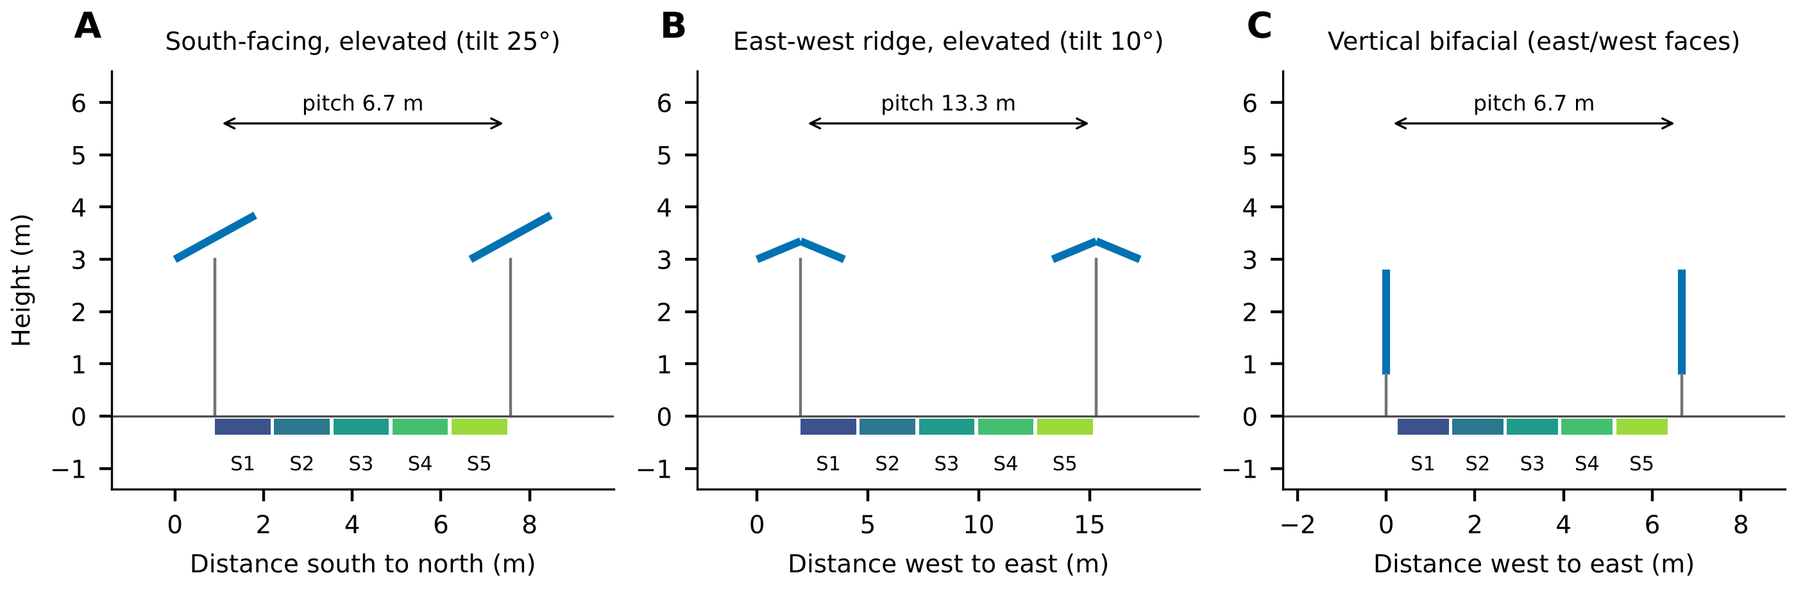
Fig. 2. Cross-sections of the three layouts at a ground coverage ratio of 0.3 (two rows shown). Blue, modules; grey, supports. The cultivated pitch is divided into five strips (S1–S5); vertical rows leave a 0.5 m uncultivated strip.
Daily radiation from the climate models was first disaggregated to hours. The Ineichen-Perez clear-sky irradiance (Ineichen & Perez, 2002) was scaled to the daily total and split into beam and diffuse parts with the Erbs model (Erbs et al., 1982), using pvlib (Anderson et al., 2023). For each ground strip, a two-dimensional infinite-row view-factor model (Dupraz et al., 2011; Nassar et al., 2022) then gave the beam transmission between the rows and the sky view factor (Text S1). The daily light factor of strip k on day d is
$f_{k,d} = \frac{\sum_{h∈d}{(T_{k}(θ_{h}) B_{h} + F_{k} D_{h})}}{\sum_{h∈d}{G_{h}}}$ (1)
where T_{k}(θ_{h}) is the beam transmission of the strip at the projected solar zenith angle θ_{h} of hour h, B_{h} the beam irradiance on a horizontal plane, F_{k} the sky view factor of the strip, D_{h} the diffuse horizontal irradiance and G_{h} the global horizontal irradiance (W m⁻²). Each strip's crop model received the open-field daily radiation multiplied by f_{k,d}, with all other weather left unchanged. Compared with the analytical functions in pvlib, the model reproduced the mean sky view factor within 0.0005 and the hourly sunlit ground fraction within 0.0015 (Table S2).

2.3 Climate data
Daily climate came from the bias-corrected NASA Earth Exchange Global Daily Downscaled Projections (NEX-GDDP-CMIP6) at 0.25° (Thrasher et al., 2022), for five global climate models (GCMs): GFDL-ESM4, IPSL-CM6A-LR, MPI-ESM1-2-HR, MRI-ESM2-0 and UKESM1-0-LL. They are the models of the Inter-Sectoral Impact Model Intercomparison Project phase 3b (ISIMIP3b), with equilibrium climate sensitivities of about 2.6 to 5.3 K (Meehl et al., 2020). We simulated three 20-year periods: 1995–2014 as the reference, and 2041–2060 under an intermediate (SSP2-4.5) and a high-emission pathway (SSP5-8.5) (Meinshausen et al., 2020). Run time ruled out the low-emission SSP1-2.6. Atmospheric CO₂ was held at the period means of 378, 507 and 563 ppm (Meinshausen et al., 2020), and Text S2 describes the variable conversion.

2.4 Crop model and calibration
All crops were simulated with DSSAT 4.8 (Jones et al., 2003; Hoogenboom et al., 2021), using Penman-Monteith evapotranspiration (Allen et al., 1998), nitrogen fixation for the legumes and each model's own CO₂ response. Sowing dates followed the Global Gridded Crop Model Intercomparison (GGCMI) Phase 3 calendar (Jägermeyr et al., 2021). Soil profiles to 2 m came from SoilGrids 2.0 (Poggio et al., 2021), with hydraulic properties from the Saxton and Rawls pedotransfer functions (Saxton & Rawls, 2006). Irrigated systems received water automatically whenever the top 30 cm dried below a set fraction of plant-available water (Text S3).
Nitrogen input explains much of the yield gap of Indian wheat and pearl millet, and it differs strongly between states. A single national rule reproduced the mean wheat yield but not its spatial pattern (Table 3), so nitrogen was calibrated by state for these two crops, as is common in large-scale crop modelling (Folberth et al., 2012; Müller et al., 2017). Open-field yields were simulated at 10 (pearl millet only), 30, 60, 90, 120 and 180 kg N ha⁻¹ with two GCMs. In each state, we kept the level whose area-weighted mean yield came closest to the observed 1995–2014 state yield (Swamikannu et al., 2021); Table S6 lists the levels chosen. This calibrated level is best read as an effective management intensity, since it also absorbs other yield-limiting factors. Across states, its Spearman rank correlation with fertiliser nitrogen per hectare of cropped area is 0.33 for wheat (15 states) and 0.26 for pearl millet (9 states; Text S4). The legumes were left uncalibrated. Chickpea was unbiased on average, while groundnut was over-estimated by a factor of 2.63; because RY is a ratio of two yields from the same model, a bias that scales both leaves it unchanged (Text S5).
Calibrated nitrogen is the base management case, and the only one used for the mid-century runs. A recommended-practice case was also run for the reference period (120 kg N ha⁻¹ for irrigated wheat; Table S4). For the headline we use a robust case, which takes in each cell the smaller GCR_{max} of the two. It therefore mixes nitrogen levels by state rather than raising nitrogen everywhere.
Table 3. Simulated against observed open-field state yields, 1995–2014 (states with at least 50 kha of the crop).
Crop | States | Case | Pearson r | Mean absolute percentage error (%) | Simulated / observed
Wheat | 15 | Uncalibrated | 0.01 | 29 | 0.92 (0.83)
Wheat | 15 | Calibrated | 0.74 | 12 | 1.01 (1.01)
Pearl millet | 9 | Uncalibrated | 0.04 | 31 | 1.01 (0.94)
Pearl millet | 9 | Calibrated | 0.28 | 24 | 1.09 (1.05)
Chickpea | 11 | Not calibrated | 0.21 | 29 | 1.02 (1.01)
Groundnut | 10 | Not calibrated | −0.19 | 163 | 2.63 (2.36)
Mean of GFDL-ESM4 and MPI-ESM1-2-HR. The mean absolute percentage error is weighted by observed harvested area. Simulated / observed is the area-weighted mean of the state ratios; in brackets, the ratio of the area-weighted mean yields.

2.5 Yield-constrained potential
Relative yield was computed for each cell, crop system, layout, GCR and GCM on a land-area basis, as in land equivalent ratio studies and in the reference-yield rule of DIN SPEC 91434 (Dupraz et al., 2011; Weselek et al., 2019; DIN, 2021):
$RY = c \frac{Ȳ_{APV}}{Ȳ_{0}}$ (2)
where Ȳ_{APV} is the yield under the array averaged over strips and seasons, Ȳ₀ the open-field yield over the same seasons (kg ha⁻¹), and c the cultivated share of the pitch (1 for the elevated layouts). Irrigated and rainfed systems were combined by production. For a threshold τ, the largest feasible GCR, GCR_{max}, is the first crossing of the RY-GCR curve, found by linear interpolation on a curve that starts at RY = 1 for GCR = 0 (Willockx et al., 2022; Dupraz, 2024). Where RY was still above τ at the largest simulated GCR, that GCR was used and flagged as a lower bound. The three thresholds come from existing rules: τ = 0.66 from DIN SPEC 91434 (DIN, 2021), 0.80, our main case, from Japan (Ministry of Agriculture, Forestry and Fisheries of Japan, 2024) and 0.90 from France (Décret n° 2024-318, 2024). DIN SPEC 91434 further limits the land lost to the structure to 15%. The 0.5 m strip of the vertical layout exceeds that limit above GCR 0.6, so vertical GCR_{max} is capped at 0.6.
Eligible land is the MapSPAM harvested area of each crop multiplied by the share of the cell with a terrain slope of at most 5%, derived from the Copernicus 90 m elevation model (European Space Agency, 2022); 5% is the limit used to screen land for utility PV in India (Deshmukh et al., 2017). An array stands all year, so within a cell the rabi area A_{r} (wheat, chickpea) and the kharif area A_{k} (pearl millet, groundnut) were assumed to overlap as far as possible, and the overlap had to satisfy both seasons. Each eligible hectare enters at its own GCR_{max}. Thresholds, layouts, management and climate therefore act on the potential through density, not land area. For a cell, capacity is
$P = η I_{STC} [ A_{ov} min(ḡ_{r}, ḡ_{k}) + (A_{r} − A_{ov}) ḡ_{r} + (A_{k} − A_{ov}) ḡ_{k} ]$ (3)
where η = 0.22 is the module efficiency, I_{STC} = 1000 W m⁻², A_{ov} = min(A_{r}, A_{k}) the double-cropped area, and ḡ_{r} and ḡ_{k} the area-weighted GCR_{max} of the rabi and kharif crops. Annual energy is capacity times the specific yield of each cell, layout and GCR. We computed specific yield with pvlib for a bifacial glass-glass module, using the infinite-sheds model, the Faiman cell temperature model (Faiman, 2008) and PVWatts (Dobos, 2014) (Table S8). To value the crop given up, we used observed rather than simulated yields, which keeps crop-model bias out of the tonnes. For each crop, the loss is eligible area times the observed 1995–2014 state yield (Swamikannu et al., 2021) times (1 − RY) at the crop's GCR_{max}, with RY from the calibrated and, separately, the recommended nitrogen runs. Food energy uses 1347, 1456 and 1201 kJ per 100 g for whole wheat, pearl millet and chickpea (Longvah et al., 2017); groundnut, mostly crushed for oil, is reported in tonnes only. Because each crop is taken at its own GCR_{max}, the loss is an upper bound on double-cropped land, which carries the lower density of the two seasons.

2.6 Uncertainty and assumptions
Every step was run separately for each GCM, and national and state totals are reported as the five-GCM median with the minimum and maximum as the range. That range is not a total uncertainty. All five GCMs are bias-corrected to the same observations, and errors in the crop model, calibration, soils and light model are not propagated. Sensitivity cases therefore change one assumption at a time (Table 5). For PV energy, daily radiation was rescaled cell by cell and month by month to the 2001–2020 NASA POWER climatology (NASA, 2026), as in linear-scaling bias correction (Teutschbein & Seibert, 2012), because aerosols dim surface radiation over India (Padma Kumari et al., 2007) and cut PV output (Bergin et al., 2017). Three assumptions shape the results. Panels change only the radiation reaching the crop, so the lower leaf temperature and evaporative demand under shade are missing. Mid-century yields include CO₂ fertilisation, which is strongest for the C₃ legumes. Finally, the potential is technical: crop yield and terrain bound it, grid capacity and land tenure are not considered, and economics enter only as a screening (Section 2.7).

2.7 Screening economics
The economic layer asks two questions: what the yield rule costs in crop, and whether elevated arrays could pay for themselves. It is a screening estimate, not a project appraisal. In each cell, the levelised cost of electricity (LCOE) starts from the price discovered in the Gujarat reverse auction for PM-KUSUM Component A, Indian rupees (Rs) 2.77–2.78 per kWh (Gujarat Electricity Regulatory Commission, 2026). That price was scaled by the ratio of the median specific yield of all cells to the cell's own, and a structure premium of 0%, 25%, 30% or 38% was added for the elevated frame. The Union Minister for New and Renewable Energy has put the extra cost of agrivoltaic plants at 25–30% (Economic Times EnergyWorld, 2026); 38% is the excess LCOE of an elevated plant in a German analysis (Schindele et al., 2020). Electricity is valued at the regulator's ceiling tariff of Rs 2.95 per kWh (Gujarat Electricity Regulatory Commission, 2026). For the crop, the gross value of an eligible hectare is the observed 1995–2014 state mean yield (Swamikannu et al., 2021) times the minimum support price (Rs 2,585, 5,875, 2,900 and 7,517 per quintal for wheat, chickpea, pearl millet and groundnut (Press Information Bureau, 2025; Press Information Bureau, 2026)), and the yield rule caps the crop loss at a share (1 − τ) of it. Land lease, grid connection, financing and crop inputs were not modelled, so we report results per kWh and per hectare rather than as national revenue.

3 Results

3.1 Model evaluation
State calibration of nitrogen brought the simulated open-field yields of both cereals closer to the observations, as Fig. S1 shows. For wheat, the correlation between simulated and observed state yields rose from r = 0.01 to 0.74, and the area-weighted mean absolute percentage error fell from 29% to 12% across 15 states. Pearl millet gained less (r from 0.04 to 0.28; error from 31% to 24%). Its southern yields stayed too high even at the lowest nitrogen level. The light model matched the pvlib view factors closely and reproduced the light measured over the whole Jodhpur system; directly below the modules, under low winter sun, it over-estimated the light (Figs. S2 and S3).

3.2 Feasible ground coverage ratio by crop and layout
Cereals tolerate roughly twice the panel density of legumes. The maps in Fig. 3A–D make the contrast plain: in the east-west layout, the area-weighted mean GCR_{max} at RY ≥ 0.80 was 0.52 for wheat and 0.53 for pearl millet, against 0.27 for chickpea and 0.32 for groundnut. The pearl millet value is the least certain of the four; it drops to 0.23 in the field-response scenario, which relies on maize as a proxy. Every crop tolerated the least density under the south-facing array. Wheat (0.34) and chickpea (0.19) were hit hardest, because their grain fills under low winter sun (Fig. 3E). Vertical rows came close to the east-west layout and reached the 0.6 cap on at least 73% of the pearl millet area. GCR_{max} also varied strongly across the country within each crop; Figs. S7, S9 and S10 map every crop and layout and their change by mid-century.
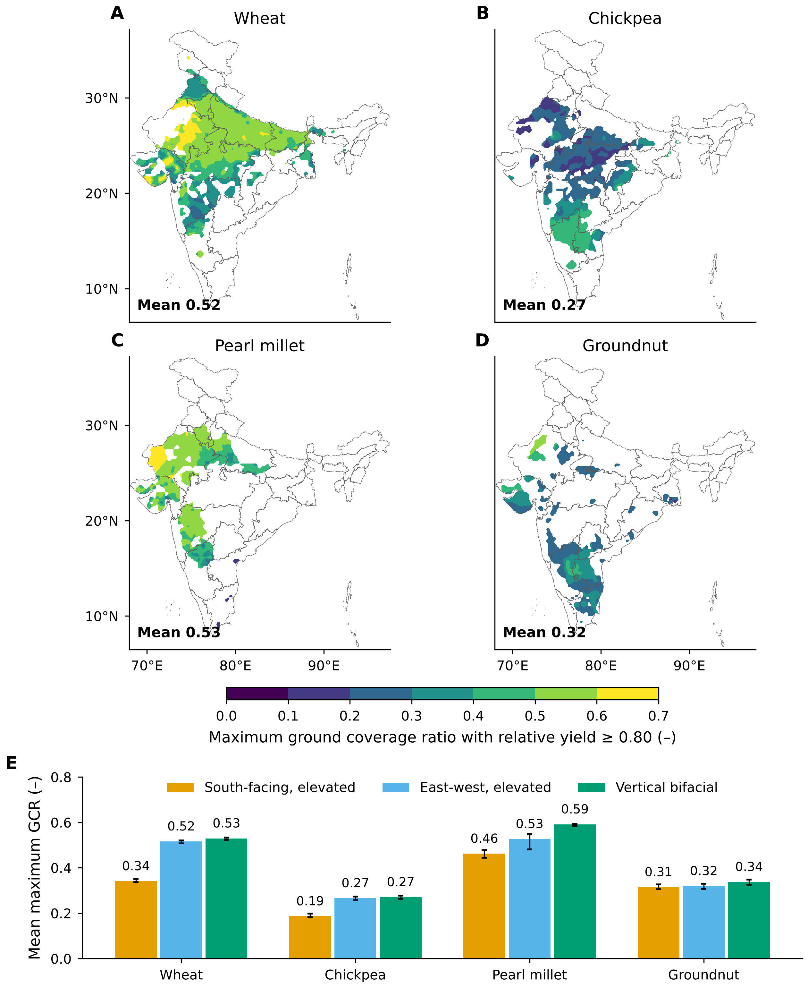
Fig. 3. Largest ground coverage ratio (GCR_{max}) that keeps relative yield at or above 0.80, 1995–2014, robust nitrogen case (smaller of the calibrated and recommended nitrogen results in each cell). (A–D) East-west layout by crop: median of five climate models, interpolated for display; number, area-weighted mean. (E) Mean by crop and layout; error bars, range of the five models. State boundaries from DataMeet India Community (2021), CC BY 4.0.

3.3 National potential
Under the yield rule, Indian cropland could host 39.2 terawatts peak (TWp) of APV. This headline uses the east-west layout at τ = 0.80 on 39.7 Mha of cropland with slopes up to 5% (GCM range 39.0–39.8 TWp; Table 4), an average of 0.99 megawatts peak (MWp) per hectare. Its annual output, 60.9 petawatt-hours (PWh), is about 36 times India's 2025–26 electricity requirement of 1,707 terawatt-hours (Central Electricity Authority, 2026). Put differently, 500 gigawatts peak at this mean density would need only 0.51 Mha, or 1.3% of the eligible cropland. As the map in Fig. 4 illustrates, density peaks across the Indo-Gangetic plain and north-western Rajasthan and is lowest in the legume-growing Deccan and the south, mirroring the crop pattern of Fig. 3.
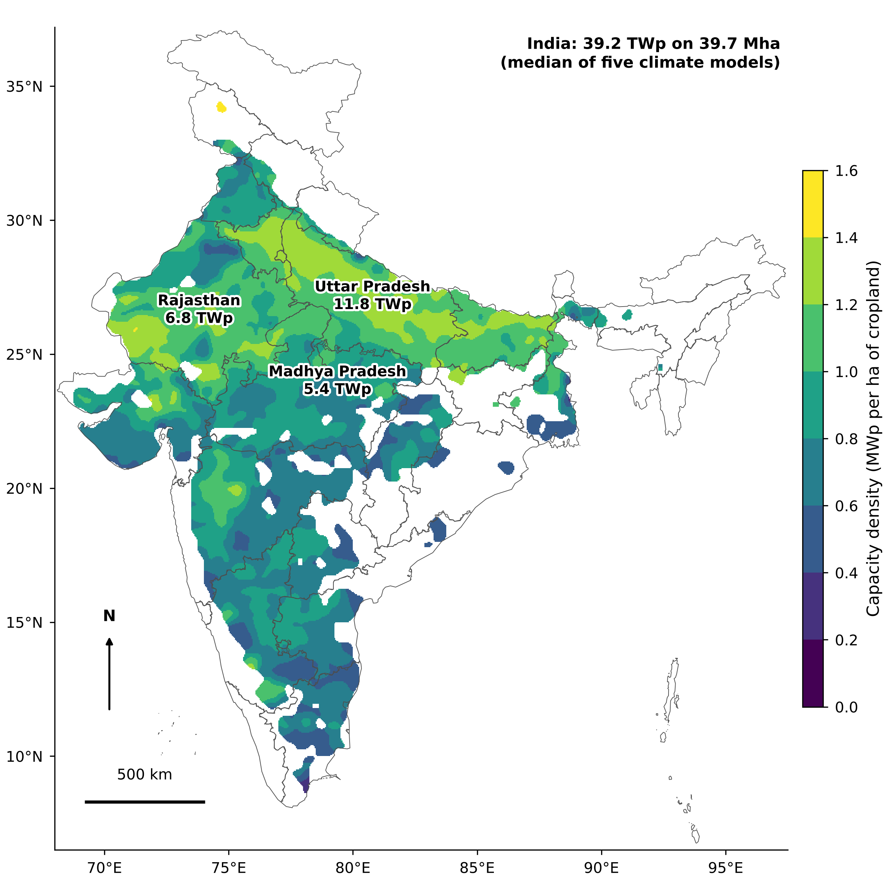
Fig. 4. Capacity density (megawatts peak per hectare of cropland, four crops combined) of east-west elevated arrays at relative yield ≥ 0.80, 1995–2014, robust nitrogen case (smaller of the calibrated and recommended nitrogen results in each cell), slope ≤ 5%. Median of five climate models, interpolated for display; blank, cells with less than 1000 ha of eligible cropland. Labels: the three leading states. State boundaries from DataMeet India Community (2021), CC BY 4.0.
Capacity and energy rank the layouts differently. Fig. 5A shows vertical rows with the most capacity, 41.2 TWp with the 0.6 cap, and the south-facing array with the least, 28.4 TWp. Yet vertical rows yield only 1,078 kWh kWp⁻¹ yr⁻¹, against 1,554 for east-west arrays, and so they produce the least energy (44.4 PWh yr⁻¹; Fig. 5B). East-west arrays give the most energy at every threshold, which is why we use them for the headline. The threshold matters far more than terrain. Capacity reaches 47 TWp at τ = 0.66 and falls to 31 TWp at τ = 0.90, whereas removing the slope limit lifts it only to 43 TWp. Three states, Uttar Pradesh (11.8 TWp), Rajasthan (6.8 TWp) and Madhya Pradesh (5.4 TWp), hold 61% of the total; they are labelled in Fig. 4, and Fig. S8 lists all states and layouts.
Table 4. Yield-constrained APV potential of India for four crops, 1995–2014: robust nitrogen case and calibrated nitrogen alone (less conservative). Slope ≤ 5%; crops combined with double-cropped land counted once; vertical GCR_{max} capped at 0.6.
Layout | τ | Capacity, TWp (robust) | Capacity, TWp (calibrated) | Energy, PWh yr⁻¹ (robust) | Energy, PWh yr⁻¹ (calibrated) | MWp ha⁻¹ (robust)
South-facing, elevated | 0.66 | 35.7 (35.4–35.9) | 40.3 (40.1–40.5) | 58.5 | 65.0 | 0.90
 | 0.80 | 28.4 (27.9–28.7) | 34.2 (33.9–34.3) | 47.1 | 55.7 | 0.72
 | 0.90 | 21.1 (20.3–21.3) | 28.7 (28.2–28.9) | 35.5 | 47.0 | 0.53
East-west, elevated | 0.66 | 47.3 (47.1–47.9) | 51.1 (50.8–51.4) | 72.7 | 77.9 | 1.19
 | 0.80 | 39.2 (39.0–39.8) | 45.5 (45.5–45.9) | 60.9 | 69.6 | 0.99
 | 0.90 | 30.9 (30.4–31.5) | 39.8 (39.6–40.3) | 48.5 | 61.0 | 0.78
Vertical bifacial | 0.66 | 47.5 (47.4–47.6) | 47.7 (47.6–47.8) | 49.9 | 50.0 | 1.20
 | 0.80 | 41.2 (40.8–41.4) | 42.8 (42.6–43.0) | 44.4 | 45.7 | 1.04
 | 0.90 | 30.4 (29.4–30.8) | 38.1 (37.8–38.3) | 34.6 | 41.0 | 0.77
Median over five GCMs, GCM range in brackets. Land is the eligible crop area, 39.7 Mha in every case; the threshold and nitrogen act through the density. Vertical rows without the 0.6 cap (robust): 53, 43 and 31 TWp at τ = 0.66, 0.80 and 0.90.
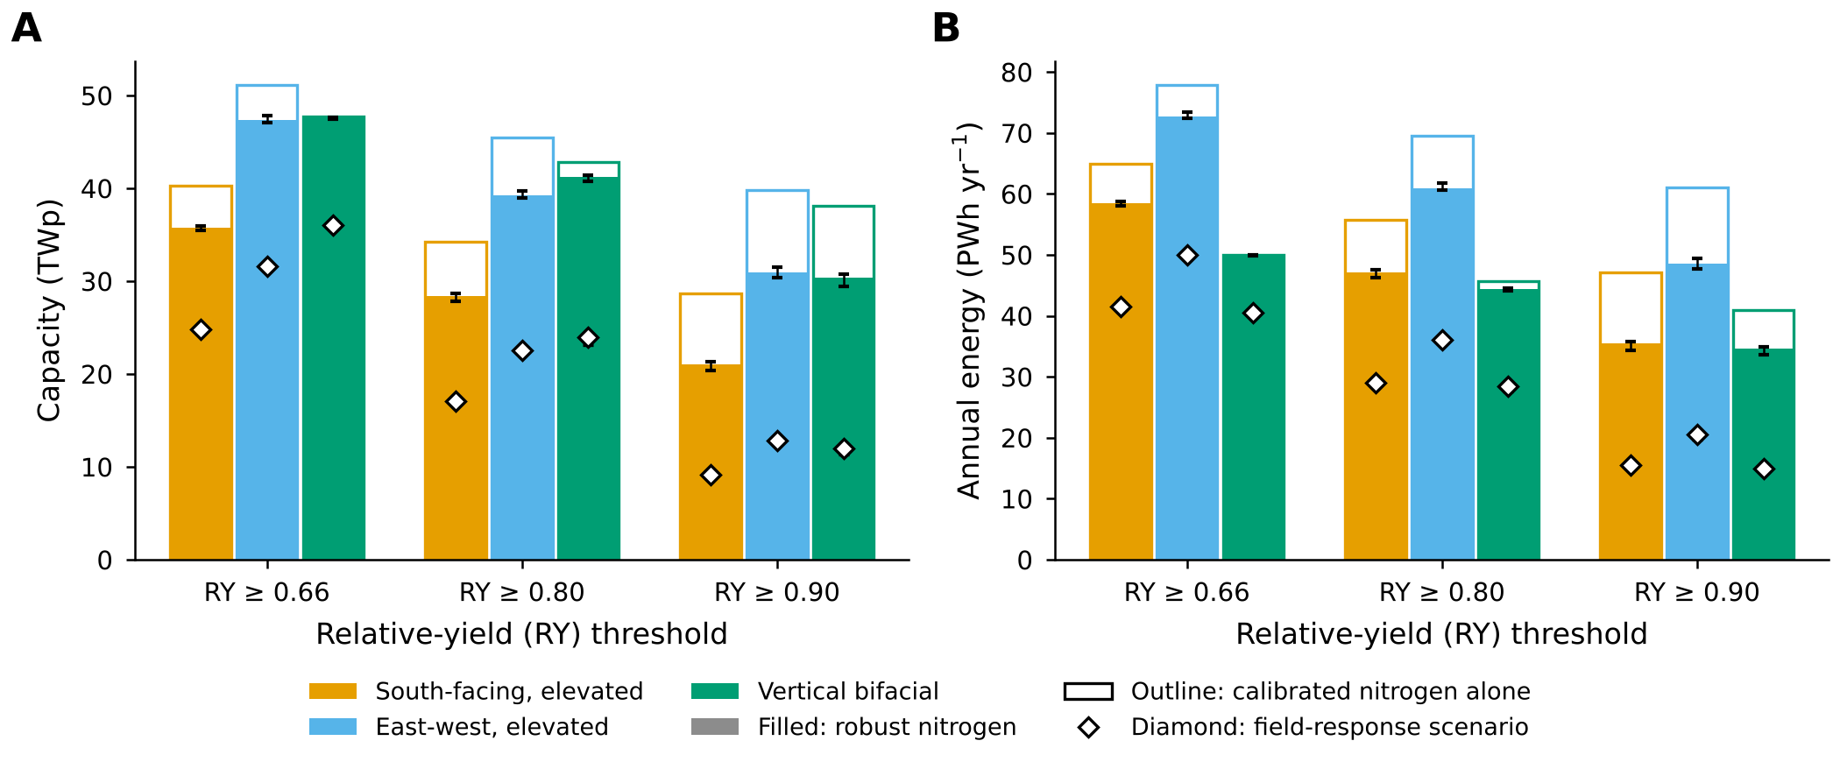
Fig. 5. National capacity (A) and annual energy (B) by layout and relative-yield (RY) threshold, 1995–2014, slope ≤ 5%. Filled bars, robust nitrogen (the lower result of the calibrated and recommended nitrogen runs in each cell); outline bars, calibrated nitrogen alone; diamonds, field-response scenario (robust nitrogen with the simulated shade response rescaled to field observations). Median of five climate models; error bars, their range.

3.4 Nitrogen management and the field-response scenario
Calibrated nitrogen alone gives a larger potential: 45.5 TWp (GCM range 45.5–45.9) and 69.6 PWh yr⁻¹ for the east-west layout at τ = 0.80. The robust case is thus 14% lower (Table 4), and the outline bars of Fig. 5 show how the gap varies by layout and threshold, from almost none for vertical rows at τ = 0.66 to about a quarter for south-facing arrays at τ = 0.90. Almost all of the difference comes from the cereals. Mean GCR_{max} falls from 0.62 to 0.52 for wheat and from 0.58 to 0.53 for pearl millet; the legumes barely move. With calibrated nitrogen, 42% of the east-west wheat area still met the threshold at GCR 0.7, compared with 1% in the robust case. Most of those cells lie in states with low calibrated nitrogen, a sign of nitrogen masking rather than genuine shade tolerance (Section 4.2). The calibrated-nitrogen maps and state results appear in Figs. S4 and S5.
A second correction matters even more. Compared with field observations, the crop models are too tolerant of shade (Text S14). The field-response scenario therefore rescales simulated RY so that its dependence on the reduction in ground light follows the observations compiled by Jha et al. (2026), with maize standing in for pearl millet. With that rescaling, the east-west potential at τ = 0.80 falls by 42% to 22.6 TWp and 36.1 PWh yr⁻¹. GCR_{max} becomes 0.31 for wheat, 0.23 for pearl millet, 0.20 for groundnut and 0.17 for chickpea, while the ranking of layouts by energy stays the same. We treat the robust case as the upper bound of the technical potential and the field-response scenario as its lower bound; the diamonds in Fig. 5 trace that lower bound across layouts and thresholds.

3.5 Food given up under the arrays
The threshold caps each crop's loss at 20%, but the food actually given up depends on where the cap binds and on how the crop is managed. At the robust east-west density, the four crops would give up 7.2 Mt a year under current management, 7.8% of the 92 Mt grown on the eligible land. With the recommended nitrogen rate the loss rises to 15.8 Mt (17%). Figure 6B breaks this down by crop. Under current management wheat loses least (6.1%), again because low nitrogen hides much of the shade loss, while chickpea and groundnut come close to the full 20%. Measured as food energy, the three food grains lose 7.1% and 17% in the two cases. Each MWh costs 0.12–0.26 kg of crop. That cost is highest in the high-yielding wheat belt of the north-west and lowest in western Rajasthan and the Deccan, as mapped in Fig. 6A. If cells are developed in order of least crop per MWh, India's entire 2025–26 electricity requirement could be met for about 98 thousand tonnes of crop a year with recommended nitrogen. Ten PWh would cost 1.0 Mt (Fig. 6C). A ground-mounted array at the same density, by contrast, would remove the whole crop.
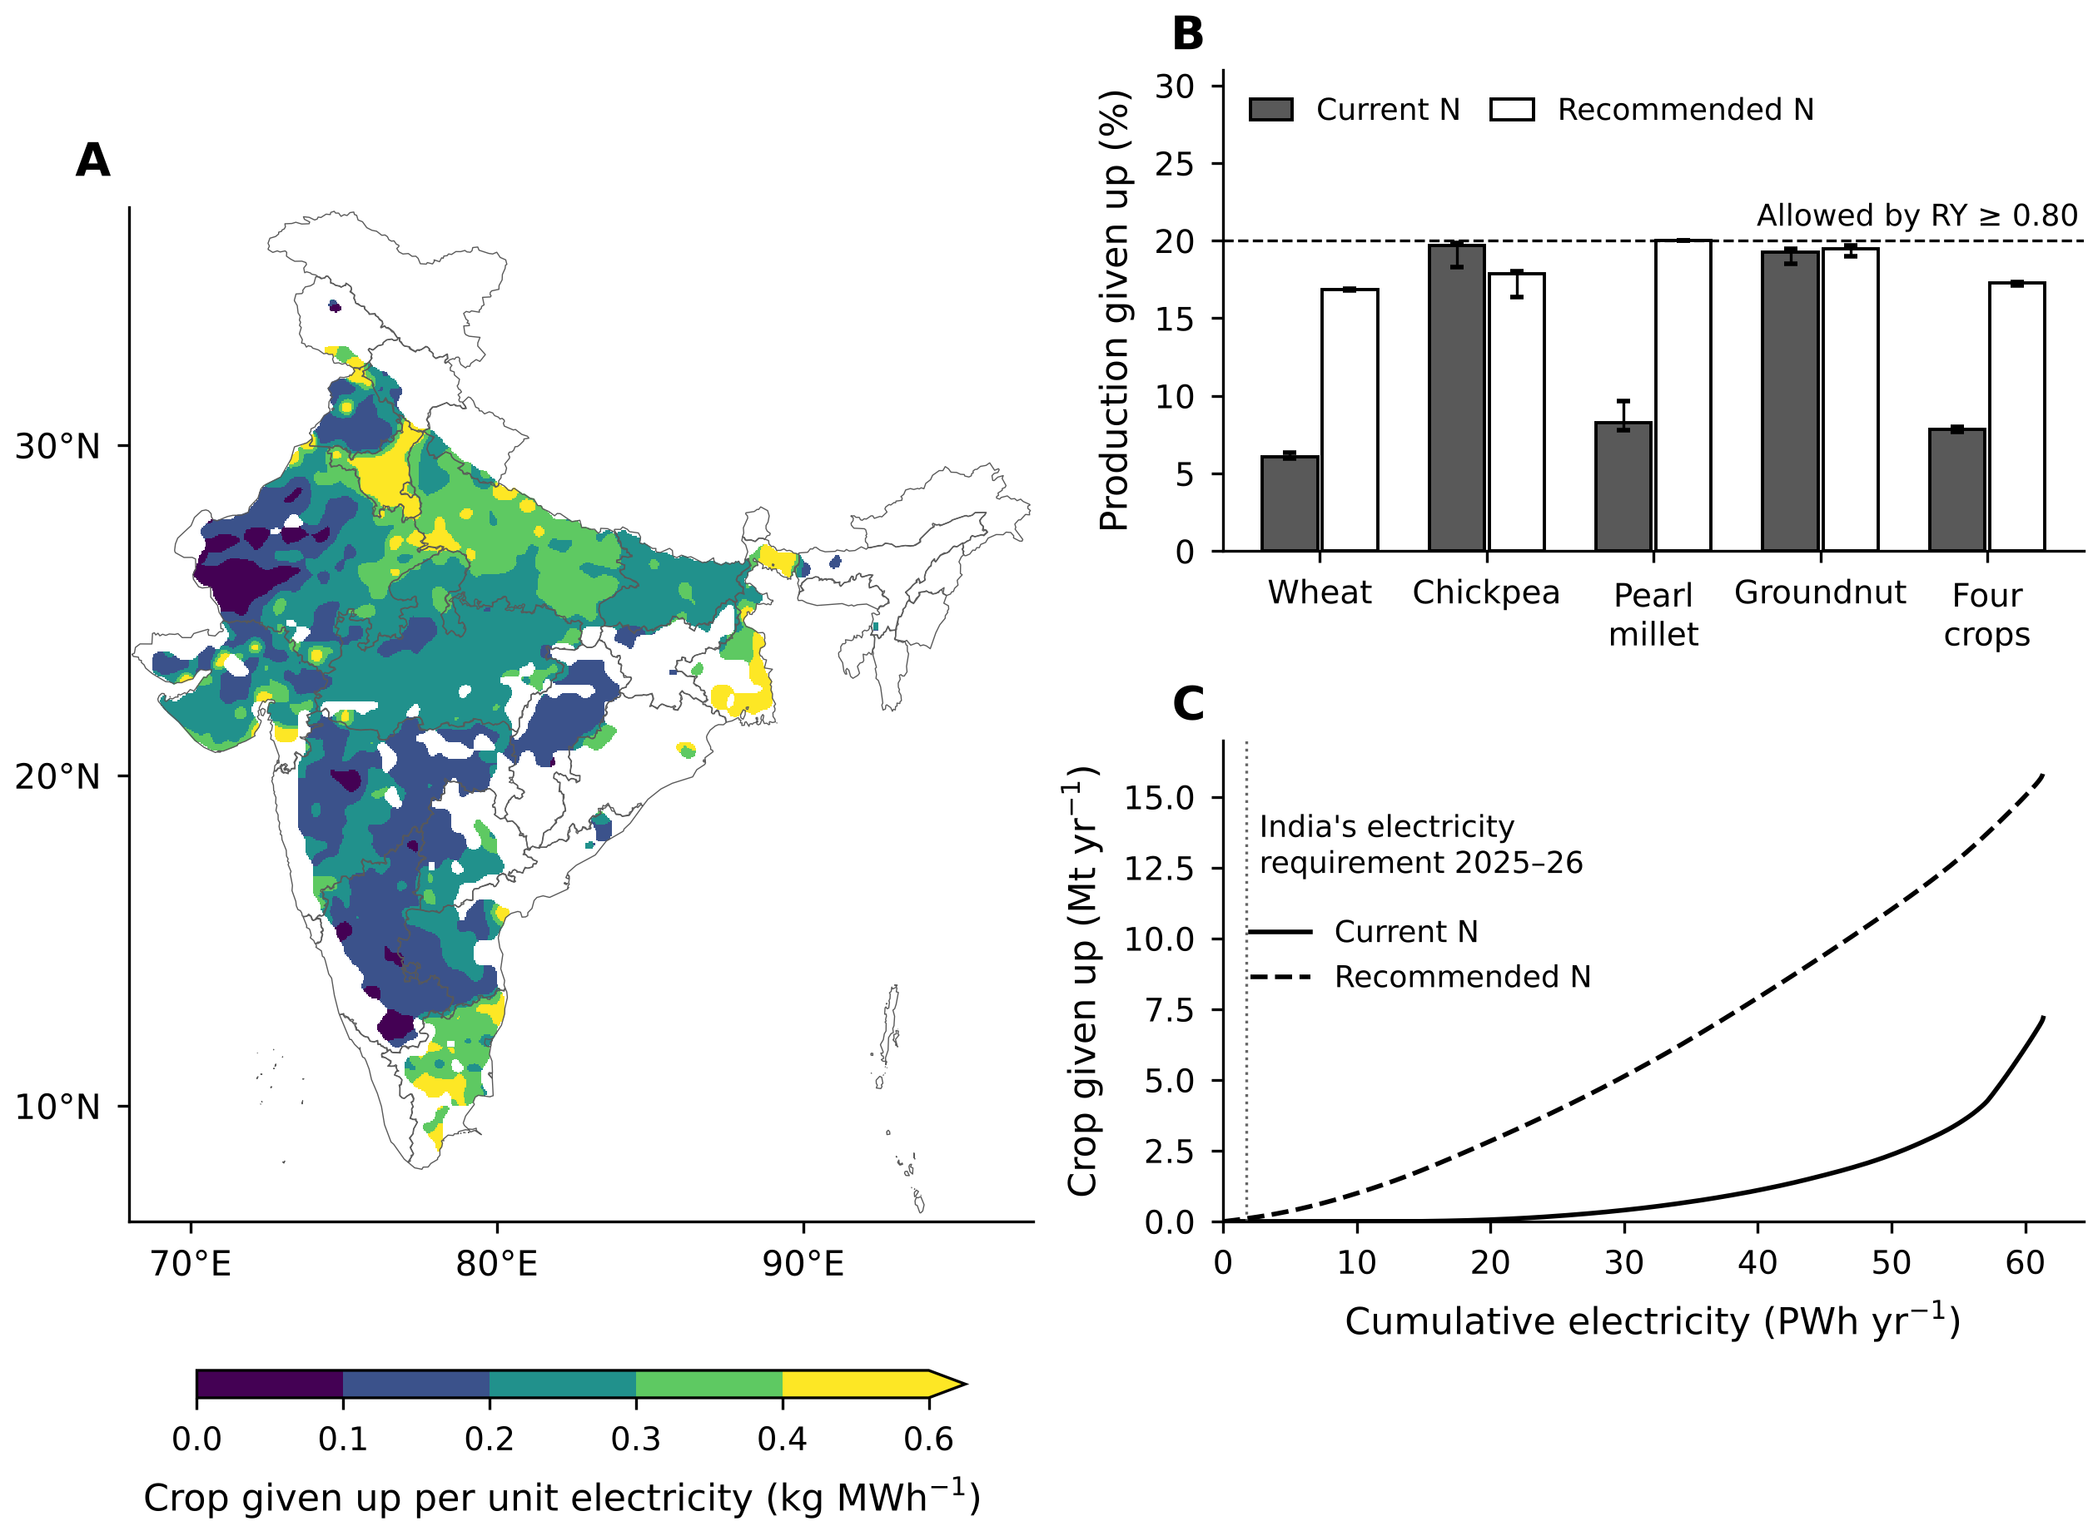
Fig. 6. Crop given up under the arrays: east-west layout, relative yield (RY) ≥ 0.80 at the robust nitrogen density, slope ≤ 5%, 1995–2014, valued with observed state yields. (A) Crop given up per MWh of electricity, with RY under recommended nitrogen. (B) Share of production given up by crop, with RY under current (filled) and recommended (open) nitrogen; dashed line, the 20% allowed by the threshold. (C) Cumulative crop given up against cumulative electricity, cells ordered from the least crop per MWh; dotted line, India's 2025–26 electricity requirement. Medians of five climate models; error bars, their range; map interpolated for display. State boundaries from DataMeet India Community (2021), CC BY 4.0.

3.6 Mid-century change
The climate runs use calibrated nitrogen, so the changes below are relative to the calibrated 1995–2014 potential of 45.5 TWp. By 2041–2060 under SSP2-4.5, the east-west potential at τ = 0.80 changes by −1% to 45 TWp (GCM range −7% to +1%). SSP5-8.5 gives almost the same answer, −1% to 44.9 TWp, with each GCM's paired change ranging from −6% to 0% (Fig. 7A). The GCMs often disagree locally: at least four of five agree on the sign of the change in GCR_{max} on only 56% of the eligible land under SSP2-4.5 and 57% under SSP5-8.5. Among crops, mean east-west GCR_{max} changes by +0.00 for wheat, −0.05 for pearl millet, +0.00 for chickpea and −0.01 for groundnut (Fig. 7B). Pearl millet in the north-west loses most, visible as the orange patches of Fig. 7C,D.
Climate barely changes capacity but lowers energy. Annual energy changes by −5% to 66.3 PWh and specific yield by −3%, mostly because irradiance falls in the climate models (−3.2%); warmer modules, which convert light less efficiently, account for the remaining −0.3%. All of these changes include the effect of higher CO₂ on the crops (Section 4.3), and Figs. S9 and S10 map them by crop and layout.
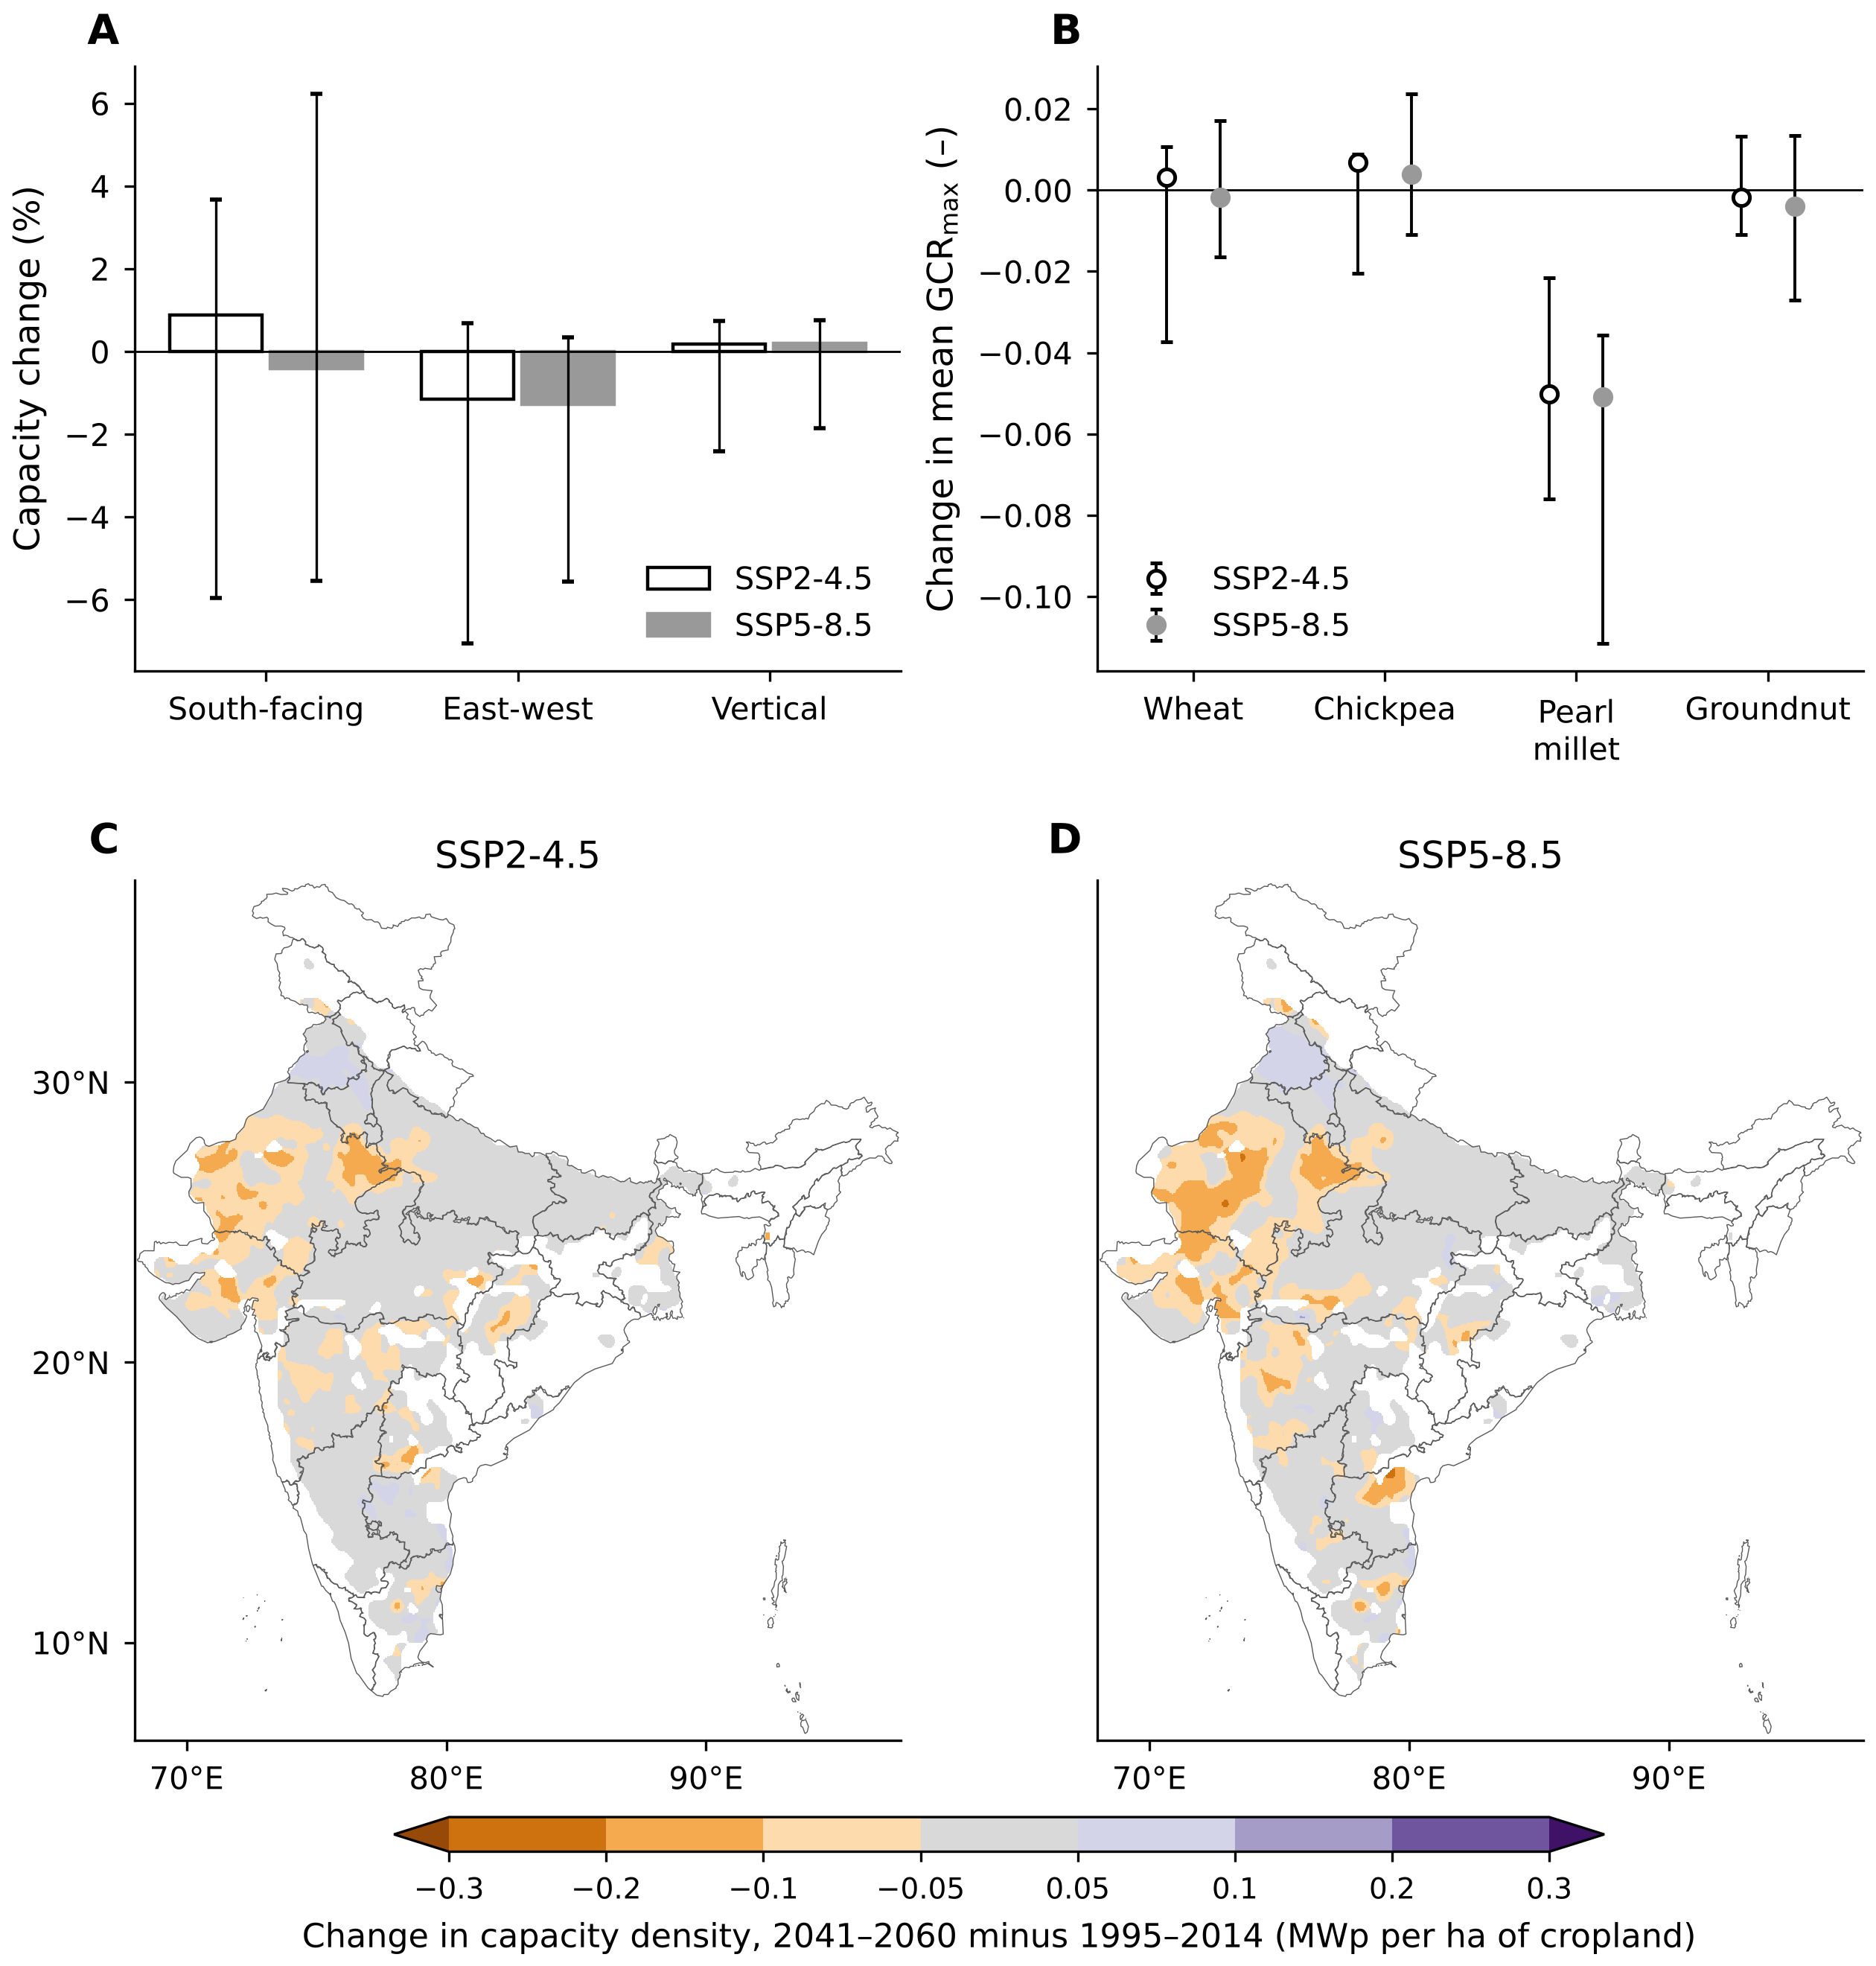
Fig. 7. Change by 2041–2060 against 1995–2014 at relative yield ≥ 0.80, calibrated nitrogen. (A) National capacity by layout and (B) mean largest ground coverage ratio by crop, east-west layout: open, SSP2-4.5 (intermediate emissions); filled, SSP5-8.5 (high emissions); median of the five paired climate-model changes, whiskers their range. (C, D) Change in capacity density, east-west layout, under SSP2-4.5 (C) and SSP5-8.5 (D); five-model median, interpolated for display. State boundaries from DataMeet India Community (2021), CC BY 4.0.

3.7 Screening economics
Electricity is worth far more than the crop on the same land. At the ceiling tariff of Rs 2.95 per kWh, an eligible hectare in the robust east-west case would earn about Rs 45 lakh a year (1 lakh = 100,000), against a gross crop value of Rs 0.72 lakh, a ratio of about 63 to one. Only the yield rule stands in the way of full conversion. At τ = 0.80 it limits the crop loss to Rs 569 billion a year, one fifth of the Rs 2,843 billion of crop grown on the eligible land.
Selling at that tariff is another matter, and it hinges on the cost of the elevated frame. The cost-supply curves of Fig. 8 make the point. Without a structure premium, the energy-weighted LCOE is Rs 2.75 per kWh, and 85% of the capacity (33.5 TWp) comes in below the ceiling. Add the ministry's 25% premium and the LCOE rises to Rs 3.44; no capacity clears the ceiling. At 38% it reaches Rs 3.80. Because the auction price sits only 6% below the ceiling, any substantial premium needs a tariff adder, of Rs 0.49 per kWh at 25%, Rs 0.63 at 30% and Rs 0.85 at 38%.
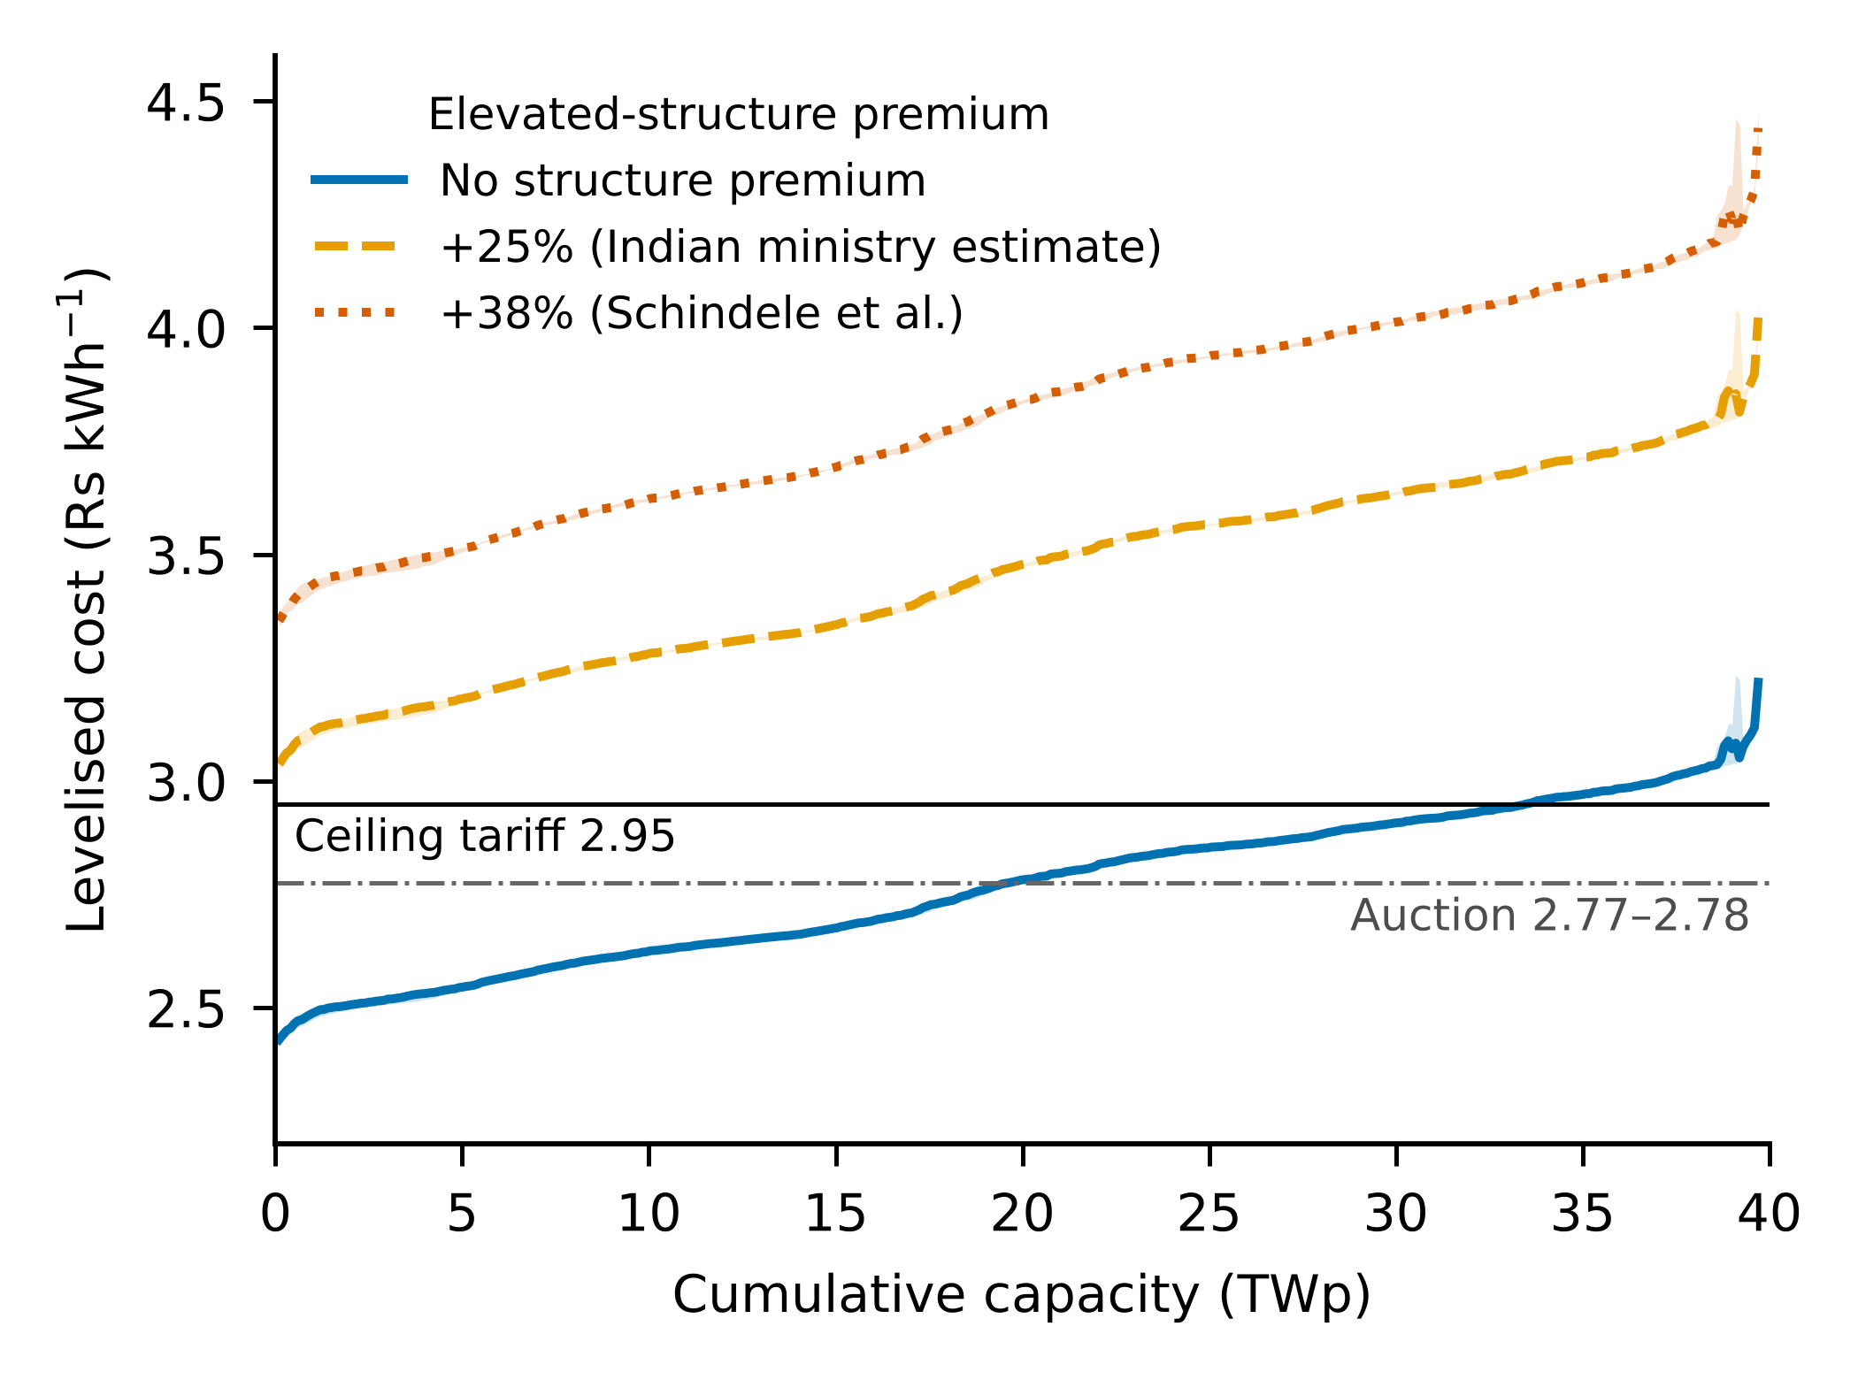
Fig. 8. Cost-supply curve: cells ordered by levelised cost of electricity, east-west layout, relative yield ≥ 0.80, robust nitrogen, slope ≤ 5%, 1995–2014. Lines, median of five climate models; bands, their range; colours, cost premium of the elevated structure over ground-mounted photovoltaics. Horizontal lines: ceiling tariff and discovered auction price of the Gujarat farmer solar scheme.
Even the smallest of these adders, at a 25% premium, comes to about Rs 8 lakh per hectare a year, many times the Rs 0.72 lakh of crop value that the yield rule protects. Crop revenue alone cannot pay for elevated frames. Their justification has to be the land kept in food production (Section 4.4).

3.8 Sensitivity
Table 5 ranks the assumptions. Apart from the layout, the yield threshold is the strongest lever: moving τ from 0.80 to 0.66 or 0.90 changes capacity by +21% and −21%. Calibrated nitrogen alone adds +16%, dropping the slope limit +10%. A module efficiency of 20% or 24% instead of 22% moves capacity and energy by about ±9%. Applying the threshold season by season, so that it must hold in at least 16 of 20 seasons, changes capacity by −14%. Against all of these, the five GCMs differ little (39.0–39.8 TWp). The choice of rule and management therefore matters far more than the choice of climate model.
Table 5. Sensitivity of the national APV potential, 1995–2014: one assumption changed at a time from the base case, with the basis of each tested value.
Case | Basis of the tested value | Capacity, TWp | Change, % | Energy, PWh yr⁻¹
Base: robust nitrogen, east-west, τ = 0.80, slope ≤ 5% | Japanese threshold (Ministry of Agriculture, Forestry and Fisheries of Japan, 2024); 5% PV slope limit for India (Deshmukh et al., 2017) | 39.2 | – | 60.9
Threshold τ = 0.66 | DIN SPEC 91434 minimum (DIN, 2021) | 47.3 | +21 | 72.7
Threshold τ = 0.90 | French decree (Décret n° 2024-318, 2024) | 30.9 | −21 | 48.5
No slope limit | No terrain screening | 43.0 | +10 | 67.1
Slope ≤ 10% | Relaxed terrain limit | 40.9 | +4 | 63.7
Calibrated nitrogen alone (less conservative) | State-calibrated nitrogen, Section 2.4 | 45.5 | +16 | 69.6
Module efficiency 20% | Older modules; 2025 mass production 21.7% (PERC) (VDMA Photovoltaic Equipment, 2026) | 35.6 | −9 | 55.4
Module efficiency 24% | Back-contact modules, 24.1% in 2025 (VDMA Photovoltaic Equipment, 2026) | 42.8 | +9 | 66.5
South-facing layout | Alternative design, Section 2.2 | 28.4 | −28 | 47.1
Vertical layout, GCR ≤ 0.6 | Alternative design, Section 2.2 | 41.2 | +5 | 44.4
Vertical layout, no DIN cap | 15% land-loss limit removed (DIN, 2021) | 43.0 | +10 | 45.7
Threshold met in ≥ 16 of 20 seasons | Rules judge single seasons (DIN, 2021; Décret n° 2024-318, 2024); one failure in five tolerated | 33.8 | −14 | 52.9
Radiation not corrected (energy only) | NEX-GDDP radiation as supplied, Supplementary Section S12 | 39.2 | 0 | 70.4
Range of five GCMs (base case) | CMIP6 ensemble, Section 2.3 | 39.0–39.8 | – | –
Five-GCM median. Module efficiency scales capacity and energy in proportion, because GCR_{max} depends on shade, not on the module rating.

4 Discussion

4.1 The yield-constrained potential against earlier estimates
How much solar can India's cropland carry without losing its crops? Our answer is a range rather than a number: 22.6 to 39.2 TWp for east-west arrays at τ = 0.80 on 39.7 Mha of gently sloping cropland. The upper end is the robust case (GCM range 39.0–39.8). The lower end rescales the simulated shade response to field observations (Section 3.4), and the last two steps of Fig. 9 show how large that correction is. Calibrated nitrogen alone would give 45.5 TWp, which we regard as less conservative because low nitrogen input hides part of the shade loss in wheat (Section 4.2). The eligible land is no niche: it covers 90% of the land the four crops occupy before the slope rule and 79% of their summed harvested area.
Both ends lie well above earlier Indian estimates. The robust figure is 19–33 times the 1.2–2.1 TW of TERI (Yadav et al., 2026) and 2.8 times the upper end of the 3.2–13.8 TW reported for the Indo-German Energy Forum (Fraunhofer ISE et al., 2024). The studies, however, measure different things. TERI converts only the 2.8 of its 47 million hectares of restricted cropland that it judged highly suitable for shade-compatible crops, and the Fraunhofer study assigns suitability from a crop matrix and screening thresholds. Our figure shows what the yield rule alone permits on the land of four crops, before any grid, economic or social limit; it does not show that the earlier studies were too cautious. Two differences account for most of the gap. One is the land base. Applied to our 39.7 Mha, TERI's fixed density of 0.42–0.75 MW ha⁻¹ would already give 17–30 TW. The other is density itself. At η = 0.22, TERI's range corresponds to a GCR of 0.19–0.34, while our yield-constrained mean of 0.99 MWp ha⁻¹ is 1.3–2.4 times higher, and far from uniform, with GCR_{max} spanning 0.20 to 0.60 across the eligible area (5th to 95th percentile). Any fixed density is therefore too high for legume land and too low for much of the irrigated wheat belt.
Fig. 9 retraces the gap on our own grid and crops. Starting from a fixed 0.75 MW ha⁻¹ on all simulated crop area gives 37.5 TW, or 21.0 TW at 0.42 MW ha⁻¹. The slope rule and counting double-cropped land once then remove 21% of the area, leaving 29.8 TW at the higher density. Swapping the fixed density for GCR_{max} raises capacity by +53% against 0.75 MW ha⁻¹ and by +173% against 0.42 MW ha⁻¹. Robust nitrogen management then changes the result by a further −14%. Strikingly, the field-response lower bound (22.6 TWp) falls between the two fixed-density totals on the same land. How crops respond to shade thus matters about as much as which fixed density an assessment assumes.
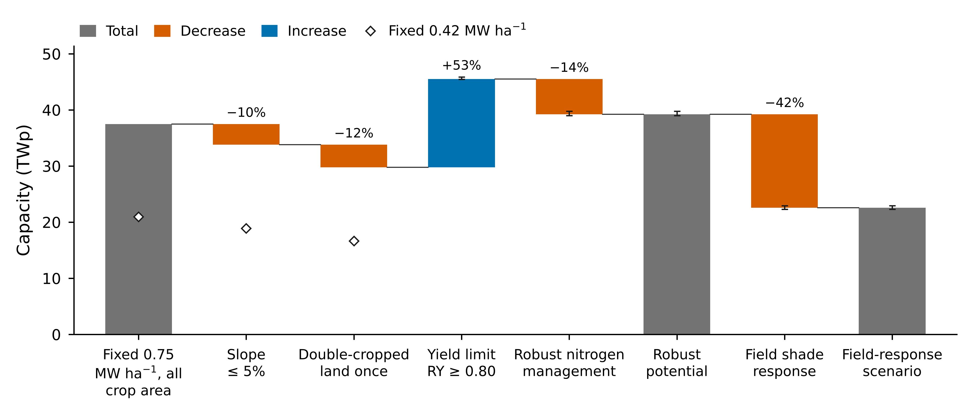
Fig. 9. From a fixed power density to the yield-constrained potential and its field-response lower bound, east-west layout, relative yield (RY) ≥ 0.80, 1995–2014; steps are cumulative on the same grid and crops. Bars, 0.75 megawatts per hectare in steps 1–3; diamonds, 0.42, the range of an Indian national assessment (Yadav et al., 2026). Robust nitrogen: the lower result of the calibrated and recommended nitrogen runs in each cell. Field shade response: the simulated RY rescaled to field observations (Section 3.4). Error bars, range of five climate models.
Outside India, spatial studies for Great Britain, Europe, Phoenix, the Middle East and North Africa and the globe have counted suitable land under assumed layouts or shading levels (Majumdar & Pasqualetti, 2018; Willockx et al., 2022; Curioni et al., 2025; Neesham-McTiernan et al., 2025; Abdalla et al., 2026). The global study, closest to ours in spirit, cut light uniformly by 10–50% for rainfed crops and found that 22–35% of rainfed harvested area could be converted with limited yield loss; it named parts of India as hotspots (Curioni et al., 2025). Our study adds array layouts, irrigated crops, nitrogen, a yield threshold and future climate on a national grid. Within India, a crop-model study of two array densities reported land equivalent ratios of 1.35–1.97 (Aswal et al., 2026), a gain in land productivity but without a minimum crop yield. In design, the nearest study is a Japanese assessment that optimised layouts under daily-light constraints; its mean GCR of 30% (Nakata & Ogata, 2026) falls inside our range (0.20–0.60).

4.2 What sets the panel density: nitrogen, crop and layout
Management mattered as much as the crop. In the Rajasthan pilot (Text S9; 498 cells, five GCMs, 1995–2014), wheat under the south-facing array at GCR 0.3 had a median RY of 1.13 at the farmer rate of 60 kg N ha⁻¹ but 0.90 at the recommended 120 kg N ha⁻¹. An RY above one is not a real yield gain. The likely cause is nitrogen dilution. A crop's critical nitrogen concentration falls as its biomass grows (Justes et al., 1994), so a shaded crop that grows less stays closer to its nitrogen demand. With little nitrogen, the open-field crop is limited by nitrogen and the shaded crop by light, and the light loss disappears from view.
The national runs carry the same signature. With calibrated nitrogen, 42% of the east-west wheat area kept RY ≥ 0.80 even at GCR 0.7, and that share tracks the calibrated nitrogen level closely: 67% in states calibrated at 30 kg N ha⁻¹ and 59% at 60, but only 10% at 90 and 4% at 180. In those wheat cells the open-field yield reaches just 34% of the yield simulated at 180 kg N ha⁻¹, compared with 61% elsewhere. Much of the apparent tolerance therefore reflects nitrogen-limited yields, not shade-tolerant crops. Management can also change. A farmer earning lease income might apply more fertiliser, which would tighten the rule at the same density. That is why the headline takes the smaller GCR_{max} of the calibrated and recommended cases, a conservative scenario rule rather than a probability. It lowers the national potential by 14% (from 45 to 39 TWp), with the largest absolute losses in Uttar Pradesh and Madhya Pradesh. Irrigation, sowing date and cultivar could shift tolerance as well; we did not vary them.
Across crops, the simulated ranking agrees with the meta-analysis of Laub et al. (2022), which found strong losses in grain legumes and maize even under light shade and smaller losses in C₃ cereals, and with a later synthesis of 546 observations (Jha et al., 2026). In the east-west layout, chickpea (0.27) and groundnut (0.32) tolerate about half the panel density of wheat (0.52) and pearl millet (0.53). The legumes hold 25% of the eligible crop area yet only 15% of the capacity at τ = 0.80. Where a legume follows a cereal on the same field, it is usually the legume that sets the density.
Pearl millet needs the most care. The global study found that C₄ crops such as millet respond poorly to reduced radiation (Curioni et al., 2025), and the meta-analyses report strong losses for maize. The simulated millet, by contrast, loses little: even with the recommended nitrogen rate its RY is 1.06 at a 20% and 1.02 at a 30% light reduction, and still 0.83 at 50%. Nitrogen limitation cannot explain this alone. Water probably can. The same global study found that crops in arid climates gain from shade because water stress falls (Curioni et al., 2025), and our runs point the same way. RY rises above one at low panel density, and at Jodhpur changing only the soil texture moves RY at a 30% reduction from 0.87 to 1.02, a water-balance effect. Lower evaporative demand under partial shade is a plausible mechanism for rainfed millet in Rajasthan, but we did not isolate it, and the model may overstate it, since the maize proxy proved over-tolerant against field data (Text S14). We found no published trial of pearl millet under panels or shade nets. Stilt-mounted maize in Japan gained 5.6% per square metre at low module density (Sekiyama & Nagashima, 2019), which shows that a C₄ cereal can tolerate sparse panels; it does not show that millet does. The pearl millet GCR_{max} should be read as a model result that still awaits field trials.
Layout mattered most for the rabi crops. Tilted at 25°, the south-facing array casts long shadows in winter, exactly when wheat and chickpea fill their grain. Its GCR_{max} was 0.34 for wheat and 0.19 for chickpea, against 0.52 and 0.27 in the east-west layout. Vertical rows spread the shade more evenly but give up cropland to the structure. On 40% of their area the yield rule alone would allow more than 0.6, yet capping them there costs only 4% of vertical capacity. Even so, their low specific yield leaves them last in energy despite leading in capacity. Layouts are better compared by energy than by peak capacity.

4.3 Climate change and the CO₂ caveat
Mid-century climate hardly moves the yield-constrained capacity: −1% under SSP5-8.5 and −1% under SSP2-4.5 with calibrated nitrogen (Section 3.6). The reason is that RY is a ratio. Warming that lowers open-field and shaded yields alike leaves it unchanged, and only the part of the climate signal that differs between sun and shade can move the threshold. The largest such difference, the cooler and less evaporative environment under the panels, is precisely what light-only shading cannot represent (Section 4.5). Energy is more sensitive. Under SSP5-8.5 it changes by −5%, mostly because irradiance declines in the climate models (−3.2%), in line with projected declines in surface solar radiation over India of 0.52–0.60% per decade (Jadhav & Bhawar, 2025). Absolute yields are another matter. The mid-century runs include CO₂ at 507 and 563 ppm, and free-air enrichment experiments show smaller yield gains for C₃ crops than the enclosure studies behind earlier model factors (Ainsworth & Long, 2005; Long et al., 2006). Mid-century production, especially of chickpea and groundnut, is therefore probably optimistic. RY is far less affected, because CO₂ raises yields under the array and in the open field alike. Under SSP5-8.5, median open-field yields rose by +45% for chickpea and +32% for groundnut, while the median RY at GCR 0.3 changed by only +0.01 and 0.00. Without a run at fixed CO₂, we could not separate its share of these changes.

4.4 Food, energy and farmers: implications for India
The resource is large against demand: the robust-case energy is about 36 times India's electricity requirement of 2025–26 (Central Electricity Authority, 2026), and about 21 times in the field-response scenario. That comparison is a benchmark of energy equivalence, not a supply estimate. Its real message lies elsewhere. A yield rule limits how densely panels can be built on farmland far more than it limits where they can go, so the food–energy trade-off becomes a question of density and crop choice. Seen from the food side, the robust potential gives up 7.8–17% of the four crops' production on the eligible land. If development started with the cells that lose the least crop per MWh, India's present electricity requirement could be met for about 98 thousand tonnes of crop a year, a negligible share of the 92 Mt grown there. How much of the resource can actually be used will depend on what we did not model: distance to substations, grid capacity, finance, land tenure and farmer acceptance.
Who pays is also unresolved. A farmer on land that meets τ = 0.80 keeps at least 80% of the open-field yield on average, but whether lease income covers the rest depends on prices, tenure and ownership of the structure. In a German case study, APV electricity cost 38% more than ground-mounted PV; the price-performance ratio favoured potato but not winter wheat, and the authors advised against APV in crop rotations (Schindele et al., 2020). Our screening (Section 3.7) reaches a similar verdict for India. At the ministry's premium of 25–30%, the elevated frame needs a tariff adder of Rs 0.49–0.63 per kWh above the Rs 2.95 PM-KUSUM ceiling (Rs 0.85 at the German 38%), roughly Rs 8 lakh per hectare a year against Rs 0.72 lakh of crop value. Such an adder could be justified by land and food policy, but not by the crop income it protects. It would also have to be tied to the yield rule, so that it pays only for arrays that keep the crop.
For now, India's main route to PV on farmland is component A of PM-KUSUM, which supports grid-connected plants of 0.5–2 MW on farmers' land, either ground-mounted or on stilts (Ministry of New and Renewable Energy, 2024; Ministry of New and Renewable Energy, 2026a). As far as we know, the scheme sets no yield rule for the crop below. Germany, Japan and France do, with thresholds of 66%, about 80% and 90% of a reference yield (DIN, 2021; Décret n° 2024-318, 2024; Ministry of Agriculture, Forestry and Fisheries of Japan, 2024), and the choice among them is no detail: moving from τ = 0.66 to 0.90 shifts the national potential from 47 to 31 TWp. Three elements could be borrowed. The first is a relative yield threshold, for which 0.80 is a defensible middle value. The second is a limit on land lost to the structure, as in DIN SPEC 91434. The third is a reference that farmers and inspectors can check; where no control plot exists, district yields from official statistics (Swamikannu et al., 2021) could serve. Simpler still would be a crop-specific density cap, low for pulses and higher for cereals, read directly from the GCR_{max} maps. Land itself does not constrain the scheme. Its 10 GW target (Ministry of New and Renewable Energy, 2024) would occupy about 65 km² at the densest cells of our map, 0.02% of the eligible land. What a yield rule would do is steer plants geographically. Five states (Uttar Pradesh, Rajasthan, Madhya Pradesh, Haryana and Punjab) hold 75% of the east-west capacity at τ = 0.80, mostly on wheat, the most shade-tolerant of the four crops.

4.5 Limitations and next steps
The five climate models agree closely (39.0–39.8 TWp), and that agreement says little about the real uncertainty. Four choices dominate it: the shade response (the field-response scenario gives 22.6 TWp, 42% below the robust case), the yield threshold (47 TWp at τ = 0.66, 31 TWp at τ = 0.90), nitrogen management (45 TWp with calibrated nitrogen alone) and the season rule (34 TWp when 16 of 20 seasons must meet the threshold). The threshold and nitrogen are policy and management choices more than scientific unknowns, so we report them as scenarios rather than error bars. The economics deserve a similar caution. They scale one auction price by specific yield, take the frame premium from a ministerial statement and a German study rather than from measured Indian projects, and omit lease, grid and financing costs; what they establish is the order of magnitude of the adder, not a tariff to adopt.
We could check the shade response only against published observations, and that check does not flatter the model. The meta-analyses agree with the simulated ranking (Laub et al., 2022; Jha et al., 2026), but the simulated RY is too high. Against the 38 wheat, 97 grain-legume and 66 maize observations compiled by Jha et al. (2026), the mean bias with recommended nitrogen is +0.09 for wheat, +0.09 for grain legumes and +0.20 for maize, our proxy for pearl millet (Figs. S11 and S12, Text S14). The comparison has weaknesses. Most observations come from temperate shade-net or intercropping trials, none are from India and none involve pearl millet, and warmer, sunnier sites tend to keep yields better under shade, which would favour more tolerance in India. Still, the direction is consistent, and the model is probably too tolerant. Rescaling it to the observations lowers the east-west potential to 22.6 TWp, with GCR_{max} of 0.31 for wheat and 0.23 for pearl millet (the latter again via maize). The truth probably lies somewhere between the two scenarios. Field data on wheat shaded during grain filling even point to more than proportional losses: in north China, 20%, 50% and 80% shade cut grain yield by 27.6%, 49.0% and 60.2% (Guo et al., 2010). Indian trials of pearl millet, chickpea and groundnut under panels would settle the question.
Shading entered the crop models only as a change in daily light, a limitation shared by current crop models in APV studies (Zainali et al., 2025). In a temperate climate, mean crop temperature barely changes under panels (Marrou et al., 2013), but in hot, dry seasons yields have risen (Barron-Gafford et al., 2019; Weselek et al., 2021), and a process-based study found that shade can raise yields where aridity dominates (Jia et al., 2026). Leaving out the microclimate therefore probably makes RY conservative for rainfed crops in the arid north-west. The models also miss diffuse light and the alternation of sunflecks and shade within a day, since they receive only daily totals. Our threshold was applied to RY of 20-year mean yields, whereas rules such as DIN SPEC 91434 judge individual seasons (DIN, 2021); requiring RY ≥ 0.80 in at least 16 of 20 seasons lowers the potential by 14% to 34 TWp (Table 5). Further limits concern the crop simulations: wheat used a short-season spring cultivar, groundnut yields were over-estimated by a factor of 2.63, and simulated yields can depend as much on soil data as on climate (Folberth et al., 2016). Only four crops and two emission pathways were run. Finally, the potential is technical in the usual sense of energy studies (Lopez et al., 2012), ignoring grid capacity, land tenure, finance and farmer acceptance. Field trials in India, crop models that carry the panel microclimate and a robust-nitrogen run for 2041–2060 are the obvious next steps.

5 Conclusions
We mapped India's agrivoltaic potential under a crop-yield rule, coupling a strip-resolved light model with calibrated DSSAT crop models for four field crops, three layouts and five climate models. The rule changes the question. It limits how densely solar can be built on farmland far more than where it can be built, so the trade-off between food and energy becomes one of density and crop choice.
On cropland with slopes up to 5%, east-west elevated arrays that keep 80% of the open-field yield could reach 39.2 TWp on 39.7 Mha, about 0.99 MWp ha⁻¹, with the shade response of the crop models. Rescaled to field observations, that response gives 22.6 TWp. Both figures exceed the published Indian estimates, which leave out field crops or fix a low density, and both are land-based technical potentials rather than deployment forecasts; grid access, finance, land tenure and farmer acceptance will decide how much can be used. In food terms, the four crops give up 7.8–17% of their production on that land, depending on nitrogen management. A ground-mounted array at the same density would take all of it.
Crop and management decide the density. Cereals tolerate a mean GCR_{max} of 0.52, legumes only 0.29, so one national density rule would be too high for pulses and too low for much of the wheat belt. Nitrogen matters almost as much. Where low nitrogen holds back the open-field crop, shade costs little extra yield and the model overstates tolerance. Taking the lower GCR_{max} of the calibrated and recommended nitrogen runs removes 14% of the calibrated potential, and with it almost all the wheat that seemed to tolerate the densest arrays (42% of the area before, 1% after). Climate, by comparison, matters little. Mid-century climate barely changes the yield-constrained capacity (−1% under SSP5-8.5 with calibrated nitrogen, −1% under SSP2-4.5) and changes annual energy by −5%, mostly through lower irradiance in the climate models. These figures include CO₂ fertilisation, which raises absolute legume yields far more than relative yield.
For policy, India could add three things to PM-KUSUM: a relative-yield threshold of about 0.80, a limit on land lost to the structure and a reference yield that can be checked. Our cost screening suggests that elevated frames would need a tariff adder of Rs 0.49–0.85 per kWh at a structure premium of 25–38%, far more than the crop value it protects, so any adder should be tied to the yield rule. Pearl millet remains the least certain crop. Its shade tolerance in the model has never been tested in a field trial, and its GCR_{max} ranges from 0.23 to 0.53 between the two shade-response scenarios. Indian field trials of the shade response should come first; the microclimate under the panels, season-by-season yield rules, and project costs with grid limits would then turn this technical potential into a usable one.

Author Contributions
Mohamed Al-Mandhari: Conceptualization, Methodology, Software, Validation, Formal analysis, Investigation, Data curation, Visualization, Writing – original draft. Aritra Ghosh: Conceptualization, Methodology, Supervision, Project administration, Funding acquisition, Writing – review & editing.

Conflict of Interest Statement
The authors declare there are no conflicts of interest for this manuscript.

Acknowledgments
[Funding information for both authors, and any thanks, to be added. If there is no funding, state that no specific funding supported this work.]

Open Research
[The simulation outputs behind the figures and tables (cell-level capacity, relative yield and economics tables) will be deposited in a public repository, with its DOI cited here and in the reference list. Software availability statement to be added if the editor requires it.]
All input data are public: climate from NEX-GDDP-CMIP6 (Thrasher et al., 2022), crop area from MapSPAM (Yu et al., 2020), crop calendars from GGCMI Phase 3 (Jägermeyr et al., 2021), soils from SoilGrids 2.0 (Poggio et al., 2021), terrain from the Copernicus digital elevation model (European Space Agency, 2022), observed yields from the ICRISAT District Level Database (Swamikannu et al., 2021), radiation for the energy correction from NASA POWER (NASA, 2026), food energy from the Indian Food Composition Tables (Longvah et al., 2017) and state boundaries from DataMeet (DataMeet India Community, 2021) (CC BY 4.0).

References
Abdalla, M., Ayadi, O., Al Omari, A., Rinchi, B., & Al-Bakri, J. (2026). A pathway to food and energy security: agrivoltaic potential in the MENA region. Energy Nexus, 21, 100610. https://doi.org/10.1016/j.nexus.2025.100610
Adeh, E. H., Good, S. P., Calaf, M., & Higgins, C. W. (2019). Solar PV power potential is greatest over croplands. Scientific Reports, 9, 11442. https://doi.org/10.1038/s41598-019-47803-3
Ademollo, A., Ulivi, N., Ferretti, L., Serafini, F., Carcasci, C., & Pacini, C. (2026). Policy-constrained agrivoltaics in Italy: a potato case study linking shading, crop and economics. Applied Energy, 405, 127225. https://doi.org/10.1016/j.apenergy.2025.127225
Ainsworth, E. A., & Long, S. P. (2005). What have we learned from 15 years of free-air CO2 enrichment (FACE)? A meta-analytic review of the responses of photosynthesis, canopy properties and plant production to rising CO2. New Phytologist, 165, 351–372. https://doi.org/10.1111/j.1469-8137.2004.01224.x
Allen, R. G., Pereira, L. S., Raes, D., & Smith, M. (1998). Crop evapotranspiration: Guidelines for computing crop water requirements (FAO Irrigation and Drainage Paper 56). FAO. https://www.fao.org/4/x0490e/x0490e00.htm
Amaducci, S., Yin, X., & Colauzzi, M. (2018). Agrivoltaic systems to optimise land use for electric energy production. Applied Energy, 220, 545–561. https://doi.org/10.1016/j.apenergy.2018.03.081
Anderson, K. S., Hansen, C. W., Holmgren, W. F., Jensen, A. R., Mikofski, M. A., & Driesse, A. (2023). pvlib python: 2023 project update. Journal of Open Source Software, 8, 5994. https://doi.org/10.21105/joss.05994
Arendarczyk, B., Saxena, A., Arneth, A., Rounsevell, M., & Alexander, P. (2026). Agrivoltaics could increase global land use efficiency compared to bioenergy. Applied Energy, 426, 128628. https://doi.org/10.1016/j.apenergy.2026.128628
Aswal, P., Sundriyal, N., Jhajharia, T., & Rawat, A. (2026). Competition for land use between solar energy and agriculture in India: modelling agrivoltaic solutions. Sustainable Energy Research, 13, 47. https://doi.org/10.1186/s40807-026-00277-0
Barron-Gafford, G. A., Pavao-Zuckerman, M. A., Minor, R. L., Sutter, L. F., Barnett-Moreno, I., Blackett, D. T., et al. (2019). Agrivoltaics provide mutual benefits across the food–energy–water nexus in drylands. Nature Sustainability, 2, 848–855. https://doi.org/10.1038/s41893-019-0364-5
Bellone, Y., Croci, M., Impollonia, G., Nik Zad, A., Colauzzi, M., Campana, P. E., & Amaducci, S. (2024). Simulation-based decision support for agrivoltaic systems. Applied Energy, 369, 123490. https://doi.org/10.1016/j.apenergy.2024.123490
Bergin, M. H., Ghoroi, C., Dixit, D., Schauer, J. J., & Shindell, D. T. (2017). Large reductions in solar energy production due to dust and particulate air pollution. Environmental Science & Technology Letters, 4, 339–344. https://doi.org/10.1021/acs.estlett.7b00197
Central Electricity Authority. (2026). Load generation balance report 2026-27. Ministry of Power, Government of India. https://cea.nic.in/wp-content/uploads/l_g_b_r_reports/2025/LGBR_2026_27.pdf
Curioni, M., Galli, N., Manzolini, G., & Rulli, M. C. (2025). Global land-water competition and synergy between solar energy and agriculture. Earth's Future, 13, e2024EF005291. https://doi.org/10.1029/2024EF005291
DataMeet India Community. (2021). India state boundaries (States/Admin2) [Dataset]. GitHub. https://github.com/datameet/maps/tree/master/States
Décret n° 2024-318. (2024). Décret n° 2024-318 du 8 avril 2024 relatif au développement de l'agrivoltaïsme et aux conditions d'implantation des installations photovoltaïques sur des terrains agricoles, naturels ou forestiers (NOR ECOR2321918D). Journal officiel de la République française n° 0083. https://www.legifrance.gouv.fr/jorf/id/JORFTEXT000049386027
Deshmukh, R., Wu, G. C., & Phadke, A. (2017). Renewable energy zones for balancing siting trade-offs in India: Multi-criteria analysis for planning renewable energy (MapRE) (Report LBNL-1007272). Lawrence Berkeley National Laboratory. https://escholarship.org/uc/item/5cf6k335
DIN. (2021). DIN SPEC 91434:2021-05. Agri-photovoltaic systems – Requirements for primary agricultural use. Beuth Verlag. https://doi.org/10.31030/3257526
Dobos, A. P. (2014). PVWatts version 5 manual (Technical Report NREL/TP-6A20-62641). National Renewable Energy Laboratory. https://doi.org/10.2172/1158421
Dupraz, C. (2024). Assessment of the ground coverage ratio of agrivoltaic systems as a proxy for potential crop productivity. Agroforestry Systems, 98, 2679–2696. https://doi.org/10.1007/s10457-023-00906-3
Dupraz, C., Marrou, H., Talbot, G., Dufour, L., Nogier, A., & Ferard, Y. (2011). Combining solar photovoltaic panels and food crops for optimising land use: Towards new agrivoltaic schemes. Renewable Energy, 36, 2725–2732. https://doi.org/10.1016/j.renene.2011.03.005
Economic Times EnergyWorld. (2026, October). Govt framing policy to enhance farmers' income via adoption of agrivoltaics. https://energy.economictimes.indiatimes.com/news/renewable/govt-framing-policy-to-enhance-farmers-income-via-adoption-of-agrivoltaics/135120304
Elamri, Y., Cheviron, B., Lopez, J. M., Dejean, C., & Belaud, G. (2018). Water budget and crop modelling for agrivoltaic systems: Application to irrigated lettuces. Agricultural Water Management, 208, 440–453. https://doi.org/10.1016/j.agwat.2018.07.001
Erbs, D. G., Klein, S. A., & Duffie, J. A. (1982). Estimation of the diffuse radiation fraction for hourly, daily and monthly-average global radiation. Solar Energy, 28, 293–302. https://doi.org/10.1016/0038-092X(82)90302-4
European Space Agency, & Airbus. (2022). Copernicus DEM, global 90 m (GLO-90) [Dataset]. https://doi.org/10.5270/ESA-c5d3d65
Faiman, D. (2008). Assessing the outdoor operating temperature of photovoltaic modules. Progress in Photovoltaics: Research and Applications, 16, 307–315. https://doi.org/10.1002/pip.813
Folberth, C., Gaiser, T., Abbaspour, K. C., Schulin, R., & Yang, H. (2012). Regionalization of a large-scale crop growth model for sub-Saharan Africa: model setup, evaluation, and estimation of maize yields. Agriculture, Ecosystems & Environment, 151, 21–33. https://doi.org/10.1016/j.agee.2012.01.026
Folberth, C., Skalský, R., Moltchanova, E., Balkovič, J., Azevedo, L. B., Obersteiner, M., et al. (2016). Uncertainty in soil data can outweigh climate impact signals in global crop yield simulations. Nature Communications, 7, 11872. https://doi.org/10.1038/ncomms11872
Fraunhofer ISE, EY, & CSTEP. (2024). Agrivoltaics in India. Indo-German Energy Forum. https://energyforum.in/fileadmin/india/media_elements/publications/20240502_AgriPV_in_India/Agrivoltaics_in_India.pdf
Government of India. (2022). India's updated first Nationally Determined Contribution under the Paris Agreement (2021–2030). UNFCCC. https://unfccc.int/sites/default/files/NDC/2022-08/India%20Updated%20First%20Nationally%20Determined%20Contrib.pdf
Gujarat Electricity Regulatory Commission. (2026). Order in Petition No. 2603 of 2026: Adoption of tariff discovered by reverse auction for PM-KUSUM Component A solar plants (DGVCL). https://jmkresearch.com/wp-content/uploads/2026/03/2603-of-2026-DGVCL.pdf
Guo, C., Gao, Z., & Miao, G. (2010). Effect of shading at post flowering on photosynthetic characteristics of flag leaf and response of grain yield and quality to shading in wheat. Acta Agronomica Sinica, 36, 673–679. https://doi.org/10.3724/SP.J.1006.2010.00673
Hoogenboom, G., Porter, C. H., Boote, K. J., Shelia, V., Wilkens, P. W., Singh, U., et al. (2021). Decision Support System for Agrotechnology Transfer (DSSAT) (Version 4.8) [Software]. DSSAT Foundation. https://dssat.net
Ineichen, P., & Perez, R. (2002). A new airmass independent formulation for the Linke turbidity coefficient. Solar Energy, 73, 151–157. https://doi.org/10.1016/S0038-092X(02)00045-2
Jadhav, A. V., & Bhawar, R. L. (2025). Future changes in surface solar radiation over India: a bias-corrected and downscaled assessment of CMIP6 projections for renewable energy planning. Energy and Climate Change, 6, 100213. https://doi.org/10.1016/j.egycc.2025.100213
Jägermeyr, J., Müller, C., Ruane, A. C., Elliott, J., Balkovic, J., Castillo, O., et al. (2021). Climate impacts on global agriculture emerge earlier in new generation of climate and crop models. Nature Food, 2, 873–885. https://doi.org/10.1038/s43016-021-00400-y
Jha, A., Heiser, G., Kelvey, R., & Huang, Q. (2026). Crop yield responses to reduced solar radiation in agrivoltaic systems: crop-specific patterns and shading thresholds. Agronomy, 16, 985. https://doi.org/10.3390/agronomy16100985
Jia, M., Peng, B., Guan, K., Lawrence, D. M., DeLucia, E. H., Knapp, A. K., et al. (2026). Climate-driven divergence in biophysical and economic impacts of agrivoltaics. Proceedings of the National Academy of Sciences of the United States of America, 123, e2514380123. https://doi.org/10.1073/pnas.2514380123
Jones, J. W., Hoogenboom, G., Porter, C. H., Boote, K. J., Batchelor, W. D., Hunt, L. A., et al. (2003). The DSSAT cropping system model. European Journal of Agronomy, 18, 235–265. https://doi.org/10.1016/S1161-0301(02)00107-7
Justes, E., Mary, B., Meynard, J. M., Machet, J. M., & Thelier-Huché, L. (1994). Determination of a critical nitrogen dilution curve for winter wheat crops. Annals of Botany, 74, 397–407. https://doi.org/10.1006/anbo.1994.1133
Laub, M., Pataczek, L., Feuerbacher, A., Zikeli, S., & Högy, P. (2022). Contrasting yield responses at varying levels of shade suggest different suitability of crops for dual land-use systems: a meta-analysis. Agronomy for Sustainable Development, 42, 51. https://doi.org/10.1007/s13593-022-00783-7
Long, S. P., Ainsworth, E. A., Leakey, A. D. B., Nösberger, J., & Ort, D. R. (2006). Food for thought: lower-than-expected crop yield stimulation with rising CO2 concentrations. Science, 312, 1918–1921. https://doi.org/10.1126/science.1114722
Longvah, T., Ananthan, R., Bhaskarachary, K., & Venkaiah, K. (2017). Indian food composition tables. National Institute of Nutrition, Indian Council of Medical Research. https://www.nin.res.in/ebooks/IFCT2017.pdf
Lopez, A., Roberts, B., Heimiller, D., Blair, N., & Porro, G. (2012). U.S. renewable energy technical potentials: A GIS-based analysis (Technical Report NREL/TP-6A20-51946). National Renewable Energy Laboratory. https://doi.org/10.2172/1219777
Majumdar, D., & Pasqualetti, M. J. (2018). Dual use of agricultural land: introducing 'agrivoltaics' in Phoenix Metropolitan Statistical Area, USA. Landscape and Urban Planning, 170, 150–168. https://doi.org/10.1016/j.landurbplan.2017.10.011
Malu, P. R., Sharma, U. S., & Pearce, J. M. (2017). Agrivoltaic potential on grape farms in India. Sustainable Energy Technologies and Assessments, 23, 104–110. https://doi.org/10.1016/j.seta.2017.08.004
Marrou, H., Guilioni, L., Dufour, L., Dupraz, C., & Wéry, J. (2013). Microclimate under agrivoltaic systems: Is crop growth rate affected in the partial shade of solar panels? Agricultural and Forest Meteorology, 177, 117–132. https://doi.org/10.1016/j.agrformet.2013.04.012
Mazzeo, D., Di Zio, A., Pesenti, C., & Leva, S. (2025). Optimizing agrivoltaic systems: A comprehensive analysis of design, crop productivity and energy performance in open-field configurations. Applied Energy, 390, 125750. https://doi.org/10.1016/j.apenergy.2025.125750
Meehl, G. A., Senior, C. A., Eyring, V., Flato, G., Lamarque, J. F., Stouffer, R. J., et al. (2020). Context for interpreting equilibrium climate sensitivity and transient climate response from the CMIP6 Earth system models. Science Advances, 6, eaba1981. https://doi.org/10.1126/sciadv.aba1981
Mehta, K., & Betz, F. (2026). Agri-photovoltaics in India: Geospatial suitability for sustainable water–energy–food nexus solutions. Energy for Sustainable Development, 91, 101915. https://doi.org/10.1016/j.esd.2025.101915
Meinshausen, M., Nicholls, Z. R. J., Lewis, J., Gidden, M. J., Vogel, E., Freund, M., et al. (2020). The shared socio-economic pathway (SSP) greenhouse gas concentrations and their extensions to 2500. Geoscientific Model Development, 13, 3571–3605. https://doi.org/10.5194/gmd-13-3571-2020
Ministry of Agriculture, Forestry and Fisheries of Japan. (2024). Handling under the farmland conversion permit system of solar power generation facilities installed on supporting pillars while farming continues (Notice 24-Noshin-2657 of 31 March 2013, superseded by a guideline in 2024; in Japanese). https://www.maff.go.jp/j/nousin/noukei/totiriyo/einogata.html
Ministry of New and Renewable Energy. (2024). Comprehensive guidelines for implementation of Pradhan Mantri Kisan Urja Suraksha evam Utthaan Mahabhiyaan (PM-KUSUM) scheme. MNRE. https://mnre.gov.in/?p=22280
Ministry of New and Renewable Energy. (2026a). PM-KUSUM: Frequently asked questions. Retrieved October 2026, from https://pmkusum.mnre.gov.in/landing-faq.html
Ministry of New and Renewable Energy. (2026b). Physical progress: Programme-wise cumulative installed capacity. Retrieved October 2026, from https://mnre.gov.in/en/physical-progress/
Müller, C., Elliott, J., Chryssanthacopoulos, J., Arneth, A., Balkovic, J., Ciais, P., et al. (2017). Global gridded crop model evaluation: benchmarking, skills, deficiencies and implications. Geoscientific Model Development, 10, 1403–1422. https://doi.org/10.5194/gmd-10-1403-2017
Nakata, H., & Ogata, S. (2026). Balancing energy and agriculture in Japan: a techno-economic assessment of agrivoltaics based on the levelized cost of electricity. Agronomy, 16, 1776. https://doi.org/10.3390/agronomy16181776
NASA Langley Research Center. (2026). Prediction Of Worldwide Energy Resources (POWER) Project, daily and climatology data [Dataset]. Retrieved November 2026, from https://power.larc.nasa.gov
Nassar, Y. F., El-Khozondar, H. J., Belhaj, S. O., Alsadi, S. Y., & Abuhamoud, N. M. (2022). View factors in horizontal plane fixed-mode solar PV fields. Frontiers in Energy Research, 10, 859075. https://doi.org/10.3389/fenrg.2022.859075
National Statistics Office. (2024). Annual report, Periodic Labour Force Survey (PLFS), July 2023–June 2024. Ministry of Statistics and Programme Implementation. https://microdata.gov.in/nada43/index.php/catalog/213
Neesham-McTiernan, T. H., Randle-Boggis, R. J., Buckley, A. R., & Hartley, S. E. (2025). The spatial potential for agrivoltaics to address energy-agriculture land use conflicts in Great Britain. Applied Energy, 385, 125527. https://doi.org/10.1016/j.apenergy.2025.125527
Padma Kumari, B., Londhe, A. L., Daniel, S., & Jadhav, D. B. (2007). Observational evidence of solar dimming: offsetting surface warming over India. Geophysical Research Letters, 34, L21810. https://doi.org/10.1029/2007GL031133
Poggio, L., de Sousa, L. M., Batjes, N. H., Heuvelink, G. B. M., Kempen, B., Ribeiro, E., et al. (2021). SoilGrids 2.0: producing soil information for the globe with quantified spatial uncertainty. SOIL, 7, 217–240. https://doi.org/10.5194/soil-7-217-2021
Poonia, S., Jat, N. K., Santra, P., Singh, A. K., Jain, D., & Meena, H. M. (2022). Techno-economic evaluation of different agri-voltaic designs for the hot arid ecosystem India. Renewable Energy, 184, 149–163. https://doi.org/10.1016/j.renene.2021.11.074
Prakash, V., Lunagaria, M. M., Trivedi, A. P., Upadhyaya, A., Kumar, R., Das, A., et al. (2023). Shading and PAR under different density agrivoltaic systems, their simulation and effect on wheat productivity. European Journal of Agronomy, 149, 126922. https://doi.org/10.1016/j.eja.2023.126922
Press Information Bureau. (2025, October 1). Cabinet approves Minimum Support Prices (MSP) for Rabi crops for marketing season 2026-27. Government of India. https://www.pib.gov.in/PressReleasePage.aspx?PRID=2173567
Press Information Bureau. (2026, May 13). Cabinet approves Minimum Support Prices (MSP) for Kharif crops for marketing season 2026-27. Government of India. https://www.pib.gov.in/PressReleasePage.aspx?PRID=2260618
Santra, P., Meena, H. M., & Yadav, O. P. (2021). Spatial and temporal variation of photosynthetic photon flux density within agrivoltaic system in hot arid region of India. Biosystems Engineering, 209, 74–93. https://doi.org/10.1016/j.biosystemseng.2021.06.017
Saxton, K. E., & Rawls, W. J. (2006). Soil water characteristic estimates by texture and organic matter for hydrologic solutions. Soil Science Society of America Journal, 70, 1569–1578. https://doi.org/10.2136/sssaj2005.0117
Schindele, S., Trommsdorff, M., Schlaak, A., Obergfell, T., Bopp, G., Reise, C., et al. (2020). Implementation of agrophotovoltaics: techno-economic analysis of the price-performance ratio and its policy implications. Applied Energy, 265, 114737. https://doi.org/10.1016/j.apenergy.2020.114737
Sekiyama, T., & Nagashima, A. (2019). Solar sharing for both food and clean energy production: performance of agrivoltaic systems for corn, a typical shade-intolerant crop. Environments, 6, 65. https://doi.org/10.3390/environments6060065
Swamikannu, N., Pingali, P. R., Padmanabhan, J., Ravula, P., Gumma, M. K., Mohammed, I. A., et al. (2021). District Level Data (DLD) and dashboard for agriculture and allied sectors in India (Version 1) [Dataset]. ICRISAT Dataverse. https://doi.org/10.21421/D2/XFB1BZ
Teutschbein, C., & Seibert, J. (2012). Bias correction of regional climate model simulations for hydrological climate-change impact studies: review and evaluation of different methods. Journal of Hydrology, 456–457, 12–29. https://doi.org/10.1016/j.jhydrol.2012.05.052
Thrasher, B., Wang, W., Michaelis, A., Melton, F., Lee, T., & Nemani, R. (2022). NASA Global Daily Downscaled Projections, CMIP6. Scientific Data, 9, 262. https://doi.org/10.1038/s41597-022-01393-4
Valle, B., Simonneau, T., Sourd, F., Pechier, P., Hamard, P., Frisson, T., et al. (2017). Increasing the total productivity of a land by combining mobile photovoltaic panels and food crops. Applied Energy, 206, 1495–1507. https://doi.org/10.1016/j.apenergy.2017.09.113
VDMA Photovoltaic Equipment. (2026). International Technology Roadmap for Photovoltaic (ITRPV): Results 2025 (17th ed.). VDMA. https://www.vdma.org/international-technology-roadmap-photovoltaic
Weselek, A., Ehmann, A., Zikeli, S., Lewandowski, I., Schindele, S., & Högy, P. (2019). Agrophotovoltaic systems: applications, challenges, and opportunities. A review. Agronomy for Sustainable Development, 39, 35. https://doi.org/10.1007/s13593-019-0581-3
Weselek, A., Bauerle, A., Hartung, J., Zikeli, S., Lewandowski, I., & Högy, P. (2021). Agrivoltaic system impacts on microclimate and yield of different crops within an organic crop rotation in a temperate climate. Agronomy for Sustainable Development, 41, 59. https://doi.org/10.1007/s13593-021-00714-y
Willockx, B., Lavaert, C., & Cappelle, J. (2022). Geospatial assessment of elevated agrivoltaics on arable land in Europe to highlight the implications on design, land use and economic level. Energy Reports, 8, 8736–8751. https://doi.org/10.1016/j.egyr.2022.06.076
Xia, Z., Li, Y., Guo, S., Jia, N., Pan, X., Mu, H., et al. (2024). Balancing photovoltaic development and cropland protection: Assessing agrivoltaic potential in China. Sustainable Production and Consumption, 50, 205–215. https://doi.org/10.1016/j.spc.2024.08.001
Yadav, S., Tiwari, A. K., Malik, H., & Dortch, R. (2026). Agri-photovoltaics potential in India: Pathways for sustainable energy–food solutions (Policy brief). The Energy and Resources Institute (TERI). https://www.teriin.org/policy-brief/agri-photovoltaics-potential-india-pathways-sustainable-energy-food-solutions
Yu, Q., You, L., Wood-Sichra, U., Ru, Y., Joglekar, A. K. B., Fritz, S., et al. (2020). A cultivated planet in 2010 – Part 2: The global gridded agricultural-production maps. Earth System Science Data, 12, 3545–3572. https://doi.org/10.5194/essd-12-3545-2020
Zainali, S., Ma Lu, S., Fernández-Solas Á, Cruz-Escabias, A., Fernández, E. F., Zidane, T. E. K., et al. (2025). Modelling, simulation, and optimisation of agrivoltaic systems: a comprehensive review. Applied Energy, 386, 125558. https://doi.org/10.1016/j.apenergy.2025.125558

