Yield-constrained agrivoltaic potential of India under current and mid-century climate

Abstract
National estimates of India's agrivoltaic potential assume fixed power densities without testing crop yield under the panels. We coupled a strip-resolved light model for three array layouts with crop models of wheat, chickpea, pearl millet and groundnut on 2977 cells of a 0.25° grid, driven by five downscaled climate models for 1995–2014 and 2041–2060, with nitrogen calibrated to observed state yields. For each cell we found the largest ground coverage ratio (GCR) that keeps relative yield at or above 0.66, 0.80 or 0.90, the thresholds of German, Japanese and French rules. In the robust case, in which each cell takes the lower density of calibrated and recommended nitrogen, cropland with slopes up to 5% could host 39.2 terawatts peak (TWp) of east-west elevated arrays at 80% relative yield on 39.7 million hectares (60.9 petawatt-hours per year). The crop models were more shade-tolerant than field observations; rescaling them to the observations gives 22.6 TWp, so we report 22.6–39.2 TWp as a technical potential, not a deployment forecast. Vertical rows gave slightly more capacity but less energy. The feasible GCR averaged 0.52 for cereals but 0.29 for legumes. Calibrated nitrogen alone gives 45.5 TWp, an upper bound: there wheat met the threshold even at the densest array on 42% of its area, against 1% in the robust case. Under the high-emission pathway SSP5-8.5 (calibrated nitrogen), capacity changed by −1% but annual energy by −5%, mainly through lower irradiance. India could pair a relative-yield threshold with crop-specific density caps in farm-based solar schemes.

Keywords
Agrivoltaics; Land use; Crop model; Ground coverage ratio; Climate change; India

Graphical abstract
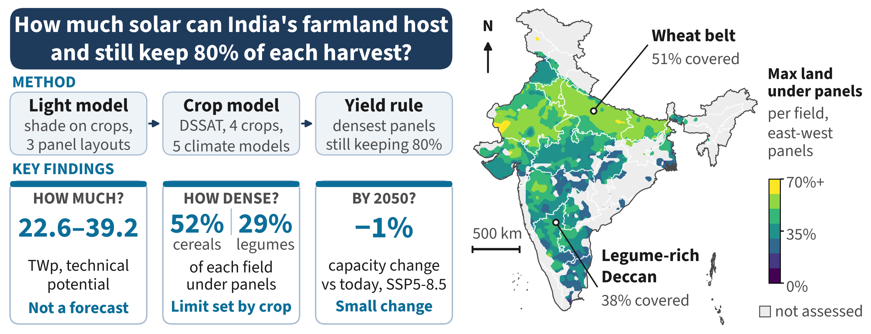

1. Introduction
India has committed to drawing half of its installed electricity capacity from non-fossil sources by 2030 [1], and solar power carries most of that growth, with more than 160 gigawatts (GW) installed by mid-2026 [2]. Utility-scale photovoltaics (PV) need flat, sunny and accessible land, which in India is mostly farmland. Agriculture still employs about 46% of the country's workers [3], so converting cropland to PV trades food and rural income for power. The conflict is sharpened by the finding that croplands are among the most productive places for PV worldwide [4]. Keeping farming and solar apart therefore costs either land or energy; growing crops under the panels is the route that avoids choosing.
Agrivoltaics (APV) shares the sunlight of one field between PV modules and crops. Early field and modelling work showed that the combined output of food and electricity can exceed that of separate fields, with land equivalent ratios above one [5,6]. In drylands, shade can also lower plant water stress and soil evaporation [7], and recent reviews summarise a growing body of trials across climates and crops [8,9]. The crop response, however, is not uniform. A meta-analysis of shading experiments found that some crops lose little yield under moderate shade while others, including grain legumes, lose yield almost in proportion to the light removed [10]. Evidence from India is still sparse: it covers grape farms [11] and the experimental system at Jodhpur in the hot arid zone, where light below the arrays and the yield of several crops have been measured for different module densities [12,13], and wheat, for which shading, light and grain yield under arrays of different density have been measured and simulated [14]. A layout that suits one crop can therefore fail another, and APV potential cannot be judged without the crop below it.
For this reason, rules that define APV set a minimum crop yield. Germany's DIN SPEC 91434 requires at least 66% of the reference yield [15]. In Japan, a permit for PV over farmland is in doubt when yields fall by about 20% against the local average [16], and France requires yields above 90% of a reference area [17]. Studies that design systems under these rules show that the yield limit, not the energy target, often sets the panel density [18]. An estimate of APV potential is only meaningful, then, if it counts land where the yield condition holds and at a density that meets it.
Most potential estimates do not apply such a condition (Table 1). For India, a national study for the Indo-German Energy Forum reported 3.2 to 13.8 terawatts (TW) from threshold screening and a crop suitability matrix [19], an assessment by The Energy and Resources Institute (TERI) found 1.2 to 2.1 TW after excluding all field crops on shade-sensitivity grounds [20], and a geospatial multi-criteria study mapped more than 200,000 km² of highly suitable land from land cover, irradiance, slope, temperature and grid access [21]. None of these studies simulates crop yield under the panels, and their authors list crop response as a main limitation. Outside India, a national multi-criteria study has mapped agrivoltaic suitability across Great Britain without modelling crop yield [22], shading-response curves have been applied to existing PV sites in China [23], a global agro-hydrological model has been run with uniform light reductions for rainfed crops [24], and European maps of the ground coverage ratio (GCR), the share of land covered by modules, have been derived from crop light requirements while assuming that yield is unchanged [25]. The tenfold spread of the Indian estimates thus comes from assumptions about which crops tolerate shade and what power density is acceptable, rather than from a model of how a given array affects a given crop.
Table 1. Studies that estimate agrivoltaic potential at regional to global scale.
Study | Region and resolution | Crop yield under PV | PV geometry | Irrigation and nitrogen | Climate | Yield rule
Fraunhofer Institute for Solar Energy Systems et al. (2024) [19] | India, district | Crop suitability matrix | Three configurations | No | Current | None
The Energy and Resources Institute (2026) [20] | India, 250 m | Field crops excluded by assumption | Fixed 0.42–0.75 megawatts (MW) per hectare | No | Current | None
Mehta and Betz (2026) [21] | India, 1 km | Not modelled (multi-criteria index) | Not modelled | No | Current | None
Xia et al. (2024) [23] | China, PV sites | Shading-response curve per crop | Two densities | No | Current | None
Willockx et al. (2022) [25] | Europe, 25 km | Assumed unchanged; GCR from crop light need | Elevated, fixed | No | Current | Light requirement
Curioni et al. (2025) [24] | Global, ~10 km | Agro-hydrological model, rainfed crops | Uniform light reduction | Rainfed only | Historical | None
Jia et al. (2026) [26] | US Midwest, county | Process-based model, maize and soybean | GCR 0.33 | Not specified | Current and projected, high-emission | None
Arendarczyk et al. (2026) [27] | Global, gridded | LandSyMM (LPJ-GUESS with PLUM) | Fixed GCR 0.25 | Nitrogen and irrigation simulated | Land-use scenarios to 2060 | None
This study | India, 0.25°, 2977 cells | Process-based, 4 crops, calibrated to state yields | 3 layouts × GCR 0.05–0.7, strip-resolved light | Irrigated and rainfed; calibrated and recommended nitrogen | 1995–2014; 2041–2060 under two emission pathways, 5 climate models | Relative yield ≥ 0.66, 0.80, 0.90
Coupled light and crop models already exist at field scale. Ground irradiance below PV rows has been computed with ray tracing [5] and with view factors [28], the latter now available in open tools such as pvlib [29]. These light fields have been fed to crop and water-balance models to predict yield and irrigation demand under specific arrays [30,31], and recent studies in this journal have used such couplings to optimise layout and density for single sites [18,32] or to rank designs at several sites under a minimum crop ratio [33]. A recent review of APV modelling notes, however, that no public crop model yet represents the APV microclimate and that field data for calibration remain scarce [34]. The approach has not been scaled to a national map, mainly because it needs weather, soil, crop calendar and management data for every location and many crop-model runs per layout.
Climate change adds a further reason to use process-based models. Shade removes light, which costs yield where light limits growth, but it also lowers canopy temperature and water demand, which helps where heat and drought limit growth. A process-based study across the United States Midwest found that the same array reduced maize and soybean yields in the humid east but moderated losses and raised soybean yields in the semi-arid west, with aridity as the main control [26]. Warming and changing rainfall may therefore move the land where APV meets a yield rule, which correlative suitability maps cannot capture. To our knowledge, no national APV potential has yet been tested with crop models, explicit array layouts and a yield threshold under future climate; the nearest precedents are a global land-system study with a fixed layout [27] and the regional study of the US Midwest above.
India is a strong test case for both questions. Its cropland spans arid, semi-arid and humid climates, and four major field crops with contrasting shade responses cover about 51 million hectares (Mha) of harvested area: wheat (28 Mha), pearl millet (9 Mha), chickpea (8 Mha) and groundnut (5 Mha) [35]. Wheat is mostly irrigated, while pearl millet and groundnut are mostly rainfed, so water and nitrogen management differ strongly across the country. Policy is also moving PV onto farms: the Pradhan Mantri Kisan Urja Suraksha evam Utthaan Mahabhiyaan (PM-KUSUM) scheme supports decentralised ground-mounted or stilt-mounted solar plants on farmers' own land [36]. Whether such plants can keep crop yields within accepted limits, and at what density, is an open question.
Three gaps follow. First, national estimates of APV potential, including all those for India, do not model how much light a given array leaves for the crop. Second, management has rarely been linked to the shade response at scale. The global land-system study [27] simulates nitrogen and irrigation, but with a fixed layout (GCR 0.25) and no yield threshold, so it cannot show how management changes the density a crop tolerates, even though irrigation and nitrogen both change how strongly a crop responds to shade. Finally, no yield-constrained potential has been tested against future climate. This study addresses these gaps by mapping the APV potential of India that keeps crop yield at or above regulatory thresholds, today and by mid-century. A strip-resolved light model for three array layouts is coupled with the Decision Support System for Agrotechnology Transfer (DSSAT) crop models for wheat, chickpea, pearl millet and groundnut on a 0.25° grid, driven by five climate models. We ask how dense APV arrays can be while India's cropland keeps the 66%, 80% and 90% yield thresholds, how crop, layout and nitrogen management change that density and the resulting capacity, and how both shift by 2041–2060 under two Shared Socioeconomic Pathways (SSPs), SSP2-4.5 and SSP5-8.5.
The paper makes four contributions. (i) It presents a coupled light and crop framework that resolves the light reaching each crop strip, benchmarked against pvlib and calibrated to observed state yields. (ii) It provides, to our knowledge, the first national map of APV potential for India constrained by simulated crop yield, resolved by crop, layout and density. (iii) It quantifies how much management, through nitrogen supply, changes the simulated effect of shade and therefore the estimated potential. (iv) It projects the yield-constrained potential to mid-century with a five-model ensemble and reports where the models agree on the sign of the change.

2. Methodology
The APV potential was estimated by coupling a two-dimensional light model of the ground below the PV rows with a process-based crop model, applied to every 0.25° cell where the four crops are grown, under the current climate and two mid-century scenarios. Fig. 1 shows the workflow: the light model (A), the crop model (B), the threshold test (C) and the conversion to capacity and energy (D). Further detail on each step is given in the Supplementary Material.
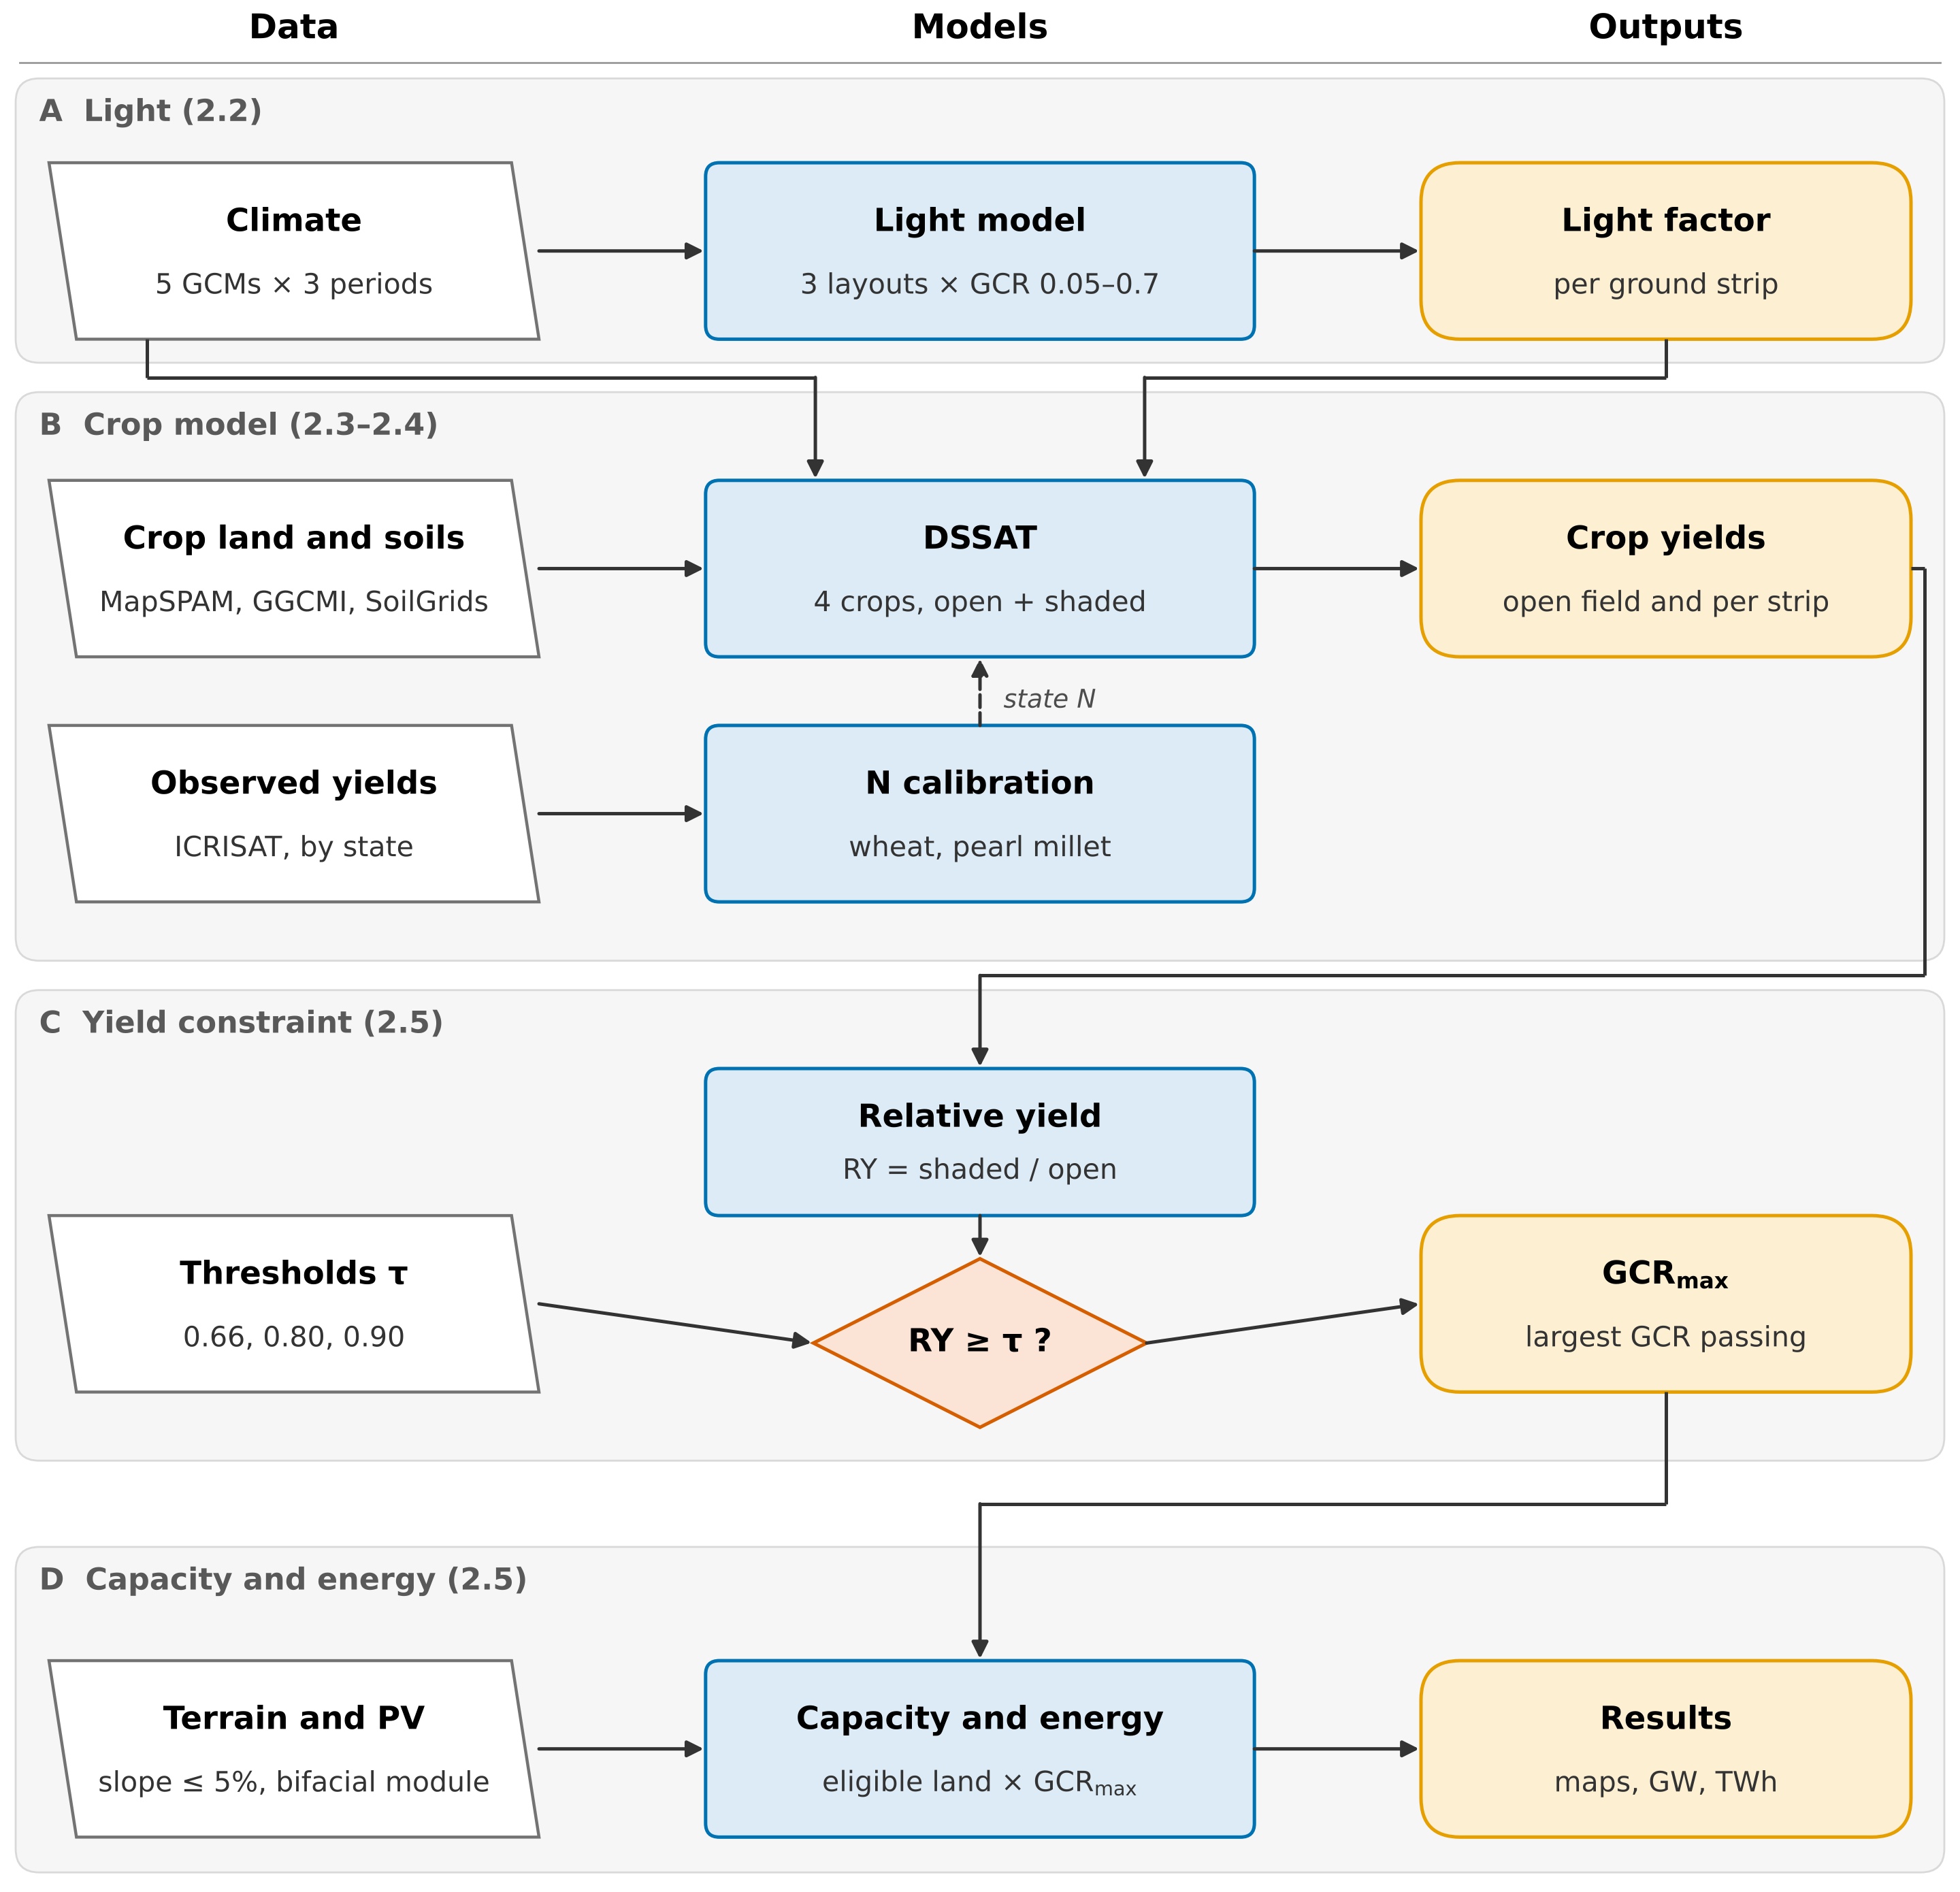
Fig. 1. Methodology flowchart. (A) A light model gives the daily light factor of five ground strips below each layout and ground coverage ratio. (B) A crop model simulates open-field and shaded yields, with nitrogen calibrated by state against observed yields. (C) Relative yield is tested against each threshold τ to find the largest feasible ground coverage ratio. (D) That ratio and the eligible land give photovoltaic capacity and energy, reported as the median and range of five global climate models. Numbers in brackets refer to sections of the text.

2.1. Study domain and crop systems
Four crops were chosen to cover both cropping seasons and the main contrasts in shade response: wheat (rabi, a C₃ cereal), chickpea (rabi, C₃ legume), pearl millet (kharif, C₄ cereal) and groundnut (mainly kharif, C₃ legume). Harvested area and irrigated share were taken from the Spatial Production Allocation Model (MapSPAM) for 2010 [35]. A crop was simulated in a cell where its harvested area was at least 1000 ha; this gives 2977 cells and keeps 93–99% of each crop's national area (Table 2). Irrigated and rainfed systems were simulated separately where each covered at least 10% of the crop's area in the cell.
Table 2. Crop systems and main crop-model settings.
Crop | DSSAT model, cultivar | Cells | Area simulated, Mha (share of national) | Irrigated share | Sowing date
Wheat | CERES-Wheat, Yecora Rojo | 2095 | 28.2 (99%) | 0.79 | Spring wheat calendar
Chickpea | CROPGRO-Chickpea, JG 74 | 1462 | 8.0 (96%) | 0.12 | Wheat date − 14 d
Pearl millet | CERES-Millet, ICMH 451 | 1024 | 8.8 (97%) | 0.05 | Millet calendar; rainfed automatic
Groundnut | CROPGRO-Peanut, TMV 2 | 897 | 5.0 (93%) | 0.19 | Groundnut calendar; rainfed kharif automatic
Cultivars from the DSSAT 4.8 genotype files; Yecora Rojo is a short-season spring wheat; the default files contain no Indian wheat cultivar, so the state calibration (Section 2.4) also absorbs cultivar differences. Automatic sowing: within ±15 d of the calendar date, triggered by soil moisture (Supplementary Section S3).

2.2. Agrivoltaic layouts and light model
Three layouts were simulated (Fig. 2): an elevated south-facing array (tilt 25°), an elevated east-west ridge (tilt 10°), both with a 3 m clearance, and vertical bifacial rows facing east and west. GCR, expressed as module area per ground area, was varied from 0.1 to 0.5, with 0.6 and 0.7 added for wheat and pearl millet and 0.05 for the legumes, whose relative yield (RY) falls fastest. Modules were treated as opaque, and tilt and height were kept the same across India so that differences between cells reflect climate, crop and soil rather than design (geometry in Table S1).
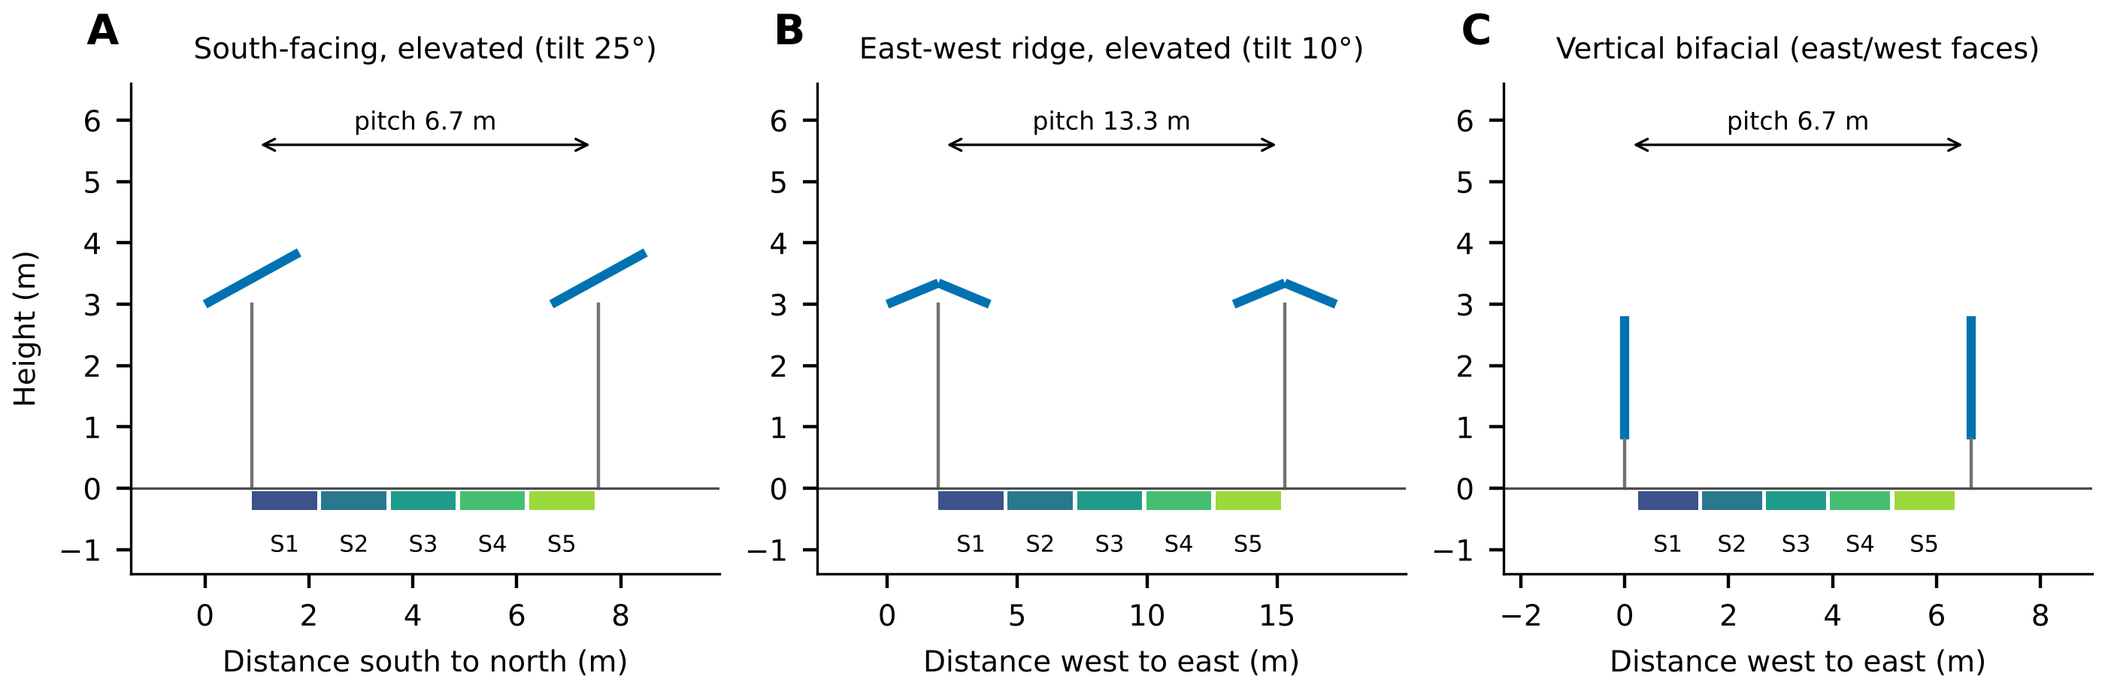
Fig. 2. Cross-sections of the three layouts at a ground coverage ratio of 0.3 (two rows shown). Blue lines are modules and grey lines supports. The cultivated row pitch is divided into five strips (S1–S5); vertical rows leave a 0.5 m uncultivated strip.
Daily radiation from the climate models was disaggregated to hourly values by scaling the Ineichen-Perez clear-sky irradiance [37] to the daily total and splitting it into beam and diffuse parts with the Erbs model [38], using pvlib [29]. For each ground strip, beam transmission between the rows and the sky view factor were computed with a two-dimensional infinite-row view-factor model, following the ray and view-factor approaches used for ground irradiance below PV rows [5,28] (Supplementary Section S1). The daily light factor of strip k on day d is
$f_{k,d} = \frac{\sum_{h∈d}{(T_{k}(θ_{h}) B_{h} + F_{k} D_{h})}}{\sum_{h∈d}{G_{h}}}$ (1)
where T_{k}(θ_{h}) is the beam transmission of the strip at the projected solar zenith angle θ_{h} of hour h, B_{h} the beam irradiance on a horizontal plane, F_{k} the sky view factor of the strip, D_{h} the diffuse horizontal irradiance and G_{h} the global horizontal irradiance (W m⁻²). The crop model of each strip was driven by the open-field daily radiation multiplied by f_{k,d}; all other weather variables were left unchanged. Against the analytical functions in pvlib, the model reproduced the mean sky view factor within 0.0005 and the hourly sunlit ground fraction with a mean absolute difference of at most 0.0015 (Table S2).

2.3. Climate data
Daily climate came from the NASA Earth Exchange Global Daily Downscaled Projections (NEX-GDDP-CMIP6), a bias-corrected and downscaled product of the Coupled Model Intercomparison Project Phase 6 (CMIP6) at 0.25° [39], for five global climate models (GCMs): GFDL-ESM4, IPSL-CM6A-LR, MPI-ESM1-2-HR, MRI-ESM2-0 and UKESM1-0-LL. These are the GCMs of the Inter-Sectoral Impact Model Intercomparison Project phase 3b (ISIMIP3b) protocol and span equilibrium climate sensitivities of about 2.6 to 5.3 K [40]. Three 20-year periods were simulated: 1995–2014 (reference) and 2041–2060 under SSP2-4.5 and SSP5-8.5. The SSPs combine a socioeconomic storyline with a radiative forcing in 2100: SSP2-4.5 is an intermediate pathway (4.5 W m⁻²) and SSP5-8.5 a high-emission pathway (8.5 W m⁻²) [41]. They give a moderate and a high case for mid-century; the low-emission SSP1-2.6, although available in NEX-GDDP-CMIP6, was not simulated because of the run time. Atmospheric CO₂ was held at the period mean, 378, 507 and 563 ppm [41]. Variable conversion is described in Supplementary Section S2, and Table S3 lists the periods and CO₂ levels.

2.4. Crop model and calibration
Crops were simulated with DSSAT 4.8 [42,43] (CERES-Wheat, CERES-Millet, CROPGRO-Chickpea and CROPGRO-Peanut), with Penman-Monteith evapotranspiration as in FAO Irrigation and Drainage Paper 56 [44], nitrogen fixation for the legumes and the CO₂ response of each model. Each season was simulated independently. Sowing dates came from the Global Gridded Crop Model Intercomparison (GGCMI) Phase 3 crop calendar [45]; chickpea was sown 14 days before the local wheat date because the GGCMI pulse calendar describes kharif pulses. Soil profiles to 2 m were built from SoilGrids 2.0 [46] with the Saxton and Rawls pedotransfer functions [47]. Irrigated systems were irrigated automatically when soil water in the top 30 cm fell below a set fraction of plant-available water. Model set-up and planting settings are given in Supplementary Section S3 (Table S5).
Nitrogen input, which controls much of the yield gap of Indian wheat and pearl millet, differs strongly between states, and a single national rule reproduced the mean wheat yield but not its spatial pattern (Table 3). Nitrogen was therefore calibrated by state for these two crops, following the common practice in large-scale crop modelling of adjusting management inputs until simulated yields match observed regional yields [48,49]. Open-field yields were simulated at 10 (pearl millet only), 30, 60, 90, 120 and 180 kg N ha⁻¹ with two GCMs for the reference period, and in each state the level whose area-weighted mean yield was closest to the observed 1995–2014 state yield [50] was selected (Table S6). The calibrated level is interpreted as an effective management intensity, since it also absorbs other yield-limiting factors, and it agrees only loosely with survey data on fertiliser use. The survey reports about 106 and 56 kg N ha⁻¹ for irrigated and rainfed wheat, 62 and 18 kg N ha⁻¹ for pearl millet, and the highest wheat rates in Haryana and Punjab [51]; the calibrated levels are 30–180 kg N ha⁻¹ for wheat, highest in Punjab and Gujarat, and 10–30 kg N ha⁻¹ for pearl millet. Across states, the Spearman rank correlation between the calibrated level and the mean fertiliser nitrogen use per hectare of gross cropped area in 1995–2014 (all crops; International Crops Research Institute for the Semi-Arid Tropics (ICRISAT) district data [50]) is 0.33 for wheat (15 states) and 0.26 for pearl millet (9 states). The calibration is described in Supplementary Section S4.
The legumes were not calibrated: chickpea was unbiased on average (Table 3), while groundnut was over-estimated by a factor of 2.63, in line with its large yield gap in India. Since RY is a ratio of two yields from the same model, a bias that scales both yields does not change it; legume yields were scaled by state yield-gap factors only when absolute production is reported (Supplementary Section S5, Table S7). Calibrated nitrogen is the base management case, and the only one used for the mid-century runs. A recommended-practice case was also run for the reference period (Table S4). Its wheat rate of 120 kg N ha⁻¹ (irrigated) is above the calibrated level in most states but below it in Punjab and Gujarat (180 kg N ha⁻¹). The robust case, which we use for the headline, takes in each cell the smaller GCR_{max} of the calibrated and recommended cases, so it mixes nitrogen levels by state and does not simply raise nitrogen everywhere.
Table 3. Simulated against observed open-field state yields, 1995–2014 (states with at least 50 kha of the crop).
Crop | States | Case | Pearson r | Mean absolute percentage error (%) | Simulated / observed
Wheat | 15 | Uncalibrated | 0.01 | 29 | 0.92 (0.83)
Wheat | 15 | Calibrated | 0.74 | 12 | 1.01 (1.01)
Pearl millet | 9 | Uncalibrated | 0.04 | 31 | 1.01 (0.94)
Pearl millet | 9 | Calibrated | 0.28 | 24 | 1.09 (1.05)
Chickpea | 11 | Not calibrated | 0.21 | 29 | 1.02 (1.01)
Groundnut | 10 | Not calibrated | −0.19 | 163 | 2.63 (2.36)
Mean of GFDL-ESM4 and MPI-ESM1-2-HR. The mean absolute percentage error is weighted by observed harvested area. Simulated / observed is the area-weighted mean of the state ratios; in brackets, the ratio of the area-weighted mean yields.

2.5. Yield-constrained potential
For each cell, crop system, layout, GCR and GCM, the relative yield was computed on a land-area basis, as in land equivalent ratio studies and the reference-yield rule of DIN SPEC 91434 [5,8,15]:
$RY = c \frac{Ȳ_{APV}}{Ȳ_{0}}$ (2)
where Ȳ_{APV} is the yield under the array averaged over strips and seasons, Ȳ₀ the open-field yield over the same seasons (kg ha⁻¹), and c the cultivated share of the pitch (1 for the elevated layouts). Irrigated and rainfed systems were combined by production (Eq. (S1)). The largest GCR that meets a threshold τ was found on the RY-GCR curve, which starts at RY = 1 for GCR = 0, by linear interpolation at the first crossing. This extends the use of GCR as the design variable that links light sharing to crop yield [25,52]:
${GCR}_{max} = g_{j−1} + \frac{({RY}_{j−1} − τ)(g_{j} − g_{j−1})}{{RY}_{j−1} − {RY}_{j}}$ (3)
where g_{j} is the first simulated GCR with RY below τ and g_{j−1} the one before it, so that every smaller GCR also meets τ. Where RY stayed above τ at the largest simulated GCR, GCR_{max} was set to that value and reported as a lower bound. Three thresholds from existing rules were used: τ = 0.66 (DIN SPEC 91434 [15]), 0.80 (Japan, where a yield drop of more than about 20% against the local average puts the permit in doubt [16]; main case) and 0.90 (France [17]). DIN SPEC 91434 also limits the land lost to the structure to 15% for systems with crops between the rows; the 0.5 m strip of the vertical layout exceeds this above GCR 0.6.
Eligible land was the MapSPAM harvested area of each crop multiplied by the share of the cell with terrain slope of at most 5%, the limit used to screen land for utility PV in India [53], computed from the Copernicus 90 m global digital elevation model [54]. Because a PV array stands all year, the rabi area A_{r} (wheat, chickpea) and kharif area A_{k} (pearl millet, groundnut) of a cell were assumed to overlap as far as possible, and the overlap had to satisfy both seasons. Eligible land is fixed by design: every eligible hectare enters at its own GCR_{max}, however small, so thresholds, layouts, management and climate change the potential through the density on that land, not through its area. Capacity follows from module area and rated efficiency, as in earlier national APV estimates [4,55]; for a cell it is
$P = η I_{STC} [ A_{ov} min(ḡ_{r}, ḡ_{k}) + (A_{r} − A_{ov}) ḡ_{r} + (A_{k} − A_{ov}) ḡ_{k} ]$ (4)
where η = 0.22 is the module efficiency, I_{STC} = 1000 W m⁻², A_{ov} = min(A_{r}, A_{k}) the double-cropped area, and ḡ_{r} and ḡ_{k} the area-weighted GCR_{max} of the rabi and kharif crops. Annual energy was obtained by multiplying capacity by the specific yield of each cell, layout and GCR, computed with pvlib for a bifacial glass-glass module from the same hourly irradiance, using the infinite-sheds model for front and rear irradiance, the Faiman cell temperature model [56] and PVWatts [57] (Table S8).

2.6. Uncertainty and assumptions
All steps were run separately for each GCM; national and state totals are reported as the five-GCM median with the minimum and maximum as the range. This range is not a total uncertainty: for 1995–2014 all GCMs are bias-corrected to the same observations, so it is narrow by construction, and crop-model, calibration, soil and light-model errors are not propagated. Sensitivity cases cover the threshold (0.66, 0.90), the slope limit (none, 10%), management (recommended practice), module efficiency and climate (both scenarios), one at a time (Table 5). Each tested value has a stated basis: the thresholds of existing rules, a bracket around the 5% slope limit, and the range of commercial module efficiency in 2025 [58]. For PV energy, daily radiation was rescaled cell by cell and month by month to the 2001–2020 NASA Prediction of Worldwide Energy Resources (POWER) all-sky climatology [59], because aerosols dim surface radiation over India [60] and reduce PV output [61]; the same factors were applied to the mid-century periods, as in linear-scaling bias correction [62]. A season-by-season variant of the rule requires RY ≥ τ in at least 16 of 20 seasons.
Three assumptions shape the results. Panels change only the radiation reaching the crop; lower leaf temperature and evaporative demand under shade are not represented, which probably makes RY conservative for rainfed crops in hot regions. Mid-century yields include CO₂ fertilisation, which is strongest for the C₃ legumes. Finally, the potential is technical, bounded by crop yield and terrain only; grid capacity, land tenure and economics are not considered. Aggregation, eligible land and the energy model are described in Supplementary Section S6, implementation and quality control in Section S7, validation figures in Section S8, and the Rajasthan pilot in Section S9 (Tables S9 and S10).

3. Results

3.1. Model evaluation
Calibrating nitrogen by state improved the simulated open-field yields of the two cereals (Fig. S1). For wheat, the correlation between simulated and observed state yields rose from r = 0.01 to 0.74 and the area-weighted mean absolute percentage error fell from 29% to 12% (15 states). Pearl millet improved less, from r = 0.04 to 0.28 and from 31% to 24% (9 states), because yields in the south remained over-predicted even at the lowest nitrogen level. The mean ratio of simulated to observed yield rose from 1.01 to 1.09 because, before calibration, under-predicted northern and over-predicted southern states cancelled. The light model reproduced the pvlib view factors closely and the light measured over the whole Jodhpur system, but over-estimated the light directly below the modules under low winter sun (Figs. S2 and S3).

3.2. Feasible ground coverage ratio by crop and layout
Cereals tolerate about twice the panel density of legumes (Fig. 3A–D). In the east-west layout, the area-weighted mean GCR_{max} at RY ≥ 0.80 was 0.52 for wheat and 0.53 for pearl millet, but 0.27 for chickpea and 0.32 for groundnut. The south-facing array allowed the lowest densities for every crop, most clearly for the rabi crops wheat (0.34) and chickpea (0.19), whose grain fills under low winter sun (Fig. 3E). Vertical rows allowed densities close to the east-west layout and reached the DIN SPEC 91434 cap of 0.6 on at least 73% of the pearl millet area. Within each crop, GCR_{max} varied strongly across the country, and few cells met the threshold at the densest GCR simulated (east-west: 1% of the wheat and 6% of the chickpea area). The maps for all crops and layouts, and their change by mid-century, are in Figs. S7–S9 (Supplementary Section S13).
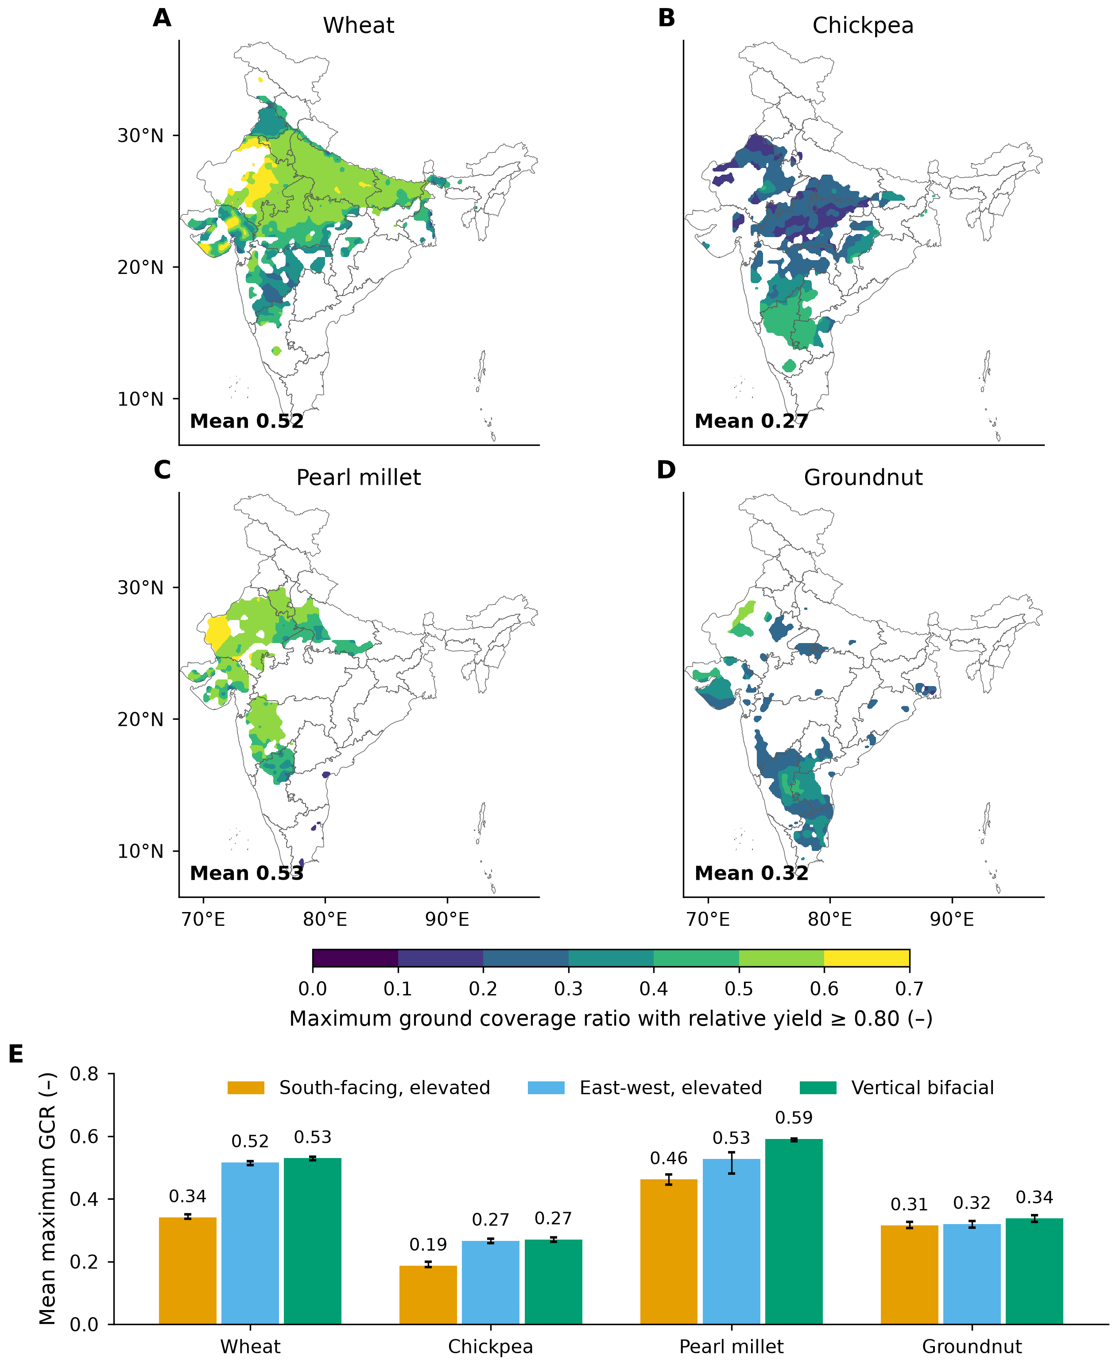
Fig. 3. Largest ground coverage ratio that keeps relative yield at or above 0.80, 1995–2014, robust nitrogen case (smaller of the calibrated and recommended nitrogen results in each cell). (A–D) East-west layout by crop: median of five climate models, interpolated for display; the number in each map is the area-weighted mean. (E) Mean by crop and layout, with error bars for the range of the five models. Boundaries: DataMeet India community, States/Admin2 (https://github.com/datameet/maps, Creative Commons Attribution 4.0 licence).

3.3. National potential
Under the yield rule, Indian cropland could host 39.2 terawatts peak (TWp) of APV (Fig. 4, Table 4). This is the east-west layout at τ = 0.80 on 39.7 Mha of cropland with slopes up to 5% (GCM range 39.0–39.8 TWp), or 0.99 megawatts peak (MWp) per hectare. It would generate 60.9 petawatt-hours (PWh) per year, about 36 times India's 2025–26 electricity requirement of 1,707 terawatt-hours (TWh) [63]. Seen the other way, 500 gigawatts peak (GWp) at this mean density would occupy only 0.51 Mha, 1.3% of the eligible cropland, and 0.35 Mha if the densest cells are used first (Fig. S6, Supplementary Section S11). Capacity density is highest across the Indo-Gangetic plain and north-western Rajasthan and lowest in the legume-growing Deccan and the south, which follows the crop pattern of Fig. 3.
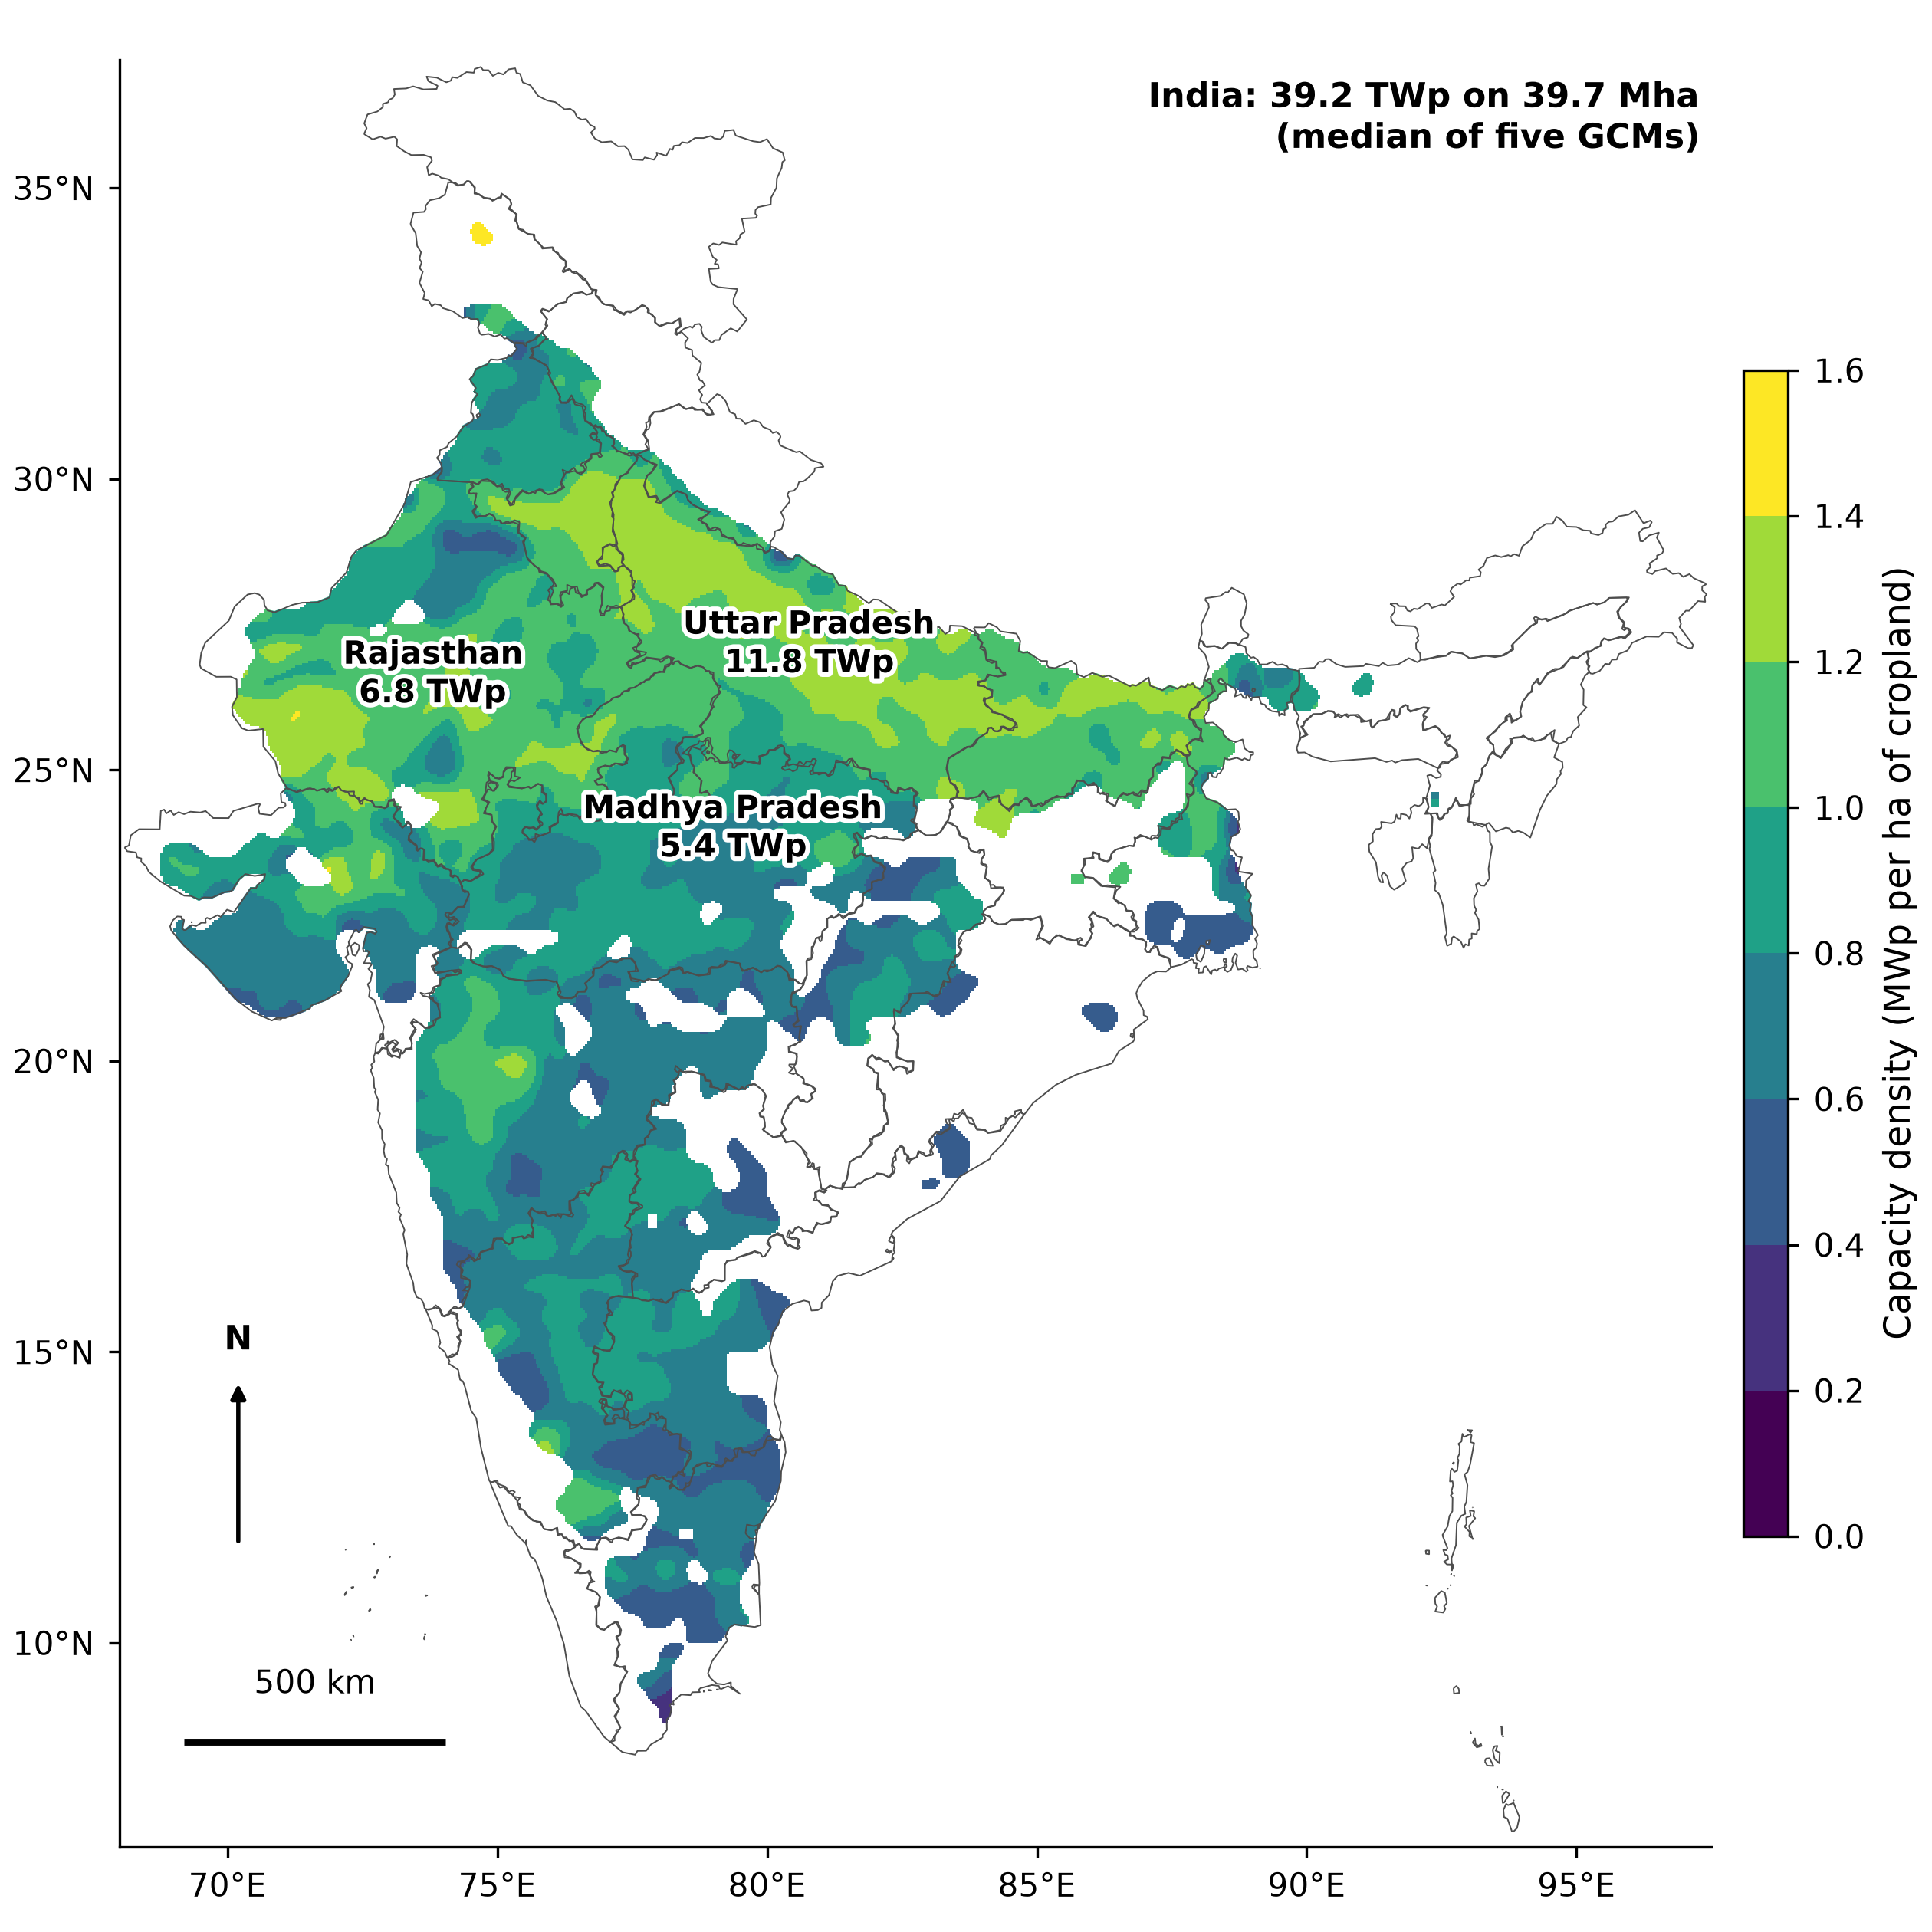
Fig. 4. Yield-constrained capacity density (megawatts peak per hectare of cropland, crops combined) for east-west elevated arrays at relative yield ≥ 0.80, 1995–2014, robust nitrogen case (smaller of the calibrated and recommended nitrogen results in each cell), slope ≤ 5%. Median of five climate models, interpolated for display; cells with less than 1000 ha of eligible cropland are blank. Labels give the capacity of the three leading states.
The layouts rank differently by capacity (Fig. 5A) and by energy (Fig. 5B). Vertical rows reached the most capacity, 41.2 TWp with the 0.6 cap, against 28.4 TWp for the south-facing array. Their specific yield, however, was only 1,078 kWh kWp⁻¹ yr⁻¹, against 1,554 for east-west and 1,660 for south-facing arrays, so they produced the least energy (44.4 PWh yr⁻¹). East-west arrays gave the most energy at every threshold and are used for the headline. The threshold mattered more than the slope rule: capacity was 47 TWp at τ = 0.66 and 31 TWp at τ = 0.90, while dropping the slope limit raised it only to 43 TWp.
The potential is concentrated in three states, which hold 61% of it: Uttar Pradesh (11.8 TWp), Rajasthan (6.8 TWp) and Madhya Pradesh (5.4 TWp) (Fig. 6).
Table 4. Yield-constrained APV potential of India for four crops, 1995–2014: robust nitrogen case and calibrated nitrogen alone (upper bound). Slope ≤ 5%; crops combined with double-cropped land counted once; vertical GCR_{max} capped at 0.6.
Layout | τ | Capacity, TWp (robust) | Capacity, TWp (calibrated) | Energy, PWh yr⁻¹ (robust) | Energy, PWh yr⁻¹ (calibrated) | MWp ha⁻¹ (robust)
South-facing, elevated | 0.66 | 35.7 (35.4–35.9) | 40.3 (40.1–40.5) | 58.5 | 65.0 | 0.90
 | 0.80 | 28.4 (27.9–28.7) | 34.2 (33.9–34.3) | 47.1 | 55.7 | 0.72
 | 0.90 | 21.1 (20.3–21.3) | 28.7 (28.2–28.9) | 35.5 | 47.0 | 0.53
East-west, elevated | 0.66 | 47.3 (47.1–47.9) | 51.1 (50.8–51.4) | 72.7 | 77.9 | 1.19
 | 0.80 | 39.2 (39.0–39.8) | 45.5 (45.5–45.9) | 60.9 | 69.6 | 0.99
 | 0.90 | 30.9 (30.4–31.5) | 39.8 (39.6–40.3) | 48.5 | 61.0 | 0.78
Vertical bifacial | 0.66 | 47.5 (47.4–47.6) | 47.7 (47.6–47.8) | 49.9 | 50.0 | 1.20
 | 0.80 | 41.2 (40.8–41.4) | 42.8 (42.6–43.0) | 44.4 | 45.7 | 1.04
 | 0.90 | 30.4 (29.4–30.8) | 38.1 (37.8–38.3) | 34.6 | 41.0 | 0.77
Median over five GCMs, GCM range in brackets. Land is the eligible crop area, 39.7 Mha in every case; the threshold and nitrogen act through the density. Vertical rows without the 0.6 cap (robust): 53, 43 and 31 TWp at τ = 0.66, 0.80 and 0.90.
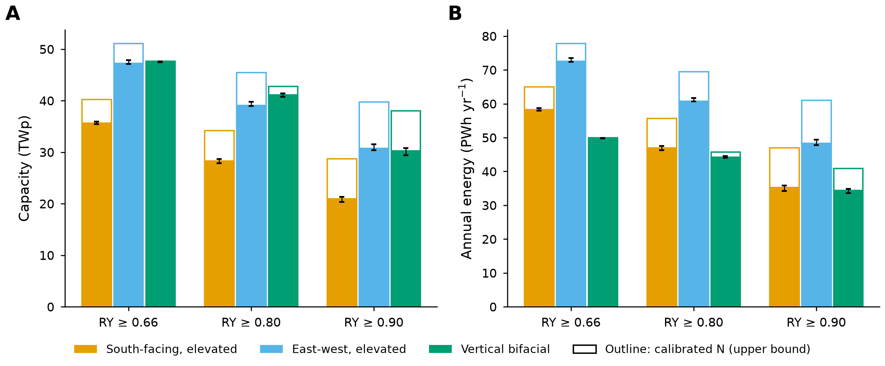
Fig. 5. National agrivoltaic capacity (A) and annual energy (B) by layout and relative-yield threshold, 1995–2014, slope ≤ 5%. Filled bars: robust nitrogen case; outline bars: calibrated nitrogen alone (upper bound). Median of five climate models, with error bars for their range.
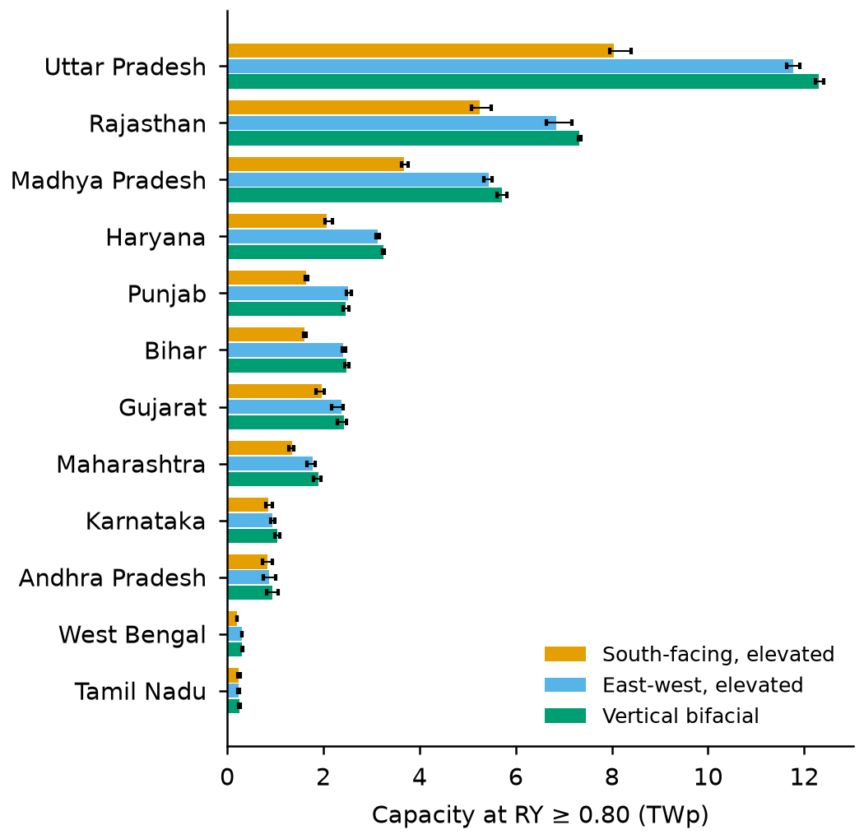
Fig. 6. Capacity of the leading states at relative yield ≥ 0.80 by layout, 1995–2014, robust nitrogen case (smaller of the calibrated and recommended nitrogen results in each cell), slope ≤ 5%. Median of five climate models, with error bars for their range.

3.4. Nitrogen management and the field-response scenario
With calibrated nitrogen alone, the east-west potential at τ = 0.80 is 45.5 TWp (GCM range 45.5–45.9) and 69.6 PWh yr⁻¹, so the robust case is 14% lower (Table 4, Fig. 5). The change is −17% for the south-facing array and −4% for vertical rows, and the largest absolute losses are in Uttar Pradesh and Madhya Pradesh. The difference comes almost entirely from the cereals: mean GCR_{max} falls from 0.62 to 0.52 for wheat and from 0.58 to 0.53 for pearl millet, while the legumes barely change. With calibrated nitrogen, 42% of the east-west wheat area still met the threshold at GCR 0.7; in the robust case 1% does. These wheat cells lie mostly in states with low calibrated nitrogen, which points to nitrogen masking rather than true shade tolerance (Section 4.2). With calibrated nitrogen the east-west layout also gave the most capacity, 45.5 against 42.8 TWp for capped vertical rows. Figs. S4 and S5 (Supplementary Section S10) show the calibrated-nitrogen maps and state results.
The crop models are also more tolerant of shade than field observations (Supplementary Section S14). In the field-response scenario, simulated RY is rescaled so that its dependence on the reduction in ground light follows the observations compiled by Jha et al. [64], with maize standing in for pearl millet. The east-west potential at τ = 0.80 then falls by 42% to 22.6 TWp and 36.1 PWh yr⁻¹, with GCR_{max} of 0.31 for wheat, 0.23 for pearl millet, 0.20 for groundnut and 0.17 for chickpea. The south-facing and vertical layouts reach 17.1 and 23.9 TWp, and the east-west potential at τ = 0.66 and 0.90 is 31.6 and 12.8 TWp. The ranking of layouts by energy is unchanged (36.1, 29.1 and 28.5 PWh yr⁻¹ for east-west, south-facing and vertical). We therefore treat the robust case as the upper bound and the field-response scenario as the lower bound of the technical potential.

3.5. Mid-century change
The climate runs use calibrated nitrogen, so the changes below are relative to the calibrated 1995–2014 potential of 45.5 TWp. By 2041–2060 under SSP2-4.5, the east-west potential at τ = 0.80 changes by −1% to 45 TWp (GCM range −7% to +1%; Fig. 7A shows all layouts). Under SSP5-8.5 it changes by −1% to 44.9 TWp. The GCM range of this change, −6% to 0%, is the range of the five per-GCM paired changes, each GCM's mid-century total against its own 1995–2014 total. At least four of five GCMs agree on the sign of the change in GCR_{max} on 56% of the eligible land under SSP2-4.5 and 57% under SSP5-8.5 (crops combined; on fixed land this is also the sign of the change in cell capacity). Mean GCR_{max} in the east-west layout changes by +0.00 for wheat, −0.05 for pearl millet, +0.00 for chickpea and −0.01 for groundnut (Fig. 7B), and pearl millet in the north-west loses most (Fig. 7C,D).
Climate barely changes capacity but lowers energy: annual energy changes by −5% to 66.3 PWh, and specific yield by −3%, from 1,529 to 1,476 kWh kWp⁻¹ yr⁻¹. Most of this loss comes from lower irradiance in the climate models (plane-of-array irradiance, front and rear, −3.2%); the remainder (−0.3%) reflects lower module efficiency at higher temperature. These changes include the effect of higher CO₂ on the crops (Section 4.3).
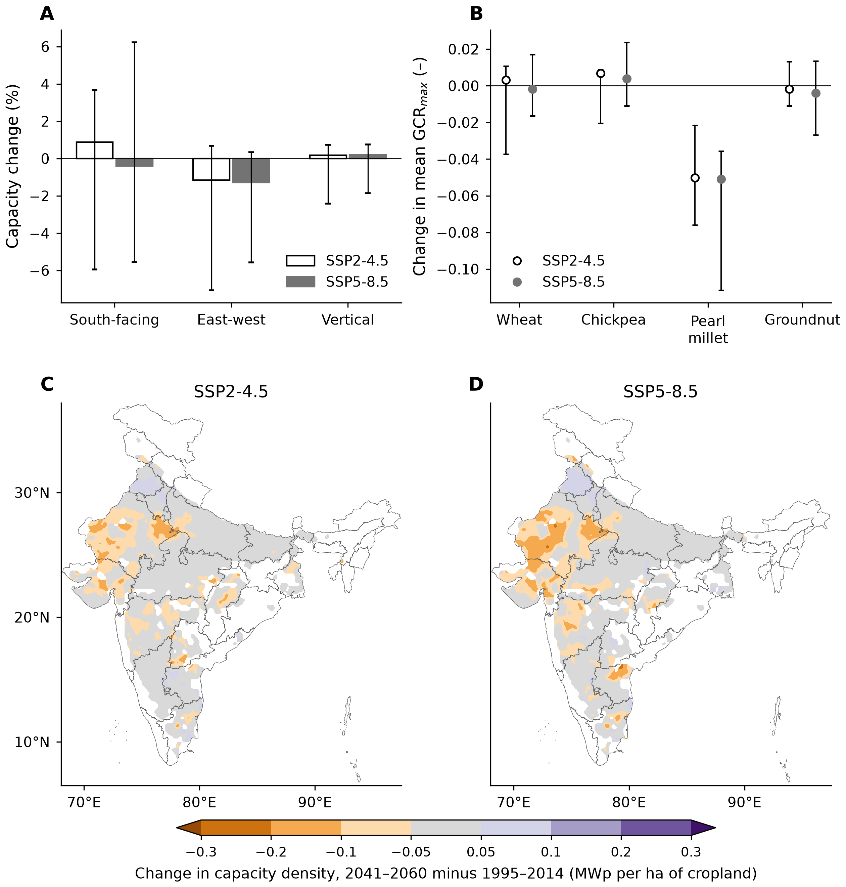
Fig. 7. Change by 2041–2060 against 1995–2014 at relative yield ≥ 0.80 with calibrated nitrogen. (A) National capacity by layout and (B) mean largest ground coverage ratio by crop, east-west layout; open symbols, SSP2-4.5 (intermediate emissions), filled symbols, SSP5-8.5 (high emissions), with the range of the five paired changes of the climate models. (C, D) Change in capacity density, east-west layout, median of five climate models, interpolated for display, for SSP2-4.5 (C) and SSP5-8.5 (D).
The full set of change maps by crop and layout is in Figs. S8 and S9.

3.6. Sensitivity
Apart from the array layout, the yield threshold is the strongest lever on the potential (Table 5): moving τ from 0.80 to 0.66 or 0.90 changes capacity by +21% and −21%. Calibrated nitrogen alone changes it by +16% and dropping the slope limit by +10%, while module efficiency of 20% or 24% instead of 22%, the span from older modules to 2025 back-contact modules [58], changes capacity and energy by about ±9%. Applying the threshold season by season, in at least 16 of 20 seasons, changes capacity by −14%. The spread of the five GCMs, 39.0–39.8 TWp, is small against all of these, so the choice of rule and management matters far more than the climate model.
Table 5. Sensitivity of the national APV potential, 1995–2014: one assumption changed at a time from the base case, with the basis of each tested value.
Case | Basis of the tested value | Capacity, TWp | Change, % | Energy, PWh yr⁻¹
Base: robust nitrogen, east-west, τ = 0.80, slope ≤ 5% | Japanese threshold [16]; 5% PV slope limit for India [53] | 39.2 | – | 60.9
Threshold τ = 0.66 | DIN SPEC 91434 minimum [15] | 47.3 | +21 | 72.7
Threshold τ = 0.90 | French decree [17] | 30.9 | −21 | 48.5
No slope limit | No terrain screening | 43.0 | +10 | 67.1
Slope ≤ 10% | Relaxed terrain limit | 40.9 | +4 | 63.7
Calibrated nitrogen alone (upper bound) | State-calibrated nitrogen, Section 2.4 | 45.5 | +16 | 69.6
Module efficiency 20% | Older modules; 2025 mass production 21.7% (PERC) [58] | 35.6 | −9 | 55.4
Module efficiency 24% | Back-contact modules, 24.1% in 2025 [58] | 42.8 | +9 | 66.5
South-facing layout | Alternative design, Section 2.2 | 28.4 | −28 | 47.1
Vertical layout, GCR ≤ 0.6 | Alternative design, Section 2.2 | 41.2 | +5 | 44.4
Vertical layout, no DIN cap | 15% land-loss limit removed [15] | 43.0 | +10 | 45.7
Threshold met in ≥ 16 of 20 seasons | Rules judge single seasons [15,17]; one failure in five tolerated | 33.8 | −14 | 52.9
Radiation not corrected (energy only) | NEX-GDDP radiation as supplied, Supplementary Section S12 | 39.2 | 0 | 70.4
Range of five GCMs (base case) | CMIP6 ensemble, Section 2.3 | 39.0–39.8 | – | –
Five-GCM median. Module efficiency scales capacity and energy in proportion, because GCR_{max} depends on shade, not on the module rating.

4. Discussion

4.1. The yield-constrained potential against national estimates
In the robust case (east-west layout, τ = 0.80, slope ≤ 5%), the four crops can host 39.2 TWp of APV (GCM range 39.0–39.8) on 39.7 Mha of eligible cropland. This is 90% of the land the four crops occupy before the slope rule (double-cropped land counted once) and 79% of their summed harvested area (Fig. 8). Calibrated nitrogen alone gives 45.5 TWp, which we treat as an upper bound because low nitrogen input masks part of the shade loss in wheat (Section 4.2). Rescaling the simulated shade response to field observations lowers the robust figure to 22.6 TWp (Section 3.4), so the technical potential lies between 22.6 and 39.2 TWp.
The figure is 19–33 times the 1.2–2.1 TW of TERI [20] and 2.8 times the upper end of the 3.2–13.8 TW reported for the Indo-German Energy Forum [19], but these studies do not measure the same thing. TERI excludes field crops on shade-sensitivity grounds, so most of the land we count is outside its scope by definition, and the Fraunhofer study assigns suitability from a crop matrix and screening thresholds [19,20]. Our larger figure is therefore not evidence that the earlier studies were too cautious. It shows what the yield rule alone permits on the land of four crops, before grid, economic or social limits.
Two differences explain most of the gap. The first is the land base: TERI's fixed density of 0.42–0.75 MW ha⁻¹ [20] applied to our 39.7 Mha would already give 17–30 TW. The second is the power density. With η = 0.22, TERI's range equals a GCR of 0.19–0.34, since one hectare at GCR g carries 2.2g MWp; our yield-constrained density of 0.99 MWp ha⁻¹ is 1.3–2.4 times higher, and it is not uniform. GCR_{max} ranges from 0.20 to 0.60 across the eligible area (5th to 95th percentile, Fig. 3A–D), and cereals keep RY ≥ 0.80 up to a median GCR of 0.55. A fixed density is thus too high for legume land and too low for much of the irrigated wheat belt, so a blanket rule over- or under-counts large areas.
Fig. 8 follows the gap on the same grid and crops. A fixed 0.75 MW ha⁻¹ on all simulated crop area gives 37.5 TW (0.42 MW ha⁻¹: 21.0 TW). The slope rule and counting double-cropped land once remove 21% of the area and leave 29.8 TW at the higher density. Replacing the fixed density by GCR_{max} raises capacity by +53% against 0.75 MW ha⁻¹ and by +173% against 0.42 MW ha⁻¹. Robust nitrogen management then changes the result by −14%. The field-response lower bound (22.6 TWp) lies between the two fixed-density cases on the same land (16.7 and 29.8 TW), so the choice of shade response matters about as much as the choice of fixed density.
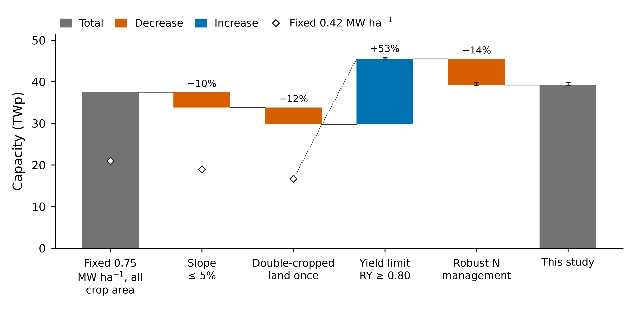
Fig. 8. From a fixed power density to the yield-constrained potential, east-west layout, relative yield ≥ 0.80, 1995–2014. Steps are applied cumulatively on the same grid and crops. Bars use 0.75 megawatts per hectare for steps 1–3 and diamonds 0.42 (the range of an Indian national assessment [20]). Error bars are the range over five climate models. The last step uses the robust case (minimum of calibrated and recommended nitrogen).
Spatial studies elsewhere, for Great Britain, Europe, Phoenix, the Middle East and North Africa and the globe, also count suitable land under assumed layouts or shading levels [22,24,25,65,66]. For India, a crop-model study of two array densities reported land equivalent ratios of 1.35–1.73 (half density) and 1.43–1.97 (full density) [67]. Such ratios show a gain in land productivity but set no minimum crop yield, which is the question our threshold answers. A geographic information system overlay for the Middle East and North Africa found 74–100% (lower scenario) and 94–100% (higher scenario) of agricultural land suitable [66]. We find a similar picture for land: 39.7 Mha, or 90% of the land the four crops occupy, passes the slope rule. The closest study in design is a national geographic information system assessment for Japan that optimised agrivoltaic layouts under daily-light-integral constraints; its average GCR was 30%, and its cost depended strongly on the crop light requirement [68]. That mean lies within our range (0.20–0.60). What separates sites is the density the crop tolerates, which a suitability overlay does not give and which here follows from a crop model run for each cell.

4.2. What sets the panel density: nitrogen, crop and layout
Management mattered as much as the crop. In the Rajasthan pilot (Supplementary Section S9; 498 cells, five GCMs, 1995–2014), wheat under the south-facing array at GCR 0.3 had a median RY of 1.13 at the farmer rate of 60 kg N ha⁻¹ and 0.90 at the recommended 120 kg N ha⁻¹. RY above one is not a real yield gain. The likely mechanism is nitrogen dilution: the critical nitrogen concentration of a crop falls as its biomass grows [69], so a shaded crop that grows less stays closer to its nitrogen demand. Under low nitrogen the open-field crop is limited by nitrogen and the shaded crop by light, and the light loss is hidden.
The national calibrated results show the same signature. 42% of the east-west wheat area kept RY ≥ 0.80 even at GCR 0.7, the densest array simulated, and this share follows the calibrated nitrogen level: 67% in states calibrated at 30 kg N ha⁻¹ and 59% at 60, but 10% at 90 and 4% at 180. The low-nitrogen states hold 65% of the eligible wheat area, and in the wheat cells at the limit the open-field yield is only 34% of the yield simulated at 180 kg N ha⁻¹, against 61% elsewhere. Much of this tolerance therefore reflects nitrogen-limited open-field yields rather than shade-tolerant crops.
Management is also not fixed: a farmer who receives APV lease income could apply more fertiliser, and the rule would then become stricter at the same density. We therefore report a robust estimate, in which each cell takes the smaller GCR_{max} of the calibrated and recommended cases. The two cases bracket management, since calibrated nitrogen reproduces current practice and recommended nitrogen is the agronomic benchmark. Taking the smaller value is a conservative scenario rule, not a probability, and it understates the potential where low rates persist alongside other limits. The robust case cuts the share of wheat area at the limit to 1% and the national potential by 14% (from 45 to 39 TWp), with the largest absolute losses in Uttar Pradesh and Madhya Pradesh. We take it as the headline because it is the safer basis for planning; the calibrated case holds only while current practice continues. Irrigation, sowing date and cultivar could also shift tolerance, and we did not vary them.
Among crops, the ranking agrees with the meta-analysis of Laub et al. [10], which found strong losses in grain legumes (and maize) even at low shade and a less than proportional loss in C₃ cereals up to a 15% reduction in radiation. A later synthesis of 546 observations from 66 studies likewise ranked maize and grain legumes as the most sensitive and cereals as declining gradually [64]. Chickpea (0.27) and groundnut (0.32) tolerate about half the panel density of wheat (0.52) and pearl millet (0.53) in the east-west layout (Fig. 3E). The two legumes hold 25% of the eligible crop area but 15% of the capacity at τ = 0.80, and where a legume and a cereal share a field in the two seasons the legume usually sets the density, because the array must satisfy both (Eq. (4)). Pearl millet is the one result that does not fit the meta-analysis, which found strong losses for maize, a C₄ cereal. The maize result is not universal, however: in a stilt-mounted system in Japan with low module density, maize yield per square metre was 5.6% above the control [70], so a C₄ cereal can tolerate sparse arrays. Rainfed pearl millet at the calibrated 10–30 kg N ha⁻¹ is limited by nitrogen and water more than by light, the same masking as in wheat, so its GCR_{max} should be read as tolerance under current low-input management and not as a property of the crop.
Layout mattered most for the rabi crops. The south-facing array, tilted at 25°, casts long shadows in winter when the sun is low, which is when wheat and chickpea fill grain: its GCR_{max} was 0.34 for wheat and 0.19 for chickpea, against 0.52 and 0.27 in the east-west layout. East-west ridges and vertical rows spread the shade more evenly through the day. Vertical rows also lose cropland to the structure: above GCR 0.6 the 0.5 m uncultivated strip exceeds the 15% land-loss limit of DIN SPEC 91434 [15]. The yield rule alone would exceed 0.6 on 40% of the vertical-layout area, so we cap it there; the cap lowers vertical capacity by only 4%. Vertical rows still reach the most capacity but, with their low specific yield, deliver the least energy (Section 3.3). A layout is better judged by the energy it delivers than by its peak capacity, so we use the east-west layout as the headline.

4.3. Climate change and the CO₂ caveat
The yield-constrained capacity changes little by mid-century: −1% under SSP5-8.5 and −1% under SSP2-4.5 (Section 3.5). Because RY is a ratio, warming that lowers open-field and shaded yields alike leaves it unchanged, and only the part of the climate signal that differs between sun and shade moves the threshold. Light-only shading cannot represent the main such difference, the cooler and less evaporative environment under the panels (Section 4.5). Annual energy falls more, by −5% under SSP5-8.5, mostly through lower irradiance in the climate models (−3.2%). Other work agrees on the direction. Bias-corrected CMIP6 projections show surface solar radiation over India declining by 0.52% per decade under SSP2-4.5 and 0.60% per decade under SSP5-8.5, most in central, southern and eastern India [71]; over the roughly four to five decades between our two periods, that rate is of the same order as our irradiance change. Photovoltaic potential is projected to fall by up to 15% in parts of Africa [72].
Absolute yields are a different matter. Mid-century runs include CO₂ at 507 and 563 ppm, and the CROPGRO legumes respond strongly to CO₂. Free-air enrichment experiments show smaller yield gains for C₃ crops than the enclosure studies on which earlier model factors were based [73,74], and C₄ crops such as pearl millet gain little [73], so mid-century production figures, especially for chickpea and groundnut, are likely to be optimistic. The effect on RY is much smaller, because CO₂ raises the yield under the array and in the open field alike. Under SSP5-8.5 the median open-field yield changed by +45% for chickpea and +32% for groundnut (area-weighted median over cells, five-GCM mean), yet the median RY at GCR 0.3 in the east-west layout changed by only +0.01 and 0.00. The legume constraint, and therefore its GCR_{max}, is thus largely insensitive to the CO₂ response even where absolute yields are not. Pearl millet is the exception: its RY at GCR 0.3 changed by −0.08, consistent with its GCR_{max} change of −0.05 (Section 3.5). The CO₂ share of these changes was not separated, because no run with fixed CO₂ was made.

4.4. Implications for India
The modelled land resource is large relative to demand: the robust-case energy is about 36 times the national electricity requirement of 2025–26 [63] (about 21 times in the field-response scenario). This is an energy-equivalence benchmark, not a supply estimate. Siting near substations, grid capacity, finance, land tenure, farmer acceptance and the choice of crop are not modelled and will decide how much of the resource can be used. A farmer on land that meets τ = 0.80 keeps at least 80% of the open-field yield on average, but whether lease income covers the remainder depends on prices and tenure. In a German case study the levelised cost of APV electricity was 38% above ground-mounted PV, and the price-performance ratio was favourable for potato (0.85) but not for winter wheat (4.62), so the authors advised against APV in crop rotations [75]. Our potential rests on annual crops in rotation, the case found least favourable there, and Indian prices need their own analysis [76]. None of this has been tested in India.
India's main route for PV on farmland is component A of PM-KUSUM, which supports grid-connected plants of 0.5–2 MW on farmers' land preferably within 5 km of a substation, either ground-mounted or on stilts [36,77]. To our knowledge the scheme sets no yield rule for the crop below. Germany, Japan and France all do, with thresholds of 66%, about 80% and 90% of a reference yield [15–17], and the choice among them is not a detail: moving from τ = 0.66 to 0.90 changes the national potential from 47 to 31 TWp in the east-west layout. Three elements could be adopted in India. First, a relative yield threshold, with 0.80 as a defensible middle value. Second, a limit on land lost to the structure, as in DIN SPEC 91434, which would rule out narrow-pitch vertical rows. Third, a reference that farmers and inspectors can check. A paired open plot is the norm in Europe; in India, district yields from official statistics [50] could serve where no control plot exists, much as Japan compares against the local average [16]. A crop-specific density cap, low for pulses and higher for cereals, would be simpler still and follows directly from the GCR_{max} maps. Water is a further reason to test the concept in the rainfed north-west, because field studies report higher water-use efficiency under panels in hot, dry conditions [7] that our crop models, which carry no panel microclimate, cannot show. In East Africa, panel shading also reduced irrigation demand [78].
The scale of the scheme and of the potential differ by orders of magnitude, which shifts the policy question from how much land exists to where it should be used. Component A has a target of 10 GW [36]. At the densest cells of our map, 10 GW would occupy about 65 km², or 0.02% of the eligible land, so land area alone is not what limits the scheme. The potential is also concentrated: five states (Uttar Pradesh, Rajasthan, Madhya Pradesh, Haryana and Punjab) hold 75% of the east-west capacity at τ = 0.80, and Uttar Pradesh alone holds 6.9–11.8 TWp (lower to upper bound). Wheat, the most shade-tolerant of the four crops in our results, dominates this region, so a yield rule would direct plants toward land where the crop tolerates the most shade. Our results contain no costs, grid constraints or farm income, and the choice among sites in practice will also depend on those. A levelised-cost comparison with standard ground-mounted PV, and a farm-income model for the yield loss that a threshold of 0.80 allows, are the natural next steps.

4.5. Limitations and next steps
The headline should be read with its structural uncertainty in mind. The spread across the five climate models is small (39.0–39.8 TWp) and says little about the real range, which comes mainly from four choices. The shade response matters most: field data suggest the simulated crops are too tolerant of shade (below), and the field-response scenario gives 22.6 TWp, 42% below the robust case, so the 39.2 TWp headline is the upper bound of a range. The yield threshold comes next (τ = 0.66 gives 47 TWp and τ = 0.90 gives 31 TWp), then nitrogen management (39 TWp in the robust case and 45 TWp with calibrated nitrogen alone) and the season rule (34 TWp when 16 of 20 seasons must meet the threshold). The threshold and nitrogen are policy and management choices more than scientific unknowns, which is why we report them as scenarios and not as error bars. The omitted panel microclimate acts in the other direction and is likely to raise the potential for rainfed crops, but we cannot size it.
The shade response has been checked against published observations only, and the check does not favour the model. The meta-analyses of other crop types agree with the simulated ranking [10,64]: chickpea and groundnut lose yield almost in proportion to light (RY 0.86 and 0.86 at a 20% reduction), and wheat loses little until about half the light is removed (Fig. S10, Supplementary Section S14). In magnitude, however, simulated RY is higher than observed. Against the 38 wheat, 97 grain-legume and 66 maize observations compiled by Jha et al. [64] (from 10, 18 and 12 studies), the mean bias with recommended nitrogen is +0.09 for wheat, +0.09 for grain legumes and +0.20 for maize, the proxy for pearl millet (calibrated nitrogen: +0.16, +0.08 and +0.26; Fig. S11). At a light reduction of about 39%, for example, the observed median wheat RY was 0.72 against 0.94 simulated. The comparison is imperfect. Most observations come from shade-net or intercropping trials at temperate sites, soybean dominates the legumes, the compilation holds no pearl millet and none of it is from India, and its authors report that warmer, higher-radiation sites keep yields better under shade, which favours more tolerance in India. Even so, the direction is consistent: the model is probably too tolerant of shade.
Rescaling the model to the observations (field-response scenario, Supplementary Section S14) lowers the east-west potential by 42% to 22.6 TWp, with GCR_{max} of 0.31 for wheat and 0.23 for pearl millet, the latter resting on maize as a proxy and likely too low. The truth probably lies between the two scenarios. The lower bound is not sensitive to the proxy sets used for crops without direct data (soybean left out of the legume set, C3 cereals added for wheat or pearl millet: 22.3–23.6 TWp across the variants, Supplementary Section S14), although every proxy is a different species from the crop it stands for. Where field shading data exist, they warn that wheat shaded during grain filling can lose more than proportionally: 20%, 50% and 80% shade for 30 days after flowering cut grain yield by 27.6%, 49.0% and 60.2% in north China [79]. If DSSAT under-estimates such losses, the wheat GCR_{max} reported here is too high. Indian field trials, listed at the end of this section, would settle this.
Shading was represented as a change in daily light only, a limitation shared by current crop models in APV studies [34]. Field studies report little change in mean crop temperature under panels in a temperate climate [80] but yield gains in hot, dry seasons [7,81], and a process-based study found that shade can raise yields where aridity dominates [26]. A global synthesis found that crops in warmer, higher-radiation environments kept their yields better under partial shade [64]. A crop-model study of tomato in Botswana likewise found yield falling with PV density, which the authors note conflicts with field reports of shade-tolerant plants thriving at low density, a limit of crop modelling [82]. Omitting the microclimate is therefore likely to make RY conservative for rainfed crops in the arid north-west. Diffuse light, which canopies use more efficiently than direct light, and the alternation of sunflecks and shade within a day are also not represented, because the crop models receive only daily totals. Indian field evidence is also thin: Santra et al. measured light within an array [12], and Modi et al. compared eight string geometries over green gram in north Gujarat, finding the highest yield under transparent panels [83]. No trial covers our four crops across a range of GCR.
The threshold was applied to RY of the 20-year mean yields, whereas rules such as DIN SPEC 91434 and the French decree check the yield of individual seasons [15,17]. Requiring RY ≥ 0.80 in at least 16 of 20 seasons lowers the potential by 14% to 34 TWp (Table 5), because a mean RY of 0.80 can include seasons well below the threshold, mostly for rainfed crops. The radiation of the climate data was checked against the NASA POWER satellite climatology [59]. The correction changes NEX-GDDP-CMIP6 radiation by −16% over the Indo-Gangetic plain, where aerosols and winter fog dim surface radiation [60] and cut PV output [61], and by −8% in the south. The energy results use the corrected radiation, which changes national specific yield by −13%. The crop runs keep the original radiation; on the 40 most affected cells, corrected radiation changed GCR_{max} by −0.18 on average and by at most 0.26.
The crop simulations have their own limits. Wheat was simulated with Yecora Rojo, a short-season spring cultivar, because the DSSAT files contain no Indian cultivar, and the state calibration absorbs the yield level but not differences in phenology that might change the timing of shade. Groundnut yields were over-estimated by a factor of 2.63; RY is unaffected by a uniform bias, but a model that over-predicts biomass may also misplace the onset of light limitation. Simulated yields can be as sensitive to soil data as to climate [84]: at Jodhpur, replacing the SoilGrids profile by a loamy sand lowered open-field rainfed pearl millet from 886 to 583 kg ha⁻¹ and its RY under the south-facing array at GCR 0.3 from 1.02 to 0.87 (Supplementary Section S9). The scope is also limited. Only four crops were simulated, and where wheat is followed by rice or cotton the array would shade a crop whose response was not tested. In the hill states the model over-estimated yields, and the cells that the slope rule leaves there are less reliable. Only SSP2-4.5 and SSP5-8.5 were run; because their results are nearly identical for 2041–2060, a low-emission pathway such as SSP1-2.6 is unlikely to change the conclusions. Finally, the potential is technical in the usual sense of energy studies [85]: it ignores grid capacity, land tenure, finance and farmer acceptance.
The most useful next steps follow from these limits: field trials of pearl millet, chickpea and groundnut under panels in India, which would test the legume thresholds and the pearl millet result; crop models that carry the panel microclimate; and a robust-nitrogen run for 2041–2060.

5. Conclusions
This study mapped the agrivoltaic potential of India under a crop-yield rule, by coupling a strip-resolved light model with calibrated DSSAT crop models for four field crops, three layouts and five climate models.
A yield rule mainly limits how densely APV can be built, not where. On cropland with slopes up to 5%, east-west elevated arrays that keep 80% of the open-field yield could reach 39.2 TWp on 39.7 Mha, about 0.99 MWp ha⁻¹, with the shade response of the crop models, and 22.6 TWp when that response is rescaled to field observations. Both figures lie above the published Indian estimates, which exclude field crops or fix a low density. They are land-based technical potentials, not deployment forecasts: grid access, finance, land tenure and farmer acceptance, which were not modelled, will decide how much can be used. The tolerable density depends strongly on the crop: 0.52 for cereals against 0.29 for legumes, so a single national density rule would be too high for pulses and too low for much of the wheat belt.
Nitrogen management changes the answer. Where the open-field crop is held back by low nitrogen, shade costs little extra yield and the model overstates shade tolerance. Taking the lower GCR_{max} of the calibrated and recommended nitrogen runs removes 14% of the calibrated potential and almost all wheat that seemed to tolerate the densest arrays (42% of the area before, 1% after). Mid-century climate barely changes the yield-constrained capacity (−1% under SSP5-8.5, −1% under SSP2-4.5) but changes annual energy by −5%, mostly through lower irradiance in the climate models; these results include CO₂ fertilisation, which raises absolute legume yields far more than relative yield.
For policy, India could add to PM-KUSUM a relative-yield threshold of about 0.80, a limit on land lost to the structure and a reference yield that can be checked. Future work should test the shade response in Indian field trials, add the microclimate under the panels, correct the radiation of the climate data, test yield rules season by season and add grid and economic limits.

References
[1] Government of India. India's updated first Nationally Determined Contribution under the Paris Agreement (2021–2030). Submitted to the UNFCCC; 26 August 2022. https://unfccc.int/sites/default/files/NDC/2022-08/India%20Updated%20First%20Nationally%20Determined%20Contrib.pdf.
[2] Ministry of New and Renewable Energy. Physical progress: programme-wise cumulative installed capacity. https://mnre.gov.in/en/physical-progress/ [accessed October 2026].
[3] National Statistics Office. Annual Report, Periodic Labour Force Survey (PLFS), July 2023–June 2024. New Delhi: Ministry of Statistics and Programme Implementation; 2024. https://microdata.gov.in/nada43/index.php/catalog/213.
[4] Adeh EH, Good SP, Calaf M, Higgins CW. Solar PV power potential is greatest over croplands. Sci Rep 2019;9:11442. https://doi.org/10.1038/s41598-019-47803-3.
[5] Dupraz C, Marrou H, Talbot G, Dufour L, Nogier A, Ferard Y. Combining solar photovoltaic panels and food crops for optimising land use: Towards new agrivoltaic schemes. Renew Energy 2011;36:2725–32. https://doi.org/10.1016/j.renene.2011.03.005.
[6] Valle B, Simonneau T, Sourd F, Pechier P, Hamard P, Frisson T, et al. Increasing the total productivity of a land by combining mobile photovoltaic panels and food crops. Appl Energy 2017;206:1495–507. https://doi.org/10.1016/j.apenergy.2017.09.113.
[7] Barron-Gafford GA, Pavao-Zuckerman MA, Minor RL, Sutter LF, Barnett-Moreno I, Blackett DT, et al. Agrivoltaics provide mutual benefits across the food–energy–water nexus in drylands. Nat Sustain 2019;2:848–55. https://doi.org/10.1038/s41893-019-0364-5.
[8] Weselek A, Ehmann A, Zikeli S, Lewandowski I, Schindele S, Högy P. Agrophotovoltaic systems: applications, challenges, and opportunities. A review. Agron Sustain Dev 2019;39:35. https://doi.org/10.1007/s13593-019-0581-3.
[9] Campana PE, Macknick J, Croci M, Elkadeem MR, Gorjian S, Pascaris A, et al. Scientific frontiers of agrivoltaic cropping systems. Nat Rev Clean Technol 2025;1:801–21. https://doi.org/10.1038/s44359-025-00110-9.
[10] Laub M, Pataczek L, Feuerbacher A, Zikeli S, Högy P. Contrasting yield responses at varying levels of shade suggest different suitability of crops for dual land-use systems: a meta-analysis. Agron Sustain Dev 2022;42:51. https://doi.org/10.1007/s13593-022-00783-7.
[11] Malu PR, Sharma US, Pearce JM. Agrivoltaic potential on grape farms in India. Sustain Energy Technol Assess 2017;23:104–10. https://doi.org/10.1016/j.seta.2017.08.004.
[12] Santra P, Meena HM, Yadav OP. Spatial and temporal variation of photosynthetic photon flux density within agrivoltaic system in hot arid region of India. Biosyst Eng 2021;209:74–93. https://doi.org/10.1016/j.biosystemseng.2021.06.017.
[13] Poonia S, Jat NK, Santra P, Singh AK, Jain D, Meena HM. Techno-economic evaluation of different agri-voltaic designs for the hot arid ecosystem India. Renew Energy 2022;184:149–63. https://doi.org/10.1016/j.renene.2021.11.074.
[14] Prakash V, Lunagaria MM, Trivedi AP, Upadhyaya A, Kumar R, Das A, et al. Shading and PAR under different density agrivoltaic systems, their simulation and effect on wheat productivity. Eur J Agron 2023;149:126922. https://doi.org/10.1016/j.eja.2023.126922.
[15] DIN SPEC 91434:2021-05. Agri-photovoltaic systems – Requirements for primary agricultural use. Berlin: Beuth Verlag; 2021. https://doi.org/10.31030/3257526.
[16] Ministry of Agriculture, Forestry and Fisheries of Japan. Handling under the farmland conversion permit system of solar power generation facilities installed on supporting pillars while farming continues. Notice 24-Noshin-2657 of 31 March 2013 (in Japanese: 支柱を立てて営農を継続する太陽光発電設備等についての農地転用許可制度上の取扱いについて); superseded by a guideline in 2024. https://www.maff.go.jp/j/nousin/noukei/totiriyo/einogata.html.
[17] Décret n° 2024-318 du 8 avril 2024 relatif au développement de l'agrivoltaïsme et aux conditions d'implantation des installations photovoltaïques sur des terrains agricoles, naturels ou forestiers (NOR ECOR2321918D). Journal officiel de la République française n° 0083, 9 April 2024. https://www.legifrance.gouv.fr/jorf/id/JORFTEXT000049386027.
[18] Ademollo A, Ulivi N, Ferretti L, Serafini F, Carcasci C, Pacini C. Policy-constrained agrivoltaics in Italy: a potato case study linking shading, crop and economics. Appl Energy 2026;405:127225. https://doi.org/10.1016/j.apenergy.2025.127225.
[19] Fraunhofer ISE, EY, CSTEP. Agrivoltaics in India. New Delhi: Indo-German Energy Forum; 2024. https://energyforum.in/fileadmin/india/media_elements/publications/20240502_AgriPV_in_India/Agrivoltaics_in_India.pdf.
[20] Yadav S, Tiwari AK, Malik H, Dortch R. Agri-photovoltaics potential in India: pathways for sustainable energy–food solutions. New Delhi: The Energy and Resources Institute (TERI); 2026. https://www.teriin.org/policy-brief/agri-photovoltaics-potential-india-pathways-sustainable-energy-food-solutions.
[21] Mehta K, Betz F. Agri-photovoltaics in India: Geospatial suitability for sustainable water–energy–food nexus solutions. Energy Sustain Dev 2026;91:101915. https://doi.org/10.1016/j.esd.2025.101915.
[22] Neesham-McTiernan TH, Randle-Boggis RJ, Buckley AR, Hartley SE. The spatial potential for agrivoltaics to address energy-agriculture land use conflicts in Great Britain. Appl Energy 2025;385:125527. https://doi.org/10.1016/j.apenergy.2025.125527.
[23] Xia Z, Li Y, Guo S, Jia N, Pan X, Mu H, et al. Balancing photovoltaic development and cropland protection: Assessing agrivoltaic potential in China. Sustain Prod Consum 2024;50:205–15. https://doi.org/10.1016/j.spc.2024.08.001.
[24] Curioni M, Galli N, Manzolini G, Rulli MC. Global land-water competition and synergy between solar energy and agriculture. Earth's Future 2025;13:e2024EF005291. https://doi.org/10.1029/2024EF005291.
[25] Willockx B, Lavaert C, Cappelle J. Geospatial assessment of elevated agrivoltaics on arable land in Europe to highlight the implications on design, land use and economic level. Energy Rep 2022;8:8736–51. https://doi.org/10.1016/j.egyr.2022.06.076.
[26] Jia M, Peng B, Guan K, Lawrence DM, DeLucia EH, Knapp AK, et al. Climate-driven divergence in biophysical and economic impacts of agrivoltaics. Proc Natl Acad Sci USA 2026;123:e2514380123. https://doi.org/10.1073/pnas.2514380123.
[27] Arendarczyk B, Saxena A, Arneth A, Rounsevell M, Alexander P. Agrivoltaics could increase global land use efficiency compared to bioenergy. Appl Energy 2026;426:128628. https://doi.org/10.1016/j.apenergy.2026.128628.
[28] Nassar YF, El-Khozondar HJ, Belhaj SO, Alsadi SY, Abuhamoud NM. View factors in horizontal plane fixed-mode solar PV fields. Front Energy Res 2022;10:859075. https://doi.org/10.3389/fenrg.2022.859075.
[29] Anderson KS, Hansen CW, Holmgren WF, Jensen AR, Mikofski MA, Driesse A. pvlib python: 2023 project update. J Open Source Softw 2023;8:5994. https://doi.org/10.21105/joss.05994.
[30] Amaducci S, Yin X, Colauzzi M. Agrivoltaic systems to optimise land use for electric energy production. Appl Energy 2018;220:545–61. https://doi.org/10.1016/j.apenergy.2018.03.081.
[31] Elamri Y, Cheviron B, Lopez JM, Dejean C, Belaud G. Water budget and crop modelling for agrivoltaic systems: Application to irrigated lettuces. Agric Water Manag 2018;208:440–53. https://doi.org/10.1016/j.agwat.2018.07.001.
[32] Mazzeo D, Di Zio A, Pesenti C, Leva S. Optimizing agrivoltaic systems: A comprehensive analysis of design, crop productivity and energy performance in open-field configurations. Appl Energy 2025;390:125750. https://doi.org/10.1016/j.apenergy.2025.125750.
[33] Bellone Y, Croci M, Impollonia G, Nik Zad A, Colauzzi M, Campana PE, Amaducci S. Simulation-based decision support for agrivoltaic systems. Appl Energy 2024;369:123490. https://doi.org/10.1016/j.apenergy.2024.123490.
[34] Zainali S, Ma Lu S, Fernández-Solas Á, Cruz-Escabias A, Fernández EF, Zidane TEK, et al. Modelling, simulation, and optimisation of agrivoltaic systems: a comprehensive review. Appl Energy 2025;386:125558. https://doi.org/10.1016/j.apenergy.2025.125558.
[35] Yu Q, You L, Wood-Sichra U, Ru Y, Joglekar AKB, Fritz S, et al. A cultivated planet in 2010 – Part 2: The global gridded agricultural-production maps. Earth Syst Sci Data 2020;12:3545–72. https://doi.org/10.5194/essd-12-3545-2020.
[36] Ministry of New and Renewable Energy. Comprehensive guidelines for implementation of Pradhan Mantri Kisan Urja Suraksha evam Utthaan Mahabhiyaan (PM-KUSUM) scheme. New Delhi: MNRE; 17 January 2024. https://mnre.gov.in/?p=22280.
[37] Ineichen P, Perez R. A new airmass independent formulation for the Linke turbidity coefficient. Sol Energy 2002;73:151–7. https://doi.org/10.1016/S0038-092X(02)00045-2.
[38] Erbs DG, Klein SA, Duffie JA. Estimation of the diffuse radiation fraction for hourly, daily and monthly-average global radiation. Sol Energy 1982;28:293–302. https://doi.org/10.1016/0038-092X(82)90302-4.
[39] Thrasher B, Wang W, Michaelis A, Melton F, Lee T, Nemani R. NASA Global Daily Downscaled Projections, CMIP6. Sci Data 2022;9:262. https://doi.org/10.1038/s41597-022-01393-4.
[40] Meehl GA, Senior CA, Eyring V, Flato G, Lamarque JF, Stouffer RJ, et al. Context for interpreting equilibrium climate sensitivity and transient climate response from the CMIP6 Earth system models. Sci Adv 2020;6:eaba1981. https://doi.org/10.1126/sciadv.aba1981.
[41] Meinshausen M, Nicholls ZRJ, Lewis J, Gidden MJ, Vogel E, Freund M, et al. The shared socio-economic pathway (SSP) greenhouse gas concentrations and their extensions to 2500. Geosci Model Dev 2020;13:3571–605. https://doi.org/10.5194/gmd-13-3571-2020.
[42] Jones JW, Hoogenboom G, Porter CH, Boote KJ, Batchelor WD, Hunt LA, et al. The DSSAT cropping system model. Eur J Agron 2003;18:235–65. https://doi.org/10.1016/S1161-0301(02)00107-7.
[43] Hoogenboom G, Porter CH, Boote KJ, Shelia V, Wilkens PW, Singh U, et al. Decision Support System for Agrotechnology Transfer (DSSAT) Version 4.8. Gainesville, FL: DSSAT Foundation; 2021. https://dssat.net.
[44] Allen RG, Pereira LS, Raes D, Smith M. Crop evapotranspiration: Guidelines for computing crop water requirements. FAO Irrigation and Drainage Paper 56. Rome: FAO; 1998. https://www.fao.org/4/x0490e/x0490e00.htm.
[45] Jägermeyr J, Müller C, Ruane AC, Elliott J, Balkovic J, Castillo O, et al. Climate impacts on global agriculture emerge earlier in new generation of climate and crop models. Nat Food 2021;2:873–85. https://doi.org/10.1038/s43016-021-00400-y.
[46] Poggio L, de Sousa LM, Batjes NH, Heuvelink GBM, Kempen B, Ribeiro E, et al. SoilGrids 2.0: producing soil information for the globe with quantified spatial uncertainty. SOIL 2021;7:217–40. https://doi.org/10.5194/soil-7-217-2021.
[47] Saxton KE, Rawls WJ. Soil water characteristic estimates by texture and organic matter for hydrologic solutions. Soil Sci Soc Am J 2006;70:1569–78. https://doi.org/10.2136/sssaj2005.0117.
[48] Folberth C, Gaiser T, Abbaspour KC, Schulin R, Yang H. Regionalization of a large-scale crop growth model for sub-Saharan Africa: model setup, evaluation, and estimation of maize yields. Agric Ecosyst Environ 2012;151:21–33. https://doi.org/10.1016/j.agee.2012.01.026.
[49] Müller C, Elliott J, Chryssanthacopoulos J, Arneth A, Balkovic J, Ciais P, et al. Global gridded crop model evaluation: benchmarking, skills, deficiencies and implications. Geosci Model Dev 2017;10:1403–22. https://doi.org/10.5194/gmd-10-1403-2017.
[50] Swamikannu N, Pingali PR, Padmanabhan J, Ravula P, Gumma MK, Mohammed IA, et al. District Level Data (DLD) and Dashboard for Agriculture and Allied-sectors in India, version 1. ICRISAT Dataverse; 2021. https://doi.org/10.21421/D2/XFB1BZ.
[51] FAO. Fertilizer use by crop in India. Rome: Food and Agriculture Organization of the United Nations; 2005. https://www.fao.org/4/a0257e/a0257e00.htm.
[52] Dupraz C. Assessment of the ground coverage ratio of agrivoltaic systems as a proxy for potential crop productivity. Agrofor Syst 2024;98:2679–96. https://doi.org/10.1007/s10457-023-00906-3.
[53] Deshmukh R, Wu GC, Phadke A. Renewable energy zones for balancing siting trade-offs in India: multi-criteria analysis for planning renewable energy (MapRE). Report LBNL-1007272. Berkeley, CA: Lawrence Berkeley National Laboratory; 2017. https://escholarship.org/uc/item/5cf6k335.
[54] European Space Agency, Airbus. Copernicus DEM, global 90 m (GLO-90). 2022. https://doi.org/10.5270/ESA-c5d3d65.
[55] Dinesh H, Pearce JM. The potential of agrivoltaic systems. Renew Sustain Energy Rev 2016;54:299–308. https://doi.org/10.1016/j.rser.2015.10.024.
[56] Faiman D. Assessing the outdoor operating temperature of photovoltaic modules. Prog Photovolt Res Appl 2008;16:307–15. https://doi.org/10.1002/pip.813.
[57] Dobos AP. PVWatts Version 5 Manual. NREL/TP-6A20-62641. Golden, CO: National Renewable Energy Laboratory; 2014. https://doi.org/10.2172/1158421.
[58] VDMA Photovoltaic Equipment. International Technology Roadmap for Photovoltaic (ITRPV): results 2025. 17th ed. Frankfurt am Main: VDMA; 2026. https://www.vdma.org/international-technology-roadmap-photovoltaic [accessed November 2026].
[59] NASA Langley Research Center. Prediction Of Worldwide Energy Resources (POWER) Project, daily and climatology data. Hampton, VA: NASA. https://power.larc.nasa.gov [accessed November 2026].
[60] Padma Kumari B, Londhe AL, Daniel S, Jadhav DB. Observational evidence of solar dimming: offsetting surface warming over India. Geophys Res Lett 2007;34:L21810. https://doi.org/10.1029/2007GL031133.
[61] Bergin MH, Ghoroi C, Dixit D, Schauer JJ, Shindell DT. Large reductions in solar energy production due to dust and particulate air pollution. Environ Sci Technol Lett 2017;4:339–44. https://doi.org/10.1021/acs.estlett.7b00197.
[62] Teutschbein C, Seibert J. Bias correction of regional climate model simulations for hydrological climate-change impact studies: review and evaluation of different methods. J Hydrol 2012;456–457:12–29. https://doi.org/10.1016/j.jhydrol.2012.05.052.
[63] Central Electricity Authority. Load Generation Balance Report 2026-27. New Delhi: Ministry of Power, Government of India; 2026. https://cea.nic.in/wp-content/uploads/l_g_b_r_reports/2025/LGBR_2026_27.pdf [accessed 2 November 2026].
[64] Jha A, Heiser G, Kelvey R, Huang Q. Crop yield responses to reduced solar radiation in agrivoltaic systems: crop-specific patterns and shading thresholds. Agronomy 2026;16:985. https://doi.org/10.3390/agronomy16100985.
[65] Majumdar D, Pasqualetti MJ. Dual use of agricultural land: introducing 'agrivoltaics' in Phoenix Metropolitan Statistical Area, USA. Landsc Urban Plan 2018;170:150–68. https://doi.org/10.1016/j.landurbplan.2017.10.011.
[66] Abdalla M, Ayadi O, Al Omari A, Rinchi B, Al-Bakri J. A pathway to food and energy security: agrivoltaic potential in the MENA region. Energy Nexus 2026;21:100610. https://doi.org/10.1016/j.nexus.2025.100610.
[67] Aswal P, Sundriyal N, Jhajharia T, Rawat A. Competition for land use between solar energy and agriculture in India: modelling agrivoltaic solutions. Sustain Energy Res 2026;13:47. https://doi.org/10.1186/s40807-026-00277-0.
[68] Nakata H, Ogata S. Balancing energy and agriculture in Japan: a techno-economic assessment of agrivoltaics based on the levelized cost of electricity. Agronomy 2026;16:1776. https://doi.org/10.3390/agronomy16181776.
[69] Justes E, Mary B, Meynard JM, Machet JM, Thelier-Huché L. Determination of a critical nitrogen dilution curve for winter wheat crops. Ann Bot 1994;74:397–407. https://doi.org/10.1006/anbo.1994.1133.
[70] Sekiyama T, Nagashima A. Solar sharing for both food and clean energy production: performance of agrivoltaic systems for corn, a typical shade-intolerant crop. Environments 2019;6:65. https://doi.org/10.3390/environments6060065.
[71] Jadhav AV, Bhawar RL. Future changes in surface solar radiation over India: a bias-corrected and downscaled assessment of CMIP6 projections for renewable energy planning. Energy Clim Change 2025;6:100213. https://doi.org/10.1016/j.egycc.2025.100213.
[72] Adigun P, Ogunrinde AT, Dairaku K, Adebiyi AA, Xian X. The future of photovoltaic energy potential in Africa under higher emission scenarios: insights from CMIP6 multi-model ensemble analysis. Sol Energy 2025;285:113078. https://doi.org/10.1016/j.solener.2024.113078.
[73] Ainsworth EA, Long SP. What have we learned from 15 years of free-air CO2 enrichment (FACE)? A meta-analytic review of the responses of photosynthesis, canopy properties and plant production to rising CO2. New Phytol 2005;165:351–72. https://doi.org/10.1111/j.1469-8137.2004.01224.x.
[74] Long SP, Ainsworth EA, Leakey ADB, Nösberger J, Ort DR. Food for thought: lower-than-expected crop yield stimulation with rising CO2 concentrations. Science 2006;312:1918–21. https://doi.org/10.1126/science.1114722.
[75] Schindele S, Trommsdorff M, Schlaak A, Obergfell T, Bopp G, Reise C, et al. Implementation of agrophotovoltaics: techno-economic analysis of the price-performance ratio and its policy implications. Appl Energy 2020;265:114737. https://doi.org/10.1016/j.apenergy.2020.114737.
[76] Feuerbacher A, Laub M, Högy P, Lippert C, Pataczek L, Schindele S, et al. An analytical framework to estimate the economics and adoption potential of dual land-use systems: the case of agrivoltaics. Agric Syst 2021;192:103193. https://doi.org/10.1016/j.agsy.2021.103193.
[77] Ministry of New and Renewable Energy. PM-KUSUM: frequently asked questions. https://pmkusum.mnre.gov.in/landing-faq.html [accessed October 2026].
[78] Randle-Boggis R, Barron-Gafford G, Kimaro A, Lamanna C, Macharia C, Maro J, et al. Harvesting the sun twice: energy, food and water benefits from agrivoltaics in East Africa. Renew Sustain Energy Rev 2025;208:115066. https://doi.org/10.1016/j.rser.2024.115066.
[79] Guo C, Gao Z, Miao G. Effect of shading at post flowering on photosynthetic characteristics of flag leaf and response of grain yield and quality to shading in wheat. Acta Agron Sin 2010;36:673–9. https://doi.org/10.3724/SP.J.1006.2010.00673.
[80] Marrou H, Guilioni L, Dufour L, Dupraz C, Wéry J. Microclimate under agrivoltaic systems: Is crop growth rate affected in the partial shade of solar panels? Agric For Meteorol 2013;177:117–32. https://doi.org/10.1016/j.agrformet.2013.04.012.
[81] Weselek A, Bauerle A, Hartung J, Zikeli S, Lewandowski I, Högy P. Agrivoltaic system impacts on microclimate and yield of different crops within an organic crop rotation in a temperate climate. Agron Sustain Dev 2021;41:59. https://doi.org/10.1007/s13593-021-00714-y.
[82] Rabasoma K, Jenkins N, Ekanayake J. Improving the land use efficiency of farmland by using agrivoltaics. Food Energy Secur 2026;15:e70207. https://doi.org/10.1002/fes3.70207.
[83] Modi V, Singh V, Poonia S. Study on agrivoltaic system for interaction among crop production and solar photovoltaic power generation. Ann Arid Zone 2024;63:43–53. https://doi.org/10.56093/aaz.v63i2.145518.
[84] Folberth C, Skalský R, Moltchanova E, Balkovič J, Azevedo LB, Obersteiner M, et al. Uncertainty in soil data can outweigh climate impact signals in global crop yield simulations. Nat Commun 2016;7:11872. https://doi.org/10.1038/ncomms11872.
[85] Lopez A, Roberts B, Heimiller D, Blair N, Porro G. U.S. renewable energy technical potentials: a GIS-based analysis. NREL/TP-6A20-51946. Golden, CO: National Renewable Energy Laboratory; 2012. https://doi.org/10.2172/1219777.

