Yield-constrained agrivoltaic potential of India under current and mid-century climate

1. Introduction
India has committed to drawing half of its installed electricity capacity from non-fossil sources by 2030 [1], and solar power carries most of that growth, with more than 160 GW installed by mid-2026 [2]. Utility-scale photovoltaics (PV) need flat, sunny and accessible land, which in India is mostly farmland. Agriculture still employs about 46% of the country's workers [3], so converting cropland to PV trades food and rural income for power. The conflict is sharpened by the finding that croplands are among the most productive places for PV worldwide [4]. Keeping farming and solar apart therefore costs either land or energy; growing crops under the panels is the route that avoids choosing.
Agrivoltaics (APV) shares the sunlight of one field between PV modules and crops. Early field and modelling work showed that the combined output of food and electricity can exceed that of separate fields, with land equivalent ratios above one [5,6]. In drylands, shade can also lower plant water stress and soil evaporation [7], and recent reviews summarise a growing body of trials across climates and crops [8,9]. The crop response, however, is not uniform. A meta-analysis of shading experiments found that some crops lose little yield under moderate shade while others, including grain legumes, lose yield almost in proportion to the light removed [10]. Evidence from India is still sparse: it covers grape farms [11] and the experimental system at Jodhpur in the hot arid zone, where light below the arrays and the yield of several crops have been measured for different module densities [12,13]. A layout that suits one crop can therefore fail another, and APV potential cannot be judged without the crop below it.
For this reason, rules that define APV set a minimum crop yield. Germany's DIN SPEC 91434 requires at least 66% of the reference yield [14]. In Japan, a permit for PV over farmland is in doubt when yields fall by about 20% against the local average [15], and France requires yields above 90% of a reference area [16]. Studies that design systems under these rules show that the yield limit, not the energy target, often sets the panel density [17]. An estimate of APV potential is only meaningful, then, if it counts land where the yield condition holds and at a density that meets it.
Most potential estimates do not apply such a condition (Table 1). For India, a national study for the Indo-German Energy Forum reported 3.2 to 13.8 TW from threshold screening and a crop suitability matrix [18], a TERI assessment found 1.2 to 2.1 TW after excluding all field crops on shade-sensitivity grounds [19], and a geospatial multi-criteria study mapped more than 200,000 km² of highly suitable land from land cover, irradiance, slope, temperature and grid access [20]. None of these studies simulates crop yield under the panels, and their authors list crop response as a main limitation. Outside India, shading-response curves have been applied to existing PV sites in China [21], a global agro-hydrological model has been run with uniform light reductions for rainfed crops [22], and European GCR maps have been derived from crop light requirements while assuming that yield is unchanged [23]. The tenfold spread of the Indian estimates thus comes from assumptions about which crops tolerate shade and what power density is acceptable, rather than from a model of how a given array affects a given crop.
Table 1. Studies that estimate agrivoltaic potential at regional to global scale.
Study | Region and resolution | Crop yield under PV | PV geometry | Irrigation and N | Climate | Yield rule
Fraunhofer ISE et al. (2024) [18] | India, district | Crop suitability matrix | Three configurations | No | Current | None
TERI (2026) [19] | India, 250 m | Field crops excluded by assumption | Fixed 0.42–0.75 MW ha⁻¹ | No | Current | None
Mehta and Betz (2026) [20] | India, 1 km | Not modelled (multi-criteria index) | Not modelled | No | Current | None
Xia et al. (2024) [21] | China, PV sites | Shading-response curve per crop | Two densities | No | Current | None
Willockx et al. (2022) [23] | Europe, 25 km | Assumed unchanged; GCR from crop light need | Elevated, fixed | No | Current | Light requirement
Curioni et al. (2025) [22] | Global, ~10 km | Agro-hydrological model, rainfed crops | Uniform light reduction | Rainfed only | Historical | None
This study | India, 0.25°, 2977 cells | DSSAT, 4 crops, calibrated to state yields | 3 layouts × GCR 0.05–0.7, strip-resolved light | Irrigated and rainfed; calibrated and recommended N | 1995–2014; 2041–2060, SSP2-4.5 and SSP5-8.5, 5 GCMs | RY ≥ 0.66, 0.80, 0.90
N, nitrogen; GCR, ground coverage ratio; RY, relative yield; GCM, global climate model.
Coupled light and crop models already exist at field scale. Ground irradiance below PV rows has been computed with ray tracing [5] and with view factors [24], the latter now available in open tools such as pvlib [25]. These light fields have been fed to crop and water-balance models to predict yield and irrigation demand under specific arrays [26,27], and recent studies in this journal have used such couplings to optimise layout and density for single sites [17,28]. The approach has not been scaled to a national map, mainly because it needs weather, soil, crop calendar and management data for every location and many crop-model runs per layout.
Climate change adds a further reason to use process-based models. Shade removes light, which costs yield where light limits growth, but it also lowers canopy temperature and water demand, which helps where heat and drought limit growth. A process-based study across the United States Midwest found that the same array reduced maize and soybean yields in the humid east but moderated losses and raised soybean yields in the semi-arid west, with aridity as the main control [29]. Warming and changing rainfall may therefore move the land where APV meets a yield rule. Correlative suitability maps cannot capture this, and to our knowledge no national APV potential has been tested with crop models under future climate.
India is a strong test case for both questions. Its cropland spans arid, semi-arid and humid climates, and four major field crops with contrasting shade responses cover about 51 Mha of harvested area: wheat (28 Mha), pearl millet (9 Mha), chickpea (8 Mha) and groundnut (5 Mha) [30]. Wheat is mostly irrigated, while pearl millet and groundnut are mostly rainfed, so water and nitrogen management differ strongly across the country. Policy is also moving PV onto farms: the PM-KUSUM scheme supports decentralised ground-mounted or stilt-mounted solar plants on farmers' own land [31]. Whether such plants can keep crop yields within accepted limits, and at what density, is an open question.
Three gaps follow. First, national estimates of APV potential, including all those for India, do not model how much light a given array leaves for the crop. Second, where crop response has been modelled at scale, irrigation and nitrogen management have been ignored, although both change how strongly a crop responds to shade. Finally, no yield-constrained potential has been tested against future climate. This study addresses these gaps by mapping the APV potential of India that keeps crop yield at or above regulatory thresholds, today and by mid-century. A strip-resolved light model for three array layouts is coupled with the DSSAT crop models for wheat, chickpea, pearl millet and groundnut on a 0.25° grid, driven by five climate models. The study asks three questions:
RQ1. How much cropland in India can host APV without breaching the 66%, 80% and 90% yield thresholds, at what ground coverage ratio and with what PV capacity and energy?
RQ2. How do array layout, crop and management change that answer?
RQ3. How do the feasible area and density change by 2041–2060 under SSP2-4.5 and SSP5-8.5?
The paper makes four contributions. (i) It presents a coupled light and crop framework that resolves the light reaching each crop strip, benchmarked against pvlib and calibrated to observed state yields. (ii) It provides, to our knowledge, the first national map of APV potential constrained by simulated crop yield, resolved by crop, layout and density, for India. (iii) It quantifies how much management, through nitrogen supply, changes the simulated effect of shade and therefore the estimated potential. (iv) It projects the yield-constrained potential to mid-century with a five-model ensemble and reports model agreement for every result. Section 2 describes the data and methods, Section 3 presents the results, Section 4 discusses their implications and limits, and Section 5 concludes.

2. Methodology
The APV potential was estimated by coupling a two-dimensional light model of the ground below the PV rows with a process-based crop model, applied to every 0.25° cell where the four crops are grown, under the current climate and two mid-century scenarios. Fig. 1 shows the workflow. Further detail on each step is given in the Supplementary Material (SM).
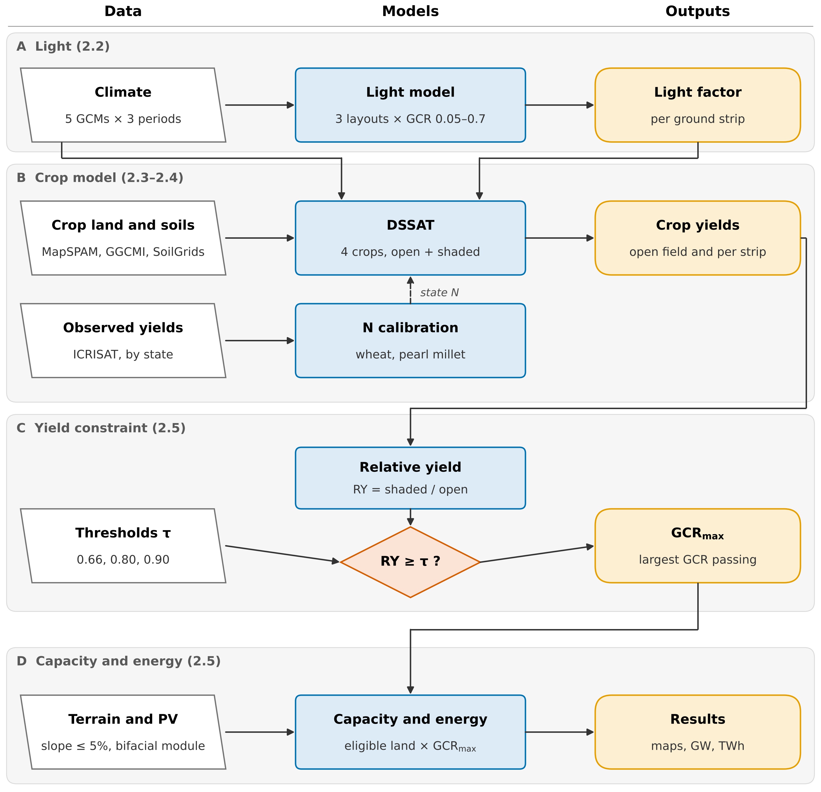
Fig. 1. Methodology flowchart. (A) A light model gives the daily light factor of five ground strips below each layout and GCR. (B) DSSAT simulates open-field and shaded yields, with nitrogen calibrated by state against observed yields. (C) Relative yield (RY) is tested against each threshold τ to find the largest feasible GCR (GCR_{max}). (D) GCR_{max} and eligible land give PV capacity and energy, reported as the five-GCM median and range. Numbers in brackets refer to sections of the text.

2.1. Study domain and crop systems
Four crops were chosen to cover both cropping seasons and the main contrasts in shade response: wheat (rabi, C₃ cereal), chickpea (rabi, C₃ legume), pearl millet (kharif, C₄ cereal) and groundnut (mainly kharif, C₃ legume). Harvested area and irrigated share were taken from MapSPAM 2010 [30]. A crop was simulated in a cell where its harvested area was at least 1000 ha; this gives 2977 cells and keeps 93–99% of each crop's national area (Table 2). Irrigated and rainfed systems were simulated separately where each covered at least 10% of the crop's area in the cell.
Table 2. Crop systems and main crop-model settings.
Crop | DSSAT model, cultivar | Cells | Area simulated, Mha (share of national) | Irrigated share | Sowing date
Wheat | CERES-Wheat, Yecora Rojo | 2095 | 28.2 (99%) | 0.79 | GGCMI spring wheat
Chickpea | CROPGRO-Chickpea, JG 74 | 1462 | 8.0 (96%) | 0.12 | Wheat date − 14 d
Pearl millet | CERES-Millet, ICMH 451 | 1024 | 8.8 (97%) | 0.05 | GGCMI millet; rainfed automatic
Groundnut | CROPGRO-Peanut, TMV 2 | 897 | 5.0 (93%) | 0.19 | GGCMI groundnut; rainfed kharif automatic
Cultivars from the DSSAT 4.8 genotype files; Yecora Rojo is a short-season spring wheat; the default files contain no Indian wheat cultivar, so the state calibration (Section 2.4) also absorbs cultivar differences. Automatic sowing: within ±15 d of the calendar date, triggered by soil moisture (SM Section S3).

2.2. Agrivoltaic layouts and light model
Three layouts were simulated (Fig. 2): an elevated south-facing array (tilt 25°), an elevated east-west ridge (tilt 10°), both with a 3 m clearance, and vertical bifacial rows facing east and west. GCR, the module area per ground area, was varied from 0.1 to 0.5, with 0.6 and 0.7 added for wheat and pearl millet and 0.05 for the legumes, whose RY falls fastest. Modules were treated as opaque, and tilt and height were kept the same across India so that differences between cells reflect climate, crop and soil rather than design (geometry in Table S1).
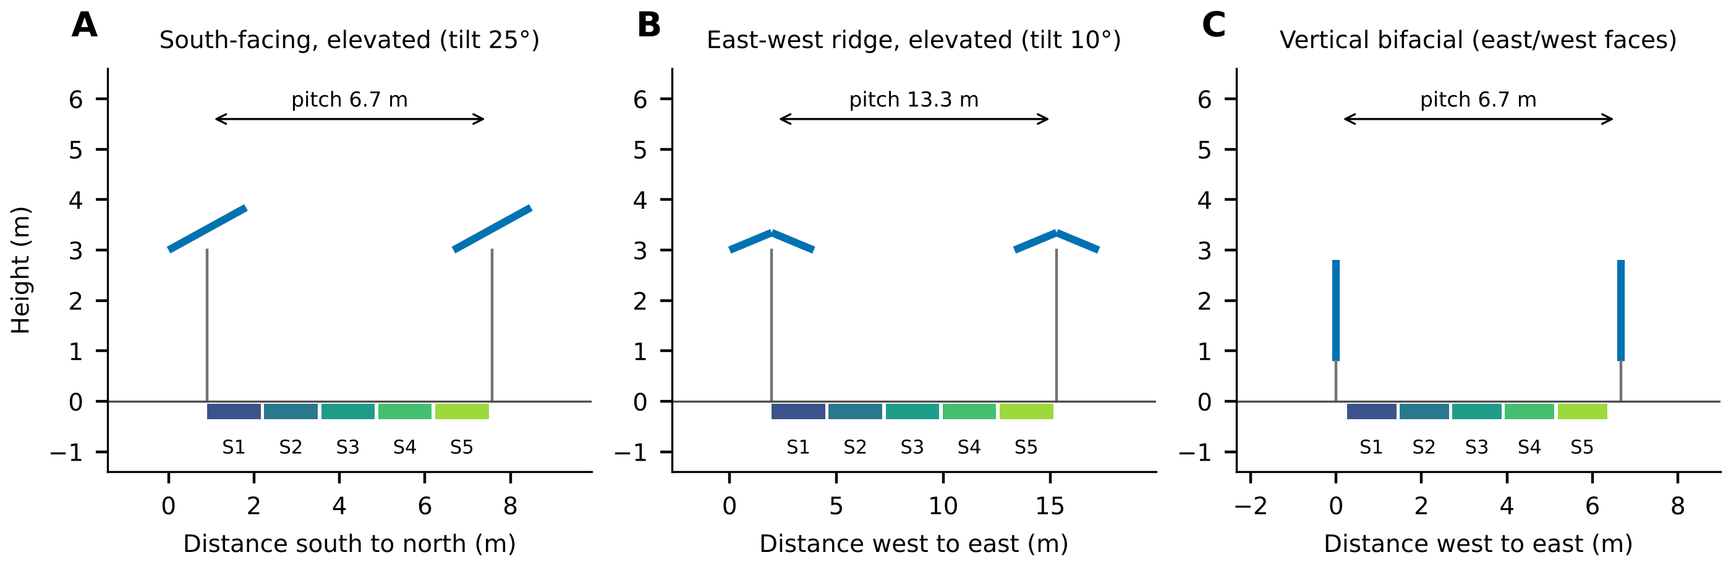
Fig. 2. Cross-sections of the three layouts at GCR 0.3 (two rows shown). Blue lines are modules and grey lines supports. The cultivated part of each row pitch is divided into five strips (S1–S5). The vertical layout leaves a 0.5 m uncultivated strip under each row.
Daily radiation from the climate models was disaggregated to hourly values by scaling the Ineichen-Perez clear-sky irradiance [32] to the daily total and splitting it into beam and diffuse parts with the Erbs model [33], using pvlib [25]. For each ground strip, beam transmission between the rows and the sky view factor were computed with a two-dimensional infinite-row view-factor model, following the ray and view-factor approaches used for ground irradiance below PV rows [5,24]. The daily light factor of strip k on day d is
$f_{k,d} = \frac{\sum_{h∈d}{(T_{k}(θ_{h}) B_{h} + F_{k} D_{h})}}{\sum_{h∈d}{G_{h}}}$ (1)
where T_{k}(θ_{h}) is the beam transmission of the strip at the projected solar zenith angle θ_{h} of hour h, B_{h} the beam irradiance on a horizontal plane, F_{k} the sky view factor of the strip, D_{h} the diffuse horizontal irradiance and G_{h} the global horizontal irradiance (W m⁻²). The crop model of each strip was driven by the open-field daily radiation multiplied by f_{k,d}; all other weather variables were left unchanged. Against the analytical functions in pvlib, the model reproduced the mean sky view factor within 0.0005 and the hourly sunlit ground fraction with a mean absolute difference of 0.0015 (Table S2).

2.3. Climate data
Daily climate came from NEX-GDDP-CMIP6, a bias-corrected and downscaled CMIP6 product at 0.25° [34], for five GCMs: GFDL-ESM4, IPSL-CM6A-LR, MPI-ESM1-2-HR, MRI-ESM2-0 and UKESM1-0-LL. These are the GCMs of the ISIMIP3b impact-model protocol and span equilibrium climate sensitivities of about 2.6 to 5.3 K [35]. Three 20-year periods were simulated: 1995–2014 (reference) and 2041–2060 under SSP2-4.5 and SSP5-8.5. Atmospheric CO₂ was held at the period mean, 378, 507 and 563 ppm [36]. Variable conversion is described in SM Section S2.

2.4. Crop model and calibration
Crops were simulated with DSSAT 4.8 [37,38] (CERES-Wheat, CERES-Millet, CROPGRO-Chickpea and CROPGRO-Peanut), with FAO-56 Penman-Monteith evapotranspiration [39], nitrogen fixation for the legumes and the CO₂ response of each model. Each season was simulated independently. Sowing dates came from the GGCMI Phase 3 crop calendar [40]; chickpea was sown 14 days before the local wheat date because the GGCMI pulse calendar describes kharif pulses. Soil profiles to 2 m were built from SoilGrids 2.0 [41] with the Saxton and Rawls pedotransfer functions [42]. Irrigated systems were irrigated automatically when soil water in the top 30 cm fell below a set fraction of plant-available water.
Nitrogen input, which controls much of the yield gap of Indian wheat and pearl millet, differs strongly between states, and a single national rule reproduced the mean wheat yield but not its spatial pattern (Table 3). Nitrogen was therefore calibrated by state for these two crops. Open-field yields were simulated at 10 (pearl millet only), 30, 60, 90, 120 and 180 kg N ha⁻¹ with two GCMs for the reference period, and in each state the level whose area-weighted mean yield was closest to the observed 1995–2014 state yield [43] was selected (Table S6). The calibrated level is interpreted as an effective management intensity, since it also absorbs other yield-limiting factors. It nonetheless follows survey data on fertiliser use by crop, which report about 106 and 56 kg N ha⁻¹ for irrigated and rainfed wheat, 62 and 18 kg N ha⁻¹ for pearl millet, and the highest wheat rates in Haryana and Punjab [44]; the calibrated levels are 30–180 kg N ha⁻¹ for wheat, highest in Punjab and Gujarat, and 10–30 kg N ha⁻¹ for pearl millet.
Calibration raised the between-state correlation for wheat from 0.01 to 0.74 and reduced the error from 29% to 12% (Table 3). For pearl millet the gain was smaller, because yields in the southern states stayed too high even at the lowest level. The legumes were not calibrated: chickpea was unbiased on average, while groundnut was over-estimated by a factor of 2.6, in line with its large yield gap in India. Since RY is a ratio of two yields from the same model, a bias that scales both yields does not change it; legume yields were scaled by state yield-gap factors only when absolute production is reported (Table S7). Calibrated nitrogen is the main management case; a recommended-practice case with higher nitrogen and irrigation was run for the reference period as a sensitivity test (Table S4).
Table 3. Simulated against observed open-field state yields, 1995–2014 (states with at least 50 kha of the crop).
Crop | States | Case | Pearson r | MAPE (%) | Simulated / observed
Wheat | 15 | Uncalibrated | 0.01 | 29 | 0.92
Wheat | 15 | Calibrated | 0.74 | 12 | 1.01
Pearl millet | 9 | Uncalibrated | 0.04 | 31 | 1.01
Pearl millet | 9 | Calibrated | 0.28 | 24 | 1.09
Chickpea | 11 | Not calibrated | 0.21 | 29 | 1.02
Groundnut | 10 | Not calibrated | −0.19 | 163 | 2.63
Mean of GFDL-ESM4 and MPI-ESM1-2-HR. MAPE and the ratio are weighted by observed harvested area.

2.5. Yield-constrained potential
For each cell, crop system, layout, GCR and GCM, the relative yield was computed on a land-area basis, as in land equivalent ratio studies and the reference-yield rule of DIN SPEC 91434 [5,8,14]:
$RY = c \frac{Ȳ_{APV}}{Ȳ_{0}}$ (2)
where Ȳ_{APV} is the yield under the array averaged over strips and seasons, Ȳ₀ the open-field yield over the same seasons (kg ha⁻¹), and c the cultivated share of the pitch (1 for the elevated layouts). Irrigated and rainfed systems were combined by production (Eq. (S1)). The largest GCR that meets a threshold τ was found on the RY-GCR curve, which starts at RY = 1 for GCR = 0, by linear interpolation at the first crossing. This extends the use of GCR as the design variable that links light sharing to crop yield [23,45]:
${GCR}_{max} = g_{j−1} + \frac{({RY}_{j−1} − τ)(g_{j} − g_{j−1})}{{RY}_{j−1} − {RY}_{j}}$ (3)
where g_{j} is the first simulated GCR with RY below τ and g_{j−1} the one before it, so that every smaller GCR also meets τ. Where RY stayed above τ at the largest simulated GCR, GCR_{max} was set to that value and reported as a lower bound. Three thresholds from existing rules were used: τ = 0.66 (DIN SPEC 91434 [14]), 0.80 (Japan, where a yield drop of about 20% against the local average voids the permit [15]; main case) and 0.90 (France [16]). DIN SPEC 91434 also limits the land lost to the structure to 15% for systems with crops between the rows; the 0.5 m strip of the vertical layout exceeds this above GCR 0.6.
Eligible land was the MapSPAM harvested area of each crop multiplied by the share of the cell with terrain slope of at most 5%, computed from the Copernicus GLO-90 elevation model [46]. Because a PV array stands all year, the rabi area A_{r} (wheat, chickpea) and kharif area A_{k} (pearl millet, groundnut) of a cell were assumed to overlap as far as possible, and the overlap had to satisfy both seasons. Capacity follows from module area and rated efficiency, as in earlier national APV estimates [4,47]; for a cell it is
$P = η I_{STC} [ A_{ov} min(ḡ_{r}, ḡ_{k}) + (A_{r} − A_{ov}) ḡ_{r} + (A_{k} − A_{ov}) ḡ_{k} ]$ (4)
where η = 0.22 is the module efficiency, I_{STC} = 1000 W m⁻², A_{ov} = min(A_{r}, A_{k}) the double-cropped area, and ḡ_{r} and ḡ_{k} the area-weighted GCR_{max} of the rabi and kharif crops. Annual energy was obtained by multiplying capacity by the specific yield of each cell, layout and GCR, computed with pvlib for a bifacial glass-glass module from the same hourly irradiance, using the infinite-sheds model for front and rear irradiance, the Faiman cell temperature model [48] and PVWatts [49] (Table S8).

2.6. Uncertainty and assumptions
All steps were run separately for each GCM; national and state totals are reported as the five-GCM median with the minimum and maximum as the range. Sensitivity cases cover the threshold (0.66, 0.90), the slope limit (none, 10%), management (recommended practice) and climate (both scenarios). Three assumptions shape the results. Panels change only the radiation reaching the crop; lower leaf temperature and evaporative demand under shade are not represented, which probably makes RY conservative for rainfed crops in hot regions. Mid-century yields include CO₂ fertilisation, which is strongest for the C₃ legumes. Finally, the potential is technical, bounded by crop yield and terrain only; grid capacity, land tenure and economics are not considered.

References
[1] Government of India. India's updated first Nationally Determined Contribution under the Paris Agreement (2021–2030). Submitted to the UNFCCC; August 2022.
[2] Ministry of New and Renewable Energy. Physical progress: programme-wise cumulative installed capacity. https://mnre.gov.in/en/physical-progress/ [accessed October 2026].
[3] National Statistics Office. Annual Report, Periodic Labour Force Survey (PLFS), July 2023–June 2024. New Delhi: Ministry of Statistics and Programme Implementation; 2024.
[4] Adeh EH, Good SP, Calaf M, Higgins CW. Solar PV power potential is greatest over croplands. Sci Rep 2019;9:11442. https://doi.org/10.1038/s41598-019-47803-3.
[5] Dupraz C, Marrou H, Talbot G, Dufour L, Nogier A, Ferard Y. Combining solar photovoltaic panels and food crops for optimising land use: Towards new agrivoltaic schemes. Renew Energy 2011;36:2725–32. https://doi.org/10.1016/j.renene.2011.03.005.
[6] Valle B, Simonneau T, Sourd F, Pechier P, Hamard P, Frisson T, et al. Increasing the total productivity of a land by combining mobile photovoltaic panels and food crops. Appl Energy 2017;206:1495–507. https://doi.org/10.1016/j.apenergy.2017.09.113.
[7] Barron-Gafford GA, Pavao-Zuckerman MA, Minor RL, Sutter LF, Barnett-Moreno I, Blackett DT, et al. Agrivoltaics provide mutual benefits across the food–energy–water nexus in drylands. Nat Sustain 2019;2:848–55. https://doi.org/10.1038/s41893-019-0364-5.
[8] Weselek A, Ehmann A, Zikeli S, Lewandowski I, Schindele S, Högy P. Agrophotovoltaic systems: applications, challenges, and opportunities. A review. Agron Sustain Dev 2019;39:35. https://doi.org/10.1007/s13593-019-0581-3.
[9] Campana PE, Macknick J, Croci M, Elkadeem MR, Gorjian S, Pascaris A, et al. Scientific frontiers of agrivoltaic cropping systems. Nat Rev Clean Technol 2025;1:801–21. https://doi.org/10.1038/s44359-025-00110-9.
[10] Laub M, Pataczek L, Feuerbacher A, Zikeli S, Högy P. Contrasting yield responses at varying levels of shade suggest different suitability of crops for dual land-use systems: a meta-analysis. Agron Sustain Dev 2022;42:51. https://doi.org/10.1007/s13593-022-00783-7.
[11] Malu PR, Sharma US, Pearce JM. Agrivoltaic potential on grape farms in India. Sustain Energy Technol Assess 2017;23:104–10. https://doi.org/10.1016/j.seta.2017.08.004.
[12] Santra P, Meena HM, Yadav OP. Spatial and temporal variation of photosynthetic photon flux density within agrivoltaic system in hot arid region of India. Biosyst Eng 2021;209:74–93. https://doi.org/10.1016/j.biosystemseng.2021.06.017.
[13] Poonia S, Jat NK, Santra P, Singh AK, Jain D, Meena HM. Techno-economic evaluation of different agri-voltaic designs for the hot arid ecosystem India. Renew Energy 2022;184:149–63. https://doi.org/10.1016/j.renene.2021.11.074.
[14] DIN SPEC 91434:2021-05. Agri-photovoltaic systems – Requirements for primary agricultural use. Berlin: Beuth Verlag; 2021.
[15] Ministry of Agriculture, Forestry and Fisheries of Japan. Handling under the farmland conversion permit system of solar power generation facilities installed on supporting pillars while farming continues. Notice of 31 March 2013.
[16] Décret n° 2024-318 du 8 avril 2024 relatif au développement de l'agrivoltaïsme et aux conditions d'implantation des installations photovoltaïques sur des terrains agricoles, naturels ou forestiers. Journal officiel de la République française; 2024.
[17] Ademollo A, Ulivi N, Ferretti L, Serafini F, Carcasci C, Pacini C. Policy-constrained agrivoltaics in Italy: a potato case study linking shading, crop and economics. Appl Energy 2026;405:127225. https://doi.org/10.1016/j.apenergy.2025.127225.
[18] Fraunhofer ISE, EY, CSTEP. Agrivoltaics in India. New Delhi: Indo-German Energy Forum; 2024. https://energyforum.in/fileadmin/india/media_elements/publications/20240502_AgriPV_in_India/Agrivoltaics_in_India.pdf.
[19] Yadav S, Tiwari AK, Malik H, Dortch R. Agri-photovoltaics potential in India: pathways for sustainable energy–food solutions. New Delhi: The Energy and Resources Institute (TERI); 2026. https://www.teriin.org/policy-brief/agri-photovoltaics-potential-india-pathways-sustainable-energy-food-solutions.
[20] Mehta K, Betz F. Agri-photovoltaics in India: Geospatial suitability for sustainable water–energy–food nexus solutions. Energy Sustain Dev 2026;91:101915. https://doi.org/10.1016/j.esd.2025.101915.
[21] Xia Z, Li Y, Guo S, Jia N, Pan X, Mu H, et al. Balancing photovoltaic development and cropland protection: Assessing agrivoltaic potential in China. Sustain Prod Consum 2024;50:205–15. https://doi.org/10.1016/j.spc.2024.08.001.
[22] Curioni M, Galli N, Manzolini G, Rulli MC. Global land-water competition and synergy between solar energy and agriculture. Earth's Future 2025;13:e2024EF005291. https://doi.org/10.1029/2024EF005291.
[23] Willockx B, Lavaert C, Cappelle J. Geospatial assessment of elevated agrivoltaics on arable land in Europe to highlight the implications on design, land use and economic level. Energy Rep 2022;8:8736–51. https://doi.org/10.1016/j.egyr.2022.06.076.
[24] Nassar YF, El-Khozondar HJ, Belhaj SO, Alsadi SY, Abuhamoud NM. View factors in horizontal plane fixed-mode solar PV fields. Front Energy Res 2022;10:859075. https://doi.org/10.3389/fenrg.2022.859075.
[25] Anderson KS, Hansen CW, Holmgren WF, Jensen AR, Mikofski MA, Driesse A. pvlib python: 2023 project update. J Open Source Softw 2023;8:5994. https://doi.org/10.21105/joss.05994.
[26] Amaducci S, Yin X, Colauzzi M. Agrivoltaic systems to optimise land use for electric energy production. Appl Energy 2018;220:545–61. https://doi.org/10.1016/j.apenergy.2018.03.081.
[27] Elamri Y, Cheviron B, Lopez JM, Dejean C, Belaud G. Water budget and crop modelling for agrivoltaic systems: Application to irrigated lettuces. Agric Water Manag 2018;208:440–53. https://doi.org/10.1016/j.agwat.2018.07.001.
[28] Mazzeo D, Di Zio A, Pesenti C, Leva S. Optimizing agrivoltaic systems: A comprehensive analysis of design, crop productivity and energy performance in open-field configurations. Appl Energy 2025;390:125750. https://doi.org/10.1016/j.apenergy.2025.125750.
[29] Jia M, Peng B, Guan K, Lawrence DM, DeLucia EH, Knapp AK, et al. Climate-driven divergence in biophysical and economic impacts of agrivoltaics. Proc Natl Acad Sci USA 2026;123:e2514380123. https://doi.org/10.1073/pnas.2514380123.
[30] Yu Q, You L, Wood-Sichra U, Ru Y, Joglekar AKB, Fritz S, et al. A cultivated planet in 2010 – Part 2: The global gridded agricultural-production maps. Earth Syst Sci Data 2020;12:3545–72. https://doi.org/10.5194/essd-12-3545-2020.
[31] Ministry of New and Renewable Energy. Guidelines for implementation of Pradhan Mantri Kisan Urja Suraksha evam Utthaan Mahabhiyan (PM-KUSUM) scheme (amended). New Delhi: MNRE; 2024.
[32] Ineichen P, Perez R. A new airmass independent formulation for the Linke turbidity coefficient. Sol Energy 2002;73:151–7. https://doi.org/10.1016/S0038-092X(02)00045-2.
[33] Erbs DG, Klein SA, Duffie JA. Estimation of the diffuse radiation fraction for hourly, daily and monthly-average global radiation. Sol Energy 1982;28:293–302. https://doi.org/10.1016/0038-092X(82)90302-4.
[34] Thrasher B, Wang W, Michaelis A, Melton F, Lee T, Nemani R. NASA Global Daily Downscaled Projections, CMIP6. Sci Data 2022;9:262. https://doi.org/10.1038/s41597-022-01393-4.
[35] Meehl GA, Senior CA, Eyring V, Flato G, Lamarque JF, Stouffer RJ, et al. Context for interpreting equilibrium climate sensitivity and transient climate response from the CMIP6 Earth system models. Sci Adv 2020;6:eaba1981. https://doi.org/10.1126/sciadv.aba1981.
[36] Meinshausen M, Nicholls ZRJ, Lewis J, Gidden MJ, Vogel E, Freund M, et al. The shared socio-economic pathway (SSP) greenhouse gas concentrations and their extensions to 2500. Geosci Model Dev 2020;13:3571–605. https://doi.org/10.5194/gmd-13-3571-2020.
[37] Jones JW, Hoogenboom G, Porter CH, Boote KJ, Batchelor WD, Hunt LA, et al. The DSSAT cropping system model. Eur J Agron 2003;18:235–65. https://doi.org/10.1016/S1161-0301(02)00107-7.
[38] Hoogenboom G, Porter CH, Boote KJ, Shelia V, Wilkens PW, Singh U, et al. Decision Support System for Agrotechnology Transfer (DSSAT) Version 4.8. Gainesville, FL: DSSAT Foundation; 2021. https://dssat.net.
[39] Allen RG, Pereira LS, Raes D, Smith M. Crop evapotranspiration: Guidelines for computing crop water requirements. FAO Irrigation and Drainage Paper 56. Rome: FAO; 1998. https://www.fao.org/4/x0490e/x0490e00.htm.
[40] Jägermeyr J, Müller C, Ruane AC, Elliott J, Balkovic J, Castillo O, et al. Climate impacts on global agriculture emerge earlier in new generation of climate and crop models. Nat Food 2021;2:873–85. https://doi.org/10.1038/s43016-021-00400-y.
[41] Poggio L, de Sousa LM, Batjes NH, Heuvelink GBM, Kempen B, Ribeiro E, et al. SoilGrids 2.0: producing soil information for the globe with quantified spatial uncertainty. SOIL 2021;7:217–40. https://doi.org/10.5194/soil-7-217-2021.
[42] Saxton KE, Rawls WJ. Soil water characteristic estimates by texture and organic matter for hydrologic solutions. Soil Sci Soc Am J 2006;70:1569–78. https://doi.org/10.2136/sssaj2005.0117.
[43] Nedumaran S, Pingali P, Padmanabhan JR, Ravula P, Gumma MK, Mohammed IA, et al. District Level Data (DLD) and Dashboard for Agriculture and Allied-sectors in India. ICRISAT Dataverse. https://doi.org/10.21421/D2/XFB1BZ.
[44] FAO. Fertilizer use by crop in India. Rome: Food and Agriculture Organization of the United Nations; 2005. https://www.fao.org/4/a0257e/a0257e00.htm.
[45] Dupraz C. Assessment of the ground coverage ratio of agrivoltaic systems as a proxy for potential crop productivity. Agrofor Syst 2024;98:2679–96. https://doi.org/10.1007/s10457-023-00906-3.
[46] European Space Agency. Copernicus DEM, global 90 m (GLO-90). 2021. https://doi.org/10.5270/ESA-c5d3d65.
[47] Dinesh H, Pearce JM. The potential of agrivoltaic systems. Renew Sustain Energy Rev 2016;54:299–308. https://doi.org/10.1016/j.rser.2015.10.024.
[48] Faiman D. Assessing the outdoor operating temperature of photovoltaic modules. Prog Photovolt Res Appl 2008;16:307–15. https://doi.org/10.1002/pip.813.
[49] Dobos AP. PVWatts Version 5 Manual. NREL/TP-6A20-62641. Golden, CO: National Renewable Energy Laboratory; 2014. https://doi.org/10.2172/1158421.

