Supplementary Material
Yield-constrained agrivoltaic potential of India under current and mid-century climate. Sections S1 to S7 give the detail behind Section 2 of the main text, and Section S8 shows the validation of the crop and light models.

S1. Layout geometry and light model
Table S1. Geometry of the agrivoltaic layouts.
Layout | Row axis | Module tilt / azimuth | Module width per row | Lower edge height | Uncultivated strip | Ground strips simulated
South-facing, elevated | East-west | 25° / 180° | 2.0 m | 3.0 m | None | 5
East-west ridge, elevated | North-south | 10° / 90° and 270° | 2 × 2.0 m | 3.0 m | None | 3, mirrored to 5
Vertical bifacial | North-south | 90° / 90° (bifacial) | 2.0 m | 0.8 m | 0.5 m | Pitch mean
Pitch = module width per row / GCR. Simulated GCR: 0.1–0.5 in steps of 0.1 for all crops, plus 0.6 and 0.7 for wheat and pearl millet and 0.05 for chickpea and groundnut.
For a ground point, beam transmission is the fraction of rays at the projected solar zenith angle that pass between the modules of 81 rows centred on the point, and the sky view factor is the visible fraction of an isotropic sky. Both were evaluated at 200 points across the cultivated part of the pitch and averaged over five strips. The east-west ridge is symmetric about the row axis, so three strips were simulated and mirrored. For vertical rows the strip factors were averaged over the pitch, because the morning and afternoon shade sweeps the whole inter-row space. Hourly irradiance used local solar days in Indian Standard Time and the pvlib Linke turbidity climatology.
Table S2. Light model against the analytical two-dimensional functions in pvlib for single-segment rows (26.4°N, 73.1°E; hourly sun positions of 2010 with solar zenith below 85°).
Layout | GCR | Mean sky view factor, this model | Mean sky view factor, pvlib | Largest pointwise difference | Hourly sunlit fraction, MAE
South-facing | 0.1 | 0.9008 | 0.9009 | 0.009 | 0.0013
South-facing | 0.2 | 0.8040 | 0.8037 | 0.009 | 0.0014
South-facing | 0.3 | 0.7089 | 0.7086 | 0.012 | 0.0015
South-facing | 0.4 | 0.6163 | 0.6162 | 0.017 | 0.0014
South-facing | 0.5 | 0.5274 | 0.5273 | 0.016 | 0.0011
Vertical | 0.1 | 0.9047 | 0.9050 | 0.005 | 0.0014
Vertical | 0.2 | 0.8202 | 0.8198 | 0.007 | 0.0012
Vertical | 0.3 | 0.7435 | 0.7440 | 0.009 | 0.0011
Vertical | 0.4 | 0.6768 | 0.6770 | 0.008 | 0.0011
Vertical | 0.5 | 0.6182 | 0.6180 | 0.011 | 0.0009
The east-west ridge has two segments per row and no direct pvlib counterpart; it uses the same ray-tracing code.

S2. Climate data processing
NEX-GDDP-CMIP6 [1] variables were converted as follows: shortwave radiation from W m⁻² to MJ m⁻² d⁻¹; precipitation from kg m⁻² s⁻¹ to mm d⁻¹; dew point from mean daily temperature and relative humidity with the Magnus formula, capped at the daily minimum temperature; and wind speed from 10 m to 2 m with the FAO-56 logarithmic profile [2]. Model calendars of 360 or 365 days were mapped onto the real calendar by nearest-day resampling. The climate grid coincides with the simulation grid, so no spatial interpolation was needed.
Table S3. Climate periods and CO₂ concentration.
Period | Years | Scenario | CO₂ (ppm) | Climate models
Reference | 1995–2014 | Historical | 378 | GFDL-ESM4, IPSL-CM6A-LR, MPI-ESM1-2-HR, MRI-ESM2-0, UKESM1-0-LL
Mid-century | 2041–2060 | SSP2-4.5 | 507 | Same five
Mid-century | 2041–2060 | SSP5-8.5 | 563 | Same five
Period-mean CO₂ [3], constant within each simulation.

S3. Crop model set-up
DSSAT 4.8 [4,5] was run through the DSSATTools Python interface. Initial soil water was 50% of plant-available water and initial mineral nitrogen was low (0.5 mg NH₄ and 1.0 mg NO₃ per kg soil), and crops were harvested at maturity. Nitrogen was applied as urea incorporated at 5 cm; irrigated wheat received two equal doses at sowing and 30 days after sowing. Rainfed pearl millet and rainfed kharif groundnut were sown automatically in a ±15-day window around the calendar date when soil water in the top 30 cm was 40–100% of plant-available water and soil temperature was 10–40 °C. Soil profiles used the six SoilGrids 2.0 depths [6], sampled at the cell centre; lower limit, drained upper limit, saturation and saturated conductivity came from the Saxton and Rawls functions [7]. The 108 cells (3.6%) without SoilGrids data at the centre took the profile of the nearest valid cell.
Table S4. Management scenarios.
Scenario | Wheat N (kg ha⁻¹) | Pearl millet N | Chickpea, groundnut N | Irrigation trigger (share of plant-available water) | Use
Calibrated (main) | 30–180 by state | 10–30 by state | 0 | 50% (wheat, millet); 20% (legumes) | All periods
Recommended | 120 irrigated (60 + 60), 60 rainfed | 40 | 20 | 50% | Reference period, sensitivity
Triggers apply to irrigated systems, in the top 30 cm of soil.
Table S5. Planting settings.
Crop | Plants m⁻² | Row spacing (cm) | Sowing depth (cm) | Sowing rule
Wheat | 225 | 22.5 | 5 | GGCMI spring wheat date
Chickpea | 33 | 30 | 5 | Wheat date − 14 d
Pearl millet | 11 | 45 | 5 | GGCMI millet date; rainfed automatic
Groundnut | 33 | 30 | 5 | GGCMI groundnut date; rainfed kharif automatic
Sowing dates from the GGCMI Phase 3 crop calendar [8], irrigated and rainfed calendars separately.

S4. Nitrogen calibration
Simulated open-field cell yields (mean of GFDL-ESM4 and MPI-ESM1-2-HR) were combined into state means weighted by irrigated and rainfed share and by harvested area, and compared with the 1995–2014 mean state yield from the ICRISAT District Level Database [9]. States without enough observed area used the area-weighted median of the calibrated levels. The hill states remained over-estimated at the lowest level; most of their cropland is removed by the slope rule.
Table S6. Calibrated nitrogen level and open-field state yield, reference period.
State | Crop | N (kg ha⁻¹) | Observed (kg ha⁻¹) | Simulated (kg ha⁻¹)
Punjab | Wheat | 180 | 4411 | 4656
Gujarat | Wheat | 180 | 2553 | 2854
Haryana | Wheat | 90 | 4172 | 3739
Rajasthan | Wheat | 90 | 2898 | 3362
Karnataka | Wheat | 90 | 852 | 876
Uttar Pradesh | Wheat | 60 | 2761 | 2652
Madhya Pradesh | Wheat | 60 | 1935 | 1623
Bihar | Wheat | 30 | 2126 | 2026
Maharashtra | Wheat | 30 | 1415 | 1351
West Bengal | Wheat | 30 | 2430 | 2989
Himachal Pradesh | Wheat | 30 | 1413 | 3952
Uttarakhand | Wheat | 30 | 1959 | 3650
Chhattisgarh | Wheat | 30 | 1067 | 1433
Assam | Wheat | 30 | 1182 | 1774
Jharkhand | Wheat | 30 | 1421 | 2281
Other states | Wheat | 60 | – | –
Gujarat | Pearl millet | 30 | 1355 | 1129
Haryana | Pearl millet | 30 | 1443 | 1328
Madhya Pradesh | Pearl millet | 30 | 1406 | 1173
Uttar Pradesh | Pearl millet | 30 | 1513 | 1336
Rajasthan | Pearl millet | 10 | 689 | 637
Maharashtra | Pearl millet | 10 | 758 | 1183
Karnataka | Pearl millet | 10 | 723 | 2023
Tamil Nadu | Pearl millet | 10 | 1492 | 2589
Andhra Pradesh | Pearl millet | 10 | 1277 | 2059
Other states | Pearl millet | 10 | – | –
Level 10 kg N ha⁻¹ was tested for pearl millet only.

S5. Legume yield-gap factors
Table S7. Observed and simulated open-field legume yields and yield-gap factors (applied to absolute production only).
State | Crop | Observed (kg ha⁻¹) | Simulated (kg ha⁻¹) | Factor (obs/sim)
Madhya Pradesh | Chickpea | 925 | 854 | 1.08
Rajasthan | Chickpea | 725 | 522 | 1.39
Maharashtra | Chickpea | 677 | 436 | 1.55
Uttar Pradesh | Chickpea | 858 | 1235 | 0.70
Karnataka | Chickpea | 550 | 1053 | 0.52
Andhra Pradesh | Chickpea | 1096 | 1292 | 0.85
Chhattisgarh | Chickpea | 746 | 1089 | 0.68
Haryana | Chickpea | 810 | 1169 | 0.69
Gujarat | Chickpea | 855 | 1191 | 0.72
Telangana | Chickpea | 1052 | 733 | 1.44
Bihar | Chickpea | 1014 | 820 | 1.24
Gujarat | Groundnut | 1313 | 2640 | 0.50
Andhra Pradesh | Groundnut | 754 | 2352 | 0.32
Karnataka | Groundnut | 721 | 2988 | 0.24
Tamil Nadu | Groundnut | 1979 | 2654 | 0.74
Maharashtra | Groundnut | 1122 | 3806 | 0.30
Rajasthan | Groundnut | 1387 | 2084 | 0.67
Odisha | Groundnut | 1488 | 3444 | 0.43
Telangana | Groundnut | 1284 | 1246 | 1.03
Madhya Pradesh | Groundnut | 1176 | 3665 | 0.32
Uttar Pradesh | Groundnut | 813 | 3676 | 0.22
States with at least 50 kha, ordered by area. Area-weighted mean factor: chickpea 1.09, groundnut 0.44.

S6. Aggregation, eligible land and energy
Irrigated and rainfed systems of a crop were combined by production, in the same way as gridded crop-model outputs are aggregated across management systems [8]:
${RY}_{crop} = \frac{\sum_{w}{a_{w} Ȳ_{0,w} {RY}_{w}}}{\sum_{w}{a_{w} Ȳ_{0,w}}}$ (S1)
where a_{w} is the share of the crop's area under water regime w and Ȳ_{0,w} and RY_{w} are the open-field yield and RY of that regime. Using the ratio of seasonal means rather than the mean of seasonal ratios in RY keeps seasons with crop failure from dominating. The eligible area of a crop is
$A_{e} = A_{c} φ_{S}$ (S2)
where A_{c} is its harvested area (ha) and φ_{S} the share of the cell with slope ≤ S % (S = 5 in the main case), computed from GLO-90 [10] by finite differences. The rule assumes that cropland is spread evenly over the slope classes of a cell. For single-crop results, capacity is η I_{STC} A_{e} GCR_{max}. Annual energy is
$E = P Y_{sp}({GCR}_{max})$ (S3)
where Y_{sp} is the specific yield, the final yield of IEC 61724-1 [11] (kWh kW_{p}⁻¹ yr⁻¹), of the cell and layout, interpolated at GCR_{max}. It was computed with pvlib [12] from the same hourly irradiance as the crop simulations, for every fifth year of each GCM (twenty model-years per period). Hourly air temperature followed a cosine between the daily minimum at 06:00 and maximum at 15:00.
Table S8. Parameters of the PV energy model.
Parameter | Value
Module | Bifacial glass-glass, n-type
Efficiency at STC | 22%
Bifaciality | 0.80
Temperature coefficient of power | −0.30% K⁻¹
Cell temperature | Faiman model [13], pvlib default coefficients, 2 m wind
Irradiance on modules | pvlib infinite sheds, isotropic sky, front and rear
Ground albedo | 0.20
DC model | PVWatts [14]
System losses | 14%
Inverter efficiency | 96%

S7. Implementation and quality control
The workflow was written in Python. Crop simulations, one task per cell, GCM, period and management case, ran on a 12-core cloud virtual machine. Each task wrote its results only on completion, so an interrupted run resumed without duplicates, and DSSAT runs that stopped with an error were retried up to three times. A report every 20 minutes checked three rules and stopped the run on a breach: failed tasks above 2%; median open-field yield of a crop outside a plausible range for India (wheat 800–7000, chickpea 200–3000, groundnut 200–5000 and pearl millet 150–4500 kg ha⁻¹, applied after a full pass over all cells); and more than 5% of irrigated open-field seasons with zero yield.

S8. Validation figures
Figs. S1 to S3 compare the crop model with observed state yields and the light model with an analytical reference and with field measurements. Fig. S1 uses the states with at least 50 kha of the crop. Fig. S2 repeats Table S2 in graphical form. Fig. S3 uses the PPFD measured by Santra et al. [15] at the 105 kW_{p} agrivoltaic plant of ICAR-CAZRI, Jodhpur, on clear days of 20 to 24 December 2018, 10 cm above the ground. Rows run east-west, modules face south at 26° tilt with the lower edge at 0.5 m, and the three blocks differ in the number of module rows (one, one and a half, two and a half) and in the interspace (2.95, 5.55 and 8.90 m). Measured and modelled values are both relative to the unshaded interspace, which removes the conversion between irradiance and photon flux.
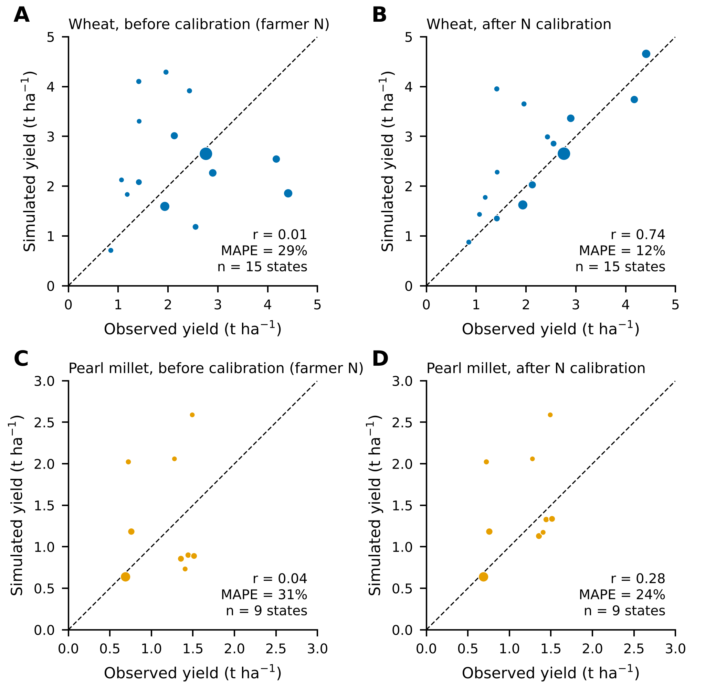
Fig. S1. State mean open-field yields, simulated against observed (ICRISAT District Level Database, 1995–2014), before and after nitrogen calibration. (A, B) Wheat. (C, D) Pearl millet. Before calibration all states used farmer nitrogen (wheat 60, pearl millet 10 kg N ha⁻¹); after calibration each state used its calibrated level (Table S6). Simulated yields are the mean of GFDL-ESM4 and MPI-ESM1-2-HR. Marker area is proportional to observed harvested area; only states with at least 50 kha are shown. The dashed line is 1:1. r is the Pearson correlation and MAPE the mean absolute percentage error weighted by harvested area. Pearl millet in the southern states (Karnataka, Tamil Nadu, Andhra Pradesh) stays over-predicted even at 10 kg N ha⁻¹.
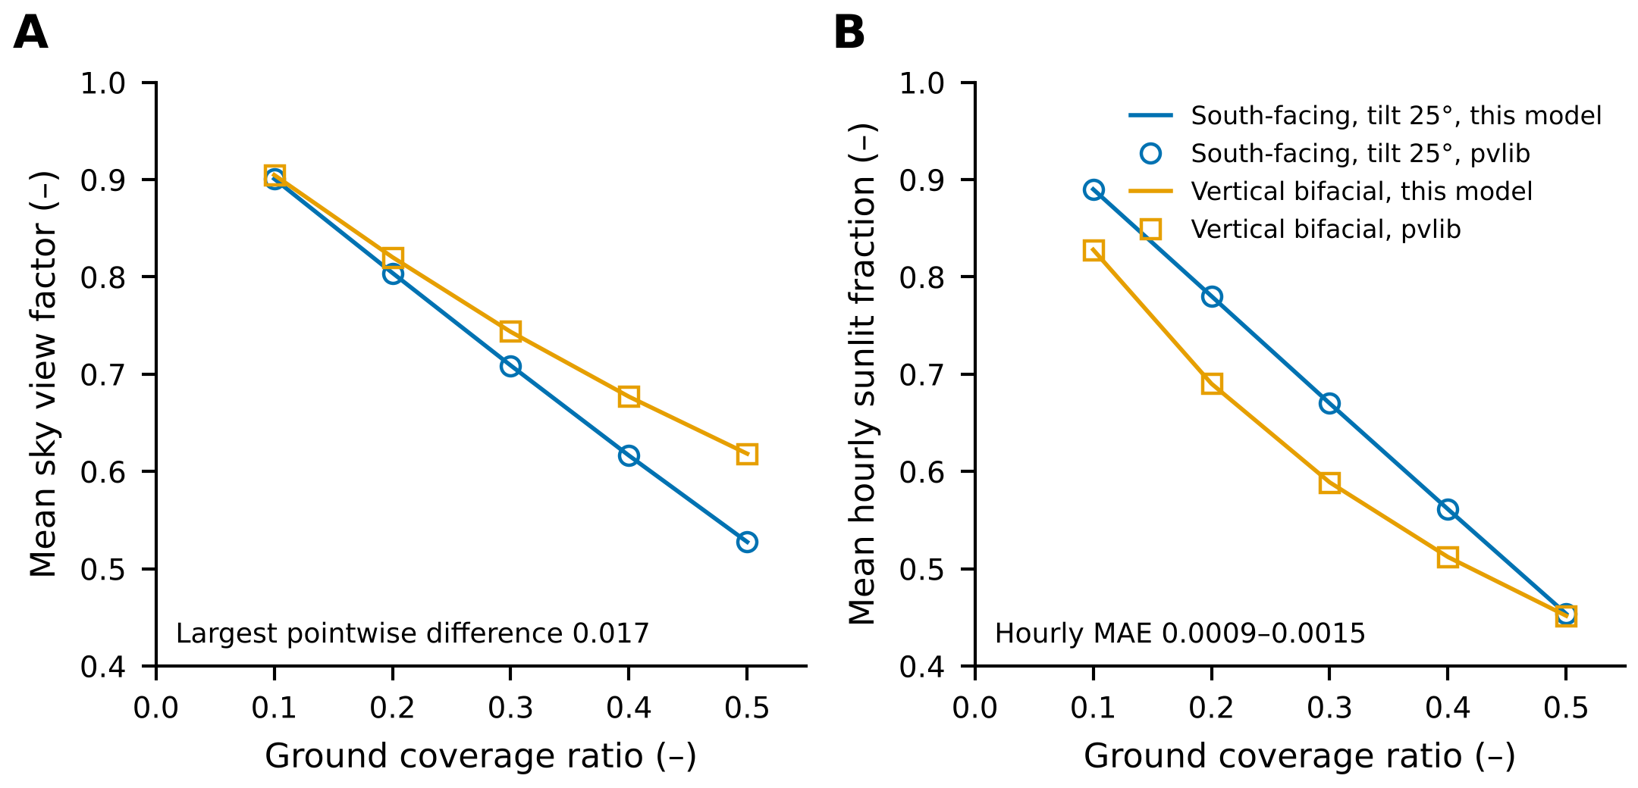
Fig. S2. Light model against the analytical view-factor functions of pvlib for single-segment rows at 26.4°N, 73.1°E (hourly sun positions of 2010, solar zenith below 85°). (A) Sky view factor of the ground averaged across the pitch. (B) Sunlit fraction of the ground averaged over all daylight hours. Lines are this model and open markers pvlib, for the south-facing layout (tilt 25°) and the vertical bifacial layout. The largest pointwise difference in sky view factor is 0.017 and the mean absolute error of the hourly sunlit fraction is 0.0009 to 0.0015.
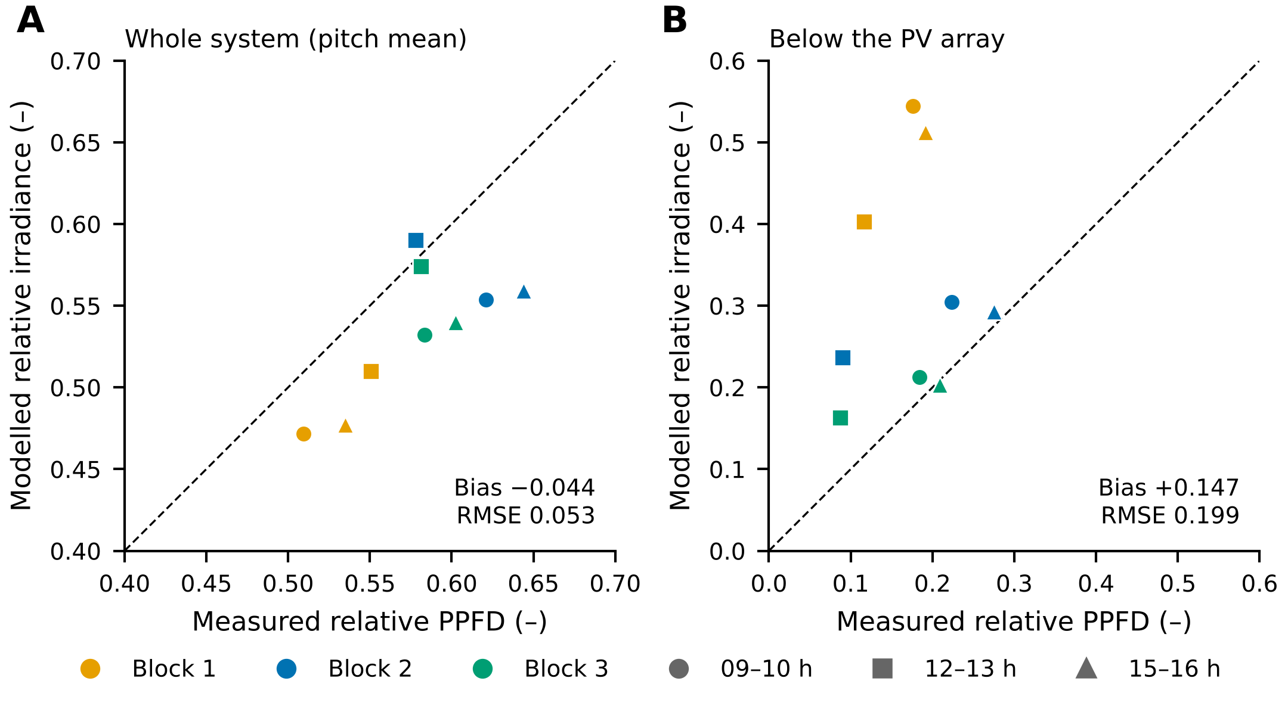
Fig. S3. Modelled relative irradiance against measured relative PPFD at ICAR-CAZRI, Jodhpur [15], by block (colour) and time window (marker). (A) Whole system, averaged over the row pitch: bias −0.044, RMSE 0.053. (B) Ground below the PV array: bias +0.147, RMSE 0.199. The model used clear-sky beam and diffuse irradiance with a broadband diffuse fraction. The dashed line is 1:1. The model reproduces the pitch-mean light but over-estimates the light directly below the modules, most strongly under the single-row Block 1. In late December the noon solar elevation at Jodhpur is about 40°, so below-array light is over-estimated for low winter sun: modelled beam reaches the ground under the low modules more often than measured, and the model includes neither frames, supports nor reflection from the ground and the array. The crop model uses light averaged over strips that span the cultivated pitch, which corresponds to panel A.

Supplementary references
[1] Thrasher B, Wang W, Michaelis A, Melton F, Lee T, Nemani R. NASA Global Daily Downscaled Projections, CMIP6. Sci Data 2022;9:262. https://doi.org/10.1038/s41597-022-01393-4.
[2] Allen RG, Pereira LS, Raes D, Smith M. Crop evapotranspiration: Guidelines for computing crop water requirements. FAO Irrigation and Drainage Paper 56. Rome: FAO; 1998. https://www.fao.org/4/x0490e/x0490e00.htm.
[3] Meinshausen M, Nicholls ZRJ, Lewis J, Gidden MJ, Vogel E, Freund M, et al. The shared socio-economic pathway (SSP) greenhouse gas concentrations and their extensions to 2500. Geosci Model Dev 2020;13:3571–605. https://doi.org/10.5194/gmd-13-3571-2020.
[4] Jones JW, Hoogenboom G, Porter CH, Boote KJ, Batchelor WD, Hunt LA, et al. The DSSAT cropping system model. Eur J Agron 2003;18:235–65. https://doi.org/10.1016/S1161-0301(02)00107-7.
[5] Hoogenboom G, Porter CH, Boote KJ, Shelia V, Wilkens PW, Singh U, et al. Decision Support System for Agrotechnology Transfer (DSSAT) Version 4.8. Gainesville, FL: DSSAT Foundation; 2021. https://dssat.net.
[6] Poggio L, de Sousa LM, Batjes NH, Heuvelink GBM, Kempen B, Ribeiro E, et al. SoilGrids 2.0: producing soil information for the globe with quantified spatial uncertainty. SOIL 2021;7:217–40. https://doi.org/10.5194/soil-7-217-2021.
[7] Saxton KE, Rawls WJ. Soil water characteristic estimates by texture and organic matter for hydrologic solutions. Soil Sci Soc Am J 2006;70:1569–78. https://doi.org/10.2136/sssaj2005.0117.
[8] Jägermeyr J, Müller C, Ruane AC, Elliott J, Balkovic J, Castillo O, et al. Climate impacts on global agriculture emerge earlier in new generation of climate and crop models. Nat Food 2021;2:873–85. https://doi.org/10.1038/s43016-021-00400-y.
[9] Nedumaran S, Pingali P, Padmanabhan JR, Ravula P, Gumma MK, Mohammed IA, et al. District Level Data (DLD) and Dashboard for Agriculture and Allied-sectors in India. ICRISAT Dataverse. https://doi.org/10.21421/D2/XFB1BZ.
[10] European Space Agency. Copernicus DEM, global 90 m (GLO-90). 2021. https://doi.org/10.5270/ESA-c5d3d65.
[11] IEC 61724-1:2021. Photovoltaic system performance – Part 1: Monitoring. Geneva: International Electrotechnical Commission; 2021.
[12] Anderson KS, Hansen CW, Holmgren WF, Jensen AR, Mikofski MA, Driesse A. pvlib python: 2023 project update. J Open Source Softw 2023;8:5994. https://doi.org/10.21105/joss.05994.
[13] Faiman D. Assessing the outdoor operating temperature of photovoltaic modules. Prog Photovolt Res Appl 2008;16:307–15. https://doi.org/10.1002/pip.813.
[14] Dobos AP. PVWatts Version 5 Manual. NREL/TP-6A20-62641. Golden, CO: National Renewable Energy Laboratory; 2014. https://doi.org/10.2172/1158421.
[15] Santra P, Meena HM, Yadav OP. Spatial and temporal variation of photosynthetic photon flux density within agrivoltaic system in hot arid region of India. Biosyst Eng 2021;209:74–93. https://doi.org/10.1016/j.biosystemseng.2021.06.017.

