Assignment 6

Mohammed AlMutairi

Calling Python Functions from MATLAB:

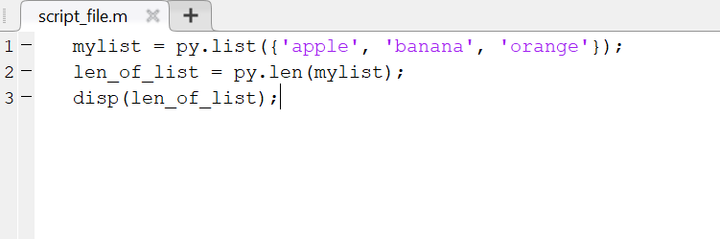

Using Python Libraries in MATLAB:

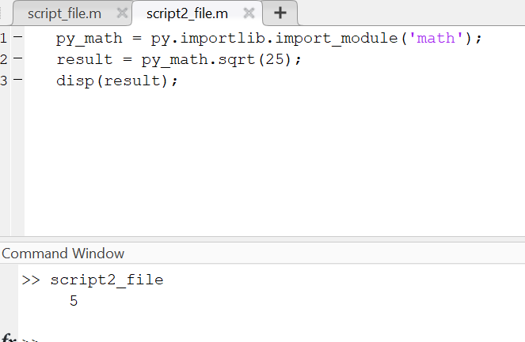

Running Custom Python Scripts:

