**Ping Pong Ping2**

**Made with CondrewCarzina Engine**

Connor Brezina 101006312 Connorb1234@hotmail.com

Andrew Caruso 101006883 andrew.caruso03@gmail.com

Koko Keheian 100960873 koko.keheian@hotmail.com

**Description:**

A recreation of the memorable classic game Pong. This game will be a blast from the past using the brand new CondrewCarzina engine showcasing its perfect physics and reliability. Ping Pong Ping2 will include all the fan favourites; 2 paddles, 1 ball, and a score board. This game will also show a splash screen for the engine, a main menu, an options menu for changing of volume and screen size, and finally a credits menu showing the creators of the game.

**Game Mechanics:**

**Controls:**

Spacebar: launch the ball

W / Up arrow: move paddle up

S / Down arrow: move paddle down

P: pause game

**Gameplay:**

The game will begin with the ball heading towards the player, then once it collides the ball will head towards the other player based on the angle the ball hit the players paddle. The ball will continue to bounce back and forth until a player misses the ball, the player that missed the ball will provide a point to the opposing player. The ball will also start to gain speed as the players continue to hit it without missing.

Gameplay screen:

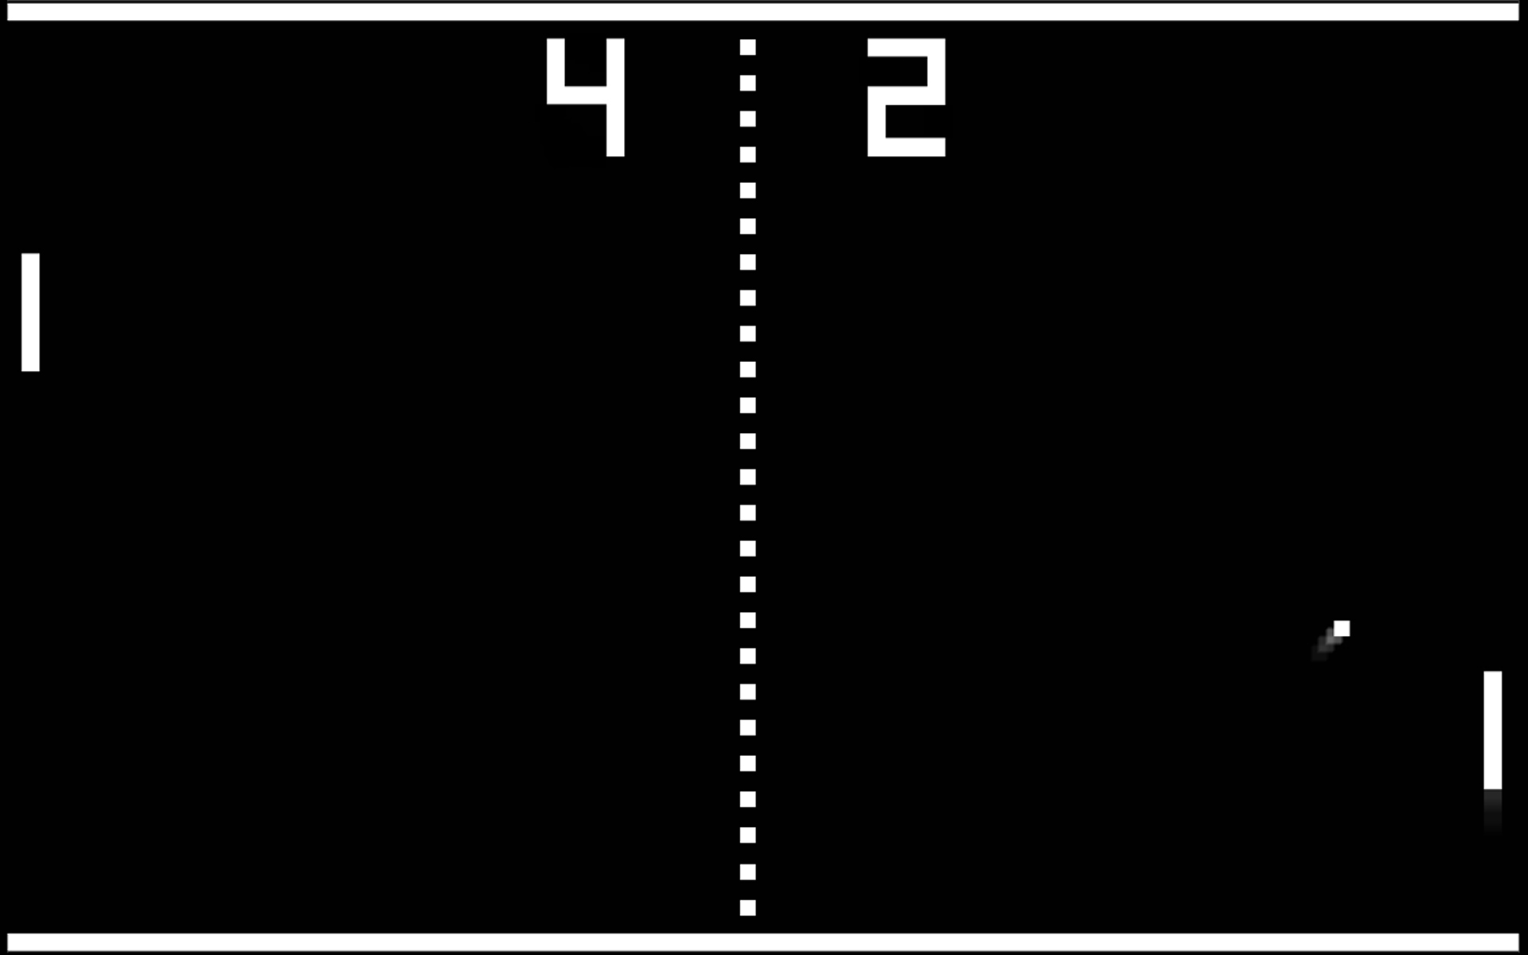

**Game Modes:**

Regular: First one to 5 points wins.

Continuous: Keep playing until you get bored!

**Screens:**

Main Menu:Main starting point when you launch the game

Options: A screen to change the options for the game: screen size and sound volume.

GameOver Screen: Will tell the players who won and what the end score was.

Credits: Credits to the people who worked on the game.