Types of functions : linear, polynomial, exponential, logarithmic, trigonometric

- f(x) = Mx+b Where m is slope, x is input k is some constant for the y intercept
- f(x) = Ax²+Bx+C Coefficients a,b,c… where A is leading coefficient and x is base
- f(x) = a^{x} Where a is base and x is exponent
- f(x) = log_{a}(x) Where a is base and x product
- f(x) = sin(x) x is input of a trig function, here sine is used

F of x means “function of x”. Function is written on calculators as func. You chose a number for x then substitute the number you chose into your equation. Function notation is: f(x) = some equation. When you find a value for the right side of the equation your work looks like: ƒ [x]= answer = the number we use for y. This describes a Cartesian pair. Cartesian pairs “map” a ratio, also called slope, between x & y values.

y= x+1 This is our function. We need to pick a value for x. We choose 0.
y= 0+1 Substitution
y= 1 Solved giving us point (0,1)

This means that our Cartesian pair is (0,1). We have infinite pairs since we can choose any number for x and it will have a matching y value. The function y = x+1 will mean that for every part y is one more than x:
This means that our pair is (1,2). Using a different x will produce a different y. Choosing for x is called “picking an input”. We input our number for x. Solving is called “receiving an output”. For y = x+1:

If x = 1 then (1)+1 = 2 y = 2 If x is 1 and y is 2 our (x,y) pair is (1,2)
If x = 2 then (2)+1 = 3 y = 3 If x is 1 and y is 2 our (x,y) pair is (2,3)
If x = 3 then (3)+1 = 4 y = 4 If x is 1 and y is 2 our (x,y) pair is (3,4)
If x = 4 then (4)+1 = 5 y = 5 If x is 1 and y is 2 our (x,y) pair is (4,5)
The x-axis is a horizontal number line. The y-axis is a vertical number line. They intersect at a 90° angle at the point (0,0). The intersection point is called the origin. This is for all grids. Every unit is equally spaced from each other.

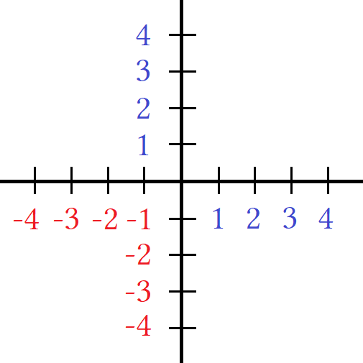
The grid is numbered like this. We plot points and label them like this. Then we draw a line.

A line in geometry is said to go on forever in both directions. A linear equation has a line that goes in both directions forever. Later in geometry the explanations get more technical. Using the function y = x+1 write a table showing the points on the graph with the blue line drawn.

y =x+1
x | y | (x,y)
–4 | –3 | (–4,–3)
–3 | –2 | (–3,–2)
–2 | –1 | (–2,–1)
–1 | 0 | (–1,0)
0 | 1 | (0,1)
1 | 2 | (1,2)
2 | 3 | (2,3)
3 | 4 | (3,4)
4 | 5 | (4,5)

Study the table and how it is setup. We write the equation at the top. This equation is called our function.
We make columns for x and y. Making a column for (x.y) showing them together is optional but very helpful.
The x column is a list of x values. x values can be any number we want. It depends on what parts of the line we want to study. For starters it is good to start at “x=0” and then add 1 every row. The y column is a list of y-values. Once we say what number we are using for x we plug that number in for x and solve for y. Once we solve for y we write the number. This creates an x,y pair which is called an “ordered pair” and uses this notation (x,y).

I will demonstrate how to solve for y using the function f(x) = x+1 and for a polynomial:

f(x) = x+1 write a function using “f(x)” notation
f(–4) = –4+1 plug in any value for x. Anywhere the is “x” replace with the number you are using.
f(–4) = –3 spoken as: “the function of –4 is – 3” or you could say “f of –4 is – 3”
f(x) = x²+3x+7 this is a polynomial function
f(–5) = (–5)²+3(–5)+7 plugging in a random number for x
f(–5) = 25 –15+7
f(–5) = 17 (–5,17) this is a point that exists on the quadratic function.

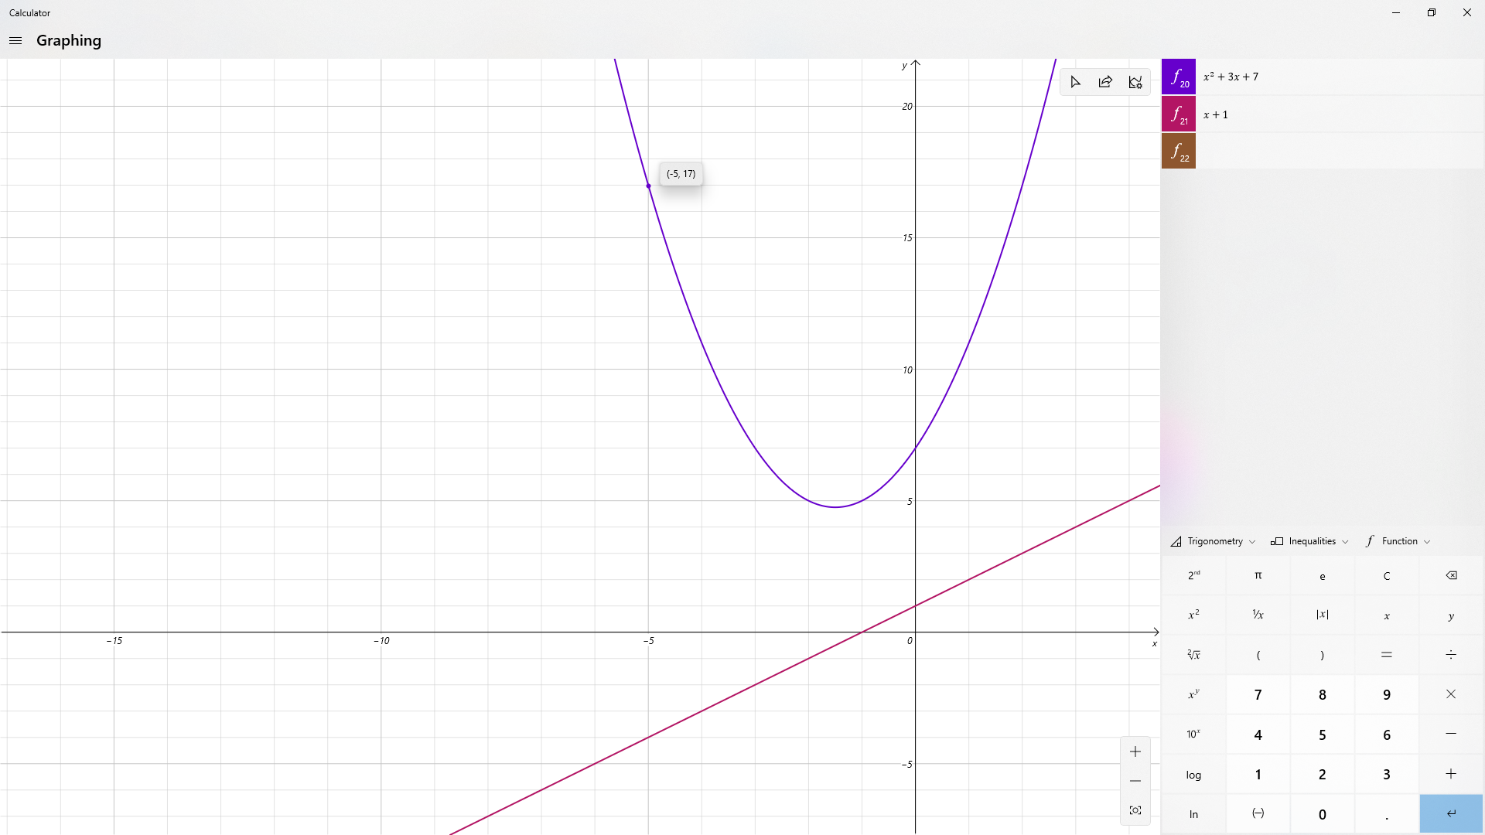
Y = 17 (–5,17)

I used Microsoft calculator to graph both functions. The linear equation is a line and the quadratic makes a shape called a parabola. The point (–5,17) is found by moving –5 units on the x-axis and 17 units on the y-axis. This is easier to show on Desmos which I highly prefer and recommend. Try it yourself. Type in equations we have done or make your own. Or make your own formulas by creating variables and using different values for your variables. Start basic first then add complexity later. Eventually the graphs should show you answers to real life applications. Applications are also called “word problems”. Application is how you apply it you your life. At the end of the book I will give applications. Algebra problems that use graphs are work, rate, and mixture problems. Geometry problems deal with physical dimensions like area and volume of solid shapes using algebra functions.

F(x) = x²+3x+7 this is a polynomial function. If we choose values for x then solve for y we find points that form a parabola shape. For a linear equation the points form a line. We can use decimals for x like 1.1 and 1.2 or 1.00001 and 1.00002. We can add as many zeros and create points that are infinitely close. This means that as locations the locations touch and when graphed make a solid line with no gaps. We can use fractions for x like ½, ⅓ or any other fraction. The only thing we can not do in a function is have an equation that somehow divides by zero. When this happens we have something called a domain error.

Domain is the set of numbers x is allowed to be. If y = 2x then our function takes x and multiplies it by 2. We can multiply any number by 2 so we say the domain of x is (–∞,∞). This means any number from negative infinity to positive infinity can be substituted for x. Once we have a number for x we call this defining x. Defining a variable means you set it equal to a constant. We define x by rewriting our equation with a numeral instead of x.
If x = 3 then y = 2x becomes y = 2∙3 = 6. Through transitivity y = 6.

Domain is the set of possible x values. Range is the set of possible y values. There are equations that limit what x or y can be. If I had the function f(x) = ¹/_{x} I can not choose x to be 0 because I would get f(0) = ¹/₀ and there is a rule called “division by zero” that says division by zero is undefined. Define means to know what number the variable represents. Define can also mean other things but in general the definition is the answer. If x=4 then x is defined as 4, since we have “something = 4”. So the answer to “something” is 4.

Take 2+2 =4. 4 is the answer to 2+2. This is called an equivalence. We have an equals sign with two quantities on either side. Left side:right side is 2+2 = 4. In general “this = that”. The point is we can write a number different ways. This is a critical concept in all math but especially this point and beyond. You have to walk away with this understanding for any situation. We can write four as “4” or as “2+2”. We can write function of x as “f(x)” or “y”.

If x = 4 then 4 = x. “The answer to four” is x and “the answer to x” is four. Very important.
We if x=4 we are not really stating a problem to be solved, it is solved. It is the solution and therefore the answer.
The solution = the answer.

The goal is to teach that x = some number is not a problem but an equality of two groups.

4=4 this is called reflexive
x=x this is called reflexive

If x = 4 then they are both 4.

x = 4 this is called substitution. This the basis for equivalence statements.

When we write an “=” sign we are equating two things. On page 44 I said you could equate an equation.
From page 43: “(j)(x+3) substitute j for x+2 (yes you can use a variable for a sum or even entire equation)”

Note: j = x+2 is an entire equation and that x+2 is a mathematical expression called a binomial. For something to be an equation it needs an equal sign. Having the binomial x+2 without an equals sign makes it an “expression” rather than a full equation. We treat expressions like equations or sometimes call expressions equations but they are not. This is technical. The difference is whether a person is speaking English correctly which translates to whether they are doing math correctly. If you do not understand what the words or notation or symbols mean how can you do math? The phrase “do your homework” can be made a sentence but is still a phrase.

- “do your homework” a phrase
- “Do your homework.” a sentence
- “Do your homework or you're grounded.” a compound sentence
- “Do your homework...” a cutoff sentence

If we add a period it becomes a sentence. If we leave it off it isn't. While technically a phrase we can use it as a sentence. This is bad grammar and syntax but people will understand you. If you lack strong reading skills your work will suffer. Bad communication and comprehension follows. This goes beyond getting the correct answer but understanding how and why. Understanding what 2+2 equals is different than understanding why 2+2=4.

- 2+2 a phrase
- 2+2 = 4 an equation
- 2+2 = 4 and x = 4 a compound equality
- 2+2 = 4 and x = an incomplete compound equality
- 2+2> x an inequality
- 2+2 > x and x > 3 a compound inequality
- 2+2 > x and x > an incomplete inequality

Starting from basic applications

A linear equation performs multiplication. That is all it does. If someone says “linear equation” it is a fancy way There are three different way to write a linear equation. You can convert from one formula to another. Form is another way to say formula. A formula is the notation we are using. Notation is any formulas or symbols used in the equation. Every lesson we learn new notation and introduce it as it appears. Math is just symbols and higher math takes basic arithmetic and garbles it in code. All math is code and learning notation is the way to decode it.

Standard form: Ax+By =C

This is used to find the intercepts. All linear equations have y and x intercepts. Rare in graphing. Used for sums.
Standard form takes two ingredients called A and B and combines them to make an ingredient called C.
The literal interpretation is mixing ratios like a cocktail made for 5% alcohol and 10% alcohol mixed to make a drink that is 7% alcohol. These are real life problems not pure math and just find a number. The number has to represent something more than just a dot on a grid. Our hypothetical drink would have some ratio of x:y to make
a 7% mixture. If we made a 1:2 ratio then we would have 1 part A and 2 parts B. This makes 3 parts not 2. Ratios are different from standard fractions. They require in depth instruction. First lets manipulate the formulas to better understand them and talk about ratios later.

y slope intercept form: y = Mx+b

This gives a form that shows the height of the point that intercepts the y-axis. This point is called the y-intercept. This is useful if you need an equation and use values that are close to the y-axis. This is used in graphing lines.
Useful if you know or need slope and/or y-intercept. Most popular. This is popular early on for business equations that show multiples of some value like x amount of units equals y amount of dollars or science applications like tracking rainfall, population, or anything else that grows at a steady rate.

Point slope form: y – y₁ = M(x – x₁)

This is useful if you are using points far from the axis. This is used in calculus when calculating tangents of curves. Useful if you have two points or if you have one point and slope. Less popular. We can convert from one formula to another by using algebra. Algebra means rewriting from one form to another. The “algebra” is the notation which people call, “the language”.

Ax+By = C standard
x+y = c the coefficients are not important
y = –x+c this is y-int form except it uses “c” and calls it “b”

Whether you call it b or c or anything else the constant added to x will be the y value. Observe:

y = –(x) +c let x = 0
y = –(0)+c there is no such thing as negative zero, –0 is 0
y = c our y value is 0 giving us point (x,0) where x is undefined

If x = 0 then from the origin (0,0) we did not move left or right any units. Our x value is 0. If y = c then from the origin (0,0) we moved “c” units up or down. Whatever “c” is that will be the height of our point.

y = –(x) +c let y = 0
0 = – (x)+c we have point (–x,c) which is the x-int
this is x-int but we have no values except that we move to the left because x is (–)
if we had numbers we would know what the x-int and y-int are

Ax+By =C this is standard form for a linear equation
By = –Ax +C this is ugly way to write y-int formula
y = Mx +b we write this way is better. We use b for vertical rise but some use other letters
note: By and Mx+b are different “b”. b is vertical rise and B is cof of y if it has 1

y = Mx+b
y – b = Mx subtract b from both sides
y – y₁ = M(x –x₁) rename b as y₁ and x as the quantity x–x₁

We did it. We rewrote all formulas using algebra. Huge success. This means that for a line using any of these forms or even the ugly ones we stated the equation for a unique line. If we put any of these forms into a graphing calculator they would all draw the same line. Note that we had – (0)+b earlier. Using commutation we change order to b – 0 = b, and 0 cancels. Also there is no such thing as “negative 0” as it is neutral so it is just 0.

5 – 4 = 1 five has a “hidden” plus sign because it is positive
–4+5 =1 the –4 is really –+4. the signs do not match so it is negative

5–0 = 5
–0+5 = 5 we do not write “ – ” in front of 0
0+5 = 5

We went from standard to y intercept to point slope. What a coup de gracè. Using algebra we can rewrite any of the forms to any of the other forms. There are 3 choose 2 combinations so 6 possible conversions. That is too many to do but practice for yourself and your graphing skills will be stronger not to mention your algebra as well.

Let's work with y = 2x+1. Let's try to convert it:

y = 2x+1 intercept form y = 2x+1 intercept form
y – 2x = 1 standard form y – 1 = 2(x – x₁) point form

y = 2x+1 if want to know where the line intercepts the x axis...
0 = 2x+1 then the height above the x axis will be 0. Use y=0
–1 = 2x subtract “b” from both sides
–½ = x divide both sides by 2
(0,–½) this is the point for the x-intercept

y = 2x+1 if want to know where the line intercepts the y axis...
y = 2(0)+1 then the horizontal distance from y axis will be 0. Use x=0
y = 1 hmm...
(0,–½) this is the point for the y-intercept

- using 0 for x or y will give you the other variables intercept
- intercept form gives you the intercept already with b as the vertical increase

This is a such a simple function we can calculate points mentally. What are the y values for 0,1,2,3,4,5,6,7,8,9,10?
[(0,1);(1,3);(2,5);(3,7);(4,9);(5,11);(6,13);(7,15);(8,17);(9,19);(10,21)] I notice a pattern. The outputs are all odd.

If inputs are integers this function gives all outputs as odd numbers, why is this so?
Let's do a different function y = 2x. Can you make a prediction about the results if we use integer inputs?
Note: Brackets are not necessary but semicolons are. Semicolons are ugly but commas are hard to read.

f(x) = 2x f(x) = 2x f(x) = 2x f(x) = 2x f(x) = 2x f(x) = 2x f(x) = 2x f(x) = 2x
f(0) = 2∙(0) f(1) = 2∙(1) f(2) = 2∙(2) f(3) = 2∙(3) f(4) = 2∙(4) f(5) = 2∙(5) f(6) = 2∙(6) f(7)=2(7)
y = 0 y = 2 y = 4 y = 6 y = 8 y = 10 y = 12 y = 14

They are all even! We learned an important fact about number theory using functions.

- Any number times two will result in an even number~ the way to write with functions is y = 2x
- Adding 1 to any even will result in an odd~ The way to write with function is y = 2x+1

We do functions to either solve a real world application or to study patterns. In graphing functions we can see a large amount of information quickly. This helps us see the bigger picture than just the answer to a single equation. A function shows the answers to many equations of a formula, infinitely many.

Last page I asked why you thought the outputs were all odd. I care more about getting you to think creatively than making you do a bunch of complicated equations. People like to solve a problem and move on but do not take time to think about their answers or what they mean. The meaning will be related to a pattern of some type. Understanding patterns in life is important. While it is important to solve math quickly for work there are calculators for that. A calculator can get an answer faster than a person but it can not think and understand what that answer means.

When I asked you to do a prediction that is called forecasting. The news has weather forecasting based on graphing weather patterns and also financial forecasting graph stock and market data. Seeing patterns in life is critical for making the right decisions at the right time. We use math for that to get money, self preservation and quality of life. If you keep making the same mistakes in life you are missing the patterns you need to notice or you are deliberately ignoring them.

Both y=2x and y=2x+1 are shown graphed together. Graphing two functions at once is more powerful than separately as we can compare the two functions side by side. We look for patterns and try to extrapolate any data we can.
What patterns if any do you see?

When we have two functions graphed together we name them alphabetically f(x), g(x), h(x)... and so on.

f(x) = 2x has y intercept 0
g(x) = 2x+1 has y intercept 1

For business the y intercept is often called “initial value”. In a way it says we should look at the graph by starting where x = 0. If you deposit money in an account that earns interest the initial value is your deposit. Over time you can graph how your money grows. The x value counts time in days, months, years, or in the case of the stock market even hours. The y value counts price in dollars. If you hear the term initial value think y intercept where before any time has passed the starting value is on the y axis somewhere. It takes practice to read and interpret graphs skillfully.

        - Notice how the two graphs do not intercept each other.
        - This is because they have the same slope.
        - Two lines with the same slope are parallel.

