Inverse of a line

The inverse of a linear function is found by taking the reciprocal of slope. This rotates a line 90° – θ° where “θ°” is the angle of original line. We use the Greek letter theta for unknown angles. A linear function and its inverse function angles are complimentary and add to90°. Slope is M = ^{y2 –y1}/_{x2 – x1} which simplifies to M = ^{y}/_{x}.
Reciprocal means opposite or inverse depending on context. A number has two types of inverses:

- Additive Inverse: The opposite sign numbers added together. “The sum total of n and –n equals zero”.
5+(–5) = 0 also –5+5 = 0. The additive inverse of 5 is –5. –5 and 5 are additive inverses of each other.

- Multiplicative Inverse. Two numbers that multiply to 1. For any x “The product of a x and ¹/_{x} equals 1”.
We call this the reciprocal of a number. The reciprocal of 5 is ¹/₅. The reciprocal of ¹/₅ is 5.

Mechanics of reciprocals

- Any number, whole or decimal, has a 1 as a denominator. For any number: x = ^{x}/₁.
- Any number divided by 1 is itself. Changing order of division creates a reciprocal.
- x÷1 = x so changing the order 1/x = ¹/_{x}. Reciprocals are reduced to dividing a number by itself.
- (x÷1)(1÷x) = (x÷x) = 1 This simply restates reciprocal exponent laws on page 32 and elsewhere.

We need to find inverse by taking the reciprocal of slope. M = y/x so ¹/_{M} = ^{x}/_{y}.
This exchanges the numerator and denominator with each other.

- M = y/x Find reciprocal
- 1÷(y/x) The numerator is 1, the denominator is (y/x). This is a complex fraction.
- 1∙(x/y) When dividing by a fraction invert the fraction and then multiply
- x/y The reciprocal of y/x is x/y because ^{y}/_{x} ∙^{x}/_{y} = ^{xy}/_{xy} = 1

1÷5 = ⅕ 1÷⅕ = 5 1÷⅖ = 2.5 1÷3.5= ²/₇

1÷1 = 1 1 is its own reciprocal hence the identity function is its own inverse.

60° line
45° identity function
30° line

f(x) = x
g(x) = (√3)x
h(x) = (¹/_{√3})x

The functions are “reflected” over the identity function. The identity function is also called the line of symmetry for a function and its inverse because it serves as an axis of symmetry between the two. Each line has a matching “twin point” on the other that will be of the form (x,y) = (y,x). The two points have inverted values of each other and will be the same distance from the identity and same absolute value angle from a point on the identity.

From trig the slope of a 60° line is √3. It's inverse is a 30° line of slope 1/√3.
Both angles add to 90° so are complimentary. Both lines cancel when multiplied so equal the identity.
I am going to take the coefficients of x and multiply them: √3 ∙ 1/√3 = 1. Multiplying the slopes gives an identity.
The identity function is always y =x and always has a slope of 1 which is always at a 45° angle with the x axis.

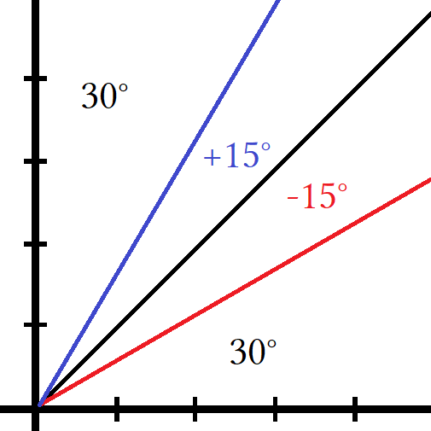
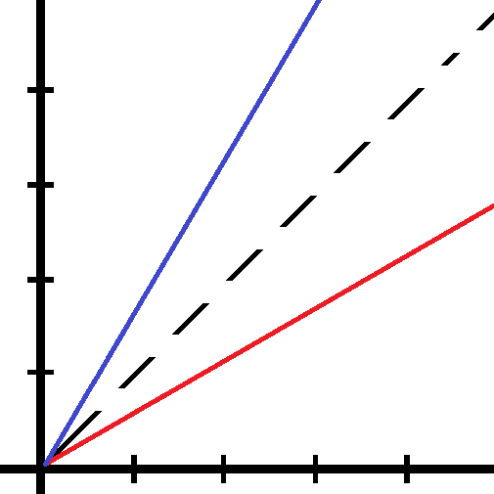
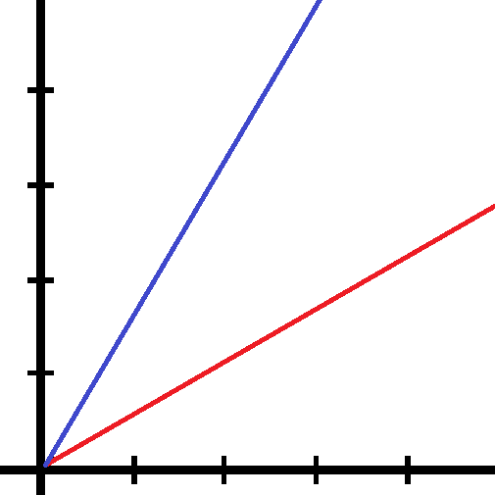

A 60° line is given by g(x) = √3x. The line of symmetry f(x) = y The rotation from f(x) is |±15°|
A 30° line is given by h(x) = ¹/_{√3}x.

We call an unknown angle theta θ. The theta of two inverses adds to 90°. The theta of two inverses from the identity function is |±θ|. If we multiply the slope of g(x) and h(x) the slope will equal 1. This is considered two functions canceling each other. This was covered in compositions. How would we use this? If I have two complicated function and they are being multiplied I want to simplify my equation by eliminating one of them and keeping the other:

f(x) ∙ g(x) = f(g(x)) multiplying two functions creates a composition as shown.

Take x and add 3, then square it, then subtract 2...call this function f(x).”;

f(x) = (x+3)² – 2 some complicated function
f(x) = x² +6x +7 I have a polynomial function that is quadratic
x² +6x+7 ∙ g(x) g(x) is some complicated quadratic function
x² +6x+7 ∙ g(x)/g(x) cancel g(x)
x² +6x+7 ∙ 1 I have an identity (1∙)
x² +6x+7 ∙ 1 = x² +6x+7

If I have something complicated I can simplify it by canceling what I don't want and keeping what I do want.
There are many reasons to do this. I do not want a monster huge equation that is degree 4 polynomial function because finding roots, factoring, or anything else is difficult. So I cancel the second function if I can and keep the first one where factoring it, or completing the square or using the quadratic formula becomes possible. I do not know if there is a formula for finding roots of a 4th degree polynomial but if there is I wouldn't use it. I would try to reduce the polynomial to quadratic form and then use the quadratic formula.

