Identity

Identity is another way of saying “canceling”.

x±0 = x 0 cancels under addition, this is the additive identity.
x∙/÷1 = x 1 cancels under multiplication this is the multiplicative identity.
x = x A number equals itself is the reflexive identity.
y = x reflexive hence the identity function.
15° = 15° reflexive since the numbers are identical.

An identity is the name of the number, when you you have an identity you have two identical numbers.
Reflexive means the first number “flexes to the left” then “reflexes to the right”.
The number on the left side of an equation will match the number on the ride side.

For 30° and 60° each line deviates 15° from the identity line. A deviation is a bending or “flexing”, a “reflex” is a bending in the opposite direction. To be “reflexive” is to have matching left side and right side values. That's all.

What type of graph is this? It has asymptotes at y=0 and x = –3±√2. The maxima is –3, –½. The y intercept is ⅐.

Remember on page 75 and 78 we said quadratic parabolas do not have inverse functions? They don't. The blue function is x²+6x+7. Writing y²+6y+7 will rotate it 90° to the right. While x²+6x+7 does not have an inverse it is the inverse for y²+6y+7. The red function is called a posinomial instead of a polynomial. It is 1/x²+6x+7.

x²+6x+7∙ 1/x²+6x+7 = 1 I canceled my function.

When books speak about canceling a function they mean something other than this. They mean:

x²+6x+7 ∙ y²+6y+7 = x I canceled the function being performed on x.

A constant like 1 is a scalar. A variable like x is a function in of itself. In formulas scalars are the coefficients of variables, ABC are scalars of the variables xyz. To have a function we need two variables to compare. This comparison is called a relation which forms a ratio. A multiple of x equals some multiple of y is a proper ratio given by Ax:By where A and B are scalar constants.

x:y = ^{y}/_{x} This ratio shows slope.
y =2x This ratio shows a slope of ²/₁. 2x means y = 2 and x =1 so...
½y = x Half of y equals x because we divide both sides by 2 to isolate x.

y = 2x It takes two x to equal one y. In a ratio the smaller variable has a bigger coefficient.
y = x+x We can write 2x as x+x.
1y = ½y+y½ 1y is equal to ½y + ½y we can substitute ½y for x because we proved ½y =x.
1> ½ y is greater than x.
y> ½y y is greater than half of y.
y = y y equals y.

x < y x is less than y.
x = x x is equal to itself.

y = x+4 this is an 'improper ratio” because we do not have differing scalars.

For y =x+b you have one x and one y but are adding to x to equal y. This will cause a “offset ratio” instead of a fixed ratio like By = Ax where rate of change is fixed. If we take slope to be rate of change it is fixed at 1. We have a 1:1 ratio of x:y but are shifting it vertically. A line can only be shifted vertically and not horizontally.

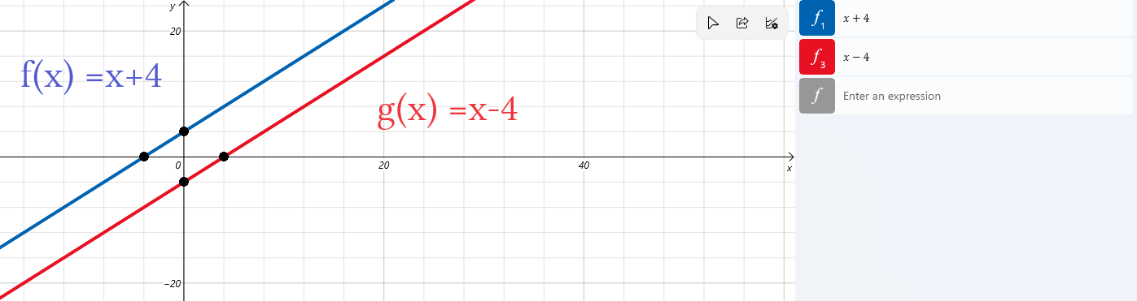

The two lines have same slope but are shifted.
The x int is (–4,0) and appears to move right to (4,0).
The y-int is (0,4) appears to move right to (8,0).

x+4 = y
x = y+4 or y+4 = x... swapping x and y gives an inverse.
We rewrite x = y+4 by subtracting 4 from both sides... y = x–4

Since slope is the same lines are parallel. Since slope is 1 the y and x intercepts are twin points. This is a unique geometry that creates a parallelogram. Also any two pairs of horizontal points will make a parallelogram. Is the red one shifted 4 units down or 8 units to the right? The truth is both but we say it is vertically shifted.

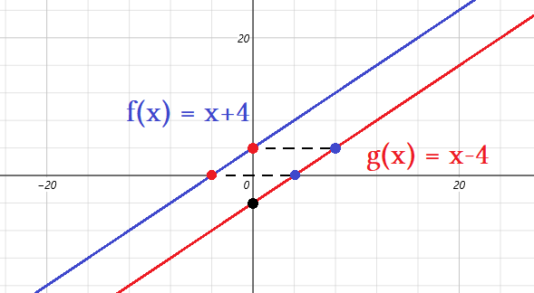
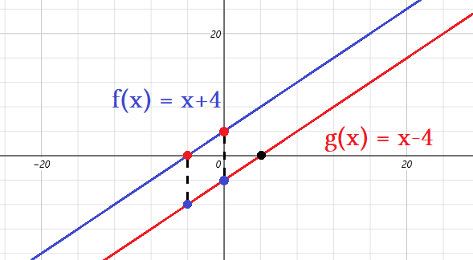
← It appears graph shifts right 8 units

It appears graph shifts down 4 units→

While it has the effect of shifting horizontally only y+4 = x or y = x – 4 will create this transformation so we say it is a vertical shift. The variable b is a vertical shift value only. Has nothing to do with horizontal shift. y = 2x+1 has a ratio of 1:2 where y is twice as big as x. Ratio is always given by slope which is ²/₁ = ^{y}/₁. We added 1 which is an “offset”. Offsets are improper ratios because they do not scale but merely offset an existing ratio.

y=2x we have 1:2; 2:4; 3:6... these are actual points written as x:y ratios. These points exist for y = 2x but also are scaled versions of the “1:2”. All the ratios will reduce to 1:2 and that is 200% as a percentage no matter what.
y = 2x+1 we have 1:3; 2:5; 3:7... These are points, they are also the formula for creating odd numbers...because we have addition we are taking a 1:2 ratio and offsetting it. This causes chaos to our percentages. For “x:y”:

1:3 = 300%
2:5 = 250%
3:7 = 233.3% or 233⅓% The percentage is dropping. How low will percentage drop?
4:9 = 225%
5:11 = 220%...
100:201 = 201%
400:801 = 200.25%
1,000,000:2,000,001 = 200.0001% This is pretty clear. Adding zeros to x will only add zeroes to y.

The percentage can never drop to exactly 200% because the 1 adds to the numerator to prevent even division. This is Zeno's paradox in that we can never reach a specified value. We call this convergence. It converges to a number but never reaches it. It is not chaos because chaos would mean unpredictability in a system and convergence is the opposite. We can predict percentage for any number of zeroes for high x to y ratios. Convergence is predictability and increases as a number settles on a value. This is used in statistics.

A function can have a common difference, exponential difference, or common ratio. We have a common difference of “2” between every two terms. This gives a very predictable system that becomes more stable as our ratio converges to 2. We had a consistent rate of 2x+1 but ratios varied wildly. To create a 90° angle of two lines:

- Find the negative of M⁻¹. This will be –M⁻¹ = ¹/_{M}
- The reciprocal of M is ¹/_{M} because M∙¹/_{M}= 1
- The “negative of” means it has a “ –“ in front
- This is used in geometry, trig, calculus to find “tangent lines”. Tangents are 90° to a point.

y = x Find the inverse to this linear equation
y = –x the slope is 1, the reciprocal of 1 is 1/1 =1, the negative of 1 is –1

y = 2x+1 Find the inverse to this linear equation
y = –½x+1 the negative reciprocal of 2 is – ½

y = ⅔x –4 Find the inverse to this linear equation
y = –1.5x –4 the negative reciprocal of 2/3 is – 3/2

y = –¼x +2 Find the inverse to this linear equation
y = 4x+2 the negative reciprocal of 2 is – ½

We use the y intercept form when graphing close to the y axis. A function and its inverse have the same y intercept. We only alter the slope variable “M” and leave the vertical rise variable “b” alone.

A reciprocal has a formula and notation. This is useful for complicated functions involving messy equations.
A reciprocal uses “1 over” notation which is a negative 1 exponent, “-1”. A number = x, its reciprocal = x⁻¹.

Raising something to the power of –1 makes a number turn into its reciprocal: x⁻¹
Raising something to the power of –1 is the same as dividing 1 by that number: 1/x
Raising something to the power of –1 is the same as dividing that number by its square: x/x²

Identity line f(x) = x f(x)= (⁵/₃)x+5 f(x)= (½)x–2
–Identity line g(x) = –x g(x)= –⅗x+5 g(x)= –2x–2

The identity line is its own inverse but we can create a line 90° perpendicular to it by multiplying slope by –1.
This the identity line negative inverse. We have two more line graphs showing the original functions in blue and inverse functions in red. Both the red and blue functions are inverses of each other just as anything else in have has an opposite, both will be “opposites” or inverses of each other.

Now that we have the inverse function of a line we could use point slope formula to find equation of a line using one point and slope. The purpose of this is to create a 90° tangent line that passes another function at an arbitrary spot. Using the point of the targeted spot and the slope for an inverse at that point you can create a tangent line anywhere. The trick is using point slope to find y-int because the y intercept formula will not work.

