Finding the inverse for a cubic function

For a function to have an inverse it must pass the horizontal test. We know that all quadratics fail.
We also know that all cubics with a negative x term or any ±x² term will fail.
A cubic does have an inverse if It is Ax³±d, or Ax³ + Cx±d. A Bx² or –Cx term will create two infliction points which a horizontal line will pass the graph at three points. This is a proven conjecture but you can prove it yourself. Get a graphing calculator and graph:

Ax³+Bx²+Cx+D Ax³+Bx² –Cx+D Ax³–Bx²–Cx+D Ax³–Bx²–Cx–D
Ax³+Bx²+Cx –D Ax³+Bx²–Cx –D Ax³–Bx²–Cx+D

There is no need to try –A because that just flips graphs vertically.

3x³ – 6x+4 not invertable because it has –x term
–2x³ +6x+4 invertable because x term is positive
3x³ – 9x²–7 not invertable because it has x² term
3x³ – 6x+4 not invertable because it has –x term
x³ invertable because there in no x² or –x

As long as the cubic does not contain x² or –x terms it is invertable. Try for yourself so you familiarize yourself with cubics. This will help you moving forward. Learn to recognize the shape, inflection pattern, and how adjusting values and polarity transforms waviness. Precalculus deals heavily with modulating sine waves while calculus has Fourier transforms. A Fourier transform is a infinite series comprised of sine waves that can talk any shape even draw images like blueprints or cartoons. So learning about cubics now and how to transform them is a smart idea. Takes about ten minutes.

The inverse of a cubic will reflect it across the identity line (y=x). Reflection is a geometry concept studied after algebra that gives precise language to what is happening on a graph while transformations and other activity is happening. A reflection happens over some line the identity line or the x or y axis. When reflected it performs a complex rotation. A complex rotation is a rotate and flip move.

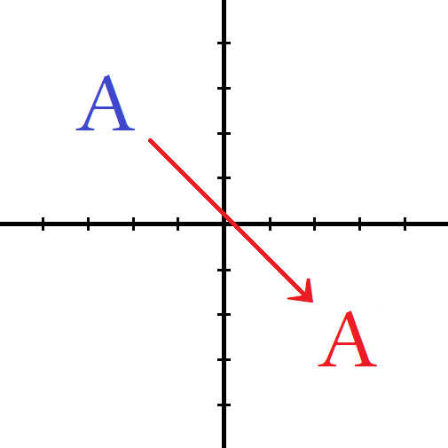
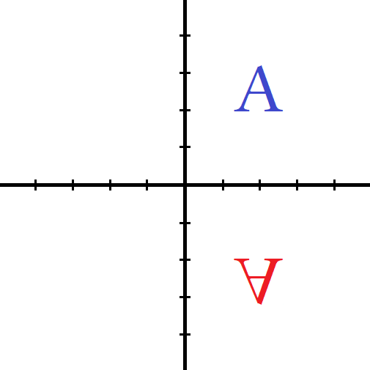
90° rotation about the origin translation using a directional slide complex rotation “flip”
reflection about x axis

A transformation is when points on a graph change locations thus altering the graph visually and numerically.
Basic geometric transforms are rotate, slide, and flip. Rotate and slide are 2-dimensional moves only needing two axis of movement but a flip is three dimensional needing to cross over an imaginary plane. For our intents we can call the third dimension z and treat it like any normal 3d space. Imagine letter magnets on a fridge. I can rotate them or slide them without them leaving their plane of existence.

If however I invert them by flipping them upside down so that front and back swap you will see the magnet on the back of letter facing you. You would need a strong magnet to overcome plastic insulation to hold letter to fridge. The letter is upside down while magnet is visible from the front. For this to occur I would need to physically remove magnet and flip it and then place it back on the surface of fridge. Flipping through space like that requires the use of a 3 axis system while the previous two types need only a 2 axis system.

