The difference between a scalar and a variable

If I say y = x+4 then a line is graphed representing infinite solutions.
If I say 0 = x+4 then a solution to x is graphed represented by a single number called a scalar.

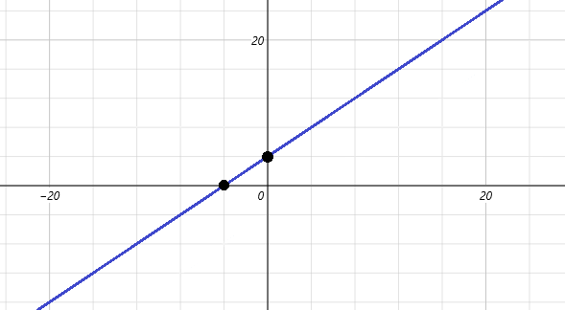

Y = x+4 shows a relation x = -4 shows the solution to x
Functions use two (or more) variables. Finite equations use only one variable.

With one variable expect a single number graphed on a single axis.
Anything above or below the x axis is an imaginary number.

This should really be graphed on a single axis “the number line” The vertical line is “imaginary”
Only “ – 4” is real. There is no y component. Only – 4 is real.

When you have two variables you have a variable function. You get different points representing different or infinite solutions. When you have only variable your equation has only one solution or no solution.

If 0 = x+4 then you really mean to say x = – 4. If x+2 = – 2 then you really mean to say x = – 4.

To solve is to define and to define is to write an equivalence.
To give a single constant as a solution is to solve in terms of scalars which are one dimensional dots.
This is the normal understanding of “a solution”. All constants are scalars. All coefficients of variables are scalars.
A scalar is a constant that scales some unknown “x or y or z”.

An equation can only be solved if it contains one variable. We eliminate variables until there is only one left and then we can solve. When graphing using a grapher a line will appear. Having one variable “forces” a solution.

y = ½x+7 a line function
5 = ½x+7 a scalar called “x” that equals: x = ^{5 –7}/_{½}
5 = ½x+7 a scalar called “x” that equals: x = –4
y = x²+8x+16 a quadratic
0 = x²+8x+16 a scalar called “x” that equals: x = √0 – 16 –8x
0 = x²+8x+16 a scalar called “x” that equals: x = –4

Setting an equation containing x to y generalizes for any x. Setting to a constant forces x to be a constant.
We call constants scalars. A scalar is graphed using the number line and not a rectangular axis system.
Oddly, ordered pairs with or without axes drawn have x and y both as scalars.
The vertical lines represent a single dot on the real axis; 1 root one vertical line, 2 roots two vertical lines.

Setting to y gives a parabola Setting to 0 gives roots

x²+8x+16=y x²+8x+16=0

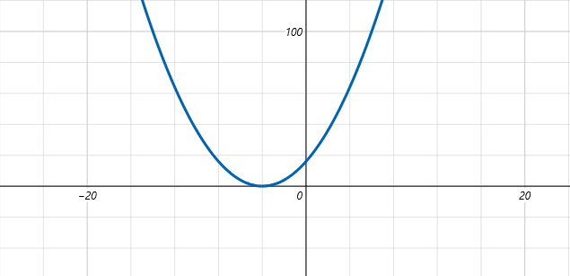

x² –8x+16=y x² –8x+16=0

x² –16=y x² –16=0

For a vertical line we want to find where it touches the x axis and then use that as an x value to solve for x.
For a linear equation an x value is the x intercept. Depending on context it will either be the solution for x in a problem like “2x+17 = 25”. We generally do not “graph” these equations but rather solve algebraically. If we did graph it we would do so by hand or whiteboard on a number line without a y axis. If graphed on a computer will interpret it as a sloped line of the form y = mx+b and then substitute “25” for “y”. This will graph as a vertical line where (x,0) is the x value would would find for x on a number line. The points above and below are imaginary and represent x±bi which we are probably not interested in.

If from an actual function the we are solving for a point (x,25) and want to know what the x distance is of the point with a height of 25. The weird thing here is that the complex axis and y axis are not the same axis but appear to be since they are both vertical axes. The complex axis is “z” not “y” or even something else. Setting a linear function to 0 will of course give the x-intercept but again anything not on the x axis is an imaginary number from a complex rotation using √–1. Since we are probably not interested in √–1 these points are ignored because they are not on our function line but an “imaginary distance” away. Same for quadratics and cubics. Imaginary points are rotations that have not occurred and are covered in geometry.

