Completing the square

Completing the square can be used to solve any quadratic equation.
Using the Quadratic formula is faster and is based off completing the square.
Before I show the quadratic formula I will show completing the square.

Solve x² +6x +4 by factoring:

There is a problem. The factors of C and not possibly add to B. The only factors of C are 1∙4, 2∙2, –1∙–4, –2∙–2.
If we add them we get 4, 5, or their negative versions –4 and –5 . Solve by completing the square:

- x²+6x+4 =f(x) this is a quadratic function. Please solve for x intercept
- x²+6x+4 =y this is an extra step: set to y
- x²+6x+4 =0 set to 0 to create an ordered pair of (x,0).
- x²+6x+4+5 =5 complete the square by adding a little bit
- x²+6x+9 =5 sum C plus the little you added last step
- (x+3)(x+3) =5 this is an extra step to show you get a perfect square
- (x+3)² =5 write your perfect square in exponent notation
- (x+3) =±√5 root both sides and add (±) to show both positive and negative roots
- x = ±√5 – 3 isolate x by clearing constant component of the factor
- x = –3 ±√5 put constants in front of radical please
- x = –3±√5 this says we have two solutions for x. We have –3 +√5 and –3 –√5.
The solution set to the quadratic is x = –3±√5.

If you want an approximation, which we don't, √5 ≈ 2.23 so –3+2.23 = – 0.77 and –3–2.23 = –5.23.
x = –3+√5 or x = –3–√5 looks nicer than messy decimals and we do to have to calculate them! Its a plus.

Check by substituting back into the original equation and not something else like an altered form of the original equation. If it was set to a number and we altered it by setting to 0 than we would need to use the original number it was set to and NOT 0. In this case we are okay because the equation was not set to anything so we can use 0. Blue terms are positive and completely cancel with the red terms which are negative:

x²+6x+4 = 0 x²+6x+4 = 0
(–3+√5)² +6(–3+√5)+4 = 0 (–3–√5)²+6(–3–√5)+4 = 0
9–6√5+5–18+6√5+4 = 0 9+6√5 +5–18–6√4 +4 =0
4+5+9+6√5 –18–6√5 = 0 4+5+9+6√5 –18–6√5 = 0
18+6√5 –18–6√5 = 0 18+6√5 –18–6√5 = 0

I do not like that last example because it was hard to read. Use the quadratic formula which is easier. Moving on...

When we have a quadratic we really have a quadratic function. Function is like saying equation with many solutions that can be graphed. Using variables turns ordinary equations into functions. Eventually we will have to graph this using ordered pairs of (x,y). What we did and why it works:

We had a quadratic that could not be factored because it was messed up. This is called an imperfect square. We added a number to make it square. If you square root a perfect square you get an integer instead of an irrational. Irrationals are to be avoided because they are not very familiar numbers, you know? Adding a little bit makes it give an integer solution. What we added made the quadratic a perfect square trinomial

We had x²+6x+4=0 and turned it into this x²+6x+9=5 which is this (x+3)(x+3)=0.
We used 9, there are many numbers that would have worked but 9 makes the most sense for multiple reasons.
We use something called determinate to determine what number to use. The determine is (b/2a)² which in our case is 9. The bx term was 6x so b = 6. We use half of b squared to get our number, 3² = 9.

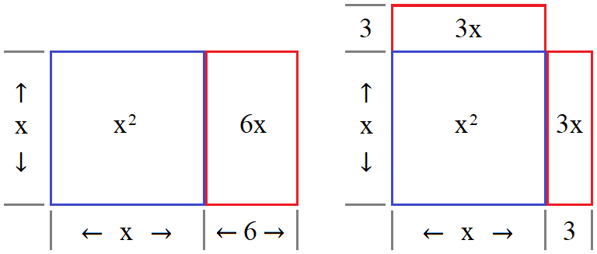
Both images have the same “area” of x² + 6x but one is a rectangle the other a square with a little bit missing. If we add the little bit we get a perfect square that can be factored as (x+3) for both sides. The little it needs is 9. The little always missing is b/2a for any perfect square trinomial. b/2a is called the discriminate.

How it works (spoiler alert! This borders on proofs students are required to do themselves in 10th geometry)

To completely understand quadratics would require vast knowledge in number theory and measure theory.
We had x²+6x+4 and could not factor it. This is frustrating.
To avoid frustration to used algebra to manipulate it by leveraging ratios.
Ask yourself, “why did the polynomial equal 0?” and “why does our sum have variables and an x² and x term?”

Setting the equation to 0 gives us an area of 0. This is based on indirect variation. This is a sneaky hack.
In math we use symmetry to solve hard problems. Setting to 0 gives us symmetry by treating the sum as a rectangle that scales to a square while maintaining same area.

“How do you add three numbers and it equals 0?” “how is that supposed to work?
This is a graphing trick that has area decreasing as side length in increases.
Obviously something is canceling to make area disappear.

Continued on next page....or go on to quadratic formula we are done with completing the square.

If we have a square: 10∙10 =100 → 10² =100 → x² =100. We have a 1:1 ratio of two numbers or side lengths.
If we fix area at 100 and then make one side longer then the other side must get shorter.
This alters the ratio from 1:1 to something else. We have a ratio for sides of a rectangle.

A rectangle: 2∙50 = 100 1∙100 = 100 ½ ∙200 = 100 ⅒∙1000 = 100 ¹⁰⁰/∞ ∙∞= 100.

Eventually we will have a side of almost zero and another side almost ∞ and still have an area of 100.
We changed to a rectangle but still want to write it as x². How very odd of a thing to do. Seems hacky.
How would you write the area of a rectangle as A=x² ? What would x be?

To Create A Quadratic From Scratch

Find a rectangle and measure base and height. Use or rotate rectangle so that height is shorter than base. Transfer your height measurements to your base. You now have cut the base into two parts. The left part will have an area of height² and the right part will have an area of height∙(base – height) = hb –h².

Area of left square: h²
Area of right square: hb –h²
Area of both:h²+ hb –h² = hb The squares cancel leaving hb which is the formula for area.

To mutate into an imperfect square divide right part into two equals parts vertically so that height side is same.
The right part hb–h² was divided into: 2(hb–h²/2). Lets call this piece I so that I = hb–h²/2.
Place I on top of left part “h²”. This should look like drawing below.

A quadratic equation is a formula for area. We have two terms representing the area of our rectangle as a sum of the areas of a square and smaller rectangle. The rectangle area could be bigger but unlikely. In fact As soon as x exceeds the coefficient of bx then x² is bigger than bx. When x = b then x² =bx. Whatever x is for x²+6x any x greater than 6 will cause x² to dominate 6x. x can be any number from 0 to ∞.

Claim

- Domain of x where x² = 6x: {(6)}
- Domain of x where x² < 6x: {(0,5.9)} 1² < 6, 2² < 12, 3² < 18, 4² < 24, 5² < 30, 5.9² < 35.9
- Domain of x where x² > 6x: {(6.01,∞)} 6.01² > 6.01∙6 = 36.012 > 36.006
- Domain where x² ≠6x:{(6>x>6)} also {(x<6 ∪ x>6)}

Proof

- 6² = 6∙6 when x = 6 both squares are congruent having areas is 36 = 36.
- The largest x²<6x can get is 5.9². This sets an upper ceiling of 36. 5.9² = 35.981 since 9 repeats and 9² = 81.
- Clearly 36.012001>36.006 proven by 1²=1 lsd is 1. If 36.0001∙6 then lsd is 6 because 6∙1 = 6.
- 6 is excluded from domain of x because there is a hole discontinuity as x→6. ■

