Graphing Sideways Parabolas

For any “y²” sideways parabola find its inverse function, make a table of x² points, and then invert the points and plot to draw the sideways parabola. For anything you might encounter use the previous steps and methods from before but modify them to work with y² instead of x². Set equations to x instead of y. Look for x intercept instead of y intercept. Use the horizontal line of symmetry for the vertex instead of vertical. Everything is the same except formulas switch x and y. Multiplying by √–1 aka “i” causes a 90° rotation about the “focus” taking the parabola through all 4 quadrants:

y² and its inverse x² –y² and its inverse –x²

Rotations involving the multiplication of i are called “complex” or “rotations around the complex plane”.
The complex plane is similar to the xy plane except x becomes the “real axis” and y becomes “the complex” axis.

For all intents and purposes the xy plane is a 2d plane of length and height the complex plane is a 2d plane of length and depth. We have three dimensions given by xyz but here they call z “i” for how this “third” dimension arrived. We could have an xyz graph and then also add a fourth dimension of i to represent time or motion or in the case of tensors some static attribute. Bear in mind the imaginary axis is not defined as the “z” axis but can be thought of that way. Complex numbers follow the form a+bi where a is a real number on the x axis (here called real line) and bi is a number on the y axis (here called imaginary of complex line). Graphing standard parabolas with no real roots always gives two imaginary roots in the form a+bi.

Here is one application. A manifold like a water or gas pipe, or maybe car muffler. Pipes at a petroleum refinery.
The traditional xy axes would graph the opening of the pipe or its fittings to give “od” and “id” which is “outside diameter” and “inside diameter”. The diameters are different because they have thickness. Different spec pipe has different gauge to deal with different pressure. A high pressure boiler needs pipe with thicker walls than a drain pipe. The complex plane would be a rotation placing a parabola outside of the y axis and into the “z” axis or depth. The back wall of the pipe is curved along its entire height so that is something to think about.

I drew a water pipe with water currents as vector arrows. As the water reaches the bend a strange occurrence happens. Vectors at the outside bend accelerate quicker approaching a velocity of ∞ while vectors near the inside of the bend slow down approaching 0. This is a study of advanced calculus in three dimensions using Stokes theorems. Stokes theorems deal with dynamics, specifically air and water currents or any type of motion that can be generalized to “flow”. Simply put the horizontal and vertical vectors have a constant acceleration. We can generalize acceleration to being a “rate” which can be given by slope. The rate of the red vectors approaches a slope of ¹/₀ the rate of the black vectors approaches ⁰/₁. In trig this is ∞ and 0 for slope respectively. Very weird.

The best description I can give is cutting a hula hoop in half and bending it to a parabola shape. Have it sitting on the ground with cut ends points up. This is an object that has distance for x and height for that can be measured on an xy graph and approximate by a quadratic equation. If you have it standing up on the ground the point that touches the ground shall be the vertex. Now without moving the vertex from its position lay it flat on the ground. This represents a transformation about the complex plane.

You went from having distance and height to distance and depth. You went from (x,y) coordinates to (x,z) coordinates. If you flip it from having a vertex at the opening to having a vertex at the back wall the parabola fits the curved wall and extends to the mouth. This can represent different thing in vector mechanics like diameter versus length ratios for pressure or flow. Decreasing diameter reduces pressure instead of increasing. Pressure is directly proportional to diameter rather than inversely proportional like most people think. Putting your thumb over the nozzle or kinking a garden hose to increase pressure is a different phenomenon.

Graph a sideways parabola that has roots at √2i and – √2i :

We have one x with two outputs. I would start with x = y². This is almost like an exponential graph but parabolic having two arms... x equals “ y²”. This makes y the square root of x. We need y = √2i or – √2i . If you can not figure it out use a graphing calculator and begin with y² = x and then start transforming it slow at first to learn very basic transformations and how to manipulate the graph.

For “normal” parabolas finding points is easy because all we have to do is input a value and solve for y. Finding their twins is harder because various issues arise with parabolas not having inverses. A twin will have the same output but used a different x to get their. It al we have us a height then knowing how to get back to “x” seems impossible as there is no way to write a function of it. Here we have a sideways parabola and are asking someone to graph it by looking for “roots”. This causes confusion in that they will look for “zeroes of x” when they should be looking for what x produces two y that are complex conjugates.]

Start with what we know and work backwards. We need x = √2i or – √2i …

x = y² We know this will give a sideways parabola; it says y∙y = x, y is root of x.
x = √2i or –√2i We have roots at (0,√2i) and (0, –√2i) plot these points on paper or table

Although not a function, x as outputs two y. When x = 0 y = √2i or –√2i. Both of these are 0±√2i when
in a+bi form. If the complex root has 0 as the coefficient your roots lie on the y axis. Try plugging in 2:

x = y²
2 = 4 We have point (2,4) but we need (0,√2).
2 – 2 = 4 – 2 We wrote 0 as 2–2 and 2 as 4–2. This gives numbers to work with.
±√2 – 2 = ±√4 – 2 I think this is it... or not...

We are saying √0 = ±√2. x = 0 should output y = ±√2i. We need i = √–1 so somehow incorporate that data...

x = y²
0 = ±√2i
0 = –2 This says is x = 0 then y = –2 but we also need to other “2”... take square root of both sides.
√0 = ±√–2 This is what it is.

y equals a square root so take the square root of both sides to create an equivalence.

x = y² Write x = y²
√x = √y² Take square root of both sides
√0 = ±√–2 Substitute x = 0 and y = –2
√0² = ±√–2 ² square both sides
0 = –2 not quite right, only one output
x = ±√2i
x = ±√2∙√–1 our x will equal ±1.414i

If x= y² produces (0,2i) then how do we transform this so that x will equal (0,1.414i)? Do we shift graph left or right or something else? If we need to turn 0 = –2 into 0 = ±1.414 then 2 needs to become √2.

If we focus only on the top part of the parabola it becomes easy to think about it as a logarithm.
x = y² will start at (0,0) and then curve toward (2,√2) we want (0,√2). We want 0 = 1.414 not 2 so...
We need to subtract 2 from something. The graph needs to be shifted to the left... so we need to add to the domain of x. We do not want the domain to start at (0,0) we want it to start further back... we only have four choices: x = y² –2 or x –2 = y² or x = y² +2 or x +2 = y²

We try all four and find that x = y² –2 is the same as x +2 = y².

x = y² this is basic shape
x +2 = y² this shifts it to the left
x = y² – 2 this is isolating to solve for x. We would call this standard form.

We used guess and check or used a grapher to quickly check guesses visually. Using a grapher is called solving by graphing. Unless we have a better way to solve that is what we are stuck with. There are better ways and we will find them. When using guess and check refine your answers and then derive a formula for all problems not just the one you are working on. Creating a formula is called “generalizing” for all x. It is what we are supposed to do. What equation has roots at ±√2?

Realize that a = 0 in a+bi. Sub that in and get 0+√2i. Change √2i to √–2 or even ±1.414 to make it easier to work with. Write x = y² and think about how it should be transformed. Realize that if y² then the line of symmetry is the x axis. This is obvious because you have matching complex conjugates –√2 and √2. If (y–h)² then it is shifted up or down and x axis is no longer line of symmetry. If shifted your two roots will have different values because you are offset by some amount. This is similar to x² = y has y axis as line of symmetry but (x–h)² will shift it left or right. x²–4 roots are –2 or 2 but (x-1)²–4 roots are –1 and 3. Difference is the same but is offset by 1. (x–1)² –4 roots are different (–1 or 3) so y axis is no longer line of symmetry. Having an axis for line of symmetry makes solving easier because we know that a vertex form is not being used. If an axis is line of symmetry then we do not have (x–h)² =y or (y–h)² =x. We are only transforming with “k”.

We are given roots at ±√2 so we know that h=0 and we have no binomial shift only lateral shift. For a sideways parabola roots are where the parabola crosses the y axis not the x axis. We know parabola crosses at ±√2 so we have two solutions. If we Shift the parabola to the far right then we have no solutions for where it crosses the y axis, not even imaginary. We would have something like imaginary solutions. Things like that need a better language to describe than algebra currently offers so we save that for pre-calculus and trigonometry where we plot these type of graphs using vector form and call them parametric equations. Let's write a clean formula, look at some graphs, and then move on to ellipses.

x = ±√2i Meaning x = the square root so...
x + 2 = y² We can get an equation by shifting to the left by the square of the radical.
x = y² – 2 y² – k or (y –h)² – k is standard form for a sideways parabola.

x² =y this gives (x,y) as points We can reverse this and make sideways parabola: √x =y this gives (x,y) as points
2² = 4 √4 = 2
3² = 9 √9 = 3
4² = 16 √16 = 4
5² = 25 √25 = 5
0² = 0 √0 = 0

x² –2 =y this gives (x,y) as points. Reverse this and make a sideways parabola x =√y–2 with points:

2² = 4–2 4 = 2–2
3² = 9 –2 9 = 3–2
4² = 16 –2 16 = 4–2
5² = 25 –2 25 = 5–2
0² = 0 –2 0 = 0–2
x² – 2 y² – 2
(0∙0) –2 = – 2 0 –√–2 = √–2
0±2 as roots 0±2i as roots

Here we square x and minus 2 Here we square y and minus 2
inputting 0 we get – 2 and 2 as roots inputting 0 we get –2i and 2i as roots

y² – 2 = x This a parabola rotated 90° right from x² = y and shifted 2 units to the left.
y² = x+2 This also shifts 2 to the left. They are the same ratio so have the same shift.

A good application for this would be rocket science. In the old days Archimedes and Da Vinci studied projectile motion because they needed to help their government win wars with ballistae, scorpions and trebuchet. A scorpion is a large crossbow that fires a huge bolt that is the size of a small log. They concerned themselves with ballistic missiles. A ballistic missile is given by some negative parabola using vector form like –a(x–h)² =y.

We are attacking a castle. We launch our missile. We launch from (0,0), this is where missile takes off.
We have to get the right trajectory to go over the castle wall and land at the right spot inside castle walls.
Missile lands at (4,0). If arc is too low we hit wall. If trajectory is wrong we miss target.

The x axis is taken to be the ground. We ignore parts of graph that are not in first quadrant. Those parts do not concern our application. Changing our equation will change height of vertex and width of parabola from “ground zero” to target. Equation used here is –0.5(x–2)²+2=y. A less violent application would be modeling golf swing flight trajectories to design a better lightweight titanium alloy golf club. When would we use a sideways parabola? Cruise missiles... We launch a missile from the ground to an incoming missile or aircraft to destroy it.

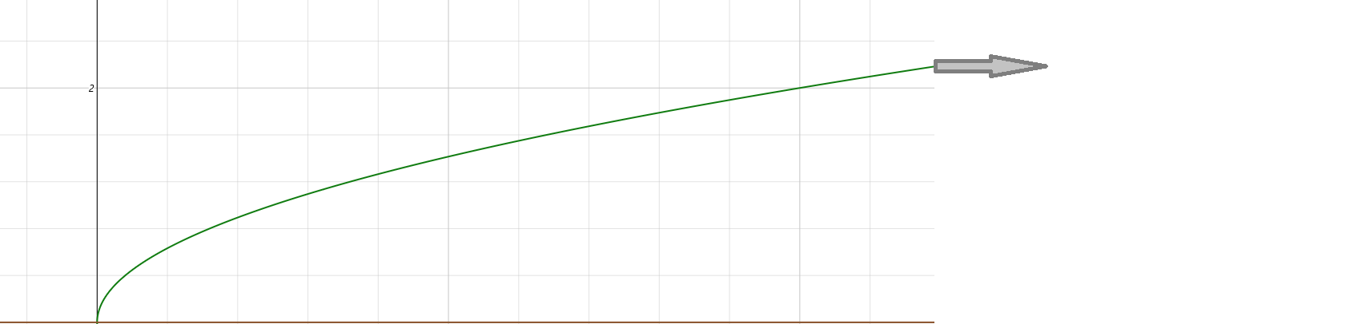

We only care about the top part. When would we care about the bottom part?
When would we have a parabola “floating” in the first quadrant? This models two things:

An aircraft taking off to intercept an enemy...and the path of its missile to destroy enemy. The green line is the flight path of our hero leaving the airbase. This equation shows path and gives eta to intercepting the enemy.
Red line is flight path of cruise missile to the enemy. Jet fighters use software with this math. From the graph it appears our hero is 4 miles away and shooting at a target 1 mile away from him and 5 miles away from us.

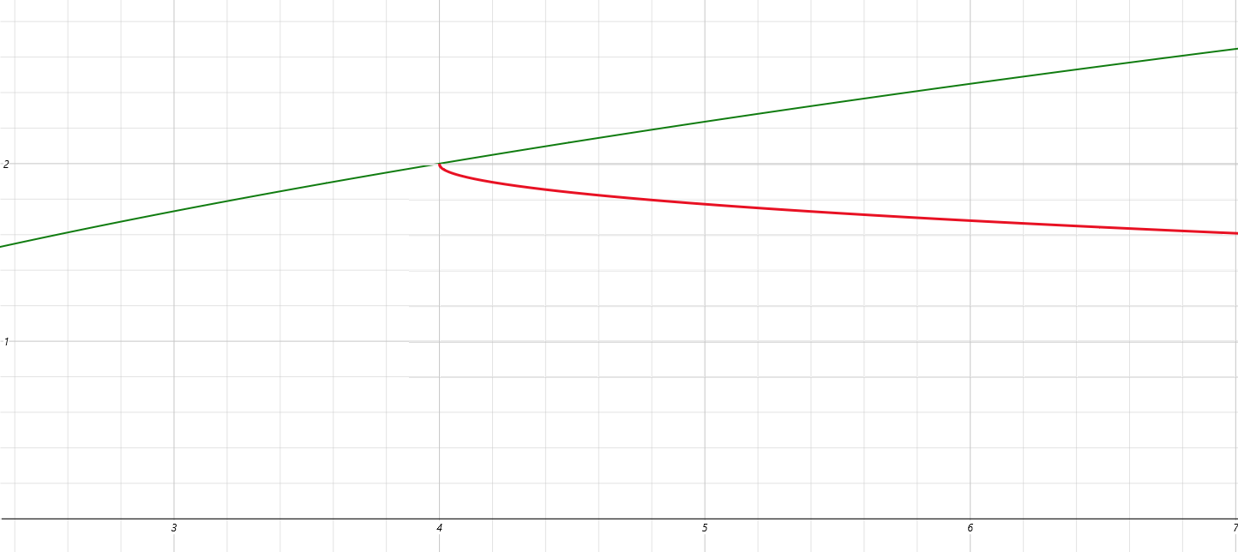

Normally we can't use the bottom part of the parabola if we are on the ground and can not use the top part if we are in the air. It gets more technical but this is rocket science. We can use this math to launch satellites in space, track trajectories of asteroids, model planet orbits, all sorts of things. This is the sort of math the airforce and NASA wants their pilots to know. Ballistic missiles fall to the ground freely being assisted by gravity so we model them with a(x–h)² +k. Cruise and hybrid missiles are rocket powered and give more of a “sideways” flight. a(y–h)² +k. The rest is a secret.
To graph y = ax² +bx + c

- Find the vertex (h,k) either by completing the square to convert to vertex form a(x–h)²+k or by unsing –b/2a to find x coordinate and substituting it to find y coordinate.
- Choose other values for x on either side of the vertex and solve for y to find points.
- Graph points up if a>0 ; graph points down if a<0.

To graph x = ay² +by + c

- Find the vertex (h,k) either by completing the square to convert to vertex form a(y–h)²+k or by using
–b/2a to find y coordinate and substituting it to find x coordinate.
- Choose other values for y on either side of the vertex and solve for x to find points.
- Graph points to the right if a>0 ; graph points to the left if a<0.
- Or instead you can find inverse of x = ay² +by + c to be y = ax² +bx + c, find points of y = ax² +bx + c
then invert point values to find points of x = ay² +by + c.

Distance and Midpoint formula

If two points are on a horizontal line then they have the same y value. These points are “twins”. The distance between them is given by the difference of their x values. The order we subtract can give positive or negative result. Use the absolute value to find difference. For a horizontal distance |x₂ –x₁| for a vertical distance |y₂ –y₁|.

Treating slope of a line line a triangle we can use the distance formula to find base and height then use the Pythagorean theorem to find hypotenuse: d² = |x₂ – x₁|² + |y₂ – y₁|².

Distance formula: d = √((x₂ – x₁ )² + (y₂ –y₁)²) … or c = √a² – b² where a² = (x₂ – x₁ )² and b² = (y₂ –y₁)².

Midpoint formula: The midpoint of a line segment is given by the averages of run and rise: (^{x2 – x1} /₂, ^{y2 –y1}/₂).

