Circles

Informal definition: A round shape but not an oval.
Formal definition: Infinite points equidistant from a central point called the center given by (h,k).

A circle is a special case of a ellipses in that both its axes are the same length.
An analogy would be a square is a special case of a rectangle in that both axes are the same length.
The distance from the the center to any point of the circle is a distance called the radius. Using the definition of a circle and the distance formula the length of a radius will be r = √(x–h)² + (y–k)². When we take r = √(x–h)² + (y–k)². and square it we get r² = (x–h)² + (y–k)². This is called the equation of a circle.

Equation of a circle: (x–h)² + (y–k)² = r²

From geometry the radius is half the diameter of a circle. When the (h,k) is (0,0) the circle is center at the origin.
Translating a circle moves it to a different position with a center h ≠0 and k≠0. If we have a circle of radius 5 with a center at (2,3) then we write:

(x–h)² + (y–k)² = r² Standard form for a circle
(x–2)² + (y–3)² = 5² Substitution
(x–2)² + (y–3)² = 25 This looks like vertex formula with extra parts
(x–2)² + (y–3)² = x²–2x+4+y²–6y+9 = 25 Sum of two perfect square trinomials
= x²–2x+y²–6y+13 = 25
= x² +y²–2x–6y+13 = 25
= x² +y²–2x–6y–12 = 0

For a circle centered at the origin: x² + y² = r². Given a radius length and a center coordinate you can write the equation for any circle centered anywhere. To write the polynomial x²+y²–2x–6y–12 in standard form we would complete the square twice, once for each x and y. To move the circle from a center of (2,3) to (0,0):

(x–2)² + (y–3)² = 25
(x–2+2)² + (y–3+3)² = 5²
(x)² + (y)² = r²
Ellipses

An oval in math is called an “ellipse”. This comes up in astronomy when studying elliptical orbits of planets using Lagrange points. Lagrange points are studied in calculus. There are typically five main Lagrange points; L₁, L₂, L₃, L₄, L₅. It seems that L₁ is a “focus” point, L₂ and L₃ are endpoints of a axis, here the major axis, and L₄ and L₅ are halfway points.

An solar or lunar eclipse is when a celestial body blocks another creating a visual effect of one circle overlapping another. They can overlap partially or completely. When sending a satellite to collect data on the sun the satellite is eclipsed by the sun at point L₃. Radiation from the sun distorts radio waves from the satellite making communication impossible when the satellite is at or near L₃. Ellipse and eclipse are related words.

Informal definition: An ellipse is a stretched circle.
Formal definition: A circle whose vertical and horizontal axes are not equal.
Strict definition: A set of points on a 2d plane whose sum of distances from two foci are constant.
Focus: A focus or plural foci are fixed points which generate a parabola or ellipse.

Standard form for an ellipse: x²/a² + y²/b² = 1 where a and b >0

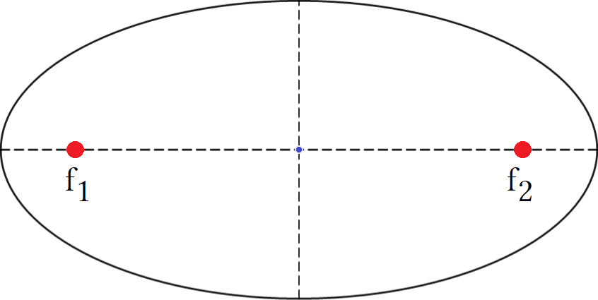
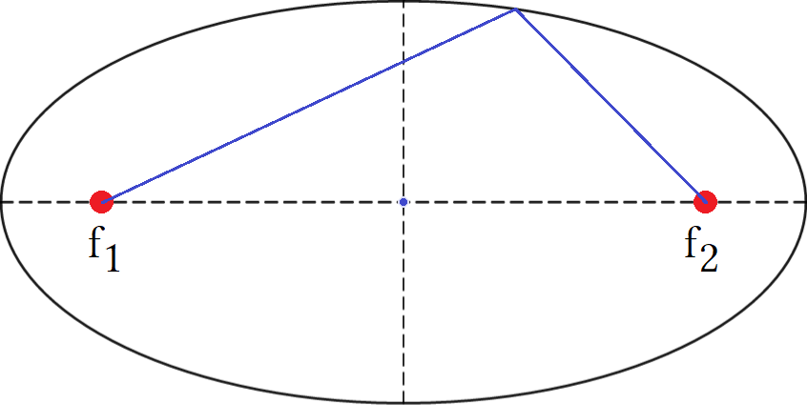
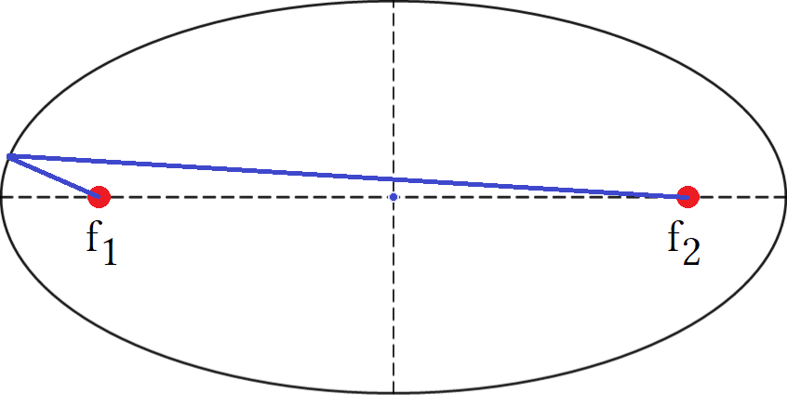

We can model this using an experiment: Draw an ellipse, use thumbtacks at two focus points to attach a piece of string. Use a pencil to trace the ellipse. Is the string is the right length the pencil will stay on the ellipse. The two string lengths, called distances from f₁ and f₂, form oblique triangles with the major axis. Any triangle formed will have the same area as any other. This amazing fact allows to later use polar coordinates.

All ellipses including circles have two axes, a major and a minor. The two foci will be on the major axis. The example ellipse is shown with x axis as the major axis and y as the minor. If we rotated the ellipse 90° then the y axis becomes the major, the x would be the minor and our foci would be on the y axis directly vertical from one another. To graph an ellipse find the intercepts first by using x=0 to find the y intercepts and y=0 to find the x intercepts. There will be two solutions for both x and y so you have 4 intercepts.

0²/a+y²/b² = y²/b² zeroing out x and rooting leaves the y intercepts ±y/b which is y = ±b
x²/a+0²/b = x²/a² zeroing out x and rooting leaves the y intercepts ±y/b which is x = ±a

Applications of ellipses

A whispering gallery has an ellipsoidal ceiling that transmits whispers from one focus to the other. A dental light uses a ellipsoidal mirror to reflect light from the source as one focus and the patients mouth as the other. The Earth uses the sun as a focus while following an elliptical orbit. Telecommunication satellites use the Earth as a focus while following elliptical orbits. A lithotripter sends shock waves from one focus to crush kidney stones in a patient at the other focus.

The directrix and focus

Parabolas, ellipses, and hyperbolas have both a directrix and foci. Foci are the focus points and directrix is a line.

For a parabola:

A parabola has one focus between the two arms and a line called the directrix below the vertex if arms point up and above if arms point down. All points on a parabola are the same distance from the focus as the directrix. Since the vertex is a point on the parabola it too will have the focus either directly above or below and the center of the directrix opposite the vertex the same distance as the focus. The formula for finding directrix or the focus is c = |¼a|.

Find the focus and directrix of y = x²:

c = |¼a|
c = ¼ The focus is at (0,¼) the directrix is at (0, –¼)

Lines y = ¼ to show the line where the focus would be at point (0,¼) and y = –¼ to show the line called the directrix. We see point (0,0) is ¼ of a unit below the focus and above the directrix. The focus is a dot but I drew a red line to extend it to touch the parabola. It touches point ( –½ , ¼) which is ½ of a unit away from the focus and ½ of a unit above the directrix.

Imagine using a paint program to scale a square. As you drag the window to make the square bigger the distance of the base equals the distance of the height. Every point on a parabola can be imagined as the top corner of a square that transforms form one point to the next by following the path given by the identity function f(x) = y. That is every point on a parabola is a transformation of a previous point. Each transformation moves the point over from the line of symmetry by the same amount up from the focus. The entire parabola is a collection of these points and the set of this points is known as the loci, a single point being a locus.

As the parabola curves upward points show an “inverse” relationship with x and y. From (0,0) to (±½, ¼) x is “winning” by growing faster than y. At point (2,2) x and y are “tied”. After (2,2) y is winning. As the parabola moves left or right it curves up maintaining a 1:1 proportion with distance from focus and distance from directrix. The vertical distance from “point” to directrix = sloped line from “point” to focus.

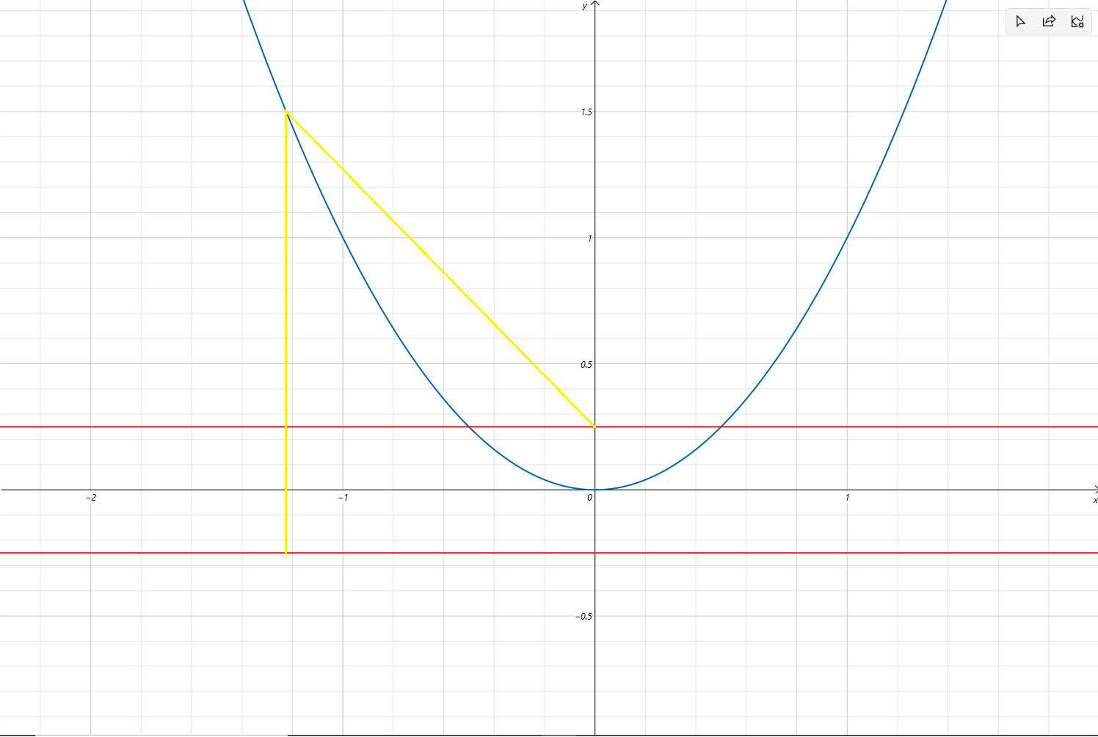

The two yellow lines are same length. We can measure the vertical line directly as 1.75 units, we can use the red focus line as a base to a triangle and use Pythagoras to find other yellow line as a hypotenuse to be 1.75 as well. WOW! This is actually pretty amazing. Anytime we have symmetry we can easily solve very very hard problems.

a = √1.5 or ^{√6}/₂ If y = x² then (x,y) = (x,x²). If y = 1.5 then x = √1.5 and (x,y) = (√1.5, 1.5).
b = 1.25 1.5 – focus = 1.25.

a² + b² = c² The square of two legs equals the square of an hypotenuse.
√1.5² +1.25² =c² This says a equals √1.5 and we must square it.
√√1.5² +1.25² =c This says c = √a²+b² .
√√1.5² +1.25² = 1.75 This says the length from (√1.5, 1.5) to (0, ¼) is 1.75.

The vertical line is 1.75 and the sloped line is 1.75. The points on the parabola are being “directed” by the focus and directrix to stay at an equal distance from these two points. It is these two points that dictate where all points on the parabola are. Deeper analysis shows the points to mark the upper left side (or upper right) of a rectangle being scaled. We will see many problems like this in geometry and be asked to find the angle or area between the yellow lines. I would guess ∠ß =44.41° from (–√1.5, 1.5) to focus and ∠ß = 34.98°.
Hyperbolas

If the equation of a circle is x²/a² + y²/b² =1 then the equation of a hyperbola is x²/a² – y²/b² =1.
Both equations have two fractions that represent a parabola. Adding two parabolas makes a circle or ellipse subtracting two parabolas makes a hyperbola. For the circle each part acts as half a circle when together but separately they are regular parabolas. For the hyperbola the two parts are opposite facing parabolas.

If x²/a² – y²/b² =1 then the parabolas are sideways which means they have a horizontal axis.
If y²/a² – x²/b² =1 then the parabolas are vertical which means they have a vertical axis.

Where a parabola has the focus and directrix to put constraints on where points are allowed hyperbolas instead have asymptotes. An asymptotes is not part of the graph but drawn as dashed lines to act as a barrier to prevent the graph from crossing into a restricted area. More formally an asymptote represents a domain error where division of 0 has occurred or there is a no x intercept. Any graph that has asymptotes will be a rational expression, the asymptotes is the region where domain is restricted. Not an issue but more of a reality. When did dividing rational expressions the same situation occurs.

Equations like “y = 1/x” can not have x = 0 and “y = ^{x–1}/_{x+2}” can not have x = –2. Any points plotted will not have a fraction with 0 as a denominator. Also any fraction with a non zero number can never reach zero due to Zeno's paradox. These create constraints on where the points will lie. The points form patterns and sometimes we draw asymptote lines to highlight this behavior. Asymptotes are a domain restriction from either preventing division by zero or a non zero numerator preventing a solution for a x intercept.

With this consideration it is not necessary to draw asymptotes. If we know that division by 0 causes asymptotes we know where to expect them. This is a domain issue. I honestly can not see how drawing them leads to an accurate graph. Dated methods encourage drawing them but I don't. I do not like putting cluttered lines on my graph so I keep them out. For reference the two asymptotes of a hyperbola are y = ±^{b}/_{a}x . Parabolas do not have asymptotes because they are polynomials not rational expressions. They do not contain division and we stated in the polynomial section what is and is not a polynomial. Hyperbolas do contain asymptotes because they are rational expressions. The range and domain of parabolas is unlimited unless one considers the vertex to be asymptotic. The graph of a parabola can never be lower than the vertex which is its minima, unless negative, but we do not define asymptotes this way. A hyperbola as |x| gets larger the parabola gets closer to the asymptote similar to y = ¹/_{x}.

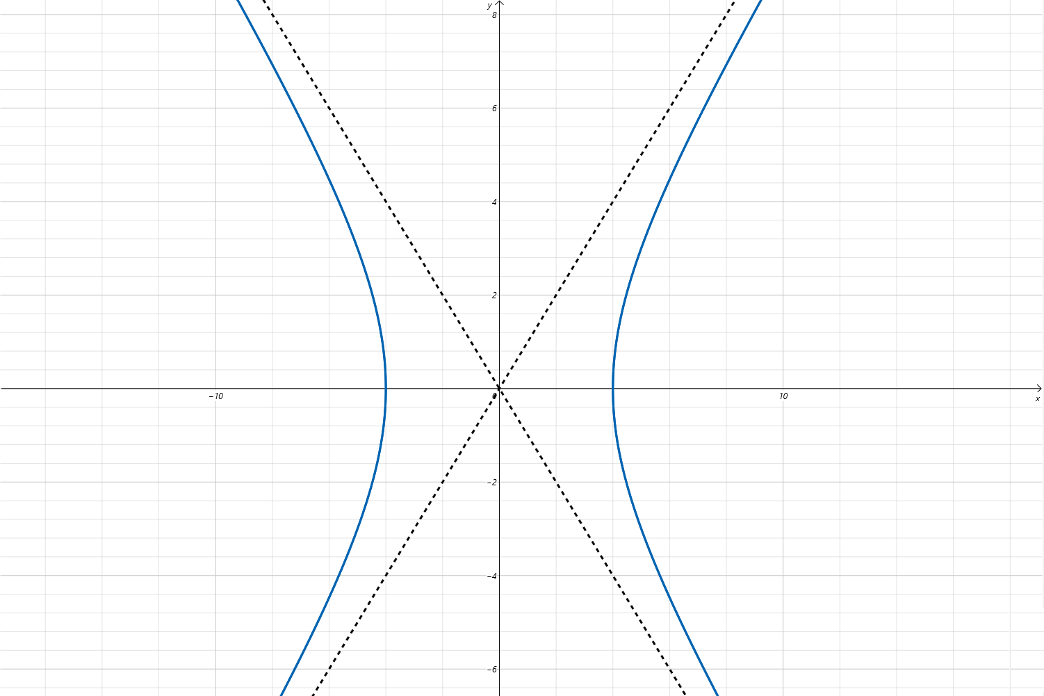
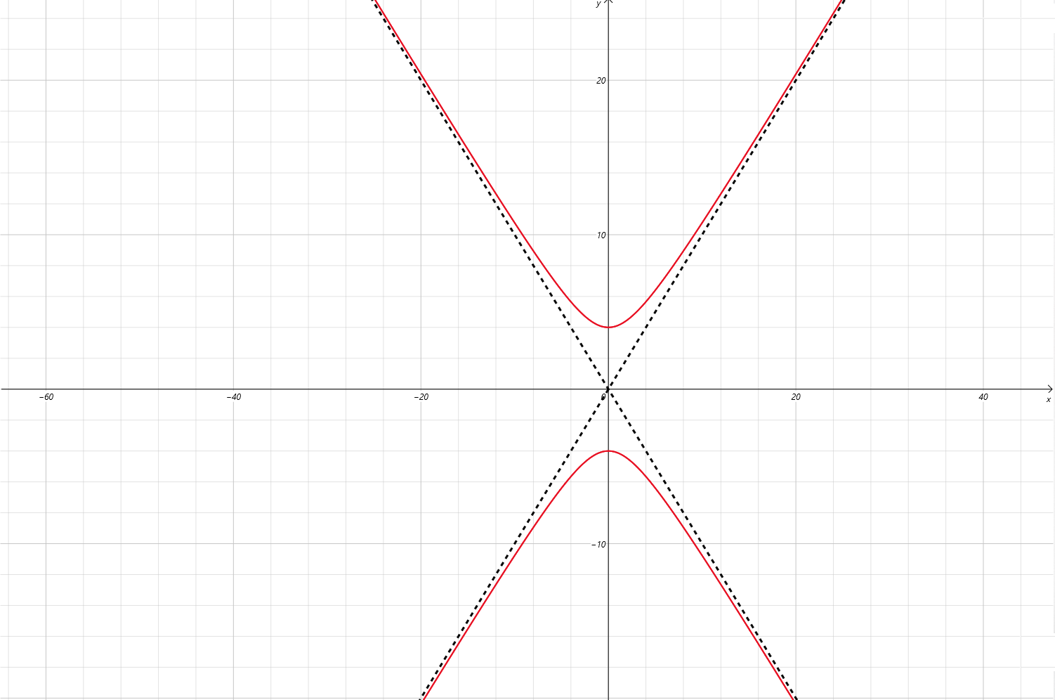

- Hyperbolas look like a pair of parabolas.
- They have a vertex for each part.
- A line through the vertices is called an axis.
- Red has a vertical axis.
- Blue has a horizontal axis.

These hyperbola are centered on the origin so their vertices are also intercepts.
Non standard hyperbolas have the equation xy = c c≠0. This is like y = 1/x because it is equal to xy = 1.

