Linear and Nonlinear Systems of equations

- Linear equations have degree 1 variables, they graph as a line.
- A system is when two or more equations are compared.
- To find a solution is to find a shared point. Shared points are found using substitution or elimination.
- To have a solution two line graphs must intersect. The point they intersect at is called the solution.
- The can intersect at 0, 1, or ∞ points.
- If they intersect at 0 points they are parallel lines that can never meet. Parallel lines have the same slope.
- If they intersect at ∞ points they are the same line but written with a different equation.
- If they intersect at exactly one point then they have different slope that is negative or positive.
- Graphing two equations to see if they cross is called having a “system of equations”.

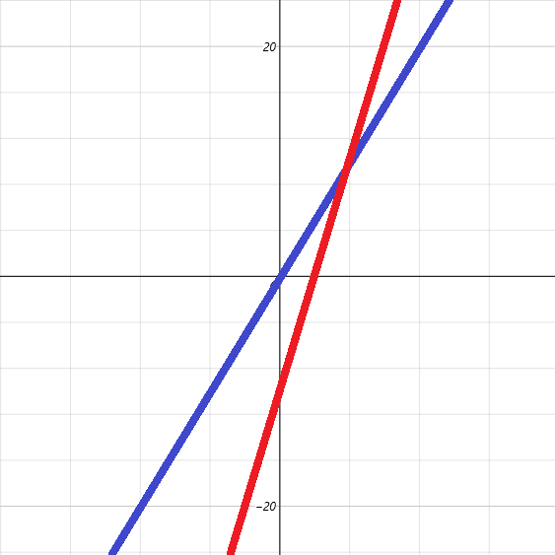
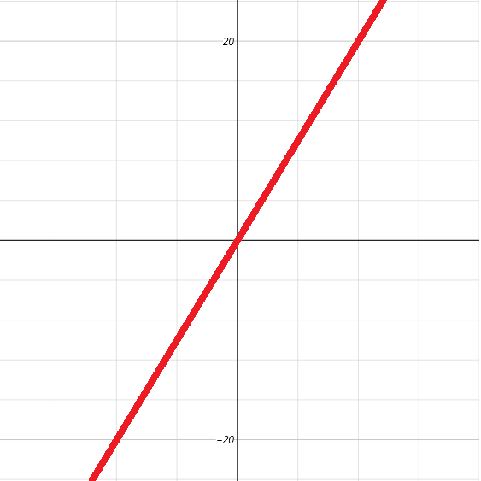
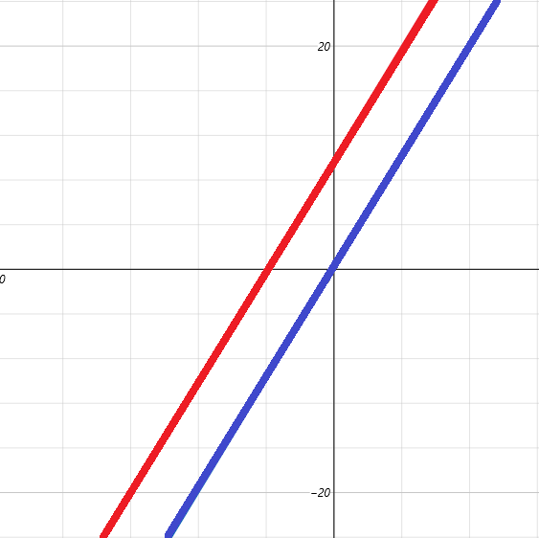
Parallel lines have same slope Dependent lines are the same line Independent lines
and no solutions, inconsistent Infinite solutions and same slope one solution, consistent

Two circles can have 0,1,2, or ∞ solutions. A circle and a hyperbola can have 0,1,2,3, or 4 solutions.
An ellipse has similar solutions as a hyperbola and can have up to 4 solutions.
For nonlinear systems it is best to use substitution if one equation is a line and elimination if both are quadratics.
Nonlinear equations is when you graph two equations an at least one of them is not a line but a conic section:

- A line and a parabola. 0,1, or 2 solutions 1 line has at most 2 solutions
- A line and a circle. 0,1, or 2 solutions
- A line and a hyperbola. 0,1, or 2 solutions
- A parabola and a parabola. 0,1,2,3 or 4 solutions
- A parabola and a circle. 0,1,2,3 or 4 solutions
- A parabola and a hyperbola. 0,1,2,3 or 4 solutions
- A circle and a circle. 0,1, or 2 solutions 2 circles have at most 2 solutions
- A circle and a hyperbola. 0,1,2,3 or 4 solutions
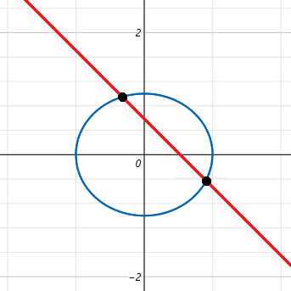
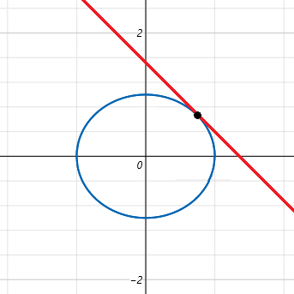
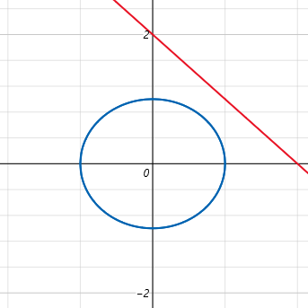
- A hyperbola and a hyperbola. 0,1,2,3 or 4 solutions
No solution 1 solution 2 solutions
Linear Equations

The goal is to find a point shared by two equations. We want to eliminate one variable so we can solve.
An equation can only be solved if there is only one unknown. If one variable is solved use substitution.

3x+y = 5
x – 2y = 4 Eliminate x by making it equal “3x” using multiplication on every term

(3x + y = 5) Put equations in () so you do the right order when sign flipping
–(3x – 6y = 12 The bottom equation is now 3(x – 2y = 4)... we scaled it by 3
0x +7y = –7 Addition principle: 3x –3x+y–(–6y) = 7y...........5–12 = –7............7y = –7
y = –1

3x+y = 5 or x – 2y = 4 substitute “ y = –1”
3x +(–1) = 5 or x – 2(–1) = 4
3x –1 = 5 or x + 2= 4
3x = 6 x = 2
x = 2

x – y = 3
x + y = 5

(x – y = 3)
–(x + y = 5) use longhand or shorthand subtraction if you want
0x–2y = 2 –2y = 2
y = –1 solve one of the other equations using substitution

x – y = 3 or x+y = 5
x –(–1) = 3 x+(–1) = 5
x+1 = 3 x – 1 = 5
x = 2 x = 6 2 ≠6.....no solutions

If answers are different we have inconsistent data. There are no solutions. This means lines never cross so we have parallel lines. An easy check is to see if they have the same slope. If coefficient of x is the same then they have the same slope. The problem is that the equations can be scaled so that slope have to be found by using y₁/x₁ = y₂/x₂. Dividing the coefficients of x and y in one equation to find the slope of that line and then do same for other equation then compare slopes. If they are the same you either have no solutions or infinite solutions. If they are different you have consistent data and one solution. Graphing will show where the first system meets and will show the other two systems as parallel lines.

x+y = 4
x – y = 2 Another system of two equations.

(x+y = 4)
– (x – y = 2)
0x+2y=2
y = 2 x2 = 2 or 4. No solutions.
Substitution Method

x+y = 9
x = y+3 x is already defined as y+3 so use it to substitute

x+y = 9
(y+3)+y = 9 Substitution
y+3+y = 9
2y +3= 9
2y = 6
y = 3 Substitute y = 3 back into one of the first equations to solve for x
x+3 = 9
x = 6 We are (almost) done.... x = 6 and y = 3 giving a solution of (6,3)

We need to check to make sure the solution is accurate:

x+y = 9 x = y+3
6+3 = 9 this one checks 6 = 3+3 this one checks

The solution (6,3) works in both equations meaning it is a point on both lines. If it does not check for an equation then the point is not shared by both so it is not the solution. If a variable is not isolated but can be, isolate it then substitute.

4x +y = 7
x – y = 3 Try –y = 3–x and then multiply by –1 to get y = x–3

4x+y = 7
4x + (x–3) = 7 When adding a binomial quantity like “x +(x – 3)” you can erase the ()
5x = 10
x = 2 We have (2,y)
x – y = 3
2 – y = 3
– y = 1
y = –1 We have (2,–1)...checking is left to the student

You can do 3 to four equations by hand but after 5 equations a matrix calculator is recommended.
Applications exist that require solving systems that have dozens or even thousands of equations.
You can have systems of as many equations as you want but the use of a matrix to solve them is needed for time constraints unless they are easy and not too numerous. The following system is easily solvable without a matrix:

x+y = 2
2x –y =1
x – 3y = –2
y = 1 These four lines share point (1,1)
Elimination Method

To eliminate get either x or y to have the same coefficient in both equations by multiplying every term.

x+y = 10 We can multiply this by 2 to eliminate x or 4 to eliminate y....
2x – 4y = 2 Or we can multiply this by ½ to eliminate x or ¼ to eliminate y.

(x+y = 10)
–(x–2y = 1) We multiplied the bottom equation by ½.
3y = 9
y = 3

x+3 = 10
x = 7 The solution is (7,3). Check to better understand linear equations.

The elimination method uses the addition principle to cancel terms. It uses additive inverses and they will sum to 0. Writing the equation horizontally is called shorthand and writing it the way usually shown is called longhand.

Longhand: Shorthand: (x+y) – (x–2y) = 10 –1

(x+y = 10)
–(x–2y = 1)
3y = 9

Longhand is used to teach beginners and shorthand is preferred. This is similar to long division or multiplication. Either style is fine. Shorthand is faster and saves space, longhand is slower and shows process better sometimes. Sometimes we can eliminate right away other times we must multiply one or even two (or more...) equations.

If: 2x+3y = 17 and 5x+7y = 29 Then: 10x+15y = 85 and 10x+14y = 58 , we find the least common multiple.

This multiplied both equations by the factors 2 and 5 to get x to cancel.
Really one equation should be multiplied by a negative factor so we can sum to eliminate instead of subtracting:

5x+7y = 29 should be multiplied by –2 instead of 2.... 10x+14y = 58 should be –10x –14y = –58.

Although we could choose to multiply one equation by ⁵/₂ or ²/₅ :

If: 2x+3y = 17 and 5x+7y = 29 Then: 5x+3=7.5y = 47.5 and 5x+7y = 58 , we scale the lesser by 2.5.
If: 2x+3y = 17 and 5x+7y = 29 Then: 2x+3y = 17 and 2x–5.6y = –23.2 , we scale the greater by 0.4.

If this can be done and get all terms or at least both x and y to have integer coefficients it might be an option but as it stands introducing fractions is something we are trying to avoid. Clearing fractions makes solving easier, we do not want to incorporate them in. If both variables are eliminated we have an equation that is true for all solutions, this is called an identity:

6x–2y = 10 and –6x+2y = –10 cancel to 0x+0y=0 or 0=0. This is an identity. You have every point shared because they are the same line written with different forms of the same equation, they are the same “number” so they are the same “identity”. An identity is the name of a number like “seventeen” or the name of a function like “f(x)” or (g(x)”. We name numbers we name functions. They have a name hence they have an identity. The set is infinite: {(x,y)| 3x –y2x = 6}.

Systems With Three Variables

Using three variables means that three dimensions (x,y,z) are used instead of two-dimensional systems that use (x,y). Sometimes (x,y,z) is written as (p,q,r) but this is only used for formalities. A system with three variables will typically use three equations or more. The standard form is written Ax+by+Cz = D. Substitution is hard unless some of the equations only contain two variables. Using elimination will let us reduce the problem into solving a system with two equations of only (x,y) or different letters.

To solve three variable systems

- Use standard form for all equations.
- Clear decimals and fractions.
- Eliminate one variable from an equation.
- Eliminate the same variable from a different equation.
- Solve the two variable system you created.
- Solve for the third variable using the solution to from the two variable system.

Given: x+y+z = 4, x – 2y – z =1, and 2x – y – 2z = – 1;

x + y + z = 4
x –2y –z = 1
2x – y = 5 We eliminated z

2x + 2y + 2z = 8 We scaled x+y+z = 4 by “2”
2x –y –2z = –1
4x + y =7

2x – y = 5 Solve using these equation we created by eliminating “z”
4x + y =7
6x = 12
x = 2

4x + y = 7 Pick either 4x+y=7 or 2x–y=5 to solve for y
4(2) + y = 7
8 + y = 7
y = –1 Either equation will show y = –1

x+y+z = 4 pick the easier of the three original equations to solve for z
2 –1+z = 4
1+z = 4
z = 3 Any of the three origin equations will show z = 3

Check (2, –2, 3) is the right ordered triple:

x+y+z =4 x –2y –z = 1 2x –y –2z = –1
2 –1+3 =4 2 +2 –3 = 1 4+1 –6 = – 1
4 =4 1 = 1 –1 = –1 They all check so we did it right.

Each equation depicts a plane in three dimensions of lwh. We are trying to see if the planes intersect each other.
This requires a 3d grapher like Mathematica or python to model. Three planes can have 0,1, 2 or ∞ solutions.

1 solution at origin. Infinite solutions along axis. 0 solutions 2 solutions
Intersects at 1 point Intersects along a common line No intersection No common point for all 3

Consistency: All planes must intersect all three at one point.
Inconsistency: All planes fail to intersect all three at one point.
Dependency: Infinite number of solutions. Equations are scaled versions of each other.
Independent: Fails to have infinite solutions. Equations are not scaled versions of each other.

Planes intersect along same line All planes coincide Two plane coincide
System is dependent and consistent System is dependent and consistent Last plane is parallel
∞ solutions ∞ solutions No solution

There are other possibilities when dealing with this type of geometry. This illustrated just a few common variations. Solving systems of three or more arises in business, science, natural , and pure math.

Example 1:

The sum of three numbers is 141. The 1st number plus 5 is the 2nd number. The 3rd number is twice the 1st.

1st = x 2nd = x+5 3rd = 2x: x+x+5+2x = 141.....4x+5 =141.....4x=136.......x=34
1st = 34 2nd = 39 3rd = 68

Example 2:

Three numbers equal 6.
The first number minus the second number plus twice the last equals 5.
Thrice the first number minus thrice the third is 8.
These three statements create a system of three variables:

Example 3: The triangle side of a roof has angles x,y,z... One angle is 5° less than one and twice as big as another.
We can use the 180° principle of triangles for our first statement: x+y+z = 180° … we have:

x = y–5 “x is 5 less than y”
x = 2z “x is twice as big as z”
x+y+z = 180 “three angles in a triangle sum to 180°”
x+ y–5 + 2z

I have said you can only solve an equation when you only have 1 variable. We can not solve x+ y–5 + 2z.
We wrote in terms of independent, or “free” variables. This is a common mistake. To solve we need to write in terms of x. To write in terms means to make every term have the same variable. Each equation is a formula for x. Use algebra to rewrite the formulas in terms of x not in terms of themselves. To be a term means to have coefficients or operations. Rewriting will make x the free variable and the others dependent.

x = x x was already in terms of itself
x+5 = y If y–5 = x then subtract both sides by 5 to “free” x
x/2 = z If 2z = x then divide by both sides 2.

x+x+5+^{x}/₂ = 180° Replace terms with x
2x+0.5x+5 = 180° Rewrite fractions as decimals
2.5x+5 = 180° Combine
2.5x = 175° Isolate constants
x = 175° ÷ 2.5 Isolate x
x = $17.50 ÷ $0.25 ??? Brilliant!!
x = 70 Solve
x°+x°+5°+^{x}°/₂ = 180° Original
70°+70°+5°+⁷⁰°/₂ = 180° Substitution
180° = 180° Reflexivity

There are 40 quarters in a $10 roll. If 175÷2.5 then $17.5 ÷ $0.25. I mapped the problem to another I was very familiar with (change): If $10.00<x<$20.00 then 1000<x<2000 then 40q<x<80q. Using a pseudo limiting process we take the midpoint (geometry) to be 60q<x<80q. The average of this is 70 which we base our answer and check finding it to be correct. If we clear the decimals 1750 is more than 1500 which translates to 60 quarters (60q).As 1750 has 50 we know that x has 2 as a least significant digit somewhere to make 50 cents. $17 is 68q so 70 is $17.5. We have 68q+2q = 70q.

Changing abstract problems to something tangible like money makes it easier to solve through intuition. Many ways to add up coins, in between slightly dirty connections. The midpoint of a line formula from geometry is used to find price where the side of a triangle or line is a numberline and the points represent cash. We take the midpoint to find the price using statistical means. Statistics is fun through geometry.

The brilliant technique was instead of clearing decimals to add more. We created a 1 to 1 relation where x is number of quarters needed to make change for $17.50 which otherwise would have been 1750. Dividing 1750 by 25 is trivial but we are looking for creative solutions. Rewriting formulas is important skill for converting formulas involving area, polynomials like the set of linear or quadratic forms or trig functions, writing series and later calculus.

x+y+z = 6 x –y+2z = 5 3x –3z = 8
(z+⁸/₃)+(x+2z-5)+z =6 x+2z = y+5 3x = 3z+8
(z+⁸/₃)+(z+⁸/₃)+2z-5)+z =6 x+2z-5 =y x = z+⁸/₃
2(z+⁸/₃)+2z+z =11
2(z+⁸/₃)+3z =11
¹⁶/₃+5z =11
5z =11-¹⁶/₃
z =(11-¹⁶/₃)/5 h

