Absolute value principle

- The solution to |x| = a is –a or a. If the absolute value is an equality you have two solutions x equals ±a.

- The solution to |x|<a is –a<x<a. If the absolute value is less than a constant you have an intersection.

- The solution to |x|>a is –a>x<a. If the absolute value is more than a constant you have a union.

- If you have ≥ or ≤ the circle becomes filled in and is a dot.
- There is no solution if |x|< –p because a positive can not be less than –p.
- If you have an inequality |x| >a replace x with what is given and a with what is given.

Inequalities with absolute value

|x|> –3
x = ∅ The solution is null because no absolute value that will equal a negative.

|x|≥8
x ≤ –8 or x ≥ 8 Notice whether we have an intersection or a union... this is a union
–8≥|x|≥8 We can use this form for the next problem.

|3x – 2| > 6 Replace |x|>a with –a<x<a
–6<3x – 2<6
– 4<3x<8
–1.3<x <2.6 This is an intersection.
x> – 1.3 and x <2.6
x> – 1.3 ∩ x <2.6 |3(–1.3)–2| = 6 and |3(2.6) –2 | = 6 so x = –1.3 and 2.6

Even though we had |x|>a x was being multiplied to be greater than a. Removing the coefficient and isolating x shows x to actually be x<a. What appeared to be x>a is x<a. It looks like a union but is really an intersection.

f(x) ≥ 6 This would be a function that gives an ordered pair.
f(|4x+2|) ≥ 6 Our “x” input is |4x+2|
|4x+2| ≥ 6 Write it without function notation
4x+2 ≤ –6 or 4x+2≥ 6 This is a union

–6≥ 4x+2 ≥ 6
–4 ≥ 4x ≥4
–1≥x≥1
x≤ –1 or x ≥1
x≤ –1 ∪ x ≥1

Unions formulas |x|>a are rewritten as x<–a or x>a. “x” is all numbers less than and more than “a”.
When |x|>a you have –a>x or x>a. In the previous example write two statements, one for equation solution set:

4x+2 ≤ –6 or 4x+2≥ 6 is X < –a and X>a where X is an expression containing little x (4x+2 = X ).

Solving inequalities is similar to solving equations, the same principles apply:

16 – 3x > 17
– 3x > 1
x < –⅓ When dividing by a negative flip the inequality to make the statement true.

Check:

16 – 3(–⅓) = 17 16 – 3(⅓) = 17
16 – (–1) = 17 16 – 1 = 17
17 = 17 15 ≠ 17

x must be less than –⅓................................................... if we do not flip the inequality we get a false statement.

–3(x+4) – 2x > 2x – 8
–3x –4 – 2x > 2x – 8 Distribute –3...
–5x > 2x – 4 Combine –3x...
–7x > – 4 Subtract 2x...
x < ⁴/₇ Divide by –7.

4x +2 > 8
4x > 6 Subtract...
x > 1.5 Divide.

Find the solution set

|x|>5
x ≈ ±5 it does not equal 5 since we used > instead of ≥ so use “≈”

Any number less than –5, and more than 5 is graphed. There is a gap between the two numbers so this is a union of x>5 and x<–5. Each inequality is its own set so we have two sets. The set A: x< –5 and the set B x>5.

For |x| >5 the solution set is the union set of A and B. |x|>5: x< –5 ∪B x>5. There at least 3 ways to write this:

- |x| >5 = x< –5 ∪ x>5 2. |x| >5 = {x:x< –5}∪{x: x>5} 3. |x| >5: (–∞,–5)∪(5,∞)

|2x+5| = 13
2x+5 = ±13
2x = –18 or 8
x = –9 or 4 Check:
2∙ –9+5 = – 13 2∙4+5 = 13
–18+5 = – 13 8+5 = 13
–13 = –13 13 = 13 both answers are right.

Because the equal sign “=” was used we only get exactly two numbers {–9,4} and so we use “{}”.

2|x+1| – 3 = 15
2|x+1| = 12
|x+1| = 6
|–7+1| = 6 or |5+1| = 6 so x = –7 or 5

|x – 2| = 3 What negative number – 2 = –3? What positive – 2 = 3?
|x – 2| = 3 The distance between x and 2 is 3 units.

There are two numbers that are 3 units away from 2. x can be 2+3 = 5 or 2 – 3 = –1. Check:

|x – 2| = 3 |x – 2| = 3
|5 – 2| = 3 |–1 – 2| = 3
|3| = 3 | –3| = 3 x = –1 or x = 5 x:{–1,5}

Using braces is preferable than drawing a graph for equations. For |x –2| = 3 there are two methods.

Method 1 (Used in calculus to find distance on a line):

We consider |x–2| = 3 to be in the form |x–a| = b then the distance between x and b is a.
We draw a number line and find both numbers that are 3 units away from 2. We find –1 and 5.

Claim: For x we move a units to reach b: |x–a| = b and |a–x| = b where (x–a) and (a–x) are additive inverses.
Proof: (7–3) = 4 (3–7) = –4 swapping “x” and “a” gives additive inverses. ■

Method 2 (this is “normal” and uses the addition principle):

Interpret |x –2| = 3 as “x minus 2 is 3 units away from 0”. This says ±3 is either 3 units to the left or right.

|x –2|= 3 Remove || and write as ± with your monomial.
x –2 = ±3
x –2 = –3 or x –2 = 3
x = – 1 or x = 5 x = –1 or 5

|2x+5| = |x+3| Both are the same distance from 0.
2x+5 = ±(x+3) Remove || and write as ± for one of the binomials.
2x+5 = x+3 or 2x+5 = – (x+5) Write as the same number or additive inverses
x+5 = 3 3x+5 = – 5
x = –2 x = –¹⁰/₃ x = –2 or –3.3
Absolute Value Equations

The absolute value of a number is the non-negative version: |–x| = x and |x| = x.
The absolute bars act as an operation and remove negative signs.
If the number is already positive then nothing changes.

If |x| = 3 we are saying that –3 and 3 is three units away from 0.

- |x| = 3 the solution set is {– 3,3} meaning only the numbers –3 or 3. {} is not () or [].
- |x| = 0 the solution set is {0}
- |x| = –3 the solution set is {∅} because an absolute value ≠ –3 or any negative number.

- The solution of |x| = a is any number where x = ±a.
- |x| = 0 is equivalent to x = 0.
- |x| = –a has no solution.

For |x| = y we have an absolute value function that is graphed like a “V” shape with a sharp corner:

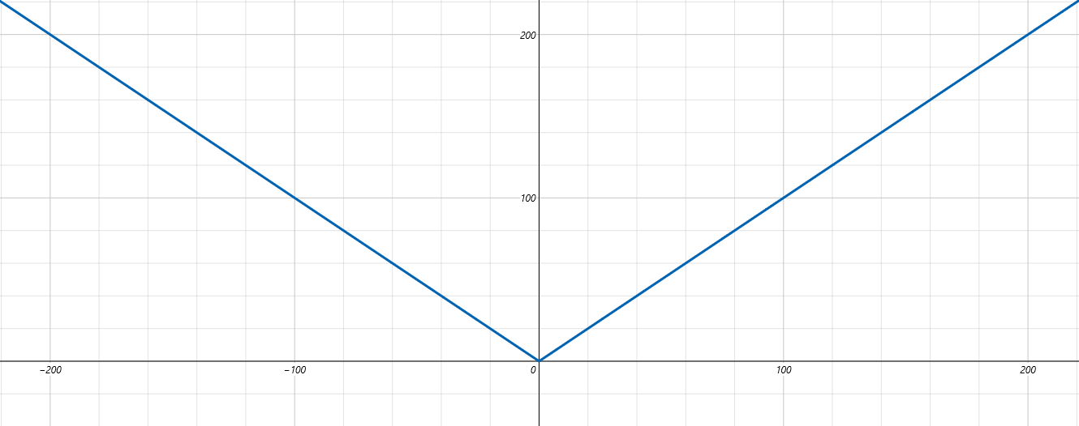

If |x| = y then the graph has two variables x,y and looks almost like a quadratic x²= y but is not a polynomial because it has a sharp corner at the vertex.

We have f(x) = |x| where f(x) =|x| ±b using “±b” is a vertical shift or f(x) = |x ±a| using “±a” will shift horizontally. Using ±a inside the absolute bars is reminiscent of vertex form f(x) = (x –h)²+k. Things inside grouping symbols directly affect the domain of x while things outside grouping symbols affect the range of y.

