Graphing Inequalities

When you graph an inequality you have to shade a region either above or below a line. If you have two inequalities forming a compound inequality you have either intersection or a union. An intersection is a shaded region with an unshaded region above and below. A union is two shaded regions with an unshaded region in the middle forming a gap where no solutions exist. A solution to x>a is a dashed line and x≥a is a solid line.
Vertical lines mean solutions are on the x axis only and anything else is an imaginary solution of the form a+bi.

x>5 x≥5 x<5 x≤5
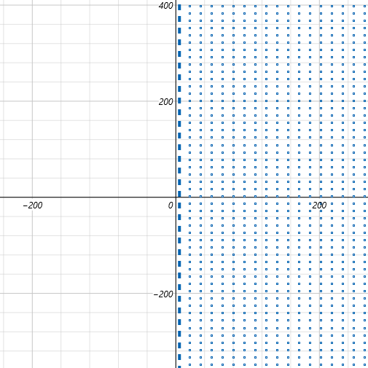
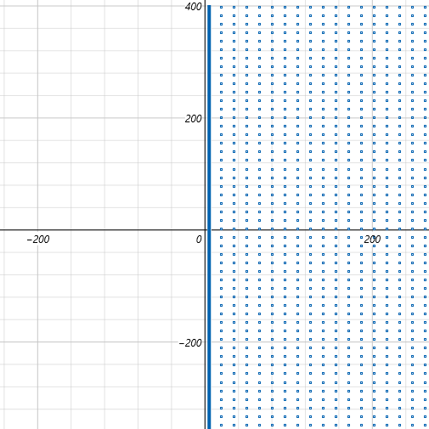
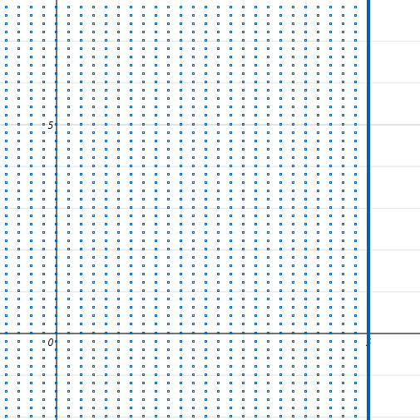

- Graph x>a on a axis you get: arrow pointing right with “a” circled.
- Graph x<a on a axis you get: arrow pointing left with “a” circled.
- Graph x≥a on a axis you get: arrow pointing right with “a” dotted.
- Graph x≤a on a axis you get: arrow pointing left with “a” dotted.
- Graph x>a on a plane you get: a dashed vertical line at “a”. All points to the right highlighted.
- Graph x<a on a plane you get: a dashed vertical line at “a”. All points to the left highlighted.
- Graph x≥a on a plane you get: a solid vertical line at “a”. All points to the right highlighted.
- Graph x≤a on a plane you get: a solid vertical line at “a”. All points to the left highlighted.

We graph x>5 using a number line putting a circle at 5 and drawing arrow to the right. (5,∞) is all solutions.
We graph x≥5 using a number line putting a dot at 5 and drawing arrow to the right. [5,∞) is all solutions.
If we have an inequality with an absolute value we have two sets that must be graphed together.
If |x| > 5 then x could be –5 or 5. If x < –5 then x: (–∞, –5). If x > 5 then x: (5,∞).

|x|>5 means we need to be more than 5 units away from “0” on a number line. Using absolute value bars means it could be 5 units to the left like –5 or 5 units to the right like 5. Absolute value symbols remove the negative sign.
Moving 6 units to the left is written as –6 but means positive 6 here since distance must be positive always.
We need to be more than 5 units so x can be (–6,– 7,–8...) or x could be (6,7,8...). We know:

- 6,7,8...∞ is more than 5 but could x be –6 or –7 or –8 or even “approach” –∞.
- |–6|>5 because 6>5
- |–7|>5 because 7>5
- |–8|>5 because 8>5
- |–∞|>5 because ∞>5
- We graph x>5 and x< –5 excluding middle values with a gap between the interval –5 and 5.
You should know the following:

- How to solve an inequality using algebra for 1 variable.
- How to write answers in set builder and in interval notation.
- How to graph solutions using a number line using circles and dots.
- How to explain why dividing by a negative causes the sign to flip.
- How the addition principle can be used to avoid multiplication or division of a negative number.
- What an identity for a compound inequality is of the form A∩B = A.
- What an identity for a compound inequality is of the form [a,b]∪B = [a,b].
- When solutions are redundant or nonexistent (trick questions).

1–a< –2 and 2a+1 >9
–a< –3 and 2a >8
a> 3 a>4 This is a special case intersection with the variable greater than both numbers.
a: (3,∞)

“a” is more than 3 is the solution. Place circle at 3 and draw arrow to the right. Being greater than 3 supercedes being greater than 4. Separately you have two graphs with right facing arrows so chose the value with the lowest value. If both inequalities had left facing arrows you would chose the number with the highest value; if a<3 and a <4 then solution is a is less than 4, a<4 is the answer giving (–∞,4).

3a – 7 –10 or 5a+2 ≤ 22 solve each side
3a – 7 > –10 or 5a+2 ≤ 22
3a > –3 or 5a ≤ 20 addition principle
a > –1 or a ≤ 4
a> –1 ∪ a≤4 interval notation
a: (–∞,4] ∪ (–1,∞) interval notation
{a|a> –1} ∪ {a|a≤4} set builder notation

To graph on the number line place a circle at –1 and draw a right arrow indicating all numbers less than –1 are solutions. Then place a dot at 4 and draw a left arrow indicating all numbers less than 4 are solutions. Note this causes a special case in that the solution must be a union of a> –1 and a≤4. The creates two graphs that have meeting arrows but are a union. A union adds all numbers from both sets. Add all the numbers from the interval (–∞,4] and (–1,∞).

(–∞,4] gives us all negative numbers plus all numbers including fractions from 0 to 4.
(–1,∞) gives us all positive numbers plus all fractions between –1 to 0 not including –1.
We get –1 from (–∞,4] plus all the fraction from –1 to 0 and we get those fractions again from (–1,∞).

The union will have all negative numbers and all positive numbers so we have the set (–∞,∞).
The set of all real numbers is the entire number line, we write x:(–∞,∞) as {x|xεr} or {x| –∞<x<∞}.
“{x|xεr}” says “ for x: x is a member of the reals” meaning x is any real number on the real number line.
“ε” is a Greek letter called epsilon and here means “member of a set”.
Having the entire number line means we do not have a gap and therefore technically have an intersection written as a union. If set A = all x– and set B = all x⁺ then the union “A∪B” will equal the intersection A∩B.

If a> –1 then (–1,∞) If a≤4 then (–∞,4]. We can call (–1,∞) set A and (–1,∞) set B and then say the union of set A and B is the domain (–∞,∞). We take the lowest value and the highest value and write them as endpoints. Because the two graphs over lap there is no gap and we have to use the “and” operator and call our union an intersection instead of a union.

How to solve an inequality using algebra for 1 variable.

If an inequality has one variable it will have one inequality like x–m > n or it will have two like x–m>n and x –p <q, where “m,n,p,q” will be constants. You solve each inequality separately following the addition principle then write your answer in interval notation like: a<x<b, x>a and x<b, or x:(a,b). Or you write the answer in set builder notation using {x|x>a ∩ x<b} for intersections and {x|x>a ∪ x<b} for unions.

How to write answers in set builder and in interval notation. This is explained above.
How to graph solutions using a number line using circles and dots.

You use algebra to solve the inequality and mark the number on the graph with a circle if not included or a dot if it is included. You draw an arrow on the number line moving away from the marked number towards positive infinity if x is greater than the number or negative infinity if x is less than the number. Every point from the marked number to ±∞ is a solution. If you have a compound inequality there should be a segment for intersections and these do not ever go to any infinity. If you have a union then you should have a gap where the left side goes to – ∞ and the right side goes to ∞ except for special cases:

- Special case #1:
You have a phrase using “or” or “union” and expect a gap but find there is no gap. This technically is an intersection and is written using the wrong terminology. Intersections will never have gaps but unions mostly do but sometimes do not. If a union does not have a gap the union is the set of all negative numbers united with all positive numbers. There may be an offset but in general it will be set A ∪ set B where set A= (–∞,0]), set B= [0,∞). An “offset” means that “0” might be a little than or more than 0 like (–∞,5)∪(2,∞). The first one is all negative numbers plus some positive ones that overlap and surpass the positive ones from the next set. The second set has all positive numbers except a few which are included in the first set. By having all The numbers from the number line that the second set lacks the first set completes the entire number line. We give (– ∞,∞) as the domain of the inequality and write it as an intersection of the form a<x<b with –∞<x<∞. Note that x cannot equal ±∞ because ∞ is not a single number but rather a concept of an ever increasing quality. For this reason we never use brackets to include ∞ and have to use parentheses.

- Special case #2
You have a union and there is no gap but both graphs extend to the same infinity. By same “infinity” I mean either both to ∞ or both to –∞. Each inequality starts at different numbers but moves either both to the right or both to the left. This would not be the entire number line, it would not have a gap between two sets, but also it would not be able to be written using the compound inequality notation a,x<b because this is reserved for intersection which are line segments. It would be easier to think of an inequality as a “ray” that has one endpoint and extends in one direction forever. If x≥4 then we put a dot at 4 and write over the number line with an arrow pointing to the right saying the solution to x≥4 is “all numbers from 4 to ∞”. If x≥400 then we do the same but start at 400 instead of 4.

If we have the compound inequality x≥4 or x≥400 one arrow start at 4 and ends at ∞. The other arrow starts at 400 and ends at ∞. We will have a “ray” from 4 to ∞ which overlaps “400 to ∞”. We can not write this as a<x<b because there is nothing to say x is less than. We write it as a union “x≥4 ∪ x≥400”. The only thing I can think of is maybe “4≤x≥400” with arrows facing away from x. This is nonstandard but simpler.
- Special case #3
If both arrows overlap pointing to the left then you would have a≥x≤b. This is non standard because of archaic rules that do not seem to be very helpful: There is an implication that there are two conditions that must be met indicating we have an intersection but I do not feel this is true. There is little justification for this claim and boils down to arguing over language. I am tempted to do away with the old style I have benn teaching and write a new style of notation that is simpler and more precise. To be continued...

How to explain why dividing by a negative causes the sign to flip.

Say “Dividing by a negative reverses signs of the values so this must be shown by reversing the sign of the inequality”. We are done and there is nothing more to prove. We want to be able to effectively state a conclusion using logical arguments and not need to depend heavily on equations for illustration. We want to be succinct in our responses. We want to say a lot without using more time than necessary. In politics and debate speakers are given 2 minutes to respond. If they go over the time given they will be cut off. In life lacking economy of words leads to people losing interest or the speaker rambling. Rambling indicates he doesn't know what he is talking about and is wasting other peoples or his own time. Please have respect for other peoples and your own time so that everyone can have longer productive lives.

If proof is asked (eye roll) counter with asking for a proof that refutes your answer. If a refutation can not be proven true then you are assumed to be right. The burden of proof lies with the person making accusations that you are wrong, you are never required to prove anything to anyone. Offering proof is done as a courtesy to help convince people you respect not suffer trolls we question the obvious. If you ever make spurious claims however then what you are saying is not obvious and so offering proof would be the polite thing to do otherwise you are asking people to trust you on blind faith and that is not only rude but abusive. Mathematicians prove things. Without proof they can not claim moral nor intellectual superiority. We base decisions on who has the right answers and the most accurate results not feelings, bias or nepotism. Bias is corruption and will lead to erroneous results and hurt innocent people which is immoral. I am not going to prove it here but it is easily demonstrable. If we do offer proof it is to help younger students learn the addition principle:

–2x < 0 This tells us that x must be a positive number since no positive product can be less than 0.
x > 0 Dividing by –2 flips the sign to show that x is a positive number and therefore larger than 0.■

–2x > 0 This tells us that x must be a negative number since no negative product can be more than 0.
x < 0 Dividing by –2 flips the sign to show that x is a negative number and therefore less than 0.■

How the addition principle can be used to avoid multiplication or division of a negative number:

You can add the variable containing a negative coefficient to both sides:

–3x+4 < 8 Normally we would have x > –⁴/₃ by dividing by a negative and flipping the sign.
–3x+4 +3x < 8 +3x Instead cancel using additive inverses.
4 < 3x+8 Now the coefficient is positive.
–4 < 3x
–⁴/₃ < x Divide by a positive number to avoid reversing the inequality sign.

What an “identity for a compound inequality is” of the form A∩B = A:

An identity means something is canceled to equal 1 so that both numbers, or in this case sets, are identical.
If A∩B = A then A = B.

Set A = (2,4,6)
Set B = (2,4,6)
Set A ∩ Set B = (2,4,6)

Set A = [2,18) also A = x≥2 and x 18 also A = 2≤x<18
Set B = [2,18) also B = x≥2 and x 18 also B = 2≤x<18
A∩B = [2,18) also A∩B = x≥2 and x 18 also A∩B = 2≤x<18

The intersection lists all matching numbers. All numbers math so the intersection is identical and therefore an identity of both set A and set B.

What an “identity for a compound inequality is” of the form [a,b]∪B = [a,b].

The identity is both sets are identical. For a union:

Set A = [–3,4]
Set B = [–3,4]
Set A∩B = [–3,4]

Note that we said a union extends to either –∞ or ∞ but this is only true if using the form a<x or x<b.
A closed interval of the form x = [a,b] has the least number and greatest number are contained so the set does not have ±∞ in it.

Inequalities in two variables

The supply and demand graphs used inequalities with variables and then graphed them. Inequalities containing graphs can be used to solve certain word problems like where to place cell phone towers to get better reception.

Two towers provide parabolic shaped coverage. Where they overlap is shown in purple. By itself the purple region is the solution to the system.

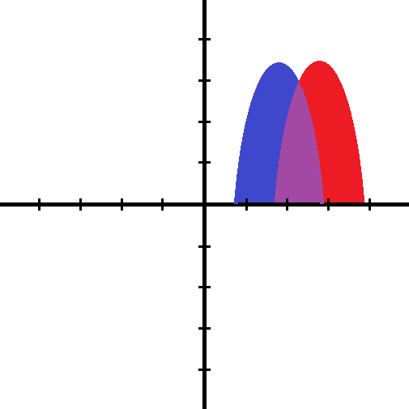
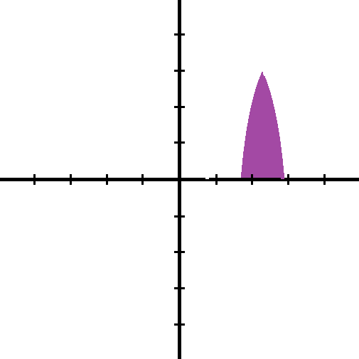
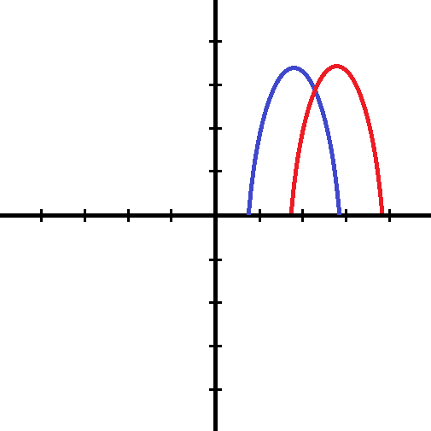

Using a hypothetical scenario; A person standing in either the red or blue zone will get 3 bars of signal strength or less. By standing in the purple region they will get 5 bars the maximum signal strength possible.

- Blue spots or red spot get less than optimal reception.
- Any spot in the purple region will get best reception and represents a solution.
- The solution to the inequality will be any ordered pair that fits the domain and range.

Domain is x values on the x axis. Range is y values on the y axis.
Domain is the furthest left and right x value a function has.
Range is the lowest and highest value a function has. Its minima and maxima.
I will show how to add functions to find intersections using compositions.

Before we graph inequalities of nonlinear systems we should learn linear system inequalities. The previous hypothetical is a creative application that would be found in real life using calculus or spherical trigonometry.
It was offered for exposure.

Linear Inequalities

y = Mx+b is the y intercept form of a linear equation. If we change the equals sign to an inequality sign we have a linear inequality:

x=y x<y x>y
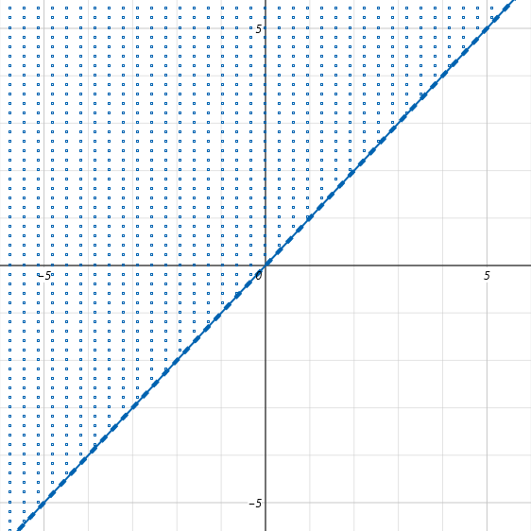
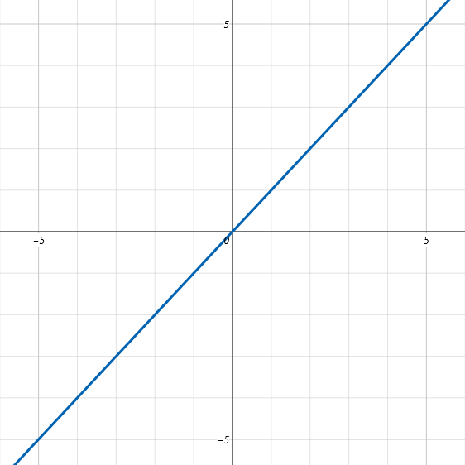

- f(x)= y then all points where (x,x) are solutions.
- f(x)< y then all points where x<y are solutions.
- f(x)>y then all points where x>y are solutions.

For x=y {(1,1);(2,2);(3,3)...} are solutions.
For x<y {(1,2);(1,3);(1,4)...} are solutions. There are many more.
For x>y {(2,1);(3,1);(4,1)...} are solutions. There are many more.

A linear equation is a line, a linear inequality is a half-plane divided by a dashed line if using > or < or a solid line if using ≥ or ≤.

Any point in the blue shaded region will be a solution for x>y. The line y=x acts as a border where any below the line will have a point given by an ordered pair where x is a bigger number than y. Any point in the pink region will have an ordered pair where y is greater than x. Any point in the pink region is a solution for y>x.

Graphing Linear Inequalities

Take a linear equation and graph the line it states. Replace the equals sign in a linear equation with an inequality sign. Shade the half plane that represents the region that contains all solutions. In math we call regions like this “fields”. The shaded region is the field representing all possible solutions given as ordered pairs. Your field will either be all points above or below the line given by the equation version of your linear inequality.

Graph y ≤ 1.5x+2 Graph y ≤ –2x –3 Graph both

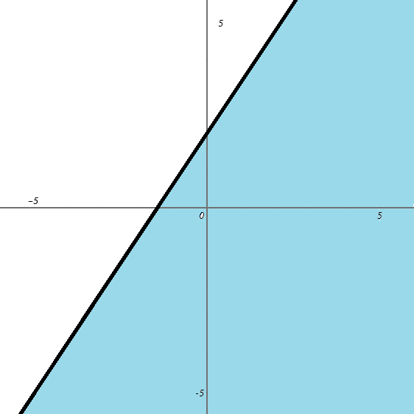
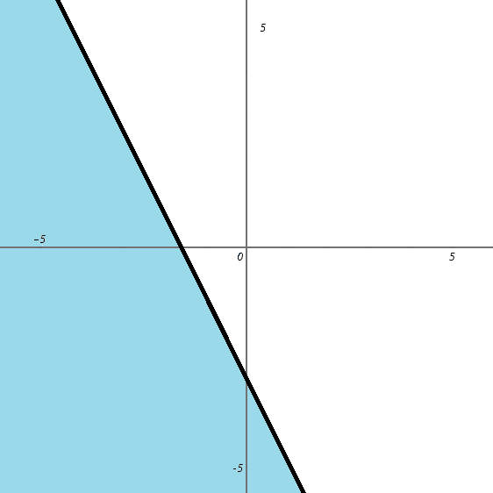
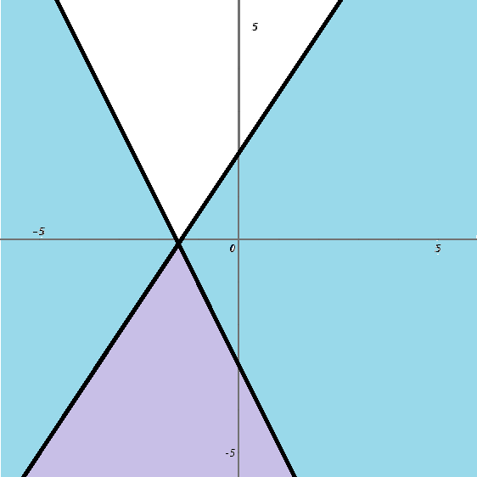

solutions in blue solutions in blue solutions in lavender

Whereas a system of equations is where both equations share a point, a system of inequalities is the shaded region shared by both inequalities. For both y≤1.5x+2 and y ≤ –2x–3 all the points under both lines are the solutions to the question,” what point is less than 1.5x+2 and –2x –3?”. A system wants a solution that satisfies both constraints.

I show solutions using red and blue for two functions and purple for where they overlap.
Changing y ≤ –2x –3 to y ≥ –2x –3 shades the half-plane above the line instead of below it.

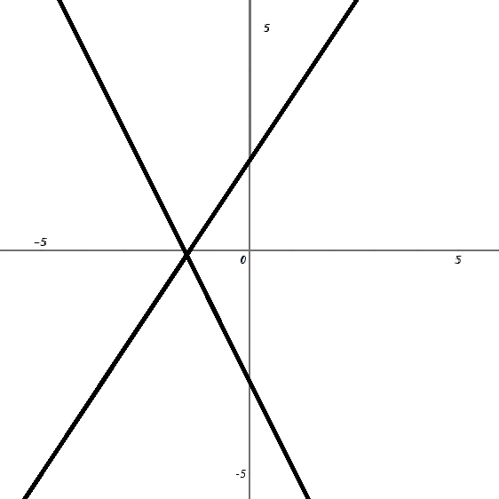

y= 1.5x+2 y≤ 1.5x+2 y≥ –2x –3 y≥ –2x –3
y= –2x –3 y≤ 1.5x+2

- Here is y = 1.5x+2 and y = –2x –3. They have solution of (–¹⁰/₇, – ¹/₇).
- Here is y ≤ 1.5x+2. Since y is less then 1.5x+2 solutions will below the line.
- Here is y≥ –2x –3. Since y is greater than –2x –3 any point above the line will be a solution.
- Here is y≥ –2x –3 and y≤ 1.5x+2. The solutions must be above y≥ –2x –3 and below y≤ 1.5x+2.

Dealing with two variables can be easier than one variable because it uses simpler terminology.
One variable is hard due to confusing notation. This is easy because you have an easy way to identify solutions.
You can visualize solutions...if “y>” then solutions are above the line, if “y<” solutions below the line, if two inequalities then solutions are where two half-planes overlap.

Blue region is solutions to y≤ 1.5x+2
Red region is solutions to y≥ –2x – 3
Purple region is solutions to both inequalities.
Using transparent sheets we could take the graphs of y≤ 1.5x+2 and y≥ –2x – 3 and superimpose them onto each other.

