Vertical lines

Vertical lines are controversial. How would you graph x=5? On a number line you put a dot at 5. On a chart you put a vertical line at (5,0). Why does x=5 make a line instead of a dot? As a function for a line we can generate this line but it fails the vertical line test so it is not a function. Graphed functions like this are parametric equations. A line is made because we are stating that for a line every x value of all points is the same constant.

x = 5 x<5 x>5 x≤5
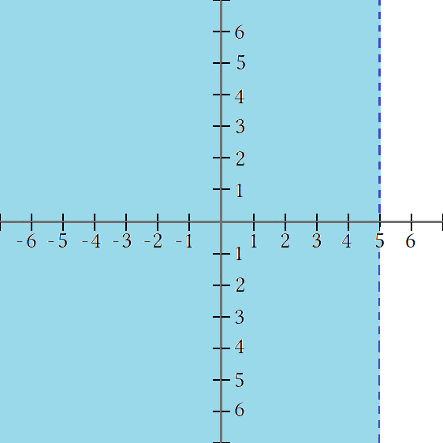
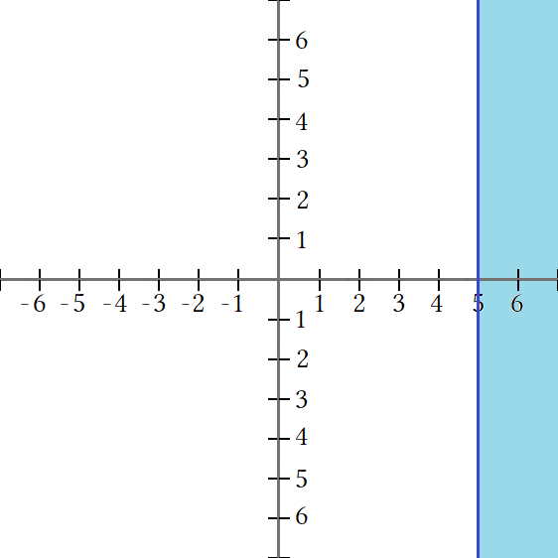
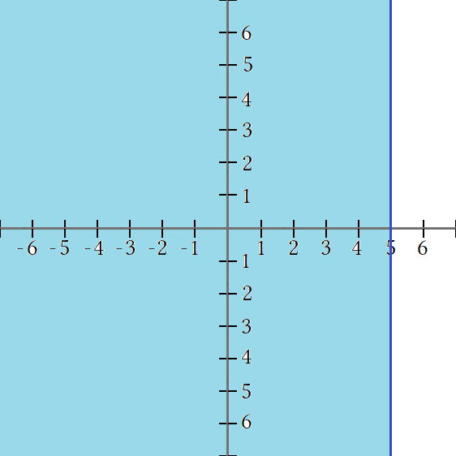
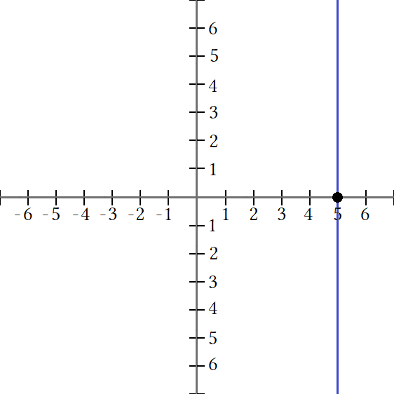

The solution for x=5 is all points on the line. Points not the x intercept are imaginary points.
The solution for x≤5 is all points in the half-plane left of the line x = 5. Points on the line x = 5 are included.
The solution for x<5 is all points in the half-plane left of the line x = 5. Points on the line x = 5 are excluded.
The solution for x≥5 is all points in the half-plane right of the line x = 5. Points on the line x = 5 are included.
The intersection of x≥3∩x≤5 is the lavender shaded region where x≥3 and x≤5 overlap.

x≥3 x≤5 x≥∩x≤5 x≥3∩x≤5

A system of three lines Ax+By=C, Ax₁+By₁=C₁ , and Ax₂+Ax₂=C₂ = form a triangle where the solution is any point in the perimeter of the triangle. More equations can lead to a polygon of more sides such as a square, pentagon et cetera. When given three inequalities graph the lines as equations and then find any vertices formed. To find vertices solve using a system of equations, the shared point will be the vertex for those two lines.

