Linear programming

Linear programming was developed during WWII to improve logistics when shipping supplies and troops to Europe. During the war the corner principle was proven to be true. It is a branch of math that finds the total profit of an objective function subject to constraints on the problem. An objective function is where you are counting objects instead of just pure numbers. Constraints are maximum and minimum values, in other words values that x or y cannot be and thus domain and range are limited by use of inequality symbols.

The corner principle: An objective function F=ax+by+c depends on and is subject to constraints on x and y.

- Graph the system of inequalities and find the vertices.
- Find y value at each vertex. Largest and smallest values are the maximum and minimum of the function.

Quantities to be maximized depend on other variables. A landscaper's profits might depend on number of flower beds and trees he plants. If he makes $5 per flower bed and $9 per tree we can write variables for flowers as f and trees as t so that 5 = f and 9 = t.

The objective function of profit would be 5f+9t = P.
If he has to plant at least 3 flower beds then f≥3 is a constraint.
If he can not plant more than 10 plants s+t ≤10 is another constraint.
We have two constraints that form a double inequality.

If flowers beds cost $20 and trees $50 and cost can not exceed $350 this is a third constraint.
20f+50t≤350 where $20 per flower bed + $50 per tree ≤$350. “f” and “t” are how many of each type of plant.

The problem is “how many trees and flower beds does he plant to make the most money?”. This is fairly simple.
Since he can not plant more than 10 plants, if he makes $9 on trees and $5 on flowers then planting 10 trees would make the most money but he can't do that because he has to plant at least 3. Then he should plant 7 trees and 3 flowers. To make the most money you plant the least amount of flowers required which is 3. But trees are expensive and planting 7 trees will exceed the customer's budget of $350. We know this because 7∙$50 = $350 so if 7 plants max out our budget we can not afford the 3 remaining plants needed to complete the project.

The objective function 5f+9t = P is subject to five constraints. Each constraint limits domain or range. Domain and range list what is possible for an answer. The area enclosed by all constraints is called area the of feasibility.

- f+t ≤10 Can not have more than 10 plants. Call this the max function.
- 20f+50t≤350 Can not have the combined total price of plants exceed $350. Budget function.
- f≥ 3 Can not have less than 3 flower beds. Additional constraint function.
- f≥0 Can not have a negative number for objects. This is just the x axis
- t≥0 Can not have a negative number for objects. This is just the y axis.

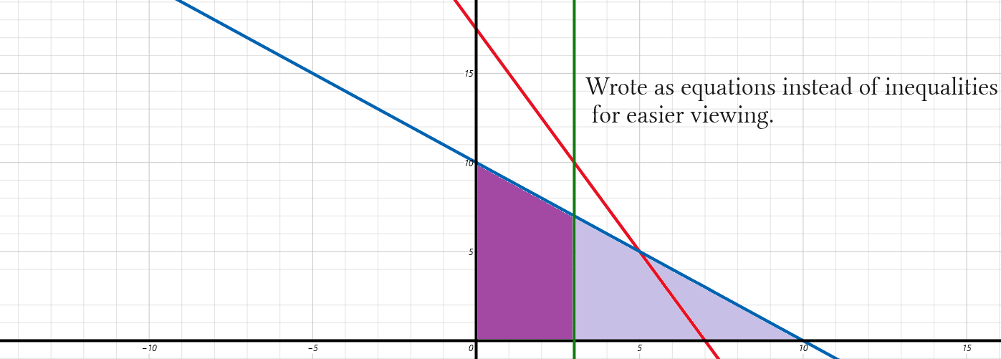

Maximum profit is where the max and budget functions intersect at (5,5). This intersection represents a solution to the correct ratio of flower beds to trees. The purple area is possible choices that are not excluded by constraints. This gives a rough idea of where our solution falls on the graph but is imprecise. The corner principle states that the max solution must be a corner called a vertex where two lines meet. The blue function makes a triangle with two axes. The red function intersects this triangle forming a quadrilateral. The vertex where the blue function is intersected forms the fourth corner of the quadrilateral. This is the corner that is referred to in the corner principle.

If we have one type only of plant we have 10,0 or 0,10. This is the line -x+10≥y which in normal form is x+y≤10. This line is negative because it is an inverse proportion. This line contains every combination of 10 plants. This is the f+t ≤10 constraint. Normally we calculate values using tables. According the list five of each type of plant would yield the most profit without going over budget. After finding (5,5) we do not need to continue the list. Further answers are just decreased profit. Find the vertices by solving systems of equations using direct substitution or by checking visually by graphing:

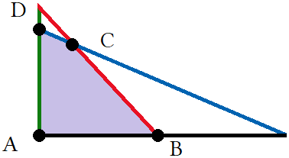
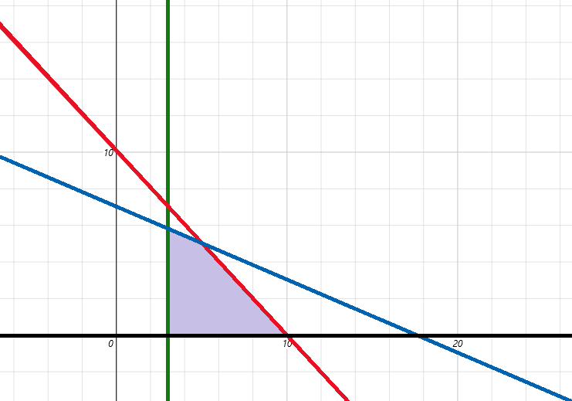

The purple region is the feasible region where any point inside the region will be an ordered pair that for (x,y) is (flowers,trees). These points are every possible combination of flowers to trees you can have and not go over $350. Note that flowers and trees must be integers so fractions do not count.
Using the f+t ≤10 constraint:

10 trees + 0 flower bed = $500 Set one variable to 0 to create a base line.
9 trees + 1 flower bed = $470 We subtracted $50 then added $20 for a total decrease of $30.
8t+2f = $440 We subtract $30 every time.
7t+3f = $410
6t+4f = $380
5t+5f = $350 This would be our solution for maximum profit.

Flowers | Trees | Cost | Profit
(10,0) | $5(10)+$9(0) | $200.00 | $50.00
(9,1) | $5(9)+$9(1) | $230.00 | $54.00
(8,2) | $5(8)+$9(2) | $260.00 | $58.00
(7,3) | $5(7)+$9(3) | $290.00 | $62.00
(6,4) | $5(6)+$9(4) | $320.00 | $66.00
(5,5) | $5(5)+$9(5) | $350.00 | $70.00

The smallest and largest profit is $50 at (10,0) and $70 at (5,5). This easy example can serve as a guide for harder problems with more constraints. This table uses pre-algebra, linear programming uses algebra to solve larger systems using series or matrix notation. You can use a graphing calculator to find points A,B,C, and D but then have to plug those ordered pairs into the objective function can calculate the highest and lowest value using algebra. At its core linear programming deals with mixture problems using the standard form for an equation Ax+By = C but uses constraints to change the equals sign to an inequality sign. Further constraints applied are represented as additional inequalities that creates a system of inequalities. Adding constraints shortens range and creates subsequent series with fewer terms.

S₁₁: (a₁, a₂, a₃, … , a₁₀) Potential profit as a series.
S₁₁: (50, (50+9–5), ((50+9–5)+9–5), … ,90) Common difference is 9 – 5 = $4.
S₁₁:(50, 54, 58, … 90) The series is finite only having 11 possible terms.
S₁₁:(50, 54, 58, 62, 66, 70, 74, 78, 82, 86,90) This gives profit as a function of flowers:trees.

S₈: (a₁, a₂, a₃, … , a₈) Potential cost as a series.
S₈: (200, (200+50–20), ((200+50–20), … , 350) Common difference is 50 – 20 = $30.
S₈: (50, 54, 58, … 90) The series is finite only having 8 possible terms.
S₈: (50, 54, 58, 62, 66, 70, 74, 78, 82, 86,90) This give profit as a function of flowers:trees.

S₆: (200, 230, 260, 290, 320, 350) Cost to profit function

S₁₁ models buying 1 to 10 trees with output as profit. S₈ models cost of buying 10 to 5 flowers with minimum 3 flowers as a constraint. S₆ models 10 to 5 flowers with the constraint of maximum $350 budget.
You are taking a test in which multiple choice questions are worth 10 points each and short-answer questions are worth 15 points each. It takes you 3 minutes to answer each multiple-choice question and 6 minutes for each short-answer question. The time allowed is 60 minutes, and no more than 16 questions can be answered. Assuming that all your answers are correct, how many items of each type should you answer in order to get the best score?

The caveat here is the time constraint. Familiarize yourself with the problem by tabulating it. The hardest part is creating formulas, translating multiple step problems into equations, then writing tables. There are different ways to setup a table. I show examples to guide readers until they find what works for them. The more examples you are exposed to the better your skill will be. Put all pertinent data into the table.

Type of question | Points | Time | # completed | Total time | Total points
Multiple-choice | 10 | 3 | x | 3x | 10x
Short-answer | 15 | 6 | y | 6y | 15y
Total |  |  | x+y ≤16 | 3x+6y≤60 | 10x+15y=C

x+y ≤16 Combinations answers must be equal to or less than 16.
3x+6y ≤60 Problems must add up to less than 60 minutes.
10x+15y = C Normal form Ax+By=C to setup the system.

Note that in standard form the coefficients act as price or points or some value as a quantity and x and y are the number of groups of each quantity. This is true for all standard form equations. Variables are how many groups and coefficients are amount per group. 1 question is worth 10 points then we have 10 points per question where
points are grouped into groups called questions. The value of each group is 10 points or 15 points. We can rename C to T can have the objective function 10x+15y = T for test.

10x+15y = T
x+y ≤ 16
3x+6y ≤ 60
x ≥ 0 Can't have negative number of questions.
y ≥ 0 Can't have negative number of questions.

Obvious points are A:(0,0), B:(16,0), D:(10,0). C is found by solving the system of equations that from the vertex of C. x+y=16 and 3x+6y=60 are the lines that form C. We scale x+y=16 to become 3x+3y=48 and subtract it from 3x+6y=60. 3x–3x+6y–3y=60–48 becomes 3y=12 which is y=4.

Plugging y = 4 into x+y = 16 gives C:(12,4). Back substituting (12,4) into 10x+15y=T gives T = 180.
The highest score is 180 points when 12 multiple-choice and 4 short-answer questions are answered. This is used as a form of Game Theory to increase odds of attaining highest score possible. Tactics like this are used on Jeopardy, poker, other game shows, contests or gambling.
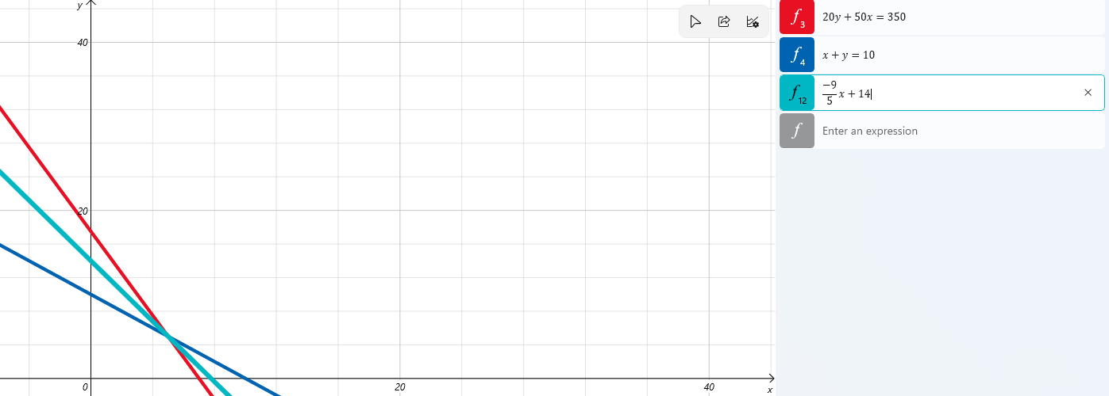

The fastest way to solve is to find intersection of maximum and budget function.
You can use the objective function to make a vertex with the maximum function.

The objective function was 5f+9t = P which is a slope of –⁵/₉. Putting into y intercept form gives y = ^{–9}/₅+x+b.
We have to calculate b. There are methods. Here we can take the absolute value of slope vales and add. This is just the coefficients of the normal form 5f+9t = y. I do not think you need to invoke inequalities and absolute value. Just add coefficients to find vertical rise. The objective function is transformed into ^{–5}/₉x+14:

^{–9}/₅ = – 9 and 5
|–9| + |5| = b
9 + 5 = 14

Change standard form into y slope intercept form:

ax+by=c 5x+9y =14 5x+9y = 70
by = –ax+c 9y = –5x+14 9y = –5x+70
y = –^{ax+c}/_{b} y = ^{–5x+c}/₉ y = ^{–5x+70}/₉
y = –ª/_{b}x + ^{c}/_{b} y = –⁵/₉x+^{c}/₉ y = –⁵/₉x+ ⁷⁰/₉

Converting the objective function is not necessary but doing so teaches some fundamental skills. Formulas use ABC for constants. You are supposed to replace all capitals with constants. The objective function 5f+9t + P does not give a constant for P. You are left with 2 variable form that cannot be solved because you do not have enough information. Using the point slope form and plugging in a point you can find P to be 70 which is the maximum profit we found.

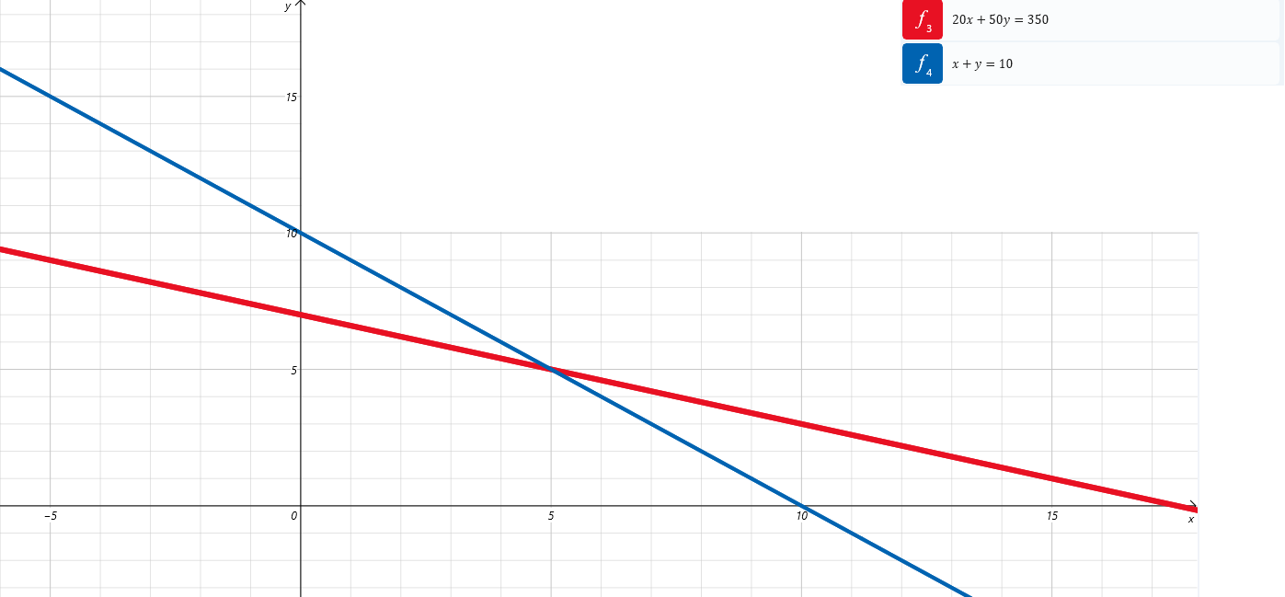

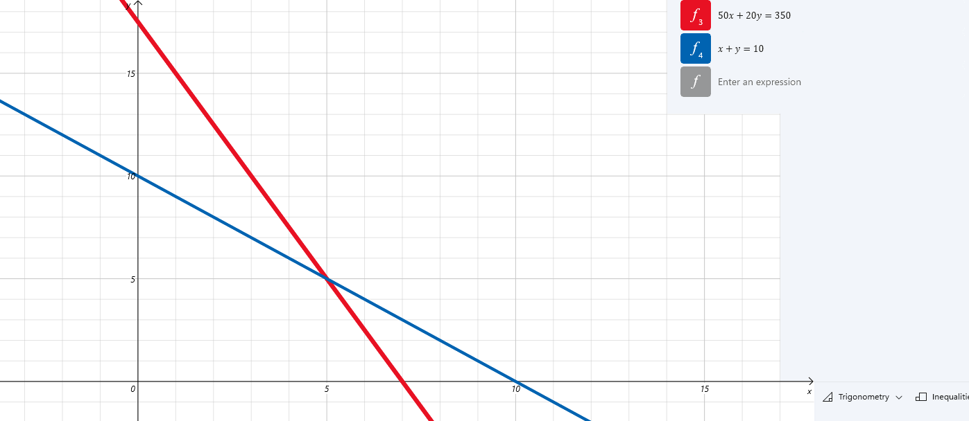

Depending on if you label your axes (f,t) or (t,f) you end up with one of these two graphs. Both will still meet at (5,5) giving $70 as maximum profit. The two graphs are rotated 90° from each other. They are inverses where x is inverted with y. The blue function is the same but 50x+20y = 350 and 20x+50y = 350.

Inverses are two functions that are the same but rotated 90° apart. For a linear function we see it forms a triangle with the x and y axes. A right triangle is the diagonal of a rectangle. Then this is like two rectangles rotated 90°. The intercepts are the corners of the rectangle. One graph has (0,17.5) and (7,0). The other has (0,7) and (17.5,0). As rectangles this is 717.5 or 17.57. We can describe right triangle with a single point as the run and rise from the origin with (x,y). If (7,17,5) we have base 7 height 17.5, if (17.5,7) we have base 17.5 height 7. The first triangle we call the pre-image the second we call the image which is the rotated rectangle, triangle, or line.
These applications are from Bittinger Algebra. I included them because they are diverse and well written.

Lunch Time Profits

Elroy's lunch cart sells burritos and chili. To stay in business, Elroy must sell at least 10 orders of chili and 30 burritos each day. Because of limited space, no more than 40 orders of chili or 70 burritos can be made. The total number of orders cannot exceed 90. If profit is $1.65 per chili order and $1.05 per burrito, how many of each item should Elroy sell in order to maximize profit?

Milling

Johnson Lumber can convert logs into either lumber or plywood. In a given week, the mill can turn out 400 units of production, of which 100 units of lumber and 150 units of plywood are required by regular customers. The profit on a unit of lumber is $20 and on a unit of plywood is $30. How many units of each type should the mill produce in order to maximize profit?

Cycle production.

Yawaka Manufactures motorcycles and bicycles. To stay in business. The number of bicycles made cannot exceed 3 times the number of motorcycles made. Yawaka lacks the facilities to produce more than 60 motorcycles or 120 bicycles. The total production pf motorcycles and bicycles cannot exceed 160. The profit on a motorcycle is $1340 and on a bicycle is $200. Find the number of each that should be manufactured in order to maximize profit.

Gas mileage

Roschelle owns a car and a moped. She has at most 12 gallons of gasoline to be used between the car and the moped. The car's tank holds at most 10 gallons and the moped's 3 gallons. The mileage for the car is 20 mpg and for the moped is 100mpg. How many gallons of gasoline should each vehicle use if Roschelle wants to travel as far as possible? What is the maximum number of miles?

Test Scores

Eddy is about to take a test that contains short-answer questions worth 4 points each and word problems worth 7 points each. Eddy must do at least 5 short-answer questions, but time restricts doing more than 10. She must do at least 3 word problems, but time restricts doing more than 10. Eddy can do no more than 18 questions in total How many of each type of question must Eddy do in order to maximize her score? What is this maximum score?

Test Scores

Phil is about to take a test that contains matching questions worth 10 points each and essay questions worth 25 points each. He must do at least 3 questions matching questions, but time restricts doing more than 12. Phil must do at least 4 essays, but time restricts doing more than 15. If no more than 20 questions can be answered, how many of each type should Phil do in order to maximize his score? What is his maximum score?

Farming

Thano's farm consists of 240 acres of cropland. Thano wishes to plant this acreage in corn or oats. Profit per acre in corn production is $400 and in oats it is $300. Furthermore, the total number of hours of labor available during the production period is 320. Each acre of land in corn production uses 2 hr of labor during the production period, while production of oats requires 1 hr per acre. Determine how the land should be divided between corn and oats in order to maximize profit.

Investing

Rosa is planning to invest up to $40,000 in corporate or municipal bonds, or both, She must invest from $6,000 to $22,000 in corporate bonds, and she does not want to invest more than $30,000 in municipal bonds. The interest on corporate bonds is 8% and on municipal bonds is 7.5%. This is simple interest for one year, How mic should Rosa invest in each type of bond in order to earn the most interest? What is the maximum income?
Investing

Jamaal is planning to invest up to $22,000 in City Bank or State Bank, or Both. He wants to invest at least $2,000 but no more than $14,000 in City Bank. State Bank does not insure more than a $15,000 investment, so he will invest no more than that in State Bank. The interest in City Bank is 6% and in State Bank 6.5%. This is simple interest for one year. How much should he invest in each bank in order to earn the most interest? What is the maximum income?

Coffee Blending

The Coffee Peddler has 1440 lb of Sumatran coffee and 700 lb of Kona coffee. A batch of Hawaiian Blend requires 8 lb of Kona and 12lb of Sumatran, and yields a profit of $90. A batch of Classic Blend requires 4 lb of Kona and 16 lb of Sumatran, and yields a $55 profit, How many batches of each kind should be made in order to maximize profit? What is the maximum profit?

Textile Production

It takes Cosmic Stitching 2 hr of cutting and 4 hr of sewing to make a knit suit. To make a worsted suit, it takes 4 hr of cutting and 2 hr of sewing. At most 20 hr per day are available for cutting and at most 16 hr per day are available for sewing. The profit on a knit suit is $34 and on a worsted suit is $31. How many of each kind of suit should be made in order to maximize profit?

Biscuit Production

The Hockeypuck Biscuit Factory makes two types of biscuits, Jumbos and Mini-mites. The oven can cook at most 200 biscuits per hour. Jumbos each require 2 oz of flour, Mitimites require 1 oz of flour, and there is at most 300 oz of flour available. The income from Jumbos is $1.00 and from Mitimites is $0.80. How many of each type of biscuit should be made in order to maximize income? What is the maximum income?

Airplane Production

Aloha Tours has two types of airplanes, P-1 and P-2, and contracts requiring accommodations for a minimum of 2000 first-class, 1500 tourist-class, and 120 economy-class passengers, whereas airplane P-2 costs $25 per mile to operate and can accommodate 80 first-class, 30 tourist-class, and 40 economy-class passengers, How many of each type of airplane should be used in order to minimize the operating cost?

Airplane Production

A new airplane P-3 becomes available, having an operating cost of $37.50 per mile and accommodating 40 first-class, 40 tourist-class, and 80 economy-class passengers. If airplane P-1 were replaced by airplane P-3 , how many P-2's and how many P-3's would be needed in order to minimize the operating cost?

Furniture Production

Guy's Home Furnishings produces chairs and sofas. The chairs require 20 ft of wood, 1 ft of foam rubber, and 2 sq yards of material. The sofas require 100 ft of wood, 50lb of foam rugger, and 20 sq yards of material. Guy had in stock 1900 ft of wood, 500 lb of foam rubber, and 240 sq yards of material. The chairs can be sold for $80 each and the sofas for $1200 each. How many of each should be produced in order to maximize income?

Investments

Jerry is going to invest $4500, part at 6% and the rest at 7%. What is the most he can invest at 6% and still be guaranteed $300 in interest each year?

Manufacturing

Simply Hardware Computer Company has two manufacturing plants. The West plant cannot produce more than 60 computers a month, while the East plant cannot produce more than 120 computers a month. The Computer Outpost sells at least 160 Simply Hardware computers each month. It costs $40 to ship a computer to The Computer Outpost from the West plant and $25 to ship from the East plant. How many computers should be shipped from each plant in order to minimize cost?
Career planning

Jessica can choose between two $5.40 as a checker at Dollar World or $9 an hour mowing lawns. To mow lawns she must buy a 450 lawnmower. How many hours of labor will it take until Jessica earns more money mowing lawns?

125 hours. She should take the clerk job for the experience and then get a job later at the mall working at Sephoria or Victoria Secret. These jobs pay more in the long run. If she Mows lawns she:

a) has to make an expensive investment
b) does not have guaranteed wages
c) will not have traditional work experience that carries to later jobs

If she works 8 hour days she will have done 125 hours in about 15 days. So after about 2 weeks she will earn more money. The problem is this is hypothetical money. If wages were guaranteed then mowing lawns would be the easy choice as she would make $1278 more over a three month period. However does she really want to mow lawns for 8 hours a day? Can she even secure enough work for 8 hour days? Most likely not. The fear is that she will do hard physical labor and fail to cover the cost of her investment of $450... were does she even have $450 to invest the first place??? The job has too many constraints. She is sending she does not have in the first place to do work that may not be available, and even if it is it does not lead to any desirable work experience. How old is Jessica? At any age the checker job is better. The question as phrased does not take into account other variables.

If she is in school she needs to work at dorky Dollar World, learn to use a digital POS system, after three months and summer ends she can continue to work at dollar world or hopefully find better work at the mall and work somewhere more prestigious. This is all very girly and sexist but being a lumberjack is not going to help her in the real world as much as being practical. There is more promotion opportunities in cosmetics and high fashion than at a discount store. If she gets fired from the mall she can always go back to Dollar store. If she mows lawns how does that help her secure work post summer? No one will hire her. She worked harder but not smarter. She needs to plan her future better than what job pays more up front and the mowing job in real life would not offer any guarantee of even that. If she is an adult then she needs long term employment with a future and 3 month seasonal work is not it.

