Combinatorics

- Sequences and series
- Arithmetic Sequences and series
- Geometric sequences ans series
- Combinatorics: Permutations
- Combinatorics: Combinations
- The Binomial Theorem
- Probability

Combinatorics are about combinations based on recursion. Recursion is adding the same amount from last row this row plus more. Row by row a pattern emerges we call Pascal's Tree. Pascal's Tree is used to teach recursion.

A concert hall has 20 seats in the first row, 22 seats in the second row... every next row adds 2 seats.
If there are 19 rows how many seats are there?

20 = 20
20+22 = 42
20+22+24 = 66
20+22+24+26 = 94
20+22+24+26+28 = 120
20+22+24+26+28+30 = 150
20+22+24+26+28+30+32 = 182
20+22+24+26+28+30+32+34 = 216
20+22+24+26+28+30+32+34+36 = 252
20+22+24+26+28+30+32+34+36+38 = 290
20+22+24+26+28+30+32+34+36+38+40 = 330
20+22+24+26+28+30+32+34+36+38+40+42 = 372
20+22+24+26+28+30+32+34+36+38+40+42+44 = 416
20+22+24+26+28+30+32+34+36+38+40+42+44+46 = 462
20+22+24+26+28+30+32+34+36+38+40+42+44+46+48 = 510
20+22+24+26+28+30+32+34+36+38+40+42+44+46+48+50 = 560
20+22+24+26+28+30+32+34+36+38+40+42+44+46+48+50+52 = 612
20+22+24+26+28+30+32+34+36+38+40+42+44+46+48+50+52+54 = 666 (boo)
20+22+24+26+28+30+32+34+36+38+40+42+44+46+48+50+52+54+56 = 722

This pattern is a form of Pascal's tree. S_{n} means “Series of n terms”. For S_{n} = sum all terms.
Combinatorics: Permutations

Probability includes the study of permutations. A permutation is a list of elements in a given order. Permutations are combinations where order matters. For a combination order does not matter. A permutation is basically a word or number jumble in which characters are rearranged from their original order but contain the same number and type of characters but in a different order.

The fundamental counting principle states that the number of choices an outcome has is based on the number of choices. The total number of outcomes for an event is the product of the set of choices for every individual element given by n₁∙n₂∙n₃∙∙∙∙∙n_{k} . We have n choices then n –1 choices then n – 2 choices... then 1 choice for the n^{th} selection. “n_{k} ” is related to “n choose k” from factorials and sigma notation. Counting principle is also called arithmetic principle.

How many unique 3-letter passwords can be created with a,b, and c?

We can choose any letter to be first giving us 3 choices but then we have only 2 choices for the second letter, finally we have only 1 choice left for the last letter. This is 3, 3–1, 2–1 or 3,2,1. We have n₁∙n₂∙n_{k} = 3∙2∙1 = 6.

- abc This is the first obvious combination.
- acb This is the second obvious combination, changing order makers it a permutation of the 1st.
- bac This is the third because after abc and acb there are no other combos that begin with “a”.
- bca Pattern continues...
- cab Pattern continues...
- cba Pattern ends...

a→b→c = abc
→c→b = acb

b→a→c = bac
→c→a = bca

c→a→b = cab
→b→a = cba

There are 6 unique combinations. We say 6 possible permutations but only 1 possible combination since it is the same 3 elements but in a different order. For a given set of elements there are more permutations than combos.
If asked to pick three items, order does not matter if the result is the same three items.

If you are owed $1.35 and receive $1, $0.25, $0.10 then that would be the same as $1, $0.10, $0.25. Changing the order in which money is given does not change the net result, so this would not count as a permutation but rather a combination. Combinations are what items you have, permutations are the order of those items like an email password or a phone number where order does matter. $1.35 is given by:

- dollar bill, quarter, dime = $1.35
- dollar bill, dime, quarter = $1.35
- quarter, dime, dollar bill = $1.35
- quarter, dollar bill, dime = $1.35
- dime, quarter, dollar bill = $1.35
- dime, dollar bill, quarter = $1.35 Order does not matter so there is only 1 combination of $1.35.

There are 3∙2∙1 = 6 permutations: {abc, acb, bac, bca, cab, cba} which is {123, 132, 213, 231, 312, 321} or
{1st2nd3rd, 1st3rd2nd, 2nd1st3rd, 2nd3rd1st, 3rd1st2nd, 3rd2nd1st}

Fine Dining: A Steakhouse offers a dinner plate composed of entree, side dish, and beverage. There are 8 entrees , 6 side dishes and 5 beverages. How many possible meals are possible? 8∙6∙5 = 240... there are 240 different meals possible.

The total number of permutations is given by n₁∙n₂∙n₃∙∙∙∙∙n_{k} can be restated as _{n}P_{n} = n(n–1)(n–2)...(3)(2)(1).
We find ₃P₃ = and ₅P₅ = to be 6 and 120:

₃P₃ = 3∙2∙1 = 6
₅P₅ = 5∙4∙3∙2∙1 = 120

Sorting and logistics: How many different ways can 9 packages be delivered to 9 different addresses?

₉P₉ = 9∙8∙7∙6∙5∙4∙3∙2∙1 = 362,880 Wow! That is a big number of possible routes!

This type of problem leads to famous classical problems like “the traveling salesman” and “Konisburg Bridge”.
Questions like this are encountered in business management and programming job interviews.

Factorial Notation

A calculator has buttons for factorials ! , permutations _{n}P_{r} , and combinations _{n}C_{r} .
A factorial is the product of successive natural numbers.

- 0! = 1 = 1 This is a special case with no real justification
- 1! = 1 = 1
- 2! = 2∙1 = 2
- 3! = 3∙2∙1 = 6
- 4! = 4∙3∙2∙1 = 24
- 5! = 5∙4∙3∙2∙1 = 120
- 6! = 6∙5∙4∙3∙2∙1 = 720
- for 0! it is really 1!/1! = 1 because n!/n = (n – 1)! as in 3!/3 = 2!, 2!/2 = 1!, 1!/1 = 0!.

Every next factorial is n!∙(n+1):

1 = 1!
1∙2 = 2∙1!
1∙2 = 2 = 2! 1∙2 = 2!
1∙2∙3 = 6 = 3∙2! Rewrite (1∙2) as 2! then (1∙2)∙3 = 2!∙3
1∙2∙3∙4 = 24 = 4∙3! Rewrite (1∙2∙3) as 3! then (1∙2∙3)∙4 = 3!∙4
1∙2∙3∙4∙5 = 120 = 5∙4! Rewrite (1∙2∙3∙4) as 4! then (1∙2∙3∙4)∙5 = 4!∙5
1∙2∙3∙4∙5∙6 = 720 = 6∙5! Rewrite (1∙2∙3∙4∙5) as 5! then (1∙2∙3∙4∙5)∙6 = 5!∙6

5! = 120
120∙6 = 6! and 5!∙6 = 6! If 5! is 1∙2∙3∙4∙5 and 6! is 1∙2∙3∙4∙5∙6 then 6! is 5!∙6.
6!∙7 = 7! If n = 6 then n!∙(n+1) = 6!∙(6+1) = 6!∙7
7!∙8 = 8! If n = 7 then n!∙(n+1) = 7!∙(7+1) = 7!∙8

Rewrite 10! with a factor of 6!: The answer is 10∙9∙8∙7∙6! because we group factors using factorial notation.

- 0! is considered to equal 1 to simplify formulas and theorems.
- For natural numbers n! = n(n–1)(n–2)...(3)(2)(1) which is the same as _{n}P_{n} = n(n–1)(n–2)...(3)(2)(1).
- By the transitive law n! = _{n}P_{n}.
- For any natural number: n! = n(n – 1)! This means 10! = 10∙9!:
10! = 10∙9∙8∙7∙6∙5∙4∙3∙2∙1 = 10(9∙8∙7∙6∙5∙4∙3∙2∙1) = 10∙9!

We can call a permutation an ordered arrangement. How many ordered arrangements are there for a set of 6 objects taken 3 at a time? Said differently: For {a,b,c,d,e,f} how many unique permutations of 3-letter codes exist?
This asks us to find all 3-letter codes of “[][][]” using the 6 letters given. Using the fundamental counting principle we know that we have:

- Six choices for the first letter (the first choice can be selected in n ways).
- Five choices for the second letter (the second choice can be selected in n–1 ways).
- Four choices for the third letter (the third choice can be selected in n–2 ways).
- We have 6∙5∙4 = 120 choices.
- This is written as 6∙5∙4 = 6∙5∙4∙3∙2∙1/3∙2∙1 = 6∙5∙4∙3∙2∙1/3∙2∙1 = 6!/3! = ^{6!}/_{3!} = ₆P₃.

We have 6 elements and can choose 3. This is known as n choose k.
n is the number of elements and k is the number of choices. This is a quotient of two factorials ^{n!}/_{k!}.
This can also be written as n! /r! Where n elements are taken r at a time.

The number of permutations is the products of n∙ (n–1)∙(n–2)∙(n–3)∙ …(n–(r–1)).
Multiplying by 1: n∙ (n–1)∙(n–2)∙(n–3)∙ …(n–(r–1))∙ ^{(n–1)}/_{(n–1)}. = ^{n!}/_{(n – r)!}.

The number of permutations of a set of n objects taken r at a time is given by _{n}P_{r} = n∙ (n–1)∙(n–2)∙(n–3)∙ …(n–(r–1)) which also equals _{n}P_{r} = ^{n!}/_{(n – r)!}.

_{n}P_{n} = n! This gives the notation for a factorial r = n.
_{n}P_{r} = ^{n!}/_{r!} = ^{n!}/_{(n–r)!} This gives the notation for a factorial when r<n.

₆P₆ = 6! = 720 …. because 6∙5∙4∙3∙2∙1 or 6∙5∙4∙3∙2∙1
₆P₅ = 6!/1! = 720 …. because 6∙5∙4∙3∙2 or 6∙5∙4∙3∙2∙1/1
₆P₄ = 6!/2! = 360 …. because 6∙5∙4∙3 or 6∙5∙4∙3∙2∙1/2∙1
₆P₃ = 6!/3! = 120 …. because 6∙5∙4 or 6∙5∙4∙3∙2∙1/3∙2∙1
₆P₂ = 6!/4! = 30 …. because 6∙5 or 6∙5∙4∙3∙2∙1/4∙3∙2∙1
₆P₁ = 6!/5! = 6 …. because 6 or 6∙5∙4∙3∙2∙1/5∙4∙3∙2∙1
₆P₀ = 6!/6! = 1 …. because 6/6 or 6∙5∙4∙3∙2∙1/6∙5∙4∙3∙2∙1

- _{n}P_{n} means “start at n” and “end after n elements”.
- _{n}P_{r} means “start at n” and “end after r elements”.
- ₆P₂ means “start at 6” and “end after 2 elements”. Elements can be called objects or factors.

₆P₂ means start at 6 and end after 2 elements so we write 6∙5. With _{n}P_{r} the n is the main factorial we are working with and r is how many factors of n to use. ₆P₂ means we have factorial 6! and need to use the first 2 factors:

₆P₆ = 6! =1∙2∙3∙4∙5∙6 Six factorial which means six factorial choose the first six factors.
₆P₂ = 6!/4! =1∙2∙3∙4∙5∙6 6 choose 2 which means six factorial choose the last two factors.
Combinatorics: Combinations

Combinations are where you are not allowed to count permutations. Combinations are the same regardless of order unlike permutations which are defined as the unique order of a given set of elements, or numbers. A combinations can be thought of as commutative and permutations as non commutative.

$(1+5+20 = $(1+20+5) simple sums like counting money are commutative, changing the order does not change the value. 555-1234 ≠ 123-5554 alphanumeric codes like phone numbers are non-commutative, changing the number changes the value. Value in this sense is considered the result.

What are all the combinations of 3 objects chosen from a set of 5 objects {a,b,c,d,e}?

There are 10 combinations or ₅C₃ = 10.

We can use a table and then eliminate duplicates
a | b | c | d | e
abc | bac = abc | cab = abc | dab=bad | eab
abd | bad=abd | cad=acd | dac | eac
abe | bae=abe | cae=ace | dae | eae
acb = abc | bca = abc | cba = abc | dba=bad | eba
acd | bcd | cbd=bcd | dbc | ebc
ace | bce | cbe=bce | dbe | ebd
adb = bad = abd | bda=bad | cda=acd | dca | eca
adc = acd | bdc=bcd | cdb=bcd | dcb | ecb
ade | bde | cde | dce | ecd

Make columns for {a,b,c,d,e} then write three letter combinations using alphabetical order. Start with the a column and work down. After listing every three letter combination for a do b,c,d,e. After all combinations are completed go back to a column and eliminate duplicates. Duplicates will be permutations of a three letter code that first appears. When a code first appears it is the original. Original codes are in alphabetical order. Any code that is not in alphabetical order is a permutation. List originals in blue and duplicates in red.

We have 10 combinations: abc, abd, abe, acd, ace, ade, bcd, bce, bde, and cde. All these codes are in alphabetical order. Every code after cde is not in alphabetical order so is eliminated. This seems to be an exhaustive list but knowledge of how to list alphabetically makes it go fast, 3 minutes tops.

The first code is abc which is in alphabetical order so we will keep it. Look for duplicates of “abc” and mark them in red. Down the list we see acb is a permutation of abc made by switching the last two letters so we eliminate it. We check the rest of the a column and do not find any more duplicates of abc so we move on to the b column. In the b column we find two duplicates of abc across from abc and acb, bac is across from abc and bda is across from acb. This tends to happen.

Abc contains “a,b,c” so any permutations of them will appear only in column containing those letters. “abc” cannot appear in the d or e columns because d or e is not in “abc” . In the d column every code contains d once and in the e column every code contains e once. Since abc does not have a “d” or “e” it can not be in those columns. We use logic like this to quickly sort and eliminate duplicates from lists. This is algorithmic processing. There are different algorithms to search and sort lists.

There will be two duplicates of abc in the first three columns and no duplicates in the last two columns.
We keep the first one in column a (the original abc) and eliminate the other five. Once we eliminated all duplicates we look at the next three letter code after abc which is abd. This is the first time the letters abd appear in any order in the list so we keep it as an original. Switching the last two letters gives us the permutation adb which we eliminate. Humorously these letters spell “bad”. Find the five other duplicates of “bad” and eliminate them. “adb” has permutations only in columns that have a,d, or b in them. Permutations of “adb” will not be in c or e columns. There are many patterns here which are not critical for solving but useful to know:

We make letter codes alphabetically. This makes generating every possible combination fast.
First write abc, then; abd, abe. Since each letter can only be used once in each code we have:

ab:c ab:d ab:e Write the first two letters then make combos using a choice of 3 letters for the last letter.

We have b range (ab:c ab:d ab:e) c range (ac:b ac:d ac:e) and d range (ad:b ad:c ad:e). Note the first letter of all codes is a then the nine codes are in three groups where they share the same second letter called range.
Range here denotes the second letter of each code.

You could quickly make lists using this method until you gain proficiency in organizing data:

Write all “a's”, then b's after the first three, then c's after the second three, and then write d's after the last three.
You now have nine two letter codes. Write the missing letters in alphabetical order.

“ab” is missing {c,d,e}, “ac” is missing {b,d,e} “ad” is missing {b,d,e}. The columns are quickly completed using this method. After experience writing only the first letter is necessary to quickly fill out the rest of the alphabetical letters: write all a's in the a column then finish it, all b's in the b column then finish it etc.

a → ab → abc
a → ab → abd
a → ab → abe
a → ac → acb
a → ac → acd
a → ac → ace
a → ad → adb
a → ad → adc
a → ad → ade

- We stop at d range because anything after that will be a permutation: After ade we would have e range aeb, aec, aed these are already given as aeb = abe, aec= ace, aed= ade. ade is the last original combination for a column.

- Originals only exist in the first three columns meaning any combo in column d or e will be a permutation of a code that appeared earlier in the first three columns. You can eliminate the d and e columns.

- This is because A column has range {b,c,d}, B column has range {a,c,d}, and C column has range {a,b,d}. Both D and E columns will have range {a,b,c} which prevents the generation of any code in alphabetical order as D followed by a, b, or c is not alphabetical nor is E followed by a, b, or c. cde is the last original code because it is the last code in alphabetical order. After cde every code is non-alphabetical so we can eliminate both columns entirely instead of checking each code individually for duplicates.

- After eliminating the last two columns using common sense we only check the first three columns.
After checking the A column and eliminating duplicates we only have to check the B and C columns which contain both originals and duplicates.

There are two duplicates per column unless containing e or possibly d

a | b | c | d | e
abc | bac | cab | dab | eab
abd | bad | cad | dac | eac
abe contains e | bae contains e | cae contains e | dae contains e | ead contains d
acb | bca | cba | dba | eba
acd | bcd | cbd | dbc | ebc
ace contains e | bce contains e | cbe contains e | dbe contains e | ebd contains d
adb | bda | cda | dca | eca
adc | bdc | cdb | dcb | ecb
ade contains e | bde contains e | cde contains e | dce contains e | ecd contains d

Each column has nine codes with 3 pairs of permutations and 1 code at the end where the 10th code would be its permutation by switching last two letters. Permutations from other columns are mostly directly across from each other.

 | a | b | c | d | e
Row 1 | abc | bac | cab | dab | eab
Row 2 | abd | bad | cad | dac | eac
Row 3 | abe | bae | cae | dae | ead
Row 4 | acb | bca | cba | dba | eba
Row 5 | acd | bcd | cbd | dbc | ebc
Row 6 | ace | bce | cbe | dbe | ebd
Row 7 | adb | bda | cda | dca | eca
Row 8 | adc | bdc | cdb | dcb | ecb
Row 9 | ade | bde | cde | dce | ecd

Duplicates appear directly across unless they are not in that column.
If they are not in that column then they appear in a later column in alphabetical order.

Row 1: Abc has 6 permutations abc,bac,cab,acb,bca and cba. They appear directly across because they are the earliest alphabetically. Row 1 has the first string of 3 permutations of abc.

Row 2: Abd has 6 permutations abd, bad, dab, adb, bda, dba. Note bad is across from abd and dab is at the top of the D column. Dab does not appear across from bad because it is not in the c column. “bad” does not have a permutation in the C column so it appears in the next available column at the top or as close to the top as possible. It will be lower if blocked by another permutation that takes precedence such as a permutation of an earlier appearing original or a permutation that is directly across from from a duplicate. Dab belongs in the D column and appears first in it to match up with bad since bad is an earliest permutation for the D column.

Row 3: Abe has only four permutations (since we cut off some e combinations) abe, bae, eab, eba. Abe and bae are across, eab is at the top of the E column.

Row 4: Row 4 contains the last string of 3 permutations for abc. Abc is complete. At the end of row 4 is eba which is the last of abe, bae, eab, eba. Abe is complete. Eba is fourth from the top because it is blocked by eab eac ead .

Row 5: acd has 6 permutations. Row 5 has acd. Acd does not have a permutation in b column but does in c column. Its permutation cad is 2nd to the top only because cab is above it. Cab is a permutation of abc so it takes precedence above cad. Cab comes before cad because abc comes before acd. This is alphabetical. Dac is across from cad in the d column.

Row 6: Ace has 4 permutations. Row 6 has ace. Its permutation cae is under cad and eac is under eab. They appear in the columns they reside, when not across from each other they are under a permutation of an original that appeared first in the a column. This is a clear sequence of data.

Row 7: Row 7 has 2 permutations of bad in it across from each other in A and B column. Bad does not have a permutation in C column but does in D column at the top. It also has dba which should be under dac except dae it under dac. So row 7 has adb with bda across from it then it has dba under dac in D column.

Row 8: Row 8 has adc which is a permutation of acd from row 5. The last of acd is in row 7 with cda and dca across from each other.

Row 9: ade has 3 permutations. It has less because of having e. ade is in cell A9, dae is in D3 across from ead in E3. Cde has 3 permutations with all of them across from each other in row 9.

Data sequencing is used in DNA, computers, biology research and other large data applications. Patterns can be manipulated once they are found and understood. We had a set of five elements {a,b,c,d,e} and needed to find every 3 letter combination. This is written as _{n}C_{r} = n!/(n – r)!r! where n is the number of elements available and r is how many we can use in a code. When we are choosing 3 elements out of a set of 5 elements we are making 3 letter subsets out of a 5 letter superset. From the superset {a,b,c,d,e} there exists ten 3 letter combinational subsets: abc, abd, abe, acd, ace, ade, bcd, bce, bde, cde. Set {a,b,c} is a subset of set {a,b,c,d,e}. Set {a,b,c,d,e} is a superset of set {a,b,c}. A combination is a subset of a larger superset.

Subsets

- A set is a collection of elements separated by commas written this symbol {} called curly braces or braces.
- A superset is the set that contains all possible members for a given application.
- A subset is a set that contains some of the members of the superset but not all of them.
- A subset cannot contain elements that are not members of the superset.
- A subset that has 0 elements is the null set or the empty set written {} or {⌀} where ⌀ means null not 0.
- If a subset does contain all members of the superset then that subset is the superset and an identity set.
- Sets are separated from other sets using semicolons. This is easier to see than commas.
- Sets are combinational not permutations so they ignore order. Set {a,b,c} is the same as set {b,c,a}.

Find all the subsets of {a,b,c,d,e}

We are asked to find all possible subsets. A subset contains less than all members.
Set with no members: Null set:{⌀}
Set with 1 members: {a};{b};{c};{d};{e}
Set with 2 members: {a,b};{a,c};{a,d};{a,e};{b,c};{b,d};{b,e};{c,d};{c,e};{d,e}
Set with 3 members: {a,b,c};{a,b,d};{a,b,e};{a,c,d};{a,c,e};{a,d,e};{b,c,d};{b,c,e};{b,d,e};{c,d,e}
Set with 4 members: {a,b,c,d};{a,b,c,e};{a,b,d,e};{a,c,d,e};{b,c,d,e}
Set with 5 members: {a,b,c,d,e}
Set with no members: There is 1 set ₅C₀ = 5!/(5 – 0)!0! = 1
Set with 1 members: There are 5 sets ₅C₁ = 5!/(5 – 1)!1! = 5
Set with 2 members: There are 10 sets ₅C₂ = 5!/(5 – 2)!2! = 10
Set with 3 members: There are 10 sets ₅C₃ = 5!/(5 – 3)!3! = 10
Set with 4 members: There are 5 sets ₅C₄ = 5!/(5 – 4)!4! = 5
Set with 5 members: There are 1 set ₅C₅ = 5!/(5 – 5)!5! = 1

How many different ways can a family of 4 travel to an event? Assume Mom, dad, Brother, sister.

We have the family set {Mom, Dad, Brother, Sister}. There are 4 members of the set so there will be sets that contain 0,1,2,3 and 4 members. There will be 8 subsets of the set {Mom, Dad, Brother, Sister}.
Think in terms of people traveling in a car and how many groups in the car at once.

0 members: {∅} 1 set
1 members: {Mom};{Dad};{Brother};{Sister} 4 sets
2 members: {Mom,Dad};{Mom,Brother};{Mom,Sister};{Dad,Brother};{Dad,Sister};{Brother,Sister} 6 sets or 3!
3 members: {Mom,Dad,Brother};{Mom,Dad,Sister};{Mom,Sister,Brother};{Dad,Brother,Sister} 4 sets
4 members:{Mom,Dad,Brother,Sister} 1 set

There are 1+4+6+4+1 subsets... there are 16 subsets. We can use the formula _{n}C_{r} = n!/(n – r)!r! to find each group of subsets individually:

0 members: _{n}C_{r} = n!/(n – r)!r! = ₄C₀ = 4!/(4 – 0)!0! = 1
1 members: _{n}C_{r} = n!/(n – r)!r! = ₄C₁ = n!/(4 – 1)!1! = 4
2 members: _{n}C_{r} = n!/(n – r)!r! = ₄C₂ = n!/(4 – 2)!2! = 6
3 members: _{n}C_{r} = n!/(n – r)!r! = ₄C₃ = n!/(4 – 3)!3! = 4
4 members: _{n}C_{r} = n!/(n – r)!r! = ₄C₄ = n!/(4 – 4)!4! = 1

We can add them to find the total: 1+4+6+4+1 = 16 or we can use summation of Σ₀³(^{4!}/_{(4 – 1)!1!}) = 16.

Σ₀³(4!/(4 – 1)!1!) = (4!/(4 – 0)!0!) + (4!/(4 – 1)!1!) +(4!/(4 – 2)!2!) +(4!/(4 – 3)!3!) +(4!/(4 – 4)!4!)
Σ₀³(^{4!}/_{(4 – 1)!1!}) = (^{4!}/_{(4 – 0)!0!}) + (^{4!}/_{(4 – 1)!1!}) +(^{4!}/_{(4 – 2)!2!}) +(^{4!}/_{(4 – 3)!3!}) +(^{4!}/_{(4 – 4)!4!})

Summing from 0 to 3 will equal summing from 1 to 4: Σ₀³(4!/(4 – 1)!1!) = Σ₁⁴(4!/(4 – 1)!1!)

Deriving the formula for combinations of n objects chosen r at a time _{n}C_{r} = n!/(n – r)!r!

Combinations | Permutations
{a,b,c} | abc | bca | cab | cba | bac | acb
{a,b,d} | abd | bda | dab | dba | bad | adb
{a,b,e} | abe | bea | eab | eba | bae | aeb
{a,c,d} | acd | cda | dac | dca | cad | adc
{a,c,e} | ace | cea | eac | eca | cae | aeb
{a,d,e} | ade | dea | ead | eda | dae | aed
{b,c,d} | bcd | cdb | dbc | dcb | cbd | bdc
{b,c,e} | bce | ceb | ebc | ecb | cbe | bec
{b,d,e} | bde | deb | ebd | edb | dbe | bed
{c,d,e} | cde | dec | ecd | edc | dce | ced

The table can be surmised as the following: A set of three objects has 6 permutations or 3!. If _{n}P_{n} = n! and ₃P₃ = 3! the number of permutations is n! if every element of the set is chosen for a permutation. If we have a 3-letter set and all the permutations are 3 letters long then we have 3! permutations. This can be generalized to “If we have n elements then number of permutations is n! if permutations are n elements long.

If we have a set of 5 elements and choose 3 letter combinations we have 10 combinations.
Each combination of 3 letters can form 3! permutations that are 3 letters long.
{a,b,c} had 10 combinations each of which had 6 permutations. The total permutations was 10∙6 or 10∙3! = 60.

Using what we know: _{n}P_{n} = n! _{n}P_{r} = n!/(n – 1)!
What we want to derive: _{n}C_{n} =[unknown] _{n}C_{r} =[unknown]

₅P₅ = 5! = 120 = 5∙4∙3∙2∙1
₅P₃ = 5!÷(5–3)! = 5!/2! = 60 = 5∙4∙3∙2∙1÷2∙1
₅C₃ = 10 = how do we get from ₅P₃ = 60 to ₅C₃ =10?

60∙6 = 10 → 60÷3! = 10 → 5!÷2!÷3! → 5!÷2!∙3! → 120÷12 =10

_{n}P_{r} = n! / (n–1)! = 60
₅P₃ = 5!÷(5–3)! = 60
5!÷(5–3)!÷3! = 10
n!÷(n–r)!÷r! = 10 We use the highlighted formula generalized as _{n}C_{r} = n!÷(n–r)!r!.

_{n}C_{r} = _{n}P_{r}÷r!
₅C₃ = ₅P₃÷3!
₅C₃ = 5!÷(5–3)!÷3!
₅C₃ = 10 also _{n}C_{n}:

_{n}C_{n} = n!÷(n–n)!÷n!
₅C₅ = 5!÷(5–5)!÷5!
₅C₅ = 5!÷1∙5!
₅C₅ = 5!÷5!
₅C₅ = 1 For any and all n: _{n}C_{n} = n!÷n! = 1

When we want to generalize a statement we use the for all symbol ∀ , that looks like an upside down capital A.
This is like an A to mean All . It is used when defining something about a formula.

∀ n:_{n}C_{n} = n!÷n! = 1 This says “for all numbers labeled n in “ _{n}C_{n} ” the result is dividing a factorial by itself.

The result “1” implies an identity which is the set itself, the superset with all elements. It means there is only 1 set. For {a,b,c,d,e} _{n}C_{n} is the set {a,b,c,d,e}. This refers to having only one set containing all elements.

You have “n” elements in a set and are choosing “n” elements for a subset. This subset will be the superset containing all n elements. If _{n}C_{n} = ₅C₅ then you choose 5 elements out of 5. That is every element.

_{n}C₁ = n because you choose subsets with only 1 element. There will be n subsets.
If _{n}C₁ = ₅C₁ then you will have 5 subsets: {a};{b};{c};{d};{e}.

_{n}C₀ = 1 because you choose subsets with only 0 elements. There will be 1 subset that is empty which is the null set. No matter what n is _{n}C₀ is the null set {∅}.

Binomial Coefficient Notation (_{r}^{n}) = _{n}C_{r}

Combination notation can be written (_{r}^{n}) or _{n}C_{r} . Sometimes “k” is used instead of r. “(_{k}^{n})” is read as “n choose k”.
You have a set with “n” elements and are counting how many subsets can be made that are “k” elements long.

(₅⁷) = 7!/(7–5)!5! = 7!/2!5! = 7∙6∙5!/2∙1∙5! = 7∙6/2 = 7∙3∙2/2 = 21
(₇⁷) = 7!/(7–7)!7! = 7!/0!5! = 7!/1∙7! = 7!/7! = 1
(₂⁷) = 7!/(7–2)!2! = 7!/5!2! = 7∙6∙5!/5!∙2∙1 = 7∙6/2∙1 = 7∙3∙2/2 = 21

You would say this as, “7 choose 5 is 21” , “7 choose 7 is 1”, and “7 choose 2 is 21”.

We can see that (₅⁷) = (₂⁷). Earlier we also saw that

Set with 5 members: There are 1 set : ₅C₀ = 5!/(5 – 0)!0! = 1
Set with 1 members: There are 5 sets ₅C₁ = 5!/(5 – 1)!1! = 5
Set with 2 members: There are 10 sets ₅C₂ = 5!/(5 – 2)!2! = 10
Set with 3 members: There are 10 sets ₅C₃ = 5!/(5 – 3)!3! = 10
Set with 4 members: There are 5 sets ₅C₄ = 5!/(5 – 4)!4! = 5
Set with 5 members: There are 1 set ₅C₅ = 5!/(5 – 5)!5! = 1

₅C₀ = ₅C₅ which is (₀⁵) = (₅⁵). The two sets both equal 1.
₅C₁ = ₅C₄ which is (₁⁵) = (₄⁵). The two sets both equal 5.
₅C₂ = ₅C₃ which is (₂⁵) = (₃⁵). The two sets both equal 10.

0 members: _{n}C_{r} = n!/(n – r)!r! = ₄C₀ = 4!/(4 – 0)!0! = 1
1 members: _{n}C_{r} = n!/(n – r)!r! = ₄C₁ = n!/(4 – 1)!1! = 4
2 members: _{n}C_{r} = n!/(n – r)!r! = ₄C₂ = n!/(4 – 2)!2! = 6
3 members: _{n}C_{r} = n!/(n – r)!r! = ₄C₃ = n!/(4 – 3)!3! = 4
4 members: _{n}C_{r} = n!/(n – r)!r! = ₄C₄ = n!/(4 – 4)!4! = 1

₄C₀ = ₄C₄ which is (₀⁴) = (₄⁴). The two sets both equal 1.
₄C₁ = ₄C₃ which is(₁⁴) = (₃⁴). The two sets both equal 4.

This shows a cyclic pattern of growth and decay. For the set (1,5,10,10,5,1) something starts at 1 then grows to 5 then grows to a maximum of 10 then repeats 10 as a sign of stagnation then drops to 5 then drops to 1. If we repeated this sequence we could show it geometrically as squares increasing and then decreasing periodically.

The number of subsets of size r equal the number of subsets of size n – r in that (_{r}^{n}) = (_{r–1}^{n}) and _{n}C_{r} = _{n}C_{n – r}.

The number of subsets of size r with n elements is the same as the number of subsets of size n – r.
The number of combinations of n objects taken r at a time is the same as number of combinations taken n – r at a time. Taken is another way of saying chosen or choose. Element, object, component, numbers, letters, colors, items, things, stuff etc. are all ways of describing whats in your set. r can be understood to mean rate and k can be used in place of r. k implies combination but is abbreviated with a k instead of a c. In sigma notation the index can use i , k, x, or a different letter for the “index of summation”.

Set with 5 members: There are 1 set : ₅C₀ = 5!/(5 – 0)!0! = 1
Set with 1 members: There are 5 sets ₅C₁ = 5!/(5 – 1)!1! = 5
Set with 2 members: There are 10 sets ₅C₂ = 5!/(5 – 2)!2! = 10
Set with 3 members: There are 10 sets ₅C₃ = 5!/(5 – 3)!3! = 10
Set with 4 members: There are 5 sets ₅C₄ = 5!/(5 – 4)!4! = 5
Set with 5 members: There are 1 set ₅C₅ = 5!/(5 – 5)!5! = 1

We have a sequence of 1,5,10,10,5,1 which as a series is 1+5+10+10+5+1. Using sigma notation:

Σ₀⁵(5!/(5 – 1)!1!) = (5!/(5–0)!0!)+(5!/(5–1)!1!)+(5!/(5–2)!2!)+(5!/(5–3)!3!)+(5!/(5–4)!5!) = (5!/(5 – 5)!5!) = 26

There are 26 sets possible. Count the blue squares below and notice the increasing then decreasing pattern.
If we thought of this as a cycle where a number or population size grew then shrank at regular intervals called
a period then this cycle would repeat every period. Notice the pattern when it is repeated.

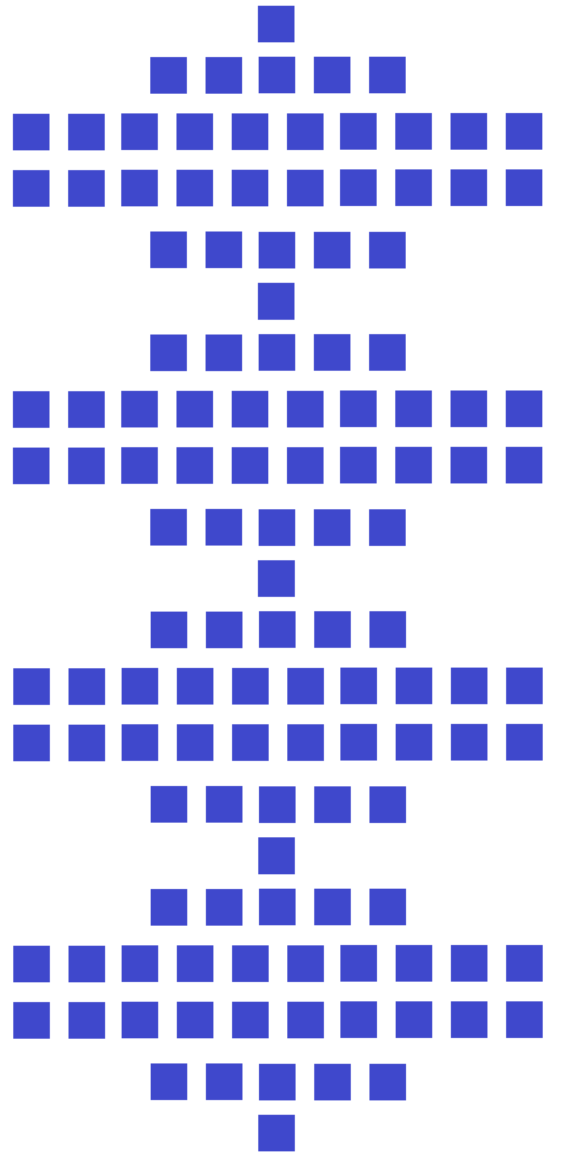


This can be applied to statistics and probability. Envision a scenario where the population of foxes rises and falls with the availability of food. During winter food is scarce so pop. Is at its lowest level “1”. Then spring arrives and mood food is available so pop. Is 5. During summer the most food is available and pop. Is 10. This continues and pop is 10. Then fall comes and food decreases so pop is 5. Finally winter arrives and food is scarce again so pop drops to 1. The numbers 1,5, and 10 can be counting the population of foxes in the tens of thousands. When something is periodic we model it with sine waves.

This is not a perfect representation. We can approximate population of foxes with the x axis being time in months and the y axis total population of foxes in the tens of thousands. We have the lowest points as winter where population is “1” the highest points as summer where population is “10” and middle points on either side of summer as spring and fall where population is “5”. Using the function 4.5sin(x) +5.5 we model our data.

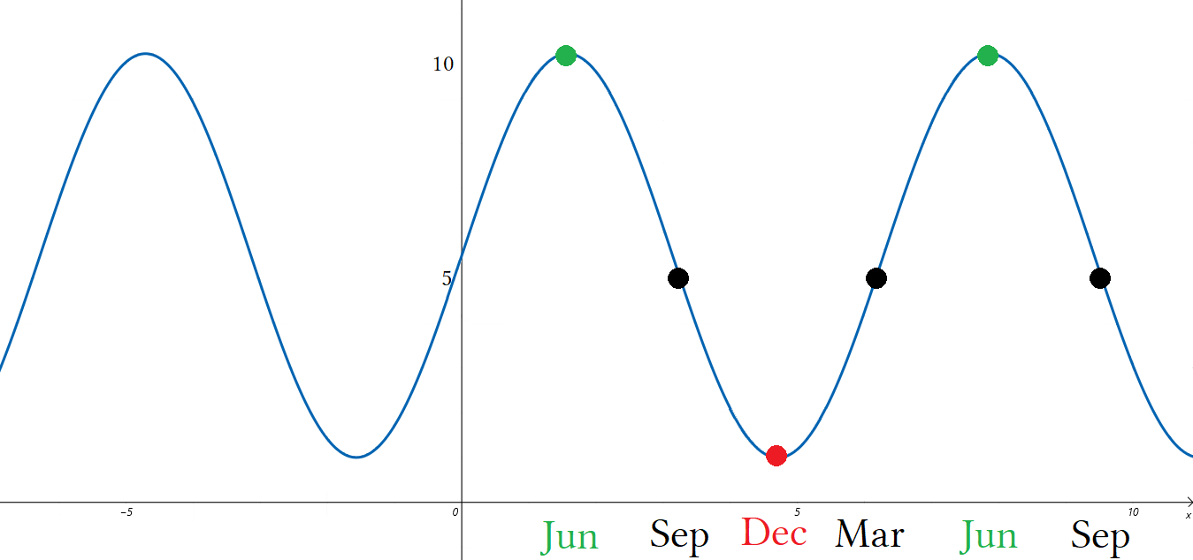

We start tracking our data at June when population is 10. We record:

Jun: 10
Sep: 5
Dec: 1
Mar: 5
Jun: 10
Sep: 5

We have a sequence of 10,5,1,5,10,5. This does not match up with 1,5,10,10,5,1 because there is only one “10”.
We would need a better model to more accurately represent two “10's”. But it gives a feel for what is happening and allows us to make predictions.

The minima:1
The maxima: 10
The interval where population is increasing: December to June.
The interval where population is decreasing: June to December.
The midpoint of December to June: 5
The midpoint of June to December: 5
We have: 1,5,10,5,1 as a sequence. We can surmise that starting in December animals are hibernating and foxes are starving, then in spring animals stop hibernating and foxes feast and start breeding causing a population explosion that continues up to summer. In summer there is an overpopulation of foxes and they compete for food. Too many foxes means that population will stop growing as it is stagnated. This is called critical max or stagnant growth. The population is at the maximum the ecosystem can bear it can not get any larger. This is called an “ upper ceiling” which sets the limit as to how high a y value can be for a point.

After summer population falls or drops. Year to year we can expect the middle of fall to maintain an average population of 5. Population of foxes drops from summer to winter having an average of 10 in summer, 5 in fall and 1 in winter. Winter is when population is at its lowest and is the critical minimum called the “lower floor”. The lower floor is the lowest a y value can be. A floor value sets the limit at which a population can drop.

A ceiling value is the highest a point can be. You can have an upper ceiling and a lower ceiling.
A floor value is the lowest a point can be. You can have an upper floor and a lower floor. This is done using inequalities.

If stating the upper ceiling value then y≤ upper ceiling, if stating lower ceiling then y≥lower ceiling.
If stating the upper floor value then y≤ floor ceiling, if stating lower floor then y≥lower floor.

This is covered in 12th grade stats but offer it for early exposure. You are not required to know this for 9th grade algebra. If we incorporate that fact that the original sequence 1,5,10,10,5,1 had two 10's we need to take population readings at two points for “10”. We would need to have a plateau in the summer months to show a “plateau effect” where population is flatting. We get something like this:

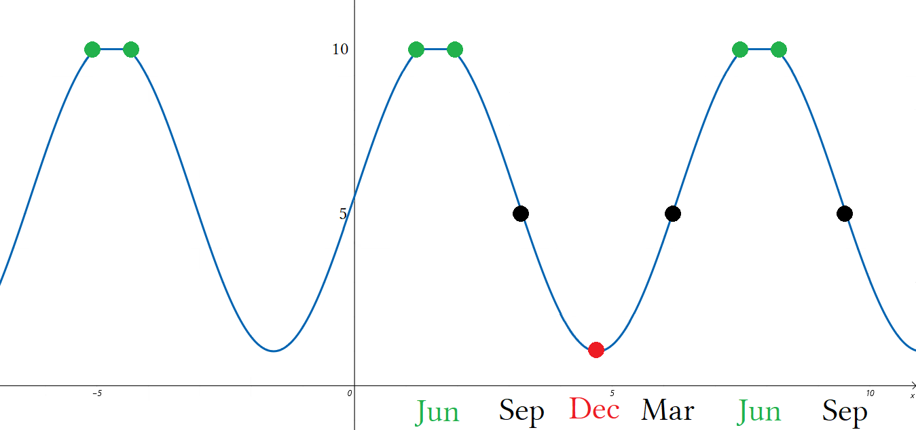

There are now two green dots directly across from each other. The function have periodic motion but plateaus rather than peaks. This is a complicated function made up of parts of other functions. Functions like this are continuous but are constructed using piece-wise functions. A piece-wise function is a segment of a function. This is studied in pre-calculus where sine functions are properly introduced or calculus where sine functions are modified using Fourier or other transforms to create square waves, triangle waves, saw tooth waves and other waves used for audio processing and recording sound making amplifiers or other studio equipment. Square waves would be used with designing electronic devices when measuring voltage output.

The sine wave graphs are not completely accurate and would need a better understanding of precalculus to draw and model accurately. They are just approximations , like a guess, so are lacking precision. The more math we know the better models we can create and the better our predictions will be. Graphs like this deal with probability in that we are basing future predictions on past performance. If every year the population of foxes is approximately 1 in the winter, 5 in the spring or fall and 10 in summer or around June, then we can safely predict this trend to continue in the immediate future. We cannot however know what to expect in the very far future because trends gradually change. In the future something could happen that either decimates the population of food or foxes or causes them to grow to higher levels due to preservation methods or adaptability.

Combinatorics has many non gambling uses but was invented by people who wanted to use math to study the odds of winning at certain games like poker or roulette. This lead to the creation of statistics as a branch of math. Statistics tries to predict the future based on past events. It is concerned with probability that an event will occur such as picking the winning lotto numbers, being dealt a winning hand in poker, whether the weather will change and it will rain, whether the stock market or a particular stock itself will go up or down. These are all forms of gambling. When people gamble on things not considered Las Vegas style casino games it is called “forecasting”. Forecasting is a form of gambling where scientists and investors try to predict future events. This is hard to due because for an application there could be literally millions of variables to account for.

A variable is an unknown. An equation containing variables can only be solved when all variables except one are solved for by being given a definition in the form of rewriting as a constant. An equation can only be solved if it contains only one variable otherwise you have a function which shows a range of possible solutions. This range of solutions can be infinite. Read possible as meaning probability or possible outcomes. You have many choices for what the right answer is with no idea which answer is the right answer. You are guessing. In math guessing is called gambling. You are basing your actions not on the science of what you know but on the faith of what you think or hope or wish. Where science and math have one solution or set of solutions for a given problem life is random and guessing your way through is a part of it. So if a guess has to be made them is has to be reasonable. To be reasonable means making an educated guess.

Ideally every problem has only one right answer and we know what that answer is. Unfortunately a problem can have multiple answers that provide varying degrees of success. Having multiple solutions is called having a set of solutions or a solution set. If the set is infinite we want to narrow that set down to the most likely to succeed solutions. Read most likely as probability or making an educated guess.
If given infinite solutions you have ∞ choices. Some choices will would and some won't. How do you know which solution to choose? If you narrow your choices down to say 5 choices and are confident that those 5 choices are the best five choices it makes guessing easier. Of the 5 choices some or maybe all of the will work but of the 5 one will work better than all the rest. You want to not only pick a choice that works but pick the choice that works the best.

x+y = 44 what is x? If x and y are reals then we have ∞ choices, if they are whole numbers we have 45 choices.

Combinations Permutations
0 + 44 =44 44 + 0 =44
1 + 43 =44 43 + 1 =44
2 + 42 =44 42 + 2 =44
3 + 41 =44 41 + 3 =44
4 + 40 =44 40 + 4 =44
5 + 39 =44 39 + 5 =44
6 + 38 =44 38 + 6 =44
7 + 37 =44 37 + 7 =44
8 + 36 =44 36 + 8 =44
9 + 35 =44 35 + 9 =44
10 + 34 =44 34 + 10 =44
11 + 33 =44 33 + 11 =44
12 + 32 =44 32 + 12 =44
13 + 31 =44 31 + 13 =44
14 + 30 =44 30 + 14 =44
15 + 29 =44 29 + 15 =44
16 + 28 =44 28 + 16 =44
17 + 27 =44 27 + 17 =44
18 + 26 =44 26 + 18 =44
19 + 25 =44 25 + 19 =44
20 + 24 =44 24 + 20 =44
21 + 23 =44 23 + 21 =44
22 + 22 =44 22 + 22 =44

0+44 = 44
22+22 =44 At this point x = y so anything past 22+22 will be a permutation (a duplicate equation).
44+0 =44

0+44 = 44+0 This is the same combination of two numbers but the order is different.
Combinations do not care about order but permutations do.

0+44 = 44+0 This is symmetric and commutative.
0+44 = 44+0 Symmetric property where LHS and RHS are reflected or commutative property.
44 = 44 Reflexive property. Simplifying shows they are the same sum.

Just because the two sums are equal does not mean that the two equations are identical.

Amy + Bob = 44 years The sum of 2 peoples ages equals 44 years.
14 + Bob = 44 years I define Amy's age to be 14.
Bob = 30 years This forces Bob's age to be 30.

14+30 = 14+30 This says we have two identical equations, m = m and n = n.
14+30 = 30+14 This says we have two congruent equations, x₁ = y₂ and x₂ = y₁.

x+y = 44 and one of them is 14. This says we have a constraint where one of the variable must be 14.
x = 14 or 30 This says we have two possible candidates, or outcomes for x.

If x = 14 or 30 then y = 30 or 14. If one is 14 then the other is 30. If order is not important than which one is which is moot. If order does matter then it is critical to determine which is which. Is it x>y or y>x?

I know two different Amys and two different Bobs. Amy₁ is 14 and Bob₁ is 30. Amy₂+is 30 and Bob₂ is 14.

Amy₁+Bob₁ = Amy₂+Bob₂
x₁+y₁ = x₂+y₂
14+30 = 30+14 Both sums are equivalent.

Amy₁ ≠ Amy₂ and Bob₁ ≠Bob₂
x₁ ≠ x₂ and y₁ ≠y₂ We have two different x's and two different y's.
14≠ 30 and 30≠14 So we can not say x =x and y = y because they don't.

Amy₁ =Bob₂ and Amy₂ = Bob₁
x₁ = y₂ and x₂ = y₁ The x's and y's are inverted.
14 =14 and 30 = 30 x₁ = y₂ and x₂ = y₁ is the result. Do not forget subscripts!

I said x = 14 or 30. For this situation we do not have two solutions but rather to possible choices for one solution.
Having to guess what x equals we have a 50% chance of guessing correctly. In the original question Amy was 14 and we wrote her as x. If so then x = 14.

Amy + Bob = 44 years and one of them is 14. How old is Amy?
Amy + 14 = 44 or Amy +30 = 44

Amy is 14 or 30, we do not know. If we said she is 30 we made an educated guess but are wrong. If we said 14 we made an educated guess and were right. Any other guess is unreasonable and uneducated.

How many choices for x do we have if x and are not of the set 𝕎?

x+y = 44
1+43 = 44
45 + (–1) = 44 This has y as an integer. Integers can be negative but whole numbers can not.
100+ (–56) = 44 This has y as an integer. Integers can be negative but whole numbers can not.
–10 + 54 = 44 This has x as an integer. Integers can be negative but whole numbers can not.
– 100 + 144 = 44 This has x as an integer. Integers can be negative but whole numbers can not.

We find that if negatives are allowed then the domain of x is (–∞,∞) where x can have infinite choices.

1.5 + y = 44 x is a rational number ³/₂.
1.55 + y = 44 x is a rational number ⁵⁵/₁₀₀.
1.555 + y = 44 x is a rational number ⁵⁵⁵/₁₀₀₀.
20½ + y = 44 x is a rational number ⁴¹/₂.
20¼ + y = 44 x is a rational number ⁸¹/₄.
20⅛ + y = 44 x is a rational number ¹⁶¹/₈.
20¹/2^{x} + y = 44 x is a mixed number. Fractional part is a power of 2.
20¹/n + y = 44 x is a mixed fraction where the fractional part could be 1 over any number.
20^{p}/q + y = 44 x is a mixed fraction where the fractional part could be any rational number.

We find that if fractions are allowed then the domain of x is (–∞,∞) where x can have infinite choices.

x+√2 = 44 If y is a radical...
(44 –√2) +√2 = 44 ... x must contain the conjugate to the radical. Conjugate is the additive inverse.

To limit the domain of x to find a list of reasonable candidates for x+y = 44 I set the constraint that x and y must both be whole numbers of the set 𝕎. This prohibits fractions or negatives from being a choice. Of the entire number line which we call the real number line that contains the set of all real numbers the set 𝕎 is a subset which excludes negatives, rationals and radicals. By choosing a word problem that involves x as an age creates the necessary constraint of x = 𝕎.

x: {0≤x≤44} where x = 𝕎 x must be a whole number greater than or equal to 0 and less than or equal to 44.
x: [0,44] where x = 𝕎 The domain of x is 0 to 44. Brackets indicate that x can be 0 or 44.

x: [0,44] where x = 𝕎 ≡ x ={0,1,2,3,4,5,6,7,8,9,10,11,12,13,14,15,16,17,18,19,20,21,22,23,24
25,26,27,28,29,30,31,32,33,34,35,36,37,38,39,40,41,42,43,44}

Set x = {0,1,…,44} is the set of all possible choices for x. This is much smaller than having Set x = {∞}.

How many 2 number subsets can be made from the set x = [0,44]? What is the formula for subsets that add to 44? We have 45 objects and want to create 2 item pairings.

Permutations: 45!÷(45–2)! = ^{45!}/_{43!} = 1980. This gives every 2 number combination of every number.
Combinations: 45!÷(45–2)!2! = ^{45!}/_{43!∙2!} = 990. This is every unique combination 0+0, 0+1... but not permutations.

If we do 990÷44 we get 22.5. If we do 990÷45 we get 22. If we do (990÷45)+1 we get 23.
We can generalize “(990÷45)+1 = (45!÷(45–2)!2!∙45)+1” to (45!÷(45–2)!2!∙45)+1 = (n!÷(n–r)!r!∙n)+1.

The formula for combinations of two numbers that add to “C” using a set of n to choose from is:(n!÷(n–r)!r!∙n)+1.
1980/990 = 2 which is clear because nCr = the number of combinations “ n!/(n–r)!r! ”.

Permutations/Combinations = (choices per combination)! = (r)!

Permutations: n!/(n–r)!
Combinations: n!/(n–r)!r!

n!/(n–r)! / n!/(n–r)!r! This is a complex fraction.
n!/(n–r)! ∙ (n–r)!r!/n! Solve by using a/b÷c/d = a/b∙d/c. This is called “flip and multiply”.
n!/n! ∙ (n–r)!/(n–r)! ∙r! Separating the fractions and rearranging gives ^{n!}/_{n!} ∙ ^{(n–r)!}/_{(n–r)!} ∙ r!
1 ∙ 1 ∙r! 1∙1∙r! = r!
r! Permutations/Combinations = r! Such that _{n}P_{r}/_{n}C_{r} = r!

Lets call nCr “C” and nPr “P”.

P÷C =r! Permutations divided by combinations.
n!/(n–r)! ÷ n!/(n–r)!r! Written out using proper formulas for nPr and nCr.
^{n!}/_{(n–r)!} ÷ ^{n!}/_{(n–r)!r!} Written using the preferred fraction notation.
^{n!}/_{(n–r)!} ∙ ^{(n–r)!r!}/_{n!} Changing the ÷ sign to ∙ and flipping the second fraction.
^{n!}/_{(n–r)!} ∙ ^{(n–r)!r!}/_{n!} Flipping moves “ r! ” to the top of the second fraction.
^{n!(n–r)!r!}/_{n!(n–r)!} Multiplying two fractions creates a product. Terms cancel except r!
n!(n–r)!r! ÷ n!(n–r)! The same colored terms cancel with each other.
r! Only r! Remains.

If I have a set of 45 numbers to choose from for x in x+y = 45 then I consider my choices x = {0,1...45}.
I want to know how many equations containing two members from the set x = {0,1...45} is equal to 44.
The number of equations will be the number of combinations that makes x+y = 44 true.
Use (n!÷(n–r)!r!∙n)+1 to find the number of combinations of equations of x+y = 44 when x and y are whole numbers.

(P/C∙N)+1 = 23 This says: (n!÷(n–r)!r!∙n)+1 = (45!÷(45–2)!2!∙45)+1 = 23

Notice that there are 23 combinations and 45 permutations. For C combinations P = n+ (n–1) which is 45 = 23+(23–1). We have 45 elements (numbers) for x. Making a list of all the numbers shows that there are 23 combinations and 45 permutations. We do not want to make a list every time we do this so we created the formula (n!÷(n–r)!r!∙n)+1. X can be 0 to 44 so that is 45 possible permutations.

For combinations we stop at x =22 because after that every equation is just an earlier one with x and y swapped. We have 23 combinations because 45/2 = 22.5. We can't have ½ a combination so we round up and get 23. Adding two unknown numbers and answer is given is a linear equation in the standard form Ax+By = C.
Very frequently this type of problem is encountered. You have two unknown variables but result is known.

nCr gives combinations that are treated like sets where order does not matter.
Solving for x+y = a unknown constant is different.
We have a constraint where the order does matter but we do not have a permutation.
If we ignore which values are assigned to x and y then we typically treat x as less than y and write numbers with the smaller one first and the larger one second like 14+30 = 44. 14<30 so we say x<y.

The equations where x is 0 to 22 gives 23 choices for x. We call x the independent variable because we can choose an input for x and that forces y to be some number that will make the equation true. This makes y dependent on x for its value so we call y the dependent variable.

If there are 23 choices for x and all permutations are inverses where x and y change values then we should have 2∙23 or 46 total permutations but we don't. When we reach the last combination 22+22 we can not invert it.
22+22 does not have a permutation. A permutation is when we change the order to get something we did not have before. Changing the order does not create a new unique pairing: x +y = 22+22 → y +x = 22+22.

How many codes can be made from 1234?

1234 1324 1423 There are six codes beginning with “1” so there are six codes for each number.
1243 1342 1432 six codes per number times four numbers is 6∙4 or ₄P₃.

We do not have to write every code to find the total possible permutations. We start at the first code in alphanumerical order and then complete one subset of possible codes then multiply total possible subsets by codes per subset.

1234 Write the first coder in numerical order. Write the second code by switching the last two digits.
1243 When there are no more codes for beginning digits create a space and move on to the next range of code.

1324 The first range of codes began with 12 so this range will begin with 13 as 3 is the next number after 2.
1342 Each range for a 4 digit code has two permutations. Range for a four digit code will be a two digit prefix.

1423 There are three ranges that begin with “1”; 12, 13, and 14.
1432 After 14 we begin the subset that begins with “2”. The subset of “2” with have ranges of 21, 23, 24.

1234 1324 1423 2134 2314 2413 3124 3214 3412 4123 4213 4312
1243 1342 1432 2143 2341 2431 3142 3241 3421 4132 4231 4321

This is like picking combinations to a safe or lock. For a four digit code with 4 possible choices we have 4 choose 4 (⁴₄) which is 4! or 24. We have four subsets with 6 codes per set:

The 1000 series: 1234 1243 1324 1342 1423 1432
The 2000 series: 2134 2143 2314 2341 2431 2431
The 3000 series: 3124 3142 3214 3241 3412 3421
The 4000 series: 4123 4132 4213 4231 4312 4321
For a master slave relationship:

master + slaves = n
slaves = n – 1
_{n}P_{n} = n!

How many many 3-letter codes can be made from three letters?

Translation: All codes possible are a permutation in the form of _{n}P_{n} where master+slaves = n and slaves = n–1.

(a,b,c) (a,c,b) (b,a,c) (b,c,a) (c,a,b) (c,b,a)

a = mom
b = dad
c = you

(mom,dad,you) (mom,you,dad) (dad,mom,you) (dad,you,mom) (you,mom,dad) (you,dad,mom)

The first element is denoted as the master to which other elements are slaves.
This can also be said as the first element is the parent element to which other elements are children.
The can also be said the first element claims ownership of the following elements hence the master slave relationship.

This “master object” “owns” this “slave” object. The slave is a subordinate of a master.
Subordinate is another way of saying “employee”.
“ordinate” implies the order or rank of something i.e. co-ordinates, an ordinate in a co-ordinate system etc.

For the set {dad,mom,you} the leading element is the master element to which all other elements follow.
The master is 1st other elements are 2nd , 3rd … n^{th} .

Dad: mom,you “Dad” is the “master” or “parent” or “owner”. The rest are “others”.
Dad: you, mom “Dad” is the “master” or “parent” or “owner”. The rest are “others”.
Mom: dad,you “Mom” is the “master” or “parent” or “owner”. The rest are “others”.
Mom: you,dad “Mom” is the “master” or “parent” or “owner”. The rest are “others”.
You: dad,you “You” is the “master” or “parent” or “owner”. The rest are “others”.
You: mom,dad “You” is the “master” or “parent” or “owner”. The rest are “others”.

The roles of master and slave are reversed giving equal opportunity to all members of a set.
This is called “equality” where all members are treated equally.

The master is the leading element for a given subset.
For a subset once removed the first two elements are the masters.
For a subset twice removed the first three elements are the masters.
Slave elements rotate positions until every permutation for that subset of leading element(s) had been completed.
Once completed a new master or masters is or are chosen.

A:bc AB:cd A:bcd
A:cb AB:dc A:bdc
B:ba AC:ad A:cad
B:ac AC:da A:cda
C:ab AD:bc A:acd
C:ba AD:cb B:adc
BA:cd B:cad
BA:dc B:cda
… … abcd has more series but is cut off.

For 3 elements A is the master of bc or cb. AB is the master of cd, dc.
For 4 elements A is the master of bcd,bdc,cad,cda.
AB:cd = A:bcd except focus is on permuting the two elements instead of 3.
A master element gives a series or range, other elements are permuted.
A master element is in charge for a series and not permuted for that series.
There should be only 1 master but having more making permuting easier.
Permuting is easier when you have only a few elements to switch for a range

For abc we have three series A,B, and C. A:(abc, acd); B:(bac,bca); C:(cab,cba).
For abcd we have four series A,B,C, and D. A:(abcd, abdc, acbd, acdb, adbc, adcb); B:{B series};C:{C};D:{D}.

I ran out of room to write the B C and D series so abbreviated them. Writing long sets is tedious.

Abc has 3 elements and 3! permutations. Each subset A,B,C has 2! permutations which is (n–1)! where n = # elements. Abcd has 4 elements and 4! permutations, Each subset A,B,C,D has 3! permutations.

A: abcd abdc acbd acdb adbc adcb Subset A is the A series. It has 3! or 6 perms.
B: bacd badc bcad bcda bdac bdca Subset B is the B series. It has 3! or 6 perms.
C: cabd cadb cbad cbda cdab cdba Subset B is the B series. It has 3! or 6 perms.
D: dabc dacb dbac dbca dcab dcba Subset B is the B series. It has 3! or 6 perms.

The use of colons in permutations is to make writing them in order faster. A colon is a spacing mark called a delimiter. Delimiters helps mathematicians, and others, to quickly organize and sort letter codes.

A: ab:cd ab:dc ac:bd ac:db ad:bc ad:cb Subset A is the A series. It has 3! or 6 perms.
B: ba:cd ba:dc bc:ad bc:da bd:ac bd:ca Subset B is the B series. It has 3! or 6 perms.
C: ca:bd ca:db cb:ad cb:da cd:ab cd:ba Subset B is the B series. It has 3! or 6 perms.
D: da:bc da:cb db:ac db:ca dc:ab dc:ba Subset B is the B series. It has 3! or 6 perms.

Notice this list is the same as the last but has colons. From one code to the next the only change is the last two letters are switched. The use of delimiters points this out.

- Write the 1st code: abcd
- Then write it again switching the last two letters to create the 2nd code: abdc
- After that the third code will have a different second element. Write the third code: acbd
- Then write the fourth code by switching the last two letters of the 3rd code. This process repeats: acdb

1st : abcd abcd is the first code. Note the last two letters.
2nd: abdc abdc is the second code. It is the first code with the last two letters switched.
3rd: acbd acbd is the third code. It went from the subset ab:xx to the subset ac:xx.
4th: acdb acdb is the fourth code. It takes the third code and switches the last two letters.

I showed how 4 choose 4 is 24 codes due to being 24 permutations of 1234. How many codes can be made from 1111? No matter how you move the digits you can have only 1 code. The notation P or C or “choose” does not deal will combinations like this. There is no notation to express this. How many codes can be made from 1112? Again there is no notation for this. 1112 will have four codes of 1112 1121 1211 2111. You would have to modify existing notation by creating a new type of formula specific to your application. The deal with x+y = 44 was that we created a set with 45 elements but only could take or choose two.

₄₅P₂ = 1980 I have 45 elements and will take two of them, this creates 1980 permutations.
₄₅C₂ = 990 I have 45 elements and will take two of them, this creates 990 combinations.

We use the word combination to mean code containing numbers where order does not matter.
This is not what we would think of as a combination in real life.1234 can be permuted into 24 codes.
As a combination it can have only one code. Remember that for combinations order does not matter.
All 24 permutations of 1234 are the same combination. 1234 has the same number of combinations as 1111.
For this reason math books argue that combination locks should be called permutation locks.

If there is no notation available how do I express I want 23 “combinations” of x+y=44?
This is critical because in math solving “What two numbers sum to 44?” is very basic.
For x+y =44 we can make a list but what if it was x+y =440 or x+y =4400?
We need a formula because writing that many equations is too time consuming.
What two numbers sum to 4400?

n! ÷((n–2 )!2!∙n )+1 This is a formula spaced out so you can see n!÷((n–2)!2!∙n)+1.
4401!÷((4401–2)!2!∙4401)+1 n = 4401 because we have the domain x: [0,4400] which is 4401 choices for x.
4401!÷4399!2!∙4401 +1 I am putting the plus one off to the side so you can see. This removes a ().
4401!÷4399!2∙4401 +1 n = 4401 so n–2 = 4399. 2! = 2.
4401!÷4399!∙8802 +1 Be practical and eliminate the 2 by multiplying with 4401 and not 4399!.

4401∙4400∙4399∙4398…1 ÷4399∙4398…1∙8802 +1 Expanding 4401! and 4399!
4401∙4400÷8802 +1 n!/(n–2)! Everything cancels except n₀ and n₁.
19,364,400÷8802 +1 4401∙4400 is 19,364,400
2200+1 19,364,400/8802 = 2200
2201 Don't forget to add the “1”

There are C combinations of x and y that sum to 4400. There are C+C–1 permutations that sum to 4400.
Call the set of choices for inputs of x “set A”. Set A= {0,1,2, … ,4400}. There are 4401 elements in set A.
The formula for combinations of 2 numbers that sum to 1 number is above. C = 2201 so P = 4401. P = n!.

x₀ +y₀ = 4400 0 +4400 = 4400
x₁ +y₁ = 4400 1 +4399 = 4400
x₂ +y₂ = 4400 2 +4398 = 4400
x₃ +y₃ = 4400 3 +4397 = 4400
x₂₂₀₀ +y₂₂₀₀ = 4400 2200 +2200 = 4400

The subscripts directly show what x is. If x = 0 then it is x₀ if x = 5 then it is x₅.
We do not know what x is because we have two undefined variables but we do know that it domain is limited to whole numbers there are 2201 choices for x representing 2201 equations that can be written. Using this formula gives us an idea of what x could be. It is a number between 0 and 4400.
If x and y are whole numbers of the set 𝕎 then how many combinations of x and y exist that sum to 4400?

This is the same problem as before but paraphrased. For any two element problem we have ^{n}/₂ +1 gives combinations.

C = ^{n}/₂ +1
C = ⁴⁴⁰⁰/₂ + 1
C = 2200+1
C = 2201

When you add two unknown numbers you get a list of possible combinations where 2_{n}C_{r} = answer+2
Duplicate equations where x and y are inverted are considered permutations. Usually duplicates are ignored.
All possible equations will be the set of permutations given by 2_{n}C_{r} – 1 = _{n}P_{r}

x+y = 4400 x+y = 10
2C= 4400+2 2C = 10+2
C = 2201 C = 6
P = 4401 P = 11

x+y = 10, what are all the possible equations? 2C –1 = P where P = 11.

set C plus P
0+10 = 10 6+4 = 10
1+9 = 10 7+3 = 10
2+8 = 10 8+2 = 10
3+7 = 10 9+1 = 10
4+6 = 10 10+0 = 10
5+5 = 10

The inputs for x start a 0 making y equal the sum. We add 1 to x and subtract 1 from y to maintain the correct output. This is a form of keeping our equation balanced. Another way is when x =y:

(x+0)+(y–0) = 10 5+5 = 10
(x+1)+(y–1) = 10 6+4 = 10
(x+2)+(y–2) = 10 7+3 = 10
(x+3)+(y–3) = 10 8+2 = 10
(x+4)+(y–4) = 10 9+1 = 10
(x+5)+(y–5) = 10 10+0 = 10

When x = y we have the point at which we have found all possible combination without duplicate equations.
If x<y our equation will appear as a combination. If x>y then our equation is a duplicate of an earlier first appearing x<y equation. If x = y we have a state of equilibrium where all combinations are found and there are no duplicates in out set of equations.

A function is a set of equations. Without limitation of domain the set contains infinite equations with infinite solutions given as ordered pairs. If we limit the domain of x or possibly the range of y we can have a finite set of equations.

x+y = 10 can be rewritten as y = –x+10. This is the intercept form of a linear equation.
Likewise x+y = 4400 becomes y = – x+4400
I will graph this on the next page.

Graph of x+y = 4400 aka y = – x+4400

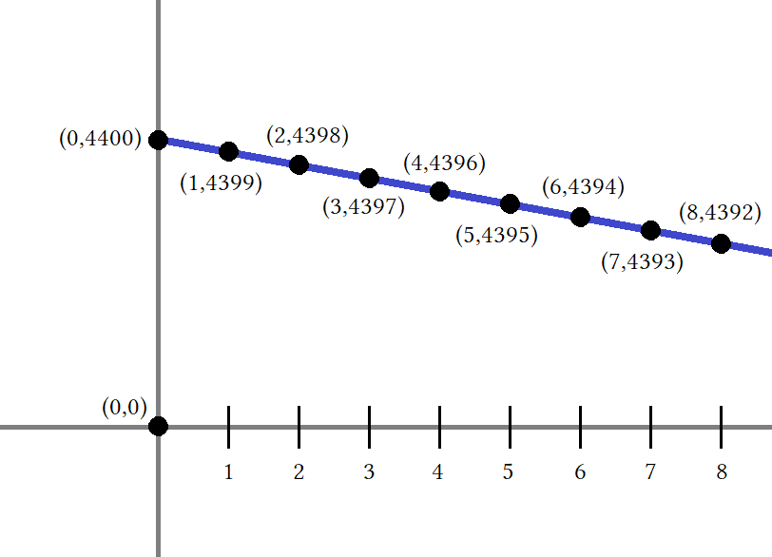
x+y = 4400
0+4400 = 4400
1+4399 = 4400
2+4398 = 4400
3+4397 = 4400
4+4396 = 4400
5+4395 = 4400
6+4394 = 4400
7+4393 = 4400
8+4392 = 4400

We are adding 1 to x and subtracting 1 from y.
M = –1 means every time we +1 to x we – 1 from y.
y-intercept: (0,4400) correlates to x₀+y₀ = 4400.
x-intercept:(4400,0) correlates to x₄₄₀₀+y₄₄₀₀ = 4400.

It is safe to say x₀ ≠ x₄₄₀₀. It is also safe to say that for this 0+4400 ≠ 4400+0 as the values denote two different locations that sum to 4400. The x-intercept ≠ y-intercept. Point (0,4400) ≠(4400,0). These are very different points.
This approaches the study of linear algebra and vectors. Vector algebra is non-commutative. Order matters in which variable you assign a value because you are dealing with dimensions. Basic geometry such as 10th grade Euclidean geometry is commutative but other non-commutative geometries exist.
Euclid lived a long time ago. There has been new developments since his time.

A quick example might be 3×2 ≠ 2×3 if we are talking vectors or even simple dimensions of of area.
Area will be the same but location of points will be different.

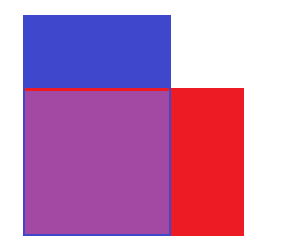
Here is a red 3×2 occupying the same corner point as a blue 2×3.
On a chart we would graph them as sharing point (0,0) for the lower left corner.
The space where they overlap is purple 2×2.
Say the red area is forbidden like lava or an electric fence.
Or property boundaries and the digging and laying of new pipe or electrical lines is required. Trespassing on property and damaging it could prove deadly.
There are applications where areas are created to show pathways and networks.
This deals will travel and logistics.
Completing a 500 mile journey means nothing if you traveled in the wrong direction.

State Lotto

The state lotto is a gambling game where you have to pick 6 matching numbers from 44 possible numbers, 1-44.
How many possible 6-number combinations are there?

For lotto the order of the numbers chosen does not matter.
The combination (12, 23, 44, 15, 28, 4) is the same as (4, 44, 28, 12, 23, 15).
We have a set of 44 elements and need to pick 6. We have 44 pick 6.
Pick is another way of saying take or choose.

_{n}C_{r} = ₄₄C₆ Use _{n}C_{r} if order does not matter and _{n}P_{r} if order does matter.
₄₄C₆ = 44!÷(44–6)!6! _{n}C_{r} = n!÷(n–r)!r!
₄₄C₆ = 44!÷38!6! 38! cancels with 44!. 44!÷38! = 44∙43∙42∙41∙40∙39. Factors > 38 cancel.
₄₄C₆ = 7,059,052 44∙43∙42∙41∙40∙39/6! = 7,059,052. There are about 7 million possible tickets.

Classic Problem: There are 9 players on a team, 4 infielders and 5 other players. The infielders bat first followed by the others. How many batting orders are possible?

Translation: The infielders can bat 4! ways and the rest 5! ways. The first action can be performed 4! and the second action 5! ways. This is stated by the fundamental counting principle.

n₁ ∙n₂ = P Fundamental principle: n1∙n2, n3 … , nk = n₁!∙n₂!∙n₂! … ∙n_{k}!
₄P₄ ∙ ₅P₅ = P n₁ = ₄P₄ = 4! and n₂ = ₅P₅ = 5!
4!∙5! = P
24∙120 = P
2880 = P There are 2880 batting orders.

The state government has a employs 5 bridge engineers and 7 accountants. The state legislature is forming a search committee containing 3 engineers and 4 accountants. How many different committees can be formed?

Translation: This is a variation of the classical “batting order problem”. You have 12 players, 5 of a first action and 7 of a second action. In this sense “action” is their job or role in the company or government.

This is a variation since we are counting engineers and accountants not baseball players.
This is a variation since we are not using full teams of 12 but rather 7.

How many different teams of 3 engineers can be formed? How many different teams of 4 accountants can be formed? (5 engineers choose 3 engineers) = ₅C₃. (7 accountants choose 4 accountants) = ₇C₄.

How many teams of 3 engineers and 7 accountants can be formed? This is the question they are asking.
(5 engineers choose 3 engineers) ∙ (7 accountants choose 4 accountants) = ₅C₃ ∙ ₇C₄.

₅C₃ = 5!÷(5 – 3)!3! Writing notation is just memorizing the formula
₅C₃ = 5!÷(2)!3! ₅C₃ = you can mentally find (n – r)!
₅C₃ = 5∙4÷2 More mental work. You can the r! with the n! on top.
₅C₃ = 10 You can use the “_{n}C_{r}” on a calculator to find combinations.
₇C₄ = 7!÷(7 – 4)!4! _{n}C_{r} = n!÷(n – r)!r!
₇C₄ = 7!÷3!∙4! (n – r) is mentally solved.
₇C₄ = 7∙6∙5÷3! Cancel the biggest n! on the bottom.
₇C₄ = 210÷6
₇C₄ = 35 ₅C₃ = 10 and ₇C₄ = 35
₅C₃ ∙ ₇C₄ Find your product
10∙35
350 There are 350 teams of n₁ and n₂ that can be formed.

Consider 3 employees Alex, Barb, and Chris and they are to serve a role in the company where position mattered. Here order matters: (1st lead, 2nd lead, 3rd lead) where a leader is the supervisor in charge of a specific project or work shift. How many different work shifts can you assign? ...If people are allowed to work double shifts? ...Triple shifts? Only doubles? Only triples?

- n! = 3! = 6 this is ₃P₃
- n^{n} – n or (n+1)! = 3³–3 = 27–3 = 24 this is ₃G₃–e = (n+1)!
- n^{n} = 3³ = 27 this is ₃G₃
- n!∙n = 3!∙3 =6∙3 = 18 this is ₃P₃∙P
- (n!+(n –1)!+(n –2)!)–n! = (3!+2!+1!)–3! = 9–6 = 3

This is complicated: The fundamental counting principle states “ Given a combined action or event the first action can be done n₁ different ways the second action n2 different ways … and so on. The total number of ways the combination of actions can be performed is the product: n₁ ∙ n₂ ∙ n₂ ∙ … ∙ n_{k}.”

What they are saying is that for a permutation or combination you are taking the product of different subgroups.
If we a permutation, and allow repetition of elements: the key phrase is we allowed repetition of characters.

aaa abc adc bbb bac bca ccc cab cbc
aab aba baa bba bab abb cca cac acc
aac aca caa bbc bcb cbb ccb cbc bcc

Repetition means you can use an element more than once. Typically we do not do this.
If we allow repetition it would be like letting a baseball player bat twice or three times in a row.
It would be like having three choices for a side dish {fries, salad, soup} and ordering (fries, fries, fries).
If we allow repetition then a 3 digit code with 3 elements to choose form would be 3³ = 27.
We can generalize this to a n digit code with n elements to choose form would be n^{n}.
We can have d = digits and e = elements and call it e^{d}.

If d = 4 and e = 4 then we have 4⁴ = 256 4 digit codes.
We are making codes as long as the number of elements where n=n or d=e.

1111 1112 1113 1114 1121 1122 1123 1124 1131 1132 1133 1134 1141 1142 1143 1144
2111 2112 2113 2114 2121 2122 2123 2124 2131 2132 2133 2134 2141 2142 2143 2144
3111 3112 3113 3114 3121 3122 3123 3124 3131 3132 3133 3134 3141 3142 3143 3144
4111 4112 4113 4114 4121 4122 4123 4124 4131 4132 4133 4134 4141 4142 4143 4144

1211 1212 1213 1214 1221 1222 1223 1224 1231 1232 1233 1234 1241 1242 1243 1244
2211 2212 2213 2214 2221 2222 2223 2224 2231 2232 2233 2234 2241 2242 2243 2244
3211 3212 3213 3214 3221 3222 3223 3224 3231 3232 3233 3234 3241 3242 3243 3244
4211 4212 4213 4214 4221 4222 4223 4224 4231 4232 4233 4234 4241 4242 4243 4244

1311 1312 1313 1314 1321 1322 1323 1324 1331 1332 1333 1334 1341 1342 1343 1344
2311 2312 2313 2314 2321 2322 2323 2324 2331 2332 2333 2334 2341 2342 2343 2344
3311 3312 3313 3314 3321 3322 3323 3324 3331 3332 3333 3334 3341 3342 3343 3344
4311 4312 4313 4314 4321 4322 4323 4324 4331 4332 4333 4334 4341 4342 4343 4344

1411 1412 1413 1414 1421 1422 1423 1424 1431 1432 1433 1434 1441 1442 1443 1444
2411 2412 2413 2414 2421 2422 2423 2424 2431 2432 2433 2434 2441 2442 2443 2444
3411 3412 3413 3414 3421 3422 3423 3424 3431 3432 3433 3434 3441 3442 3443 3444
4411 4412 4413 4414 4421 4422 4423 4424 4431 4432 4433 4434 4441 4442 4443 4444

There are n^{n} codes where d = e. 4⁴ = 256. This is 16² or 4²∙4² or 4∙4∙4∙4. There are 16 groups of 16 individual codes.
Codes are not in numerical order from left to right and top to bottom but could be.
There are many patterns. The larger the table the easier it is to see the patterns.
For brevity: 1111-1114 starts at 1 and ends at 4. Then 1121-1141, 1131-1134, 1141-1144.
I made this quickly using copy and paste and then changing numbers. There are 16 codes per line and 16 columns. From left to right: 1111,1112,1113,1114,1121,1122,1123,1124,1131,1132,1133,1134,1141,1142,1143,1144

Column A: 1111,2111,3111,4111, 1211,2211,3211,4211, 1311,2311,3311,4311, 1411,2411,3411,4411
Column B: 1112,2112,3112,4112, 1212,2212,3212,4212, 1312,2312,3312,4312, 1412,2412,3412,4412
Columns end in: 11,12,13,14, 21,22,23,24, 31,32,33,34, 41,42,43,44
Column A: 1111,2111,3111,4111, 1211,2211,3211,4211, 1311,2311,3311,4311, 1411,2411,3411,4411
Column B: 1112,2112,3112,4112, 1212,2212,3212,4212, 1312,2312,3312,4312, 1412,2412,3412,4412

We could analyze the data and look for patterns to try to predict where next numbers appear... we could say
for any code that moving by 1 code:

- up or down is 1000
- left or right is –1 or +1
- moving by 4 codes left or right is – 10 or +10.
The codes skip and jump because domain is limited and the way it is organized. City planners list home addresses with 4 digits and when they run out 5 digits. They count by 4's so an address set might be 1000, 1004, 1008. In the event a new home is built in between 1000 and 1004 they will call it 1002. If a home is built between 1000 and 1002 they will call it 1000a. They can not call it 1001 because odd numbers are across the street from even numbers. After 1000a would be 1000b, 1000c... it is unlikely they would ever have a home with address 1000z. Product lines can also have upc codes that skip and for inventory knowing how to navigate manufacturer or warehouse codes is important.

Lists of codes like this are used by data scientists and the government for various purposes. These companies and agencies gather large amounts of data and need to quickly gather, sort, classify, and be able to search it. Popular programming jobs involve either using or creating an algorithm for this such as quick search and sort and search. In the beginning Linux used awl and sed and then later grep and grep+.

By cutting and pasting I can quickly sort the data how I want. This is used in clerical work when managing tables or databases. Scientists and governments need people with these skill sets. Adding color helps but is not necessary. I am now going to organize the data so it is in numerical order.

- Moving ↔ is ±1
- Moving ↕ is ±100
- Moving ↔ by 4 is still ±10
- Color was used before just to help see the numbers but now denotes range.
- We have 4 ranges, or series: The 1000, 2000, 3000, and 4000 series.

1111 1112 1113 1114 1121 1122 1123 1124 1131 1132 1133 1134 1141 1142 1143 1144
1211 1212 1213 2114 1221 1222 1223 1224 1231 1232 1233 1234 1241 1242 1243 1244
1311 1332 1313 1314 1321 1322 1323 1324 1331 1332 1333 1334 1341 1342 1343 1344
1411 1412 1413 1414 1421 1422 1423 1424 1431 1432 1433 1434 1441 1442 1443 1444

2111 2112 2113 2114 2121 2122 2123 2124 2131 2132 2133 2134 2141 2142 2143 2144
2211 2212 2213 2214 2221 2222 2223 2224 2231 2232 2233 2234 2241 2242 2243 2244
2311 2312 2313 2314 2321 2322 2323 2324 2331 2332 2333 2334 2341 2342 2343 2344
2411 2412 2413 2414 2421 2422 2423 2424 2431 2432 2433 2434 2441 2442 2443 2444

3111 3112 3113 3114 3121 3122 3123 3124 3131 3132 3133 3134 3141 3142 3143 3144
3211 3212 3213 3214 3221 3222 3223 3224 3231 3232 3233 3234 3241 3242 3243 3244
3311 3312 3313 3314 3321 3322 3323 3324 3331 3332 3333 3334 3341 3342 3343 3344
3411 3412 3413 3414 3421 3422 3423 3424 3431 3432 3433 3434 3431 3442 3443 3444

4111 4112 4113 1414 4121 4122 4123 4124 4131 4132 4133 4134 4141 4142 4143 4144
4211 4212 4213 4214 4221 4222 4223 4224 4231 4232 4233 4234 4241 4242 4243 4244
4311 4312 4313 4314 4321 4322 4323 4324 4331 4332 4333 4334 4341 4342 4343 4344
4411 4412 4413 4414 4421 4422 4423 4424 4431 4432 4433 4434 4441 4442 4443 4444

How should we name the set 4⁴ = 256? In general we start with set A, set B... but can we do something more descriptive? For now lets settle for set A. We can rename it later if we want.

Set A: {1111,1112,1113,1114, umm} how do we write a set that has skipping elements or codes? We need to write enough info so that people understand what the pattern is. We cannot say Set A:{1111,1112, … 4444} because then we would have over 3,000 elements. Let's examine all sets and subsets and try to write a good sequence. We have 256 codes where each code will be treated as a 4 digit element. We have a set of 256 codes
so we have a set of 256 elements. This can be called the generic set A that has all codes.

Set A is divided into four subsets called 1000, 2000, 3000, and 4000 series. Maybe we can call them A₁ ,A₂ ,A₃ ,A₄ .where the subscript gives us a clue as to the contents of the subset?
If “set A” was not already taken we would be tempted to name our sets A,B,C,D.
Set theory has fancy ways of grouping sets but let's keep it simple for now.

Set A: {set A₁, set A₂, set A₃, set A₄} This says that set A has 4 subsets in it.
Set A₁: {the set containing all members of the “1000” series} This speaks for itself.

Set A₁:
{1111,1112,1113,1114,1121,1122,1123,1124,1131,1132,1133,1134,1141,1142,1143,1144,1211,1212,1213,1214,1221, 1222, 1223,1224,1231,1232,1233,1234,1241,1242,1243,1244,1311,1312,1313,1314,1321,1322,1323,1324,1331,1332, 1333,1334,1341,1342,1343, 1344,1411,1412,1413,1414,1421,1422,1423,1424,1431,1432,1433,1434,1441,1442,1443, 1444,}

Without a slick sequence notation we have to write every single member. Not fun. Try to break up the 1000 series of four lines into separate lines. Set A₁ contains 64 codes with 16 codes per line. We can think of each line as a subset of set A₁ which itself is a subset of set A.

Turn this into a set: 1111,1112,1113,1114,1121,1122,1123,1124,1131,1132,1133,1134,1141,1142,1143,1144.
Turn this into a set: 1211,1212,1213,1214,1221,1222,1223,1224,1231,1232,1233,1234,1241,1242,1243,1244.

Set A_{1-a}:{1111,1112,1113,1114,1121,1122,1123,1124,1131,1132,1133,1134,1141,1142,1143,1144}
Set A_{1-a}:{1111...1114,1121...1124,1131...1134,1141...1144}

Set A1-a is pronounced “Set A one dash a”. We could us A_{1_a} pronounced “Set A one sub a” or “Set A one underscore a”. The underscore mark means subscript. When used in a subscript it means sub-subscript.
Exponents are written in superscripts like 2⁴ or can use the caret symbol 2^4. If b²^⁴ we have a superscript in a superscript. For exponents this means raise b² to a higher power. Term numbers are written in subscripts like x₁+y₁ or (a₁, a₂, … a_{n}). A term like a₁ means a_1. The underscore means subscript.

From the context it seems clear that Set A_{1-a}: means A_1-a where the hyphen means “dash”.
A hyphen is not a minus sign like n_{4 – 1} where we using a minus sign to specify a previous term.
It is clear from context because sets do not perform subtraction operations on the term number.
If we wanted to be even clearer we would use underscore so that A_1_a means A_{1_a}.
Honestly we should rename our sets once we find them all and organize them properly so that underscore or hyphen is not utilized. It is an option we reserve for the most difficult of times and this is not one of them.

Set A_{1_a}:{1111,1112,1113,1114,1121,1122,1123,1124,1131,1132,1133,1134,1141,1142,1143,1144}
Set A_{1_a}:{1111...1114,1121...1124,1131...1134,1141...1144}

Using ellipsis makes the sequence shorter and therefore more manageable. Making it shorter using ellipsis is a form of truncation. We went from 16 codes to only 8 and saved space of 7 codes. The ellipsis takes up some space so we do not get a full space of 8 codes saved. There are 7 terms in red showing how much longer it is with ellipsis. While still long it is still much shorter than before.

1111...1114 This says (1111,1112,1113,1114)
1114,1121...1124 This says (1114,1121,1122,1123,1124)
1124,1131...1134 This says (1124,1131,1132,1133,1134)
1134,1141...1144 This says (1131,1141,1142,1143,1144)

The ellipsis means assume every integer in numerical order is included. If I had a sequence like (1,2,3,4,5,10,11,12,13,14,15,20...) ellipsis means continue the pattern. I could shorten this to:

(1,2,3,4,5,10,11,12,13,14,15,20...) = (1...5,10...15,20...) where the first two “ ...” mean every integer in between.
(1,2,3,4,5,10,11,12,13,14,15,20...) =(1,2,3,4,5,10...) where the ending ellipsis means continue the pattern.

The pattern was five consecutive numbers and then next multiple of 10. This shows three ways of writing the same pattern using ellipsis to truncate it. The last way is simplest, clearer, and shortest. When we have a large
set that skips it will be long so we try to shorten it as much as possible knowing that it may still be quite long.

Can we shorten Set A_{1_a}:{1111...1114,1121...1124,1131...1134,1141...1144} any further?

11...14,21...24,31...34,41...44 The pattern is almost 1,2,3,4,11,12,13,14,21

Partially ignoring the tens digit: one, two, three, four, 10+one,two, three, 20+one...
Every term has a pattern for the least significant digits of 1,2,3,4. Let's try this:

Set A_{1_a}:{1111...1114,1121...1144} This says “1,2,3,4,(next multiple of ten)+1” stop when you reach 1144.

Set A_{1_a}:{1111,1112,1113,1114,1121,1122,1123,1124,1131,1132,1133,1134,1141,1142,1143,1144}
Set A_{1_a}:{1111...1114,1121...1124,1131...1134,1141...1144}

Set A_{1_a}:{1111...1114,1121...1144} works and is 4.5 codes shorter than the last for a total of 11.5 codes of space saved. It looks better and it a huge improvement.

Set A: {set A₁, set A₂, set A₃, set A₄} This says set A has 4 subsets A₁, A₂, A₃, A₄
Set A₁: {set A_{1_a}, set A_{1_b}, set A_{1_c}, set A_{1_d}} This says set A₁ has 4 subsets 1_{a} , 1_{b} , 1_{c} , 1_{d}
Set A_{1_a}:{1111...1114,1121...1144} This lists the elemental codes of set A_{1_a}
Set A_{1_b}:{1211...1214,1221...1244} This lists the elemental codes of set A_{1_b}
Set A_{1_c}:{1311...1314,1321...1344} This lists the elemental codes of set A_{1_c}
Set A_{1_d}:{1411...1414,1421...1444} This lists the elemental codes of set A_{1_d}

Upon second consideration I want to rename my subsets before continuing.

Set A: {A₁, A₂,A₃, A₄} This says set A has 4 subsets A₁, A₂, A₃, A₄.
Set A₁: {a₁, a₂, a₃, a₄} This says set A₁ has 4 subsets a₁ , a₂, a₃, a₄.
Set a₁: {1111...1114,1121...1144} This lists the elemental codes of set a₁.
Set a₂ : {1211...1214,1221...1244} This lists the elemental codes of set a₂.
Set a₃ : {1311...1314,1321...1344} This lists the elemental codes of set a₃.
Set a₄: {1411...1414,1421...1444} This lists the elemental codes of set a₄.

Set A₂: {b₁, b₂, b₃, b₄} This says set A₁ has 4 subsets b₁ , b₂, b₃, b₄.
Set b₁: {2111...2114,2121...2144} This lists the elemental codes of set b₁.
Set b₂ : {2211...2214,2221...2244} This lists the elemental codes of set b₂.
Set b₃ : {2311...2314,2321...2344} This lists the elemental codes of set b₃.
Set b₄: {2411...2414,2421...2444} This lists the elemental codes of set b₄.

Set A₃: {c₁, c₂, c₃, c₄} This says set A₁ has 4 subsets c₁ , c₂, c₃, c₄.
Set c₁: {3111...3114,3121...3144} This lists the elemental codes of set c₁.
Set c₂ : {3211...3214,3221...3244} This lists the elemental codes of set c₂.
Set c₃ : {3311...3314,3321...3344} This lists the elemental codes of set c₃.
Set c₄: {3411...3414,3421...3444} This lists the elemental codes of set c₄.

Set A₄: {d₁, d₂, d₃, d₄} This says set A₁ has 4 subsets d₁ , d₂, d₃, d₄.
Set d₁: {4111...4114,4121...4144} This lists the elemental codes of set d₁.
Set d₂ : {4211...4214,4221...4244} This lists the elemental codes of set d₂.
Set d₃ : {4311...4314,4321...4344} This lists the elemental codes of set d₃.
Set d₄: {4411...4414,4421...4444} This lists the elemental codes of set d₄.

Set A: {A₁, A₂,A₃, A₄} Set A has 4 subsets each of which have 4 subsets.
Set A₁: {a₁, a₂, a₃, a₄}
Set A₂: {b₁, b₂, b₃, b₄}
Set A₃: {c₁, c₂, c₃, c₄ }
Set A₄: {d₁, d₂, d₃, d₄}

There are countless naming conventions. It does not matter what you name them as long as they are logically defined.

Set A: {A₁, A₂,A₃, A₄} Set A: {B, C,D, E} Set A: {a, b, c, d}
Set A₁: {a₁, a₂, a₃, a₄} Set B: {a₁, a₂, a₃, a₄} Set a: {a₁, a₂, a₃, a₄}
Set A₂: {b₁, b₂, b₃, b₄} Set C: {b₁, b₂, b₃, b₄} Set b: {b₁, b₂, b₃, b₄}
Set A₃: {c₁, c₂, c₃, c₄ } Set D: {c₁, c₂, c₃, c₄ } Set c: {c₁, c₂, c₃, c₄ }
Set A₄: {d₁, d₂, d₃, d₄} Set E: {d₁, d₂, d₃, d₄} Set d: {d₁, d₂, d₃, d₄}
Set A: {A_{a}, A_{b},A_{c}, A_{d}} Set A: {A_{a}, A_{b},A_{c}, A_{d}} Set A: {A₀, A₁,A₂, A₃}
Set A_{a}: {a₁, a₂, a₃, a₄} Set A_{a}: {a_{a}, a_{b}, a_{c}, a_{d}} Set A₀: {A₀₁, a₀₂, a₀₃, a₀₄}
Set A_{b}: {b₁, b₂, b₃, b₄} Set A_{b}: {b_{a}, b_{b}, b_{c}, b_{d}} Set A₁: {b₀₁, b₀₂, b₀₃, b₀₄}
Set A_{c}: {c₁, c₂, c₃, c₄ } Set A_{c}: {c_{a}, c_{b}, c_{c}, c_{d} } Set A₂: {c₀₁, c₀₂, c₀₃, c₀₄ }
Set A_{d}: {d₁, d₂, d₃, d₄} Set A_{d}: {d_{a}, d_{b}, d_{c}, d_{d}} Set A₃: {d₀₁, d₀₂, d₀₃, d₀₄}
The point of this is to show subsets of larger sets and how to name, list, and classify them. This turns monstrous work into child's play. There are literally combinations of combinations of ways to name your combinations. Try to avoid underscores and dashes because they are ugly and probably not necessary if you understand set theory correctly. Adding extra means you should rename and trim it down to look better and be more approachable as a task or subject.

When dealing with repetition you either have the elements = digits = e^{d} = n^{n} or you elements ≠ digits.
If we have e≠d we can still use e^{d}. If 3 digits and 4 letters available we have 4³:

111 112 113 114 211 212 213 214 311 312 313 314 411 412 413 414
121 122 123 124 221 222 223 224 321 322 323 324 421 422 423 424
131 132 133 134 231 232 233 234 331 332 333 334 431 432 433 434
141 142 143 144 241 242 243 244 341 342 343 344 441 442 443 444

For smaller groups it is easier to complete a series from row to row working down as you exhaust a digits place.
For larger groups it is easier to complete a series from column to column working sideways as you exhaust a digits place. It is hard to see the individual numbers here because of over coloring but blue counts “1234” and red counts “1234”. The numbers should line up this way if you are grouping series in blocks. If you want to put them in numerical order after finishing it is very easy to manipulate the data by using “copy paste”.

111 112 113 114 121 122 123 124 131 132 133 134 141 142 143 144
211 212 213 214 221 222 223 224 231 232 233 234 241 242 243 244
311 312 313 314 321 322 323 324 331 332 333 334 341 342 343 344
411 412 413 414 421 422 423 424 431 432 433 434 441 442 443 444

This is in numerical order. You can always just write the series this way first which is probably better.
Each block is 4∙4 or 4². There are four blocks of 4² so you have 4³ codes. The formula is #elements^{#digits} = # of codes. There is not any standard notation for this that I know so I invented “e^{d} = g” which is “the number of elements raised to a power of the number of digits equals the number of groupings” where a “grouping” is a multi-digit alphanumeric code. I am sure this math is well understood but nobody has formalized it yet and made their notation popular so I suggest we should write this as _{n}G_{r} = e^{d} = G_{n}. For n = elements and r = digits or the rate at which things are taken. If so then ₄G₃ = 64 and ₃G₄ = 81.

If I have 4 elements and can make 64 3-digit codes then how many codes will 3 elements with 4 digits?

1111 1112 1113 1121 1122 1123 1131 1132 1133 Write this first line in numerical order.
1211 1212 1213 1221 1222 1223 1231 1232 1233 Copy and use insert key to change 100 to 200.
1311 1312 1313 1321 1322 1323 1331 1332 1333 Repeat changing 100 to 300.

This is our first completed series we have 2 more.

2111 2112 2113 2121 2122 2123 2131 2132 2133 Copy the first series changing 1000 to 2000.
2211 2212 2213 2221 2222 2223 2231 2232 2233
2311 2312 2313 2321 2322 2323 2331 2332 2333

3111 3112 3113 3121 3122 3123 3131 3132 3133 Copy the first series changing 1000 to 3000.
3211 3212 3213 3221 3222 3223 3231 3232 3233
3311 3312 3313 3321 3322 3323 3331 3332 3333

We start writing by making the smallest number 1111. The we do 1112,1113. At 1113 we exhausted the all the elements for the ones unit. We press tab on our keyboard to start the next mini range. This is “clock math” or “modulus”. Modulus means “mode” Mode is how many number before you have to go to the next digit place (ones,tens,hundreds...). A clock starts at 1 and ends at 12 so it is mode 12. When it gets to 12:59 it does not go to 13:00 it goes to 1:00. Likewise we have something like mode 3 where we have 3 numbers to use before we have to carry over to the next higher up unit. Things dealing with mode are considered positional math. We are focused on the position of the least significant digit and anticipating when it will exhaust its range and carry over to the next least significant digit.

After 1111 1112 1113 I ran out of numbers for the ones place so that is the end of the range “eleven-teens” or 1110-1119. In the eleven-teens we have three numbers that “place”. We can say place, record, exist and other words. In the range 1110-1119 we have 1111,1112,1113. These three numbers exist for our set. We have 3 numbers in this range. After 1113 we can not write any more numbers of the form 111x where the first 3 digits are 1. When this happens we have to start another “mini-range”. I call it a mini range because ranges tern to vary. The entire first block was the 1000 series which we could call the 1000 range 1000-1999, next block was all codes in the 2000-2999 range, last block was 3000 range.

We can shorten a range by defining all but the last digit which we denote as x like this:

Numbers in the 111x range are 1111,1112,1113. 111x is 1100 plus at least 10 but no more than 20.
All numbers in the 112x range are 1121,1122,1123. 112x is 1200 plus at least 20 but no more than 30.
All numbers in the 113x range are 1131,1132,1133. 113x is 1300 plus at least 30 but no more than 40.

111x is the eleven-teen or the eleven-teen^{th} range.
112x is the eleven-twenty or eleven-twentieth range.
113x is the eleven-thirty or eleven-thirtieth range.

For the range “abcx” where “a,b,c” are constants we are only changing the last digit I consider this a mini range.
We can lengthen a range by using more x in our least digits like this:

11xx: eleven-hundreds range.
12xx: twelve-hundred range.
13xx: thirteen-hundred range.
21xx: twenty one-hundred range.
22xx: twenty two-hundred range.
23xx: twenty three-hundred range.
31xx: thirty one-hundred range.
32xx: thirty two-hundred range.
33xx: thirty three-hundred range.
1xxx: one thousand range.
2xxx: two thousand range.
3xxx: three thousand range.
xxxx: ten thousand range.

This primary reading and math from 2nd to 4th grade. It deals with powers of ten to teach the decimal system which has base ten. This is taught early so people forget but this terminology is used everywhere. On the news they might report there was an accident near the “1200 block”. Social security numbers have nine digits and are blocked out in mail like xxx-xx-abcd where only the last four are visible. Credit card numbers are 16 digits long and on transaction receipts the numbers are shown as xxxx-xxxx-abcd.

We want the first digits visible and use x at the end to be able to change it to suit our needs.
Pronouncing these numbers this way is correct but uncommon so it will sound funny.
The problem is most people have a poor math understanding so math terminology is not heard by most people and when it is it is ignored and glossed over.
1111 1112 1113 end of range 1121 1122 1123 end of range 1131 1132 1133 end of range
1211 1212 1213 end of range 1221 1222 1223 end of range 1231 1232 1233 end of range

At the end of a range a greater digit has to carry or “roll” over. This is like a counter on an odometer or electric meter. Since x can only be three different numbers each abcx range is a set of three numbers.
This gives the domain of x to be x:[1,3]. For the smallest ranges we can write each range is a series of three numbers each three digits long and having the same first two digits. We can write ranges as subsets.

Ranges written in order: After 111x we get 112x … and so on.

Range 111x: {1111,1112,1113} After range 111x we need to go to the next range 112x.
Range 112x: {1121,1122,1123} After range 112x we need to go to the next range 113x.
Range 113x: {1131,1132,1133} After range 113x we need to go to the next range 113x.

11xx: (111x, 112x, 113x) This is the 1100's range.
12xx: (121x, 122x, 123x) This is the 1200's range.
13xx: (131x, 132x, 133x) This is the 1300's range.

21xx: (211x, 212x, 213x) This is the 2100's range.
22xx: (221x, 222x, 223x) This is the 2200's range.
23xx: (231x, 232x, 233x) This is the 2300's range.

31xx: (311x, 312x, 313x) This is the 3100's range.
32xx: (321x, 322x, 323x) This is the 3200's range.
33xx: (331x, 332x, 333x) This is the 3300's range.

1xxx: (111x, 112x, 113x, 121x, 122x, 123x, 131x, 132x, 133x) This is the 1000 range.
2xxx: (211x, 212x, 213x, 221x, 222x, 223x, 231x, 232x, 233x) This is the 2000 range.
3xxx: (311x, 312x, 313x, 321x, 322x, 323x, 331x, 332x, 333x) This is the 3000 range.

After the 111x we write the 112x range by changing every member of 111x to 112x by making 10 change to 20.
We write a 2 in the tens place instead of a 1. After 112x we change every member of 111x to 113x by writing a 3 in the tens place. The last number in the 1000 series is 1333. There are 9∙3 codes in this series so there will be that many in the other 2 series. When you know how many number codes are in a single series multiply the number of codes in a series by the number of series. After finding 1333 to be the last number of the series you realize there are 27 numbers per series for a total of 81 numbers.

1111 1112 1113 1121 1122 1123 1131 1132 1133 There are nine numbers per line.
1211 1212 1213 1221 1222 1223 1231 1232 1233 There are 3 lines.
1311 1312 1313 1321 1322 1323 1331 1332 1333 There are 27 numbers per series.

2111 2112 2113 2121 2122 2123 2131 2132 2133
2211 2212 2213 2221 2222 2223 2231 2232 2233
2311 2312 2313 2321 2322 2323 2331 2332 2333 Another 27 codes

3111 3112 3113 3121 3122 3123 3131 3132 3133
3211 3212 3213 3221 3222 3223 3231 3232 3233
3311 3312 3313 3321 3322 3323 3331 3332 3333 And another 27 codes. 3∙27 = 81.

We write “three elements repetition 4 digits” as ₃G₄ = 4³ = 81. There are 81 codes or 4-digit number groupings.
Notice that ₃G₄ has r>n. If you try this with a calculator for _{n}P_{r} or _{n}C_{r} you will get an error. This is based on the formulas used. If for P or C n<r what you have is a fraction less than 1. A fraction can not be a whole number so this is not allowed. In fact only natural numbers are allowed for combinatoric formulas. The formulas I am showing do not exist on calculators. This is weird since number sequences like this are used for codifying many objects, books in libraries, bookstores, product upc codes, etc. The numbers run in numerical order. Lists like this are encountered every day in work and play. It is a good thing I did the work to invent a formula to help people study them. Before Binomial Theorem lets look at random problems from all combinatorics.

Consider 3 employees Alex, Barb, and Chris and they are to serve a role in the company (1st lead, 2nd lead, 3rd lead). Here order matters where a leader is the supervisor in charge of a specific project or work shift. How many different work shifts can you assign? ...If people are allowed to work double shifts? ...Triple shifts?
Only doubles? Only triples?

- n! = 3! = 6 this is ₃P₃
- n^{n} – n = 3³–3 = 27–3 = 24 this is ₃G₃–e = (n+1)!
- n^{n} = 3³ = 27 this is ₃G₃
- n!∙n = 3!∙3 =6∙3 = 18 this is ₃P₃∙P
- (n!+(n –1)!+(n –2)!)–n! = (3!+2!+1!)–3! = 9–6 = 3

We have five different questions. If we have 3 people and three time slots how many shift rotations can we assign? Right away (3 people) to a power of (3 shifts) is 3³ = 27. This is every type of shift possible including singles, doubles, and triples. As pure numbers it is every number that can be made with 3 digits 1,2,3 from 111 to 333. There are 27 numbers from 111 to 333 that contain only 1, 2 , or 3. This answers question 3.

To find only triples we can only have 111, 222, and 333. There are 3 triples for 3 elements. If codes were 4-digits long and we could use 1234 then there would be 4 quadruples containing a single element 1111,2222,3333, and 4444. We generalize this to: If n elements with n-digits there are n-tuples where (number of elements = number of digits). This answers question 5.

If we everything except triples then (all codes–triples = 27–3 = 24). We can write as 3³ – 3 = 4! This answers question 2. Question 1 is how many unique codes. This is a permutation where there is no repetition of elements meaning elements only appear once. This is a factorial given by _{n}P_{n} = n! Where n is number of elements. n = 3 so we have n!=3!= 6 codes. Question 4 is only doubles. We take all codes and subtract number of singles and triples to isolate doubles: 27 codes is (singles+doubles+triples): (singles+doubles+triples) – (singles+triples) = (doubles):

27 –6 –3 = 18 codes

We can write this as 3³–2∙3–1∙3 = n^{n}–2n–n = n^{n}–3n = n²–n². What formulas can you write for the patterns below?

aaa aab aac aba abb abc aca acb acc A triple would be aaa, bbb, ccc. For for n elements there are
baa bab bac bba bbb bbc bca bcb bcc n n-digit codes. 3(elements)∙3(digits)∙3(repeats)
caa cab cac cba cbb cbc cca ccb ccc = n^{n}. n^{n} – n removes n-repeat codes.

aaa aab aac aba abb abc aca acb acc 3 elements∙3 digits∙2 repeats= 2n² = n!∙n = 2(3)² = 3!∙3.
baa bab bac bba bbb bbc bca bcb bcc There are n! in each group and n groups.
caa cab cac cba cbb cbc cca ccb ccc

aaa aab aac aba abb abc aca acb acc n! is codes that contain each element only once.
baa bab bac bba bbb bbc bca bcb bcc
caa cab cac cba cbb cbc cca ccb ccc

This teaches combinatorics using matrices. These operations give intuition to matrix elimination. It is canceling objects from the matrix that are not valid solutions.

Random Combinatorics Problems

Another employee is hired named Dave. How many shifts are possible if we allow:

- singles
- doubles
- triples
- only doubles
- only triples

Without a formula we have to make a list of every possible code them formula a formula so we never have to make a master list again. Even with formulas it is helpful to see large format data.

aaaa aaab aaac aaad aaba aabb aabc aabd aaca aacb aacc aacd aada aadb aadc aadd
abaa abab abac abad abba abbb abbc abbd abca abcb abcc abcd abda abdb abdc abdd
acaa acab acac acad acba acbb acbc acbd acca accb accc accd acda acdb acdc acdd
adaa adab adac adad adba adbb adbc adbd adca adcb adcc adcd adda addb addc addd

baaa baab baac baad baba babb babc babd baca bacb bacc bacd bada badb badc badd
bbaa bbab bbac bbad bbba bbbb bbbc bbbd bbca bbcb bbcc bbcd bbda bbdb bbdc bbdd
bcaa bcab bcac bcad bcba bcbb bcbc bcbd bcca bccb bccc bccd bcda bcdb bcdc bcdd
bdaa bdab bdac bdad bdba bdbb bdbc bdbd bdca bdcb bdcc bdcd bdda bddb bddc bddd

caaa caab caac caad caba cabb cabc cabd caca cacb cacc cacd cada cadb cadc cadd
cbaa cbab cbac cbad cbba cbbb cbbc cbbd cbca cbcb cbcc cbcd cbda cbdb cbdc cbdd
ccaa ccab ccac ccad ccba ccbb ccbc ccbd ccca cccb cccc cccd ccda ccdb ccdc ccdd
cdaa cdab cdac cdad cdba cdbb cdbc cdbd cdca cdcb cdcc cdcd cdda cddb cddc cddd

daaa daab daac daad daba dabb dabc dabd daca dacb dacc dacd dada dadb dadc dadd
dbaa dbab dbac dbad dbba dbbb dbbc dbbd dbca dbcb dbcc dbcd dbda dbdb dbdc dbdd
dcaa dcab dcac dcad dcba dcbb dcbc dcbd dcca dccb dccc dccd dcda dcdb dcdc dcdd
ddaa ddab ddac ddad ddba ddbb ddbc ddbd ddca ddcb ddcc ddcd ddda dddb dddc dddd

We need to label blocks by lines or sets. There are 16 lines so we could say for every 4 lines we have a superset made of 4 subsets with each line a subset. For lines 1-4 we could call them sets A1, A2, A3, A4 where A1 is the first line of 16 codes and the subsets A1-A4 = the superset A. We would have 4 supersets containing 4 subsets. Set A ={A1,A2,A3,A4} Set B ={B1,B2,B3,B4} and so on. Or we could consider each block a 4×4 matrix set and call the first yellow block A₁ then the second yellow block A₂. The Four matrices leading with d would be D₁ ,D₂ ,D₃ ,D₄ .

We want to use the first matrix A₁ to make assumptions about all the matrices:

If using matrix notation for the first matrix A₁ there are 16 codes all beginning with “1”. A₁ contains the 4-tuple aaaa. This is the only 4-tuple containing a. There are 3 other matrices that begin with a. Only one of these matrices contains a 4-tuple and it is A₁. We assume every superset contains only one 4-tuple. Checking we find this true and the distribution is they appear diagonally. The 4-tuples are in A₁ B₂ C₃ D₄. This is like saying A_{a} B_{b} C_{c} D_{d} or 1₁ 2₂ 3₃ 4₄ .

The first line of A₁ is aaaa aaab aaac aaad.
This contains 6 “3-tuples” for A₁. That are aaab, aaac, aaad, abaa, acaa, adaa.
If we check the other A matrices we find abbb, accc, addd in A₂, A₃, and A₄.
The A matrix has 6 3-tuples and the others have 2 3-tuple each. We can write this as 2∙3!= 3!+3! = 6+3(1).

We now can make the assumption that every superset contains 3!+3 3-tuples. Checking we find this to be true.
We have 4∙3!+3 3-tuples = 36 codes for the entire group of possibilities.

aaaa aaab aaac aaad aaba aabb aabc aabd aaca aacb aacc aacd aada aadb aadc aadd
abaa abab abac abad abba abbb abbc abbd abca abcb abcc abcd abda abdb abdc abdd
acaa acab acac acad acba acbb acbc acbd acca accb accc accd acda acdb acdc acdd
adaa adab adac adad adba adbb adbc adbd adca adcb adcc adcd adda addb addc addd

To limit our focus we study only the A group. It is confirmed that every code in A group is the same for every other group except for the first digit. This means every pattern in A group will be in the BCD groups. We say that the leading digit of B group is offset by 1 letter, C group by 2 letters, and D group by 3 letters. If we had 1234 instead of abcd then they would be offset by 1,2, and 3 numbers.

For the A group how many singles, doubles, triples, and quadruples are there and what is their distribution? Distribution is where or how often they appear. We can now use table notation to label position of 4-letter elemental codes by column:row. We have 16 columns and 4 rows.

For the entire A group:

- Quadruples: 1 quadruple of aaaa. It appears in A:1 which is first column first row.
- Triples: 12 triples of aaab aaac aaad abbb accc addd. They appear in B:1; C:1; D:1; F2; K:3; P:4

Geometrically aaaa abbb accc addd are co-linear meaning they would line on the same line in a 3d graghing system. This is reminiscent of 3d chess.

- Doubles: Counting doubles is tricky because they are numerous and scattered. Using a table makes more sense. 45 doubles that appear everywhere. There are three double per line per subgroup except A₁ which has 3 triples instead.

A₁=9 A₂=12 A₃=12 A₄=12 45 = (3!+3)+3!(2!+2!+2!)
9+12+12+12 = 3²+3!∙2!+3!∙2!+3!∙2! = (3!+3)+3!(2!+2!+2!) = (3!+3)+(3!∙2)+(3!∙2)+(3!∙2)

- Singles: 0+2+2+2 = 6 = 3! abcd:abcd:acbd:acdb:adbc:adcb we will use a table to position the codes.

Set A = singles:doubles:triples:quadruples = 6:45:9:1: 64 –1 –12 –45 –6 = 0

We can assume if Set a has a distribution of 6:45:9:1 then BCD also do. We can check with a proper table.

Set A = 6:45:9:1 = 64
Set B = 6:45:9:1 = 64
Set C = 6:45:9:1 = 64
Set D = 6:45:9:1 = 64

Set ABCD = 4∙64 = 256 codes.

Note that A₁ has 6 triples all on the edge like a border with aaaa in the corner as a vertex.
A₁ is a 3×3 matrix of doubles and then an edge border of 6 triples and a quadruples.
B₁ C₁ D₁ all have 12 doubles + 2 triples + 2 singles.
A₁ has 9 doubles + 6 triples + 1 quadruple.

It is almost like A₁ is missing 3 doubles and was given an extra 3 triples to make up the space.
Instead of 2 singles it has 1 quadruple and another triple.

Singles are called unique codes in that an element is used once. Instead of 2 unique singles it has 1 quadruple which is unique to the set A₁ in terms of having only 1 unique element. So ~ missing 3 doubles and 1 unique and given 4 extra triples to make up the space. Make a proper table to organize this much data or you are doomed. Then make geometric planes and treat the codes as tensors to find their vector space. Don't worry I will explain. Note that the table is a 16×16 matrix. White letters are separate to help see the columns from the tables column:row perspective. “aaaa” is in A:1 “dddd” is in P:16.

A | B | C | D | E | F | G | H | I | J | K | L | M | N | O | P

Aaaa | aaab | aaac | aaad | aaba | aabb | aabc | aabd | aaca | aacb | aacc | aacd | aada | aadb | aadc | aadd
abaa | abab | abac | abad | abba | abbb | abbc | abbd | abca | abcb | abcc | abcd | abda | abdb | abdc | abdd
acaa | acab | acac | acad | acba | acbb | acbc | acbd | acca | accb | accc | accd | acda | acdb | acdc | acdd
adaa | adab | adac | adad | adba | adbb | adbc | adbd | adca | adcb | adcc | adcd | adda | addb | addc | addd
baaa | baab | baac | baad | baba | babb | babc | babd | baca | bacb | bacc | bacd | bada | badb | badc | badd
bbaa | bbab | bbac | bbad | bbba | bbbb | bbbc | bbbd | bbca | bbcb | bbcc | bbcd | bbda | bbdb | bbdc | bbdd
bcaa | bcab | bcac | bcad | bcba | bcbb | bcbc | bcbd | bcca | bccb | bccc | bccd | bcda | bcdb | bcdc | bcdd
bdaa | bdab | bdac | bdad | bdba | bdbb | bdbc | bdbd | bdca | bdcb | bdcc | bdcd | bdda | bddb | bddc | bddd
caaa | caab | caac | caad | caba | cabb | cabc | cabd | caca | cacb | cacc | cacd | cada | cadb | cadc | cadd
cbaa | cbab | cbac | cbad | cbba | cbbb | cbbc | cbbd | cbca | cbcb | cbcc | cbcd | cbda | cbdb | cbdc | cbdd
ccaa | ccab | ccac | ccad | ccba | ccbb | ccbc | ccbd | ccca | cccb | cccc | cccd | ccda | ccdb | ccdc | ccdd
cdaa | cdab | cdac | cdad | cdba | cdbb | cdbc | cdbd | cdca | cdcb | cdcc | cdcd | cdda | cddb | cddc | cddd
daaa | daab | daac | daad | daba | dabb | dabc | dabd | daca | dacb | dacc | dacd | dada | dadb | dadc | dadd
dbaa | dbab | dbac | dbad | dbba | dbbb | dbbc | dbbd | dbca | dbcb | dbcc | dbcd | dbda | dbdb | dbdc | dbdd
dcaa | dcab | dcac | dcad | dcba | dcbb | dcbc | dcbd | dcca | dccb | dccc | dccd | dcda | dcdb | dcdc | dcdd
ddaa | ddab | ddac | ddad | ddba | ddbb | ddbc | ddbd | ddca | ddcb | ddcc | ddcd | ddda | dddb | dddc | dddd

Is the general formula n³ or n!∙n?: aaa aab aba abb bbb bba bab baa

The general formula is n³ where n³ is number of elements raised to a power of number of digits.
{a,b,c,d} is n⁴ or 4⁴ = 256. Allowing repetition introduces exponents.
The The Sanders Theater has 20 seats in the first row, 22 seats in the second row, 24 seats in the third row... for 19 rows. How many seats are in the theater?

We will guess then formulate the proper formula after solving. Think of rows as term numbers. Write 1 through 19 for 19 lines and match the corresponding number of seats per row. In the end this will be a summation using sigma notation Σ of something like n+2 starting at 20 and going to 38.

x₁ = 20 Write every row as an x term. Write 20 for the first row.
x₂ = 22 Every row add 2 to the number of seats. This is an arithmetic series.
x₃ = 24 The least digits are 0,2,4,6,8 because we are counting by 2.
x₄ = 26 Every full range of ten has 0+2+4+6+8.
x₅ = 28 Rearrange this to be 2+8+4+6.
x₆ = 30 The only group that is cut off is the 50 range.
x₇ = 32 20,30,40 is 3 full groups. 50 has 50,52,54+56. It is missing 58.
x₈ = 34 Write 3(2+8)+4(4+6). This is 3 groups of (2+8) and 4 groups of (4+6).
x₉ = 36
x₁₀ = 38 We are doing this: 20+22+24+26+28 = 5(20)+(2+8)+(4+6).
x₁₁ = 40 Do this for 20,30,40 and 50.
x₁₂ = 42
x₁₃ = 44 20+22+24+26+28 = 5(20)+1(2+8)+1(4+6)
x₁₄ = 46 30+32+34+36+38 = 5(30)+1(2+8)+1(4+6)
x₁₅ = 48 40+42+44+46+48 = 5(40)+1(2+8)+1(4+6)
x₁₆ = 50 50+52+54+56 +0 = 4(50)+1(2+0)+1(4+6) missing 58 so (2+0)
x₁₇ = 52 We have 4 groups of (2+8) and 3 groups of (4+6)
x₁₈ = 54 Add the coefficients to find that there 4 and 3 groups respectively.
x₁₉ = 56 We have 5 groups of 20, 30, 40, and 4 groups of 50.

S_{n} =20+22+24+26+28+30+32+34+36+38+40+42+44+46+48+50+52+54+56
S_{n} = 5(20)+ (2+8)+ (4+6) + 5(30)+ (2+8)+ (4+6) + 5(40)+ (2+8)+1(4+6) + 4(50)+ (2+0)+1(4+6)

I am using distribution property to write the ones and tens separately.

5(20+30+40) + 3(2+8) + 4(4+6) + 4(50) + (2+0) This is the ones and tens written separately.
5(20+30+40) + 30 + 40 + 200 + 2
5(90) + 272
450+272
722 Simplifying gives the sum as 722.

Σ₁¹⁹= 3(2+8) + 4(4+6)+ 5(20+30+40)+ 4(50)+2 This is one way to write it but it is only an equivalence.
S_{n}=^{n}/₂ (a₁+a_{n}) would be 722 = ¹⁹/₂(20+56) 722 is the correct answer but is not in sigma notation.
Σ₀¹⁸(20+2x)= 722 722 is correct and we have clean sigma notation.
Σ₁¹⁹(18+2x)= 722 This is clean because it gives terms as row numbers directly.

2x is the general term. The general term is what we are adding. A₁ is the starting point or first term we are adding to. Before we can write in sigma notation we need to have the general term and the first term. The general term or first term may need to be found by first solving the problem using series notation S_{n}=^{n}/₂ (a₁+a_{n}) and then writing as sigma notation.

Σ₀¹⁸(20+2x)= 722 722 is correct and we have clean sigma notation.
Σ₁¹⁹(18+2x)= 722 This is just as clean because it gives terms as row numbers directly.

We were told that the first term is 20 and that there are 19 rows. We know that the common difference in the series is 2. The last row which is the 19th row can be found by starting at the first term 20 and adding the product of the common difference and term number of the last row.

First term = a₁ = 20 Common difference = 2 Last term = a_{n}= a₁₉ Term number of last row = 19

a₁+(d∙a_{n}) a=1 and n= the number of the term you are summing to, usually the last term.
20+(2∙a₁₉) a_{n} is the last term of a sequence or series even if a partial series.
20+(2∙19) = 56 The last term a_{n} has a value of 56. There are 56 seats in the last row.

We can write the sequence as the first term plus multiples of the common difference:

(20+0∙2, 20+1∙2, 20+2∙2, 20+3∙2 … 20+17∙2, 20+18∙2)

This can be generalized to S = (20, 20+x, 20+2x … 20+nx). Sequencing uses commas not “+”.
This can be serialized to S_{n} = (20+20+x+20+2x+ …+ 20+nx). Serializing uses “+” we want a single number.

Sequencing is like writing the codes you have in a list and you do not add them like serial numbers on license plates. The serial numbers contain letters and numbers but we do not add them we just try to find how many combinations are possible so we know how many plates we can have on the road. This is mostly a state tax issue. More numbers means more people to pay license fees. In math series means a single sum. In life series means what math calls a sequence.

(20+0∙2, 20+1∙2, 20+2∙2, 20+3∙2 … 20+17∙2, 20+18∙2)
20+0=20 20+2=22 20+4=24 20+6=26 20+34=54 20+36=56

The first term is 20+0∙2=20 and the last term is 56. This is the important part: 56 was found by starting at the first term of the series and then adding the 18th multiple of 2 which is 36. 20+36=56. We have 19 rows so should have 19 terms but we only have 18 multiples of the common difference? To make our formulas work we sometimes have to be creative. We need to have 19 multiples of 2. We can write a summation either way but need to know how to do both.
Is 0∙2 to be the 19th multiple? How many multiples do you see in each list? Is 0 to 18 the same as 1 to 19?

1. 0∙2=0 1∙2=2
2. 1∙2=2 2∙2=4
3. 2∙2=4 3∙2=6
4. 3∙2=6 4∙2=8
5. 4∙2=8 5∙2=10
6. 5∙2=10 6∙2=12
7. 6∙2=12 7∙2=14
8. 7∙2=14 8∙2=16
9. 8∙2=16 9∙2=18
10. 9∙2=18 10∙2=20
11. 10∙2=20 11∙2=22
12. 11∙2=22 12∙2=24
13. 12∙2=24 13∙2=26
14. 13∙2=26 14∙2=28
15. 14∙2=28 15∙2=30
16. 15∙2=30 16∙2=32
17. 16∙2=32 17∙2=34
18. 17∙2=34 18∙2=36
19. 18∙2=36 19∙2=38
20. 19∙2=38

If a₁ = 20+0∙2 then we have n–1 for number of multiples where n is the term number of the last term. If 19 rows then 19 terms the 19–1 = 18 multiples of 2. The problem with calling 0∙2 a multiple is because 0 isn't a multiple. The point is we are trying to get the number 18 to use in our formulas. We need 18∙2 from the third list. For 19 rows we have 18 multiples. Okay so 0∙2 is not the 19th multiple. 0 to 18 and 1 to 19 are not the same and when used for summation may give different, same, or similar results depending on formula used. We have 19 rows. We want to sum the number of seats from row 1 to row 19.
As a series we have: S_{n} =(20+22+24+26+28+30+32+34+36+38+40+42+44+46+48+50+52+54+56)

The series S_{n} = (20+ 20+x + 20+2x + 20+3x + 20+4x + …+ 20+nx) is basically a function of y =Mx+b. Remember everything from functions about term numbers and initial value. Initial value = intercept value for y. We know how to write functions and need to connect functions with polynomials and summation.

f(x) = y The function of our input equals our output.
a(n) = y The same thing but uses different variables. Oddly it spells “any”.
a_{n} = y The same thing but it wants us to write using series notation S_{n}.
S_{n} = y The same thing but I will repeat: The sum of inputs is the sum called “output”.
S_{n} = f(x) f(x) is another way of saying “total”. Different notation same meaning.
S_{n} = ^{n}/₂(a₁+a_{n}) This is the important formula for series. It says something about summing two numbers.

y = Mx+b
y = 2x+20 Slope is 2. Every time we add 1 to x we add 2 to y. Initial value is 20.
f(x) = 2x+20
f(0) = 20 20+2x = 20+0∙2 = 20+0 = 20
f(1) = 22 20+2x = 20+1∙2 = 20+2 = 22
f(2) = 24 20+2x = 20+2∙2 = 20+4 = 24
f(3) = 26 20+2x = 20+3∙2 = 20+6 = 26
f(4) = 28 20+2x = 20+4∙2 = 20+8 = 28
f(5) = 30 20+2x = 20+5∙2 = 20+10 = 30
f(6) = 32 20+2x = 20+6∙2 = 20+12 = 32
f(18)= 56 20+2x = 20+18∙2 = 20+36 = 56
With exceptions the following is true:

- All equations are functions. What is the difference between 4+3 = [ ] and 4+3 = x?
- All functions are polynomials. What is the difference between y =mx+b and x+b?
- All polynomials are series. What is the difference between x²+bx+c and a₁+a₂+a₃?
- An equation = a function = a polynomial = a series.
- Therefore all of the above can be written as an equation, a function, a polynomial, and a series using any notation including sigma notation.

19 rows starting at a₁ = 20 and ending at a₁₉ we have to find a₁₉.
The first term has the zeroth multiple of the common difference.
This cancels or “zeros out” the difference so that nothing is added to the first term..
We have n terms and n–1 multiples of the common difference.

S₁₉ = 19/2(a₁+ a₁∙18d) The first 19 terms.18 is chosen for 18d because n = 19.
S₁₉ = 19/2(a₁+ a₁∙18d) The total of terms must be divided by 2 to get results.
S₁₉ = 19/2(a₁+ a₁∙18d) We need to sum the first and last term.
S₁₉ = 19/2(a₁+ a₁∙18d) The last term has n–1 multiples of the common difference from the first term.

To solve this find the common difference, find the first and last terms, find the number of terms if applicable and use series formula.

a_{n} – a_{n-1} or a₂ – a₁ = common difference “d”
a_{n} = a₁ ∙(n–1)d

We can see that the first term is 20 and the last term is 56. The common difference for two successive terms is 2.
Every term is two more than the last and 2 less than the next.

20 = a₁ = n or n–4 a₁ = a₁ = a₁+0 1st term is itself.
22 = a₂ = n+2 or n–2 a₁₊₁ = a₂ = a₁+2 2nd term is 1st term plus 2.
24 = a₃ = n+4 or n a₂₊₁ = a₃ = a₂+2 3rd term is 2nd term plus 2.

Series notation can tell you:

- The value of a single term.
- The sum of a partial series. A partial series is from any term to any term.
- The sum of all terms in the series.

Let's explore the formula S_{n} = n/2(a₁+a_{n}). Find the first term, first 3 terms, or n terms of S_{n} = ([ ],22, 24, 26 ...a_{n}):

This requires knowing or finding the first term and d. Formulas do not work if you do not have them.
Once you have them you can sum to any term number. Then last term is not specified so you can
continue the series as long as you want.

- This requires knowing or finding the first term a₁: S₁ =20

24 – 22 = 2 or 26 – 24 = 2 Subtract two successive terms to find difference “d”.
22 –1∙2 = 20 24 –2∙2 = 20 Subtract (number of multiples∙d) from higher term.

- Sum the first three terms of [ ],22, 24, 26 ...a_{n}.

S₃ = a₁+a₂+a_{n}
S₃ = 3/2(22 –2+24) If the second term a₂ = 22 then a₁ = 22–2.
S₃ = 1.5(20+24)
S₃ = 1.5(44)0
S₃ = 66

- Sum n terms.

S_{n} = a₁+a₂+a₃ … a_{n} We can choose any term for the last, a₁₀ sounds good.
S₁₀ = a₁+a₂+a₃ … a₁₀
S₁₀ = 10/2(22 –2+20+9∙2)
S₁₀ = 5(20+20+18)
S₁₀ = 5(58)
S₁₀ = 290

- Sum 5 terms starting with the 3rd term.

S₅ = a₃+a₄+a₅+a₆ +a₇ = 24 + 26 + (26+2) + (26+4) + (26+6) = 24+(24+2)+(24+2∙2)+(24+3∙2)+(24+4∙2)
S₅ =5/2(a₃+a₇) = 24+26+26+2+26+4+26+6 = 24+(24+2)+(24+4)+(24+6)+(24+8)
S₅ =2.5(24+(24+2∙4) = 24+2 +26+26+26+26+6+4 = 24+24+2+24+4+24+6+24+8
S₅ =2.5(24+(24+8) = 26+26+26+26+26+10 = 24+24+24+24+24+8+2+6+4
S₅ =2.5(24+32) = 5(26)+10 = 5(24)+20
S₅ =2.5(56) = 130 +10 = 120+20
S₅ =140 = 140 = 140

When () go away or come back it is called associative, when we move them around it is commutative. With ten or less terms you can do it the long way. If you have dozens to hundreds of terms then you should use the formula.

S₅ = a₃+a₄+a₅+a₆ +a₇ We started at a₃ and ended at a₇ so these are our first and last terms.
S₅ =5/2(a₃+a₇) Write your terms and your number n for terms. We have 5 terms to sum.
S₅ =2.5(24+(24+2∙4) We were given 24 as a₃ but needed to find the last term.
S₅ =2.5(24+(24+8) Last term is first term plus n–1 multiples of d. 5 terms means 4 multiples.
S₅ =2.5(24+32) a₃+4d = a₇. Note 7–3 = 4. We have a difference of 4d from a₃ and a₇.
S₅ =2.5(56) The sum of a₃+a₇ = 56. We have to multiply this by 5 terms then divide by 2.
S₅ =140

For S₅ =5/2(a₃+a₇) We are taking the average of the first and last term and then multiplying by number of terms.
There are different ways of saying this and different commutative orders to produce this. The sum is a product that is a quotient of numbers involved. It has a lot going on. You could say we are adding products of quotients or adding quotients of products. This is a complicated function.

More Sigma Notation

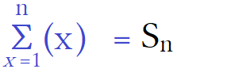

Σ_{k}^{n}(x) =S_{n} This is the notation for summation. It is called sigma notation.
Σ “Σ” is capital sigma it means we are going to sum add terms of a series. Lowercase σ is different.
Σ_{k} “k” is the index of summation. This is what term number we are starting at.
Σ_{k}^{n} “n” is the term number we are ending at. This is called the general term.
Σ_{k}^{n}(x) “(x)” is “the thing to be summed” or “that which is summed”. It is where we write our formula.

The general term means the term that is generalized. To generalize means it has a variable.
Typically this can be thought as the last term. For series notation it is written as “a_{n}” , for here just “n”.
It is written above the “Σ”. I will show some easy then harder summations.

The first summation to learn is that of the whole. This is adding the numbers (0+1+2+3...).
When summing on a calculator you have to stop at a last term. For now this means using only finite sums.

Σ₀⁰(x) = 0 Add 0 We have (0) Σ₀⁰(x) = (a₀)
Σ₀¹(x) = 1 Add 0+1 We have (0+1) Σ₀¹(x) = (a₀+a₁)
Σ₀²(x) = 3 Add 0+1+2 We have (0+1+2) Σ₀²(x) = (a₀+a₁+a₂)
Σ₀³(x) = 6 Add 0+1+2+3 We have (0+1+2+3) Σ₀³(x) = (a₀+a₁+a₂+a₃)
Σ₀⁴(x) = 10 Add 0+1+2+3+4 We have (0+1+2+3+4) Σ₀⁴(x) = (a₀+a₁+a₂+a₃+a₄)

We are starting at the 0th term and summing to the n^{th} term. We are summing (x).
x stands for the term numbers themselves. The pattern formed when taken to infinity is Σ₀∞(x) = (0,1,2,3, …,∞).
When starting at 0 and summing “x” you get a partial sum of the first whole numbers.
Note that 0 to 0 is one term the 0th term, 0 to 1 is two terms the 0th plus the 1st , and so on.
0 is one number, 0+1 is two numbers, 0+1+2 is three numbers.
“n” is the last term you sum to both in term number and numerical value.
If you want to sum to the number 37 then your last term is 37 which has a term number of 37, a₃₇ = 37.
When summing (x) and the index = 0 the ordinal matches the cardinal.

The next summation is the natural numbers (1+2+3...).

Σ₁¹(x) = 1 Add 1 We have (1) Σ₁¹(x) = (a₁)
Σ₁²(x) = 3 Add 1+2 We have (1+2) Σ₁²(x) = (a₁+a₂)
Σ₁³(x) = 6 Add 1+2+3 We have (1+2+3) Σ₁³(x) = (a₁+a₂+a₃)
Σ₁⁴(x) = 10 Add 1+2+3+4 We have (1+2+3+4) Σ₁⁴(x) = (a₁+a₂+a₃+a₄)
Σ₁⁵(x) = 15 Add 1+2+3+4+5 We have (1+2+3+4+5) Σ₁⁵(x) = (a₁+a₂+a₃+a₄+a₅)

The two series are similar but different. They have the same pattern of numbers but summing the first terms we get 0 and 1 and summing the first 5 terms we get 10 and 15. These values are offset by one term. 0 ≠ 1 and 10 ≠ 15. We do not need to start at k = 1. We can start at any number for as long as k<n. The index must be lower than the general term.

Σ₃⁵ (x) = 12 Add 3+4+5 We have (3+4+5) Σ₃⁵(x) = (a₃+a₄+a₅)
Σ₅⁹(x) = 35 Add 5+6+7+8+9 We have (5+6+7+8+9) Σ₅⁹(x) = (a₅+a₆+a₇+a₈+a₉)

The next summation is the even numbers (1+2+3...).

Σ₁¹(2x) = 2 Add 2 We have (2) Σ₁¹(2x) = (a₁)
Σ₁²(2x) = 6 Add 2+4 We have (2+4) Σ₁²(2x) = (a₁+a₂)
Σ₁³(2x) = 12 Add 2+4+6 We have (2+4+6) Σ₁³(2x) = (a₁+a₂+a₃)
Σ₁⁴(2x) = 20 Add 2+4+6+8 We have (2+4+6+8) Σ₁⁴(2x) = (a₁+a₂+a₃+a₄)
Σ₁⁵(2x) = 30 Add 2+4+6+8+10 We have (2+4+6+8+10) Σ₁⁵(2x) = (a₁+a₂+a₃+a₄+a₅)

If you start at k = 0 you get the same pattern but again the values are offset by 1 term number

Σ₀⁰(2x) = 0 Add 0 We have (0) Σ₀⁰(2x) = (a₀)
Σ₀¹(2x) = 2 Add 0+2 We have (0+2) Σ₀¹(2x) = (a₀+a₁)
Σ₀²(2x) = 6 Add 0+2+4 We have (0+2+4) Σ₀²(2x) = (a₀+a₁+a₂)
Σ₀³(2x) = 12 Add 0+2+4+6 We have (0+2+4+6) Σ₀³(2x) = (a₀+a₁+a₂+a₃)
Σ₀⁴(2x) = 20 Add 0+2+4+6+8 We have (0+2+4+6+8) Σ₀⁴(2x) = (a₀+a₁+a₂+a₃+a₄)

The next summation is the odd numbers (1+3+5...).

Σ₀⁰(2x+1) = 1 Add 1 We have (1) Σ₀⁰(2x+1) = (a₀)
Σ₀¹(2x+1) = 4 Add 1+3 We have (1+3) Σ₀¹(2x+1) = (a₀+a₁)
Σ₀²(2x+1) = 9 Add 1+3+5 We have (1+3+5) Σ₀²(2x+1) = (a₀+a₁+a₂)
Σ₀³(2x+1) = 16 Add 1+3+5+7 We have (1+3+5+7) Σ₀³(2x+1) = (a₀+a₁+a₂+a₃)
Σ₀⁴(2x+1) = 25 Add 1+3+5+7+9 We have (1+3+5+7+9) Σ₀⁴(2x+1) = (a₀+a₁+a₂+a₃+a₄)

This time changing start position gives different pattern because we have a bigger formula.

Σ₁¹(2x+1) = 3 Add 3 We have (3) Σ₁¹(2x+1) = (a₁)
Σ₁²(2x+1) = 8 Add 3+5 We have (3+5) Σ₁²(2x+1) = (a₁+a₂)
Σ₁³(2x+1) = 15 Add 3+5+7 We have (3+5+7) Σ₁³(2x+1) = (a₁+a₂+a₃)
Σ₁⁴(2x+1) = 24 Add 3+5+7+9 We have (3+5+7+9) Σ₁⁴(2x+1) = (a₁+a₂+a₃+a₄)
Σ₁⁵(2x+1) = 35 Add 3+5+7+9+11 We have (3+5+7+9+11) Σ₁⁵(2x+1) = (a₁+a₂+a₃+a₄+a₅)

Here is what it is actually doing:

Σ₁⁵(2x) = 30 Add 2+4+6+8+10 We have (2+4+6+8+10) Σ₁⁵(2x) = (a₁+a₂+a₃+a₄+a₅)
Σ₁⁵(2x) = 30 Add (2∙1) + (2∙2) + (2∙3) + (2∙4) + (2∙5) = (2+4+6+8+10)

It is taking 2x and then k=x so that x₁=1; x₂=2; x₃=3; x₄=4; x₅=5.
2 is being multiplied by x and x is acting as the number of multiples of 2.
x₁ is the 1st multiple of 2, x₂ is the 2nd multiple of 2, x₃ is the 3rd multiple of 2, x₄ is the 4th multiple of 2, and so on.

Σ₀⁴(2x) = 20 Add 0+2+4+6+8 (0+2+4+6+8)
Σ₀⁴(2x) = 20 Add (2∙0) + (2∙1) + (2∙2) + (2∙3) + (2∙4) = (0+2+4+6+8)

Σ₀⁴(2x+1) = 25 Add 1+3+5+7+9 (1 +3 +5 +7 +9)
Σ₀⁴(2x+1) = 25 Add (2∙0)+1 + (2∙1)+1 + (2∙2)+1 + (2∙3)+1 + (2∙4)+1 = (1+ 2+1+ 4+1+ 6+1+ 8+1)

Σ₁⁵(2x+1) = 35 Add 3+5+7+9+11 (3 +5 +7 +9 +11)
Σ₁⁵(2x+1) = 35 Add (2∙1)+1 + (2∙2)+1 + (2∙3)+1 + (2∙4)+1 + (2∙5)+1 = (2+1 +4+1 +6+1 +8+1 +10+1)

Firstly they are function that can be written in f(x) notation. Second they are compositions of a function in a function (a functional). The only difference is that instead of giving a single output it is giving a sum of outputs for a specified range. For the notation “y” is the same however “x” is different. The can be expressed as y_{Σ} ≠ y_{f(x)} . x_{Σ} ≠ x_{f(x)} . The “x” in sigma does not equal the x in f(x) but the “y” in sigma does equal the y in f(x) =y.
The summation Σ₀∞(x) is the function f(x) = x where x = y where every input matches every output.

Σ₀∞(x) = ∞ f(x) = x
Σ₀⁰(x) = 0 f(0) = 0
Σ₀⁷(x) = 28 f(28) = 28

Σ₀∞(x) = ∞ = f(∞) = ∞
Σ₀^{n}(x) = n = f(x) = x
Σ₀⁷(x) = x₀ + x₁ + x₂ + x₃ +x₄ + x₅ + x₆ + x₇ = f(28) = 28
Σ₀⁷(x) = f(28) = x₀+x₁ + x₂ + x₃ +x₄ + x₅ + x₆ + x₇ = 28
Σ₀⁷(x) = 0+1+2+3+4+5+6+7 = 28

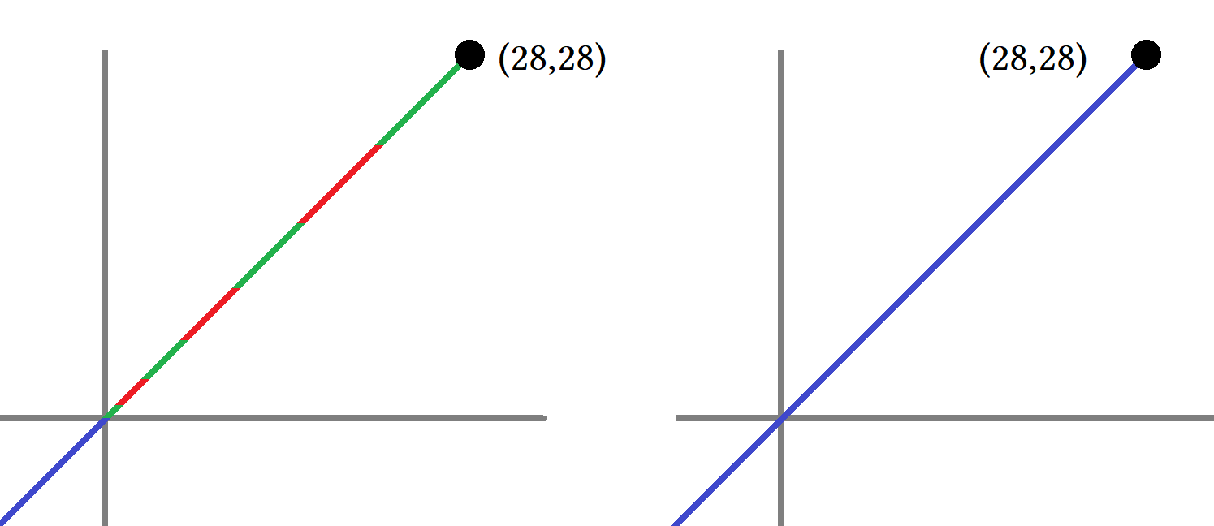

If we sum Σ₀⁷(x) we get 28. It is a partial sum of 0+1+2+3+4+5+6+7. It is called partial because the entire sum goes to ∞. I drew lengths of 0+1+2+3+4+5+6+7 to match the inputs given by x₀+x₁ + x₂ + x₃ +x₄ + x₅ + x₆ + x₇ = 28.
I consider slope to be 1 for Σ₀⁷(x) because we summed f(x) = x.

Both f(x) = x and Σ₀⁷(x) have a slope of 1. For sigma I take whatever is in the () to be a function.
When Σ_{k}^{n}(2x) is Σ₀⁰(x) output is zero. This would be the y-intercept when x = 0 for f(x)= x.

Σ_{k}^{n}(2x) would be f(x) = 2x since (2x) = 2x. Σ_{k}^{n}(2x+1) would be f(x) = 2x+1 since (2x+1) = 2x+1.

About compositions. Σ_{k}^{n}(2x+1) is a composition of Σ_{k}^{n}(1) and Σ_{k}^{n}(2x) although we can not write it as such.
This would match f∘g where f(x) = x+1 and g(x) = 2x.

Σ₀⁴(2x) = 20 Add (2∙0) + (2∙1) + (2∙2) + (2∙3) + (2∙4) = (0+2+4+6+8+10)
Σ₀⁴(2x+1) = 25 Add (2∙0)+1 + (2∙1)+1 + (2∙2)+1 + (2∙3)+1 + (2∙4)+1 = (1+2+1+4+1+6+1+8+1)

The first summation creates a series based on multiples of 2. The second summation takes that series and adds 1 to every term. This is exactly what f∘g where f(x) = x+1 and g(x) = 2x does:

f(x) = x+1 g(x) = 2x f∘g =f(g(x)) = f(2x+1)
f(0) = 0+1 g(0) = 0 f(g(0)) = 0+1 = 1 0 is replaced with 2∙0
f(1) = 1+1 g(1) = 2 f(g(1)) = 2+1 = 3 1 is replaced with 2∙1
f(2) = 2+1 g(2) = 4 f(g(2)) = 4+1 = 5 2 is replaced with 2∙2
f(3) = 3+1 g(3) = 6 f(g(3)) = 6+1 = 7 3 is replaced with 2∙3
f(4) = 4+1 g(4) = 8 f(g(4)) = 8+1 = 9 4 is replaced with 2∙4

Σ₀⁴(2x) =(2∙0) + (2∙1) + (2∙2) + (2∙3) + (2∙4) = (0+2+4+6+8)
Σ₀⁴(2x+1) =(2∙0+1)+ (2∙1+1)+ (2∙2+1)+ (2∙3+1)+ (2∙4+1) = ((2+1)+(4+1)+(6+1)+(8+1)) = (1+3+5+7+9)

a₀: (2∙0) a₁: (2∙1) a₂: (2∙2) a₃: (2∙3) a₄: (2∙4)

Σ₀⁴(1) |  | Σ₀⁴(2x) |  | Σ₀⁴(2x+1)
a₀: 0(1) | 0 | a₀: (2∙0) | 0 | a₀: (2∙0)+1 | 0+1
a₁: 1(1) | 1 | a₁: (2∙1) | 2 | a₁: (2∙1)+1 | 2+1
a₂: 2(1) | 2 | a₂: (2∙2) | 4 | a₂: (2∙2)+1 | 4+1
a₃: 3(1) | 3 | a₃: (2∙3) | 6 | a₃: (2∙3)+1 | 6+1
a₄: 4(1) | 4 | a₄: (2∙4) | 8 | a₄: (2∙4)+1 | 8+1

Σ₀⁴(2x+1) is a composition of Σ₀⁴(1)∘(2x) read as Σ₀⁴(1) “circle” Σ₀⁴(2x).
We can sum anything. To sum the series (0+1+1+1... ) use Σ₀∞(1). To sum (1+1+1...) use Σ₁∞(1).
Change ∞ to the n^{th} term you want to end on. We can also factor things out of series. For Σ₀∞(1):

a₀: (0) = 0
a₁: (0+1) = 1
a₂: (0+1+1) = 2(1) = 2 We factored 1 out twice.
a₃: (0+1+1+1) = 3(1) = 3 We factored 1 out thrice.
a₄: (0+1+1+1+1) = 4(1) = 4 We factored 1 out quince.

Σ₁¹⁰(1) = (1+1+ 1+1+1+1+1+1+1+1) = 10(1) = 10 We can factor things out of series.
Σ₁⁵⁷(1) = (1+1+1...a₅₇) = 57(1) = 57 We factored 1 out 57 times.

Σ₀⁴(x² –4) is a geometric series. This subtracts 4 from every term of Σ₀⁴(x²).
Σ₁⁵(x²) is also a geometric series. Let's write this out out.

S_{n} =(1²+2²+3²+4²+5²+6²) = (1+4+9+16+25+36) = 91

Also 91∙0² = 91 so Σ₀^{n}(x²) = Σ₁⁵(x²). They are the same for every sum.

Σ₀⁴(x² –4) = ((0²– 4) + (1²– 4) + (2²– 4) + (3²– 4) + (4²– 4)) = ( –4–3+0+5+12 ) = (18–7) = 11

For a series x² has is an exponential function so it does not have a common difference nor a common ratio.
For a sequence or series you can have a common difference, ratio, exponential, or nothing.

Σ₀⁴(x!) = (0!+1!+2!+3!+4!) = (1+1+2+6+24) = 34 We can sum anything.
2Σ₀⁴(x!) = Σ₀⁴(x!) + Σ₀⁴(x!) = 2∙34 = 34+34 = 68 We can perform any operation since a sum is just a number.
Σ_{k}^{n}(x²) will also equal Σ_{k}^{n}(x – 1)². There are different ways of writing the same sum.

Σ₂⁵( –1)^{x}(2x) = (–1²∙(2∙2) + –1³∙(2∙3) + –1⁴∙(2∙4) + –1⁵∙(2∙5) ) = (4–6+8–10) = 8

You have a first term called a₁ and a general term called a_{n}. We want to find the general term because it is the term that is used to find what to put in () for sigma notation. It is “the thing to be summed” or “that which is summed”.

Σ₁ This says start at a₁.
Σ₁¹⁰⁰ This says end at a₁₀₀. We have to add 100 terms: (a₁+a₂+a₃+a₄+a₅+...+a₁₀₀).
Σ₁¹⁰⁰() The () is where we write what we are summing.
Σ₁¹⁰⁰(a_{n}) The a_{n} is called the general term. The general term is what we are summing.

In sigma notation this is Σ₁¹⁰⁰(x) = 5050. This says sum of (x) from 1 to 100 equals 5050.

Σ₁¹⁰⁰(x) = (1+2+3+…+100) Starts at 1st term and end at 100th term.

Explaining sigma notation:

Σ₁¹⁰⁰(x) = (1+2+3+…+100)

Σ is the capital Greek letter sigma. It means summation. We are going sum numbers. Sum means add.
Σ“_{x=k}” under sigma we write “k or i”. “i” is called the “index of summation”.
Σ“_{x=0}” and Σ“_{x=1}”. If x = 0 we start at the 0th term a₀. If x = 1 we start at the 1st term a₁.

Σ₁¹(x) =1 This says the first term a₁ = 1
Σ₁₀₀¹⁰⁰(x) = 100 This says the 100th term a₁₀₀ = 100

Gaussian Sums

The ones range is 0-9.
x: {0+1+2+3+4+5+6+7+8+9} Notice that for a set order does not matter.
S₁₀: (1+9+2+8+3+7+4+6+5) Use commutative property to create sums of 10.

x = (1+9+2+8+3+7+4+6+5) A Gaussian sum since every two numbers except 5 sums to 10.
x = (10+10+10+10+5) = 4(10)+5 Use associative property then factor out 4.

x = (10+10+10+10+5)
x = (10+10+10+10) + 5 Associative property.
x = 10(4) + 5 Factor 10 out.
x = 4(10) + 5 Commutative and associative properties.
x = 45 0-9 = 45 for all sets of 10

The teens range is 10-19.
1x:{10+11+12+13+14+15+16+17+18+19}
x = (+11+19+12+18+13+17+14+16+15+10)
x = (10+30+30+30+30+15)
x = (100+45)
x = 145

Sums like this demonstrate the commutative property. People do this all the time. Here is the important one:

S₁₀₀ = (1+2+3+ … +100) Add all the numbers from 1 to 100.
x = (1+99+2+98+…+100) Rearrange all numbers so that every two pairs except 50 equals 100
x = 5050

100/2 50 We can make 50 pairs of 2 numbers out of 100 by using 100/2.
50∙100 = 5000+50 This says there will be 50 pairs of 100 plus 50 so 50(100)+50.
50.5∙100 = 5050 This says we have 50.5 pairs of 100. It treats the “+50” as a ½ pair.

Using the formula for “summation of a series” S_{n} = ^{n}/₂(a₁+a_{n}):

S_{n} = ^{n}/₂(a₁+a_{n})
S₁₀₀ = ¹⁰⁰/₂(a₁+a₁₀₀)
S₁₀₀ = 50(1∙1+1∙100)
S₁₀₀ = 50(1+100) = 5000+50
S₁₀₀ = 50(101) This says we have 101 groups of 50.
S₁₀₀ = 5050

When rearranging all numbers have a co-number that sums to 100 except 50 because we would need 50+50 to equal 100. Since every two numbers equals 100 we can take 100 numbers and make 50 groups of two numbers.
50 groups that sum to 100 means 50(100) = 5000. We actually have (50+½) groups: (50+½)100 = 5000+50 = 5050.

Here starting at 0 is the same thing as starting a 1. Adding or subtracting 0 does not change sum.
(0+1+2+3+... +100) =5050
( 1+2+3+... +100) =5050

Proof:

0+100=100 1+99=100 2+98=100 3+97=100 4+96=100 5+95=100 6+94=100 7+93=100
8+92=100 9+91=100 10+90=100 11+89=100 12+88=100 13+87=100 14+86=100 15+85=100
16+84=100 17+83=100 18+82=100 19+81=100 20+80=100 21+79=100 22+78=100 23+77=100
24+76=100 25+75=100 26+74=100 27+73=100 28+72=100 29+71=100 30+70=100 31+69=100
32+68=100 33+67=100 34+66=100 35+65=100 36+64=100 37+63=100 38+62=100 39+61=100
40+60=100 41+59=100 42+58=100 43+57=100 44+56=100 45+55=100 46+54=100 47+53=100
48+52=100 49+51=100 50 ■

0+ 1+ 2+ 3+ 4+ 5+ 6+ 7+ 8+ 9 =1+9+2+8+3+7+4+6+5 = 45
10+11+12+13+14+15+16+17+18+19 =1+9+2+8+3+7+4+6+5 + 10(10) = 100+45
20+21+22+23+24+25+26+27+28+29 =1+9+2+8+3+7+4+6+5 + 10(20) = 200+45
30+31+32+33+34+35+36+37+38+39 =1+9+2+8+3+7+4+6+5 + 10(30) = 300+45
40+41+42+43+44+45+46+47+48+49 =1+9+2+8+3+7+4+6+5 + 10(40) = 400+45
50+51+52+53+54+55+56+57+58+59 =1+9+2+8+3+7+4+6+5 + 10(50) = 500+45
60+61+62+63+64+65+66+67+68+69 =1+9+2+8+3+7+4+6+5 + 10(60) = 600+45
70+71+72+73+74+75+76+77+78+79 =1+9+2+8+3+7+4+6+5 + 10(70) = 700+45
80+81+82+83+84+85+86+87+88+89 =1+9+2+8+3+7+4+6+5 + 10(80) = 800+45
90+91+92+93+94+95+96+97+98+99 =1+9+2+8+3+7+4+6+5 + 10(90) = 900+45
100 = 100

S₁₀₀ = ( 45 + 100+45 + 200+45 + 300+45+ 400+45+ 500+45+ 600+45+ 700+45+ 800+45+ 900+45 + 100 )
S₁₀₀ = ( 10(45) + 100 + 200 + 300 + 400 + 500 + 600 + 700 + 800 + 900 + 100 )
S₁₀₀ = ( 10(45) + 100 + 900 + 200 + 800 + 300 + 700 + 400 + 600 + 500 + 100 )
S₁₀₀ = ( 10(45) + 45(100))
S₁₀₀ = ( 450 + 4500)
S₁₀₀ = 5050■

The 4 4-tuples are the diagonal row. In a 3d graphing system this is the line from (1,1,1) to (4,4,4). This would be a straight line traveling through 4 points. The line moves in three dimensions through A:1; B:2; C:3; D:4.
aaaa | aaab | aaac | aaad | aaba | aabb | aabc | aabd | aaca | aacb | aacc | aacd | aada | aadb | aadc | aadd
abaa | abab | abac | abad | abba | abbb | abbc | abbd | abca | abcb | abcc | abcd | abda | abdb | abdc | abdd
acaa | acab | acac | acad | acba | acbb | acbc | acbd | acca | accb | accc | accd | acda | acdb | acdc | acdd
adaa | adab | adac | adad | adba | adbb | adbc | adbd | adca | adcb | adcc | adcd | adda | addb | addc | addd
baaa | baab | baac | baad | baba | babb | babc | babd | baca | bacb | bacc | bacd | bada | badb | badc | badd
bbaa | bbab | bbac | bbad | bbba | bbbb | bbbc | bbbd | bbca | bbcb | bbcc | bbcd | bbda | bbdb | bbdc | bbdd
bcaa | bcab | bcac | bcad | bcba | bcbb | bcbc | bcbd | bcca | bccb | bccc | bccd | bcda | bcdb | bcdc | bcdd
bdaa | bdab | bdac | bdad | bdba | bdbb | bdbc | bdbd | bdca | bdcb | bdcc | bdcd | bdda | bddb | bddc | bddd
caaa | caab | caac | caad | caba | cabb | cabc | cabd | caca | cacb | cacc | cacd | cada | cadb | cadc | cadd
cbaa | cbab | cbac | cbad | cbba | cbbb | cbbc | cbbd | cbca | cbcb | cbcc | cbcd | cbda | cbdb | cbdc | cbdd
ccaa | ccab | ccac | ccad | ccba | ccbb | ccbc | ccbd | ccca | cccb | cccc | cccd | ccda | ccdb | ccdc | ccdd
cdaa | cdab | cdac | cdad | cdba | cdbb | cdbc | cdbd | cdca | cdcb | cdcc | cdcd | cdda | cddb | cddc | cddd
daaa | daab | daac | daad | daba | dabb | dabc | dabd | daca | dacb | dacc | dacd | dada | dadb | dadc | dadd
dbaa | dbab | dbac | dbad | dbba | dbbb | dbbc | dbbd | dbca | dbcb | dbcc | dbcd | dbda | dbdb | dbdc | dbdd
dcaa | dcab | dcac | dcad | dcba | dcbb | dcbc | dcbd | dcca | dccb | dccc | dccd | dcda | dcdb | dcdc | dcdd
ddaa | ddab | ddac | ddad | ddba | ddbb | ddbc | ddbd | ddca | ddcb | ddcc | ddcd | ddda | dddb | dddc | dddd

All sets have 64 codes arranged in a 16×4 matrix that can be re-arranged into 4 4×4 matrices. Leave as a 16×4 for now. There are 9 triples per set with 6 in the main subset and 1 each per other subset. Look at the 4×4 with 6 triples and how the 4-tuple is not highlighted. Compare the 4-tuple with triple s from other levels. Aaaa lines up with baaa,caaa, and daaa.... Bbbb with abbb,cbbb, and dbbb Cccc,accc,bccc,dccc...dddd,addd,bddd,cdddd
aaaa | aaab | aaac | aaad | aaba | aabb | aabc | aabd | aaca | aacb | aacc | aacd | aada | aadb | aadc | aadd
abaa | abab | abac | abad | abba | abbb | abbc | abbd | abca | abcb | abcc | abcd | abda | abdb | abdc | abdd
acaa | acab | acac | acad | acba | acbb | acbc | acbd | acca | accb | accc | accd | acda | acdb | acdc | acdd
adaa | adab | adac | adad | adba | adbb | adbc | adbd | adca | adcb | adcc | adcd | adda | addb | addc | addd

baaa | baab | baac | baad | baba | babb | babc | babd | baca | bacb | bacc | bacd | bada | badb | badc | badd
bbaa | bbab | bbac | bbad | bbba | bbbb | bbbc | bbbd | bbca | bbcb | bbcc | bbcd | bbda | bbdb | bbdc | bbdd
bcaa | bcab | bcac | bcad | bcba | bcbb | bcbc | bcbd | bcca | bccb | bccc | bccd | bcda | bcdb | bcdc | bcdd
bdaa | bdab | bdac | bdad | bdba | bdbb | bdbc | bdbd | bdca | bdcb | bdcc | bdcd | bdda | bddb | bddc | bddd

caaa | caab | caac | caad | caba | cabb | cabc | cabd | caca | cacb | cacc | cacd | cada | cadb | cadc | cadd
cbaa | cbab | cbac | cbad | cbba | cbbb | cbbc | cbbd | cbca | cbcb | cbcc | cbcd | cbda | cbdb | cbdc | cbdd
ccaa | ccab | ccac | ccad | ccba | ccbb | ccbc | ccbd | ccca | cccb | cccc | cccd | ccda | ccdb | ccdc | ccdd
cdaa | cdab | cdac | cdad | cdba | cdbb | cdbc | cdbd | cdca | cdcb | cdcc | cdcd | cdda | cddb | cddc | cddd

daaa | daab | daac | daad | daba | dabb | dabc | dabd | daca | dacb | dacc | dacd | dada | dadb | dadc | dadd
dbaa | dbab | dbac | dbad | dbba | dbbb | dbbc | dbbd | dbca | dbcb | dbcc | dbcd | dbda | dbdb | dbdc | dbdd
dcaa | dcab | dcac | dcad | dcba | dcbb | dcbc | dcbd | dcca | dccb | dccc | dccd | dcda | dcdb | dcdc | dcdd
ddaa | ddab | ddac | ddad | ddba | ddbb | ddbc | ddbd | ddca | ddcb | ddcc | ddcd | ddda | dddb | dddc | dddd
I am going to break up the set that begins with a, set A1 or “set a” into 4 4×4 matrices.
For now I am not going to name these sets. There are different ways to write a matrix so I want to hold off on naming until I know how I want arrange my data before I commit to a certain naming scheme.
Naming schemes are largely dependent more on your application than what data you have.
Right now I want to look at patterns of where singles, doubles, triples, and quadruples appear.

This shows all 64 codes of set a highlighting the triples and quadruple:

aaca | aacb | aacc | aacd
abca | abcb | abcc | abcd
acca | accb | accc | accd
adca | adcb | adcc | adcd

aaaa | aaab | aaac | aaad
abaa | abab | abac | abad
acaa | acab | acac | acad
adaa | adab | adac | adad

aaba | aabb | aabc | aabd
abba | abbb | abbc | abbd
acba | acbb | acbc | acbd
adba | adbb | adbc | adbd

aada | aadb | aadc | aadd
abda | abdb | abdc | abdd
acda | acdb | acdc | acdd
adda | addb | addc | addd

This shows all 64 codes highlighting the doubles:

aaaa | aaab | aaac | aaad
abaa | abab | abac | abad
acaa | acab | acac | acad
adaa | adab | adac | adad

aaba | aabb | aabc | aabd
abba | abbb | abbc | abbd
acba | acbb | acbc | acbd
adba | adbb | adbc | adbd

aada | aadb | aadc | aadd
abda | abdb | abdc | abdd
acda | acdb | acdc | acdd
adda | addb | addc | addd

aaca | aacb | aacc | aacd
abca | abcb | abcc | abcd
acca | accb | accc | accd
adca | adcb | adcc | adcd

This shows all 64 codes highlighting the singles:

aaaa | aaab | aaac | aaad
abaa | abab | abac | abad
acaa | acab | acac | acad
adaa | adab | adac | adad

aaba | aabb | aabc | aabd
abba | abbb | abbc | abbd
acba | acbb | acbc | acbd
adba | adbb | adbc | adbd

aada | aadb | aadc | aadd
abda | abdb | abdc | abdd
acda | acdb | acdc | acdd
adda | addb | addc | addd

aaca | aacb | aacc | aacd
abca | abcb | abcc | abcd
acca | accb | accc | accd
adca | adcb | adcc | adcd

Notice the quadruple aaaa is surrounded by triples. Every quadruple is in the 4×4 matrix containing the 6 triples. The quadruple is the center of the 6 triples but more precisely it is the vertex. Codes appear in lines.
A vertex is where two lines cross. The quadruple aaaa acts as the vertex of a right corner.
The other quadruples act as a vertex of two lines that are perpendicular.

Try to find patterns. Find patterns when letters repeat so you can predict where a sequenced term will appear.
Look for diagonal patterns and diagonal wrap around patterns. Treat the matrix as a quadratic or polynomial sum. We taught sequences and series and now we are using that for matrices. A sequenced term is a serial code that has skipping numbers that repeat in a sequence. Your job would be to guess what the next term should be or where a specific term is in a matrix grid.

Our codes have 4 letters of abcd where each letter is an element of each code. This is like saying component or part that makes up the whole code. When we have a matrrix and make a table each square contains a code. We will call each code an element itself. For the table codes are written in areas called “cells”. “Cell” means an area which something is stored. A prison cell or wine cellar are examples from English. Plants and animals have cells that contain genetic information called DNA. A cell is where we store information. For a matrix every cell contains one element.

For the 16×4 matrix of set A₁ that here we are simply calling “set a” the main patterns are as follows:
The entire matrix mat:a =

aaaa | aaab | aaac | aaad | aaba | aabb | aabc | aabd | aaca | aacb | aacc | aacd | aada | aadb | aadc | aadd
abaa | abab | abac | abad | abba | abbb | abbc | abbd | abca | abcb | abcc | abcd | abda | abdb | abdc | abdd
acaa | acab | acac | acad | acba | acbb | acbc | acbd | acca | accb | accc | accd | acda | acdb | acdc | acdd
adaa | adab | adac | adad | adba | adbb | adbc | adbd | adca | adcb | adcc | adcd | adda | addb | addc | addd

We call this set a because every element has the first character as “a”. For 16 letters times 16 numbers we have a 16×16 matrix of 256 unique codes. By arranging the entries by alphabetical order we get 16 rows that have 4 rows each of a, b, c, and d. Thus we have set a, set b, set c, and set d. For any 16×4 matrix we can break it down into 4×4 matrix to make the easier to manage. Each 4×4 matrix is a subset of a 16×4 matrix which is a subset of a 16×16 matrix. Set A₁ = set a where set a is made of 4×4 matrices a₁,a₂,a₃, and a₄.

Mat:a₄
aada | aadb | aadc | aadd
abda | abdb | abdc | abdd
acda | acdb | acdc | acdd
adda | addb | addc | addd

Mat:a₂
aaba | aabb | aabc | aabd
abba | abbb | abbc | abbd
acba | acbb | acbc | acbd
adba | adbb | adbc | adbd

Mat:a₁
aaaa | aaab | aaac | aaad
abaa | abab | abac | abad
acaa | acab | acac | acad
adaa | adab | adac | adad

Mat:a₃
aaca | aacb | aacc | aacd
abca | abcb | abcc | abcd
acca | accb | accc | accd
adca | adcb | adcc | adcd

If we can do this for “set a” then we can do this for all other subsets of “set A”. The number of singles, doubles, triples, and quadruples for one subset of set A will exist in all other subsets of set A.

Set A: {a,b,c,d}
Set a: {a₁,a₂,a₃,a₄}
Set b: {b₁,b₂,b₃,b₄}
Set c: {c₁,c₂,c₃,c₄}
Set d: {d₁,d₂,d₃,d₄}

From the last page we found that set a contained 64 codes of which we had: 6 singles, 45 doubles, 9 triples,1 quadruple. If the subset, set a, contains these codes then all subsets of set A contain them.
Every subset: contains 64 codes comprised of 6 singles, 45 doubles, 9 triples,1 quadruple.
By listing all sets as subsets of set A we can then examine set a to solve for sets b,c and d.

Naming sets is often difficult. Start at the entire set of data, arrange it logically, determine how many subsets you can make, use a convenient naming scheme. Set a = {a₁,a₂,a₃,a₄}. Sets contain the codes they do because they are taken as “4 codes long by 4 codes down”. This will cause additional “skips” in a set because codes in sequential order are spread throughout other sets. Skips happen in two ways. First way is due to not using full range of letters or numbers , second way is using a sub-subset.

Mat:a₂
aaba | aabb | aabc | aabd
abba | abbb | abbc | abbd
acba | acbb | acbc | acbd
adba | adbb | adbc | adbd

Mat:a₁
aaaa | aaab | aaac | aaad
abaa | abab | abac | abad
acaa | acab | acac | acad
adaa | adab | adac | adad

Mat:a₃
aaca | aacb | aacc | aacd
abca | abcb | abcc | abcd
acca | accb | accc | accd
adca | adcb | adcc | adcd

Mat:a₄
aada | aadb | aadc | aadd
abda | abdb | abdc | abdd
acda | acdb | acdc | acdd
adda | addb | addc | addd

Mat:a₂
1121 | 1122 | 1123 | 1124
1221 | 1222 | 1223 | 1224
1321 | 1322 | 1323 | 1324
1421 | 1422 | 1423 | 1424

Mat:a₁
1111 | 1112 | 1113 | 1114
1211 | 1212 | 1213 | 1214
1311 | 1312 | 1313 | 1314
1411 | 1412 | 1413 | 1414

Mat:a₃
1131 | 1132 | 1133 | 1134
1231 | 1232 | 1233 | 1234
1331 | 1332 | 1333 | 1334
1431 | 1432 | 1433 | 1434

Mat:a₄
1141 | 1142 | 1143 | 1144
1241 | 1242 | 1243 | 1244
1341 | 1342 | 1343 | 1344
1441 | 1442 | 1443 | 1444

A 4×4 matrix is 4 codes long and 4 codes tall. Changing the letters to numbers shows a sequence of:

1111,1112,1113,1114,1121,1122,1123,1124,1131,1132,1133,1134,1141,1142,1143,1144 which is spread across 4 matrices: 1111,1112,1113,1114,1121,1122,1123,1124,1131,1132,1133,1134,1141,1142,1143,1144.
The first row is in numerical order but has missing numbers. When next numbers are missing this is called a “skip” because it is skipped over. The first skip is at 1114,1121 where 1115,1116,1117,1118,1119,1120 are missing.
We have 4 elements so will skip 6 numbers. For elements we have a,b,c,d which correspond to 1,2,3,4. We map a=1, b=2, c=3, d=4, this is the end of our range so we can not map e to 5. The set A skips numbers that end in 5-9 or 0. Subsets like Matrix a₁ skip numbers outside of its 16 element range.

1111,1112,1113,1114,1211,1212,1213,1214,1311,1312,1313,1314,1411,1412,1413,1414

1111 | 1112 | 1113 | 1114
1211 | 1212 | 1213 | 1214
1311 | 1312 | 1313 | 1314
1411 | 1412 | 1413 | 1414

1114,1211 skips codes from 1121. 1214,1311 skips from 1221.
1314,1411 skips from 1321.

1144:1121,1122,1123,1124,1131,1132,1133,1134,1141,1142...
1344:1221,1222,1223,1224,1231,1232,1233,1234,1241,1242...
1444:1321,1322,1323,1324,1331,1332,1333,1334,1341,1342...

Set a has 64 codes, each subset of set a has 16, each row of a subset has 4 codes.
There are 16 are codes per line for set a, 4 code per line for set a₁.
A 4×4 has 4 codes a line. 16–4=12. There are 12 codes skipped per line for these 4×4 matrices.

After 1114 12 codes excluded:

1111 1112 1113 1114 1121 1122 1123 1124 1131 1132 1133 1134 1141 1142 1143 1144

After 1214 12 codes excluded:

1211 1212 1213 1214 1221 1222 1223 1224 1231 1232 1233 1234 1241 1242 1243 1244

After 1314 12 codes excluded:

1311 1312 1313 1314 1321 1322 1323 1324 1331 1332 1333 1334 1341 1342 1343 1344

After 1414 12 codes excluded:

1411 1412 1413 1414 1421 1422 1423 1424 1431 1432 1433 1434 1441 1442 1443 1444

As a function we can map letters to numbers. The function x:# is a ratio of letters to numbers. It converts letters to numbers. Hash symbol “#” means number, x means letter as in “insert letter here” as f(x) = [abc]:#.
For all letters of the English Alphabet:

Function x:# |  |  | Function #:x
Input (x) | Output (#) | correspondence | Input(#) | output(x) | correspondence
a | 1 | a maps to 1 | 1 | a | 1 maps to a
b | 2 | b maps to 2 | 2 | b | 2 maps to b
c | 3 | c maps to 3 | 3 | c | 3 maps to c
d | 4 | d maps to 4 | 4 | d | 4 maps to d
e | 5 | e maps to 5 | 5 | e | 5 maps to e
f | 6 | f maps to 6 | 6 | f | 6 maps to f
g | 7 | g maps to 7 | 7 | g | 7 maps to g
h | 8 | h maps to 8 | 8 | h | 8 maps to h
i | 9 | i maps to 9 | 9 | i | 9 maps to i
j | 10 | j maps to 10 | 10 | j | 10 maps to j
k | 11 | k maps to 11 | 11 | k | 11 maps to k
l | 12 | l maps to 12 | 12 | l | 12 maps to l
m | 13 | m maps to 13 | 13 | m | 13 maps to m
n | 14 | n maps to 14 | 14 | n | 14 maps to n
o | 15 | o maps to 15 | 15 | o | 15 maps to o
p | 16 | p maps to 16 | 16 | p | 16 maps to p
q | 17 | q maps to 17 | 17 | q | 17 maps to q
r | 18 | r maps to 18 | 18 | r | 18 maps to r
s | 19 | s maps to 19 | 19 | s | 19 maps to s
t | 20 | t maps to 20 | 20 | t | 20 maps to t
u | 21 | u maps to 21 | 21 | u | 21 maps to u
v | 22 | v maps to 22 | 22 | v | 22 maps to v
w | 23 | w maps to 23 | 23 | w | 23 maps to w
x | 24 | x maps to 24 | 24 | x | 24 maps to x
y | 25 | y maps to 25 | 25 | y | 25 maps to y
z | 26 | z maps to 26 | 26 | z | 26 maps to z

For the function f(x) = # the inputted letter outputs a number. The domain of f(x) = # is (a,z) the range is (1,26).
For the function f(x) = # the inputted number outputs a letter. The domain of f(#) = x is (1,26) the range is (a,z).

Definition of an inverse function:

A function has an inverse only if every element of domain maps to every element of range.
A function has an inverse only if every element of range maps to every element of domain.
Both of these two constraints must be met. If they are our have a 1 to 1 correspondence.
For f(x)=# and f(#)=x this happens so they are both inverses of each other.
We say set x is the set of unknown letters and set # is the set of unknown numbers:

Set x: (a,z) Set #: (1,26)

The function takes the 1st letter and maps it to number 1, the 2nd letter and maps it to 2...the 26th letter and maps it to 26. Z is the last letter of the alphabet so we can only have 26 pairings of (x,#). Z is the highest number we can input for f(x)=#. Likewise 26 is the last number for domain of set #:(1,26).

For sets {} means every element is the set like {1,2,3...26}. We have to write every element but can use ellipsis to truncate. For sets () means domain or range where we only write the first term and the last term.

A set q:(2,5) has a domain of 2 to 5. We do not know what numbers are contained we only know the lowest and highest values which are the first term and last term of a set. If natural numbers are used then they are the first term and last term of a sequence.

Set q:{2,3,5} has three elements and every one is listed. 4 is excluded so we can not use that number.
Set r:(2,5) has a domain of 2 to 5 and has members set r:{2,3,4,5} where 4 is included.
These are two different sets with the same domain but different members.

Set q:(2,5)
Set r:(2,5) Both have the same domain.

Set q:{2,3,5}
Set r:{2,3,4,5} But have different elements. This is usually said as they have different members.

Set k:{5,6,7,8,9,10}
Set k:{5,6,7...10} Set k has all natural numbers from 5 to 10 so we can truncate it using ellipsis.

To use ellipsis you have to demonstrate a clear pattern first. You need at least three numbers to start a pattern because only 2 is not enough to demonstrate a pattern. Three numbers is the minimum, you might need to use more. Some set have no pattern and there for can not use ellipsis at all. Some sets the pattern is as long as writing with ellipsis as without so its use is not helpful even if you could use it.

You are running a marathon around city blocks. The course is rectangle shaped. Every mile has a colored flag as a mile marker. The pattern is green,red,red,blue. Each lap is 4 miles. There are 2 laps. The race begins and ends at the blue flag.

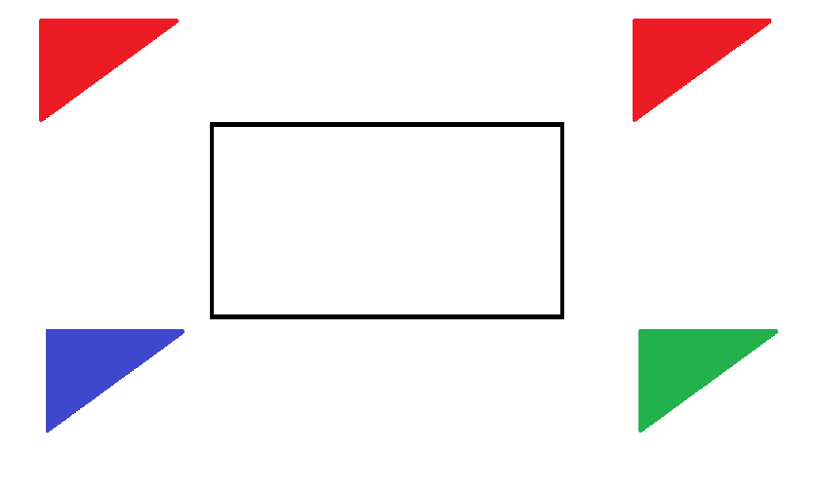
Set flags: (green,blue) The first flag is green the last flag is blue.
Set flags: {green,red,blue} The set allows these 3 colors.
S: (g,r,r,b,g,r,r,b) The sequence is green first at 1 mile, blue last at 4 miles.

The notation S: is used for sequences. Sequences are not sums they are the order of a pattern of elements.
A sequence uses commas to separate elements, a sum uses plus signs to separate elements. Some sequences can be written as sums but not all. When a sequence is written as a sum we call it a polynomial. All polynomials are sums that can be written using series notation S_{n} = y where y is the output (final #) and S_{n} is the series.

A series is a list of summed terms. A polynomial written in series notation is S_{n}: (a₀+a₁+a₃ …a_{n}). All Polynomials are sums. All sums can be written as a sequence and the as a series. A series is a polynomial where many numbers are to be added. Series just like polynomials are written lists of numbers written by being separated by plus signs. A series equals a single number. Polynomial means many numbers but equals a single number. Whether a polynomial or a series they are both sums. They are the same.

Let's say there were more laps. How would we write the sequence if there were 4 laps? 5 laps? 10 laps? Infinite laps?

We can not sum the sequence S: (g,r,r,b,g,r,r,b) because they do not have numerical value. But we can write truncate it. Other sequences with numerical value can not be summed for summing them would not make sense.
They can but it would be pointless.

2 laps = S: (g,r,r,b,g,r,r,b) = S: (g,r,r,b,g...b) “repeat what happens after green all the way to blue”.
4 laps = S: (g,r,r,b,g,r,r,b,g,r,r,b,g,r,r,b) = S: (g,r,r,b,g...b...b) “repeat g,r,r,b. Then “b...b” says repeat “g...b”.

We have the pattern “green,red,red,blue”. The pattern starts at green because green is the first term.
Should we state the pattern this way or should we state it as “blue, green, red,red”? Why or why not?

The race starts at the blue flag and ends at the blue flag. Begin at the blue flag and run the race:

After 1 mile you pass the green flag.
After 2 miles you pass the 1st red flag.
After 3 miles you pass the 2nd red flag.
After 4 miles you pass the blue flag. This is one lap or “cycle”.
I would prefer to think of this as green,red,red,blue to count miles passed. This is a “distance”.
Blue,green,red,red is saying what mile marker you are at. This is a “position”.

There are 4 flags. We are counting 1 mile, 2 miles, 3 miles, 4 miles.

0th mile = 0th term = a₀ = 0 = blue location is 4th mile marker start here: distance is 0
1st mile = 1st term = a₁ = 1 = green distance: 0+1 = 1
2nd mile = 2nd term = a₂ = 1 = red distance: 1+1 = 2
3rd mile = 3rd term = a₃ = 1 = red distance: 2+1 = 3
4th mile = 4th term = a₄ = 1 = blue distance: 3+1 = 4

Stating the pattern as blue green red, red only get you to the 3rd term. This means the pattern of the race course is four flags but only 3 miles. We want 4 flags and 4 miles. For this count the distance by adding 1 to 0.
Do not list the location as 0 and then do 0+1+1+1 = 3. Saying (b,g,r,r) is saying 0+1+1+1 = 3.
It is almost like saying “0 to 3 is four numbers so 0+3 =4”. This is wrong.

This seems recursive where the next input is the last output. f(x) = x+1.
(a₀ +a₁ +a₂ +a₃ +a₄ ) = (a₁ +a₂ +a₃ +a₄ ) = (0 + 1 + 1 +1 + 1) = (1 + 1 +1 + 1).

If (a₀ +a₁ +a₂ +a₃ +a₄ ) then (0 + 1 + 1 +1 + 1) then (0,1,1,1,1) then (b,g,r,r,b) not ((b,g,r,r). This needs 5 elements to write and is not quite right. We tend not to add 0 and we do not write a sequence with extra elements.

If (a₁ +a₂ +a₃ +a₄ ) then (1 + 1 +1 + 1) is sum of miles, then (1,1,1,1) is sequence of miles, then (g,r,r,b) is sequence of flags. For a single lap use (g,r,r,b). This gives us the general pattern for n laps.

1 lap: (g,r,r,b)
2 laps: (g,r,r,b,g,r,r,b) = (g,r,r,b,g...b) “g...b” means repeat “g,r,r,b”. replace “g...b” with “g,r,r,b”.
3 laps: (g,r,r,b,g,r,r,b,g,r,r,b) = (g,r,r,b,g...b...b) “b...b” means repeat “g...b”.
4 laps: (g,r,r,b,g,r,r,b,g,r,r,b) = (g,r,r,b,g...b....b) “b....b” means repeat “g...b” twice. There are 4 ellipsis dots.
10 laps (g-b,g-b,g-b,g-b,g-b,g-b,g-b,g-b) = (g,r,r,b,g...b..........b) “b....b” means repeat “g...b” twice. There are 7 ellipsis.

infinite laps: (g,r,r,b,g...b...) this is actually true but I would not write it this way.(g,r,r,b,g...). is best
g,r,r,b, this is one lap
g...b this is “repeat the sequence that gave one lap”
…) this is “repeat two laps forever” which would be infinite laps

How would you write infinite laps? Does repeating 2 laps forever make sense or should we repeat one lap forever? How would would you state 1 lap repeating? I think a common mistake is to do this: (g,r,r,b...)

Doe it make sense to use g,r,r,b... for infinite laps? We are not told what comes after blue so how do we know what to write after blue? The ellipsis mark “ … ” means repeat but in a specific way.

If I told you to repeat what came after blue last time and there was no last time what do you do?
I am being unreasonable. How can you know what to repeat last time if there was not a last time? You can't. You can assume someone is abusing notation and is trying to imply repeat the entire sequence over and over but you can not be sure. Either way it is wrong to write it that way: (g,r,r,b...) does not mean (g,r,r,b,g,r,r,b...).

Does 1,2,3,4... mean (1,2,3,4,1,2,3,4,1,2,3,4,1,2,3,4,...)? Of course not.

(1,2,3,4,1,2,3,4,1,2,3,4,1,2,3,4,...) can be truncated as short as you want depending on what you want to show to your audience. Sometimes we leave more elements than needed to help younger readers. We want to write the minimum unless it is hard to understand or think our readers will struggle to see the pattern. We do not want to be obtuse.

Something too long is too verbose and something too short is too obtuse. When it is obtuse we need to clarify. If something it too truncated we need to unpack it. If something is too expanded we need to truncated it.

(1,2,3,4,1,2,3,4,1,2,3,4,1,2,3,4,...) This is too long...
(1,2,3,4,1,2,3,4,1,2,3,4,...) Too long...
(1,2,3,4,1,2,3,4,...) Just right for all readers...
(1,2,3,4,1...) Perfect. This is the absolute minimum to write and fully express the pattern.

We have “1...” which says repeat what came after “1” last time. What came after “1” was 2,3,4.
After 2,3,4 we had 1 again. Ellipsis here means repeat what should come between 1 and 1.

The difference between 1,2,3,4... and 1,2,3,4,1... is that 1,2,3,4... does not have any repeating numbers.
If numbers repeat then the last number is the end of your range and you have one cycle.
After repeating one cycle you repeat it again to infinity.

When we have 1,2,3,4,1... we were moving in one direction on the number line and then stopped and restarted counting at an earlier number. We have the sequence “1,2,3,4” where 1,2,3,4,1 the blue number is the beginning and end of our sequence and 4 is the end of our range. The sequence “1,2,3,4” and we reach “4” we have to “restart numbering” or “restart or sequence”. If moving in a positive direction then the last number of a sequence will also be highest usually unless you have something else like 1,2,3,15,10. Sequences like this have a definite pattern but finding the general term or a common difference or ratio or function is difficult. These type of sequences do not conform to our basic assumptions of what a sequence should be.

1,2,3,15,10,1,2,3,15,10,1,2,3,15,10... there is a pattern and it continues forever. This could be anything.

On Monday I order the #1, Tuesday the #2, Wednesday the #3, Thursday the #10, Friday the number #15.
These are the daily specials and they come with free dessert so I make sure to exploit the offer. I am a predictable creature of habit.

1,2,3,10,15 could be a rotation of jerseys on a basketball team or people assigned a task at work like clean out cage 1 on Monday, cage 2 on Tuesday etc for a zookeeper. The zookeeper has a predictable work schedule.

Take pill 1 on Monday pill 2 on Tuesday... pill 10 on Friday. This could be a medical schedule for a patient in the hospital, on recovery, or they simply have a condition different from but like diabetes that requires daily medicine of some type. Or it could be an athlete taking different vitamins and supplements like creatine on different days as part of a training regiment.

If numbers do not repeat then you continue going in the same direction using the correct pattern, you have four choice: common difference, common ratio, common exponential, common pattern. A common pattern would be a multi-step function. Multi-step functions are harder to define in simple terms. Focus is on common differences and ratios. 1,2,3,4... the common difference is 1 so add 1 to find the next term.

a₄ = 4 We can call 4 the last given term since we are given (1,2,3,4...a_{n}) = (a₁,a₂,a₃,a_{g}...a_{n}).
a_{g}+ d = 4+1 The given term plus the common difference.
a₅ = 4+1 The given term plus the common difference.
a₆ = 4+1+1
a_{n} = a_{g}+(n–g)d a_{g} = the given last term, n is the term number of a_{n} , g is the term number of a_{g}.
a₁₇ = 4+(17–4)1 d is the common difference.
a₁₇ = 4+(13)
a₁₇ = 17

4,3,2,1... this pattern moves to the left on the number line. The common difference is –1.
(4,3,2,1...) = (4,3,2,1,0,–1,–2,–3...)

You can have sequences that are increasing or decreasing. For arithmetic sequences the last number of the sequence will be the highest if increasing or lowest if decreasing. This is true for geometric sequences unless the common ratio is a negative because a negative ratio is both increasing and decreasing. For a negative ratio the last term given will be the lowest if the first term is negative and will be the highest if the first term is positive.

–1, 5, –25,–1... the common ratio is –5. (–1, 5, –25, –1...) has a negative ratio. The last term –25 is the lowest.
1, –4, 16, 1… the common ratio is –4. (1, –4, 16, 1...) has negative ratio. The last term 16 is the highest.

Technically –25 and 16 are the last terms before the sequence restarts at the first term.
a₁= 1 This is a sequence of 3 numbers that restarts on the fourth number.
a₂ = –4
a₃ = 16 End of sequence. 16 is the last term of the sequence and the highest.
a₄ = 1 Restarts at after the third term.

Because the last term is either the highest or lowest we call it the end of the range. Technically if it is the lowest it should be called the begging of the range but we may not do that for ease of speaking.

1,2,3,4,1,2,3,4,1,2,3,4... Ellipsis says repeat the sequence “1,2,3,4” three times forever. The sequence repeats …1,2,3,4,1,2,3,4 … Ellipsis says repeat the sequence “1,2,3,4” two times forever. The sequence repeats … 1,2,3,4 … Ellipsis says repeat the sequence “ +1 ”.............forever. The sequence of +1 repeats …

(1,2,3,4...) = (1,1+1,1+1+1,1+1+1+1....) has a common difference of 1 where (Term_{n} – Term₋₁) = 1. Subtracting two successive terms is written as (Term_{n} – Term_{n-1}) or a_{n} – a_{n-1}. The result is called the common difference. If any term minus the one before it has the same difference then the sequence has a common difference. The definition of a arithmetic sequence is it has a common difference. Sequences are also called progressions. The definition of a geometric sequence is it has a common ratio.

1,2,3,4,1,2,3,4... can be shortened to 1,2,3,4,1...4... which can be shortened to (1,2,3,4,1...).
infinite laps: (g,r,r,b,g...b...) can be shortened to (g,r,r,b,g...). I would write it this way.

Functions of letter to number conversions

The decimal counting system uses the numbers 0-9. If we have letter conversions of a-z = 1-26 then we are missing 0.If all we care about is inputting letters then this is okay. If we want to convert numbers to letters this is not okay. To include 0 we have two choices. 1-9 = a-i and 0 is the 10th number so we map it to the 10th letter. 0 =j.
We should do this instead 0-9 = a-j.

a = 0 or a = 1 Blue is used for converting # to abc.
b = 1 or b = 2 Red would not be used for converting unless using a number cipher.
c = 2 or c = 3
d = 3 or d = 4
e = 4 or e = 5
f = 5 or f = 6
g = 6 or g = 7
h = 7 or h = 8
I = 8 or i = 9
j = 9 or j = 0

Function x:# |  |  | Function #:x
Input (x) | Output (#) | Alt Output(#) | Input(#) | Output(x) | Alt Output(#)
a | 1 | 0 | 0 | n/a | a
b | 2 | 1 | 1 | a | b
c | 3 | 2 | 2 | b | c
d | 4 | 3 | 3 | c | d
e | 5 | 4 | 4 | d | e
f | 6 | 5 | 5 | e | f
g | 7 | 6 | 6 | f | g
h | 8 | 7 | 7 | g | h
i | 9 | 8 | 8 | h | i
j | 10 | 9 | 9 | i | j

For any function the list of inputs is the domain and the list of outputs is the range. Any input is “x” any output is “y”. A function turns x's into y's. An inverse function is the function that turns y's into x's. For a-z = 1-26 “0” is excluded from both range and domain. It can not be an input or output. It is not a member of any set.

For domain set a₁-a₂₆: [a,z] = {a-z} = {a,b,c...z}. [] means the numbers are included.
For range set a₁-a₂₆: [1,26] = {1-26} = {1,2,3...26}. [] means the numbers are included.

For domain: (a,z) need not write every letter, just the lowest and highest.
set a₁-a₂₆ I have the set of term 1 thru term 2.
[a,z] I have domain of a as the lowest and z as the highest.
{a-z} This says I have domain of “every member a thru z”.
{a,b,c...z} = {a-z} You can write {a-z} as {a,b,c...z}. {a-z} is preferred for letters.
[1,26] This says I have range of “1 as the lowest and 26 as the highest”.
For range: (1,26) need not include every number.
{1-26} This says I have range of “every member 1 thru 26”.
{1,2,3...26} = {1-26} You can write {1-26} as {1,2,3...26}. {1,2,3...26} is preferred for #'s.

Definitely write {a,b,c...z} as {a-z}. Maybe write {1,2,3...26} as {1-26}. I write as {1-26} as I have confidence with set theory.{1-26} is thought to look like “1 minus 26”. To avoid confusion with whether it is a minus sign or hyphen ellipsis is used. You can not perform operations in braces so I know to write {1-26}. A minus sign is “ – ” and a hyphen “ - ”. “– ≠ -”. For computer fonts the minus sign is longer. This can not be identified by sight alone.
Visually they are barely indistinguishable. Sets can use either [], (), {}. You can do operations in brackets [], parentheses (), but not braces {}. Brackets means “input” where x is inputted into “[]”. Our “x” may be a function meaning it is an equation containing operations. This happens with compositions where you put one function into another function.

Brackets also mean a number is included. For inequalities included means “equal to” x≥2 then 2 is included.

If 2≤x≤4 we have domain of x as [2,4]. We have {2-4} for domain.
If 2<x<4 we have domain of x as (2,4). 2 and 4 are excluded. We have {2.01-3.9} for domain.

If x is ≥ 2 the 2 is the least x can be. 2 = 2
If x is > 2 the 2.01 is the least x can be. 2.01 = 2.000000000000000...1 ellipsis means the 0's never end.

“2.01 = 2.00...1” mean the same thing where x has to be any decimal fraction larger than 2.
It can get as close to to as it wants as long as it does not equal exactly 2. This is what is meant by “x>2”.
The problem with “2.01” is that people are unfamiliar with seeing the repeat overline above a digit that is not the last. This is the correct way to say what is being said so use it this way if applicable. “2.00...1” is not preferred.

The problem with “2.00...1” is that the ellipsis and decimal point seem funny together. When writing many 0's it makes sense but when it is close to the decimal point the ellipsis looks like general punctuation for a sentence. For this reason use overline and not ellipsis. Both ellipsis “ … ” and overline “ ” mean repeat some digit or digits but are used differently for clarity.

2.1 = 2.11111...1 Can be written as 2.1...1 but this is unclear.
2.01 = 2.01111...1 Can be written as 2.01...1 this is unclear but clearer than 2.1...1.
2.01= 2.000...1 Three 0's to demonstrate the pattern of “000 000 000” that the 0's repeat forever is useful.
2.01 = 2.01010... The overline includes the last digit so this is easy and familiar as “01 01 01” repeats forever.
More complicated fractions and decimals are discussed elsewhere.

Sequences just list the order of termed elements. They do not necessarily sum. I have a soccer team that has jersey numbers in successive order from 25 to 35. How many players are on my team?

I have for x the domain [25,35]. I think a mistake is to subtract the highest and lowest numbers and say:
“35–25 = 10 so I have ten players”. The mistake is stating the value rather than the number of terms.
The question sounds like “what is the distance of 25 to 35” when we need “what is the number of terms from 25 to 35”.

Domain of set Players: [25,35] The lowest and highest values for domain.
Set Players:{25,26,27,28,29,30,31,32,33,34,35} The middle number is 30. It has 5 players on either side.

In reality there are 11 or n+1 players. Domain means “inputs” or “terms”. Which leads to:

Set:[0,10] | 0 | 1 | 2 | 3 | 4 | 5 | 6 | 7 | 8 | 9 | 10
Set:[25,35] | 25 | 26 | 27 | 28 | 29 | 30 | 31 | 32 | 33 | 34 | 35
Set:[1,11] | 1 | 2 | 3 | 4 | 5 | 6 | 7 | 8 | 9 | 10 | 11
Term # | 1 | 2 | 3 | 4 | 5 | 6 | 7 | 8 | 9 | 10 | 11
a_{n} notation | a₁ | a₂ | a₃ | a₄ | a₅ | a₆ | a₇ | a₈ | a₉ | a₁₀ | a₁₁
Ordinal | 1st | 2nd | 3rd | 4th | 5th | 6th | 7th | 8th | 9th | 10th | 11th

From x+1 to x+n you will have n terms. From x+0 to x+n you will have n+1 terms.

Set:[0,9] | 0 | 1 | 2 | 3 | 4 | 5 | 6 | 7 | 8 | 9 | 10
Set:[25,35] | 25 | 26 | 27 | 28 | 29 | 30 | 31 | 32 | 33 | 34 | 35
Set:[1,11] | 1 | 2 | 3 | 4 | 5 | 6 | 7 | 8 | 9 | 10 | 11
Term # | 1 | 2 | 3 | 4 | 5 | 6 | 7 | 8 | 9 | 10 | 11
a_{n} notation | a₁ | a₂ | a₃ | a₄ | a₅ | a₆ | a₇ | a₈ | a₉ | a₁₀ | a₁₁
Ordinal | 1st | 2nd | 3rd | 4th | 5th | 6th | 7th | 8th | 9th | 10th | 11th

If I have domain of [25,35] then I have every number from 25 to 35 including 25 and 35.

Set:[25,35] | 25 | 26 | 27 | 28 | 29 | 30 | 31 | 32 | 33 | 34 | 35
a_{n} notation | a₁ | a₂ | a₃ | a₄ | a₅ | a₆ | a₇ | a₈ | a₉ | a₁₀ | a₁₁

Terms use a_{n} notation. Our terms is how many objects we have. Here an object is a player denoted by its jersey number. To solve make a table and list values set to corresponding terms starting at the first term a₁.
We have a function f(a_{n}) = jersey number. This is written as a_{n} = jersey number or f(x) = jersey number.
f(x) = jersey
Input | Output
1 | 25
2 | 26
3 | 27
4 | 28
5 | 29
6 | 30
7 | 31
8 | 32
9 | 33
10 | 34
11 | 35
It is easier to write the function we did in a table that is horizontal as it takes up less space but says the same data.
Notice in the horizontal table that instead of actually writing inputs we read the term numbers as inputs and get the same as this table.

We have 11 inputs so we have 11 outputs. We have 11 jerseys so we have 11 players.
When counting physical objects we use the natural numbers starting at 1.
1 is the 1st number and 10 is the 10th number. When you see ordinal numbers it means you have term numbers.
The superscript numbers “1st , 2nd , 3rd ...” are ordinal numbers, they are the number of objects we have not the value of the objects.

x = inputs = terms = ordinals = a_{n}. y = outputs = values = cardinals = # .

The trick here is that when counting or doing math we can start at 0 or 1. Then we are using the whole numbers or natural numbers. This is called we are using the set of whole number or the set of natural numbers for our domain. The mistake people make is that they are using the wrong set for there domain.

They used set ℕwhen they were supposed to use set 𝕎. Observe:

0+9 = 9 0-9 is ten numbers meaning we have ten terms.
1+9 = 10 1-10 is ten numbers meaning we have ten terms.
0+10 = 10 0-10 is eleven numbers meaning we have eleven terms.
1+10 = 11 1-11 is eleven numbers meaning we have eleven terms.

25+10 = 35 We start at jersey number “25” and add ten players to get jersey number “35”.
We had one player and added ten more. Do not forget to include the player you started with!.

35 – 25 = 10 We start at jersey number “35” and minus ten players to get jersey number “25”.
This is first player – ten more players = 11 players. We had one player and “counted down ten players”. Do not forget to include the player you started with!
Blue is basic arithmetic. Red is more algebraic in that you rearrange the equation to look like the blue one.
Use the blue one unless you need to use the red one. Blue is easier red is annoying.

35 – 25 = 10 This is red equation
35 – 25 +25 = 10 + 25 Algebra... moving 25 to right side
35 = 10 + 25 This is blue equation
25 + 10 = 35 This is blue equation in original format

It is better to be given 25 to start with and be asked how many players if 35 is the last jersey rather than be given 35 to start with and be asked how many players if 25 is the last jersey. They are equivalent it is just harder to calculate the number of terms if you are given a decreasing sum and have to subtract rather than given an increasing sum and have to add.

We have 1+10 players not 0+10 players. We have 1+n players not 0+n players.
Rearranging we have 1+10 or n+1 players not 0+10 or n players.

We are counting by 1's so the common difference for the variable d is 1. This is true whether we are using set ℕor 𝕎 as they both count by 1's with the only dissimilarity being the two sets are offset by a value of “1”.

If 1+10 then a₁+a₂+a₃+a₄+a₅+a₆+a₇+a₈+a₉+a₁₀+a₁₁= d+d+d +d+d+d +d+d+d +d+d = 1+1+1 +1+1+1 +1+1+1 +1+1 = 11
d+d+d +d+d+d +d+d+d +d+d = 11(d) = 11(1) = 11

I have eleven terms from a₁ to a₁₁ because 1 thru 11 is eleven “objects”, here called terms... I have eleven terms.

If 0 +10 then a₀+a₁+a₂+a₃+a₄+a₅+a₆+a₇+a₈+a₉+a₁₀ = d+d+d +d+d+d +d+d+d +d+d = 1+1+1 +1+1+1 +1+1+1 +1+1 = 11
d+d+d +d+d+d +d+d+d +d+d = 11(d) = 11(1) = 11

I have eleven terms from a₁ to a₁₁ because 1 thru 11 is eleven “objects”, here called terms... I have eleven terms.

0+10 = 10 0-10 is eleven numbers meaning we have eleven terms.
1+10 = 11 1-11 is eleven numbers meaning we have eleven terms.

Here terms directly counts the number of players. This is easier to say in set notation which one is correct.

Set red :{player 0, player 1, player 2, player 3, player 4, player 5, player 6, player 7, player 8, player 9, player 10}
Set blue: {player 1, player 2, player 3, player 4, player 5, player 6, player 7, player 8, player 9, player 10, player 11}

The red set starts at 0 and has player 0. We can not have a “0th player”. Having a 0th player means the player does not exist. We are excluding him from the count. We have 0 players plus 10 players for a total of 10 players.
The blue set starts at 1 and has player 1. We need to have a “1st player”. Having a 1th player means the player does exist. We are including him in the count.

We have 1 player plus 10 players for a total of 11 players. When counting physical objects like people or conceptual objects like numbers we list them as terms and start at the first term a₁ not the 0th term a₀. I spent time on this because your future success depends on it. This deals with the existence of something or not. This is high level college work written at a 5th grade level. For now the difference is whether a₀ or a₁. The lecture is almost over. I want to do all the nagging here so I do not have to do it later and leave you will gaps in your knowledge.

Basic would be having a sequence of elements and every element is ordered by it's term number. Generally we start at the first term a₁ and end at the last term a_{n} . The n in a_{n} means whatever terms we have. If we have 10 terms the last term is a₁₀ If we have 17 terms the last term is a₁₇. When we do not know what the last term is we have to calculate it. Until we find it we use n as a variable to mean unknown term number. We also use this same n as a variable in our formulas to find it.

A sequence can be however long. If we assume a sequence to be infinite then the sequence goes on for ever. If we have an infinite sequence we can not write the last term or the last value because something that never ends can not be calculated under normal circumstances. There are exceptions but in general dealing with infinity is like dealing with something that is undefined, similar to but not quite the same as dividing by 0. We do not know what 17/0 is and we do not know what a∞ is. 0/0 is undefined and so is ∞/∞. These are called indeterminate forms in calculus. Calc has cheats to solve these but algebra does not. In calculus the L'Hopital rule solves these for a function. Until then we say this:

“I do not know what infinity is because to write it as a number “ blahblah” there is a bigger number “ blahblah +1”. If I use this number as infinity there is a bigger number that is 1 more than even it. Whatever I write as a final sum of “+1” there is always another sum that is plus one more than it. I will never find ∞ and so I am doomed”.

When we sum we take the values of the terms and add them. When we had 11 players we gave each term a numerical value of 1 because the sequence had a common difference of 1. This was taken to mean each term equaled “1 player”.

We summed the number of terms but not the numbers of their jerseys. Usually this is not the case. Usually we do sum the numerical values of the terms. We identify how many terms we have, what there values are, and then find total value of terms. As demonstrated sequences are not the same as series. The sequence (25,26,27...35) is a
list of number that we have to know but will never care about adding.

A set is a collection of objects called elements that may be made of other elements but are taken in whole as a single element of a set. If a set contains more than one of the same type of element or member it need not list duplicates.

A set needs not be ordered in any manner. As such a set is not a sequence by definition but can be if we put constraints on a set that forces it to be ordered. A set does not have to be in order, how can you have a sequence if it is not in order?

A member of a set is any element in the set. A sequence is a set of objects that have an order that forms pattern.
The pattern can be classified as 4 main types of arithmetic, geometric, exponential, or none of the above.

Arithmetic:

When subtracting any two terms that appear in a row you have a common difference. This is written as a_{n} – a_{n – 1} = d. a_{n} can be any term and a_{n – 1} is the term before it. This is “n – 1” with a minus not a hyphen.
The notation allows for arithmetic to be performed in the subscripts. If a_{n} is a₁₇ then we have a₁₇ – a₁₇₋₁ = d which is a₁₇ – a₁₆ = a₁ . This implies that the first term is the common difference although this may not be the case.
a₁₇ – a₁₆ = d which is the common difference. The common difference is only the first term if the sequence is not staggered buy use of an offset.

An offset is a number that tells how many units staggers the first term of a sequence from being the common difference. An offset is found by subtracting the first term from second term: a₂ – a₁ = offset or a₁ – (a_{n} – a_{n – 1}).
1,4,7,10,13 has an offset of 2 because 13–10 = 3 which is 2 different than the first term 1. 3–1 = 2.
4,16,28,40 has an offset of 8 because 40 – 28 = 12 which is 8 different than the first term 4. 12 – 4 = 8.
The important formulas are a_{n+1} = a_{n}+d and a_{n} = a₁ + (n–1)d. The 1st defines a progression, the 2nd finds the n^{th} term.

Geometric:

When dividing any two terms you find the same common ratio. A common ratio is the scalar that multiples a previous term to find the next. Every term of a geometric sequence is a scaled multiple of the common ratio. As before this implies that a_{n} ÷ a_{n – 1} = a₁. This is only sometimes true. a_{n} ÷ a_{n – 1} = r where r is the common ratio. An offset will do the same thing to an arithmetic as a geometric progression. You can not trust a_{n}÷a_{n – 1} = a₁ to always work.

Ratios:

Ratios imply fractions. A fraction is the inverse of multiplication. A multiple of a common ratio therefore will multiples of multiples. A multiple of a multiple is a power. The quotient between two terms is an exponential of the common ratio r. This is given by a₁r⁰, a₁r¹, a₁r², a₁r³, … ∙a₁r^{n} every next term is scaled by r¹. For any term a_{n}r^{n} = a_{n – 1}r^{n – 1}∙r¹. This is not an exponential sequence but causes confusion due to similarity. I will explain all generalizations during series.

2,4,8,16 the common ratio is 2. For any two terms in order a_{n} ÷ a_{n – 1} = r ≡ 16/8 =the common ratio 2 which is a₁.
3,6,12,24 the common ratio is 2. a_{n} ÷ a_{n – 1} = r ≡ 36/12 = 2 but 2 is not a₁. This is an offset of 1: a₁ = 3 and 3–2= 1.
a₁ – (a_{n} ÷ a_{n – 1} ) = offset.

2,4,8,16 looks to be an exponential progression but we will cover that in a moment.

Exponential:

Like a geometric progression but instead of every next term scaled by r they are scaled by r^{n+1}.
This is similar an exponential function f(x) = n^{x} but more specific.
Every term has a scalar of r^{n+1} where the term before has a scalar of r^{n}.

Common difference:

2,4,6,8,10,12,14,16...we are adding 2 to find the next term. We have a_{n}+2 = a_{n+1} or a_{n} –2 = a_{n – 1}.

a_{n}+2 = a_{n+1} (the current term)+2 = next term. The term a_{n} our n^{th} term. The term after it is a_{n+1} our (n+1)^{th} term.
a_{n} –2 = a_{n – 1} (the current term)–2 = common ratio.

Common ratio:

Common ratio means you are finding the next term by multiplying by a number. If the number used is the same for every two terms in a row the ratio is said to be common. You can always divide by multiplying by a fraction. Every linear equation where b = 0 multiplies x with slope to find the next y. For y = 4x, 4x:(0,4,16,64,256...)

Common exponential:

This would be an exponential function. The difference with a common ratio being common ratios create linear equations of the form y = Mx+b where the common ration is slope. Exponential functions are of the form y = b^{x} where the exponent varies with x for a base called b. Exponential functions are curved and linear equations are lines.

For y = 4^{x}, 4^{x}:(1,4,16,64,256...) there might be other differences other than the first term differing from 0 to 1 depending on how the function is written. This does highlight the emphasis on whether to use a₀ or a₁ as the beginning term of your summation. Beginning meaning appearing first in the series, not to be confused with term number a₀.

The 0th term is a₀ and implies an initial value before a function modifies a first event or action. The 1st term is a₁ and implies the first term in a sequence or the first term in a sequence that has been modified by the a function acting on it. a₀ is never the first term and never called that as it is always the the “term before the first term a₁”.

5, (5+2), (5+2+2), (5+2+2+2)... 5 may be the 0th or 1st term depending on what is being modeled. As written 5 appears to be the 0th term because nothing is being added to it. We only have something happening at (5+2). This is the first true “ event” where an operation is occurring.

If I have the sequence (5,7,9,11...) then 5 is the first term.
If I have the sequence (5, 5+2, 5+2+2, 5+2+2+2...) then 5 is the zeroth term.

Both sequences have the same common difference but the way it is stated the first one is straight forward as having similarity between terms while the second sequence shows the beginning term as static and the rest of the terms as dynamic. If all terms are static this implies the set is ℕ, if only the beginning term is static this implies the set is 𝕎.

If I have ($5, $7, $9, $11...) then a₁ = 5.
If I have ($5, $5+$2, $5+$2+$2, $5+$2+$2+$2) then a₀ = 5.

If all terms look similar then you would be better using the set of natural numbers and excluding 0.
If all but the first term look similar then you would be better using the set of whole numbers and including 0.

Loosely speaking a first term begins at that value and cannot “go backwards”.
A zeroth term is a term that may not be apart of the sequence but can be found using algebra.
A negative term makes no sense but can also be found using algebra.

Money is always easiest to explain: If I have 5 dollars in an account for a period of several months and then I suddenly start putting in $2 every day,week,month etc then the sequence is formed and easy to predict. I deposit the same amount every same passage of time. This makes the next deposit very predictable and so a function or pattern.

5 would be a 0th term because no money was added, 5+2 would be the first term where money was added so it is the 1st term. If I insert a negative term number I can find a sequence of (–5, – 3, – 1, 1, 3, 5, 7 , 9 , 11...) but anything before 5 does not count. I can find these negative or 0th terms but if they were not in my original sequence then they do not count. If my initial deposit was $5 how could I have $1, $3, or negative dollars in my account? They are anomalies. Let's look at the table again:

Set:[0,9] | 0 | 1 | 2 | 3 | 4 | 5 | 6 | 7 | 8 | 9 | N/a
Set:[25,35] | 25 | 26 | 27 | 28 | 29 | 30 | 31 | 32 | 33 | 34 | 35
Set:[1,11] | 1 | 2 | 3 | 4 | 5 | 6 | 7 | 8 | 9 | 10 | 11
Term # | 1 | 2 | 3 | 4 | 5 | 6 | 7 | 8 | 9 | 10 | 11
a_{n} notation | a₁ | a₂ | a₃ | a₄ | a₅ | a₆ | a₇ | a₈ | a₉ | a₁₀ | a₁₁
Ordinal | 1st | 2nd | 3rd | 4th | 5th | 6th | 7th | 8th | 9th | 10th | 11th

We have three sets stating their domain. Domain is at once the input used for x and the term # for our value which we call y, or f(x), or a_{n}. Term number is the input for x and also the subscript on a_{n.} Ordinal numbers are English words that tell you what term # you have. These are words like “first, second, third...” and are written like 1st, 2nd , 3rd.

If I have set:[0–9] then as a sequence I have (0,1,2,3,4,5,6,7,8,9) where I have ten numbers and 0 is my first term written as a₁. I do not have a a₀ for this set or any in this table but could with different sets that are not mentioned here.

Question:
- A ball bounces 21 times.
- The first bounce is 10 feet.
- The second bounce is 5 feet.
- Every bounce is half the last.
- What is the average height of each bounce?

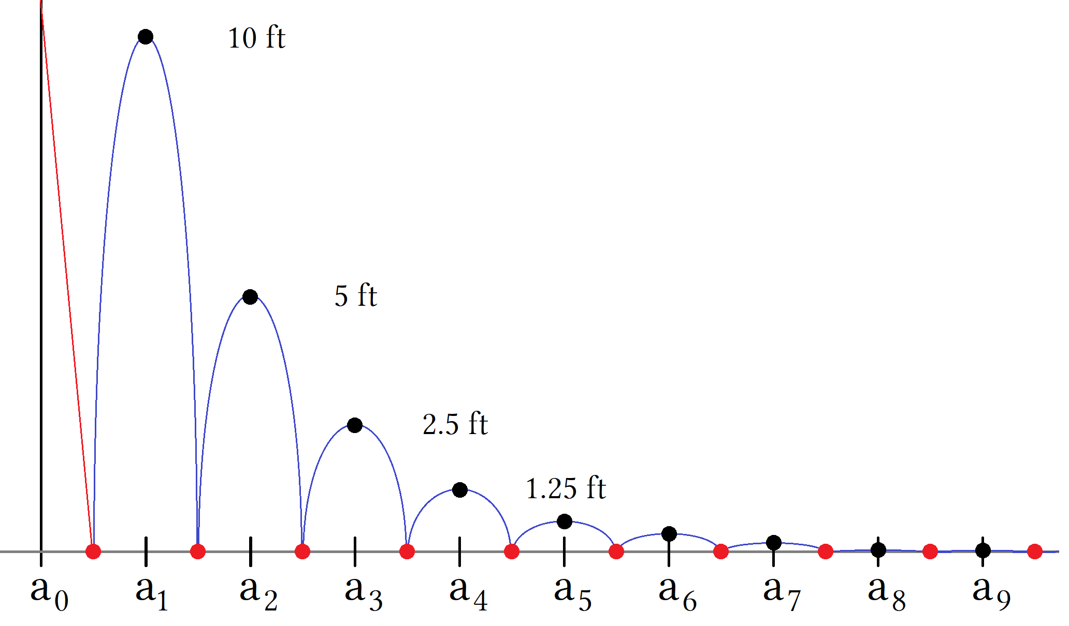

This graph is not to scale. This graph shows a geometric progression as a series of parabolic bounces.
The red line is a fall from some initial value that is not given. Each blue “bounce” is shown as a negative parabola that is cut off at the x axis. The middle of each parabola this the vertex that gives the highest point of each bounce. The bounces are spaced equally apart so that we record each height as f(x) where x is each term number and y is each height for that number.

Given the function f(x) = 10/2^{x} our input for x will be the term number as bounces or “jumps”. We input the jump number to find the height for that jump. The ball falls and hits the ground which has a height of y = 0, this is the x axis. It then rebounds in a parabolic arc upwards. The middle of each arc is the vertex for that parabola where vertex is the highest point for that parabola. After reaching the vertex it descends downwards following the same trajectory it did upwards. Black dots are the vertices and red dots are where the ball touches the x axis after falling.

a₀ = This is not given.
a₁ = 10 feet.
a₂ = 10÷2 = 5 feet.
a₃ = 10÷2÷2 = 10÷2(2) = 2.5 feet.
a₄ = 10÷2÷2÷2 = 10÷3(2) = 1.25 feet.
...
a₂₁ =10÷20(2) = 1.25 feet.

If we sum the first few terms 10+5+2.5+1.25 = 19.75. Using general knowledge of the fact that geometric series of decreasing fractions less than 1 sum to finite values we can guess the following:

21 jumps will be a combined height of (sum of whole numbers) plus sum of (fraction less than 1). This gives us:

(10+5+2+1) + ( ½ + ¼ + ⅛...) ≈18+1 = 19. we can assume a combined height of 19 ft. This is a lazy approximation.
An average is (combined value)÷(number of terms) = 19ft/21 = ¹⁹/₂₁ ft.
We can find this using sigma notation or something else.

We have 21 terms. After calculating we find our terms to have a common exponential of 1/2^{x} which is the algebra way to write “divide current term by 2 to find the next term”. This is a complicated way to write but true.

The first term is 10. It is not divided by 2. The second term is 5. It is 10 divided by 2 one.
The third term is 2.5. It is divided by 10 twice. Every term is found by dividing the current term by 2.

We can say that n is the number of terms and n – 1 is the how many times 10 is divided by 2 to find a term.
A₁ = 10 so 10 is divided by 2 n – 1 times which for a₁ is a₁ = 2(n – 1) 2(1 – 1) = 2(0) = 0.

10 is divided “0 times” which is to say it is not divided at all.
Maybe we write ¹⁰/₂^{(n – 1)} as a formula to find any term where n is the number of the term you are trying to find.

a₁ = ¹⁰/₂^{(n – 1)} = ¹⁰/₂^{(1st – 1)} = ¹⁰/₂^{(1 – 1)} = ¹⁰/₂⁰ = ¹⁰/₁ = 10 = a₁. The first term is a₁, the first term is 10.
a₂ = ¹⁰/₂^{(n – 1)} = ¹⁰/₂^{(2nd – 1)} = ¹⁰/₂^{(2 – 1)} = ¹⁰/₂¹ = ¹⁰/₂ = 5 = a₂. The second term is a₂, the first term is 5.
a₃ = ¹⁰/₂^{(n – 1)} = ¹⁰/₂^{(3rd – 1)} = ¹⁰/₂^{(3 – 1)} = ¹⁰/₂² = ¹⁰/₄ = 2.5 = a₃. The third term is a₃, the first term is 2.5.
a₃ = ¹⁰/₂^{(n – 1)} = ¹⁰/₂^{(4 – 1)} = ¹⁰/₂^{(4 – 1)} = ¹⁰/₂³ = ¹⁰/₈ = 1.25 = a₄. The fourth term is a₃, the first term is 2.5.

For this formula to work n must be substituted with a constant representing the subscripts of a_{n} notation.
Using a variable or something else will break the formula. Only integers can be used, fractions and radicals are forbidden. The domain for n is the choices we have for inputs. The domain can only be ℕ, 𝕎, or ℤ. Assume ℕfor most sequences.

Every term is divided by some multiple of 2. We had 2,4,8 which is 2¹, 2², and 2³. We found the power using 2^{(n – 1)} where the power of 2 is the exponent (n – 1). We state “ we have a binomial as an exponent in our formula”. Observe:

First term: 10 feet = 10 feet divide by 2 0 times or First –1 = 0
Second term: 10 feet ÷ 2 = 5 feet divide by 2 1 time or Second–1 = 1
Third term: 10 feet ÷ 2 ÷ 2 = 5 feet divide by 2 2 times or Third –1 = 2
Fourth term: 10 feet ÷ 2 ÷ 2 ÷ 2 = 2.5 feet divide by 2 3 times or Fourth –1 = 3
Fifth term: 10 feet ÷ 2 ÷ 2 ÷ 2 ÷ 2 = 1.25 feet … divide by 2 4 times or Fifth –1 = 4

21st term: 10 feet ÷ 2÷2÷2÷2÷2÷2÷2÷2÷2÷2÷2÷2÷2÷2÷2÷2÷2÷2÷2÷2 = ? feet
21st term: 10 feet ÷ 2÷2÷2÷ … ÷2 = ? feet divide by 2 20 times or 21st –1 = 20

10 = 10/1 = 10/2⁰ anything raised to a power of 0 equals 1 so 2⁰ = 1.

10 feet ÷ 1 we have zero factors of 2 as a divisor 1 = 1 = 2⁰
10 feet ÷ 2 we have one factor of 2 as a divisor 2 = 2 = 2¹
10 feet ÷ 2 ÷ 2 we have two factors of 2 as a divisor 2∙2 = 4 = 2²
10 feet ÷ 2 ÷ 2 ÷ 2 we have three factors of 2 as a divisor 2∙2∙2 = 4 = 2³

Repeated multiplication of the same number is caller power operation. Repeated division by the same number is called division by powers. We are diving by powers of 2.

10÷2÷2÷2 = 10/(2∙2∙2) = 10/2³ This basically restates the exponent laws. I will do this less in the future.

I should not have to restate a law every time I use it but do so when it is a special application. We are at the end of algebra and there is room to review previous lessons. The more examples you see the better your experience will be and the quicker your knowledge will grow.
Using sigma is when you have a infinite series and need a partial total. How can we write this sum using sigma notation? We need the total of 21 terms so how would we write our function for the summation?

An average is (combined value)÷(number of terms) = 19ft/21 = ¹⁹/₂₁ ft, what 21 terms do we have to sum “in terms of x”?

We need to find what we are summing and write every term “in terms of x”.
What we are summing is called the general term “a_{n}”.

Every term must have x in it:

10 = some x
5 = some x
2.5 = some x …

After multiples tries and failures we come up with:

Σ_{x=1}²¹(20/2^{x}) – 1 = 18.99999046 This is perfect. The general term is 20÷2^{x}.
20Σ_{x=0}²¹(1/2^{x}) = 19.999995234 This is clever but forgets to minus 1 and has an extra term.
20Σ_{x=1}²¹(1/2^{x}) = 19.99999046 This is clever but forgets to minus 1.

Σ_{x=0}²¹(10/2^{x}) = 19.999995234046 Appears correct but sums ¹/₁ twice and has an extra term.
Σ_{x=1}²¹(10/2^{x}) = 19.99999046 Appears correct but sums 1 twice.
Σ_{x=0}²⁰(10/2^{x}) – 1 = 18.99999046 Correct but requires summing a 0th term which is wrong.
Σ_{x=1}²⁰(10/2^{x}) – 1 = 8.99999046 Wrong but correctly does not sum 0th term but is missing 1 term.
Σ_{x=1}²¹(10/2^{x}) – 1 = 8.999995232 Wrong but correctly does not sum 0th term but is missing 1 term.

Deriving....The main function is something like f(x) = 10/2^{x} and here's why:

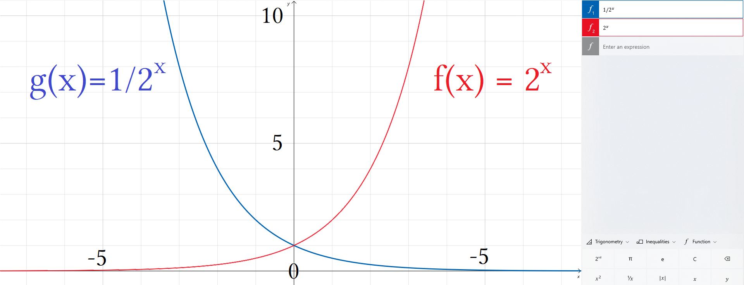
The two functions are inverses. We have 1∙2^{x} and 1÷2^{x}. We are either raising or lowering by a power of 2.
We have a decreasing series so we use g(x) = 1/2^{x} as our base or parent function.
For g(x) = 1/2^{x} when x = 1 g(1)= ½ . We need our first term to be 10.

g(x) = 1/2^{x} → 10g(x) = 10/2^{x} → h(x) = 10/2^{x} 20g(x) = 1/2^{x} → i(x) = 20/2^{x}
g(0) = 1/1 → 10g(0) = 10/1 → h(0) = 10/1 20g(0) = 1/1 → i(0) = 20/1
g(1) = 1/2 → 10g(1) = 10/2 → h(1) = 10/2 20g(1) = 1/2 → i(1) = 20/2

We can multiply a function like this to get what we need as an output. we write a new function i(x) = 20/2^{x} and that gives a first term of 10 and the correct geometric sequence to as many terms as we want forwards or back.

f(x) = 2^{x} |  | g(x) = 1/2^{x} |  | h(x) = 10/2^{x} |  | i(x) = 20/2^{x}
f(x) = a_{n} |  | f(x) = a_{n} |  | f(x) = a_{n} |  | f(x) = a_{n}
x or n | y | x or n | y | x or n | y | x or n | y
– 3 | ⅛ | – 3 | 8 | – 3 | 60 | – 3 | 160
– 2 | ¼ | – 2 | 4 | – 2 | 40 | – 2 | 80
– 1 | ½ | – 1 | 2 | – 1 | 20 | – 1 | 40
0 | 1 | 0 | 1/1 | 0 | 10/1 | 0 | 20/1
1 | 2 | 1 | 1/2 | 1 | 10/2 | 1 | 20/2
2 | 4 | 2 | 1/4 | 2 | 10/4 | 2 | 20/4
3 | 8 | 3 | 1/8 | 3 | 10/8 | 3 | 20/8
4 | 16 | 4 | 1/16 | 4 | 10/16 | 4 | 20/16
5 | 32 | 5 | 1/32 | 5 | 10/32 | 5 | 20/32
6 | 64 | 6 | 1/64 | 6 | 10/64 | 6 | 20/64
7 | 128 | 7 | 1/128 | 7 | 10/128 | 7 | 20/128
8 | 256 | 8 | 1/256 | 8 | 10/256 | 8 | 20/256
9 | 512 | 9 | 1/512 | 9 | 10/512 | 9 | 20/512
10 | 1024 | 10 | 1/1024 | 10 | 10/1024 | 10 | 20/1024
11 | 2048 | 11 | 1/2048 | 11 | 10/2048 | 11 | 20/2048
12 | 4096 | 12 | 1/4096 | 12 | 10/4096 | 12 | 20/4096
13 | 8192 | 13 | 1/8192 | 13 | 10/8192 | 13 | 20/8192
14 | 16384 | 14 | 1/16384 | 14 | 10/16384 | 14 | 20/16384
15 | 32768 | 15 | 1/32768 | 15 | 10/32768 | 15 | 20/32768
16 | 65536 | 16 | 1/65536 | 16 | 10/65536 | 16 | 20/65536
17 | 131072 | 17 | 1/131072 | 17 | 10/131072 | 17 | 20/131072
18 | 262144 | 18 | 1/262144 | 18 | 10/262144 | 18 | 20/262144
19 | 524288 | 19 | 1/524288 | 19 | 10/524288 | 19 | 20/524288
20 | 1048576 | 20 | 1/1048576 | 20 | 10/1048576 | 20 | 20/1048576
21 | 2097152 | 21 | 1/2097152 | 21 | 10/2097152 | 21 | 20/2097152
Powers of ten is called scientific notation that is used in the metric system of millimeters, centimeters, and kilometers. Division by 2 is called imperial fractions that is used in the imperial system of inches, feet, and miles.

1×10⁻¹ = 1 ∙ ⅒ = ⅒ 1÷2^{–3} = 1 ÷ ⅛ = 1 ∙ 8 = 8
1×10⁰ = 1 ∙ 1 = 1 1÷2^{–2} = 1 ÷ ¼ = 1 ∙ 4 = 4
1×10¹ = 1 ∙ 10 = 10 1÷2^{–1} = 1 ÷ ½ = 1 ∙ 2 = 2
1×10² = 1 ∙ 100= 100 1÷2⁰ = 1 ÷ 1 = 1 ∙ 1 = 1
1×10³ = 1 ∙ 1000= 1000 1÷2¹ = 1 ÷ 2 = 1 ∙ ½ = ½
1×10⁴ = 1 ∙ 10000= 10000 1÷2² = 1 ÷ 4 = 1 ∙ ¼ = ¼

Realizing that division of 2 is occurring we can make naive assumptions and guess our way to the truth or we can understand the master table of the 4 functions and appropriately choose i(x) = 20/2^{x} = S_{n} :(10, 5, 2.5 … a_{n}).

Our first term is 10. This is our “ a₁”. We can choose to either find the next term of our series a₂ our choose to find a₀ which is not apart of our series but contains the general term. The general term for this is a₀.

a_{n} ÷ 2 = a_{n + 1} This says multiplying by ½ gives the next term.
a_{n} ∙ 2 = a_{n – 1} This says multiplying by 2 gives the previous term.

Naively we can use “An average is (combined value)÷(number of terms)”.
This means writing two series of list₁ if whole numbers and list₂ of proper fractions less than 1.
Do this by converting mixed numbers of the form a.b into a + ^{b}/₁₀.
We do this to be lazy and take a quick estimate so as to not have to find the actual value of every term.

Start at the first term and write every term until you reach a proper fraction. S₂₁:( 10, 5, 2.5 … a₂₁):

We were given 10 and found 5, 2.5, 1.25, 0.625. Stop calculating terms at 0.625.
2.5 and 1.25 are mixed numbers also called a mixed decimals.
Convert them into components of natural numbers and proper fractions.
2.5 =⁵/₂=(⁴/₂+½)=(2+½) and 1.25 =⁵/₄=(⁴/₄+¼)=(1+¼).

Write two series to be summed together:

S₂₁: (10+5+2+1) + ( ½ + ¼ + ⅛ + … + a₂₁)
S₂₁: (18) + ( ½ + ¼ + ⅛ + … + a₁₉)

The first partial sum of S₂₁ = 18 and the second partial sum is the first n number of imperial fractions starting with ½. We do not have 21 imperial fractions. We have 19 imperial fractions.

21 terms = 10 + 5 + (19 terms containing imperial fractions). This is subtle and easily missed. Of the 21 terms:

a₁ | a₂ | a₃ | a₄ | a₅ | a₆ | a₇ | a₈ | a₉ | a₁₀ | a₁₁ | a₁₂ | a₁₃ | a₁₄ | a₁₅ | a₁₆ | a₁₇ | a₁₈ | a₁₉ | a₂₀ | a₂₁
10 | 5 | 2.5 | 1.25 | 0.625 | y₆ | y₇ | y₈ | y₉ | y₁₀ | y₁₁ | y₁₂ | y₁₃ | y₁₄ | y₁₅ | y₁₆ | y₁₇ | y₁₈ | y₁₉ | y₂₀ | y₂₁
N/a | N/a | 1 | 2 | 3 | 4 | 5 | 6 | 7 | 8 | 9 | 10 | 11 | 12 | 13 | 14 | 15 | 16 | 17 | 18 | 19

The first terms are excluded because they do not contain fractions. The rest due. Counting we find 19 fractions.
Tables help make this point clear. Without a table we use complicated formulas that appear confusing but save time once mastered.

Number of terms – number of naturals = number of fractions to be summed in the second series.
21 – 2 = 19 we write this as a formula a_{n} – ℕ= ℚ.

S₂₁: 18 + ( ½ + ¼ + ⅛ + … + a₁₉) 18 plus the sum of 19 imperial fractions { a₁-a₁₉}.
S₂₁ = 18 + S₁₉:(1/2^{x}) Total sum equals 18 + sum of the first 19 imperial fractions.
S₂₁ = 18 + Σ_{x=1}¹⁹(1/2^{x}) Sigma notation is used for S₁₉:(1/2^{x}) = Σ_{x=1}¹⁹(1/2^{x}).

Σ_{x=1}¹⁹(1/2^{x}) +18 = S₂₁: This is what we want. It puts focus on sigma and not S₂₁.
Σ_{x=1}¹⁹(1/2^{x}) +18 We can solve this with a calculator.
Σ_{x=1}¹⁹(1/2^{x}) +18 = 18.99999809 Solved. Do not forget to divide by 21 to get average jump.
S₂₁: 18.99999809 Solved. Do not forget to divide by 21 to get average jump.

We wanted to use sigma. We wanted to use f(x) = 1.2^{x}. Writing sigma is hard. Breaking up into pieces makes getting to the answer slow and cautious. We add little bits, check our work, see what our sum is doing, then add more. We want a careful structured approach. We do not want to guess wildly. That is called gambling and is not a good practice. You get wrong answers and do not have a way of modifying your function in a way that gets you closer to the truth. You are just making things up and seeing if it “checks”. Something can “check” but still be erroneous.

Σ_{x=1}¹⁹(1/2^{x}) I have terms a₁ thru a₁₉ for a total of 19 terms.
Σ_{x=1}¹⁹(1/2^{x}) I am summing the reciprocal of powers of 2 which are imperial fractions.

You type Σ_{x=1}¹⁹(1/2^{x}) into a calculator using the sigma function. Sigma is a powerful function so let calculator handle it. We learn algebra so we can write functions correctly into a calculator. This is the difference between a bean counter who counts every term individually and a mathematician who uses advanced knowledge and formulas to rearrange equations based on logic and then entering that logic into a computer to do the grunt work of computations.

The takeaway here is important:

Sums of fractions that decrease or have an upper limit will converge to a single value. A infinite series of such fractions converges to a single number. If we summed ∞ terms of 1/2^{x} it would equal exactly 1. After only 19 terms we are pretty much there. After 19 terms the only thing that happens is the list of 9's gets longer every 3 to 4 terms. This itself creates a sequence of:

0.9x, 0.9x, 0.9x, 0.99x, … 0.99x, 0.99x, 0.99x, 0.999x, ...0.999x, 0.999x, 0.999x, 0.9999x, ...0.9999x, 0.9999x, 0.9999x, 0.99999x, ...

Bean counting work:

Filling out this table would be hard because the fractions are too long and there are to many terms.

a₁ | a₂ | a₃ | a₄ | a₅ | a₆ | a₇ | a₈ | a₉ | a₁₀ | a₁₁ | a₁₂ | a₁₃ | a₁₄ | a₁₅ | a₁₆ | a₁₇ | a₁₈ | a₁₉ | a₂₀ | a₂₁
10 | 5 | 2.5 | 1.25 | 0.625 | y₆ | y₇ | y₈ | y₉ | y₁₀ | y₁₁ | y₁₂ | y₁₃ | y₁₄ | y₁₅ | y₁₆ | y₁₇ | y₁₈ | y₁₉ | y₂₀ | y₂₁
N/a | N/a | 1 | 2 | 3 | 4 | 5 | 6 | 7 | 8 | 9 | 10 | 11 | 12 | 13 | 14 | 15 | 16 | 17 | 18 | 19

I do not want to fill this table out. I would say y = a such that for finding the value of a single term y_{n} = 1/2^{n} which is the same as y_{x} = 1/2^{x}. Which is the same for x as Σ_{x}^{n}(1/2^{x}) where red x and blue x are the same x.

Σ_{x=1}∞(1/2^{x}) = 1 Infinite terms sums to 1. Note it is impossible to sum infinite terms.
Σ_{x=1}¹⁹(1/2^{x}) +18 = 18.99999809 Since we only summed 19 fractions we do not reach 18+1 only very close.
2¹⁹ = 524288 When denominator is a power The fractions get very small very quick.
2²⁰ = 1048576 This is the previous term times 2: 524288∙2 = 1048576
2²¹ = 2097152 This is the previous term times 2: 1048576∙2 = 2097152

As a fraction:

1/2¹⁹ = 1/524288
1/2²⁰ = 1/1048576 This is the previous term divided by 2: 1/524288/2 = 1/1048576.
1/2²¹ = 1/2097152 This is the previous term divided by 2: 1/1048576/2 = 1/2097152.

As a inch 1/2²¹ '' inches is “one two millionth of an inch plus change”. The height ¹/₂₀₉₇₁₅₂'' is a very short line.
The fractions are called “one over term” because they have 1 as a numerator. We literately wrote 1 over the powers of 2.

A 1 over term can be defined as the reciprocal to the term it is reciprocating.

2: ½
3: ⅓
¾ :⁴/₃ 1÷ ¾ or 1/¾
2/127:127/2 a reciprocal inverts p and q for p/q.

Reciprocal:

If we define the set of rationals to be p/q for integers only we can extend this definition to define reals as any number other than a+bi to be p/1 and its reciprocal to be 1/p. If a number is fractional either terminating or not terminating, integer or mixed decimal this definition holds true.

Real number | reciprocal | 1/ notation
√n | √n/n | 1/√n
√3 | √3/3 | 1/√3
1.23 | 0.81300 | 1/1.23
¾ | ⁴/₃ | 1/(¾)
3/4.5 | 4.5/3 | 1/(3/4.5)
1.7/x | x/1.7 | 1/(1.7/x)
3π/2 | 2/3π | 1/(2/3π)

We did a lazy estimate of the sum ≈1 and then did 18+1/21 = 19/21 ft per jump.
The truth is 18.99999809/21 = 0.9047618139. Normally we cut off after four decimals so 0.90476 rounds to 0.90477 feet = 0.90477 feet ∙ 12'' ≈ 10.8571''.

I am going to write the summation Σ_{x=1}¹⁹(1/2^{x}) +18 = 18.99999809 in parts to explain each action.

Σ_{x=1}¹⁹ We are summing 19 terms from a₁ to a₁₉.
(1/2^{x}) We are summing the reciprocals of the powers of 2.
+18 After which we are adding the partial sum we found earlier “ 18”.
= 18.99999809 This is the final sum of our two partial sums.

Σ_{x=1}¹⁹(1/2^{x}) +18 = 18.99999809 Same as before but now find the average per jump.
(Σ_{x=1}¹⁹(1/2^{x}) +18)/21 = 18.99999809/21 Divide both sides by 21.
(Σ_{x=1}¹⁹(1/2^{x}) +18)/21 = 0.9047618139 Multiply both sides by 12''.
12(Σ_{x=1}¹⁹(1/2^{x}) +18)/21 = 10.8571477
¹²/₂₁(Σ_{x=1}¹⁹(1/2^{x}) +18) = 10.8571477 Divide by 2; multiply by 12. This is 12/21 as a scalar.
Σ_{x=1}¹⁹(1/2^{x}) +18 This sums the fractions separately from the natural numbers.
(Σ_{x=1}¹⁹(1/2^{x}) +18)/21 This divides by 21 terms to find average per bounce.
12(Σ_{x=1}¹⁹(1/2^{x}) +18)/21 This multiplies by 12'' to convert feet into inches.
¹²/₂₁ ∙ (Σ_{x=1}¹⁹(1/2^{x}) +18) This combines two operations cleaning up the equation.
(Σ_{x=1}¹⁹(1/2^{x}) +18) ∙ ¹²/₂₁ This moves the quotient to the right-side of the operator.
(Σ_{x=1}¹⁹(1/2^{x}) +18) ∙ ¹²/₂₁ This has a lot of things going on. It is complicated and ugly.
Not too compacted that it needs to be unpacked or separated.

Entire sums like this need to be entered into a calculator at once so the machine and process the output for you.
I do not think the average layman could write this function into a calculator if he did not know how to solve it by hand. From this point on calculators are allowed and almost required for speed and accuracy. I believe you can divide by 2 without a calculator so you do not need to prove that to me.

We will work a popular or classic problem to death by hand to teach notational tricks and then give word problems and expect fast answers.

Powers of 2 is simple I believe you can multiply and divide by 2 over and over. You are not being tested on that. You are being tested in ability to translate word problems into mathematical language, equations into words problems. Briefly state a problem, its critical parts, and then its answer. Ability to rewrite equations into long and short forms to better exploit its weaknesses and find creative new solutions or ways of deriving answers to older problems. This last part puts emphasis on research.

Past simple arithmetic people struggle with complex formulas. They opt out of using formulas that are new or exotic and use primary school solutions. This acts as a crutch. They are simple solutions and hard solutions. Simple methods do not prepare for later coursework. Using a calculator to sum the series I can get the answer in 15 seconds or less, by hand might take me 20 minutes to an hour or longer.

If I use a calculator with the intent to approximate it anyways I could type a number of functions or domains that are wrong but will give me an answer close to what the truth specifies. This is called “winging it”.

The process of exhaustion examines all possibilities till many ways of achieving success are found and then formulates generalized formulas for later use. Of the winning combinations only the best methods are kept and the worst ones thrown out. Using (Σ_{x=1}¹⁹(1/2^{x}) +18) ∙ ¹²/₂₁ was a hacky way to get the correct result.

This process showed more about sigma notation and general terms because I believe sigma is hard for beginners.
The reason this summation is popular is because it uses distribution to isolate whole numbers which can be summed mentally.

As a dumb guess: 10+5+2.5+1.25+0.625+0.3125+0.15625+0.078125+0.0390625+ umm...0.390625+ …. +a₂₁.

I can get to the 9th term before I need to get a calculator because I use imperial fractions and conversions in machining tools and weapons. These skills are needed in metal and other type of production shops. I do not use Starett brand cheat sheets. They cost $20 and I am stubborn and cheap. I can make my own and have.

:10+5+2.5+1.25+0.625+0.3125+0.15625+0.078125+0.0390625+ …. +a₂₁.
As a dumb guess it is easy for people to take the red numbers and sum them:

10+5+2+1 = 18 This tell us that our sum is at least 18. We assume it can be no higher than 20. We guess 20/21 feet and call it a day. If we grab a calculator and type the wrong general term for our sigma function we could get 19.9 which is wrong because it is off by 1. A smarter guess would realize that we have 18 and the infinite sum of imperials of whatever decreasing fractions can not be more than 1. So we have at least 18 and at most 19. By knowing what we know or think we know, we assume 18.9 which is a very good approximation but not the actual number of18.99999809 because it is missing a 8 and 0.

Writing the range as possible sums as 18≤y≤20 is a mistake but writing 18≤y≤19 is sound. 20/21 is a good rough calculation. Our answer should be something like 18.9 but mistakes allow 19.9. to happen. This finishes the problem even though we already have our answer and can move on. It teaches skills where we exhaust a problem to show notation once and then never have to show it again. This is not the way to solve and errors exist. This is for exposure to techniques that are used in the field. Check to see which errors exist and why but do not spend too much time. Focus on seeing how sums are written and methods used and what attempts are sound and which ones are unsound.

21 bounces is 21 terms. Write a sequence of 21 terms starting at the term a₁. We call this the first term.
Then sum the sequence by writing it as a series. Change every comma to a plus sign.

S: (a₁,a₂,a₃,a₄,a₅,a₆,a₇,a₈,a₉,a₁₀,a₁₁,a₁₂,a₁₃,a₁₄,a₁₅,a₁₆,a₁₇,a₁₈,a₁₉,a₂₀,a₂₁) This is a sequence.
S_{n}: (a₁+a₂+a₃+a₄+a₅+a₆+a₇+a₈+a₉+a₁₀+a₁₁+a₁₂+a₁₃+a₁₄+a₁₅+a₁₆+a₁₇+a₁₈+a₁₉+a₂₀+a₂₁) This is a series.

Every bounce is half the last. You can write this many ways. I am going to go through a thorough process.
First as a series of powers of 2. This is popular because you can write long sums neatly. The powers of 2 will be term numbers starting at 0 to 20. the first term a₁ with be 10/2⁰. The second term will be 10/2¹.
There is an offset of 1 between term number and exponent.

S: (10/2⁰,10/2¹,10/2²,10/2³,10/2⁴,10/2⁵,10/2⁶,10/2⁷,10/2⁸,10/2⁹,10/2¹⁰,10/2¹¹,10/2¹²,10/2¹³,10/2¹⁴,10/2¹⁵,10/2¹⁶,10/2¹⁷,10/2¹⁸,10/2¹⁹,10/2²⁰, )
S_{n}: (10/2⁰+10/2¹+10/2²+10/2³+10/2⁴+10/2⁵+10/2⁶+10/2⁷+10/2⁸+10/2⁹+10/2¹⁰+10/2¹¹+10/2¹²+10/2¹³+10/2¹⁴+10/2¹⁵+10/2¹⁶+10/2¹⁷+10/2¹⁸+10/2¹⁹+10/2²⁰ )

Looks pretty. We have neat terms written in ascending order: S_{n}:(10/2⁰, 10/2¹, 10/2²...10/2²⁰).
Note that the powers of 2 are 1 less than the term number. For any term it is easy to predict what to write.
A term will be 10/2^{n – 1} where n is the term number.
For any term pick the term you want then write it as 10 over 2 the the power of n–1.

a₂₁ = 10/2^{21 – 1} power is term number minus 1. a₁₅ = 10/2^{15 – 1} power is term number minus 1.

To write it without exponent notation find the product of the power:

S_{n}:(¹⁰/₁+¹⁰/₂+¹⁰/₄+¹⁰/₈+¹⁰/₁₆ +¹⁰/₃₂+¹⁰/₆₄+¹⁰/₁₂₈+¹⁰/₂₅₆+¹⁰/₅₁₂ +¹⁰/₁₀₂₄+¹⁰/₂₀₄₈+¹⁰/₄₀₉₆+¹⁰/₈₁₉₂+¹⁰/₁₆₃₈₄ +¹⁰/₃₂₇₆₈+¹⁰/₆₅₅₃₆+¹⁰/₁₃₁₀₇₂+¹⁰/₂₆₂₁₄₄ +¹⁰/₅₂₄₂₈₈ +¹⁰/₁₀₄₈₅₇₆)

I wrote it spaced out every 5 terms with the 21st term by itself if you want:

(¹⁰/₁+¹⁰/₂+¹⁰/₄+¹⁰/₈+¹⁰/₁₆+¹⁰/₃₂+¹⁰/₆₄+¹⁰/₁₂₈+¹⁰/₂₅₆+¹⁰/₅₁₂+¹⁰/₁₀₂₄+¹⁰/₂₀₄₈+¹⁰/₄₀₉₆+¹⁰/₈₁₉₂+¹⁰/₁₆₃₈₄+¹⁰/₃₂₇₆₈ +¹⁰/₆₅₅₃₆ +¹⁰/₁₃₁₀₇₂ +¹⁰/₂₆₂₁₄₄ +¹⁰/₅₂₄₂₈₈ +¹⁰/₁₀₄₈₅₇₆)

Either way it is to long to fit on an entire line. We can truncate a sum but to work it we need to see as many terms as possible. Can't have them hiding in a truncated form. So here it helps to unpack them. The trouble is it is hard to read and unwieldy. Spacing it every 5 terms does two things. First we can break it up into smaller pieces so it is easier to read. Second we can take 4 partial sums and then sum the 4 sub totals with the last sum.
So we add 5 terms 5 times. The first 4 times is adding 5 actual terms of the series. The last time is 4 subtotals as terms of a 5 term equation that is made of 4 partial sums and the last term.

S_{n}: (a₁+a₂+a₃+a₄+a₅ +a₆+a₇+a₈+a₉+a₁₀ +a₁₁+a₁₂+a₁₃+a₁₄+a₁₅ +a₁₆+a₁₇+a₁₈+a₁₉+a₂₀ +a₂₁)
S_{n}: (S_{n1}+S_{n2}+S_{n3}+S_{n4}+a₂₁) Sn₁ means the first partial sum, Sn₂ means the second partial sum...

Dealing with 5 sums at a time seems reasonable. We had:

(¹⁰/₁+¹⁰/₂+¹⁰/₄+¹⁰/₈+¹⁰/₁₆+¹⁰/₃₂+¹⁰/₆₄+¹⁰/₁₂₈+¹⁰/₂₅₆+¹⁰/₅₁₂+¹⁰/₁₀₂₄+¹⁰/₂₀₄₈+¹⁰/₄₀₉₆+¹⁰/₈₁₉₂+¹⁰/₁₆₃₈₄+¹⁰/₃₂₇₆₈+¹⁰/₆₅₅₃₆+¹⁰/₁₃₁₀₇₂+¹⁰/₂₆₂₁₄₄+¹⁰/₅₂₄₂₈₈+¹⁰/₁₀₄₈₅₇₆)

I was able to squeeze it in by changing font size and eliminating any gaps. To be neat you sometimes write smaller. The sum is written in terms of powers of 2. That is every term has a power of 2. You might hear “write in terms of x”. Notice that every numerator 10. This means we can factor a 10 out. Do that.

10(1+½+¼+⅛+¹/₁₆+¹/₃₂+¹/₆₄+¹/₁₂₈+¹/₂₅₆+¹/₅₁₂+¹/₁₀₂₄+¹/₂₀₄₈+¹/₄₀₉₆+¹/₈₁₉₂+¹/₁₆₃₈₄+¹/₃₂₇₆₈+¹/₆₅₅₃₆+¹/₁₃₁₀₇₂+¹/₂₆₂₁₄₄ +¹/₅₂₄₂₈₈ +¹/₁₀₄₈₅₇₆)

Every fraction is now a “1 over” term or “in terms of 1 over”. Every way I wrote this monster sum is considered pretty. There exist ugly ones I will not mention are not as good looking. Please write tidy sums.

10(1+½+¼+⅛+¹/₁₆+¹/₃₂+¹/₆₄+¹/₁₂₈+¹/₂₅₆+¹/₅₁₂+¹/₁₀₂₄+¹/₂₀₄₈+¹/₄₀₉₆+¹/₈₁₉₂+¹/₁₆₃₈₄+¹/₃₂₇₆₈+¹/₆₅₅₃₆+¹/₁₃₁₀₇₂+¹/₂₆₂₁₄₄ +¹/₅₂₄₂₈₈ +¹/₁₀₄₈₅₇₆)

Do you see the last terms? They are close to 0. They are fraction with 0's are the decimal points. I do not want to deal with adding tidbits like 1/65536 = 0.0000152587906. Even calculators struggle with these fractions.
A standard calculator reads 1÷65536 as 1.525878906×10⁻⁶ when the actual number is 0.0000152587890625.
It runs out of memory or space and has to round up or cut off when more than ten digits. 90625 is cut to 906.

How are you supposed to sum these if it is too many terms to type into a calculator?
21 terms is ridiculous and the fact they are tiny fractions is unreasonable.
Thankfully I have a solution that makes life easier. For now sum just whats inside () in groups of 5.

S₂₁:10(1+½+¼+⅛+¹/₁₆+¹/₃₂+¹/₆₄+¹/₁₂₈+¹/₂₅₆+¹/₅₁₂+¹/₁₀₂₄+¹/₂₀₄₈+¹/₄₀₉₆+¹/₈₁₉₂+¹/₁₆₃₈₄+¹/₃₂₇₆₈+¹/₆₅₅₃₆+¹/₁₃₁₀₇₂+¹/₂₆₂₁₄₄ +¹/₅₂₄₂₈₈ +¹/₁₀₄₈₅₇₆)

10 ∙ s:(1+½+¼+⅛+¹/₁₆+¹/₃₂+¹/₆₄+¹/₁₂₈+¹/₂₅₆+¹/₅₁₂+¹/₁₀₂₄+¹/₂₀₄₈+¹/₄₀₉₆+¹/₈₁₉₂+¹/₁₆₃₈₄+¹/₃₂₇₆₈+¹/₆₅₅₃₆+¹/₁₃₁₀₇₂+¹/₂₆₂₁₄₄ +¹/₅₂₄₂₈₈ +¹/₁₀₄₈₅₇₆)

s₁ = 1+½+¼+⅛+¹/₁₆ = 1.9375 or ³¹/₁₆
s₂ = ¹/₃₂+¹/₆₄+¹/₁₂₈+¹/₂₅₆+¹/₅₁₂ = 0.060546875 or ³¹/₅₁₂
s₃ = ¹/₁₀₂₄+¹/₂₀₄₈+¹/₄₀₉₆+¹/₈₁₉₂+¹/₁₆₃₈₄ = 0.001892089844 or ³¹/₁₆₃₈₄
s₄ = ¹/₃₂₇₆₈+¹/₆₅₅₃₆+¹/₁₃₁₀₇₂+¹/₂₆₂₁₄₄ +¹/₅₂₄₂₈₈ = 0.00005912780762 or ³¹/₅₂₄₂₈₈

s₁+s₂+s₃+s₄ = 1.999998093 This is the total of the four partial sums.
10(s₁+s₂+s₃+s₄) = 10(1.999998093) ≈ 20 This is a shortcut where I ignore the last term.

20 bounces gives a total height of 19 feet. I did not add the last term 1/2²⁰. Doing so yields:

19+ ¹/₁₀₄₈₅₇₆ ≈ 19 The last term is minuscule so I ignored it.
¹/₁₀₄₈₅₇₆ = 0.0000009536743164
s₅ = (s₁+s₂+s₃+s₄+¹/₁₀₄₈₅₇₆) = 1.999999047 Adding the last term give us an extra 9.

We factored out a 10 so have to distribute it back in:

10(s₁+s₂+s₃+s₄+¹/₁₀₄₈₅₇₆) = 10(1.999998093+¹/₁₀₄₈₅₇₆) = 19.99999047+0.000009536743164 ≈ 20

We have an average of 20 feet. 20 feet divided by 21 feet is 20/21 feet or about 0.9523 feet which is 11.42'' per jump.

Okay so you saw all the glaring errors right? Honestly this is a sound approach every step of the way except for one mistake. First we need to have 18.9 not 19.9. That is an unforgivable mistake. How come the answer reached is 20/21 and not 19/21?
The following 4 pages surmises what was done and offers important discussion (lectures) that occurs in classrooms but is neglected from other text books because they are designed to be used with classroom instruction and need not pick things apart so much as that is the teachers job.
The mistake is in the way the terms are ordered and how 10/2^{x} was used as the general term and not 20/2^{x}.
The question tricked us into thinking that since the first bounce had a height of 10 that 10 was the “number to use”. This is a case of misdirection. We are supposed to use 20. Why? In short : domain of x. 20 is right and 10 is wrong.

10 ÷ 2 = 5 5÷ 2 = 2.5 2.5∙2 = 5 5∙2 = 10 10∙2 = 20 20∙2 =40

Terms are ordered by using the natural numbers to count the height of each bounce. For brevity height = bounce.

Bounce₁ = Height₁ = a₁ = y₁
Bounce₂ = Height₂ = a₂ = y₁
Bounce₃ = Height₃ = a₃ = y₁

We take this to be a function where the domain of x can only be “ For x: x: {x: ℕ} ”.

S: (a₁,a₂,a₃,a₄,a₅,a₆,a₇,a₈,a₉,a₁₀,a₁₁,a₁₂,a₁₃,a₁₄,a₁₅,a₁₆,a₁₇,a₁₈,a₁₉,a₂₀,a₂₁) This is a sequence.
S_{n}: (a₁+a₂+a₃+a₄+a₅+a₆+a₇+a₈+a₉+a₁₀+a₁₁+a₁₂+a₁₃+a₁₄+a₁₅+a₁₆+a₁₇+a₁₈+a₁₉+a₂₀+a₂₁) This is a series, not the same.

This was good. In the future will will not write every term because we will not need to.
We will write S:(a₁,a₂,a₃ … a₄,) and S_{n}: (a₁+a₂+a₃+ … +a₄)

S: (10/2⁰,10/2¹,10/2²,10/2³,10/2⁴,10/2⁵,10/2⁶,10/2⁷,10/2⁸,10/2⁹,10/2¹⁰,10/2¹¹,10/2¹²,10/2¹³,10/2¹⁴,10/2¹⁵,10/2¹⁶,10/2¹⁷,10/2¹⁸,10/2¹⁹,10/2²⁰, )
S_{n}: (10/2⁰+10/2¹+10/2²+10/2³+10/2⁴+10/2⁵+10/2⁶+10/2⁷+10/2⁸+10/2⁹+10/2¹⁰+10/2¹¹+10/2¹²+10/2¹³+10/2¹⁴+10/2¹⁵+10/2¹⁶+10/2¹⁷+10/2¹⁸+10/2¹⁹+10/2²⁰ )

This was good. In the future abbreviate using only the first three terms to start a sequence, then ellipsis and the last term. Having this written all in terms of powers of 2 saves space and is smart. In any case writing every term is only necessary when you are desperate to sum and can not use sigma. The only reason for not being able to write sigma would be you do not know the general term. The only reason to not know the general term is you do not understand what your domain should be.

If written out in full carefully use a calculator to find each individual sum and keep separate lists where you have one series in terms of x or as here powers of 2 and the next list as calculated values for each term. When we say term we mean the y value for that term. When we say term number we mean the input used for x that finds that y value.

term number = x
term = y value
term = this can also mean how many terms we have in an equation which is like saying how many x's do we have.

2+4 = 6 has 3 terms: (2,4,6) where term means the y value but we are asking or stating “how many terms we have” which is like asking how many inputs or x's do we have that correspond to these y values. The important thing is knowing that term number always means what the x value is.

Term number:

The constant that replaces n on a_{n} to indicate what x value to insert into a function of the type f(x) =y.
Term number specifies the domain of x. For a single input we have a single term number that is a constant. This constant is the x value of a point located on a graph. It is the x in an ordered pair (x,y). It is the number on the x axis directly. The term number is the number on the x axis. A term is located by finding its x value on an x axis. Term numbers are always integers with special attention given to whether it is allowed to be negative or include 0, or if there are constraints to where it can not be either one. We state or specify this by limiting the domain of x. From most restrictions to least: we are counting something like “ 1st item, 2nd item, 3rd item..” them we can not have a negative item counted or a 0th item counted. If so then we have the set of natural numbers ℕ. I tend to think this is most common. Next if we can have 0 we have the whole numbers which sets the domain of x as being limited to the set 𝕎. Finally if x can be an integer then the domain of x is ℤ. Sequences that are only positive will be the set of ℕ or 𝕎 with strong bias towards being ℕ. Sequences that have negative numbers are likely so would be ℤ but we have not done any of those.

Term:

The terms are the numbers given for any equation. This references the value of the term. Term can be used to say I have this many terms or it can be used to say the value of my term equals this constant. That's it. A term is a values and number of terms is number of values. x²+bx+c has 3 terms of unknown value. None of these are term numbers they are just simply numbers as the terms of a formula. x²+5x+6 has 3 terms where 6 is given and the other two terms are unknown. Nothing is being mentioned about the value of x which as a function really means the input for x:

x²+bx+c I have a formula containing 3 terms with 3 unknown variables.
x²+5x+6 I have defined b to equal 5 and c to equal 6. x is still unknown.

This is glossed over because it is boring and not very important but since I started I will finish.
We want to focus on x itself but I will say this about coefficients of x:

Ax²+bx+c Ax+By+C y = Mx+b abc and M are coefficients of x. x and y are true variables.
Ax²+bx¹ +cx⁰ Ax¹+By¹+Cx⁰ y¹ = Mx¹+bx⁰ Coefficients are also called scalars, scale some factor.

x²+bx+c b and c can be anything. The domain of b:(–∞, ∞) The domain of c:(–∞, ∞).
x²+5x+6 b = 5 and c = 6. Their domain is set to b = 5 and c = 6, they must be this for this equation.
x²+5x+6 The domain of b:[5] The domain of c:[6]. They only have one number in their domain.

The domain for any constant is the single number that is its value. coefficients like abc or m are always given in a problem or found very quickly in the case of slope. Once found the are no longer variable coefficients but constant coefficients. Since standard formulas are designed to be efficient the variables abc are usually constants in actual problems. Constant do not have domain issues. The point of domain is to limit our choices for what the variable could be to help us solve what the variable is. These cof are always given constants so there is no question to what they could be. x²+5x+6 Here there is no question about what b or c equal. There is no consideration about how to limit their domains. Their domain is already limited to the value specified. Despite not being a consideration their domain still exists. We limit a variables domain to make solving for it easier. Constants are not variables, their domain does not need to be limited and can't because it is already the most limited being subject to already being solved for. Their domain of what they could be is only the number they already are.

x²+5x+6 The domain of 6 is 6. The domain of 5 is 5. I can not limit their domain any more.
x²+5x+6 The only questions I can ask is: What is the domain of x? What does the sum equal when x is...

x is a true variable in the sense it is not a place holder in a formula for inserting known values, x exists as a variable even after all known values are substituted. We define abc variables right away and then solve for x,y,z. This is why abc is used for coefficients, they are what is solved first by being substituted for first. Xyz are at the end of the alphabet and are chosen as true variables because they are what is solved for last. To solve is to define to define is to substitute.

x²+5x+6 = f(x) I want to ask what the sum equals when I define x to be a specific constant
0²+5∙0+6 = f(0) This forces x to be a constant and forces the sum to be revealed for this input.
x²+5x+6 = f(x) The domain of x is (–∞,∞)
0²+5∙0+6 = f(0) The domain of x is [0]. This is a forcing maneuver. Domain of x:[0]
1²+5∙1+6 = f(1) The domain of x is [1]. This is a forcing maneuver. Domain of x:[1]
2²+5∙2+6 = f(2) The domain of x is [0]. This is a forcing maneuver. Domain of x:[2]
3²+5∙3+6 = f(3) The domain of x is [0]. This is a forcing maneuver. Domain of x:[6]
0²+5∙0+6 = f(0) f(0) corresponds to a(0) which is a₀. This is the 0th term.
1²+5∙1+6 = f(1) f(1) corresponds to a(1) which is a₁. This is the 1th term.
2²+5∙2+6 = f(2) f(2) corresponds to a(2) which is a₂. This is the 2nd term.
3²+5∙3+6 = f(3) f(3) corresponds to a(3) which is a₃. This is the 3rd term.

Therefore domain is the list of inputs allowed for x. Therefore term number is the number that we force x to be by limiting its domain. The entire function has a domain that is unchanged by individual substitutions however.
S_{n}:(¹⁰/₁+¹⁰/₂+¹⁰/₄+¹⁰/₈+¹⁰/₁₆ +¹⁰/₃₂+¹⁰/₆₄+¹⁰/₁₂₈+¹⁰/₂₅₆+¹⁰/₅₁₂ +¹⁰/₁₀₂₄+¹⁰/₂₀₄₈+¹⁰/₄₀₉₆+¹⁰/₈₁₉₂+¹⁰/₁₆₃₈₄ +¹⁰/₃₂₇₆₈+¹⁰/₆₅₅₃₆+¹⁰/₁₃₁₀₇₂+¹⁰/₂₆₂₁₄₄ +¹⁰/₅₂₄₂₈₈ +¹⁰/₁₀₄₈₅₇₆)

This was acceptable. Other than aesthetics you may want to you write the series as p/q notation for a fraction instead of powers of 2. There are pros and cons to both. Pros: You know excatly what your denominator is. Cons: harder to find the value of the denominator making it more time consuming, takes up more space, and is harder to write as a summation for sigma to solve for you. We first wrote it as powers of 2 to find a general term to write as a power series for sigma. As regular fractions we have 21 different denominators so that makes summing harder.
Write as powers if you want a calculator to sum the entire thing in under 20 seconds.
Write as powers if you want to simply state a sum without having to calculate it and are more concerned about neatness and making things compact. Mathematicians like doing thins. They want everything as compact as possible. It is thought to be the sign of an accomplished mathist.

Write as fractions if you want to spend 5 minutes writing the sum and then another 15 minutes solving it.
Write as fractions if you need to check the verity of your sigma calculation. Write as fractions if you do not know how to use sigma or as powers. This is if you are in early school 5th to 9th grade. Write as fractions if you need to not only know the sum but the value of each term. Individual terms can be found using sigma functions.

Write as fractions and every term if you need to unpack something and want to examine every term individually.
Although not ideal for solving this is a good idea for finding larger patterns. The more data written in full the more patterns emerge. This is part of the point of writing function in tables. Writing a lot of data down in a small space and being able to organize the data but also analyze it to predict future patterns of term values.

S_{n}: (a₁+a₂+a₃+a₄+a₅ +a₆+a₇+a₈+a₉+a₁₀ +a₁₁+a₁₂+a₁₃+a₁₄+a₁₅ +a₁₆+a₁₇+a₁₈+a₁₉+a₂₀ +a₂₁)
S_{n}: (S_{n1}+S_{n2}+S_{n3}+S_{n4}+a₂₁)

This is getting on track by making this more compact and pushing the idea of taking partial sums of a partial sum. This is required in certain areas of math so learning this concept early is smart whether the work is actually performed this way or not.

(¹⁰/₁+¹⁰/₂+¹⁰/₄+¹⁰/₈+¹⁰/₁₆+¹⁰/₃₂+¹⁰/₆₄+¹⁰/₁₂₈+¹⁰/₂₅₆+¹⁰/₅₁₂+¹⁰/₁₀₂₄+¹⁰/₂₀₄₈+¹⁰/₄₀₉₆+¹⁰/₈₁₉₂+¹⁰/₁₆₃₈₄+¹⁰/₃₂₇₆₈+¹⁰/₆₅₅₃₆+¹⁰/₁₃₁₀₇₂+¹⁰/₂₆₂₁₄₄+¹⁰/₅₂₄₂₈₈+¹⁰/₁₀₄₈₅₇₆)
10(1+½+¼+⅛+¹/₁₆+¹/₃₂+¹/₆₄+¹/₁₂₈+¹/₂₅₆+¹/₅₁₂+¹/₁₀₂₄+¹/₂₀₄₈+¹/₄₀₉₆+¹/₈₁₉₂+¹/₁₆₃₈₄+¹/₃₂₇₆₈+¹/₆₅₅₃₆+¹/₁₃₁₀₇₂+¹/₂₆₂₁₄₄ +¹/₅₂₄₂₈₈ +¹/₁₀₄₈₅₇₆)

The first one is very smart because it allows us to see all the terms and realize we can factor a 10 out.
Seems obvious but you would be surprised at how many people neglect this. The second one shows factoring out of many terms at once. This is the first time in this book such a long string of sums has been factored like this. This builds strong background for working with sums and all types of polynomials. The main point of this was to attempt to isolate the fractions to set it up for summation using Σ₁¹⁹(1/2^{x}).

It appears this way is summing 21 fractions instead of 19. Hopefully this will be a minor error. This is called winging or or “leaving slop on the table”. You may get away with slop like this sometimes ut not always. This approaches shaky ground and leads to weaker skills. Part of formulating formulas to failing and learning from mistakes. This is very common in object oriented programming where recursive function get the first few outputs right then the function breaks and the system crashes. Try...try...try again.

S₂₁:10(1+½+¼+⅛+¹/₁₆+¹/₃₂+¹/₆₄+¹/₁₂₈+¹/₂₅₆+¹/₅₁₂+¹/₁₀₂₄+¹/₂₀₄₈+¹/₄₀₉₆+¹/₈₁₉₂+¹/₁₆₃₈₄+¹/₃₂₇₆₈+¹/₆₅₅₃₆+¹/₁₃₁₀₇₂+¹/₂₆₂₁₄₄ +¹/₅₂₄₂₈₈ +¹/₁₀₄₈₅₇₆)

10 ∙ s:(1+½+¼+⅛+¹/₁₆+¹/₃₂+¹/₆₄+¹/₁₂₈+¹/₂₅₆+¹/₅₁₂+¹/₁₀₂₄+¹/₂₀₄₈+¹/₄₀₉₆+¹/₈₁₉₂+¹/₁₆₃₈₄+¹/₃₂₇₆₈+¹/₆₅₅₃₆+¹/₁₃₁₀₇₂+¹/₂₆₂₁₄₄ +¹/₅₂₄₂₈₈ +¹/₁₀₄₈₅₇₆)

Again sloppy but it does show how to manipulate series with clever ideas like pulling out the ten so fractions are easier to sum then taking the sum of all fractions and multiplying it back to 10 to get a true result. Problem is term numbers seem to be off which indicates a domain error. The final sum may be very close but you summed the wrong terms to get it.

s₁ = 1+½+¼+⅛+¹/₁₆ = 1.9375 or ³¹/₁₆
s₂ = ¹/₃₂+¹/₆₄+¹/₁₂₈+¹/₂₅₆+¹/₅₁₂ = 0.060546875 or ³¹/₅₁₂
s₃ = ¹/₁₀₂₄+¹/₂₀₄₈+¹/₄₀₉₆+¹/₈₁₉₂+¹/₁₆₃₈₄ = 0.001892089844 or ³¹/₁₆₃₈₄
s₄ = ¹/₃₂₇₆₈+¹/₆₅₅₃₆+¹/₁₃₁₀₇₂+¹/₂₆₂₁₄₄ +¹/₅₂₄₂₈₈ = 0.00005912780762 or ³¹/₅₂₄₂₈₈

s₁+s₂+s₃+s₄ = 1.999998093 This is the total of the four partial sums.
10(s₁+s₂+s₃+s₄) = 10(1.999998093) ≈ 20 This is a shortcut where I ignore the last term.

Hmmm... this is taking the entire sum and summing only five term at a time. This uses set theory to organize large data into smaller packets for portability. This is probably key for database management of other administrative and clerical positions but for pure lack is lacking. This is a very strong skill to have and does incorporate applied math so it is an excellent example.

He says the first 20 terms are ≈ 19.9<x<20. Then he skips the last term because he doesn't require more precision.
Since the last term is so small skipping it does seem reasonable. What is not reasonable is stating 19.9<x<20 when x<19. The mistake here is slight but costly. The first sum contain 1, presumably as ¹/₁. When 10 is factored back in as the first five terms as 10,5,2.5,1.25,0.625 which is correct but this is not a good summation. This is written as the sum of 21 fraction times 10 equals 19.9 or close. For any number after 5 or 6 decimal 9's you can approximate it as the next whole number up and be done.

It states 21 fractions but skips the lst because it is puny and so is really summing 20. This is very close to the solution we found in the beginning but accidentally leaves in 1. Maybe did not notice or did not have the understanding of convergent series that we do. While it is true that (1+ ½ + ¼ + ⅛ …) does sum to 2 he should be summing ( ½ + ¼ +⅛...)... his sum is “1” to much. I am not sure how to fix this series function and do not care to. Summing individual term like this it is time consuming and prone to error. While it helps to unpack and inspect what you have this is simply to much work for my taste and the answer is still wrong. It looks bad to do all that work and still be wrong. It lacks efficiency and accuracy. There is no upside to this method other than academic review and practice “doing it the hard way”.

Finally it states its conclusions as: “We have an average of 20 feet. 20 feet divided by 21 feet is 20/21 feet or about 0.9523 feet which is 11.42'' inches per jump.”

This is off by 0.05 feet or about and inch per jump incidentally 0.05∙21 = 21/20 which is 1.05 feet.

There is something wrong with the domain being used. With series and summations unless it is just a straight total the summations are hard to write and proving them to be correct is harder. This begs to take many approximations and set which solutions fit the data best. This is studied in pre-caluclus and calculus courses and applied in statistics. This is a form of “data fitting” or “curve fitting”. It does not model data perfectly buts gives insight into the behavior of a series of equations (also called “system”).

A system is many equations and you plot data on a graph and try to represent all the equations with a single formula. Government and corporations pay mathematicians to write formulas for them so they can quickly train there employees to perform a specific limited function without needing extensive mathematical backgrounds. This book I am writing trains individuals to formulate their own formulas. Once you know how to write your own formulas you do not need to lookup online what standard formulas are. Creating your own formula is called “deriving”. It is where the formula comes from.

I offer Σ_{x=1}²¹(20/2^{x}) – 1 = 18.99999046 and Σ_{x=0}²⁰(10/2^{x}) – 1 = 18.99999046.
These are quick ways to get accurate results. The general formula would be Σ_{x=1}²¹(20/2^{x}) – 1 = Σ_{x}^{n}(a_{n – k}/b^{x}) – 1.

Σ_{x}^{n}(a_{n – k}/b^{x}) – 1

This says the general term is the term before the first bounce. You can take the sum of any geometric series with this even partial sums from any term to any term. This is generalized to the point it will solve for any b_{ase}^{x} .
The geometric sequencing of Imperial division by 2

25÷2 = (20+5 )÷2 = (20÷ 2)+(5 ÷ 2) = 10+2.5 = 12.5
12.5÷2 = (12+½)÷2 = (12÷ 2)+(½ ÷ 2) = 6+0.25 = 6.25
6.25÷2 = (6 + ¼)÷2 = (6 ÷ 2)+(¼ ÷ 2) = 3+0.125 = 3.125
3.125 = (3 + ⅛)÷2 = (3 ÷ 2)+(⅛ ÷ 2) = 6+0.25 = 1.5625
1.5625 = (1 + ⁹/₁₆)÷2 = (3 ÷ 2)+(⁹/₁₆ ÷ 2) = ½ +⁹/₃₂ = 0.78125
0.78125 = 0.390125
1.5625 = (1 + ⁹/₁₆)÷2 = (3 ÷ 2)+(⁹/₁₆ ÷ 2) = ½ +⁹/₃₂ = 0.78125
1.5625 = (1 + ⁹/₁₆)÷2 = (1 + ⁸/₁₆ + ¹/₁₆) ÷2 = ½ +⁹/₃₂ = 0.78125
0.78125 = 0.78+¹/₈₀₀ = ½ + ⁹/₃₂ = ½ + ⁸/₃₂ +¹/₃₂ = ½ + ¼ + ¹/₃₂
5∙5 = 25 = 25/100 = 0.5∙0.5 = 0.25 = ½ ∙ ½ = ¼

This is a key sequence. Everything is derived by either dividing 25 or 12.5: 25÷2 = 12.5÷10 = 0.125 = ⅛.

12+12 = 24 so it makes sense that 12.5+12.5 = 25.
12÷2 = 6 so it makes sense that 12.5÷2 = (12 + ½) ÷ 2 = ¹²/₂ + ^{½}/₂ = 6 + ¼ = 6.25.
6.25÷2 = 3.125 This ends in 0.125 or ⅛. 3125 appears every 8th term
3.125÷2 =1.5625 This ends in 0.5625 or ½ + ¹/₁₆. 15625 appears every 8th term.

a₀ is not a fraction so we need to subtract it out Σ_{x=0}²⁰(10/2^{x}) – 1 = 18.99999046 of term.

1 1 This is the a₀ term.
½ 0.5 This is the a₁ term where we get our first “bounce”.
¼ .25 This is the a₂ term where we get our second “bounce”.
1/8 0.125 Every term alternates from ending with 125 to 625.
1/16 0.0625 0625 repeats every fourth term.
1/32 0.03125 03125 repeats every 8th term after this
1/64 0.015625 15625 every 8 5625 repeats every 4
1/128 0.0078125 78125 every 8 8125 repeats every 4
1/256 0.00390625 90625 every 8 0625 repeats every 4
1/512 0.001953125 53125 every 8 3125 repeats every 4
1/1024 0.0009765625 65625 every 8 5625 is repeated here
1/2048 0.00048828125 28125 every 8 8125 is repeated here
1/4096 0.000244140625 40625 every 8 0625 is repeated here
1/8192 0.0001220703125 03125
1/16384 0.00006103515625 this is 8
1/32768 0.000030517578125 this is 8
1/65536 0.0000152587890625 this is 8
1/131072 0.00000762939453125 this is 8
1/262144 0.000003814697265625 this is 8
1/524288 0.0000019073486328125 this is 8
1/1048576 0.000000953672431640625 this is 8
1/2097152 0.0000004768371582 03125 03125
S:(03125,15625, 78125, 90625, 53125, 65625, 28125, 40625,03125...) 03125 is the 1st and 8th , the beginning and ending. αΩ. 03125 is the first 5 digit number. It repeats the sequence after 7 numbers. There are eight of these numbers that cycle. For the last 5 digits the pattern repeats infinitely. There are deeper patterns to be found if more terms are written. Patterns will be geometric. They will add a digit to the 5-digit codemaking it 6-digits. Next cycle 7-digits, then 8-digits,9,10...

0.00390625→0.0 00000059604644775390625→?. 5390625 will appear every 16 terms.
Numbers for denominators do not matter after awhile we will just write as powers of 2 like 1/2^{x}

½ 0.5 This is the a₁ term where we get our first bounce.
¼ .25 This is the a₂ term where we get our second bounce.
1/8 0.125 Every term alternates from ending with 125 to 625.
1/xx 0.0625
1/xx 0.03125
1/xx 0.015625
1/xxx 0.0078125
1/xxx 0.00390625
1/xxx 0.001953125
1/xxx 0.0009765625
1/xxxx 0.00048828125
1/xxxx 0.000244140625
1/xxxx 0.0001220703125
1/xxxxx 0.00006103515625
1/xxxxx 0.000030517578125
1/xxxxx 0.0000152587890625
1/xxxxxx 0.00000762939453125
1/xxxxxx 0.000003814697265625
1/xxxxxx 0.0000019073486328125
1/xxxxxxx 0.000000953672431640625
1/xxxxxxx 0.0000004768371582 03125

Start at green bar and end at red bar. There are 16 6 digits numbers that form a sequence.

- 0.00390625 First 6 digit number
- 0.001953125 Second 6 digit number
- 0.0009765625 Third 6 digit number
- 0.00048828125 Fourth 6 digit number
- 0.000244140625 Fifth 6 digit number
- 0.0001220703125 Sixth 6 digit number
- 0.00006103515625 Seventh 6 digit number
- 0.000030517578125 Eighth 6 digit number
- 0.0000152587890625 ninth 6 digit number
- 0.00000762939453125 tenth 6 digit number
- 0.000003814697265625 eleventh 6 digit number
- 0.0000019073486328125 twelveth 6 digit number
- 0.000000953672431640625 thirteenth 6 digit number
- 0.0000004768371582 03125 fourteenth 6 digit number
- 0.0000002384185791015625 fifteenth 6 digit number
- 0.00000011920928955078125 sixteenth 6 digit number
- 0.000000059604644775390625 First 6 digit number
- 0.0000000298023223876953125 Second 6 digit number
- 0.00000001490116119384765625 Third 6 digit number
- 0.000000007450580596923828125 Fourth 6 digit number
- 0.0000000037252902984619140625 Fifth 6 digit number
- 0.00000000186264514923095703125 Sixth 6 digit number
- 0.0000000009313225746154 78515625 Seventh 6 digit number
- 0.0000000004656612873077392578125 Eighth 6 digit number
- 0.00000000023283064365386962890625 ninth 6 digit number
- 0.000000000116415321826934814453125 tenth 6 digit number
- 5.82076609134674072265625e-11 eleventh 6 digit number
- 2.910383045673370361328125e-11 twelveth 6 digit number

The function for imperial fractions is f(x) = 1/2^{x}. F(0) = 1/2⁰ = 1/1 = 1. When x = 0 we call this the 0th term.
We have zero powers of 2 which means “not any”.

A 0th term means you are are either excluding something or including something. It means we are including 1/1 as a fraction but not counting it as a fraction. 1 is a whole number not a fraction so it does not count. This is not us saying this it is the math saying this. If we have 1 then we have 0 powers of 2. When you have 0 of something it means it does not count. So we are including 1 but not counting it. Funny. The domain of powers of 2 is (–∞,∞) so term number can be any integer positive or negative.

F(–∞) = 1/2∞ = 2∞ = ∞ a –∞ Not really a term number or value but rather a concept.
F(–2) =1/2^{–2} = 2² = 4 a _{–2} Term number –2 corresponds with exponent –2.
F(–1) = 1/2^{–1} = 2¹ = 2 a _{–1} Term number –1 corresponds with exponent –1.
F(–x) = 2^{x} All powers of 2. This is a _{–n} where –n is negative term number.
F(x) = 1/2^{x} All imperial fractions this is a_{n} where n is positive term.
F(0) = 1/2⁰ = 1/1 = 1 This is the 0th term a₀. 0th term is term before action begins.
F(1) = 1/2¹ = ½ = 0.5 This is our first fraction. It is the first term a₁, the 1st division.
F(2) = 1/2² = ¼ = 0.25 a₂
F(3) = 1/2³ = ⅛ = 0.125 a₃
F(4) = 1/2⁴ = ¹/₁₆ = 0.0625 a₄

f(x) = a(x) = a(n) = a_{n}. For f(x) write the term number as your input for x.

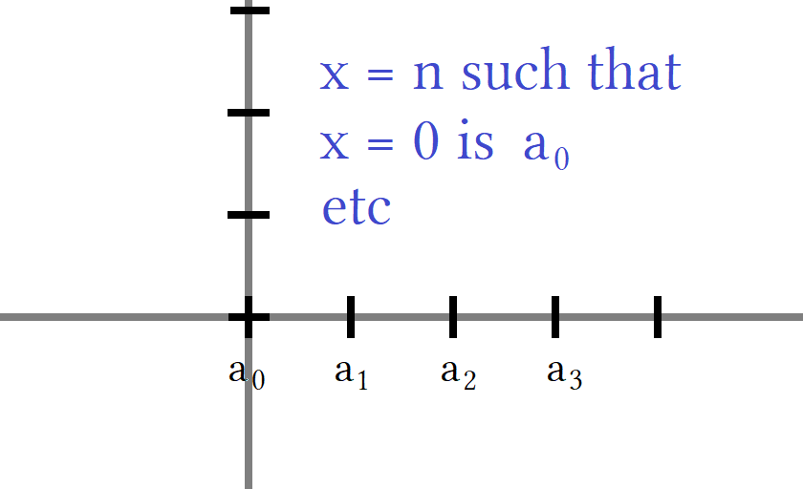
The 0th term is always x = 0
The 1st term is always x = 1
The 2nd term is always x = 2
The 3rd term is always x = 3
The 4th term is always x = 4

The graph of f(x) = 1/2^{x} looks something like this. When x = 0 y = 1. The graph intercepts the y axis at (0,1).
As x increases y decreases. The fractions are getting smaller. At x = 5 it looks to be close to 0.
x = 5 is a₅ the fifth term. At x = 21 the graph must be awfully low. When x = 10 the graph appears to be getting flat. Its seems almost horizontal at this point.

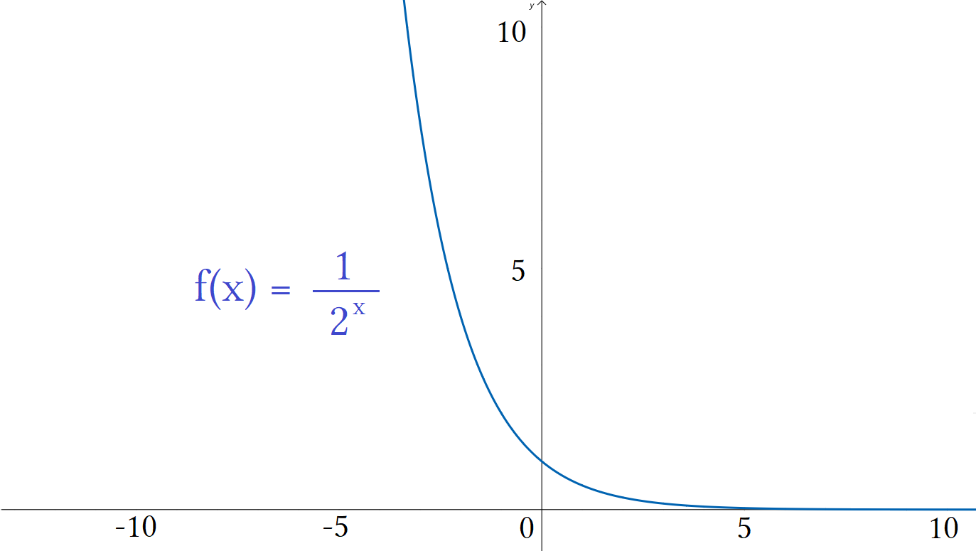

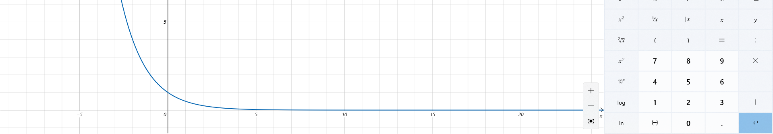

Yep it is very flat after x =20. Here is some general knowledge. A series can either converge to a single y value, diverge, or constantly oscillate. This is rapidly diverging to 0. What the graph is modeling is a ball bouncing and measuring the height of each bounce. A ball will have the largest height at the 1st bounce and then lose height with each bounce due to gravity. In the end the ball stops bouncing and has a height of zero because it is resting on the ground.

Graphs are not perfect representations. Our function can never reach 0 because the only fraction that equal 0 have a 0 in the numerator. There is an asymptote at y=0 preventing the graph from ever crossing this boundary. Consider it a quirk or imperfection to using graphing computers. They help illustrate an event but do not tell the whole story. And this is not even a good graph of this function. Better computers have better scale formats. This one does not show detail well. Another general fact is the infinite series of imperial fractions sums to 2. That is ¹/₁+ ½ + ¼ + ⅛... = 2. This is well known. If we only count the fractions and exclude 1 we have ½ + ¼ + ⅛... = 1. We can check this with a calculator.

S_{n}=( ½ + ¼ + ⅛... )
S₁ = 0.5
S₂ = 0.75
S₃ = 0.875
S₄ = 0.9375
S₅ = 0.96875
S₆ = 0.984375
S₇ = 0.9921875
S₈ = 0.99609375
S₉ = 0.998046875
S₁₀ = 0.9990234375
S₁₁ = 0.9995117188
S₁₂ = 0.9997558594
S₁₃ = 0.9998779297
S₁₄ = 0.9999389648
S₁₅ = 0.9999694824
S₁₆ = 0.9999847412
S₁₇ = 0.9999923706
S₁₈ = 0.9999961853
S₁₉ = 0.9999980927
S₂₀ = 0.9999990463

The partial sum of the first 20 terms is the same as the fractions for 21 bounces. If we add 1 to the sum we get approx 1.9.
(½+¼+⅛+¹/₁₆+¹/₃₂+¹/₆₄+¹/₁₂₈+¹/₂₅₆+¹/₅₁₂+¹/₁₀₂₄+¹/₂₀₄₈+¹/₄₀₉₆+¹/₈₁₉₂+¹/₁₆₃₈₄+¹/₃₂₇₆₈+¹/₆₅₅₃₆+¹/₁₃₁₀₇₂+¹/₂₆₂₁₄₄ +¹/₅₂₄₂₈₈ +¹/₁₀₄₈₅₇₆)

If we finished the infinite series S_{n}=( ½ + ¼ + ⅛... ) as S∞=(¹/₁+ ½ + ¼ + ⅛... ) we would get exactly 2.
Excluding 1 we get 1.

Final Matrix

After crashing through set theory, sequences, functions that contain objects and not numbers here are some final finishing touches on a 16×16 of inputs abcd. We can name sets and have different subsets or subsets within subsets. The only hard part is finding a consistent naming system. Using set theory and tools from sequence notation can help. As a reminder we start where information is the densest and spread it out into manageable groups. Find the data, see the data, organize the data, name the data. Naming comes last. You can not name what you do not have.

aaaa aaab aaac aaad aaba aabb aabc aabd aaca aacb aacc aacd aada aadb aadc aadd
abaa abab abac abad abba abbb abbc abbd abca abcb abcc abcd abda abdb abdc abdd
acaa acab acac acad acba acbb acbc acbd acca accb accc accd acda acdb acdc acdd
adaa adab adac adad adba adbb adbc adbd adca adcb adcc adcd adda addb addc addd

baaa baab baac baad baba babb babc babd baca bacb bacc bacd bada badb badc badd
bbaa bbab bbac bbad bbba bbbb bbbc bbbd bbca bbcb bbcc bbcd bbda bbdb bbdc bbdd
bcaa bcab bcac bcad bcba bcbb bcbc bcbd bcca bccb bccc bccd bcda bcdb bcdc bcdd
bdaa bdab bdac bdad bdba bdbb bdbc bdbd bdca bdcb bdcc bdcd bdda bddb bddc bddd

caaa caab caac caad caba cabb cabc cabd caca cacb cacc cacd cada cadb cadc cadd
cbaa cbab cbac cbad cbba cbbb cbbc cbbd cbca cbcb cbcc cbcd cbda cbdb cbdc cbdd
ccaa ccab ccac ccad ccba ccbb ccbc ccbd ccca cccb cccc cccd ccda ccdb ccdc ccdd
cdaa cdab cdac cdad cdba cdbb cdbc cdbd cdca cdcb cdcc cdcd cdda cddb cddc cddd

daaa daab daac daad daba dabb dabc dabd daca dacb dacc dacd dada dadb dadc dadd
dbaa dbab dbac dbad dbba dbbb dbbc dbbd dbca dbcb dbcc dbcd dbda dbdb dbdc dbdd
dcaa dcab dcac dcad dcba dcbb dcbc dcbd dcca dccb dccc dccd dcda dcdb dcdc dcdd
ddaa ddab ddac ddad ddba ddbb ddbc ddbd ddca ddcb ddcc ddcd ddda dddb dddc dddd

I found all my data, have seen it, have organized it, and am now ready to name it.

- I have 16 rows. Each row will be a set using the name r_{n} where n states row number.
- I have all 16 sets as the superset R:{r₁,r₂,r₂...r₁₆}.
- Sets need not be ordered. Using ellipsis orders them. This is called an “ordered set”.
- Every four rows contains entries with the same leading letter. Every four rows will be a set.
- Each 4 row set will be captil letter of the leading letter of the set.
- The master set Mat A:{A,B,C,D}
- As before every 4×4 matrix will be named by lowercase letters with subscripts 1-4 for order of left to right.

- Set A:{a₁,a₂,a₃,a₄}; Set b:{b₁,b₂,b₃,b₄};Set C:{c₁,c₂,c₃,c₄};Set D:{d₁,d₂,d₃,d₄};
- If I only want four elements from a row I will name that sub-row a combination lead letter:row_{n} given by x_{n}:r_{n}.

- The first row of a₁ will be a₁:r₁ the second row will be a₁:r₂. The first row of a₂ will be a₂:r₁.
- I have columns from [A-P]. Entire columns will be named X_{c} where c is not numbered it just represent column.

- The A column is A_{c}, a custom set of the first three columns is given by set:{A_{c},B_{c},C_{c}}.
- If I want to limit members from a column I can do so by specifying row number like X_{c}:r_{n}.
- X_{c}:r_{n} Chooses a column and then allows only members from row number given.
- If I want only the first and last rows of column A and C this is set:{A_{c}:r₁r₁₆, C_{c}:r₁r₁₆}.
- There are many ways to specify a range under this naming system. {A_{c}:r₁r₁₆, C_{c}:r₁r₁₆} = {A_{c}:r₁,A_{c}:r₁₆,C_{c}:r₁,C_{c}:r₁₆,}.

- If I want only the four vertical members of 4×4 matrix then E_{c}:a₂ gives me {aaba, abba, acba, adba}.
- I have 16 row groups, 16 column groups, and 16 4×4 matrix groups. I have 48 subsets that contain 16 members.

- I can add single entries by typing them in set:{E_{c}:a₂, aaad} contains all the members from set:{E_{c}:a₂} plus aaad.

- I can target entries. Set:{cabb} = set:{ F_{c}:r₉}. A row and column search only selects one element.

Final Letter to number conversion

If I need to convert my data to numbers I use the function from page 289.
I determine to map a = 1 instead of a = 0 because none of my codes contain 0.
I have 4 letters to choose from. This is my domain. My domain is x:{a,d}.
I have 256 entries. This is my range. My range is x:[aaaa,dddd]
If I convert letters to numbers I have domain x:[1,4] and range x:[1111,4444].

1111 1112 1113 1114 1121 1122 1123 1124 1131 1132 1133 1134 1141 1142 1143 1144
1211 1212 1213 1214 1221 1222 1223 1224 1231 1232 1233 1234 1241 1242 1243 1244
1311 1312 1313 1314 1321 1322 1323 1324 1331 1332 1333 1334 1341 1342 1343 1344
1411 1412 1413 1414 1421 1422 1423 1424 1431 1432 1433 1434 1441 1442 1443 1444

2111 2112 2113 2114 2121 2122 2123 2124 2131 2132 2133 2134 2141 2142 2143 2144
2211 2212 2213 2214 2221 2222 2223 2224 2231 2232 2233 2234 2241 2242 2243 2244
2311 2312 2313 2314 2321 2322 2323 2324 2331 2332 2333 2334 2341 2342 2343 2344
2411 2412 2413 2414 2421 2422 2423 2424 2431 2432 2433 2434 2441 2442 2443 2444

3111 3112 3113 3114 3121 3122 3123 3124 3131 3132 3133 3134 3141 3142 3143 3144
3211 3212 3213 3214 3221 3222 3223 3224 3231 3232 3233 3234 3241 3242 3243 3244
3311 3312 3313 3314 3321 3322 3323 3324 3331 3332 3333 3334 3341 3342 3343 3344
3411 3412 3413 3414 3421 3422 3423 3424 3431 3432 3433 3434 3441 3442 3443 3444

4111 4112 4113 4114 4121 4122 4123 4124 4131 4132 4133 4134 4141 4142 4143 4144
4211 4212 4213 4214 4221 4222 4223 4224 4231 4232 4233 4234 4241 4242 4243 4244
4311 4312 4313 4314 4321 4322 4323 4324 4331 4332 4333 4334 4341 4342 4343 4344
4411 4412 4413 4414 4421 4422 4423 4424 4431 4432 4433 4434 4441 4442 4443 4444

Mat A forms a clear pattern which we call the sequence Mat A:(aaaa,aaab,aaac … dddd) or Mat A:(1111,1112,1113, … ,4444) depending on scheme we are using. The sequence has skips so summing is difficult. The sequence uses letters so summing is difficult.

A sequence does not always sum. Basic sequences of numbers can be written as series but how would you write
Mat A:(aaaa,aaab,aaac … dddd) or Mat A:(1111,1112,1113, … ,4444) as a series?

First of all as written the sequences do not should the pattern of having skips. As is the sequence implies no skips. What would no skips be? Would it be ten letters a-j to be converted to numbers 0-9? Or would it use all 26 letters a-z? How would that work?

The sequence as written would be specified first by stating what elements are allowed. This is domain.

Mat A:(aaaa,aaab,aaac … dddd) where domain is x:[a,d] or x:[a,d] Mat A:(aaaa,aaab,aaac … dddd)
Mat A:(1111,1112,1113, … ,4444) where domain is x:[1,4] or x:[1,4] Mat A:(1111,1112,1113, … ,4444)

Domain would be mentioned somewhere to eliminate having to write a messy sequence. By stating domain we state the sequence implicitly. By not stating domain we are giving the sequence but it is not clear what the pattern is. You can write a sequence and not give the pattern but that makes it hard for readers to know what members are in the set. By converting to numbers we can write the sequence easier and then convert back to letters to maintain the original letter format. The minimum to write the entire range x:{1111,4444} would need 18 entries:

Mat A:(1111,1112,1113,1114,1121,1122,1123,1124,1131,1132,1133,1134,1141,1142,1143,1144,1121, … ,4444)

This shows the entire sequence for the first row then the first entry for the second row. Ellipsis after the 17th entry means continue the pattern from the first 16 entries all the way to 4444 which is the end of our range. Because this is odd we sometimes do not care if readers can understand what the pattern is as long as they understand that a pattern is there. We shorten the pattern or use non standard ellipsis placement to cheat.

Mat A:(1111,1112,1113,1114,1121,1122,1123,1124,1131,1132,1133,1134,1141,1142,1143,1144,1121, … ,4444)
Mat A:(1111,1112,1113,1114,1121, … ,1124,1131, … , 1134,1141, …,1144,1121, … ,4444) this is standard.
Mat A:(1111,1112,1113,1114,1121…1124,1131…1134,1141…1144,1121…4444) this is nonstandard but looks better.
Mat A:(1111...1114,1121…1124,1131…1134,1141…1144,1121…4444)

The last two are nonstandard in that they remove commas around ellipsis. This is not cheating but not the standard way sequences are written. You can write your sequence how ever you want. There are many conventions that are non standard. The only caveat is whether you are dealing with technology like doing boolean searches. If you have something that is non-standard and enter it as a search parameter some systems will recognize you code and others won't. You can be non standard and choose from many popular non standard ways that are commonly used or you can write your sequence badly. If using a popular style better systems will recognize it and lesser systems won't. If you write something badly it is almost guaranteed not to be recognized.

Writing something like 1111...1114 does not have commas like 1111, … , 1114. Without commas the ellipsis is used like a hyphen to say “include every member possible under domain constraints”. It means include every successive term.

With commas means “continue the pattern” where the pattern may skip. Notation can be strictly followed or abused. If abused then the notation means whatever the writer wants it to mean. This is called “eccentric”. Eccentricity makes it hard for other people to be a part of the conversation. They do not understand your notation. They do not speak your “ language”. Standard notation if for including people into a discussion. Eccentricity is for obscurity and secrecy. Even standard notation has a level of secrecy in that people not trained in that specific notation will struggle with what is specified for any formula, code, or sequence. It is better to use standard notation unless we have something like a letter sequence where writing the exact pattern in difficult and not important. This leads to cheating.

Mat A:(1111...1114,1121…1124,1131…1134,1141…1144,1121…4444)
Mat A:(1111,1112,1113,1114, … , 1121... , 1131... , 1141... , 2111 … 3111 … 4111.…4444)

Honestly I would call the blue one standard or very close. From it I can easily surmize the pattern and identify every element in the set. This is good and short. The red one is more how people outside of math write sequences as it more closely follows human speech patterns:

Every member of a beginning sequence, then the twenties range, thirties range, forties range, up to the 2000's, 3000's, 4000's .

I can easily see someone speaking like this where they are giving the pattern not by specifying the pattern but by specifying what ranges are allowed, and by specifying domain by giving every member of the beginning sequence so you can see what numbers are allowed for a digits place thereby setting domain.

They targeted 1111 1112 1113 1114 then considered this the end of range for the teens. Next they said the twenties which would be the same pattern as before but teens are switched to 20's 1121 1122 1123 1124 followed by 30's and 40's 1131 1132 1133 1134 11411142 1143 1144. This completes the 1000's so they move on to the 2000's, 3000's, and end with the 4000's. The do not state the last entry 4444 but could by saying something similar to what I just wrote, “ 2000's, 3000's, 4000's … ending with 4444 ”. They do not need say this because it is already implied from 1444, 2444, and 3444. For the 4000's the last entry must be 4444. You can add or take away as much description as you want for your sequence. If for yourself make it short, if for others make it clear.

Tables of number or letter or number-letter codes can represent anything. They can represent something geometrical in 0, 1 ,2 3, 4, or more dimensions up to as many dimensions as you want. In linear algebra, with the use of tensors, up to 56 dimensions can be observed with area being able to be accurately measure in up to 27 dimensions. Obviously I am talking non-Euclidean geometry here.

I focus on euclidean geometry for physical measurements and then allow up to 9 dimensions for engineering as a starting point. After understand 3 dimensions, a fourth is introduced. After introducing that we quickly move up to 9 dimensions. After 9 we allow 2 more for a total of 11 and then for academic research we go to 27 and stop there.

aaaa aaab aaac aaad aaba aabb aabc aabd aaca aacb aacc aacd aada aadb aadc aadd
abaa abab abac abad abba abbb abbc abbd abca abcb abcc abcd abda abdb abdc abdd
acaa acab acac acad acba acbb acbc acbd acca accb accc accd acda acdb acdc acdd
adaa adab adac adad adba adbb adbc adbd adca adcb adcc adcd adda addb addc addd

baaa baab baac baad baba babb babc babd baca bacb bacc bacd bada badb badc badd
bbaa bbab bbac bbad bbba bbbb bbbc bbbd bbca bbcb bbcc bbcd bbda bbdb bbdc bbdd
bcaa bcab bcac bcad bcba bcbb bcbc bcbd bcca bccb bccc bccd bcda bcdb bcdc bcdd
bdaa bdab bdac bdad bdba bdbb bdbc bdbd bdca bdcb bdcc bdcd bdda bddb bddc bddd

caaa caab caac caad caba cabb cabc cabd caca cacb cacc cacd cada cadb cadc cadd
cbaa cbab cbac cbad cbba cbbb cbbc cbbd cbca cbcb cbcc cbcd cbda cbdb cbdc cbdd
ccaa ccab ccac ccad ccba ccbb ccbc ccbd ccca cccb cccc cccd ccda ccdb ccdc ccdd
cdaa cdab cdac cdad cdba cdbb cdbc cdbd cdca cdcb cdcc cdcd cdda cddb cddc cddd

daaa daab daac daad daba dabb dabc dabd daca dacb dacc dacd dada dadb dadc dadd
dbaa dbab dbac dbad dbba dbbb dbbc dbbd dbca dbcb dbcc dbcd dbda dbdb dbdc dbdd
dcaa dcab dcac dcad dcba dcbb dcbc dcbd dcca dccb dccc dccd dcda dcdb dcdc dcdd
ddaa ddab ddac ddad ddba ddbb ddbc ddbd ddca ddcb ddcc ddcd ddda dddb dddc dddd

This picture shows where triples are located in set a.

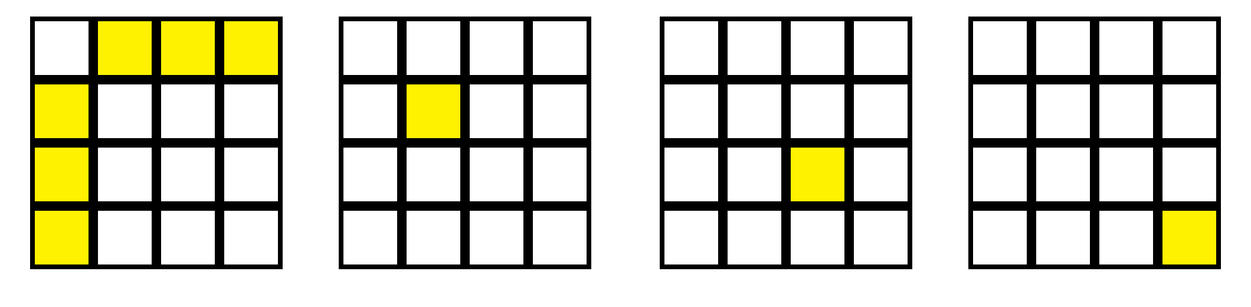

This picture shows where quadruples are located for the entire matrix.

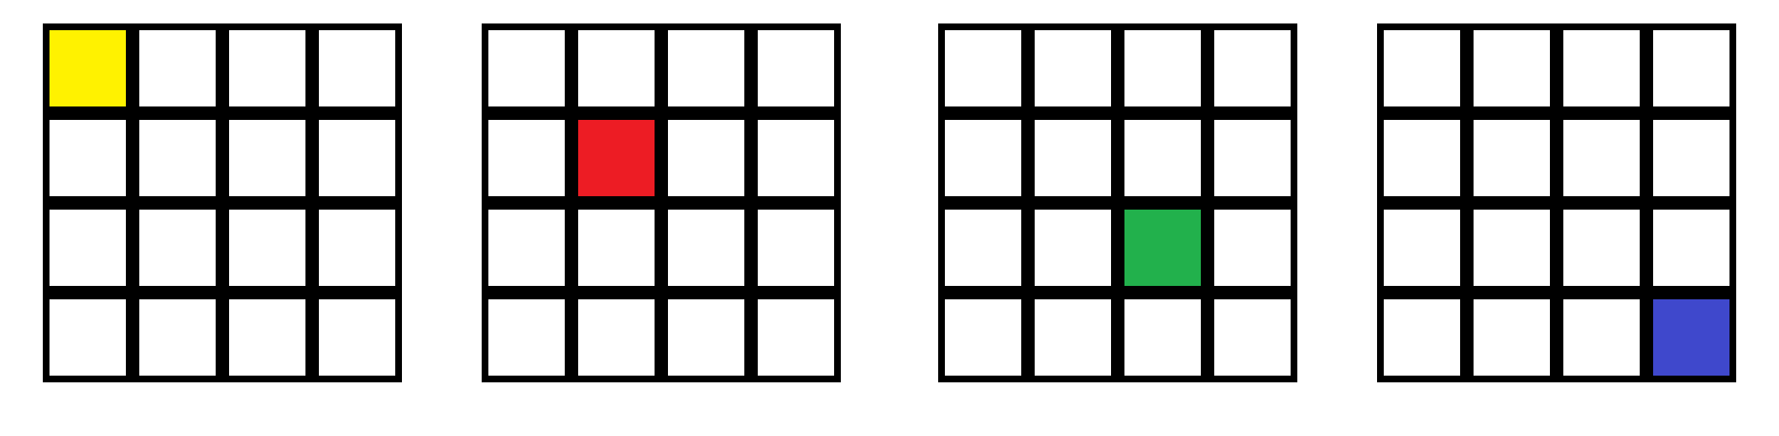



This picture shows four 4×4 matrices as 2-dimensional planes stacked on top of of each other.
A m×n matrix can be treated like a base×width or base×height area.
Yellow, red, green, blue correspond to set a on top of set b on top of set c on top of set d.
Order from top to bottom is as follows (set:a, set:b, set:c, set:d).
This implies a 3d coordinate system but could be something else.
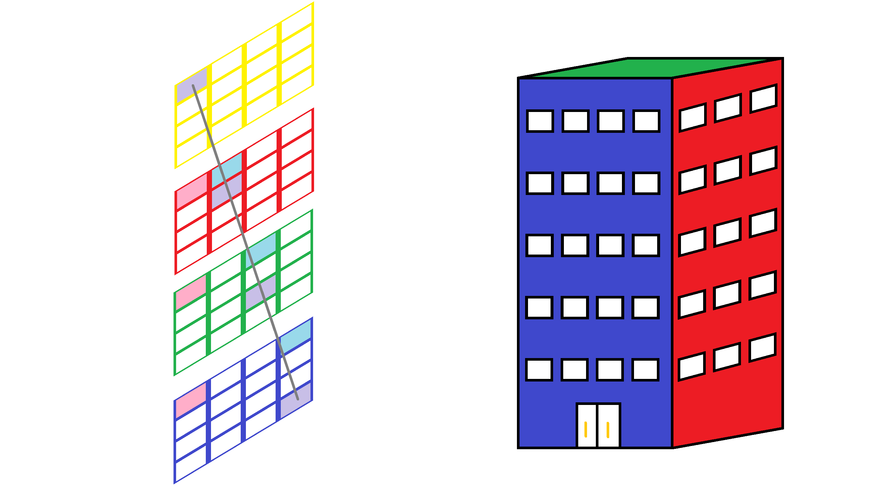

Imagine a four floor building. From the top down you have a yellow floor, red floor, green floor, blue floor.
For now 4 flours with 16 rooms arranged in a 4×4 matrix.
If I shoot a bullet from cell A:1 or “yellow room 1” then the bullet passes through center of rooms:

Scenario 1 Scenario 2 Scenario 3 Scenario 4

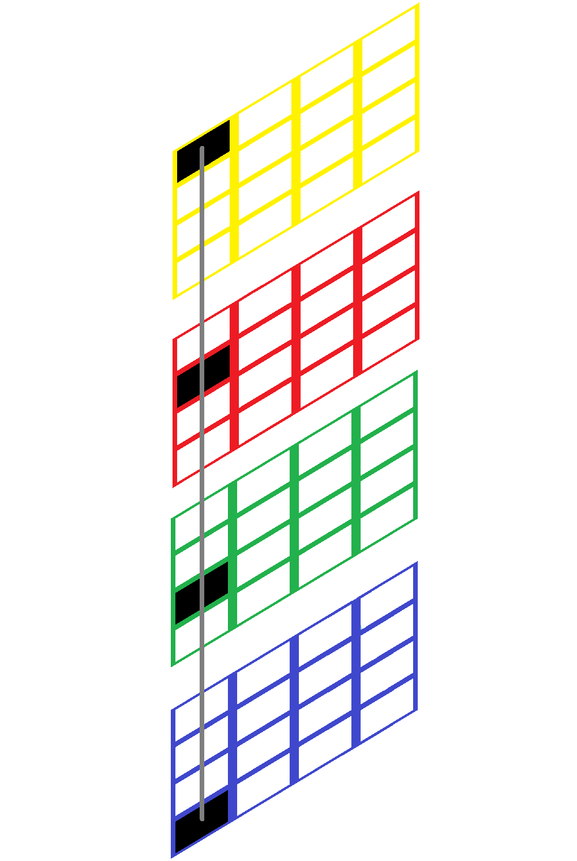
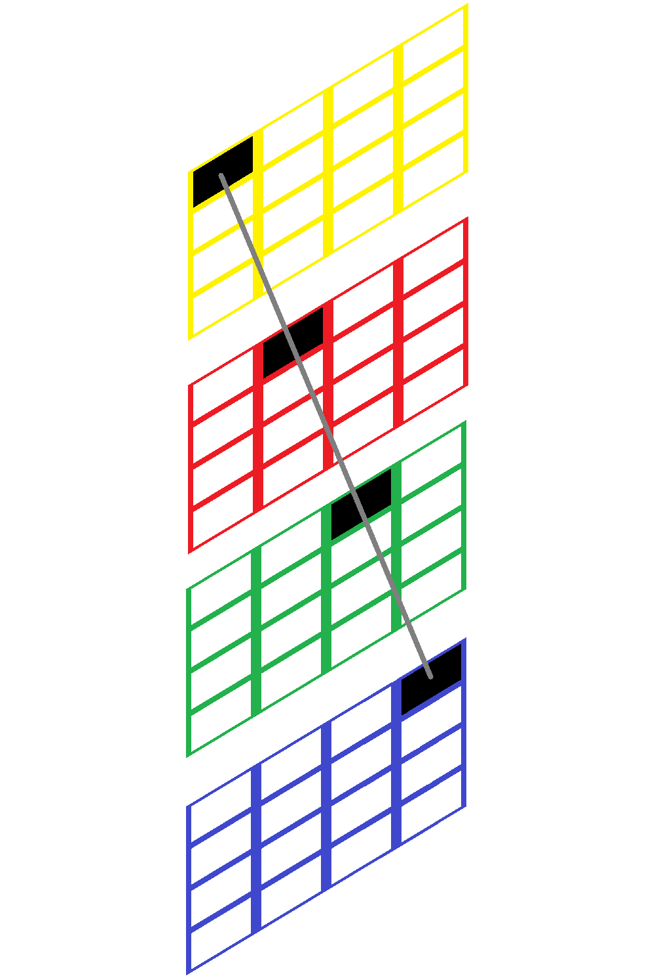
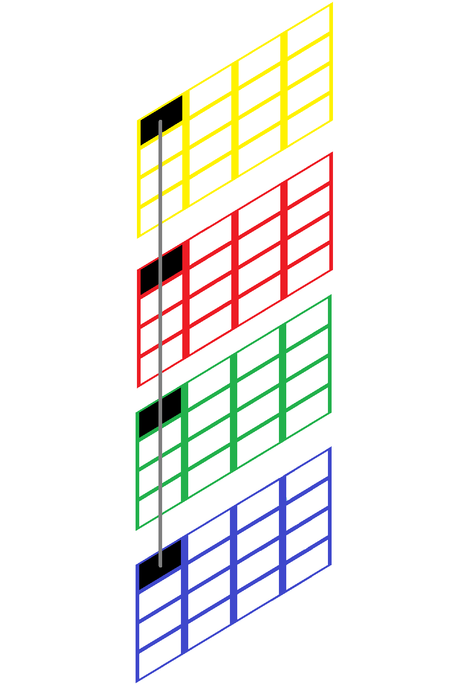
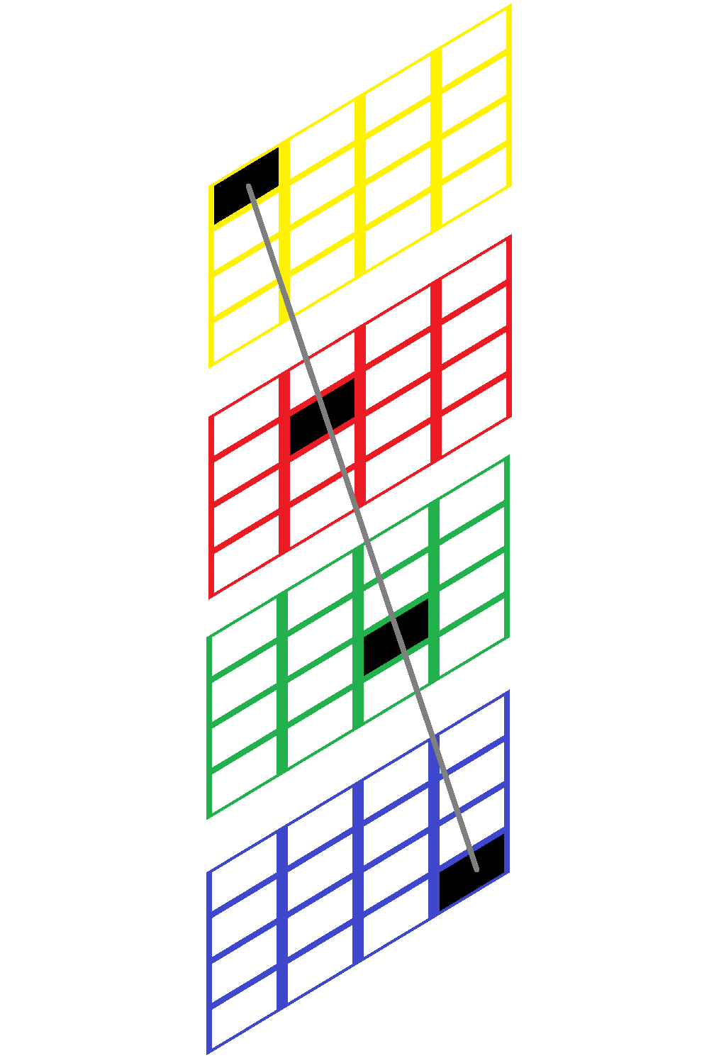

Scenario 1: Bullet travels straight down through (y1,r1,g1,b1). This is aaaa,baaa,caaa,daaa.
Scenario 2: Bullet travels down the y and z axis through (y1,r4,g9,b13). This is aaaa,bbaa,ccaa,ddaa.
Scenario 3: Bullet travels down the y axis and up the x axis. This is aaaa,babb,cacc,dadd
Scenario 4: Bullet travels diagonally through 3 dimensions xyz from aaaa to dddd. This is aaaa,bbbb,cccc,dddd.

A matrix is given by base×height or base×width. This is columns×rows = m×n.
We say “ m columns by n rows ” which correlates to base× 2nd axis. Your second axis is your 2nd dimension.
This could be y = height or z = width, x always is x = base. There are only two exceptions to this:
- You perform a matrix rotation and 3 columns×4 rows becomes 4 columns×3 rows in which case x×y is now y×x such that your base is your height (or width) and your height is now your base. Normally x = base and y = height but rotating a 2d object, like a rectangle or triangle, inverts x and y so that x = height and y = base.

- You have two dimensions that neither is x.
You have y = base and z = height or they are inverted and you have y =height and z = base.

I have the 16×16 matrix broken into four 16×4 matrices which make up the sets A,B,C, and D. This is matrix a:

aaaa aaab aaac aaad aaba aabb aabc aabd aaca aacb aacc aacd aada aadb aadc aadd
abaa abab abac abad abba abbb abbc abbd abca abcb abcc abcd abda abdb abdc abdd
acaa acab acac acad acba acbb acbc acbd acca accb accc accd acda acdb acdc acdd
adaa adab adac adad adba adbb adbc adbd adca adcb adcc adcd adda addb addc addd

This is matrix b:

baaa baab baac baad baba babb babc babd baca bacb bacc bacd bada badb badc badd
bbaa bbab bbac bbad bbba bbbb bbbc bbbd bbca bbcb bbcc bbcd bbda bbdb bbdc bbdd
bcaa bcab bcac bcad bcba bcbb bcbc bcbd bcca bccb bccc bccd bcda bcdb bcdc bcdd
bdaa bdab bdac bdad bdba bdbb bdbc bdbd bdca bdcb bdcc bdcd bdda bddb bddc bddd

This is matrix c:

caaa caab caac caad caba cabb cabc cabd caca cacb cacc cacd cada cadb cadc cadd
cbaa cbab cbac cbad cbba cbbb cbbc cbbd cbca cbcb cbcc cbcd cbda cbdb cbdc cbdd
ccaa ccab ccac ccad ccba ccbb ccbc ccbd ccca cccb cccc cccd ccda ccdb ccdc ccdd
cdaa cdab cdac cdad cdba cdbb cdbc cdbd cdca cdcb cdcc cdcd cdda cddb cddc cddd

This is matrix d:

daaa daab daac daad daba dabb dabc dabd daca dacb dacc dacd dada dadb dadc dadd
dbaa dbab dbac dbad dbba dbbb dbbc dbbd dbca dbcb dbcc dbcd dbda dbdb dbdc dbdd
dcaa dcab dcac dcad dcba dcbb dcbc dcbd dcca dccb dccc dccd dcda dcdb dcdc dcdd
ddaa ddab ddac ddad ddba ddbb ddbc ddbd ddca ddcb ddcc ddcd ddda dddb dddc dddd

Each 16×4 is broken into four 4×4 matrices where mat a:{a₁,a₂,a₃,a₄} ; b:{b₁,b₂,b₃,b₄} ; c:{c₁,c₂,c₃,c₄} ; d:{d₁,d₂,d₃,d₄}.
Visualize each 4×4 as a square that is 4 units×4 units. This will be an area of a floor where base×width is m×n.

Picture drawing a line on this page from aaaa to dddd. This is scenario 4.
Picture drawing a line on this page from aaaa to dadd. This is scenario 3.

In 2 dimensions we can not accurately model the data of drawing the lines for any 3d scenario but scenario 1 and 2 seem harder since they show a vertical line passing multiple members of a 4×4 matrix. This is okay. We just need an idea of what's happening. If drawing lines on this page through lettered entries we get the same problem of touching multiple members. This is not the best representation but it provides valuable insight.

Picture drawing a line on this page from aaaa to ddaa. This is scenario 2.
Picture drawing a line on this page from aaaa to daaa. This is scenario 1.

The 2nd and 3rd scenarios pass through two dimensions and the fourth scenario passes through all 3 dimensions.

Scenario 1: This is a vertical line = y
Scenario 2: height×width = y×z
Scenario 3: base×height = x×y This is m×n where x = columns and y = rows
Scenario 4: base×height×width = x×y×z This is l×m×n where l = width

The perpendicular lines that form a vertex at the center of a circle is called a bullseye or a cross hair. A crosshair implies that lines as thin as two thin “hairs” are intersected or “crossed” to form a targeting system. Systems like this are used to “sight” sn object. “Sighting” is being able to locate visually or with the aid of electronic equipment like radar, sonar. For a crosshair system the technical term is “reticule”. The iron sights on a gun are reticules. A rifle scope has a bullseye:

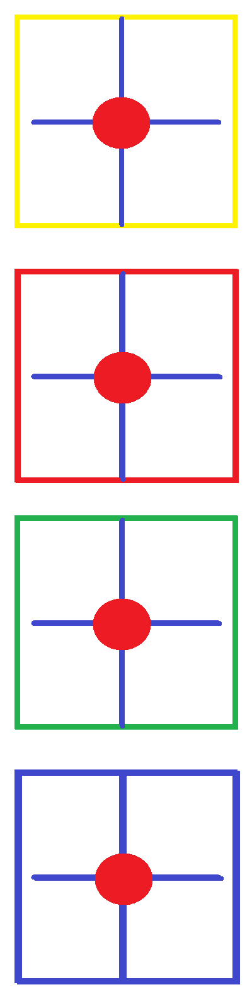

This picture is if I shoot straight down like scenario 1. The red dot is the center of a square area like a room of table cell. Drawing a line from top to bottom a vertical line passes all 4 bulleyes. This shows a vertical trajectory.
The red dots are said to be co-linear. They are in 4 different planes but a straight line can pass through all of them. Co-linear means a set of locations called points are in a row or in a line.

Let's pretend we have a 4 story apartment building but instead of calling the floors by ordinal we list them a,b,c,d in descending order. Instead of a,b,c,d we have d,c,b,a. We inverted our y axis.

4th floor = a Floor a = top. This is the fourth floor.
3rd floor = b Floor b = second to top This is the third floor which is third from bottom.
2nd floor = c Floor c = third to top. This is the second floor which is second to bottom.
1st floor = d Floor d = fourth to top. This is the bottom or 1st floor.

Let's say an apartment building only have 4 apartment units where their designations of a-1, b-1,c-1, and d-1 refers to story by letter in descending order and number refers to unit number on each story.
A-1 is on top of b-1. B-1 is on top of C-1. D-1 is on the bottom story.

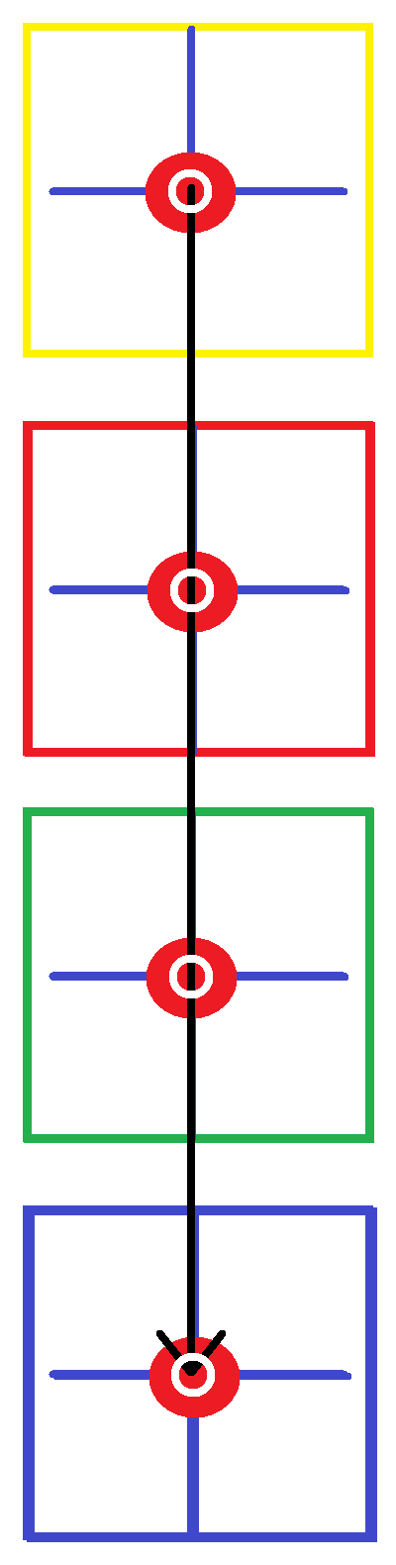
A-1 If I am in A-1 I am at the top. If I shoot through the floor in the center of A-1:

B-1 The bullet passes through the ceiling of B-1 which is the floor of A-1...

C-1 The bullet passes through the ceiling of C-1 which is the floor of B-1...

D-1 The bullet passes through the ceiling of D-1 which is the floor of C-1.

The bullet should be fired from the center of the room straight down in a vertical manner so that the center of each room is a bullseye the bullet passes through. A 1'' bullet will leave a 1'' hole in the center of the room.
The bullet will pass through the red bullseye somewhere. I drew a black line through all the bulleyes.
This is the path of the bullet. The bullet will leave a hole in the center of the bulls eye's approximated with a white hollow circle. You can see the black line passing through the center of each bullseye.

The white circle limits the domain of x to be a single value of set of values.
The distance from floor to floor is range given by “y”.
The distance left to right is x axis.
The distance back & forth is z axis..

The white circle is either “some area” or “no area”. Its range is whatever gives the diameter of the bullet or 0. If 0 then this is the center of the hole made by the bullet. This range will be for a 1×1 square (½, ½ ) or just (½) where the bottom of the circle is y = ½ and the top of the circle is y = ½.

To find the center of a hole placed at the center of the square treat the square as x² = 1.
This assumes the circle to be an area of 0. This limits any values above or below the circle.
This “cuts off” the black line above and below the white circle thereby excluding and values for placement of the bullet. If the room is 10ft by 10ft the center of the room is at (5ft, 5ft). This is a location of x = 5 and y = 5.
If a bullet leaves a hole 1” in diameter at the location (5ft,5ft) then the hole is this:

Domain for the hole of a 1” bullet: x:[ 5ft – ½'', 5ft + ½'' ]
x:[ 59.5'' , 60.5'' ]
x:[(60± ½)'']

The center of the 1'' hole is: (60'',60'') This is a point.
Domain for the center of the 1'' holes: [60''] or (60'',60'') This is not a point.
Range for the center of the 1'' hole: [60''] or (60'',60'') This is not a point.




The 1'' circle has been embellished to be easier to see.
To the right is a 1'' hole through a floor painted green.
If you ignore the blue lines there is a white hole showing material has been removed by the bullet.

Let's say this square is a 10×10 room with the center located at (5ft,5ft). The red circle is a hole left by a 1'' bullet.
If we color the floor solid green the white area is a hole 1'' high and 1'' wide. This gives the hole two axes; an x axis and a y axis both 1'' long centered at (5ft,5ft).

The blue lines cross at (5ft,5ft). This point can be considered the origin (0,0) for the axes of the hole.
The lines are not equal length but that is a different story, here they do not need to be as long as they accurately mark the center. The blues lines cross at a point which as a circle has 0 height and 0 width. This is the definition of a point. A point has no physical measurements.

1''/2 = ½'' The radius of the circle is ½ ''. From the origin of the hole distance to the boundary of the circle is ½ '' in any direction following a straight line. We focus on the height of the hole and call it its y axis and the width and call it its x axis.

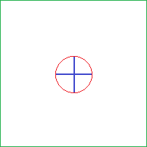
The hole is 1'' tall and 1'' wide. We write 1'' diameters for its x and y axis.
The red circle shows the outer bounds of the hole.
The blue lines are diameters for the hole. The blue lines are located at:

On the x axis: 60''± ½'' = 59.5'' to 60.5''
On the y axis: 60''± ½'' = 59.5'' to 60.5''

This says that a line from – ½'' to ½ '' is 1 inch long and that two such lines
start at 59.5'' and end at 60.5'' for both the x and y axis of the red circle.

If a bullet shoots straight down through 4 floors there will be 4 squares with identical 1'' diameter holes in the center.








This shows the bullet travelling from the top yellow floor to the bottom blue floor.
The black line starts at the center of yellow's hole and ends at the center of blue's hole.

This is confusing because it seems to say two opposite things:

- The line is traveling down through the holes.
- The line is traveling across the rooms sideways over the floors
entering through one side wall and exiting out the other.

The first statement is correct. The second statement is false.
Look at how the black line crosses the green square from top to bottom.
In 2d the room floor shows the x and z dimension.
Top to down is width or z axis.
This is the back of the room down to the front of the room.



This colors the holes a contrasting color so it is easier to see.
Red has a “blue” hole because red would not contrast with red.

This shows a tiny white circle at the center of the red “hole”.
This white circle limits the z range of the black line.
We want to force the black line to only register in the white hole.

We want to force the white hole to be at the largest the diameter of
the bullet itself but in reality want the white hole to be a dimensionless
dot that marks the center of the room itself.

If we say the bullet can travel any where in the white hole then any part of the black line inside the white circle is a possible bullet path. Any part of the black line outside the white circle is not allowed as a point on the 2d plane meaning the bullet can only follow lines that pass through these white circles. This limits the line trajectory to follow bullet holes only. These white circles are called “waypoints”. It is used in aviation.
It is used in GTA as the check points for races. We are describing calculus techniques for linear algebra and beyond. Algebra is over and I am bridging the gap to geometry, trig, statistics, and calculus.
Everything at this point is advanced material. This is instruction that is not found elsewhere.
It's value is priceless. You may understand the word problem but translating it into formulas is difficult.
This is teaching skills that become clearer as time passes.

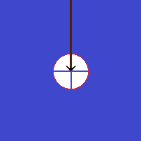
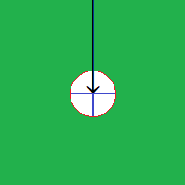
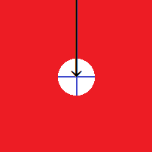
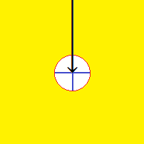

The red circle is the holes circumference. The black arrow has to pass only through the hole.
If so why is the arrow touching every z value above the hole?

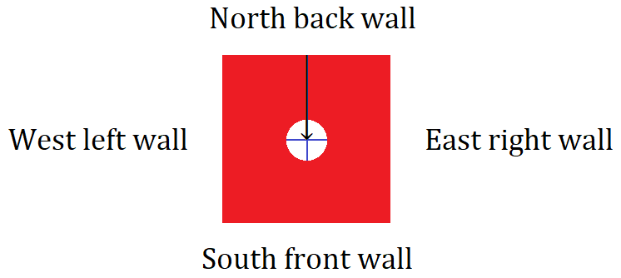
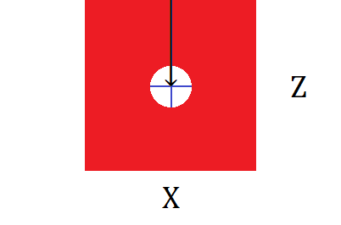

All rooms are 10ft×10ft. The base is the x axis the width is the z axis.
We can not use the y axis because it is the vertical dimension the bull is traveling.

We limit the range of z instead of y to limit the range to only include widths from top to bottom that fit inside the bullseye which is to be the hole left by the bullet's diameter of 1''. The bullseye is 1'' the bullet is 1''. When the bullet hits the bullseye it will remove every part of it only leaving a hole where the bulleye used to be.

We want the “dead center” for range. This means we want to consider a line to be a 1 dimensional object that has only length but no width or height. The line will have a vertical length but no thickness for its x or y dimensions.
We use parameter notation to specify a line, later called a vector, in three dimensions. For three dimensions [x:y:z] gives a heady or bearing a line is traveling. This bearing is called it's “vector”. The vector is the path of the line and so is the line itself. The room is 10ft×10ft with a 1'' bullseye at [x:y:z]: = [5':y:5'] where y is undefined mean its value changes as y changes. The circumference of the bullseye can be written two ways. x²+y²= (½)² feet gives its size... to position its origin at (5,5) we use vector formula and do this: (x–5)²+(y–5)² = (½)² . This is similar to vertex formula and shifting a parabola except we are shifting a circle from (0ft, 0ft) to (5ft,5ft).

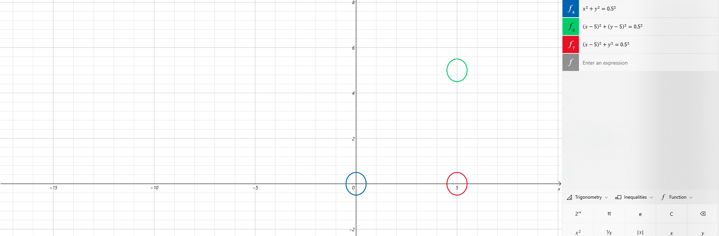

For a circle x²+y² = r². Squaring the x axis and the y axis of the circle makes it wrap around like a circle.
“r²” is radius squared. The radius makes the size of the circle by sweeping a path, called a “swath” 360°.
A circle is therefore a function of it's radius.

The blue circle is centered at (0,0) which we take to be (0ft,0ft) or the corner of the room.
Shifting the blue circle 5 units to the right places it where the red circle is centered at (5ft,0ft).
Shifting the red circle 5 units up places it where the green circle is centered at (5ft,5ft).

Blue circle: x²+y²= ½² =x²+y²= ¼ This is centered at the origin of the xy plane.
Red circle: (x –5)²+y²= ¼ This subtracts 5 from the domain of x shifting it 5 units to the right.
Green circle: (x –5)²+(y –5)²= ¼ This subtracts 5 from red circle pushing it up 5 units.

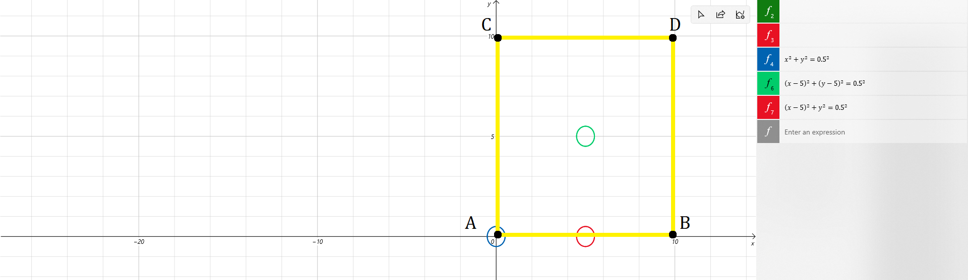

The rooms are squares with 4 corners called vertices where two lines intercept each other to form a vertex.
For a square these vertices are 90° angles. 90° is called perpendicular or orthogonal.
Every vertex is marked with a dot named in alphabetical order.
The named points give the corners of the square room: A:(0,0) B:(5,0) C:(5,5) D:(0,5)

Units are in feet. The circles have radius of ½ inch but the units are in feet. Thus the circles are not to the correct scale. They should be smaller that would make them harder to see. The true size should be ½'' for radius not ½ '.

Blue circle: x²+y²= ¼ divide by 12'' to convert feet to inches x²+y²= ¹/₄₈'
Red circle: (x –5)²+y²= ¼ divide by 12'' to convert feet to inches (x –5)²+y²= ¹/₄₈ '
Green circle: (x –5)²+(y –5)²= ¼ divide by 12'' to convert feet to inches (x –5)²+(y –5)²= ¹/₄₈'

Normally we leave as r² in exponent notation so that it is easier to scale our circle by simply changing r and not needing to write out the equations. The following equations are shown once for exposure but very basic.

For a 1 inch diameter radius is ½ inches.

r² = ½² This says we have a radius of ½ feet because we are using feet for units of our room.
r² = (½)²÷12 This says we are converting from feet to inches. We could leave it this way and be done.
r² = (¹/_{√48})² This is cleaner. It says I really know what I am doing.

r² = (½)²÷12 For starters try this approach...
r² = (½∙½)÷12 (½)² = ( ½∙½) = 1/2∙2 = 1/4 = ¼
r² = (¼)÷12 This is where ¼ came from. This is basic.
r² = (¼)÷12 (¼)÷12 = (1÷4)÷12 = 1÷(4∙12) = 1/48 = ¹/₄₈
r² = ¹/₄₈ We are done, this is the final answer...but for my graph it would be too hard to see.

r² = ¹/₄₈ This says radius squared is ¹/₄₈ feet. “¹/₄₈ feet” = 0.02083 feet which is ¼ of a foot. ¼' ≠ ¼''.
r² = ¹/₄₈ To clarify: ¹/₄₈' = ¼''

r² = 1/48 feet is defined as being equal to r² = ¼ inches, we say r² = 1/48 ≡ r² = ¼ inches. If we need to write this in exponent notation we need to find the square root of 1/48. This is to state radius in feet instead of inches or being squared.

r² = 1/48
√r² = √1/48 Because we have a distance which must be positive we only take the principal root. Do not use “±”.
r = √1 ÷ √48 √(1/48) = (√1 ÷ √48 ) … this is a basic exponent law.
r = 1 ÷ √48 The square root of 1 is 1.
r = ¹/_{√48} This is cleaner than r² = (½)²÷12 because it eliminates the division symbol.
r = ¹/_{√48}

r = 1/√48 a calculator gives √48 ≈6.928
r = 1/√6∙8 pulling out largest factors
r = 1/√2∙3∙2∙4 4 = 2∙2 so r = √2∙3∙2∙4 becomes r = 2∙2√2 ∙ 3∙ 2 ∙ 4 = 2∙2√3 = 4√3 do this to skip next 2 steps

r = 1/√2∙3∙2∙2∙2 factor 4
r = 1/√2∙2∙2∙2∙3 write the prime factorization
r = 1/4√3
r = ¹/_{4√3} This is not bad or we can rationalize the denominator.
r = ¹/_{4√3} ∙ √3/√3 To rationalize a denominator multiply radical fraction with its conjugate. ^{√3}/_{√3} = 1
r = ¹/_{4√3} ∙ ^{√3}/_{√3}
r = ^{1√3}/_{4√3}∙_{√3}
r = 1√3/4√3∙√3
r = √3/4∙3
r = √3/12 = there are no more operations to do

x²+y² = r² = x²+y² = (^{√3}/₁₂)² = x²+y² = (¹/_{√48})² = x²+y² = (¹/₄₈) where (¹/₄₈)' = ¼''.

Dividing the radius by 12 will shrink the circle by a factor of 12. Keep this in mind for the next few pages.

I will call the squares “planes”. All planes they have the same measurements as the yellow plane so everything same about the yellow plane applies to the red green and blue planes. Shifting the circles is a matter of changing the domain of x and range of y. A shift forces a value on the x and y variable. This defines the variable to be whatever number we are subtracting from them. For (x – 5)² we have x=5 as a value for a point (x,y). We are defining x to be “5” so our point will have a value of “5”. Likewise (y – 5)² forces y =5 and so we have x=5 and y =5 our point is (5,5).

This formula makes shifting the circle just as easy as vertex formula makes shifting parabolas as they are derived from the same formula. I will not derive that here now. The point we are creating is the center of the circle but more specifically It is the beginning end point for the radius. We are specifying where we want our radius to be. We are writing a formula for a circle and then writing a shifts for x and y to move the entire circle to a new position based on where the beginning of the radius is placed. A radius has to points, one at the center of a circle and one at some other point that is located on the circle. A circle is defined by the radius not a radius is defined by a circle. This is because a radius creates a circle not the other way around.

We need to know where our radius starts and where it ends. The shifts locate the beginning point “ o ” by limiting the domain and range for a single point called “ o ” to just one x and one y possibility. This means that (x,y) can be only one location. This is why we study domain. It is necessary for everything we do. The end of the radius is a point called “r ”. The length of a radius is r – o if r is a quadrant angle location and o is at the origin. Simply put the length of the radius is the distance between point o and r and equals r. A radius is “ r” long.

Point o is shifted to where we want dragging the set of points that form the circle with it. Point r can be placed on any point on the set of points that form the circumference of the circle. We write the formula for a circle. We shift point o where we want a circle centered. We define a length for a radius. This length generates a set of points called a “circle” around point o at a distance called “r”. For a radius have slope 0 r is the length where domain of x is x:[o,r]. this is the lowest number and highest number for the domain of the radius of slope 0.
For a radius of ∞ slope or “ 90° ” length is given by range instead of domain. Length for a 90° radius is y:[o,r]



If we view the floors in one dimension we get horizontal lines corresponding to the colors of the floor.
To show bullet holes you normally just show holes. You do not show an arrow indicating it's flight path.
This causes domain errors that can only be eliminated using a limiting process. The black arrow show the path of the bullet. The gap that arrows travels through is the hole caused y the bullet. This correctly shows a vertical arrow passing through the rooms. In 2d dimensions the line is going down which could be interpreted as going horizontal through a room instead of down. We need to do this:

The white circles segment the black line. Only points of the black line inside the white circle is counted as existing on or touching the plane. This allows the line to pass through it vertically
but prohibits it from passing through it horizontally. This prevents domain errors.



The pink dot is a “bullet hole” with black dots that are pathways of 1 dimensional lines. If a hole is 1'' then a line of 0'' thickness has multiple entry/exit ways through it. There are two good uses for the pink dot that become clear later. One is describing the 0 dimensional activity inside a particle showing the cluster of protons and electrons neutrons and the probability of where they might be. This would be an application of Buffoon's needle. The other is to finish fixing domain. Let's say the pink dot is 1'' diameter hole left by bullet.

Smaller bullets can pass through this hole and not cross the circles outer perimeter.
Then the black dots are smaller bullets passing through this hole.

Then the flight path of this bullets is given by the centers of these black dots, which are 0 dimensional points.
We can put many points inside this pink circle and toss things at it to see where they land. We can find the centers of these points. We can approximate pi. We can write limits to make ugly paint pictures be logically sound even if the artwork is hideous. Using formal rules called “constraints” we can draw horrible pictures and still be right if of logic holds up. Pictures make excellent visual aids but lousy proofs.

Domain is “how wide on the x axis”. The widest part of the hole is 1''. This is a domain of x:[5' – ½ '', 5'+ ½ ''].
As the domain of x gets smaller the thickness of the black line gets thinner. It is being squeezed by the left and right side.








Applying a similar process for range shortens the distance above and below the centerline for where a black line may be allowed to reside. It is like we are applying asymptotes on the left and right to squeeze it to being 0 thickness then doing the same for height and squeezing it from the top and bottom to get it 0 height (here height is z for width). After crushing it on both sides and both top and bottom the domain and range are restricted to the center of the bullseye. The centerlines of the bulleye are shown here as white lines that appear once the black line goes from being visible to non-visible.

We can do the same thing by writing an equation for a circle and lowering radius till domain and range equal 0. This gives a circle of 0 length and 0 width centered at (5',5') as a location with no physical distance to be measured. This location exists as a concept because we can not measure something that equals 0.
To measure a distance you need a line and a line needs two points a beginning and ending.
We are creating a dot that for lines has x and y axes but we are setting those lengths to 0 so it truly is just a 0d dot and not something else.

The white circle has a smaller range and domain than the red dot. Set your rules to say that black particles must be in the same domain and range as the circle.

Due a limiting process where you shrink the circle step by step by writing smaller values for “r”. Eventually write r as r =0. This shrinks the circle to a 0D dot where the line passing through the plane can only pass through this dot. This gives the bullet actually traveling the line a dead center trajectory.

Although circles themselves are not functions you can write functions for them. Write a function for a circle and say the domain and range of the circle is the same for where a black particle is being measured anywhere on the entire 5ft×5ft plane. Writing a circle equation is easier since it limits both parameters just with one variable, “r”
But maybe overkill as we only need to limit width of the line across the room since domain is a distance of 0'0''.
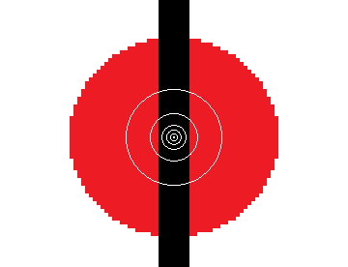
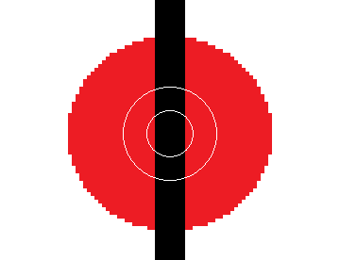

A series of concentric circles tightens control of upper and lower values for both x and z.
A close-up shows the limiting action in progress: only keep what's inside the first circle, then 2nd , then 3rd ...





Concentric circles are circles inside one another. This pattern looks like a dart board. The second picture show red removed and black outside of the white circle. This black has larger domain and range than the circle. We exclude values outside the circle. The last picture shows the last circle as a cluster of points touching. The circle is pixilated so the smallest I could draw is 4 white pixels arranged in a 2×2 manner. As a circle this arrangement of 2×2 has no black in it. Doing this limits black to only one number for x and one number for z. This forces a single ordered pair to exist for possible pathways. This single ordered pair is the dead center of the “2×2 circle” which is really a 2×2 square.

The center of a 2×2 square is (1,1) or over one up one. A 2×2 square is four smaller squares, the center of these 4 squares is the vertex we call a “cross hair”. The center is where all 4 squares share a single point. This is where two 90° axes intercept. Using the smallest circle we find 0 area of black in it meaning that black must exist in a single point given by the center of whatever area we are limiting. The center of the smallest white circle is also the center of the largest white circle. It is also the center of any of the black lines. It is the center of the red hole. It is the center of the entire room.

The center of the 10ft×10ft room is the location (5ft,5ft) so the center of the white circle is (5ft,5ft).
We are geometrically showing how to limit possible x values to be 5ft.
We are geometrically showing how to limit possible y values to be 5ft.

Domain of the hole is 1'' long. Hole:[59.5,60.5] This is 1'' long located in the middle of room.
Range of the hole is 1'' wide. Hole:[59.5,60.5] This is 1'' long located in the middle of room.

Domain of the circle is 1'' long. Circle:[60] This is 0'' long located in the middle of room.
Range of the circle is 1'' wide. Circle:[60] This is 0'' long located in the middle of room.

The circle is a point of 0D located at (60'',60'').
Path of the bullet can not pass the plane higher or lower, more left or mo right that 60'' for both x and z values.

