How to draw squares and cubes

Squares are 2 dimensional shapes. The 1st dimension is called “base” it is the x dimension.
The 2nd dimension is called “height” it is the y dimension. This is a vertical square like a wall it has a base and height. If we have a square flat on the ground then the second dimension called “width” it is the z dimension.
When only working with squares they usually substitute y for z even though y means altitude in 3 dimensional systems. We can not do that for 3D systems. If we have a “width” we must specify it as being measured on the z axis. If we fail to do this it will confuse when we are talking about y or z.

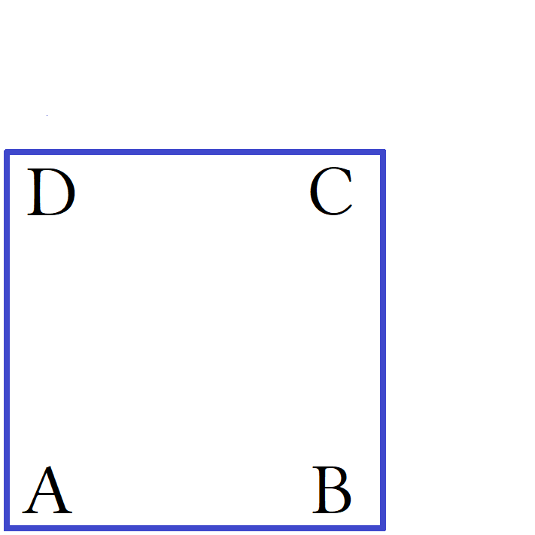
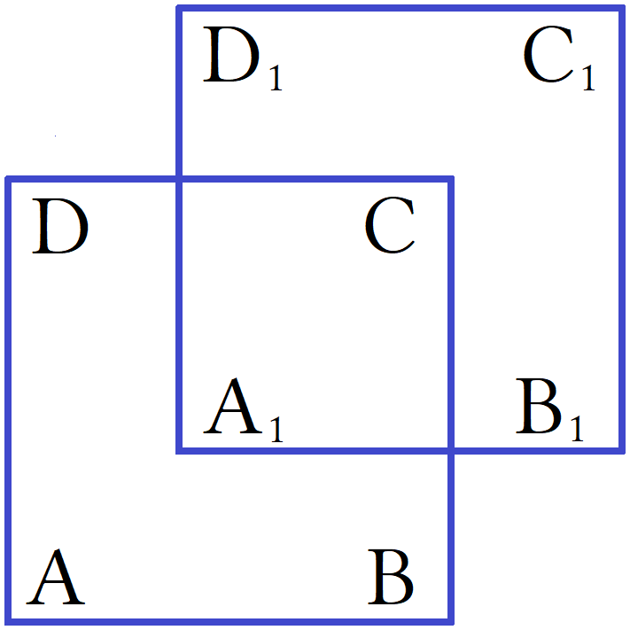
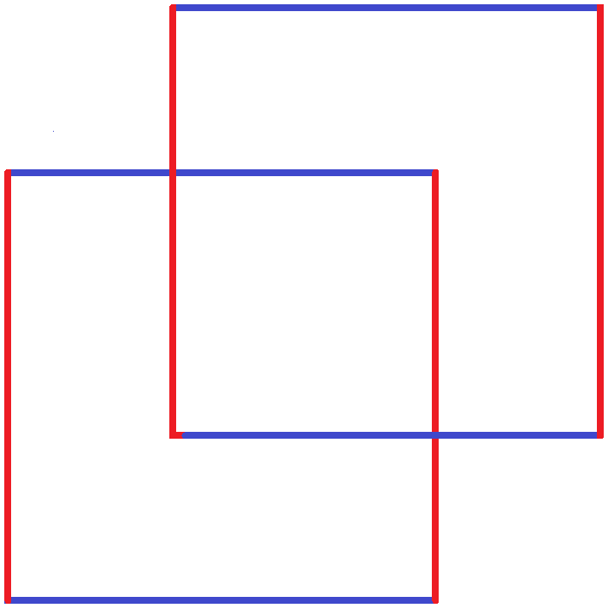
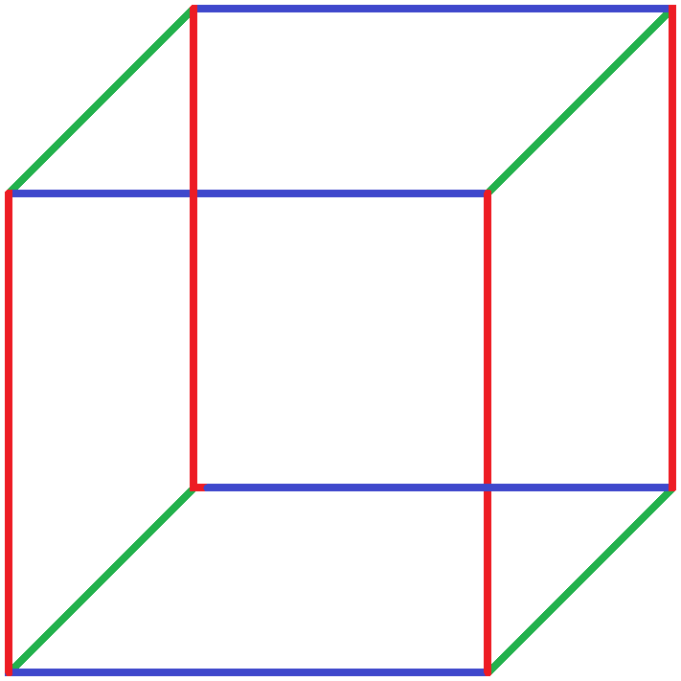

- Draw a blue square that has height = length. For every vertex we mark it with a capital letter.
Capital letters mean point. Generic points are called P. We graph points on a xy grid.
You can use any letters and any order but this is preferred:

For a 1×1 square: A:(0,0) B:(1,0) C:(1,1) D:(0,1).

- Draw an identical square “up and over” from it. Over can be left or right. Up can even be down.
Please draw it “up” and “right”. This 2nd square is behind the 1st square. These two squares are vertical walls. The 1st square is the front wall of a room or cube. The 2nd square is the back wall of a room or cube.

- When we draw the 2nd square all we are doing is creating a 2nd set of points that are translated from their original positions. In geometry we graph objects and then move them. Moving them is called “transforming” them. There are different transformations. You can slide, rotate, or flip.

- When a point is moved it is transformed. We write the transformed point with the same letter as the original point and then give it a subscript to indicate how many times the point has been moved from it's original position; this is if you have multiple copies of the same point otherwise just write “1”.

- Color the vertical lines red please. Red vertical lines mean “y axis” or “y dimension”.
Blue horizontal lines mean “x axis” or “x dimension”.
The length of the square is it's x-value. We put the square on a xy plane and position point A at (0,0).

- The distance from point A to point B is called the “length”. This is not interchangable with “width”.
Since point A has an x-value of “0” then the distance recorded for length will be the x-value of point B.
The distance from point B to point C is called the “height”. This is not interchangable with “width”.
Since point B has an y-value of “0” then the distance recorded for height will be the y-value of point C.

- For a 2d square, rectangle or triangle written in terms of (x,y) the third point gives both length and height for the object. For squares and rectangles third point is called point C but for a triangle it may be called point B or point C depending on how it is rotated.

- Draw green lines from “each point P to each point P₁”. This is the z axis and measures width.
Not to be interchanged with depth.
For 3 dimensions to choose from how many 2d pairings can we create?

This is a combination problem. We have 3 choose 2 as a combination or ₃C₂ which is 3.

3!÷2! = (1∙2∙3)÷(1∙2) = (3∙2)÷(2) = 3 where 3!÷2! = ₃P₃/₂P₂ = ₃C₂ = 3.

There are only 3 possible combinations. This is memorized as 3! is 6 permutations of 3 combinations or 6/2.
Any combination where k = n – 1 is: _{n}C_{n – 1} = n.

First pairing: [x,y] = L×H = length×height This covers the main two variables.
Second pairing: [x,z] = L×W = length×width This is all combinations using x.
Third pairing: [y,z] = H×W = height×width This is the leftover combination .

The permutations just switch the first dimension with the second dimension.
This causes geometric objects to rotate 90°. This is used for matrix rotations.
Every variable has two combinations: x has x,y and x,z; y has x,y and y,z; z has x,z and y,z.
Which creates 6 permutations: x,y ; y,x ; y,z ; z,y ; x,z ; z,x.

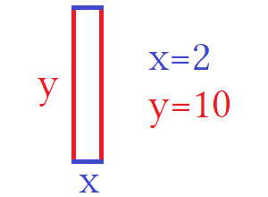
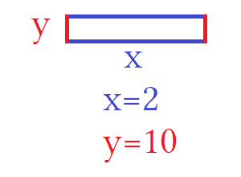
If a rectangle is: 2×10 then base is 2 and height is 10.
If a rectangle is: 10×2 then base is 10 and height is 2.

This is a 90° rotation. This inverts the x and y axes with each other. We did this before with inverse functions.
The inverse of y = 2x is x = 2y.

Dividing we get: y/x = 2x/2y.
Multiplying we get : ^{y}/_{x} ∙ ^{2x}/_{2y} = ^{2xy}/_{x2y} = ^{x}/_{y}
x/y is the reciprocal of y/x: ^{x}/_{y} ∙ ^{x}/_{y} = 1 the two functions cancel.
This is the definition of an inverse function, the function that cancels the first function.

2:10 ∙ 10:2 = 20:20 = 1:1 This is a 1 to 1 correspondence.

What planes of existence are represented by the 3 combinations?

First pairing: [x,y] = L×H = length×height This covers the main two variables.
Second pairing: [x,z] = L×W = length×width This is all combinations using x.
Third pairing: [y,z] = H×W = height×width This is the leftover combination .

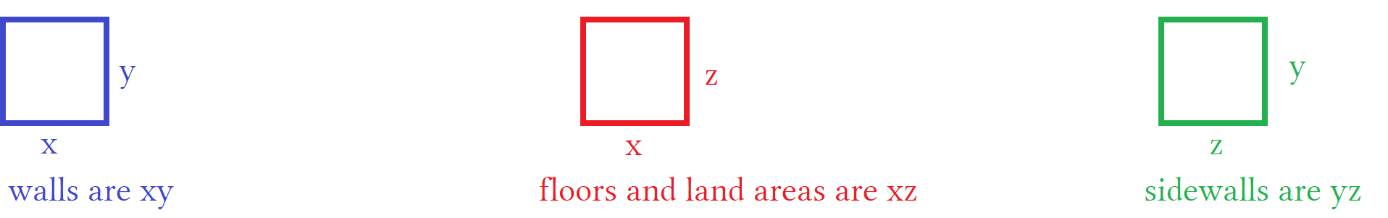

Blue is what we usually use. This is used for anything when we have two dimensions regardless of what they are.
Specifically it is length×height. For a building this would be its base and height. This is for vertical areas of base×height. For a room this would be a wall. Red is for ground area. For a building this would be the base×width of the building. For a room this is a wall. Green is for vertical areas of height×width. You can permute this to width×height. For a building this would be base×height using the z axis for base. Any three of the dimensions can be considered “depth” based on context. For this reason it is not a preferable word.

Deep can mean:

n columns deep. This implies x axis.
m rows deep. This implies y axis or z axis.
l rows deep. This implies z axis.

- A bookcase has 4 shelves with 4 dividers per shelf.
- A library has 4 such bookcases.
- For a single book case the 4th divider separates the 4th and 5th columns. This is 4 columns deep.
- The top shelf is the fourth shelf from the ground. From the top shelf, the 1st shelf is 4 rows deep.
- The first bookshelf is one bookcase deep. The last bookcase is 4 cases deep.

Depth is dependent on where you are taking your measurement. For depth the y axis is usually inverted. Instead of a lower height is a lower number, a lower height is a higher number. This takes the absolute value instead of using negative numbers. For example at a beach a swimmer dove 10ft deep. As he surfaced he was at 9ft, 8ft , 7ft … this has the y axis upside. We call this “y-axis is inverted”. Deep means adding by “+1” in whatever direction you are traveling. Breadth×width×depth has a basket of bread where breadth is length of a of a loaf on the x-axis, width on the z-axis, and how many loafs deep as y-axis. Y-axis is the vertical axis and x or z is a horizontal axis.

Y is bottom to top or inverted as top to bottom. This is height or depth.
X is the front from left to right. Length...sometimes width or depth.
Z is the side from front to back. Width but people say depth even though it's unclear.
Depth is taken to mean z-axis but can mean any axis. If it is not clear which which dimension is which for a x×z area the longest side is x-axis and the shortest side is z-axis. The exceptions to this are dependent on the language used which should be clear. Some objects specify which side is length and others is clear from common interpretation.

When order is different from the alphabetical order I am using then you have a permutation. These are used for rotating triangles in trigonometry to solve for hard to find areas. I will not cover that until trig. I will say that you start will axes listed in order but then rotate your entire graphing plane so that the y-axis is horizontal and the x-axis is vertical. You are not rotating an object on a page you are rotating the entire page axes included.
For a 16×16 matrix we want to select four entries in 3 dimensions. Imagine each plane is not 2D but 3D.
Each entry is not enclosed in a 2D table but 3D cube:

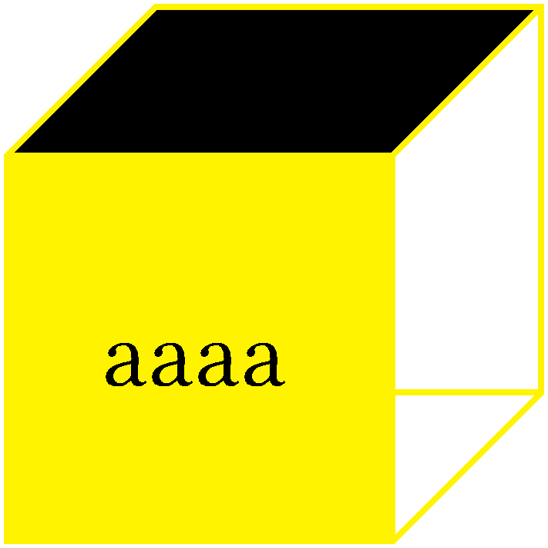
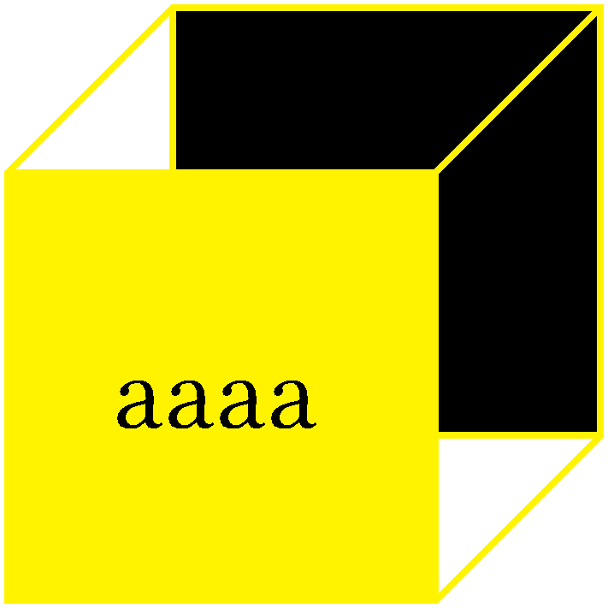
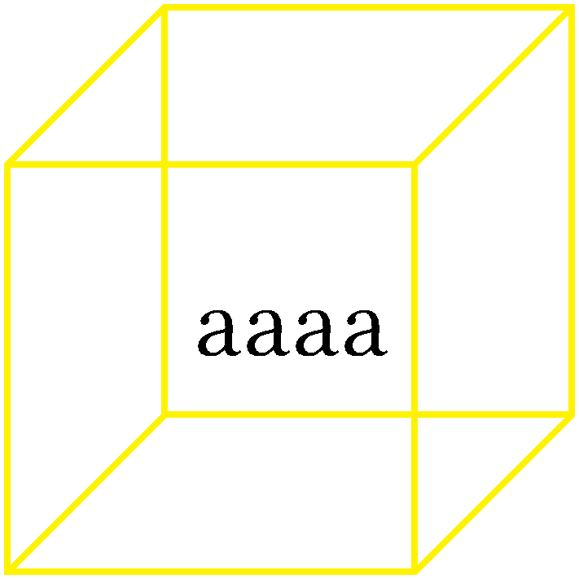
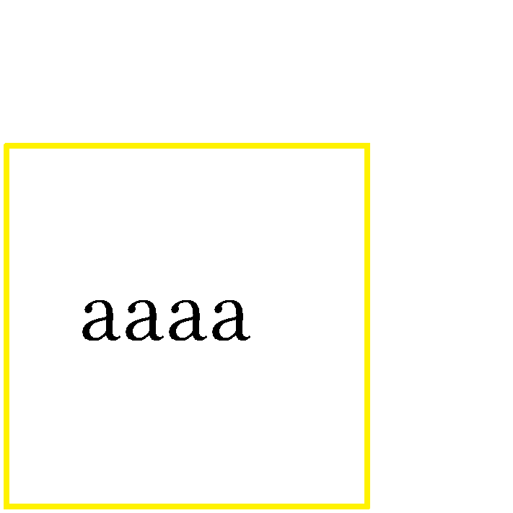
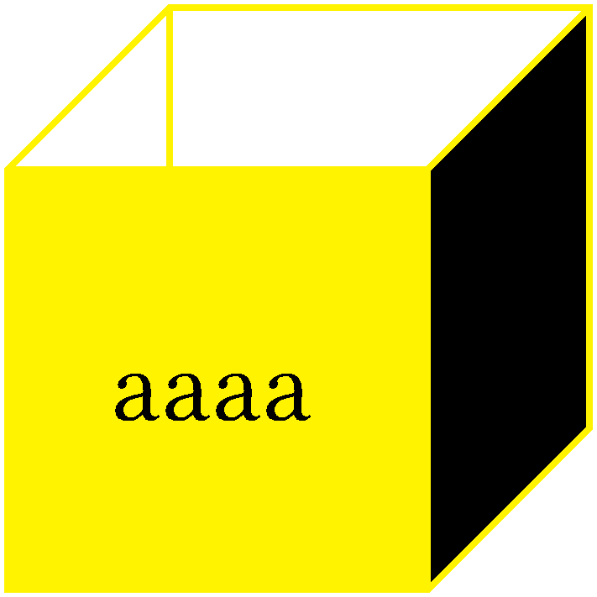

This shows a 2d entry and a 3d entry. Then is shows a cube with the front a solid yellow and another side black.
In order this is top, back and right side. From this perspective it is hard to show the left side or bottom but they are:

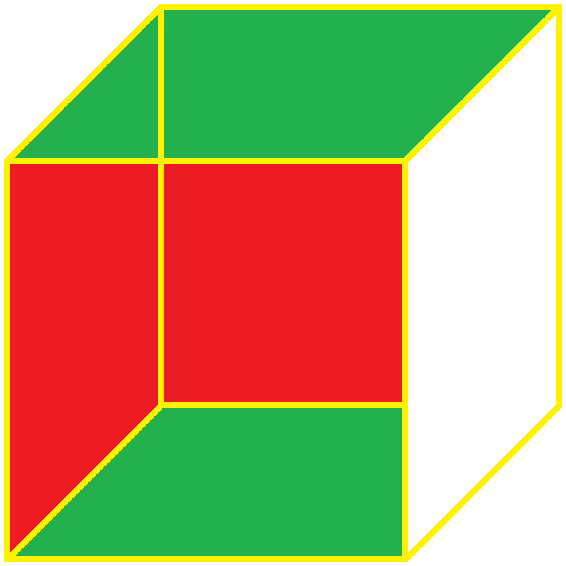
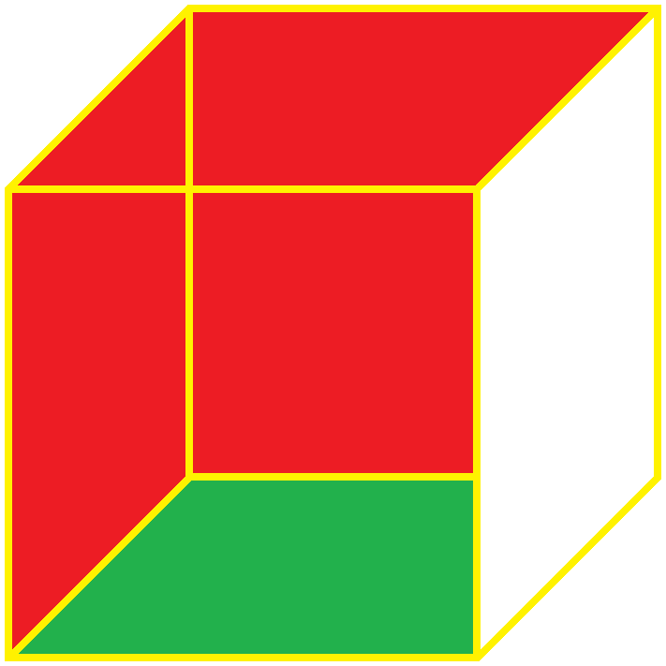
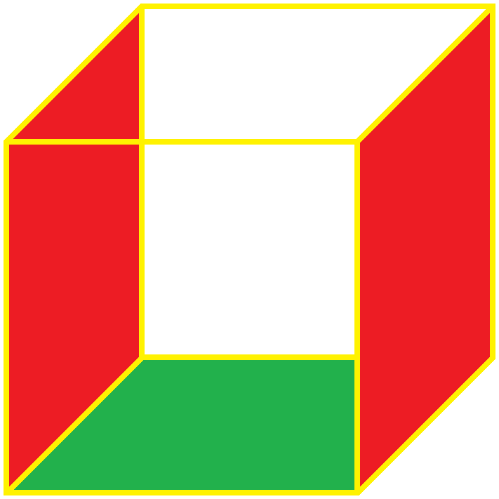
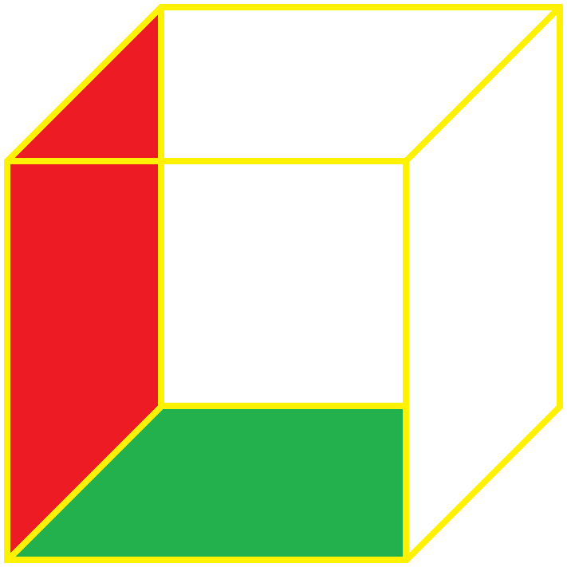
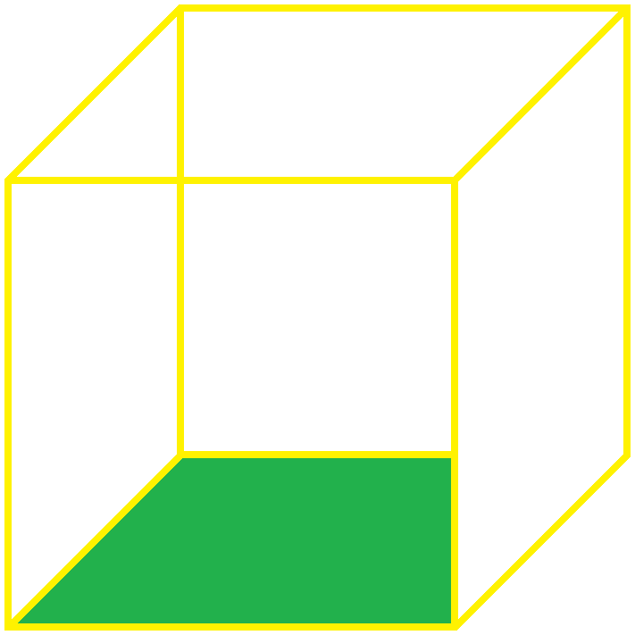
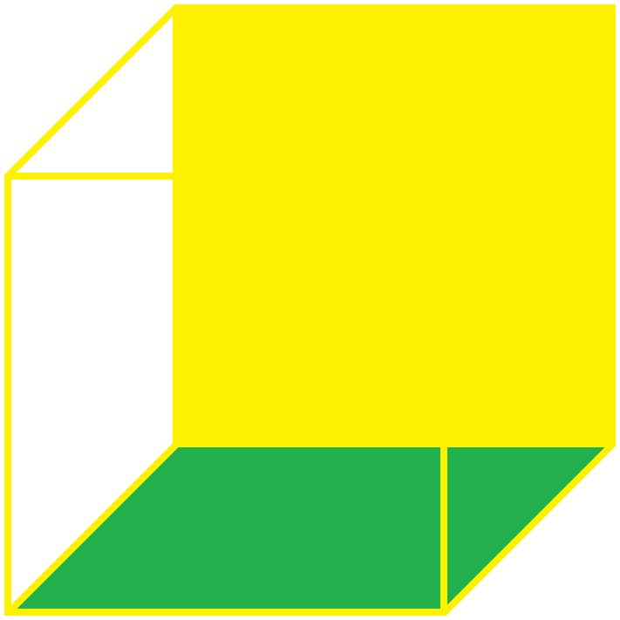
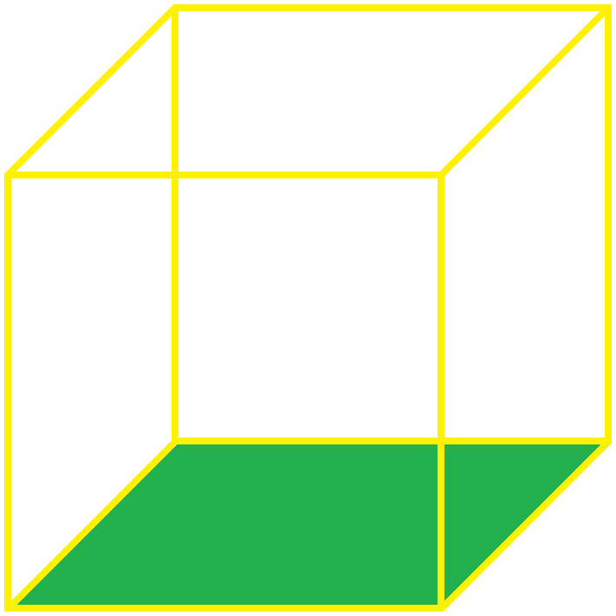
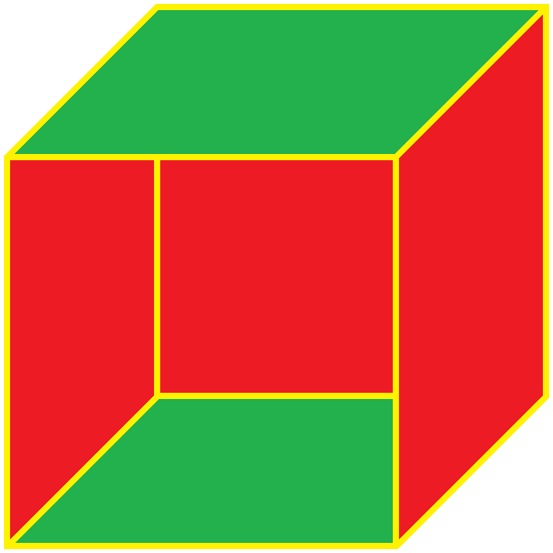
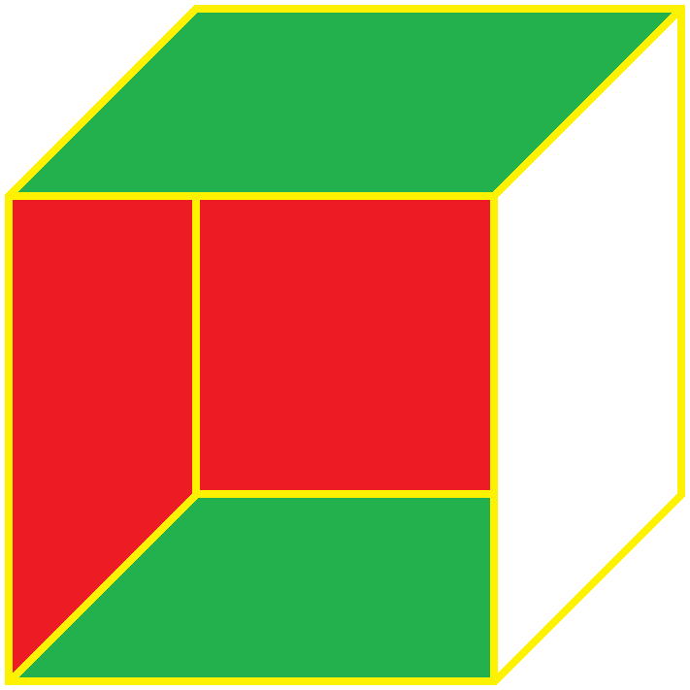
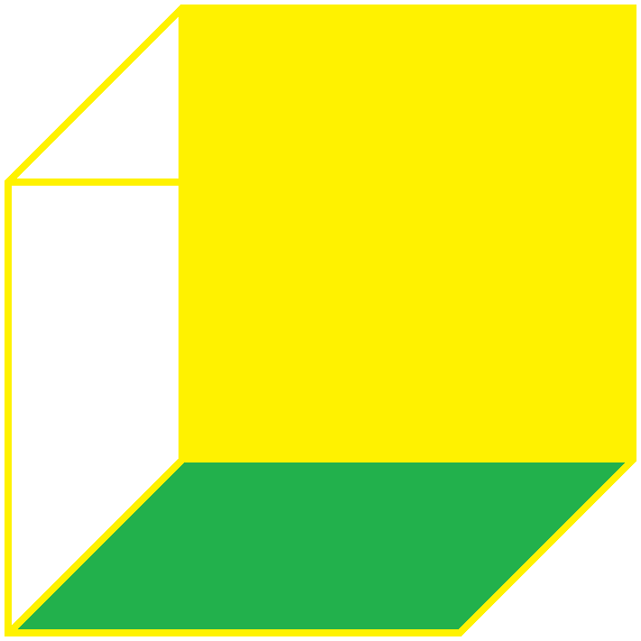

Outlines are used to show transparency to see into the cube.
Outlines are partially removed to make a plane appear solid and stand out.
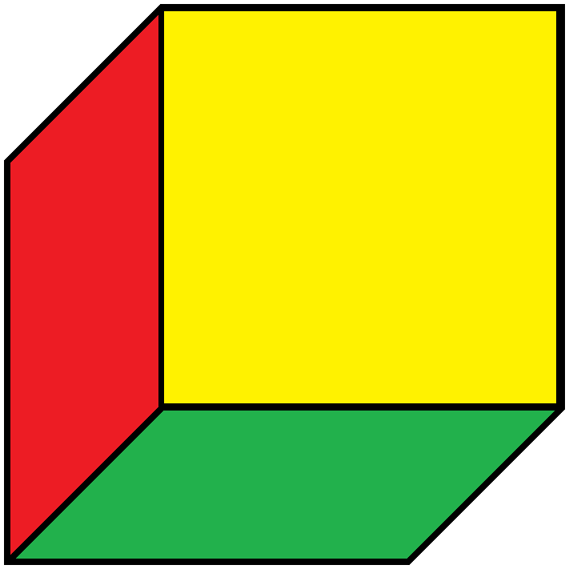

Red are walls green is floor or ceiling. Yellow is front.
The green ceiling has a yellow outline but on the next picture it is removed to look better.
The last 4 show a transition to viewing from underneath with the cube above you.
This view is a second “perspective”.
There are mistakes. There are different perspectives. This is the general basics.
An art class can help you better. Ask for “one point” and “multiple point” perspective drawing.

To graph in 3 dimensions we treat table entries as being 2d representations of 3d storage boxes that in real life look like:

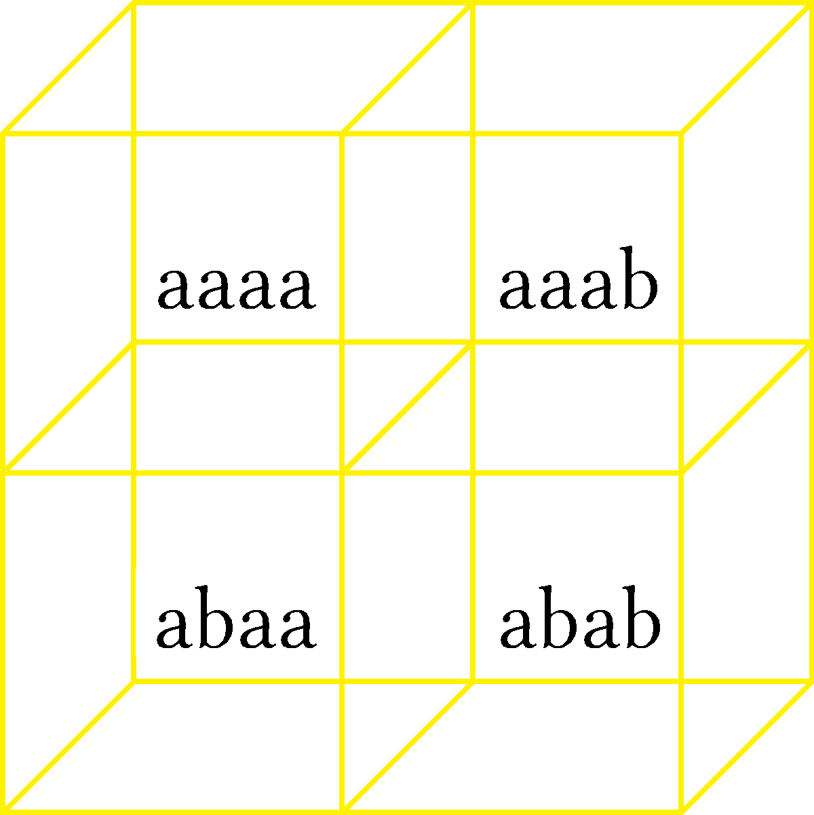
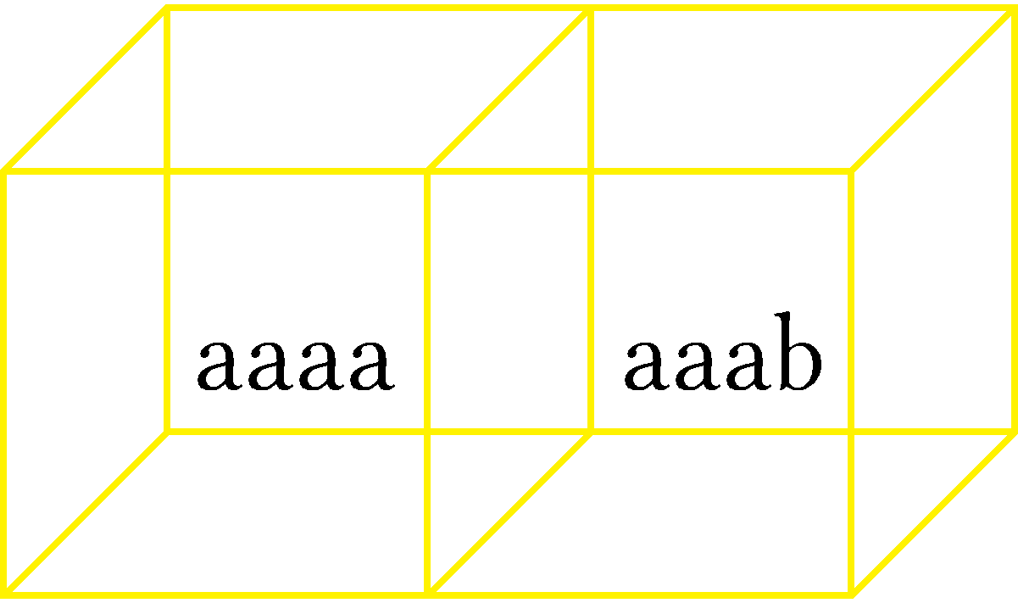

1×1 matrix treated as a 1×1×1 tensor 2×1 matrix

2×2 matrix

On our table they look more like this.
Size is what we specify it to be not what is drawn.
Assume that all dimensions count by 1 unit.

aaaa aaab aaac aaad We can use deep as long as we do not expect anyone to understand.
abaa abab abac abad If clarity is unimportant then we can be more ambiguous.
acaa acab acac acad This is a bad habit so try to avoid it.
adaa adab adac adad A Code is four letters deep, each sub set is 4 columns deep and 4 rows deep.

Here the word deep implies long. It is how I “think” but would never communicate this way. You can get away with this with square matrices where n = m but not with rectangular ones. You will lose orientation.

These are like 3d tables. You can select by row, column, or diagonal row.

From baaa to baad is a horizontal line.
From baaa to bdaa is a horizontal line. Inverting 2nd element with 4th element is a 90° rotation this setup.
From baaa to bdad is a horizontal line. Replacing the 2nd element with the 4th element is a 45° rotation.

Multiplying by a scalar causes these rotations to occur.
Normally permutations do not allow repetitions as this increases the number of possible codes. If we allow repetitions we have the complete list of possibilities for combinations, permutations, and repetitions. Repetitions can allow a element to repeat once, twice, thrice, or how ever amount you want up to the length of your code.

- Combinations are: _{n}C_{k} = n!÷(n – k)!∙k!
- Permutations are: _{n}P_{k} = n!÷(n – k)!
- Factorials are : _{n}P_{n} = n!
- Repetitions of every element every digit are: n^{n} we did this with 4⁴ = 256 codes for abcd.
- Repetitions of every element k times is

For a 3×3 matrix with n^{n} codes:

aaa abc acb bbb bac bca ccc cab cbc
aab aba baa bba bab abb cca cac acc
aac aca caa bbc bcb cbb ccb cbc bcc

aaa aab aac aba abb abc aca acb acc This is a diagonal line that finds all the triples “xxx”
baa bab bac bba bbb bbc bca bcb bcc
caa cab cac cba cbb cbc cca ccb ccc

aaa aab aac aba abb abc aca acb acc This finds all the doubles
baa bab bac bba bbb bbc bca bcb bcc
caa cab cac cba cbb cbc cca ccb ccc

aaa aab aac aba abb abc aca acb acc This finds all the singles of (abc)
baa bab bac bba bbb bbc bca bcb bcc
caa cab cac cba cbb cbc cca ccb ccc

aaa aab aac baa bab bac caa cab cac Rotating the matrix inverts columns with row.
aba abb abc bba bbb bbc cba cbb cbc If you multiply two inverse matrices they cancel to 1.
aca acb acc bca bcb bcc cca ccb ccc When something cancels to 1 you have an identity.

aaa aab aac baa bab bac caa cab cac Arranging the data differently does not change the data so
aba abb abc bba bbb bbc cba cbb cbc we still have the same number of doubles, singles, triples.
aca acb acc bca bcb bcc cca ccb ccc And they are in predictable places.

aaa aab aac baa bab bac caa cab cac The last table showed where the singles and triples were
aba abb abc bba bbb bbc cba cbb cbc by being unmarked so borrowing from that we easily find
aca acb acc bca bcb bcc cca ccb ccc the singles in this table.

aaa aab aac aba abb abc aca acb acc aaa aab aac baa bab bac caa cab cac
baa bab bac bba bbb bbc bca bcb bcc aba abb abc bba bbb bbc cba cbb cbc
caa cab cac cba cbb cbc cca ccb ccc aca acb acc bca bcb bcc cca ccb ccc

These are diagonal lines connecting diagonal elements. These are used for later computations. Now they prove similarity: left matrix is the original arrangement and the one on the right has been rotated 90°. We get the same diagonals but the elements are in different order. There are 9 diagonals in both matrices that match each other.

aaa-bbb-ccc:aaa-bbb-ccc aab-bbc-cca:aab-bbc-cca aac-bba-ccb:aac-bba-ccb
aba-bcb-cac:cac-aba-bcb abb-bcc-caa:caa-abb-bcc abc-bca-cab:cab-abc-bca
aca-bab-cbc:bab-cbc-aca acb-bac-cba:bac-cba-acb acc-baa-cbb:baa-cbb-acc

This shows the patterns for solving a rubix cube. You find the pattern and do series of twist horizontally and then twist vertically to fill colors up. The cubes I drew are pretty much individual cubes of a Rubik's cube.
Noticing the patterns and practicing helps to perform matrix row operations where rows can be multiplied, added, or subtracted. They can not do division.

I took a 16×16 matrix in a table called a spreadsheet. Spreadsheets have n columns where n has the domain
[A-Z] and m rows where m is [1-65536]. Columns are limited by the number of letters available. There are 26 English letters so the domain is every letter from A through Z. We write A through Z as “A-Z” and for domain put it in brackets as [A-Z]. Brackets indicate that you can use the letter A and letter Z. Brackets mean included, parentheses mean excluded.

If we had written as (A-Z) it literally means we can only use [B-Y] because our domain must be greater than A and less than Z. If someone wrote “(A-Z)” I would assume they mean [A-Z] and do not understand proper punctuation and syntax. When people use the wrong syntax it is called an abuse of notation. You are either abusing math or language. You are using the wrong words or symbols or writing formulas wrong.
A rectilinear plane has 2 dimensions of xy, zy, or yz, or something else. This gives 2 axes per plane.
A 2d plane has 4 quadrants. A 3d cube or sphere has 8 octants. Think of blue as xy, red as zy, and green as xz.

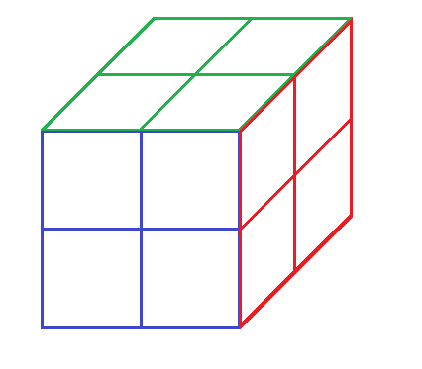
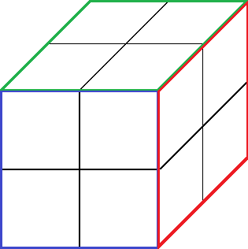
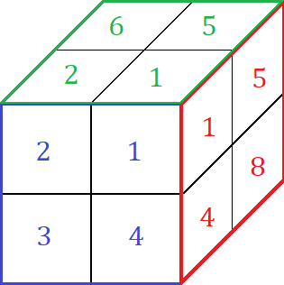
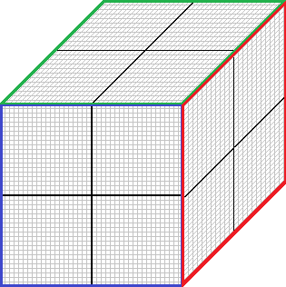

We imagine a 3d cube to be 2×2×2. This is 8 1×1×1 blocks. The center of the cube is 0×0×0.
From the center left/right is ±x, up/down is ±y and front/back is ±z.

The xy plane has four quadrants. Assuming the x and y axes are of equal length we have a square grid.
If x = y then the length of x is x and the length of y is x. We have x² for area. x² can be the area of the entire plane or just 1 quadrant. Lets say x² is just the area for 1 quadrant. Then we can set x = 1 and say that the x axis is from –1 to 1 and the y-axis is from –1 to 1. We have a length and height of 2 for an area of 4. Each quadrant is an area of 1 and we have 4 quadrants. A quadrant is 1 unit long by 1 unit tall.

Then the xy plane is 2×2 for an area of 4. Each quadrant is 1×1 for an area of 1. To add a dimension in the z axes would add width depth-wise. From 2×2 we would get 2×2×1 and then 2×2×2. We draw a xy plane that has axes of –1 to 1 for x and y. This is the blue square on the front. The center of blue is 0,0.

We stretch the square into a cube of 2×2×2. This stretched it 2 units along the z axis.
We are stretching the square away from us so that it is heading “to the back”.
This adds to the z length by 2 units. We had 2×2×0 and added 2 units to the 3rd dimension z.

Octants are used for: space exploration, submarine/deep sea navigation, dividing a sphere into octants.
A cube can be made into a sphere and the sphere divided in half then each half quartered.
The in geometry the Earth is called the great sphere.

We have a layer of four cubes on top of 4 cubes. Each cube is called an octant. Any point inside a cube is given by 3 parameters of [x,y,z]. This is like ordered pairs for graphs except we have (x,y,z) instead of (x,y).
For this system all axes have domain of [–1,1] and range of [–1,1].
Otherwise for a rectangular system we have domain of [–x,x] and range [–y,y].
If the rectangular system is a square we have domain of [–x,x] and range [–x,x].

