Matrix in 3 dimensions

To talk about matrices we needed to have several discussions.

- How a matrix is a table
- How to organize data entries in a table using set theory
- How to generate data for matrix entries
- How matrix data forms sequences and predict future entries based on previous patterns

Now to talk about selecting targeted groups of data from a matrix. First 4×4 matrices then 16×16 matrices.
This treats four 4×4 matrices as a 4×4×4 cube with yellow on top and blue on the bottom.
Each matrix is stacked on top of each other. All planes are 4×4×0 but can be thought of as 4×0×4.
This shows a top down view like looking at a floor plan for a house.

This is a vertical line through aaaa-baaa-caaa-daaa. There are 16 cubes in the yellow matrix. Selecting any of them will also select the corresponding cubes in the other 3 planes. Selecting acac will be acac-bcac-ccac-dcac. Selecting aaab will be aaab-baab-caab-daab. A vertical line will have all the same letters except the first letter which varies. The squares highlighted are all back corner cells or rooms straight down from floor to floor.
For 3d y: This is shooting a bullet straight down scenario. This moves in 1 dimension downwards.

For 3d xy: This moves down a level and over a cell.

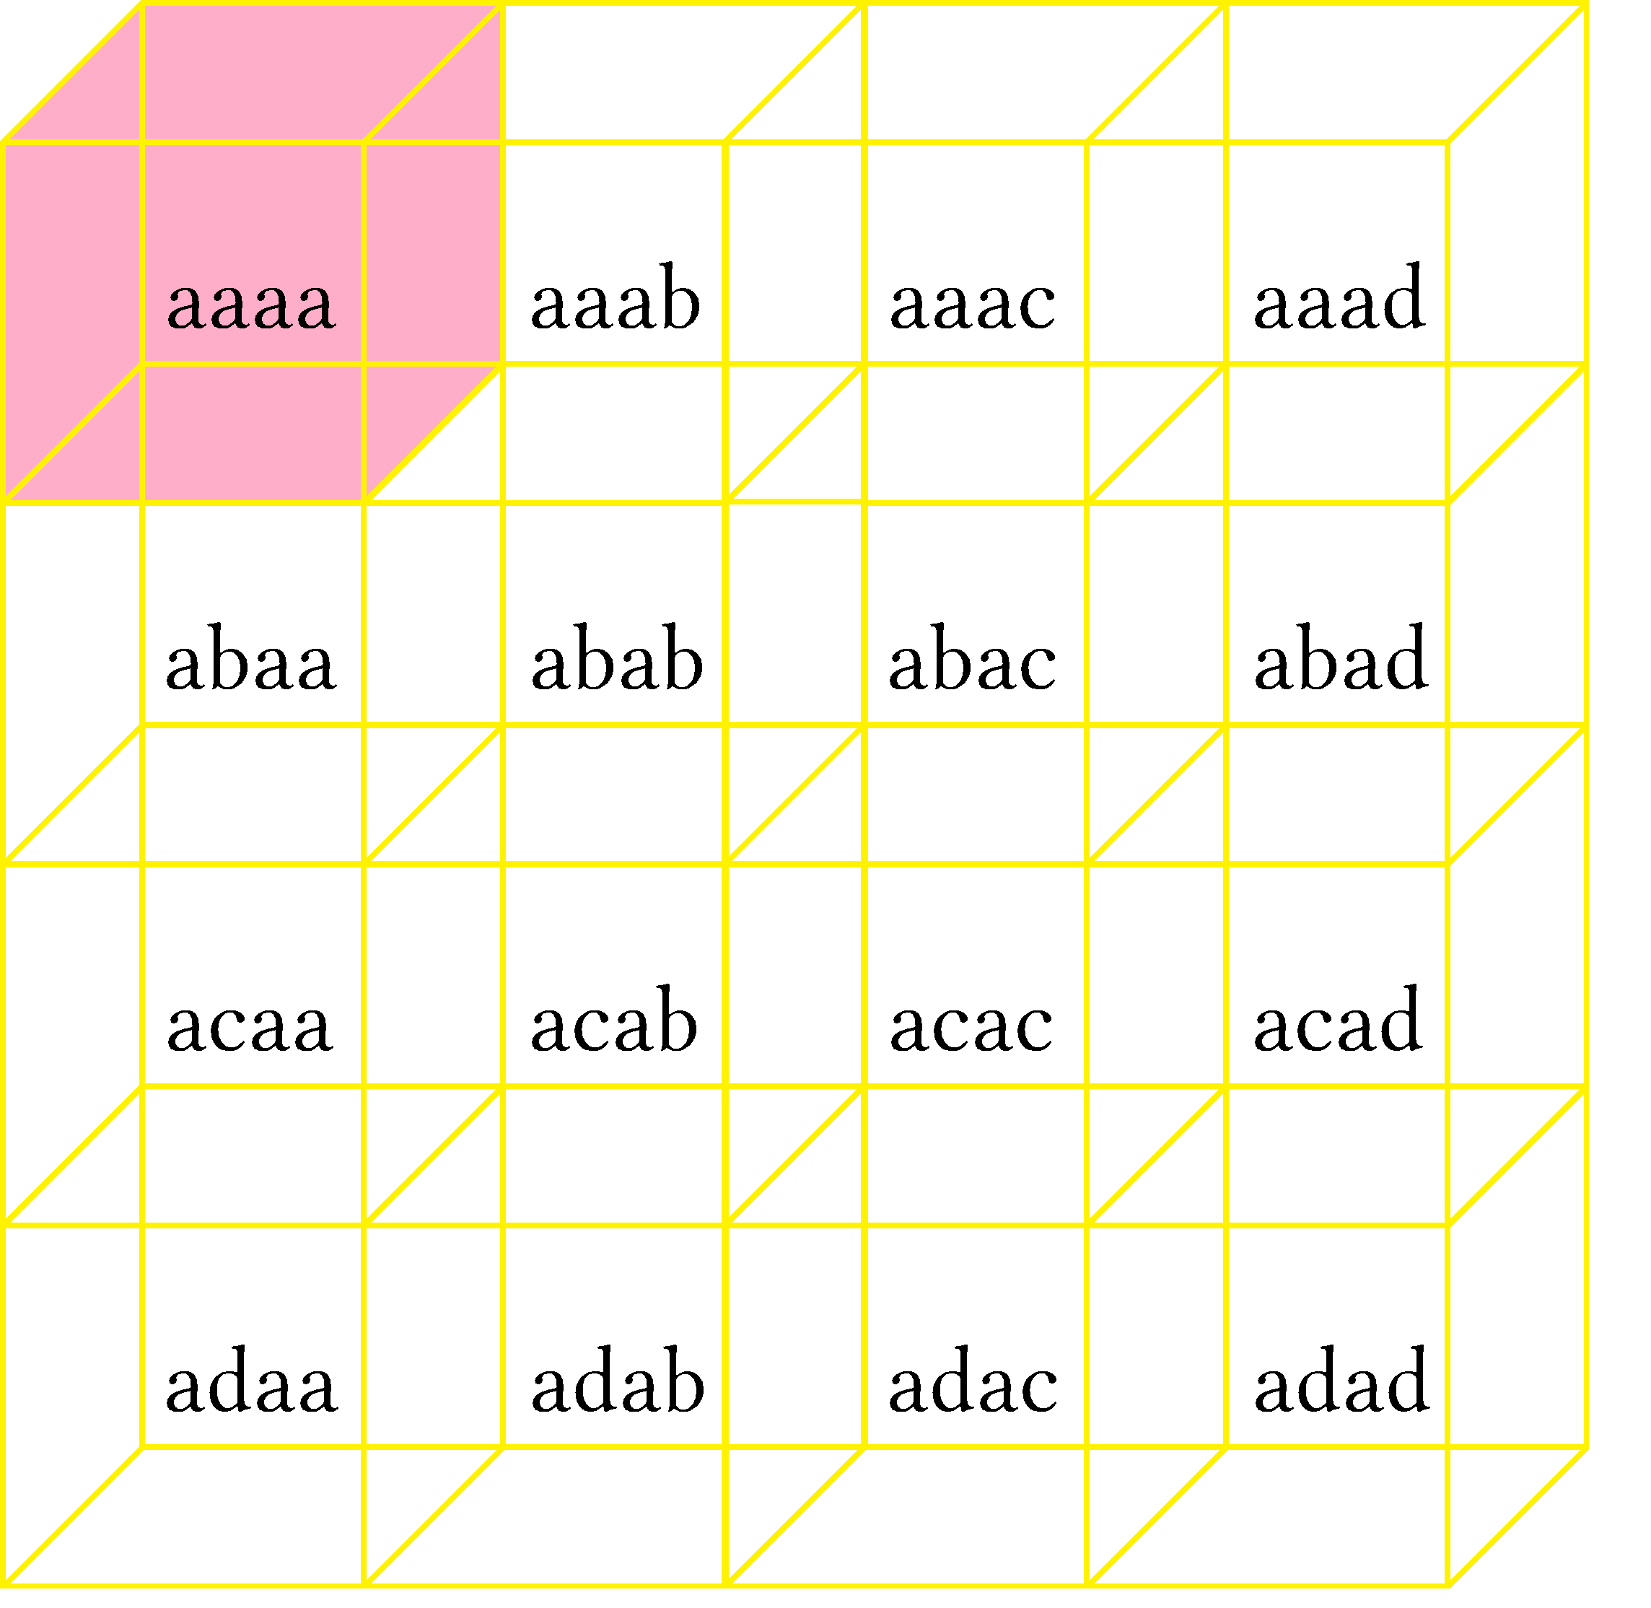
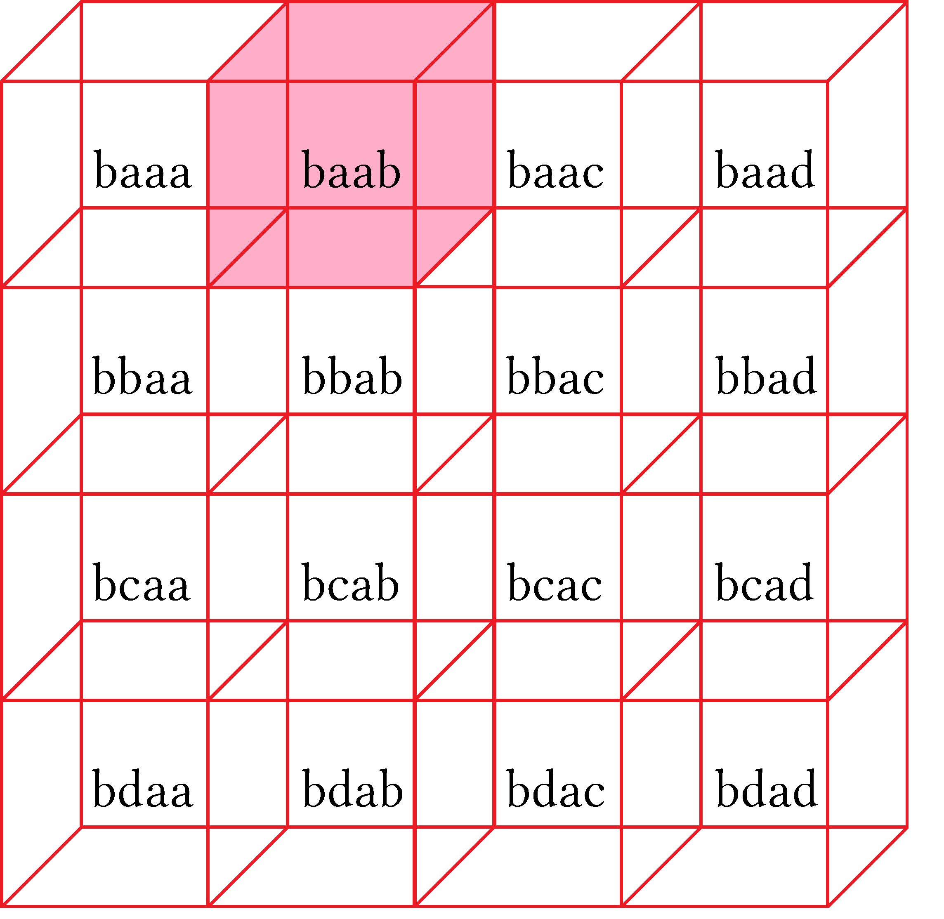
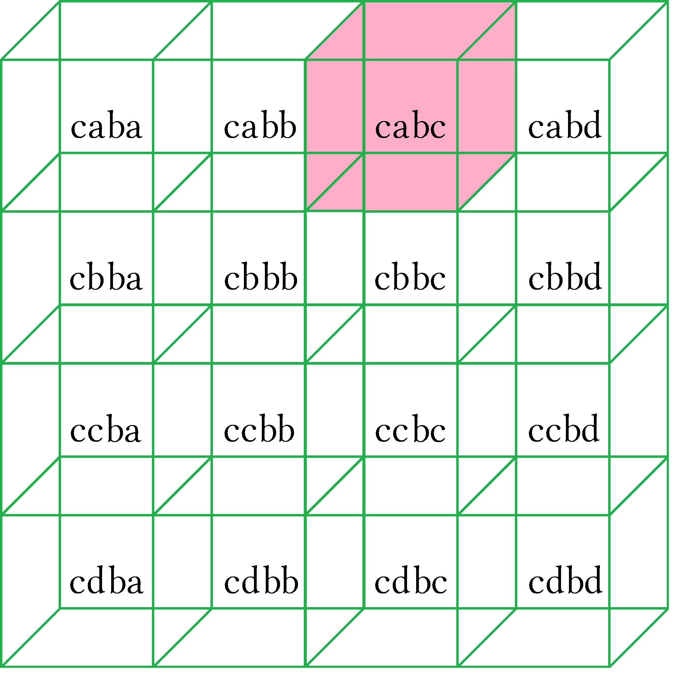
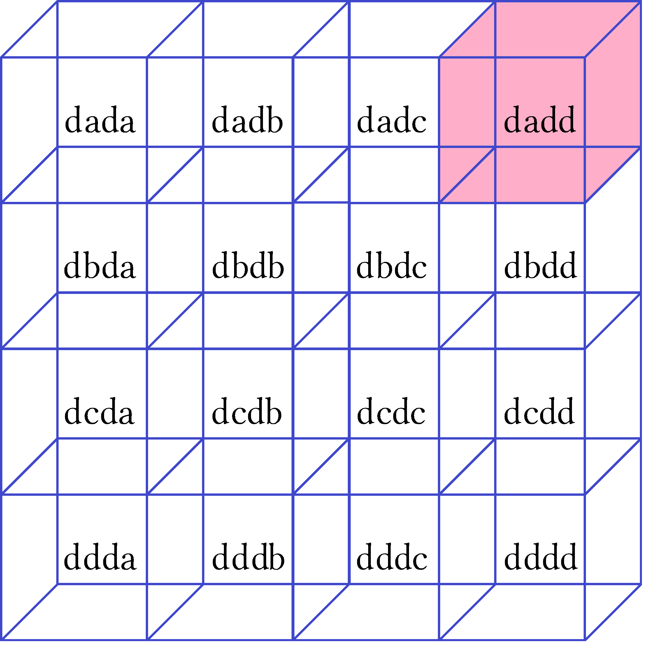

This selected aaaa-baab-cabc-dadd. It moves down and to the right.
This is the selection closest to y = Mx+b.
This moves through 2 dimensions.
Cubes highlighted are all back row or ball “wall” rooms from left to right.
For 3d zy: This moves from row to row instead of column to column like xy.

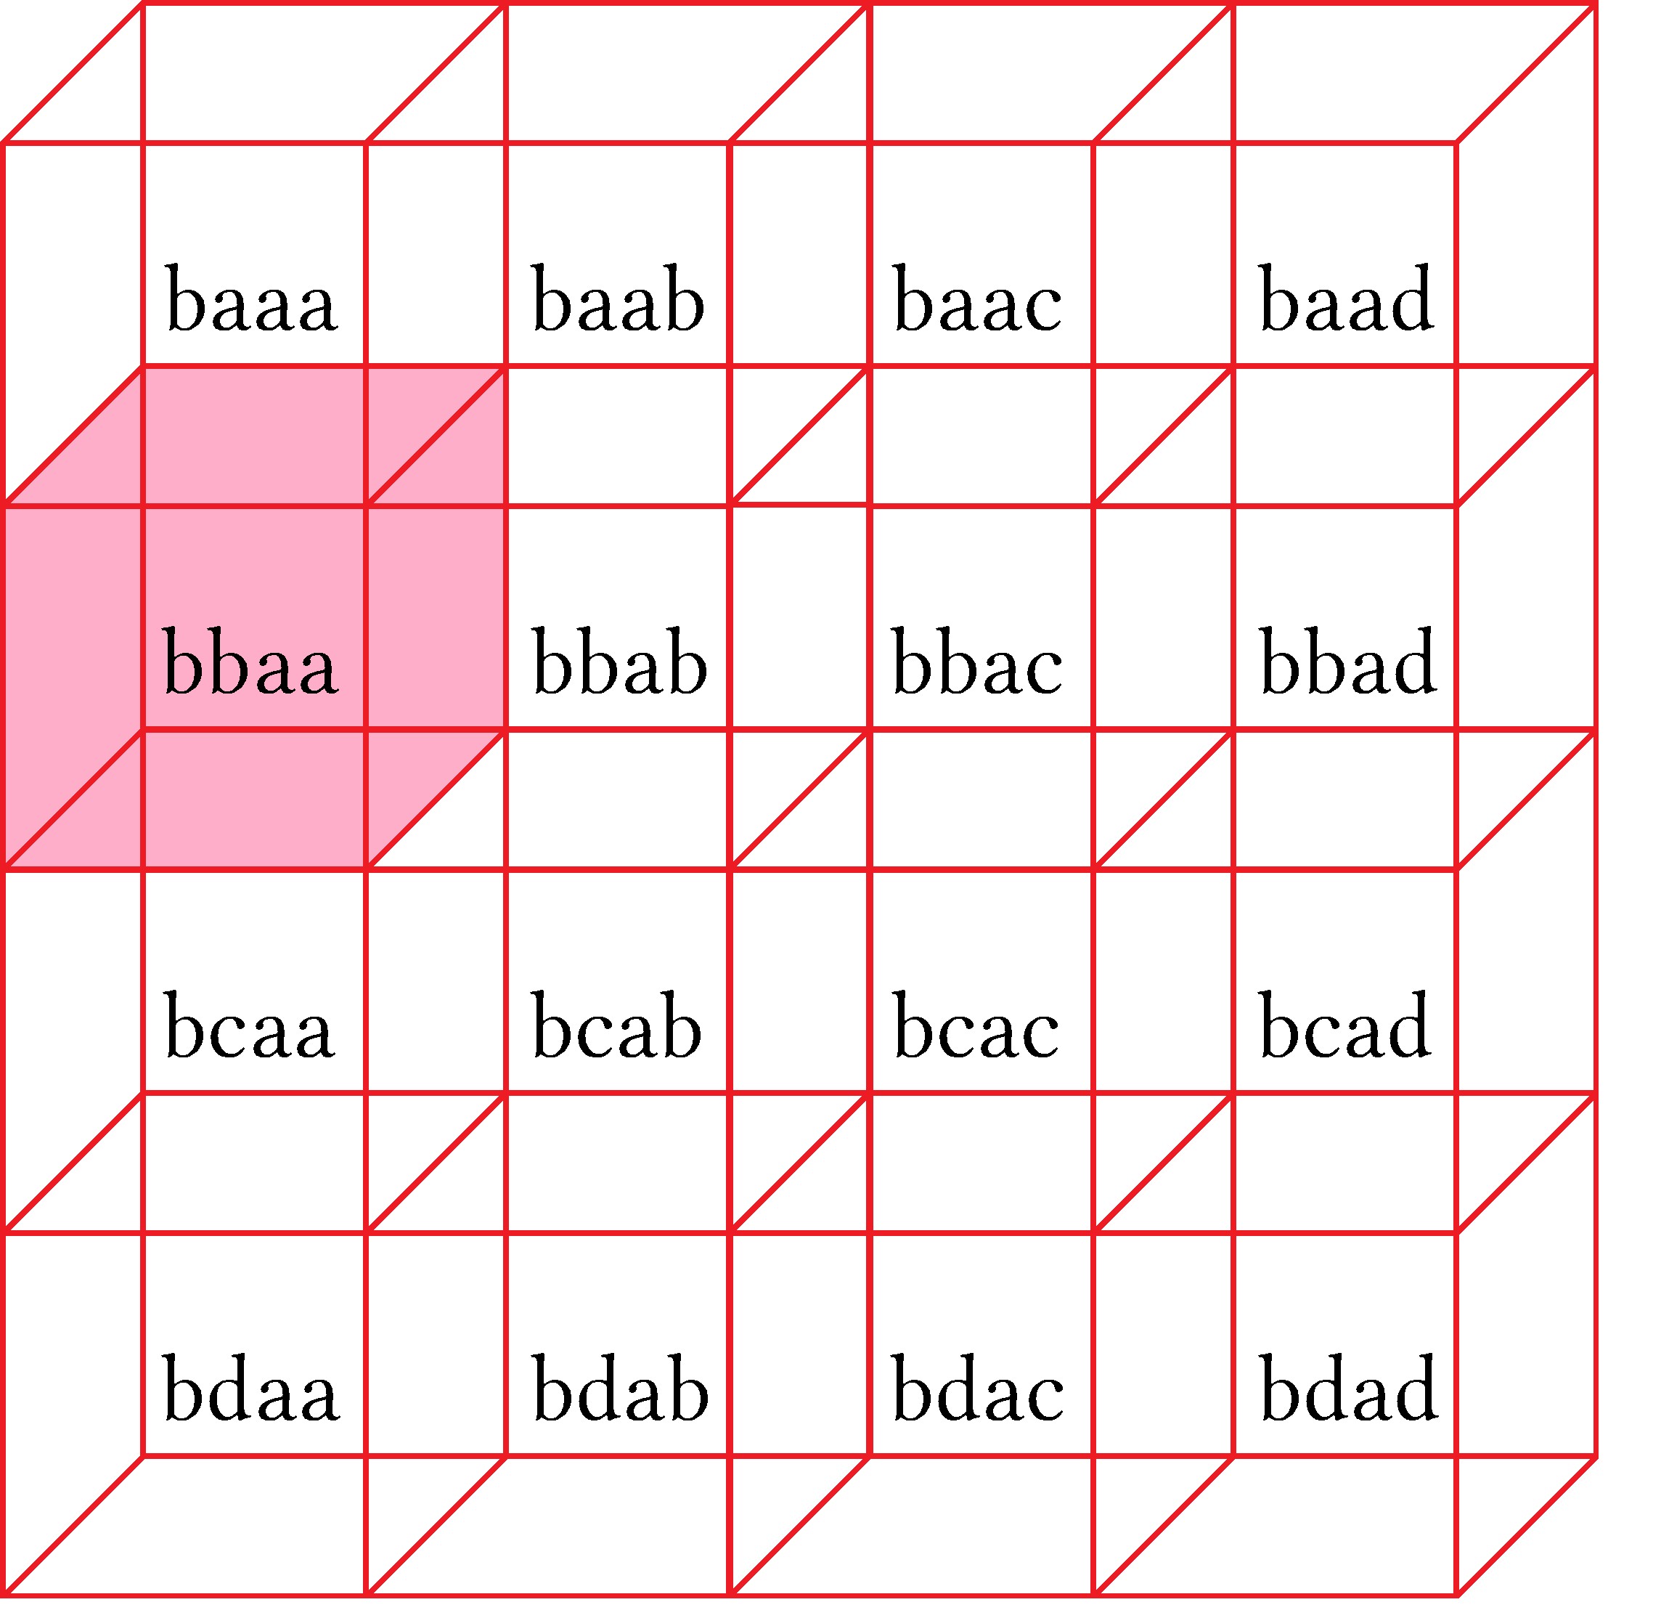
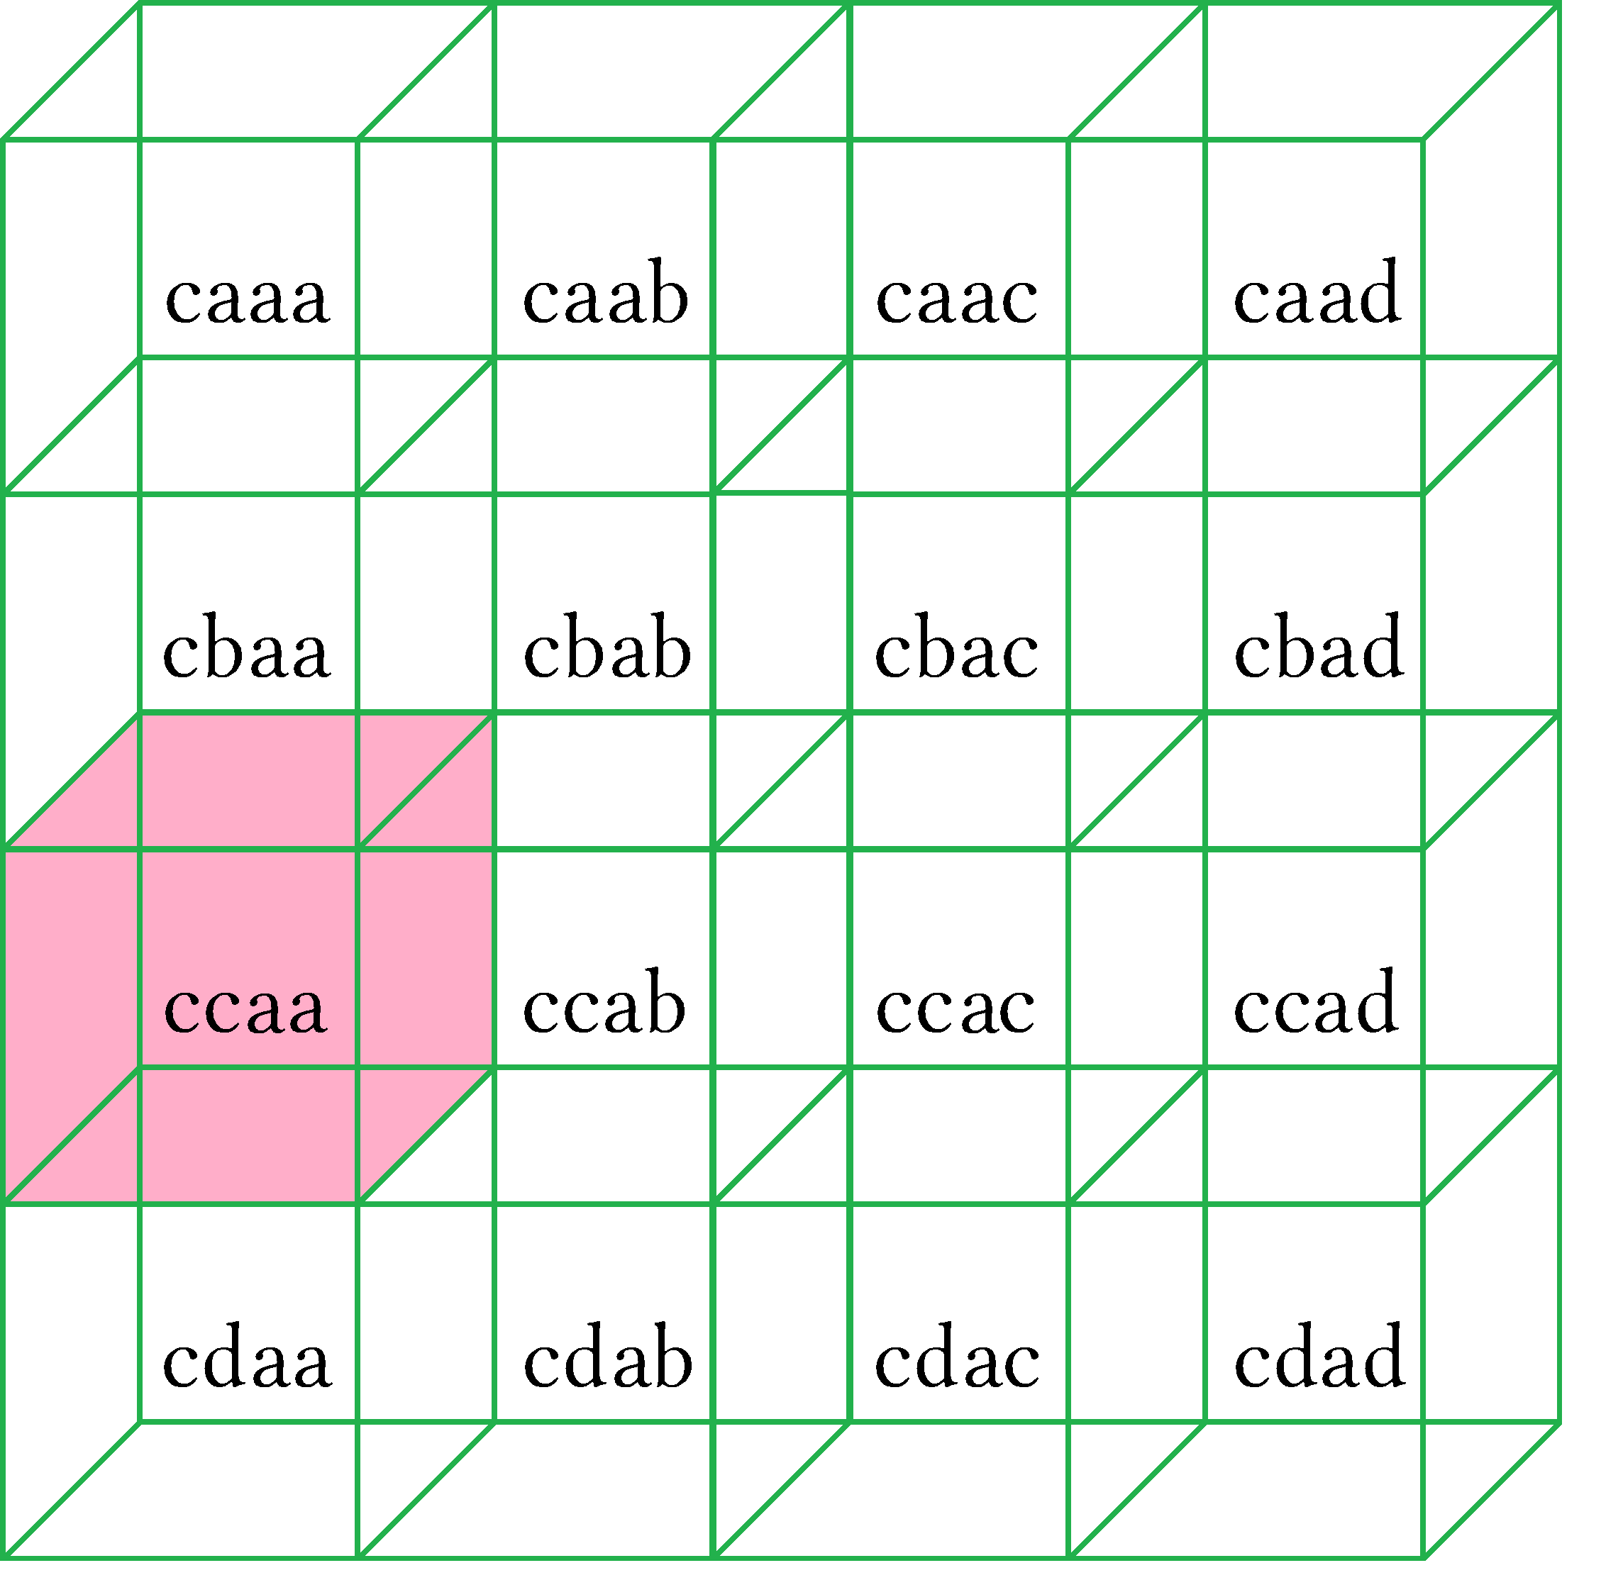

In a 4 story building Bullet travels along the y and z axes diagonally through aaaa-bbaa-ccaa-ddaa.
Cubes highlighted are all left wall rooms from back to front.

For xyz diagonally: This selects the diagonal row of a square matrix.

This passes through all dimensions of x, y, and z. This is important for matrix operations and is called the determinant of a matrix.

This treats a 16×16 2d matrix like a 16×4×4 rectangular array. For a 16×4×4 x axis horizontal: A horizontal line will only pass through the selected plane and none of the others.

For a 16×4×4 z-axis horizontal : This is a horizontal line through the z axis.

For x-axis there are 4 lines that can be drawn for each of the yellow red green blue planes.
For z-axis there are 16 lines that can be drawn for each of the 4 colored planes.

For a 16×4×16 z-axis vertical : This is a horizontal line through the z axis.

For a 16×16 3d diagonal a line travels along the x, y, and z axes: Note that this is a rectangular cube of 16×4×4.

For four planes floating on top of each other a diagonal line passes only through these 4 cubes and no other. The line being centered in on of them will pass through the centers of all of them.
For a 1×1×1 cube the exact center is ½ × ½ × 1/2

In 3D a line passes through the center of each square diagonally like this:

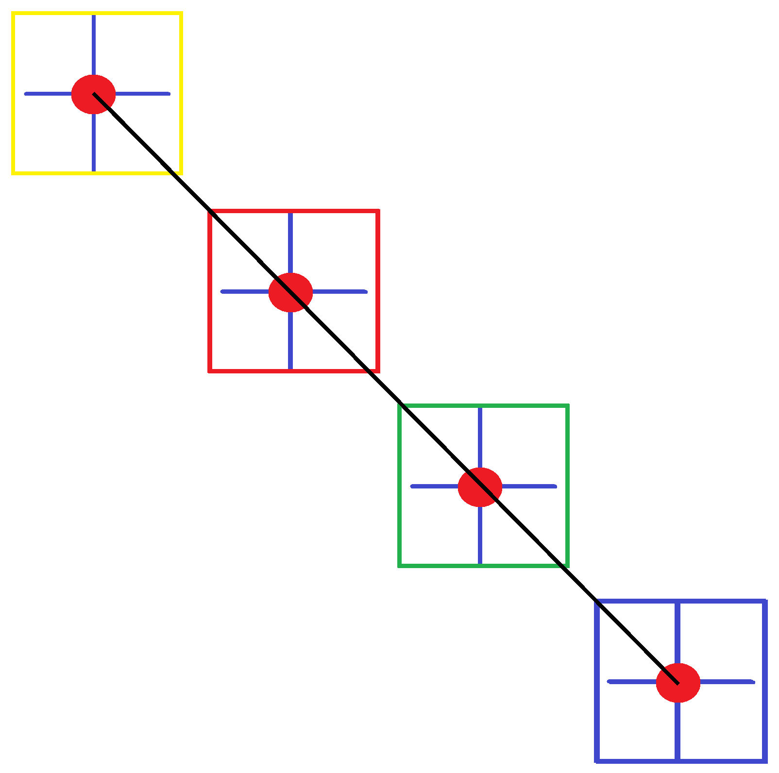
From fourth floor to first floor we pass through each center.
This can be for 2d like xy or zy or 3d like xyz.
In forensics this tracks the path of a bullet.
In construction this aids the placement of wires or pipes.
In surveying this aids line of sight by using transits or lasers.

Shooting a bullet or laser line diagonally in 2 dimensions along the y and z axes:

For a rectangular cube selecting elements can be done:

- By 1 dimension of row, column, or aisle.
- By 2d dimensions of xy, xz, or yz using diagonals.
- By 3d dimensions of xyz using diagonals.
- This appears in geometry and linear algebra.
This ends introduction to matrices. Next 25 pages deals with creating tables that have more than 26 columns and is a part of sequences rather than matrices. It incorporates the heavy use of set theory, sequences, combinatorics, series, and polynomials. These topics are needed for topology, linear algebra, and discrete mathematics.
If we need more than 26 columns we repeat letters. After (A,B,C … Z) we start the Aa series (Aa,Ba,Ca … Za).
The Aa series can be named the AA series where both are capital for aesthetics. This is easier for the reader.

The first series is A:[A-Z]. This is an example...
The second series is AA:[AA-ZA]. This is an example...
The third series is AB:[AB-ZB]. This is an example...
The fourth series is AC:[AC-ZC]. This is an example...

The n^{th} series is An^{th}:[An^{th}-Zn^{th}]. This is the generalized formula found by noticing the pattern in the previous examples. There are different naming schemes. This is the most logical and therefore mist popular. You can say:

The first series is A:[A-Z] A₀ or A₁ or A or A_{a} or A_{a}
The second series is AA:[AA-ZA] A₁ or A₂ or AA or A_{aa} or A_{b}
The third series is AB:[AB-ZB] A₂ or A₃ or AAA or A_{aaa} or A_{c}
The fourth series is AC:[AC-ZC] A₃ or A₄ or AAAA or A_{aaaa} or A_{d}
The n^{th} series is An^{th}:[An^{th}-Zn^{th}] A_{n} or A_{n+1} or A........ or A.......... or A _{nth}

The first letter is always capital. The second letter can be lowercase or capital in either regular or subscript.
The second letter can be a number. You can start at 0 or 1. If starting at 0 you can write 0 or not write 0 and leave it as just “ A ”. You can do a lot of different setups depending on how you wan to organize your data and express yourself. This is more a language thing and less math. You do not want data from one set to conflict with data from another set so large sets of data use logical naming and smaller sets use abstract naming. A large set allows for scalability where you can add more data and not run out of labels or destinations for your data. Abstract naming works for smaller sets but as data gets large you run out of designations to put your data and then have to rename your sets using a more logical way. Pros and cons:

- “Logical” is more complicated and may be harder to read but you never run out of names for your data and never have to re-name previously organized sets.
- “Abstract” is less complicated and easier to read unless you have large sets and then your naming is confusing and seems misplaced, abstract, or haphazard. This will force you to rename sets which wastes valuable time.

Here logic and abstract mean:

Logic is how a computer interprets data. It uses either binary logic or some other letter number code like hexadecimal. Abstract is how people interpret data. It allows for emotion, feelings, and aesthetics.
If something is logical in a math sense it may make no sense to ordinary people. This is because math is right and people are wrong. Binary is a computer language that only computers can read... it is a logical language. English is a language people can read.... it is a very highly abstracted language. Abstract is related to art, like poetry and songs. A song or poem may make no sense but you like it because language arts do not care for grammar rules or even accuracy. It only cares about conveying a meaning through metaphor whether the actual words make sense or not. It is wordplay and wordsmithing. The phrase “raining cats and dogs” makes no sense but people talk this way. What does rain have to do with “cats and dogs”? Nothing but people will still understand you.
You can write a small set improperly and it works because you are only trying to convey a small amount of information. As data grows the sets become confused. If you want scalability which means the ability to grow a set as large as you want as quickly as you want then a more logical approach is better.

Scalability is often used with start-up companies in describing their ability to gain more subscribers, stock value, profits, products to offer, market share etc. In these cases they are wishing to increase the set of subscribers, customers, products offered, or whatever, as quickly as possible. A person who is creative and does art would need a person who is more logical to push their art as quickly as possible. So professional design teams for furniture, cars, clothing, household goods..., take peoples creative works and apply math logic to it to increase the number of people who benefit from it.

Art types tend to be bad at math. They need a business manager. Architects and industrial designers do both art and math together. Design is the combination of art and engineering plus math and science.
We call this S.T.E.A.M. It is an acronym for: Science, Technology, Engineering, Art, Mathematics.

For a standard computer the maximum for memory is 256 memory blocks by 256 memory blocks.
The largest table a computer is able to create is one that is 256 columns by 256 rows for a total of 65536 cells.
This is 256×256 = n × m. What is the “letter ” for the 256th column?

n columns: 256 and m rows: 256

256 rows would be a “number” that is simply “256” or the 256th row for the last row. 256 columns would be a “letter” that is found by taking 256 and dividing it by the 26 letters used then taking that number and translating it into a letter code using any or a different method earlier described. Either 256÷26 or 256÷52.

If 256 columns then the 256th column with be the 10th occurrence of the 22nd letter.
Pick any logic to give this column a alphanumeric code. Computers use this system for tables to save space...

1st set of [a-z]: [A-Z#] This is columns 1-26
2nd set of [a-z]: [a-z] This is columns 27-52
3rd set of [a-z]: [AA-AZ] This is columns 53-78
4th set of [a-z]: [Aa-Az] This is columns 79-104
5th set of [a-z]: [BA-BZ] This is columns 105-130
6th set of [a-z]: [Ba-Bz] This is columns 131-156
7th set of [a-z]: [CA-CZ] This is columns 157-182
8th set of [a-z]: [Ca-Cz] This is columns 183-208
9th set of [a-z]: [DA-DZ] This is columns 209-234
10th set of [a-z]: [Da-Dz] This is columns 235-260 under this naming system the 256th column is Dv
11th set of [a-z]: [EA-EZ ] This is columns 261-286
54th set of [a-z]: [Za-Zz] This is columns 1379-1404

This implies a base 26 system but we really have 52 since case matters giving 52 distinct characters as outputs.
Using 26 as the base is dirty but quick. Dirty math is cumbersome at times and called “nonsense”.
It makes learning harder. We should use 256÷52 ≈ 4.923. We need an exact value so use a calculator that can do fractions or convert decimals to fractions. Using a calculator:

- Type [256÷52]. Answer is 4.923076923
- Isolate decimal by subtracting 4. Answer is 0.923076923
- Convert decimal to Fraction. Answer is 48/52. This means the 48th letter out of 52 letters.
- Find the 48nd letter in our system to be v.
- 4 means 4 sets of 52. Find last column of 4th set of 52. A-z, AA-Az, BA-Bz,CA-Cz. Cz is the 208th column.
- We need V as the last letter and the set after Cz. The answer is Dv.

We are doing this: (256 – 52 – 52 – 52 – 52 = 48) = 256÷52 = 4+⁴⁸/₅₂.
Divide by your base of 52: 256÷52 = 4+⁴⁸/₅₂. Take this to mean 4 full sets and a partial set ⁴⁸/₅₂.
Subtract (number of sets) times (base of 52) from target 256: 256 – 4∙52 = 48 256 – 208 = 48

Find the column that has a value of being a distance of 4+⁴⁸/₅₂ sets away from 0 sets.
We are past 4 sets and ⁴⁸/₅₂ through the fifth set. The fifth set is DA-Dz. The 48th letter is v so we have Dv.
It gets easy after some practice with a calculator. You can count this on your hand as “A-z,A,B,C,D” = “D”.
If 4 sets and a partial we need to be in the fifth set. DA-Dz is the fifth set and v is the 48th letter so Dv is the answer. There are dirty and cleaner ways to count but this works.

This system allows for 2∙(26) sets of 26 columns for a total of 52 columns per set.
Using a mix of capital and lowercase letters saves precious space in memory.
This is the same reason they use hexadecimal: to save memory space so that calculations are faster.
You can write this as a function where x = ordinal number of column and y = letter code of the column.

f(x) = (letter code)
f(ordinal) = (code) x = ordinal number which means term number. We start at the 1st term there is no 0th term.

f(1)=A 1st column Beginning of first set of a-z This is the “A^{th} ” column but we say “1st “ or “column A”
f(2)=B 2nd column This is the “B^{th}” but we say “ 2nd ” or column B
f(3)=C 3rd column
f(26)=Z 26th column End of first set of a-z This is the Z^{th}
f(27)=a 27th column Beginning of second set of a-z This is the a^{th} with lowercase a
f(28)=b 28th column
f(52)=z 52nd column End of second set of a-z
f(53)=AA 53rd column Beginning of third set of a-z This is the Aa^{th} and so on...
f(78)=AZ 78th column End of third set of a-z
f(79)=Aa 79th column Beginning of fourth set
f(80)=Ab 80th column Ab is next after Aa
f(104)=Az 104th column End of fourth set
f(105)=BA 105th column Beginning of fifth set
f(256)=Dv 256th column This is the highest column that can be stored in a standard processor for 32 bit machines.
f(1379)=Za 1379th column
f(1404)=Zz 1404th column
f⁻¹(Zz) = 1404 this shows the inverse function for the function f(column#) = (column letter code)

Remember input\output = x\y = domain\range.

The domain is the list of inputs and the range is the list of outputs. Domain:{ℕ} Range:{A......}
Specifying range is hard because range is not given as numbers. When this happens you have to write a sequence.

The range is infinite: A,B,C...Z,a,b,c...z,Aa,Ab,Ac...Az,Ba,Bb,Bc...Bz...Zz,aA,aB,aC...aZ,aa,ab,ac...az....zz..... .

Set 10:{Da,Db,Dc,Dd,De,Df,Dg,Dh,Di,Dj,Dk,Dl,Dm,Dn,Do,Dp,Dq,Dr,Ds,Dt,Du,Dv,Dw,Dx,Dy,Dz}

The tenth set contains columns Da-Dz. This system is probably the most common for computers. Computers like this logic but I don't and want something more abstract so it is easier to read. Instead of listing set first and then column I would state the column first and then the set. I also would not mix letter case. Mixing allows twice as many options for a total of 2(n+1) choices but I do not need that many. I would use something like this; After Z I would do “column A, A^{th} set, column B A^{th} set... It is not “logical” in the purest sense but easier to read.

A1 | B1 | C 1 | D 1 | E1 | F1 | G1 | H1 | I1 | J1 | K1 | L1 | M1 | N1 | O1 | P1 | Q1 | R1 | S1 | T1 | U1 | V1 | W1 | X1 | Y1 | Z1 | AA1 | BA1
A2 | B2 | C 2 | D 2 | E2 | F2 | G2 | H2 | I2 | J2 | K2 | L2 | M2 | N2 | O2 | P2 | Q2 | R2 | S2 | T2 | U2 | V2 | W2 | X2 | Y2 | Z2 | AA2 | BA2
A3 | B3 | C 3 | D 3 | E3 | F3 | G3 | H3 | I3 | J3 | K3 | L3 | M3 | N3 | O3 | P3 | Q3 | R3 | S3 | T3 | U3 | V3 | W3 | X3 | Y3 | Z3 | AA3 | BA3

I researched tables using the OpenOffice Writer program. The sequence found required setting a page width as wide as possible. I tried for 120'' but apparently the limit is 118.11''. I was able to generate 8192 columns. Computer spreadsheets tell you the name of the cell you are in.
Using “Ctrl End” took me to the last column “Blo”. As a pattern I found:

A...Z,AA...ZZ,Aa...Az.....Zz,aA...aZ,aa...az,aA...aZ,ba...bz,bA...bZ...zZ...zz,AAA,AAB...AAZ,AAa...AAz,ABA...
ABZ,ABa...ABz,ACA...ACa....

Which is a confusing mix of double and triple digits of varying case:

A...Z, The first 26 columns: This is one set of a-z range is [A,B,C...z]
AA...ZZ, 2∙26² columns: There are 26 sets of a-z in AA-ZZ where [AA-AZ,BA-BZ,CA-CZ...ZA-ZZ]
Aa...Az 26 columns: one set of a-z range is [Aa-Az]
Az.....Zz, 2∙26² columns not including column Az is 26×26. (Az-Zz] Az is excluded.
aA...aZ, 26 columns is 1 set of a-z, range is [aA,aZ] which is extended to 26² is going to be [aA,zZ]
aa...zz, 2∙26² columns is 26 sets of a-z, range is [aa,zz]
bA...bZ 26 columns; range is [bA,bZ] this is one of the sets inbetween aa...zz
...zZ 2∙26² is going to be [aA,zZ]
...zz 26 columns. This is one of the sets in between aa...zz for az-zz range is [az-zz]
AAA...AAZ, After column zz is column AAA. This is the 1st triple digit code.
Aaa...AAz, After column AAZ is Aaa
ABA...ABZ, After column Aaz is ABA
Aba...ABz, After column ABZ is ACA
ACA...ACa.........

Finding AAA as a triple digit code convinces me that the range under this naming scheme is infinite. 26² will be a reoccurring sequence because we have 26 letters in the alphabet and they are used to make 26 sets per series of a-z. 26 sets where each set contains 26 columns is 26×26 or 26².

Even though the series can go to infinity PC architecture is based on blocks of 256×256 so the largest memory available for a table will be 65536. I am dating myself here. Quantum computers or new architecture can remove these limits. In 2010 the case was these limits existed for windows xp through windows 7 and 8. Microsoft excel had these limits for a spreadsheet. There was talk of removing them even though there is no practical use for a table larger than maybe a few dozen.

Spreadsheets are for financial data for a company. Whatever format is used for business is what computers are setup and tasked to do. Scientific tables containing data will limit their findings to separate tables if need be. For large format printouts data can be printed out horizontally as a continuous output but this is a different matter Printed materials are not the same as stored tables. In any other application 26 columns is sufficient considering data that is large incorporates more rows not more columns. Rows can break over to the next page leading to endless pages for endless rows.

The previous examples and anecdotes were said to provide technology, science, and business connections.

A lot of people got their start in different fields by studying math and analyzing the structure of data and tables.
They specifically studied software programs to try to debug or decode it. We ask questions like “what logic is the program using to write letter codes? What will such and such column be?”. We are analyzing the codes to unlock patterns so we can predict what the next codes will be, where they will be, and what their distribution is.

What is the code for the 1000th column? 2000th? 3000Th?

The first code is A and the 4000th code is Blo. We can not use standard math to just calculate any arbitrary code in the middle of a specified range. Math in algebra uses base 10 decimals. This problem requires switching to a base 26 system. Not only that but it is also uses different case making it not a true base 26 system. We could find the answer by trial and error, also called “guess and check” but that would be exhausting. We would need a better understanding of base systems and how modulus and modulo works. I do not feel like doing that right now.

We are studying column letters to better understand sequences, series, sets, domain, and range.
We are becoming more abstract in our logic. Oddly by studying computers we become more human.
In most instances PasSwoRd ≠ password so case matters.

26+26 = 52 characters to choose form. So we have 52 elements in the set “alphabet”:
set:{A,B,C,D,E,F,G,H,I,J,K,L,M,O,N,P,Q,R,S,T,U,V,W,X,Y,Z,a,b,c,d,e,f,g,h,i,j,k,l,m,o,n,p,q,r,s,t,u,v,w,x,y,z,}

A = 1 a = 27
B = 2 b = 28
C = 3 c = 29
D = 4 d = 30
E = 5 e = 31
F = 6 f = 32
G = 7 g = 33
H = 8 h = 34
I = 9 i = 35
J = 10 j = 36
K = 11 k = 37
L = 12 l = 38
M = 13 m = 39
O = 14 o = 40
N = 15 n = 41
P = 16 p = 42
Q = 17 q = 43
R = 18 r = 44
S = 19 s = 45
T = 20 t = 46
U = 21 u = 47
V = 22 v = 48
W = 23 w = 49
X = 24 x = 50
Y = 25 y = 51
Z = 26 z = 52

The lowercase letters are offset by 26 from their uppercase versions. Take the ordinal of the capital and add 26 to find the ordinal of the lowercase. Take the ordinal of the lowercase and subtract 26 to find the ordinal of the uppercase. A lowercase ordinal minus an uppercase ordinal is 26.

We observe the following about the logic used in naming the columns regardless of whatever code comes out:

The base set is 26 letters from a to z. Every set begins with “some a” and ends with “some z”.
Since a to z is 26 letters every set with have 26 terms for 26 elements.
The letter codes are the output of a term number called “column #”. Therefore we are mostly interested in the range of outputs and not term numbers. Outputs are the code for the column. Hyphens show a set of 26, 52, or more columns in alphabetical order. 26 columns is a set, more is a range of outputs of multiple sets.

A-Z This is akin to 0-9
AA-ZZ No comparison to decimal. You could say 0-99 since we added a digit. But case is invoked so not really.
AAA-ZZZ Getting to this skips some lowercase sets so this is premature to introduce.

Set A-Z:[A,Z] We have 26 elements. {A,B,C,D,E,F,G,H,I,J,K,L,M,N,O,P,Q,R,S,T,U,V,W,X,Y,Z}
Set a-z:[a-z] We have 26 elements.
Set AA-ZZ:[AA,ZZ] We have 1352 elements.
Set Aa-ZZ:[Aa,Zz] We have 26 elements.
Set aA-zZ:[aA-zZ] We have 1352 elements.

1st set :{A,B,C,D,E,F,G,H,I,J,K,L,M,N,O,P,Q,R,S,T,U,V,W,X,Y,Z}
2nd set {a,b,c,d,e,f,g,h,i,j,k,l,m,n,o,p,q,r,s,t,u,v,w,x,y,z}

set 3 to set 28
{AA-AZ BA-BZ CA-CZ DA-DZ EA-EZ FA-FZ GA-GZ HA-HZ IA-IZ JA-JZ
KA-KZ LA-LZ MA-MZ NA-NZ OA-OZ PA-PZ QA-QZ RA-RZ SA-SZ TA-TZ
UA-UZ VA-VZ WA-WZ XA-XZ YA-YZ ZA-ZZ}

set 29 to set 54
{Aa-Az Ba-Bz Ca-Cz Da-Dz Ea-Ez Fa-Fz Ga-Gz Ha-Hz Ia-Iz Ja-Jz
Ka-Kz La-Lz Ma-Mz Na-Nz Oa-Oz Pa-Pz Qa-Qz Ra-Rz Sa-Sz Ta-Tz
Ua-Uz Va-Vz Wa-Wz Xa-Xz Ya-Yz Za-Zz }

set 55 to set 82
{aA-aZ bA-bZ cA-cZ dA-dZ eA-eZ fA-fZ gA-gZ hA-hZ iA-iZ jA-jZ
kA-kZ iA-iZ mA-mZ nA-nZ oA-oZ pA-pZ qA-qZ rA-rZ sA-sZ tA-tZ
uA-uZ vA-vZ wA-wZ xA-xZ yA-yZ zA-zZ}

set 83rd to set 108th
{aa-az ba-bz ca-cz da-dz ea-ez fa-fz ga-gz ha-hz ia-iz ja-jz
ka-kz ia-iz ma-mz na-nz oa-oz pa-pz qa-qz ra-rz sa-sz ta-tz
ua-uz va-vz wa-wz xa-xz ya-yz za-zz}

AAA-AAZ and AAa-AAz is the 109th and 100th set.

A-Z,a A-Z is 26. After Z, is “a”.
a-z,AA “a-z” is 26. After z, is AA.
AA-AZ,Aa AA-AZ is 26. After AZ is Aa.
Aa-Az,BA Aa-Az is 26. After Az is BA.
BA-BZ,Ba BA-BZ is 26. After Bz is Ba
Ba-Bz,CA …...
CA-CZ,Ca …...
Ca-Cz,DA …...
DA-DZ,Da.... The pattern Is XX...Xx...X₁x₁...X₂X₂...X₂x₂..... AA...Aa...BA...Ba....

There are 26 columns where both letters are capital. The 26th column is the end of range for that series.
The next series is the same as the last except that the last letter, “the least significant digit”, is lowercase.

In groups of 26: A-Z then a-z then AA-AZ then Aa-Az then BA-BZ then Ba-Bz.
We have 26 sets that have 2 capital letters and 26 sets that have upper/lowercase letters. This is 52 sets.
26 columns per set times 52 sets is 1352 columns. This is 52∙26=1352 = 2∙26∙26 = 2∙26².
AA-Az is the range of 2 sets of 26, the AA-AZ set and the Aa-Az set.
General formula is []A-[]Z or is []a-[]z. A-Z and a-z are the only single digit sets.

A-Z and a-z; these two sets count as a double set of 26+26 = 52 columns.
Every set two sets starts with the same letter making 26 double sets.
There are 53 double sets from A=Zz. There are 52 double sets from AA-Zz.

After the first two single sets we add a leading digit in front of the last digit.
“A” is a single digit, “AA” is a two digits.

Everything is multiplied by 26 in some way sooner or later because 26 letters is 26 columns per set.
26 letters for sets is 26(sets)= 26(26) = 26². This is (range of sets)(range per set) = (26 sets)(26 columns a set) = 26².
It does a weird thing by using a lowercase letter for the even sets. Every even set is a “pseudo permutation” of the previous odd set.
The pseudo set permutes the previous set by changing the case of every last digit.
To be a true permutation you need a to switch order of of the given code. This does not change order it changes the digit itself.
So we call it pseudo which means fake, pretend, or imitation. You will see:

A-Z is A-Z This is a single digit set of 26 columns.
a-z is a-z This is a single digit set of 26 columns.
AA-AZ is [A]A - [A]Z This is an [A] set of 26 columns.
Aa-Az is [A]a - [A]z This is an [A] set of 26 columns. Both [A] sets is 26+26 = 2∙26 = 52 A sets.
BA-BZ is [B]A - [B]Z This is an [B] set of 26 columns.
Ba-Bz is [B]a - [B]a This is an [B] set of 26 columns. Both [B] sets is 26+26 = 2∙26 = 52 B sets.
AA-Zz is [A]a - [Z]z This is the set of all “[A-Z] sets of upper/upper and upper/lower”. 26∙2∙26

- The brackets act as a range for series. Series is used as “slang” to describe what is happening. Not a formal definition.
- Every double digit set is formally considered it's own sequence which by abusing language call series for easier speaking.
- A subset of A-Z or a-z has 26 columns no matter what. A full set of A-z has 52 columns.
- We are trying to find how many sets we have and then what their codes are.

AA-Aa This is the set AA-AZ and Aa-Az. This is 2 sets of 26 for a full set of 52 elements.
AA-Zz AA-Zz is 26 sets of 52 elements for a total of 1352 elements.
aA-aZ A-Z is 1 subset of 26 elements. AA and aZ differ only from A-Z.
aZ-zZ aZ-zZ is 26 sets of 52 elements for a total of 1352 elements.
aa-zz aa-zz is 26 sets of 52 elements for a total of 1352 elements.

A-Z First subset.
a-z Second subset.
A-z First two subsets makes the first full set which is the base of our system.
AA-Az Third set to the fourth set is the second full set.
AA-Zz The 3rd to 54th sets is 52 sets. 54 sets minus (1st set as “1 set”) and (2nd set as “1 set”) = 54 – 2 = 52.
A-Zz 54 sets, this is the 1st set to the 54th set.
aA-aZ 55th set.
aa-az 56th set.
aA-az The 55th set to the 56th set. This is 2 sets of 26+26 = 52 columns.
aA-zz The 55th set to the 82 set.
AAA The 83rd set.

The range is [1-∞] because endless digits can be added. Every set is 26 columns. Using integer for term numbers we have 1-26 is the first set 27-52 is the second set and so on: 1-26 27-52 53-78 79-104 104-130 130-156 156-182 182-208 208-234 234-260 260-286 286-312 312-338 338-364 364-390 390-416.

This makes it easy to find beginning and ending codes for a set to show alternating case.
After examining all the data I have decided to simplify the sequence to make it less messy and more logical.
The set of characters available is 52. We write this as A-z which means 26 capital and then 26 lowercase letters.
These 52 characters are elements that act as counting numbers in a base 52 system.
We can think of the system as base 26 because it is but changing case makes it a multiple of that so 52 is more accurate.

The base 52 system employed is based on the base 26 system of the alphabet.
If case does not matter then base 26 if case does matter.

The previous pages noticed a few patterns of when digits change and tried to solve for an arbitrary column using guess and check. Using a formula is always better than guess and check but sometimes we do not know what that formula is. This will be because of lack of training or experience with that type of problem. There is a better way to find codes for a given column. Use base 26 to find the first few sets, use base 52 to find any set to set ∞.

Use (set #)∙26 to find the ordinal of the last number of any set of 26. This will have a capital letter as a last digit.
Use (set #)∙52 to find the ordinal of the last number of any set of 52. This will have a capital letter as a last digit.
Use (set # ∙26) +1 to find the ordinal of the first number of any set of 26. This will have a lowercase letter as a last digit. Use (set # ∙26) +1 to find the ordinal of the first number of any set of 52. This will have a lowercase letter as a last digit.

We have to write the set number as a codename for the column. A code is the letters used to name a column.
Set #1 is named set A, set #2 is named B... we want to find how and when digits are added to make longer names like A,AA,AAA,AAA.

A-Z is 26 columns followed by a-z as another 26 columns. This gives us 52 characters for 52 different columns. This is what I referred to as a double set of two sets of 26 when it is really just a single set of 52. There should be 52 columns in a set but we tend to think of there being 26. 52 per set is more logical than 26. It just depends on how you think.

A-Z then the next column is a. a-z then the next column is AA. AA-AZ then the next column is Aa.
Aa-Az then the next column is BA. The letters are acting like digits in a numerical base system.
We compare to decimal. In decimal we only have 10 characters which are [0-9] as inputs for a single digit.
When we get to 9 we have exhausted the range for single digits and need to add a digit. We treat it as 09,10,11,12... . This adds a digit to the left of the number that is 1 more than the current number that is there.

01,02,03,04,05,06,07,08,09,10,11,12...19,20,21...29,30,31...39,40,41....99,100,101...109,110,110...119,120,121.....999,1000,1001.

This is units, tens, hundreds, thousands. Every 10 units we add 1 to the tens, every 10 tens we add 1 to the hundreds, every ten hundreds we add 1 to the thousands. Decimal is based on groups of 10. This is a sequence.

9+1 = 10 99+1 = 100 999+1=1000 9999+1=10,000 999,999=1,000,000 9,999,999+1=10,000,000

The sequence we have is based on 52:

Z+1 = a z+1=AA AZ+1=Aa Az+1=BA BZ+1=Ba...
Zz+1=aA aZ+1=aa az+1= bA bZ+1= ba
zz+1=AAA AAZ+1= AAa Aaz+1=AbA AbZ+1=Aba ABz+1=ACA

26 columns: A-Z Z+1=a
26 columns: a-z z+1=AA
26 columns: AA-AZ AZ+1=Aa
26 columns: Aa-Az Az+1=BA

52 columns: A-z z+1=AA
52 columns: AA-Az Az+1=BA
52 columns: BA-Bz Bz+1=CA
52 columns: CA-Cz Cz+1=DA

1-52 is A-z at which point we run out of 2 digit codes and need a third digit. This is analogous to 0-99.
53-104 is AA-Az which is analogous to 100-199.

Base 52 means that 52 characters have to occur before another digit can be added. More accurately, 52 characters have to occur before the digit to the left is increased by 1, which is the next character in the sequence.

This is one way to explain it although slightly abstract...

There are 26 sets. The pattern is “ [blank]A-[blank]-Z ” Where blank is a capital letter from A-Z. There are 26 capital letters so we get 26 sets of “ranges”. A range is a set consisting of a specified interval of the number between a beginning and ending value. The range is the numbers between the first and last numbers given for range where the first and last can be included or not. Here is all the two-digit all-capital sets:

{AA-AZ;BA-BZ;CA-CZ;DA-DZ;EA-EZ;FA-FZ;GA-GZ;HA-HZ;IA-IZ;JA-JZ;
KA-KZ;LA-LZ;MA-MZ;NA-NZ;OA-OZ;PA-PZ;QA-QZ;RA-RZ;SA-SZ;TA-TZ;
UA-UZ;VA-VZ;WA-WZ;XA-XZ;YA-YZ;ZA-ZZ}.

Every one of these is followed by a set where the last digit is lowercase. This is another set of 26 except the pattern is [blank]a-[blank]-z instead of [blank]A-[blank]-Z. This lowercase set is interpolated with the first set.
A slang term for interpolate could be splice or shuffle. Upper and lower case is blended in like a card shuffle.

Think of the two following sequences: 1,3,5,7,9... and 2,4,6,8,10... .
We have odds and evens. Splicing the two sets we get this:

Odds: 1,3,5,7,9
Evens: 2,4,6,8,10
Set 1 interpolated with set 2: 1,2,3,4,5,6,7,8,9,10.

We mixed in the two sets given by numerical order. This is called sequencing. It is used in sound production to mix audio. It is used in video production to do several things, mix video clips or even deeper affect resolution and image quality. Older TVS had scan-lines where resolution was determined by interpolating horizontal lines to create an image. This happens with modern TVS but on a higher scale. Could be used for upscaling to turn 480p to 720i, 1080i, or higher. Note that upscaling a low quality video source will causes distortion and actually degrade the image just like too much sharpness will. This is called audio and video editing. There are other types of editing by they are archaic and will not be discussed. Here is the first set of 54 columns where each set is a range of 26 columns:

The first 2:{A-Z;a-z}

All the double caps:

{AA-AZ;BA-BZ;CA-CZ;DA-DZ;EA-EZ;FA-FZ;GA-GZ;HA-HZ;IA-IZ;JA-JZ;
KA-KZ;LA-LZ;MA-MZ;NA-NZ;OA-OZ;PA-PZ;QA-QZ;RA-RZ;SA-SZ;TA-TZ;
UA-UZ;VA-VZ;WA-WZ;XA-XZ;YA-YZ;ZA-ZZ}.

All the single caps:

{Aa-Az;Ba-Bz;Ca-Cz;Da-Dz;Ea-Ez;Fa-Fz;Ga-Gz;Ha-Hz;Ia-Iz;Ja-Jz;
Ka-Kz;La-Lz;Ma-Mz;Na-Nz;Oa-Oz;Pa-Pz;Qa-Qz;Ra-Rz;Sa-Sz;Ta-Tz;
Ua-Uz;Va-Vz;Wa-Wz;Xa-Xz;Ya-Yz;Za-Zz}.

All 54 sets of ranges:

{A-Z;a-z;AA-AZ;Aa-Az;BA-BZ;Ba-Bz;CA-CZ;Ca-Cz;DA-DZ;Da-Dz;EA-EZ;Ea-Ez;FA-FZ;Fa-Fz;
GA-GZ;Ga-Gz;HA-HZ;Ha-Hz;IA-IZ;Ia-Iz;JA-JZ;Ja-Jz;KA-KZ;Ka-Kz;LA-LZ;La-Lz;MA-MZ;Ma-Mz;
NA-NZ;Na-Nz;OA-OZ;Oa-Oz;PA-PZ;Pa-Pz;QA-QZ;Qa-Qz;RA-RZ;Ra-Rz;SA-SZ;Sa-Sz;TA-TZ;Ta-Tz;
UA-UZ;Ua-Uz;VA-VZ;Va-Vz;WA-WZ;Wa-Wz;XA-XZ;Xa-Xz;YA-YZ;Ya-Yz;ZA-ZZ;Za-Zz }.

First I listed all sets by type based on digits and case then I mixed all three sets together in order of appearance, which is numerical in the sense that using a “letter to number function” creates the cipher shift that was already shown. A cipher is a type of encryption to protect secrets. It is a form of security to pass coded messages. A Caesar cipher was used by Julius Caesar and is a simple number letter shift. We map letters to numbers and pass codes written in numbers to our friends who can later decrypt the message using an encryption key to unlock the message. Roughly said “The cipher used assigns the ordinal of the letter to the letter”. This means the first letter is A=1 and so the 1st column is A, the 26th letter is z so Z= 26, the 27th letter is a so a = 27 and the 52nd letter is z so z = 52. A real encryption would shift numbers in a manner that is not so easy to break by skipping numbers like A=5 B=6 C=7... or by permuting letters in a word by rearranging the letters and then using a cipher shift.

If case does not matter then: Cat = [3][1][20] = 3120
If case does matter then: Cat = [29][27][46] = 292746
If permuted by rotating letters like a matrix: Cat = [C][a][t] = [t][a][C] = [46][29][27] = 462927

We will discuss encryption in computer science and applied math courses. For now realize that sequences, series, combinatorics and matrices are used for possibilities for what type and how many codes we can have.
These topics come up in code breaking classes for government and military. If is used for business and finance to secure transactions and private messages. It is critical to safeguarding banking data. Atms, point of sale, and online banking require this type of security. As such the math and tools used by security professionals are not openly discussed to the general public for fear of creating more opportunity for crime. By making crooks dumb and using math to defeat their attempts people feel safer. Math is not taught to criminals for this reason or most of the general public. They do not want the average person to be armed with intelligence. If that were to happen they would lose control and be powerless.

I separated the sets so it was easy to see what the individual ranges were so you could see that there were 26 sets where each set differed only by changing the first letter. For 26 letters then 26 sets. By allowing the last letter change case then we get 52 total sets plus the first 2 for a total of 54 sets. The numbers 26,52, and 54 are important for calculating the next range and what letter code is assigned to it.

The sets written this way show us all the data but is messy. We can clean it up by truncating the sets if we do this:

{A-z;AA-Az;BA-Bz;CA-Cz;DA-Dz;EA-Ez;FA-Fz;
GA-Gz;HA-Hz;IA-Iz;JA-Jz;KA-Kz;LA-Lz;MA-Mz;
NA-Nz;OA-Oz;PA-Pz;QA-Qz;RA-Rz;SA-Sz;TA-Tz;
UA-Uz;VA-Vz;WA-Wz;XA-Xz;YA-Yz;ZA-Zz }.

Copy and paste the first set of ranges and then delete extra terms that are not necessary. This merges very set with the same beginning letter together. For example A-Z becomes merged with a-z to become A-z and AA-AZ becomes merged with Aa-Az to become AA-Az. For the first example we consider A-Z or a-z to be ∅A-∅Z or ∅a-∅z meaning that there is not a “beginning or 1st letter” since they are single digits and our definition only applies to double digit sets.

This is similar to writing 0-9 as 00-09. There was only one digit so we had to write a 0 infront of it as a place holder. We could say 0A-0Z but 0 is not a letter so we use null “ ∅ ” which means “not 0”. And we really can't sat OA-OZ because O is a letter that has no business coming before A. It is just nonsense.

We use the truncated form of the sets to show to other people. We use the non-truncated sets to write the sequence for our selves to find all 54 sets of 26 columns and then truncate it to 54/2 or 27 sets of 26 columns.

- 1st write all the sets you can and stop when you have them all or notice a predictable pattern.
- 2nd truncate your ranges so that only the bare minimum is shown giving the full pattern.

We don't want to be writing forever. If we notice a pattern that is reliably predictable then we can stop and shorten set by using sequence notation. But some sequences are difficult to predict or fully understand. Writing in long form allows us to inspect every single element in the set which in this case was a range of elements. Writing in short form makes it easier to write saving time and space. When truncated we call this “packed”. Something that is tightly packed is said to be easier to “move around”. However the tighter something is packed the less we know about what is inside it and what patterns we have. Patterns only become clearer when you add terms and more blurry when you subtract terms. This is expressed as “ more patterns emerge as you increase terms” and “less patterns emerge as you decrease terms”.

Here a term is simply how many objects or elements you have.
We have columns as an object and we have sets of 26 columns as objects and we have sets of 52 columns as objects.

{A, B} is two objects that represent the first two columns. 2 columns
{A-Z, a-z} is two objects that represent the first two sets of 26 columns. 52 columns
{A-z, AA-Az} is two objects that represent the first two sets of 52 columns. 104 columns
{A-Zz, aA-zz} is two objects that represent.

For “easier to move around” this is related to the use of variables. Consider Ax²+bx+c = y...
...I have the sum Ax²+bx+c or I have the sum y. Both sentences are equivalent because both sums are equivalent.

For a quadratic or any standard form of a function y is a variable that represents the entire function. We can state the entire “function” or we can simply state “y”. Stating a single variable is a form of truncation where we are packing an entire function into it. If we need to put the function somewhere else in our writing we can write y as a fill in for the function. We are moving an earlier expression to lower in a page. Moving a single letter is easier than moving long phrases. This is easier to move but does not tell us what is in y unless earlier stated. We state what something is then use a variable or other form of truncation to pack it and then refer only to the abbreviated form with the idea that the contents of short form will be understood.

We want to write the sequence in a short form. We want to be able to do things like find AAA aaa AAAA aaaa and know set set number they are. We want to be able to know things like “what column number is hGiz?”.

1-52 is A-z at which point we run out of 2 digit codes and need a third digit. This is analogous to 0-99.

Base 52 means that 52 characters have to occur before another digit can be added. More accurately:
52 characters occur before the digit to the left is increased by 1, which is the next character in the sequence.

1-52 A-z 365-416 GA-Gz 729-780 NA-Nz 1093-1144 UA-Uz
53-104 AA-Az 417-468 HA-Hz 781-832 OA-Oz 1145-1196 VA-Vz
105-156 BA-Bz 469-520 IA-Iz 833-884 PA-Pz 1197-1248 WA-Wz
157-280 CA-Cz 521-572 JA-Jz 885-936 QA-Qz 1249-1300 XA-Xz
209-260 DA-Dz 573-624 KA-Kz 937-988 RA-Rz 1301-1352 YA-Yz
261-312 EA-Ez 625-676 LA-Lz 989-1040 SA-Sz 1353-1404 ZA-Zz
313-364 FA-Fz 677-728 MA-Mz 1041-1092 TA-Tz 1405-1456 aA-az

1457-1508 bA-bz 1821-1872 iA-iz 2185-2236 pA-pz 2549-2600 wA-wz
1509-1560 cA-cz 1873-1924 jA-jz 2237-2288 qA-qz 2601-2652 xA-xz
1561-1612 dA-dz 1925-1976 kA-kz 2289-2340 rA-rz 2653-2704 yA-yz
1613-1664 eA-ez 1977-2028 lA-lz 2341-2392 sA-sz 2705-2756 zA-zz
1665-1716 fA-fz 2029-2080 mA-mz 2393-2444 tA-tz 2757-2808 AAA-AAz
1717-1768 gA-gz 2081-2132 nA-nz 2445-2496 uA-uz 2809-2860 ABA-ABz
1769-1820 hA-hz 2133-2184 oA-oz 2497-2548 vA-vz 2861-2912 ACA-ACz

What is aaa, AAAA, and aaaa? What is aAA, aAa, and AaAa?

Most library or catalog directories will list a table of index entries showing what ranges have what index numbers. Indexing is attaching a numerical code to some letter code to find that range of numbers quicker. Digital computers use indexing to perform file searches. Indexed searches are quicker but use more storage to save a list for the paging file.

Computer “cookies” are a form of indexing. The file saves meta data to either save site preferences but mostly spy on users and track usage for profit. Tracking usage for profit is called “analytics”. It says what sites you visit and when and links data from web traffic to social media profiles to link personal data to the web traffic being recorded.

A social media account will tell your age and location. Web site operators want to know who their visitors are so they can sell ads for companies at targeted demographics. If information says who is visiting the site then operators share this information with marketing companies who market for various companies. Marketing companies will take money from every type of business then push products and services targeted at young people on sites that record more young viewers and services for older wealthier people on sites that record more older viewers.
The better the algorithms for monitoring who visits what sites the more attractive these analytics companies are to marketing companies who in turn are more attractive companies.

- Companies want a marketer who is more effective at getting new customers for them.
- Marketers are more effective in delivering new customers when they are better at targeting audiences.
- To do that they need better analytics.
- The best companies hire the best marketers who hire the best analytics teams.

This is an invasion of privacy that is used to increase profit. Privacy is important because when it is violated it is hard to maintain freedom. Stalkers can find and track you and kill you. Criminals can steal your identity and money. In short freedom of life and property rights are compromised. It is a serious issue. Do not give out your personal information on the internet. Never give your social security number over the internet or phone, carefully guard your address and other personally identifiable information. Hackers who expose your information is known as doxing. Do not dox yourself.

We can consider the column number to be a term number so we call it an ordinal number.
We then call the column letter the cardinal number. Ordinal refers to input and cardinal refers to output.
We input a column number and a conversion function will output a column letter.
The number is the ordinal and the cardinal is the letter.

For a quadratic function f(x) = x² we have {1,2,3,4,5...} as inputs and {1,4,9,16,25...} as outputs. The inputs given are term numbers “the 1st input, 2nd input, 3rd 4th ,5th ...”. This is the order in which the inputs are listed so they are the ordinals. The ordinals are the roots for the function and the cardinals are the squares of the function.

For an abstract function like f(column number)= (column letter) the number is ordinal and the letter is cardinal.
If we used the inverse function f(column letter) = (column number) then the letter is the ordinal and the number is the cardinal. Finally:

2757-2808 AAA-AAz 3121-3172 AHA-AHz 3485-3536 AOA-AOz 3849-3900 AVA-AVz
2809-2860 ABA-ABz 3173-3224 AIA-AIz 3537-3588 APA-APz 3901-3952 AWA-AWz
2861-2912 ACA-ACz 3225-3276 AJA-AJz 3589-3640 AQA-AQz 3953-4004 AXA-AXz
2913-2964 ADA-ADz 3277-3328 AKA-AKz 3641-3692 ARA-ARz 4005-4056 AYA-AYz
2965-3016 AEA-AEz 3229-3380 ALA-ALz 3693-3744 ASA-ASz 4057-4108 AZA-AZz
3017-3068 AFA-AFz 3381-3432 AMA-AMz 3745-3796 ATA-ATz 4109-4160 AaA-Aaz
3069-3120 AGA-AGz 3433-3484 ANA-ANz 3797-3848 AUA-AUz 4161-4212 AbA-Abz

Use bracket notation [][][] where A=1, Z=26, a=27, z=52.

AAA = ZAA = [1][1][1] = [26][1][1]
AAZ = ZAZ = [1][1][26] = [26][1][26]
AAa = ZAa = [1][1][27] = [26][1][27]
AAz = ZAz = [1][1][52] = [26][1][52]
AZA = ZZA = [1][26][1] = [26][26][1]
AZZ = ZZZ = [1][26][26] = [26][26][26]
AZa = ZZa = [1][26][27] = [26][26][27]
AZz = ZZz = [1][26][52] = [26][26][52]
AaA = ZaA = [1][27][1] = [26][27][1]
AaZ = ZaZ = [1][27][26] = [26][27][26]
Aaa = Zaa = [1][27][27] = [26][27][27]
Aaz = Zaz = [1][27][52] = [26][27][52]
AzA = ZzA = [1][52][1] = [26][52][1]
AzZ = ZzZ = [1][52][26] = [26][52][26]
Aza = Zza = [1][52][27] = [26][52][27]
Azz = Zzz = [1][52][52] = [26][52][52]

aAA = zAA = [27][27][1] = [52][27][1]
aAZ = zAZ = [27][27][26] = [52][27][26]
aAa = zAa = [27][27][27] = [52][27][27]
aAz = zAz = [27][27][52] = [52][27][52]
aZA = zZA = [27][52][1] = [52][52][1]
aZZ = zZZ = [27][52][26] = [52][52][26]
aZa = zZa = [27][52][27] = [52][52][27]
aZz = zZz = [27][52][52] = [52][52][52]

aaA = zaA = [27][27][1] = [52][27][1]
aaZ = zaa = [27][27][26] = [52][27][26]
aaa = zaZ = [27][27][27] = [52][27][27]
aaz = zaz = [27][27][52] = [52][27][52]
azA = zzA = [27][52][1] = [52][52][1]
azZ = zzZ = [27][52][26] = [52][52][26]
aza = zza = [27][52][27] = [52][52][27]
azz = zzz = [27][52][52] = [52][52][52]

Bracket notation:

column | AAA | AAZ | AAa | AAz | AZA | AZZ | AZa | AZz
bracket | [1][1][1] | [1][1][26] | [1][1][27] | [1][1][52] | [1][26][1] | [1][26][26] | [1][26][27] | [1][26][52]
ordinal | 2757 | 2782 | 2783 | 2808 | 2809 | 2834 | 2835 | 2860
column | AaA | AaZ | Aaa | Aaz | AzA | AzZ | Aza | Azz
bracket | [1][27][1] | [1][27][26] | [1][27][27] | [1][27][52] | [1][52][1] | [1][52][26] | [1][52][27] | [1][52][52]
ordinal | 2861 | 2886 | 2887 | 2912 | 2913 | 2938 | 2939 | 2964
column | ZAA | ZAZ | ZAa | ZAz | ZZA | ZZZ | ZZa | ZZz
bracket | [26][1][1] | [26][1][26] | [26][1][27] | [26][1][27] | [26][26][1] | [26][26][26] | [26][26][27] | [26][26][52]
ordinal
column | ZaA | ZaZ | Zaa | Zaz | ZaA | ZaZ | Zaa | Zaz
bracket | [26][27][1] | [26][27][26] | [26][27][27] | [26][27][52] | [26][27][1] | [26][27][26] | [26][27][27] | [26][27][52]
ordinal
column | aAA | aAZ | aAa | aAz | aZA | aZZ | aZa | aZz
bracket | [27][1][1] | [27][1][26] | [27][1][27] | [27][1][52] | [27][26][1] | [27][26][26] | [27][26][27] | [27][26][52]
ordinal
column | aaA | aaZ | aaa | aaz | azA | azZ | aza | azz
bracket | [27][27][1] | [27][27][26] | [27][27][27] | [27][27][52] | [27][52][1] | [27][52][26] | [27][52][27] | [27][52][52]
ordinal
column | zAA | zAZ | zAa | zAz | zZA | zZZ | zZa | zZz
bracket | [52][1][1] | [52][1][26] | [52][1][27] | [52][1][52] | [52][26][1] | [52][26][26] | [52][26][1] | [52][26][52]
ordinal
column | zaA | zaZ | zaa | zaz | zzA | zzZ | zza | zzz
bracket | [52][27][1] | [52][27][26] | [52][27][27] | [52][27][52] | [52][52][1] | [52][52][26] | [52][52][27] | [52][52][52]
ordinal

Table entries

A | B | C | D | E | F | G | H | I | J | K | L | M | N | O | P | Q | R | S | T | U | V | W | X | Y | Z
a | b | c | d | e | f | g | h | i | j | k | l | m | n | o | p | q | r | s | t | u | v | w | x | y | z
AA | AB | AC | AD | AE | AF | AG | AH | AI | AJ | AK | AL | AM | AN | AO | AP | AQ | AR | AS | AT | AU | AV | AW | AX | AY | AZ
Aa | Ab | Ac | Ad | Ae | Af | Ag | Ah | Ai | Aj | Ak | Al | Am | An | Ao | Ap | Aq | Ar | As | At | Au | Av | Aw | Ax | Ay | Az
BA | BB | BC | BD | BE | BF | BG | BH | BI | BJ | BK | BL | BM | BN | BO | BP | BQ | BR | BS | BT | BU | BV | BW | BX | BY | BZ
Ba | Bb | Bc | Bd | Be | Bf | Bg | Bh | Bi | Bj | Bk | Bl | Bm | Bn | Bo | Bp | Bq | Br | Bs | Bt | Bu | Bv | Bw | Bx | By | Bz
CA | CB | CC | CD | CE | CF | CG | CH | CI | CJ | CK | CL | CM | CN | CO | CP | CQ | CR | CS | CT | CU | CV | CW | CX | CY | CZ
Ca | Cb | Cc | Cd | Ce | Cf | Cg | Ch | Ci | Cj | Ck | Cl | Cm | Cn | Co | Cp | Cq | Cr | Cs | Ct | Cu | Cv | Cw | Cx | Cy | Cz
DA | Db | Dc | Dd | De | Df | Dg | Dh | Di | Dj | Dk | Dl | Dm | Dn | Do | Dp | Dq | Dr | Ds | Dt | Du | Dv | Dw | Dx | Dy | Dz
Da | Db | Dc | Dd | De | Df | Dg | Dh | Di | Dj | Dk | Dl | Dm | Dn | Do | Dp | Dq | Dr | Ds | Dt | Du | Dv | Dw | Dx | Dy | Dz
EA | EB | EC | ED | EE | EF | EG | EH | EI | EJ | EK | EL | EM | EN | EO | EP | EQ | ER | ES | ET | EU | EV | EW | EX | EY | EZ
Ea | Eb | Ec | Ed | Ee | Ef | Eg | Eh | Ei | Ej | Ek | El | Em | En | Eo | Ep | Eq | Er | Es | Et | Eu | Ev | Ew | Ex | Ey | Ez
FA | FB | FC | FD | FE | FF | FG | FH | FI | FJ | FK | FL | FM | FN | FO | FP | FQ | FR | FS | FT | FU | FV | FW | FX | FY | FZ
Fa | Fb | Fc | Fd | Fe | Ff | Fg | Fh | Fi | Fj | Fk | Fl | Fm | Fn | Fo | Fp | Fq | Fr | Fs | Ft | Fu | Fv | Fw | Fx | Fy | Fz
GA | GB | GC | GD | GE | GF | GG | GH | GI | GJ | GK | GL | GM | GN | GO | GP | GQ | GR | GS | GT | GU | GV | GW | GX | GY | GZ
Ga | Gb | Gc | Gd | Ge | Gf | Gg | Gh | Gi | Gj | Gk | Gl | Gm | Gn | Go | Gp | Gq | Gr | Gs | Gt | Gu | Gv | Gw | Gx | Gy | Gz
HA | HB | HC | HD | HE | HF | HG | HH | HI | HJ | HK | HL | HM | HN | HO | HP | HQ | HR | HS | HT | HU | HV | HW | HX | HY | HZ
Ha | Hb | Hc | Hd | He | Hf | Hg | Hh | Hi | Hj | Hk | Hl | Hm | Hn | Ho | Hp | Hq | Hr | Hs | Ht | Hu | Hv | Hw | Hx | Hy | Hz
IA | IB | IC | ID | IE | IF | IG | IH | II | IJ | IK | IL | IM | IN | IO | IP | IQ | IR | IS | IT | IU | IV | IW | IX | IY | IZ
Ia | Ib | Ic | Id | Ie | If | Ig | Ih | Ii | Ij | Ik | Il | Im | In | Io | Ip | Iq | Ir | Is | It | Iu | Iv | Iw | Ix | Iy | Iz
JA | JB | JC | JD | JE | JF | JG | JH | JI | JJ | JK | JL | JM | JN | JO | JP | JQ | JR | JS | JT | JU | JV | JW | JX | JY | JZ
Ja | Jb | Jc | Jd | Je | Jf | Jg | Jh | Ji | Jj | Jk | Jl | Jm | Jn | Jo | Jp | Jq | Jr | Js | Jt | Ju | Jv | Jw | Jx | Jy | Jz
KA | KB | KC | KD | KE | KF | KG | KH | KI | KJ | KK | KL | KM | KN | KO | KP | KQ | KR | KS | KT | KU | KV | KW | KX | KY | KZ
Ka | Kb | Kc | Kd | Ke | Kf | Kg | Kh | Ki | Kj | Kk | Kl | Km | Kn | Ko | Kp | Kq | Kr | Ks | Kt | Ku | Kv | Kw | Kx | Ky | Kz
LA | LB | LC | LD | LE | LF | LG | LH | LI | LJ | LK | LL | LM | LN | LO | LP | LQ | LR | LS | LT | LU | LV | LW | LX | LY | LZ
La | Lb | Lc | Ld | Le | Lf | Lg | Lh | Li | Lj | Lk | Ll | Lm | Ln | Lo | Lp | Lq | Lr | Ls | Lt | Lu | Lv | Lw | Lx | Ly | Lz
MA | MB | MC | MD | ME | MF | MG | MH | MI | MJ | MK | ML | MM | MN | MO | MP | MQ | MR | MS | MT | MU | MV | MW | MX | MY | MZ
Ma | Mb | Mc | Md | Me | Mf | Mg | Mh | Mi | Mj | Mk | Ml | Mm | Mn | Mo | Mp | Mq | Mr | Ms | Mt | Mu | Mv | Mw | Mx | My | Mz
NA | NB | NC | ND | NE | NF | NG | NH | NI | NJ | NK | NL | NM | NN | NO | NP | NQ | NR | NS | NT | NU | NV | NW | NX | NY | NZ
Na | Nb | Nc | Nd | Ne | Nf | Ng | Nh | Ni | Nj | Nk | Nl | Nm | Nn | No | Np | Nq | Nr | Ns | Nt | Nu | Nv | Nw | Nx | Ny | Nz
OA | OB | OC | OD | OE | OF | OG | OH | OI | OJ | OK | OL | OM | ON | OO | OP | OQ | OR | OS | OT | OU | OV | OW | OX | OY | OZ
Oa | Ob | Oc | Od | Oe | Of | Og | Oh | Oi | Oj | Ok | Ol | Om | On | Oo | Op | Oq | Or | Os | Ot | Ou | Ov | Ow | Ox | Oy | Oz
PA | PB | PC | PD | PE | PF | PG | PH | PI | PJ | PK | PL | PM | PN | PO | PP | PQ | PR | PS | PT | PU | PV | PW | PX | PY | PZ
Pa | Pb | Pc | Pd | Pe | Pf | Pg | Ph | Pi | Pj | Pk | Pl | Pm | Pn | Po | Pp | Pq | Pr | Ps | Pt | Pu | Pv | Pw | Px | Py | Pz
QA | QB | QC | QD | QE | QF | QG | QH | QI | QJ | QK | QL | QM | QN | QO | QP | QQ | QR | QS | QT | QU | QV | QW | QX | QY | QZ
Qa | Qb | Qc | Qd | Qe | Qf | Qg | Qh | Qi | Qj | Qk | Ql | Qm | Qn | Qo | Qp | Qq | Qr | Qs | Qt | Qu | Qv | Qw | Qx | Qy | Qz
RA | RB | RC | RD | RE | RF | RG | RH | RI | RJ | RK | RL | RM | RN | RO | RP | RQ | RR | RS | RT | RU | RV | RW | RX | RY | RZ
Ra | Rb | Rc | Rd | Re | Rf | Rg | Rh | Ri | Rj | Rk | Rl | Rm | Rn | Ro | Rp | Rq | Rr | Rs | Rt | Ru | Rv | Rw | Rx | Ry | Rz
SA | SB | SC | SD | SE | SF | SG | SH | SI | SJ | SK | SL | SM | SN | SO | SP | SQ | SR | SS | ST | SU | SV | SW | SX | SY | SZ
Sa | Sb | Sc | Sd | Se | Sf | Sg | Sh | Si | Sj | Sk | Sl | Sm | Sn | So | Sp | Sq | Sr | Ss | St | Su | Sv | Sw | Sx | Sy | Sz
TA | TB | TC | TD | TE | TF | TG | TH | TI | TJ | TK | TL | TM | TN | TO | TP | TQ | TR | TS | TT | TU | TV | TW | TX | TY | TZ
Ta | Tb | Tc | Td | Te | Tf | Tg | Th | Ti | Tj | Tk | Tl | Tm | Tn | To | Tp | Tq | Tr | Ts | Tt | Tu | Tv | Tw | Tx | Ty | Tz
UA | UB | UC | UD | UE | UF | UG | UH | UI | UJ | UK | UL | UM | UN | UO | UP | UQ | UR | US | UT | UU | UV | UW | UX | UY | UZ
Ua | Ub | Uc | Ud | Ue | Uf | Ug | Uh | Ui | Uj | Uk | Ul | Um | Un | Uo | Up | Uq | Ur | Us | Ut | Uu | Uv | Uw | Ux | Uy | Uz
VA | VB | VC | VD | VE | VF | VG | VH | VI | VJ | VK | VL | VM | VN | VO | VP | VQ | VR | VS | VT | VU | VV | VW | VX | VY | VZ
Va | Vb | Vc | Vd | Ve | Vf | Vg | Vh | Vi | Vj | Vk | Vl | Vm | Vn | Vo | Vp | Vq | Vr | Vs | Vt | Vu | Vv | Vw | Vx | Vy | Vz
WA | WB | WC | WD | WE | WF | WG | WH | WI | WJ | WK | WL | WM | WN | WO | WP | WQ | WR | WS | WT | WU | WV | WW | WX | WY | WZ
Wa | Wb | Wc | Wd | We | Wf | Wg | Wh | Wi | Wj | Wk | Wl | Wm | Wn | Wo | Wp | Wq | Wr | Ws | Wt | Wu | Wv | Ww | Wx | Wy | Wz
XA | XB | XC | XD | XE | XF | XG | XH | XI | XJ | XK | XL | XM | XN | XO | XP | XQ | XR | XS | XT | XU | XV | XW | XX | XY | XZ
Xa | Xb | Xc | Xd | Xe | Xf | Xg | Xh | Xi | Xj | Xk | Xl | Xm | Xn | Xo | Xp | Xq | Xr | Xs | Xt | Xu | Xv | Xw | Xx | Xy | Xz
YA | YB | YC | YD | YE | YF | YG | YH | YI | YJ | YK | YL | YM | YN | YO | YP | YQ | YR | YS | YT | YU | YV | YW | YX | YY | YZ
Ya | Yb | Yc | Yd | Ye | Yf | Yg | Yh | Yi | Yj | Yk | Yl | Ym | Yn | Yo | Yp | Yq | Yr | Ys | Yt | Yu | Yv | Yw | Yx | Yy | Yz
ZA | ZB | ZC | ZD | ZE | ZF | ZG | ZH | ZI | ZJ | ZK | ZL | ZM | ZN | ZO | ZP | ZQ | ZR | ZS | ZT | ZU | ZV | ZW | ZX | ZY | ZZ
Za | Zb | Zc | Zd | Ze | Zf | Zg | Zh | Zi | Zj | Zk | Zl | Zm | Zn | Zo | Zp | Zq | Zr | Zs | Zt | Zu | Zv | Zw | Zx | Zy | Zz
aA | aB | aC | aD | aE | aF | aG | aH | aI | aJ | aK | aL | aM | aN | aO | aP | aQ | aR | aS | aT | aU | aV | aW | aX | aY | aZ
aa | ab | ac | ad | ae | af | ag | ah | ai | aj | ak | al | am | an | ao | ap | aq | ar | as | at | au | av | aw | ax | ay | az
bA | bB | bC | bD | bE | bF | bG | bH | bI | bJ | bK | bL | bM | bN | bO | bP | bQ | bR | bS | bT | bU | bV | bW | bX | bY | bZ

Table index notation

Column Range | Range | Set
A-Z | 1-26 | 1
a-z | 27-52 | 2
AA-AZ | 53-78 | 3
Aa-Az | 79-104 | 4
BA-BZ | 105-130 | 5
Ba-Bz | 131-156 | 6
CA-CZ | 157-182 | 7
Ca-Cz | 183-208 | 8
DA-DZ | 209-234 | 9
Da-Dz | 235-260 | 10
EA-EZ | 261-286 | 11
Ea-Ez | 287-312 | 12
FA-FZ | 313-338 | 13
Fa-Fz | 339-364 | 14
GA-GZ | 365-390 | 15
Ga-Gz | 391-416 | 16
HA-HZ | 417-442 | 17
Ha-Hz | 443-468 | 18
IA-IZ | 469-494 | 19
Ia-Iz | 495-520 | 20
JA-JZ | 521-546 | 21
Ja-Jz | 547-572 | 22
KA-KZ | 573-598 | 23
Ka-Kz | 599-624 | 24
LA-LZ | 625-650 | 25
La-Lz | 651-676 | 26
MA-MZ | 677-702 | 27
Ma-Mz | 703-728 | 28
NA-NZ | 729-754 | 29
Na-Nz | 755-780 | 30
OA-OZ | 781-806 | 31
Oa-Oz | 807-832 | 32
PA-PZ | 833-858 | 33
Pa-Pz | 859-884 | 34
QA-QZ | 885-910 | 35
Qa-Qz | 911-936 | 36
RA-RZ | 937-962 | 37
Ra-Rz | 963-988 | 38
SA-SZ | 989-1015 | 39
Sa-Sz | 1015-1040 | 40
TA-TZ | 1041-1066 | 41
Ta-Tz | 1067-1092 | 42
UA-UZ | 1093-1118 | 43
Ua-Uz | 1119-1144 | 44
VA-VZ | 1145-1170 | 45
Va-Vz | 1171-1196 | 46
WA-WZ | 1197-1222 | 47
Wa-Wz | 1223-1248 | 48
XA-XZ | 1249-1274 | 49
Xa-Xz | 1275-1300 | 50
YA-YZ | 1301-1326 | 51
Ya-Yz | 1327-1352 | 52
ZA-ZZ | 1353-1378 | 53
Za-Zz | 1379-1404 | 54
aA-aZ | 1405-1430 | 55
aa-az | 1431-1456 | 56
bA-bZ | 1457-1482 | 57
ba-bz | 1483-1508 | 58
cA-cZ | 1509-1534 | 59
ca-cz | 1535-1560 | 60
dA-dZ | 1561-1586 | 61
da-dz | 1587-1612 | 62
eA-eZ | 1613-1638 | 63
ea-ez | 1639-1664 | 64
fA-fZ | 1665-1690 | 65
fa-fz | 1691-1716 | 66
gA-gZ | 1717-1742 | 67
ga-gz | 1743-1768 | 68
hA-hZ | 1769-1794 | 69
ha-hz | 1795-1820 | 70
iA-iZ | 1821-1846 | 71
ia-iz | 1847-1872 | 72
jA-jZ | 1873-1898 | 73
ja-jz | 1899-1924 | 74
kA-kZ | 1925-1950 | 75
ka-kz | 1951-1976 | 76
lA-lZ | 1977-2002 | 77
la-lz | 2003-2028 | 78
mA-mZ | 2029-2054 | 79
ma-mz | 2055-2080 | 80
nA-nZ | 2081-2106 | 81
na-nz | 2107-2132 | 82
oA-oZ | 2133-2158 | 83
oa-oz | 2159-2184 | 84
pA-pZ | 2185-2210 | 85
pa-pz | 2211-2236 | 86
qA-qZ | 2237-2262 | 87
qa-qz | 2263-2288 | 88
rA-rZ | 2289-2314 | 89
ra-rz | 2314-2340 | 90
sA-sZ | 2341-2366 | 91
sa-sz | 2367-2392 | 92
tA-tZ | 2393-2418 | 93
ta-tz | 2419-2444 | 94
uA-uZ | 2445-2470 | 95
ua-uz | 2471-2496 | 96
vA-vZ | 2497-2522 | 97
va-vz | 2523-2522 | 98
wA-wZ | 2523-2548 | 99
wa-wz | 2549-2600 | 100
xA-xZ | 2601-2626 | 101
xa-xz | 2627-2652 | 102
yA-yZ | 2653-2678 | 103
ya-yz | 2679-2704 | 104
zA-zZ | 2705-2730 | 105
za-zz | 2731-2756 | 106
AAA-AAZ | 2757-2782 | 107
AAa-AAz | 2783-2808 | 108
ABA-ABZ | 2809-2834 | 109
ABa-ABz | 2835-2860 | 110
ACA-ACZ | 2861-2886 | 111
ACa-ACz | 2887-2912 | 112
ADA-ADZ | 2913-2938 | 113
ADa-ADz | 2939-2964 | 114
AEA-AEZ | 2965-2990 | 115
AEa-AEz | 2991-3016 | 116
AFA-AFZ | 3017-3042 | 117
AFa-AFz | 3043-3068 | 118
AGA-AGZ | 3069-3094 | 119
AGa-AGz | 3095-3120 | 120
AHA-AHZ | 3121-3146 | 121
AHa-AHz | 3147-3172 | 122
AIA-AIZ | 3173-3198 | 123
AIa-AIz | 3199-3224 | 124
AJA-AJZ | 3225-3250 | 125
AJa-AJz | 3251-3276 | 126
AKA-AKZ | 3277-3302 | 127
AKa-AKz | 3303-3328 | 128
ALA-ALZ | 3329-3354 | 129
ALa-ALz | 3355-3380 | 130
AMA-AMZ | 3381-3406 | 131
AMa-AMz | 3407-3432 | 132
ANA-ANZ | 3433-3458 | 133
ANa-ANz | 3459-3484 | 134
AOA-AOZ | 3485-3510 | 135
AOa-AOz | 3511-3536 | 136
APA-APZ | 3537-3562 | 137
APa-APz | 3563-3588 | 138
AQA-AQZ | 3589-3614 | 139
AQa-AQz | 3615-3640 | 140
ARA-ARZ | 3641-3666 | 141
ARa-ARz | 3667-3692 | 142
ASA-ASZ | 3693-3718 | 143
ASa-ASz | 3719-3744 | 144
ATA-ATZ | 3745-3770 | 145
ATa-ATz | 3771-3796 | 146
AUA-AUZ | 3797-3822 | 147
AUa-AUz | 3823-3848 | 148
AVA-AVZ | 3849-3874 | 149
AVa-AVz | 3875-3900 | 150
AWA-AWZ | 3901-3926 | 151
AWa-AWz | 3927-3952 | 152
AXA-AXZ | 3953-3978 | 153
AXa-AXz | 3979-4004 | 154
AYA-AYZ | 4005-4030 | 155
AYa-AYz | 4031-4056 | 156
AZA-AZZ | 4057-4082 | 157
AZa-AZz | 4083-4108 | 158
AaA-AaZ | 4109-4134 | 159
Aaa-Aaz | 4135-4160 | 160
AbA-AbZ | 4161-4186 | 161
Aba-Abz | 4187-4212 | 162
AcA-AcZ | 4213-4238 | 163
Aca-Acz | 4239-4264 | 164
AdA-AdZ | 4265-4290 | 165
Ada-Adz | 4291-4316 | 166
AeA-AeZ | 4317-4342 | 167
Aea-Aez | 4343-4368 | 168
AfA-AfZ | 4369-4394 | 169
Afa-Afz | 4395-4420 | 170
AgA-AgZ | 4421-4446 | 171
Aga-Agz | 4447-4472 | 172
AhA-AhZ | 4473-4498 | 173
Aha-Ahz | 4499-4524 | 174
AiA-AiZ | 4525-4550 | 175
Aia-Aiz | 4551-4576 | 176
AjA-AjZ | 4577-4602 | 177
Aja-Ajz | 4603-4628 | 178
AkA-AkZ | 4629-4654 | 179
Aka-Akz | 4655-4680 | 180
AlA-AlZ | 4681-4706 | 181
Ala-Alz | 4707-4732 | 182
AmA-AmZ | 4733-4758 | 183
Ama-Amz | 4759-4784 | 184
AnA-AnZ | 4785-4810 | 185
Ana-Anz | 4811-4836 | 186
AoA-AoZ | 4837-4862 | 187
Aoa-Aoz | 4863-4888 | 188
ApA-ApZ | 4889-4914 | 189
Apa-Apz | 4915-4940 | 190
AqA-AqZ | 4941-4966 | 191
Aqa-Aqz | 4967-4992 | 192
ArA-ArZ | 4993-5018 | 193
Ara-Arz | 5019-5044 | 194
AsA-AsZ | 5045-5070 | 195
Asa-Asz | 5071-5096 | 196
AtA-AtZ | 5097-5122 | 197
Ata-Atz | 5113-5148 | 198
AuA-AuZ | 5149-5174 | 199
Aua-Auz | 5175-5200 | 200
AvA-AvZ | 5201-5226 | 201
Ava-Avz | 5227-5252 | 202
AwA-AwZ | 5253-5278 | 203
Awa-Awz | 5279-5304 | 204
AxA-AxZ | 5305-5330 | 205
Axa-Axz | 5331-5356 | 206
AyA-AyZ | 5357-5382 | 207
Aya-Ayz | 5383-5408 | 208
AzA-AzZ | 5409-5434 | 209
Aza-Azz | 5435-5460 | 210
BAA-BAZ | 5461-5486 | 211
BAa-BAz | 5487-5512 | 212
Zaa-Zzz | 73034-73060 | 2810
aAA-aAZ | 73061-73086
aaa-aaz | 73087-73112
zaa-zzz | 143339-143364
AAAA-AAAZ | 143365-143391

AAA = [1][1][1] where 100 = 52², 10 = 52¹, 52⁰ = 1 52²+52¹+52⁰ = 2704+52+1 = 2757

Notice that 52²+52¹+52⁰ is a polynomial sum in the form x²+x¹+x⁰. Normally we write polynomials like this as a₀+a₁+a₂ . This is fundamental counting basics. This is where other formulas and notation comes form.

We do not want to make endless lists ever. We want a general formula to be able to find any term for any term number. For a base n system the number of digits for a term is calculated by writing the term as a polynomial series where every additional digit has 1 more for the exponent than the one after it. Be careful if trying to covert systems where the base changes. A system with variable bases is called mixed radix.

Caveat: Imperial is a mixed radix! There are 12 inches in 1 foot, 3 feet in 1 yard, 1760 yards or 5280 feet in 1 mile. Imperial uses what is called a mixed base system depending on unit. Metric is a fixed base system.

Binary: 15 = 2³+2²+2¹+2⁰. Binary is base 2.
Octal: 585 = 10³+10²+10¹+10⁰. Octal is base 8.
Decimal: 1111 = 10³+10²+10¹+10⁰. Decimal is base 10.
Hexadecimal: 4369 = 10³+10²+10¹+10⁰. Hexadecimal is base 16.
Sexagisimal: 219661 = 10³+10²+10¹+10⁰. Sexagisimal is base 60.
Imperial: 1885 = 12³+12²+12¹+12⁰. Imperial is base 12. (caveat applies, we only should have 12³ = 1728)
Base 52: 143365 = 52³+52²+52¹+52⁰. A-AAAA is a cubic in the form Ax³+bx²+cx¹+dx⁰.

There are 104 sets of 26 columns from set 107 to set 210. This is AAA-Azz.
There is 1 set of 26 columns from AAA-AAZ.
There is 1 set of 26 columns from AAa-AAz.
There are 1 set of 52 columns from AAA-AAz.

We can start with two characters fixed at AA and then have the last character vary from A-z which is 52 choices.
For any single position we can have 52 choices for input. The range of any position is A-z. AA[input] = 52 combinations where the first two characters are AA. We get A-Z is 26 and a-z is another 26 for 52 total. We can take every one of those 52 combinations and change the second character to something else in the A-z range. This gives 52 combinations times 52 or 52² = 2703. We can change the first character. This is 52²∙52 or 52³ = 140608.

b^{b} > b! > _{b}P_{k} > _{b}C_{k} where n = b and n>k specifically k ≤ n – 2.
4⁴ > 4! > ₄P₂ > ₄C₂ = 256 > 24 > 12 > 6

- A base to a power of itself is larger than that base factorial “b!”.
- A base factorial is larger than a permutation that has k less than or equal to n – 2.
- A permutation is larger than a combination with the same n choose k.
- Exponentials > factorials > permutations > combinations.
- Exponentials are the biggest and combinations are the smallest for number of outcomes.

Exponentials include every number in a given range starting at 1 and ending at the last number in the range.
Factorials exclude numbers from the range given by an exponential term.
Permutations are factorials that have members removed.
Combinations are permutations that have duplicates removed.

For counting number of outcomes we have four options to choose from with each considered its own set:

- Exponents
- Factorials
- Permutations
- Combinations

A base system deals with outcomes exponential. The number of combinations we have is said to be given exponentially not factorially, permutatively, nor combinationally. Base systems list combinations of possibilities but not combinatorically.

The sets of columns where broken into groups of A-Z followed by a-z for easier counting but are really should be put in groups of 52 since we have a base 52 system. Base 52 means that a character is increased by 1 after 1 is added to the 52nd character in the place to the right of it.

For ease I will call characters digits and refer to digits as how long something is to reference place in a positional system such as ABC has A in the 1st digit, B in the 2nd digit, and C is the last digit.
For single digits base 52 has 52 terms before we need to add another digit to create two-digit entries.
Z is the 52nd term and AA is the 53rd term. The term after z is AA. Adding a 1 to z creates AA.

z+1 = AA This says 52+1 = 53 and that AA is 52¹+52⁰.

After the 52nd column I have the 53rd column. The 53rd column needs to have two digits because we ran out of single digit options.

A+1 = B 1 column after A is column B... we continue until the end of the single digit range which is z.
z+1 = AA 1 column after z is column AA.

After the last character in our range “z” we have to start over at “A”.
We add a 1 to the place left of z by writing “A” and then write a 1 in the digit z was by writing “A”.
Note that 0 is not used in this system. We do not have a letter that equals zero. Decimal uses 0 but this system doesn't we could create a letter system where A=0 and z = 51 but we didn't because we do not want to say that our first column was the 0th column nor that A is the 0th letter, but we could have.

A triple digit code has three brackets like this: [][][]
Each bracket is a place kinda like hundreds, tens, ones is in decimal.
The first column is A so [][][A]. Because we do not have a letter to represent 0 we leave it blank. We could do:

A = [A] or A = [0][0][A]. We can write a single bracket or use 0 as a place holder. There is no letter we can write there. If we called A the 0th letter then AAA = [0][0][0] and AAB = [0][0][1] and AAZ = [0][0][51] but we do not do this.

A = [A] = 1
Z = [Z] = 26
a = [a] = 27
z = [z] = 52 ~end of range~ we are out of ways to write a column as a single digit and must add a digit.

AA = [A][A] = 53 This is the first double digit column. We increased the digit to the left by 1 letter.
AB = [A][B] = 54 This is the second double digit column. We increased the unit digit by 1 letter.
AC = [A][C] = 55 This is the third double digit column. We increased the unit digit by 1 letter.

We call the digit most to the right the units digit. It is the least significant digit. For decimal this would be the ones unit place. Any digits to the left of it are places that are multiples of the base system we are using. When we reach the end of the range for one digit place the digit to the left of it is increased by 1. When that digit place reaches the end it has to start back at the first character available and the digit to the left of it is increased by 1.

AD = [A][D] = 56 AD is the 56th column. Letter to number conversions give the term number of the column.

AD is the 56th because it is the fourth column after the 52nd column: z = 52 and D = 4 so 52+4 = 56 and z+D= 56.

AZ = [A][Z] = 78 because z = 52 and Z = 26 so 52+26 = 78.

We use z because it is at the end of its range. AZ has Z in the least digit.
(value of ending term in previous range)+(value of last digit in next range) = a decimal number for column term number. We add the value of the least digit to the value of the column that was the last of the previous range.

Every time we do A-Z we have 26 columns, every time We do A-z we have 52 columns. Every time z comes up the column after it has to “add a letter” to the digit to the left of it. By “add a letter” I mean “increase the letter currently there by1 letter”. I do not mean add another digit. If another digit needs to be added we write “A” there because it is the lowest letter we can write.

The letters cycle from A to B to C to … Z to a to b to c to … z. This is 52 letters each with a numerical value from 1-52. This numerical value is called the term number which is called the ordinal number because it tells how many terms we have where a term in an individual item given by natural numbers. We will use ordinal, and term number interchangeably with a preference for ordinal because it is clearer. It is the order in which the columns are appearing one after another.

AZ Z is the 26th letter
Aa a is the 27th letter
Ab b is the 28th letter
Ac c is the 29th letter …
Az z is the 52nd letter... we ran out of letters to put in the units place
BA We added a letter to A and restarted the units place at A

A+1 = B this is the right bracket.
z+1 = AA. We have to write A in the units place and add A to the place left of it.

AA is the 53rd column which in base 52 is 52¹+52⁰. 52¹+52⁰ = 52+1 = 53.
BA is the 79th column which is 52¹+52⁰ +26= 52+1+26 = 79.

Or we could say 52¹+ (52¹/2)+52⁰ = 52+26+1 = 79. We are adding 52/2 which is 26, this is half of our base.

z This is 52 Add 52 if going from A-z or
AA This is 52+1 = 53
AZ This is 52+26 = 78 Z or z ends in an even number
Aa This is 53+26 = 79 A or a ends in an odd number because it is “plus 1”.
Az This is 78+26 = 104 Add 26 if going from A to Z or a to z
BA This is 104+1 = 105 Add 1 if going from z to A
BZ This is 104+26 = 130 Add 26 if going from z to Z or a to A
Ba This is 131
Bz This is 156

Start at AA = 53. If:

- AZ then we added 25 and got 78. We could start at z and add 26 to get 78 as well.
- Aa then we added 26 and got 79.
- Az then we added 52 – 1 and got 104. 104 is an important number for this as it is 52+52.

It would be easier to start at z instead of AA and add 52. 52 is a full set of A-z.
We think AA to BA is adding 26 for AA-AZ and then adding 26 for Aa-Az for a total of 52. AA-Az is 52 columns. It is the entire range that begins with “A” for two-digits.

- BA then we added 52 which is a full range of double digits. We went for the A range to the B range.
- There are 52 columns in each double digit range, there are ₅₂P₂ double digit columns.
- AA-AZ is 26 AA-Az is 52. After Az is BA. From AA to BA is adding 52. From AZ to BZ is adding 52.
From z to Az is adding 52. From Az to Bz is adding 52. From Bz to Cz is adding 52.
- From z to Zz is adding 26(52) or 1352. This is ₅₂P₂+26.

After z we restart at A and add to the digit to the left of z. When that digit becomes z we restart at A and add a digit to the left of it.

A,B,C...z We are at the end of the range and have to restart at A.
z,AA,AB,AC...Az We are at the end of the range and have to restart at A.
Az,BA,BB,BC...Bz We are at the end of the range and have to restart at A.
Bz,CA,CB,CC...Cz We are at the end of the range and have to restart at A.

Eventually we get to the ZA range:

Yz,ZA,ZB,ZC...Zz We are at the end of the range and have to restart at A.
Zz,AAA,AAB,AAC...AAz We are at the end of the range and have to restart at A.
AAz,ABA,ABB,ABC...ABz We are at the end of the range and have to restart at A.
ABz,ACA,ACB,ACC...ACz We are at the end of the range and have to restart at A.

Eventually we get to the ZAA range:

Yzz,ZAA,ZAB,ZAC...ZAz
ZAz,ZBA,ZBB,ZBC...ZBz
ZBz,ZCA,ZCB,ZCC...ZCz

Eventually we get to the ZZA range:

ZYz,ZZA,ZZB,ZZC...ZZz
ZZz,ZaA,ZaB,ZaC...Zaz
Zaz,ZbA,ZbB,ZbC...Zbz
Zbz,ZcA,ZcB,ZcC...Zcz

Eventually we get to the ZzA range:

Zyz,ZzA,ZzB,ZzC...Zzz
Zzz,aAA,aAB,aAC...aAz
aAz,aBA,aBB,aBC...aBz
aBz,aCA,aCB,aCC...aDz
Eventually we get to the zZA range then zZZ then zZa then zZz then zaA then zaZ then zaa then zaz then zzA then zzZ then zza then zzz. This is factorial in that 3!∙3 = 12 combinations. We have 3 groups of 3!.
We have two letters, two cases, three digits but only . This is 2∙2∙3 = 12 combinations. Or 2²∙3 or 3∙3!.

AAA AAa AaA aAA Aaa aAa aaA aaa
ZZZ ZZz ZzZ zZZ Zzz zZz zzZ zzz

AAZ AAz AaZ aAZ Aaz aAz aaZ aaz
AZA AZa AzA aZA Aza aZa azA aza
ZAA ZAa ZaA zAa Zaa zAa zaA zaa

ZZA ZZa ZzA zZA Zza zZa zzA zza
ZAZ ZAz ZaZ zAZ Zaz zAz zaZ zaz
AZZ AZz AzZ aZZ Azz aZz azZ azz

These are not arranged in order but by repetition of triples and doubles. Done this way there are 8² possibilities.
Excluding ones that lead with A we have 8²÷2. This is 4!+2(4). We can generalize this to n!+2n.
We need to eliminate any that do not begin with Z or z...

AAA AAa AaA aAA Aaa aAa aaA aaa
ZZZ ZZz ZzZ zZZ Zzz zZz zzZ zzz
AAZ AAz AaZ aAZ Aaz aAz aaZ aaz
AZA AZa AzA aZA Aza aZa azA aza
ZAA ZAa ZaA zAA Zaa zAa zaA zaa
ZZA ZZa ZzA zZA Zza zZa zzA zza
ZAZ ZAz ZaZ zAZ Zaz zAz zaZ zaz
AZZ AZz AzZ aZZ Azz aZz azZ azz

Then eliminate ones that do not begin with z...

ZZZ ZZz ZzZ zZZ Zzz zZz zzZ zzz
ZAA ZAa ZaA zAA Zaa zAa zaA zaa
ZZA ZZa ZzA zZA Zza zZa zzA zza
ZAZ ZAz ZaZ zAZ Zaz zAz zaZ zaz

We started with 8² then reduced by half, and then reduced by half again. This is imperial division by 2.

64 64/2 = 32 32/2 = 16
8² 8²/2 8²/2∙2 or 8²/2²

There are many formulas we can write for this. We are left we 4² = 16. We could express this is powers of 2 as 2⁶÷2² = 2⁴. We have an exponential for possibilities for z as a leading character which means there are 2⁴ possibilities for any character as a leading character.

- zAA Yellow, red, green , or blue is 2 sets of 26 or 1 set of 52.
- zAZ There are 4 sets of of 2 sets of 26 or 4 sets of 1 set of 52.
- zAa
- zAz Let's use 52. There are 4 sets of 52 which is 208 columns
- zZA If we include Z we have 416 columns
- zZZ
- zZa
- zZz
- zaA
- zaZ
- zaa
- zaz
- zzA
- zzZ
- zza
- zzz

yzz,zzA,ZzB,ZzC...Zzz
There are 2704 sets from AAA-Zzz. This is 104(26) = 2704.
There are 2704 sets from aAA-zzz. This is 104(26) = 2704.
There are 5408 sets from AAA-zzz. This is 2∙104(26) = 2704.
There are 104 sets of 26 columns from set 107 to set 210. This is AAA-Azz.
There are 104 sets from [A-Z]AA-[A-Z]zz.
There are 104 sets from [a-z]AA-[a-z]zz.
There are
There are 2704 sets from AAA-Zzz. This is 104(26) = 2704.
There are 2704 sets from aAA-zzz. This is 104(26) = 2704.
There are 5408 sets from AAA-zzz. This is 2∙104(26) = 2704.
A-z = 52 {ABCDEFGHIJKLMONPQRSTUVWXYZabcdefghijklmonpqrstuvwxyz}

This forms our base system. We have 52 elements where is character is considered a single digit. We have [A-z].
The last single digit is z for 52. After z we need double digits. We have 52 digits for the first digit and 52 digits for the second digit. We have 52∙52 code combinations. This is 52² = 2704 codes. We have [A-z][A-z].

AA-zz = 52² codes = [A-z][A-z]

{AA-AZ Aa-Az BA-BZ Ba-Bz CA-CZ Ca-Cz DA-DZ Da-Dz EA-EZ Ea-Ez FA-FZ Fa-Fz GA-GZ Ga-Gz HA-HZ Ha-Hz IA-IZ Ia-Iz JA-JZ Ja-Jz KA-KZ Ka-Kz LA-LZ La-Lz MA-MZ Ma-Mz NA-NZ Na-Nz OA-OZ Oa-Oz PA-PZ Pa-Pz QA-QZ Qa-Qz RA-RZ Ra-Rz SA-SZ Sa-Sz TA-TZ Ta-Tz UA-UZ Ua-Uz VA-VZ Va-Vz WA-WZ Wa-Wz XA-XZ Xa-Xz YA-YZ Ya-Yz ZA-ZZ Za-Zz aA-aZ aa-az bA-bZ ba-bz cA-cZ ca-cz dA-dZ da-dz eA-eZ ea-ez fA-fZ fa-fz gA-gZ ga-gz hA-hZ ha-hz iA-iZ ia-iz jA-jZ ja-jz kA-kZ ka-kz lA-lZ la-lz mA-mZ ma-mz nA-nZ na-nz oA-oZ oa-oz pA-pZ pa-pz qA-qZ qa-qz rA-rZ ra-rz sA-sZ sa-sz tA-tZ ta-tz uA-uZ ua-uz vA-vZ va-vz wA-wZ wa-wz xA-xZ xa-xz yA-yZ ya-yz zA-zZ za-zz }

The last double digit is zz. After zz we need triple digits of the form [][][]. We take the 2704 codes and write a digit from A-z in front of it. This is 52∙2704 = 52³ = 140608. We have [A-z][A-z][A-z].

AAA-zzz = 52³ codes = [A-z][AA-zz] = [A-z][A-z][A-z]

[A-z][{AA-AZ Aa-Az BA-BZ Ba-Bz CA-CZ Ca-Cz DA-DZ Da-Dz EA-EZ Ea-Ez FA-FZ Fa-Fz GA-GZ Ga-Gz HA-HZ Ha-Hz IA-IZ Ia-Iz JA-JZ Ja-Jz KA-KZ Ka-Kz LA-LZ La-Lz MA-MZ Ma-Mz NA-NZ Na-Nz OA-OZ Oa-Oz PA-PZ Pa-Pz QA-QZ Qa-Qz RA-RZ Ra-Rz SA-SZ Sa-Sz TA-TZ Ta-Tz UA-UZ Ua-Uz VA-VZ Va-Vz WA-WZ Wa-Wz XA-XZ Xa-Xz YA-YZ Ya-Yz ZA-ZZ Za-Zz aA-aZ aa-az bA-bZ ba-bz cA-cZ ca-cz dA-dZ da-dz eA-eZ ea-ez fA-fZ fa-fz gA-gZ ga-gz hA-hZ ha-hz iA-iZ ia-iz jA-jZ ja-jz kA-kZ ka-kz lA-lZ la-lz mA-mZ ma-mz nA-nZ na-nz oA-oZ oa-oz pA-pZ pa-pz qA-qZ qa-qz rA-rZ ra-rz sA-sZ sa-sz tA-tZ ta-tz uA-uZ ua-uz vA-vZ va-vz wA-wZ wa-wz xA-xZ xa-xz yA-yZ ya-yz zA-zZ za-zz }]

Let's write a function where input is ordinal and output is cardinal: f(ordinal) = cardinal.
It's inverse is f(cardinal) = ordinal. Name the term number to column function f(x) and it's inverse g(x) or f –(x).

g(A) = 1
g(a) = 26
g(z) = 52
g(AA) = 53
g(zz) = 2756 = 2704+52 The doubles are 2704 and it has the set A-z before it so add 52.
g(AAA) = 2757 = 2704+52+1 zz+1 = AAA 2756+1 = 2757

g(A) = 52⁰
g(z) = 52¹
g(AA) = 52¹ + 52⁰
g(zz) = 52² + 52¹
g(AAA) = 52² + 52¹ + 52⁰
g(zzz) = 52³ + 52² + 52¹
g(AAAA) = 52³ + 52² + 52¹+52⁰
g(zzzz) = 52⁴ + 52³ + 52² + 52¹
g(AAAAA) = 52⁴ + 52³ + 52² + 52¹+52⁰

To answer What is aaa, AAAA, and aaaa? What is aAA, aAa, and AaAa? we use our knowledge of base systems.

aaa = zzz+1 aAA = Zzz+1
AAAA = 52³ + 52² + 52¹+52⁰ aAa = aAA+26
aaaa = AAAA+ 26(52³)+ 26(52²)+ 26(52¹)+26 AaAa = AAAA+26(52³)+26

aaa = AAA+26(52²)+26 = 2757+70,304+26 = 73087 note that 26∙52²=52³÷2
aaaa = aaa+a000 = aaa+27(52³) note zzz = 26(52²)+25 note Zzz= 25(52²)+25

In decimal 100 has the first digit as hundreds and so on. Here we will count digits from right to left.

A The first Digit is A
BA The second digit is B
CBA The third digit is C.

We count digits added from right to left. This is easier since we can not call them ones,tens, hundreds like in decimal.

A= 1 AA= 53 BA=105 ZA=1353 aa=1431 zA=2705
B= 2 AB= 54 BB=106 ZZ=1378 ab=1432 zB=2706
C= 3 AC= 55 BC=107 Za=1379 ac=1433 zC=2707
Z= 26 AZ= 78 BZ=130 Zz=1404 az=1456 za=2731
a= 27 Aa= 79 Ba=131 aA=1405 bA=1457 zb=2732
b= 28 Ab= 80 Bb=132 aB=1406 bB=1458 zc=2733
c= 29 Ac= 81 Bc=133 aC=1407 BC=1459 zz=2756
z= 52 Az= 104 Bz=156 aZ=1430 bZ=1482 AAA=2757

From A to a we add 26. This is 52¹÷2. Adding 26 moves the first digit from uppercase to lower case or vice versa.
This is 52¹÷2 can also be stated as 26(52⁰). From A to AA we add 52. This is 52¹. Adding 52 moves the second digit by 1 letter up. We are adding “1 letter” to the column name. If I have A and then move to B I added “1 letter” because the name changed by 1 letter.

From AA to aA we add 1352. This is 26(52¹) or 52²÷2. Adding 52²÷2 changes case of the second digit.
From AA to aa we add 1378. This is 26(52¹)+26 or 52²÷2+26. Adding 52²÷2+26 changes case of the both digits.
From AA to AAA we add 2704. This is 52². This adds 1 letter to the third digit.
From AAA to aaa we have to change the case of the third, second, and first digit.

AAA→AAa we added 52¹÷2.
Aaa→Aaa we added 52²÷2.
Aaa→ aaa we assume we added 52³÷2.
We say assume because the only way to prove it for sure is to make long lists of columns and I am not doing this. However by repeating a demonstrated pattern this does count as proof by induction. By writing sums to be added as powers of 52 divided by 2 I have written sums “in terms of powers of 52” or “as powers of 52”. Writing things in like terms is convenient and how standard formulas for polynomials are derived.

y=Bx¹+Cx⁰ ≡ y=mx+b

y= 0x²+ bx¹+cx⁰ This is a linear equation.
y= ax²+ bx¹+cx⁰ This is a quadratic equation.
y= ax³+ bx²+cx¹+dx⁰ This is a cubic equation.
y= a This is a single number called a “sum”.
y= a(52⁰) This is a linear equation.
y= a(52¹)+b(52⁰) This is a linear equation.
y= 0(52²)+ b(52¹)+c(52⁰) This is a linear equation.
y= a(52²)+ b(52¹)+c(52⁰) This is a quadratic equation.
y= a(52³)+ b(52²)+c(52¹)+d(52⁰) This is a cubic equation.
y= a(52⁴)+ b(52³)+c(52²)+d(52¹)+e(52⁰) This is a quartic equation.
y= a(52⁵)+ b(52⁴)+c(52³)+d(52²)+e(52¹)+f(52⁰) This is a quintic equation.
y= a(52⁶)+ b(52⁵)+c(52⁴)+d(52³)+e(52²)+e(52¹)+e(52⁰) This is a sextic equation.

We name other names with a latin base for sestic, octic, nontic, dectic, unadectic, and so on.
For a base system x is the base that is replaced by the number of our system.
For our column system we have a base of 52. We replace x with 52.

A = 1 digit []
AA = 2 digits [][]
AAA= 3 digits [][][]
AAAA= 4 digits [][][][]
AAAAA= 5 digits [][][][][]
AAAAAA= 6 digits [][][][][][]
AAAAAAA= 7 digits [][][][][][][]

A-z = 1 digit [] y= a(52⁰)
AA-zz = 2 digits [][] y= a(52¹)+b(52⁰)
AAA-zzz = 3 digits [][][] y= a(52²)+ b(52¹)+c(52⁰)
AAAA-zzzz = 4 digits [][][][] y= a(52³)+ b(52²)+c(52¹)+d(52⁰)
AAAAA-zzzzz = 5 digits [][][][][] y= a(52⁴)+ b(52³)+c(52²)+d(52¹)+e(52⁰)
AAAAAA-zzzzzz = 6 digits [][][][][][] y= a(52⁵)+ b(52⁴)+c(52³)+d(52²)+e(52¹)+f(52⁰)
AAAAAAA-zzzzzz = 7 digits [][][][][][][] y= a(52⁶)+ b(52⁵)+c(52⁴)+d(52³)+e(52²)+e(52¹)+e(52⁰)

For how ever many characters long a letter code is we denote each character by a bracketed space.
This space represents the area for a single character to be inserted after which it will be converted into a power of 52 with a coefficient variable representing the range of [1-52]. The brackets are replaced by a polynomial sum where each term is a coefficient times a power of 52.
The powers show brackets an output of powers of 52.
Every term has n–1 as a power where n is the number of digits counting from right to left.
The 7th digit has 52⁶ where 7 – 1 = 6 for the power of 52. The 1st digit has 52⁰ where 1-1=0 for the power of 52.

BNA = [B][N][A]
BNA = B(52²) + N(52¹) + A(52⁰)
BNA = 2(52²) + 14(52¹) + 1(52⁰)
BNA = 2(2704)+ 14(52)+1(1)
BNA = 5408+ 728+1
BNA = 6137

The answers to: “ What is aaa, AAAA, and aaaa? What is aAA, aAa, and AaAa?”

aaa = [a][a][a] This is a quadratic equation.
aaa = a(52²) + a(52¹) + a(52⁰) Convert to base 52.
aaa = a(2704) + a(52) + a(1) Expand exponents. (base)⁰ cancels to 1...a(base⁰) cancels to a.
aaa = 27(2704) + 27(52) + 27(1) Convert a using a = 27th letter.
aaa = 73008 + 1404 + 27 Simplify.
aaa = 74,439 aaa is the 74,439rd column.

Note that this is a polynomial that is factorable since all letters are the same. We can factor “ a ” out:

aaa = 27(2704) + 27(52) + 27(1) Same as before...
aaa = (27(2704) + 27(52) + 27(1)) Write () around entire sum...
aaa = 27(2704 + 52 + 1) Factor out 27 by dividing every term by 27...
aaa = 27(2757) Write 27 outside() and sum internal numbers...
aaa = 74,439 y = 74,439

The amazing thing about this is that the entire conversion can be written all as terms of x as a quadratic.
Using standard form our sum is the output “ y ”.
We have a generalized formula to write the conversion of letters to ordinal sums as a function.
We have a polynomial function that is a quadratic function: We have a polynomial quadratic function.
For different base system change 52 to your base of choosing be it binary, hexadecimal, or whatever.

AAAA = [A][A][A][A] y = ax³ + bx² + cx¹ + dx⁰
AAAA = A(52³) +A(52²) + A(52¹) + A(52⁰) y = 1x³ + 1x² + 1x¹ + 1x⁰
AAAA = 1(52³) +1(52²) + 1(52¹) + 1(52⁰) y = 52³ +52² + 52 + 1
AAAA = 140,608 + 2704 + 52 + 1 y = 52(52² +52¹ + 1) +1
AAAA = 143,365 y = 52(52² +52¹ + 1+ ¹/₅₂)

aaaa = [a][a][a][a] y = ax³ + bx² + cx¹ + dx⁰
aaaa = a(52³) + a(52²) + a(52¹) + a(52⁰) y = 27x³ + 27x² + 27x + 27
aaaa = 27(52³) + 27(52²) + 27(52¹) + 27(52⁰) y = 27∙52³ +27∙52² + 27∙52 + 27
aaaa = 3,796,416 + 73,008 + 1404 + 27 y = 27(52³ + 52² + 52 + 1)
aaaa = 3,870,855

aAA = [a][A][A] y = ax² + bx¹ + cx⁰
aAA = a(52²) + A(52¹) + A(52⁰) y = 27x² + 1x¹ + 1x⁰
aAA = 27(52²) + 1(52¹) + 1(52⁰) y = 27∙52² + 52 + 1
aAA =73,008 + 52 + 1
aAA =73,061

aAa = [a][A][a] y = ax² + bx¹ + cx⁰
aAa = a(52²) + A(52¹) + a(52⁰) y = 27x² + 1x¹ + 27x⁰
aAa = 27(52²) + 1(52¹) + 27(52⁰) y = 27∙52² + 52 + 27
aAa = 73008 + 52 +27
aAa = 73087

AaAa = [A][a][A][a] y = ax³ + bx² + cx¹ + dx⁰
AaAa = A(52³) +a(52²) + A(52¹) + a(52⁰) y = 1x³ + 27x² + 1x¹ + 27x⁰
AaAa = 1(52³) +27(52²) + 1(52¹) + 27(52⁰) y = 1∙52³ + 27∙52² + 1∙52¹ + 27∙52⁰
AaAa = 140,608+73008+52+1 y = 52³ + 27∙52² + 52 + 27
AaAa = 213,695

A is a single sum
AA is a scaled sum called a linear equation.
AAA is a quadratic function.
AAAA is a cubic function.

Take y = ax³+bx²+cx¹+dx⁰ and replace coefficients of x with letters from the code. Work right to left.
If you have a shorter code than four characters then write 0 as a coefficient for a term that you are missing.

AAA = y = 0x³+bx²+cx¹+dx⁰ = ax²+bx+c
AA = y = 0x³+0x²+cx¹+dx⁰ = ax+b = Mx+b
A = y = 0x³+0x²+0x¹+dx⁰ = a

If you have a longer code than four characters then write higher powers of x for terms that you are missing.

ABCDZ = y = (A000+ ax³+bx²+cx¹+dx⁰ ) = y = ax⁴+bx³+cx²+dx¹+ex⁰
ABCDZF = y = (AB000+ ax³+bx²+cx¹+dx⁰ ) = y = ax⁵ + bx⁴+cx³+dx²+ex¹+fx⁰

We can sum anything.

S:{1,5,11,7,3,9} This is a set. Sets need not be in order. Numbers are jumbled.
S:{1,3,5,7,9,11} This is same set in order. When the terms are in order it is called an ordered set.
S:(1,5,11,7,3,9) This is the non-ordered set written as a sequence.
S:(1,3,5,7,9,11) This is the ordered set written as a sequence.
S₆:(1+5+11+7+3+9) This is the non-ordered set written as a series.
S₆:(1+3+5+7+9+11) This is the ordered set written as a series.

Sets can be ordered or jumbled. Sets do not need to write duplicates of the same number or element.
Sets use braces {}.

Sequences have to list every member including duplicates. They are allowed to use ellipsis … to show repeated elements. Sequences use parentheses () to state the order must be followed. The non ordered set when written using () makes it a sequence that the order is the jumbled pattern.

A series is a summation of a sequence of terms. Only numbers can be summed. Other non-number elements can not be summed. For a sequence (boy,girl,boy,girl...) we can not write (boy+girl+boy+girl...) because they are not numbers. Neither can we with (green,red,blue, green...) as you can only sum numbers.

We have three options of whether to use set, sequence, or series notation. Each has its purpose. There is some overlap. Despite being or looking similar they are all very different and have different rules. Sometimes we can write one as another but that is not the point. Use sets to organize data. Use sequences to determine the pattern of elements or numbers not being summed. Finally use series to calculate the sum of a polynomial. Do not confuse sequences with series, do not confuse {} with () with [] or , with +.

