The Binomial Theorem

The binomial theorem is a formula from algebra that is used in statistics for calculating probability.
The square of a binomial is (a+b)² = a²+2ab+b². The long form is called the expanded form.
Using the binomial theorem we will investigate expanded forms for powers greater than 2.
(^{n}_{k}) is also written as _{n}C_{k} . This is the number of combinations for n elements chosen k at a time.

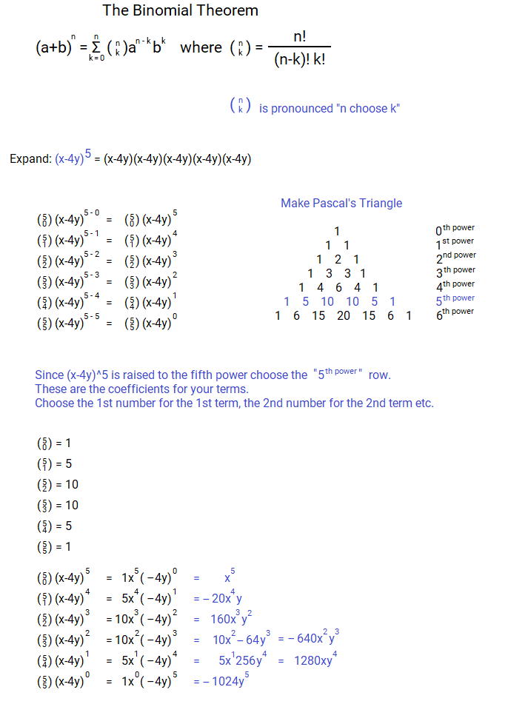

Pascal's Triangle

Pascal's Triangle is a triangle that generates rows of numbers by summing the two numbers above it to the left and right.

1
1 1
1 2 1
1 3 3 1
1 4 6 4 1
1 5 10 10 5 1
1 6 15 20 15 6 1
1 7 21 35 35 21 7 1
1 8 28 56 70 56 28 8 1
1 9 36 84 126 126 84 36 9 1
1 10 45 120 210 252 210 120 45 10 1
1 11 55 165 330 462 462 330 165 55 11 1
1 12 66 220 495 792 924 792 495 220 66 12 1
1 13 78 286 715 1287 1716 1716 1287 715 286 78 13 1
1 14 91 364 1001 2002 3003 3432 3003 2002 1001 364 91 14 1
1 15 105 455 1365 3003 5005 6435 6435 5005 3003 1365 455 105 15 1
1 16 120 560 1820 4368 8008 11437 12864 11437 8008 4368 1820 560 120 16 1
…

Two numbers add to find the sum below. Every number on the edge is 1 because it is the sum of 0+1 since there is no number additional number there. I did 17 rows. 21 or more would be impressive but I ran out of room. Most people only do 5 or 6 rows just to show the idea. There are many patterns. As always generating more data shows more patterns. Pascal's Triangle using binomials:

(a+b)⁰ 1
(a+b)¹ a+b
(a+b)² a²+2ab+b²
(a+b)³ a³+3a²b+3ab²+b³
(a+b)⁴ a⁴+4a³b+6a²b²+4ab³+b⁴
(a+b)⁵ a⁵+5a⁴b+10a³b²+10a²b³+5ab⁴+b⁵

- There are n+1 terms for (a+b)^{n}. There is 1 more term than the power of the polynomial.
- Every term has the same sum for powers.
- The sum of powers is the power called the degree of the polynomial.
- Powers of a start at n and decrease to 0. Powers of b start at 0 and increase to n.
- The coefficients are the sum of the two coefficients above it just like the numbers in Pascal's triangle.
- The coefficients for binomial powers are given by Pascals triangle.

(a+b)⁵ = (a+b)(a+b)(a+b)(a+b)(a+b)
(a+b)(a+b)(a+b)(a+b)(a+b)

a²+2ab+b²(a+b)(a+b)(a+b) 1a²+2ab+1b² coefficients are 1,2,1. This is the 3rd row.
a³+2a²b+ab²+a²b+2ab²+b³(a+b)(a+b)
a³+3a²b+3ab²+b³(a+b)(a+b) Coefficients 1,3,3,1. This is the 4th row of Pascal's ▲.
a⁴+3a³b+3a²b²+ab³+a³b+3a²b²+3ab³+b⁴(a+b)
a⁴+4a³b+6a²b²+4ab³+b⁴(a+b) Coefficients are 1,4,6,4,1. This is the 5th row of ▲.
a⁵+4a⁴b+6a³b²+4a²b³+ab⁴+a⁴b+4a³b²+6a²b³+4ab⁴+b⁵
a⁵+5a⁴b+10a³b²+10a²b³+5ab⁴+b⁵ Coefficients are 1,5,10,10,5,1. This is the 6th row of ▲.

(a+b)⁰ 1
(a+b)¹ a+b
(a+b)² a²+2ab+b²
(a+b)³ a³+3a²b+3ab²+b³
(a+b)⁴ a⁴+4a³b+6a²b²+4ab³+b⁴
(a+b)⁵ a⁵+5a⁴b+10a³b²+10a²b³+5ab⁴+b⁵

- 1a¹+1b¹
- 1a²+2a¹b¹+1b²
- a²+2a¹b¹+b²
- a³+3a²b¹+3a¹b²+b³
- a⁴+4a³b¹+6a²b²+4a¹b³+b⁴
- a⁵+5a⁴b¹+10a³b²+10a²b³+5a¹b⁴+b⁵

a+b is both have a coefficient of 1. The second row of Pascal's ▲ is 1 1.
a+b is both have a power of 1. The degree of the polynomial is 1.
For a⁵+5a⁴b¹+10a³b²+10a²b³+5a¹b⁴+b⁵ every term has powers that add to 5 which is the degree of the polynomial.

a⁵: 5 =5 5a⁴b¹: 4+1=5 10a³b²: 3+2=5 10a²b³: 2+3=5 5a¹b⁴: 1+4=5 b⁵: 5=5

The coefficient are 1,5,10,10,5,1. This is the 6th row of Pascal's ▲.
This pattern holds true for every power of a binomial of the form (a+b)^{n}.
N is the power that the binomial is being raised to.
N+1 is the number of terms it will have. N+1 is the row that it's coefficients appear in Pascal's triangle.

1
1 1
1 2 1
1 3 3 1
1 4 6 4 1
1 5 10 10 5 1
1 6 15 20 15 6 1
A polynomial will have n+1 terms. If power 8 then 9 terms. Read carefully then move on:

a⁸ + c₁a⁷b + c₂a⁶b² + c₃a⁵b³ + c₄a⁴b⁴ + c₅a³b⁵ + c₆a²b⁶ + c₇ab⁷ + b⁸ .

The c variables are the coefficients of x. The subscripts are the term numbers “ coefficient 1, coefficient 2, ...”.
The powers are the same as the so-called special factoring formulas given back in the factoring chapter near exponent laws. These powers always sum to the degree of the polynomial for each term. In standard form it would be written Ax⁸+Bx⁷+Cx⁶+Dx⁵+Ex⁴+Fx³+Gx²+Hx¹+Ix⁰ with b^{n±?} as a co-factor of every term except the leading term Ax^{n}. a⁸ would be x⁸ and so on... a = x and b = the constant in the binomial pair. Note that the 1's are formed by adding 0:

0
0 1 0
0 1 1 0
0 1 2 1 0
0 1 3 3 1 0
0 1 4 6 4 1 0
0 1 5 10 10 5 1 0
0 1 6 15 20 15 6 1 0

a⁸ + c₁a⁷b + c₂a⁶b² + c₃a⁵b³ + c₄a⁴b⁴ + c₅a³b⁵ + c₆a²b⁶ + c₇ab⁷ + b⁸ = Ax⁸+Bbx⁷+Cb²x⁶+Db³x⁵+Eb⁴x⁴+Fb⁵x³+Gb⁶x²+Hb⁷x¹+Ib⁸x⁰

9th row of ▲: 1 8 28 56 70 56 28 8 1

Ax⁸+Bx⁷+Cx⁶+Dx⁵+Ex⁴+Fx³+Gx²+Hx¹+Ix⁰ = 1x⁸+8x⁷+28x⁶+56x⁵+70x⁴+56x³+28²+8x¹+1x⁰

a⁸ + 8a⁷b + 28a⁶b² + 56a⁵b³ +70a⁴b⁴ + 56a³b⁵ + 28a²b⁶ + 8ab⁷ +b⁸
x⁸ + 8bx⁷ + 28b²x⁶ + 56b³x⁵ +70b⁴x⁴ + 56b⁵x³ + 28b⁶x² + 8b⁷x¹ +b⁸x⁰ Change a to x, move b.

The b terms have to be calculated and then multiplied with the coefficients of x.
Without knowing what b is the general form is very messy. It is not like that when b is known.

- (a+b)⁸ = (x+2)⁸ This says b = 2.
- (a+b)⁸ =a⁸ + c₁a⁷b + c₂a⁶b² + c₃a⁵b³ + c₄a⁴b⁴ + c₅a³b⁵ + c₆a²b⁶ + c₇ab⁷ + b⁸ c = coefficients.
- (a+b)⁸ = a⁸ + 8a⁷b + 28a⁶b² +56a⁵b³ +70a⁴b⁴ + 56a³b⁵ + 28a²b⁶ + 8ab⁷ +b⁸ Plug c with coefficients.
- (a+b)⁸ = x⁸+8bx⁷+28b²x⁶+56b²x⁵+70b²x⁴+56b²x³+28b²x²+8b²x¹+b²x⁰ Move b in front of x.
- (a+b)⁸ = x⁸+8(2)x⁷+28(2)²x⁶+56(2)²x⁵+70(2)²x⁴+56(2)²x³+28(2)²x²+8(2)²x¹+(2)²x⁰ Replace b with 2.
- (a+b)⁸ = x⁸+16x⁷+56²x⁶+112²x⁵+140²x⁴+112²x³+56²x²+16²x+4 Multiply co-factors.
- (a+b)⁸ = x⁸+16x⁷+3136x⁶+12544x⁵+19600x⁴+12544x³+3136x²+256x+4 Done.
We start at step 5 filling in what we know instead because the general form it is too messy and time consuming.

- (a+b)⁸ = x⁸+()x⁷+()²x⁶+()²x⁵+()²x⁴+()²x³+()²x²+()²x¹+()²x⁰
- (a+b)⁸ = x⁸+(2)x⁷+(2)²x⁶+(2)²x⁵+(2)²x⁴+(2)²x³+(2)²x²+(2)²x¹+(2)²x⁰
- (a+b)⁸ = x⁸+8(2)x⁷+28(2)²x⁶+56(2)²x⁵+70(2)²x⁴+56(2)²x³+28(2)²x²+8(2)²x¹+(2)²x⁰

Know that the form will be line I . Start writing the polynomial at line II leaving spaces for blue coefficients.
Use Pascal to find blue coefficients. Once found use a calculator to sum terms one at a time. Use a hand calculator at the end to find the powers of 56², 112² etc. If possible use a website like Mathway or Tiger Math to sum large polynomials using their online polynomial calculator. Search online for “polynomial calculator”. Find a free site. There are at least 5 good free polynomial calculators online that can solve this easily.

This polynomial has many powers and is very large. Problems like this are called “monsters”.
Learn to use technology to solve these. I understand the need to train people to use calculators to solve problems quickly and accurately. Using polynomial and graphing calculators helps you learn math faster. Use a calculator when you see this .

Times you will absolutely need an online calculator are for matrix multiplication for 4×4 or larger matrices, monster polynomials, things needing to be graphed in 3 dimensions. There are specific calculators for hard math.
We teach the math formulas so you know what to type into a calculator. Every branch of math has its own notation and if you can not read it then you will not be able to solve hard problems beyond basic arithmetic.

The Binomial Theorem long form: (a+b)^{n} = c₀a^{n}b⁰ + c₁a^{n–1}b1 + c₂a^{n–2}b² + … + c_{n–1}a₁b^{n–1}+c_{n}a⁰b^{n}.
The Binomial Theorem short form: (a+b)^{n} = (^{n}₀)a^{n} + (^{n}₁)a^{n–1}b + (^{n}₂)a^{n–2}b² + … + (^{n}_{n})b^{n} .

Where (a+b) is a binomial, n is a natural number, and c are coefficients of a.
Coefficients are from the (n+1)^{th} row of Pascal's Triangle.
Normally we (a+b) = (x+ constant).

Expand: (u – v)⁵

a = u, b = – v, n = 5 and the 6th row of Pascal is 1 5 10 10 5 1.

(u – v)⁵ = u⁵ + 5u⁴(–v) + 10u³(–v)² + 10u²(–v)³ + 5u(– v)⁴ –v
= u⁵ – 5u⁴v + 10u³v² – 10u²v³ + 5uv⁴ –v

An even negative power cancels and odd doesn't. You do not have to write 1 as an exponent or coefficient.

Expand: (2t+³/_{t})⁶

(2t+³/_{t})⁶ = 2t⁶ + 6(2t)⁵(³/_{t}) + 15(2t)⁴(³/_{t})² + 20(2t)³(³/_{t})³ + 15(2t)²(³/_{t})⁴ + 6(2t)(³/_{t})⁵ + (³/_{t})⁶
= 64t⁶ + 576t⁴ + 2160t² + 4320 + 4860^{–2} + 2916^{–4} + 729^{–6}

There are a bunch of cancellations particularly t³/t³ .

The disadvantage is having to write Pascal's triangle every time we need to do solve a polynomial. The short form is used in discrete mathematics etc to avoid this difficulty. The short form is uses n choose k notation also called binomial coefficient notation.

(3x+y)⁴

(3x+y)⁴ = (⁴₀)(3x)⁴ + (⁴₁)(3x)³y + (⁴₂)(3x)²y² + (⁴₃)(3x)²y² + (⁴₃)(⁴₄)y⁴
= ^{4!}/_{4!0!}∙3⁴x⁴ + ^{4!}/_{3!1!}∙3³x³ + ^{4!}/_{2!2!}∙3²x²y² + ^{4!}/_{1!3!}∙3x³ + ^{4!}/_{0!4!}∙y⁴
= 81x⁴ + 108x³y + 54x²y² + 12xy³ + y⁴

(x² – 2y)⁵

(x² – 2y)⁵ = (⁵₀)(x²)⁵ +(⁵₁)(x²)⁴(–2y) + (⁵₂)(x²)³(–2y)² + (⁵₃)(x² )²(–2y)³ + (⁵₄)(x² )²(–2y)⁴ +(⁵₅)(–2y)⁵
= ^{5!}/_{5!0!}∙x¹⁰ + ^{5!}/_{4!1!}∙x⁸(–2y) + ^{5!}/_{3!2!}∙x⁶(–2y)² + ^{5!}/_{2!3!}∙x⁴(–2y)³ + ^{5!}/_{1!4!}∙x²(–2y)⁴ + ^{5!}/_{0!5!}∙(–2y)⁵
= x¹⁰ – 10x⁸y + 40x⁶y² – 80x⁴y³ + 80x²y⁴ – 32y⁵

Finding a specific term

The (r+1)^{th} term of (a+b)^{n} is (^{n}_{r})a^{n–r}b^{r}. The1st , 2nd, and 3rd terms are : (^{n}₀)a^{n}b⁰ (^{n}₁)a^{n–1}b¹ (^{n}₂)a^{n–2}b².

What is the 5th term of (2x – 3y)⁷?

(⁷₄)(2x)^{7–4}(–3y)⁴ = ^{7!}/_{3!4!} (2x)³(–3y)⁴ = 22,680x³y⁴

Because of the binomial theorem (^{n}_{r}) is called the binomial coefficient.
0! is defined as 1 because we want (^{n}₀) to equal 1 and we want (^{n}_{r}) to equal ^{n!}/_{(n–r)!r!} for all whole numbers.
Including 0 means that to satisfy (^{n}₀) = ^{n!}/_{(n–0)!0!} = ^{n!}/_{n!0!} = 1 then 0! must equal 1.
Use both forms to expand each binomial.

1. (m + n)⁵ 2. (a – b)⁴ 3. (x – y)⁶ 4. (p + q)⁷ 5. (x² – 3y)⁵
6. (3c – d)⁷ 7. (3c – d)⁶ 8. (t^{–2} + 2)⁶ 9. (x – y)³ 10. (x – y)⁵
11. (x – ²/_{y})⁵ 12. (3s + ¹/_{t})⁹ 13. (a² – b³)⁵ 14. (x³ – 2y)⁵ 15. (√3 – t)⁴
16. (√5 – t)⁶ 17. (x^{–2} – x²)⁵ 18. (¹/_{√x} – √x)⁶

Find a specific term.

19. 3rd : (1/x² + y)⁷ 20. 4th : (x+y)⁶ 21. 5th : (2m³+√n)⁸ 22. 6th : (a+b)⁷
23. 7th : (x – 3)¹⁴ 24. middle : (2x – 3y²)¹⁰ 25. middle 2: (√x + √3)⁵ 26. 10th : (x +2)¹²

Applications.

27. Write two problems using the binomial theorem where the first is solved easier by the long form and the second by
the short form. Explain why each form was easier for each problem.

28. A peer asserts that the first and last coefficient of the expansion of any binomial are always 1.
Why or why not is this assertion correct?

29. a) During a season in the 1990's, while playing for the LA Dodgers, Mike Piazza had a batting average of 0.313. If he came to bat 5 times in a game his chances of getting 3 hits is the 3rd term of the binomial expansion (0.313 + 0.687)⁵.
Using a calculator find the 3rd term and estimate the probability.

b) The probability he will get at most 3 hits is found by adding the last 4 terms. Estimate probability of this happening.

30. a) A woman has something like a 85% chance of being widowed or divorced.
For a survey sample of 8 women the probability that 5 of them will be alone is the 6th term of (0.15+0.85)⁸.
Find the 6th term and calculate the probability.

b) The probability that at least 6 of them will be widows or divorcees is found by adding the last three terms.
Find these terms and calculate the probability.

31. Find the term of (3x²/2 – 1/3x)¹² that does not contain x.
32. Find the middle term of (x² – 6y^{3/2})⁶.
33. Find the ratio of the 4th term of (p² – ½ p∛q)⁵.
34. Find the term containing 1/x^{1/16} of (∛x – ¹/_{√x})⁷.
35. What is the degree of (x² + 3)⁴.

Probability

Probability extends of study of combinatorics and the Binomial theorem and eventually all these things form the study of 12th grade statistics. Common introductory topics include application of various games of chance because that was its origin purpose but now it applied to many fields beyond gambling such as political science, crime prevention, quality control and manufacturing.

Definition of Probability: P(event) = number of favorable outcomes/number of possible outcomes.

Definition of Odds: The odds of an event occurring is the ratio of the number of ways the event can occur to the number of ways the event cannot occur. We write this as successes:failures or happens:fails = h:f.

Simple probability says that an event can happen in (h) number of ways and fail in (f ) number of ways.
Assuming that different (h+f) ways are equally likely the probability an event happens successfully is p=h/(h+f) = h/n, while the probability it fails is q = f/(h+f) = f/n. Success and failure are fractions. If we add these fraction they equal 1.

Success: p = ^{h}/_{n} = ^{h}/_{h+f}
Failure: q = ^{f}/_{n} = ^{f}/_{h+f}
Success+failure = ^{h}/_{h+f} + ^{f}/_{h+f} = ^{h+f}/_{h+f} = 1. We get these equations: p+q = 1; 1– p = q; 1– q = p.

The odds in favor it will happen is p:q = p:(1 – p) or ^{p}/_{(1 – p)}.
The odds against it will happen is q:p = (1 – q):p or ^{(1 – p)}/_{p.}

