Probability

Probability extends of study of combinatorics and the Binomial theorem and eventually all these things form the study of 12th grade statistics. Common introductory topics include application of various games of chance because that was its origin purpose but now it applied to many fields beyond gambling such as political science, crime prevention, quality control and manufacturing.

Definition of Probability: P(event) = number of favorable outcomes/number of possible outcomes.

Definition of Odds: The odds of an event occurring is the ratio of the number of ways the event can occur to the number of ways the event cannot occur. We write this as successes:failures or happens:fails = h:f.

Simple probability says that an event can happen in (h) number of ways and fail in (f ) number of ways.
Assuming that different (h+f) ways are equally likely the probability an event happens successfully is p=h/(h+f) = h/n, while the probability it fails is q = f/(h+f) = f/n. Success and failure are fractions. If we add these fraction they equal 1.

Success: p = ^{h}/_{n} = ^{h}/_{h+f}
Failure: q = ^{f}/_{n} = ^{f}/_{h+f}
Success+failure = ^{h}/_{h+f} + ^{f}/_{h+f} = ^{h+f}/_{h+f} = 1. We get these equations: p+q = 1; 1– p = q; 1– q = p.

The odds in favor it will happen is p:q = p:(1 – p) or ^{p}/_{(1 – p)}.
The odds against it will happen is q:p = (1 – q):p or ^{(1 – p)}/_{p.}

In general we have a linear equation of the form Ax+By = C where a ratio x:y is one outcome and y:x is the opposite. Some texts replace x:y with p:q. There are simpler much ways to state the above as illustrated by the coin toss example.

A single dice is called a die. We roll it and get a 4. Since a die has 6 possible outcomes our probability for getting any number is 1 out of 6 written as “ ⅙ chance” or “ 1:6 odds”. In probability the numerator of the fraction is always the favored outcome over all possible outcomes and left number of the ratio is always the hypothesized result over all possible results. This differs from standard algebra notation where ^{y}/_{x} = x:y.

In statistics they are using something like ^{x}/_{y} = x:y. When a wager is made you are either for or against. You either want success or you want failure. This is a language thing. “I bet you he makes that shot” or “I bet you he doesn't make that shot”. Either way what you are betting is your hypothesis and it is “x” for this fraction: ^{x}/_{y} and this ratio x:y.

A hypothesis is a question you are asking about whether something works or doesn't, it comes from hypothetical.
When outcomes have an equal chance of occurring they are said to be equally likely.
- If something is impossible it have a probability of 0. This means 0% chance.
- If something is certain to be it has a probability of 1. This means 100% chance.
- If something is neither impossible nor certain it has a probability of 0≤event≤1.
- All events have a probability of 0%-100% written as 0≤event≤1.

Events that are equally likely involve luck or chance. Events that are unequal involve skill. We use probability and statistics to make educated guesses about uncertain future events.

Chance | Skill
Grabbing a snack at random from a vending machine | Passing a test
Drawing a card from a deck | Winning at chess
Rolling a die | Competing in Sports
Winning the lottery | Ordering a pizza

Key words, phrase, and ideas

Some of the content here is for later work in statistics and not necessarily for basic probability.
An experiment is an activity for the purpose of gathering data and making assumptions based on the findings.
A trial is one complete round of the experiment. The more trials performed the better the experiment.
The result of one trial run is called an outcome.

Simple probability is given as as fraction ^{h}/_{n} where h is favorable outcome and n is all possible outcomes.
Simple probability is also called marginal or classical probability.

Mathematical expectation is the product of probability and desired outcome written p(outcome).
If the probability of winning $100 is ¹/₂₅ the expectation is ¹/₂₅($100) = $4.

Measures of central tendency include the mean, mode,and median.

Measures of variation include range and interquartile range. Quartiles are values used to divide a set of data into four equal part. The median divides the data in half, the lower quartile divides the lower half in two, the upper quartile UQ divides the upper half in two. The interquartile range is the difference between the upper and lower quartiles, UQ–LQ = interquartile range. The interquartile range represents the middle half or 50% of data in a set.

The interquartile range is used to determine how much data varies from the lowest and highest numbers of the middle 50% of data. A value much higher or lower than the others is called an outlier. Outliers are defined to be values that differ by 1.5 times or more than the upper or lower quartiles. Example:

76 80 88 91 95 99 99 101 102 103 105 105 112 115 140
↑ ↑ ↑ ↑
lower quartile median upper quartile outlier

Notice there are 15 numbers. Notice the 8th number is 101, and that there are 7 numbers on either side of it:
7(numbers)+1(number)+7(numbers) = 15(numbers) = 7+1+7 = 15. The middle number is going to be the single number between two matching amounts of numbers. The single number is the 8th number and the 8th number has 7 numbers on either side of it, we write 7+1+7=15 to show the 8th number is the middle number. Notice that the seven numbers on the right has 91 in the middle and that 91 has three numbers o neither side of it. 91 is the middle number form the first number to the median of the set. So tto 105 is the median of the upper half having three numbers on either side of it and being the middle number between the median and the last number of the set.

- The range is [76,140] because that is the highest and lowest recorded numbers.
- 101 is the median because it is the middle number having 7 numbers to either side of it.
- 91 is the LQ because it is the median of the data to the left of the median 101.
- 105 is the UQ because it is the middle of the data to the right of the median.
- Data to the left of the median 101 is called the lower half, data to the right the upper half.
- The interquartile range is 14 because UQ – LQ = 14. 105 – 91 = 14.

To determine outliers add 150% of the interquartile range to the UQ or subtract it from the LQ:

LQ= 91 UQ= 105 UQ – LQ = 105 – 91 = 14

Interquartile range is 14. This means that the data varies by 14 between UQ and LQ. Multiply, subtract and add:
Add and subtract “1.5∙14 = 21” to the quartiles.

91 – 21 = 70 Anything below 70 is an outlier. We do not have any numbers below 70.
105 + 21 = 126 Anything above 126 is an outlier. 140 >126 so 140 is an outlier.
Average, Median and Mode

Average is the total successes divided by total tries. An average is also called the mean.
Median is the number that is most in the middle of a sequence of data.
Mode is the number that appears the most.

To find a mean add all your numbers and divide the total by the number of tries.
As a function this would be add the value of all outputs y by the number of terms you have.

A player scores 20 point in the first game and 10 points in the second game. His 2 game average is 20+10/2 = 15 per game. On the third game he scores 15. Adding this to his average his 3 game average is 20+10+15/3 = 15. The average is unchanged because he scored in 1 game what his average already was. If he scores 5 points in the fourth game his average drops to 20+10+15+5/4 = 12.5. He was scored 50 points total over 4 games so we divide 50 points by 4 games to see he is contributing 12.5 per game.

He had a 3 game average of 15. In the fourth game if he scored:

Less than 15 his average would have gone done down.
Exactly 15 his average would remain at 15.
More than 15 his average would go up.

In the fifth game he scores 20 points and his average increases because 20 is more than his current average of 12.5. Points÷games: 20+10+15+5+30/5 = 80/5 = 16. An average does not mean this is how many point you score every game but a running total of all points scored divided by all games competed in. We can take an average if we have at least 2 scores divided by 2 games. We can not take an average of 1 score divided by 1 game. We can but that is not really an average. His averages for games are:

1 game: avg. of 20 (20)= (20)÷1 = 20
2 games: avg. of 15 (20+10)= 30÷2 = 15
3 games: avg. of 15 (20+10+15)= 45÷3 = 15
4 games: avg. of 12.5 (20+10+15+5)= 50÷4 = 12.5
5 games: avg. of 14 (20+10+15+5+30)= 80÷5 = 16
Last 2 games: avg. of 17.5 (5+30)= 35÷2 = 17.5
Last 3 games: avg. of 13⅓ (15+5+30) = 50÷3 = 16⅔
Last 4 games: avg. of 12.5 (10+15+5+30)= 60÷4 = 15
Last 5 games: avg. of 14 (20+10+15+5+30)= 80÷5 = 16

The average of the last 5 games is the average of all games played. We abbreviate average as avg. and we write averages using fractional notation instead of divisional notation. The Last 2 game average would be written as ³⁵/₂ = 17.5.

The scores are called the output of a function the number of games is called the number of terms. We have 5 scores so we have 5 terms. The total points is given by a series of the points recorded and the points recorded can be written as a sequence. An average is the series of outputs divided by number of terms: ^{sum of series}/_{number of terms} = average. In all but the 4th game the player scored over 10 points. We we exclude game for we have (20+10+15+30)/4 = 18.75. Excluding the weakest performance because the player was sick or other reasons is called a weighted average.

We assume the player would average around 15 points per game and that having a very low score under 10 would be out of character. We might exclude the score of 5 if we do not feel it gives an accurate portrayal of the players true capabilities. Sports averages are used by fans to bet on which team will win and by coaches to bet on which players to draft so that they can win. In Both cases motive is money. In this case removing the lowest score 5 improves the average from 17.5 to 18.75. A difference of 1¼ might matter or not. If weighting the average makes a big difference than it makes sense. Here I do not think it does and feel that 17.5 does show true capabilities so would not exclude lowest term.

If we write the scores as a sequence: (20, 10, 15, 5, 30).
If we write the scores as an ordered set: (5, 10, 15, 20, 30). The middle term of a sequence is the median.

As a function the points are given as a domain of x:[1,5] having a range of y:[5,30]. We can write a function:

f(x) = y Where x is game played and y is points scored is f(n^{th} game) = points.
f(0) = ∅ Score is null because there is no 0th game for data to be recorded.
f(1) = 20 1st game had 20 points.
f(2) = 10 2nd game had 10 points.
f(3) = 15 3rd game had 15 points.
f(4) = 5 4th game had 5 points.
f(5) = 30 5th game had 30 points.

Use tables to track scores, plot points to graph data.

Game (x) | 1 | 2 | 3 | 4 | 5
Score (y) | 20 | 10 | 15 | 5 | 30

This is called a scatter plot graph.

- Write a function.
- Find y for a given x.
- Make a table, list results.
- Plots points.
- Connect points with lines.
- Exclude points when weighting an average like the third graph.

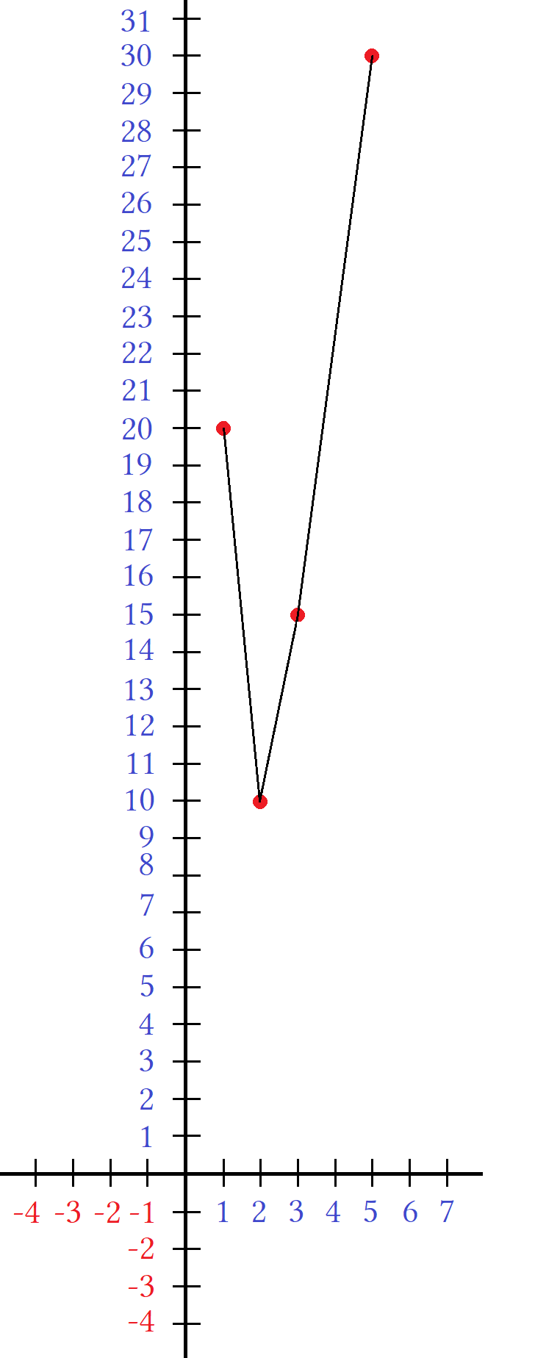
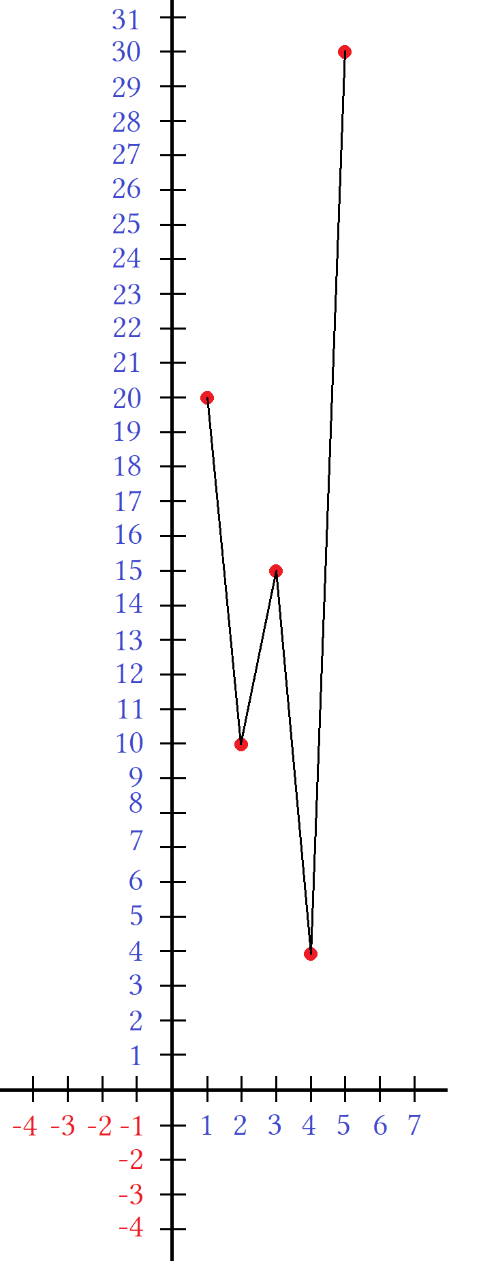
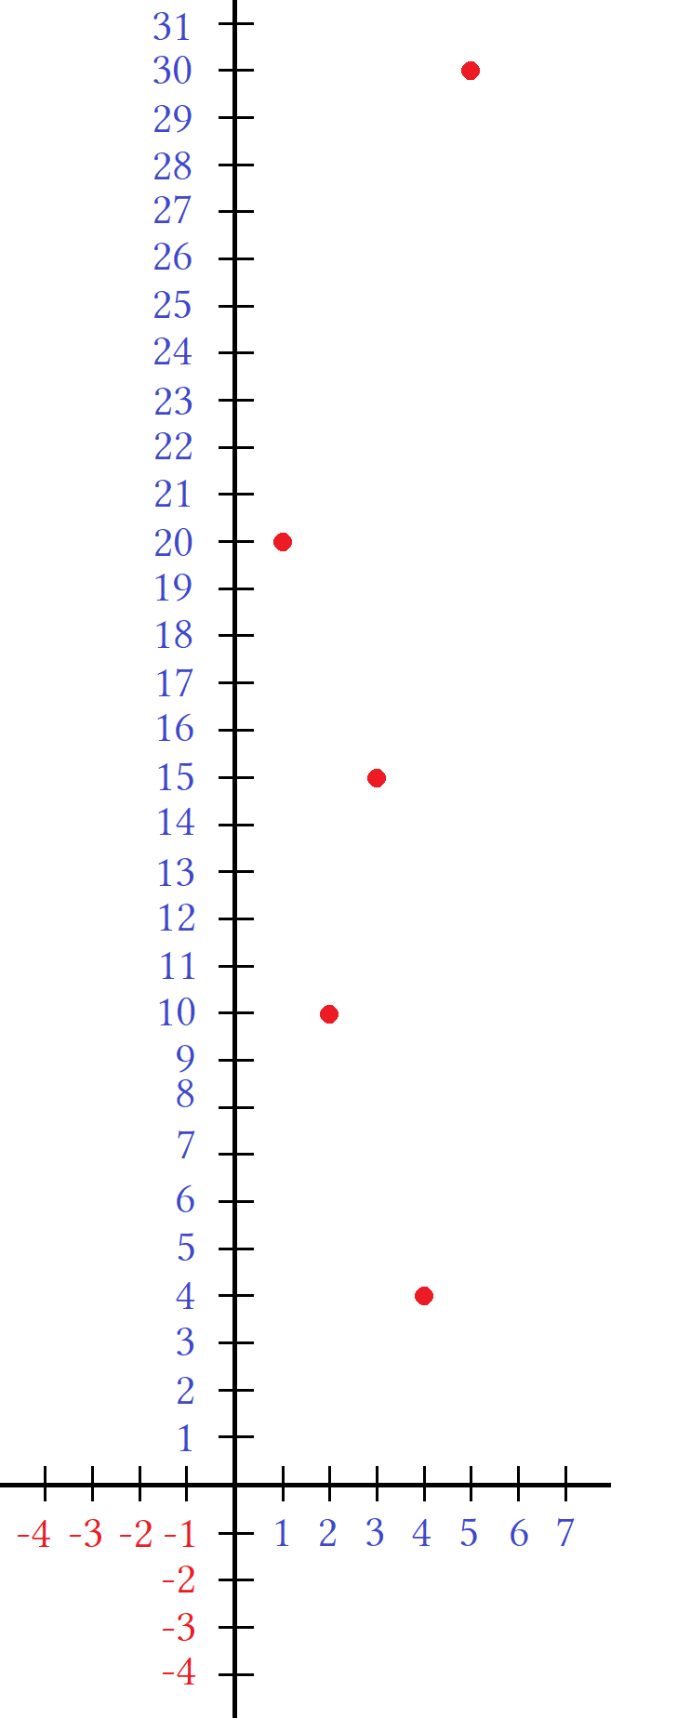

For a graph to be drawn we first plot the points. Usually this in of itself can be enough information and we are done. Other times situations require connecting the dots with lines. Each line segment drawn is the result of a linear function with domain restricted so that the line does not extend infinitely. We do this with the use of interval notation. Every line segment is an intersection of two points of the form a≤x≤b or P₁≤x≤P₂ or P≤x≤P₁. Where “P” stand for point and the subscripts are saying we have two different points.

The third graph excluded the lowest value. Values that are very high or low compared to others are called outliers or anomalies. An outlier should beat least 50% bigger or smaller than all normal values. Anomalies are flukes or data that is otherwise atypical of expected results and so we are allowed to exclude these points if including them would skew our results and lead to false assumptions and prediction. Be careful not to exclude points only to achieve results that are favorable to you. Doing so is a form of corrupting data. Some scatter plots are so scattered that data does not benefit from connecting lines and are left as clusters of dots. Others have a clear pattern upwards, downwards or sideways. We call this data trends or the trend of the data.

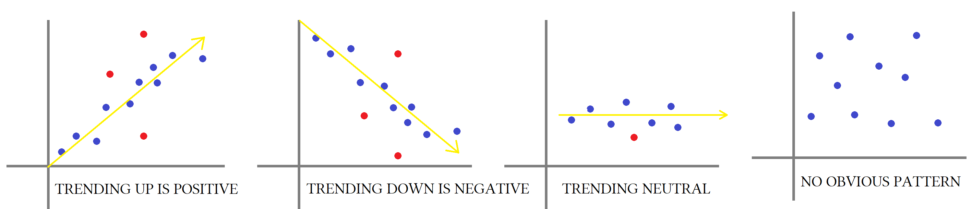

For whatever data set we try to see if the data trends upwards, downwards, or sideways. We call these patterns positive, negative and neutral respectively. Patterns need not be exact but merely approximations, usually made by taking two values and finding their average and the placing a line at these values. The yellow line in the picture shows what looks like an approximation of these values. For the line to be straight all points on the line must be of some linear function and the points of the actual data within a certain threshold called margin of error. A margin is how much the real data deviates from this hypothetical line. The smaller the margin of error the more we can trust the results, the greater the margin the less accurate the model is. Plotting points on a graph is called analysis in statistics. We call this data analysis or data reporting. Noticing patterns is called spotting trends.

If people shop online, visit certain websites, stream or download songs or view social media channels this data is collected. Unsorted data is called aggregate data. This data is monitored, tracked, and labeled. It is then analyzed and displayed by use of some type of chart be it scatter, bar, or pie. The goal is to help corporations maximize profit.

If a media source says something is “trending” they may be lying just to sell more products for companies they are paid to advertise for. Even if something is trending that is no reason to buy into a product or lifestyle. Doing so is called bandwagon mentality. To doing something because someone else says so is a sign of being a conformist. Conformity with bad ideas or views ruined this great nation and lead to apathy in young people and killed great American debate.

Being a conformist is akin to being a sellout and prevents people from being strong and winning in life. Conformity is similar to being in a cult. American society places value on people who are independent thinkers and convey original thought. Example: If a musician had a sound that was new and original they would be popular. If everybody else started coping them and making derivative works they would be seen as posers or wannabes. They would be seen as fake. Selling out is being fake, being a conformist is the same as being fake. You are not being true to yourself you are trying to live up to others expectations of you and they do not have your best interests in mind.

If an artist like Kanye West started a fashion trend then the trend would catch on if people liked the look. This is different than conformity with the masses this is called “slice of life” or diversity. When given a choice about how you express yourself and communicate the type of person you want to be this is not conformity this is free thinking. Conformity is when you do something because the government or authority or corporations dictate it. With dictation there can be no freedom and thus no originality. Freedom is the tool that creates wealth. Without freedom there is no wealth and thus poverty.

In poverty people can not afford to differentiate themselves from the crowd. It's everyone wearing the same gray clothes, taking the same gray bus, to work at the same gray factory. This is not freedom this is totalitarianism typically depicted by fascist communism dictatorships or other far left fringe groups who claim to be for the people but really are the ones who cause the misery in which they claim to be trying to fix. Other types of fascism exist in ultra conservative forms but in any case the result is more police power and government control over citizens.

If something was popular with you and your peers you would know it and not need social media to advertise it to inform you. Either you know what's up or you don't.

Technology connection:

Data collection is called sampling. The larger the data set the better the sample. Statistics is more important than ever with artificial intelligence and social media increasing in popularity (trending up). Artificial intelligence is nothing more than feeding a computer vastly large data sets and having it mathematically spot patterns to make future predictions. These predictions are used to help guide decisions. Social media tracks all data on it's platforms. A content creator is given tools called analytics to track how many views each post receives, how long a person watches a post, when they stop on a video or replay a part, and how many people like or dislike the post. This is used by content creators to make more videos that are more popular.

Say a creator has two videos. The first one receives many views but only some likes. The second video receives less views but receives more likes per viewer. This information is used to help the creator make new videos that more people want to see but put in the style that more people like. The goal is to combine the high views of the first video and the high likes of the second. We can say the most viewed video is a topic that is more popular but the style is lacking while the second video has unpopular topic but the style it is presented in is very popular. Get a better topic that people want to hear about an then use the talking style that people found most funny, entertaining, or informative.
Numerical information is called data. Statistics is the study of how to collect, analyze, and organize data.
The median, mode, and mean are called measures of central tendency.
Centralized values are used to best describe the data because they represent middle values of the data.

Here is some random data: (1,2,2,3,4,5,6)

The median is 3 because median means middle number. On a busy road or freeway the center divider is called a median. Median means middle. In geometry a median is a line that divides the center of another line like drawing a line through the center of a square. Actually it is a line from the corner of the square to the center of the side opposite it.

The mode is 2 because it appears twice and the others appear once. When a number appears more than the others it is called the mode. Mode means modulus and is related to base systems.

The total is 23. A total is a sum. It is the result of adding all the numbers.
The average is 3²/₇ . An average or mean is the total of the numbers divided by the number of numbers.
The range is 1 to 6 written using interval notation as y:[1,6].
The number of numbers is called the number of terms. There are 7 distinct numbers so there are 7 terms.

Set a:{1,2,3,4,5,6}

Written as a set we remove duplicates so write 2 only once.
Using curly braces {} says we may have move terms than shown but they must be duplicates.

S:(1,2,2,3,4,5,6)

Written as a sequence we use () and have to show all terms or truncate the sequence by using ellipsis.

S₇:(1+2+2+3+4+5+6)

Written as a set we still use () and have to show all terms or truncate the sequence by using ellipsis but replace commas with plus signs.

Temperatures for a given week: 71°, 68°, 79°, 65°, 68°, 70°, 73°.
We organize the terms as an ordered set: (65°, 68°, 68°, 70°, 71°, 73°, 79°).
The middle number 70° is the median. It is the middle number since it has the same number of terms before and after it.

The value 68° is the mode since it appears more than any other.
The mean or average is about 70.57 because as a series S₇:(65+68°+68°+70°+71°+73°+79)= 494/7 = 70⁴/₇.
We have a domain of 1 to 7 and a range of 65 to 79. x:[1,7] y:[65,79].

If we change the highest or lowest temperatures, or both of them , it will not affect the median or mode.

(0°, 68°, 68°, 70°, 71°, 73°, 79°). Lowest temp 0° doesn't change 70° as median and 68° as mode.
(65°, 68°, 68°, 70°, 71°, 73°, 179°). Highest temp 179° doesn't change 70° as median and 68° as mode.
(0°, 68°, 68°, 70°, 71°, 73°, 179°). 0° and 179° doesn't change 70° and 68° as being median and mode.

Changing extreme highs and lows will have an effect on the average.

(0°+68°+68°+70°+71°+73°+79°)÷7 = 61²/₇
(65°+68°+68°+70°+71°+73°+179°)÷7 = 84⁶/₇
(0°+68°+68°+70°+71°+73°+179°)÷7 = 75⁴/₇

For weather temperature does 0° or 179° seem like;y or reasonable? No so exclude those data points when taking an average. These values are too extreme and see anomalous or outright wrong. Anomalies can be due to equipment malfunction recording the data wrong or correct data but so rare that including it gives the false impression that these values are normal and likely to repeat again. For a week having temps on average in the low 70's 0 and 179 are not likely to be valid temperatures for the week listed. We should exclude these values.

Extreme values are also called extremes and different from maxima and minima in that max and min can register normal are seem reasonable. We would call extremes anomalies that are extreme max and extreme min, and then look to the second lowest and second highest as the true max and min. We would call normal values the relative maxima and minima and the anomalies the extreme max and min.

Coin Toss

A fair coin is a coin that is balanced so that it will fall on heads or tails with the same probability. This probability is 50% or ½. Probability is determined by how many times something happens divided by total choices. We predict since there are 2 sides each will the same possibility of landing that we have a 1 in 2 chance of getting a heads or a 1 in 2 chance of getting a tails. Using probability is called an educated guess. If we flip a coin 10 times we may get 5 heads and 5 tails or something else. We could get 6 heads and 4 tails or 10 heads and 0 tails. What we guess is the probability and what we get is the recorded data. If the recorded data does not match the probability we are said to have beaten the odds.

If we flip a coin and get more heads than tails then we beat the odds by a number called a margin.
Using ratio notation x:y to say “x to y” we can write probabilistic odds for a coin toss as heads:tails.

x:y = heads:tails

5:5 = ½ or 50% chance of this happening.
5:10 = 5 heads out of 10 chances.

If ten coin flips then 10 chances, each with a 50% of heads or 50% chance of tails. This is a 50%:50% chance or 5 out of 10 which as a fraction equals reduces to 1 out of 2. If I flip a coin 10 times I am not guaranteed to get 5 heads. This is just a prediction that is made based on statistical means. If a coin if flipped 10 tens I may get more heads or more tails or exactly the same number of heads and tails.
The more flips the closer the average of heads to tails becomes to 5:5 or 50%.

If I flip 10 times I may get 7 heads and 3 tails.
If I flip 100 times I may get 65 heads and 35 tails.
If I flip 1,000 times I may get 543 heads and 457 tails.
If I flip 10,000 times I may get 5023 heads and 4973 tails.

The more flips the closer the number approaches the statistical average. What if we start asking questions like,
“what are the odds I get 2 heads in a row? How about 3, 4, 5, or 6 heads in a row?”.
We will investigate this situation by writing all possibilities and then deriving a general formula.

5:5 is a 50% of getting heads on 1 coin toss with ten tosses being 5 heads and 5 tails.
6:4 this is saying we got 6 heads and 4 tails but is not the way to write a probability. It is just recording data.
6:10 this is saying we got 6 heads out of 10 tosses but this is not the way to calculate odds either.

6:10 = ⁶/₁₀ = 60% We do not have 60% of a chance of anything so this is not telling us anything relevant.
If we get 6 heads and 4 tails does this mean we have a 60% of getting 6 heads?
No! It means that 60% of our outcomes was heads and 50% was tails.
Taking a probability is different that recording outcomes as raw data. We need a formula.
We want to ask what the odds are of “2-in-a-row, 3-in-a-row, 4-in-a-row...etc”.

x:y This sets up a “proportion” also called a “ratio”.
heads:flips We want to know the proportion of heads to coin flips.
1:1 If we get 1 heads the we have 1-in-a-row for 1 flip.

1:1 1 heads 1 flip
2:2 2 heads 2 flip
3:3 3 heads 3 flip
4:4 4 heads 4 flip
5:5 5 heads 5 flip
6:6 6 heads 6 flip

We have two possible outcomes for each flip heads or tails.
We flip once and get heads. We flip six times and get heads every time. We record our results.

H We know we have a 50% of this as 1 out of 2.
HH We don't know this or the others.
HHH
HHHH
HHHHH
HHHHHH

List all possible combinations for 2 flips:

HH Both are heads.
HT first flip is heads second is tails.
TH First flip is tails second is heads.
TT Both are tails.

There are 4 possible outcomes. The outcome we want is satisfied by only one of them, the first one HH.
Out of 4 possibilities we have only one desired result. This is 1 out of 4. We like 1 result but not the other 3.

- x:y Setting up a ratio.
- (What we want):(what is possible) Replacing x and y with words describing what we are doing.
- 1 win:4 chances to win As a ratio we have 1:4
- 1:4 Translating to math.
- 1÷4 = ¼ or 25% Converting to a percent.

We have a 25% chance of 2-in-a-row or 1 out of 4. Repeat this method to solve for the other problems.

3-in-a-row: HHH HHT HTH THH
TTT TTH THT HTT

We have 4 outcomes with mostly heads and if we invert H and T we get 4 outcomes for mostly tails.

These are permutations made of 2 elements and three digits. Knowing what we know about combinations do we have a formula based on exponents, permutations, combinations or something else?

We have 2 elements and three digits for 8 permutations. The standard formulas for combinatorics will not work unless we modify them which seems problematic. While maybe true there is probably a simpler method.
This appears to be exponents.

2! = 2 or 3! = 6 This does not equal 8 combinations. We do not have a factorial answer.
₂P₂ = 2 ...
₃P₂ = 6 ...
₃P₃ = 6 ...
₂C₂ = 1 ...
₃C₂ = 3 ...
₃C₃ = 1 ... None of the combinatorics formulas work.

3² = 9 so that is not it. 2³ = 8 so that is it. We have found a formula that works: elements^{digits} = chances.
We take this further to get number of winning combinations/chances = odds.

elements^{digits} = chances ≡ e^{d} = c
winning combinations/chances = odds ≡ w/e^{d} = ^{w}/_{c}.

The number of wins divided by the number of chances for wins-in-a-row will be w = 1 and e^{d} will be based on how many elements and how many wins in a row.

1/e^{d} ₌ ¹/_{c} There is only one winning combination out of e^{d} chances.

For w/e^{d} =w/c:

w is how many times we won for an entire game. This is always 1 for certain games because there is only 1 winning combination out of many.

e is our base of how many possible outcomes for a single round. A coin toss has 2 outcomes heads or tails.
d is the number of win-in-a-row we are calculating.
c is the number of chances to win we have written as the number of combinations of permutations we have.

Wins-in-a-row | w/e^{d}=^{w}/_{c} | Translation
1 | 1/2¹ = ½ = 50% | Odds are 1 out of 2 is 50% chance of this happening
2 | 1/2² = ¼ = 25% | Odds are 1 out of 4 is 25% chance of this happening
3 | 1/2³ = ⅛ = 12.5% | Odds are 1 out of 8 is 12.5% chance of this happening
4 | 1/2⁴ = ¹/₁₆ = 6.25% | Odds are 1 out of 16 is 6.25% chance of this happening
5 | 1/2⁵ = ¹/₃₂ = 25% | Odds are 1 out of 32 is 3.125% chance of this happening
6 | 1/2⁶ = ¹/₆₄ = 25% | Odds are 1 out of 64 is 1.5625% chance of happening

Conclusion:

Flipping coins is a binary process that for successive sides in a row is given by 1 over powers of 2 yielding odds that are imperial fractions where 2 is the base of the fraction and wins in a row is the exponent of 2. This can be restated simply as “ with a 50% chance for the 1st flip every additional flip chances of winning are divided by 2”.

Summary:

We will prove our findings by listing all combinations. Combinations represent how many different permutations we can get when repetitions are allowed, digits show how many rounds were played and what the result of each round was. Each flip is 1 round.

Writing H and T is messy after 3 round so we will use inverted binary where H = 0 and T = 1.
Regular binary would make H = 1 for positive or true. There are two columns where the first is a blue column for heads. The second column is tails, it is made by taking every code from the first column and inverting H with T.

For one round we have a 50% chance of getting either H or T:

H T 0 1 1: odds is 50% for H

For two rounds we have a 50% chance of getting either HH or TT combined and 25% chance of getting HH:

HH TT 00 11 1:4 odds is 25% for HH
HT TH 01 10

For three rounds we have a 25% chance of getting either HHH or TTT combined and 12.5% chance of getting:

HHH TTT 000 111 1:8 odds is 12.5% for HHH
HHT TTH 001 110
HTH THT 010 101
THH HTT 100 011

For four rounds we have 1:16 odds or 6.25% chance for HHHH:

HHHH TTTT 0000 1111
HHHT TTTH 0001 1110
HHTH TTHT 0010 1101
HHTT TTHH 0011 1100
HTHH THTT 0100 1011
HTHT THTH 0101 1010
HTTH THHT 0110 1001
HTTT THHH 0111 1000

For five rounds we have 1:32 odds or 3.125% chance for HHHHH:

HHHHH TTTTT 00000 11111
HHHHT TTTTH 00001 11110
HHHTH TTTHT 00010 11101
HHHTT TTTHH 00011 11100
HHTHH TTHTT 00100 11011
HHTHT TTHTH 00101 11010
HHTTH TTHHT 00110 11001
HHTTT TTHHH 00111 11000
HTHHH THTTT 01000 10111
HTHHT THTHT 01001 10110
HTHTH THHTH 01010 10101
HTHTT THTHH 01011 10100
HTTHH THHTT 01100 10011
HTTHT THHTH 01101 10010
HTTTH THHHT 01110 10001
HTTTT THHHH 01111 10000

For six rounds we have 1:64 odds or 1.5625% chance for HHHHH:

HHHHHH HHHHHT HHHHTH HHHHTT HHHTHH HHHTHT HHHTTH HHHTTT
HHTHHH HHTHHT HHTHTH HHTHTT HHTTHH HHTTHT HHTTTH HHTTTT
HTHHHH HTHHHT HTHHTH HTHHTT HTHTHH HTHTHT HTHTTH HTHTTT
HTTHHH HTTHHT HTTHTH HTTHTT HTTTHH HTTTHT HTTTTH HTTTTT

000000 000001 000010 000011 000100 000101 000110 000111
001000 001001 001010 001011 001100 001101 001110 011111
010000 010001 010010 010011 010100 010101 010110 010111
011000 011001 011010 011011 011100 011101 011110 011111

TTTTTT TTTTTH TTTTHT TTTTHH TTTHTT TTTHTH TTTHHT TTTHHH
TTHTTT TTHTTH TTHTHT TTHTHH TTHHTT TTHHTH TTHHHT TTHHHH
THTTTT THTTTH THTTHT THTTHH THTHTT THTHTH THTHHT THTHHH
THHTTT THHTTH THHTHT THHTHH THHHTT THHHTH THHHHT THHHHH

111111 111110 111101 111100 111011 111010 111001 111000
110111 110110 110101 110100 110011 110010 110001 100000
101111 101110 101101 101100 101011 101010 101001 101000
100111 100110 100101 100100 100011 100010 100001 100000
■

These are all combinations of heads and tails written binary because binary is easier to read.

HHH= 000 TTT= 111
HHT= 001 TTH= 110
HTH= 010 THT= 101
HTT = 011 THH=100

Check the pattern reading down: 0,10,10,11 and 11,10,01,00. This is used as a checksum to make sure we have the correct codes. Turn HHH into TTT by changing all H to T. Turn HHT into TTH by changing all H and T to T and H. Turn HTH→THT by changing all the t's to h's and and the h's to t's. This is what is meant by inversion.

Our binary code is easier to read and for a single code easy to convert back to letters if need be.

Reading columnwise: Reading from top to bottom, check the last three digits what do you see?
Reading rowwise: Reading from left to right, check the first three digits what do you see?

000000 000001 000010 000011 000100 000101 000110 000111
001000 001001 001010 001011 001100 001101 001110 011111
010000 010001 010010 010011 010100 010101 010110 010111
011000 011001 011010 011011 011100 011101 011110 011111

111111 111110 111101 111100 111011 111010 111001 111000
110111 110110 110101 110100 110011 110010 110001 100000
101111 101110 101101 101100 101011 101010 101001 101000
100111 100110 100101 100100 100011 100010 100001 100000

Pattern: 111, 110, 101, 100, 011, 010, 001, 000. It is easier to work rowwise for heads and columnwise for tails.
This is like a matrix that shows winning combinations. We have 1 out of 64 codes that wins “000000” for odds of 1:64. This teaches statistics through game theory based on what we know of : the binomial theorem, combinations, imperial fractions, permutations and combinations, factorials, set theory, interval notation, sequences and series, matrices and base systems. You should be proud of the education you have received. It doesn't matter how you get it as long as you get it. For four heads in a row we have ⅟ ₂⁴ odds. There will be 2⁴ permutations. In general if repetitions are allowed then we have to abandon formulas and use exponent notation:

HHHH= 0000 00 SERIES: rowwise we have 0,1,10,11.
HHHT= 0001
HHTH= 0010
HHTT= 0011

HTHH= 0100 01 SERIES: rowwise we have 100,101,110,111.
HTHT= 0101
HTTH= 0110
HTTT= 0111

THHH= 1000 10 SERIES: rowwise we have 000,001,001,010,011.
THTH= 1001
THTT= 1010
TTHH= 1011

TTHH= 1100 11 SERIES: rowwise we have 00,01,10,11.
TTHT= 1101
TTTH= 1110
TTTT= 1111

- All the last digits follow the pattern 0,1,10,11. This repeats from the first code to the sixteenth code.
- The first 2 digits are 00,00,00,00,01,01,01,01,10,10,10,10,11,11,11,11.
- Because this is binary predicting the next numbers in a sequence is very predictable and straightforward.
- This is preferable to letters like HT or any others.
- When we win many times in a row we have a winning streak.
- When we finally lose our winning streak is over because our series is broken.
Dice Rolls

A single dice is called a die. A pair of dice has 2 dies. Each die has 6 sides numbered 1 to 6.
A cube has 6 sides and so should a die. What is the possibility of rolling a 4?

The possibility is 1 out of 6. This is true for any of the numbers on the die. What is the possibility of rolling a 7?
The possibility is 0 out of 6 since no side has a 7. We say “It is statistically impossible”.

There is no way to roll a seven with 1 die. Each of the 6 sides is a “chance” and none of those chances will ever have an outcome of rolling 7 so we say there is 0% chance, there is 0 possibility that this could happen ever. We know this to be true and we are correct in our thinking. The empirical evidence for our belief is so strong that it is considered common sense and not open to debate or opinions contrary to our own.

- Rolling any number once: 1:6 = 16²/₃% = 16.6%
- Rolling any number once: 1:6² =1:36 = 2⁷/₉% =2.7%
- Rolling any number once: 1:6³ =1:216 = 0.4¹⁷/₂₇₀₀₀% =0.004629%
- Rolling any number once: 1:6⁴ =1:1296 ≈ 0.0077%
- Rolling any number once: 1:6⁵ =1:7776 ≈ 0.00128%
- Rolling any number once: 1:6⁶ =1:46656 ≈ 0.00021%

Rolling a die once we can get this set of outcomes: {1,2,3,4,5,6}.
For a chosen number to be a winner “W” and the other losers “L” we have: {W,L,L,L,L,L}.
Sets can be jumbled so W can be any number of the range 1 to 6. Lets say we want 4 so W = 4.

Rolling for W once in a row is 1:6.
W L L L L L
4 1 2 3 5 6

Rolling for W twice in a row is 1:36.
WW WL WL WL WL WL 44 41 42 43 45 46
LL LL LL LW LL LL 11 12 13 14 15 16
LL LL LL LW LL LL 21 22 23 24 25 26
LL LL LL LW LL LL 31 32 33 34 35 36
LL LL LL LW LL LL 51 52 53 54 55 56
LL LL LL LW LL LL 61 62 63 64 65 66

- WW = 44 means we rolled a 4 and then a 4 so have a winning streak.
- LL any two-digit combination that is not 44. 41 means we rolled a 4 and the a 1.
- The first digit is the outcome of the first roll,the second digit is the outcome of the second roll.
- We shorten this to the digit is the outcome of the roll.
- Six numbers on the die gives us six outcomes per roll. This gives us a base system of 6.
- Rolling once gives us 6 possibilities and rolling twice gives us those 6 times 6 more.
- Every first possibility of 1,2,3,4,5,6 has to be matched by a second digit of 1,2,3,4,5,6. We call these patterns “exponents”
- Repeated multiplication will occur, by definition this is a base system raised to higher powers.
mat A:6×6 mat B:6×6
11 12 13 14 15 16 11 21 31 41 51 61
21 22 23 24 25 26 12 22 32 42 52 62
31 32 33 34 35 36 13 23 33 43 53 63
41 42 43 44 45 46 14 24 34 44 54 64
51 52 53 54 55 56 15 25 35 45 55 65
61 62 63 64 65 66 16 26 36 46 56 66

We organize the data into matrix. Blue is a range [01-66]. Red is also [01-66] but rotated 90°. Using matrix notation the first matrix is mat A: 6 columns×6 rows and the second matrix is mat B: 6 columns×6 rows.

Matrix B is the transpose of matrix A. A transpose is a way of saying inverse, meaning invert the output.
We need to swap the 1st digit with the 2nd digit like we would with x and y during an inverse function of
f(x) = y and f^{–1}(x) = x giving x = y → y = x.

11 12 13 14 15 16 11 21 31 41 51 61
21 22 23 24 25 26 12 22 32 42 52 62
31 32 33 34 35 36 13 23 33 43 53 63
41 42 43 44 45 46 14 24 34 44 54 64
51 52 53 54 55 56 15 25 35 45 55 65
61 62 63 64 65 66 16 26 36 46 56 66

If (x,y)→(y,x) then our matrix entries when rotated 90 are (1st,2nd)→ (2nd,1st)→ 12→21.
Think of our first digit as x and our second digit as y and we have xy→yx = 12→21. Use x and y are variables for our entries and perform inverse operations on the blue matrix to find the next entry in our sequence for the red matrix.

a_{n} | a₁ | a₂ | a₃ | a₄ | a₅ | a₆ | a₇ | a₈ | a₉ | a₁₀ | a₁₁ | a₁₂ | a₁₃ | a₁₄ | a₁₅ | a₁₆ | a₁₇ | a₁₈ | a₁₉ | a₂₀ | a₂₁ | a₂₂ | a₂₃ | a₂₄ | a₂₅ | a₂₆ | a₂₇ | a₂₈ | a₂₉ | a₃₀ | a₃₁ | a₃₂ | a₃₃ | a₃₄ | a₃₅ | a₃₆
a | 11 | 12 | 13 | 14 | 15 | 16 | 21 | 22 | 23 | 24 | 25 | 26 | 31 | 32 | 33 | 34 | 35 | 36 | 41 | 42 | 43 | 44 | 45 | 46 | 51 | 52 | 53 | 54 | 55 | 56 | 61 | 62 | 63 | 64 | 65 | 66
b | 11 | 21 | 31 | 41 | 51 | 61 | 12 | 22 | 32 | 42 | 52 | 62 | 13 | 23 | 33 | 43 | 53 | 63 | 14 | 24 | 34 | 44 | 54 | 65 | 15 | 25 | 35 | 45 | 55 | 65 | 16 | 26 | 36 | 46 | 56 | 66

In linear algebra this is a well defined operation known as a Hermitian matrix. The language they use involves 4d rotations. I want to wait until naive understandings of matrices and their usage before throwing college algebra.

The blue matrix mat A has entries written in the first row labeled row a.
Red entries for matrix mat B are found by inverting the 1st and 2nd digit of mat A.

a₁₁ a₁₂ a₁₃ a₁₄ a₁₅ a₁₆ b₁₁ b₂₁ b₃₁ b₄₁ b₅₁ b₆₁
a₂₁ a₂₂ a₂₃ a₂₄ a₂₅ a₂₆ b₁₂ b₂₂ b₃₂ b₄₂ b₅₂ b₆₂
a₃₁ a₃₂ a₃₃ a₃₄ a₃₅ a₃₆ b₁₃ b₂₃ b₃₃ b₄₃ b₅₃ b₆₃
a₄₁ a₄₂ a₄₃ a₄₄ a₄₅ a₄₆ b₁₄ b₂₄ b₃₄ b₄₄ b₅₄ b₆₄
a₅₁ a₅₂ a₅₃ a₅₄ a₅₅ a₅₆ b₁₅ b₂₅ b₃₅ b₄₅ b₅₅ b₆₅
a₆₁ a₆₂ a₆₃ a₆₄ a₆₅ a₆₆ b₁₆ b₂₆ b₃₆ b₄₆ b₅₆ b₆₆

- Rotating a matrix inverts first and second digits. Rotating a linear function inverts first and second parameters.
- For an ordered pair x is → and y is ↑. Then x is the base of the matrix and y is the height of the matrix.
- Taken to 3d z would be the depth of a matrix.

We call this a 90° but is this really so? We are fibbing a little bit.

- It is a 90° rotation about the center of the object followed by a 180° rotation about the z axis.
- This is a rotate and flip. Rotate and flip is a complex rotation about the z axis or imaginary axis.
- There may be other transformations to describe this rotation.

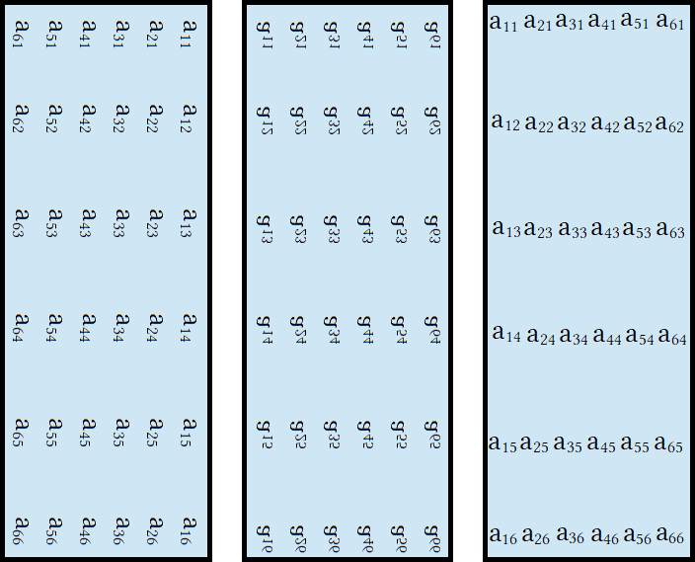
- This literally shows the matrix rotated 90° about its center.
- Then shows it reflected about it's vertical line of symmetry.
- A y axis reflection is a complex rotation of 90°.
- The last two are the same only the terms but I rotated them so you read
them easier. Orientation of the elements does not matter only location.

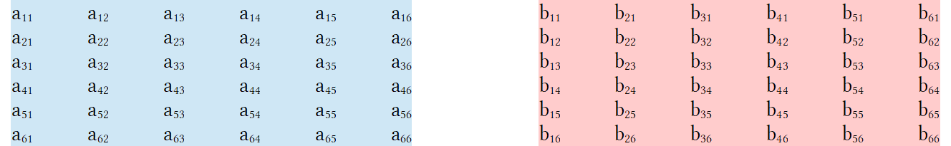

Matrix B is the transpose of matrix A.
Moving over adds 1, moving down adds 10, moving over and down adds 11.

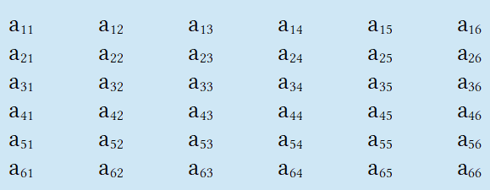
- Start with matrix A:

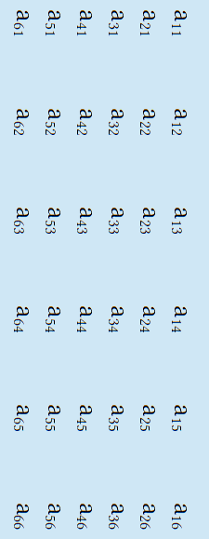
- Rotate this image 90° to the right:

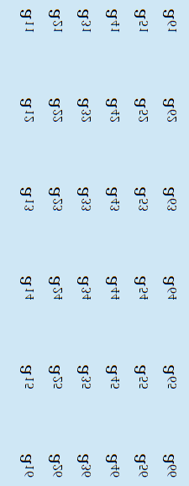
- Flip horizontally:

- The last two are the same but the terms
are re-orientated so you can read them.

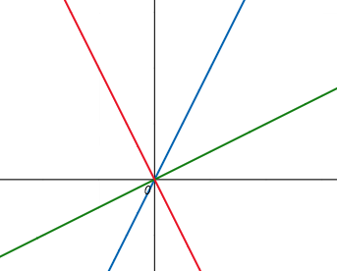
Start with a blue function like f(x) = 2x.
The red function reflected of it at some point like g(x) = – ½x.
The inverse of f(x) as a green function by using the reciprocal of slope h(x) = ½x.

The angle between any point on the red and green functions is 90°.
To transform a point on the red function to the green function there
are three options:

- P→P' is a 90° rotation clockwise.
- P→P' is a 270° rotation counter-clockwise.
- P→P' is a 180° rotation about the complex plane followed by a rotation of θ°.
We are interested in this last one.

More importantly any point the red function has a horizontal twin on the blue function.
We can transform a point to its twin with a horizontal slide or a “twirl”. A twirl is a complex rotation.
This is what we are interested in if dealing with matrices. A twirl is a horizontal “flip”.
A matrix tends to rotate along its “diagonal row” using it as a diagonal axis.
This is two rotations called “flip and rotate” that can be treated as a single complex rotation of 180°.
The point it rotates about is the only complicated thing to solve. This is covered in geometry or linear algebra.
Geometry uses plain language to state the transformation but lacks mathematical models to describe it.
Linear algebra provides precise tools to write this transformation using matrices and imaginary numbers.
Linear algebra equations (mathematical models), geometry doesn't.

Compared to the red the the green is a 90° rotation about (0,0) in the xy plane.
Compared to the blue the red is rotated θ° where theta is a reflection about the y axis.

A “reflection” is a 180° rotation about (0,0) in the xz plane.
This is also called 180° complex rotation since graph only has x and y axes.
Reflections are relation to conic sections. Imagine the red and blue functions as reflections.
Now imagine they trace a circle that forms the base of a cone.

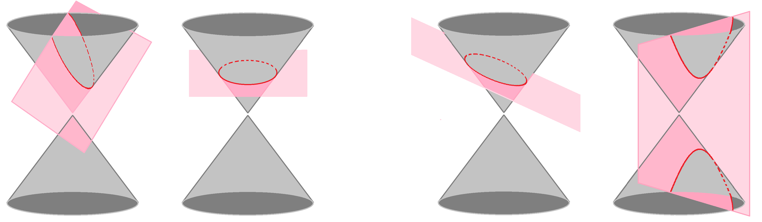

The sides of the cone could be formed by a function and its opposite like f(x)= 2x and g(x) = –2x.
These are reflections made by rotating one segment so its endpoint traces the base of the cone.
A reflection is a “flip” which is a 180° rotation which is a half circle or half turn.
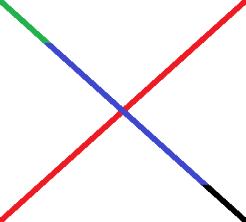
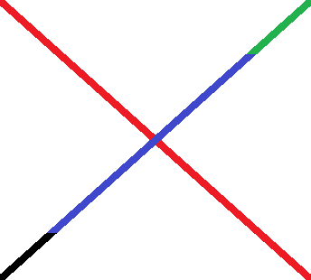
This “flip” is really a 180° rotation about the complex plane.
Note the green and black indicator tips.

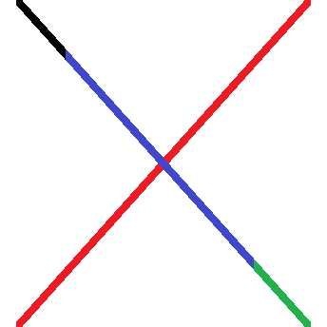
This is a 90° rotation clockwise. Without the indicator tips
It would be hard to tell whether the rotation was clockwise or counterclockwise and impossible to tell whether it was a 90° rotation in the xy plane or a 180°rotation in the xz plane.

a_{n} | a₁ | a₂ | a₃ | a₄ | a₅ | a₆ | a₇ | a₈ | a₉ | a₁₀ | a₁₁ | a₁₂ | a₁₃ | a₁₄ | a₁₅ | a₁₆ | a₁₇ | a₁₈ | a₁₉ | a₂₀ | a₂₁ | a₂₂ | a₂₃ | a₂₄ | a₂₅ | a₂₆ | a₂₇ | a₂₈ | a₂₉ | a₃₀ | a₃₁ | a₃₂ | a₃₃ | a₃₄ | a₃₅ | a₃₆
a | 11 | 12 | 13 | 14 | 15 | 16 | 21 | 22 | 23 | 24 | 25 | 26 | 31 | 32 | 33 | 34 | 35 | 36 | 41 | 42 | 43 | 44 | 45 | 46 | 51 | 52 | 53 | 54 | 55 | 56 | 61 | 62 | 63 | 64 | 65 | 66
b | 11 | 21 | 31 | 41 | 51 | 61 | 12 | 22 | 32 | 42 | 52 | 62 | 13 | 23 | 33 | 43 | 53 | 63 | 14 | 24 | 34 | 44 | 54 | 65 | 15 | 25 | 35 | 45 | 55 | 65 | 16 | 26 | 36 | 46 | 56 | 66

The inverse is a transformation that maps the original position of an element to a new position.

a₁₁ → b₁₁ a₁₂ → b₂₁ a₁₃ → b₃₁ a₁₄ → b₄₁ a₁₅ → b₅₁ a₁₆ → b₆₁
a₂₁ → b₁₂ a₂₂ → b₂₂ a₂₃ → b₃₂ a₂₄ → b₄₂ a₂₅ → b₅₂ a₂₆ → b₆₂
a₃₁ → b₁₃ a₃₂ → b₂₃ a₃₃ → b₃₃ a₃₄ → b₄₃ a₃₅ → b₅₃ a₃₆ → b₆₃
a₄₁ → b₁₄ a₄₂ → b₂₄ a₄₃ → b₃₄ a₄₄ → b₄₄ a₄₅ → b₅₄ a₄₆ → b₆₄
a₅₁ → b₁₅ a₅₂ → b₂₅ a₅₃ → b₃₅ a₅₆ → b₄₅ a₅₅ → b₅₅ a₅₆ → b₆₅
a₆₁ → b₁₆ a₆₂ → b₂₆ a₆₃ → b₆₃ a₆₄ → b₄₆ a₆₅ → b₅₆ a₆₆ → b₆₆

The diagonal row values that do not change when inverted. Iff we are drawing vectors as line segments in the xy plane values like these are called eigen values. The vector containing all eigen values is called the eigen vector.
Eigen values are more complicated than simply the diagonal of a matrix. If you hold a piece of paper crooked then rotate it so that you can only see the edge then the line representing the edge is an eigen vector and all points on that line are eigen values because they did not move during the transformation.
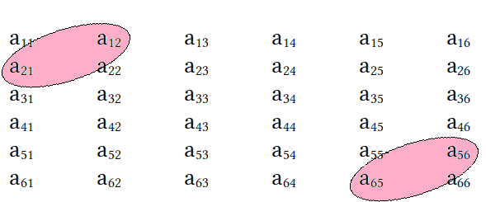
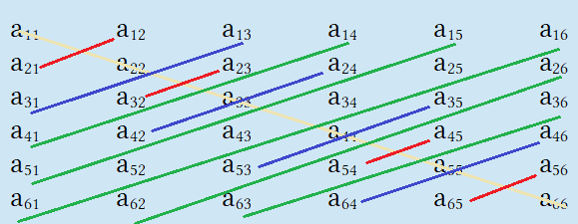

Diagonal lines connect values with their inverses as shown by the pink bubbles. If we rotated the image with lines along it's yellow diagonal so that instead of being in the xy plane it was in the xz plane then all points in the plane are transformed to different locations except points on the yellow diagonal. The yellow diagonal would be the axis of rotation so everything above and below it spins 90° while it spins in place.

Think of everything above the diagonal spinning 90° and stopping behind the diagonal. Then think of everything below the diagonal spinning 90° and stopping in front of it. Everything above and below would spin out of view. After spinning we are no longer looking at a 2d plane or shape we are looking at a 1d line that is the yellow diagonal. We can spin things on other axes of rotation. If we use the green diagonal as the axis of rotation then rotating 90° along it makes everything move except points on the green diagonal. When points do not move like this they are called eigen values and the line they form is called an eigen vector. A vector is just a line segment. A vector has a more technical definition but ignoring that for a casual talk it is just a line segment.

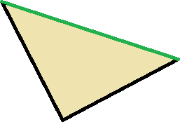
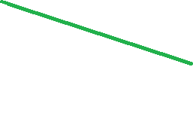

This is some 2d shape or plane. Rotating this object 90° along the green line makes everything disappear from view except the green line. The green line is then the eigen vector and all points on it eigen values.

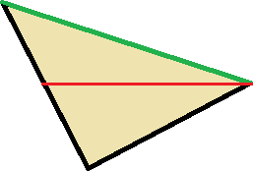
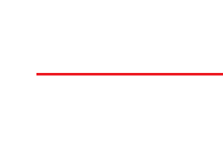

Here is an arbitrary line to serve as an axis of rotation. We can put it anywhere on the object at any angle. We rotate 90° and change from seeing a 2d object to a 1d object. Such transformations are called complex in that we are spinning the object into dimensions not accessible to our plane of view. For a 2d object it means spinning in a third dimension (usually z). For a 1d object it means spinning in a second dimension (usually y). This is what happens with quadratics when you have a negative square root as a solution. Your imaginary solution acts like a number that rotates your object 90°, or more or less, in and out of a higher dimension. In definition there are differences between the imaginary axis and y or z axes but in practice and application there isn't. The imaginary axis is the axis 1 dimension higher. Reducing an object by 1 dimension changes it from a cube to a square, pyramid or cone to a triangle, sphere to a circle, and so on. A 1d line or curve changed to 0d would just be a dot and a 0d dot change3d to –1d would not exist. 4d to –1d analogues.

4d→3d→2d→1d→0d→–1d
Hyper cube→cube→square→line→dot→nothing.
Hyper pyramid→pyramid→triangle→line→dot→nothing.
Hyper sphere→sphere→circle→line→dot→nothing.

The more hypothetical a dimension the harder it is to justify some results.
We can accurately measure up to at least 4 dimension easily. The keyword is easily.
We can add as many dimensions as we want if we take dimensions to be conceptual rather than empirical.

We can treat the previous triangle as half of a quadrilateral:

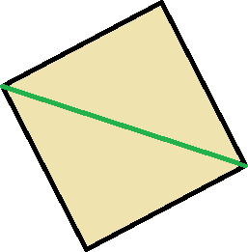
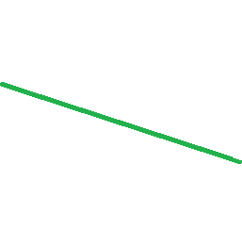

Rotating the 2d plane 90° along the green line in the xz dimensions (xz plane) makes the points not on it disappear. This means we are looking at a flat plane first from top down and then from the side. In theory we would not be able to see the points on the green line and use the green line to embellish their thickness so they are visible.

Rolling for W thrice in a row is 1:216.

111 112 113 114 115 116 121 122 123 124 125 126
131 132 133 134 135 136 141 142 143 144 145 146
151 152 153 154 155 156 161 162 163 164 165 166
211 212 213 214 215 216 221 222 223 224 225 226
231 232 233 234 235 236 241 242 243 244 245 246
251 252 253 254 255 256 261 262 263 264 265 266
311 312 313 314 315 316 321 322 323 324 325 326
331 332 333 334 335 336 341 342 343 344 345 346
351 352 353 354 355 356 361 362 363 364 365 366
411 412 413 414 415 416 421 422 423 424 425 426
431 432 433 434 435 436 441 442 443 444 445 446
451 452 453 454 455 456 461 462 463 464 465 466
511 512 513 514 515 516 521 522 523 524 525 526
531 532 533 534 535 536 541 542 543 544 545 546
551 552 553 554 555 556 561 562 563 564 565 566
611 612 613 614 615 616 621 622 623 624 625 626
631 632 633 634 635 636 641 642 643 644 645 646
651 652 653 654 655 656 661 662 663 664 665 666

This is a 12×18 matrix. This was the easiest way to show the data. This is every roll possible. Red numbers are a roll that contains at least one 4. The roll we want is 444. We target this entry by locating it in the 10th column 11th row.

- 216 rolls possible. 216 = 6³ which is 3!³.
- 81 rolls contain at least one 4. 81= 3⁴.
- 12 rolls contain two 4's. 12 = 2∙3!
- 1 roll that contains three 4's. 1 = 216⁰.

There are other ways to display the data. Using letters would have taken up to much space and been hard to figure where WWW WLW LLL LWL etc would go. Using numbers is much easier and more direct as it clearly shows what combinations are. Use number codes then convert to letters later if necessary.

We could have used different matrix sizes. We could have used any factors of 216 to create a matrix. Popular would have been 6×36 but that would have been too tall and taken up to much space vertically while wasting space horizontally. This would have been hard to see all the data at once due to excessive scrolling. A square is the most compact shape so we want our rectangular matrix to be as close to a square as possible as that allows us to see all the data at once. The square root of 216 is irrational and we can not have fractional lengths for our matrix, they must be integers. So we can not use the square root and have a √216×√216 because although it would the most compact it isn't a whole #.

Factors of 216: 2×108 3×72 4×54 6×36 8×27 9×24 12×18 18×12 24×9 27×8 36×6 54×4 72×2 108×2.

12×18 or 18×12 is the closest to a square matrix as we can get using them makes data entries line up nicer.
Notice that we have 14 possible matrices. 14 is an even number. If we want something closest to a square we need the combination that is most in the middle because the two numbers will have the smallest difference. They are closest to equaling each other and are of by the least amount compared to the others. Even amount of items has two middle numbers while odd amount of items has 1 middle number. Notice that the last 7 options are inverted forms of the first 7.

If 1,2,3 then 2 is the median. Odd items have 1 middle number. Formula for middle term # is ^{n}/₂ = x+½ use x+1.
If 1,2,3,4 then 2 and 3 are the two median numbers. Even items have 2 middle numbers. ^{N}/₂ = x^{th} use x and x+1.
If 14 terms: 6+1+1+6 = 14 then 14/2 = 7. 7 and 8 are the two median terms because ¹⁴/₂ = x^{th} so x=7th and x+1=8th.
If 15 terms the 7+1+7 = 15 then “1” is the middle term. We have 7 terms on either side of the 8th term.
Option #1 is 12×18. This limits columns and is easy to work with.
It looks the most square because our entries are 3 digits. This is a good option.

111 112 113 114 115 116 121 122 123 124 125 126
131 132 133 134 135 136 141 142 143 144 145 146
151 152 153 154 155 156 161 162 163 164 165 166
211 212 213 214 215 216 221 222 223 224 225 226
231 232 233 234 235 236 241 242 243 244 245 246
251 252 253 254 255 256 261 262 263 264 265 266
311 312 313 314 315 316 321 322 323 324 325 326
331 332 333 334 335 336 341 342 343 344 345 346
351 352 353 354 355 356 361 362 363 364 365 366
411 412 413 414 415 416 421 422 423 424 425 426
431 432 433 434 435 436 441 442 443 444 445 446
451 452 453 454 455 456 461 462 463 464 465 466
511 512 513 514 515 516 521 522 523 524 525 526
531 532 533 534 535 536 541 542 543 544 545 546
551 552 553 554 555 556 561 562 563 564 565 566
611 612 613 614 615 616 621 622 623 624 625 626
631 632 633 634 635 636 641 642 643 644 645 646
651 652 653 654 655 656 661 662 663 664 665 666

Option #2 is 18×12. This uses more columns so wastes less space horizontally. It is just as square as option #1 but looks more rectangular. This highlights codes with two 4's better.

111 112 113 114 115 116 121 122 123 124 125 126 131 132 133 134 135 136
141 142 143 144 145 146 151 152 153 154 155 156 161 162 163 164 165 166
211 212 213 214 215 216 221 222 223 224 225 226 231 232 233 234 235 236
241 242 243 244 245 246 251 252 253 254 255 256 261 262 263 264 265 266
311 312 313 314 315 316 321 322 323 324 325 326 331 332 333 334 335 336
341 342 343 344 345 346 351 352 353 354 355 356 361 362 363 364 365 366
411 412 413 414 415 416 421 422 423 424 425 426 431 432 433 434 435 436
441 442 443 444 445 446 451 452 453 454 455 456 461 462 463 464 465 466
511 512 513 514 515 516 521 522 523 524 525 526 531 532 533 534 535 536
541 542 543 544 545 546 551 552 553 554 555 556 561 562 563 564 565 566
611 612 613 614 615 616 621 622 623 624 625 626 631 632 633 634 635 636
641 642 643 644 645 646 651 652 653 654 655 656 661 662 663 664 665 666

Option #3 is 9×24, it designed to use the most horizontal space. It has 24 columns which is just under 27 keeping it from needing double character column names after 26 columns. This misses double 4's like 144 and 344 which are in the red columns in the other two arrangements.

111 112 113 114 115 116 121 122 123 124 125 126 131 132 133 134 135 136 141 142 143 144 145 146
151 152 153 154 155 156 161 162 163 164 165 166 211 212 213 214 215 216 221 222 223 224 225 226
231 232 233 234 235 236 241 242 243 244 245 246 251 252 253 254 255 256 261 262 263 264 265 266
311 312 313 314 315 316 321 322 323 324 325 326 331 332 333 334 335 336 341 342 343 344 345 346
351 352 353 354 355 356 361 362 363 364 365 366 411 412 413 414 415 416 421 422 423 424 425 426
431 432 433 434 435 436 441 442 443 444 445 446 451 452 453 454 455 456 461 462 463 464 465 466
511 512 513 514 515 516 521 522 523 524 525 526 531 532 533 534 535 536 541 542 543 544 545 546
551 552 553 554 555 556 561 562 563 564 565 566 611 612 613 614 615 616 621 622 623 624 625 626
631 632 633 634 635 636 641 642 643 644 645 646 651 652 653 654 655 656 661 662 663 664 665 666
Rolling for W 4 times in a row is 1:1296.

1111 1112 1113 1114 1115 1116 1121 1122 1123 1124 1125 1126 2111 2112 2113 2114 2115 2116 2121 2122 2123 2124 2125 2126
1131 1132 1133 1134 1135 1136 1141 1142 1143 1144 1145 1146 2131 2132 2133 2134 2135 2136 2141 2142 2143 2144 2145 2146
1151 1152 1153 1154 1155 1156 1161 1162 1163 1164 1165 1166 2151 2152 2153 2154 2155 2156 2161 2162 2163 2164 2165 2166
1211 1212 1213 1214 1215 1216 1221 1222 1223 1224 1225 1226 2211 2212 2213 2214 2215 2216 2221 2222 2223 2224 2225 2226
1231 1232 1233 1234 1235 1236 1241 1242 1243 1244 1245 1246 2231 2232 2233 2234 2235 2236 2241 2242 2243 2244 2245 2246
1251 1252 1253 1254 1255 1256 1261 1262 1263 1264 1265 1266 2251 2252 2253 2254 2255 2256 2261 2262 2263 2264 2265 2266
1311 1312 1313 1314 1315 1316 1321 1322 1323 1324 1325 1326 2311 2312 2313 2314 2315 2316 2321 2322 2323 2324 2325 2326
1331 1332 1333 1334 1335 1336 1341 1342 1343 1344 1345 1346 2331 2332 2333 2334 2335 2336 2341 2342 2343 2344 2345 2346
1351 1352 1353 1354 1355 1356 1361 1362 1363 1364 1365 1366 2351 2352 2353 2354 2355 2356 2361 2362 2363 2364 2365 2366
1411 1412 1413 1414 1415 1416 1421 1422 1423 1424 1425 1426 2411 2412 2413 2414 2415 2416 2421 2422 2423 2424 2425 2426
1431 1432 1433 1434 1435 1436 1441 1442 1443 1444 1445 1446 2431 2432 2433 2434 2435 2436 2441 2442 2443 2444 2445 2446
1451 1452 1453 1454 1455 1456 1461 1462 1463 1464 1465 1466 2451 2452 2453 2454 2455 2456 2461 2462 2463 2464 2465 2466
1511 1512 1513 1514 1515 1516 1521 1522 1523 1524 1525 1526 2511 2512 2513 2514 2515 2516 2521 2522 2523 2524 2525 2526
1531 1532 1533 1534 1535 1536 1541 1542 1543 1544 1545 1546 2531 2532 2533 2534 2535 2536 2541 2542 2543 5254 2545 2546
1551 1552 1553 1554 1555 1556 1561 1562 1563 1564 1565 1566 2551 2552 2553 2554 2555 2556 2561 2562 2563 2564 2565 2566
1611 1612 1613 1614 1615 1616 1621 1622 1623 1624 1625 1626 2611 2612 2613 2614 2615 2616 2621 2622 2623 2624 2625 2626
1631 1632 1633 1634 1635 1636 1641 1642 1643 1644 1645 1646 2631 2632 2633 2634 2635 2636 2641 2642 2643 2644 2645 2646
1651 1652 1653 1654 1655 1656 1661 1662 1663 1664 1665 1666 2651 2652 2653 2654 2655 2656 2661 2662 2663 2664 2665 2666

3111 3112 3113 3114 3115 3116 3121 3122 3123 3124 3125 3126 4111 4112 4113 4114 4115 4116 4121 4122 4123 4124 4125 4126
3131 3132 3133 3134 3135 3136 3141 3142 3143 3144 3145 3146 4131 4132 4133 4134 4135 4136 4141 4142 4143 4144 4145 4146
3151 3152 3153 3154 3155 3156 3161 3162 3163 3164 3165 3166 4151 4152 4153 4154 4155 4156 4161 4162 4163 4164 4165 4166
3211 3212 3213 3214 3215 3216 3221 3222 3223 3224 3225 3226 4211 4212 4213 4214 4215 4216 4221 4222 4223 4224 4225 4226
3231 3232 3233 3234 3235 3236 3241 3242 3243 3244 3245 3246 4231 4232 4233 4234 4235 4236 4241 4242 4243 4244 4245 4246
3251 3252 3253 3254 3255 3256 3261 3262 3263 3264 3265 3266 4251 4252 4253 4254 4255 4256 4261 4262 4263 4264 4265 4266
3311 3312 3313 3314 3315 3316 3321 3322 3323 3324 3325 3326 4311 4312 4313 4314 4315 4316 4321 4322 4323 4324 4325 4326
3331 3332 3333 3334 3335 3336 3341 3342 3343 3344 3345 3346 4331 4332 4333 4334 4335 4336 4341 4342 4343 4344 4345 4346
3351 3352 3353 3354 3355 3356 3361 3362 3363 3364 3365 3366 4351 4352 4353 4354 4355 4356 4361 4362 4363 4364 4365 4366
3411 3412 3413 3414 3415 3416 3421 3422 3423 3424 3425 3426 4411 4412 4413 4414 4415 4416 4421 4422 4423 4424 4425 4426
3431 3432 3433 3434 3435 3436 3441 3442 3443 3444 3445 3446 4431 4432 4433 4434 4435 4436 4441 4442 4443 4444 4445 4446
3451 3452 3453 3454 3455 3456 3461 3462 3463 3464 3465 3466 4451 4452 4453 4454 4455 4456 4461 4462 4463 4464 4465 4466
3511 3512 3513 3514 3515 3516 3521 3522 3523 3524 3525 3526 4511 4512 4513 4514 4515 4516 4521 4522 4523 4524 4525 4526
3531 3532 3533 3534 3535 3536 3541 3542 3543 3544 3545 3546 4531 4532 4533 4534 4535 4536 4541 4542 4543 4544 4545 4546
3551 3552 3553 3554 3555 3556 3561 3562 3563 3564 3565 3566 4551 4552 4553 4454 4555 4556 4561 4562 4563 4564 4565 4566
3611 3612 3613 3614 3615 3616 3621 3622 3623 3624 3625 3626 4611 4612 4613 4614 4615 4616 4621 4622 4623 4624 4625 4626
3631 3632 3633 3634 3635 3636 3641 3642 3643 3644 3645 3646 4631 4632 4633 4634 4635 4636 4641 4642 4643 4644 4645 4646
3651 3652 3653 3654 3655 3656 3661 3662 3663 3664 3665 3666 4651 4652 4653 4654 4655 4656 4661 4662 4663 4664 4665 4666

5111 5112 5113 5114 5115 5116 5121 5122 5123 5124 5125 5126 6111 6112 6113 6114 6115 6116 6121 6122 6123 6124 6125 6126
5131 5132 5133 5134 5135 5136 5141 5142 5143 5144 5145 5146 6131 6132 6133 6134 6135 6136 6141 6142 6143 6144 6145 6146
5151 5152 5153 5154 5155 5156 5161 5162 5163 5164 5165 5166 6151 6152 6153 6154 6155 6156 6161 6162 6163 6164 6165 6166
5211 5212 5213 5214 5215 5216 5221 5222 5223 5224 5225 5226 6211 6212 6213 6214 6215 6216 6221 6222 6223 6224 6225 6226
5231 5232 5233 5234 5235 5236 5241 5242 5243 5244 5245 5246 6231 6232 6233 6234 6235 6236 6241 6242 6243 6244 6245 6246
5251 5252 5253 5254 5255 5256 5261 5262 5263 5264 5265 5266 6251 6252 6253 6254 6255 6256 6261 6262 6263 6264 6265 6266
5311 5312 5313 5314 5315 5316 5321 5322 5323 5324 5325 5326 6311 6312 6313 6314 6315 6316 6321 6322 6323 6324 6325 6326
5331 5332 5333 5334 5335 5336 5341 5342 5343 5344 5345 5346 6331 6332 6333 6334 6335 6336 6341 6342 6343 6344 6345 6346
5351 5352 5353 5354 5355 5356 5361 5362 5363 5364 5365 5366 6351 6352 6353 6354 6355 6356 6361 6362 6363 6364 6365 6366
5411 5412 5413 5414 5415 5416 5421 5422 5423 5424 5425 5426 6411 6412 6413 6414 6415 6416 6421 6422 6423 6424 6425 6426
5431 5432 5433 5434 5435 5436 5441 5442 5443 5444 5445 5446 6431 6432 6433 6434 6435 6436 6441 6442 6443 6444 6445 6446
5451 5452 5453 5454 5455 5456 5461 5462 5463 5464 5465 5466 6451 6452 6453 6454 6455 6456 6461 6462 6463 6464 6465 6466
5511 5512 5513 5514 5515 5516 5521 5522 5523 5524 5525 5526 6511 6512 6513 6514 6515 6516 6521 6522 6523 6524 6525 6526
5531 5532 5533 5534 5535 5536 5541 5542 5543 5544 5545 5546 6531 6532 6533 6534 6535 6536 6541 6542 6543 6544 6545 6546
5551 5552 5553 5554 5555 5556 5561 5562 5563 5564 5565 5566 6551 6552 6553 6554 6555 6556 6561 6562 6563 6564 6565 6566
5611 5612 5613 5614 5615 5616 5621 5622 5623 5624 5625 5626 6611 6612 6613 6614 6615 6616 6621 6622 6623 6624 6625 6626
5631 5632 5633 5634 5635 5636 5641 5642 5643 5644 5645 5646 6631 6632 6633 6634 6635 6636 6641 6642 6643 6644 6645 6646
5651 5652 5653 5654 5655 5656 5661 5662 5663 5664 5665 5666 6651 6652 6653 6654 6655 6656 6661 6662 6663 6664 6665 6666

This is the same sequencing as 3 rolls except we add a digit to the from. As this is exponential 3 rolls is 6³ = 216 or 6∙6∙6. Four rolls will be 6⁴ = 1296 or 6³∙6. We take our list of 216, treat it as a group, and then multiply that group by 6. We write the groups six times for six groups that all have the same leading digit of 1-6.
When typing out the previous code a separate master list wast used where the list had a variable x as the first digit which then could be changed to 1-6 and copy and pasted into this main document.

x111 x112 x113 x114 x115 x116 x121 x122 x123 x124 x125 x126
x131 x132 x133 x134 x135 x136 x141 x142 x143 x144 x145 x146
x151 x152 x153 x154 x155 x156 x161 x162 x163 x164 x165 x166
x211 x212 x213 x214 x215 x216 x221 x222 x223 x224 x225 x226
x231 x232 x233 x234 x235 x236 x241 x242 x243 x244 x245 x246
x251 x252 x253 x254 x255 x256 x261 x262 x263 x264 x265 x266
x311 x312 x313 x314 x315 x316 x321 x322 x323 x324 x325 x326
x331 x332 x333 x334 x335 x336 x341 x342 x343 x344 x345 x346
x351 x352 x353 x354 x355 x356 x361 x362 x363 x364 x365 x366
x411 x412 x413 x414 x415 x416 x421 x422 x423 x424 x425 x426
x431 x432 x433 x434 x435 x436 x441 x442 x443 x444 x445 x446
x451 x452 x453 x454 x455 x456 x461 x462 x463 x464 x465 x466
x511 x512 x513 x514 x515 x516 x521 x522 x523 x524 x525 x526
x531 x532 x533 x534 x535 x536 x541 x542 x543 x544 x545 x546
x551 x552 x553 x554 x555 x556 x561 x562 x563 x564 x565 x566
x611 x612 x613 x614 x615 x616 x621 x622 x623 x624 x625 x626
x631 x632 x633 x634 x635 x636 x641 x642 x643 x644 x645 x646
x651 x652 x653 x654 x655 x656 x661 x662 x663 x664 x665 x666

That way I write the list of 216 terms once, then change it 6 times and copy and paste. This reduces error, is organized, and time efficient. Instead of writing one huge matrix we break the table up into 6 tables that are easier to manage. Each table is a 12×18 matrix. Each entry is located by table format of letters for column and numbers for row. Writing in a table took up more space but also enhanced functions to reorganize or modify data. I do not need to do that. I need to show the data as clear as possible. It is more visible writing outside a table sometimes.

x111 | x112 | x113 | x114 | x115 | x116 | x121 | x122 | x123 | x124 | x125 | x126
x131 | x132 | x133 | x134 | x135 | x136 | x141 | x142 | x143 | x144 | x145 | x146
x151 | x152 | x153 | x154 | x155 | x156 | x161 | x162 | x163 | x164 | x165 | x166
x211 | x212 | x213 | x214 | x215 | x216 | x221 | x222 | x223 | x224 | x225 | x226
x231 | x232 | x233 | x234 | x235 | x236 | x241 | x242 | x243 | x244 | x245 | x246
x251 | x252 | x253 | x254 | x255 | x256 | x261 | x262 | x263 | x264 | x265 | x266
x311 | x312 | x313 | x314 | x315 | x316 | x321 | x322 | x323 | x324 | x325 | x326
x331 | x332 | x333 | x334 | x335 | x336 | x341 | x342 | x343 | x344 | x345 | x346
x351 | x352 | x353 | x354 | x355 | x356 | x361 | x362 | x363 | x364 | x365 | x366
x411 | x412 | x413 | x414 | x415 | x416 | x421 | x422 | x423 | x424 | x425 | x426
x431 | x432 | x433 | x434 | x435 | x436 | x441 | x442 | x443 | x444 | x445 | x446
x451 | x452 | x453 | x454 | x455 | x456 | x461 | x462 | x463 | x464 | x465 | x466
x511 | x512 | x513 | x514 | x515 | x516 | x521 | x522 | x523 | x524 | x525 | x526
x531 | x532 | x533 | x534 | x535 | x536 | x541 | x542 | x543 | x544 | x545 | x546
x551 | x552 | x553 | x554 | x555 | x556 | x561 | x562 | x563 | x564 | x565 | x566
x611 | x612 | x613 | x614 | x615 | x616 | x621 | x622 | x623 | x624 | x625 | x626
x631 | x632 | x633 | x634 | x635 | x636 | x641 | x642 | x643 | x644 | x645 | x646
x651 | x652 | x653 | x654 | x655 | x656 | x661 | x662 | x663 | x664 | x665 | x666

I used xy11-xy66 to make the last table. I only changed y 6 times using [find and replace] to write 6 groups of 36 entries. This changes the second digit or the “hundreds” digit. Methods like this make generating entries for tables much easier. You can use as many variables as you want to modify and generate an many sets and subsets as you want. All the entries are the master set called the superset. If we change the first digit we have 6 series in the range of x111-x666 where x can be 1-6 so we say the domain is x:[1,6]. We could maybe even say x has a range of x:[1,6] but I do not like that. (x111) is an output where (1,2,3,4,5,6) are inputs for x. {1,2,3,4,5,6} is the domain of x not the range. The range is numbers that result like (1111,2111,3111,4111,5111,6111). For 1111-6666 there are 1296 entries. Here we can call each entry a “term” so we can say there are 1296 terms. We have 1296 different 4-digit numbers. Each number is an entry and each entry is a term. Our superset is the set containing 1296 entries or terms. 1296÷6 = 216... we have 6 subsets of 216 entries. We call each subset a series even though sequence is more accurate.

Pronunciation | Series | Range | Terms
Thousand series | 1xxx | 1111-1666 | 216
Two Thousand series | 2xxx | 2111-2666 | 216
Three Thousand series | 3xxx | 3111-3666 | 216
Four Thousand series | 4xxx | 4111-4666 | 216
Five Thousand series | 5xxx | 5111-5666 | 216
Six Thousand series | 6xxx | 6111-6666 | 216

216÷6 = 36 We have 6 sub-subsets of 36 entries. We call each sub-subset a mini-series.

Pronunciation | Series | Range | Terms
Eleven hundred series | 11xx | 1111-1166 | 36
Twelve hundred series | 12xx | 1211-1266 | 36
Thirteen hundred series | 13xx | 1311-1366 | 36
Fourteen hundred series | 14xx | 1411-1466 | 36
Fifteen hundred series | 15xx | 1511-1566 | 36
Sixteen hundred series | 16xx | 1611-1666 | 36

This can be generalized to all sub-subsets in the superset of 1296 entries by choosing 1-6 for x:

Pronunciation | Series | Range | Terms
x hundred series | x1xx | x111-x166 | 36
x two hundred series | x2xx | x211-x266 | 36
x Three hundred series | x3xx | x311-x366 | 36
x Four hundred series | x4xx | x411-x466 | 36
x Five hundred series | x5xx | x511-x566 | 36
x Six hundred series | x6xx | x611-x666 | 36

This gives us A 6×6 matrix of 36 sub-subsets. Matrices can be written in a table or not:

1111-1166 1211-1266 1311-1366 1411-1466 1511-1566 1611-1666
2111-1166 2211-2266 2311-2366 2411-2466 2511-2566 2611-2666
3111-1166 3211-3266 3311-3366 3411-3466 3511-3566 3611-3666
4111-1166 4211-4266 4311-4366 4411-4466 4511-4566 4611-4666
5111-5166 5211-5266 5311-5366 5411-5466 5511-5566 5611-5666
6111-6166 6211-6266 6311-6366 6411-6466 6511-6566 6611-6666

Note that a 6×6 is a square matrix. Originally we had a 12×18. Doing this allows us to “square” our matrix.
This is possible because all cells of our table has the same “weight” meaning value of 6 individual entries.
Each cell is 6 single codes and each row is 6 cells. The are 36 codes per row. Each row is a series “x000”.
Breaking the sub-subsets into sub-sub-subsets we would have a 36×6 matrix of 216 mini-miniseries.
The 36×6 matrix would collapse this:

1111 1112 1113 1114 1115 1116 1121 1122 1123 1124 1125 1126 1131 1132 1133 1134 1135 1136 1141 1142 1143 1144 1145 1146 1151 1152 1153 1154 1155 1156 1161 1162 1163 1164 1165 1166
1211 1212 1213 1214 1215 1216 1221 1222 1223 1224 1225 1226 1231 1232 1233 1234 1235 1236 1241 1242 1243 1244 1245 1246 1251 1252 1253 1254 1255 1256 1261 1262 1263 1264 1265 1266
1311 1312 1313 1314 1315 1316 1321 1322 1323 1324 1325 1326 1331 1332 1333 1334 1335 1336 1341 1342 1343 1344 1345 1346 1351 1352 1353 1354 1355 1356 1361 1362 1363 1364 1365 1366
1411 1412 1413 1414 1415 1416 1421 1422 1423 1424 1425 1426 1431 1432 1433 1434 1435 1436 1441 1442 1443 1444 1445 1446 1451 1452 1453 1454 1455 1456 1461 1462 1463 1464 1465 1466
1511 1512 1513 1514 1515 1516 1521 1522 1523 1524 1525 1526 1531 1532 1533 1534 1535 1536 1541 1542 1543 1544 1545 1546 1551 1552 1553 1554 1555 1556 1561 1562 1563 1564 1565 1566
1611 1612 1613 1614 1615 1616 1621 1622 1623 1624 1625 1626 1631 1632 1633 1634 1635 1636 1641 1642 1643 1644 1645 1646 1651 1652 1653 1654 1655 1656 1661 1662 1663 1664 1665 1666

2111 2112 2113 2114 2115 2116 2121 2122 2123 2124 2125 2126 2131 2132 2133 2134 2135 2136 2141 2142 2143 2144 2145 2146 2151 2152 2153 2154 2155 2156 2161 2162 2163 2164 2165 2166
2211 2212 2213 2214 2215 2216 2221 2222 2223 2224 2225 2226 2231 2232 2233 2234 2235 2236 2241 2242 2243 2244 2245 2246 2251 2252 2253 2254 2255 2256 2261 2262 2263 2264 2265 2266
2311 2312 2313 2314 2315 2316 2321 2322 2323 2324 2325 2326 2331 2332 2333 2334 2335 2336 2341 2342 2343 2344 2345 2346 2351 2352 2353 2354 2355 2356 2361 2362 2363 2364 2365 2366
2411 2412 2413 2414 2415 2416 2421 2422 2423 2424 2425 2426 2431 2432 2433 2434 2435 2436 2441 2442 2443 2444 2445 2446 2451 2452 2453 2454 2455 2456 2461 2462 2463 2464 2465 2466
2511 2512 2513 2514 2515 2516 2521 2522 2523 2524 2525 2526 2531 2532 2533 2534 2535 2536 2541 2542 2543 2544 2545 2546 2551 2552 2553 2554 2555 2556 2561 2562 2563 2564 2565 2566
2611 2612 2613 2614 2615 2616 2621 2622 2623 2624 2625 2626 2631 2632 2633 2634 2635 2636 2641 2642 2643 2644 2645 2646 2651 2652 2653 2654 2655 2656 2661 2662 2663 2664 2665 2666

3111 3112 3113 3114 3115 3116 3121 3122 3123 3124 3125 3126 3131 3132 3133 3134 3135 3136 3141 3142 3143 3144 3145 3146 3151 3152 3153 3154 3155 3156 3161 3162 3163 3164 3165 3166
3211 3212 3213 3214 3215 3216 3221 3222 3223 3224 3225 3226 3231 3232 3233 3234 3235 3236 3241 3242 3243 3244 3245 3246 3251 3252 3253 3254 3255 3256 3261 3262 3263 3264 3265 3266
3311 3312 3313 3314 3315 3316 3321 3322 3323 3324 3325 3326 3331 3332 3333 3334 3335 3336 3341 3342 3343 3344 3345 3346 3351 3352 3353 3354 3355 3356 3361 3362 3363 3364 3365 3366
3411 3412 3413 3414 3415 3416 3421 3422 3423 3424 3425 3426 3431 3432 3433 3434 3435 3436 3441 3442 3443 3444 3445 3446 3451 3452 3453 3454 3455 3456 3461 3462 3463 3464 3465 3466
3511 3512 3513 3514 3515 3516 3521 3522 3523 3524 3525 3526 3531 3532 3533 3534 3535 3536 3541 3542 3543 3544 3545 3546 3551 3552 3553 3554 3555 3556 3561 3562 3563 3564 3565 3566
3611 3612 3613 3614 3615 3616 3621 3622 3623 3624 3625 3626 3631 3632 3633 3634 3635 3636 3641 3642 3643 3644 3645 3646 3651 3652 3653 3654 3655 3656 3661 3662 3663 3664 3665 3666

4111 4112 4113 4114 4115 4116 4121 4122 4123 4124 4125 4126 4131 4132 4133 4134 4135 4136 4141 4142 4143 4144 4145 4146 4151 4152 4153 4154 4155 4156 4161 4162 4163 4164 4165 4166
4211 4212 4213 4214 4215 4216 4221 4222 4223 4224 4225 4226 4231 4232 4233 4234 4235 4236 4241 4242 4243 4244 4245 4246 4251 4252 4253 4254 4255 4256 4261 4262 4263 4264 4265 4266
4311 4312 4313 4314 4315 4316 4321 4322 4323 4324 4325 4326 4331 4332 4333 4334 4335 4336 4341 4342 4343 4344 4345 4346 4351 4352 4353 4354 4355 4356 4361 4362 4363 4364 4365 4366
4411 4412 4413 4414 4415 4416 4421 4422 4423 4424 4425 4426 4431 4432 4433 4434 4435 4436 4441 4442 4443 4444 4445 4446 4451 4452 4453 4454 4455 4456 4461 4462 4463 4464 4465 4466
4511 4512 4513 4514 4515 4516 4521 4522 4523 4524 4525 4526 4531 4532 4533 4534 4535 4536 4541 4542 4543 4544 4545 4546 4551 4552 4553 4554 4555 4556 4561 4562 4563 4564 4565 4566
4611 4612 4613 4614 4615 4616 4621 4622 4623 4624 4625 4626 4631 4632 4633 4634 4635 4636 4641 4642 4643 4644 4645 4646 4651 4652 4653 4654 4655 4656 4661 4662 4663 4664 4665 4666

5111 5112 5113 5114 5115 5116 5121 5122 5123 5124 5125 5126 5131 5132 5133 5134 5135 5136 5141 5142 5143 5144 5145 5146 5151 5152 5153 5154 5155 5156 5161 5162 5163 5164 5165 5166
5211 5212 5213 5214 5215 5216 5221 5222 5223 5224 5225 5226 5231 5232 5233 5234 5235 5236 5241 5242 5243 5244 5245 5246 5251 5252 5253 5254 5255 5256 5261 5262 5263 5264 5265 5266
5311 5312 5313 5314 5315 5316 5321 5322 5323 5324 5325 5326 5331 5332 5333 5334 5335 5336 5341 5342 5343 5344 5345 5346 5351 5352 5353 5354 5355 5356 5361 5362 5363 5364 5365 5366
5411 5412 5413 5414 5415 5416 5421 5422 5423 5424 5425 5426 5431 5432 5433 5434 5435 5436 5441 5442 5443 5444 5445 5446 5451 5452 5453 5454 5455 5456 5461 5462 5463 5464 5465 5466
5511 5512 5513 5514 5515 5516 5521 5522 5523 5524 5525 5526 5531 5532 5533 5534 5535 5536 5541 5542 5543 5544 5545 5546 5551 5552 5553 5554 5555 5556 5561 5562 5563 5564 5565 5566
5611 5612 5613 5614 5615 5616 5621 5622 5623 5624 5625 5626 5631 5632 5633 5634 5635 5636 5641 5642 5643 5644 5645 5646 5651 5652 5653 5654 5655 5656 5661 5662 5663 5664 5665 5666

6111 6112 6113 6114 6115 6116 6121 6122 6123 6124 6125 6126 6131 6132 6133 6134 6135 6136 6141 6142 6143 6144 6145 6146 6151 6152 6153 6154 6155 6156 6161 6162 6163 6164 6165 6166
6211 6212 6213 6214 6215 6216 6221 6222 6223 6224 6225 6226 6231 6232 6233 6234 6235 6236 6241 6242 6243 6244 6245 6246 6251 6252 6253 6254 6255 6256 6261 6262 6263 6264 6265 6266
6311 6312 6313 6314 6315 6316 6321 6322 6323 6324 6325 6326 6331 6332 6333 6334 6335 6336 6341 6342 6343 6344 6345 6346 6351 6352 6353 6354 6355 6356 6361 6362 6363 6364 6365 6366
6411 6412 6413 6414 6415 6416 6421 6422 6423 6424 6425 6426 6431 6432 6433 6434 6435 6436 6441 6442 6443 6444 6445 6446 6451 6452 6453 6454 6455 6456 6461 6462 6463 6464 6465 6466
6511 6512 6513 6514 6515 6516 6521 6522 6523 6524 6525 6526 6531 6532 6533 6534 6535 6536 6541 6542 6543 6544 6545 6546 6551 6552 6553 6554 6555 6556 6561 6562 6563 6564 6565 6566
6611 6612 6613 6614 6615 6616 6621 6622 6623 6624 6625 6626 6631 6632 6633 6634 6635 6636 6641 6642 6643 6644 6645 6646 6651 6652 6653 6654 6655 6656 6661 6662 6663 6664 6665 6666

Into this:

1x11 1x12 1x13 1x14 1x15 1x16 1x21 1x22 1x23 1x24 1x25 1x26 1x31 1x32 1x33 1x34 1x35 1x36 1x41 1x42 1x43 1x44 1x45 1x46 1x51 1x52 1x53 1x54 1x55 1x56 1x61 1x62 1x63 1x64 1x65 1x66
2x11 2x12 2x13 2x14 2x15 2x16 2x21 2x22 2x23 2x24 2x25 2x26 2x31 2x32 2x33 2x34 2x35 2x36 2x41 2x42 2x43 2x44 2x45 2x46 2x51 2x52 2x53 2x54 2x55 2x56 2x61 2x62 2x63 2x64 2x65 2x66
3x11 3x12 3x13 3x14 3x15 3x16 3x21 3x22 3x23 3x24 3x25 3x26 3x31 3x32 3x33 3x34 3x35 3x36 3x41 3x42 3x43 3x44 3x45 3x46 3x51 3x52 3x53 3x54 3x55 3x56 3x61 3x62 3x63 3x64 3x65 3x66
4x11 4x12 4x13 4x14 4x15 4x16 4x21 4x22 4x23 4x24 4x25 4x26 4x31 4x32 4x33 4x34 4x35 4x36 4x41 4x42 4x43 4x44 4x45 4x46 4x51 4x52 4x53 4x54 4x55 4x56 4x61 4x62 4x63 4x64 4x65 4x66
5x11 5x12 5x13 5x14 5x15 5x16 5x21 5x22 5x23 5x24 5x25 5x26 5x31 5x32 5x33 5x34 5x35 5x36 5x41 5x42 5x43 5x44 5x45 5x46 5x51 5x52 5x53 5x54 5x55 5x56 5x61 5x62 5x63 5x64 5x65 5x66
6x11 6x12 6x13 6x14 6x15 6x16 6x21 6x22 6x23 6x24 6x25 6x26 6x31 6x32 6x33 6x34 6x35 6x36 6x41 6x42 6x43 6x44 6x45 6x46 6x51 6x52 6x53 6x54 6x55 6x56 6x61 6x62 6x63 6x64 6x65 6x66

Using x as a variable to represent the digit available digits makes the table more compact and portable.
This is 6 sets of 216 entries written as set sets of 36 variable entries. This is a 6×36 matrix but each entry counts as 6 single values. This is approaching tensor territory. Inside each black x term is a hidden red entry that has a 4 in it. Compare truncated matrix with full matrix. Also note the full matrix is 36×36 and has a highlighted in dark yellow and bold diagonal row of {1111,2222,3333,4444}.

For the 36×36 matrix I spaced lines between the different groups of “x000's” for easier readability but it wasn't required. The truncated matrix is the same data as the full matrix but different ranges are used. Doing this changes 36 sets of 36 entries to 6 sets of 36 entries all with the same data.

For the full matrix each block of data shows 216 term per series . There are 6 series in the thousands range.
“x,000” means we have the 1000, 2000, 3000, 4000, 5000 and 6000 series.

We can collapse the 36×6 into a 1×6 or many other matrices:

|1xxx|
|2xxx|
|3xxx|
|4xxx|
|5xxx|
|6xxx|
We can group numerically or semi-numerically by listing sets as containing sequential or semi sequential terms. Semi looks like all the “10's” or “100's” or “110's” and so on.

{1111,1112,1113...2111,2112,2113...6116} would be the set that has 11 in the middle.
{1121,1122,1123...2121,2122,2123...6126} would be the set that has 12 in the middle.
{1221,12212,1223...2221,2222,2223...6226} would be the set that has 22 in the middle.

We are grouping all the numbers that share middle values. We call this x11x, x12x, x22x... and so on.
We can specify by just about anything. There are too many possibilities to list and many reasons to do this.
Being able to codify data by specific digit helps control data and have more power over it.

This is teaching how to organize data and later how to do advanced matrix operations. There are no limits.

Random examples: Last digit varies from 1-6. First digit varies from 1-6.

111x: {1111, 1112, 1113, 1114, 1115, 1116} x111: {1111, 2111, 3111, 4111, 5111, 6111}
112x: {1121, 1122, 1123, 1124, 1125, 1126} x112: {1112, 2122, 2112, 2112, 2112, 2112}
113x: {1131, 1132, 1133, 1134, 1135, 1136} x113: {1113, 2113, 3113, 4113, 5113, 6113}
114x: {1141, 1142, 1143, 1144, 1145, 1146} x114: {1114, 2114, 3114, 4114, 5114, 6114}
115x: {1151, 1152, 1153, 1154, 1155, 1156} x115: {1115, 2115, 3115, 4115, 5115, 6115}
116x: {1161, 1162, 1163, 1164, 1165, 1166} x116: {1116, 2116, 3116, 4116, 5116, 6116}

Combing 111x-116x with x111-x116 we get x11x:

x11x: {1111, 1112, 1113, 1114, 1115, 1116,2111, 2112, 2113, 2114, 2115, 2116...6116}
x22x: {1221, 1222, 1223, 1224, 1225, 1226,2221, 2222, 2223, 2224, 2225, 2226...6226}
x33x: {1331, 1332, 1333, 1334, 1335, 1336,2331, 2332, 2333, 2334, 2335, 2336...6336}
x44x: {1441, 1442, 1443, 1444, 1445, 1446,2441, 2442, 2443, 2444, 2445, 2446...6446}
x55x: {1551, 1552, 1553, 1554, 1555, 1556,2551, 2552, 2553, 2554, 2555, 2556...6556}
x66x: {1661, 1662, 1663, 1664, 1665, 1666,2661, 2662, 2663, 2664, 2665, 2666...6666}

There are 36 codes for per xAAx. A is used to mean a non variable constant. There are 36 codes each for x11x, x22x, x33x, x44x, x55x, x66x. 36∙6 = 1296. This is all the codes but grouped in sets that are not numerical but semi-numerical. Semi-numerical has more “skips”.

xx1x: {1111,1112,1113...1116,1211,1212,1213...6616} every term must have 1 as it's third digit.
xx2x: {1121,1122,1123...1126,1221,1222,1223...6626} every term must have 2 as it's third digit.
xx3x: {1131,1132,1133...1136,1231,1232,1233...6636} every term must have 3 as it's third digit.
xx4x: {1141,1142,1143...1146,1241,1242,1243...6646} every term must have 4 as it's third digit.
xx5x: {1151,1152,1153...1156,1251,1252,1253...6656} every term must have 5 as it's third digit.
xx6x: {1161,1162,1163...1166,1261,1262,1263...6666} every term must have 6 as it's third digit.

x1xx: {1111,1112,1113...1116,2111,2112,2113...6166} every term must have 1 as it's second digit.
x2xx: {1211,1212,1213...1216,2211,2212,2213...6266} every term must have 2 as it's second digit.
x3xx: {1311,1312,1313...1316,1231,1232,1233...6366} every term must have 3 as it's second digit.
x4xx: {1411,1412,1413...1416,2411,2412,2413...6466} every term must have 4 as it's second digit.
x5xx: {1511,1512,1513...1516,2511,2512,2513...6566} every term must have 5 as it's second digit.
x6xx: {1611,1612,1613...1616,2611,2612,2613...6666} every term must have 6 as it's second digit.

By ones,tens, hundreds, or thousands we have 1296÷6 = 216 subsets but they skip more numbers because the data is selected by different parameters. Depending on how matrices are set up this boils down to selecting all codes by row or column. There are Boolean operators that can select specific combinations and exclude others in a row or column. These are advance operations reserved for computer science and not covered here. Rolling for W 5 times in a row is 1:7776.

This is the same as the others. The larger the data set the more unwieldy and so more truncation is required. We write all possibilities no matter the digits as a formula where e^{d} = C is proven to be true for all cases. The use of matrices was not to calculate our odds but rather to prove that our formula holds up and to teach critical concepts of data storage, organization, manipulation, and retrieval. We did this with use of matrices to familiarize before the hard work of linear algebra. These skills are essential in cloud technologies, managing databases, data learning, AI, big data, Docker, Kubenetes, and system administration.

Rolling a 4 is 5 times is the same as 4 times except we are scaling the 4 in a row matrix by 6 by raising another power. 6⁵ = 7776. 7776 is a degree 1 number but 6⁵ is a 5 dimensional array. It is degree 5 meaning we have 5 dimensions in a conceptual way but not in a physical geometry way. 5 dimensions is hard to draw but the mathematician Coxeter and others have 2d pictograms that can represent such higher powers. Wikipedia has articles on higher geometries called simplexes like simplex-4, simplex-5, and higher. This is not the scope of this study of basic probability and probably not in even an advanced statistics course. We said we could collapse the 36×6 into a 1×6. By multiplying this matrix by 6 we will have 1296∙6 =7776:

The previous matrix of 4 rolls had mostly boring repetitive data that could be surmised by “6 choose 4 with repetition allowed” instead of a writing a time consuming massive matrix. Likewise 6⁵ rolls could be surmised by “6 choose 5 with repetition allowed”. When we have repetition allowed our permutations have to be written in exponential notation.

Four rolls of a die was 6∙6∙6∙6. Here was 6⁴ = 1296:

1111 1112 1113 1114 1115 1116 1121 1122 1123 1124 1125 1126 1131 1132 1133 1134 1135 1136 1141 1142 1143 1144 1145 1146 1151 1152 1153 1154 1155 1156 1161 1162 1163 1164 1165 1166
1211 1212 1213 1214 1215 1216 1221 1222 1223 1224 1225 1226 1231 1232 1233 1234 1235 1236 1241 1242 1243 1244 1245 1246 1251 1252 1253 1254 1255 1256 1261 1262 1263 1264 1265 1266
1311 1312 1313 1314 1315 1316 1321 1322 1323 1324 1325 1326 1331 1332 1333 1334 1335 1336 1341 1342 1343 1344 1345 1346 1351 1352 1353 1354 1355 1356 1361 1362 1363 1364 1365 1366
1411 1412 1413 1414 1415 1416 1421 1422 1423 1424 1425 1426 1431 1432 1433 1434 1435 1436 1441 1442 1443 1444 1445 1446 1451 1452 1453 1454 1455 1456 1461 1462 1463 1464 1465 1466
1511 1512 1513 1514 1515 1516 1521 1522 1523 1524 1525 1526 1531 1532 1533 1534 1535 1536 1541 1542 1543 1544 1545 1546 1551 1552 1553 1554 1555 1556 1561 1562 1563 1564 1565 1566
1611 1612 1613 1614 1615 1616 1621 1622 1623 1624 1625 1626 1631 1632 1633 1634 1635 1636 1641 1642 1643 1644 1645 1646 1651 1652 1653 1654 1655 1656 1661 1662 1663 1664 1665 1666

2111 2112 2113 2114 2115 2116 2121 2122 2123 2124 2125 2126 2131 2132 2133 2134 2135 2136 2141 2142 2143 2144 2145 2146 2151 2152 2153 2154 2155 2156 2161 2162 2163 2164 2165 2166
2211 2212 2213 2214 2215 2216 2221 2222 2223 2224 2225 2226 2231 2232 2233 2234 2235 2236 2241 2242 2243 2244 2245 2246 2251 2252 2253 2254 2255 2256 2261 2262 2263 2264 2265 2266
2311 2312 2313 2314 2315 2316 2321 2322 2323 2324 2325 2326 2331 2332 2333 2334 2335 2336 2341 2342 2343 2344 2345 2346 2351 2352 2353 2354 2355 2356 2361 2362 2363 2364 2365 2366
2411 2412 2413 2414 2415 2416 2421 2422 2423 2424 2425 2426 2431 2432 2433 2434 2435 2436 2441 2442 2443 2444 2445 2446 2451 2452 2453 2454 2455 2456 2461 2462 2463 2464 2465 2466
2511 2512 2513 2514 2515 2516 2521 2522 2523 2524 2525 2526 2531 2532 2533 2534 2535 2536 2541 2542 2543 2544 2545 2546 2551 2552 2553 2554 2555 2556 2561 2562 2563 2564 2565 2566
2611 2612 2613 2614 2615 2616 2621 2622 2623 2624 2625 2626 2631 2632 2633 2634 2635 2636 2641 2642 2643 2644 2645 2646 2651 2652 2653 2654 2655 2656 2661 2662 2663 2664 2665 2666

3111 3112 3113 3114 3115 3116 3121 3122 3123 3124 3125 3126 3131 3132 3133 3134 3135 3136 3141 3142 3143 3144 3145 3146 3151 3152 3153 3154 3155 3156 3161 3162 3163 3164 3165 3166
3211 3212 3213 3214 3215 3216 3221 3222 3223 3224 3225 3226 3231 3232 3233 3234 3235 3236 3241 3242 3243 3244 3245 3246 3251 3252 3253 3254 3255 3256 3261 3262 3263 3264 3265 3266
3311 3312 3313 3314 3315 3316 3321 3322 3323 3324 3325 3326 3331 3332 3333 3334 3335 3336 3341 3342 3343 3344 3345 3346 3351 3352 3353 3354 3355 3356 3361 3362 3363 3364 3365 3366
3411 3412 3413 3414 3415 3416 3421 3422 3423 3424 3425 3426 3431 3432 3433 3434 3435 3436 3441 3442 3443 3444 3445 3446 3451 3452 3453 3454 3455 3456 3461 3462 3463 3464 3465 3466
3511 3512 3513 3514 3515 3516 3521 3522 3523 3524 3525 3526 3531 3532 3533 3534 3535 3536 3541 3542 3543 3544 3545 3546 3551 3552 3553 3554 3555 3556 3561 3562 3563 3564 3565 3566
3611 3612 3613 3614 3615 3616 3621 3622 3623 3624 3625 3626 3631 3632 3633 3634 3635 3636 3641 3642 3643 3644 3645 3646 3651 3652 3653 3654 3655 3656 3661 3662 3663 3664 3665 3666

4111 4112 4113 4114 4115 4116 4121 4122 4123 4124 4125 4126 4131 4132 4133 4134 4135 4136 4141 4142 4143 4144 4145 4146 4151 4152 4153 4154 4155 4156 4161 4162 4163 4164 4165 4166
4211 4212 4213 4214 4215 4216 4221 4222 4223 4224 4225 4226 4231 4232 4233 4234 4235 4236 4241 4242 4243 4244 4245 4246 4251 4252 4253 4254 4255 4256 4261 4262 4263 4264 4265 4266
4311 4312 4313 4314 4315 4316 4321 4322 4323 4324 4325 4326 4331 4332 4333 4334 4335 4336 4341 4342 4343 4344 4345 4346 4351 4352 4353 4354 4355 4356 4361 4362 4363 4364 4365 4366
4411 4412 4413 4414 4415 4416 4421 4422 4423 4424 4425 4426 4431 4432 4433 4434 4435 4436 4441 4442 4443 4444 4445 4446 4451 4452 4453 4454 4455 4456 4461 4462 4463 4464 4465 4466
4511 4512 4513 4514 4515 4516 4521 4522 4523 4524 4525 4526 4531 4532 4533 4534 4535 4536 4541 4542 4543 4544 4545 4546 4551 4552 4553 4554 4555 4556 4561 4562 4563 4564 4565 4566
4611 4612 4613 4614 4615 4616 4621 4622 4623 4624 4625 4626 4631 4632 4633 4634 4635 4636 4641 4642 4643 4644 4645 4646 4651 4652 4653 4654 4655 4656 4661 4662 4663 4664 4665 4666

5111 5112 5113 5114 5115 5116 5121 5122 5123 5124 5125 5126 5131 5132 5133 5134 5135 5136 5141 5142 5143 5144 5145 5146 5151 5152 5153 5154 5155 5156 5161 5162 5163 5164 5165 5166
5211 5212 5213 5214 5215 5216 5221 5222 5223 5224 5225 5226 5231 5232 5233 5234 5235 5236 5241 5242 5243 5244 5245 5246 5251 5252 5253 5254 5255 5256 5261 5262 5263 5264 5265 5266
5311 5312 5313 5314 5315 5316 5321 5322 5323 5324 5325 5326 5331 5332 5333 5334 5335 5336 5341 5342 5343 5344 5345 5346 5351 5352 5353 5354 5355 5356 5361 5362 5363 5364 5365 5366
5411 5412 5413 5414 5415 5416 5421 5422 5423 5424 5425 5426 5431 5432 5433 5434 5435 5436 5441 5442 5443 5444 5445 5446 5451 5452 5453 5454 5455 5456 5461 5462 5463 5464 5465 5466
5511 5512 5513 5514 5515 5516 5521 5522 5523 5524 5525 5526 5531 5532 5533 5534 5535 5536 5541 5542 5543 5544 5545 5546 5551 5552 5553 5554 5555 5556 5561 5562 5563 5564 5565 5566
5611 5612 5613 5614 5615 5616 5621 5622 5623 5624 5625 5626 5631 5632 5633 5634 5635 5636 5641 5642 5643 5644 5645 5646 5651 5652 5653 5654 5655 5656 5661 5662 5663 5664 5665 5666

6111 6112 6113 6114 6115 6116 6121 6122 6123 6124 6125 6126 6131 6132 6133 6134 6135 6136 6141 6142 6143 6144 6145 6146 6151 6152 6153 6154 6155 6156 6161 6162 6163 6164 6165 6166
6211 6212 6213 6214 6215 6216 6221 6222 6223 6224 6225 6226 6231 6232 6233 6234 6235 6236 6241 6242 6243 6244 6245 6246 6251 6252 6253 6254 6255 6256 6261 6262 6263 6264 6265 6266
6311 6312 6313 6314 6315 6316 6321 6322 6323 6324 6325 6326 6331 6332 6333 6334 6335 6336 6341 6342 6343 6344 6345 6346 6351 6352 6353 6354 6355 6356 6361 6362 6363 6364 6365 6366
6411 6412 6413 6414 6415 6416 6421 6422 6423 6424 6425 6426 6431 6432 6433 6434 6435 6436 6441 6442 6443 6444 6445 6446 6451 6452 6453 6454 6455 6456 6461 6462 6463 6464 6465 6466
6511 6512 6513 6514 6515 6516 6521 6522 6523 6524 6525 6526 6531 6532 6533 6534 6535 6536 6541 6542 6543 6544 6545 6546 6551 6552 6553 6554 6555 6556 6561 6562 6563 6564 6565 6566
6611 6612 6613 6614 6615 6616 6621 6622 6623 6624 6625 6626 6631 6632 6633 6634 6635 6636 6641 6642 6643 6644 6645 6646 6651 6652 6653 6654 6655 6656 6661 6662 6663 6664 6665 6666

5 rolls would be copying this matrix 6 times and writing the 6 copies as 6 subsets where each of the six had every term start with a digit from 1-6. If the list above is 1111-6666 then 6⁵ would be 11111-66666.
We have 1111-6666 and need 11111-66666. We take 1111-6666 and write x1111-x6666 and so x can be 1-6.
We have:

The list above with an x in front of every term. Here is a partial sample:

1611 1612 1613 1614 1615 1616 1621 1622 1623 1624 1625 1626 1631 1632 1633 1634 1635 1636 1641 1642 1643 1644 1645 1646 1651 1652 1653 1654 1655 1656 1661 1662 1663 1664
1665 1666

Becomes:

x1611 x1612 x1613 x1614 x1615 x1616 x1621 x1622 x1623 x1624 x1625 x1626 x1631 x1632 x1633 x1634 x1635 x1636 x1641 x1642 x1643 x1644 x1645 x1646 x1651 x1652 x1653 x1654 x1655 x1656 x1661 x1662 x1663 x1664 x1665 x1666

This was taken from the sixth row. I do not have enough space on my paper to write 7,776 terms. That's crazy.
Using the smallest font size 6 I barely get the entire line on 1 line. When matrices get to big we break them into smaller matrices and reorganize the data to make what we need visible and obscure the rest. Otherwise we state our results with a formula and move on.

Rolling for W 6 times in a row is 1:46656.

I have nothing more to add then what has already been said ■

In closing:

We could convert to binary where 4441 is wwwl is 0001 or 1110 but not useful since 1-6 is better.
If studying computer science this may be useful for familiarizing oneself with different base systems.
2-digits are binary, 3-digits are tertiary, 4-digits are quaternary, 5-digits are 5-ary, n-digits are n-ary.
Card Shuffles

There are 52 cards in a deck. If a coin toss is heads or tails giving ½ odds of getting any side, if a single die roll is 1-6 giving ⅙ odds of getting any number, then selecting a single card is ¹/₅₂. We have a base 52 system. This is the same base as the number of sets for columns of a table. As such we should be very familiar with base 52 systems.
The basic probability is given below but not for n times in a row. Figure that yourself.

- What is the probability of selecting a card n times in a row?
- What is the probability of selecting a black card? N times in a row?
- What is the probability of selecting a spade? N times in a row?
- What is the probability of selecting a king? N times in a row?
- What is the probability of selecting a red king? N times in a row?
- What is the probability of selecting a face card? N times in a row?
- What is the probability of selecting 2 of a kind?
- What is the probability of selecting 3 of a kind?
- What is the probability of selecting 4 of a kind?
- What is the probability of selecting 5 of a kind?
- What is the probability of selecting a straight?
- A flush?
- A royal flush?
- A full house?
- 2 face cards and three numbered card?
- 3 face cards and 2 numbered cards?
- A spade or a diamond?
- 2 7's and a 5?

A card n times in a row? We know this as 1/base^{times-in-a-row} = 1/52^{n}.
Black card n times in a row? Half the deck is black so ²⁶/₅₂ = ½.
Spade n times in a row? 52(cards)÷4(suits) =13 so ¹³/₅₂.
King n times in a row? 52(cards)÷13(cards) = 4 so ⁴/₅₂ = ²/₁₃.
Red king card n times in a row? ²/₁₃÷2 = ²/₂₆ = ¹/₁₃.

Some of these questions use something called combined probability, also called compound events.
Two or more events are said to independent if one does not influence the other. This is simple probability.
The probability of 2 or more independent events, like flipping a coin, equals the product of their separate probabilities. Flipping a coin is considered independent because the outcome of the second flip is not influenced by the first flip. If 5 heads in a row the 6th flip can be heads or tails because previous flips does not influence it.

The probability of getting 6 heads in a row is (½)⁶ = ¹/₆₄ but the probability of getting a heads on the 5th and 6th or any other two flips is (½)² = ¼. Two or more events are dependent if their outcome is influenced by previous outcomes.

Dependent events

Imagine a bowl of candy that has 10 pieces of four different flavors so there are 40 pieces total. The probability you will get any flavor is ¼ because you have 10 chances to get any flavor out of 40 possible pieces.
You pick a piece and remove it form the bowl. Now the bowl has 39 pieces. Whatever flavor you picked now has a lower chance of being chosen but the others have a higher chance.

10 grape, 10 orange, 10 lemon, 10 cherry = ¹⁰/₄₀ + ¹⁰/₄₀ +¹⁰/₄₀ +¹⁰/₄₀ = ⁴⁰/₄₀ = 1. You pick grape.
9 grape, 10 orange, 10 lemon, 10 cherry = ⁹/₃₉ + ¹⁰/₃₉ +¹⁰/₃₉ +¹⁰/₃₉ = ³⁹/₃₉ = 1. You pick cherry.
9 grape, 10 orange, 10 lemon, 9 cherry = ⁹/₃₈ + ¹⁰/₃₈ +¹⁰/₃₈ +⁹/₃₈ = ³⁸/₃₈ = 1.

The odds are changing because you are affecting what possibilities for outcomes are available by removing them.
We no longer have a 10/40 chance of getting grape because there are not ten grapes left anymore only 9.
We no longer have a 10/40 chance of getting orange because there only have 39 instead of 40 total.
Removing a piece effects the possibility of getting that piece because that piece is not an option anymore.
Changing the first example to 3 white chocolates and 2 milk chocolates we have a bowl with 5 chocolates.
These are the simple odds:

We have a 3:2 ratio of white:black. This is a 3 to 2 ratio of white versus black.
We have a 2:3 ratio of black:white. This is a 2 to 3 ratio of black versus white.
We have a 3:5 ratio of white:total. This is a 3 out of 5 chance of getting white.
We have a 2:5 ratio of black:total. This is a 2 out of 5 chance of getting black.

The first two ratios are used in gambling where they try to confuse you so you lose. They are also used for other things. The last two ratios can be converted to simple probability as ⅗ = 60% chance and ⅖ = 40% chance.

If you choose two pieces at random and receive two white chocolates then the probabilities are:
For the first candy white is ⅗ because we have 3 out of 5 chances to get white.
For the second candy white is ½ because we now have 2 out of 4 chances to get white.
The probability of getting both white is (⅗)(½) = ³/₁₀ because probability is the product of both separate probabilities.

For coin tosses probability of getting 1 heads is ½ for 2 heads ¼ for three heads ⅛ because (½)(½)= ¼ and (½)(½)(½)= ⅛. For multiple tries the probability is the product of the separate probabilities. Because each try is independent and not influenced by previous tries the probability is the same for every attempt.

For randomly selecting candy from a bowl the probability for each try is different because the events are not independent, they are dependent. What piece you get depends on whats left after previous tries.
This is the meaning of dependent which states something relies on something else for its value.
Its value depends on what is specified or chosen for the independent variable.

This is related to functions where x is the independent variable and y is the dependent:

If f(x) = 2x then the value of y is 2x and y is dependent on what x is. What we choose for x determines the fate of y. Since we can choose anything for x (within the bounds of its domain) it is said to be independent.
If f(x) = 2x then f(7) = 14, f(4) = 8, and f(21) = 42 and so y depends on what 2x is which depends on what x is.

For choosing candy at random the last choice depends on what the 4th choice was which depends on the 3rd which depends on the 2nd which depends on the 1st. I have 5 pieces and am going to eat them all at random. I eat them in this order: Black, white, white, black,white. Here is the probability for getting this:

Choice # is the number of attempts written as term numbers.
Outcome is what candy was picked.
Separate probability is the probability for pulling that candy at that attempt.
Combined probability is the probability for pulling that sequence of candies up to that attempt.

choice # | 1st = a₁ | 2nd = a₂ | 3rd = a₃ | 4th = a₄ | 5th = a₅
outcome | black | white | white | black | white
separate probability | ⅖ = 40% | ¾ = 75% | ⅔ = 66⅔% or 66.6% | ½ = 50% | 1 = 100%
combined probability | ⅖ | (⅖)(¾) = ³/₁₀ | (⅖)(¾)(⅔) = ⅕ | (⅖)(¾)(⅔)(½)= ⅒ | (⅖)(¾)(⅔)(½)(1)= ⅒

On the fifth attempt white was the only piece left so there is 100% chance of getting it as it is the only piece left. This is certain to happen. After four pieces are removed we know what the last piece is and so we know what will be chosen for the 5th try. Probability tries to guess about uncertainty and give a statistical number to help make decisions, here we have 0% uncertainty and 100% certainty.

Notice that the probability of getting the order (black, white, white, black) has the same probability as getting the order (black, white, white, black, white). This is because if those 4 are chosen and have a probability of 10% then the last piece must be white. Having (black, white, white, black, white) guarantees having (black, white, white, black, white).

We say that there is a 10% chance of (black, white, white, black) happening.
If is does then we have a 100% chance of (black, white, white, black, white) happening.
Once all but the last piece are chosen the last piece is said to be “locked in”.
We have a sure bet that the 5th piece is white. In gambling this is a cutoff point for placing bets.
In a horse race once all but one horse comes in gambling stops.

Let's say n amount of horses are racing. We can place many different wagers as to whose first or last or third or who the first 3 will be or last 4 etc. The horses run and all but two finish. Informally two gentlemen can place a side bet as to who will finish second to last. At this point there are still two horses racing. Who will win? We don't know!

If both horses are equally likely to win and tied neck to neck then we say they have about a 50% either way or 1:1 odds. And so we bet on horse a or horse b. Once one of the horse finishes there can be no more betting. The horse that lost is still running but he has nobody to race against. At this point their horse might as well stop running because his fate as last is sealed whether he finishes the race or not. Let's say horse a and horse b are still racing. Horse a has three options as possible outcomes:

- He beats horse b.
- He ties with horse b.
- He loses to horse b.

Horse b comes in second two last and horse a is still running, what are his options now?

- He can not beat horse b because horse b “won” against him.
- He can not tie with horse b because horse b “won” against him.
- The only option left is that he loses to horse b which he does.
- If he is already decided to be the loser should he keep running? Probably not.

If 18 horses finish and 2 horses are still racing the betting house stops accepting bets 5 minutes before the race begins. To bet after the race starts is called off-track gambling or at the track its called a “side wager”. However once the 19th horse finishes not even side bets are made because there is 100% chance the last horse will finish last.

Likewise for 5 candies if if 4 are eaten or “finished” then only 1 remains we know with 100% probability that it will be the last one. Mathematically 4 eaten and 1 remaining is the same odds as 5 eaten and 0 remaining. This is related to many things including the binomial theorem and (^{n}_{k}) notation.

For black to be chosen first is 40% chance. If black is chosen first then white has a 75% chance of being picked 2nd.
There is a 40% chance black is the first and a 30% chance black and two are the first two chosen. This probability of them both being the first two is 30% or ³/₁₀. This is a compound probability in that we want two things to happen and it is a dependent probability in that after each attempt something is removed to change the odds.
Removing candies by 1 candy each turn reduces the possible outcomes by 1 each turn. This is n–1 possibilities each turn.

1st candy has p = ^{h}/_{h+f} = ^{h}/_{n} = ^{h}/₅. If we want white: ^{h}/_{h+f} = ³/₃₊₂ = ³/₅ If we want black: ^{h}/_{h+f} = ²/₃₊₅ = ²/₅
2nd candy has p = ^{h}/_{h+f} = ^{h}/_{n} = ^{h}/₄. If we want white: ^{h}/_{h+f} = ³/₂₊₂ or ²/₂₊₂ = ³/₅ or ½ If we want black: ^{h}/_{h+f} = ³/₃₊₂ = ³/₄
3rd candy has p = ^{h}/_{h+f} = ^{h}/_{n} = ^{h}/₃. If we want white: ^{h}/_{h+f} = ³/₁₊₂ or ²/₂₊₂ = ³/₅ or ½ If we want black: ^{h}/_{h+f} = ³/₃₊₂ = ³/₃
4th candy has p = ^{h}/_{h+f} = ^{h}/_{n} = ^{h}/₂. If we want white: ^{h}/_{h+f} = ²/₂ or ²/₂₊₂ = ³/₅ or ½ If we want black: ^{h}/_{h+f} = ³/₃₊₂ = ³/₂
5th candy has p = ^{h}/_{h+f} = ^{h}/_{n} = ^{h}/₁. If we want white: ^{h}/_{h+f} = ¹/₁ or ²/₂₊₂ = ³/₅ or ½ If we want black: ^{h}/_{h+f} = ³/₃₊₂ = ¹/₁

The probability that 1 thing out of 2 or more things that are mutually exclusive is the sum of the individual probabilities.

1st candy has p = ^{h}/_{h+f} = ^{h}/_{n} = ^{h}/₅. If we want white: ^{h}/_{h+f} = ³/₃₊₂ = ³/₅ If we want black: ^{h}/_{h+f} = ²/₃₊₅ = ²/₅
2nd candy has p = ^{h}/_{h+f} = ^{h}/_{n} = ^{h}/₄. If we want white: ^{h}/_{h+f} = ³/₂₊₂ or ²/₂₊₂ = ³/₅ or ½ If we want black: ^{h}/_{h+f} = ³/₃₊₂ = ³/₄
3rd candy has p = ^{h}/_{h+f} = ^{h}/_{n} = ^{h}/₃. If we want white: ^{h}/_{h+f} = ³/₁₊₂ or ²/₂₊₂ = ³/₅ or ½ If we want black: ^{h}/_{h+f} = ³/₃₊₂ = ³/₃
4th candy has p = ^{h}/_{h+f} = ^{h}/_{n} = ^{h}/₂. If we want white: ^{h}/_{h+f} = ²/₂ or ²/₂₊₂ = ³/₅ or ½ If we want black: ^{h}/_{h+f} = ³/₃₊₂ = ³/₂
5th candy has p = ^{h}/_{h+f} = ^{h}/_{n} = ^{h}/₁. If we want white: ^{h}/_{h+f} = ¹/₁ or ²/₂₊₂ = ³/₅ or ½ If we want black: ^{h}/_{h+f} = ³/₃₊₂ = ¹/₁

If we want white: ^{h}/_{h+f} = ³/₃₊₂ = ³/₅
If we want white: ^{h}/_{h+f} = ³/₂₊₂ or ²/₂₊₂ = ³/₅ if 1st pick was black or ½ if 1st pick was white.
If we want white: ^{h}/_{h+f} = ³/₁₊₂ or ²/₁₊₂ or ¹/₁₊₂ = ¹/₁ if 1st and 2nd pick were both black ³/₅ or ½
If we want white: ^{h}/_{h+f} = ²/₂ or ²/₂₊₂ or = ³/₅ or ½
If we want white: ^{h}/_{h+f} = ¹/₁ or ²/₂₊₂ or = ³/₅ or ½

Trial | If candies are picked in this order | probability | possibilities
1 round | Black or white | ½ | 2¹
2 round | bb or bw or wb or ww | ¼ | 2²
3 round | bbb or bbw or bwb or bww or wbb or wbw or wwb or www | ⅛ | 2³
4 round | bbbb or bbbw or bbwb or bbww or bwbb or bwbw or bwwb or bwww  wbbb or wbbw or wbwb or wbww or wwbb or wwbw or wwwb or wwww | ¹/₁₆ | 2⁴
5 round | bbbbb, bbbbw, bbbwb, bbbww, bbwbb, bbwbw, bbwwb, bbwww  bwbbb, bwbbw, bwbwb, bwbww, bwwbb, bwwbw, bwwww, wbbbb  wbbbw, wbbwb, wbbww, wbbbw, wbbwb, wbwbb, wbwwb, wbwww  wwbbb, wwbbw, wwbww, wwwbb, wwwbw, wwwww, bbwwb, bbwww | ¹/₃₂ | 2⁵

Set A: {something in here} superset
set b: {something else} subset
set c: {something else} subset
set d: {something else} subset

B=0 w=1 where set:{0,1} which is {0-11111}.

Trial | If candies are picked in this order | probability | possibilities
1 round | Black or white | ½ | 2¹
2 round | bb or bw or wb or ww | ¼ | 2²
3 round | bbw or bwb or bww or wbb or wbw or wwb or www | ⅛ | 2³
4 round | bbbb or bbbw or bbwb or bbww or bwbb or bwbw or bwwb or bwww  wbbb or wbbw or wbwb or wbww or wwbb or wwbw or wwwb or wwww | ¹/₁₆ | 2⁴
5 round | bbbbb, bbbbw, bbbwb, bbbww, bbwbb, bbwbw, bbwwb, bbwww  bwbbb, bwbbw, bwbwb, bwbww, bwwbb, bwwbw, bwwww, wbbbb  wbbbw, wbbwb, wbbww, wbbbw, wbbwb, wbwbb, wbwwb, wbwww  wwbbb, wwbbw, wwbww, wwwbb, wwwbw, wwwww, bbwwb, bbwww | ¹/₃₂ | 2⁵
Cubes

A toy cube can be painted red of blue on each side. Some cubes can be one color and some can be two colors. Have many different cubes can there be if rotating a cube makes two cubes the same?

1: all red 0 blue 6 red blue:red = 0:6
2: all blue 6 blue 0 red b:r= 6:0
3: 1 side red 5 blue 1 red b:r= 5:1
4: 1 side blue 1 blue 5 red b:r= 1:5
5: top and bottom red 4 blue 2 red b:r= 4:2
6: top and bottom blue 2 blue 4 red b:r= 2:4
7: 2 adjacent sides red 4 blue 2 red b:r= 4:2
8: 2 adjacent side blue 2 blue 4 red b:r= 2:4
9: 3 adjacent sides red/blue 3 blue 3 red b:r= 3:3
10: 3 opposites sides red/blue 3 blue 3 red b:r= 3:3

- 0+6 0:6
- 1+5 1:5
- 2+4 opp 2:4 Two sides are opposite if they are parallel planes.
- 3+3 opp 3:3
- 4+2 opp 4:2
- 5+1 5:1
- 6+0 6:6
- 2+4 adj 2:4 Two sides are adjacent if the share a vertex.
- 4+2 adj 4:2
- 3+3 adj 3:3

We can use y-intercept slope formula. What two numbers equal c? What two numbers have a sum of c?
What two numbers sum to blank? What two numbers sum to 6? Answer: h.

a) 0+6
b) 1+5
c) 2+4
d) 3+3 P: (24,42) ; (xy,yx); (06,60); (15,51); (33,33) 33 can not be a permutation of 33.
e) 4+2 4+2 is the same as 2+4
f) 5+1 If order doesn't matter combination. If order matters its a permutation.
g) 6+0
h) all of the above

Notice that we have 7 sums where the last three are permutations of the first three and the middle sum can not have a permutation because both numbers are the same. The following pages show cubes being rotated to show that you can have any of these cubes by having only one of these cubes. This is not important but added for interest.

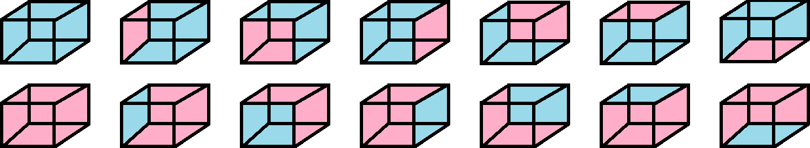
blue is 1st choice.
red is 2nd choice.
1 side blue is 3rdchoice.
1 side red is 4th choice.

Notice that rotating the cube changes orientation. Painting any of the six sides is the same combination of 1(red) and 5(blue) or alternatively 1(blue) and 5(red). The rotation order is from:{left,front,right,back,top,bottom}.
From left to right red is the: (all blue), (left-side), (front-side), (right-side), (backside), (topside), (bottom-side).
From left to right blue is the: (all red), (left-side), (front-side), (right-side), (backside), (topside), (bottom-side).

- We start we all one color then paint the left side a different color. This is the left yz plane.
- A 90° rotation along the z-axis places colored side in the front. This is the front xy plane.
- A 90° rotation along the z-axis places colored side on the right side. This is the right yz plane.
- A 90° rotation along the z-axis places colored side in the back. This is the back xy plane.
- A 90° rotation along the x-axis places colored side at the top. This is the top xz plane.
- A 90° rotation along the x-axis places colored side at the bottom. This is the bottom xz plane.

All six rotations are the same combination of 1:5. We can think of this as _{n}C_{k} = ₆C₁ = 1 combination or ₆P₁ = 6 rotations where each rotation is a permutation since the position or order has changed. We can have all blue then paint 1 side red. Then we can invert the colors and have all red then paint 1 side blue. We have 1 combination for for 1blue:5red and 1 combination for 1red:5blue for 2 combinations. We have 1 combination for 0blue:6red and 6blue:0red for 2 more combinations.

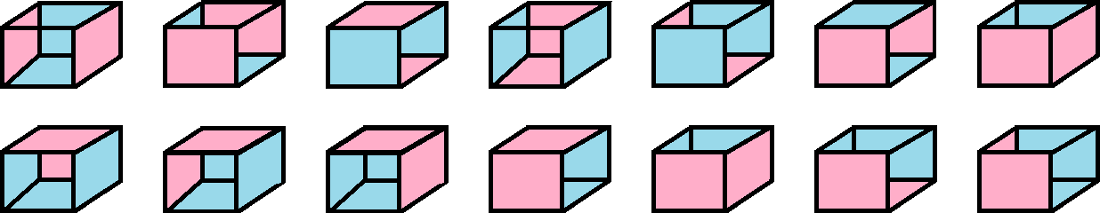
2 red opposite 4 blue is 5th choice.
4 red 2 blue opposite is 6th choice.
2 red adjacent 4 blue is 5th choice.
4 red 2 blue adjacent is 6th choice.

2 red: left/right, front/back, top/bottom. 2 blue: left/right, front,back, top/bottom. Last is 2 red front/right.
2 red: top/back, top/left, top/right, top/front...then same as before but with bottom instead of top.

The top row shows 7 permutations of two colored sides that are opposite like front/back and 1 permutation of two sides adjacent specifically front/right. Opposite sides means they are in the dimension but different plane like front and back are opposite because they are both xy planes and top and bottom are opposite because they are both xz planes. For opposite sides there is 1 combination and 3 permutations. For adjacent sides there is 1 combination and 12 permutations. Adjacent means two planes touch and share a line. Adjacent sides will be rotated 90° from the other whereas opposite sides are parallel. For opposite parallel sides:

- Left/right are both red. This is the same appearance as right/left.
- Front/back are both red. This is the same appearance as back/front.
- Top/bottom are both red. This is the same appearance as bottom/top.
We have these three rotations because the other possible three rotations are identical.
The other three permutations cancel because they are inverses of the three already listed.
L/R→R/L, F/B→B/F, T/B→B/T.

For adjacent 90° orthogonal sides:

- Top/Back
- Top/Left
- Top/Right
- Top/Front
- Bottom/Back
- Bottom/Left
- Bottom/Right
- Bottom/Front
- Front/Left
- Front/Right
- Right/Back
- Left/Back

This is 12 permutations or 4!/2. All rotations count as only one combination of two adjacent colored sides.
We are only concerned with combinations. I only show the rotations for later work in 3d.
If I have a cube will all side one color then no matter how I rotate it I have the same combination of 1.
If I have a cube will all side one color then no matter how I rotate it I also have the same permutation of 1.

This is really not even permutation at all because repetition is involved. This is 1⁶ = 1 combination.
Every single permutation is (red, red, red, red, red, red) so no matter how you permute the order it is the same order. 111111 can only have 1 permutation because there is only 1 element to choose form likewise if red is the only choice all permutations of six reds is the same permutation. Without subscripts you would not know which red is which.

(red_{left}, red_{front}, red_{right}, red_{back}, red_{top}, red_{bottom}) = (red₁,red₂,red₃,red₄,red₅,red₆) = (red,red,red,red,red,red)

- (red₁,red₂,red₃,red₄,red₅,red₆) = Left, Front, Right, Back, Top, Bottom.
- (red₄,red₁,red₂,red₃,red₅,red₆) = Back, Left, Front, Right, Top, Bottom.
- (red₃,red₄,red₁,red₂,red₅,red₆) = Right, Back, Left, Front, Top, Bottom.
- (red₂,red₃,red₄,red₁,red₅,red₆) = Front, Right, Back, Left, Top, Bottom.
- (red₂,red₃,red₄,red₁,red₆,red₅) = Front, Right, Back, Left, Bottom, Top.
- (red₁,red₂,red₃,red₄,red₆,red₅) = Left, Front, Right, Back, Bottom, Top.
- (red₄,red₁,red₂,red₃,red₆,red₅) = Back, Left, Front, Right, Bottom, Top.
- (red₃,red₄,red₁,red₂,red₆,red₅) = Right, Back, Left, Front, Bottom, Top.
- (red₆,red₂,red₅,red₄,red₃,red₁) = Top, Front, Bottom, Back, Right, left.
- (red₄,red₆,red₂,red₅,red₃,red₁) = Back, Top, Front, Bottom, Right, left.
- (red₅,red₄,red₆,red₂,red₃,red₁) = Bottom, Back, Top, Front, Right, left.
- (red₂,red₅,red₄,red₆,red₃,red₁) = Front, Bottom, Back, Top, Right, left.
- (red₆,red₂,red₅,red₄,red₁,red₃) = Top, Front, Bottom, Back, left, Right.
- (red₄,red₆,red₂,red₅,red₁,red₃) = Back, Top, Front, Bottom, left, Right.
- (red₅,red₄,red₆,red₂,red₁,red₃) = Bottom, Back, Top, Front, left, Right.
- (red₂,red₅,red₄,red₆,red₁,red₃) = Front, Bottom, Back, Top, left, Right.
- (red₁,red₆,red₃,red₅,red₄,red₂) = Left, Top, Right, Bottom, Back, Front.
- (red₅,red₁,red₆,red₃,red₄,red₂) = Bottom, Left, Top, Right, Back, Front.
- (red₃,red₅,red₁,red₆,red₄,red₂) = Right, Bottom, Left, Top, Back, Front.
- (red₆,red₃,red₅,red₁,red₄,red₂) = Top, Right, Bottom, Left, Back, Front.
- (red₁,red₆,red₃,red₅,red₂,red₄) = Left, Top, Right, Bottom, Front, Back.
- (red₅,red₁,red₆,red₃,red₂,red₄) = Bottom, Left, Top, Right, Front, Back.
- (red₃,red₅,red₁,red₆,red₂,red₄) = Right, Bottom, Left, Top, Front, Back.
- (red₆,red₃,red₅,red₁,red₂,red₄) = Top, Right, Bottom, Left, Front, Back.

All six sides in the “Top” position and 4 rotations putting all vertical sides in the front once. Every side was on top during 4 rotations. This is 4 rotations times 6 sides = 24. This is 4! This is three side red, 3 blue opposite.
This is three red/blue adjacent. 1-7 are opposites. 9-14 are adjacent.

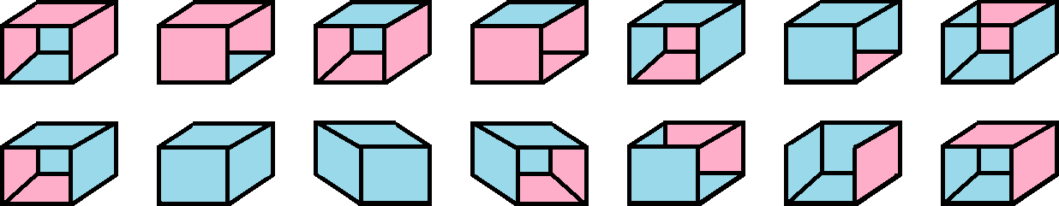

- left/right/top
- front/back/top
- left/right/bottm
- front/back/bottom
- left/right/top
- front/back/top
- left/right/bottom
- top/back/right From 8-11 are all 90° rotations on the y-axis.
- top/right/front
- top/front/left
- top/left/back
- bottom/front/left
- bottom/left/back with top removed
- bottom/left/back with top attached
To answer “A toy cube can be painted red or blue on each side. Some cubes can be one color and some can be two colors. Have many different cubes can there be if rotating a cube makes two cubes the same?” we first have to realize that we are looking for combinations and not permutations. Then we have to realize a cube has six sides and we are essentially asking “what two numbers sum to 6” but with a twist.

We find that the numbers that add to 6 is a linear equation in standard form meaning we have an inverse proportion.

x+y = c x and y sum to c.
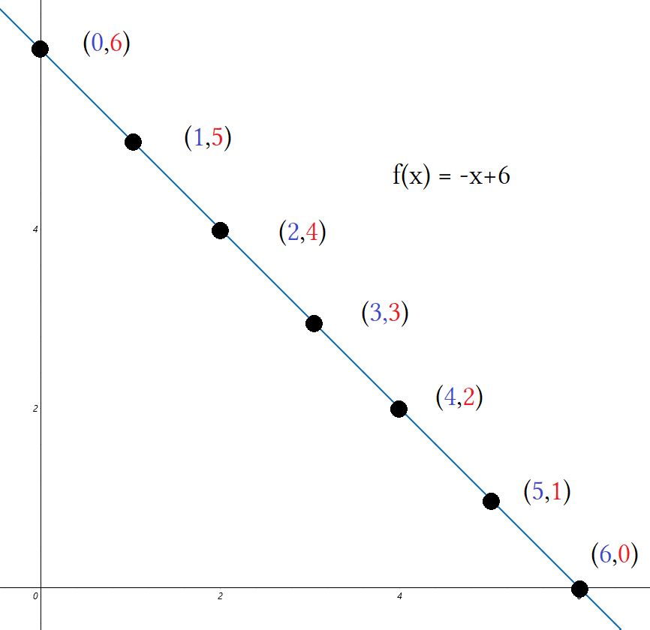
x+y = 6 x and y sum to 6.
y= –x+6 Written as t-intercept slope formula.
f(0)= 6 Inputting x outputs y.
f(1)= 5 Inputs are blue sides outputs are red sides.
f(2)= 4
f(3)= 3
f(4)= 2
f(5)= 1
f(6)= 0

This gives us 7 combinations alone.
(2,4), (4,2), and (3,3) have two permutations for an additional 3 combinations for a total of 10 combinations. Normally something like (3,3) cannot be permuted but because we are dealing with cube geometries it can.

(2,4) is either 2 blue opposite or 2 blue adjacent.
(4,2) is either 2 red opposite or 2 red adjacent.
(3,3) is either 3 blue opposite or 3 blue adjacent.
Add one combination for each adjacent combination. 7+3 =10 combinations.

