City Blocks and taxicab Algebra

Taxicab algebra is slang for a type of non-commutative algebra where the statistical probability is determined using formulas like the binomial theorem to find the number of shortest paths between two points where only 0° and 90° segments are allowed, no diagonals. This is similar to driving a cab around the city and counting the number of routes to a location and needing to pick the fastest route if say there is varying amounts of traffic slowing down certain lanes. For this simple example we are really only counting the number of routes.

If you do python programming to study statistics a bug area of study is Monte Carlo simulations. A Monte Carlo simulation is basically where a computer program counts how many paths and uses statistics to determine the single fastest path. The result can be a number so in number theory this is used to determine the output of some x value. This moves from algebra to quite advanced modern geometry. Here is a simple question with advanced applications:

A man must walk home and is 15 blocks away. If he walks 8 blocks 0° and then turns 90° he can walk the remaining 7 blocks home. We graph this as his starting point is the origin (0,0), then he walks 8 blocks east and stops at (8,0). Finally he turns 90° and is facing north and walks 7 blocks to (8,7). How many ways can he walk from (0,0) to (8,7) and not exceed 15 blocks?
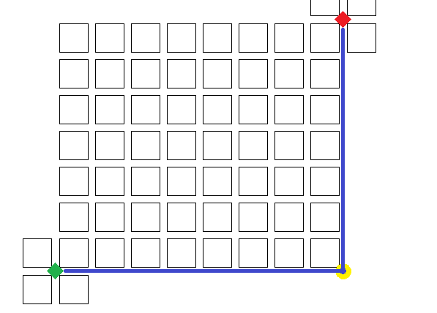

First draw a picture to familiarize yourself with the problem:

The green diamond the starting point at (0,0) and the red diamond the stopping point (8,7). This makes the x-axis west to east and the y axis south to north.

- Origin “ ◆ ” is (0,0) . Destination “ ◆ ” is (8,7). “●” is (8,0).
- Left is west or –x. Right is east or +x.
- Down is south or –y. Up is north or +y.

The shortest path between two points is a straight line however we cannot use a straight line because we must stick to the roads and sidewalks, we cannot walk diagonally across blocks because of buildings etc. Therefore the shortest path will be the 90° segments of a square or failing to produce a square a rectangle that is closest to a square as possible. This means that base≈height as close as possible. Our rectangle is 8×7 so the shortest path is 8+7 = 15 blocks. Anything more than 15 blocks means we are backtracking and adding more distance than necessary like “over 1, up 3, over 1, down 2”.

We could try to draw every route but that would be difficult because there are over 5,000 routes.
We need to try a simpler problem then solve it and reverse engineer the solution to find a general formula for all problems of this type. Unfortunately we don't have time so here it goes.

Blue has 1 route. Purple has 7. Yellow follows purple and adds n–1 of it's own. Orange is complex.

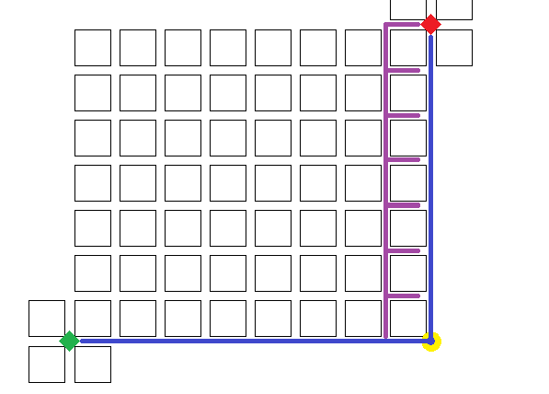
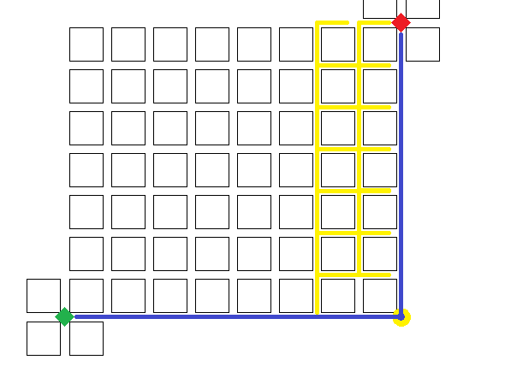
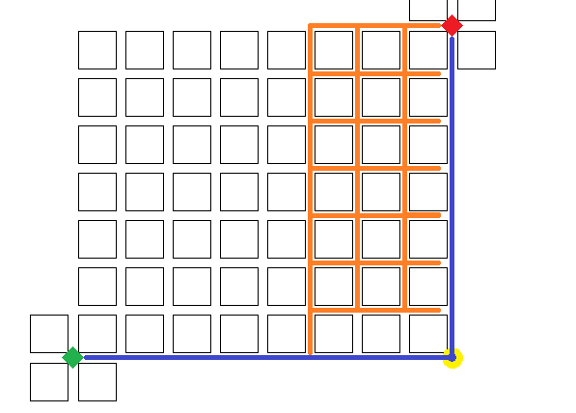

If you count you will see From purple there are 7 paths starting at (7,1). Yellow does this: It starts at (6,1) and moves to (7,1) The does the 7 purple routes. This gives yellow 7. Then it restarts at (6,1) and goes to (6,2) then moves to (7,2). Instead of going from (0,0) to (6,0), then (6,1) and doing the 7 purple it goes (0,0):(6,0):(6,2) and does the 6 above purple. All colors are a deviation off the blue line. They are said to start at the 7th row. Each color 1 block behind another. From where they start and other points they have a choice of moving right or up. Going right completes all the routes possible for that row without skipping any. Once done it has to restart and this time go up instead of right since all those routes are no longer options. We can't count the same routes more than once.

This is 7 routes This is 6 routes This is 5 routes This is 4 routes
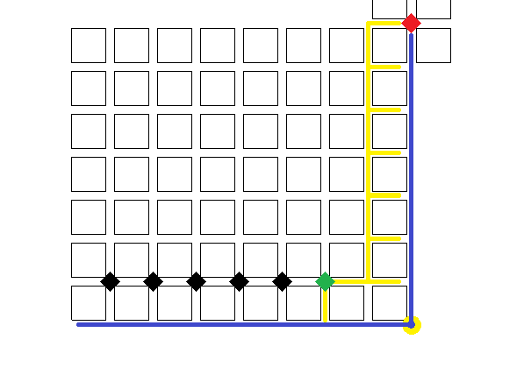
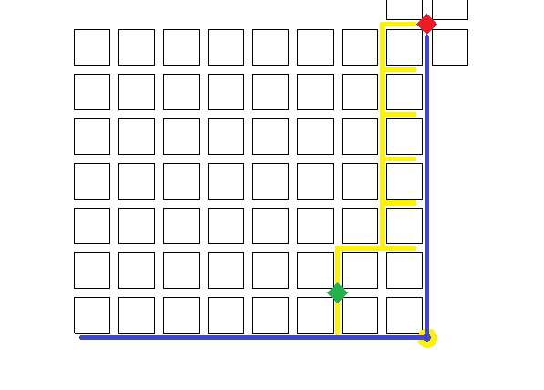
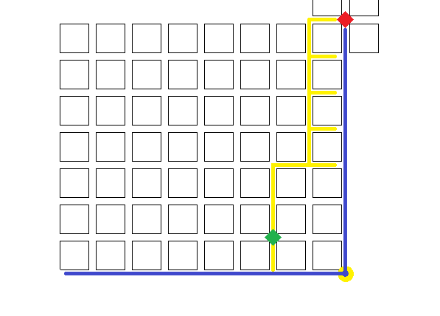
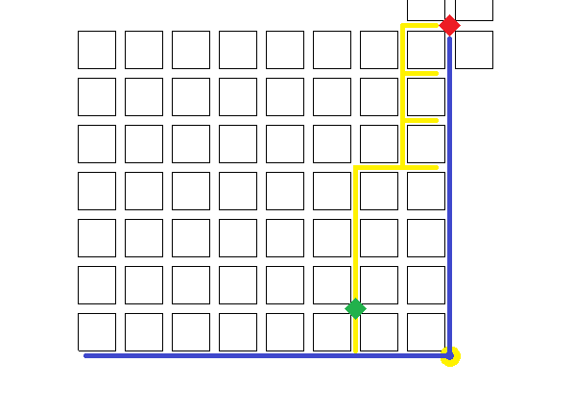
Basically purple has 7 routes and is done. Yellow does those same routes but has the option of going up and over and doing more routes. It can do this multiple times. Because at each intersection there s the option of going right or up. The pattern that forms is that It does purples 7, then 6 more, then 5 more, then 4, 3, 2, 1. It has a recursive pattern. This is what is meant by n–1 rows. The 7th row gave 7 routes, the 6th gave 6 routes and so on. This continues till the 1st row where there is only 1 route because we are on the edge. Edge paths always end after 1 route.

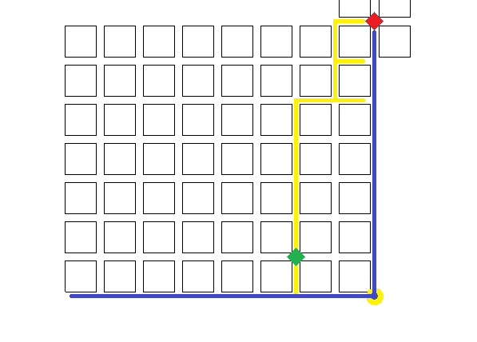
This is 3 routes This is 2 routes This is 1 route
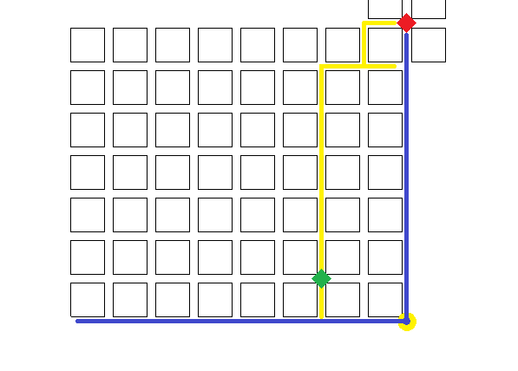
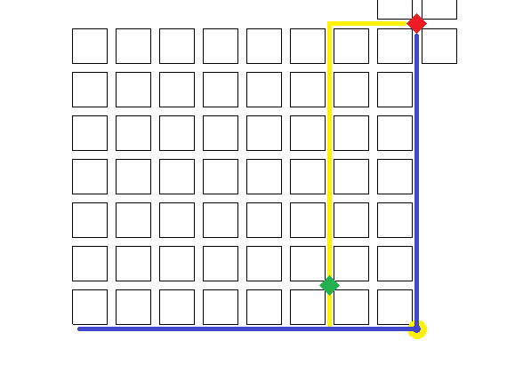

All future paths start at the 6th row because they all deviate away from the blue route. They have to since blue route is an edge case. Yellows does the same exact routes as purple but instead of deviating at the 7th block it deviates on the 6th causing a new routes to form that are independent from purple and thus are counted as new routes belonging only to yellow. Green diamond is at (6,1) where yellow truly starts. The future colors to be added start at the black diamond behind it. They will be colored later but do not want to crowd my map.

As yellow completes routes it is left with less options the next time it restarts at (6,1).
Picture 1 shows it doing the same 7 as purple except for passing (6,1) instead of (7,0).
Once yellow gets to (7,1) everything after that is identical to purple.
After completing the 7 purple routes it has 6 more series of routes.
The most efficient process is to reach every new intersection and turn right, do all possible routes from turning right then restarting another series by this time continuing up until a new intersection and then turning right again. This process creates series where going up starts on a higher row that will have 1 route less than the last rows series.

- Every row has a series.
- Every series is 1 route less than the one before it.
- Every series is one more than the one after it.
- 7 rows means 7 routes per column. This creates a recursive pattern.

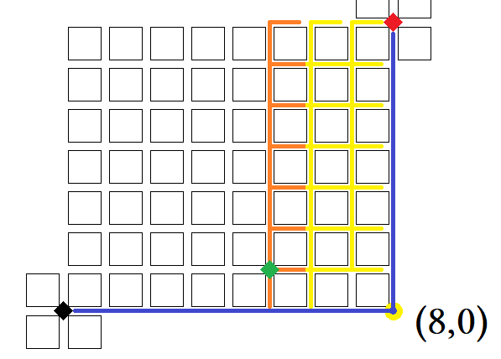
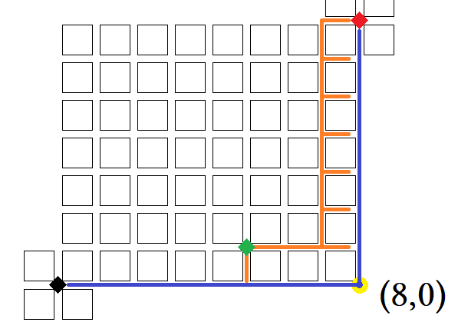
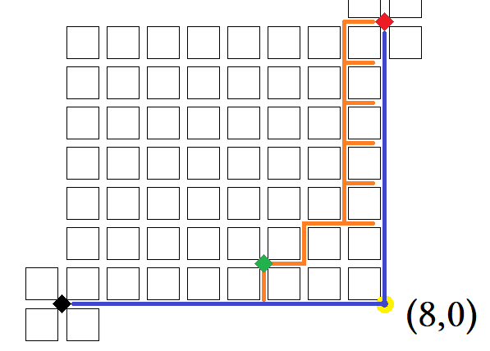

Orange copies the 28 yellow and The same 7 as purple and yellow. Same 6...note it turned left
adds many more. at (6,1) instead of going straight.

On the first 7 orange went straight for 2 blocks. This time it goes 1 block then turns left goes one block and turns right. It had the choice of continuing up or going right. It turned right this time but next time it will go up because all paths to the right will be exhausted.

First picture shows 7 paths, next one shows 6. This is showing the paths that yellow took with maybe a 1 or 2 block difference. It takes a different path to get on track but once it is it does the same as yellow because it is the only way to end. After doing the 28 yellow does it adds new routes using its own line. It will have a total of 84 routes. The color after it will be green and it will copy those 84 and have a total of 210. The color after that is pink which copies those 210 and has a total of 462. This continues... the last color color has 3003 routes.
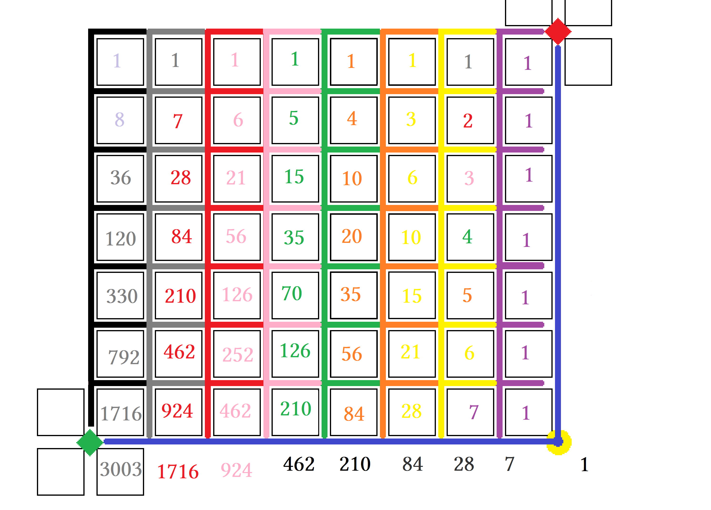

The numbers in the boxes show how many paths are available for the lane above it.
Numbers outside the grid at the bottom give totals for each column color.

Blue = 1, Purple = 7, Yellow = 28, Orange = 84, Green = 210, Pink = 462, Red = 924, Gray = 1716, Black = 3003.

Compare diagonals and look for meaningful patterns. Numbers are repeated which is a sign of recursion.
The total number of paths that one color has is carried over to the next color. Every color starts on the 7th row by completing all the paths the previous color did then moves up to the 6th row to adds its own.

This is me trying to fill a table incorrectly. I counted every route and there are 6,435. By the binomial theorem this is 15!/7!∙8!. 15! comes from the distance being 15 blocks. The 7! is the 7 rows and 8! is the 8 columns.

Blue (8,0) | Purple (7,1) | Yellow (6,1) | Orange (5,1) | Green (4,1) | Pink (3,1) | Red (2,1) | Gray (1,1) | Black (0,1)
1 | 7 | 28 | 84 | 210 | 462 | 924 | 1716 | 3003
Σ₁¹(1) | Σ₁⁷(1) | Σ₁⁷(x) | Σ₁⁷(x+2x) | Σ₁⁶(10x) | Σ₁⁶(22x) | Σ₁⁶(44x) | Σ₁⁶(44x) | Σ₁⁶(44x)
 |  | 8C3 | Σ₁⁶(4x) | Σ₁⁶(2x+6x) | Σ₁⁶(4x+18x)
 |  |  |  |  | 7P3
 | 7 | 28 | 21 | 15 | 10 | 6 | 3 | 1

Filling out the table is problematic because I am going about it wrong, I do not know the general term for my summation. I seem to be targeting individual cells as to how many paths form that particular intersection or finding partial sums of two columns. It is all hit and miss. Working up to it is easier.

Blue | Blue has only one route. Once it is taken no other colors can follow it.
Purple | Purple has 7 routes, 1 for each row above the x axis. This excludes 0 so we have natural numbers 1-7.
Yellow | Yellow begins a process. It has the 7 purple has plus n–1 each row after that. This is Σ₁⁷(x).  There are r paths per row: row 7 has 7, row 6 has 6... we get 7+6+5+4+3+2+1 = 28
Orange | Orange extends the process. There are r summations for orange. Every row has Σ₁^{r}(x) where we sum to the number of rows. Because every row is n–1 from yellow we get this:  7th row from the bottom = Σ₁⁷(x) = 28  6th row from the bottom = Σ₁⁶(x) = 21  5th row from the bottom = Σ₁⁵(x) = 15  4th row from the bottom = Σ₁⁴(x) = 10  3rd row from the bottom = Σ₁³(x) = 6  2nd row from the bottom = Σ₁²(x) = 3  1st row from the bottom = Σ₁¹(x) = 1 We need a way to sum all the summands.

Just adding them: Using Σ: Writing a series using Σ:
(1+2+3+4+5+6+7) = 28 Σ₁⁷(x) = 28 Σ₁⁷(x)+Σ₁⁶(x)+Σ₁⁵(x)+Σ₁⁴(x)+Σ₁³(x)+Σ₁²(x)+Σ₁¹(x)= 84
(1+2+3+4+5+6) =21 Σ₁⁶(x) = 21 Σ₁⁶(x)+Σ₁⁵(x)+Σ₁⁴(x)+Σ₁³(x)+Σ₁²(x)+Σ₁¹(x)= 56
(1+2+3+4+5) = 15 Σ₁⁵(x) = 15 Σ₁⁵(x)+Σ₁⁴(x)+Σ₁³(x)+Σ₁²(x)+Σ₁¹(x)= 35
(1+2+3+4) =10 Σ₁⁴(x) = 10 Σ₁⁴(x)+Σ₁³(x)+Σ₁²(x)+Σ₁¹(x)= 20
(1+2+3) =6 Σ₁³(x) = 6 Σ₁³(x)+Σ₁²(x)+Σ₁¹(x)= 10
(1+2) =3 Σ₁²(x) = 3 Σ₁²(x)+Σ₁¹(x)= 4
(1) = 1 Σ₁¹(x) = 1 Σ₁¹(x)= 1

The top three examples just show different versions of summing the sums individually when we need to sum all at once. The yellow is the series 1+2+3+4+5+6+7 = 28, orange has this but because is farther way has n – 1 so that it has 7 sums each where the next sum is minus the largest integer of the previous. The examples show above where n – 1 means minus all the paths form the row below a current sum. Yellow has 28 paths orange has 84. Orange has the same 28 paths yellow has (except starts 1 block earlier so counts as a different path than yellow), plus 56 more paths. Where “Just adding..” is highlighted shows 28 yellow that orange has plus 56. Look at the pattern. This gets continued for all other colors. Yellow is (7+6+5+4+3+2+1) Orange is (7+6+5+4+3+2+1) + (6+5+4+3+2+1) + (5+4+3+2+1) + … +(1).

Clearly the farther away a point is the more paths it has to the end.
Every point can follow the same eventual paths of closer points plus it's own.

We treat data like it is in a table. We treat The blocks as a n×m matrix or table where the bottom row is also graphed as the x axis on a chart. The origin to point (8,0) is the bottom row therefore 7th row. We start at the bottom and count up. The blue path is the only path blue has because it is on the edge. It is the “gutter ball” of options being forced to end its options after only one venture. This happens in statistics with edge cases or computer hardware design.

7th row:(1+3+6+10+15+21+28) = 84 Σ₁⁷(x)+Σ₁⁶(x)+Σ₁⁵(x)+Σ₁⁴(x)+Σ₁³(x)+Σ₁²(x)+Σ₁¹(x)= 84 S₇:(a₇+a₆+a₅+...+a₁)= 84
6th row:(1+3+6+10+15+21) = 56 Σ₁⁶(x)+Σ₁⁵(x)+Σ₁⁴(x)+Σ₁³(x)+Σ₁²(x)+Σ₁¹(x)= 56 S₆:(a₆+a₅+a₄+...+a₁)= 56
5th row:(1+3+6+10+15) = 35 Σ₁⁵(x)+Σ₁⁴(x)+Σ₁³(x)+Σ₁²(x)+Σ₁¹(x)= 35 S₅:(a₅+a₄+a₃+...+a₁)= 35
4th row:(1+3+6+10) = 20 Σ₁⁴(x)+Σ₁³(x)+Σ₁²(x)+Σ₁¹(x)= 20 S₄:(a₄+a₃+a₂+a₁)= 20
3rd row:(1+3+6) = 10 Σ₁³(x)+Σ₁²(x)+Σ₁¹(x)= 10 S₃:(a₃+a₂+a₁)= 10
2nd row:(1+3) = 4 Σ₁²(x)+Σ₁¹(x)= 4 S₂:(a₂+a₁)= 4
1st row:(1) = 1 Σ₁¹(x)= 1 S₁:(a₁)= 1

Σ₁⁷(Σ₁⁷(x)) = 210 This is the total paths orange has. It is the first series green does.
Σ₁⁶(Σ₁⁷(x)) = 126 After finishing the first series green restarts and does this series...
Σ₁⁵(Σ₁⁷(x)) = 70 Then restarts and does this series...
Σ₁⁴(Σ₁⁷(x)) = 35 Then restarts and does this series...
Σ₁³(Σ₁⁷(x)) = 15 Then restarts and does this series...
Σ₁²(Σ₁⁷(x)) = 5 Repetition is a hallmark of recursive programming. Expect ellipsis...
Σ₁¹(Σ₁⁷(x)) = 1 We are at the edge so there is only 1 route available.

I was unsure how to write this series or series is this is the best I could do. My calculator does not have a button for this. It claims putting Σ inside Σ is an invalid argument. There are other ways to write this but is inappropriate for this lesson. I want to unpack what's inside but standard notation makes this difficult. You either are too packed or way not packed enough.

Σ₁⁶(Σ₁⁷(x)) reads as “the summation from 1 to 6 of (Σ₁⁷(x)) = 126”. I put Σ₁⁷(x), whole thing, inside the () to sum it because that is what recursion is doing. It reminds me of countdowns for rocket launches or something like that:
“Five, four, three, two, one... four, three, two, one... three, two, one... two, one... one”. It counts down from 7 to 1, then 6 to 1, then 5 to 1 until it covers all paths and gets to the edge which is Σ₁¹(x)= 1.

All the sums together are ugly looking so we have to truncate them somehow.

- S₇:(Σ₁⁷(x)+Σ₁⁶(x)+Σ₁⁵(x)+Σ₁⁴(x)+Σ₁³(x)+Σ₁²(x)+Σ₁¹(x)= 84 Even terms are blue odd terms are red.
- S₇:(Σ₁⁷(x)+Σ₁⁶(x)+Σ₁⁵(x)+...+Σ₁¹(x)= 84
- S₇:(a₇+a₆+a₅+...+a₁)= 84
- Σ₁⁷(S_{n})

#1 is all the terms and looks bad. #2 uses ellipsis to remove three terms but it still looks hideous. #3 looks really good and #4 is perfect. #1 shows everything so you know what all 7 terms are. #2 sets up a process to start making things smaller. #3 is brilliant in that it uses changes sigma notation to regular term notation. Since we showed the change we know what the original terms are but to not have to look at them if we do not want to which we don't. #4 is very compact and without the previous setups it would be hard to ascertain what S_{x} is. S_{x} is “Series to the x^{th} term”. We have 1 thru 7 terms and we will be needing to countdown from 7 to 1.

x = 1 through 7 of S_{n} … we are summing the series from first series to the seventh series.
S_{n}:(S₁, S₂, S₃, … S_{n}) we are writing every possible summation of x as a sequence.
S_{x}:(S₁+S₂+S₃+ … +S_{n}) we are writing every possible summation of x as a series.
S₇:(S₁+S₂+S₃+ … +S₇) we are writing every summation of x as a partial sum from 1 to 7 as a series.

Blue leaves (0,0) and traces border for one path. Since it can not access upper rows it ends after finishing its first route. Purple leaves (0,0) and follows blue line until (7,0) at which point it turns left, goes 1 block, turns right goes one block, turns left again and heads up for 6 blocks straight to finish it's first route. This is one route. Count the purple horizontal lines, there are seven ⸫ seven routes. After this it is done. Purple has Σ₁⁷(1) routes. Inside () is 1 which means we are adding 1 seven times like (1+1+1+1+1+1+1). This is the only color that sums 1. All the others sum x which means adding successive numbers like (1+2+3+4+5+6+7). All the others do this because they start farther back.

Blue: 1 =1 This can be considered the mainline.
Purple: (1+1+1+1+1+1+1) =7
Yellow: (7+6+5+4+3+2+1) = 28 After yellow does purples 7 it “restarts” meaning it is going to do 6 routes.

Yellow does 6 routes by going up to (6,2). Front there it can only do 6 routes because it is 1 higher than where 7 routes are possible. After doing 6 routes it restarts and does 5 then restarts and does 4 then 3 then 2 the 1. We write these routes as a series as shown. Yellow is done. We move on to another color once the current color ends at its last route. Orange: (7+6+5+4+3+2+1) + (6+5+4+3+2+1) + (5+4+3+2+1) + (4+3+2+1) + (3+2+1) + (2+1)+ (1).

Orange does the same series are yellow but then does 6 more series with the last series by 1 route by itself.
We say these are the same as yellow because once orange gets to the same spot yellow traveled orange copies the path verbatim. It is just coping the same path as those that went before it. The reason that this is counted as a different path is because orange deviates off the blue line 1 block earlier. Before traveling yellows path it traveled 2 different blocks then copied yellow. All colors to this with regards to the color that came before it.

Blue is the main line. Different colors are labeled based off when they deviate of the mainline.
Every color deviates just one block earlier so we can keep an accurate count of all paths.
Let every path orange took be called O. O has 84 paths Green has every path of orange and then some.

Blue: (1) = 1 Blue is the seed that starts the recursive sequence.
Purple: (1+1+1+1+1+1+1) = 7 Purple does blues 1 then adds 6.
Yellow: (7+6+5+4+3+2+1) = 28 Yellow does purples 7 then adds 21.
Orange: (28+21+15+10+3+1) = 84 Orange does yellows 28 then adds 56.
Green: (84+56+35+20+15+10+4+1) = 210 Green does oranges 84 then adds 126.
Pink: (210+126+70+35+15+5+1) = 462 Adds greens and 252. Notice 126 comes after 210.
Red: (462+252+126+56+21+6+1) = 924 Adds pinks and adds 462. Notice 252 comes after 462.
Gray: (924+462+210+84+28+7+1) = 1716 Adds reds and adds 462. 462 comes after 924.
Black: (1716+792+462+330+120+36+8+1) =3003 Adds grays then adds 1287. Patterns break at edges.

(3003+1716+924+462+210+28+7+1) = 6435 paths from point A to point B. 6435 = ^{15!}/_{7!∙8!}
We need a general formula so we do not have to count because it is confusing!
Here is Pascal triangle. The number of paths are shown by highlighting diagonals.
The color of diagonal is the same as the picture.

1
1 1
1 2 1
1 3 3 1
1 4 6 4 1
1 5 10 10 5 1
1 6 15 20 15 6 1
1 7 21 35 35 21 7 1
1 8 28 56 70 56 28 8 1
1 9 36 84 126 126 84 36 9 1
1 10 45 120 210 252 210 120 45 10 1
1 11 55 165 330 462 462 330 165 55 11 1
1 12 66 220 495 792 924 792 495 220 66 12 1
1 13 78 286 715 1287 1716 1716 1287 715 286 78 13 1
1 14 91 364 1001 2002 3003 3432 3003 2002 1001 364 91 14 1
1 15 105 455 1365 3003 5005 6435 6435 5005 3003 1365 455 105 15 1
1 16 120 560 1820 4368 8008 11437 12864 11437 8008 4368 1820 560 20 16 1
…

Blue: (1) = 1 This is initial value. It has a seed value of 1. Watch it grow:
Purple: (1+1+1+1+1+1+1) = 7 1+7 = 8
Yellow: (7+6+5+4+3+2+1) = 28 8 + 28 = 36
Orange: (28+21+15+10+3+1) = 84 36+84 = 120
Green: (84+56+35+20+15+10+4+1) = 210 120 + 210 = 330
Pink: (210+126+70+35+15+5+1) = 462 330+462 =792
Red: (462+252+126+56+21+6+1) = 924 792+924 = 1716
Gray: (924+462+210+84+28+7+1) = 1716 1716+1716 = 3432
Black: (1716+792+462+330+120+36+8+1)=3003 3432+3003 = 6435

The left side of the triangle counts down 8 rows from 1 to 1. The right side of the triangle counts over 7 columns 1 to 1. This is what we we trying to sum, the rows of Pascal's triangle.

Graph with axes labeled like this please. This is longitude and latitude.
Our starting point is the origin (0,0) labeled with green diamond.
Red diamond is (8,7). The vertex where blue turns is (8,0).
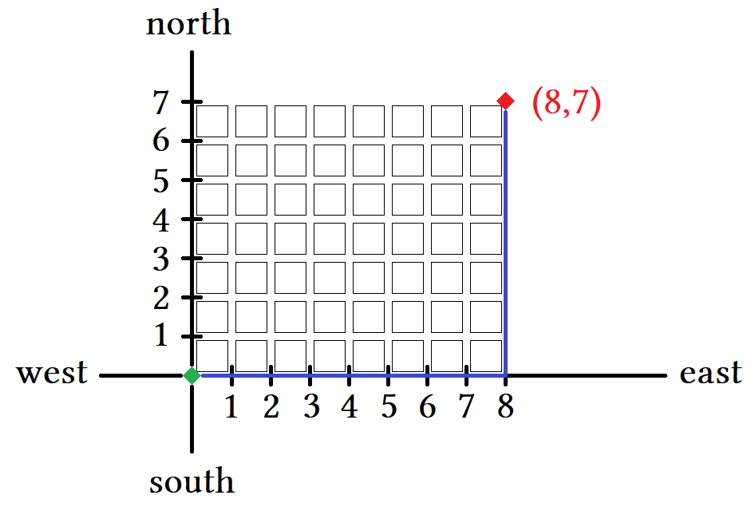

The number of paths from Start to Finish is given by pascal's triangle which in term is generalized by the binomial theorem. The binomial theorem is a formula for writing combinations as a polynomial series.
This is why we can write it in term notation a(n) and later as sigma notation. We can write it simplest as a Permutation of 15 objects that
are alike and 8 that are alike.

According to our graph the shortest distance is found by traveling east and north.
We can turn north or we can turn east. This is ↑ or →.
We can write a path using different notation. For the blue route:

English: From origin head east 8 blocks. Turn right and head 7 blocks.
Algebra: (0,0)→(8,0)→(8,7) This is best.
Arrows: →,→,→,→,→,→,→,→,↑,↑,↑,↑,↑,↑,↑. This is 15 arrows.
Compass: E,E,E,E,E,E,E,E,N,N,N,N,N,N,N. This is 15 angles.

Algebra is the most succinct however compass is better for elaborate explanations like discussing complicated subjects like combinatorics. E and N stand for east and north which in angle notation is 0° and 90°.
We have 15 letters for 15 blocks. It takes arrow notation and changes them into compass headings.
We can rephrase “how many paths are there?” to “how many permutations are there of 7 E's and 8 N's?”.
Every letter represents traveling that direction for 1 block.

Writing symbols or characters without spaces is called a string, such as a EEEEEEEENNNNNNN is a string of letters characters long. For brevity we say digits even through they are not numerals. Each string of 15 letters represents 1 unique path. Since only 7 E's and 8 N's are used every permutation of these letters will be the number of possible paths. We are permuting the string eeeeeeeennnnnnn to find the number of combinations.

A each permutation of the string is a unique path so counts as a combination rather that a permutation.
This is strange and confusing at first but is true. Combinations and permutations can be confused for one
another as can whether multiply or raise to a power. Simple logic dictates that changing the order of letters
takes a different path that is not the same as another path having same letters but in different order.

- How many Permutations are there of EEEEEEEENNNNNNN?
This is a loaded question because we are really looking for combinations.
- How many Combinations are there of EEEEEEEENNNNNNN?
This is a loaded question because we are allowing repetitions by having many E's and N's.
- How many paths of 15 blocks are given by EEEEEEEENNNNNNN? 15!/(7!8!) = 6435.

The basic trick for permutations is taught to children using boxes and then rearranging the boxes.
How many ways can you put 7 N's and 8 E's in the 15 boxes below?

□ □ □ □ □ □ □ □ □ □ □ □ □ □ □

15! means we have 15 discrete objects. Discrete means individual or distinct. Discrete is the opposite of continuous, not to be confused with discreet which means private. The boxes hold 1 discrete item each. Here they hold 1 letter. How many ways can we put 8 N's in here? We can put them in 15!/(7!8!) ways. Because we have 15 boxes and two different things for for the boxes 7+8 = 15 so n =15 and either 7 or 8 is r and the other n – r:

(r) +(n – r) = n (8) +(15 – 7) = 15 or (7) +(15 – 8) = 15.

If we say how many ways can 7 N's fit in 15 boxes then for n!/(n – k)!, then k = 7(N) and n – k = 8(E).
If we say how many ways can 8 E's fit in 15 boxes then for n!/(n – k)!, then k = 8(E) and n – k = 7(N).
Recall the formula for permutations is n!/(n – k)! truncated using the notation _{n}P_{k}.
A permutation is a combination that has less restrictions thereby allowing more possibilities.

Older texts write this differently such as P(n,r) where: The number of n objects taken r at a time.
The n is “total number of items” and r is taken to mean rate. They also use j instead of k and i instead of n for exponents so that it is not confused with the n as the base. You may possibly see i,j,k,n or even x in depending on usage. The n represents the number of things we have. Here we have 15 blocks corresponding to 15 moves or 15 directions. We have 15!/(7!8!) where 15 is the total of 7+8. This can be interpreted many different ways.

For distance problem: 8 columns + 7 rows = 15 for distance.
For Permutation problem: 8 E's + 7 N's = 15 characters.
We have a length of 15 characters either way. 15 is the answer how you interpret it is up to you.

