Basic Geometry

Types of Shapes

Shapes are either 2d, 3d, 4d, or higher. 2d and 3d are basic and natural. 2D shapes have matching 3d counterparts called their 3d analogs. The analog of a square is a cube, of a rectangle a prism, of a circle is a sphere and so on.

2D Shapes

- Circle: A oval with two foci that overlap at one point. This makes it a special case of an ellipse.
- Triangle: Three sided polygon.
- Square: 4 sided polygon with same side lengths. This makes it a special case of rectangle, and a regular polygon having 40 corners of 90°.

- Oval/ellipse: A stretched out circle making it have two foci. Foci is the plural of focal points.
- Rectangle: A stretched out square. It has four 90° corners and two pairs of matching parallel sides.

- Parallelogram: Matching pairs of bases and sides with sides slanted. A slanted rectangle.

- Rhombus: Similar to a square in having four equal sides lengths but angles are not 90°. Is has two pairs of obtuse angles and acute angles opposite each other. It is a deformed square that looks squished transforming angles but preserving side length.

- Kite: It has two pairs of equal sides. It takes its name from the aerial kite shape.

- Trapezoid: 4 sided polygon. It has two bases of differing length and two sides of equal length set at the same angle.

- Trapezium: A four sided polygon that has unequal lengths. Could be a trapezoid that is irregular or started as a square that has one longer than the other. Generically called quadrilateral. A quadrilateral is any 4-gon.

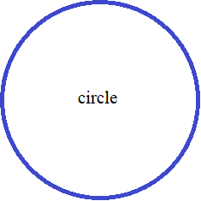
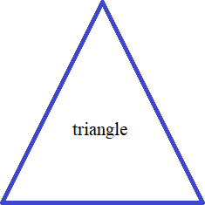
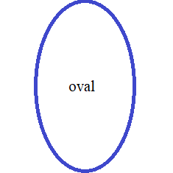
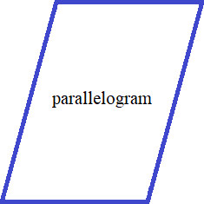
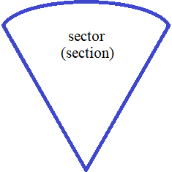
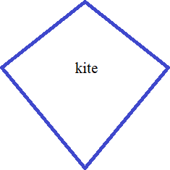
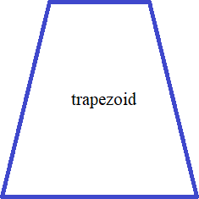
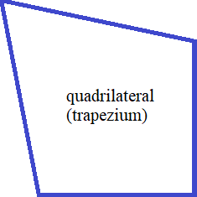
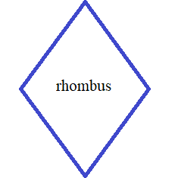

Perimeter and Area Formulas

Perimeter is number of side times length of each side if a regular polygon. If not then the length of all sides added up. Area is ½ the height times the perimeter if it is a regular polygon. Use apothem for height.

Square: P =4s where s is side length. Multiply the length of one side by 4 to get perimeter.
A =s² , square any side to get area.

Triangle: A = ½bh where b is base and h is height. Can be written bh/2. For a right triangle the height it the vertical side, for other triangle it is the distance from top to bottom (maxima and minima). In other words highest and lowest y-value. Height is also know as the altitude and is called the sine in trigonometry.

Circle: P = πd or 2πr multiply pi by the diameter or by two times the radius to get perimeter.
A = πr² square the radius and multiply by pi (3.14) to get the area.

Better approximations of pi give better answers 3.1415 or use calculator pi button for full precision.
The perimeter is also called the circumference.

Rectangle: P = 2w + 2h or 2(w+h) where w is width or length and h is height.
A = bh where b is base and h is height.

Parallelogram: P = 2b + 2s or 2(b+s) where b is base and s is the angled side.
A = bh. Height is the distance from the bottom base to the top base.

If you don't know the height you have to measure it. If you already know the area then area divided by base equals height. If you can't measure it then you must use trigonometry and pythagoreans to solve.

Rhombus: P = 4s A = bh

Kite: P = 2(a+b)
A = pq/2 where p is the length of the short diagonal and q is the length of the long diagonal.

Trapezoid: P = add the length of all four sides.
A = (B+b)/2 ∙h or (B+b)h/2. B is the long base b is the short base and h is the height.

Quadrilateral: Perimeter: Add the four sides together.
Area: There are 6 formulas for area. Use a diagonal to divide into two triangle and find the areas of those and then add them together. See Heron's formula: √(s –a)(s –b)(s –c).

Oval: P = 2π√a²+ b² / 2 ) where a and b are the major and minor axes of the oval.
A = abπ where a and b are the x and y lengths from the center point of the ellipse.
Distance and Midpoint Formulas

- Midpoint Formula
- Distance Formula
- Section Formula
- Cross-section Formula
- Midpoint Formula in three dimensions
- Distance Formula in three dimensions

Midpoint Formula M(x₁ + x₂/2 , y₁ + y₂/2 )

What is the midpoint of A(–7, –7) and B(–5, 5)?

(x₁ + x₂/2 , y₁ + y₂/2)
( –7 + –5/2 , –7 + 5/2)
( –6, –1 )

What is point B if A(–2, –7) and midpoint is (2.5, –1.5)?

(x₁ + x₂/2 , y₁ + y₂/2)
( –2 + –7/2 , 2.5 + –1.5/2)
( ¼ , –4.25 )

Multiply displacement of x,y by 2 then add to beginning point A:

–2 + d_{x} = 2.5
d_{x} = 4.5 The x displacement of half the segment AB
2d_{x} = 9

–7 + d_{y} = –1.5
d_{y} = 5.5 The y displacement of half the segment AB
2d_{y} = 11

point B = ( – +2d_{x}, –7 +2d_{y})
point B = ( – +9, –7 +11)
point B = (7, 4)

The average displacement for x should be ½(–2 + x) = 2.5
The average displacement for y should be ½(–7 + y) = – 1.5

½(–2 + x) = 2.5 ½(–7 + y) = – 1.5
–2 + x = 5 – 3.5 + y = – 3
x = 7 y = 5.5

These values show the displacement from point A to the midpoint. Multiplying these values shows displacement from point A to point B. Adding the displacement to values of point A gives the coordinates of point B.
The midpoint of a line segment divides it internally in the ratio 1:1. Applying the section formula for internal division.

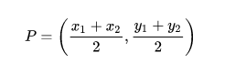
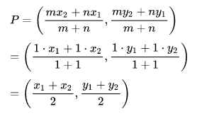

Sector Formula

If a point P (lying on AB) divides AB in the ratio m:n then: P = (^{mx2} ^{+ nx1}/_{m + n} , ^{my2} ^{+ ny1}/_{m + n})

The ratio m:n can also be written as m/n : 1, or k: 1, where k = m/n. So, the coordinates of point P dividing the line segment joining the points A(x₁,y₁) and B(x₂,y₂)are:

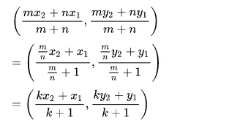

Similarly, the ratio can also be written as k : k – 1 and the coordinates of P are ((1 – k)x₁ + kx₂,,(1 – k)y₁ + ky₂).
If a point P (lying on the extension of AB) divides AB in the ratio m:n then:

Midpoint Formula in 3-Dimensions

Let A and B be two points with Cartesian coordinates (x1, y1, z1) and (x2, y2, z2) and P be a point on the line through A and B. If AP:PB = m:n. Then the section formula give the coordinates of P as :
If P is a point on the line where AP:PB=k:1 – k its coordinates are ((1 – k)x₁ + kx₂ ,(1 – k)y₁ + ky₂, (1 – k)z₁ + kz₂.
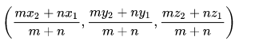

Midpoint Formula as Vectors

The position vector of a point P dividing the line segment joining the points A and B whose position vectors are
a→ and b→ .

- In the ratio m : n internally is given by na→ + mb→/ m + n
- in the ratio m : n externally is given by mb→ – na→ / m – n

Distance formula

The distance of two points on the x -axis is the absolute value of the difference in x₁ and x₂ , d(x₁ , x₂) = |x₁ – x₂ |.
Generally a slope is measured using x,y coordinates so slope is thought of as the hypotenuse of a triangle with the x distance as the base and y distance as the height.

A modified version of Pythagoras Formula is used to find distance of a sloped line segment: d(a,b) = √a² – b² .

Since distance must be positive both formulas give a positive number. For point A(x₁, y₁) and point B(x₂, y₂)

To find the changes in x and y d(A,B) = √a² – b² becomes d(a,b) = √(x₁, y₁)² +(x₂, y₂)² .
This formula treats the distance as the hypotenuse of a triangle formed with imagined sides for base and height.

For polar coordinates

If polar coordinates of two points A and B are (r, θ) and (s, φ) distance is d(a,b) = √r² + s² – 2abcos(θ – φ).

Complex numbers and Higher dimensions

For complex numbers in the complex plane the same formula as the x,y plane is used.
For three dimensions distance is : d(A,B) = √(x₁, y₁)² + (x₂, y₂)² + (x₃, y₃)² .
Further formulas arise in topology, metric theory and Hilbert and all other metric spaces.

- Ptolemy's Inequality
- Hausdorff distance
- Frechet distance
- Gamma convergence and other convergence formulas

[Further study]

Borel–Cantelli lemma
Wijsman convergence
Hausdorff distance
Hemicontinuity
Vietoris topology
Gamma convergence
Chebyshev distance
Manhattan distance
Minkowski distance

Full example of Sector Formula

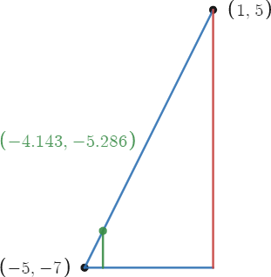
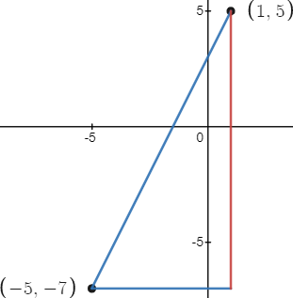
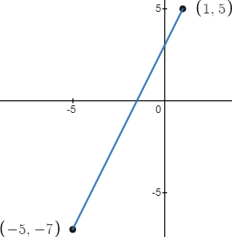

I have Point A (– 5, – 7) and Point B (1, 5). I need Point D to make segments AD and AB have a 1:6 ratio.
AB is 6 times longer than AD. There are 7 parts total. AD is ⅐ as long as AB.

We can find change in x as 1 – (–5) = 6
We can find change in x as 5 – (–7) = 12
We find the slope to be 12/6 = 2

AD has 1/7 the x change and y change of AB. We add this scaled change to Point A.

Add to x: (1/7 ∙ 6) = 6/7 Add to y: (1/7 ∙ 12) = 12/7
Point A: ( –5, –7) Point D: ( –5 + 6/7, –7 + 12/7) = ( –29/7 , –37/7 )

The green line shows Point D. As a triangle it has ⅐ the base, height, and hypotenuse of larger figure.
The line AB is the hypotenuse of the large triangle drawn. The line AD is the hypotenuse of the smaller triangle drawn. The smaller triangle is 1/7 the large one. It is a scaled down version. A 1/7 scale is a 1:6 ratio. The large triangle with 7 cross sections. Each cross section is evenly spaced. It shows the large triangles base and hypotenuse segmented into 7 segments. Line AB is from ( –5, –7) dot to the next. It forms the triangle with the green height. Every vertical red line makes a larger triangle than the last. Each triangle is 1/7 larger than the last. There are eight dots on each blue line and seven vertical pairs of dots. The first dot does not have a partner so it can't be a triangle.
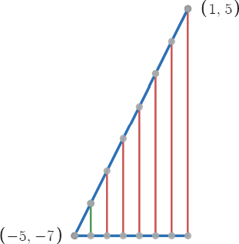

First dot = 0:7 ratio
Second dot = 1:7 ratio
Third dot = 2:7 ratio
Fourth dot = 3:7 ratio
Fifth dot = 4:7 ratio
Sixth dot = 5:7 ratio
Seventh dot = 6:7 ratio
Eighth dot = 7:7 ratio

Distance Formula for a point on the line

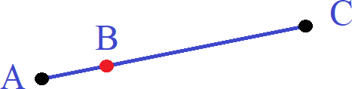

Point B is dividing a line. Line BC has a ratio of 3:1 with Line AB.
Find coordinates of Point B if Point A is ( – 7,1) and Point C is (9,5).

The difference in x is x₂ – x₁ = d_{x}.
The difference in y is y₂ – y₁ = d_{y}.

The ratio 3:1 gives slope as x:y which is y/x = 1/3.
AB/BC = 1/3 meaning AB represents ⅓(AC) where ⅓ is the scale factor.
It would be easier to find ⅓ of AC for AB than find ⅔ of AC for BC.

Key point:

- Find slope
- Multiply slope M with parts P
- Use

If ratio is 3:1 then 3 parts + 1 parts = 4 parts. Out of 4 parts AB is 1 part and BC is 3 parts hence 3:1.
You have two choices: Add 1(¼) of the change in x and y to Point A, or subtract 3(¼) of the change to Point B.

(x₁ + PM, y₁ + PM) (x₂ – drM, y₂ – drM)
( – 7 + 1∙4, 1 + 1∙1) (9 – 16(¾), 5 – 4(¾)
(– 7 + 4 , 1 + 1) (9 – 12, 5 – 2)
(– 3, 2) ( –3, 2)

Ab : Ac = 1: 3 ⅓AC

(-2 , -3) (2,7)

horizontal displacement is from a to c is 4 to the left vertical displacement is from a to c is 10 down
horizontal displacement is from a to b is 4/3 vertical displacement is from a to b is 10/3

Ax, Ay =( –4/3, 10/3)
Types of polygons

All shapes are made from lines connected to points called dots. A dot is 0 dimensions.
For a line to exist a segment must be drawn connecting two dots. A line is 1 dimensional. A curved line can simply be called a curve. It needs many points to pass through to trace its shape. Curves are also one dimensional because they do not enclose an area. A 2d circle is not a polygon because it does not have straight lines as sides.

The first 2 dimensional shape is the circle. It has no corners as it infinitely circle back on itself. In theory it is composed of infinitely many points that touch and are arranged in a circle. This is also true for all types of ellipses as well.

The first true polygon is the triangle followed by the square. These shapes have straight lines that join at points called vertices. These vertices are sharp corners compared to smooth curves. When properly formed these shapes enclose area and thus are 2d. After the triangle and square polygons are named by the number of sides they have. Poly means many and gon means angle. Similar to Polynomial means many numbers. The First polygon with a gon ending is the pentagon.

Polygons that have the same angle for each side are called regular. This makes them symmetrical,
Polygons that have differing angles are called irregular. They are asymmetrical. Assume all polygons are regular unless told otherwise. For all polygons the exterior angles is 360° divided by the number of sides.
The interior angle is 180° – the exterior angle.

Pentagon:
Penta means 5. A regular pentagon has 5 sides with 108° for internal angles and 72° for exterior angles. See how 108 and 72 add to 180? The inside and outside angles must equal 180°. Since each inside angle is 108° a pentagon has 540° degrees. Polygons are mostly ranked by their internal angles but the exterior angles are important to. The difference depends on whether you are approaching the angled wall from the inside or outside.

If traveling inside the pentagon on the base heading right you turn 72° to go up the next side. If you are out side the pentagon and traveling left you turn 108° to go up the side. This is seeming backwards but accurate. From inside we can see that the base and right side make an angle greater than 90°. The base acts like the negative side of the x axis and the corner the (0,0) origin of the unit circle. The right side extends at a 108° angle from the base but if placed inside the unit circle we can see it is pointing at where 72° would be.

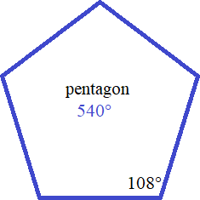

Hexagon:
Hexa means 6. A regular hexagon has 720° degrees, each inside angle is 120° each supplementary outside angle is 60°. A hexagon can be sectioned into 6 equilateral triangles by drawing three line from a corner to the furthest corner like so:

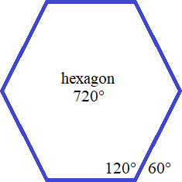
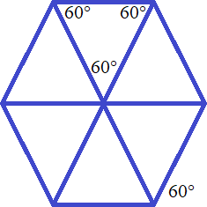

Fact: It is impossible to tile a curved surface with hexagons. A single 7-sided hole will be left needed to be filled with a 7-gon.

Septagon:

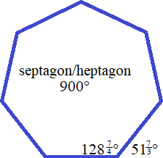
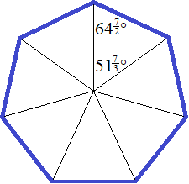
7 sides
Inner angle 128⁴/7 °
Outer angle 51³/7°
Central Angle 51³/7°

Formulas:
d = a / ( 2 ∙ sin ( π/2 / 7 ) )
e = 2 ∙ a ∙ cos ( π / 7 )
h = a / ( 2 ∙ tan ( π/2 / 7 ) )
p = 7 ∙ a
A = 7/4 ∙ a² / tan ( π / 7 )
rc = a / ( 2 ∙ sin ( π / 7 ) )
ri = a / ( 2 ∙ tan ( π / 7 ) )
Angle: 5/7∙180° ≈ 128,57°
14 diagonals

Fact: It is impossible to construct a septagon with a compass and straight rule.
Octagon: 8 sides

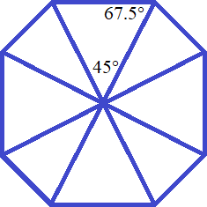
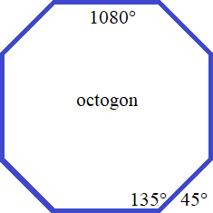
Octagon is a truncated square. The corners are cut at 45°.
The area of an octagon is 7/9 times its width or ¹/3 x ⁷/9
Internal angles are 45° making external angles 135°.
It is made of eight isosceles triangle's

Make two squares of equal size then rotate one 45° placing it so so centers overlap.


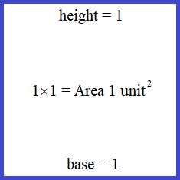
A basic square of 11 square sectioned into a 33 grid.
length and height 1. This divides each side into ⅓ segments.
Each side is 1 unit long. Each resultant tile is 1/3 long. Its area is ¹/3∙ ¹/3 = ¹/9 units².

To make the octagon divide the corner tiles diagonally like so:

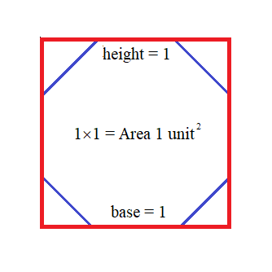
1. Rotate 45° 2. Cut off points of star

An octagon does not have 9 squares the same size as a square. It has 4 triangles, 4 rectangles and 1 large square in the center. The polygons after octagons are considered special shapes are require mastery of basics before constructing. They can be constructed using a compass and straight edge or graphed using analytical geometry. Analysis means plotting points on graph paper and studing them. Later we will construct: Nonagon, Decagon, Undecagon, Dodecagon.

Equilateral triangle: Square: Pentagon: Hexagon:
h = √3 / 2 ∙ a d = √2 ∙ a d = a / 2 ∙ ( 1 + √5 ) d = 2 ∙ a
p = 3 ∙ a p = 4 ∙ a h = a / 2 ∙ √5 + 2 ∙ √5 d2= √3 ∙ a
A = a² ∙ √3 / 4 A = a² p = 5 ∙ a p = 6 ∙ a
rc = √3 / 3 ∙ a rc = a / √2 A = a² / 4 ∙ √25 + 10 ∙ √5 A = 3/2 ∙ √3 ∙ a²
ri = √3 / 6 ∙ a ri = a / 2 rc = a / 10 ∙ √50 + 10 ∙ √5 ri= √3 / 2 ∙ a
Angle: 60° Angle: 90° ri = a / 10 ∙ √25 + 10 ∙ √5 Height = d2 = 2 ∙ ri
0 diagonals 2 diagonals Angle: 108° Circumcircle radius = a
5 diagonals Angle: 120°
9 diagonals

Octagon: Nonagon: Decagon: Undecagon:

d = a ∙ √ 4 + 2 ∙ √2 a = 2 ∙ rc ∙ sin( π / 9 ) d = a ∙ ( 1 + √5 ) di = a∙sin(π∙i/11)/sin( π/11 )
e = a ∙ ( 1 + √2 ) d = 2 ∙ rc ∙ sin( 2 ∙ π / 9 ) e = a ∙ √ 5 + 2 ∙ √5 h = a /(2∙tan(π/2/11))
f = a ∙ √ 2 + √2 e = 2 ∙ rc ∙ sin( 3 ∙ π / 9 ) f = a/2 ∙ √ 14 + 6 ∙ √5 p = 11 ∙ a
Height = e = 2 ∙ ri f = 2 ∙ rc ∙ sin( 4 ∙ π / 9 ) g = a/2 ∙ √ 10 + 2 ∙ √5 A = 11 ∙ a² /(4∙tan(π/11))
p = 8 ∙ a h = rc + ri Height = e = 2 ∙ ri rc = a / ( 2 ∙ sin(π/11)
A = 2 ∙ a² ∙ ( 1 + √2 ) p = 9 ∙ a p = 10 ∙ a ri = a / ( 2 ∙ tan(π/11))
rc = a / 2 ∙ √ 4 + 2 ∙ √2 A = 9/2 ∙ rc ∙ sin( 2 ∙ π / 9 ) A = 5/2 ∙ a² ∙ √ 5 + 2 ∙ √5) Angle: 9/11∙180° ≈ 147.27°
ri = a / 2 ∙ ( 1 + √2 ) ri = a / 2 ∙ tan( π / 9 ) rc = a/2 ∙ ( 1 + √5 ) 44 diagonals
Angle: 135° Angle: 140° ri = a/2 ∙ √ 5 + 2 ∙ √5
20 diagonals 27 diagonals Angle: 144°
35 diagonals
Dodecagon: Hexadecagon: N-gon:104 diagonals
d6 = ( √6 + √2 ) ∙ a d8 = a / sin(π/16) n ∈ ℕ, n > 2
d5 = ( 2 + √3 ) ∙ a d7 = sin(7π/16) / sin(π/16) ∙ a p = a ∙ n
d4 = ( 3∙√2 + √6 ) / 2 ∙ a d6 = sin(3π/8) / sin(π/16) ∙ a h = 2 ∙ ri if n is even, else
d3 = ( √3 + 1 ) ∙ a d5 = sin(5π/16) / sin(π/16) ∙ a h = a / ( 2 ∙ tan( π/2/n ))
d2 = ( √6 + √2 ) / 2 ∙ a = d6 / 2 d4 = √2/2 / sin(π/16) ∙ a A = n ∙ a² / ( 4 ∙ tan(π/n))
Height = d5 d3 = sin(3π/16) / sin(π/16) ∙ a rc = a / ( 2 ∙ sin(π/n))
p = 12 ∙ a d2 = sin(π/8) / sin(π/16) ∙ a ri = a / ( 2 ∙ tan(π/n))
A = 3 ∙ ( 2 + √3 ) ∙ a² Höhe = d7 Angle = 180° - 360° / n
rc = d6 / 2 = d2 p = 16 ∙ a d = n ( n - 3 ) / 2
ri = d5 / 2 A = 4 ∙ a² ∙ cot(π/16) Diagonal across m edges, m∈ℕ, m≤n/2: rc = d8/2 = √( 4 + 2√2 + √20+14√2 ) / 2 ∙ a dm = a ∙ sin( π ∙ m/n) / sin(π/n)
Angle: 150° 54 diagonals ri = d7/2 = ( 1 + √2 + √ 2 ∙ ( 2 + √2 )) / 2 ∙ a
Angle: 157.5°

Polygon rings: Line:

n ∈ ℕ, n > 2 y = mx + b (linear equation)
c = ( a - b ) / ( 2 ∙ sin(π/n)) m = ( y2 - y1 ) / ( x2 - x1 )
d = ( a - b ) / ( 2 ∙ tan(π/n)) b = y1 - x1 ∙ m
p = ( a + b ) ∙ n d = √ (x2 - x1)² + (y2 - y1)²
A = n ∙ ( a² - b² ) / ( 4 ∙ tan(π/n))
Other triangles: SAS: ASA and AAS:
SSS: Law of cosines a = √b² + c² - 2bc ∙ cos( α ) Third angle = 180° - other two angles,
α = arccos( (b² + c² - a²) / 2bc ) b = √a² + c² - 2ac ∙ cos( β ) then law of sines to find side lengths.
β = arccos( (a² + c² - b²) / 2ac ) c = √a² + b² - 2ab ∙ cos( γ )
γ = arccos( (a² + b² - c²) / 2ab )
SSA: Law of sines

a/sin( α ) = b/sin( β ) = c/sin( γ )
p = a + b + c
A = √p/2 ∙ (p/2-a) ∙ (p/2-b) ∙ (p/2-c) (Heron's formula)

unique, if the known angle is opposite to the larger of the two given sides, otherwise there are two solutions.

ha= c ∙ sin( β ) ma= √2 ∙ ( b² + c² ) - a²/ 2 rc= a / (2 ∙ sin( α ))
hb= a ∙ sin( γ ) mb= √2 ∙ ( c² + a² ) - b²/ 2 ri= 4r ∙ sin( α/2 ) ∙ sin( β/2 ) ∙ sin( γ/2 )
hc= b ∙ sin( α ) mc= √2 ∙ ( a² + b² ) - c²/ 2

Right triangle: Isosceles: right isosceles:

a² + b² = c² (Pythagorean theorem) a² + b² = c² (Pythagorean theorem) c = √2 ∙ a
p = a² / c p = a² / c hc = mc = √2 ∙ a / 2
q = b² / c q = b² / c ha = hb = a = b
h = √ p ∙ q h = √ p ∙ q ma = √5 ∙ a / 2
Perimeter = a + b + c Perimeter = a + b + c p = ( 2 + √2 ) ∙ a
A = a ∙ b / 2 A = a ∙ b / 2 A = a² / 2
α = arccos( (b² + c² - a²) / (2bc) ) α = arccos( (b² + c² - a²) / (2bc) ) rc = a / √2
β = arccos( (a² + c² - b²) / (2ac) ) β = arccos( (a² + c² - b²) / (2ac) ) ri = a / (2 + √2 )
γ = π/2 = 90° γ = π/2 = 90° Hypotenuse angles: 45°
rc = c / 2 rc = c / 2
ri = ( a + b - c ) / 2 ri = ( a + b - c ) / 2
ma = √2 ∙ ( b² + c² ) - a² / 2 ma = √2 ∙ ( b² + c² ) - a² / 2
mb = √2 ∙ ( c² + a² ) - b² / 2 mb = √2 ∙ ( c² + a² ) - b² / 2
mc = √2 ∙ ( a² + b² ) - c² / 2 mc = √2 ∙ ( a² + b² ) - c² / 2

Apothem:

The line drawn from the center of a regular polygon to the midpoint of a side.
Sectioning polygons into equal isosceles triangles at the center the apothem gives the height of each triangle.
Area of a polygon = ½nsa = ½pa = ¼ns²cot(π/n) = na²tan(π/n) . As sides increase to infinity the polygon becomes more like a circle and its area is found using πr². A = pa/2 = 2πr²/2 = πr²
Quadrilateral: Rectangle: Rhombus: Parallelogram:

c = √2 ∙ a d = √ a² + b² β = 180° - α β = 180° - α
hc = mc = √2 ∙ a / 2 p = 2 ∙ (a + b) p = 4 ∙ a e = √a² + b² – 2a∙b ∙ cos(β)
ha = hb = a = b A = a ∙ b A = a² ∙ sin (α) f = √a² + b² – 2a∙b ∙ cos(α)
ma = √5 ∙ a / 2 rc = 1/2 ∙ √ a² + b² e = 2 ∙ a ∙ cos (α/2) p = 2 ∙ ( a + b )
p = ( 2 + √2 ) ∙ a f = 2 ∙ a ∙ sin (α/2) A = ab∙ sin(α) = a∙ha = b∙hb
A = a² / 2 ri = a/2 ∙ sin (α) ha = b ∙ sin ( α )
rc = a / √2 h = A/a = a ∙ sin (α) hb = a ∙ sin ( α )
ri = a / (2 + √2 )
p = 2a ∙ ( 1 + 1/φ )
A = a² / φ

Concave quadrilateral: Concave deltoid

e = √ a² + b² - 2ab ∙ cos( β ) α + β + 2 ∙ γ = 360°
f = √ b² + c² - 2bc ∙ cos( γ m = a ∙ sin( γ ) / sin( β / 2 ) a / sin( β / 2 ) = b / sin( α / 2 )
β1 = arccos( (f² + b² - c²) / 2fb ) n = b ∙ sin ( β / 2 - 90° )
β2 = β – β1 l = m + n
d = √ a² + f² - 2af ∙ cos( β2 ) h = 2 ∙ √ b² – n²
α = arccos( (a² + d² - f²) / 2ad ) p = 2 ∙ ( a + b )
δ = 360° - α - β – γ A = l ∙ h / 2 - n ∙ h / 2
p = a + b + c + d
A = √(a+f+d)/2 ∙ ((a+f+d)/2-a) ∙ ((a+f+d)/2-f) ∙ ((a+f+d)/2-d) + √(b+c+f)/2 ∙ ((b+c+f)/2-b) ∙ ((b+c+f)/2-c) ∙ ((b+c+f)/2-f)
Crossed rectangle: Axial pentagon:

c = √ a² + b² / 2 d = √ 2c² - 2c² ∙ cos( α )
γ = arccos( (2c² - a²) / (2c²) ) e = √ b² - ( d/2 - a/2 )² + √ c² - ( d/2 )²
β = 180° - γ β = acos{ [ b² + c² - e² -(a/2)² ] / ( 2bc ) }
α = β / 2 γ = ( 540° - α - 2β ) / 2
p = 2a + 4c p = a + 2b + 2c
A = ab / 2 A = 1/4 ∙ √ ( d + a )² ∙ ( d - a + 2b ) ∙ ( a - d + 2b ) + 1/2 ∙ √( 4 ∙ c² - d² ) / 4 ∙ d

Crossed parallelogram: House:
b > a b > a
b = p + q b = p + q
α = arccos( (p² + q² - a²) / (2pq) ) α = arccos( (p² + q² - a²) / (2pq) )
β = arccos( (a² + q² - p²) / (2aq) ) β = arccos( (a² + q² - p²) / (2aq) )
γ = arccos( (a² + p² - q²) / (2ap) ) γ = arccos( (a² + p² - q²) / (2ap) )
δ = 180° - α δ = 180° - α
s = √2p² - cos( 180° - α ) ∙ 2p² s = √2p² - cos( 180° - α ) ∙ 2p²
t = √2q² - cos( 180° - α ) ∙ 2q² t = √2q² - cos( 180° - α ) ∙ 2q²
h = √ a² - [ (s-t)/2 ]² h = √ a² - [ (s-t)/2 ]²
p = 2 ∙ ( a + b ) p = 2 ∙ ( a + b )
A = 2 ∙ √u/4 ∙ (u/4-a) ∙ (u/4-p) ∙ (u/4-q) A = 2 ∙ √u/4 ∙ (u/4-a) ∙ (u/4-p) ∙ (u/4-q)
Cut rectangle: Concave pentagon: Concave regular pentagon:

e = √ (a-c)² + (b-d)² b = √2 ∙ a / 2 b = a/2 ∙ ( 1 + √5 )
p = a + b + c + d + e p = 3 ∙ a + 2 ∙ b p = 5 ∙ a
A = a ∙ b - ( a - c + b - d ) / 2 A = 3/4 ∙ a² A = a²/4(√25 + 10∙√5 –√10 + 2∙ √5)
Parallelogoon:

α + β + γ = 360°
da = √b² + c² - 2bc ∙ cos( α )
db = √a² + c² - 2ac ∙ cos( β )
dc = √a² + b² - 2ab ∙ cos( γ )
dab = √a² + da² - 2ada ∙ cos{ arccos[ ( a² + dc² - b² ) / 2adc ] + arccos[ ( da² + dc² - db² ) / 2dadc ] }
dac = √a² + da² - 2ada ∙ cos{ arccos[ ( a² + db² - c² ) / 2adb ] + arccos[ ( da² + db² - dc² ) / 2dadb ] }
dbc = √b² + db² - 2bdb ∙ cos{ arccos[ ( b² + da² - c² ) / 2bda ] + arccos[ ( db² + da² - dc² ) / 2dbda ] }
ha = da ∙ sin{ arccos[ ( a² + da² - dac² ) / 2ada ] }
hb = db ∙ sin{ arccos[ ( b² + db² - dab² ) / 2bdb ] }
hc = da ∙ sin{ arccos[ ( c² + dc² - dbc² ) / 2cdc ] }
p = 2 ∙ ( a + b + c )
v = a + b + dc
w = a + db + c
x = da + b + c
y = da + db + dc
A = √v/2 ∙ (v/2-a) ∙ (v/2-b) ∙ (v/2-dc) + √w/2 ∙ (w/2-a) ∙ (w/2-db) ∙ (w/2-c) + √x/2 ∙ (x/2-da) ∙ (x/2-b) ∙ (x/2-c) + √y/2 ∙ (y/2-da) ∙ (y/2-db) ∙ (y/2-dc)

When cross multiplying you are multiplying both ratios by the product of both denominators.
The apothem is polygon height/2. The octagon height is a ratio of 2(x√2)+side, in this case side is 10.

Golden rectangle: Golden ratio phi:
rc = a / √2 φ = ( 1 + √5 ) / 2 = 1.618033988749895..
ri = a / (2 + √2 )
p = 2a ∙ ( 1 + 1/φ )
A = a² / φ

Constructing an Octagon

Outside the octagon you have a 45-45-90 triangle so using ratio 1:1:√2 makes the height 10(√2/2) for each
triangle. The height of the octagon is two of these triangles plus the side of ten so you get:

10+(10√2) = 24.14213 = height of octagon ≈ 24.14/2 = 12.07 for Apothem.

Octagons are easy because they use 45° angles. If you divide a 1 by 1 square diagonally you get a base and height of 1 and a hypotenuse of √2, which is 1.414213. Since the sides where 10 we have to scale all sides of the triangle by 10, we have a triangle of 7.07106 by 7.07106 with a hypo of 14.14213. The height of the octagon is the height of two of these triangles plus the height of the vertical side. The height of the apothem is half this or one of these triangles plus half the side of the vertical side. 24.14213/2 = 5 + 7.071065 ≈ 12.07

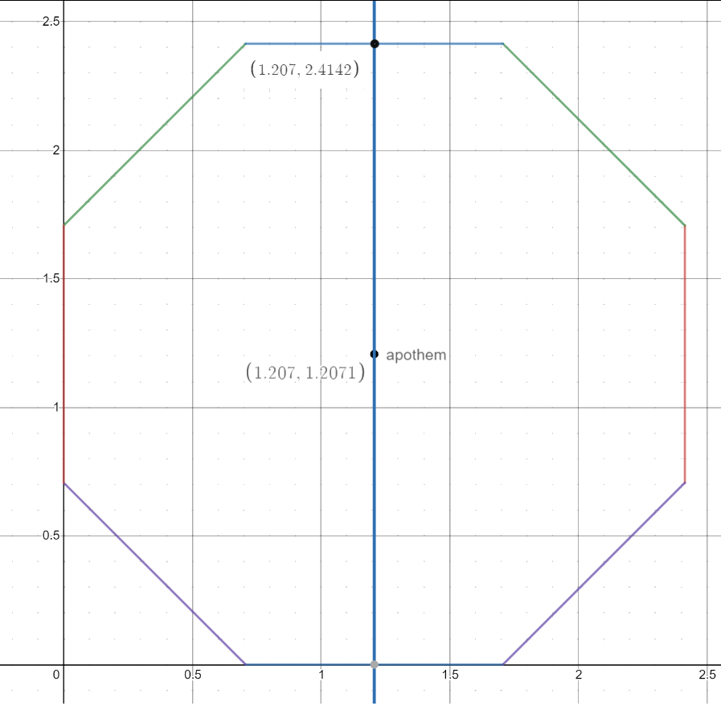

The area of an octagon is made of the following shapes: 1 center square, 4 rectangles, 4 triangles. 4r+4t+s =Area.
The rectangle are all identical. The triangles are all identical. The sides are all identical and have 45° at the vertex.
This is side A enlarged. Since the sides are all the same length we can set a side ratio of 1 to 1 for all the sides.
The sides will be 1 unit long. To avoid confusing sides with angles the angles use lowercase Greek letters α,β,γ.

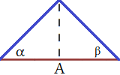
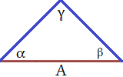
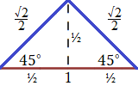

Alpha and beta are 45° while gamma is 90°. Drawing a line from vertex gamma to side a creates an altitude line.
This creates two right isosceles triangles. There is only one type of right isosceles and it is a ratio of 45-45-90 for its degrees. This gives a side ratio of 1:1:√2. The sides of our octagon are 1 unit so dividing it's base makes the two triangle's have a scale reduction of ½. This means all sides are ½ the original size giving actual lengths of ½, ½, ^{√2}/2. We can figure its area from this. Area = b² = ½² = ¼ units² , Area = 4r+4(¼) + s. We should call this triangle A since it has side A. We need to find the area of the rectangles. The is an enlargement of side H:

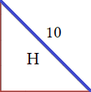

The x,y plane is represented by the red lines making a triangle where side H touches the x and y axis. Side H is 1 unit long and has a 45° angle, we can call this object triangle H. Triangle H must be identical to the triangle formed by the base of the octagon. They both have a 45° and a side of 1 unit. If we rotate triangle A 90° about the point of its A it be triangle H. Since we know H is 1 unit long then the rectangles long side must be 1 as they share that side. We also know that the short side of the rectangle shares a side with the top of triangle A so it must be √2/2 long.

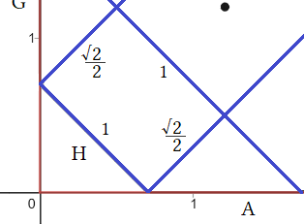

Left corner of the octagon enlarged showing sides A and H

Area of rectangle = 1 ∙ √2/2) ≈ 0.707106 units²
Multiply the base of 1 by height of 0.707106 to get the area.
Area = 4t + 4(¼) + s
Area = 4(0.707) + 4(¼) + s

Lastly we need to know the square. It shares all its sides with the long side
of the rectangles so it has four sides all 1 unit long making it 1² for its area.

Area = 4(0.707) + 4(¼) + s Area of rectangle = 2(1 + √2/2) ≈ 3.414213 units²
Area = 4(0.707) + 4(¼) + 1 Using distribution = 2(1 + √2/2) = (2∙1) + (2√2/2) = 2+√2
Area = 2.828427125 + 1 + 1 ≈ 4.8284 units² Using Pemdas = 2(1 + √2/2) ≈ 2(1.707106) ≈ 3.414213

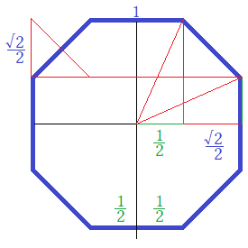
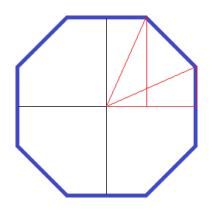
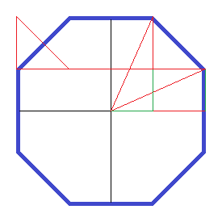
We quarter an octagon using axes. Draw a line to the two vertices in the first quadrant.
Make two triangles by dropping an altitude line down to the x axis.

- Assume each side of the octagon to be 1 unit long.
The base of the triangle will be ½ the side length.
The short triangle will be ½ the height of the side length.

- A third triangle is made from the corner with the 8-gon side being the hypotenuse.
Since the side is 1 we have a ratio of √2/2:√2/2:1.

- The height of the short triangle is one half the side of the octagon: ½.
The height of the large triangle is that plus the height of the triangle made from the corner. Together ½ + √2/2.

Dimensions of Base and height

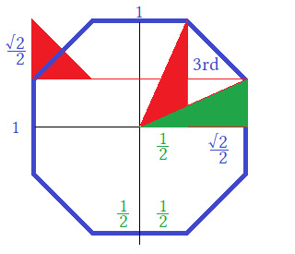

The two triangles in the 1st quad are congruent. The triangle on the left is a mirror of the one with “3rd” in it.
You can see that the two triangles are the same except they have been rotated 90° and flipped horizontally.
The base of the largest is ½, the base of the short is ½ plus √2/2. The height of the short one is ½. The height of the tall one is ½ + √2/2. Because each side of the octagon is length 1 when axes are placed inside it it makes the sides divided in half giving ½ + ½ = 1. This is where we get our measures of ½ for the base and height.

The third triangle is the one that is made in all four corners. Since the side of the octagon is 1
finding the base and height of the triangle made drawing lines from its vertices is easy.
We have an isosceles right triangle. It is obvious that its base and height are both √2/2.
Here is the corner enlarged. You can side the hypotenuse is 1 because the side is one.

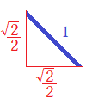

√2(1:1:√2) → √2:√2:2 → (√2:√2:2)÷2 → ^{√2}/₂:^{√2}/₂:1

Since we have a hypotenuse of 1 we have to use the equivalency scale that matches.
Basic algebra finds a:b:c to be ^{√2}/₂:^{√2}/₂:1.

This the large red triangle

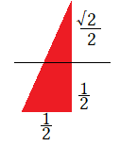

It's base is half of the top side of the octagon so ½. It's height is half of the right side of the octagon plus the height of isosceles triangle so ½ + √2/2. Height can also be written as ^{1+√2}/2. The other right triangle has same measurement just switch base and height. Since we have base and height we can find the angle from center to each vertex. It is not important to find the hypotenuse of the triangle but for understanding algebra and root numbers better we should.

a² + b² = c² Use Pythagoras to find missing hypotenuse length
(½)² + (½ + √2/2)² = c² This is explained in blue below...¹
¼ + ^{3+2√2}/4 = c² ½ squared is ¼ , the other thing is 3+2√2/4
^{2+√2}/2 = c² This ≈ 1.707106 ≈ 1 + √2/2, an important fact
√^{2+√2}/2 = c Take the root of both sides
1.306 ≈ c Use a decimal approximation of at least 4 digits if needed

...¹ continued from above:

(½ +√2/2)² This is a perfect square trinomial. We need to foil it out.
(½ +√2/2)(½ +√2/2) This makes two binomials of (½ +√2/2)²
(½ +√2/2)(½ +√2/2)” is actually a quadratic since it has square 2.

F: ½ ∙ ½ = ¼
O: ½ ∙√2/2 = ½√2/2 There are a few ways to write this: ½(^{√2}/₂) = ^{√2}/₄
I: √2/2 ∙ ½ = ½√2/2
L √2/2 ∙ √2/2 = ½ (^{√2}/₂∙^{√2}/₂) = ^{√2∙√2}/_{2∙2}

¼ + ½√2/4 + ½√2/4 + ½ The middle two terms are always added leaving a trinomial.
¼ + 1√2/4 + ½ The middle term coefficients ½ and ½ add to make 1.
¾ + √2/4 1st and last are common denominator fractions so their numerators add.
b² = ¾ + ^{√2}/4. Don't forget to add a² to b² to = c². a² was ¼.
(¼ + ¾ ) + √2/4 Adding a²
1+ √2/4 Final... ≈ 1.306562965. This is the length from center to any vertex.

You can use a casio fx-115es plus to do all this calculation in one or two steps but you should understand the process of how it works. Use the calculator as a crutch to overcome fear of radical terms and learn how to use the calculator then ween yourself off it when you need to algebraically manipulate terms by hand. Sometimes things are messy to put into a calculator or you don't understand the answer a calculator gives even though it is right. A calculator just gives an answer without showing its work leaving students mystified into what algorithm it is using to compute sums.

The final answer is 1+^{√2}/4 ≈ 1.306562965 and it means the length of center to any vertex.
If we double it we get the length of any diagonal that crosses the center. There are four that do and 16 that don't.
The four that do are called the longest diagonals.
The longest diagonals cross the center and go to the vertex directly opposite it.
This also shows how the two vertical and two horizontal diagonals make all rectangles.

8 Triangles Of The Octagon.

- From the upper vertex we see all the diagonals from it except the longest.
- These are called the short and medium diagonals.
- An octagon has 4 longest, 8 medium and 8 short diagonals;
- From each vertex 1 long, 2 medium and 2 short.
- Note the symmetry and the triangles formed are reflections.
- Note the shape formed between the 2 medium is symmetrical and can be split
- into two 90° triangles. These triangles would be reflected over the line that divided them.

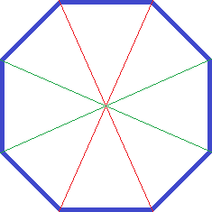
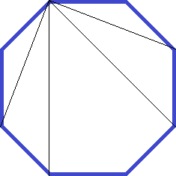
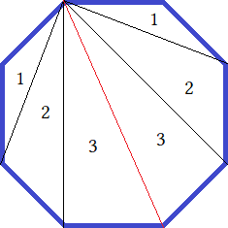

- The red line divides the octagon along its longest diagonal.
- This line is called the line of symmetry. Created are three pairs of triangles.
- Pair 1 are obtuse isosceles , pair 2 oblique scalene and 3 is right scalene.
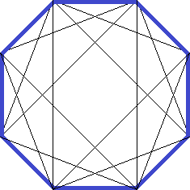
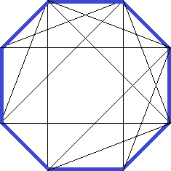
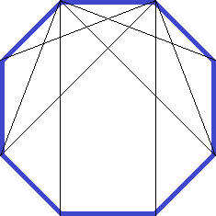
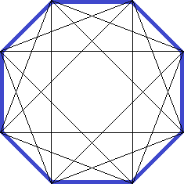
The two short diagonals form a 90° angle. The red line splits it into 45° and the medium lines split that into 22.5°.

You can count 4 angles inside the 90° each one symmetric at 22.5°.
The three lines make the 90° divided into four parts so 90°/4 = 22.5°.
Using color we can find area of the 4 , 4  and the . 4()+4()+1( ) = Area.

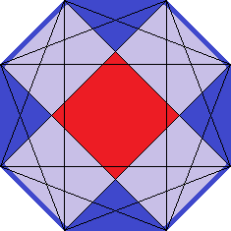
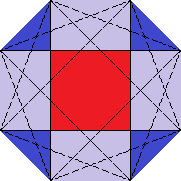
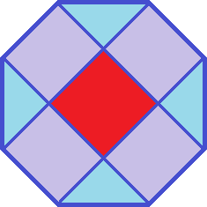
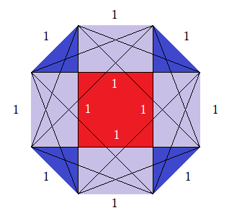
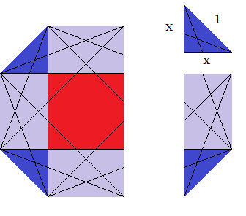

The area of the small triangle is going to be (x² ÷ 2) where x = √2/2.
We can derive this many ways but simply: for a 45-45-90 we have 1:1:√2 ratios.
Then we have 1x:1x:x√2 → 1:1:√2 → divide all sides by √2 → 1/√2:1/√2√1

1/√2 1 over √2 is ¹/_{√2}.
1∙(√2) / √2∙(√2) Scaling by (√2) to rationalize the denominator. ^{1∙√2}/_{√2∙√2} = ^{1∙√2}/_{√2∙2} = ^{√2}/₂
√2/2 x = ^{√2}/₂ is a key identity in geometry.

(√2/2)² /2 = (√2*√2) / (2*2) = ²/₄ = ½ and then ½ ÷2 = ¼ . Area of blue triangle is ¼ of a unit squared.

4(¼) = 1 The area of all blue triangles is 1 unit squared.

Red square is: 1² so it equals 1 unit squared. This means that each blue triangle is ¼ of the red square and four of them make a square the size of the red one. The rectangle is 1∙x where x = √2/2 or about 0.707

1∙ √2/2 = √2/2 This is obvious.
4(√2/2) = 4√2/2 = 2√2 4 cancels with the denominator 2 to leave a numerator of 2.
4√2/2 = 4/2 ∙ √2 = 2·√2 = 2√2 You can pull fractions apart this way to manipulate them.
All rectangles is 2√2 units squared.
Total area of octagon is 1+ 1 + 2√2 = 2 + 2√2 ≈ 4.828213.

What is the angle of alpha & beta? Finding to angle from center to vertices B and C.

The same two angles as before except now we their trig ratios:

sin² + cos² = r² = base² + height² = diagonal² = a² +b² = c².
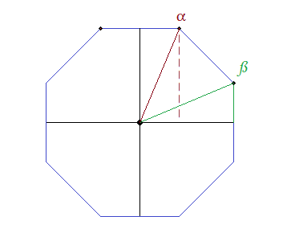

(½)² + (½ + ^{√2}/2)² = c²
¼ + (½ + ^{√2}/2)(½ + ^{√2}/2) = c²
¼ + ¼ + ^{√2}/2 + ½ = c²
1 + ^{√2}/2 = c²
√1 + ^{√2}/2 = c
1.306562965 = c

x(α) = ½
y(α) = ½ + √2/2
hypo = 1+√2/4

sin = x/hypo
cos = y/hypo
tan = y/x

sin(α) = ^{1+√2}/₂ /1.306562965 = 0.9238795325 sin⁻¹(α) = 67.5° sin(ß) = cos(α)
cos(α) = ½ /1.306562965 = 0.3826834324 cos⁻¹(α) = 67.5° cos(ß) = sin(α)
tan(α) = 0.9238795325/0.3826834324 = 2.4142135629 tan⁻¹(α) = 67.5° tan(ß) = 1/cot(α)

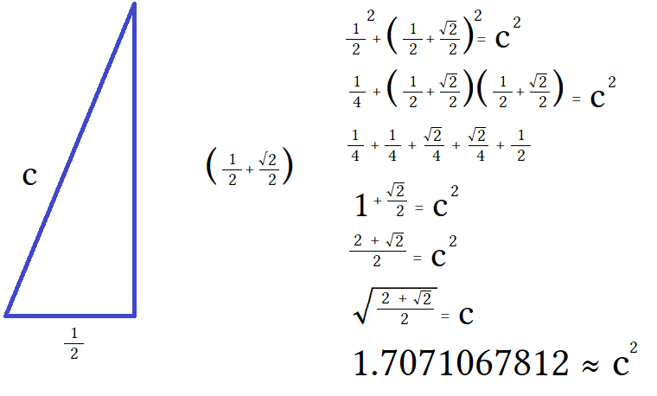
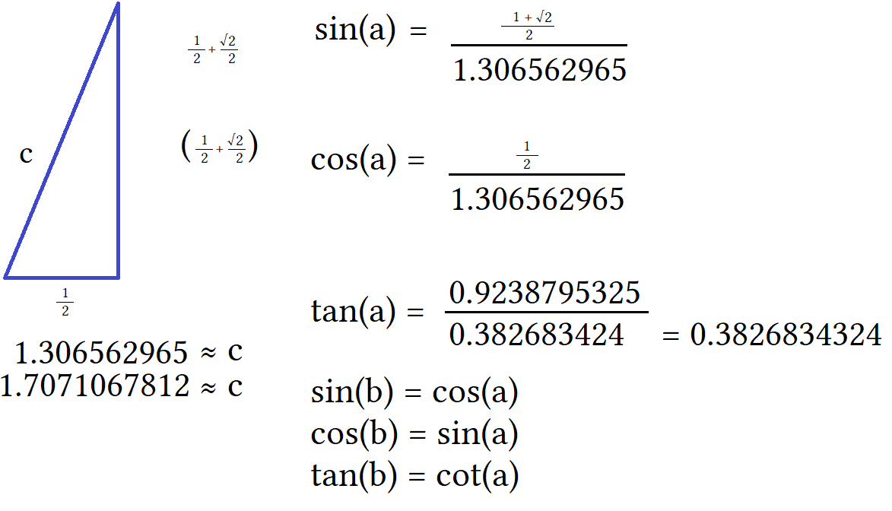

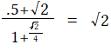
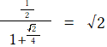

Right Scalene Triangle

Side a = 0.5 Angle ∠A = 67.5° = 67°30'0" = 1.1781 rad = 3/8π
Side b = 1.30656 Angle ∠B = 22.5° = 22°30'0" = 0.3927 rad = π/8
Side c = 1.20711 Angle ∠C = 90° = 1.5708 rad = π/2

Radius of a polygon is the length from the center to any vertex. The apothem is the length from origin (0,0) to the center of a side. This is also called the inradius. Origin in graphing, is where axes meet at (0,0).

Radius = side length/ 2 sin(180/n) Apothem = side length/ 2tan(180/n)
Radius = apothem length/ cos(180/n) Apothem = radius∙cos(180/n)

Incircle is the circle made by using the apothem as a radius and sweeping a line 360°. This is the largest circle that will fit inside a polygon. This is why apothem is called inradius because it is the radius of the incircle.

Side Length: 1 Central Angle: 45°
Height Length: 1 +√2 External Angle: 45°
Width Length: 1+√2 Internal Angle: 135°
Apothem: 1+√2

Circumcircle is related to the unit circle. Is is a circle drawn around the polygon. Its radius is the radius of the polygon. If you graph a polygon then draw a line to a vertex the length is called the radius. Using that length to sweep a 360° path creates a circle that only touches the vertex points. Find the center of a polygon. This is your origin. Draw a line to a corner in the first quadrant. This is your radius. Draw a line from the vertex straight down and stop at the x axis. This makes a triangle with radius, altitude, and x axis. Find the lengths of your triangle. Divide the hypotenuse but itself to reduce it to 1 making it a radius of 1. Divide all other sides by hypotenuse length to maintain proportion. This makes a triangle with radius the hypotenuse and the altitude the sine and the x axis the cosine. With a radius of 1 and other sides adjusted the circumcircle now is the unit circle. This will change the dimensions of all polygons but keep their proportions. You will have similar polygons but congruency is lost.

Details on 67.5-22.5-90 triangle

Area = 0.30178 Height ha = 1.20711 Median ma = 1.23272
Perimeter p = 3.01367 Height hb = 0.46194 Median mb = 0.65328
Semiperimeter s = 1.50683 Height hc = 0.5 Median mc = 0.78376
Vertex coordinates: A[0, 0] B[1.20711, 0] C[1.20711, 0.5] Inradius r = 0.20027
Centroid: [0.80474, 0.16667] Circumradius R = 0.65328
Inscribed Circle Center: [1.00683, 0.20027] Circumscribed Circle Center: [0.60355, 0.25]

Graphing the Octagon

There are two ways to orientate the octagon. The easy way is to have it orientated with a vertex pointing down. This is easier to draw but doesn't look as good. The other way is to have the the top and bottom side parallel at 0°.
This looks better but is harder to draw.

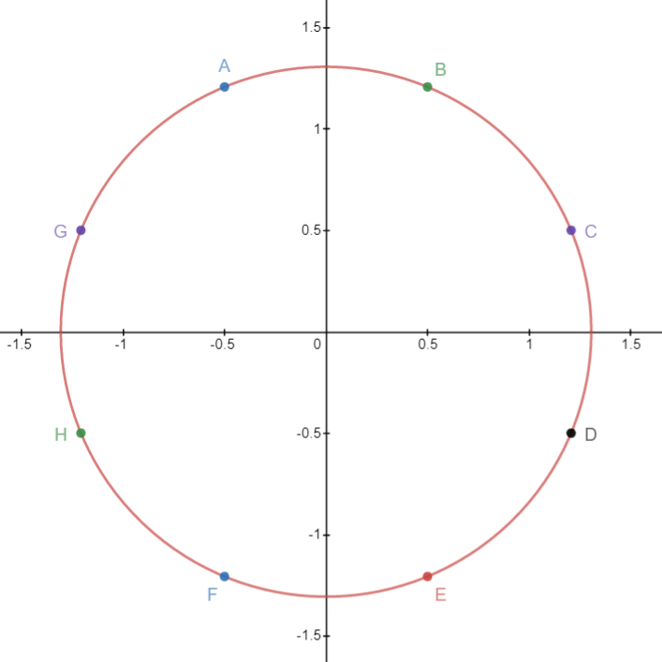
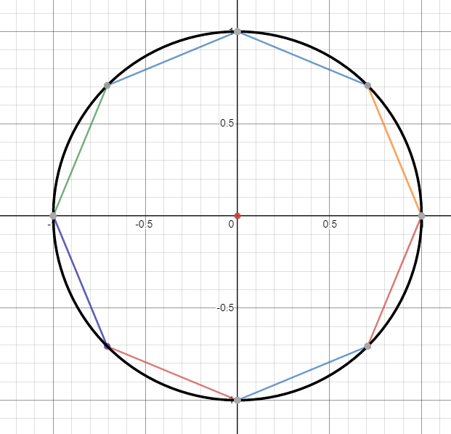

r = √^{2+√2}/2
r² = (√^{2+√2}/2)²
x² + y² = r²
x² + y² = (√^{2+√2}/2 )²
x² + y² = ^{2+√2}/2 = 1 + √2/2

First you have to write the equation for the circle. The equation for a circle is x² + y² = r². If you chose a value for r² like x² + y² = 1 it gives a radius of 1 making a diameter of 2. We need the radius of our circle to be the same value as the circumradius of our polygon. The circumradius (called radius) is the length from center to vertex.

A regular octagon with side length 1 has a radius of about 1.306. It's exact value was an irrational square root derived by finding the hypotenuse of the triangle made from the radius to the vertex. This was square root of 1+√2/2. Radius is (1+√2/2)^{1/2} written ^{√2+√2}/₂. We need to input that into our formula. I will use x² + y² = 1 + √2/2 as the equation for our circle. This gives a radius as 1.30656296 or the square root of what we entered. Typing in r instead of r² gives a radius of √r.

We have our circle and now need to plot the eight points for the vertices. Points are 1 unit away from the nearest point. Connecting these points will make eight sides 1 unit long. The intuition is that the axes divide the circle in two. We need sides 1 unit long so the points need to be reflected on either side of the axis it is nearest to.
Points A and B need to be the same distance from the y axis and that distance needs to equal 1 unit.

We take 1 unit and divide it by 2: 1÷2 = ½. Point A needs to have – ½ for its x and Point B needs to have ½ for its x value. From the y axis you go ½ a unit to the left and for point B you go ½ to the right. The other points follow a similar scheme.

Point B: This is the point from which we found it to be at an angle of 67.5°. We made a triangle. It had a base of ½ and a height of (½+ √2/2 ). Point B is ½ unit to the right and about 1.207 units up. This gives it the coordinates (½, ^{1+√2}/2).

Point A: If we know point B is ½ over and 1.207 up then we know point A is –½ over and 1.207 up. It uses the same height as point B but its x distance is negative instead of positive since it is going left instead of right.

Incidentally this is the same as saying point A is located by taking the triangle of point B and reflecting it across the y axis. Roughly speaking this means the triangle gives width as cosine and height as sin but we would have to shrink our circle to a diameter of 2 and right now it has a diameter of about 2.6 since our radius is about 1.3.

To find the vertex points find the triangle and the reflections that transform the triangle to the new location with α as the origin angle, ß as the vertex angle and γ as the 90° angle. To avoid confusing angle letter with point letter you can use Greek letters alpha, beta , and gamma for angle letters and English letters for point letters.

Our circle with radius √1+√2/2 : x²+y² = 1+√2/2
Our equation for line 67.5° : y= (1+√2)x
Tangent is slope where m = y2 – y1/x2 – x1
Equation for a line is y = mx+b

Tangent of our triangle was y/x = 1+√2 so we use this as the slope of our line.
About tangent: Tangent means slope. Our 67.5° triangle had the trig ratios:

sin(α) = ^{1+√2}/2 /1.306562965 = 0.9238795325 sin⁻¹(α) = 67.5°
cos(α) = ½ /1.306562965 = 0.3826834324 cos⁻¹(α) = 67.5°
tan(α) = 0.9238795325/0.3826834324 = 2.4142135629 tan⁻¹(α) = 67.5°

½ = .5 and √2/2 ≈ .707 , then ½ + .707 = 1.207 for height (y). This is the numerator for sine above. ½ = ½ this is the numerator for cosine above. The tangent is opposite over adjacent. It is ½ +.707 divided by ½ = 2.414 or 1+√2 to be exact.

x(α) = ½ triangle had a base of 0.5
y(α) = ½ + √2/2 triangle has a height of 1.707
hypo = (1+√2/2)^{1/2} the triangle had a hypotenuse of 1.307

Tangent really is sine/cosine. The crazy decimals in tangent are the result from dividing whatever height or base of the triangle by the hypotenuse and then taking those ratios and dividing them against each other because I felt more confident using that approach at the time.

Upon further consideration I could have used ^{1+√2}/2÷ ½.
I used the decimals so that I could see that about .92/.38 ≈ 2.4. This gives a slope of about 2.4.
Use tangent for slope when writing an equation for the line.
y = x is 45°. This is called the identity equation or the line of symmetry.
y = ( ^{sine}/cosine)x is the slope being multiplied by x where x is the input for our function.

In other words tangent = m for slope. y = ( ^{sine}/_{cosine})x + b where b is the y value when x = 0. B is called the y-intercept and where the formula gets its name y slope intercept formula but will will just call it the equation for a line. Mostly we want the intercept to be at the origin so b will sometimes equal 0. When this happens we do not add b at all since we will be adding 0. y = x is also y = x+0, the intercept is at (0,0). We will call (0,0) the “origin”.
We start with the equation for a line y = x then add our slope 1+√2. We then have y = (1+√2)x. This is a line at 67.5° because this is the tangent of 67.5°.

- We need to make an altitude line dropping from point B.
- Point B has the coordinates (.5,1.207).
- The equation for a vertical line is x = (some constant).

Use the constant for the value you want x to be set to. Saying x = constant makes a vertical line at that x value.
The equation for the y axis itself is x=0, this makes a vertical line pass through all points from -∞,∞ in the y range with 0 as the x value for every point. You could define the y axis as: y axis  x = 0. For the altitude line
x = 1+√2. 1+√2 ≈ 1.207 so every point on this line is (1.207,y) where y is any number from -∞ to ∞. It is unnecessary but to show the the equation for a horizontal line you set y to some constant instead of x. For the x axis definition: y axis  x = 0.

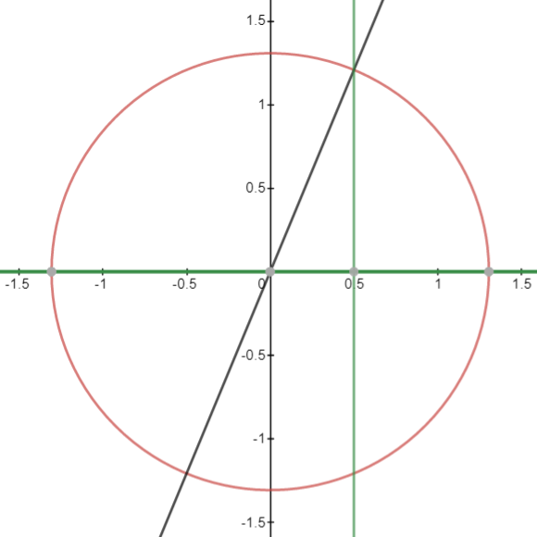
This diagram has three equations:

Black line at 67.5°: y = (1+√2)x
Green Line at 90°: x = 1+√2
Green line at 0°: y = 0

These are lines and not line segments. To limit the range or domain of a line you have to
set constraints using set notation. I want to limit these lines so they only form the 67.5° △.

Inequality set notation limits domain and range: {n≤x≤n} or {n≤y≤n}. If you use < or > the line segment will extend to the value indicated but have a hole at that point where your function will be undefined. We want our function defined at that point so will be using ≤.

It doesn't matter which way your signs point at long as x or y are inside them and the values make sense. The lower number has to be less than and the bigger number has to greater than your variable. 1<x<2 makes sense but 1>x>2 doesn't since 1 can not be 1>2. You could write it as 2>x>1 but convention is to always use inequality signs pointing left.

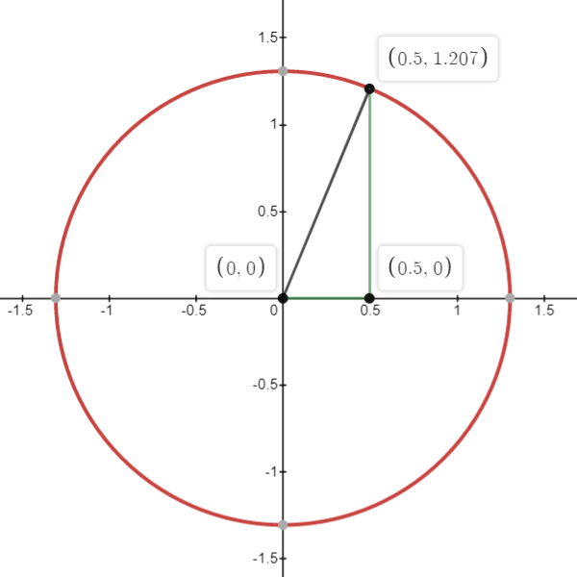

There are many ways to write constraints on domain and range. A simple way is that since the base goes from 0 to ½ write {0 ≤ x ≤ ½}. The line will begin at x= 0 and stop at x = ½. We do something similar for the radius line. Unlike a horizontal or vertical line we can limit a slope line using either x or y in our inequality since it crosses two dimensions. The 0° line can only use {x₁ ≤ x ≤ x₂} to limit the domain of x. The 90° can only use {y₁ ≤ y ≤ y₂} to limit the range of y. The slope line can use both. Using the values from two points, here the origin (0,0) and point B (½ ,1+√2/2) can choose to limit the domain or the range.

Domain of the line we want is {0 ≤ x ≤ ½}. Range of the line we want is {0 ≤ y ≤ 1+√2/2}. Both start the line at (0,0) and stop it at ( ½, 1+√2/2 ) so they are equal. Choose domain because here it is easier to read. Given a choice it is best to write your inequalities as clear as possible using the simplest values. Write the inequality after the function:

Black line at 67.5°: y = (1+√2)x {0 ≤ x ≤ ½}
Green Line at 90°: x = 1+√2 {0 ≤ y ≤ ½ +√2/2}
Green line at 0°: y = 0 {0 ≤ x ≤ ½}

{0 ≤ x ≤ ½} means that x₁ = 0 and x₂ = ½ giving a length of ½.
The equality does not change the function but segments the infinite line into finite length at the
specified points. The key is to use the x,y values from two points to select a start and finish point.

These three equations make segments that form a triangle. Note that we do not need to write and equation for the 0° line since that is already represented by the x axis itself. We merely did so to highlight the base of the triangle in a different color than the black the x axis is.

This triangle of 67.5° is hitting point B (0.5,1.207). We need to reflect this triangle over the y axis to hit point A. Reflecting of this triangle will produce a second triangle that hits at 67.5° + 45° = 112.5°.

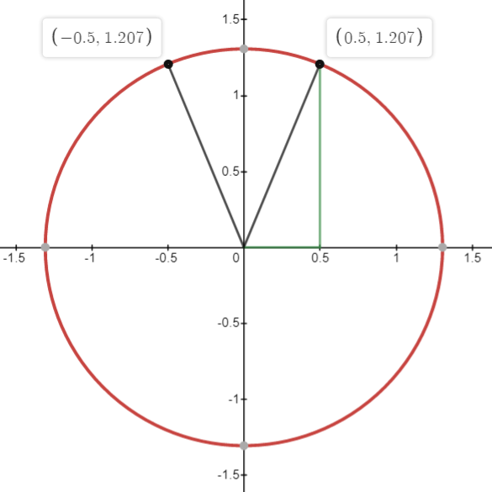

To reflect the triangle to 112.5°:

Instead of using (0.5,1.207) use (-0.5,1.207). This will give a reflection over the y axis and keep symmetry since the height is unchanged and the distance from the y axis is the same but in quadrant 2 instead of quadrant 1.

Be careful with range and domain for your inequalities. They can get jumbled.
Write the equation for the radius line only this time:

y = (-1+√2)x This is the same as point B except it has a negative slope.
{-0.5≤ x≤ 0} This is the same as point B except we begin at – ½ and end at 0.

From the picture the points A and B are symmetric across the y axis. It is clear dropping altitude line from point A results in the same triangle as point be because they have the same base and height. As such we don't need to draw the entire triangle again. It was only used for reference to show the comparison from the octagon we did earlier. We only need to find the points of the octagons vertices, write the equations for the radius and write the equations for the sides of the octagon.

Points C and G

Points C and G are are located by rotating and flipping the radii of points A and B. There are several creative ways to do this and boring straightforward ways. Most creative would be to rotate both radii 90° each away from each other and then reflect them over the x axis. The most boring way would be to rotate them each 67.5° away from each other then horizontally flip them over there centerlines.

A way I won't explore is taking the 135° radius and subtracting 112.5° from it to place it at 22.5° while taking the 67.5° radius and adding 90° then leaving them as is or flipping them vertically. It works but seems to lack simplicity and elegance. What other ways can you thing of to transform the radii or their imaginary triangles to make them point to the new locations?

The boring way takes the 67.5° triangle and rotates it clockwise by -67.5° and places it 0°. The alpha point moves from (0,0) up the y axis to (0, ½), the beta point moves 67.5°→ 0° and the gamma point moves the origin. Flipping them along a vertical midpoint line switches beta and gamma and puts alpha from (0, ½) →(1.207, ½) where it hits the unit circle at 22.5°. This is a safe transformation and usually taught this way.

It is important to say that it is rotated at its center rather than rotated at the origin. Rotating at the origin is completely different!! A origin rotation makes point alpha pinned to (0,0) while beta and gamma move freely. Beta goes to 0° and gamma goes to (0, - ½). Two points are on the x axis and gamma is on the y axis with a negative value, you have the hypotenuse/radius pointing at 0° and the entirety of your triangle resides in the 4th quadrant. THIS IS NOT WHAT WE WANT! THIS IS A FAILED TRANSFORMATION! It is not solved and the only way to do so is to use linear algebra and leverage vector multiplication to end some way that works. This is unnecessary and tedious. Transformations get complicated so I will only show what is necessary to complete it in a straightforward way.

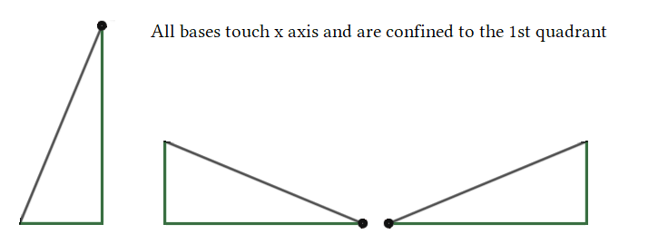
Rotation 90° then flip horizontally 180°:

The height of the triangle is only 1.2 so will not touch the boundary of the circle at 1.307.
Move beta to (1.207,0); Move alpha to (0,0.5); Move gamma to (0,0).

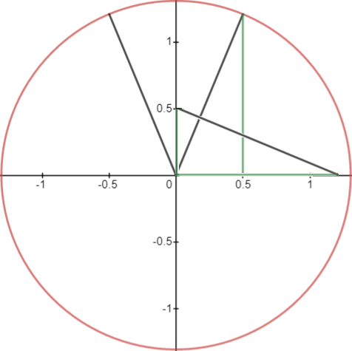
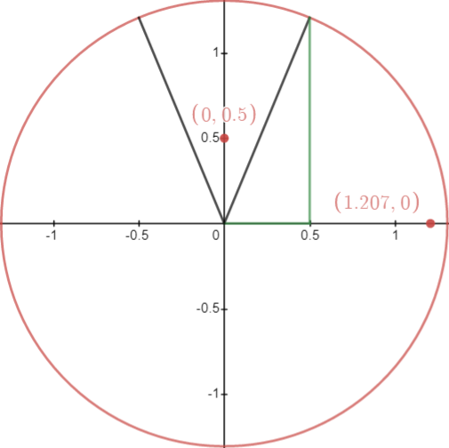
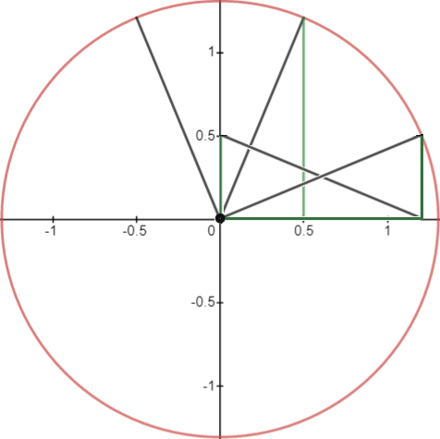

Transformations are quite involved. It is easier to find points of the octagon by dividing 360° by number of sides and just counting the locations From 22.5° we should get degrees of:

- 22.5°
- 67.5°
- 112.5°
- 157.5°
- 202.5°
- 247.5°
- 292.5°
- 337.5°
- Adding another 45° brings you back to 22.5°

We could use a calculator to find the points. Cosine of degrees will give a trig ratio of base/hypotenuse. To calibrate for being outside the unit circle we must multiply this ratio by our hypotenuse of about 1.307. The output will be the x value for that coordinate point. Sine of degrees will give a trig ratio of height/hypotenuse. Multiplying by the hypotenuse will give the true length of out height. This will be the y value for that coordinate point. Instead lets use another approach and then check with our calculator. Every point has the radius at a multiple of 45°. The radius has a length of 1.307 making it the hypotenuse of some triangle with legs 1.207 & 0.5.
All we have to do is look at the circle and move every combination of 1.207 & 0.5 to find the x,y pairs.
There are at most 8 combinations for these and everyone of those is a vertex point of our octagon.

Quad 1: x,y and y are both positive Quad 2: x is negative

      - ( – ½ , 1.207) ( ½ , 1.207)
      - (- 1.207, ½) (1.207, ½)

Quad 3: x,y are both negative Quad 4: y is negative

      - ( - ½, -1.207 ) ( ½, -1.207)
      - (- 1.207, - 1.2) (1.207, ½)

We could say there are 2 coordinates in each quadrant and write is as four quadrants times 2 coordinates is
4(2) = 8 but this is naive. On a deeper level we could look at this as a simple combinatorics problem given by
2 positions [x,y] times 2 numbers [½,1.207] times 2 signs [+, –] equals (2)(2)(2)= 2³ = 8. Switch x and y to find
the correct rotate and flip for each set of in a quadrant.

Every combination: (x,y);(y,x) (-x,y);(-y,x) (-x,-y);(-y,-x) (x,-y);(y,-x)

There are eight combinations because we had an octagon and it allows for the maximum of possibilities, other polygons may not be so easy. Chose a number for x and a number for y and simply fill out the chart of combinations. In seconds you will have solved every coordinates. The hard part of graphing is dealing with choices of what number is x and y, what number is positive or negative. It is time consuming to keep all of this straight and people get confused slowing them down. Thinking about it logically builds intuition and speed. The 8 combinations are used once for each point.

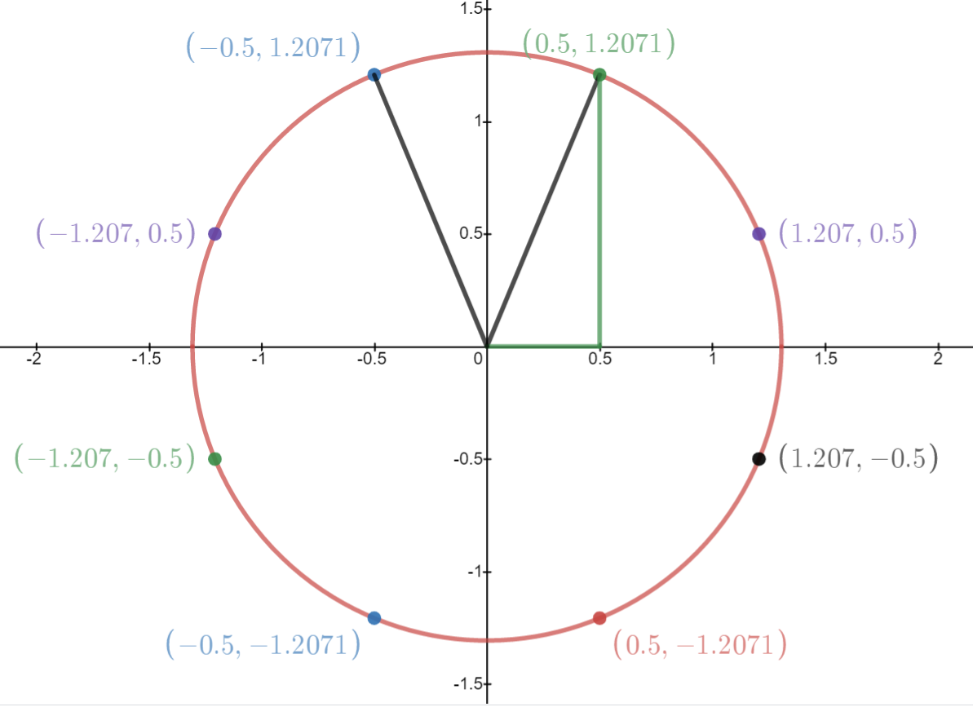
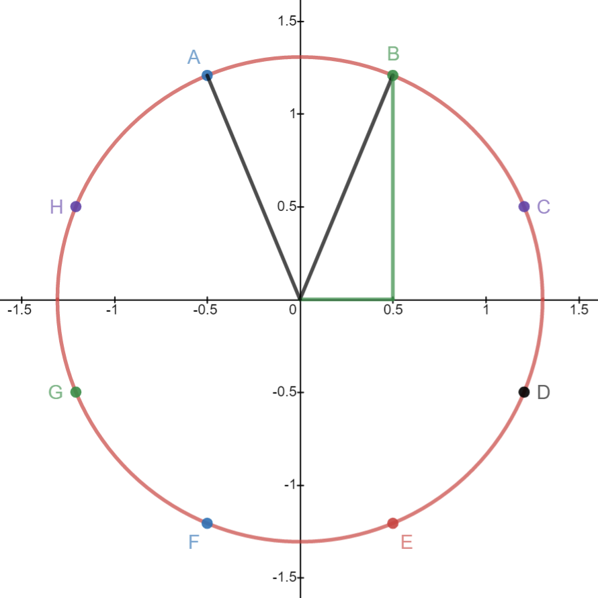

All points are some combination of the same two numbers namely the sine and cosine of the starting triangle.
There is a lot of symmetry here making writing the equations easy. Slope will be easy and intercept will be easy.
Look for patterns and predict what intercepts will be. Slope is rise over run. Point B is 1.207 over 0.5. If we scale it by a factor of 2 we have change to 2.414 over 1. ^{2.414}/₁ = 2.414. This is an approximation used for convenience. When we write our equation we have to use the exact value of else or angle will be off. The original number was ½ + ^{√2}/₂. We will use different forms of this as it becomes relevant to do so. In fact use radicals instead of any ≈.

To write the equations for the lines to all points find slope and then write as y = mx+b formula. Use this to calculate distances of the lines to trace diagonals to all points. Graph sides of octagon using the locations of the points you find.
Slope of Point B and C:

M = 1.207/0.5 = 2.417/1
^{y}/_{x} = ^{1+√2}/₂ ÷ 2 = 1+√2.

Line to B is given by y = (1+√2)x. Point C is the reciprocal of point B so C = ¹/_{B}. Invert x and y of B to find C.
Line to C given by y = (–1+√2)x. This line is a 22.5° reflection over the identity function y= x.

1÷1+√2 = – 1+√2

Decimals are used for writing on graphs when using radicals is hard to read. We use decimals in the real world for engineering applications but in pure math we use radicals. Radicals are better. I use decimals when I do not want to tell someone “ the exact value is one half plus root two over two” when I can just say “ the number is about 1.207” which I then abbreviate as 1.2 knowing that I really have ^{1+√2}/₂. I know the radical so am not really interested in approximations, it is only for ease of use during speaking we use approximations.

Typing in 0.5 ÷ ^{1+√2}/₂ will give –1+√2 but does not explain where this number comes from or why the 1 is negative.

- A rational expression is a fraction with a binomial as its numerator, denominator, or both.
- This differs from a complex fraction that has a fraction or decimal in its numerator, denominator, or both.
- We are trying to get rid of a radical to write more simply. This is related to quadratics.
- From quadratics we will use square roots, compound operators, difference of squares, and foil.

A square has a base of 1 and a height of 1. It's diagonal makes a triangle with a length of c. Using pythagoras we find the hypotenuse to be √2 thus an isosceles right triangle with base and height 1 has side ratios of 1:1:√2. Dividing by 2 shows ½ : ½ : ^{√2}/₂ which tells us that √ ½ = ^{√2}/₂. A decimal approximation of (0.707106)² is used as a quick check that (0.707106)² = 0.4999988536 which would be 0.5 had we used ^{√2}/₂ instead of a decimal ≈:

What is √½?

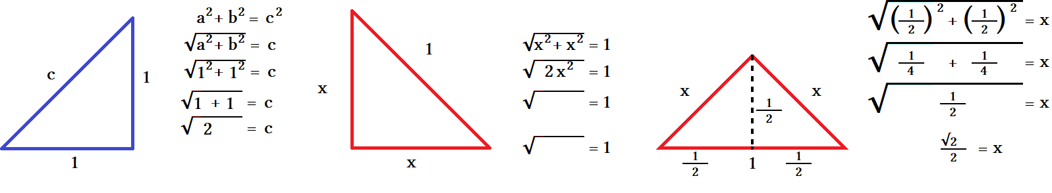

- √1² +1² = √2 We have a  with sides of 1:1:√2.
- √2x² = 1 2x² = 1 dividing by 2... x² = ½ ... x = √½.
- x = √½ root∙root = ½ where r = root we have r² = ½ and r = √½.
- r∙r = ½ What times itself is ½? Guessing we get 0.7∙0.7 = 0.49 so about 0.7.

- We could continue to guess by trying every decimal by using method of exhaustion but that is tedious and imprecise. We are approximating a root using decimals and do not know how to write it in radical notation other than √½. Roots should not have fractions under the radicand so this is unacceptable. 0.71∙0.71 = 0.5041 so we know that x<0.71 then x must be 0.70<x<0.71. It is more than 0.7 and less than 0.71. We then know that the second decimal is 0 since 1 is too big so we try 0.709² , 0.708², 0.707², and find that all are to big except for 0.707 which is too small at 0.499849 which is very close to 0.5. We now know that 0.707<x<0.708. This is a form of a liming process that is used in calculus to find the limit of a number. We try the next number after 0.7070 which is .7071 and get 0.49999041, we are getting closer... 0.7071<x<0.708. Eventually we would find the ≈ 0.707106 but this is not good enough we need a better method instead of calculator crunching.

What x for x²∙2 = 1? We have a with sides  x:x:1. By rotating the x:x:1  to hypotenuse as base then dividing base by 2 makes two smaller  with ½ as new base. Since a 45°:45°:90° has base = height then the height must be ½ as well. We have a²+b² = c² as (½)² + (½)² = x² .

- (½)² + (½)² = x² ¼ + ¼ = x² ½ = x² √½ = x and so 2√¼ = 1.
- x² = ½ because x² = ½∙½ = ¼ → 2(x)² = 2(½)² = ½ → (½)² + (½)² = x² → ¼ + ¼ = x² → ½ = x² → √½ = x

We notice that a square has base = height giving a ratio of base:height = x:x where x and x are the same value.
Making a triangle by cutting along the diagonal of a square gives ratios of 1:1:√2 regardless of the value of x.
We could also write x1:x1:x√2 → x:x:x√2 where x is some number other than 1. This scales a 45°:45° triangle.

1:1:√2 means that base = 1 height = 1 and hypotenuse = √2... this comes from a² +b² = c² = (1)² + (1)² = (√2)².
This says that a and b = 1 and c = √2. For and this we write x =1 since a and b are both the same length we need
only one variable to stand for both of them. If we divide all sides by the same common ratio: 1:1:√2 → ½ : ½ : ^{√2}/₂ this says x now is ½ and hypotenuse is ^{√2}/₂. a² +b² = c² = (½)² + (½)² = (^{√2}/₂)²... this says that the base and height are ½ and that √½ = ^{√2}/₂. We are trying to find the base of a triangle that has x:x:½ ratios. x = ^{√2}/₂ because of the above logic.
We check by substituting: ^{√2}/₂∙^{√2}/₂ = ^{√2∙√2}/_{2∙2} = ²/₄ = ½. This proves x = ^{√2}/₂.

1. The first  is 1:1:√2. 2.This is a median. This shows  with hyp as base. 2x² = 2(^{√2}/₂)²
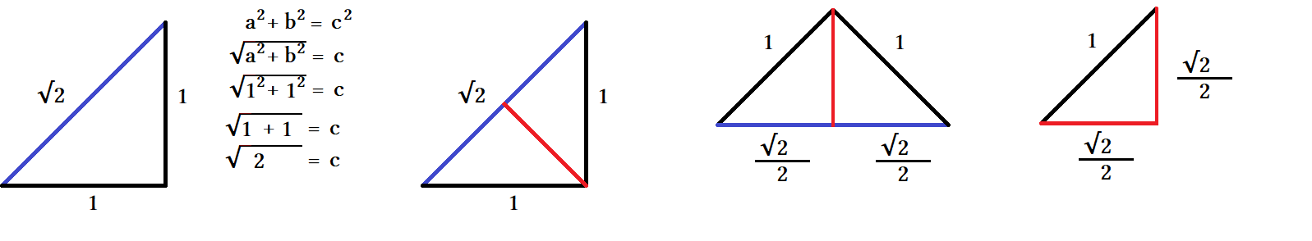
^{√2}/₂∙^{√2}/₂=1
√½ = ^{√2}/₂

- Make a 1×1 square and create two 1:1:√2 triangles by dividing along the diagonal.
- A median is a line drawn from one corner to the middle of the opposite side. This separates the  into two . Draw a median from the 90° corner to the middle of the hypotenuse or rotate so that the hypotenuse is base.

- With base down we see that the hyp of 1 is split into two equal lengths of ½ and ½. This follows since ½ + ½ =1.

- The red line is called sine regardless of rotation. It is the height of the fourth triangle.
- Sine measures the height or altitude of a triangle. Rotating a triangle does not affect the length or value of sine.

- If a triangle is rotated odd degrees trig functions are used to calculate sine by sine = opposite/hypotenuse.

- For last triangle we have sine of ∠A = ^{√2}/₂÷1 = ^{√2}/₂. The height is sine and sine is ^{√2}/₂.
- This is only true when a triangle has a hypotenuse of 1 otherwise you have to multiply sine by scale factor s.

- Sine is the ratio of ^{opp}/_{hyp} also written hyp:opp. Sine is related to height so height is either sine or a multiple of sine if scaled. This is explained during unit circle tutorials.

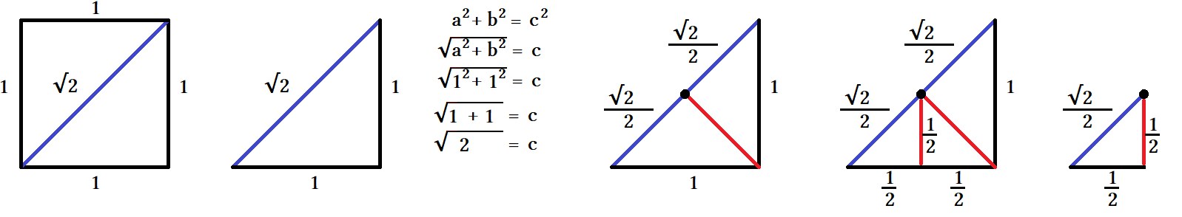
- A square of 1:1 was divided diagonally resulting in two 1:1:√2 .
- A median was drawn from ∠90°. This has same effect as dropping a sine line from ∠90°.
- The median of a ∠90° is the same thing as a sine line.
- The median divides the side it touches into two equal segments. √2 was divided into ^{√2}/₂.
- Dropping another sine from the middle of the hyp creates a small triangle of ½:½:^{√2}/₂.
- Dropping the sine or median makes two ^{√2}/₂:^{√2}/₂:1 . This means a few things... mostly √½ = ^{√2}/₂.
- Most people do not know how to take a square root. We know how to take a square root know using geometry and trig. The square root we are taking does not have to be the side of a  but we can use a triangle to solve it.

For √½ = ^{√2}/₂ we can use the a Malone algorithm for rationalizing the denominator. Rationalizing removes the radical.

- A radical fraction can have the radical in the numerator, denominator, or both.
- If the radical in only in the numerator then the denominator is rational.
- If the radical is not in the numerator then the denominator is not rational.

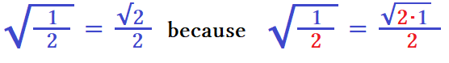

- Start with radical on entire term.
- Replace numerator with product of numerator and denominator.
- Write radical sign only on numerator.

Two things happen: 1. The numerator is scaled by the denominator. 2. The radical sign is moved up to the top.

- √1/2 = ^{√1∙ 2}/₂ =^{√2}/₂
- Instead of dividing ½ multiply them: √1/2 becomes √1∙2.
- Divide √1∙2 by the denominator 2: (√1/2)÷2 = ^{√2}/₂.

Examples:

√¹/₂ = ^{√2}/₂ √⅔ = ^{√6}/₃ √³/₂ = ^{√6}/₂
√¹/₃ = ^{√3}/₃ √⅖ = ^{√10}/₃
√¹/₄ = ^{√4}/₄ = ½ √²/₇ = ^{√14}/₇
√¹/₅ = ^{√5}/₅ √²/₉ = ^{√18}/₉
√¹/₆ = ^{√6}/₆ √⁷/₂ = ^{√14}/₂
√¹/₇ = ^{√7}/₇ √⁹/₂ = ^{√18}/₂
√¹/₈ = ^{√8}/₈ √¹⁰/₂ = ^{√20}/₂ = √5 This can be converted to √5 right away because √10/2 = √5
√¹/₉ = ^{√9}/₉ = ⅓ √¹⁰/₃ = ^{√30}/₃
√¹/₁₀ = ^{√10}/₁₀ √³/₄ = ^{√12}/₄ = ^{√2∙2∙3}/₄ = ^{2√3}/₄ = ^{√3}/₂ 2 cancels with 4
Square roots of fractions:

^{√1}/₁ ∙^{√1}/₁ = ¹/₁ = 1 The square root of 1 is 1.
^{√2}/₂ ∙^{√2}/₂ = ²/₄ = ½ The square root of ½ is ^{√2}/₂.
^{√3}/₃ ∙^{√3}/₃ = ³/₉ = ⅓ The square root of ⅓ is ^{√3}/₃.
^{√4}/₄ ∙^{√4}/₄ = ⁴/₁₆ = ¼ The square root of ¼ is ^{√4}/₄.
^{√5}/₅ ∙^{√5}/₅ = ⁵/₂₅ = ⅕ The square root of ⅕ is ^{√5}/₅.
^{√6}/₆ ∙^{√6}/₆ = ⁶/₃₆ = ⅙ The square root of ⅙ is ^{√6}/₆.
^{√7}/₇ ∙^{√7}/₇ = ⁷/₄₉ = ⅐ The square root of ⅐ is ^{√7}/₇.

A simple conjugate has a monomial term and a binomial conjugate has binomial terms. Conjugates are used to change a fraction with a radical denominator to a fraction with a radical numerator because it is easier to find the radical first then divide by an integer then the other way around. If ³/_{√3} then it's conjugate is √3/√3 because squaring a square root will cancel the radical and dividing a radical by itself will cancel the radical. ³/_{√3} ∙ ^{√3}/_{√3} = ^{3∙√3}/_{√3∙√3} = ^{3√3}/₃ = √3.

³/_{√3} ∙ ^{√3}/_{√3} = ^{3∙√3}/_{√3∙√3} = ^{3√3}/₃ = √3 During ^{3√3}/₃ the numerator 3 cancels with the denominator 3.
²/_{√3} ∙ ^{√3}/_{√3} = ^{2∙√3}/_{√3∙√3} = ^{2√3}/₃. During ^{2√3}/₃ the numerator 2 cannot cancel with denominator 3.

Example: A 60° right triangle has a base of ½ and a height of ^{√3}/₂ or about 0.866. Find tangent or slope, then cotangent:

Tan = height÷base
Tan = ^{√3}/₂ ÷ ½ Tangent is the same as M = ^{y}/_{x} for slope. ^{y}/_{x} = ^{√3/2}/_{1/2}
Tan = ^{√3}/₂ ∙ 2 When dividing by a fraction we instead multiply by its reciprocal.
Tan = ^{2√3}/₂ For 2∙√3 ÷ 2 we basically have √3 ∙ ²/₂ = √3 ... the 2's cancel.
Tan = √3 Tangent of 60° is √3. A line given by y = √3x will have a 60° slope.
Cot = ¹/_{tan} = ¹/_{√3}
Cot = ¹/_{√3} = ¹/_{√3} ∙ ^{√3}/_{√3} = ^{√3}/₃ The tangent of a ∠60° is √3, cotangent is ^{√3}/₃.

This example illustrates having a complex fraction where there was a fraction in a fraction: ^{√3}/₂ ÷ ½ = ^{√3/2}/_{1/2} .
This example illustrates having a simple conjugate where the denominator was radical: ¹/_{√3} ∙ ^{√3}/_{√3} = ^{√3}/₃ .

Simple Conjugates, binomial conjugates, and complex fractions: 1+√2 – √2

¹/_{√2} = ¹/_{√2} ∙^{√2}/_{√2} ∙ =^{√2}/₂ ¹/_{1+√2} = ¹/_{1+√2} ∙^{1–√2}/_{1–√2} ∙ =^{1–√2}/_{–1} = –1+√2 ¹/⅔ = ³/₂
¹/_{√3} = ¹/_{√3} ∙^{√3}/_{√3} ∙ =^{√3}/₃ ¹/_{1–√2} = ¹/_{1–√2} ∙^{1+√2}/_{1+√2} ∙ =^{1+√2}/_{–1} = –1 –√2 ²/⅔ = ⁶/₂ = 3
¹/_{√4} = ¹/_{√4} ∙^{√4}/_{√4} ∙ =^{√4}/₄ = ²/₄ = ½ ¹/_{–1+√2} = ¹/_{–1+√2} ∙^{–1–√2}/_{–1–√2} ∙ =^{–1–√2}/_{–1} = –1+√2 ³/⅔ = ⁹/₂
¹/_{√5} = ¹/_{√5} ∙^{√5}/_{√5} ∙ =^{√5}/₅ ¹/_{√5} = ¹/_{√5} ∙^{√5}/_{√5} ∙ =^{√5}/₅ ⁴/⅔ = ¹²/₂ = 6
¹/_{√6} = ¹/_{√6} ∙^{√6}/_{√6} ∙ =^{√6}/₆ ¹/_{√6} = ¹/_{√6} ∙^{√6}/_{√6} ∙ =^{√6}/₆ ¹/⅔ = ³/₂
¹/_{√7} = ¹/_{√7} ∙^{√7}/_{√7} ∙ =^{√7}/₇ ¹/_{√7} = ¹/_{√7} ∙^{√7}/_{√7} ∙ =^{√7}/₇ ¹/⅔ = ³/₂
¹/_{√8} = ¹/_{√8} ∙^{√8}/_{√8} ∙ =^{√8}/₈ = ^{2√2}/₈ = ^{√2}/₄ ¹/_{√8} = ¹/_{√8} ∙^{√8}/_{√8} ∙ =^{√8}/₈ = ^{2√2}/₈ = ^{√2}/₄ ¹/⅔ = ³/₂
We found the slope of point C to be -1+√2. To find slope for any of your points use y/x and divide your y value
by your x value. Using other formulas is not necessary because all lines rune through the origin as its intercept.
The intercept for all lines will be 0.

To write your slope multiply by 2 so that ½ becomes 1 and 1.207 becomes 2.414 which is really 2.41421356 so write it as 1+√2 because that is 1+1.414213... and we need exact values so radical terms are necessary.
For negative slope put a negative sign in front of slope. Use parentheses as needed. All points in 2nd and fourth quadrant will have negative slope all points in 1st and 3rd will have positive slope.

Point C: From origin go over ½ + √2/2 and up ½ making a slope of : ½ ÷ (½ +√2/2) .

½ ÷ (½+^{√2}/₂)
½∙2 ÷(½ +^{√2}/₂) ∙ 2 Use a scale factor of 2 to remove fractions.
1/ 1+√2 The numerator and denominator cancel.
^{1∙1–√2} /_{1+√2(1 –√2)} Rationalize the denominator by scaling with the conjugate ^{1–√2}/_{1–√2}.
^{1–√2} /_{–1} (+1–√2) ÷ –1 → –1+√2 dividing by –1 flips signs.
– 1 + √2 This slope is ≈ 1.414 – 1 = 0.414.
1–√2 ÷ 1–√2 The conjugate is a difference of squares 1 –√2 = (1+√2)(1 –√2)

y = (– 1 + √2 )x {0 ≤ y ≤ ½ } is equation for point C (½+^{√2}/₂). Using y is easier than x for endpoints.

Point H: A reflection of point C use negative sign for slope and x values.

y = mx
y = – ½ / (½+√2/2)x We could finish here or continue to rationalize the denominator
y = – 1 / (1+√2/)x Scale by 2 to remove fraction
y = (– 1+√2 )x Conjugate the rest
y = (– 1+√2 )x {0 ≤ y ≤ ½ } Finish by adding inequality constraints

We have the top half completed and need to finish the bottom.
The last four points are reflections of the top four.

Point D is a reflection of C: use –y instead of y and flip inequality values.

Point C is y = (– 1 + √2 )x {0 ≤ y ≤ ½ }
Point D is – y = (– 1 + √2 )x {– ½ ≤ y ≤ 0 }

The rest of the points can be figured out individually as radii but is easier to do as diameters. Changing all constraints from 0 to – ½ will extend the lines from the upper quadrants to the lower ones.
Since the Four points above share the same slope as the four below you only need four equations instead of eight.
The value 0 set the points to end at the origin but – ½ will hit the four bottom points.

Points And Coordinates
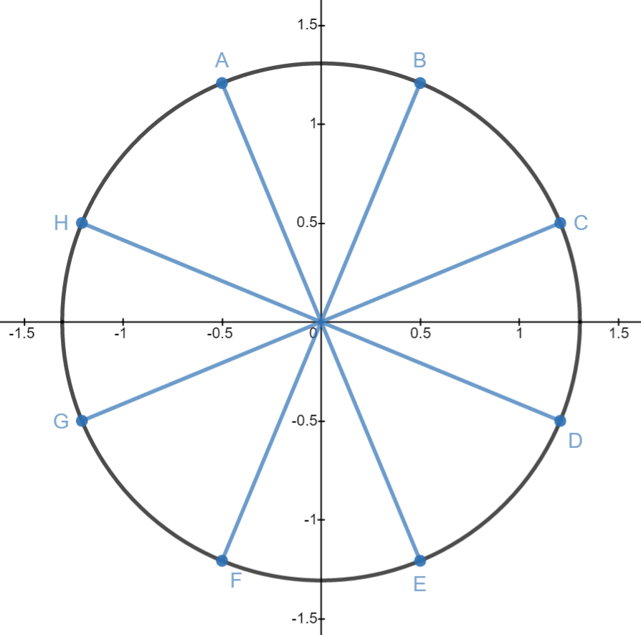
Four diameters:
AE: y = – (1 + √2)x { – ½ ≤ x ≤ ½}
BF: y = (1+√2) x { – ½ ≤ x ≤ ½}
CG: y = ( – 1+√2)x { – ½ ≤ y ≤ ½}
DH: y = (1 – √2)x { – ½ ≤ y ≤ ½}

Eight Points:

A: ( – ½ , ^{1+√2}/2 )
B: ( ½ , ^{1+√2}/2 )
C: ( ^{1+√2}/2 , ½ )
D: ( ^{1+√2}/2 , – ½ )
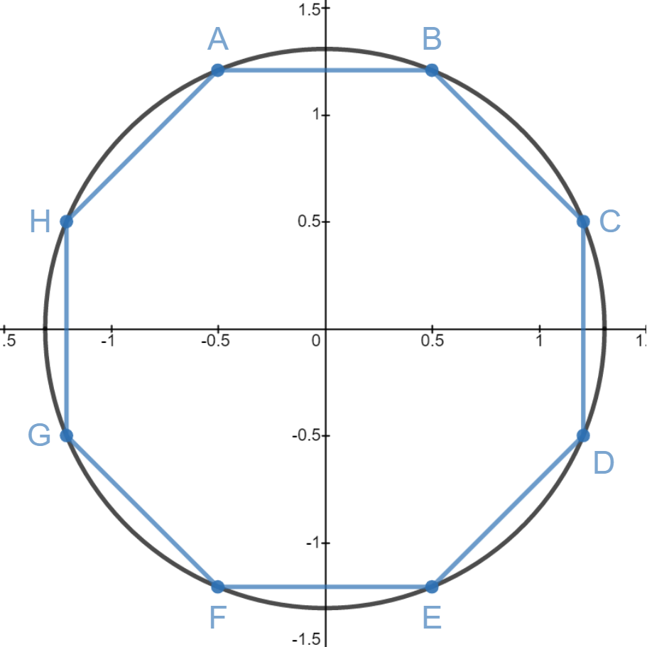
E: ( ½ , – ^{1+√2}/2 )
F: ( – ½ , – ^{1+√2}/2 )
G: ( – ^{1+√2}/2 , – ½ )
H: ( – ^{1+√2}/2 , ½ )

Eight Sides:

AB: y = ^{1+√2}/2 { – ½ ≤ y ≤ ½ } [112.5°,67.5°]
BC: y = –x + ^{2+√2}/2 { ½ ≤ y ≤ ^{1+√2}/2} [67.5°,22.5°]
CD: x = – ^{1+√2}/2 { – ½ ≤ y ≤ ½ } [22.5°,337.5°]
DE: y = x – ^{2+√2}/2 { – ^{1+√2}/2 ≤ y ≤ – ½} [337.5°,292.5°]
EF: y = – ^{1+√2}/2 { – ½ ≤ x ≤ ½ } [292.5°,247.5°]
FG: y = – x – ^{2+√2}/2 { – ^{1+√2}/2 ≤ y ≤ – ½ } [247.5°,202.5°]
GH: y = – ^{1+√2}/2 {– ½ ≤ y ≤ ½ } [202.5°,157.5°]
HA: y = x – ^{2+√2}/2 { ½ ≤ y ≤ ^{1+√2}/2 } [157.5°,112.5°]

Sides: 1 unit
Height: 1 +√2 sin(α°): (½ +^{√2}/2)/c = 0.92387953
Width: 1+ √2 cos(α°): ½ /c = 0.3826834324
Apothem: ^{1+√2}/2 tan(α°): ^{sin(α°)}/cos(α°) = 1+√2
Central Angle: 45° sin⁻¹(sin(α°)): 67.5°
External Angle: 45° cos⁻¹(cos(α°)): 67.5°
Internal Angle: 135° tan⁻¹(tan(α°)): 67.5°
α = 67.5° sin(ß°) = cos(α°)
ß= 22.5° cos(ß°) = sin(α°)
circumradius (^{2+√2}/₂)^{1/2} tan(ß°) = cot(α°)

½² +(½ +^{√2}/2) ² = c²
¼ + (½ + ^{√2}/2)² = c²
¼ + (½ + ^{√2}/2)( ½ + ^{√2}/2)= c²
¼ + ¼ + ^{√2}/2 + ½ = c²
1 + ^{√2}/2 = c²
√^{1+√2}/2 = c ≈ 1.306 radius
Unit Circle Conversion

Octagon with side length of 1 has a circumcircle circumradius of 1.306. The unit circle always has a radius of 1.
Using the radius as a hypotenuse and altitude line dropped from the vertex the triangle made with the x axis
has ratios of ½ :1.207:1.306 . Dividing all three sides by the hypotenuse fits the triangle into the unit circle.
This is the conversion for any triangle to fit unit circle definitions.

Height : 1.207
Base: ½
hypotenuse: 1.306
Dividing all three sides by 1.306:

1.306/1.306 = 1
1.207/1.306 = 0.92387953
½ / 1.306 = 0.38268343

These are the same values from last page for sine and cosine but we went the extra step and also divided the hypotenuse by itself as well. The new ratios .3826:.9238:1 preserve the same angles, only the sides have become shorter maintaining proportion. The angles and by extension trig values for sin, cosine, and tangent are the same as the last page so both triangles are similar. New side lengths of smaller triangle:

sine = o/h, equals: 0.9238/1 = 0.9238 the sine is the same as the height therefore height = sine.
cosine = a/h, equals: 0.3826/1 = 0.3826 the cosine is the same as the base therefore base = cosine.

Tangent is still 1+√2 and is the slope of our hypotenuse line.
Using large triangle's opposite/adjacent: (½ +^{√2}/2)/ ½ = 1+√2
Using small triangle's opposite/adjacent: .9238/.3826 = 1+√2

All trig ratios match so we now that our two triangles have the same angles and are similar meaning we can represent the large triangle in a scaled down version using the unit circle to do analysis.

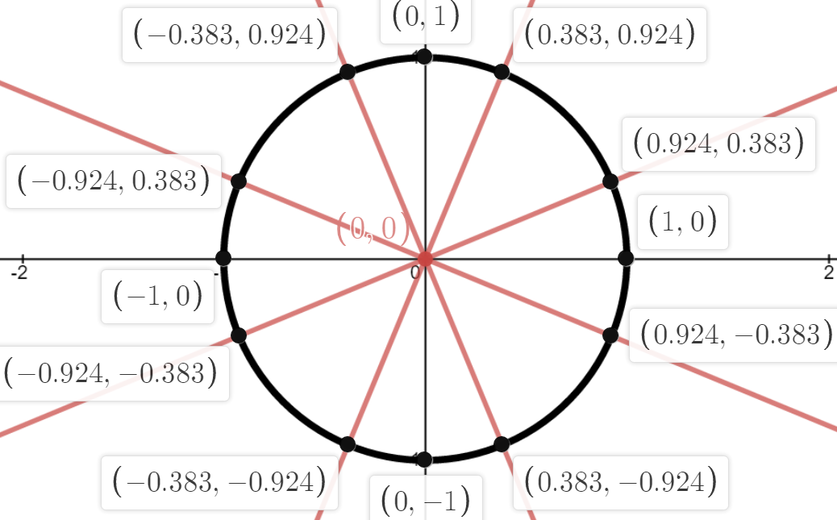
Base = cosine, the x value
Height = sine, the y value
slope of a line = tangent, the y/x from y = mx+b

Tangent is slope, where slope is m = y2-y1/x2-x2,
also rise/run or opp/adj.
Can be height/base because y is height and x is base.
It is sin/cos because sin is y and cos is x.

Tangent has different names disguising it is really 1 thing. When the hypotenuse is 1 sine becomes height/1 making the sine the height itself. When the hypotenuse is 1 cosine becomes base/1 making the cosine the base itself. All it takes to make any hypotenuse of any triangle 1 unit is to divide the hypotenuse over itself:

_{(For all)} hypotenuse: hypotenuse/hypotenuse = 1 unit.

The inverted A means “For all”. A means all and inverted means it is extending out into the universe applying whatever law written to all elements it referred to. There is more symbolism in it but it takes long to explain, short answer inverting it prevents mistaking it for a variable. The points of the octagon can be found in the unit circle by using x and y to locate to points in each quadrant.

Sine = 0.9239, cosine = 0.3827

x,y = (0.3827,0.9239)
y,x = (0.9239 ,0.3827)
-x,y = (-0.3827,0.9239)
-y,x = (-0.9239,0.3827)
-x,-y = (-0.3827,-0.9239)
-y,-x = (-0.9239,-0.3827)
x,-y = (0.3827,-0.9239)
y,-x = (0.9239,-0.3827)

Plot these points. The equations for the diagonals that pass through these points are:

BF: y = (1+ √2)x This goes to point B from origin. This is our main equation.
AE: – y = (1+ √2)x Same as BH but inverting y makes the slope negative
CG: y = ( –1+ √2)x Same as BH but with -1 instead of 1 making slope smaller
DH: –y = ( –1+ √2)x Same as CG but with – y to make slope negative.

Making the slope negative has the same effect as reflecting the line. All of these lines are reflections of another.
The second equation reflects the first line over both axes. The third equation reflects the first line over the line y =x, called the identity. The forth equation is actually an inverse of the first and a reflection of the third.

The 1st and 4th , and the 2nd and 3rd lines are inverses of each other. An inverse of a line is made by taking the negative reciprocal of the slope to use as the slope for the inverse line. Two equations can be thought of as two functions and these functions are said to be inverses when they form a 90° angle at the point they touch. A reflection over a line places it the same distance from it on the other side as the side it started. Look at any two lines that intercept and divide them down the middle with a third line. This line divides the angle between them equally with each line being a reflection of each other.

You can think of this dividing line as a angle bisector. An angle bisector divides an angle at the vertex leaving congruent angles on either side. Lines that formed the angle have symmetry and are said to be symmetric across the line or axis of symmetry. With limiting the domain the lines extend forever. They need to have constraints using inequalities to create endpoints to segment the line at locations on the unit circle. Using the constraints segments the lines and keeps the lines confined to the domain we choose. Set r² to 1 to make a unit circle: x² + y² =1 (same as 1²).

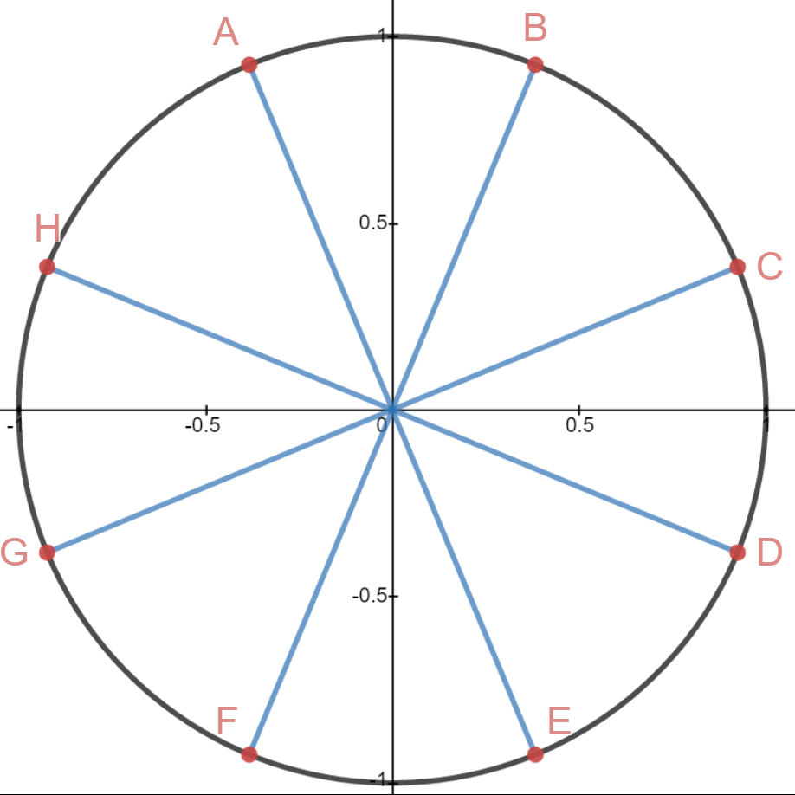
BF: y = (1+ √2)x {-.3827≤x≤.3827}
AE: – y = (1+ √2)x {-.3827≤x≤.3827}
CG: y = ( –1+ √2)x {-.9239≤x≤.9239}
DH: –y = ( –1+ √2)x {-.9239≤x≤.9239}

Four quadrangle sides:

AB: y = .9237 {-.3827 ≤ x ≤ .3827} A horizontal line set with y set to .9237.
FE: y = -.9237 {-.3827 ≤ x ≤ .3827} Sme as above except y is set to -.9237.
CD: x = .9237 {-.3827 ≤ y ≤ .3827} Same as first except y is the constraint not x.
GH: x= -.9237 {-.3827 ≤ y ≤ .3827} Same as last except x is set to -.9327.

Four mitered sides:

HA: y = x+1.307 {.3827 ≤ y≤ .9237} a 45° slope with 1.307 as the intercept.
BC: y =-x+1.307 {.3827 ≤ y ≤ .9237} as above but with x inverted giving negative slope.
DE: y = x -1.307 {.3827 ≤ x ≤ .9237} a reflection of the 1st over the x axis.
FG: y =-x-1.307 {-.9237 ≤ x ≤ -.3827} a reflection of the 3rd over the y axis.

Without constraints the equations are lines. Technically lines never end. These lines form the sides of the unit circle octagon. See right pic; Their domain is {-∞,∞} and their range is {-∞,∞}.

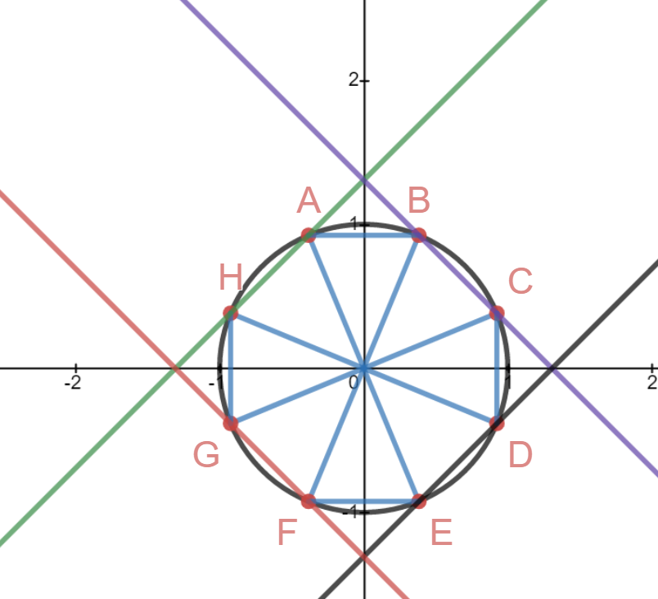
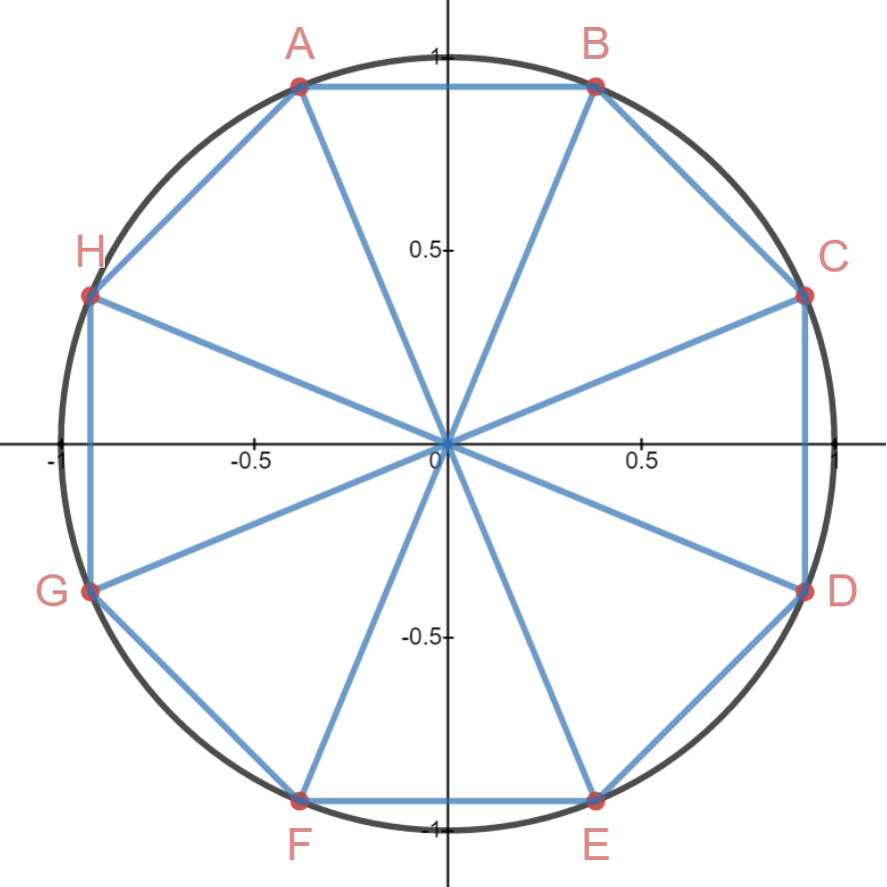

It is smaller than an octagon with side 1 unit because it has a radius of 1 unit. Technically we should write domain and range in set notation using brackets and parentheses but it would be confused as a point so we are writing our constraints in braces. The unit circle is mainly for measuring the distance followed along the circular path using π radians. We are using it to plot points for triangles and polygons. The lines meet outside the circle at 90°. The slope of the negative lines must be an inverse of the positive lines. To find slope of the inverses use the inverse. An inverse is the negative reciprocal. F(x) = –M+b so f⁻¹(x) = – (1/M)x+b.
Points And Coordinates

Four diameters: The inverses need to be rewritten with y positive: Use – reciprocal of M.

BF: y = (1+ √2)x {-.3827≤x≤.3827}
AE: – y = (1+ √2)x {-.3827≤x≤.3827} AE: y = – (1+ √2)x {-.3827≤x≤.3827}
CG: y = ( –1+ √2)x {-.9239≤x≤.9239}
DH: –y = ( –1+ √2)x {-.9239≤x≤.9239} DH: y = – ( –1+ √2)x {-.9239≤x≤.9239}

Eight Points: Eight Sides:

A: ( – ½ /c, ^{1+√2}/2/c ) AB: y = .9237 {-.3827 ≤ x ≤ .3827} horizontal line set with y set to .9237
B: ( ½/c , ^{1+√2}/2/c ) BC: y =-x+1.307 {.3827 ≤ y ≤ .9237} same as above but with x inverted
C: ( ^{1+√2}/2/c , ½/c ) CD: x = .9237 {-.3827 ≤ y ≤ .3827} same as first except y changed with x
D: ( ^{1+√2}/2/c , – ½/c ) DE: y = x -1.307 {.3827 ≤ x ≤ .9237} reflection of the 1st over the x axis
E: ( ½/c , – ^{1+√2}/2/c ) EF: y = -.9237 {-.3827 ≤ x ≤ .3827} same as above except y is set to -.9237
F: ( – ½/c , – ^{1+√2}/2/c ) FG: y =-x-1.307 {-.9237 ≤ x ≤ -.3827} reflection of the 3rd over the y axis
G: ( – ^{1+√2}/2/c , – ½/c ) GH: x = -.9237 {-.3827 ≤ y ≤ .3827} same as last except x is set to -.9327
H: ( – ^{1+√2}/2/c , ½/c ) HA: y = x+1.307 {.3827 ≤ y≤ .9237} 45° slope with 1.307 as the intercept.

Sides: 1 unit
Height: 1 +√2 sin(α°): (½ +^{√2}/2)/c = 0.92387953
Width: 1+ √2 cos(α°): ½ /c = 0.3826834324
Inradius or Apothem: ^{1+√2}/2 tan(α°): ^{sin(α°)}/cos(α°) = 1+√2
Radius (^{2+√2}/₂)^{1/2} tan(ß°) = cot(α°)

First the math then the explanation:

AE: – y = (1+ √2)x {-.3827≤x≤.3827}
– y = (1+√2)x 1 + √2 ≈ 1 + 1.414 = 2.414. We are using this as slope. Find it's inverse.
– y ∙ (– 1) = (2.414x) ∙ (–1 ) multiply both sides by –1
y = –2.414x the inverse of f(x) = 2.414x is f⁻¹(x)= – 2.414x

This is true but doesn't explain why. This worked only because we converted an equation that wasn't written properly. It is like improperly factored code. Writing the inverse as – y is lazy. It doesn't tell us the slope of the line it tells us to take the inverse of a line we do know. Sometimes it is hard to find the inverse of lines that have radicals because writing the number is messy or hard to compute. This was a shortcut to the answer but doesn't teach the best practices. Putting a – inverts any line or function but it does not tell the slope and that is not good enough. It would be like saying “I do not know the slope of that line but the slope of a line 90° to it is 1+√2”.

To find any inverse we must start with the original equation, find it's slope, then find the inverse of it's slope all while keeping x and y positive or the same sign. The original equation to be inverted was BF = (1+ √2)x

- Slope is 1+√2
- Its reciprocal is 1/1+√2
- The negative of the reciprocal is – 1/1+√2
- The inverse equation should be written as y = (– 1/1+√2)x

I didn't write it that way initially because I was in a rush to get the answer, improperly taken to explain inverses of the lines in the easiest way possible. That was not the cleanest math. It is dodgy and open to questions of if it is actually the inverse or not since unorthodox methods were used. In truth you will find shortcuts like this used through math and science because they are real time savers but it would be frowned upon in a rigorous setting, like school. People use these shortcuts because they are easier to write, quicker to solve, and easier on the eyes.

About Inverses

In y = mx + b Slope = M = y₂ – y₁/x₂ – x₁

Take two points (x₁, y₁) and (x₂, y₂) and put into the formula for slope. After subtracting you are left with one y and one x such that M = ^{y}/_{x} . We do not want to confuse the x,y of our slope with the input and output of the function so we write as m instead of y/x or else we would get the confusing y = ^{y}/_{x}x + b. This is algebraically correct but y = ^{y}/_{x}x + b uses the same variables twice but with different values. That's not good. When you use a variable in an expression it can have only one value or your function breaks.

You would have to call f(x) “big y” as the output of the function , and call x “big x” the input of the function , whereas slope is “little x and y” and BOTH are INPUTS of slope. It is more convenient to write slope as M.

To find and inverse take the negative reciprocal and use it as slope for a new equation of the form y = mx+b.
To find an inverse through a specific point plug the point you want the inverse to intersect and solve for b.
f(x) = x→ f⁻¹(x) = –x → f⁻¹(x) = -x + 2 will pass through the point (1,1). This point is the “solution” of both equations. When two line intersect they are called a system of equations. The point they share is the solution.

y = (–1/1+√2)x y = (1+ √2)x
½² +(½ +^{√2}/2) ² = c² M =slope is 1+√2
¼ + (½ + ^{√2}/2)² = c² reciprocal is 1/1+√2
¼ + (½ + ^{√2}/2)( ½ + ^{√2}/2) = c² negative of the reciprocal is – 1/1+√2
¼ + ¼ + ^{√2}/2 + ½ = c²
1 + ^{√2}/2 = c²
√^{1+√2}/2 = c = 1.306 radius (circumradius of a polygon, unit circle always has a radius of 1)

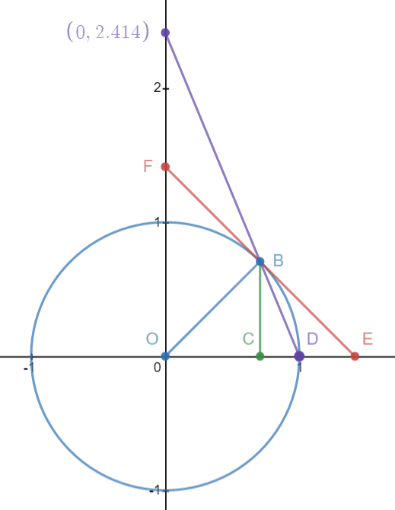

OB: The radius to our measured angle
OD: The radius to 0°. A measured angle needs two point to take a measurement from.
OC: Base and cosine of unit triangle. Do not confuse cosine length with base of a scaled triangle.
BC: Height or sine of unit triangle. Do not confuse sine length with base of a scaled triangle.
BE: Tangent of angle alpha. A line rotated 90° from the radius. From the unit circle to the x axis.
BF: Cotangent is the compliment of tangent. Radius divides a tangent line into two parts: tan and cot.
OE: Secant. This is the reciprocal of sine. It is from origin (0,0) to tangent.
CD: Versine. The versine is the amount the cosine is short from being a radius. Cos+versine = radius.
BD: Chord.

Point O is the origin (0,0)
Point B is the angle 45° (√2/2,√2/2)
Point C is the 90° vertex (√2/2, 0)

Point O is normally called Point A in a ABC triangle.
OB is the radius to our angle point.
Normally we call this line AB on a triangle. (OD also is a radius of at 0°)
BC is the height of the triangle (sine)
OC is the base of the triangle (cosine)

In a unit circle we take height and base directly as sine and cosine because hypotenuse is the radius which in a unit circle is always 1. For any triangle ABC we can assign point A to be the origin (0,0) point O. We can then divide all sides of the triangle by the hypotenuse to scale the triangle to fit in a circle with a radius of 1 with the origin as its center. ABC is a triangle with a hypotenuse of 1 that acts as the radius draws a circle around the triangle. The circle is called the unit circle and has radius 1 diameter 2. Of our triangle we call the hypotenuse radius, the base cosine, and the height sine. We take this to literally be the lengths when in a unit circle. When scaling this triangle to be larger we can these lengths the trig ratios of the triangle.

A triangle has ratios of: base:height:hypotenuse → sine:cosine:radius

The ratios are the lengths of each side. Note that tangent is sine/cosine and not listed in the sides but rather is a ratio that is used to determine the slope of the radius. Tangent will always be separate than sine and cosine since it is the only ratio that is not directly a side of our triangle but something else. It is weird.

You use the main three trig functions and some of the other ones to calculate your triangle. The obscure trig functions are useful for understanding the geometric construction of triangles. The trig functions are shown accurately shown as line segments with length proportional to each other. This aids in understanding why the calculator gives the values it does when computing a sin or trig value. The tangent line is the entire length from y axis, point F to x axis, point E. A line is 180°. The radius divides the line into two parts: Tangent and cotangent. When a straight line is divided by a second line this creates two angles on either side of the line. These two angles are called “compliments”.

A complimentary angle is the angle that adds to 90°. Given this definition Tangent and cotangent each form a 90° with the radius and are supplementary to each other making the 180° tangent line. If you stack two 1² squares onto or next to each other and take the diagonal of both together you have this triangle. Because of this its equation is y = 2x double that of a perfect square.

Sine: line BC
Cosine: Line OC
Tangent: BE
Cotangent: BF
Tangent line: EF The entire line is called a “Tangent Line”

Special triangle slope 2:

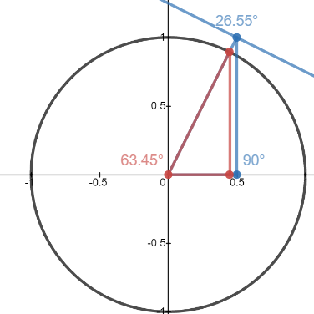
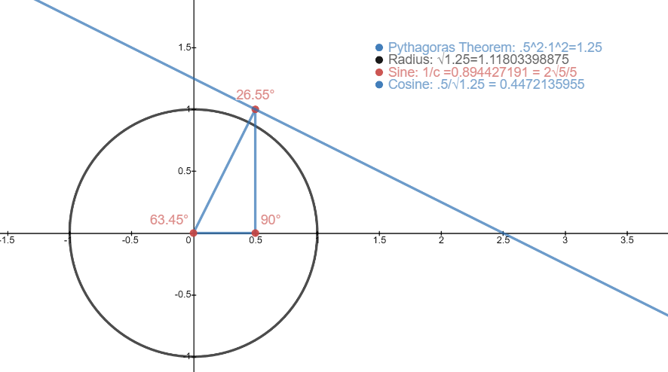

y = 2x creates a triangle of a height twice the base. Using Pythagoras the hypotenuse is √1.25:

x² + y² = c²
½ ² + 1² = c²
½ +1 = c²
1.25 = c²
√1.25 = c
√5/2 = c
1.118 ~ c We have a base:height:hypotenuse of ½:1:√5/2

There are two ways to proceed; use original definitions of SOHCAHTOA to find ratios or divide all sides by the hypotenuse.

Sine = 1/√5/2 = 2√5/5 Base is half the height we can divide this by 2 to get cosine)
Cosine = ½ /√5/2 = √5/5
Tangent = 2 Tangent is the simplest use its inverse to find angle in degrees
tan⁻¹(2) = 63.43° A is 63.43°
90° – 63.43° = 26.57° B is 26.57°

This special triangle is the diagonal of a rectangle with twice the height as the base. Its ratios and angles are as listed. The blue triangle has a height of 1 and a base of ½. It's hypotenuse is √5/2 or about 1.19. While good enough for as estimate of actual objects this is not good enough for precise graphing, the use of tilde ~ means the number is not accurate enough for calculating. Less attention will be paid to approximations in favor of becoming familiar with radical values.

The inverse of y = 2x is y = -½x but we need y = - ½x + 1.25 to shift the inverse to cross at the point of tangency at point B. The tangent makes a 90° angle with line y = 2x. This happens at (cosine,sine) in the unit circle and here (base,height). Finding the inverse of a line is easy but finding the correct value for b in y = mx +b to make the lines cross at the tangent point can be hard. Using a known point on the line and plugging it in y = mx + b works when you know the slope of a line. When you have slope and a point solving for b finds the intercept of your inverse at that point.

The red triangle has the same ratios as the blue triangle. It has had all it's sides divided by hypotenuse and now fits in the unit circle. We can see the angles and therefore ratios are the same, these are similar triangles. With a slope of 2 we can write base to height as y = 2x because y is two times bigger than x. x +x =y, conversely y/2 = x. There are many equivalences we could write. Recognizing how to separate variables to isolate them is an important algebra skill.

y =2x becomes either y/2 = x or y/x=2 . The first isolates y set to 2x, the second isolates x set to y/2 and the third gives slope. With a ratio of 1:2 we could have a triangle with base one and height two. Dividing the sides by 2 we get the blue triangle with a base of 0.5 and a height of 1. This is intentional so that is shows the height as the same length as radius, that it is as tall as the unit circle. The blue line touching it is a tangent line. The alpha line intersects it making two 90° supplementary angles. Of the two parts one touches the y axis and the other the x axis. To write the equation for this line we need to know the intercepts.

y = mx +b The equation for a line (y intercept slope formula)
1 = -1/2 (½) +b Substitute using point (½, 1) for x,y values – ½ solve for b
1 = - ¼ + b
1.25 = b b = 1.25

The equation for the tangent line is y = -1/2x + 1.25. The next part is hard. We need to know the equation for the line tangent to the circle at point B. We have to know all the points of the red triangle and then use the coordinates for point B to find it's tangent line.

Blue triangle as ABC: A(0,0) B( ½, 0) C( ½ ,1) we found hypotenuse to be √5/2
Red triangle as ABC: A(0,0) B( ½/c, 0) C( ½/c ,1/c) where c is the hypotenuse of the blue triangle.

The base of the red triangle is:

- ½/√5/2 or ½ ÷ ^{√5}/2
- (½ /√5/2) ∙ (√5/2/√5/2) ½ ÷ ²/√5
- √5/4 /5/4 ²/2√5
- √5/4 ∙ 4/5 ²/2√5 ∙^{√5}/√5
- 4√5 /20 ^{2√5}/2∙5
- √5/5 ^{2√5}/10 = ^{√5}/5

The Height Of The Red Triangle is:

1/√5/2
1∙2/√5
2/√5
2√5/5 We could have figured height would be 2∙√5/5 since it is twice the base.

Using standing ratios allows you to figure your length conversions without having to prove it.
The hypotenuse of the red triangle is course 1 as it is the radius, c/c = 1

 | Red Triangle | Blue Triangle
base(x) | √5/5 | ½
height(y) | 2√5/5 | 1
hypotenuse(c) | 1 | √1/25
Alpha line | y = 2x {0 ≤ y ≤ 2√5/5} | y = 2x { 0 ≤ y ≤ 1}
Beta line | x = √5/5 {0 ≤ y ≤ 2√5/5} | x = ½ { 0 ≤ y ≤ 1}
Tangent line | y = – ½x + √1.25 {0 ≤ y ≤ √5/2} | y = – ½x + 1.25 {0 ≤ y ≤ 1.25}

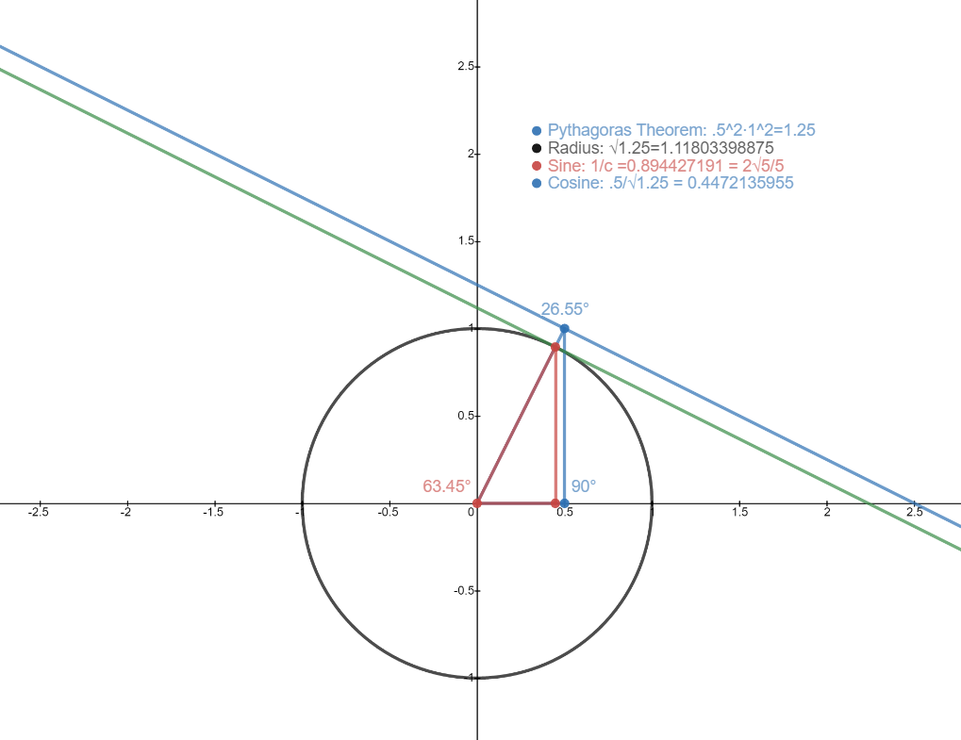

Unit triangle without tangent and with tangent in green. Only this part of the tangent line that touches unit circle and x axis is called a tangent. This comes straight fro m original definitions of tangent in the trig rations. Angle A is at 63.45° and tangent is it's inverse forming a 90° angle with it.

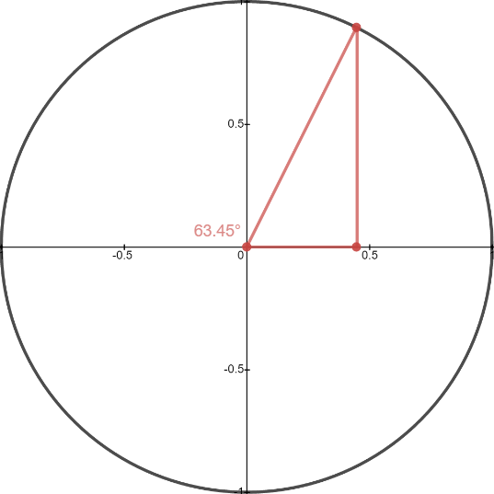

Where tangent touches the x axis must make a complimentary angle to angle A and therefore is congruent to angle B 26.55°. Tangent angle at x axis is the compliment to angle A.

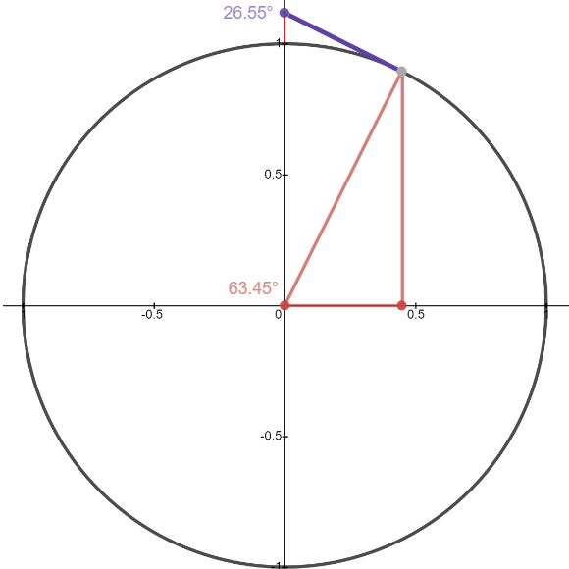
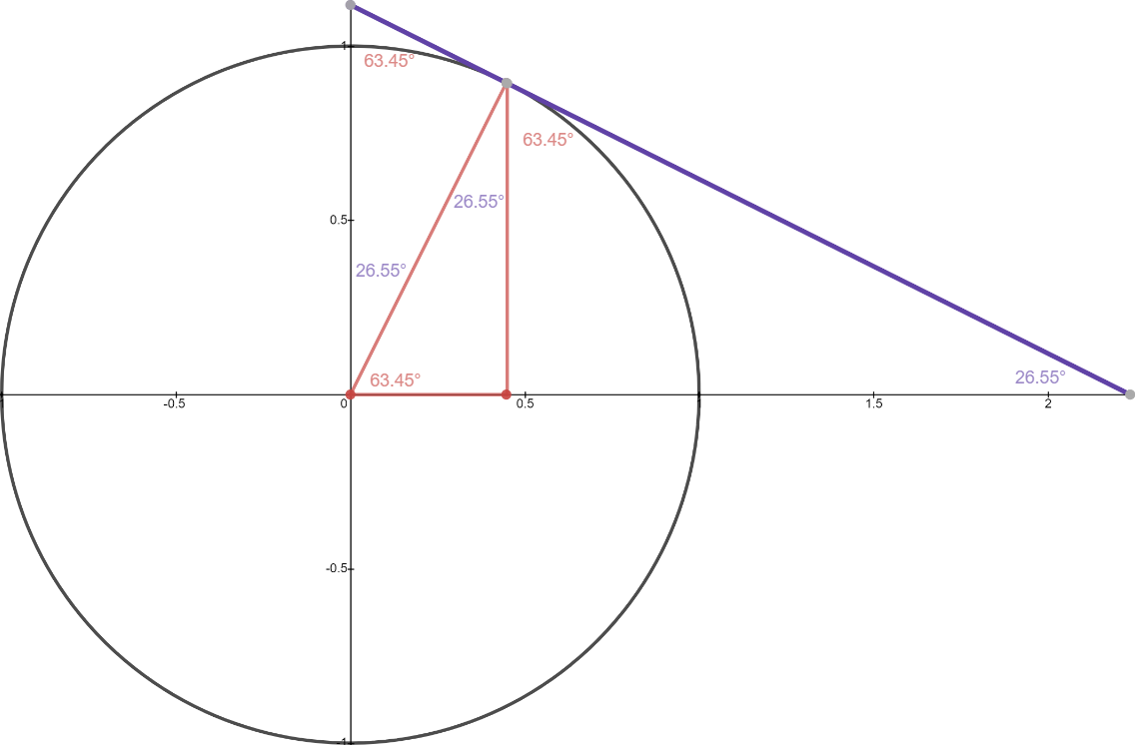

Tangent is from point B to x axis. Cotangent is from Point B to y axis. Both tangent and cotangent together are called a tangent line. Tan = ^{opposite}/_{adjacent} = for A ^{height}/_{base} = for B ^{base}/_{height}. For convenience try to solve using angle all for most problems and refer to it as the alpha angle with angle B the beta angle. Using alpha for the following:

Tan⁻¹(height/base)
Tan⁻¹(2/1)
Tan⁻¹(2) = 63.43°
The Tangent Line Has Three Points: Y -int, X-Int, And Tangency Point

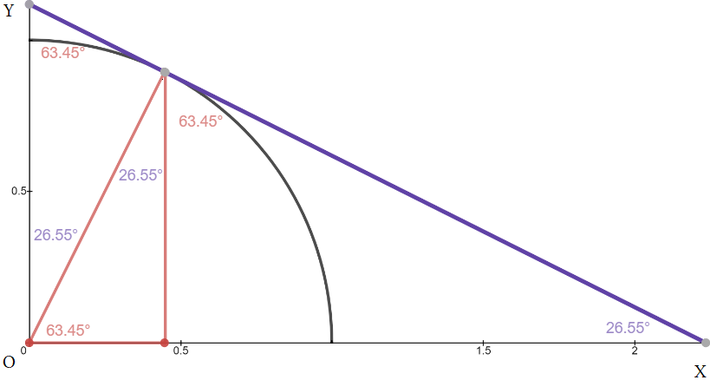
For tan(63.45°):

y int: (0,√5/2)
x int: (√5,0)
tangence point: (√5/5,2√5/5)

How big is the triangle that tangent forms with the axes?

OY: √5/2 We know this as we found OY earlier.... we have a base:height:hypotenuse of ½:1:√5/2.
OX: √5 If hypotenuse is √5/2 then slope of 2 becomes 2√5/2, the 2's cancel leaving √5 as the x-intercept.
XY: ? This is unsolved.

(√5/2)² + (√5)² = c²
1.25 +5 = c²
6.25 = c²
√6.25 = c
2.5 = c This is related to the connection of powers of 2 and 5.
XY: 2.5 This is related to the tangent lines equation y = -1/2x + 1.25 and the slope 2.

√6.25 should be recognized as ¼ ² = 0.625, that √0.625 = ¼.
It seems the length of the hypotenuse is the intercept times slope m(b) equals

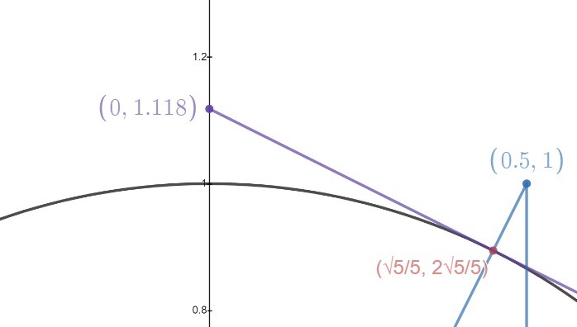

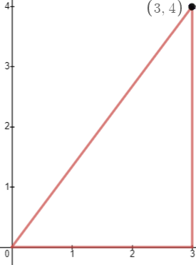
3² + 4² = 5²
9 + 16 = 25 x=3 {0 ≤x≤ 4}
sin: 4/5 = .8 y=0 {0 ≤x≤ 3}
cos: 3/5 = .6 y = 4/3x {{0 ≤x≤ 4}}
tan: 4/3 = 1.3

From a single (3,4) a purple triangle can be made showing the tangent of a 3,4,5 triangle.
Take the point B, called beta point and find the intercepts of a line that is inverse to the alpha line.
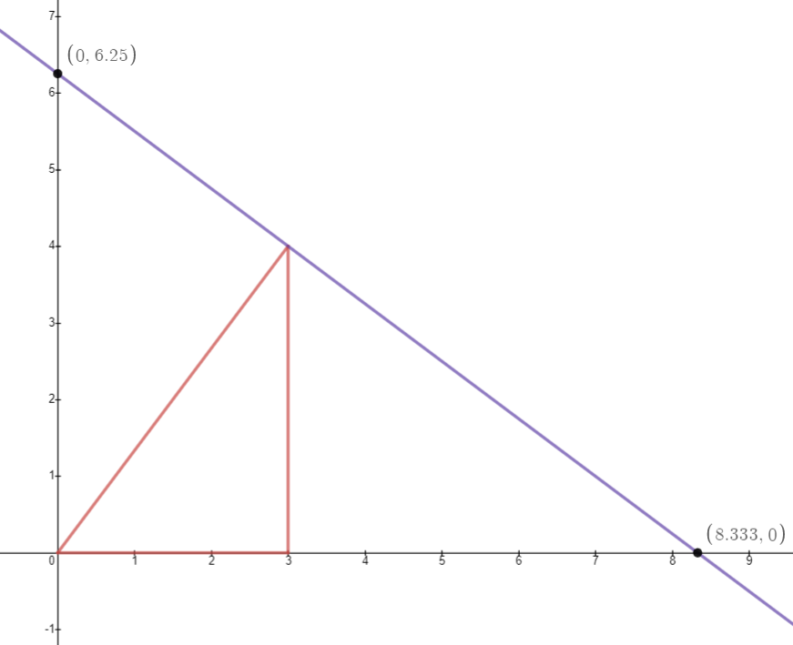

For alpha line: y = 4/3x+0
It's inverse at point (3,4)): y = -3/4x+6.25

y = -3/4x+6.25 {0 ≤x≤ 6.25}
(0,6.25)
(8.3,0)

Start with y= 4/3x+0
Find its inverse y = -3/4+0
Find the vertex at angle B
Note you are 3 units from the x axis.

- Convert slope from -3/4 to – ¾ /1 by dividing top and bottom by 4.
- This gives a – ¾ y move for every 1 x move.
- You have to move –3(1) for x so –3( –¾) for y.
- Move – 3 for x, +9/4 for y.
- From (3,4) This finds the y intercept at 6.25
- Write your intercept as y = –¾ + 6.25
- This means that the tangent triangle as a height of 6.25.
- Finding x intercept: make y =0 and solve for x
- 0 = – ¾x + 6.25
- ¾x = 6.25
- x = 6.25 ÷ ¾
- x = 6.25 ∙ 4/3
- x = 25/3
- x = 8.3 your x intercept is 8¹/3 . Mark this point on your graph and draw the tangent line.
- Draw the height from (0,0) to (0,6.25)
- Draw the base from (0,0) to (8.3, 0)
- Find the length of the hypotenuse. √8.3² + 6.25² = 10.416

The purple triangle has the same ratios as a 3:4:5 triangle.
Note the triangle is rotated so angle A and B are switched.
Sin: 6.25/10.416 = 3/5 or .6
cos: 8.3 /10.416 = 4/5 or .8
tan: 6.25/8.3 = ¾ or .75

The angles are switched because the large side is touching the x axis making a ratio of 4:3:5 instead of 3:4:5.
Orientating it properly makes it 3:4:5, it is still a 3:4:5 triangle because the ratios are the same.
Find the lengths of tangent and cotangent.

- Tangent is .75 co tangent is 1/.75.
- .75(5) = 3.75 cotangent is 3.75. This is how long the segment from (0,6.25)U(3,4)
- 1/.75(5) = 6.6 tangent is 6.6 units long from point (3,4) ∪ (8.3,0). They can be found other ways.
- 6.25/5∙3 = 3.75 cotangent length 5/3 ∙ 4 = 6.6 tangent length. All sides can be found using these methods.

6.25/5∙3 = 3.75 cot
5/3∙4 = 6.6 tan

5∙3÷6.25∙8.3/3 = 6.6 tangent length
4/3∙6.25 = 8.3 this gives x intercept if you only know small triangle and y intercept of large triangle.
125/12/6.25∙3 = 5 hypotenuse

Different combinations are made by dividing a side by a side, then multiplying by a side. Some are useful others are redundant. Make a list using known triangles and study as many combinations as you can so you can prove it to yourself that all ratios are interlocked. These can also be used to check your work or do various proofs. They can also be used to invent your own triangle formulas.

S/s∙C=H

From a right triangle with with two known sides or a side and an angle we can find the rest of the sides and angles and graph it. From there we can graph the tangent line. We can shrink the target triangle down to fin in the unit circle by making the hypotenuse a radius of length 1. The tangent line can be calculated giving use tangent and co tangent. This explains tangent as a length and its geometric construction. Next is secant.

Secants:

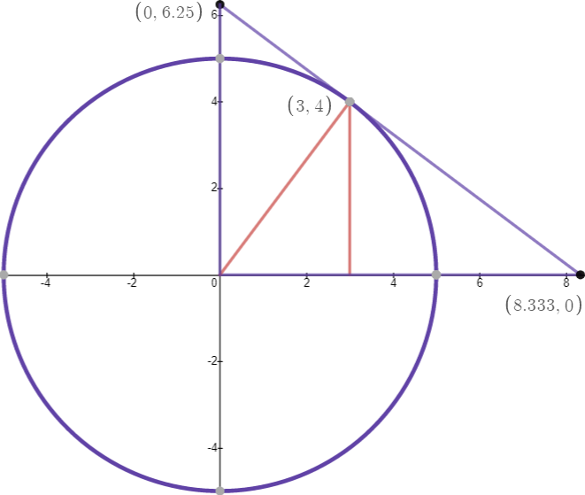
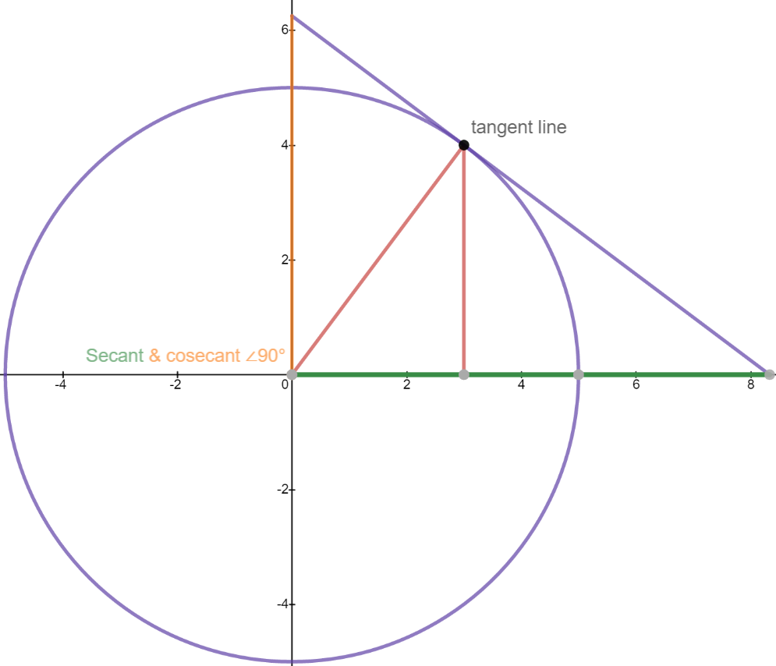

Here is the 3-4-5 triangle with a circumcircle around it. Since hypotenuse is 5 the radius of the circumcircle is 5. Dividing all three sides by 5 reduces this triangle to the unit circle at which point we will call it the unit triangle. There is only 1 unit circle but any triangle with a hypotenuse of 1 can be a unit triangle. To run tangent to a circle is to touch it a one point on the outside. The tangent is never inside the circle.

The tangent (of angle A) is 4/3. The inverse tangent function tan⁻¹ (4/3) ≈53.13°
If we rotate the purple triangle and compare it to the unit triangle we have 3:4:5 and 6.25:8.333:10.41.
To find how much bigger the purple triangle is scaled we divide matching sides: either 6.25/3, 8.333/4, 10.41/5.

6.25/3 is best since it doesn't have irrational decimals so we will get and exact answer. The quotient is 2.083.
This quotient is called the scale factor. If we multiply a small side by this we find the corresponding side of the large triangle. 2.083 times smaller triangle hypotenuse 5 equals 10.41, the hypo of the larger triangle. It is useful for finding side lengths of similar triangles without using Pythagoras Theorem.

The base of the purple triangle is the secant of the red triangle. The height of the purple triangle is the cosecant of the red triangle. These are called reciprocals. There are three reciprocals in trig and they are the first three ratios as a denominator of a fraction with 1 as the numerator. Simply put 1/sin, 1/cos, and 1/tan are the reciprocals. We already discussed the reciprocal of tangent.

Secant is the reciprocal of cosine and is 1/cosine.
Cosecant is the reciprocal of sine and is 1/sine.
Sine is a line that is complimentary to cosine.
They form a 90° angle, namely the the point C where cosine and cosine meet.
Secant and cosecant are complimentary. They form a 90° angle at the origin (0,0).
Secant has two definitions: 1/sine or the length from (0,0) to where tangent touches the x axis.
Using a 3-4-5 triangle secant is 8.333 long.
Cosecant has two definitions: 1/cosine or the length from (0,0) to where cotangent touches the y axis.
Using a 3-4-5- triangle cosecant is 6.25 long.

Sine is the height of the triangle when in the unit circle but a 3-4-5 triangle is not a unit triangle.
Sine is the line from the top of the triangle down. We call this an altitude line and is the height of the triangle making sine the ratio of height/hypotenuse. Sine divides the secant into two parts, cosine and versine. Cosine is the base of the triangle and versine is the gap from cosine to the unit circle.

Secant is the base of the large triangle.
Cosecant is the height of the large triangle.
Tangent line is the hypotenuse of the large triangle.

All three lines are physical representations of the trig ratios they stand for. All three lines have two parts.

Cosine is the base of the small triangle.
Sine is the height of the small triangle.
Radius is the hypotenuse of the small triangle.

Red triangle | Purple triangle
Sin: 4/5= .8 | Sin: 8.3/(125/12) = .8
Cos: 3/5 = .6 | Cos 6.25/(125/12) = .6
Tan: 4/3 = 1.3 | Tan: 8.3/6.25 = 1.3
Red ratios taken from (0,0) and Purple taken from (0.625) to make comparison easier. The purple triangle is a 3-4-5 with all side multiplied by 25/12 or 2.083. It is rotated 90° clockwise so that it's long height and short base have been exchanged. If drawn as a normal triangle instead of as a construction of a tangent line it would be a scaled model of a 3-4-5 with height 8.3 and base 6.25. The hypotenuse of purple is 10.416 and is written exactly as 125/12. The other leg 8.3 could have been written exactly as 25/3.

- The tangent line was already discussed as having two parts: tangent and cotangent.
- Secant is touched by the sine of the red triangle. This marks the divide between cosine and versine.
- Versine is the gap between the base of the triangle and the unit circle.
- Secant actually has three parts: Secant = cosine + versine + exsecant.
- Cosine is the base of the triangles.
- Versine is the gap between the triangles base and the unit circle.
- Exsecant is the part of secant that sticks out of the unit circle and touches the tangent line.
- The secant resides on the x axis and has a heading of 0°.

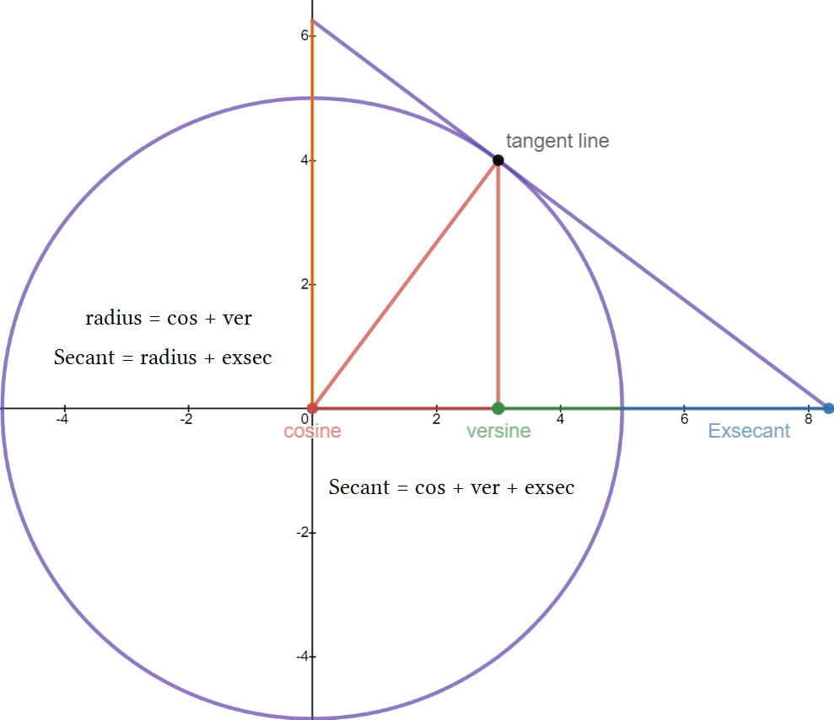
Secant = cos + ver + exsec
Secant = radius + exsec
Radius = cos + ver

Cosine is the base of the unit triangle.
Versine Is the distance form base to unit circle.
Exsecant is the distance from unit circle to tangent.

Secant has two parts when sine divides it.
Left part is cosine, right part is versine + exsecant.

These have functions in calculus but are not used often. They simply some equations by writing the formulas.
Mostly this is to give a geometric understanding of how trig functions relate to each other.

A an understanding of secant and tangent lines is important the rest are just extensions. Calculators define trig functions based on cosine and work good except for small angles. The smaller the angle the more likely a computer will round it to zero giving a degenerate triangle with a height of 0. It will incorrectly give the 0° as zero degrees and this is problematic for navigation and satellite operations. It is tricked into thinking cosine has a value of 1 and then divides it by a height of 1.

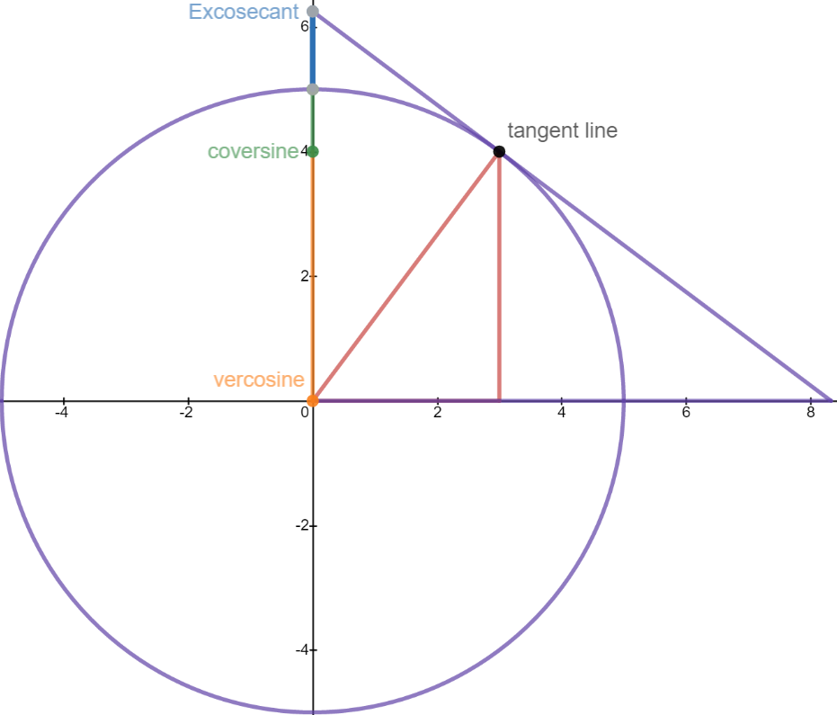
Cosecant is the entire length from (0,0)
up the y axis to the tangent line.

Cosecant ∙ sine = r²
√Cosecant ∙ sine = r
4∙ 6.25 = 25
√4 ∙6.25 = 5

This is true because they are reciprocal.
Same goes for all reciprocal pairs. For sine:

3∙ 8.3 = 25
√3∙ 25/3 = 5

Vercosine is the ver-co-sine.
Coversine is the co-ver-sine.
Excosecant is the ex-co-secant.

These are preffixes. “Ver” means “versed” and implies a 90° angle. “Co” means complimentary 90° side.
When you see these two suffixes it means something to do with a 90° angle. “Ex” refers to a length that is exterior to the circle. Lastly “ha” is added to mean “half”. Haversine is half the versine and so on. There are many of these but tangent and secant are worth knowing. In calculus this gets taken further.

Sine The altitude of a triangle. Can be found by drawing a line from any 90° vertex to the opposite
side and making a 90° angle where it touches.

Cosine The compliment to sine. It is the adjacent side of an angle.
Tangent The slope of a radius in the unit circle given by y/x where y is sine and x is cosine.
The part of a tangent line that forms a 90° angle with the radius of a unit circle.

Cosecant The reciprocal of sine. Written as csc or 1/sine. The compliment to secant. Side of a tan triangle.
Secant The reciprocal of cosine. Written as sec or 1/cosine. The base of a tangent triangle.
Cotangent The reciprocal of tangent. Written as cot or 1/tan. Compliment to hypotenuse or radius.

Versine The “versed” sine. To verse is to rotate 90°. It is the gap from cosine to unit circle on the x axis.
Vercosine The versed cosine. The compliment to cosine. Half of this is called “hacoversine”. Equal to sine.
This is just the height or value of sine and as such is deprecated. Functions requiring vercosine would be written in terms of sine.

These are mostly co-functions. A co-function exists when you have two sides of a triangle and when multiplied they produce the square of a hypotenuse. Finding the the root of the square gives the value of the hypotenuse.

In Trig the 6 main functions are co-functions of each other. The purpose of co-functions is to find a complimentary angle. For a angle θ it's co-function is 90° – θ. For right triangles angle A has the compliment 90° – A = Angle B. To define co-functions conventionally would go against what I have written. There is a list of co-function identities that is used as formulas to find the complimentary angle of a divided 90° angle. I am focusing here on intuition of the ratios as lengths rather than angles.

Under co-function laws tangent is the co-function of cotangent but as we can see tangent and cotangent do not make a 90° angle but a 180° line. The tangent line is a straight line of 180° divided by the hypotenuse of a triangle at a point B that touches the tangent line at a 90° angle making both tangent and co tangent co-functions of of the hypotenuse rather than each other. As line segments they are supplementary to each other not complimentary. Different definitions would need to be used to define them as each half of a 90° angle. This in my opinion goes past the original definition of trigonometry and uses advanced definitions where periodicity such as sine and cosine waves are concerned. It treats trig as numerical analysis rather than the angles and side of a triangle. It is more spherical in approach. I want to introduce that differently rather than throwing contradicting terms at the reader to avoid confusion.

Some of my definitions are not rigorous but they are easy to comprehend. As time advances we will continually update definitions as we develop new uses and find new properties of whatever we are studying.
This is to be expected since there are different definitions, depending on context and without building understanding from the ground up, subjects like trig are taught with bias that limits creativity and makes not only comprehension lower but forces an individual viewpoint of the material on the reader and gives the impression of being authoritative or definitive when it is not, it is simply bias. I worry that this bias makes learning harder not easier. Ask a math teacher if tangent is weird compared to sine and cosine. Then ask a teacher if tangent and it's reciprocal are complimentary to a 90° angle. They will tell you something is amiss and not quite right with standard definitions.

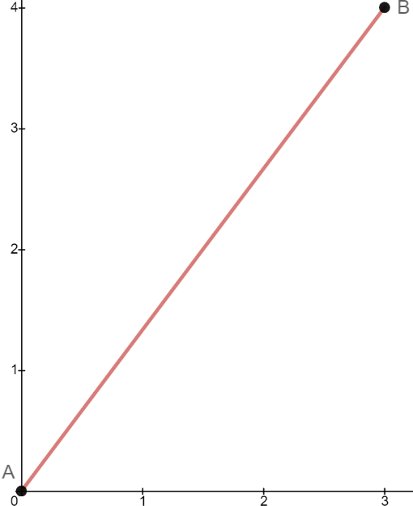
The construction of all trigonometric ratios of angle A:

Start with two points called A and B. Connect them with a line.
Point A shall be at (0,0) and point B some (x,y) where x and y are not negative or 0.
In algebra this is called the segment of a linear equation where y = Mx +b.
M = slope and b = y value of the y intercept.

The solutions to the linear equation are any x,y pair that makes the equation true. For a line there are infinite solutions so the line extend forever in both directions. We take the point (0,0) to be the origin of this line that starts as a single point that is stretched in opposite directions to infinity.

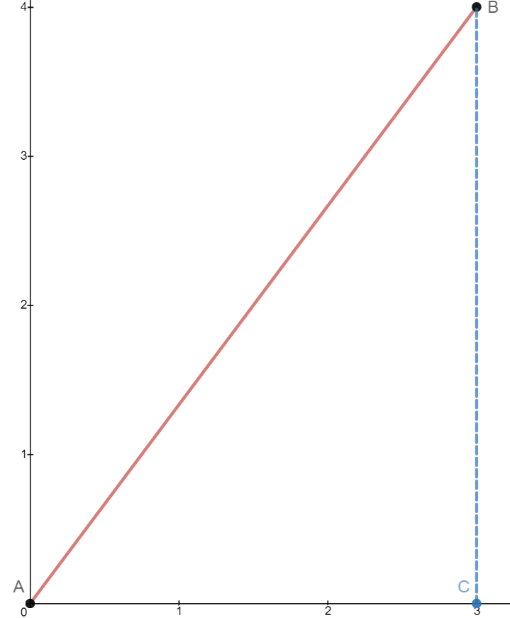
Place point C on the x axis directly below point B.
These three points make a triangle with point B the vertex of angle B. All points are the vertex of their corresponding angle given by the letter of the point.

The distance From A to C is the width of the triangle, called x.
The distance from B to C is the height of the triangle, called y.
The slope of the triangle's diagonal side is given by y/x.
Slope = y/x. As we will see tan = y/x and therefore is the slope of the diagonal.

A closeup of the x distance and y distance shows this makes a 90° angle.
These two side lengths are said to be complimentary because they make 90°.
We call x cosine and y sine. The cosine compliments the sine.
If point B has a coordinate of (3,4) then cosine = 3 and sine = 4.
Tangent must be 4/3 because x= 3 y=4 and tan = 4/3.

This is the easiest way to explain, rigorous definitions contradict themselves and violate other systems of math.
I am aiming for an informal concise overview of basics.

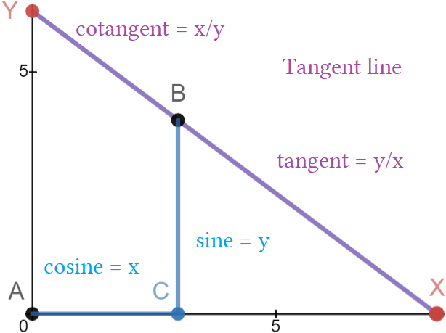
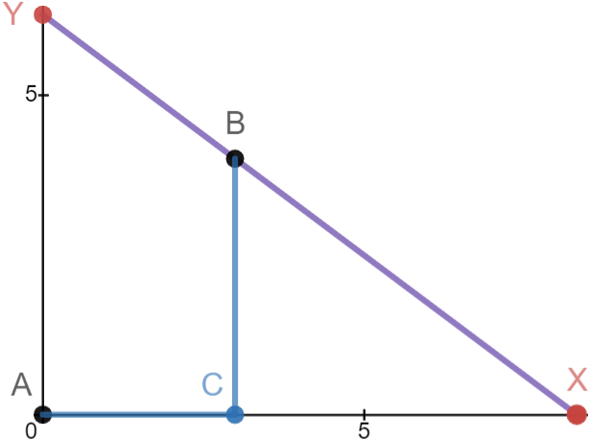
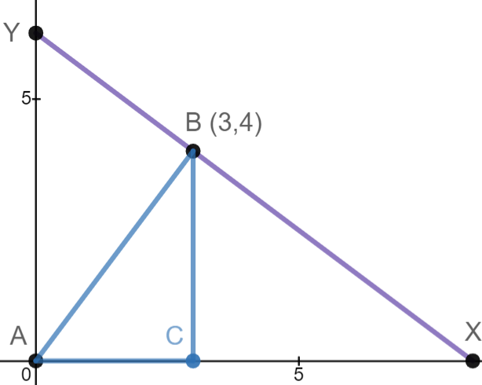

The purple line is the tangent line made up of tangent + co-tangent. Mostly we care about tangent.

AC is the cosine of angle A.
BC is the sine of angle A.
BX is the tangent of angle A.
BY is the cotangent of angle A.

We do not have a fully formed triangle we only have cosine and sine making a single 90° and a tangent line passing through points YBC. If we draw a line from A to B we have a triangle and these lines are the geometric representation of the trig functions of angle A.

A line drawn from (0,0) through point be will make a 90° intersection.
An intersection is the point where two lines meet making four angles.

If one angle is 90° then all four angles are 90°. This is true of the x and y axes. They meet at 90° making all four angles 90°. Tangent and co-tangent are reciprocals of each other because they flip the numerator and denominator but they are not complimentary lines. As you can see they are supplementary segments.
The equation y = 4/3x+0 creates a line that passes through the origin shared by point A and through point B. Point B now has 5 angles coming from it. Four are 90° and one of the 90° angles is bisected by segment BC.
Sine is always a line that divides a tangent line. The linear equation creates a triangle ABC with base 3 and height 4. The only triangle this could be is 3-4-5 so we know the hypotenuse is 5. Using Pythagoras confirms this.

The equation y = 4/3x passes through all points for every pair of x and y that solve it.
It passes through the purple tangent line dividing it into tangent and co tangent.
It is complimented by the purple line. Tan and cot are compliments to segment AB.

ABY is 90°. YB∞ is 90°. XB∞ is a 90°. CBY is the compliment to angle “B” , formally BAC
The use of infinity symbol means the point is traveling to infinity and can not be contained.
B and A of the blue triangle are complimentary angles that add to 90°.
Segments cot and tan are complimentary segments that make 90° with the line AB↔ .

You can see the blue line is 90° orthogonal to the purple. This means several thing one of which is that these lines, called functions, are inverses of each other. The altitudinal line BC divides the 90° of BAC making it the sine of the blue triangle when it divides the x axis. Consequently it makes supplementary 90° with the x axis.

The blue line has the purple as its inverse and vice versa. The distance from A to B is the hypotenuse of the blue triangle. It is perpendicular to the tangent. They compliment. Sine divides this compliment making B the compliment to A. From B to X is tangent. From B to C is sine. From A to C is cosine. The weird thing is that the ratios For angle A are sin cosine and tangent but only sin and cosine are sides of a triangle. Tan is not a side of the triangle is is the slope of the hypotenuse. Tangent is always weird and hypotenuse is always weird.

You can label a triangle's sides base, height, diagonal. You can change base and height to cosine and sine but you can not change diagonal to tangent. Sine and cosine are complimentary but cotangent and tangent are not in the sense of this illustration. This goes against it's “co” suffix. They are reciprocals but not compliments.
The sine and cosine of any triangle are a ratio less than 1 but tangent can be bigger than 1. These are three differences that make sine and cosine related while excluding tangent. Tangent is a weirdo and so is hypotenuse. The three main functions were kept because they were useful but this changed understanding and how people are taught. The names have been altered and new definitions added. There is a lack of cohesion between branches of math as a result. There is not one single definitive answer so I am giving my best.

From a single point (3,4) we drop a sine to the x axis. We draw a segment from origin to the sine.
We draw a segment from A to B completing the target triangle. We take the x,y from the point (3,4) and use it as slope of the hypotenuse. We can do this for any single point to make a triangle with A at the origin and B as the apex of the triangle. Apex is the highest point or peak of a triangle, mountain or incline. Using y/x as slope we write the equation y = (y/x)x+0 → y = (4/3)x → y = ⁴/₃x. We use slope as our ratio for tangent to calculate the length of tangent. We must multiply the length of the hypotenuse with tan ratio to do this.

(4/3)∙5 = 6.6. is the length of tangent and it will be the hypotenuse of a proscribed triangle of the target triangle. Sometimes knowing it's length is enough, we still don't know the angle of deflection and more precisely where it touches the x axis. If we knew where point X was knowing the length is less important. Graphing this requires taking the inverse of y = 4/3 to be y = -¾x and manually plotting points to the x axis or using point slope formula y-y₁ = m(x-x₁) or rewriting to isolate x. You will find point X to be (8.3). This is the length of secant.

You have five of the 6 trigonometric functions of A. Cosecant is found by using 1/sin∙hypotenuse = 6.25.
Point Y is at (6.25).

- Make a single point (3,4) and call it B
- Draw a sine 90° down from B to the x axis and call the intercept point C
- Draw a cosine to (0,0) from C and call the intercept point A
- Draw a hypotenuse from A to B. Use Pythagoras to find the length
- To find secant (point X) take the reciprocal of cosine, 1/cos and multiply by hypotenuse.
Add this distance to C and mark on the x axis. Label this X.
- To find cosecant (point Y) take the reciprocal of sine, 1/sin and multiply by hypotenuse.
Add this distance to A and mark on the y axis. Label this Y.
- Draw a line from Y to X. This is tangent line. The starting point bisects into two parts: top is cotangent bottom is tangent.
- To find tangent divide sine/cosine or use (3,4) and write it 4/3. Multiply tan∙ hypo to find length.
- To find cotangent take reciprocal of tangent using 1/tan. 1/ means invert top and bottom numbers of the fraction. Multiply with hypo to find the length.

All six trig functions can be obtained from a single point which forms the triangle. Then it forms the triangle around it. The first triangle has two functions sine and cosine as sides with hypotenuse as the third side. The other four function make the second larger triangle which contains the first. This leads to understanding how the triangles angles work.

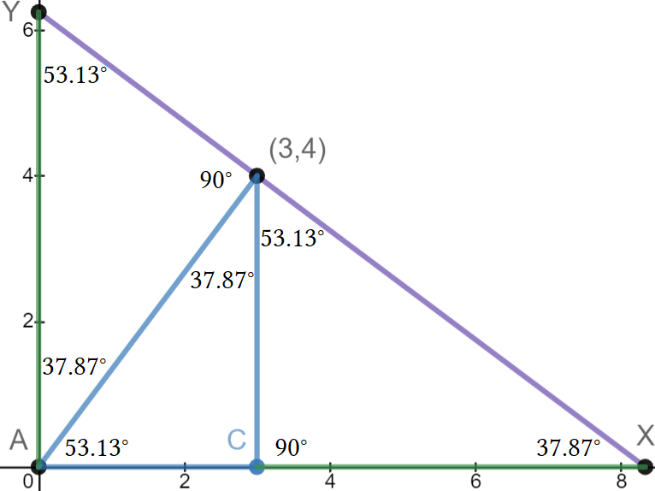

When you draw a line from a corner and it hits the other side at 90° you always make more triangles and that drawn line is the sine of the newly formed triangle. If we started with the large triangle first we would draw the line AB to make a 90°. This would make two triangles, one above the line and one below it. To find where to draw the line we would have to rotate the triangle onto it's longest side the hypotenuse placing angle A in the air. From there drawing a line straight down places this line at an angle of 90° because the hypotenuse is resting at 0°. Rotating it back into its original position we could drop the sine line down from point B.

There are now three smaller triangles in the larger triangle making a total of four. All the angles are complimentary and repeat, they are smaller versions of themselves. This is handy if you need a smaller triangle of same angles. Smaller triangles that have same angles are called similar. The picture above proves triangle similarity for four triangles.

y is already isolated as 1y unit = -0.75x units oddly written as slope of 1/-¾, move at this rate until you reach the x axis to find point X. From (3,4) move down 4 units on the y-axis: 4 – (4∙1) = 0 For x: 3+(4∙4/3) = 8¹/₃

Set x,y using (3,4) to find point X (x,0):

Proscribed is the superior form of circumscribe not to be confused with the profane meaning of banish or prohibit. They took proscribe to mean an action falls under prohibited writing in an attempt to deceive and make confusing the law using made up fake Latin words.

Those are provincial terms used by the mathematically and linguistically inept who chose to be punishers instead of educators. Proscribe here means outside of the enclosed boundary. It comes from the same root as protractor which it a tool to draw a line outside of the circle. Fools take it to mean “outside of the law” hence “outside the written law”. This is a colorful colloquialism used by circuit judges and southern lawyers. We can not say circumscribe because we are drawing a triangular boundary not a circular one.

They are abusing language and using doublespeak. They ignore the original meanings of the Latin roots pro meaning forward and con meaning backwards usually in a vote the “pros and cons” where you are for(ward) something or against something. To forward a motion is to “pro-mote” it. To protract is to lengthen as opposed to contract as in muscle movement. I don't think these people speak English.

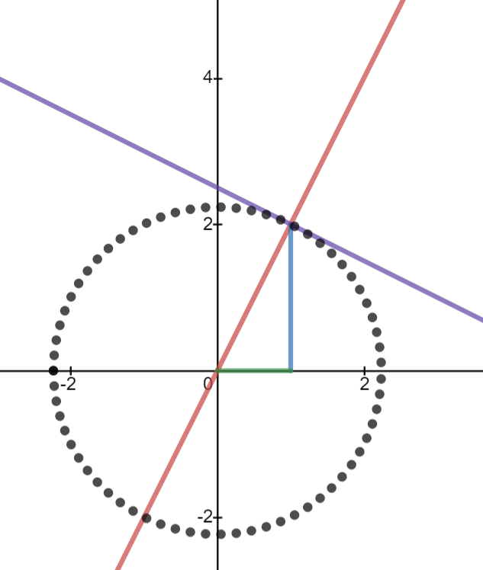
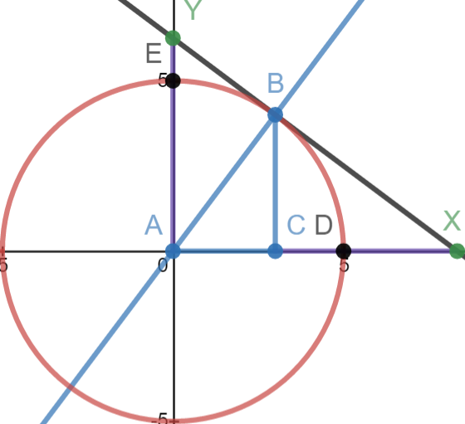

Write as decimals otherwise you have y = ²⁵/₃x + ²⁵/₄ and it is too easy to confuse one for the other and you will always second guess which one you have. It makes it easier later if you convert them now. For any rectangle x is the base and y is the height. Its area is xy.

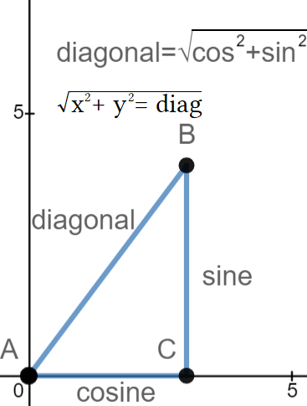
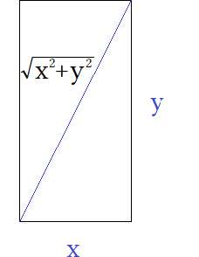
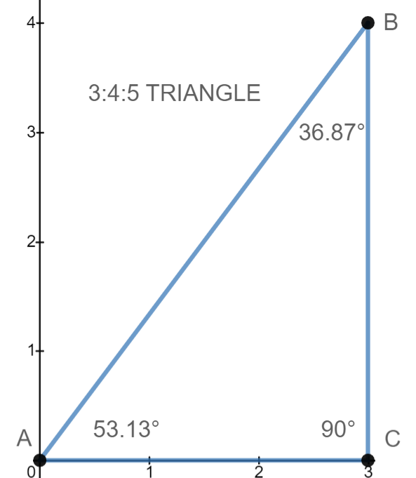

Dividing a rectangle diagonally creates two right triangles of equal area. This is called the diagonal of a rectangle. The most famous one is the diagonal of a square called √2. It is used to make many parts of polygons and all polygons are made of triangles. The length of a diagonal is given by √x² + y² = diag. Diagonal is written this way. It is never written dia. because that is how diameter is written. To avoid confusion it is probably better to use something else. Some people use z or r. Z usually refers to a third dimension and r to a radius. The formula for a diagonal is just the Pythagoras with a different spelling. The diagonal of any rectangle is the hypotenuse of the triangle it forms. Basic concepts like this helped form algebra and geometry.

This special triangle is called 3-4-5 because it has those sides lengths. It is special because it has integers for all sides. This is rare. I use this in most early examples because it makes showing ideas easier when the sides lengths are not decimals. It has degrees as shown. All multiples of this triangle are still 3:4:5 triangles even if they stop having integer side lengths because the ratios from side to side have not changed. If divided by two we have a 1.5:2:2.5 triangle and it is still a 3:4:5! That's sneaky. All triangles with three integer sides lengths are called Pythagorean triples.

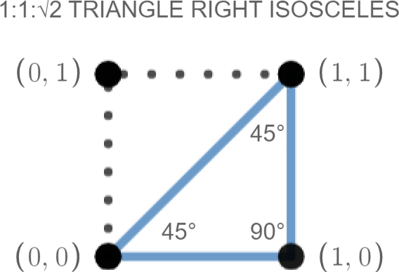

This is the square. It has already been mentioned. It is important to see where it's points are so you can graph them. Graphing gets harder and this is always used to simplify things. Symmetry is important and the square is the most important shape because of this. Between the three basic shapes, circle , triangle and square, all other shapes are made. The right isosceles is one half of a square cut along its diagonal. The dotted lines show where the sides would be if it was a square. If flipped over its diagonal it would fill the dotted space.
This is true for all triangle but they of course have different diagonals. A squares diagonal is the most special in that it is given by the equation y = x. This is called the “identity equation” in algebra and is usually the first step in graphing linear equations before moving on to quadratics. It is called that because it identifies an equation as being linear of 1 degree for x and has a 1:1 ratio of x to y. All squares are specials cases of rectangles where the y =x meaning its base is equal that of its height. In design basic shapes are studied and a theme is to see how far you can take a basic square and maximize its potential while playing off its symmetry while maintaining its minimalism.

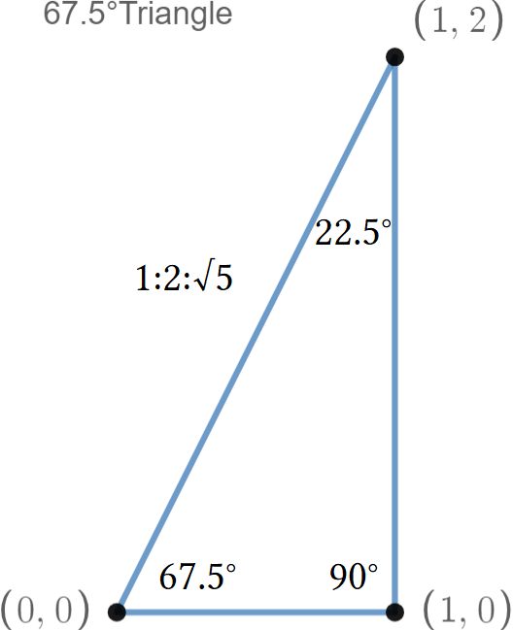

A 67.5 triangle is the diagonal of a 1:1+√2 rectangle. These are used in making octagons and are the degree of the its diagonal. An octagon has a 135° interior angle that is bisected by the radius of the polygon making two pairs of matching 67.5° angles on either side. Its hypotenuse is √5 another famous root that should be recognizable to at least four digits 2.236. 67.5° is an important angle in building things like architecture and construction. Roofs rafters stairs and most basic carpenters square include this angle for easy reference.

Unit circle

This shows the unit circle in degrees This shows the unit circle in radians

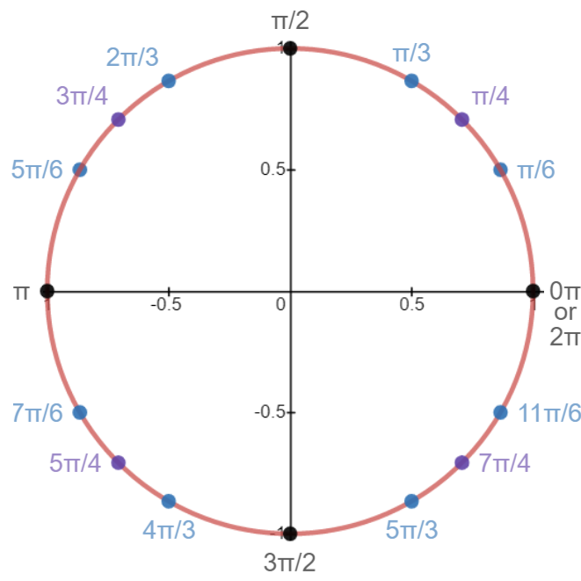
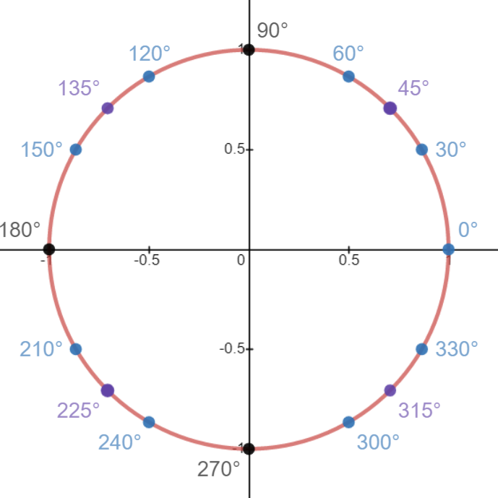

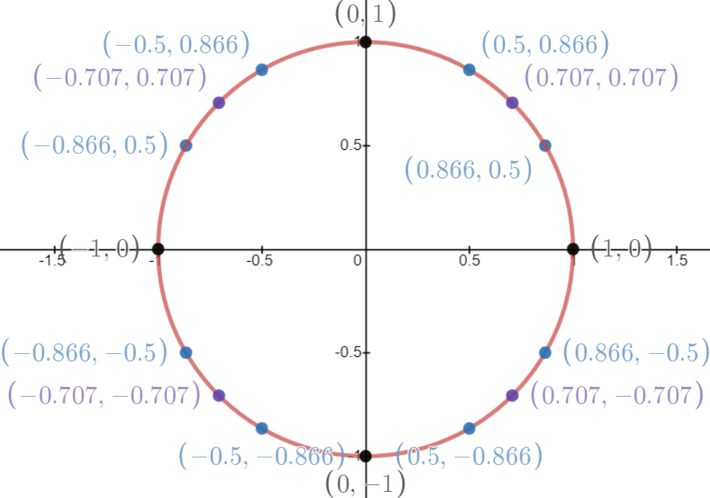
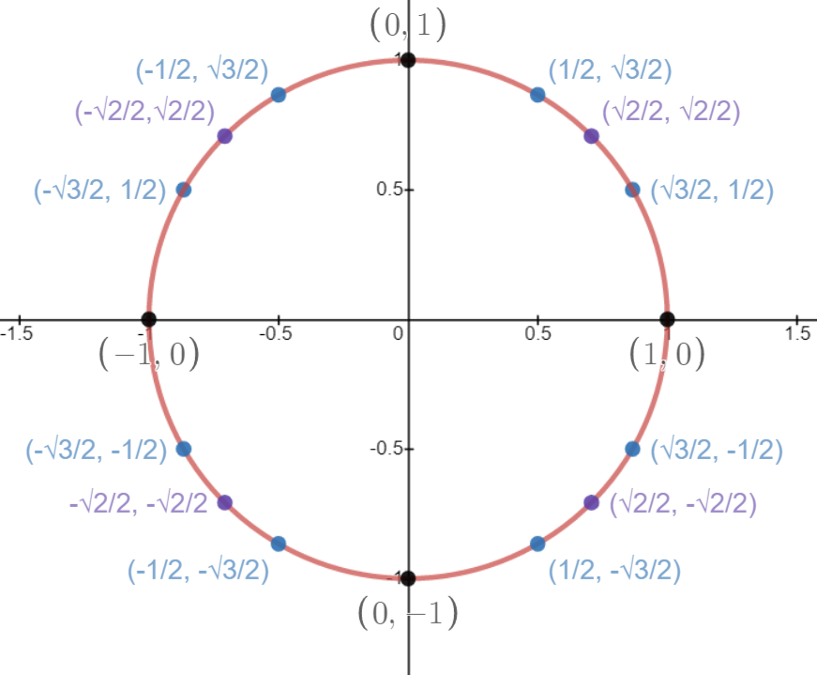
This shows the unit circle in exact ratios This shows the unit circle in decimals

Navigation uses degrees, physics uses radians, triangles use exact ratios, engineering uses decimal approximations of the exact ratios. The exact ratios is the most important to learn so you are not put off by radical terms. The radians are second most important to learn because they are for advanced trigonometry like polar coordinates and sines waves. The decimals is the third important because sometimes we need to use decimals and they are easier to write. They degrees is the least important. The next pages are dedicated to each version because they are best described separately for easy reference.

Classical Unit Circle part 1: Degrees

A circle is 360°. It can be divided into four quadrants using two axes, a vertical y and horizontal x.
The four quadrants are divided into 90° sections just like a Cartesian graph. Really the unit circle is drawn on a Cartesian graph. It simply is a circle centered on the origin with a radius of 1.

Each quadrant a rotation to the left is considered positive and each movement to the left is considered negative. Babylonians invented degrees because they used a number system based on 60 instead of the modern number system decimal based on 10 digits. They used this for construction and to chart the path of the sun. The system of time comes from this having 60 seconds in a minute and 60 minutes in an hour. It is a very old system. The sun rises in the east and sets in the west. On a map east is to the right and west is to the left so they considered sunrise 0° on the horizon, 90° high noon and 180° sunset. Past this point it was night and therefore negative until the sun came back up. Wasn't really like this but close enough.

Divide the circle like you would a pizza.

1 circle = 360°
½ circle = 180°. This is the x axis from 180° to 0°. Half a circle is called a semicircle. Half a circle is called a diameter. The axes are diameters of the unit circle. Their points are:

x axis: (-1,0) to (1,0) this give a diameter of 2 units. The location of 180 is (-1,0). The location of 0° is (1,0).
y axis: (0,1) to (0,-1) this give a diameter of 2 units. The location of 90° is (0,1). The location of 270° is (0,-1).

¼ of a circle = 90°. From 0° every 90° increment touches the y or x axis marking the boundary between quadrants. The axes or any point on the axes is not considered a part of any quadrant. They are neutral territory since they are equally in both quadrants they divide.

Quad 1 0°-90°
Quad 2 90°-180°
Quad 3 180°-270°
Quad 4 270°-360°

1/8 of a circle = 45°. There are four degrees that end in 5 on the unit circle that are multiples of 45°.
1/12 of a circle = 30°. 5°12 = 60° and this reflects the base system 60 degrees come from. There are 8 of these locations on the unit circle.

Four 90° angles
Four 45° angles
Eight 30° angles
16 locations total.

Using graph paper draw a circle with a diameter of 2 units and label the center (0,0). Call this the x axis.
Write 180° at (-1,0) and 0° (1,0). Draw a second diameter at (0,1) to (0-1). This is the y axis. Label (0,1) 90° and (0,-1) 270°. These axes cross at 90°. You now have four circular slices called the four quadrants. Divide each quadrant in half and mark the locations 45°,135°,225° and 270°. It takes two lines to divide the quadrants in half. Each line is two units long and also a diameter. These are the 45° diameters. These lines cross each other at 90° and are 45° to the x and y axis. You now have eight sections. It takes four lines to divide them equally at 30° increments. Label the locations where the line touches the circle 30°,60°, 120°, 150°, 210°, 240°, 300° and 330°
These are the degrees of the unit circle.
Classical Unit Circle part 2: Radians

Radians measure the lengths of 1 radius. A radius is half the diameter of a circle. Two radii makes a diameter. The diameter is any straight line that passes the center and touches two opposite sides of the circle. A circle has infinitely many diameters. Everyone of the lines drawn on the unit circle touch a location in two opposite quadrants while going through the center making each a diameter.

People wanted to know the ratio of a circles circumference to its diameter. The circumference is the length of the perimeter of the circle, its circular length. They found that no matter what the size of a circle the ratio of circumference/radius ≈ 3.141592. They called this number “pi” using the Greek letter π. This made the formula for circumference of a circle 2πr and from that the formula for area πr². Π is a irrational number that never ends much like some fractions so we use π as a variable to represent it.

If we draw the unit circle it has a diameter of 2 and a radius of 1. Using the formula for circumference our circle has a distance of about 6.28 units. This is how many radii long the distance is if we traveled along the circular path.

If diameter is 1 unit then radius is ½ a unit: 2πr becomes 2π∙½ which is 2∙ ½π= 1π ≈ 3.14.
If diameter is two units then radius is 1 a unit: 2πr becomes 2π∙1 which is 2∙ 1π= 2π ≈ 6.28.

Because radians are based on the ratio of a circumference to a radius it is a natural system. Systems like imperial or metric are called “fixed” systems because their lengths do not change. The length of a radian does change. It's length depends on the size of the circle being measured. Bigger circles have longer radii and so have radians that are longer. Because size can change it makes it easy to convert from one system to another. Systems like this are called “natural units” and are based off of nature and not man made fixed systems. Another natural system is pixels in your TV or smartphone. You can see the same image because the picture automatically scales to fit your screen. If a non scaleable system was used it might not fit properly. This is an issues with some older websites or one not properly coded.

Since the distance around a the unit circle is 2π long we say 2π equals 360°. Only circles with a radius of 1 radian are 2π but all circles are 360°. In short the radius of a circle must be set to 1 for any circle to be 2π. A mile radius can be said to make a circle that is 2π around but a 5 mile radius is a circle 2π5 or 10π long. To convert to radians divide the distance by itself to equal 1. That is what we are doing with the unit circle. We are dividing all sides of the triangle by the hypotenuse to use the hypotenuse as a radius of 1 radian.

The word unit means 1. The number 321 has a place for hundreds, tens , and ones. The ones place is also called the units place. Unit circle is a unit of 1 measure. We are trying to measure something with the smallest unit 1.
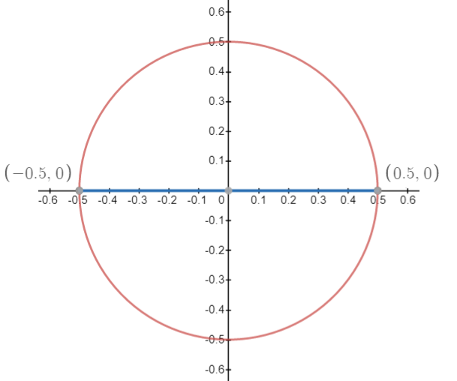
This circle has a radius of ½ unit with x² +y² = (½)²
The diameter is 1 so its circumference is π.
Doubling the diameter doubles the circumference.
x² +y² = 1² is a diameter of 2 so its circumference is 2π.

Circumference/radius = π
3.141592653/1 = π
2∙(3.141592653)/2 = π

Doubling the radius doubles diameter so that the ratio is always is π.
Classical Unit Circle part 3: Radicals

The equation for a circle is x² + y² = r² . This looks suspiciously like a² + b² = c² Triangles and circles must be related somehow. We will explore that later, for now:

x² + y² = r² a² + b² = c²
√x² + y² = √r² √a² + b² = √c²
√x² + y² = r √a² + b² = c
^{some length} = r ^{some length} = c

To find the length of of radius or hypotenuse we need to find a square root. These are irrational neverending decimals and it is best to keep them in radical form because it is just easier.

I have a rectangle with x = 3 and y = 4. Its area is 3∙4 = 12
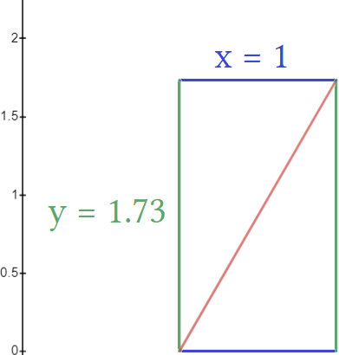
If I divide it in half I create two triangles. The area of the triangle (½)xy = A.
Its the length of its hypotenuse it some radical.

x² + y² = r² ⇔ a² + b² = c²
1²+1.73² =r²
1+2.9929 = r²
3.9929 = r²
√3.9929 = r
1.9982 = r

In reality this is a ∠60° at the base. Using the true value would give a hypotenuse of 2 instead of 1.9982.
A ∠60° is made by bisecting an equilateral triangle for the simplest case consider a triangle with all three sides having length 1.

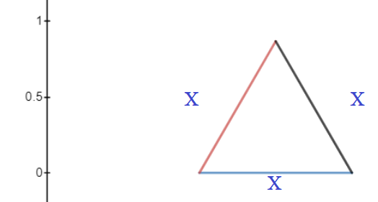
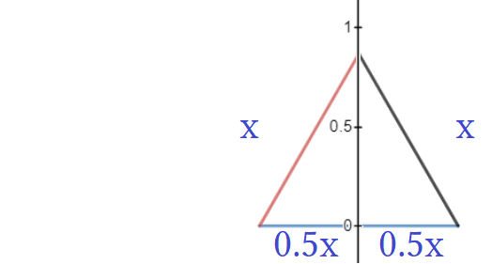

A triangle with all sides the same length must have three angles all the same measure.  the measures must be all 60°. Placing the ruler on the triangle takes the height as between [0.5,1] and divides the base into ½x on either side. We take this to mean that all sides were 1, the base is now 0.5 because of the bisection, and the height is less and than 1 because it is an altitude and  the sine of both triangles.

1 = ½² +y²
1= ¼ +y²
.75 = y²
√.75 = y = .8660 = √3/2
If we have a triangle with all angles 60° dividing it by creating a line down the middle creates two right angle triangles. The sides had a ratio of 1:1:1 but now have a ratio of 1:√3/2:2. I write ratio in the order base:height:hypotenuse or x:y:c. This creates a new angle of 90° which is up 30° from the 60° it was and the old 60° is divided in half. This creates angles of 60°:30°90° for A:B:C.

If is very hard to find triangles that do not have a radical for a hypotenuse length. If you do then you end up having the x and y length be radicals instead. To find c² you have to take its square root and mostly they can be non square numbers so you get an irrational radical root. This is why the unit circle is written with radicals ; there are only three angles in it: the 30°, 45° and the 60°. Since the 30° and 60° are really from the same triangle they have the same hypotenuse that is a non square radical.

The two triangles used are half an equilateral triangle and half a square. These shapes are very basic and in building can make many different shapes and polygons. They are the “unit” triangles or smallest piece triangles to build larger more complex shapes that have unique symmetry.

So you have to use radicals as is or else you run the risk of using approximations that are not exact. When you do this you are opting for an easy number upfront that is wrong and will get a end result that is even more wrong. Approximations when used are to four decimals. Since these angles are often you used you need to learn them and how to write their equations and solve them using algebra.

Classical Unit Circle part 4: Decimals

Decimals are used when writing as a radical is inconvenient or not possible. Some computer programs and calculators only accept decimals or your input device is not capable of writing radical or fractional terms properly. Because of this you have to learn the Decimal approximations as well.

Classical Unit Circle part 5: Committing facts to memory

The better you understand the math required to use the figures in the unit circle the easier it is to memorize the conversions. This means doing problems that require calculating angles. Much of trig requires the use of a calculator but you need to know from memory what the conversions are so you can input the correct figures and operations.

Degrees are easiest to memorize since they are the most familiar. There are four quadrants bounded by two angles which are multiples of 90°. In between them are three angles: a 45° multiple with a 30° multiple on either side of it. Out of the 16 locations the first four are just the points on the axes leaving 12 angles which are just a 30°,45° and 60° in each of the quadrants making up the remaining 12.

Memorizing the first quadrant is easy given enough practice doing problems involving those angles.
The others come naturally with time and greater exposure.

Dealing with the angles mentioned teaches you the sine and cosine x,y values that make up their coordinates. It is just a matter of dividing a square along its diagonal and learning what √2 and √2/2 is about. Then learning what √3 and √3/2 is about. Learning √2 is important because it comes up very very frequently. Other triangles can be a multiples of this such as √8 = 2√2. √2 it to be thought of as the most basic building block.
How the Unit Circle is derived

Using a Cartesian graph make a circle that has diameters at {(-1,0)≤ x ≤ (1,0)} and {(-1,0)≤ y ≤ (1,0)}.
The equation given will be x² + y² =1². This makes a radius of 1 and diameter of 2. The center of the circle has a x,y of (0,0) and this is called the origin. Unless otherwise denoted it is marked with the letter O but I tend to replace this with A if I and making a right triangle and using the origin for the point A of my triangle.

For illustrative purposes imagine you have two points that make a straight line point O (0,0) and point R (1,0).
On a Cartesian graph this is straightforward. If you rotated the segment OR about point O, point O would not move but point R would. In doing so it would move away from the x axis in the positive direction ↑ and towards the y axis in the negative direction ←.

If you move away from the x axis you have to increase or decrease your y value. You go up or down ↨.
If you move away from the y axis you have to increase or decrease your x value. You go left or right ↔.

This is an inverse proportion. Increasing y decreases x. Moving left increases x while y decreases. Inverse proportion is when one increases and the other decreases. Direct proportions have the same sign for both variables and inverse proportions the signs are opposite. If one of the slopes variables is positive and one of them is negative you have an inverse proportion.

y=x is a direct proportion because it is a positive slope. Y= -x in an inverse proportion because the signs are opposites or additive inverses of each other. Inverse means opposite sometimes called indirect.
y=x is the same as -y = -x. They have the same sign and therefore are direct proportions.

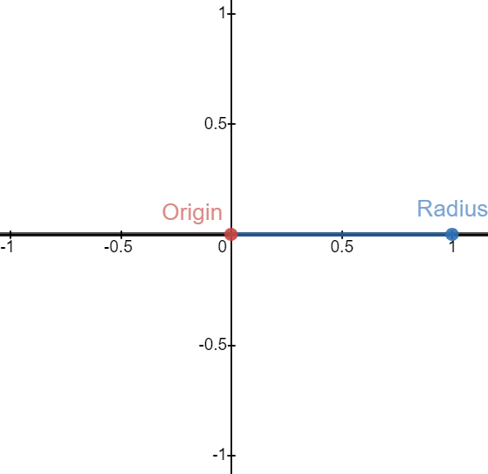
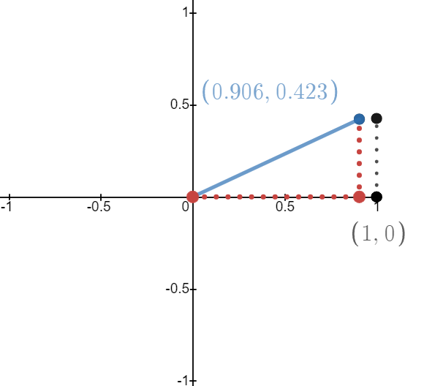

A segment with length 1. It is at 0°. Algebraically it is y = 0 {0 ≤ x ≤ 1}. Red dot is the origin or point O.
Blue dot is the radius length point R. These dots are the endpoints of the radius. Points have capital letters and sometimes script or italics to avoid confusion with variables in a equation or on a graph. The points measure a distance of 1 radian. 1 radian is equal to the length of 1 radius. If we rotate the segment it moves away from the x axis and towards the y axis in a circular path. The red dots form a triangle with the radius showing the location of the radius endpoint. The black dots show a vertical line of how far the endpoint is from 1 unit. When the radius was 0° it was at (1,0). Here it is at 25° as measured from blue dot to the red dot directly below it. At 25° its location is (.906, .423).

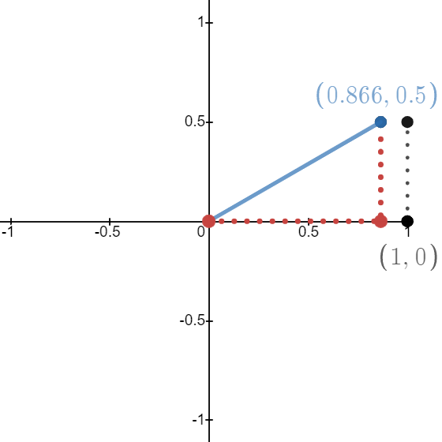

This shows a 30° rotation about the origin. It show how far it moved when it was at 25°. The x,y value went from ~(0.9,0.4) to ~(0.86,0.5). Lines can rotate from any point given by an equation called a parametric. The tilde symbol “ ~ “ is half of the approximation symbol “ ≈ ” and means a bad approximation not good enough to use for calculations. In trig we use four decimals. I am writing fewer decimals for brevity. In the unit circle the radius only rotates around the origin and the origin is always (0,0). We say it rotated “about” the origin to differentiate from other rotations that happen with lines.

The blue line is a length called the radius and it is always 1 unit long.
The red dots form the base and side of a triangle with it.
The base is the length of the cosine of the triangle so we call the base cosine.
The height is the sine. The three sides of the triangle in the unit circle are cosine, sine and radius for the base, height, and radius.

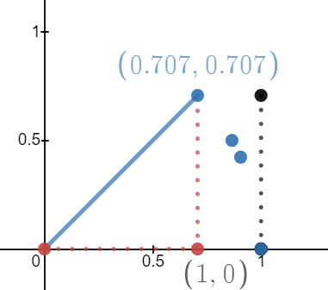

Here is 45°. It is the diagonal of the square.
Cos(45°) = .7071
sin(45°) = .7071
tan(45°) = 1

The blue dots are where the radius was for 0°, 25°, 30°. When you push sin, cos, tan into a calculator you have to enter in a number of degrees. This is the number is is giving you. It is the definitions of the functions divided by the hypotenuse. Dividing all sides by the hypotenuse makes the hypotenuse 1 since it is divided over itself.
Since the hypotenuse is the longest side the other sides divided by it must be less then 1. You get a smaller number for cosine and sine because:

hypo/hypo = 1 we call this radius
height/hypo < 1 we call this sine
base/hypo <1 we call this cosine

Tangent is not a side of the unit circle it is the slope of the radius given by a linear equation.
Tan = height/base so it equals y/x which is the x,y coordinate of the endpoint of radius.
Example: Tan(45°) = 1/1 =1 because a square has a ratio of 1 over and 1 up or base = height, so its x = its y.
This is 67.5 °. On every picture the black dot has a width of 1 and a height of the blue dot.
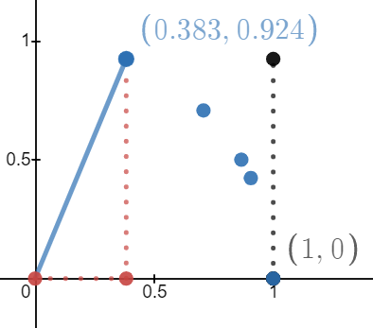

This shows how far the radius is traveling away from the starting position of 0° The path it draws is called an arc.

- The blue dots are moving progressively away from the black “wall”
- The blue dots seem to be following a curve.
- As radius moves the height gets taller and the base smaller.
- The moving red dot is heading towards the y axis it's location is
(x,0) where x is the x of the radius.

The base is shrinking while the height is increasing. The for the blue dot it's x-value is getting smaller while its y-value is getting bigger. This could be written as y = -x where y is adding numbers to grow and x is a negative number where it is subtracting numbers to shrink. This is an inverse proportion. The function has a negative slope.

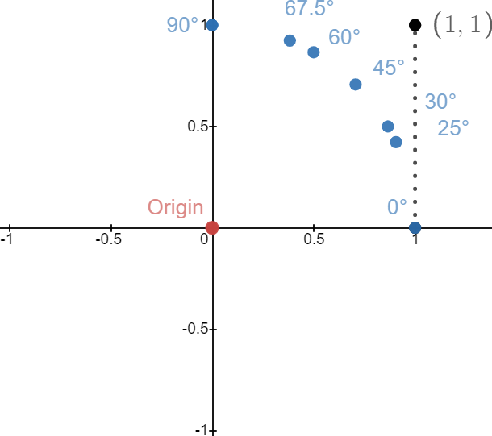

Here are the degrees for the blue dots. They are arcing towards 90°. This is the path from 0° to 90° or ¼ of a circle. They path they make is a quarter circle. From the axes we see four quadrants and that if continued it would make a ring of dots in a circle. When the radius gets to 90° the triangle disappears. At 90° it has a height of 1 radius and a base of 0 radii. It didn't have a triangle at 0° and it doesn't at 90° because of technical reasons. At the four quadrantal angles (quadrangles) this happens. At 0° there was zero height so you had 0 sine making essentially a one dimensional line. In the unit circle the sine is the height of the triangle and cosine is the base. If your base or height is 0 then you can not have a 2 dimensional triangle. Any time x or y is 0 you have a 180° line that is 1 dimensional. X is a dimension of horizontal movement, y is a dimension of vertical movement.

This happens at the 90° angles: 0°, 90°, 180°, 270°. These lie on the x and y axes themselves and these points are not considered part of any quadrant. As such this helps form the definition of the x,y axes themselves. Before math was modernized the archaic words for these were abscissa and ordinate and referred to the x,y values but now may refer to the axes themselves.

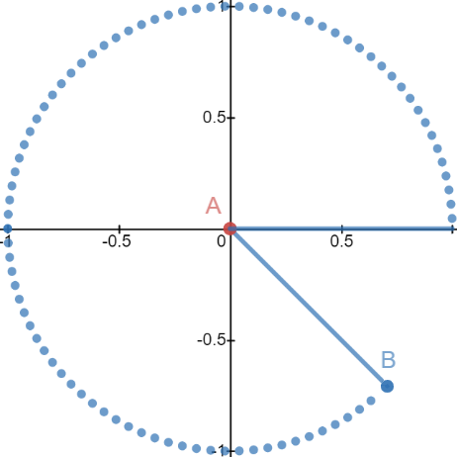

This shows the radius at 315°.
The blue dots are points the that point B passes through.
It is clear that rotating a radius makes a circle.
If continued the radius would complete a circle.

Normally the Origin is labeled O to introduce the unit circle.
The endpoint is usually labeled R. I tend not to use italics but
script letters are deemed superior.

Dividing all sides of a triangle by the hypotenuse makes the hypotenuse 1 unit. Labeling a triangle ABC is convenient. Making point of Origin point A is convenient. The Hypotenuse should be from point A to point B with A replacing the letter O and B replacing the letter R.
The two blue lines are exactly one radius long. Just as you need two points to make a line you need two lines
to make an angle. Technically a 0° is two radii at 0°. If both lines are at 0° then the measured distance between them is 0°. A single line at (1,0) is NOT a 0° but rather a single line. You NEED two lines for an angle. At 0° the two lines are overlapped making it appear as one line.
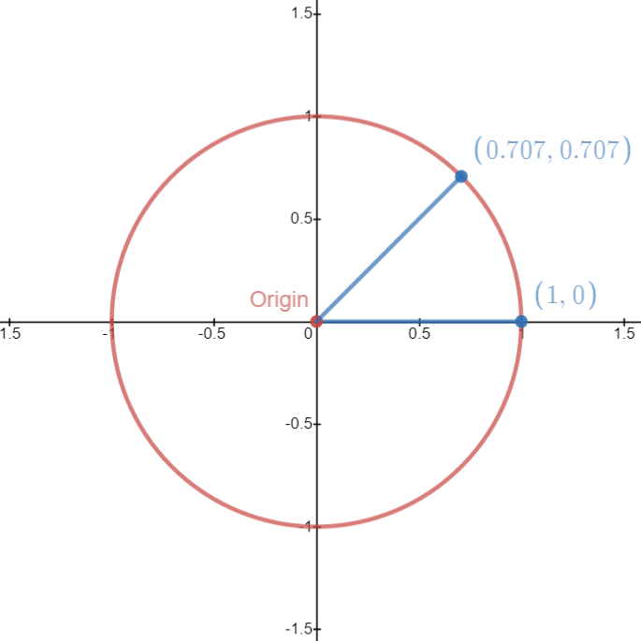

The first line starts at the center of the circle and ends at point (1,0). We call this point “0°” or “0π”. The second line starts at (0,0) and ends at some point on the circle. Here it is at 45° or π/4.

Both of the lines have the same length. It needs to be clear that as you rotate the 2nd line it moves away from the right side of the circle and heads towards the left side. When it does so it no longer is as far right as the 1st one. We know the second dot is not as far right as the 0° dot because it is not directly above it. Instead it is slightly to the left. If the first line is at (1,0) then the second one is at (1-x,0+y). Something less than 1 from the origin, and something more than 0 from the x axis. We have to subtract a number from 1 and add a number to 0.

The name for the distance subtracted from 1 is versine and the name added to 0 is called sine.
1 – versine = cosine “the base x”. This is the x value for the radius endpoint.
0+ sine = sine “the height y”. This is the y value for the radius endpoint.

1 – .2929 = 0.7071
0 + 0.7071 = 0.7071

Take the initial point of 0° (1,0) and subtract distance traveled to the left .2929
x = cosine
1 - .2929 = 0.7071
cosine = 0.7071

Take the initial point of 0° (1,0) and add distance traveled to the up 0.7071
y = sine
0 + 0.7071 = 0.7071
sine = 0.7071

Cosine is the x value of the radius endpoint. Sine is the y value of the radius endpoint.
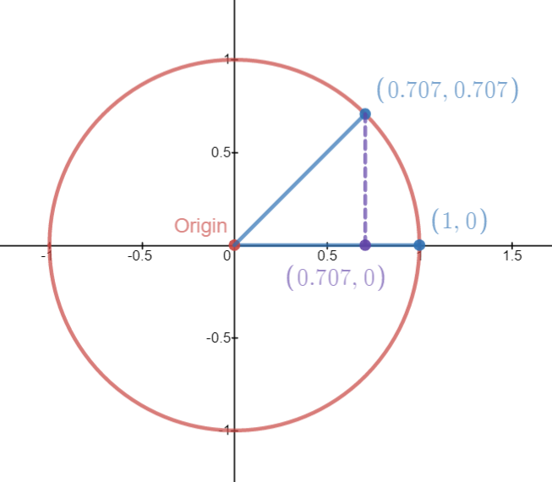

The purple is called the altitude. This is a line drawn down from the radius endpoint to the x axis. This is the height of the endpoint and marks it distance above from the x axis. An altitude is the sine of the angle. When we draw this line we can measure the distance not only from from the x axis but the y axis as well. When it touches the x axis we can see the location (0.7071,0). This point is 0.7071 units away from the origin along the x axis. This distance is the cosine of the angle.

From red dot to purple dot is cosine. From purple dot to blue dot directly above is sine. Since there are two radii in the picture it is helpful to Think of the 0° radius as point O to point R and the 45° line as Point A to point B. Calling two points on a line A to B is more straightforward and less cumbersome.

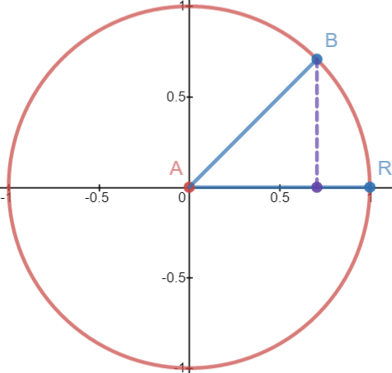
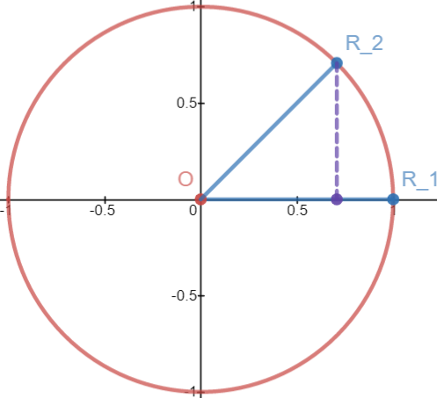

Since point O is (0,0) and point A is (0,0) they overlap. We want to refer to the second radius endpoint without calling it the radius endpoint So we need to replace the letter O with the letter A. Letter A supercedes letter O because that is the line segment we are emphasizing. The distance for x is the same as distance y. We write this as y=x. We graph this by writing points like (1,1), (2,2), (3,3), (4,4) etc. I wrote extensively about squares and their diagonal being a 45° like given by this equation. If we travel 0.7071 from point A on the x axis we must travel 0.7071 on the y axis.

I will go to show angles that have different sine and cosine values. At this point we can consider the three lines a solid triangle of the form ABC with a straight line AB as the hypotenuse.
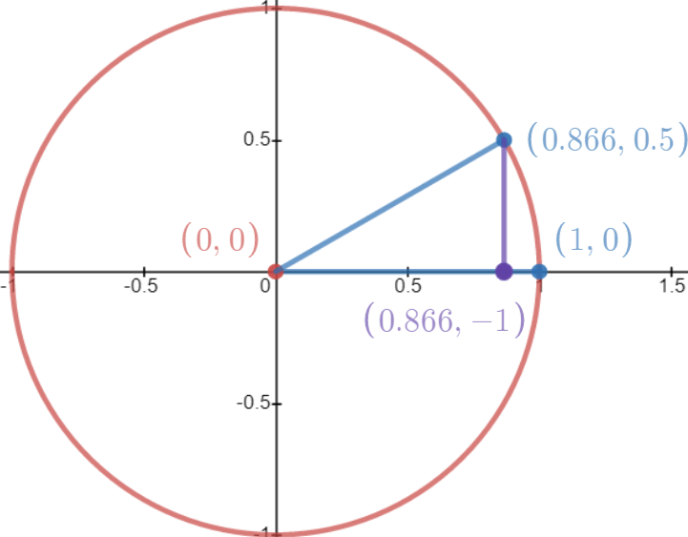
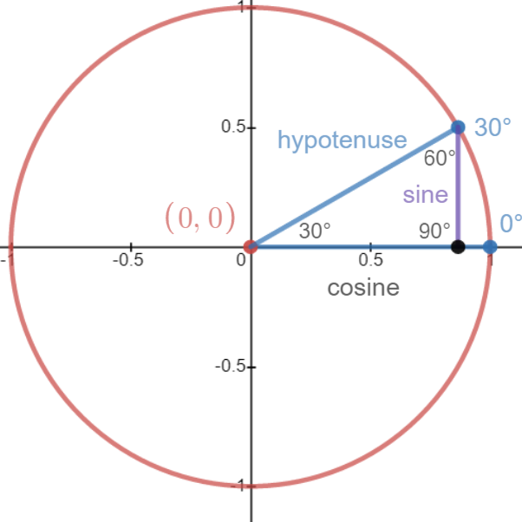
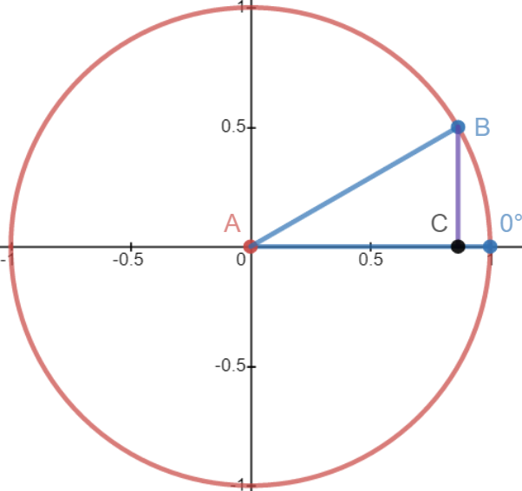

As a triangle we now have three sides and three angles. All angles must add to 180° under the Law of Triangles. Angle C is always a 90° in the unit circle so A + B = 90°. Angle A is the target angle meaning the angle that is measured on the unit circle. Angle B is its complement that adds to 90°. Theta is the Greek letter for unknown angle measures. The measure is the number given in degrees of radians. Theta lowercase looks like this θ.
The symbolism is a circle with a diameter across the middle. There are two systems of notation:

- A = θ (A is theta) B = 90° – θ (B is 90° minus theta)
- Angles A,B,C are angles α,ß,Γ

Alpha, beta, gamma are the first three letters of the alphabet. Uppercase gamma Γ is used to mean 90° and is replaced with a square at angle C in modern literature. Placing Γ at a corner does make a square so its use is indistinguishable from that of a square. Gamma was used with a small gap so upon closer inspection it was not touching the side in an attempt to hide its use from stupid people who thought it was only a square. People are stupid and forgot about its origin. Other times gamma may be used as a lowercase γ such as in physics to describe gamma radiation. Alpha is the target or main angle while beta is its compliment and gamma is always a 90°. Unless there is a need to use Greek letters they are avoided. A need to use they would be for clearly labeling sides A:B:C while labeling angles α:ß:Γ.

Alpha is the angle at the origin and beta is the angle at the unit circle (boundary).
Sometimes we see A replaced with θ and B replaced with 90°-θ:

A = θ
B = 90° –θ

So that is why we say angle A is the target angle. Knowing the target angle means we only have one variable to solve for instead of three. It is more efficient. Angle A and angle B can be switched making a taller triangle with a narrower base. They are the reciprocals of each other. Do not confuse this statement with the reciprocal functions of trigonometry. Rotating the triangle 90° makes the base the height and the height the base.
This inverts the ratio of base to height essentially switching x with y. A 30°:60° becomes a 60°:30° triangle. This type of action takes ^{x}/hypo and ^{y}/hypo and interchanges the values of y and x. Y becomes the new x value and x becomes the new y value.

The basic special triangles

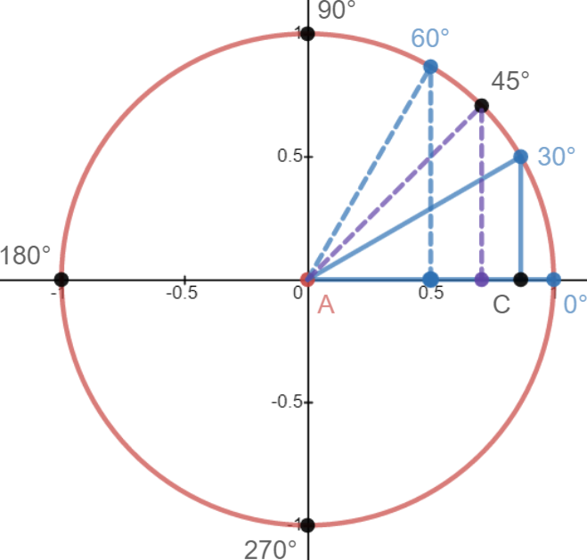

3:4:5 | 0.8 | 0.6 | 4/3 | y =4/3x
30°:60° | 0.5 | √3/2 | √3/3 | y = √3/3x
45°:45° | √2/2 | √2/2 | 1 | y =x
22.5°:67.5° | 0.3827 | 0.9239 | 0.4142 | Y = (-1+√2)

The ones in blue appear on the unit circle. 3:4:5 is a triple used to teach concepts because it has even numbers. 22.5°/67.5° are ¼ ans ¾ of 90° and are used in construction. They are special marking that appear on a speed square or miter saw.

45° plus or minus 15° is 30° and 60°. The 45° angle divides the two equally.
The dashed lines show a rotation from 30° to 45° and 60°.
At 60° you have the reciprocal of 30°.

Sin of 30° equals ½. The height of the 30° triangle is 0.5 radians.
Cos of 30° equals ^{√3}/₂. The width of the 30° triangle is 0.8660 radians.
Sin of 60° equals ^{√3}/₂. The height of the 30° triangle is 0.8660 radians.
Cos of 60° equals ½. The width of the 30° triangle is 0.5 radians.

The bases and height changed values. The xy values were inverted. Cosine changed to sine, and sine changed to cosine. The dots on the x axis show the horizontal distance of each point on the circle from y axis (and origin).

0° is 1 radian away from the origin.
30° is 0.8660 radians away from the origin. This 86.6% of 1 unit.
45° is 0.7071 radians away from the origin. This 70.71% of 1 unit.
60° is 0.5 radians away from the origin. This is 50% of 1 unit.

We use radians to say how long something is compared to the length of a radius of a circle.
If the radius goes from (0,0) to (1,0) then it is 1 unit long. The unit for circles is called a radian.

The reason for using radians is because we are using percentages. Different circles have different sizes but angle ratios never change no matter how big or small the circle is.

When the radius reaches 90° the base of the triangle shrinks to 0 forming what is called a degenerate triangle. There are many forms of degenerate triangles. It is when one side is too short or too long or there are gaps.
The degenerate triangle happens when you try to take tan(90) or tan(270) to find ratio:

tan(90) = MATH ERROR … because tan(90) = 1/0 and you can not divide by 0 since it is not defined. tan(270) = MATH ERROR … because tan(270) = 1/0 and you can not divide by 0 since it is not defined.

Cosine = adjacent/hypotenuse, if the base is 0 then your ratio is 0/hypotenuse. You have a straight line of 0°.

Sine = opposite/hypotenuse, if height is 0 then your ratio is 0/hypotenuse and this is okay because 0 divided by any number equals 0. The reason being that any number times 0 is 0. It is a law in algebra called the identity of zero.

The equation y = x goes through the 45° point and the (1,1) point. This proves the diagonal of a square is 45°. A red box with imaginary dashed lines fits the arc to the axes. It has the same four points as the box of side 1² described on page 60.

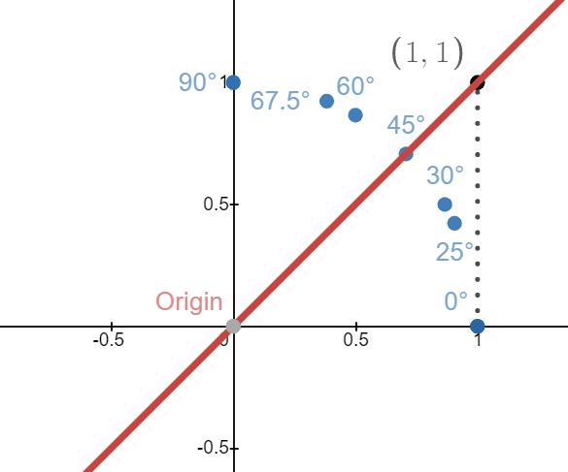

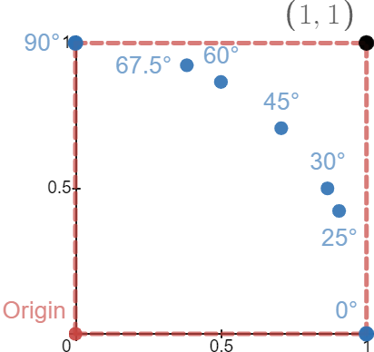
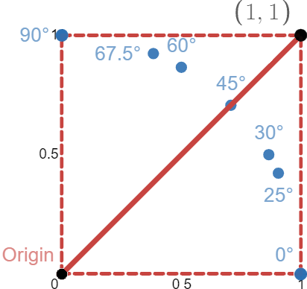

We explained why tan(90°) is undefined and this explains why half a 1² box is a 45° diagonal but does not explain why 12 is not double the angle or a 21 half the angle. Division is linear while differing angles are nonlinear. Direct vs. Indirect.

Take a box that is 1 by 1 and divide along the diagonal corners. The sides are the same length and using Pythagoras or any of its modified versions the diagonal is √2. Its ratios are 1:1:√2 and anytime the box is bigger
we multiply all sides by the ratios to find missing side lengths. It is easier to explain using tangent because it doesn't use hypotenuse like sine or cosine. tan(45°) = 1 because 45° is the height/base so that tan⁻¹(height/base) is tan⁻¹(1/1) … 1/1 = 1.

Tan(45°) = tan(1/1)
Tan(45°/2) does not equal tan⁻¹(1/2)

The calculator takes a height of 1 and divides it by a base of 1 then writes the quotient as a single decimal rather than a ^{y}/_{x} fraction. It gives the result of the slope ^{height}/_{base} as single number then takes that single number and finds the angle that has that ratio and gives the answer as a degree. From now I will refer to height over base as “y/x” with the implication that it is to be taken as the height of a diagonal divided by the base of the square or triangle it is taken from.

Tan = opposite/adjacent. The opposite side of a triangle is the height y. The adjacent is the base x. Tan = ^{y}/_{x}.
This is the same as m = ^{y}/_{x} from y = mx+b. Tangent is the slop of the line of a triangle given by the equation

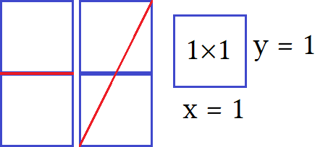
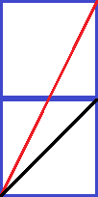
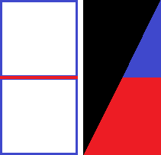

y =(tan)x + b. When you have a ratio it is two numbers that form a quotient. Dividing the height only acts on the height but not the base. These two rectangles have the same area but are cut differently. Each triangle formed will mirror the other. Each is ½ half of the rectangle area. This derives the formula for area of a right triangle ½ bh =A.

The divided squares on the left have the same area as the triangles on the right. Dividing two loosely stacked boxes makes two pairs of matching triangles and trapezoids. The black triangle has the same area as the red and blues shapes. Together the red and blue shapes make a triangle. The base is a trapezoid. Trapezoids are quadrilaterals that have four sides of different lengths except the isosceles trapezoid.

The trapezoid is a truncated triangle. Truncated means the tip has been cut off.
Shapes that have been truncated are also called frustums.

I placed a cut line at the corner of the top and bottom boxes.
The red line has a slope of 2 the black line has a slope of 1.

These are triangles:
RED: 1:2:√5 given by y = 2x y = 2, x =1
BLUE: 1:1:√2 given by y = x y = 1, x =1

The height of the black line is half the height of the red line.
Does dividing the height of a triangle divide the angle? No.

RED: Tan⁻¹(2/1) = Tan(63.43°)
BLUE: Tan⁻¹(1/1) = Tan(45°) 64.43°/2  45°

It only takes one counterexample to disprove a theory for all cases. When a theory seems true for most if not all cases and such a counterexample exists it is called a special case. Specials cases are exceptions that disprove a rule that is true for all other cases. They are the exception to the rule.

Example: “All numbers can to multiplied by another number to produce a higher number”.
Counterexample: Reciprocals and 0.

While generally true 0 is the main exception to this and many other rules. When a special case is invoked it is said to violate said law or rule. When a law is stated is will usually list exceptions to these rules such, “ for all non zero numbers” or “ when x is not zero”. This leads to being rigorous but a bit pedantic. To avoid such stuffiness laws can be broken but only when you are advanced to know what you are doing or else it leads to bad math. We define things for ease of understanding, then become more rigorous, and then finally break rules as needed out of necessity. Breaking to many rules leads to errors and bad logic while blindly adhering them leads to wasting time proving the obvious or being overly fussy about language for fear of misleading the reader. A balance between good legal adherence and natural explanations must be achieved for math to be practical.
When we make exceptions to the rules these are called constraints. A constraint is an additional property that must be followed for the rule to be true in every case. NO EXCEPTIONS ALLOWED! Not allowing x =0 by saying x  0 is a constraint on the relationship.

RED: 1:2:√5 given by y = 2x y = 2, x =1
BLUE: 1:1:√2 given by y = x y = 1, x =1
Rotate red 90°: given by y = ½x y = 2, x = 1

tan⁻¹(1÷2) = tan(26.56°) 45°  26.56°

- A triangle that has slope 2/1 has a 63.43° angle.
- A triangle that has slope 1/1 has a 45° angle.
- A triangle that has slope 1/2 has a 26.56° angle.

y =2x meaning tangent of 2
y =1x meaning tangent of 1
y = 0.5x meaning tangent of 0.5

tangent equals ^{y}/_{x} so you take ^{y}/_{x} and use use it to
convert a slope into an angle degree.
y=mx+b  y= Tanx+b

“” means definition or defined by.
I am using it to separate two equations
so they do not run into one another.

These are the lines given by the equations.
These lines form triangles.

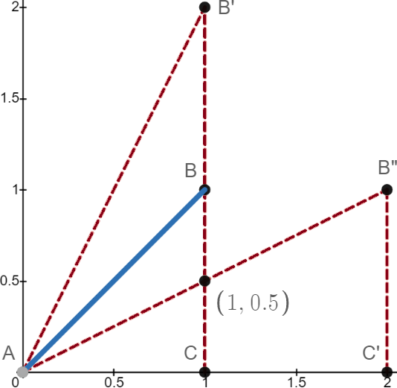

The purple line has an equation x=1. There is no y. It states ALL points on the line have x =1. The solutions to this equation is every point on the grid that has (1,y) where y is any number from –∞ to ∞. The domain of x is 1 {1} The range of y is {–∞,∞}. It can be written differently but this way uses braces to show it is a range or domain instead of a point. Using parentheses might confuse people into thinking it is a point like (-∞,∞). You can use parentheses for domain and range but usually when you are talking only about 1 dimension such as a number line (group theory when you are using the x axis as a number line).

Lines have been cut and the points have been replaced with letters.
△ABC means the triangle with points ABC. It is 45° having slope 1/1.
The other two triangles are the same triangle but reflected over the blue line.

The tall △ is △AB'C. It is 63.43° at the origin and 25.56° at angle B'.
The short △ is △AB”C'. It is 25.56° at the origin and 63.43° at angle B'.
It is saying that the tall triangle is rotated to the short one.
The triangles are “flipped” over the blue line.
There are many ways to name this.
What is happening is that Angle A and angle B are switched.

About notation

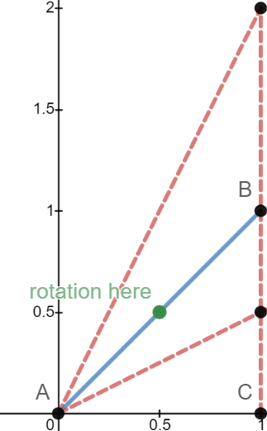

The triangle symbol is used to state a triangle.
I will use it to save space and when referring to a triangles three points.

△ABC This is triangle ABC. It is the beginning triangle with base 1 height 1 and hypotenuse √2.
△AB'C This is the tall dotted red one. It has the same letters as before but B has a prime mark.
It means point B moved from (1,1) to (1,2). When we use the prime notation we are translating a point.
A translation means moving to a new Cartesian coordinate.

Of △AB'C it has the same base as △ABC which is the line AB. Those points are shared so their notation does not change. B' has a notation mark because it started as point B and moved up one unit. A prime mark indicates that a change occurs involving slope. In calculus this is called a derivative.

△AB''C' only shares point A with either △'s so it is the only same point notation. B” is a translation of both B and B' but emphasis is on B”, C' is a translation of C.

△ABC is a right isosceles triangle meaning 45°:45°:90°
△AB'C is a 63.43° right scalene made by taking a 45° and doubling it's height.
△AB”C' is a 26.56° is a right scalene made by rotating flipping △AB'C.

From △ABC to △AB'C we move point B indicating this by writing it as a derivative of B. Technically derivatives should be smaller so we are writing an antiderivative but that makes explanations inconsistent. I will lie here for brevity and tell the truth in calculus. Calculus defines derivatives better so ignore the abuse of “derivative here”.

Counterintuitive Example of Matrix Rotation:

Counterintuitive means against intuition. In math there are two types of answers: the easy one and the correct one. The correct one is always counterintuitive. The easy one is to give an easy explanation that lacks precision.

Here is the truth:

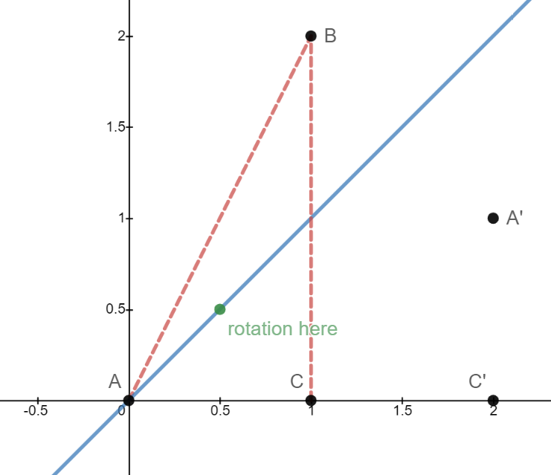
Point A must move to A' (formally called something else that is completely unrelated to this)

Point C must move to point C'

This is a flip and rotate. When two transforms happen it is called a composition (of transformations).

This is hard. This is linear algebra.
It needs matrix notation.

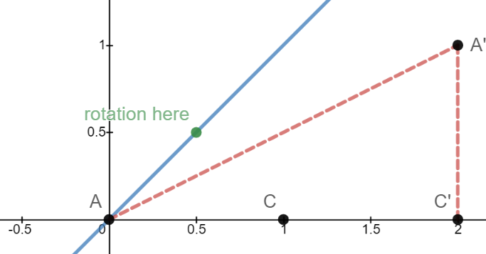

To move this way crosses the 3rd dimension
By moving along the third axis z it is twisted.
Rotate and flip is a “twisting” action.

You need a matrix transformation for this to happen and those are only covered in linear algebra. Instead rotations and shifting an object is taught because it is more intuitive but not what is really happening. It depends on the transformation you are using.

Less hard counter intuitive example:

The line BC has been rotated about point (½,½) placing it on the x axis.
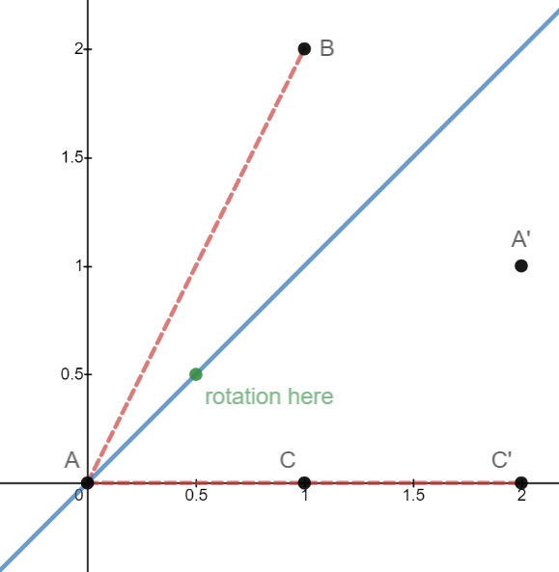

It's old equation was x=1
It new new equation is y = 0
These are perpendicular lines.
Perpendicular lines are always 90° to each other.
Perpendicular lines are called inverses.
This is a special case because we are already dealing with a 90° line so finding the inverse gives a funny equation.

For this case the x and y swapping is what made it an inverse.
We inverted the x and y of the line.
(but then “cheated by shifting it down by 1 unit.”)

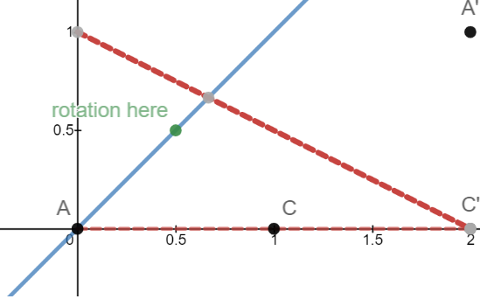
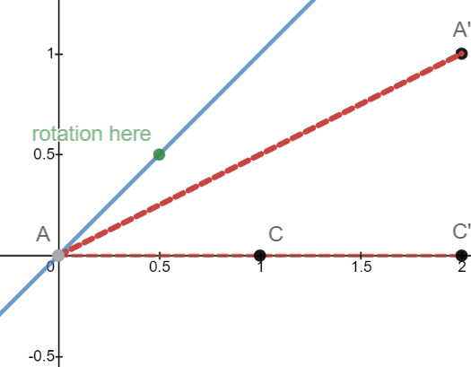

When you rotate a solid object the entire object is rotated also. Treating my “triangle” as separate line functions this rotation shows the 63.43° formed with line AB. The Line AB has to rotate around the point (½,½). This is just a simple rotation. Rotating a single point of ABC around point (½,½) moves the entire angle.

We called it a triangle because we imagined it made one with the x axis as a base. Now we are imagining it makes a triangle with the y axis. The angle needs to be flipped 3 dimensionally over its centerline x=1
to produce the desired result. A 90° rotation around point (½,½) and a horizontal flip over the line x=1 turns ABC into A'BC'. The two transformations are a composition of transformations.

If this were triangle △ABC to △AB'C then it swapped angles A and B. Because this swaps the cosine and the sine the angles have traded places. Other transformations are easier to explain but wrong and therefore inferior.

Inferior rotations (Intuition):

Rotate somehow, flip somehow, then shift somehow and “magically” it is in the correct location. There is no math to this and just guessing and eyeballing it. The inferior uses four transformations of which the two translational shifts can be combined into one. The problem with inferior transformations is that you can not accurately predict where your objects final location will be.

Basic Rotations:

There are rotations for 0,1,2,3,4 and higher dimensions. It is easier to explain 1 dimension then 2 dimension.

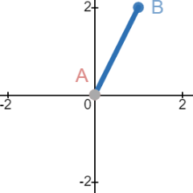
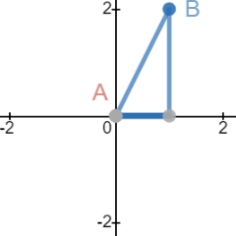
0 = dot
1 = line
2 = area
3 = volume
4 = quaternion
5 = quintion

Slope of 2

y=2x {0 ≤ x ≤ 1}
(1,2) Label B
(0,0) Label A

This is rotated 90° to the right (clockwise) using point (0,0) as rotation point.
It rotates from 1st quadrant into 4th quadrant.

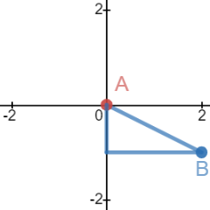
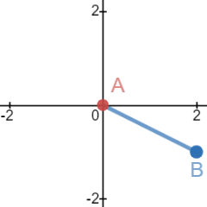
Slope of -0.5

y= -0.5x {0 ≤ x ≤ 1}
(1,-2) Label B
(0,0) Label A

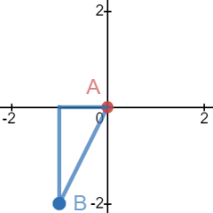
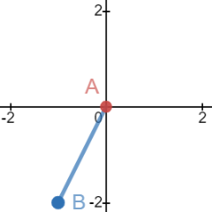
Another 90° rotation

Slope of 2

y= 2x {-1 ≤ x ≤ -2}
(-1,-2) Label B
(0,0) Label A

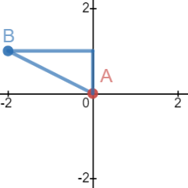
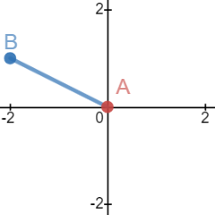
Another 90° rotation

Slope of -0.5

y= -0.5x {-1 ≤ x ≤ -2}
(1,-2) Label B
(0,0) Label A

Slope of 2

y=2x {0 ≤ x ≤ 1}
(1,2) Label B
(0,0) Label A

I four rotations of 90° takes us back to the beginning. Even basic rotations are hard.
It is counter intuitive because without physical objects it is hard to visualize.

Slope two has an angle of 63.43°. Angles like this are irrational. It is difficult to where odd angles should be if trying first subtract the degree to find angle B, then subtract angle B from 360°. Then figure where that new angle is and how it relates to your base and side. It is better to look at the base of the triangle set at 0° then every 90° rotation places the base on an axis alternating from x axis 0°, to y axis ±90°, x axis 180°, then back to 0°.

We want to rotate shapes primarily in the 1st quadrant then later the other four. How do we rotate the shape so that A and B switch places? The easiest way is rotate right 90° then shift up by the length of the base (which is now the side on the -y axis). Single points follow the same rules for rotations. If you have many translated points use either prime or subscript notation.

ABC→ABC'→ABC''→ABC'''
ABC₁, ABC₂, ABC₃, ABC₄,
AB''''''C looks weird and is hard to read so calling it AB₆C looks better.

If y = x then 45° with 1:1:√2 ratio
If y = 2x then 63.43° with 1:2:√5 ratio

y = mx+b
m = tangent = y/x
arctan(y/x) = the degree of ∠A
arctan(2/1) = ∠A = 64.43°
∠b = 90° – 63.43° = 26.56°

A box of length 1 and height 2. Divide diagonally. The diagonal is y = 2x. The diagonal is the hypotenuse of the triangle formed. It's length is given by Pythagoras:

x² + y² = d²
1² + 2² = d²
1 + 4 = d²
5 = d²
√5 = d The diagonal has a length of √5 ie 2.23606

Dividing all sides by the hypotenuse makes all triangles have hypotenuse 1 and fit into the unit circle.
Doing this makes the diagonal a radius in the unit circle with length 1.

Original 1:2:√5
New ¹/_{√5}: ²/_{√5}: 1 ^{√5}/_{√5} as a fraction reduces to 1. The hypotenuse has to be 1 to work in a unit circle.

If necessary rationalize the denominator if it makes it easier.

¹/_{√5}: ²/_{√5}: 1 → ^{√5}/₅: ^{2√5}/₅: 1 The fractions were multiplied by ^{√5}/_{√5} which is 1 so the value is unchanged.

Before we had “One root fifth to two root fifths” which became “root 5 fifths to 2 root 5 fifths”.
It is easier to say “over five” than “root fifths” but this is to illustrate that we have twice as much in the second as the first ie ⅕ to ⅖ is a 1:2 ratio. As long as we have same denominator a ¹/_{x} and ²/_{x} quantity will be a 1:2 ratio. Also √5 is the same as 1∙√5 so 2√5 is twice as much as it since they have the same denominator of 5. x:y:r is the base: height: radius where radius is always 1, x is always cosine, and y is always sine.

When radius touches a point on the unit circle we measure the vertical distance to to the x axis and call it sine. We measure the horizontal distance from the origin to to the sine and call it cosine. We say these are the sine and cosine of angle A. The sine and cosine of ∠A is the vertical and horizontal purple dotted lines. We consider the radius the hypotenuse of an imaginary triangle made by the imaginary lines of the sine and cosine.
Cosine = ^{√5}/₅ Sine = ^{2√5}/₅ with practice these can be done mentally but not required. Use a calculator.

The “unit triangle” has a ratio of ^{√5}/₅ : ^{2√5}/₅ :1

There are four other triangles two of which are important as they contain tangent,cotangent,secant and cosecant while the other two are redundant but already drawn. More triangles can be drawn but that is not the point. At a minimum 5 are drawn with the “unit triangle” being the one targeted. Here are the others:

The red triangle has three sides: radius/tangent/secant.
The radius is the line from point A to point B.
The tangent is from point B to the x axis.
The secant is from point A to the tangent along the x axis.

The equation was y = 2x which means the slope of m = ^{y}/_{x}.
A slope of 2 = ²/₁ so ^{y}/_{x} = ²/₁.
Our tangent = 2.
If radius is 1 and tangent is 2 then our secant is √5.

This is the same ratio as triangle we formed with the diagonal of a 1 by 2 box, both these triangles are congruent they are just rotated into different positions. Tangent is the slope of the radius. Secant is the reciprocal of cosine. ¹/_{sine} = secant.

Using a matrix rotation to map point B to (1,0) would make the base 1 and the height 2 as if we had a box of 1 across, 2 up, and divided with a diagonal of √5 long. The green triangle has sides: radius/cotangent/cosecant.

Cotangent is from point B to the y axis.
Cosecant is from origin to cosecant along the y axis.

Cotangent is the reciprocal of tangent.
Since tangent was ²/₁ cotangent is ½.

Cosecant is the reciprocal of sine.
Since sine was ^{2√5}/₅ cosecant is ⁵/_{2√5} which when rationalized:

(⁵/_{2√5}) ∙ ^{√5}/_{√5} = ^{5√5}/₂∙₅ = ^{√5}/₂. Note the “5's” cancel.

This is a ratio of ½ : 1: ^{√5}/₂ making this triangles sides all have as long as 1:2:√5. It is similar to the bigger red triangle having the same ratios and angles but all sides have been divided by 2. These three triangles (purple,red,green) show the important relations of the trig ratios. The last two triangles are unimportant and will be shown on next page.

△AXY is the biggest triangle.
The base is secant with length √5.
The height is cosecant with length ^{√5}/₂.
The hypotenuse is tangent plus cotangent with length 2.5.
It has ratio of √5: ^{√5}/₂ : 2.5 or about 2.236: 1.118: 2.5.

It is 2.5 times bigger than the unit triangle.
It is √5/2 times bigger than the red triangle.
It is √5 times bigger than the green triangle.

If the unit triangle has a hypotenuse of 1, and this has a hypotenuse of 2.5, then all three sides of this triangle are 2.5 times longer. Using the similar logic we ask what does it take to scale one triangles side to another triangles matching side? These triangles are all similar and have a short side, a medium side, and a long side making them all scalene right triangles. Divide the red/green triangles hypotenuse by the other three triangles hypotenuses:

2.5 ÷ 1 = 2.5 this is how much bigger than the unit triangle.
2.5 ÷ √5 = ^{√5}/₂ this is how much bigger than the red triangle.
2.5 ÷ ^{√5}/₂ = this is how much bigger than the green triangle.
2.5 ÷ ^{4√5}/₅ = ^{5√5}/₈ this is how much bigger than the last triangle which I will show next.

I saved this one for the end because it is unusual. It is a scaled down version of the red/green triangle made by the sine line cutting off the green parts of the red parts. It consists of the x axis/sine/tangent.

The hypotenuse is tangent: 2
The height is the literal sine of angle A: ^{2√5}/₅
The base is the weird part: secant – cosine.

Note that cosine is from (0,0) to sine (the missing part).
Note that secant is from (0,0) to point X.

Secant = √5
cosine = ^{√5}/₅
base = √5 – ^{√5}/₅ = ^{4√5}/₅
The ratios are ^{4√5}/₅ : ^{2√5}/₅ :2

We are subtracting ⅕ of the secant making it 20% shorter.

√5 – ^{√5}/₅ = ^{√5}/₁ – ^{√5}/₅ = √5 ∙ ⅘ = ^{4√5}/₅ because x – ^{x}/₅ = ^{4x}/₅ where x = √5. 5x – x = 4x and ^{4x}/_{5x} = ⅘.

I showed this last triangle because the math was interesting. We are taking five fifths of something and subtracting ⅕ of it so we should have ⅘ of that initial amount. With messy sums you can substitute x for it and then add groups of x to get all the like terms combined. Then as a last step substitute the number back in for x. Or you can get a like denominator and subtract by combining fractions.

√5 – ^{√5}/₅ means that √5 is 5 times bigger than ^{√5}/₅ because ^{√5}/₅ is √5 ÷ 5. Dividing by 5 makes it 5 times smaller.
When you have a number “x” subtracting a fraction of the form x – ^{x}/_{n} you are subtracting ⅟_{n} from x.

⁵/₅x – ⅕x = ⅘x because 100% of x – 20% of x = 80% of x which is ⅘x.

x = ¹/₁x This is saying that we have 100% of x.
^{x}/₅ = ⅕x This is saying x divided by 5 is the same as multiplying x by ⅕. It says we have 20% of x.
⁵/₅ – ⅘ = ⅕ This is saying 100% – 80% = 20%. We note that this implies ^{5x}/₅ – ^{x}/₅ = ^{4x}/₅ = ⅘x.
√5 = x This says we are substituting x for √5 to make the equation less messy.
√5 – ^{√5}/₅ = ^{4√5}/5 We substitute x then plug √5 at the end.

This works because we are combining like groups of x. With fractions all we are doing is combining like fractions. If fractions have the same denominator they are like terms because the denominator gives them the same base raised to the same power. The normal longer way is to find a like denominator to add fractions but the methods above are faster and reflexive. They imply 1 – ⅕ = ⅘ without the need to change ¹/₁ to ⁵/₅ but the answer is obvious. If x – ^{x}/₂ = ^{x}/₂ then we are saying “a number minus half the number always equals the subtrahend”.

97 – ⁹⁷/₂ = ⁹⁷/₂ → 97 – 48.5 = 48.5 because x – ^{x}/₂ = ^{x}/₂ is true for all numbers.

Likewise x – ^{x}/_{n} is the entire value of x minus a fraction of x given by the denominator so that n is the fraction being subtracted from 1.

If x – ^{x}/₂ then you are subtracting half of x from x leaving ½ of x: ^{x}/₂.
If x – ^{x}/₃ then you are subtracting a third of x from x leaving ⅔ of x = ^{2x}/₃
If x – ^{x}/₄ then you are subtracting a fourth of x from x leaving ¾ of x = ^{3x}/₄
If x – ^{x}/₅ then you are subtracting a fifth of x from x leaving ⅘ of x = ^{4x}/₅

You perform the arithmetic by subtracting the fraction from 1 then adding the x or root in the last step.
This eliminates the need to find like denominators of scale “x” to be anything bigger than it already is.
We are adding the coefficients of x first and then write x or our root after to be multiplied by that coefficient.
Coefficients are always the numbers of groups we have and the variable is always the quantity per group.

x – ^{x}/₂ becomes 1 – ½ = ½ ∙x = ^{x}/₂

We took the coefficient of x which is 1 and subtracted the other coefficient ½ to get ½ then wrote
x (or our root) in the numerator. The coefficient is the number of x's we have while x is the quantity of discrete (or continuous) units we have per group. Writing the x or root in the numerator multiples it with the coefficient. Essentially the coefficient is a scalar and x is the thing to be scaled. A scalar is the number of groups we have x is the number per group always.

In early math there is no distinction between 2∙3 and 3∙2 because multiplication is commutative but if asked to write “3 groups of 2” every person surveyed would indicate 2 + 2+ 2 and not 3 + 3 even though algebraically they are both 6. If 3 groups of 2 then 3(2), if 2 groups of 3 then 2(3) where groups are the first number and quantity is given in the parentheses and stated as “3(2) is 3 groups of the quantity 2”.
Parentheses means quantity so it is the quantity and not the groups when referring to the value inside ( ).

x – ^{x}/₃ becomes 1 – ⅓ = ⅓ ∙x = ^{x}/₃
x – ^{x}/₄ becomes 1 – ¼ = ¼ ∙x = ^{x}/₄
x – ^{x}/₅ becomes 1 – ⅕ = ⅕ ∙x = ^{x}/₅

Compare to x² – 0.8x – 0.2 where – 0.8x is the difference of x – (⅕∙x)

(x – ⅕)(x +1)
x² +x – ⅕x – 0.2

We see the coefficient of x is 1 and the coefficient of ⅕x is ⅕. We subtract the coefficients, 1 – 0.2, and then write x after it. We are not really doing anything to x except using it as a variable after of difference. The variable is the quantities of the groups we are summing. Here we have 1 group of x minus a partial group 0.2 from x. Groups and continuous quantities can be partial but discrete quantities must always be whole. Discrete quantities are things like living beings and continuous quantities are things like time or distance.

If tiles come 22 to a box and I have a 61 boxes and 5 loose tiles then I have 61⁵/₂₂(22) tiles where ⁵/₂₂ is five tiles out of a box of 22 and (22) is the quantity per box. Tiles are a discrete quantity because I can not use fractions of a tile added up to make 1 whole tile. Solid items that can not be broken fractionally and then added back are discrete quantities.

61⁵/₂₂(22) = 1347 tiles. If I wrote it as 22(61⁵/₂₂) = 1347 it is algebraically correct but impractical in real world use. I am saying I have 22 boxes of 61 and ⁵/₂₂ tiles per box. Having a ⁵/₂₂ of a tile makes no sense because tiles only function when whole. Further 22 fractional tiles cannot be combined to form the 5 whole tiles implied. Instead of 1347 tiles I would have only 1342 tiles and 22 broken partial tiles . Boxes are the groups which can be fractional but tiles are the discrete quantities that have to be whole integers. As you get further into Algebra you will also learn about non commutative algebras when order matters even more and the discussion of scalars becomes more important.

If I had a class of 21 children of a trip and they had to be put into groups of 2 then I would have 21/2 = 10.5 groups written as 10.5(2) = 21. I can have 10.5 groups of 2 children but I can not have 2(10.5) which is 2 groups of 10.5 children because I put half a kid in two groups. That would break my function because either I killed the kid physically cutting him into two separate parts or I simply lost track of him because his group was not well defined and somebody kidnapped him.

Compare f(x) = ½x where x is number of children and y is number of groups with the alternate expression
f(x) = 2x defining x is as number of groups y as number of children.

f(21) = ½(21) = 10.5 This tells me I have 10 full groups of 2 and 1 partial group of 1.
f(10.5) = 2(10.5) = 21 This tells me that I have 21 kids.
Knowing how many full and partial groups I have seems useful. Knowing I have 21 kids seems like previous knowledge and to get that I would have to know to input 10.5 groups which is counter intuitive. We input x values so that we can track the why values. Tracking the number of groups is useful while tracking number of kids in class isn't because that is foreknown information. A teacher already understand the number of kids enrolled in theory class but is more tasked with grouping them.

In y = mx + b y is the total number, m is the quantity, x is the number of groups, and b is the starting initial value. M is the quantity because it is written in parentheses like y = (²/₁)x + b . My tile example is

1347 = (²²/₁)61⁵/₂₂ + 0 or if I counted the 5 tiles as a starting point then 1347 = (²²/₁)61 + 5.

√5 – ^{√5}/₅ is of the form x – ^{x}/₅ as long as the numerator of the subtrahend has the same value as the minuend.
When the numerator is being scaled it has a different value than the minuend so you can not subtract them as easily but they are still like terms. Even without the same denominator they are like terms because the whole number is over one and we consider a number over one to be easy to subtract from.

If I had a box of tiles and subtracted 5 tiles I could write 1 – ⁵/₂₂ = ¹⁷/₂₂. Convert the minuend to 22/22 and subtract ⁵/₂₂ . Once you have ⁵/₂₂ using it as this form gives the percentage of a box you have and gives the number of tiles you have since the denominator is the same as a full box. Multiply by ²²/₁ to eliminate the denominator to just show 5 as a whole number of tiles.

The normal way:

√5 – ^{√5}/₅ convert to a same denominator
(⁵/₅ ∙√5) – ^{√5}/₅
^{5√5}/₅ – ^{√5}/₅ 5√5 – √5 is the same as saying (√5 +√5 +√5 +√5 +√5 +) – √5 = (√5 +√5 +√5 +√5 +) = 4√5
^{5√5 – √5}/₅

You combine fractions in the numerator like this because the denominators are the same. Numerators are the numbers being operated one. Denominators are not being operated on and only go all for the ride when they as like. When they are like this gives you like terms. You are combining fraction just as you would when you combine coefficients of a variable.

Having the same denominator means you are operating with the same base, the denominator becomes your base and the numerator is how many groups you have of that fractional base. If ³/₂ then you have 3 groups of the quantity ½ with the quantity being the base. If ³/₂ + ⁷/₂ you add the coefficients of ½ which are 3 and 7 to get 10 and then write 10 in the numerator.

³/₂ + ⁷/₂ is 3 groups plus 7 groups equals 10 groups of the quantity ½. Quantities are bases or how many per group, groups are scalars or how much we are scaling up or down. Numbers > 1 scale up, numbers < 1 scale down and 0 cancels the quantity out.
³/₂ + ⁷/₂ is really saying 3(½) + 7(½) = 10 (½) = 5

Since the quantity is fractional it must be continuous. Fractions are in the set of ℚ since they are ratios while integers are in the set ℤ because they are whole. Blackboard ℤ stands for “Zahlen” and includes counting numbers, 0, whole numbers, and the the additive inverses of whole numbers. It does not include decimals.

A fraction is a base system of the denominator it is using.
The integers are whole numbers belonging to the set ℤ.
Integers are written as a ratio as ^{n}/₁. They are divided by 1 to equal themselves thus they are whole numbers.

The rationals are quotients belonging to the set ℚ that are written as ratios of ^{y}/_{x} where x ≠ 0 or 1. ^{n}/₀ is undefined and ^{n}/₁ is already well defined as an integer. Blackboard ℚ stands for “quotient” but is said as the set of rationals.

Counting numbers are positive whole numbers not including 0.
Whole numbers are positive numbers including 0. ^{+n}/₁ this is the same set as ℕ the natural numbers below.
ℕatural numbers are the whole numbers. They are explicit by being defined as including 0 but not negatives.
Integers are whole numbers do not contain fractions or decimals, they can only be written ^{±n}/₁.

Rationals are fractions. They do not include irrational fractions since irrationals only come from square roots like √2 or mathematical constants like π, e, the speed of light, Boltzmann constant, Avogadro number, Reynolds number, the gravitational constant, the golden ratio φ, τ

x – ^{x}/₅
^{5x}/₅ – ^{x}/₅ 5x – x

f(x) = (33⅓)x +33⅓ |  | f(x) = (– 100)x + 300
x | y | x | y
0 | 33⅓ | 0 | 300
1 | 66⅔ | 1 | 200
2 | 100 | 2 | 100

If f(x) = (33⅓)x +33⅓ and f(x)= (– 100)x + 300 then (2,100) is the solution.

(33⅓)x +33⅓ = – 100x + 300

3x= ⅓y
x+x+x = ^{y}/₃

⅓(x) states ⅓ of an unknown quantity with the coefficient being the numbers of groups and x being the amount per group. Written as ⅓x says to add groups then divide total groups by 3 to isolate x to find the amount per group. We are trying to solve x to find how much per group. This is the most common when solving for x.

x(⅓) states unknown coefficients of groups of ⅓. Written as ⅓x is saying coefficients are now the known quantity per group with unknown groups. We are trying to find how many groups we have of a known quantity of ⅓.

3(x) is three groups of an unknown quantity. x+x+x = 3x. We have three groups but of what is not known. Adding the coefficients is counting the number of groups. This provides a method to solve x and ultimately multiply to find total value of 3x = y where y is the total number of units.

x(3) is unsolvable in this form because we know how may per group, (3), but we do not know how many groups of three to count. Compare 3(x) to x(3). Try to answer how many of groups of each there are.

3(x) could be said as, “three groups of x where x is unknown but written as x+x+x = 3x. I have three groups of an unknown quantity. My coefficient is the number of groups and my group is the x enclosed in grouping symbols.”
x(3) could be said as, “I have an unknown number of groups. Each group contains 3 units. I do not know how many groups there are so I do not know how to write as a series of summation.

If I rewrite as 3x then I lose context of the grouping symbols and am now treating both numbers as scalars instead of quantities and so am dealing with a magnitude of unknown proportions. Additionally switching the order to (3)x still implies (3) is a quantity because it is enclosed in the parentheses and parentheses are pronounced as 'the quantity of' when referring to them. Moving forward I have no choice but to remove the parentheses as they hinder completion rather assist it.”

When 33⅓x +33⅓ = – 100x + 300 we are illustrating weird scaling going on. We are say 3(x) = ⅓(y) where three groups of x equals ⅓ of a group of y. 3 and ⅓ are reciprocals of each other. X is ⅑ of y and y is 9 times x. X has to triple (grow by a factor of 3) and y has to shrink by scale factor of ⅓:

either 3∙x or x+x+x x has to grow by either multiplying or adding.
either y ÷ 3 or y – ⅔y. y has to shrink so either divide or subtract.

X is straightforward with needing to start at “x” then “+x+x” resulting in two transactions or operations taking place. These transactions are also called “jumps” and refer to distance moved on the number line.

Y is peculiar in that the fraction ⅓ is given but seems to hide the ⅔ needed to perform the required operation. It literally is stating the value of y without an operation needed to achieve a result. 3(x) can be written as 3x which implies x+x+x or ^{3x}/₁ while ⅓(y) can be written as ⅓y or ^{y}/₃ the first being a scalable quantity and the latter a quotient. How ever it seems less obvious that ⅓y is really y – ⅓y – ⅓y even though it should be. “Three x” means “add x twice times starting from x” or more naively “add x three times” with starting from zero assumed while “one third y” means “subtract a third of y twice from y”.
3x = 300% of x, take x and add 200% once or 100% twice or just calculate 300% of x.
You should have 3 times more.

⅓y = 33⅓% of y, take y and subtract 66⅔% from it once or subtract 33⅓% from it twice or just calculate 33⅓%.
You should have ⅓ total.

Tangents, Secants, Chords, Diameters

A circle is made of a curved line that is drawn 360° around a center point called a focus. The curved line is made of infinite points with no space between them along the curved path so that the line is continuous. A tangent line touches only one point of a circle. A secant or chord touches two points. A tangent is a special case of secants.

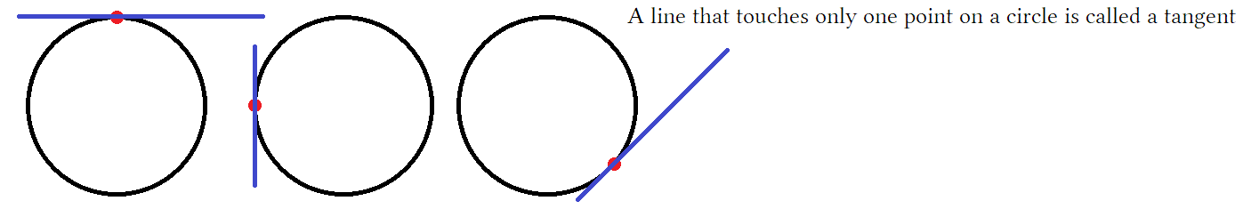
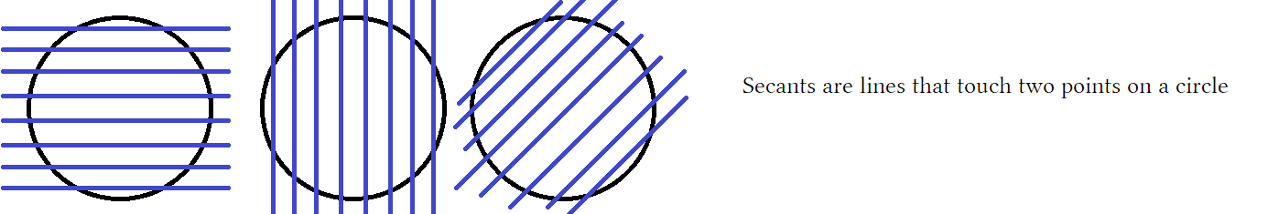

As you can see lines can be horizontal, vertical or tilted. When a secant does not extend beyond the circle it can be used to measure the distance between two points. This is a special case of the secant called a chord. Secants and chords are the same except secants extend outside the circle while chords don't.

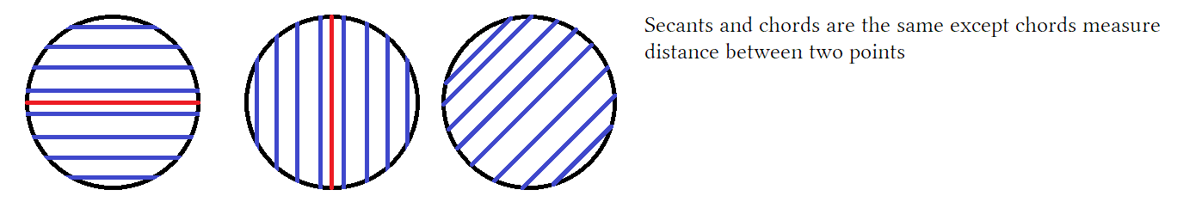

- Lines that touch two points on a circle are called either secants, chords, or diameters.
- A secant is a line that extends forever past the circle.
- A chord doesn't extend past the circle as a special case of secants used to measure distance between points.
- A diameter is a special case of chords. They only measure the width of the circle nothing else.

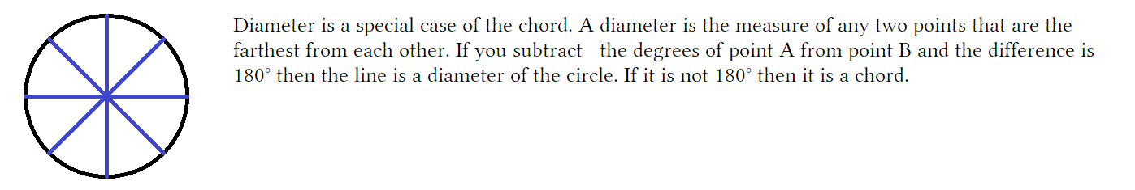
About lines of a circle:

They can be drawn at any angle since rotating the circle will tilt previously horizontal line. Either the line was drawn horizontally and then the circle was rotated with the line along with it or the line was just drawn at a tilt. Either way what the line represents, its name, and its measure is unchanged.

About diameters:

- We say there are 360° in a circle.
- If we consider fractions of a degree we can get infinite points on the circle.
- That is why we say a circle is composed of infinite points, and also infinite degrees that max out at 360°.
- There are 360 whole degrees but we could have 1°, 1.1°, 1.01° etc leading to infinite degrees.
- Usually the diameter is drawn on the unit circle from 0° to 180°, note 180° – 0° = 180°.
- The purpose of the diameter is to measure the width of a circle, it is done in the middle because base = 0.
- Diameters can be drawn between any two points with a difference of 180° such as 90° and 270°
- On a compass we have labeled the points 0° to 359°, this is 360° as 0° and 360° share same point.
- We can make 180 diameters as follows: 0° to 180°, 0° to 180°, 1° to 181°, 2° to 182° … 179° to 359°.
- Since 360/2 = 180, this will make 180 diameters or pairs of points.
- The pairs 0:180 and 180:360 are the same line so we do not count 180:360 as doing so would give us 181.
- If we used fractional degrees we would follow the same logic and give infinitely many diameters.

Measuring the base of a square with a width of 10 inches easy. First to measure distance we need two points A and B, with A as the starting point and B as the ending point. We place a ruler at the base and start at the left bottom corner (point A) as 0 inches then stop at the bottom right corner (point B) as 10 inches. If we drew a circle inside this square it would have a width of 10 inches as well as given by the box we drew around it but trying to find it's width by measuring the base would be difficult.

The circle would touch the box at four points each at the 5 inches mark. If we focus on the base and try to measure we find that the starting point of the base is 5” and the ending point is 5”. This gives us 5” – 5” = 0”. This says that either the base is zero units long or that it is non-existent. This is why diameter is usually done horizontally at the middle of the circle. It is The widest horizontal points to find width since we cannot measure base like we would with a square.

A diameter gives us this equation: Point B – Point A = 180°: If θ₂° – θ₁° = 180° the line is the width of the circle.

180° – 0° = 180° 194° – 14° = 180° 208° – 28° = 180° 225° – 45° = 180°
181° – 1° = 180° 195° – 15° = 180° 209° – 29° = 180° 270° – 90° = 180°
182° – 2° = 180° 196° – 16° = 180° 210° – 30° = 180° 315° – 135° = 180°
183° – 3° = 180° 197° – 17° = 180° 211° – 31° = 180°
184° – 4° = 180° 198° – 18° = 180° 212° – 32° = 180°
185° – 5° = 180° 199° – 19° = 180° 213° – 33° = 180°
186° – 6° = 180° 200° – 20° = 180° 214° – 34° = 180°
187° – 7° = 180° 201° – 21° = 180° 215° – 35° = 180°
188° – 8° = 180° 202° – 22° = 180° 216° – 36° = 180°
189° – 9° = 180° 203° – 23° = 180° 217° – 37° = 180°
190° – 10° = 180° 204° – 24° = 180° 218° – 38° = 180°
191° – 11° = 180° 205° – 25° = 180° 219° – 39° = 180°
192° – 12° = 180° 206° – 26° = 180° 220° – 40° = 180°
193° – 13° = 180° 207° – 27° = 180° 221° – 41° = 180°
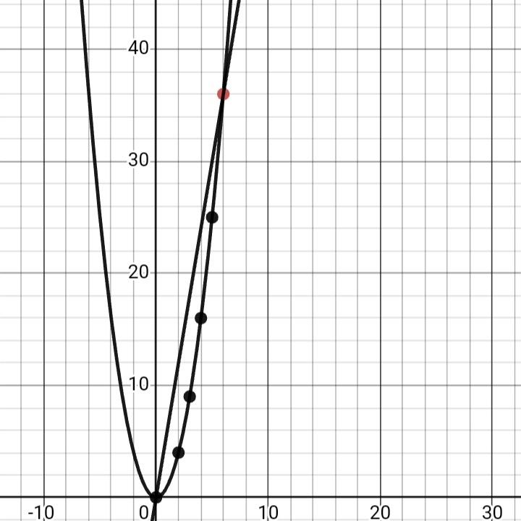

The function f(x) = x² is graphed. We have points A:(0,0), B:(1,1), C:(2,4), D:(3,9), E:(4,16), F:(5,25), and G:(6,36).
If we draw a line through two of these points we make a secant. The secant cuts off a portion of the parabola. This portion has measurable area. The angle of the line is the slope through these two points. We make these secants to represent slope:

- AG Where M = 36 – 0/6 – 0 = 6
- BG M = 36 – 1/6 – 1 = 7
- CG M = 36 – 4/6 – 2 = 8
- DG M = 36 – 9/6 – 3 = 9
- EG M = 36 – 16/6 – 4 = 10
- FG M = 36 – 25/6 – 5 = 11
- GG M = 36 – 36/6 – 6 = 0/0 indeterminate

All of these lines are secants except GG which is actually a tangent. To have a secant it needs to pass through two points. Drawing a line tangent to point G only passes through point G of the graph. The secants are easy to find slope using M = ^{(y2 – y1)}/_{(x2 – x1)} because we have two points. With the line through point G we only have one point to use for inputs, using point G inputs twice gives an indeterminate form of ⁰/₀.

Since we only have that points co-ordinates we tried simply using them twice.
This fails to give slope at that point.

On the graph We have points plotted for all the integers and their squares. We want to find the line tangent to point G so that we know the slope, or acceleration at that singular point. Using slope formula only gives us slope between two points. Since we need two points to find slope here is our strategy:

- Decide what point you want to find slope for. Make this point fixed and immovable, we chose (6,36).
- Pick a second point that is easy to calculate, we chose (0,0).
- We will make a series of slopes where The first point never changes but the second one does.
- We will go from (6,36) to (0,0); (6,36) to (1,1); (6,36) to (2,4); (3,9) to (4,16); etc.
- Since (6,36) is our fixed point it is used in every calculation for slope.

We have two points, a fixed and a movable, Where we continue to move the location of the second point closer so that eventually both point are actually the same one. They will be on top of each other. The closer the second point is to (6,36) the better approximation for slope at (6,36) will be. When we have the second point equal (6,36) we will have an exact line for slope at exactly that single point. Since slope formula requires two separate points we can cheat a little by picking a point that is on the parabola and very close to (6,36) such as (5.999999,36.999988).

By moving the second point closer and closer to our target point we are performing a type of limiting process.
A limit is the height of a point that we are trying measure, in particular a point that has a hole, gap, or other domain error such that we can never get a suitable y for an input of x.

The secant has two points the tangent has one point when we reach the tangent we are said to have found the limit for a single point. To reach a tangent we have to move the dots so they overlap completely.

