Basic Trigonometry

Trigonometry is the study of triangles and their measure. The clues are found in its etymology. Trigon-o-metry comes from Greek words. The word poly-gon means many-sides. We can say pentagon, hexagon, octagon and so on. They are made from Latin and Greek prefixes and suffices. A triangle can be called a tri-gon or 3-gon. Trigon means a 3 sided polygon. Triangle is the Latin word and trigon is the Greek. Metry means measure. Trigonometry then is “measure-of-triangles”.
General facts:

- All triangles have 180°.
- Triangles are classified by their sides and angles.
- A triangle has three sides and three angles.
- An angle can be θ<90°, θ = 90°, or θ>90°.
- If θ < 90° then the angle is acute.
- If θ = 90° then the angle is right.
- If θ > 90° then the angle is obtuse.
- If all sides match it is equilateral.
- If 2 matching sides isosceles.
- If all different lengths scalene.
- For all △ including oblique and right the hypotenuse is always opposite the largest angle.
- Largest ∠ hypotenuse, 2nd largest ∠ opposite longest leg, smallest ∠ opposite shortest leg.

The triangle angle sum formula states: the sum of the interior angles of all triangles is 180°.

This is based off the Angle sum formula from geometry that S = (n – 1)∙180°. For triangles 180° = (3 – 2)∙180°.
If a triangle is obtuse then the other angles are acute. If obtuse then 180° – (90°+x°) = (90°+y°). Subtracting more than 90° from 180° leaves less than 90° for the other two angles and so they are both acute. I have three angles and I will call them A, B, and C. If C is the obtuse angle then 180° – ∠C = (90°–x°). If C = 91° then I have only 89° left for my other two angles. If angles are integers what could the other two angles be? An angle can not be 0° because then it wouldn't exist and we would have a degenerative triangle with only 2 sides. The smallest integer for an angle would be 1°. We can have A° or B° be any integer from 1-88: 1+88 = 89, 2+87 = 89 , 3+86 = 89 … 88+1 = 89. This looks to be 88 different combinations since A can be 88 different numbers with B as the complementary number to sum to 89°.

There are three types of triangles based on angles:

a) right triangle that has 1 ∠90°.
b) acute triangle where all ∠ are less than 90°. An acute triangle has 3 acute ∠.
c) obtuse triangle that has 1 ∠ greater than 90°. An obtuse triangle has 1 obtuse ∠ and 2 acute ∠.

There are other names for triangles. If a triangle is not a right triangle it is an oblique triangle. All triangles are either oblique or right. There are only two types of oblique triangles and we already discussed them, they are acute and obtuse.

Acute: An oblique triangle with all angles less than 90°
Obtuse: An oblique triangle with 1 angle larger than 90° and 2 acute angles whose sum is 180° – (largest angle).
Right: A right triangle with 1 ∠90° and 2 acute angles whose sum is 90°.
There are three types of triangles based on sides:

If all three sides are the same length it is called an equilateral triangle because side a = side b = side c. Equilateral triangles have three angles that are all 60° because 180°÷3=60°. If a triangle has two sides that are the same length then it is an isosceles triangle. Isosceles means “equal scale” in Greek. If none of the sides are equal then it is called scalene. Scalene has the root word scale. All sides have different scaled lengths. To scale means to multiply or stretch something to make it longer. A multiplier called a scalar is used to make this happen.

All equilateral triangles have 60° for all angles so they can not be right nor obtuse triangles. Since they are non-right triangles they are all oblique triangles. Since all sides have the same length they are never isosceles nor scalene.

A right triangle can be isosceles or scalene but never equilateral because it has at least two different angle measures with one being 90°. We have two types of right triangles: Right isosceles and right scalene.

Equilateral: Triangles with side ratios of 1:1:1 and angle ratios of 60°:60°:60° are only acute equilateral.
Isosceles: You can have acute isosceles, right isosceles, and obtuse isosceles.
Scalene: You can have acute scalene, right scalene, and obtuse scalene.

There are 3 classifications based on side and 3 classifications based on angle. You can make compound statements about a triangle when appropriate by stating one of {acute,right,obtuse} followed by one of {equilateral, isosceles, scalene,}.

The most basic definition of a scalar:

In general a scalar is constant. Deeper it is a constant that is a factor. If two factors produce a product then each of those factors is a scalar. If we denote one of the factors as a base being scaled by a random number then we write a variable to represent the scalar. In formulas we may state a certain number as a constant and the other as a scalar. If circumference is πd the diameter is a scalar that varies depending on what circle we have. 1π, 2π, 3π, etc all give different circumference. In the formula the coefficient in front of π is a variable but becomes a constant when we actually work the problem. If we use a scalar to modify a base then we can write a series such as 0,6,12,18,24,30... where we have base 6 and a common difference of 6. We can write the series as 0∙6, 1∙6, 2∙6, 3∙6, 4∙6, 5∙6... where the coefficients of 6 are scalars. The formula may be written with the coefficient as a variable but when we substitute a constant we call that factor the scalar. The scalar is the factor that changes based on how much we are scaling our base. This definition is true for all scalars in all conditions. This is generalized for all cases (no bias).

Advanced definition of a scalar: A scalar is the coefficient of a scaled vector or other entity. This is biased towards special cases of vector calculus where all sides of a triangle are vectors each with their own length.
In trig we will prove similarity using scalars such as 3:4:5  6:8:10.

Visual Aids

We give side lengths as ratios so sidea:sideb:sidec = x:y:z. The variables stand for the length of the side, when you have a triangle write the numbers you know and solve for the variables you don't. The equilateral triangle has side ratios 1:1:1 regardless of what the side length is. Trigonometry deals with ratios. We will use Greek methods to demonstration ratios then move up to modern methods.

If sides are x:x:x then the are all the same, this is an equilateral △.
If they are x:x:y then two are the same, this is an isosceles △.
If they are x:y:z then they all different, this is a scalene △.

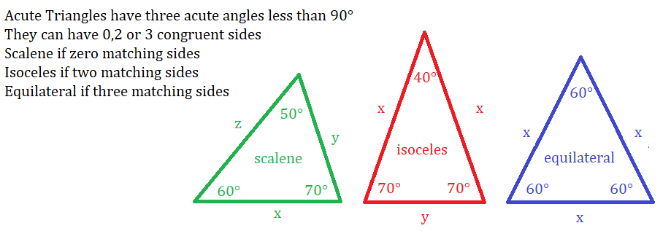

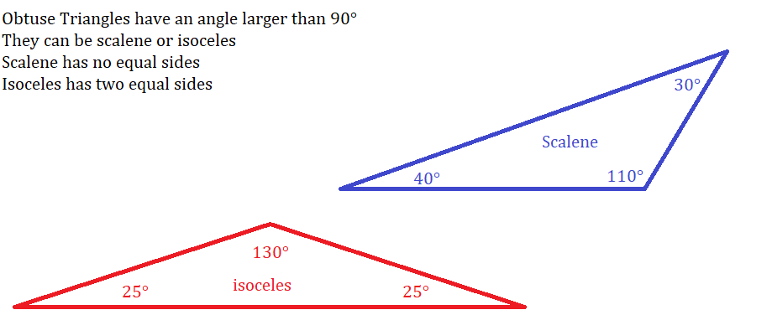

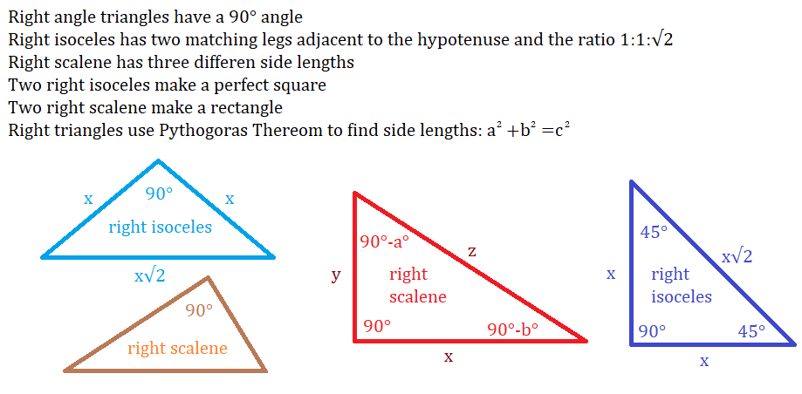

All △ are the result of bisecting a quadrilateral. This could be an oblique △.
All right scalene △ are the result of bisecting a rectangle along its diagonal.
All right isosceles are the result of bisecting a square along its diagonal. There is only 1 right isosceles: 45-45-90.

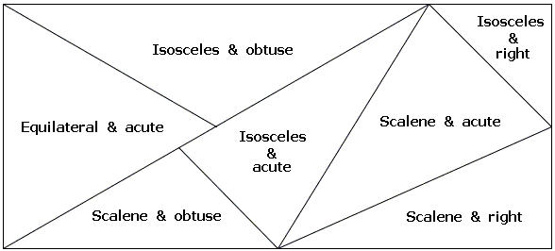
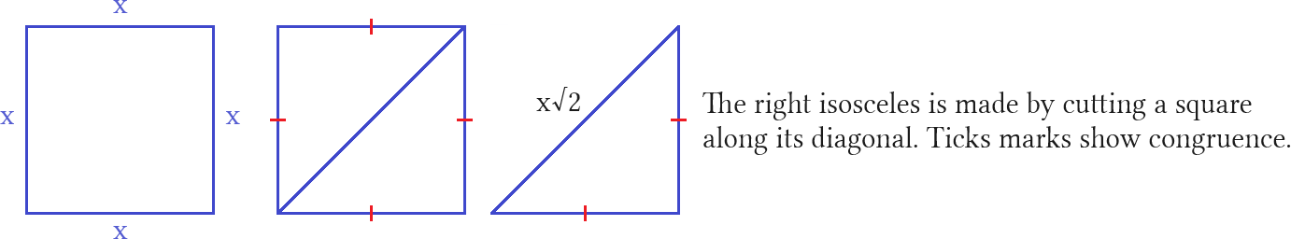

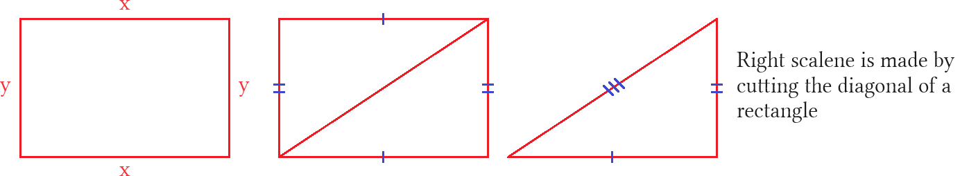

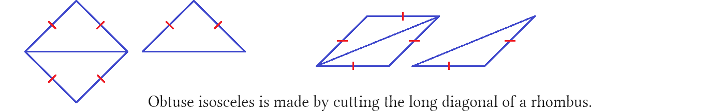

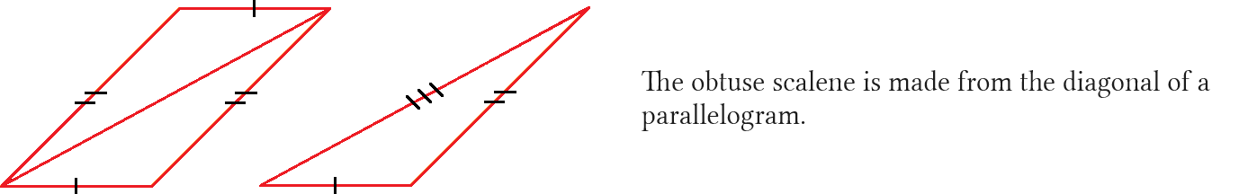

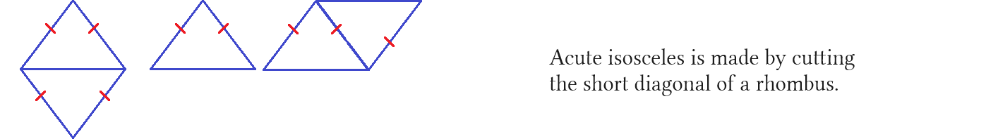
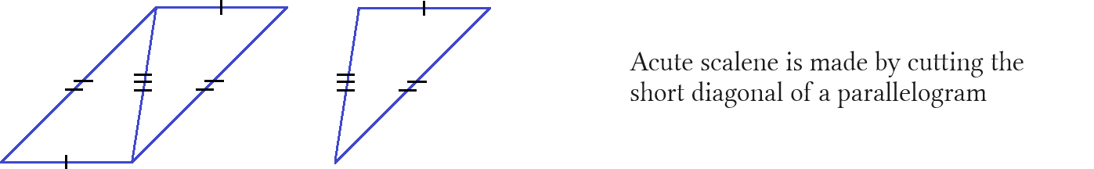

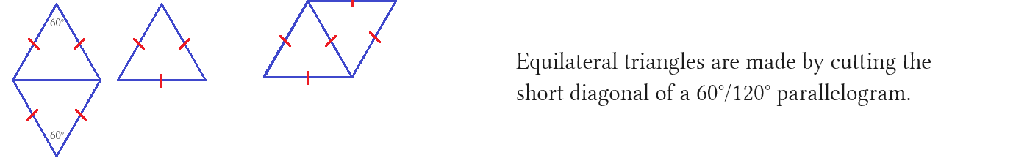

- Right isosceles 45°: Diagonal of a square.
- Right scalene: Diagonal of a rectangle.
- Obtuse isosceles: Long diagonal of a rhombus.
- Obtuse scalene: Long diagonal of a parallelogram.
- Acute isosceles: Short diagonal of a rhombus.
- Acute scalene: Short diagonal of a parallelogram.
- Acute equilateral 60°: Short diagonal of a 60/120 rhombus.

These are literally shapes not numbers. They have symmetry that forms fundamental relationships. Fundamental means basic as in very beginning core understanding. In math these are the most important things to learn first. We have three types of angles. Each can be isosceles or scalene. Any type of triangle either two sides match or none match. Except for equilateral. It is unique. It has the most symmetry. It is the most perfect triangle.

Notice Obtuse isosceles and scalene. Obtuse △ come from long diagonals.
Notice Acute isosceles and scalene. Acute △ come from short diagonals.
The big angles come from big diagonals, the small angles come from small diagonals.

Notice Obtuse and Acute isosceles. Isosceles come from diagonals of a rhombus.
Cut the long diagonal and get 2 obtuse △, cut the short and get 2 acute △.

Notice Obtuse scalene and Acute isosceles. Isosceles come from diagonals of a parallelogram.
Cut the long diagonal and get 2 obtuse △, cut the short and get 2 acute △.

The previous page the isosceles triangles are blue the scalene are red. The if two sides match they have matching tick marks. The symbols used are so far were ∠ for angle, △ for triangle,  for similarity or proportional. If something is a paragraph read it at a normal pace. If something is short sentences spaced out pause and take in what it is saying and refer to pictures or equations until you are ready to move on. This page I really emphasis pausing on the Greek methods of dividing quadrilaterals to create one of the 7 triangles. Each type can be isosceles of scalene. This gives 6 triangles. The seventh triangle is the equilateral. All since equilaterals have all 60° angles it is redundant to say 60° equilateral. Since 60° is less than 90° it is redundant to say acute equilateral. Saying 60° acute equilateral is doubly redundant. Saying equilateral states those other things through common sense. The black and white rectangle will all 7 △'s is a mess. It is hard to construct and I found on the internet. My guess is the person is showing what they know instead of showing you how to make the triangles a hard proof that is left to the reader as an exercise. I don't teach that way. It is too complicated. Greeks never liked anything complicated. I show triangle constructions that are easy to remember for a life time. They are color coded to speed learning.
Constructing a 3-4-5 Triangle

A review on how to construct a triangle is appropriate.

We can create a triangle using graphing from algebra. Starting with a the real plane we need to make three points. Any three points in the plane makes a triangle once connected with straight lines. We place points
at (0,0); (3,0); and (3,4) . Points use capital letters. We label the points A:C:B then draw line segments.
This gives 3 lines as sides of a triangle. We name the lines as AC; BC; AB. We have:

AC from Point A (0,0) to Point C (3,0). From origin move right 3 units.
BC from Point C (3,0) to Point B (3,4). From Point C move up 4 units.
AB from Point A (0,0) to Point C (3,0). From Point B move left 3 units and down 4 units.

From Point B to Point A is a tilted line. This line is the diagonal of a 3x4 rectangle. It crosses two dimensions.
The other two lines cross one dimension each. These two lines form a 90° angle at Point C.

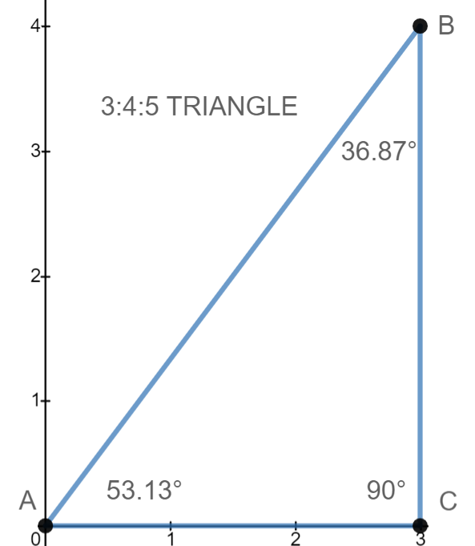

We know the base = 3 and height = 4. We do not know the hypotenuse. To find we use Pythagoras Formula.

a²+b² = c²
4² + 3² = c²
16+9 = c²
25 = c²
5 = c The hypotenuse is 5.

We have a special triangle called a Pythagorean triple. A triple is a triangle whose sides are all integers. Many exist but they are still rare. The 4:3:5 triangle is often used as a teaching aid in trigonometry. We can learn many techniques using this triangle. We will refer to it often.
345 Triangle

We label points outside the triangle using ABC. We label angles inside the triangle using Greek letters for abc which are alpha α, beta ß, and gamma Γ, When we have a right triangle one of the angles is 90°. Instead of writing 90° we draw a small square in the corner. A square has 90° for all its angles so a square is a symbol for a ∠90°. Uppercase gamma looks like a square when touching the sides of the 90° corner so we use Γ for 90°. Gamma is the third letter of the Greek alphabet so it is equivalent to our third letter C. In fact we get the word alphabet from alpha and beta. If we have an oblique triangle then we use lowercase gamma γ for ∠C. If 90° we use Γ because it looks like a square, if not 90° then we use γ. Basic trig uses ABC while advanced physics uses the Greek letters. This is a beginning trig lesson so we will only use English letters.

This triangle has base = 3, height = 4, and a hypotenuse = 5. We write this as base:height:hypotenuse as 3:4:5. Writing numbers with colons is called ratio notation. This is the ratio of the three side lengths. Some ratios compare only two numbers. This ratio compares three. Other ratios compare any amount of numbers.

A triangle has 6 pieces of information called data which are 3 sides and three angles. We know all the sides and that ∠C is 90° because when we made the triangle we made a 90° rotation from point C to point B. What we don't know is the measure of ∠A and ∠B. We use inverse trig ratios to find these missing angles.

To find missing sides we use the trig ratios sine, cosine, and tangent.
To find missing angles we use the inverse functions of sine, cosine, and tangent.

A trig function needs a known angle to work. You create a function where the angle in the input and the missing side is the output.

Labeling a △ sides and angles

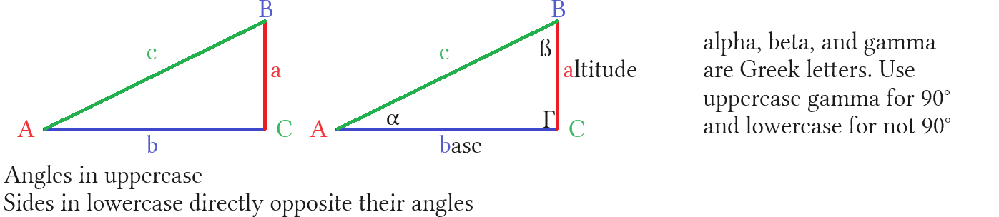

A triangle can be labeled however you want. This is the most common way for right triangles. If a triangle is oblique then we like to rotate triangle so angle c is at the top. This is done for special purposes not for aesthetics. We apply formulas like law of cosines with ∠c at top. A triangle has angles ABC which in Greek are αßΓ. Notice gamma looks like a square. This symbolizes a square angle. Use uppercase for 90° and lowercase for oblique angles. Using these Greek letters prevents mistaking them for other variables. We use θ° (theta degrees) as a Greek letter to represent unknown degrees. We use θrad for missing angles in radians.

- Use a calculator or paper and graph a line with positive slope that passes through the origin.
- Find a point on the line and draw a line down to the x axis. The angle formed at the x axis is 90°.
- The function and vertical line make a triangle with the x axis.
- The point (0,0) is taken to be ∠A.
- The point (x,0) is where the vertical line meets x axis is ∠C.
- ∠B is (x,y) where vertical line meets the function.

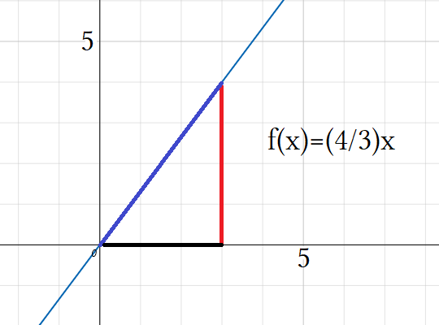
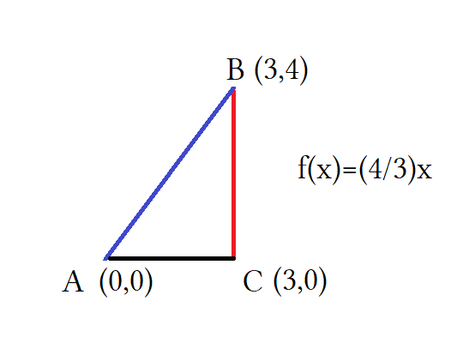

We can graph triangles and list their angles by point coordinates. Put ∠A as Point A at (0,0). Put ∠B as Point B at the (x,y). Put ∠C as Point C at (x,0). A and C are endpoints of the base of the △. A and B are endpoints of the hypotenuse. Point B is special because its coordinates give the base and height of the triangle.

In the unit circle this would be the cosine and sine of ∠A. The sides of a △ are given by three parameters of base:height:hypotenuse. This is a 3:4:5 triangle. The distance from point A to C is 3 units, B to C 4 units. This is known by looking at the coordinates. Base is given by x_{c} – x_{a} = 3, height is given by y_{b} – y_{c} = 4. Subscripts denote the angle to use for the component. For angles we have ∠A: (0,0) ∠B: (3,4) ∠C: (3,0). x_{c} – x_{a} = 3 because x_{c} uses the x value from ∠C. The other variables follow the same logic.
The triangle is formed by three distinct points on the plane. We will explore methods for choosing where these points should be. The method here relied on the fact ∠A is placed at the origin. We can use origin at the first point, slope for the second point where ⁴/₃ = (3,4), and (3,0) will be a like from ∠B to the x-axis. This is very popular method.

For Pythagoras we can use √a²+b² = c as a shortcut: √a²+b² =c...√3²+4² = 5

We label right triangles mostly this way:

- ∠A is our targeted angle or alpha denoted as α. It is to be graphed at the origin (0,0)
- ∠B is the complimentary angle to α. This is the beta denoted as ß. It is graphed at the top (x,y).
- ∠C is our 90° angle. This is gamma denoted as Γ. It is graphed at (x,0).

The origin of the xy plane is the point (0,0). In graphing this point is labeled o for origin. For triangles we
replace o with A and use a point A as our vertex for ∠A. This is convenient because it makes measuring the base easy. The base is given by the distance from point A to point C. Point C is located at (x,0) which means the x is a variable and 0 is a height of 0. A height of 0 means it is on the x axis. Both A and C have a height of 0 so the distance between them is a horizontal line segment. We can change the distance of this segment but not it's height. Changing the height would make the base sloped like the hypotenuse and we do not want that.

For basic trig we concern ourselves with solving right triangles because they are easier. If we do not have a right triangle we draw a sine line inside the △ to bisect it into two right triangles. Right triangles are easier to solve.

Sohcahtoa

The main tool of trigonometry is the trig functions. Together they are taught using the mnemonic Sohcahtoa. A mnemonic is a memory aid. The mnemonic for order of operations is Pemdas. Pemdas itself is an acronym where every letter stands for a word: parentheses-exponents-multiplication-division-addition-subtraction. It can be remembered as “ Please excuse My Dear Aunt Sally”.

Sohcahtoa is three formulas. The formulas themselves are called the trig ratios or trig functions. We have two definitions; first as ratios, second as functions. The ratios are used as equations in a function. Remember that a function is a set of operations to achieve an answer using an input and output. The trig functions use degrees as inputs and gives ratios as outputs. Inverse functions use ratios from dividing two sides of the △ as an input, and give the angle between those two sides as an output. In other words we have a function that inputs x and outputs y. We will be measuring triangles to find missing sides and angles using these functions. The three ratios are sine, cosine, and tangent.

Soh stands for sine = opposite/hypotenuse. We write the formula as S = o/h
Cah stands for cosine = adjacent/hypotenuse. We write the formula as C = a/h
Toa stands for tangent = opposite/adjacent. We write the formula as T = o/a

Then SohCahToa is S=º/_{h}, C = ª/_{h}, T = º/_{a}.

A triangle has three angles. Each angle has a sine, a cosine, and a tangent. Each angle can be calculated using these three ratios. Then each triangle has 9 potential equations. We can find the ratio of each angle:

The sine of ∠A= ^{O}/_{H} The sine of ∠B = ^{O}/_{H} The sine of ∠C = ^{O}/_{H}
The cosine of ∠A = ^{A}/_{H} The cosine of ∠B = ^{A}/_{H} The cosine of ∠C = ^{A}/_{H}
The tangent of ∠A = ^{O}/_{A} The tangent of ∠B = ^{O}/_{A} The tangent of ∠C = ^{O}/_{A}

So far we have 9 equations for one triangle. We will only use 1 equation per triangle. This just says we have many options for which ratio we use. Which ratio we use will depend on what information is missing that we are solving for.

f(x) = y This says we have a function.
f(put degrees in here) = put a ratio here This says x = θ° and y = side÷side or ^{side}/_{side}.
f(θ°) = side/side Trig ratios are a side divided by a side
f(θ°) = ratio Trig functions input degrees and output ratios.
f^{–1}(ratio) = θ° Trig inverses input ratio and output degrees.
Special Triangle 30-60-90

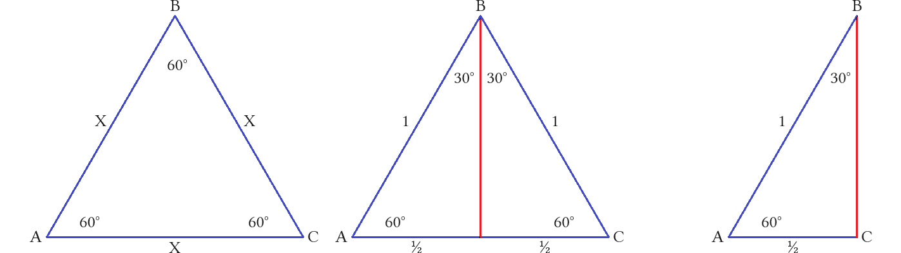

The 30°:60°:90° is a special triangle in the unit circle. Of a equilateral there is 3 equal angles and three equal sides. Each angle is 180° ÷ 3 = 60°. If we bisect ∠B two identical 30°:60°:90° triangles are formed. The tilted side is still 1 and the base is ½ since it was divided equally in the middle. What is not known is the height. We can use trig ratios to find the missing height of the 30°:60° right triangle.

We consider sine the height of an angle (not the triangle itself).
We consider cosine the base of an angle (not the triangle itself).
We consider tangent the slope of an angle (not the triangle itself).

Using Sine of ∠A: Using Cosine of ∠B: Using Tangent ∠A or ∠B:

∠A = 60° ∠B = 30° ∠A = 60° ∠B = 30°

sine (θ°) = opposite/hypotenuse cosine(θ°) = adjacent/hypotenuse tangent(θ°) = opposite/adjacent
sine(∠A) = opp/hyp cos(∠B) = adj/hyp tan(∠A) = opp/adj
sin(60°) = x/1 cos(30°) = x/1 tan(60°) = x/½
√3/2 = x √3/2 = x ½tan(60°) = x
Side a is ^{√3}/₂ units long. Side a is ^{√3}/₂ units long. Side a is ^{√3}/₂ units long.

tangent(θ°) = opposite/adjacent
tan(∠B) = opp/adj
tan(30°) = ½x
xtan(30°) = ½
x = ½/tan(30°)
Side a is ^{√3}/₂ units long.

We can check this is correct height using Pythagoras formula:

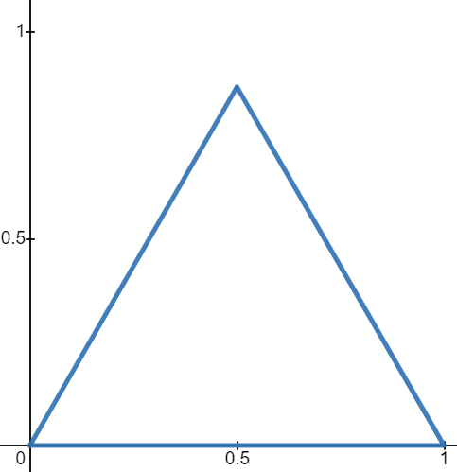
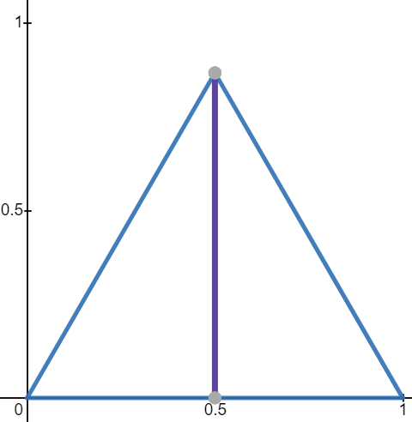
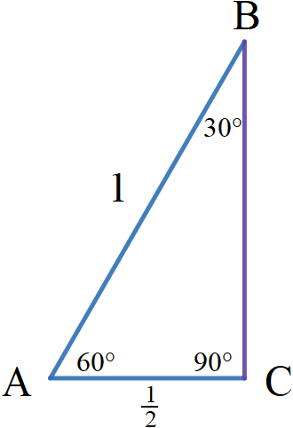
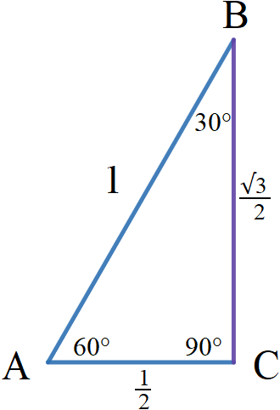

Each angle is 60°. I drew this to be 1 unit long for all sides. The base is 1 but we see the height is less than 1.
How can we find the height? Lets use the technique of dropping a perpendicular line. Dropping a perpendicular line is also called dropping a sine or sine line. A perpendicular line crosses the base making a 90° angle.

The perpendicular line evenly divides the equilateral triangle. This splits the base from 1 to ½ + ½ and the top angle from 60° to 30° on either side. This forms two congruent 30°/60°/90° triangles. The 90° angle is formed with the base. The new angles add to 180°. We know all the angles and two sides. We are only missing the height. We can use Pythagoras to find the missing height.

The Pythagoras Theorem or Pythagoras formula leverages symmetry to find missing sides. It states: a² + b² = c² where a and b are legs are c is the hypotenuse.

a = height = I don't know
b = base = ½
c = hypotenuse = 1

(½)² + b² = 1²
(½ ∙ ½) + b² = 1
¼ + b² = 1
b² = 1 – ¼
b² = ¾ (also 0.75)
b = √¾
b = √3/2

Is √3/2 really the height? The number looks weird so lets check with Pythagoras:

(½)² +(√3/2)² = 1²
(½ ∙ ½) + (√3/2 ∙√3/2) = 1
¼ + ¾ = 1
1 = 1 okay good it checks

That is how we find a 30°-60°-90° triangle. The triangle is not some random thing but a very fundamental part of trigonometry. We learn special triangles, master them and the techniques associated with them, them work on harder triangles as our skill improves. Lets find as much info as we can about this triangle. What are its ratios?
Let's be greedy and sleuth as much as we can about this new triangle we discovered!

For ∠A I expect the values to be inverted (swapped) with ∠B:

sin(60°) = √3/2 approx. 0.866025 This is the height
cos(60°) = ½ exactly 0.5 This is the base
tan(60°) = √3 approx. 1.7320 This is the slope

For ∠B I expect the values to be inverted (swapped) with ∠A:

sin(30°) = ½ This is the height
cos(30°) = √3/2 This is the base
tan(30°) = 1/√3 = √3/3 approx. .5774 This is the slope

For trig rationalize the denominator. In calculus we actually go the other way and rationalize the numerator!
Our forecast proved true. The values are inverted if we take a ratio to be of the form y/x where y is the output and x is the input then inverting means that we are swapping places of y and x. The swapped values are the reciprocals of the former ratios. We can therefore define an inverse as a reciprocal ratio where x and y are inverted. This is a multiplicative inverse not to be confused with an additive or trig function inverse.
All three functions give the same answer if we input the correct ratios for that function. √3≈ 1.732 and √3/2≈ 0.866025. The height is ≈ 0.866. The side ratios for a 30°:60°:90° triangle are 1:√3:2 or dividing all sides by 2
½:^{√3}/₂:1. Both these ratios describe two triangles that are similar. The have the ratio, which means proportion, but one is scaled by 2 making its sides twice as long as the other.

When we rotate the triangle we get a 30°-60°-90°. The ∠30° changed places with the ∠60° as the height changes places with the base.

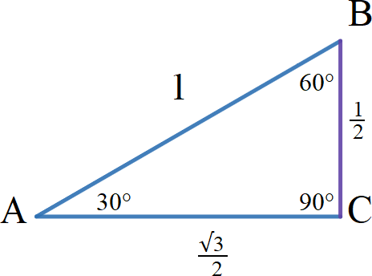
Sin(30°) = ½ height
cos(30°) = √3/2 base
tan(30°) = √3 slope

sin⁻¹(½) = 30° height
cos⁻¹(√3/2) = 30° base
tan⁻¹(√3) = 30° slope

After comparing the trig values for 30° and 60° we see that cosine and sine are inverses of each other. An inverse for a function switches the input x variable with the output y variable. Doing this is called “inversion”. Inversion creates something called an inverse. All an inverse is, is an inverting of the y/x to x/y written as:

f(x) = y to f⁻¹(x) =y function notation
sin(x) = y to sin⁻¹(x) = y trigonometric notation

∠A and and ∠B are inverses of each other. This makes their sines and cosines inverted by switching one for the other. Sine becomes cosine and cosine becomes sine. This also makes their tangents inverted. Slope of 1 is y/x and slope of the other is x/y. If we think of a true inverse slope would have to change from positive to negative to make a 90° angle at the point where the two slopes meet. In algebra this point is called the solution of the two functions. In algebra lines are graphed using the formula y = mx+b which is the function f(x) = mx+b where m is slope. Since slope is tangent we can substitute tangent for m.

y=mx + b
f(x) =mx + b
f(x) = tan(θ)+ b

- Know that ∠A and ∠B have inverted trig functions
- Know why they are inverted
- Know the algebra to graph it

Some math regarding radicals: Tangent is calculated using slope.

∠30° = ½ ÷ √3/2

½ ÷ √3/2 write height ÷ base
½ ∙ 2/√3 flip and multiply when divisor is a quotient (fraction)
2/2√3 ^{1∙2}/_{2∙√3} = (1∙2)/(2∙√3) = 2/2√3 simplify
1/√3 cancel any constants that are scalar multiples
√3/3 rationalize the denominator, we multiplied by √3/√3
3|√3 we are asked to divide a radical by 3
3|1.732050808 we covert to a decimal of sufficient precision. Memorize 1.732 the “20 50 808”
0.577352696 when doing by hand the last digit is incorrect because we truncated the radical
When we say trig ratio we refer to a ratio like ^{y}/_{x} where we are dividing a side by a side.
When we say trig function we refer to the name of the ratio we are using such as sine, cosine, or tangent.

In a triangle sine is a ratio of the side opposite of an angle, divided by the longest side, the hypotenuse.
Sine is a ratio but it is also a function. The ratio for sine is ^{opposite side}/_{hypotenuse}.
All functions follow the form f(x) = y. The function is sin(θ°) = x/h or sin(θ°) = o/x.
If x is the numerator we are trying to solve the opposite side of the angle.
If x is the denominator we are trying to find the hypotenuse.

sin(θ°) = ^{x}/_{hyp} This says I want to find the side opposite my angle.
sin(θ°) = º/_{x} This says I want to find the hypotenuse.

The ratio is made of two sides. One side will be given in the problem and the other side will be missing. The missing side is the one we are solving for. To use trig ratios sine, cosine, or tangent we need to know the degree of the angle. We need to know the angle so that we can put it into the function where the parentheses are:

sin(put your known angle here) = opp/hyp.

When I write sin(θ) it means I am writing a general formula not that I do not know what the angle is. You need to know the angle and then replace theta wit that angle:

sin(θ°) General formula.
sin(60°) Inputting angle into our function.

Your function needs to input the angle in degrees and then set it to the ratio of a side divided by a side:

sin(60°) = opp/hyp General formula.
sin(60°) = x/1 This says my hypotenuse is 1 and I am solving for a side called “x”.
sin(60°) = 1/x This says my side is length 1 and I am solving for the hypotenuse.

If sin(60°) = x/hyp then the solution is hyp∙sin(60°) = x. This isolates x. The solution is found using a calculator to calculate sine of 60 degrees multiplied by the length of the hypotenuse. In this problem hypotenuse was given and we needed to find the height of the angle.

If sin(60°) = opp/x then the solution is x = opp/(sin(60°)). This isolates x which is the hypotenuse. The solution is found using a calculator to calculate the opposite side divided by sine of 60 degrees. In this problem the height of the angle was given and the hypotenuse needed to be found.

This explains sine as a function and ratio. The other functions follow similar logic.
Why Sine of ∠A = 60° = Cosine of ∠B = Tangent ∠A or ∠B

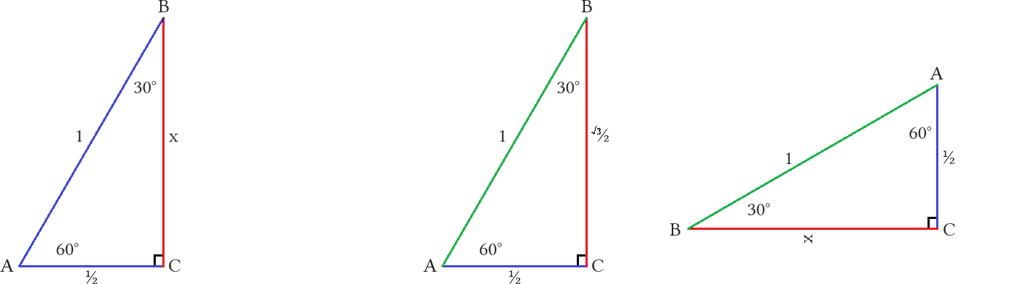

There is a difference in the height of a triangle and the height of an angle. When graphed on the real plane ∠A will be at the origin. In this example the height of the triangle is the red side with an unknown length of x. The height of ∠A is also x. If we rotate the triangle 90° and flip horizontally we have ∠B at the origin. The height of the triangle and the height of ∠B are both ½ a unit.

Side x is opposite ∠A because it is side a. Side x is also adjacent to ∠B. Sides are always marked with the letter of the angle they are opposite. What follows is that angles are always adjacent to the side that is marked differently.

If ∠A then: opposite side is side a and adjacent side is side b.
If ∠B then: opposite side is side b and adjacent side is side a.

Rotating the triangle inverts ∠A with a ∠B. Either we have base ½ and height x or base x and height ½.
If we want to find x using ∠A then we need sin(60°).
If we want to find x using ∠B then we need cos(30°).
Both functions are solving for side a.

Sine uses opposite over hypotenuse. Side a is opposite ∠A so we use sin(∠A) = sin(60°).
Cosine uses adjacent over hypotenuse. Side a is adjacent to ∠B so we use cos(∠B) = cos(∠30°).

The height of ∠A is the base of ∠B. The base of ∠A is the height of ∠B. The red side is side a. It is opposite angle A. If I rotate the triangle angles and lengths are persevered. Angle A is at top but nothing material changes because side a is still opposite it. The red side is marked x because we do know know the length. When x is the height of the triangle ½ is the base. When rotated x is the base and ½ is the height. We can see that to find the red side (side a) we need to use sine with angle A or cosine with angle B. They are referring to the same side. Side “x” is opposite angle A and adjacent to angle B. Using the trig formulas we can solve using either sin(60°) or cos(∠30°) as they are equal in length. Tangent follows similar logic. This proves the sin(∠A) = cos(∠B). ■
Inverse Trig functions

There are five types of functions: Polynomial, Exponent, Power, Logarithm, and trigonometric. All functions follow f(x) = y. If a function is invertable it has an inverse given by f⁻¹(x) = y. An inverse finds the starting number that was used in the original function.

Trig Main functions: f(x) = y

f(x) = y This says we have a function.
f(put angle here) = put a ratio here This says x = θ° and y = side÷side or ^{side}/_{side}.
f(θ°) = side/side Trig ratios are a side divided by a side
f(θ°) = ratio Trig functions input degrees and output ratios.

sin(θ) = o/h Either o or h is missing so then sin(θ) = x/h or sin(θ) = o/x.
cos(θ) = a/h Either a or h is missing so then cos(θ) = x/h or cos(θ) = a/x.
tan(θ) = o/a Either o or a is missing so then tan(θ) = x/a or tan(θ) = o/x.

Trig inverse functions: f^{–1}(x) = y

f–1(x) = y
f(put ratio here) = put angle here
f(side/side) = θ°
f^{–1}(ratio) = θ° Trig inverses input ratio and output degrees.

sin^{–1}(o/h) = θ Either o or h is missing so sin^{–1}(x/h) = θ° or sin(o/x) = θ°.
cos^{–1}(a/h) = θ Either a or h is missing so cos^{–1}(x/h) = θ° or cos(a/x) = θ°.
tan^{–1}(o/a) = θ Either o or a is missing so tan^{–1}(x/a) = θ° or tan(o/x) = θ°.

Every angle uses the main 3 functions making 9 equations for a triangle. Likewise every angle uses the 3 inverse functions adding another 9 equations. This is 18 possible equations. We only use 1 or 2 equation per problem.

Use main functions to turn given angles into missing sides.
Use inverse functions to turn given sides into missing angles.

Very quickly will show inverse functions. Lets say I knew the sides of a triangle but not its angles. I could find them using inverse trig functions.

f ^{– 1}(x) = y General form for any inverse function.
sin^{–1}(^{O}/_{H}) = θ General form for a inverse sine function.
sin^{–1}(^{√3/2}/₁) = ∠A Write the sine ratio for your angle. Set to your angle or theta.
sin^{–1}(^{√3}/₂) = ∠A Use a calculator. This is pretty much a 1 step operation.
60° = ∠A This is our answer.

If we know we have a right triangle then ∠C = 90°. We can use the angle sum formula to find the third angle. Subtract the angle you found from 90°: 90° – ∠A = ∠B. 90° – 60° = 30°. ∠B = 30°. This is the easiest way to find the last angle or we can use either cos^{–1}(∠A) or sin^{–1}(∠B):

sin^{–1}(^{O}/_{H}) = ∠B Write the inverse function.
sin^{–1}(^{½}/₁) = ∠B Fill in data.
sin^{–1}(^{½}/₁) = ∠30° Use a calculator. This is our answer. ∠B = 30°.

cos^{–1}(∠A) = ∠B This is a little trickier.
cos^{–1}(^{√3}/₂) = θ We can write ^{√3}/₂, because dividing by 1 is: ^{√3/2}/₁ = ^{√3}/₂.
∠30° = θ This is our answer.

Using sine of angle B is easier. Using angle sum formula is easiest. Using cosine of angle A is hardest because we have a complex fraction and need to understand that cosine of A equals sine of B. We can use cosine of A to find sine of B because we proved sin(∠A) = cos(∠B) earlier. If sin(∠A) = cos(∠B) then sin^{–1}(∠A) = cos^{–1}(∠B). We can use tangent inverse to find ∠A or ∠B. This creates about four equations. This is true but I am not going to prove that here. Proof is left as an exercise for the reader. In truth there are many ways to derive an answer but here is neither time nor place.
Trig reciprocal ratios

Initially reciprocals are only taught for the main functions but the inverse functions have reciprocals as well.
A reciprocal is an inverse fraction, not to be confused with the inverse trig functions themselves. An inverse fraction simply says x^{–1} = ¹/_{x}. We are inverting the fraction hence it is an inverse fraction. Inverse fractions, called reciprocals, are used for canceling terms in higher level math notably calculus. Advanced trig or pre-calculus may offer exercises but they are only to prepare for calculus.

As previously stated there is a difference between a trig ratio and a trig function. All following terms are ratios. What they do is their function.

Cosecant: cosecant is the reciprocal of sine ergo csc = ¹/_{sin}. csc(θ) = ¹/_{sin}.
Secant: secant is the reciprocal of sine ergo sec = ¹/_{cos}. sec(θ) = ¹/_{cos}.
Cotangent: cotangent is the reciprocal of sine ergo cot = ¹/_{tan}. cot(θ) = ¹/_{tan}.

Arccosecant: arccosecant is the inverse function of cosecant. csc^{–1}= θ
Arcsecant: arcsecant is the inverse function of secant. sec^{–1}= θ
Arccotangent: arctangent is the inverse function of cotangent. cot^{–1}= θ

A reciprocal is a 1 over term meaning 1 divided by a number gives that numbers reciprocal. If x then 1 ÷ x = ¹/_{x}. This new fraction is called “one over x”. Its reciprocal is then 1 ÷(¹/_{x}) = x. x is the reciprocal of ¹/_{x} and ¹/_{x} is the reciprocal of x. As a number, “x” can be a single term or even a function or complete equation: 1 ÷ f(x) = ¹/_{f(x)} and 1÷¹/_{f(x)} = f(x). Also 1 ÷ f^{–1}(x) = ¹/f^{–1}(x) and 1 ÷¹/f^{–1}(x) = f^{–1}(x). These tend to be complex fractions.

At some point we will use special cases to define these functions using the unit circle as it is simpler that way. Until then we only use sine, cosine, and tangent and there inverses arcsine (sin^{–1}), arccosine (cos^{–1}), and arctangent (tan^{–1}). We have 3 main function to find sides and their 3 inverses to reverse the process to find angles.

Review of Trigonometric Functions

- Functions use angles to find side ratios.
- Inverses called arc functions use side ratios to find angles.
- Reciprocals cancel out in intermediate or higher trig functions.
- Basic trig: Uses cosine, sine, and tangent as functions. Uses arccosine, arcsine, and arctangent as inverses.

Definitions vary depending on whether using original definitions of SohCahToa (which is true in all cases), unit circle definitions (only apply under special circumstances), or something else altogether (???).

- The sine of an angle is the ratio of the height divided by the hypotenuse.
- The cosine of an angle is the ratio of the base divided by the hypotenuse.
- The tangent is the height of of an angle divided by the base of an angle.
- In the unit circle sine is the height and cosine is the base of a △. This is different than the above 3 def.
- In algebra tangent is also known as slope M = ^{y}/_{x}.

Function | Abb | Inverse | Abbreviations | Reciprocal | Abbr. | Inverse reciprocal | Abbrs.
Sine | Sin | arcsine | arcsin, asin, sin^{–1} | cosecant | csc | arccosecant | arccos, acos, csc^{–1}
Cosine | Cos | arccosine | arccos, acos, cos^{–1} | secant | sec | arcsecant | arcsec, asec, sec^{–1}
Tangent | Tan | arctangent | arctan, atan, tan^{–1} | cotangent | cot | arccotangent | arccot, acot, cot^{–1}

Sine: sine is a ratio of the side opposite an angle and the hypotenuse ergo S = ^{O}/_{H}.
Cosine: cosine is a ratio of the side opposite and angle and the hypotenuse ergo S = ^{A}/_{H}.
Tangent: tangent is a ratio of the side opposite the angle and the the side adjacent ergo T = ^{O}/_{A}.

As a function sin(x) = y. Input (substitute) angle in degrees for x and it outputs a ratio of sides for y.
As a function cos(x) = y. Input angle for x and it outputs a ratio for y.
As a function tan(x) = y. Input angle for x and it outputs a ratio for y.

Arcsine: arcsine is the inverse function of sine. sin^{–1}(x) = y. Input ratio for x and it outputs an angle for y.
Arccosine: arcsine is the inverse function of sine. cos^{–1}(x) = y. Input ratio for x and it outputs an angle for y.
Arctangent: arctangent is the inverse function of sine. tan^{–1}(x) = y. Input ratio for x and it outputs an angle for y.

Cosecant: cosecant is the reciprocal of sine ergo Csc = ¹/_{sin}. Csc(θ) = ¹/_{sin}.
Secant: secant is the reciprocal of sine ergo Sec = ¹/_{cos}. Sec(θ) = ¹/_{cos}.
Cotangent: cotangent is the reciprocal of sine ergo Cot = ¹/_{tan}. Cot(θ) = ¹/_{tan}.

Arccosecant: arccosecant is the inverse function of cosecant ergo csc^{–1}=
Arcsecant: arcsecant is the inverse function of secant.
Arccosecant: arcsine is the inverse function of sine.
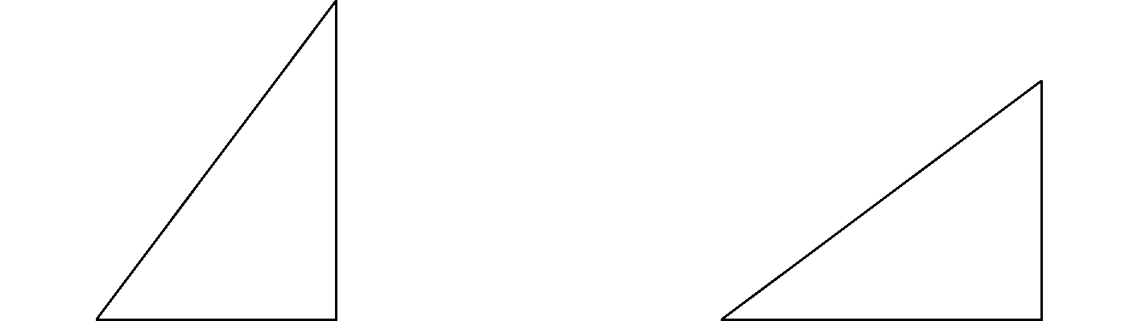

∠A for a 3:4:5 triangle is:

sine 4/5 53.130102354155978703144387440907
cosine 3/5 53.130102354155978703144387440907
tangent 4/3 53.130102354155978703144387440907
cosecant 5/4 53.130102354155978703144387440907
secant 5/3 53.130102354155978703144387440907
cotangent 3/4 53.130102354155978703144387440907

∠A for a 4:3:5 triangle is:

sine 3/5 36.869897645844021296855612559093
cosine 4/5 36.869897645844021296855612559093
tangent ¾ 36.869897645844021296855612559093
cosecant 5/3 36.869897645844021296855612559093
secant 5/4 36.869897645844021296855612559093
cotangent 4/3 36.869897645844021296855612559093

The two triangles are congruent or at least similar. Knowing ratios alone does not explicitly state side lengths. The first triangle has 53.13° for ∠A and 36.87° for ∠B.
The second triangle has 36.87° for ∠A and 53.13° for ∠B.
They are similar triangles that have been rotated 90° so ∠A and ∠B are inverted.

The angles of a square

All rectangles have 4 90° angles. All polygons have as many angles as sides so from that first statement alone we know a rectangle has 4 sides. A square is a special case of a rectangle. A special case is a subset of all cases. When you hear the phrase special case you need to know it relates to set theory. If you defined a rectangle as being a polygon with 4 90° angles then a square would fit that definition. To differentiate a square from a rectangle we have have to place constraints on a set of rectangles called squares. Constraints are called rules.
The rule we create will say squares are a subset of rectangles that have all sides the same length. If all rectangles belong to the set rectangles then squares are a subset of set rectangles.

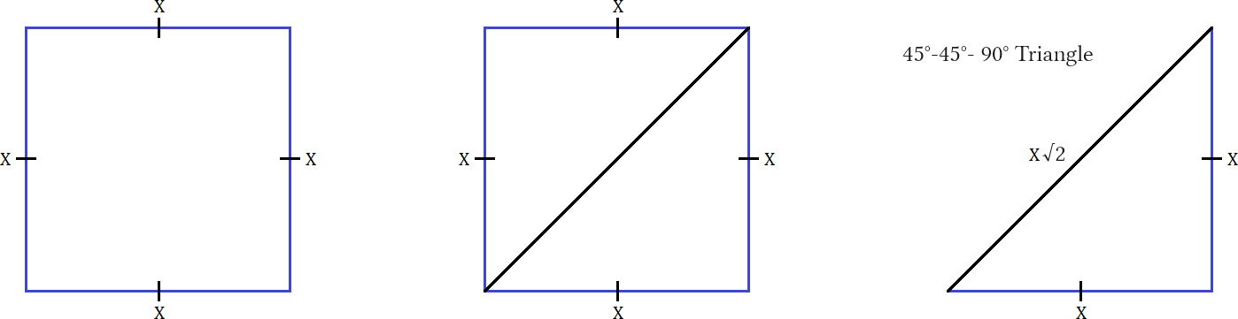

A square has 4 sides all the same length. It has 4 ∠90°. A triangle is made by taking the diagonal of a quadrilateral. If we take the diagonal of a square we get two isosceles right triangles. The only isosceles right triangle is the 45°:45°:90°. This is a special triangle on the unit circle. If we make x = 1 then it's side ratios are 1:1:√2. We know the corner is 90° (∠C).

Angle A = θ.
Angle B = 90 – ∠A.

If 90° before cutting diagonally then 90°/2 = 45° after cutting. Both ∠A and ∠B = 45°. This triangle is solved for all sides and angles meaning we do not need to use trig functions to find anything. Yay! Special triangles can be solved by memorizing their values from a table and using algebra alone. Using trig functions:

sin(∠A) = ^{O/}_{H} sin(45) = ^{O/}_{H} sin^{–1}(^{O/}_{H}) = ∠A
sin(45) = ^{x/}_{H} sin(45) = ^{O/}_{x} sin^{–1}(^{1/}_{√2}) = ∠A
sin(45) = ^{x/}_{√2} sin(45) = ^{1/}_{x} 45° = ∠A
√2sin(45) = x xsin(45) = 1
1 = x x = 1/sin(45)
x = √2

Since this is an isosceles triangle using cosine and cosine inverse will give the exact same values as sine and sine inverse.

Trig values can be calculated for all three angles not just angle A. If trig is taught at the elementary level school children like to rotate or flip the △ till the angle they need is where ∠A is pictured. For mastery all ratios need to be solved. Solving ∠C as a right angle might be pushing it... values are not defined for 90° angles.

For ∠A: For ∠B: For ∠C:
sin: ⅘ = 0.8 sin: ⅗ = 0.6 sin: ^{hyp}/_{hyp} = 1 this a given in right triangles
cos: ⅗ = 0.6 cos: ⅘ = 0.8 cos: undefined both side a and b are adj
tan: ⁴/₃ = 1.3 tan: ¾ = 0.75 tan: undefined both side a and b are adj

Note that tangent for ∠A and ∠B are reciprocals of each other. This is because the angles are rotated 90° from each other. Rotated 90° right, flipped horizontally:



∠B where at the origin where we expect ∠A. This swaps point A with point B causing their tangents to be reciprocal fractions of each other. Rotating 90° inverts base with height and height with base. We had 3/4 but after the transformation we have 4/3. Rise and run values are swapped.

The horizontal flip is actually a complex rotation about the imaginary plane. Picture the two triangles like a flag spinning around a pole or a door swinging 180°. A door swinging 180° would cause it to be flipped horizontally and show its backside instead of its front side. We can say the triangle with a negative slope is the front and the other one is the back. To perform complex rotations in math we treat the lines as vectors and multiply by an imaginary number. We need to build more foundation before we can do that.
Finding angles when all sides are given

Suppose we know a △ has sides 3,4,5 but none of the angles except ∠C = 90°. We convert side ratios to angles.
Using a calculator in degree mode find the sin, cos, and tan buttons. Push only buttons denoted by [button].

For ∠A: sin: ⅘ = 0.8 For ∠B: sin: ⅗ = 0.6
cos: ⅗ = 0.6 cos: ⅘ = 0.8
tan: ⁴/₃ = 1.3 tan: ¾ = 0.75

To find ∠A press: To find ∠B press:

sin^{–1}:[shift] [sin] [0.8] [enter] ≈ 53.13°... or sin^{–1}:[shift] [sin] [0.6] [enter] ≈ 36.87°... or
cos^{–1}:[shift] [cos] [0.6] [enter] ≈ 53.13°... or cos^{–1}:[shift] [cos] [0.8] [enter] ≈ 36.87°... or
tan^{–1}:[shift] [tan] [(4÷3)] [enter] ≈ 53.13° tan^{–1}:[shift] [tan] [(0.75)] [enter] ≈ 36.87°

All three ratios will convert the ratio to an angle measured in degrees if in degree mode or an arc length if in radians. Save radian mode for pre-calculus or calculus and use degree mode.

In a right triangle one side will be 90°. It should not be hard to find. It is the biggest angle that is directly across from the hypotenuse. The hypotenuse is the longest side in any triangle. Note that we know ∠C is 90° because this angle was formed by dropping a vertical line from Point B straight down to the x axis. A ∠90° is made by crossing a vertical line with a horizontal line. We really only have to solve for ∠A then subtract ∠A from 90° to find ∠B. Since the sum of the two acute angles in a right triangle are 90° we get these two equations:

90° – ∠A = ∠B and 90° – ∠B = ∠A.

Pressing shift change the trig functions to the trig inverses. The main functions sine, cosine, and tangent take an angle as an input and give a side length as an output. Their inverses reverse the process and take a side length as an input an give an angle as an output. We abbreviate sine, cosine, and tangent as sin, cos, and tan. We abbreviate arcsine, arccosine, and arctangent as sin^{–1}, cos^{–1}, and tan^{–1}.

Sin(x°) = o/h Cos(x°) = a/h Tan(x°) = o/a
Sin^{–1}(^{O}/_{H}) = x° Cos^{–1}(adj/hyp) = x° Tan^{–1}(opp/adj) = x°

Trig functions like sin, cos, or tan take angles and turn them into ratios.
Trig inverse functions like sin^{–1}, cos^{–1}, or tan^{–1} take ratios and turn them into angles.
Angles can be in degrees or radians depending on mode calculator is in. Without calculus there is no way to find these conversions by hand and so we use the calculator to perform in seconds what would take us hours, days(?).

Converting angles in degrees to ratios

Functions turn degrees into ratios and inverses turn ratios into degrees:

To find ∠A press: To find ∠B press:
sin^{–1}:[shift] [sin] [0.8] [enter] ≈ 53.13°... or sin^{–1}:[shift] [sin] [0.6] [enter] ≈ 36.86°... or
cos^{–1}:[shift] [cos] [0.6] [enter] ≈ 53.13°... or cos^{–1}:[shift] [cos] [0.8] [enter] ≈ 36.86°... or
tan^{–1}:[shift] [tan] [(4÷3)] [enter] ≈ 53.13° tan^{–1}:[shift] [tan] [(0.75)] [enter] ≈ 36.86°

Using a calculator we press shift to get the arc functions which are the inverse functions then we press the function we want. Pressing [shift] then [tan] gives us arctan which on a calculator is notated as tan^{–1}. All functions use f^{–1}(x) to mean inverse function so it is weird that textbooks lament about how bad the notation is. The concern is not to confuse an inverse function for a reciprocal function. Arctan = tan⁻¹ not ¹/_{tan} which is cotangent. Inverse functions are not the reciprocal functions that have 1 over notation. Personally I think this is from older professors who are mad slide rules are obsolete and want to trick you and make you think the notation is worse that it really is to sabotage you. If you were not told it was bad you would not think it, they put that idea in your head! I don't mind it but created a solution using dagger notation. Anyways back to math:

Press this: [shift] [tan] [(4÷3)] [enter] = 53.13010235...°
Press this: [tan] [53.13010235.....°] [enter] = ⁴/₃.

- We divided the height by the base to give us the tangent of angle A.
- Then we took that ratio and used it as an input for a inverse function.
- The inverse function converted it into an angle in degrees.
- Take the full answer and use it as an input for tangent.

Press this: [shift] [tan] [(4÷3)] [enter][tan] [ans] [enter] = ⁴/₃
That last full sequence turns ⁴/₃ into 53.13° then turns 53.13° back into ⁴/₃.

For ∠A For ∠B
sin(53.13010235...°) = ⅘ sin(53.13010235...°) = ⅘
cos(53.13010235...°) = ⅗ cos(53.13010235...°) = ⅗
tan(53.13010235...°) = ⁴/₃ tan(53.13010235...°) = ⁴/₃

The values have been truncated to four decimals so using them to convert to ratios would not yield accurate results. We must start over or use different angles that are integers and not transcendentals (irrational fractions from a Pythagorean rooting process).We had a base of 3 and a height of 4. Dividing them gives us the slope of the line form point A to point B. 4÷3 = ⁴/₃ = 1.3. This repeats as a fraction and would be imprecise to enter into a calculator. Use the fraction instead or use (4÷3). Any fraction can be entered in using (p÷q). This is useful even if your calculator has a fraction button which most modern calculators do.
Solving for a missing side

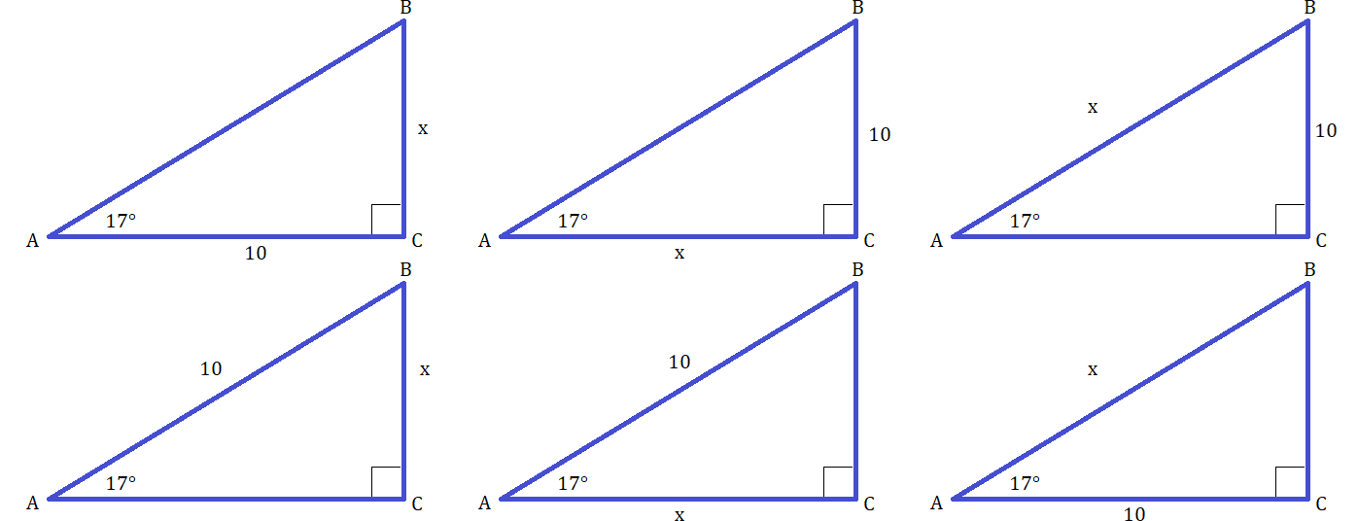

Write the function you need. Input the angle into the function. Set the function equal to a ratio of two sides being divided. Rewrite the expression using algebra to isolate x. Once x is isolated use a calculator to solve.
Use critical thought and ask yourself questions like this for every problem:

Do I need to find a side or angle? Main functions find sides and arc functions find angles.
Is hypotenuse given or asked for? If not we must use tangent to solve.
Hypotenuse is given or asked for so we must use sine or cosine, but which one?
If involved side is opposite use sine; if adjacent use cosine.

∀△ All triangles are defined by the hypotenuse. It dictates most everything.

- 10:x:h 17°:73°:90° △1 Hypotenuse is not involved so we must use tangent.
- x:10:h 17°:73°:90° △2 Hypotenuse is not involved so we must use tangent.
- b:10:x 17°:73°:90° △3 Asks for hypotenuse. Use sine to find height cosine to find base.
- b:x:10 17°:73°:90° △4 Hypotenuse is given. Use sine to find height cosine to find base.
- x:a:10 17°:73°:90° △5 Hypotenuse is given. Use sine to find height cosine to find base.
- 10:a:x 17°:73°:90° △6 Asks for hypotenuse. Use sine to find height cosine to find base.

- To solve for a missing side the Pythagoras theorem is simplest but only works if you know two sides.
- If solving for the hyp you take the square root of the sum the squares of the legs.
- If solving for a leg you you take the square root of the difference of squares of the hyp and known leg.
- Base:height:hypotenuse = leg:leg:hyp = b:a:c and B°:A°:C°.
- All triangles have angle A given as 17° so that will be the number to put in our function.

△1 10:x:h

tan(θ) =opp/adj Write the correct function set to the correct ratio.
tan(17)=^{x}/₁₀ Fill in values using x for the missing side we are solving for.
10tan(17)=^{10x}/₁₀ Multiply both sides by denominator to isolate x.
3.05≈ x 10x/10 reduces to x. 10tan(17) is approximately 3.05.

△2 x:10:h

tan(θ) =opp/adj
tan(17)= ¹⁰/_{x} This time x is the denominator.
xtan(17)= 10x Multiply both sides by x to cancel x in the denominator.
x =¹⁰/_{tan(17)} Divide both sides by the function to isolate x.
32.709 ≈ x

△3: b:10:x

sin(θ) = opp/hyp
sin(17)=¹⁰/_{x} Again x is the denominator.
xsin(17)=^{10x}/_{x} Multiply both sides by x to cancel x in the denominator, we did this for △2.
^{xsin(17)}/_{sin(17)}= ¹⁰/_{sin(17)} Isolate x by dividing both sides by sin(17).
x= ¹⁰/_{sin(17)} Use calculator: [10][÷][sin][17][enter] = 34.2030362...
x≈ 34.2 This is the hypotenuse of △2 and △3 . They are the same triangle.

△4 b:x:10

sin(θ)=º/_{h} This is Soh stands for Sin = (^{opp}/_{hyp})
sin(17)=^{x}/₁₀ Plugging in our known values and the x we are solving for.
10sin(17)=x Algebra is used to arrive here. Now solve using a calculator.
10sin(17)≈ 2.92 Height is about 2.92.

△5 x:a:10

cos(17)= ^{x}/₁₀
10cos(17)= x Multiply both sides by 10 to isolate x.
9.56 ≈ x Base is about 9.56

△6 10:x:h

cos(17) =¹⁰/_{x}
xcos(17)= ^{10x}/_{x} Multiply both sides by x to cancel x in the denominator.
^{xcos(17)}/_{cos(17)}= ¹⁰/_{cos(17)} Divide both sides by cos(17) to isolate x on the right side.
x = 10÷cos(17) x is isolated. This concludes the algebra now use calculator to solve.
x = [10][÷][cos][17][enter] Push these buttons on a calculator. If possible use fraction button for ¹⁰/_{cos(17)}.
x ≈ 10.45 The hypotenuse is about 10.45.
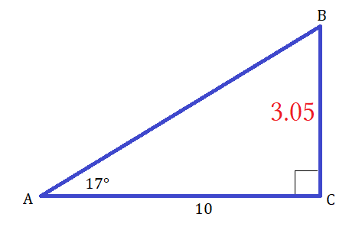
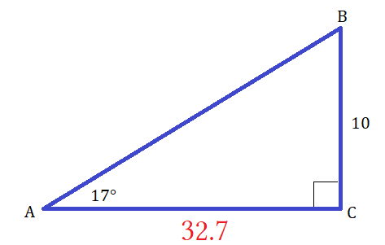
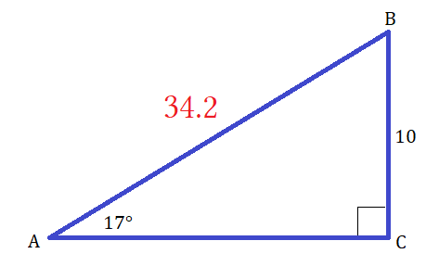
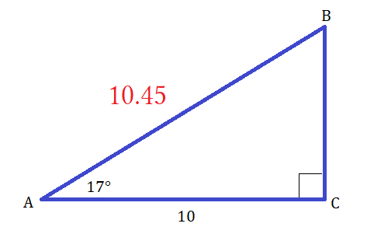
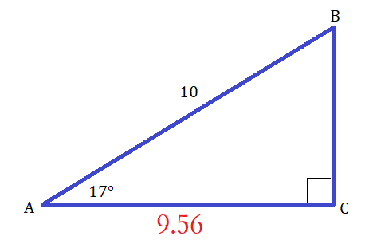
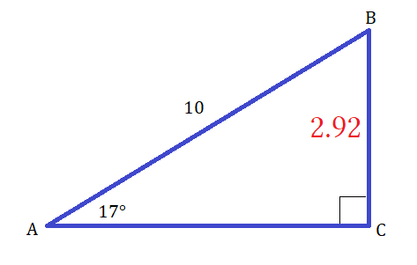

Do these values make sense? If a number seems way too big or way to small we must perform a sanity test to insure we are not saying crazy things and producing errors that common sense dictate must be wrong even without checking with a calculator. △1 had ∠A = 17° and base of 10 ⸫ hyp must be bigger than 10 but not by much. An angle of 17° is going to make the height the smallest size. That being the case then the base is going to be close to hyp which 10:10.45 is. Using the same logic on the other triangles all the measurements seem reasonable.

△2 has base:hyp ratio of 9.56:10 Since base is close to hyp this makes sense.
△3 has height to base ratio of 2.92:10 Since height is smallest this makes sense.
△4 has height to hyp ratio of 10:34.2 34.2 seems big but when we look at others it makes sense.
△5 has base to height of 3.05:10 Height is about ⅓ the other sides.
△6 has base to height of 10:32.7 Height is about ⅓ the other sides.

Triangle 4 is beyond reasonable because ¹⁰/_{sin(17)} = 34.2030362 and so ^{hyp}/_{side a} = 34.2030362÷10 = 3.42030362.
Compared with triangle 3 10sin(17) = 2.92317047 and so ^{hyp}/_{side a} = 10÷2.923717947 = 3.42030362.

This proves similarity that these two triangles are the same angles and therefore have the same side and angle ratios. We can prove similarity either angles or sides. All triangles have angle ratios of A°:B°:C° = 17°:73°:90°:

- Every △ has ∠A = 17°
- Every △ has ∠C = 90°
- Every △ has ∠B = 90° – 17° = 73°.

This proves similarity under the AAA similarity law. When two △ have three angles all the same they are said to be similar. Similar triangles are scaled versions of each other. All sides are multiplied by the same number . If we take the 3:4:5 △ and multiply all the side by 2 we get a 6:8:10 △ and the angles will be the same as the 3:4:5.
If we divide 2 sides the △ it will match the same division of sides on any of the other 5 △. Next describes how to solve a missing side in 1 step for all three functions. After that number theory is used to determine the probability of getting 1 out of the 4 possible combinations of x.

There were two versions of the problem. Either x was a numerator or x was a denominator.
x on the bottom seems harder because it has extra steps. But with the carefully selected problems I created a pattern emerges and we learn to do all the problems in 3 steps and then finally one step. The goal is to be able to write the equation then look at it and be able to enter in the necessary keystrokes into a calculator to solve it without having to do all the algebraic manipulation shown. I showed the algebra because you have to understand it but it is not the fastest way to solve. Solving the long way teaches how algebra works in general and can be applied to other problems. Trigonometry is more about knowing what formula to use and how to write the equation rather than being able to solve it by hand. We made light work out of some intermediate problems. The ones with x as a numerator were 2, 3, and 4:

cos(17)= ^{x}/₁₀ x is a numerator
10cos(17)= x Denominator becomes coefficient of the trig function
9.56 ≈ x We use a calculator to solve [denominator][function] = x

sin(17)=^{x}/₁₀ x is a numerator
10sin(17)=x Denominator becomes coefficient of the trig function
2.92 ≈ x We use a calculator to solve [denominator][function] = x

tan(17)=^{x}/₁₀ x is a numerator
10tan(17) = x Denominator becomes coefficient of the trig function
3.05≈ x We use a calculator to solve [denominator][function] = x

Based on what we just observed it seems that we can solve problems of the form f(θ°) = ^{x}/_{n} simply by entering n∙f(θ°) into our calculator and be done. Using the method described to solve the next three random problems:

sin(54) = ^{x}/₄ cos(71) = ^{x}/₁₂ tan(45) = ^{x}/_{6.5} step 1 write your problem
4sin(54) = x 12cos(71) = x 6.5tan(45) = x step 2 isolate x
3.23 = x 3.9 = x 6.5 = x step 3 solve for x

- x is a denominator
- Denominator becomes coefficient of the trig function
- We use a calculator to solve (denominator)∙(function). This is a 1 step process.

This is easy, the other ones seemed harder, but were they? Nope. On 5 I gave the answer on the first step.

cos(17) =¹⁰/_{x} sin(17)=¹⁰/_{x} tan(17)= ¹⁰/_{x}
xcos(17):10 xsin(17) =10 xtan(17)=10
x=10/cos(17) x=10/sin(17) x = 10/tan(17)

- x is a denominator
- Function becomes denominator of ratio and x is isolated. This is an inversive swap.
- We use a calculator to solve (numerator)÷(function). This is a one step process.
Whether x is numerator or denominator it is a three step process if you use the right algorithm.
It can have an extra step if you use long algebra but on △4 I used ten steps taking my sweet time.
These are really 1 step problems: For ^{p}/_{q} if x is p then multiply (q)func to solve. If x is q then divide p÷func to solve.

- Tan is the only function the excludes hypotenuse. Tangent is slope so a ratio of ^{y}/_{x} or ^{sin}/_{cos}.
- Hypotenuse is always a denominator, nothing more, for base or height during cos and sin,.
- Cos uses adj sin uses opp.

Number Theory

If we have a right triangle and a given angle then we have all 3 angles: given ∠, 90° – given ∠, and the ∠90° itself. This solves for all three angles the only thing left is the sides. If we have one side given in a right △ then we choose a side to solve for by naming that side x. To solve for x we need to use a trig function set to x with x as either a numerator or denominator. For brevity let numerator = p and denominator = q.

If x is a numerator then x is a side adjacent or opposite an angle we have cos, sin, or tan: ^{adjx}/_{hyp}, ^{oppx}/_{hyp}, ^{oppx}/_{adj}.
If x is a denominator then x is a side adjacent to an angle or the hypotenuse we have cos, sin, or tan: ^{adj}/_{x}, ^{opp}/_{x}, ^{opp}/_{x}.

The unknown side has two choices for numerator, adj or opp, and two choices for denominator, hyp or adj.

- There are 3 trig functions.
- There are 6 possible cases.
- There are x 2 possible choices of {p,q} of two possible choices of the set {adj, opp, hyp}.
- This is 4 possible options for to be:
a) adj as a numerator.
b) opp as a numerator.
c) adj as a denominator.
d) hyp as a denominator.

You can use statistics to calculate the probability of what x can be.
There are 3! cases because three functions choose 2 types of p or q = 6 cases where p or q is num or den.
There are 2² possible outcomes for x because 2 choices of p or q times 2 choices of adj vs. opp or adj vs. hyp has an overlap of adj. Any fraction is the ratio p:q or ^{p}/_{q}. First choice:

Numerator → second choice: adj or opp. Here we have (numerator,adj) or (numerator,opp).
Denominator → second choice: adj or hyp. Here we have (denominator,adj) or (denominator,opp).

We have four pairs of outcomes to choose from so we have four possible chooses for 6 possible cases.
Choosing numerator of denominator is our first choice and then choosing from the set {adj, opp, hyp} is our second choice. However our first choice limits our second choice to the sets of {adj,opp} if we choose x = p and {adj,hyp} if x = q. If x = p we have (p,adj) or (p,opp) where choosing one or the other represents a single choice because each pair counts as 1 item we have to make a single choice between two items.

If x = q we have (q,adj) or (q,hyp). We have a choice of p or q for x. This is our first set of choices of two options. After choosing on or the other we are forced to have (p,adj) or (p,opp) if we choose p or (q,adj) or (q,hyp) if we choose q.

Let's look at this from a naive perspective. Assume that for 3 functions and 2 positions for x, p or q, that we have 3∙2 = 6 possible combinations for x. This lists data incorrectly. This is true for possible cases but not possible combinations. When it comes to choice we only have 4 choices to solve for the 6 cases. This is the mathematics of the choice. This deals with how many choices for an answer we have rather than an answer itself since getting the answer is trivial. Getting an answer for any of the six test samples was made trivial by finding the non trivial algorithm:

If x is a numerator p then solution for x is x = q(func) and if x is a denominator q then x = p/(func).
We can abbreviate function as func or simply f.
The answer to any missing side is either p/f or qf where x is the inverse of p/f or qf.

Note: This is trigonometry through number theory through statistics through combinatorics through algebra. We are using all skills up to this point to organize data and think about our problem to be more efficient and solve problems better. This is not the standard approach. The standard approach will not incorporate diverse skills. The standard approach has some algebra and button pushing. It lacks fundamental treatment, it fails to make connections with different branches of math. This is the beauty of math. Standard trig is ugly because of decimals. I have to make it prettier by unifying the math instead of putting it in separate courses to be taken individually. A combined approach to math is best.

Note: Sometimes knowing how many answers are possible is more important than what the answer is. I am looking for patterns to solve basic trig faster without doing all the algebra. I am looking for patterns to create algorithms to speed work. I have found such algorithms and am sharing them.

Note: After trig we take calculus or statistics. College statistics is based on calculus. We need calculus for calculus based statistics. High school statistics are not calculus based. They are simpler. Calculus students take calculus because they are told calculus is important. Calculus is theory based, statistics are the application of that theory. Should we do simple statistics before calculus or take calculus and then do calculus based statistics? What is the best order? We can take calculus and statistics at the same time. Calculus will give the theory, statistics will give the applications. Do not think that theory alone is enough. You need applications. Applications are examples that show calculus in action. This will look very different that in a purely theoretical classroom setting. A person only exposed to theory will struggle will the actual application and know how to solve nothing.

Note: There are many caveats in math and how it is instructed. The end of book I will address some of the biggest errors in pedagogy.

Malone Algorithm for trig functions: ∀ f the answer to any missing side is either p/f or qf where x is the inverse of p/f or qf.

When a solution is this generalized it solves problems beyond the ones you were actively researching.
It helps more people in ways that can not be predicted.

Hypothesis:

All problems where solving for a missing side of a triangle can be broken down into two methods for solving based on whether the unknown is a p or a q in a trig ratio of the form = ^{p}/_{q}.

Thought experiment:

Naively list all possibles cases and their possible generalized solutions:

- S =^{x}/_{h} qf
- S =º/_{x} p/f
- C =^{x}/_{h} qf
- C =º/_{x} p/f
- T =^{x}/_{a} qf
- T =º/_{x} p/f

Gather and record data:

Of the six possible cases there can be only four outcomes for solutions:

- x is a numerator. It's value is for the opposite side.
- x is a numerator. It's value is for the adjacent side.
- x is a denominator. It's value is for the hypotenuse side.
- x is a denominator. It's value is for the opposite side.
- Of the six cases two blues and two reds collapse into a single blue and a single red.
- S =^{x}/_{h} and T =^{x}/_{a} collapse to outcome #1.
- C =º/_{x} and T =º/_{x} collapse to outcome #3.
- Why does this happen?
- Of the four possible outcomes both cases collapse to 1 method of solving as 1 solution for all of that type.
- Of the four possible outcomes both cases collapse to 1 method of solving as 1 solution for all of that type.
- Outcome #1 and outcome #2 collapse to solution 1.
- Outcome #3 and outcome #4 collapse to solution 2.

Conclusion: ∀ problems of the type f(θ)= ^{p}/_{q} there are only 2 solutions: p = qf and q = pf.
For the six triangle's calculate the full value of each side and then prove similarity using side-side-side:

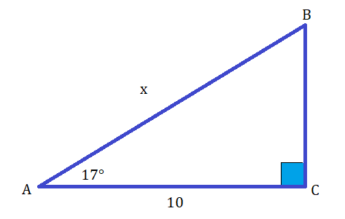
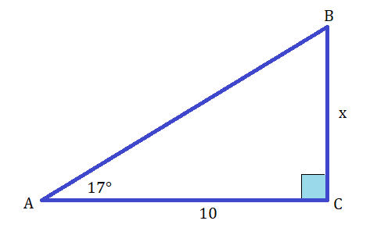

Triangle 1 10:x:h 17°:73°:90°
Base |  | Height |  | hypotenuse
10 |  | a |  | x
given |  | 10tan(17) or 10÷tan(73) |  | √[10²+(10÷tan(73))²]
10 |  | 3.057306815 |  | 10.45691756
^{b}/_{a} | ^{b}/_{c} | ª/_{b} | ª/_{c} | ^{c}/_{a} | ^{c}/_{b}
3.270852618 | 0.9563047564 | 0.3057306815 | 0.2923717047 | 3.420303618 | 1.045691756
Cotangent of ∠A | Cosine of ∠A | Tangent of ∠A | Sine of ∠A | Cosecant of ∠A | Secant of ∠A
¹/_{tan} | ¹/_{sec} | ¹/_{cot} | ¹/_{csc} | ¹/_{sin} | ¹/_{cos}

Triangle 4 10:x:h 17°:73:90°
Base |  | Height |  | hypotenuse
10 |  | x |  | h
given |  | 10tan(17) or 10÷tan(73) |  | 10÷cos(17) or 10÷sin(73)
10 |  | 3.057306815 |  | 10.45691756
^{b}/_{a} | ^{b}/_{c} | ª/_{b} | ª/_{c} | ^{c}/_{a} | ^{c}/_{b}
3.270852618 | 0.9563047564 | 0.3057306815 | 0.2923717047 | 3.420303618 | 1.045691756
Cotangent of ∠A | Cosine of ∠A | Tangent of ∠A | Sine of ∠A | Cosecant of ∠A | Secant of ∠A
¹/_{tan} | ¹/_{sec} | ¹/_{cot} | ¹/_{csc} | ¹/_{sin} | ¹/_{cos}

Under ASA both these triangles are similar. Under SSS both these triangles are congruent.

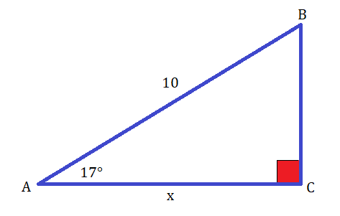
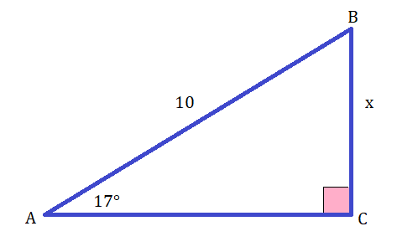

Triangle 2 x:a:10 17°:73°:90°
Base |  | Height |  | hypotenuse
x |  | a |  | 10
10cos(17)or 10sin(73) |  | 10sin(17) or 10÷tan(73) |  | given
9.563047564 |  | 2.92317047 |  | 10
^{b}/_{a} | ^{b}/_{c} | ª/_{b} | ª/_{c} | ^{c}/_{a} | ^{c}/_{b}
3.270852618 | 0.9563047564 | 0.3057306815 | 0.2923717047 | 3.420303618 | 1.045691756
Cotangent of ∠A | Cosine of ∠A | Tangent of ∠A | Sine of ∠A | Cosecant of ∠A | Secant of ∠A
¹/_{tan} | ¹/_{sec} | ¹/_{cot} | ¹/_{csc} | ¹/_{sin} | ¹/_{cos}

Triangle 3 b:x:10 17°:73°:90°
Base |  | Height |  | hypotenuse
b |  | x |  | 10
10cos((17) or 10sin(73) |  | 10sin(17) or 10cos(73) |  | given
9.563047564 |  | 2.92317047 |  | 10
^{b}/_{a} | ^{b}/_{c} | ª/_{b} | ª/_{c} | ^{c}/_{a} | ^{c}/_{b}
3.270852618 | 0.9563047564 | 0.3057306815 | 0.2923717047 | 3.420303618 | 1.045691756
Cotangent of ∠A | Cosine of ∠A | Tangent of ∠A | Sine of ∠A | Cosecant of ∠A | Secant of ∠A
¹/_{tan} | ¹/_{sec} | ¹/_{cot} | ¹/_{csc} | ¹/_{sin} | ¹/_{cos}

Under ASA both these triangles are similar. Under SSS both these triangles are congruent.
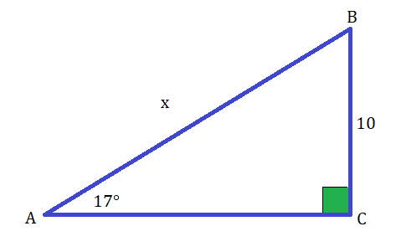
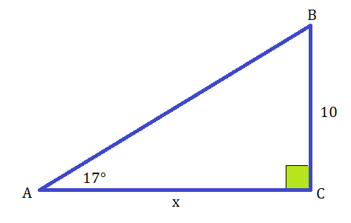

Triangle 5 b:10:x 17°:73°:90°
Base |  | Height |  | hypotenuse
b |  | 10 |  | x
10÷tan(17) or 10tan(73) |  | given |  | 10÷cos(73) or 10÷sin(17)
32.70852618 |  | 10 |  | 34.2030362
^{b}/_{a} | ^{b}/_{c} | ª/_{b} | ª/_{c} | ^{c}/_{a} | ^{c}/_{b}
3.270852618 | 0.9563047564 | 0.3057306815 | 0.2923717047 | 3.420303618 | 1.045691756
Cotangent of ∠A | Cosine of ∠A | Tangent of ∠A | Sine of ∠A | Cosecant of ∠A | Secant of ∠A
¹/_{tan} | ¹/_{sec} | ¹/_{cot} | ¹/_{csc} | ¹/_{sin} | ¹/_{cos}

Triangle 6 x:10:c 17°:73°:90°
Base |  | Height |  | hypotenuse
x |  | 10 |  | c
10÷tan(17) or 10tan(73) |  | given |  | 10÷cos(73) or 10÷sin(17)
32.70852618 |  | 10 |  | 34.2030362
^{b}/_{a} | ^{b}/_{c} | ª/_{b} | ª/_{c} | ^{c}/_{a} | ^{c}/_{b}
3.270852618 | 0.9563047564 | 0.3057306815 | 0.2923717047 | 3.420303618 | 1.045691756
Cotangent of ∠A | Cosine of ∠A | Tangent of ∠A | Sine of ∠A | Cosecant of ∠A | Secant of ∠A
¹/_{tan} | ¹/_{sec} | ¹/_{cot} | ¹/_{csc} | ¹/_{sin} | ¹/_{cos}

Under ASA both these triangles are similar. Under SSS both these triangles are congruent.
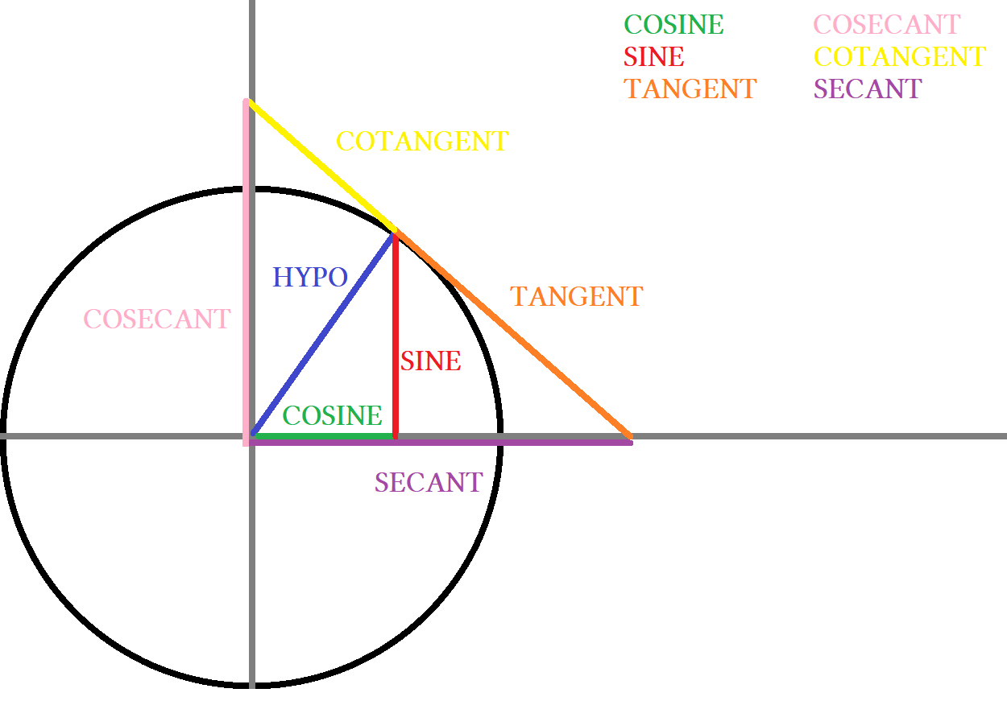

The reciprocals of a function are just 1 divided by that function. Cotangent is (1÷tan), cosecant is (1÷sine) and so on. Somehow multiplying two reciprocals equals 1 ∠90°... a bit technical to explain here. They are supposed to be 90° rotations of each other except in the case of tangent where cotangent and tangent make a straight line of 180°. If a triangle has a hypotenuse of 1 it fits in the unit circle. This makes a triangle with three lines called hypotenuse, cosine and sine. A triangle with a hypotenuse of 1 has:

Cosine as base. Sine as height. The tangent line is made of two parts called tangent and cotangent.
A larger triangle is made that fits around it with lines called secant, cosecant, and the tangent line.
This large triangle has a hypotenuse that makes a ∠90° with the small triangle's hypotenuse. It has:
Secant as base. Cosecant as height. Cotangent+tangent as hypotenuse.

Whenever I select an angle to base my formulas for I am specifying that angle to use either a sin, cos, or tan function. I might treat the angle as though it were in the unit circle and denote its vertex as point O_{rigin} for origin. The next step is to find the opposite side from it and make that side as o. I have O for my selected angle's point and o for the side opposite it.

- The blue side is opposite from ∠O_{rigin} and considered side o
- The hypotenuse is assumed to be the sloped line and would be normally listed as side h for hypo
- The side listed as 8 would be listed as a for adjacent (or adj) if it was not given a number or letter.
- The squared corner would normally be marked with a box to indicate its perpendicularity.

Instead of inverse function written as tan ^{– 1}, dagger will be used instead like tan† because it serves the dual purpose of looking like a “T” for the transpose of the function and noting the spurious use of inverse notation given its ambiguous double meaning. Other alternatives might include “arc” or “a” as suffixes like arctan or atan. True multiplicative inverses known as “reciprocals” will either be written with their corresponding names or the use of a double dagger (dieresis) like “ tan‡ ” when an operation is needed to do a conversion. Historically ‡ invokes the musical notion of ratios. Use dagger for transpose (bad note) use dieresis for ratio (musical note).

Solve the length of the blue side using tangent:

To solve we need to relate the given side and known side using the correct trig ratio. We have adj side and oppo side is unknown. So we relate them using tan because that is the only ratio that uses adj and oppo together;
tan = opp side/adj side. The solution:

tan(30°) = o side/8 Write the trig formula for the data given and unknown you are solving for.
8tan(30°) = o Isolate the variable you are solving for using algebra.
4.6188 = o Round to four digits for basic trig.

The method:

You can solve using knowledge of unit unit special values since 30° is one of them or you can use a calculator.
Tangent of 30° is √3/3 where the slope of 30° is y/x with y = √3 and x = 3. Due to the need for simplicity and the ambitiousness of triangle orientation it is better to use o for the height and a for the base instead of x and y. Using o and a makes solving faster and clearer in terms of explaining ratios but less useful at other times.
I am not seeking to “solve” the entire triangle just the part asked of me.
This shows the filled in value for the blue side. It has length ≈4.619.

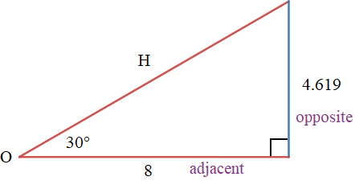
Note the word opposite appears on the side opposite
The given angle and the given angles point is labeled O.
The adjacent side is the side connected to the given angle.
The hypotenuse is labeled H.

There are many labeling conventions and I do not want to crowd the picture at this moment.

Solve for x using tangent:

Side opposite ∠O is given and the adjacent side unknown. If hypotenuse is not involved (not given or asked for) the ratio we use is tangent. Tangent is the same as slope from algebra. In this case and many more it will be useful to label the base x and the height y. Put simply we start at Point O and treat it like the origin from the unit circle. We travel from point O to the 90° vertex and then go up the vertical side stopping at its end point. This gives us a rise over run situation. The relationship is described using y/x. Tangent substitutes o/a for y/x so we can think of the adjacent side as a base x and the opposite side as a height of y in any situations regardless of orientation or rotation of the triangle. The solution:

tan(30°) = 6/x
(x)tan(30°) = 6
x = 6/tan(30°)
x ≈ 10.39

The method:

- Start by realizing the function needed
- Put in your given angle
- Then set to a ratio of the two sides you are working with

The solution shows the steps to achieve an answer written out the long algebraic way. For simple trig we realist that the equation is going to be and type it in the calculator to get an answer in one step. Mentally picture what the equation will look like in step one. If you are solving for x then the process is really to cross multiply. In other words take y and divide by func(θ°).

Recap
In the two examples we did we showed both versions of tangent. Either we are solving for x, or solving for y.
Solving for y is more direct because we simply multiply the length of the given side “x” with the tan function.
Compare the two versions and note the shortcuts:

Version 1 we are missing y. Multiply length × tan(30°)”
Version 2 we are missing the x. Divide length by tan(30°)”

Tangent is defined as opposite/adjacent so height/base is written as y/x. Tan(30°) = y/x is saying the ratio of y/x can be expressed as a number in degrees using the tangent function. We are using the tangent function because y/x is the ratio assigned to it. For example 60° creates a ratio of 3 sides as x:y:h = 1:√3:2. Hypo is 2 times longer than the base, the height is √3 times longer than the base. Dividing ^{height}/_{base} i.e. ^{y}/_{x} the x will cancel. Doing so we get a slope of √3 which is our tangent ratio. To convert slope to degrees we use the transpose of tangent.
Arctan(√3) = tan(60°) because arc function uses ratios and coverts them into degree notation, and functions use degrees and turn them into ratios. Note Ratios are fractions that once converted lose original values of y and x.

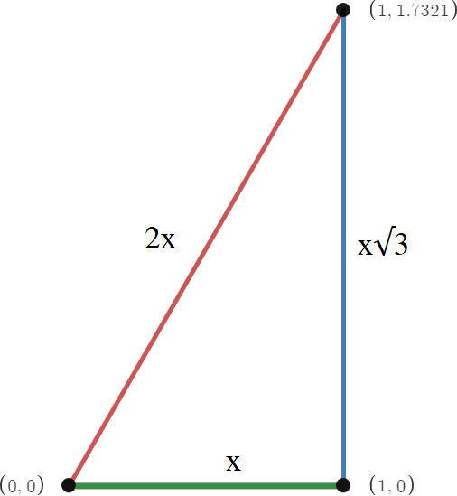
The angle at point (0,0):

arctan(√3) = 60°
arcsin(√3 ÷2) = 60°
arcos(½) = 60°

All three ratios give the same value of 60° for the angle at point (0,0). I am dividing a side by a side, getting a fraction that we will call a ratio, then using that fraction in an operation called a trigonometric function. The ratio was put into each of the three main trig functions and all three produced the same results. When you have all three sides you can use any trig function to check the validity of your angles but what we are most interested in is that if we have only two sides can we find the length of the missing side, or if we have one side and one angle as we have seen. We will also use these functions to find missing angles.

Solve for x using cosine:

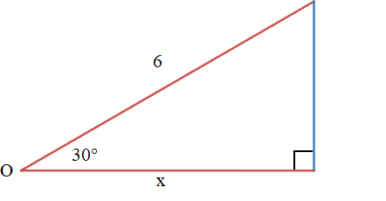

Use cosine when you have adjacent and hypo. The formula for cosine is cos = a/h. Here the hypo is 6 units long and adjacent side is x units long. x is unknown so solve it by creating a equation like we did before. In any situation you will have a function in degrees equal an inverse function in units. It will look something like this:

sin(10°) = arcsin(.1736) or cos(70°) = arccos(.342)

The solution:

- First identify the angle you are using
- Then identify the sides you are using
- Then identify the trig function you need
- Solve using the correct simplifications to isolate the variable on one side and constants on the other.

We are using 30°, hypo, and adjacent side. The hypo is unknown and we will solve it using the cosine function.
Cos(30°) =arccos(6/x) has x in the denominator again. We can solve this with a calculator:

- cos(put degrees in here°) = arccos(put a/h in here)
- cos(degrees°) = arccos(a/h)
- cos(30°) = arccos(x/x)

Type “ 6cos(30)” then press “ = ”. You should get 3√3 or 5.196152423. In trig we round to four digits so our answer will be given either a 3√3 or 5.196. Radicals are exact values and decimals are only approximations.

Here is the algebra by hand :

- cos(30) = x/6 multiply 6 to both sides to get it out of the denominator
- 6cos(30) = x multiplying canceled the division on the right side. Now x is isolated
- 5.196 ≈ x the adjacent side has a length of 5.196
That was when hypo was given. Next we we will at when adjacent is the given side.
This time the hypo is unknown so we will have to divide instead of multiply like we did last time.

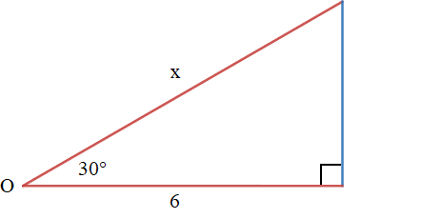
Cos(30) = a/h using cosine formula
cos(30) = 6/x using values of a and h
xcos(30) = 6 removing x from the denominator
x = 6/cos(30) isolating x
x = 4√3 or ≈ 6.928 simplifying our answer

Dividing by cosine is the same as multiplying by its reciprocal secant written as sec or 1/cos

This works because of many factors but mostly in that we are harnessing the powers of reciprocals and the flip and multiply rule when dividing by fractions. So far we have covered two of the three main trig functions tan, and cos. The last function sin will be similar in that for both tan and cos we had to choices for where the x would be, either in the numerator or the denominator.

When x is in the numerator just multiply the trig function with the given side.
When x is in the denominator divide the given side by the trig function.

Solve for x using sine:

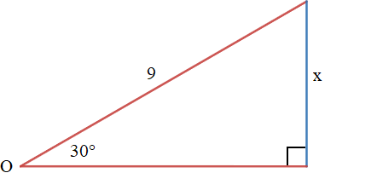
Solution when x is height:

x = 9sin(30)
x = 4.5

Method: Use sine

Note that we are asked to solve x and that x is opposite the given angle. We are also given the hypotenuse as being length 9. We can write this using a trig function.

Our Output = Our Input This is the definition of a function.
f(x) = some x This is function notation.
sine = oppo/hypo This is the definition of the sine function.
sin(30) = o/h Abbreviate sine as sin then write the degree of the of the angle.
sin(30) = x/9 This is the equivalence statement of the degree equaling the ratio.

After showing all the necessary definitions of function and notation we learn to start at the equivalence statement. The equivalence statement writes an equation showing what the degree of an angle equals when written as a side divided by another side.

sin(30) = x/9 We start here when solving for x. This is our trig function set to our trig ratio.
9sin(30) = x We isolate x by multiplying both sides by the denominator when x is the numerator.
4.5 = x Solving shows that x is 4.5 units long. The height is 4.5 units long.

Solution when x is hypo use sine:

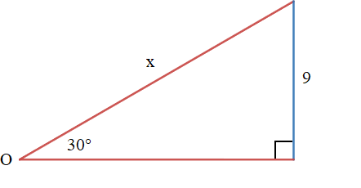
x = 9/sin(30)
x = 18

Ask what sides and info do we have? We have an angle of 30° (and 90°) and a two sides: side 9 and side x.
We are asked to solve for the length of x. Think about what trig function (sin, cos, or tan) we need to use.

- Use sine if the two sides are opposite and hypotenuse then write as º/_{h}.
- Use cosine if the two sides are adjacent and hypotenuse then write as ª/_{h}.
- Use tangent if the two sides are opposite and adjacent then write as º/_{a}.

Since we have a hypotenuse side and opposite side we must use sine. We have to plug in values of 9 and x for º/_{h}. We get º/_{h} = ⁹/_{x}. ⁹/_{x} means we have a height of 9 but unknown for hypotenuse. ⁹/_{x} is called a trig ratio. A ratio is the other way of writing a trig function. Trig ratios and trig functions are different but they both equal the same value. It would be wrong to use the terms interchangeably. Example: ²/₁₀ = 0.2 but 0.2 is a decimal not a fraction.
The process is to write an equation with the function on one side and the ratio on the other.

- If two sides are o and h then either ^{x}/_{h} or º/_{x}. Use sine sin(Θ) = ^{x}/_{h} or º/_{x}
- If two sides are a and h then either ^{x}/_{h} or ª/_{x}. Use sine cos(Θ) = ^{x}/_{h} or ª/_{x}
- If two sides are o and a then either ^{x}/_{a} or º/_{x}. Use sine sin(Θ) = ^{x}/_{h} or º/_{x}

Fact: Each trig function uses two sides.
Assumption: You will have one known and two unknown but you are asked to solve only one.
Fact: If all sides are known then you need to solve an angle
Fact: The trig function you use to solve will be either sin,cos, or tan.
Fact: Trig functions equate a degree to a ratio.
Fact: If we have to solve a missing side our ratio will include two sides being divided.

- We can assume that “x” will be either our numerator or denominator.
- From that assumption we know that our equation either ^{x}/_{given side} or ^{given side}/_{x} .
- We have two possible choices for our ratio: ^{x}/_{given side} or ^{given side}/_{x} .
- We know we only have three choices for choice of function.
- Choose the correct function then choose your ratio.
- We have choice of function(given angle) = ^{x}/_{given side} or ^{given side}/_{x}.
- The choice of function depends on what sides are used.
- Whether x is the numerator or the denominator depends on what function we are using and how.

If x is the numerator then direct multiplication is used to isolate and solve.
If x is the denominator then indirect multiplication is used to isolate and solve.
Indirect multiplication is a terse way of saying divide by the reciprocal.

X as numerator then solution is: x = givenside∙f(x)
X as denominator then solution is: x = givenside/f(x)
Trig func(given angle) where trig func is choice of function written as “trig f(x)” or simply (f(x)” for brevity.

The extended explanation for solving ratios for missing lengths:

Sin(30) = ½ The function is sin(30) and the ratio is ½ or 2:1

½ as a fraction is easy to deal with but the values we deal with in trig are irrational and must approximated decimally. Calculators will take what we give them and give back a decimal as a answer. We write these decimals to 4 digits because that is very accurate in estimating distances.
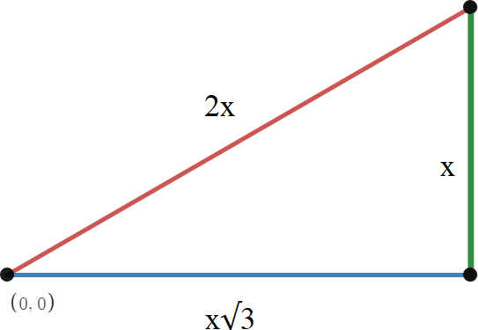

Here is a 30:60:90 triangle with ratios for sides lengths shown.
Ratios state the length of sides as a percentage of the hypotenuse.
This shows every side scaled by 2 for convenience.
Technically it should be ½:^{√3}/₂:1.

The hypotenuse is shown as 2x meaning it is twice as long as the height.
The base is shown as x√3 meaning it is √3 times the height.

A good understanding of radicals and percentages is required for trigonometry. A radical is a term that has been rooted. In general all radicals of non square numbers are irrational. Irrational means they can not be written as a ratio of two integers. The irrationals have never ending digits without an obvious pattern. Fractions that repeat with a pattern are called rational fractions because they can be written with two integers such as ⅓ or ⅐ despite their intimidating decimal length. The goal is to educate so people are not intimidated by these numbers and can approach them confidently and solve problems fast. x is written in front of the number so that we can scale it. This variable is called the scale factor. Trig uses a lot of scaling and the decimals a calculator gives is the scaled numbers of the ratios. If we divide all sides by 2x the hypotenuse will just be 1.

We want to factor out this scale factor and x so that we have the smallest numbers for each side.
We want to make the hypotenuse equal 1 because the hypotenuse is the longest side of a triangle.
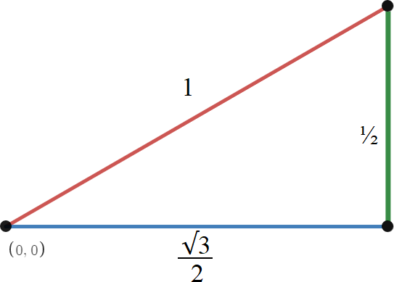

2x ÷ 2x = 1
x ÷ 2x = ½
x√3 ÷ 2x = ^{√3}/₂

- When the hypotenuse equals 1 all other sides must be less then 1.
- This sets up comparisons of length of the base or height to the hypotenuse.
- This comparison shows how long each side is as a percentage.
- This percentage and others are what our trig ratios are.
- A calculator will show the ratios as a percentage of the hypotenuse length.
- Sin(30) = ½ because the hypotenuse has a length of 1 and the height has a length of 0.5.
- ½ as a ratio means 50% as long as the hypotenuse.
We cut values to 4 digits because we want a percentage that looks like 57.74% instead of 57.73502692%.
The number will go on forever so we round the percentage to the nearest¹/₁₀₀ of a percent. We call them trig ratios but it would be more accurate to call them trig percentages. Mainstream math uses different descriptions for nuance depending on the context of the moment while I strive for more consistency. I am showing triangles that are right angle only and have a base that is horizontal for easy explanations. These are contrived triangles that are rather easy. It is lazy to think of cos and sine as the base and height but for simple problems it makes explanations easy. Later these descriptions will be misleading and hurt rather than help.

In this real life example it is hard to see what the base and height are but sin and cos for each angle are clearly defined. Even an isosceles triangle causes problem because height of the triangle is not side length.

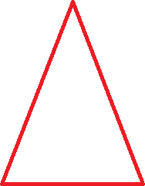
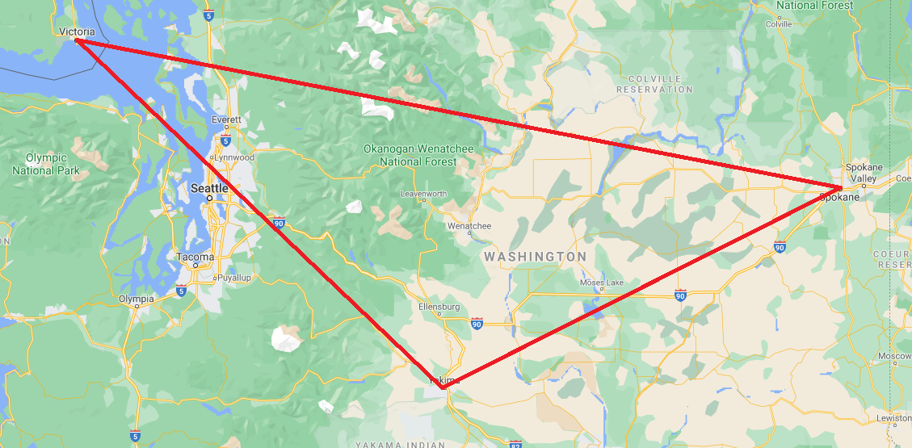

The three sides of a 30:60:90 have ratios of ½ :^{√3}/₂:1 written as decimals they are .5:0.866:1.

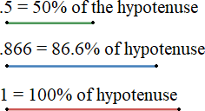

Take apart the triangle and arrange them by length as shown. These are the three lengths and their decimal and percentage conversions. In trig we are taking two side lengths, comparing them as a ratio, writing this ratio as a fraction, taking this fraction and converting it to a decimal, then reading this decimal as a percentage or at least mentally thinking of it as a percentage. Statistics use percentages heavily and trig is the prerequisite because you are supposed to have mastered percentages in trig. If you are not thinking of trig this way statistics will be harder or avoided altogether. This leads to politicians and their staffers making heavy use of statistics in hopes their audience is ignorant of foundational math. They will lie using statistics and those with math we be masters and those without it will be slaves. Its that important.
Theta θ° is used for unknown degrees. I am going to use it here because I want to use x for cosine and y for sine. Understand with non-right angle triangles using x and y is less intuitive than it is for right angle triangles because base and height do not directly apply as side lengths.

Key points:

- functions
- inverse functions
- understanding the complete definition of function, ratio, and theta
- converting a ratio to a fraction to a decimal to a percentage
- understanding percentages as a ratio decimal and as a geometric drawing using three lines
- understanding how to not only use a calculator but also its results
- solve for a missing side or angle using trig functions
- unit circle and scale factors

Real number: Numbers with a zero imaginary component. All numbers excluding complex numbers.
Complex number: Any real number whose imaginary component is nonzero. “x + bi” where x is a real number.
x-axis: The number line for all real numbers.
y-axis: A number line rotated 90° at the origin for any 2d graphing system.
z-axis: A number line 90° orthogonal to both the x and y axes at the origin for any 3d graphing system.
i-axis: A number line 90° to the real number line of i numbers. The real axis and it make the complex plane.
t-axis: A number line denoting time used in physics.
xy plane: Regular graphing using the Cartesian plane. The x and y axes meet at 90° at the origin point of (0,0).
xz plane: Regular graphing using the Cartesian plane. The x and z axes meet at 90° at the origin point of (0,0).
yz plane: Regular graphing using the Cartesian plane. The x and y axes meet at 90° at the origin point of (0,0).

Unit square: A square of diameter 2 placed about the origin. It is a square enclosing the unit circle.
Unit circle: Graphing trig functions in a circle of diameter 2. It is the circle inscribed inside the unit square.
Unit cube: 3d physical representation of the 3 2d planes. It has three axes x:y:z and the center is located at 0:0:0.
Unit sphere: A sphere inscribed inside the unit cube.

Median: The line from a corner to the midpoint of the opposite side.
Centroid: Where three medians meet. It is ⅔ from vertex to side.
Bisector: A line that divides an angle or line equally in two.
Perpendicular Bisector: A median in a 90° triangle. Three perpendicular bisectors meet at the circumcenter.
Angle Bisector: A line that divides an angle equally. Angle bisectors meet at the incenter.
Inscribed: The circle in a polygon.
Inradius: The radius of the inscribed circle.
Incenter: Equidistant from the three sides. It is the center of an incircle and where the angle bisectors meet.
Incircle: The circle inside a triangle that touches each side once.
Circumscribed: The circle around a polygon.
Circumradius: The radius of the circumscribed circle.
Circumcircle: Circle around a triangle. Any three points on a circle form a △ with the circle its circumcircle.
Circumcenter: Where all three ≅ medians meet. It is inside an acute△, outside an obtuse△, and on hypo of a ∟△. It is equidistant from the vertices.

Midsegment: Line connecting two midpoints of two sides.
Triangle Midsegment Theorem: The midsegment is parallel to one side and equal to two segments.
Altitude: Line from vertex to opposite side making a 90° angle. It is the height of a △ also the sine of opposite ∠.
Orthocenter: Where three altitudes meet.
Tangent is the same as slope from linear equations from algebra. You divide the height by the base. If a triangle has a 90° made of a horizontal line on the x axis and a vertical line a connection between y = mx + b and triangles can be made. If x is the base then y is the height. Them y/x is slope. We call slope m in y = mx + b but call slope tangent in a right triangle. There are some slight differences but is mostly interchangeable.
Difference between trig functions and trig ratios

Functions and ratios are said to be equal but this causes some confusion. While they do equal each other they need to be defined separately so you know which one is which and they operate. Each function has a matching ratio and each ratio has a matching function. A trig function takes your given angle and converts it to a ratio. The given angle is the input and the ratio is the output. The output is represented as a decimal approximation or a fraction or a radical term.

A trig ratio is a fraction made by dividing one side by another side. Hence side a/side b would be a ratio.
The ratio needs to be converted into an angle in degrees. To do so you need to use and arc function. An arc function is the inverse function of a trig function. Inverse functions invert a process to achieve an answer. The comparison is that every operation in math has an inverse operation. Add and subtract, multiply and divide, power and root are inverse operations of each other. An inverse reverse the operation to arrive back at the value you started with or moves forward to the value you want. The regular functions sin, cos, and tan have the inverses arcsin, arccos, and arctan.

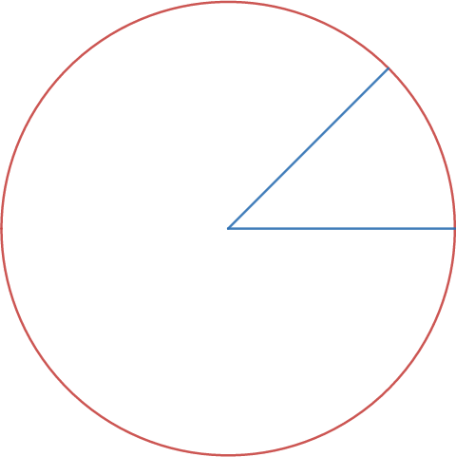
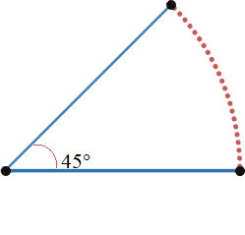

Angles are based on how much one line is rotated from another inside a circle. Circles have 360° and so an angle is based on how much of the circle the angle lines are rotated from each other in the circle. A circles width is called the diameter. Half of the diameter is called the radius. The radius is the line segment from the center of the circle to any point on the circle. The angle shown has two blue segments. The first is at 0° on the circle and the other is at 45° making the angle 45°.

The picture on the left shows a circle with a shape called a sector in it. The picture on the right shows the sector as an angle with a red dotted curve called an arc. The two blue lines are both the same length so are both radii. In geometry this is called being 1 radian long. The point they share is called a vertex. The arc measures the distance from the radii endpoints. This distance is used to calculate the angle in either degrees or radians of the angle at the vertex.

A calculator uses arc functions to turn ratios into degrees, and uses regular functions to turn degrees into ratios.
This helps us find unknown angles or side lengths. A function is written with f(x) = y and an inverse function is written f⁻¹(x) = y.

Trig inverse functions are often written as sin⁻¹, cos⁻¹, and tan⁻¹. This is common on most calculators but it takes away from the understanding of arcs as the reason for the angle and people complain is confusing because it implies a different kind of inverse called a multiplicative inverse which is the reciprocal.

Unit circle

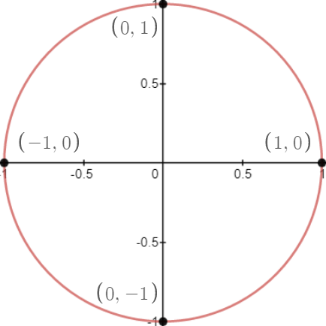
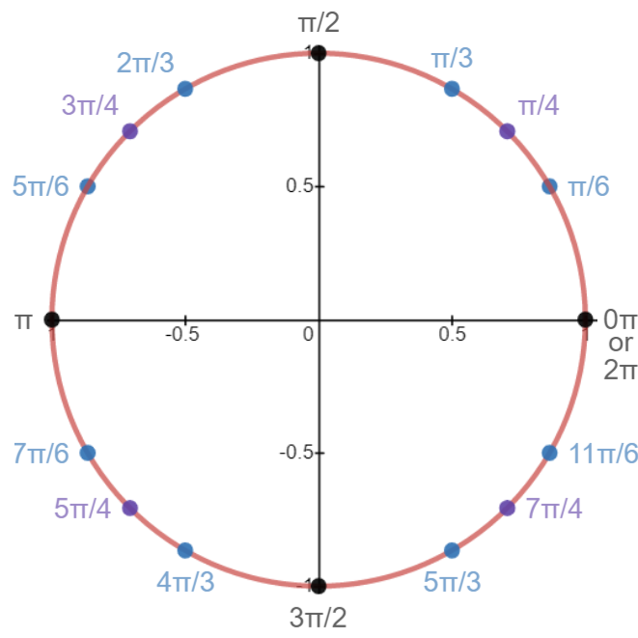

The unit circle has a radius of 1. Unit is synonymous with 1. The diameter of a circle is two radians so it is 2 units. Measuring lengths of the unit circle is done in radians where 1 rad is the length of 1 radius. The center is called the origin and is labeled with O. Its coordinates are (0,0). The four points shown are the specials 90° angle points that locate the x and y axes. These points are called quadrantals. The area between them is the four quadrants. Graphing is similar to Cartesian graphing. Pay special attention to the coordinates of the four quadrantals.

The unit circle is measured in radians also called pi radians. It uses the Greek letter π. Pi is the ratio of circumference/diameter. This means that every circle's circumference divided by its diameter equals pi. This is true for every circle as long as it is perfectly round. If it is not perfect then its ratio will be very close to π. Pi is an irrational number. Its digits go on forever. Writing pi as π saves space. When we need to use a decimal approximation we use 3.141592. Since every circles circum/dia ratio equals π we can express any circles circumference as 2πr. 2πr is the formula for the circumference of a circle. It can also be written as dπ for diameter times pi since 2∙radius = diameter.

When numbers like π are found they are called universal constants or transcendentals. A transcendental is some number that always has the same value. A normal constant would be a real number like 2 or 17. Transcendentals are constants that always has the same value like 2 is always 2 and 17 is always 17 but appears in nature like the speed of light and the gravitational constant. We use these constants in physics and other formulas.

A circle has circumference for the distance around it, diameter for the width of it and radius for the center of the circle to any point on the circle. The formula for area of a circle is πr². Because of these facts the unit circle is labeled with points using pi notation. The diameter of the unit circle is 2 radians, if you look it makes sense. From ( –1,0) to (0,0) is one radius long, which is halfway, and from (0,0) to (1,0) is another radius long. This makes 2 radians or 2rad for short. We can not do trig or calculus without radians so we are introducing it here even if we do most of our work in degrees in the beginning. Your calculator has three angle modes, degrees radians, and gradians. The screen of your calculator will show a tiny d,r, or g letting you know what mode you are in. Look at your screen to see what mode you are in. If you are in the wrong mode you will get your answer in the wrong units.

Degrees, Radians, and Gradians are all units for circular length. Degrees are the most familiar and are based on the base 60 system used by the Babylonians. The made this system to measure time and had 60 seconds in a minute, 60 minutes in an hour and 24 hours in a day. They also had 360 days in a year with a leap week every 7 years. The divided circles into 360° because they used this system to chart things like the sun. For comparison at dawn the sun is at 0° to the horizon, at noon it is at 90°, and at sunset it is at 180°. Midnight would be 270° and next dawn would be 360° a full day. Notice 0° and 360° is the same point on the unit circle.

A protractor is a tool used to make angles. It is a half circle or 180°. The unit circle is a circular distance of 2π units long so half of the unit circle is π units long. We say pi units long in radians. I already said π ≈ 3.14 so for the unit circle 2π would be about 6.28 radians, and π would be about 3.14 radians.

The unit circle is: 2rad across, 6.28rad around, and 3.14rad around from 0° to 180°.
If the unit circle is 2π for its circumference the half of that, 1π, would be halfway around.
A full circle is 360° a half circle is 180°.
π on the unit circle is 180°, 2π is 0°.

Notice that π is labeled at the 180° point on the circle. This is important and confusing. π on the unit circle is both 180° and 3.14.The point of using π is to simply engineering problems that involve circular rotation like gears and engines. The chart can be memorized or calculated but it is important to understand what π is and why it is used first. Many people do not understand π or where given sloppy explanations so avoid trying to use it outside of basic area formulas. Measure any circles circumference. Then measure its diameter. The divide the circumference by the diameter and the ratio will always equal close to 3.141592... we call this number π. In reality circular things are not perfectly circular so you get numbers that are not quite π due to being natural items or made imprecisely.

A radius is half a diameter. A radius is from the center to any point on the circle. The length of 1 radius is called a radian. The unit circle has a diameter of 2 units. We can these units radians so it has a diameter of 2 radians. The distance around the unit circle is 2π radians. π≈ 3.14 so 2π radians is ≈ 6.28 radians. This means that it takes 2 radius lengths to go straight across the circle and 6.28 radius lengths to go around the circle if traveling on the red curve.

Different circles are NOT the unit circle. They have different lengths and different circumferences. This is confusing. If I measure a circle that is 8 inches across then it has a diameter of 8”. inches are a different unit than radians. If I put 8” into my formula for circumference it will say 8π ≈ 25.13”. But that same 8” diameter circle still has a diameter of 2 radians and a circumference of 6.28 radians:

8π” ≈ 25.13274123” about 25 inches
8π”/4” ≈ 2π
2π ≈ 6.283185307 about 6.28 radians

This is weird but divide eight pi inches by four inches canceling the unit “inches” and makes the unit “radians”.

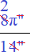
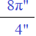
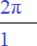

Units cancel when converting from one unit system to another. Same thing happens with feet and inches. Although the way its taught most conversions are done mentally or written sloppily so that the canceling of units is obscured. When you cancel your “real” units you are left with a “natural” unit, which here are radians.
Let's see that one more time but use the standard formula 2πr.

2πr = Circumference The standard formula is written 2 ∙ π ∙ radius
2π4” = C The radius of an 8” diameter circle is 4”
8π” = C Multiply the constants, meaning 2∙4”
25.13” ≈ C Multiply the diameter with pi
25.13”/r” = radians Divide by the radius to get radians
2π = 6.28 radians Dividing by radius in inches canceled the unit and reduce 8 to 2

Canceling the man-made unit of inches left the natural unit radians. This is the concept and key point of radians. It also shows science related applications where in physics there are bizarre units like foot-pound and pound-foot that need to be canceled. Not important now but to illustrate the bizareness a foot-pound is NOT a pound-foot. They measure different things. One measures torque the other measures work. Torque is circular force and work is linear force.

The unit circle has special points called special values. The special values are multiples of 30° and 45°.
We draw a line from the center of the circle to one of these points on the unit circle. When we do the angle made with the x axis and the line we drew is called a special angle. These are radical terms. In the beginning we deal with only the 3 in the first quadrant. Of all the terms the only radicals are √3 ÷ 2 and √2 ÷2. It is best to memorized 4 numbers. First memorize √2 and √3. The memorize what they are when divided by 2.

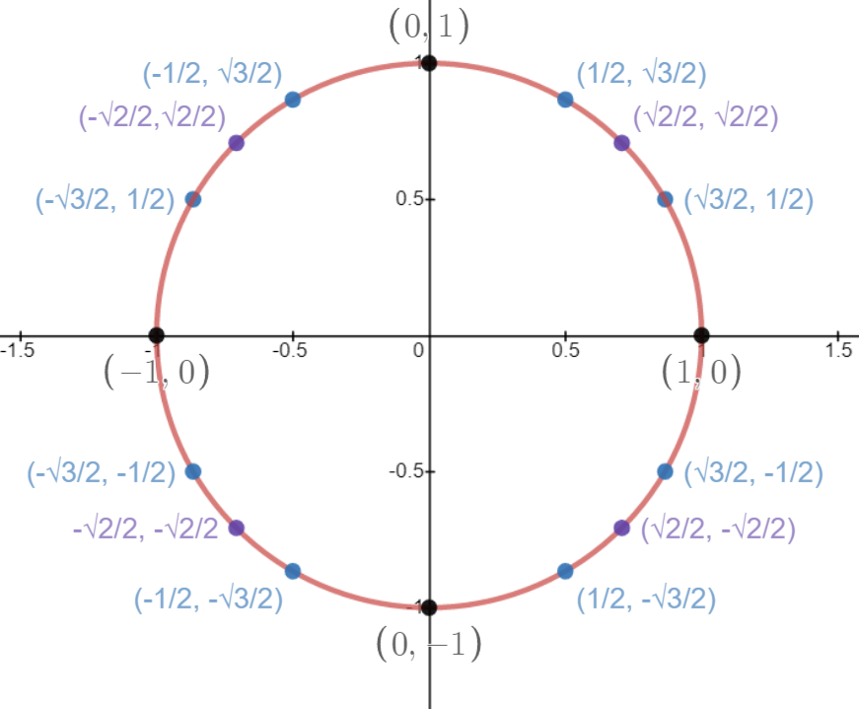
√3 = 1.732050 ^{√3}/₂ = 0.866025
√2 = 1.414213 ^{√2}/₂ = 0.707106

Use a calculator to check these numbers are right. They by hand do long division of 1.732050 and 1.414213 by 2 and then at a later time practice multiplying 0.707106 and 0.866025 by 2. Because the number is a decimal approximation the least significant digit will be incorrect but all the ones before it will be accurate. You can approximate a root or π to as many digits of accuracy as you want but trig only uses 4 digits. 6 digits is enough to model the entire universe to 1 trillionth of an inch so accuracy is not really a concern.

When using a calculator use exact values. The purpose of practicing by hand is to learn through practice what the approximations are and to understand the concepts of least significant digit and suitable precision. Will experience you will have enough memory to know what the numbers are and what approximations are used where.

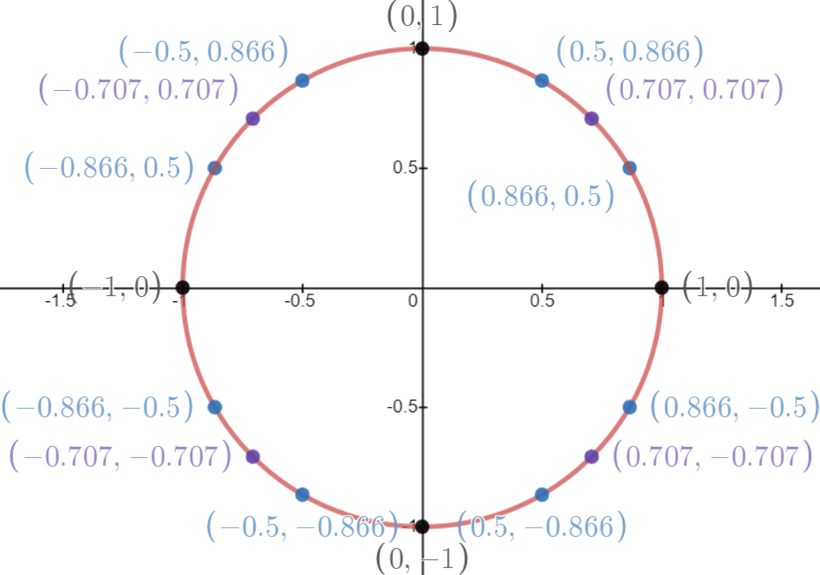

This shows the decimal approximations. Decimal approximations are not recommended because they are messy and complicate equations. This is shown to illustrate that the numbers are repeated throughout so knowing the decimal approximations gives a good idea of what numbers to expect and how to train to spot familiar numbers when they appear in problems or as answers. This builds a further understanding of higher math. There are tricks to memorize or calculate what an angle is but for the most part rely on your calculator. After doing many problems dealing with polygons 30° and 45° angles will be very familiar.

In the unit circle an angle is made with two radii. This differs from general geometry that will tell you that an angle is made from two rays. One radius extends from the center to 0°, we call this radius the co-terminal radius. The other radius extends from the center to an arbitrary point on the circle, we can this radius the terminal radius. For now just realize that they are two segments of equal length touching the circle with the origin as their vertex.

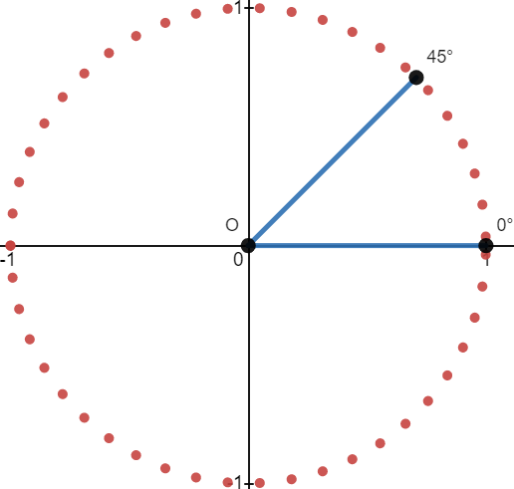

This is an angle of 45°. It is halfway between 0° and 90°. Incidentally this is the same slope as the algebra function f(x) = x. There are 360° in a circle. 45° is ⅛ of a circle. We take a circle to be 2π radians, divided by 8 we get

2π/8 = π/4 2π/8 = ¼ ∙ π

And so 45° is written as ^{π}/₄ . This means that the length of the circular arc is π/4 radians long which is 3.14/4 or approximately 0.7854. We are not interested in approximations so we give π/4 as our answer. It is easier and looks better but also is the full value and not a cut off approximation. If we had a word problem it would be something like: A circle has a diameter 2 miles long. The radius of the circle is 1 mile long. How long, in miles is a 45° arc on the circles circumference? The answer would be π/4 miles to be exact or 0.7854 miles if a decimal number was needed. To covert to feet multiply by 5,280 feet in a mile: 0.7854m ∙5280' ≈ 4146.9''.

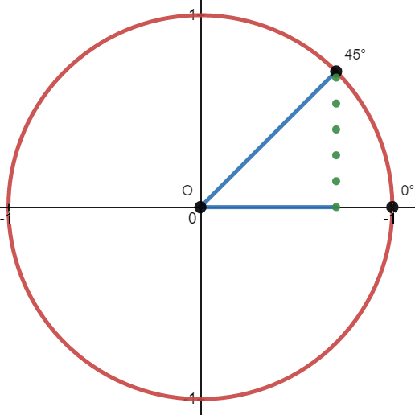

The angle is given by the blue radial lines but the distance we are measuring is the length of the red dotted circle.
Here is a technique called dropping a perpendicular line to the x-axis. This line becomes the height of a triangle made with the blue radial lines. We call this perpendicular line the sine of the angle. Technically this is an imaginary line so an imaginary triangle but that is a bit fussy. None the less the sine is dotted meaning not really there. The base of this triangle is called the cosine of the angle. The hypotenuse of this triangle is called the radius of the triangle. We have three lines for our triangle cos, sin, and radius. Both blue lines started the same length but now the sine has cut the 0° blue line shorter. A right angle is formed with the cosine and the sine, Let us can this vertex point C or angle C.

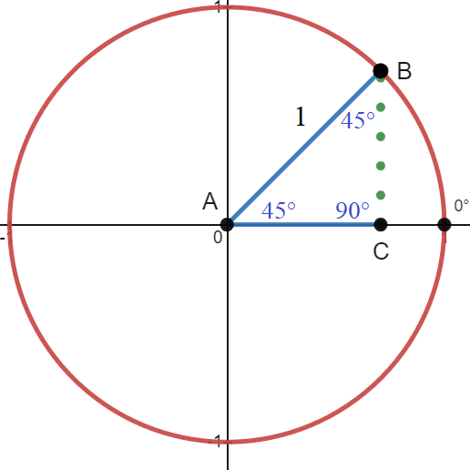

A right triangle has the hypotenuse as its longest side. Inside the unit circle the longest side is always the radius so we can think of the radius as a hypotenuse. We can label the triangle ABC or we can label it ORC or ORX. ABC is straightforward and best. ORC is saying origin:radius endpoint:90° ORX is saying origin:radius endpoint:x for where the sine intercepts the x-axis. The are reasons for all and many other ways to label including α,ß,Γ but I am going to keep it simple and use ABC. All triangles have 180°, in fact it is a rule called the 180° rule. A 90° triangle has one angle that is 90 so the other two must add to 90°. This is called the 90° complementary rule. We know the angle at the origin is 45° so the angle at point B must be 45°. If the radius is 1 and the angles are 45° and 90°, what is the base and height of the triangle? We should use a trig function for this.
Lets find the base first using cosine. First setup our function:

cos(θ) = ? we are asked to input a degree for cos
cos(45) = ? we input 45°
cos(45) = ^{√2}/₂ we are told cosine of 45° equals root 2 over 2
^{√2}/₂ ≈ 0.7071 we are told √2/2 is approximately 0.7071

So now we know the base is 0.7071 radians long. Without using a man made unit the units of length in the circle are always radians even if we are using degree mode on our calculator. If that seems weird ask yourself,
“What is the length of a radius in degree mode?”. The length of a radius is the length of a radius. Radius mode if for giving the angle in radians but some peculiarities do arise.

Lets find the height next using sine:

sin(θ) = ? we are asked to input a degree for sin
sin(45) = ? we input 45°
sin(45) = ^{√2}/₂ we are told sine of 45° equals root 2 over 2
^{√2}/₂ ≈ 0.7071 we are told √2/2 is approximately 0.7071

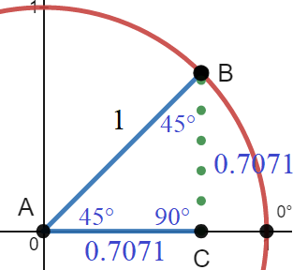

They are the same! We can use this information to write the co-ordinate of the point as (^{√2}/₂ ,^{√2}/₂ ) which is what is shown on the unit circle picture from before. We have a triangle that is base:height:hypotenuse ratio of ^{√2}/₂ :^{√2}/₂ :1. These three numbers are called the ratio of our triangle. A bit cluttered but we can see the side lengths written in.

To recap:

- Are angles are 45°:45°:90°
- The sides opposite the angles have length ^{√2}/₂ :^{√2}/₂ :1.
- The decimal approx. to 4 digit is 0.7071.
- The hypotenuse is 1 radian long, the other two sides are 0.7071 radians long.

When you have two sides that are the same length you have an isosceles triangle. We have two sides that are the same length and a 90° angle so we have a 90° isosceles. This is the most special right triangle because most right triangles are scalene. Scalene triangles have 3 sides that are different lengths. When you have two sides the same length you will also get two angles that are the same measure. We know all 3 sides and 3 angles so we have solved this triangle. Knowing all angles and sides is called solving a triangle. Even thought the triangle is solved let's find the ratios using the side lengths now that we know them.

Angle | Sine | Cosine | Tangent
∠A | ^{√2}/₂ /1 = ^{√2}/₂ ≈ 0.7071 | ^{√2}/₂ /1 = ^{√2}/₂ ≈ 0.7071 | ^{√2}/₂ /^{√2}/₂ = 1
∠B | ^{√2}/₂ /1 = ^{√2}/₂ ≈ 0.7071 | ^{√2}/₂ /1 = ^{√2}/₂ ≈ 0.7071 | ^{√2}/₂ /^{√2}/₂ = 1
∠C | 1/1 = 1 | N/a | N/a

This interesting thing here is that sine and cosine do not change because we are dividing them by the length of the radius which is always 1 in the unit circle. Other circles can have any length radius because they can have larger or smaller diameters but the unit circle is fixed so that the radius is 1. This is so we can read sin and cosine as the base and height directly to make scaling easier. “Fixed” is a term that means setting the value artificially similar to the stock market where prices are “fixed” like gold prices or other commodities. Price fixing is done so that price does not fluctuate wildly thus creating a fair standard and expectation of exchange.

Lets see what degree and radian mode does on our calculator. First degree mode:
Sin(45) = √2/2 This tells us that a ∠45° has a height of √2/2 in the unit circle.
cos(45) = √2/2 This tells us that a ∠45° has a base of √2/2 in the unit circle.
Tan(45) = 1 This tells us that the slope of a ∠45° is 1 creating the equation y = x or f(x) = x

sin⁻¹(√2/2) = 45 This tell us that a ratio of √2/2 (√2/2 divided by 1) is made from a ∠45°
cos⁻¹(√2/2) = 45 This tell us that a ratio of √2/2 (√2/2 divided by 1) is made from a ∠45°
tan⁻¹(√2/2) = 45 This tell us that a slope of √2/2 divided √2/2 is made from a ∠45°

The function coverts the angle we type into a ratio. If we need to find a missing side we need a main function.
The anti functions covert a ratio into a degree. If we need to know an angle is we need to use an anti function.

In Radian mode

Degree mode was giving us right angle trigonometry conversions. Radian mode is going to walk us around the circle and tell us how long a curved distance is. Set mode to radian. We can not use the “degree” of an angle here so be patient. Start with the inverse function first. Lets use arcsin.

sin⁻¹(ratio) = radian length this is asking us to use a sin ratio to find length of the curve
sin⁻¹(√2/2) = radian length we used the sin ratio we know from 45°
sin⁻¹(√2/2) ≈ 0.7854rad this tells us the curved length in the unit circle from 0° to 45° is 0.7854rad

cos⁻¹(ratio) = radian length this is asking us to use a sin ratio to find length of the curve
cos⁻¹(√2/2) = radian length we used the sin ratio we know from 45°
cos⁻¹(√2/2) ≈ 0.7854rad this tells us the curved length in the unit circle from 0° to 45° is 0.7854rad

tan⁻¹(ratio) = radian length this is asking us to use a tan ratio to find length of the curve
tan⁻¹(1) = radian length we used the tan ratio we know from 45°
tan⁻¹(1) ≈ 0.7854rad this tells us the curved length in the unit circle from 0° to 45° is 0.7854rad

Okay that worked. The length from 0° to 45° is 0.7854 radians. We are learning how to find the distance of curves using radian mode. Lets think about what a radian length is, in pi units, on the unit circle. The Greeks wondered about the circumference and diameter of a circle. They did drew circles, then labeled 3 points on the circle and connected them to form a triangle. As such they used a diameter of 1 whereas we are using a diameter of 2. They would measure a circumference then divide it by the diameter. Every time they did this they got the same number 3.141592... they got this number for every circle they tried. Finally they accepted it as a fact and began creating formulas we know today.

With a diameter of 1 they would have circum/diameter = π making circum/1 = π. The circumference of their circle was 3.1415. We have a diameter of 2 so our circumference is twice that at 6.283. The unit circle we have is diameter 2 and circumference 2π. 2π ≈ 6.283.

Going around our circle once is a distance of 2π radians. 2π ≈ 6.283
Going around ½ the unit circle is a distance of π radians. 2π ≈ 3.141592
Going around ¼ our circle is a distance of π/2 radians. π/2 ≈ 1.571
Going around ⅛ our circle is a distance of π/4 radians. π/4 ≈ 0.7854
Standing still at 0° is a distance 0π radians. 0/π ≈ 0 radians

We could make some comparisons and conversions. Our circle is a round distance of 2π, which correlates to 360° which is a curved length of 6.283 radians. Then half of 2π is π. So π must be 180° or a half circle and also a curved distance of 3.1415 radians. We can make all the divisions we want but this is a lot of material to take in for such a short period of time. We are in radian mode and radians does not really consider the degree of an angle but rather the length of arc made by our two radius segments. We are making an arc by taking two segments of equal length and spreading them rotationally.

Think about two segments of equal length attached at one end and free at the other. What happens when you rotate one counterclockwise? The same as when you draw with a compass, you make a curved arc.
The change in thinking is we are not making an angle, we are making an arc. If you walk around a lake you are not thinking about your angle to the lake you are thinking about how far is the curved path you just walked. We are not solving an angle problem but rather a distance problem. Our diameter is 2 giving us a circumference of 2π.

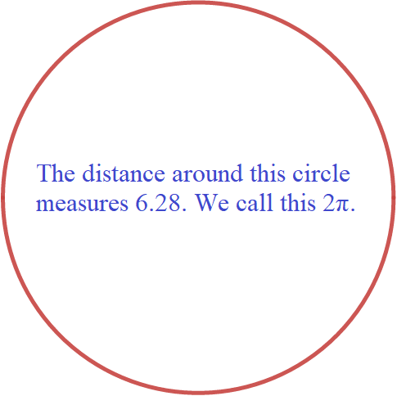
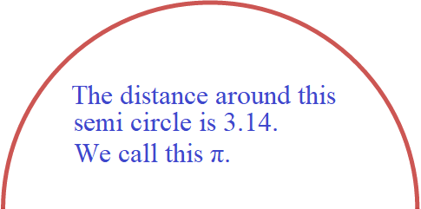
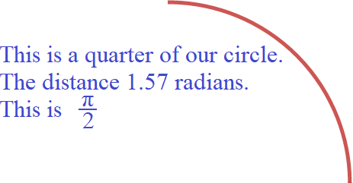
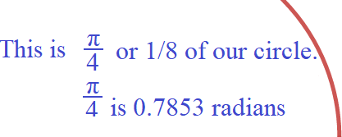

Pi equals approximately 3.14. So you use 3.14 for pi and either divide or multiply just like you would any other number. The units we use is radians. Our circle 2π so 2π is 6.28 radians long. Half our circle is π so the distance of half our circle is 3.14 radians. π is equal to almost 3.14. If I have 2 of them my distance is 6.28 units. 2π = 2∙ π = 2∙ 3.14 = 6.28 radians. A semi circle is half of a circle. My circle is 2π around so half of my circle is only 1 pi or just π. π is a distance of 3.14 units, π =3.14 radians. A quarter circle is ¼ of a circle. I now have half of π so I write it as a fraction indicating division. Half of pi is π/2 = 3.14/2 = 1.57 radians. This is π/4 is 3.14/4 which is 0.7854 radians.

We want to draw arcs starting at the 0° point on the unit circle and extend them as far as we need to. We use the chart written in pi to tell use the special points where multiples of 30° and 45° are. This chart serves as a guide but we are not concerned with the actual degrees of the arc and will have unique arc lengths not given by these special labeled points.

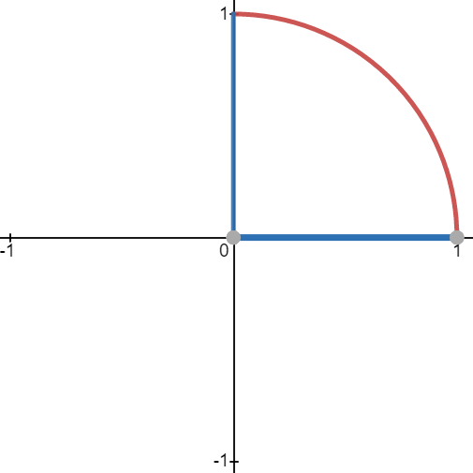
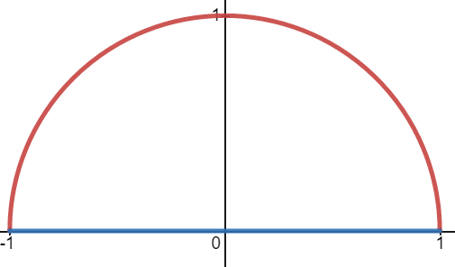

A 90° arc made by 2 radii. The end point is at (0,1) the 90° graduation. When rotated 90° the radii travel the path of the red arc. This length is 1.57 radians in the unit circle, Unless stated otherwise all lengths are based on the unit circle. Different circles will have different lengths as we will see. When two radii are rotated 180° the terminal radius touches (– 1,0). The terminal radius is the one traveling away from 0° and the radius fixed at 0° is called co-terminal. A 180° angle is called a straight line. Technically all lines are straight and it is curves that have bend. The point the terminal radius locates is called the terminal point. To terminate something means to end or make a connection. 180° is 3.14 radians.

To convert degrees into radians multiply by π/180°.

360π°/180° = 2π These four are the boundaries of the four quadrants called ∠90°
270π°/180° = 3π/2
180π°/180° = π
90π°/180° = π/2

45π°/180° = π/4 These are the 45° angles called miter angles.
135π°/180° = 3π/4
225π°/180° = 5π/4
315π°/180° = 7π/4

30π°/180° = π/6 These are the 30° multiples
60π°/180° = π/3
20π°/180° = 2π/3 120° is a ⅓ of a circle or 2π/3 radians.
150π°/180° = 5π/6 π/6 + 2π/3
210π°/180° = 7π/6 π + π/6
240π°/180° = 4π/3
300π°/180° = 5π/3
330π°/180° = 11π/6

To convert from radians to degrees multiply 180°/π. This reverses what we just did so is an inverse operation.
When dividing for conversions write units and cancel them if required.

From before using inverse functions:

sin⁻¹(ratio) = radian length This is asking us to use a sin ratio to find length of the curve.
sin⁻¹(√2/2) = radian length We used the sin ratio we know from 45°.
sin⁻¹(√2/2) ≈ 0.7854rad This tells us the curved length in the unit circle from 0° to 45° is 0.7854rad.

cos⁻¹(ratio) = radian length This is asking us to use a sin ratio to find length of the curve.
cos⁻¹(√2/2) = radian length We used the sin ratio we know from 45°.
cos⁻¹(√2/2) ≈ 0.7854rad This tells us the curved length in the unit circle from 0° to 45° is 0.7854rad.

tan⁻¹(ratio) = radian length This is asking us to use a tan ratio to find length of the curve.
tan⁻¹(1) = radian length We used the tan ratio we know from 45°.
tan⁻¹(1) ≈ 0.7854rad This tells us the curved length in the unit circle from 0° to 45° is 0.7854rad.

All inverse functions give π/4 rads as an exact answer which we can approximate as a decimal as 0.7854 rads.
And now using main functions:

sin(radian length) = trig ratio This is asking us to use a radian length based on height to find trig ratio.
sin(0.7854rad) = trig ratio We used the arc length we know from sin⁻¹(√2/2) ≈ 0.7854rad.
sin(π/4) = √2/2 Use exact lengths.

cos(radian length) = trig ratio This is asking us to use a radian length based on width to find trig ratio.
cos(π/4) = trig ratio We used the arc length we know from sin(π/4) = √2/2.
cos(π/4) ≈ 0.7854rad This tell us trig ratio for that length.

tan(radian length) = slope This is asking us to use a radian length to find slope .
tan(π/4) = slope We used the tan ratio we know from 45°.
tan(π/4) = 1 This tells us the curved length touches a radius with slope 1.

Exact answers are better but engineers might need a decimal approximation. Use exact values as they are shorter and cleaner and only convert to a decimal when you need to.

For ∠C I naively predict that sin of a 90° will always equal 1 and that other values are undefined

sin(90) = 1/1 = 1 as the length of the radius (as a percentage).
cos(90) = undefined since adjacent is ambiguous not knowing what side to use for adjacent breaks this function .
tan(90) = same as cosine for same reasons as cosine.

A function only works when you have exactly one output for one input. Such functions are said to be 1-to-1 or 1:1. If a function has two outputs for a single input it breaks the function. A broken function does not work because it is broken. We can define cosine and tangent of a ∠90° in terms of the unit circle but we can not define cosine and tangent for any arbitrary ∠90°. For these reasons ∠90° will be considered undefined under trig functions. We will not take trig values using ∠90°. For a right triangle only ∠A and ∠B will be considered. We eliminate the ∠90°. In trig and calculus we use many different types of notation and we have to know them all.
In general:

- Theta is the known angle we are solving using the letter θ
- ∠A is our primary angle called alpha using α. ∠B is the complement to ∠A called beta using ß
- A ∠90° is called gamma using Γ and we do not use it in our functions because it produces two outputs.
- Trig functions are function of the type f(x) = y and f⁻¹(x) = y using sin,cos,tan and sin⁻¹,cos⁻¹,tan⁻¹.
- Thinking of trig functions in a pure sense of the word “function” supercedes mnemonics like SohCahToa.
- Our goal is to unite algebra and geometry under one branch of math for real and complex analysis.

When we rotate the triangle we get a 30°-60°-90°. The ∠30° changed places with the ∠60° as the height changes places with the base.

sin(30) = ½ (height)
cos(30) = √3/2 (base)
tan(30) = √3 slope

sin⁻¹(½) = 30° (height)
cos⁻¹(√3/2) = 30° (base)
tan⁻¹(√3) = 30° slope

After comparing the trig values for 30° and 60° we see that cosine and sine are inverses of each other. An inverse for a function switches the input x variable with the output y variable. Doing this is called “inversion”. Inversion creates something called an inverse. All an inverse is, is an inverting of the y/x to x/y written as:

f(x) = y to f⁻¹(x) =y function notation
sin(x) = y to sin⁻¹(x) = y trigonometric notation

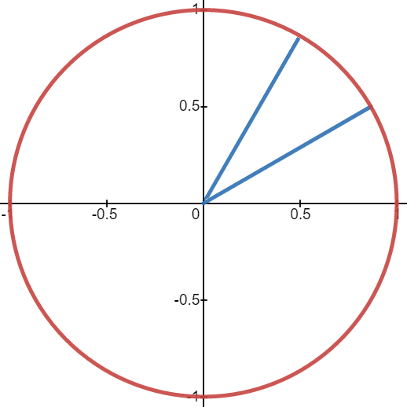
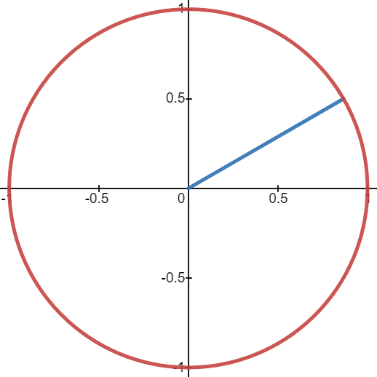
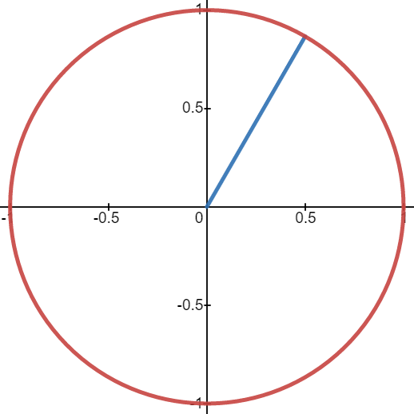

Use tangent for slope in equations and set notation to limit range and domain of segments. The lines graphed:

A ∠30° has y = (1/√3)x {0 ≤ x ≤ ^{√3}/₂} or y = (√3/3)x {0 ≤ y ≤ ½}
A ∠60° has y = (√3)x {0 ≤ x ≤ ½} or y = (√3)x {0 ≤ y ≤ ^{√3}/₂}

Angle lines can be thought of as vectors that have direction and magnitude.
Angles themselves are scalars not vectors (how long is 45°? 0 units. It is dimensionless).

For 30° we have a function given by y = tan(30)x .
We know tan(30°) is slope so we substituted it for M.
We know tan(30) = 1/√3 .
Both y = (1/√3)x and y = (√3/3)x are equivalent.
The line crosses the y-axis at (0,0) so b = 0.
These are exact values. We do not want an approximation for slope.

Note: We can think of a line as a vector and slope its scalar. In all contexts tangent is a scalar quantity. A scalar is the coefficient of a term that multiples it causing an increase or decrease in magnitude while preserving direction. In many instances we can think of a scalar as the amplitude of something. In arithmetic a magnitude is a product, here we are multiplying to get area. In signal processing, or any signal analysis, amplitude is equivalent of the leading coefficient of a polynomial. Direction is a generic term for slope. In aeronautics the term heading is slope with other components of velocity.

Vectors have two components that can be graphed as x and y in the real plane. Velocity is a vector of displacement and speed. Displacement is how far an object is from a starting location. Speed is a scalar of distance divided by time given by d/t. It is not a vector because it does not have direction. Acceleration is a vector of velocity divided by time. There are two types of acceleration, average and instantaneous. Mass is a scalar because it has no direction. By transition tangent is a scalar because it is a direction with no magnitude or a magnitude with no direction.

Slope = M and Slope = Tangent. By transitivity M = Tangent. M being a scalar quantity of ^{y}/_{x} means that tangent is a scalar. If M = 4/5 = 0.8 then tangent = 0.8 which is a scalar. Angle or slope or tangent is a scalar not a vector.

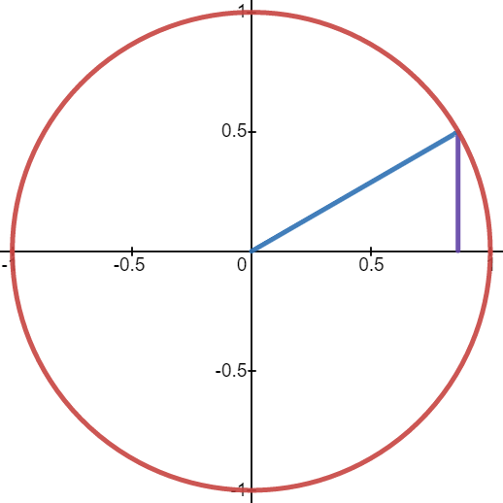
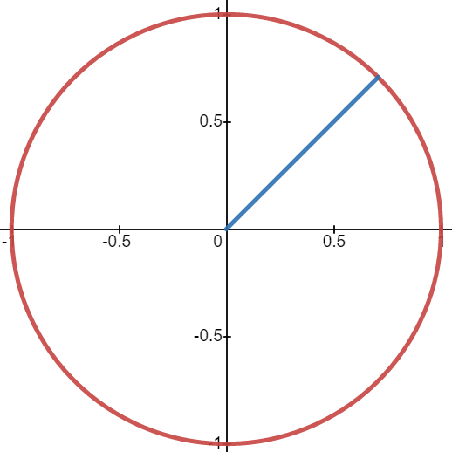

Set notation is just writing the first x or y value from slope followed by the second value with an inequality sign in them. Then the inequality is put in braces to show it is not a part of the equation for the line but rather the set of allowable values for the line. The unit circle is made up of 30° and 45° multiples so knowing the equations for them lets you derive the equations for the others. This line is given by y = (√3/3)x.

Following this idea we can graph lines at all the 30° multiples on the unit circle. This with 45° makes the unit circles. The pi values and their conversions are called the special values of the unit circle. Mastering the unit circle requires mastering 30° and 45° triangles.

A 45° line is shown here. From algebra this is called the line of symmetry.
It is given by y = x . It has a slope of 1. This is the diagonal of a square.
A square has height “y” = base “x”.

The sine of a 45°/45° is √2/2
The cosine of a 45°/45° is the same.

For if y = x then sin = cos. If sin = cos then tan = 1.
If tan = slope then sin/cos = slope and sin/cos = tan. Sin/cos = tan.

Lets examine a 45° triangle next.
This is an application of graphing lines made using Desmos online graphing calculator.

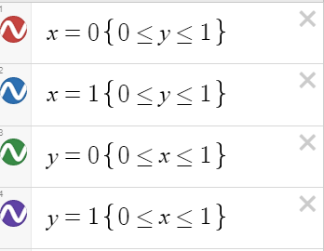
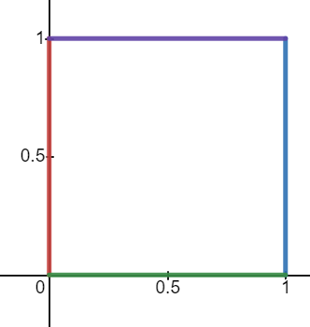

A diagonal of a polygon is from one corner to another without traveling a side. A square has two diagonals. Drawing a diagonal divides a square into two equal area. Because all sides of a square are the same height equals the base. For reference the area is A = x² ,the perimeter is P = 4x ,and the diagonal is = √x² + x².

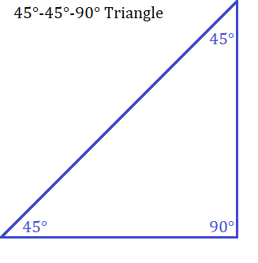
Here is a square of length 1 that was divided along its diagonal creating this triangle.
A perfect square has a 45/45/90 triangle as its root. This is an odd statement be true.

What is the length of the hypotenuse?
Pythagoras says a² + b² = c² which can be seen as c = √a² + b².

base² + height² = hypotenuse² 1² + 1² = c² 1+1 = c² 2 = c² √2 = c

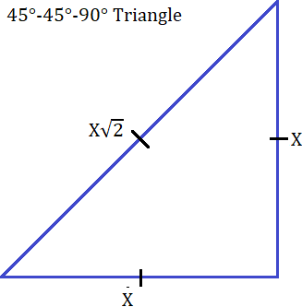
It is hard to find square roots of prime numbers or rectangular areas. We can leave √2 as is or use a calculator to get a decimal approximation. The point is that this is where √2 first appears in all of mathematics. The idea was to keep math simple and use simple numbers such as 1 for base and height. Then later use y = x for the equation of the triangle of base and height 1. From this simple attempt we run into a complicated problem: √2 is is a radical. Radicals are the hardest of the 6 arithmetic operations. We tried for simple but instead got hard. Oh well. Calculator tells us that √2 = 1.414213...

This is important to know. We have the ratios of base to height to hypotenuse for a 45°45° triangle. If we want to make a larger triangle we multiply all three sides of a triangle the the same number. This number is called a scalar and the the size of the triangle is said to have a scale factor of the number we used to scale it. If we multiply by 2 then we have a scale factor of 2.

In general the ratios of a triangle are written base:height:hypotenuse. We write a variable such as x or sin front of the number to indicate we are going to scale the triangle (or other polygon) by the number we substitute. x:x:x√2 where the base and height are just 1 so we do not write 1 in front of x when it is a coefficient. We are saying we have a 1:1:√2 ratio and are multiplying it by some x. There are different formulas for the midpoint of a line but first want to demonstrate a specific technique for this triangle. To find the middle of any length simply divide it by 2. If you know the length then divide it by two. The length of the hypotenuse is √2 so half the distance would be √2/2. This value comes up in the unit circle for the sine and cosine of a 45/45 triangle.

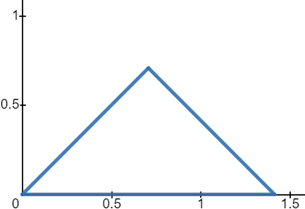
I want to flip the triangle so that the hypotenuse is laying face down. Then I want to draw a line from the 90° at the top down to the hypotenuses which is now the base. This will divide the hypotenuse in half turning the base from simply √2 to √2/2 + √2/2. I will have two halves of √2.

This will make bisect the base from a 180° line into two 90° angles.
This will bisect the 90° at the top into two 45°angles.
This will create two congruent triangles.

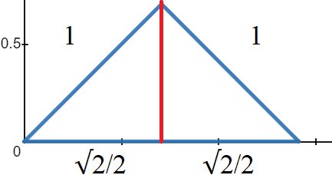
The original sides that were 1 unit are unchanged. The hypotenuse side in divided evenly in two. It is now √2/2. I have identical 45/4590 triangles.
By removing one of the triangle's we clearly see a hypotenuse of 1 and
sides of √2/2. The lengths of this triangle are √2/2:√2/2:1.

Another way of looking at it is this:

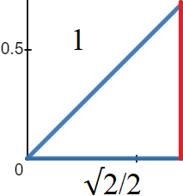
- A square is 1×1 units.
- I divide it along its diagonal creating a 1:1:√2 triangle.
- I flip the triangle and divide it vertically down the middle.
- I now have a √2/2:√2/2:1 triangle.
- Dropping a vertical line down gives me the sine as height.

Because I know the angles are 45,45, and 90, I know that two sides must be the same. Since I know one side is 1 and the other is √2/2 then the height must be √2/2. Bisecting a 90° angle with a line creates another triangle with that line as the sine of the new triangle. We can do two things. We can ignore what we know from above and attempt to find the missing red side using Pythagoras. Or we can scale all sides of the original triangle so that we have a hypotenuse of 1.

Pythagoras: c² = x² + y² or c = √x² + y²

c² = x² + y²
1 = (√2/2)² + y²
1 = 2/4 + y²
1 = ½ + y²
1 – ½ = y²
½ = y²
√½ = y

What is the square root of ½ ???? Think logically! Solve for x: x∙x = x² and x² = ½:

- 1∙1 = 1 so x must be less than 1, so x must be a fraction. Change x to the form p/q.
- For convenience we try 0.9.² = 0.81, 0.8²= 0.64, 0.7² = 0.49.
- p/q must be more than 0.7 and less than 0.8. We write this in set notation {0.7< p/q <0.8}.

^{p}/_{q} ∙ ^{p}/_{q} = ½ p∙ p = 1 and q∙q = 2 1∙1 = 1 and √2 ∙√2 = 2 therefore p/q = 1/√2

√½ = y
1/√2 = y
¹/_{√2} ∙^{√2}/_{√2} = √2/2 This is where √2/2 make there first appearance in mathematics.
√2/2 = y

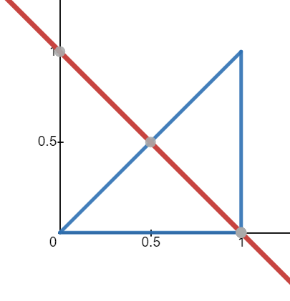

We can write a law that says both sides adjacent to a 90° angle must be equal. This avoids having to do long Pythagoras for these triangles. If we didn't flip the triangle the sine line would be at -45°. You can see where a line for 0 to 1 on the y axis and (0,1) to (1,1) would complete the square. The red line measured from the middle of the hypotenuse to the 90° corner is the sine of the resulting two smaller triangles it creates.

30° and 45° triangles are special and we need to master them. All other polygons are made from triangles. If we master the special triangles we can master all triangles and eventually master all polygons and shapes.

Every time a 45°/45° triangle is divided like this you get two identical smaller ones. Since they are both 45/45 you can repeat this process forever. Notice how the blue triangle under the red line looks like the one we flipped over? The blue triangle has its hypotenuse as its base. Clearly from the graph we can see this triangle has a height of ½ . Hmm … We were trying to find the √½ … what is the connection between ½ appearing twice?
√½ = √2/2 such that (√2/2)² = ½ … is it trying to tell us that the root of the height is the length of the legs?

Does √height = leg? It seems for 45/45 it does. A triangle of height ½ is ¼ of the square. The root of the height is the area. If a square 1×1 has area = 1 then a 1×1 triangle has area ½. This would be ½ the square made from a diagonal bisection. A bisection divides the angle or side evenly in two. Then a √2/2×√2/2 triangle has area = ¼.

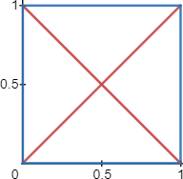

The two diagonals of a 1 by 1 square show the square divided into 4 equal areas of ¼ of a unit². We can use this to derive the formula for an area of any triangle. Take the base and height and treat as a rectangle. Base times height gives area for a rectangle. Divide the rectangle diagonally and you have a triangle with the base and height of the rectangle. Dividing by 2 is the same as multiply by ½. Bh/2 becomes ½bh.

Area of a rectangle or square = bh
Area of a 90° triangle = ^{bh}/₂

Triangle of 1:1:√2 has A =½
Triangle of √2/2:√2/2:1 has A = ¼

We already proved that 1/√2 = √2/2.
The smaller triangle is really all three sides divided by the hypotenuse √2 of the bigger triangle.
This is called scaling all sides so we have a hypotenuse of 1. When a hypotenuse equals 1 we have a triangle that fits completely in the unit circle. I call this triangle the unit triangle.

Unit triangle

A triangle that has 1×1 is to big to fit in the unit circle. Dividing all sides by a scale factor equal to the hypotenuse will result in a unit circle radius for the hypotenuse of the triangle. The radius in the unit circle is always 1 and any number divided by itself is 1 so that is how triangles are made to fit in the unit circle and give their trig ratios.

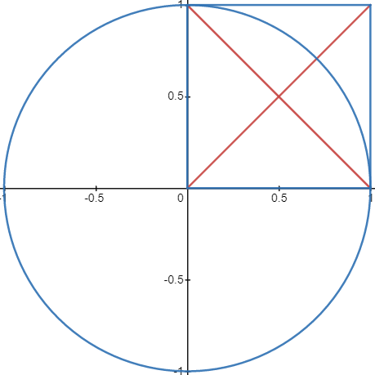
A square with all sides 1
The four vertices of the square are (0,0), (1,0),(1,1),(0,1)
The diagonals given by y= x and y = -x +1
The points of the diagonal are (0,0) and (1,1)
The negative or inverse diagonal points (0,1) and (1,0)

If a radius is 1 then we need to divide the hypotenuse by itself to shrink the hypotenuse to 1.

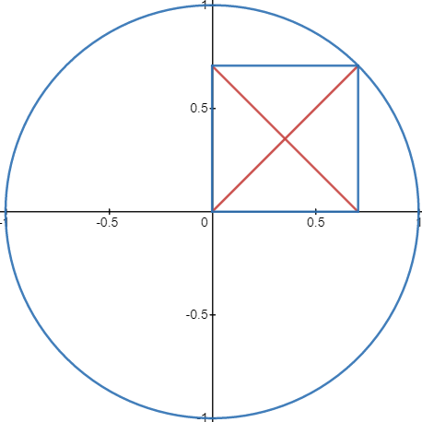
1:1:√2 becomes 1/√2:1/√2:√2/2
The lines are scaled down by a factor of the hypotenuse.
The area fitted around the triangles fits in the circle.
The area if the square must be ½ because the sides are both √2/2. (√2/2)² = ½
If the square has an area of ½ then the diagonal triangle must have an area of ¼ .

A right angle triangle with hypotenuse of length 1 is called the unit triangle.
A triangle with 45° at the origin has ratios of √2/2:√2/2:1
This is where the radical values from the unit circle come from.
The lengths are the ratios written in the order cos:sin:radius.
Cosine is the base of the unit triangle, sine is the height, and tangent is the slope of the radius found by sin/cos sometimes written y/x.
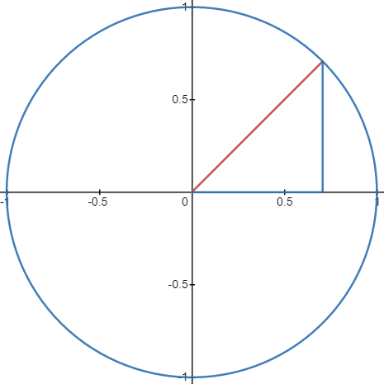

Sin(45) = √2/2 height ≈ .07071
cos(45) = √2/2 base ≈ same as height
tangent = √2/2/√2/2 = 1

There are four unique 45° multiples which are 45°, 135° , 225°, 315°.
They are reflections across the y axis and x axis.
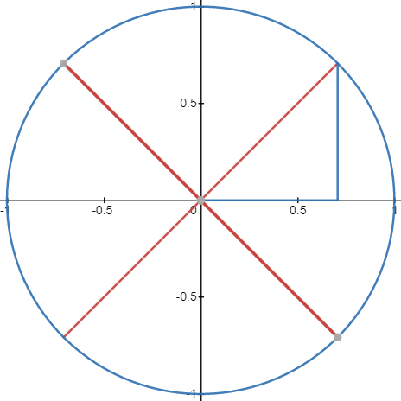

More on 45/45 triangles
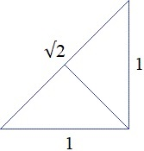
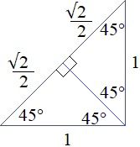

When hypotenuse is 1 legs are √2/2
When legs are 1 hypotenuse is √2

When hypotenuse is 2 legs are √2
When hypotenuse is √2/2 legs are ¼

When we asked the height of an equilateral or 30/60 triangle we found c² = ¾ and then √¾ = √3/2.
Using the p/q setup would have been simpler than pythagoras:

If c = √3/4 then p²/q² = ¾

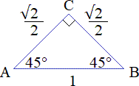
If p² = 3 then p = √3
If q² = 4 then q = 2
p/q then √3/2, similar to √1/2 being 1/√2.

Remember rules for radicals and fractions:

The radicand is a square. If √1/2 then ½ is a square.

√square = root
Root ∙ root = square
x² = ½
x ∙ x = ½
1°1 = 1
x < 1
x = p/q
(p/q)² = ½
p/q ∙ p/q = ½

If p²/q² = ½ then: p² = 1 and q² = 2

p² = 1 q² = 2
√p² = √1 √q² = √2
p = 1 q= √2

Similarity Theorems

There are three similarity theorems. SSS,SAS, and AA.

SSS- Side-Side-Side Theorem

When two triangles are similar they have the same ratios of sin cos and tan. In general you have two triangle with the same three angles but the three sides are different. This means you have a small triangle and a big triangle. The small triangle is scaled to become the large triangle. You have the small triangle and the scaled triangle. To prove similarity you have to prove the ratios match. There are different ways to do this. Here is one way.

Call your small triangle △ABC and your big triangle △A'B'C' or △A₁B₁C₁ . Either you multiplied the small triangle by a number lager than 1 to get the bigger triangle or you multiples the bigger one by a number less than one (a fraction) to get the smaller one. The number you multiplied with is the scalar called the scale factor.

△ABC times all three sides by S_{calar} = △A'B'C'
△A'B'C' times all three side by 1/s = △ABC

Setup three ratios like A/A' = B/B' = C/C'
Lets say we have △ABC is 3:4:5 and △A'B'C' = 6:8:10

3/6 = 4/8 = 5/10
½ = ½ = ½

How do you know which side to use if the other triangle is rotated?
Trial and error does not but not recommended:

3:4:5 = 10:6:8

3/10 ≠ 4/6 ≠ 5/8
3/10 ≠ 4/8 ≠ 5/6 combinatorics states that for every initial pair there are 2 possible pairs.

3/8 ≠ 4/10 ≠ 5/6
3/8 ≠ 4/6 ≠ 5/10 we see a possible pattern … and it is the only last option

3/6 ≠ 4/6 ≠ 5/8 not this one …
3/6 = 4/8 = 5/10 this one works
Trial and error is also called method of exhaustion. It is when you do not have a formula and have to try every combination. Also called a brute force method. Brute force methods are used to crack ciphers or passwords.

- Start with a problem you think is easy
- work it to learn as much as you can
- gradually add more layers of complexity
- get to a point where you are stuck
- use brute force or any other guessing method to stumble on the solution
- look at your problem now that you know the answer and look for a pattern
- find a pattern and solve more efficiently. This is called creating a formula or formal definition
- Formulas are the end result of guessing not the first step.

Under guess and check if we do not know the correct sides to use we would be forced to try every pair until we found a pair that proved similarity or exhausted all pairs proving dissimilarity. There is a better way. If they are similar then it is a case of scaling a small triangle to make it bigger. Write the sides as ABC and A'B'C' with smallest to largest:

A/A' = shortest side/shortest
B/B' = other side/ other side
C/C' = longest side/longest side.

If it is truly a scaled version then the short sides dived with be the same ratio of the long sides divided, and of course the other sides divided as well. We can then call SSS “the short side long side ratio law”.

SAS- Side-Angle-Side Theorem

This theorem deals with two sides and an included angle. Every ratio of two sides has 1 included angle and two excluded angles. The included angle is the angle between the two sides.

For a 30-60-90 triangle

Between the hypotenuse and base, 30° is the included angle. The two other angles are excluded.
Between base and height, 90° is the included angle.
Between hypotenuse and height, 60° is the included angle.

For a 45-45-90 triangle

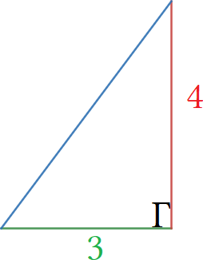
Between the hypotenuse and base or height, 45° is the included angle. The two other angles are excluded.
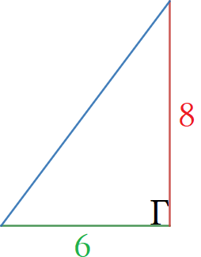
Between base and height, 90° is the included angle.

Are these triangles similar?
They have the same included angle so we can use a proportion. Does 4/3 = 8/6?

4/3 = 8÷2/6÷2
4/3 = 8/6 factoring out 2 reduces 8/6 to 4/3 proving they are equal.

Since they are equal proportions they are similar triangles. To find missing hypotenuse use Pythagoras.

AA- Angle-Angle Theorem

If two triangles have two matching angles then the third angle must match. Similar triangles have all three matching angles so this proves similarity. If two match then all three match.

Law of Sines a/sina = b/sinb = c/sinc

A sine is a ratio of the opposite side divided by the hypotenuse in a 90° right triangle but we are going to use this information for oblique angle triangles. Input the sines of the degrees using a calculator in degree mode. Anytime you are measuring degrees use degree mode. Anytime you are measuring arcs use radian mode.
This says that the ratio of one angle is the same as the ratio of the other angles. They share a common ratio.

Sina/a = sinb/b / sinc/c and a/sina = b/sinb = c/sinc

This picture uses an example from Khan Academy. The claim is that with two angles and one side you can solve all the missing parts.

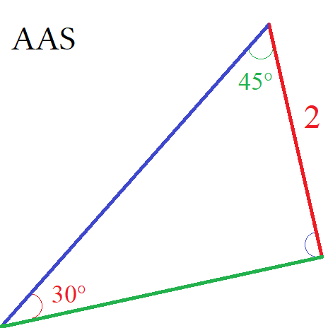
Point A: 30°
Point B: 45°
Point C: θ°
Side a is 2 units

We do not know the other two sides. Lets call the green side b and the blue side c. Lets call the missing angle θ.
30° and 45° are angles listed on the unit circle. We know their sines to be ½ and √2/2. We see side a is 2 units.
Put what we know in the in the law of sines formula.

sin(a)/a = sin(30)/2
sin(b)/b = sin(45)/b

And so sin(30)/2 = sin(45)/b = sin(θ)/c. Using the law of 180 we subtract the measures of the two angles from 180 to find the third angle theta: 180° – 30° – 45° = 105°, θ = 105°. And so sin(30)/2 = sin(45)/b = sin(105)/c.
Using ½ and √2/2 as the sine of 30° and 45° we get :

½/2 = √2/2/b = sin(105)/c
¼ = √2/2/b = sin(105)/c sin(105) is messy so lets leave it I this form.

¼b = √2/2 ¼c = sin(105)
b = √2/2 c = sin(105)/¼
b = 2√2 c ≈ 3.864
b ≈ 2.828 side a = 2, side b ≈ 2.828, side c ≈ 3.864.
The last triangle was AAS (angle,angle,side)
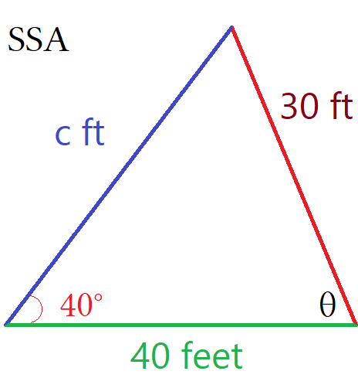
This triangle is a SSA relation (side, side, angle)
Use the law of sines to find out the missing ∠C.

Law of sines says sin(C°)/c = sin(40)/30.
We have two unknowns for the ratio sin(C°)/c so we need to find a
different ratio that has only one unknown to compare to sin(40)/30.
The other side is known so that will work using sin(B)/40.
We have to solve angle B using:

Sin(40)/30 = sin(B°)/40 sin(A°)/a = sin(B°)/b this is what we are saying
40sin(40)/30 = sin(B°) isolate theta by canceling the divisor
40sin(40)/30 = sin(B°) is saying that sine of this degrees equals sine of that degrees.
0.8570501462 = sin(B°) ratio = sin(θ₁) this is saying one ratio equals another.

Sine of “degree” turns a degree into a ratio. The ratio is the percentage of a radius in the unit circle so its length is less than 1. Use sin⁻¹() convert a ratio into a degree. To do this we wrap the entire function in an inverse function. Put all of 40sin(40)/30 in sin⁻¹() so that it is sin⁻¹(40sin(40)/30). This is a function in a function. A function in a function is called a functional.

sin⁻¹(40sin(40)/30) = ∠B
58.987° ≈ ∠B

180° – ∠A – ∠B = ∠C
180° – 40° – 58.987° = ∠C
81° ≈ ∠C

Proof of the law of sines

If point D is the 90° angle of base and h_{c} then h_{c} is the sine of both ACD and BCD and angle D is 90°:

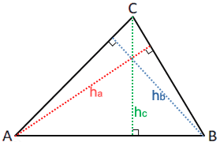
Sine of A is hc/AC
Sine of B is hc/BC
Sine of C is AB/AC

SSA something called the ambiguous case where you have a second solution of an obtuse triangle. This triangle also meets the criteria for the data given. From the context and rough shape of the triangle we are given we assume that we are correct choosing 81°:58° for an acute triangle instead of 19°:121° for an obtuse.
The obtuse triangle is shown below.

This obtuse triangle also has ssa with same 40° excluded from a side of 40 and a side of 30.

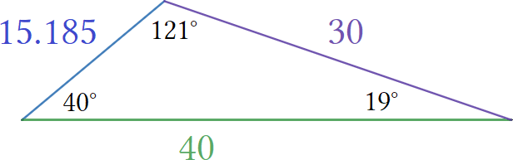
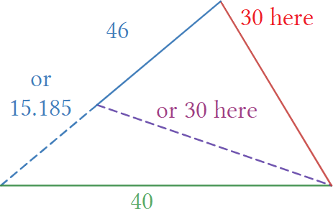

- The base if a fixed length of 40. The rotating red leg is a fixed length of 30.
- 40° is fixed to the blue leg the other two angles are nonrigid.
- Rotate the red leg 19° and the blue leg is cut off at 15.185 units.
- Rotate the red leg 81° and the blue leg stretches to 46 units.

This idea of stretching brought about the word hypotenuse which means to stretch. We can have these two triangles. Rotating the red leg to 90° would cause the blue leg to stretch more to meet it BUT we would need to change its 40° or have a degenerate triangle. The blue leg would hit too high and there would be a gap.
We either would have to rotate the blue leg down to close the gap or lengthen the red leg to meet it.

SSA the Ambiguous case

When dealing with SSA you have three possibilities: zero triangles, 1 triangle, or two triangles.

If angle A is greater than 90°

Zero triangles if: side a ≤ side b
One triangle if: side a > side b

Having two triangles is not possible if given angle > 90°

If angle A is less than 90°

Zero triangles if: side a < height or a < b
One triangle if: side a = b or a ≥ b
Two triangles if: h < a or a < b

Summary: If the given angle is acute or obtuse and a > b then 1 triangle. If acute and h < a < b then two triangles.
Height is found by h = bsina The types of info we can solve are:

- SSS side-side-side
- SSA side-side-angle The angle is excluded
- SAS side-angle-side The angle is included
- ASA angle-side-angle
- AAS angle-angle-side
- AAA angle-angle-angle We cannot solve AAA

A sine is the height of any triangle. A sine extends from a vertex to the opposite side making a 90° angle.
Any line that does this is a sine.

Law of Cosines: Solve a unknown side if you know two sides and an angle between them or three sides.

This is a modified version of Pythagoras theorem to solve non-right angle triangles for SSS or SAS triangles.

Solving for a side: c² = a² + b² – 2abcos(C°) Solving for angle: cos(C) = a² + b² – c²/2ab
c = √a² + b² – 2abcos(C°)

a = 13 c² = a² + b² – 2abcos(C°)
b = 6 c² + 2abcos(C°)= a² + b²
c = ?cos (C) = a² + b² – c²/2ab
∠C = 91°
c = √36 +169 – 2 ∙ 6 ∙ 13cos(91)
c = 14.142

I have a triangle as shown. Key points are base of 6 and 60° and 40° angles at each side of base.
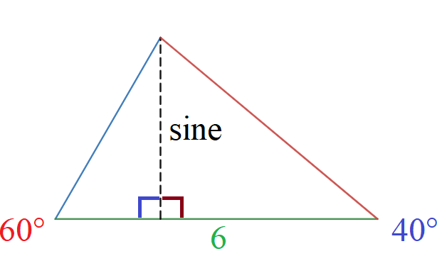

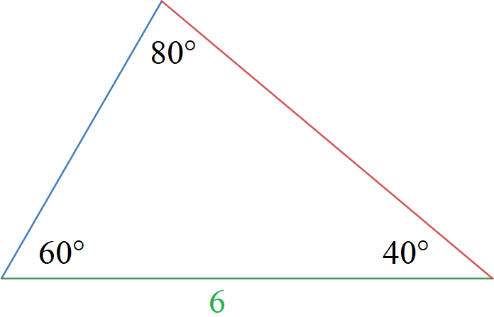

Creating a sine makes a 60°30°90° triangle. Sine is the height of both triangles. The is the case for Law of sines, however the left triangle is familiar as a 30°/60° triangle so we can use standard formulas.

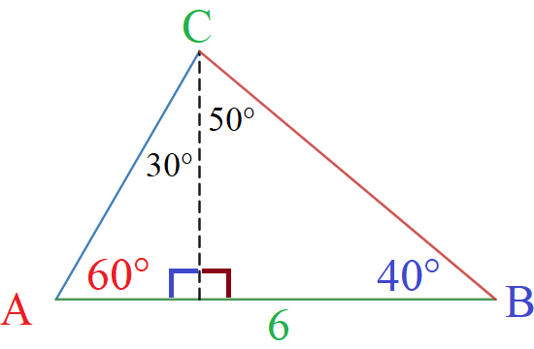
6cos(60) = a = 3
6sin(60) =b = 5.196152423
height 2.598076211
cos(60) = a/h
sin(60) = o/h
hcos(60) = a
hsin(60) = o
sina/a = sinb/b

△BCD: △ACD: △ACD:

a² = h² + (c – x)² b² = x² + h² cos(A) = x/b
a² = h² + c² – 2cx + x² h² = b² – x² x = bcos(A)
a² = (b² – x²) + c² – 2cx + x²
a² = b² + c² – 2cx

Law of cosines:c² = a² + b² – 2bccos(C)

Solve for side c

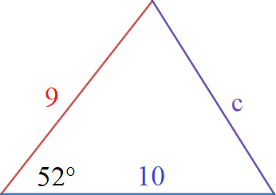
c² = a² + b² – 2abcos(C)
c² = 9² + 10² – 180cos(52)
c = 8.377406188
c ≈ 8.377

If sas is: 5, 74°, 6

c² = a² + b² – 2abcos(C)
c² = 5² + 6² – 60cos(74)
c = 6.667965106
c ≈ 6.668

If sas is: 11, 86°, 16

c ≈ √11² + 16² – 2∙11∙16cos(86)
c ≈ 18.77

To rewrite the formula for angles isolate the angle using this:

c² = a² + b² – 2ab∙cos(C)
c² + 2abcos(C) = a² + b²
2abcos(C) = a² + b² – c²
cos(C) = (a² + b² – c² )/2ab

Solve for angle C

C° = a² + b² – c²/2ab
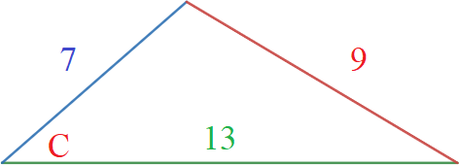
C° = 7² + 13² – 9²/2(7)(13)
C° = 137/182
C° = cos⁻¹(137/182)
C° ≈ 41.17°

If sss is: 11,13,10

C° = 11² + 13² – 10² /2(11)(13)
C° = 190/286
C° ≈ 48.37°

If: 12,14,6

C° = 12² + 14² – 6² /2(12)(14)
C° = 19/21
C° ≈ 25.209°

If: 7,8,13

C° ≈ cos⁻¹((7² + 13³ – 8² )÷(2∙7∙13)
C° ≈ 32.204
If: 11,14,15

cos⁻¹(y/x) where y = a² + b² – c² and x = 2ab
cos⁻¹((11² + 14² – 15²)/(2∙11∙14))

More examples of law of sines

20,48°,26

Law of sines is you have two sides a and an excluded angle. SSA
Law of cosines is you have two sides a and an included angle. SAS
If you know all sides then you have to use Law of cosines. SSS

THE MISSING SIDE IS NOT PART OF THE ANGLE THE MISSING SIDE IS PART OF THE ANGLE
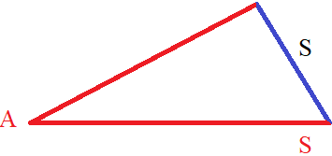
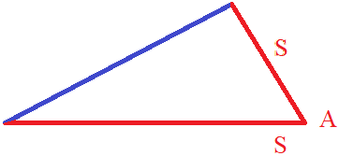

 | Solving for | formula
Laws Of Sines SSA | Side | C = csin(A)/a
Law Of Sines ASA | Side | Use find angle by 180° law then use C = csin(A)/a to find side
Law Of Sines acute SSA | angle | sin⁻¹(csin(A)/a)
Law Of Sines obtuse SSA | angle | 180 – sin⁻¹(csin(A)a)
Law Of Cosines (SAS) | side | c = √a² + b² – 2abcos(C°)
Law Of Cosines (SAS) | angle | Use law of cosines to find third side then use SSS
Law Of Cosines (SSS) | angle | C° = (a² + b² – c² )/2ab

The Ambiguous case: When taking the arc sine of a number we get two angles between 0° and 180°.
For example the arc sine of 0.5 is 30° and 150°.To avoid ambiguous case Use the law of cosines for side-side-side.

- When you calculate the first angle using the Law of Cosines, always calculate the largest angle.
The largest angle will be the angle opposite the largest side.

- When using the Law of Sines, never use it to calculate the largest angle.
- Always use the Law of Cosines for the calculations.

Fundamentals of Oblique Triangles

Use the law of sines for ASA and SSA.
Use special rules for SSA to avoid ambiguity. Be careful when angle is close to 90°
Use law of cosines for SAS and SSS.

Failing to do forces reliance on tangent to solve. This is not desirable. Memorize Law of sines and cosines for speed and accuracy. Using tangent is a lesson in fundamental relationships. In other words it is slow and mechanical. We want fast and mechanical.

ASA

We have ASA triangle: 75°, 5, 25°. The third angle is found 180° – α – ß = γ.
Then 180° – α – ß = 80°. Dropping a sine splits γ into 65°/15° .
Side 5 becomes two parts x and 5 – x.

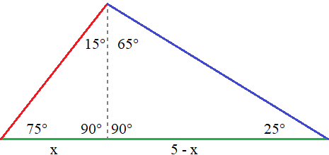
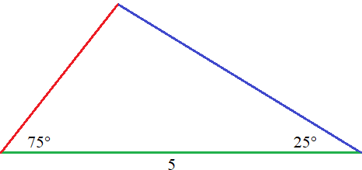

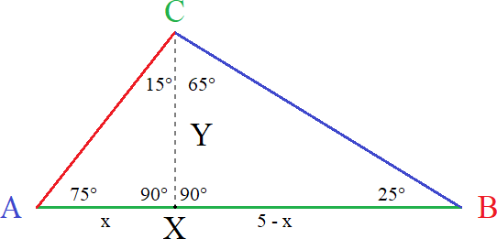
The sine is the height of the two 90° triangles.

Note that lowercase gamma resembles y which
I am using for height. Gamma cab be the angle
or the height of angle C ~ height of point C”.

To find height: Y = x/tan(15°)
To find x: x = tan(15°)∙Y

If we take CX to be the base of △AXC then:

cos(C) = Y/side b Can't use because side b unknown.
sin(C) = x/side b Can't use because side b unknown.
tan(C) = x/Y We can use because both triangles share angle C.

△AXC △BXC

tan(C) = tan(15) tan(C) = tan(65)
tan(15) = x/Y tan(65) = (5 – x)/Y
Ytan(15) = x ytan(65) = 5 – x
Y = x/tan(15) Y = (5 – x)/tan(65)

tan(15) = x/y and tan(65) = (5 – x)/Y
y = x/tan(15) and y = 5 – x/(tan(65) Because both share the same height.

For starters:

tan(15°) = opp/adj Which is x/Y.
tan(15°) = x/Y Use tan(15°).
y∙ tan(15°) = x x is isolated. We want to equate x to 1.
ytan(15°)/ytan(15°) = x/ytan(15°) Divide both sides by ytan(15°).
1 = x/ytan(15°) This canceled. Do this for the other equation.

For the second triangle:

tan(65°) = opp/adj Which is (5 – x)/Y.
tan(65°) = (5 – x)/Y Use (5 – x)/Y.
Ytan(65°) = 5 – x 5 – x is isolated. We want to equate (5 – x) to 1.
Ytan(65°)/Ytan(65°) = 5 – x/Ytan(65°) Divide both sides by Ytan(65°).
1 = 5 – x/Ytan(65°) This canceled.

1 = x/Ytan(15°) and 1 = (5 – x)/Ytan(65°). Since they both equal 1 you can equate them to each other.

1 = 1 This is a 1 to 1 ratio.
x/Ytan(15°) = (5 – x)/Ytan(65°) Substitute the equations for 1.
x/tan(15°) = (5 – x)/tan(65°) Cancel the denominator by multiplying both sides by Y.

At this point we essentially have the law of sines except we did it with tangent. We could call this the law of tangents. We have x and 5 – x as known sides. We should solve for x and find 5 – x:

x/tan(15°) = 5 – x/tan(65°) is the end result of doing all that algebra. To continue requires an understanding of trig identities. This is much more complicated than law of sines. This is more the study of pre-calculus rather than basic trig. If you can not remember law of sines on a test there is no way you are remembering this.
The next part is scary a nightmare so I put it on next page.

x/tan(15°) = 5 – x/tan(65°) What we had.
xtan(65°) = (5 – x)tan(15°) Cross multiply to create proportional.
tan(65)/tan(15) = 5 – x / x Divide both sides by tan(15) to get x terms on RHS.
tan(65)/tan(15) = x(5/x – 1) / x TRICKY factor x out of 5 – x like with polynomials.
tan(65)/tan(15) = ⁵/_{x} – 1 Canceled x twice which is the point.
^{tan(65)}/_{tan(15)} + 1 = ⁵/_{x} Added 1 on both to isolate 5/x further.
x(^{tan(65)}/_{tan(15)}) + 1 = 5 Multiplied both sides by x.
x = 5/(^{tan(65)}/_{tan(15)}) + 1 Divide both sides by ^{tan(65)}/_{tan(15)} + 1.
x = 5/9.0034 Extra step for clarity.
x = 0.55535 End result 5 – x = 4.4447.

side a = .55535/sin(15) = 2.1457
side b = 4.4447/sin(65) = 4.0942

Once x is completely isolated the extra step and use calculator to solve (^{tan(65)}/_{tan(15)}) + 1 in one go. Type the whole equation and find (^{tan(65)}/_{tan(15)}) + 1 = 0.5553452164. Truncate decimal to 4-6 digits. I find step 4 tricky for some people to understand where the “+1” for tangent comes from so I wrote extra steps.

Remember when completing the square you can do things like: 5x²+12x+6=5x(x+12/5)+6 where 12x/5x becomes 12/5 we are creating a denominator where there wasn't before. More importantly: x² – x looks fully simplified but isn't. It can be further reduced by factoring x out like x(x – 1). If we had x² – 5 / 5 we can not cancel the 5's because the minus sign prevents that however we can do things like:

x² – x / x which is like (5 – x)/ x
x(x – 1) /x which is like x(5/x – 1)/x we divided both terms in (5 – x) by x
x – 1 which is like (5/x) – 1 x∙(sum) / x we can cancel x now

Recap:

x/sin(15) = side a and 5 – x/sin(65) = side b
tan(15) = x/Y and tan(65) = (5 – x)/Y
Y = x/tan(15) and Y = (5 – x)/tan(65)

x/tan(15) = (5 – x)/tan(65)
tan(65)/tan(15) = (5 – x)/x
tan(65)/tan(15) +1 = 5/x
5/tan(65)/tan(15) +1 = x
The fast way

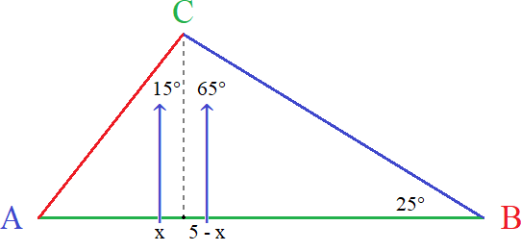
Find x and the angle opposite, do same for 5 – x and set them to each other.

x/tan(15) = 5 – x/tan(65)
T = (5 – x)/x
T + 1 = 5/x t+1=6/x
x =5/(T+1) x=6/t+1
x/sin(15) = side a x/sin(30)=side a
5 – x/sin =(65) side b 6-x/sin(50) = side b

Take form a/b = c/d and turn into d/b = c/a. Turn x/tan(15) = 5 – x/tan(65) → tan(65)/tan(15) = 5 – x/x
Call tan(65)/tan(15) “T” or another variable such as “sum” or approximate as a decimal like 8.003.

The law of tangents is only useful in two places and has largely been superseded by the use of calculators. It used to matter when angles were found using log tables that are now obsolete. The other use is when an angle is close to 90°. This method splits an angle into two parts and has potentially higher accuracy. But here for this example the law of sines solves a missing side in one step.

5sin(75)/sine(80)≈ 4.904
5sin(25)/80)≈ 2.147

SSA

SSA triangles have the “Ambiguous Case” of two possible triangles when side a is longer than the height.
In general use “side c” as the hypotenuse of a triangle opposite the 90° angle:

- If a < c∙sin(A) “no solutions”. In other words you have a degenerate triangle.
- If a = c∙sin(A) “one solution”. This is a right triangle. ∠C = 90° ∠B = 90° – A and side b = c∙cos(A).
- If c > a > c∙sin(A) two solutions.

Use side b as the side opposite the modified 90° angle, acute or obtuse only refers to ∠A.

Ex:1 Acute ∠A | Ex:2 Obtuse ∠A | Ex:3 Acute ∠A | Ex:4 Acute ∠A | Ex:5 acute ∠A | Ex:6 Obtuse ∠A
a < h | a ≤ b | b > a > h | a = h | a > b > h | a > h
No △ | No △ | 2 △'s | 1 ∟△ | 1 △ | 1 △

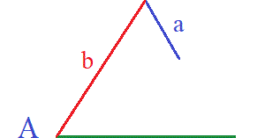
- If angle A is acute, and a < h no triangle exists:
Side a is shorter than the height so it can not reach the ground.
This is degenerate case #1.

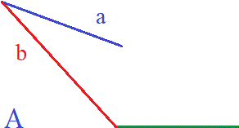
- If angle A is obtuse, and a ≤ b no triangle exists (degenerate case):
Side A is too short to make any triangle. This is degenerate case #2.

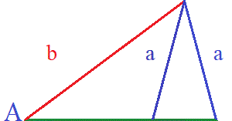
- If angle A is acute and h < a < b two possible triangles exists:
Side A is small enough to place both inside and outside.
This is the ambiguous case.

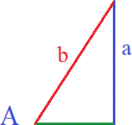
- If angle A is acute and a = h then one possible triangle exists:
Side a is the height and 90° to the base. This is the right angle triangle case.

- If angle a is acute a > b then one possible triangle exists:
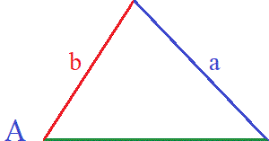
Side a is too big to place “inside” the triangle.
This is the one solution case #1.
This is an acute triangle.

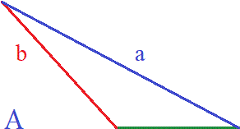
- If angle A is obtuse and a > b then one triangle exists:
Side a is too big to place “inside” the triangle.
This is the one solution case #2.
This is an obtuse triangle.

If sine value larger than 1 then no triangle's.
If supplementary angle fits in triangle then one triangle.
If supplementary angle does fit then two triangle's.

- Situation 1: no triangle exists
- Example 1: acute where a < h
- Example 2: obtuse where a ≤ b
- Situation 2: two triangles exist
- Example 3: ambiguous case where h < a < b
- Situation 3: 1 triangle exists
- Example 4: acute right where a = h
- Example 5: acute where a > b > h
- Example 6: obtuse where a > b

Situation 1: no triangle exists

Example 1: acute where a < h
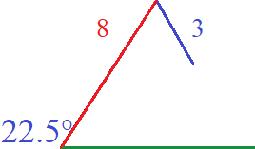
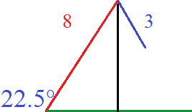

SSA is (22.5°, 8, 6)
8sin(22.5) = 3.06
The height is 3.06
3 < 3.06 so no triangle

Example 2: obtuse where a ≤ b

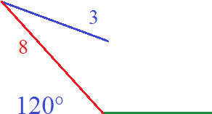
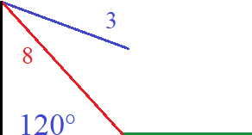
SSA is (120°, 8, 3)
8sin(120) = 6.92
The height is 6.92
3 < 6.92 so not triangle
3 ≠ b will be explained

Note that if a = b then the blue leg would have to be as lone as the red line. How would that work? The angle between the red and blue would have to decrease to zero and still you have blue = 8 on top of red = 8. The two legs would we overlapped. You would have an angle of 120° with green base unknown and two legs overlapped forming a degenerative case of a triangle. Side a is too short.

Sohcahtoa is based on right angle trigonometry. The sine function gives height when hypotenuse is known.
A 30°/60°/90° triangle is created when making the black sine line. When you have an obtuse angle you draw the height outside the triangle. The sine is the height and forms ∠90° with the ground. We can call this right triangle a “shadow triangle”. This shadow triangle is the 30/60/90 and indirectly measures the 120° angle.

Situation 2: two triangles exist
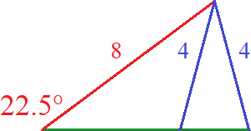

Example 3: ambiguous case where h < a < b

SSA is (22.5°, 8, 4)
Again height is 8sin(22.5) = 3.06 but side a is long enough to reach the ground.
First possible triangle: Obtuse scalene (22.5°, 49.94°, 107.56°) and (4, 8, 9.965)
Second possible triangle: Obtuse scalene (22.5°, 130.06°, 27.44°) and (4, 8, 4.817)
There are two solutions so ∠B and ∠C will have two values which are supplementary angles of the first triangle.

Situation 3: 1 triangle exists
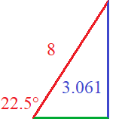

Example 4: acute right where a = h

SSA is (22.5°, 3.061, 8)
We have an acute angle for ∠A.
Again height is 8sin(22.5) ≈ 3.061
That is the length of side a so we must have a 90° triangle.

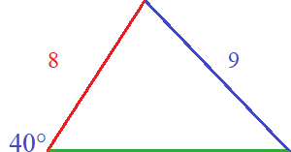
Example 5: acute where a > b > h

SSA is (40°, 8, 9)
We have an acute angle for ∠A.
8sin(40) ≈ 5.142
Side a is too big to fit inside triangle so one solution.

Example 6: obtuse where a > b
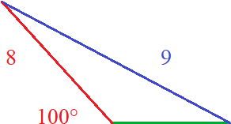

SSA is (100°, 8, 9)
Height = 8sin(100) ≈ 7.878
We have an obtuse angle for ∠A.
Side a is too big to fit inside triangle so one solution.
Side a is longer than side b causing this type of slant.

Examples 4, 5, and 6 are the only ones where we get 1 unique triangle. Ignoring the right triangle we have examples 5 and 6.

Example 5 looks like the first possible triangle from the ambiguous case because the triangles look like pyramids.
Example 6 looks like the second possible triangle from the ambiguous case because the triangles looks slanted.
Rotating the slant type to longest side on bottom makes it look like a pyramid.

Solving SSA without Law of Sines or Cosines

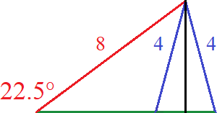

Draw triangle label known points and drop a sine line.

- Find the height using height = hypo∙sin(A) 3.061 ≈ 8sin(22.5)
- Find ∠B by arc sine(height ÷ side a) sin⁻¹(3.061 ÷ 4) ≈ ∠49.92°
- Find ∠C by 180 – ∠A – ∠B 180° – 22.5° – 49.92° = 107.57°
- Find side c with c = c' + c''
- side AD = √b² – height² c' = √8² – 3.061²
- side BD = √a² – height² c'' = √4² – 3.061²
- side c = c' + c'' c = √8² – 3.061² + √4² – 3.061²

Check for second solution. If b > a > bsin(A) there are two solutions. Secondary solutions use supplementary angles of ∠B and ∠C. If 180 – ∠C = ∠C' then 180 – ∠C' = ∠B'. Subtract ∠C from 180° to get supplementary acute angle and subtract both acute angles from 180° to find ∠B'.

Given this triangle we don't know whether 0, 1 or 2 triangles.
First we need to find the height of both potential triangles.

Sin(22.5) = missing side/8 Missing side is height.
8sin(22.5) = missing side Multiply both sides by 8 to isolate missing height of black line.
8sin(22.5) ≈ 3.061 Missing side is about 3.061.
height ≈ 3.061
h < a < b Side a is less than side b but more than height

We have ambiguous case of ASS when h < a < b so we know there are two triangles.

Triangle 1: Divide the oblique triangle into two right triangles and sum their bases to find the base of 1st triangle.

hyp² = base²₁ + height² hyp² = base²₂ + height²
8² = base²₁ + 3.061² 4² = base² + 3.061²₂
8² – 3.061² = base²₁ 4² – 3.061² = base²₂
√8² – 3.061² = base₁ √4² – 3.061² = base₂
7.391 ≈ base₁ 2.57377 ≈ base₂

base₁ + base₂ = 9.964 Triangle 1 is (4, 8, 9.964) and (22.5°, 49.94°, 107.56°)

Triangle 2: Subtract ∠B from180 to get supplementary angle ∠B'. 180 – ∠A – ∠B' = ∠C'. Subtract base₁ – base₂.

180 – ∠B = ∠B' 180 – ∠A – ∠B' = C'
180° – 49.94 = 130.06° 180° – 22.5 – 130.06 = 27.44°
∠B' ≈ 130.06° ∠C' ≈ 27.44°

Base is 7.392 – 2.57377 = 4.81723. Triangle 2 is (22.5°, 130.06°, 27.44°) and (4, 8, 4.817)

SAS

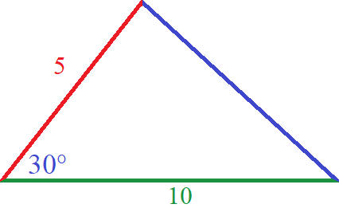
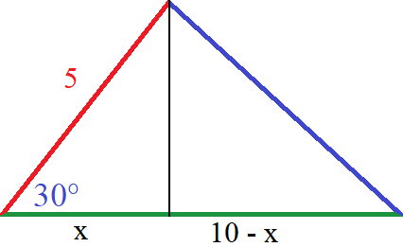

SAS is usually solved with cosine law. Instead we can follow same steps as we did with ASA and use same process. Drop a sine. You get two right triangles with same height. The first triangle has angles 30°/60°/90°.
Using sine we get 5sin(30) = 2.5. The height of both right triangles is 2.5 units. The base x is both x = 5cos(30) and 5sin(60) because 30° and 60° are complements. x ≈ 4.3301 and so 10 – x ≈ 5.6698. ∠B is found using 5.6698 and arc tangent. Tan⁻¹(2.5 ÷ 5.6698) ≈ 23.79°. ∠C can be found two ways, side a can be found two ways. The triangle is 6.197/5/10 for sides and 30°/23.79°/126.206° for angles.

∠C: 180° – 23.79° – 30° = 126.21° or tan⁻¹(5.6698 ÷ 2.5) ≈ 66.21° + 60 = 126.21°
The black sine line split the 126.21° angle into 60° on the left and 66.21° on the right.

Side a: 2.5÷ sin(23.79) ≈ 6.197 or 6.197 ≈ √2.5² + 5.6678²

SSS

Normally we use cosine law twice to find two angles then 180° rule to find the last angle or Second Step Sines: law of cosines 1st to find the largest angle, law of sines next angle, then law of 180° last angle. If you have an obtuse angle, the law of sines can give two answers because this creates the ambiguous case. If we use law of cosines first it ensures the other two angles are acute. If you have two angles, using law of sines a calculator will only give the smaller one. This is why we need to find the larger angle first. An obtuse angle is outside right angle trig. In the unit circle it would be in the second quadrant where x is negative. It will not do the math of finding both angles, just the acute one. The largest angle is always opposite largest side, the smallest angle is always opposite shortest side, and the middle side is always opposite the middle angle.

Another way is to reverse engineer two area formulas, ½bh = Area and Heron's law. If triangle SSS is (2, 3, 4) find semi perimeter and then area. Use area to find height, sin⁻¹ to find ∠A and ∠B,180 rule to find ∠C.

(2 + 3 + 4)/2 = 4.5 ∠B = sin⁻¹(1.452/2) ≈ 46.57°
Area = √(4.5(4.5 – 2)(4.5 – 3)(4.5 – 4)) ∠C = sin⁻¹(1.452/3) ≈ 28.95°
2.905 = ½∙4height 180 – ∠B – ∠C = ∠A ≈ 104.48°
1.452 = height

Area formulas

½bh works for all triangles. If a triangle is half of a quadrilateral then its area is half of bh = A. Right triangles are easy because we can measure the height directly given that we have a 90° angle causing a vertical side.

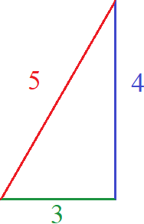
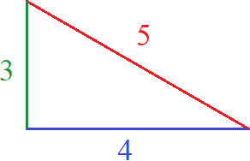
½bh = A ½ bh = A
1.5 ∙ 4 = 6 2∙3 = 6

Rotating it once changes base and height but area is still the same because rotating does not change side lengths. . Even rotating to the hypotenuse however this makes finding the height harder because we lose a having a vertical side. The height must be found by dropping a sine from the top angle. Use the law of cosines can find the height.

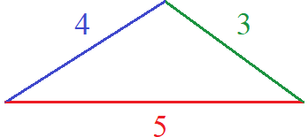
∠A = cos⁻¹(b² + c² – a² ÷ 2bc) ½bh = A
∠A = cos⁻¹(4² +5² – 3² ÷ 2(4)(5)) 2.5∙2.4 = 6
36.87° ≈ cos⁻¹(4/5)
4sin(36.87) ≈ height
2.4 ≈ height

This proves the area formula works for all triangles. If you have a right angle, height is measured as the distance of the vertical leg. If you have a right triangle on its hypotenuse you can rotate it onto a side that shares the 90° angle and get a vertical leg. If you have a oblique triangle use law of cosines to find the height. If you have a very sharp scalene triangle draw the height outside like this.

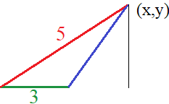

Graphing can also help find the height. If we labeled our triangle ABC and made the green line AC the points would be: A = (0,0) B = (3,0) C = (x,y) where y is the height of the triangle.

Graphing is just drawing a picture. Drawing a picture helps. Another example:

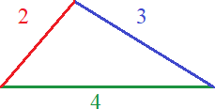

What is height? What are angles? What is area?

∠A = cos⁻¹(b² + c² – a² ÷ 2bc) 46.57° ≈ cos⁻¹(11 ÷ 16)
∠B = cos⁻¹(a² + c² – b² ÷ 2ac) 28.96° ≈ cos⁻¹(21 ÷ 24)
∠C = cos⁻¹(b² + a² – c² ÷ 2ab) 104.47° ≈ cos⁻¹(– ¼ )
height = 2sin(A) or height = 3sin(B) 1.452 ≈ 2sin(46.57) or 1.452 ≈ 3sin(28.96)
Area = ½bh Area ≈ 2.905

Instead of using cosine to find the third angle just use angle sum property.
I used cosine to show signed ratios are are outside the realm of 90° for cosine.

Using Sine to calculate height

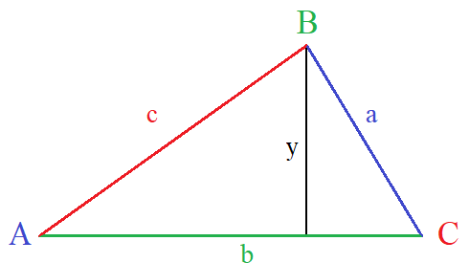

Formulas using trig functions are based on how a triangle is labeled. The convention is to label sides opposite their angles in lowercase letters. Angles and sides are labeled from least to greatest ABC and abc.
For right triangles the greatest angle is 90° and labeled ∠C. The hypotenuse is the longest side and opposite ∠C. It is labeled c. ∠A is usually at bottom left and ∠B is at top. This follows the convention of graphing a triangle with ∠A at the origin. Oblique triangles largest angle is not 90° but is still labeled ∠C. All angles and sides follow normal conventions whether right angled or not.

The smallest: ∠A and side a
The middlest: ∠B and side b
The largest: ∠C and side c

This is consistent with Pythagoras theorem ABC, abc labeling. Using different labeling causes different variables for standard formulas. If you change the labels you have to change formula, which is annoying. The law of cosines does something different. It assumes a non-right triangle is drawn with largest side as base. As a result it inverts b and c making angles and side not appear where you would expect. The reason is that it assumes that the method of finding height by dropping a sine is easier this way as you have a wider base to divide. The law of cosines orientates a triangle as shown top of page.

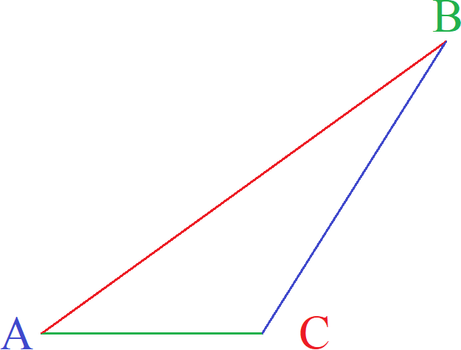
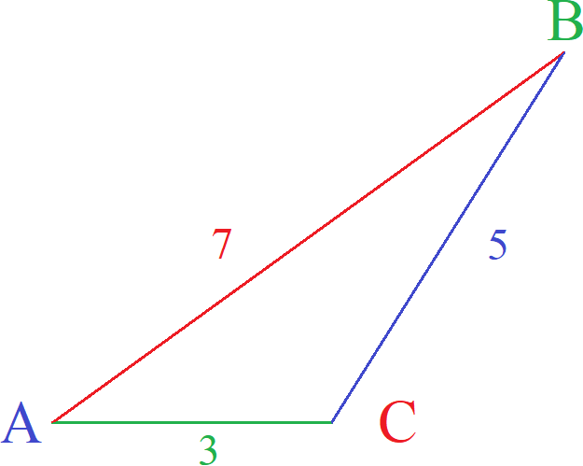
If side c is on the bottom then we assume that an obtuse triangle labeled ABC was rotated to ACB making angle Band C inverted. It is a “flip and rotate” transformation. To be accurate it must flip over its diagonal. A reflection over it's diagonal keeps the vertex of angle A unchanged. The amount needed to rotate side c is given as the inverse of angle A. An obtuse triangle like this has ∠C at the lower left and obtuse. This follows since the largest angle should be the largest letter if we follow conventional labeling. The only time it is absolutely necessary to break convention is if we are solving for unknowns. It is impossible to label sides and angles according to size if you do not know what the sizes are. We can guess but that is iffy at best. Breaking convention is optional.

Another rotation that would give ACB but lose origin coordinates of ∠A is rotate till hypotenuse is a flat base then flip horizontally. Rotating gives ∠B on the bottom left and flipping swaps it with ∠A.

What is the height of △ ABC?

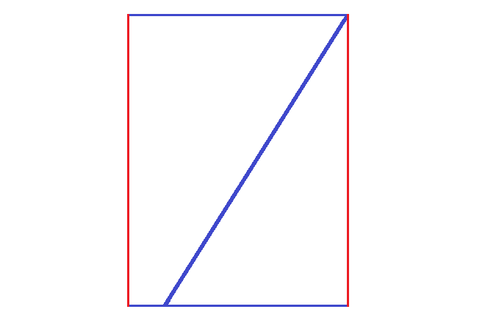
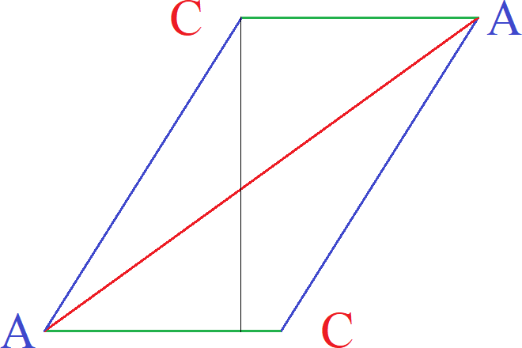
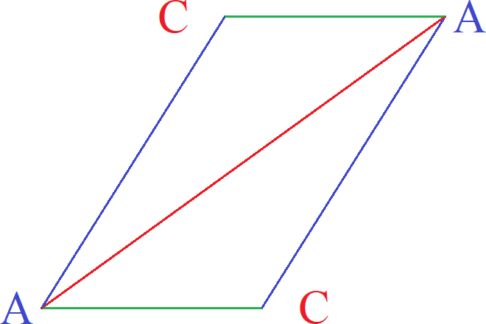
We know that Area = ½bh and (½)(b)(h) is commutative so we can rearrange it as ½hb to take half the height instead of half the base, and also bh/2. Rotating a superimposed congruent triangle about the middle of the hypotenuse creates a perfect parallelogram. This parallelogram is then cut from the line made straight down its upper left vertex. The resulting area is added to the right of the figure to make a perfect rectangle. All corners are 90°. Area of this rectangle is given by bh  area of triangle is ½ this rectangle. But we still don't know the height.

But without height we can't even know the area of the rectangle. The height of both triangles is given by the height of this black triangle. Sin(θ) = ^{opposite}/_{hypotenuse} . We could say hyp∙sin(θ) = opposite.If we know hypotenuse, sin(θ), and opposite side we could find height. Formula for height: osin(θ) = height where o is opposite side of theta. We can then find height for △ABC with asin(A) = height.
Using law of cosines ∠A = cos⁻¹(7² + 3² – 5² /(2∙7∙3) ≈ ∠38.21°

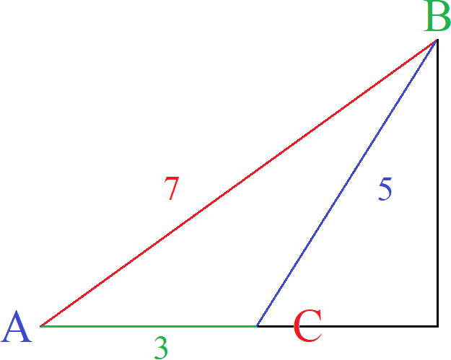
height = 7sin(38.21) ≈ 4.33
Area = ½ bh
Area ≈ 6.5

To find height using sine multiply length of hypotenuse to sine of an angle.

Height = hsin(θ) where h is hypotenuse.

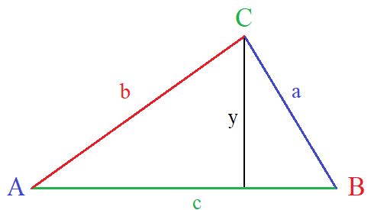

For this triangle For this triangle
y = csin(A) y = bsin(A)
y = asin(C) y = asin(B)

You may see height given as h or hgt. These examples used y to avoid confusing height with hypotenuse.
You may see B or C as top angle so both examples are shown. Changing the orientation of angles changes the formula. You could have ∠A at the top or even different letters used instead of ABC. To use sine you need a right triangle. The black line created a 90° angle allowing the use of sine.

- If we have this triangle, the law of cosines solves the missing angles.
- For faster results use the law of cosines for the largest angle first.
- The largest angle is opposite the longest side.
- Then use law of sines to find the second angle.
- Then use angle sum property to find the third angle.
- If enough information is known then the triangle should be labeled appropriately with ABC and abc reflecting their ordinal status.

Using the law of cosines first finds the largest angle. If the angle is obtuse it forces the other two angles to be acute. No triangle can have two obtuse angles, or an obtuse and a 90° angle, or two 90° angles. If you have an obtuse angle and use the law of sines you produce the the ambiguous case where the obtuse angle has a leg that can make two triangles. Such an angle is said to be non-rigid. However using the law of sines to find an acute acute does not create the ambiguous case. Acute angles are then rigid.

Starting position Rotated right θ° Flipped horizontally

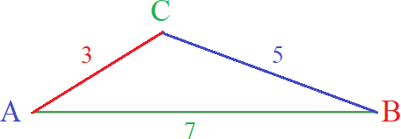
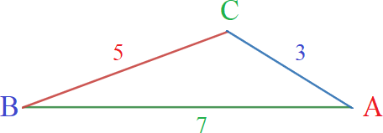

The rotate and flip transform as shown is popular for describing the law of cosines though I do not think it is needed. Either way lets us this position and solve. Drop a sine from ∠C. Divide the perimeter by 2. 15÷2 = 7.5.

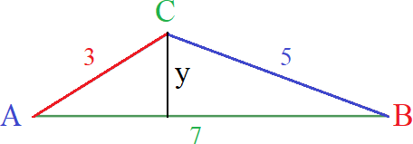
area = sqrt (7.5(7.5 – 3)(7.5 – 5)(7.5 – 7))
area ≈ 6.5 Same as last page
area = ½bh
h = area/½b
h = 6.5/½7
h~ 1.857 Rough estimate
h ≈ 6.49519/3.5
h ≈ 1.85577 More accurate
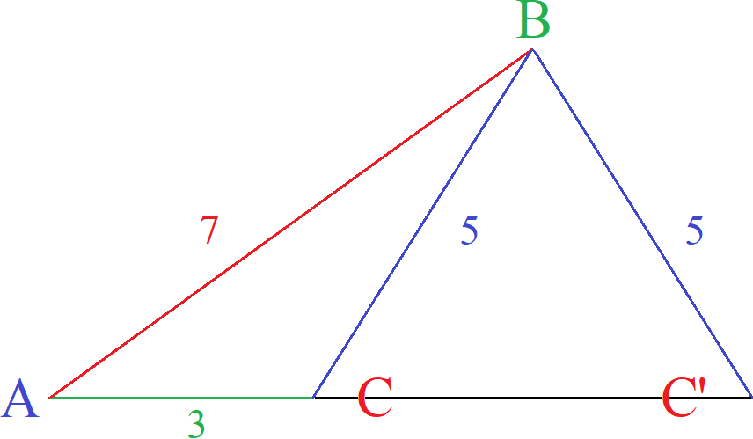

This first estimate used an approximation for area that threw off accuracy.
The second estimate used a better approximation taken from law of cosines.
Seems preferable to use law of sines to get height then find area.
This formula is a rehash of Heron's Formula.
Heron's Formula

Heron's formula states area of a triangle is A = √s(s – a)(s – b)(s – c) where s is semi-perimeter as ½(a + b + c).

Law of Cosines Proof

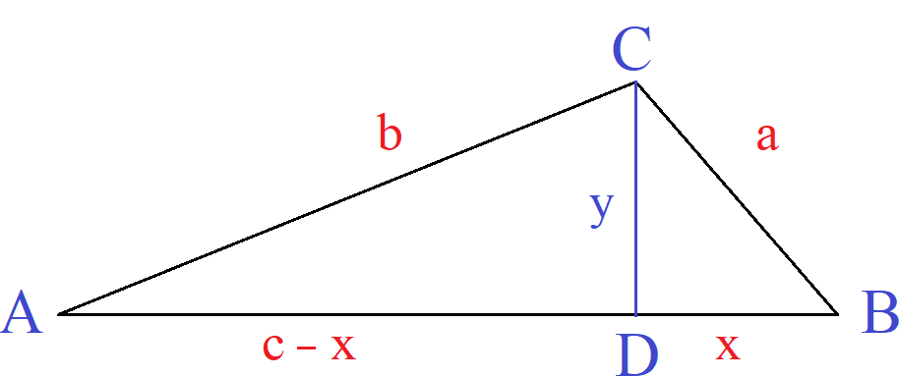
area = ½bh
area = ½ absinC
area = ½∙ 5∙7∙sin(21.787)
height = asin(B) or bsinC

c² = a² + b² – 2abcos(C)
sin² + C + cos²C + 1

Area² = (2ab)² /16(1 – (a² +b² – c²)/2ab)²
1/16 ((2ab)² – (a² + b² – c²)²)
1/16 (2s)(2s + 2c)(c + a – b)(c – a + b)

Given △ABC, with an area of 8.94 square units, a perimeter of 16 units and sides AB = 3, CA = 7, what is BC?

- Calculate the semi perimeter.
- Substitute known values into A = √s(s – a)(s – b)(s – c) .
- Solve for x.
8.942=(√8(5)(8−x)(1)))²
79.9236=8(5)(8−x)(1)
79.9236/4 =(8−x)
79.923640 = 8−x
1.999809 = 8−x
x ≈ 6.0

■

