# Design Methodology

Algorithm Used

The filtering algorithm used for this application is the Sorbel algorithm. I outline the algorithm below:

1. **Convert the image to grayscale**:
   1. This can be done by averaging the RBG values of each pixel and assigning the average to the RGB components of the pixel. Weighting can be used to give better results.
   2. This application uses the built in *convertedTo(QImage::Format_Grayscale16);* method to achieve this.
2. **Blur the image**:
   1. This is done by assigning to each pixel in the image the average of its intensity summed up with the intensities of the surrounding pixels.
3. **Sorbel Filter:**
   1. Using two 3 x 3 kernels, one for the horizontal gradient and the other for the vertical gradient -that is, the rate of change of intensities horizontally and vertically- we convolve over each pixel to get the horizontal and vertical gradient approximations.

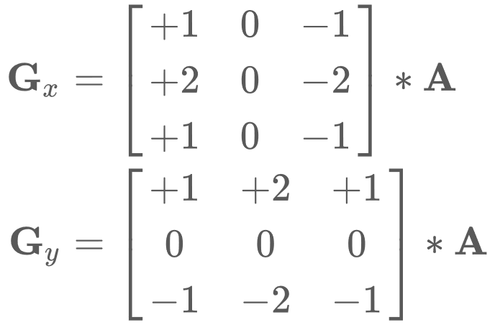

* 1. The Pythagorean theorem is used to calculate the gradient magnitude *G* for each pixel that will be tested against some threshold *t* such if *G < t* then the pixel will be given a white colour otherwise black.

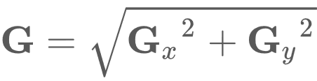

Design

The app is designed as follows:

h

g

f

e

d

c

b

a

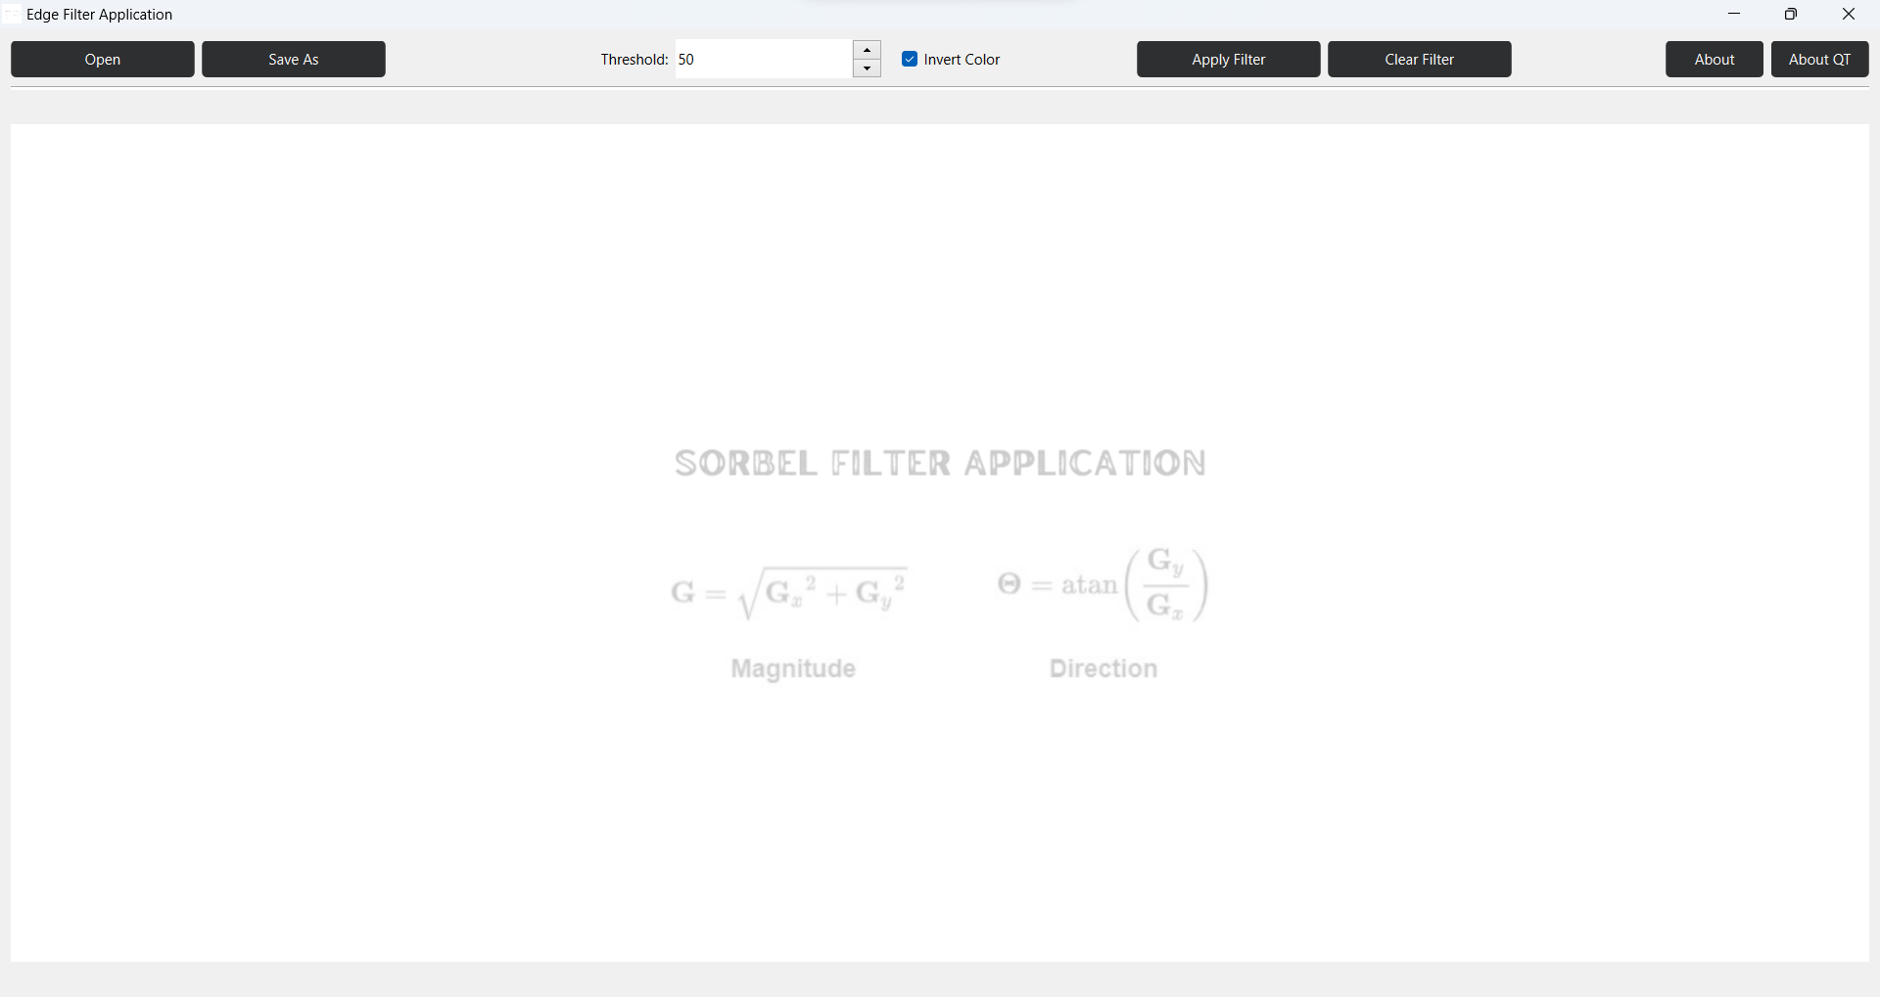

i

j

1. **Open Button**: Opens a dialog that allows users to browse their folders and choose an image to open (only .png is recognized).
2. **Save As Button**: Opens a dialog that allows users to browse their folders and choose a location to save the image and saves the image.
3. **Threshold Spinbox**: Allows the user to enter a threshold number that will be used to test is a pixel should be black or white.
4. **Invert Colour Checkbox**: If checked the image will be black and the lines will be white and if unchecked then the image will be white and the lines black.
5. **Apply Filter Button**: Applies the filter with the given settings to the image.
6. Clear Filter Button: Removes the applied filter if any.
7. **About Button**: Gives information about the developer and description of the application.
8. **About Qt Button**: Gives information about the framework used. It is required for applications developed in Qt without a commercial license.
9. **Canvas**: Images are displayed here.
10. **Status bar**: Useful information from the application is shown here.

Test Procedure and Test Results

To test if the application is functional different images where used. These images were picked from websites about image filtering that contained both before and after images. After using the application to filter the before images, the after images from the website were compared to the application output and the images were similar.

**Results of image one**

*Original image*:

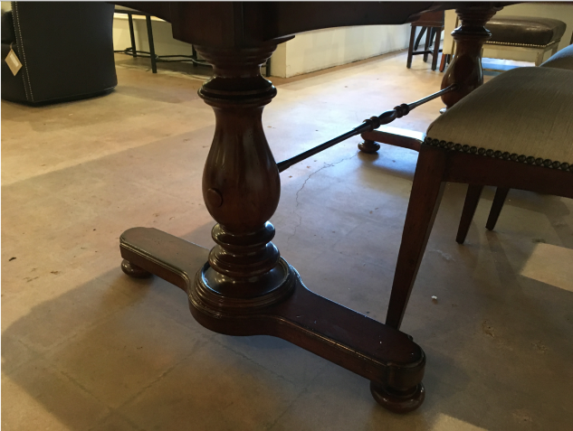

*Filtered image from website*:

*Image filtered by this application*:

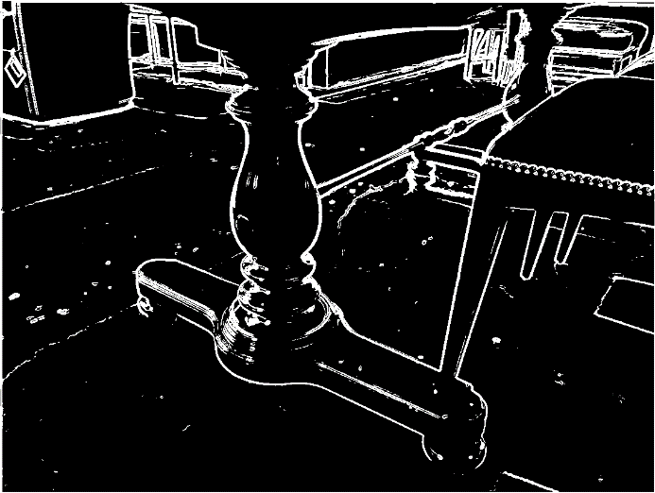

**Results of image two**

*Original image:*

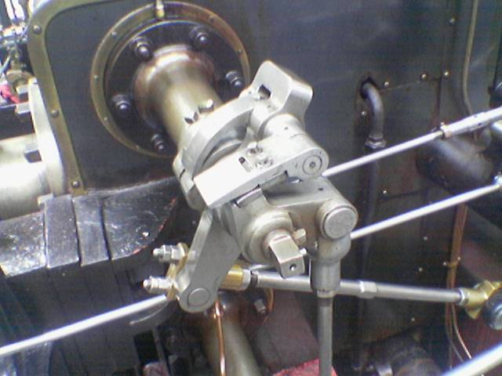

*Filtered image from website:*

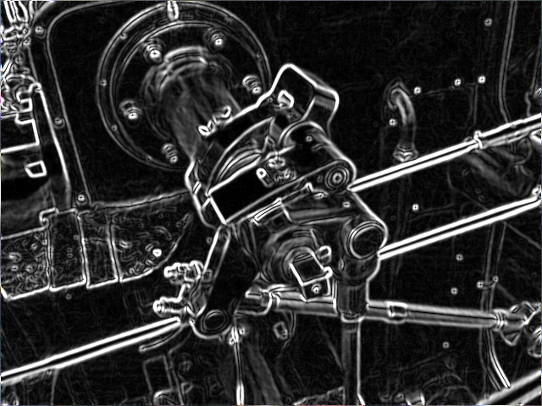

*Image filtered by this application:*

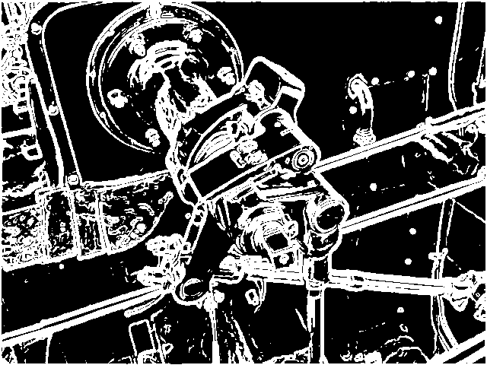

*Conclusion:*

The images above show that the application functions as required.

# References

Website links:

<https://aryamansharda.medium.com/how-image-edge-detection-works-b759baac01e2#:~:text=The%20Sobel%20algorithm%20works%20by,B%20values%20in%20a%20pixel.>

[https://en.wikipedia.org/wiki/Sobel_operator#](https://en.wikipedia.org/wiki/Sobel_operator)

Test image links:

<https://commons.wikimedia.org/wiki/File:Valve_original_(1).PNG#/media/File:Valve_original_(1).PNG>

<https://commons.wikimedia.org/wiki/File:Valve_sobel_(3).PNG#/media/File:Valve_sobel_(3).PNG>

<https://www.projectrhea.org/rhea/index.php/File:Original_image.png>

YouTube links:

Session 17 - Sobel Edge Detector: <https://youtu.be/H4kKKU2_tJM>

Edge Detection Using Gradients: <https://youtu.be/lOEBsQodtEQ?si=zIWxPLlGuOg-ZwG6>

What is an Edge?: <https://youtu.be/lOEBsQodtEQ?si=zIWxPLlGuOg-ZwG6>

LSIS and Convolution: <https://youtu.be/0OHRJMNKhX0?si=X-91NngwjXLzsvCs>