**Figures**

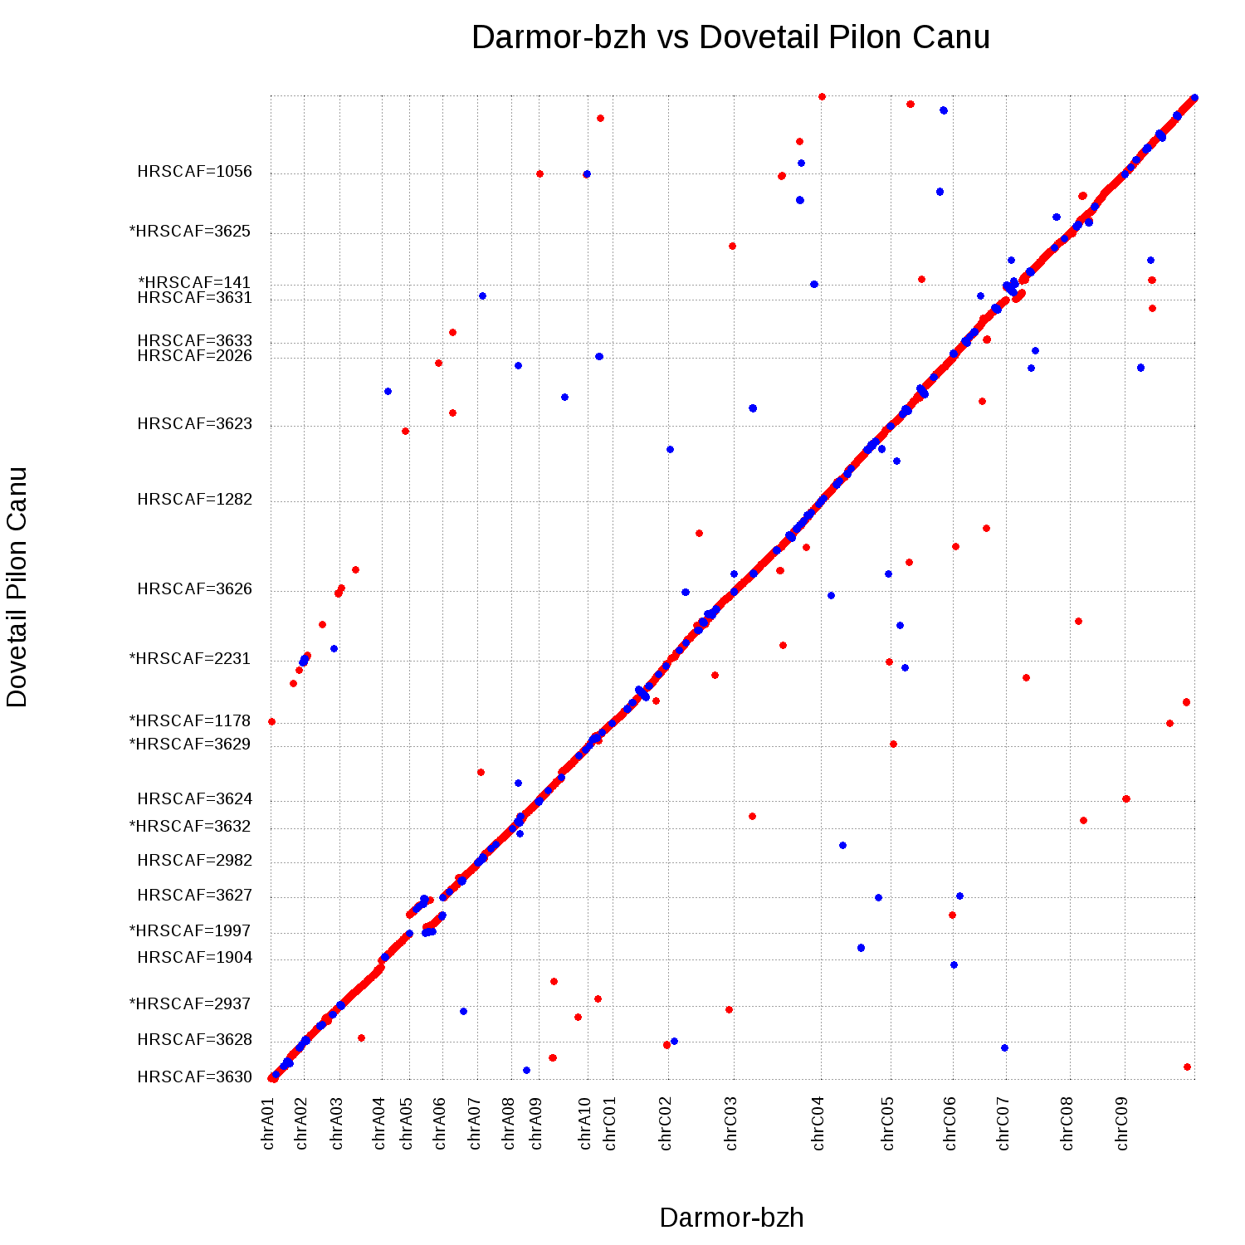

Figure 1 Nucmer plot of Dovetail_Pilon_Canu aligned to Darmor-bzh reference chromosomes. All sequences aligned are 1 Mbp or greater. A total of 21 Dovetail_Pilon_Canu scaffolds are aligned to 19 reference chromosomes. Red indicates an alignment in the forward direction and blue indicates an alignment in the reverse direction.

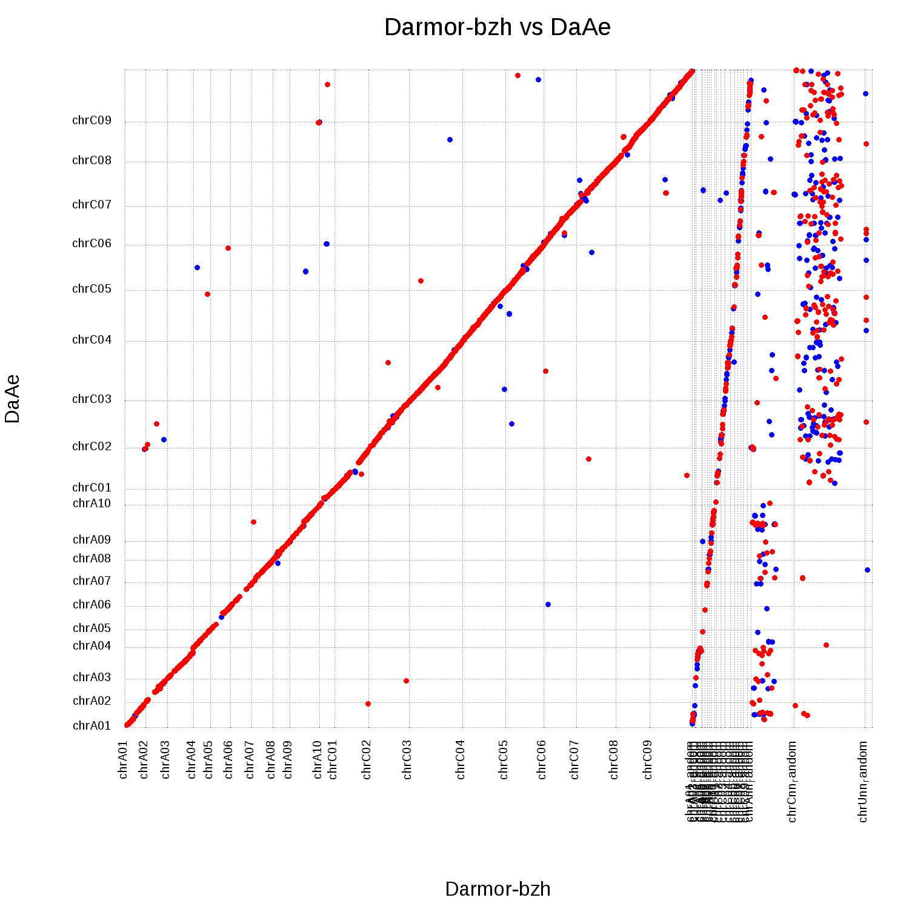

Figure 2 Nucmer plot of the final assembly aligned to the complete Darmor-bzh v4.1 reference. A total of 19 final assembly pseudomolecules are aligned to 41 reference pseudomolecules. Reference pseudomolecules 1–19 are anchored and orientated sequences, reference pseudomolecules 20–38 contain sequences that could be anchored to a chromosome but could not be confidently positioned, reference pseudomolecules 39 and 40 contain sequences that could only be anchored to a subgenomes, and reference pseudomolecule 41 contains sequences that could not be anchored. Alignments of the final assembly to pseudomolecules 20–41 indicate regions where previously unanchored sequences were able to be placed in the new assembly. Red indicates an alignment in the forward direction and blue indicates an alignment in the reverse direction.

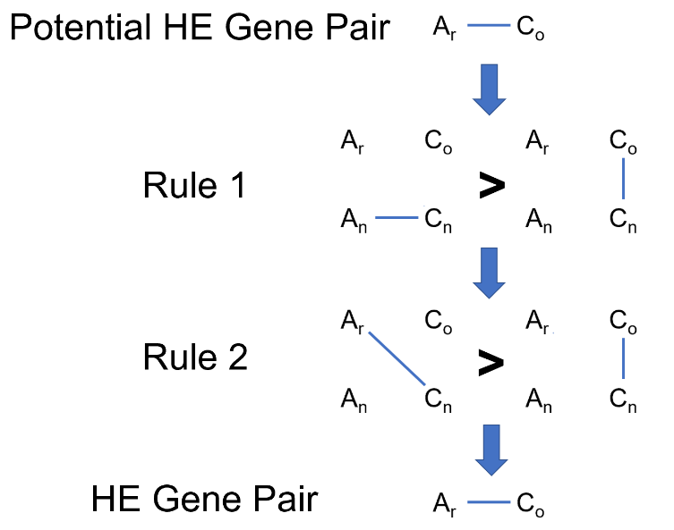

Figure 3 Example of a C gene being converted to an A gene. B. rapa = Ar, B. oleracea Co, B. napus A = An, and B. napus C = Cn. A potential homoeologous gene pair must pass two rules. First, the Cn gene of the pair must align better to its homoeolog (An) than it does to its ortholog (Co). Second, the Cn gene must also align better to its homoeolog's ortholog (Ar) than it does to its own ortholog (Co). If both rules are satisfied, the pair is declared a homoeologous gene pair.

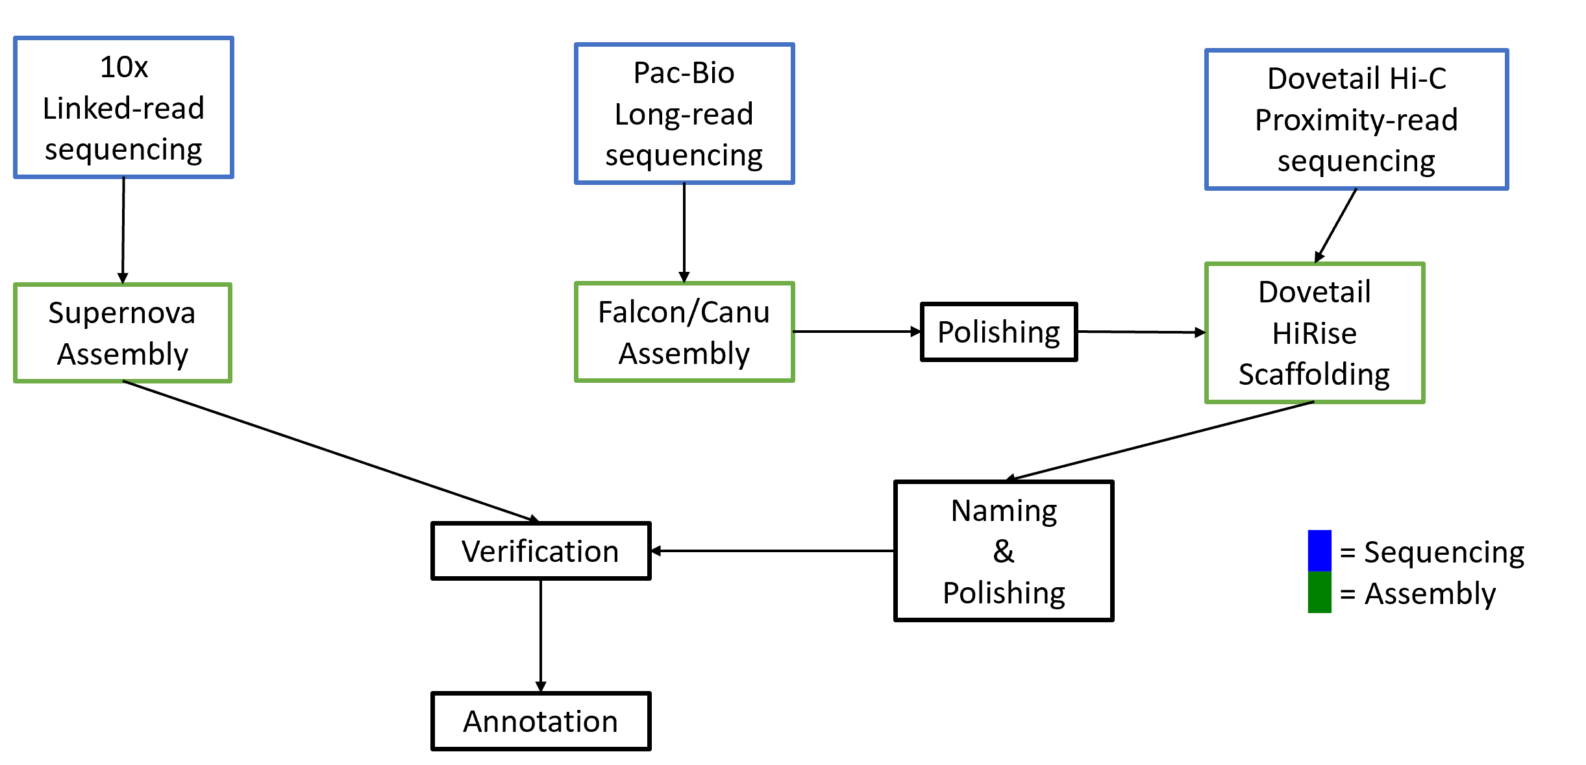

Figure 4 Genome assembly and annotation strategy

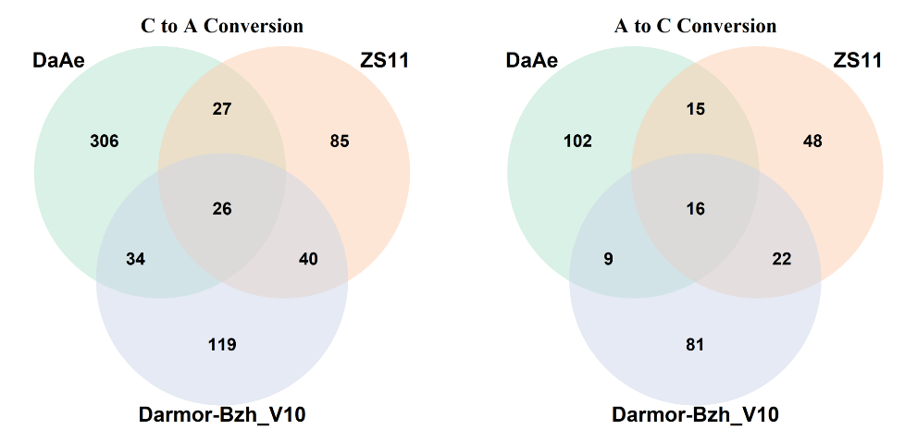

Figure 5 Conserved orthologous gene pairs between Da-Ae, Darmor-bzh v10, and ZS11

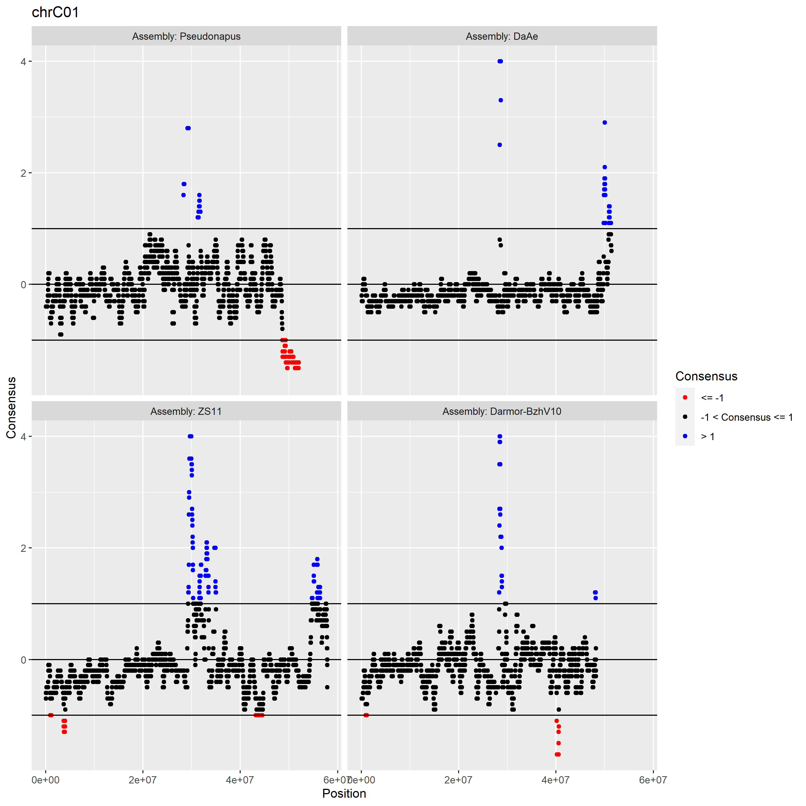

Figure 6 Coverage of each genome. There are peaks of increased coverage shared among Da-Ae, Darmor-bzh v10, and ZS11, suggesting sites of shared homoeologous exchange.

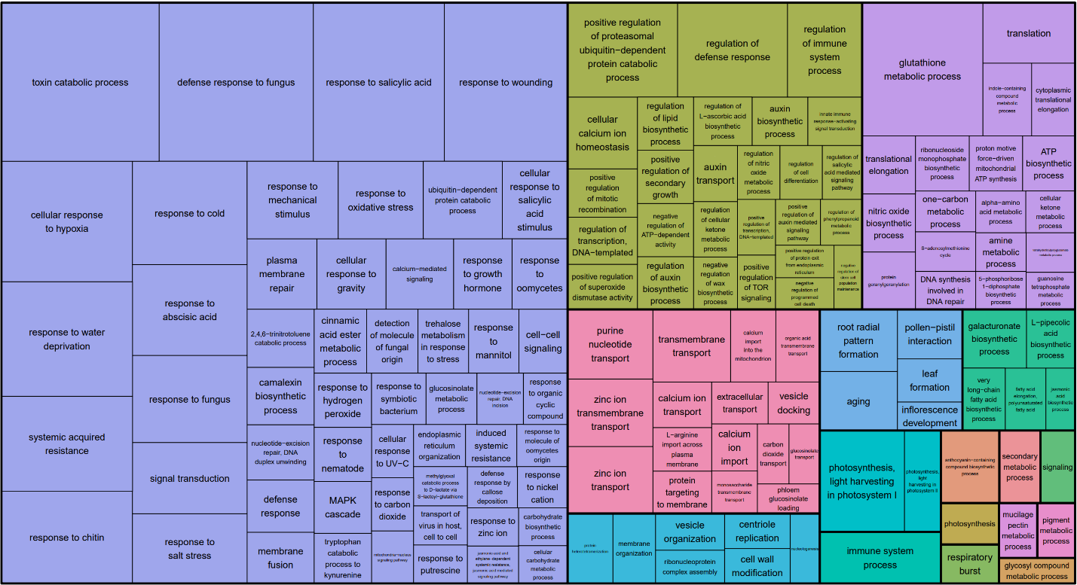

Figure 7 Tree map displaying over-represented BP:GO terms in the set of Unigene sequences not found in Da-Ae or Darmor-bzh v10

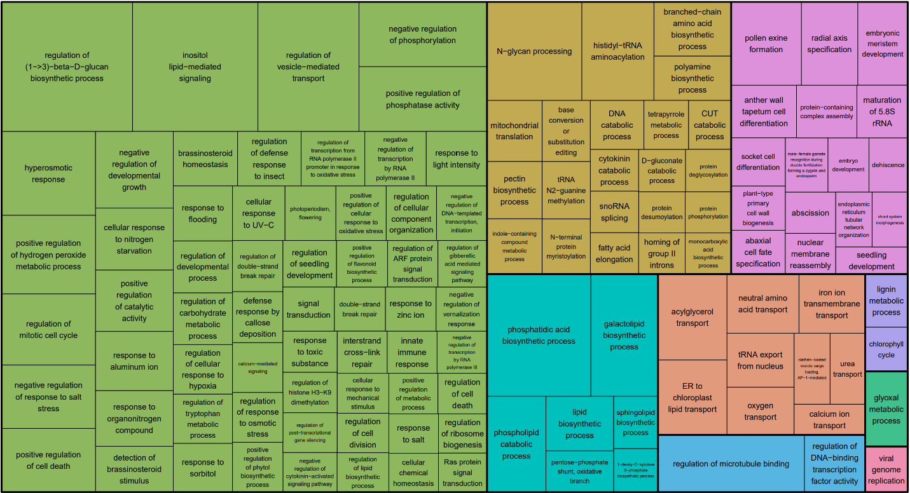

Figure 8 Tree map displaying over-represented BP:GO terms in the set of Unigene sequences found in Da-Ae but not Darmor-bzh v10 and vice versa