Table 1. Length of the 19 pseudomolecules, N50 of the pseudomolecules, total assembly N50, total pseudomolecule length, total number of scaffolds, and total assembly length.

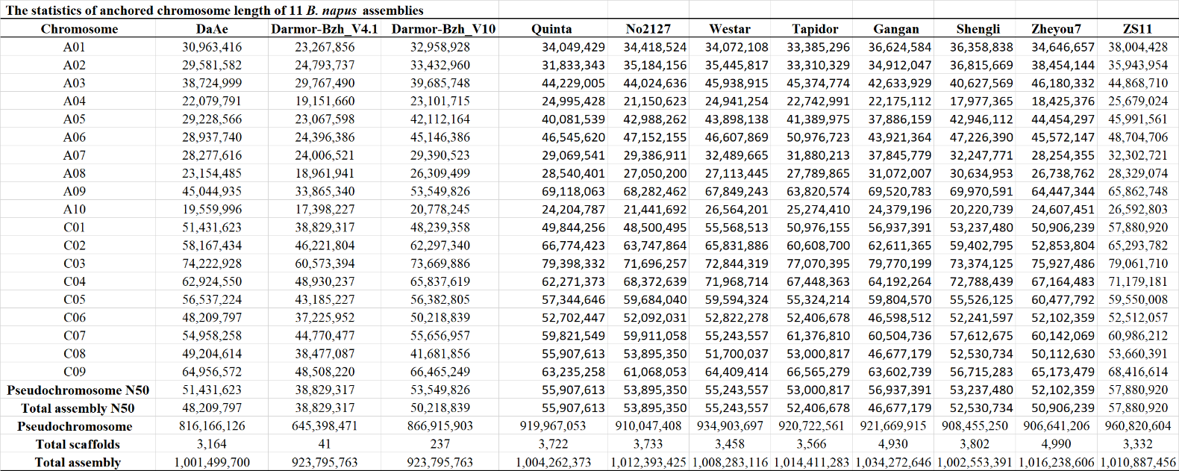

Table 2. Percentages of BUSCOs. BUSCOs percentages were calculated using the brassicales_odb10 dataset, which contains 4,596 BUSCOS.

