Table Length of the 19 pseudomolecules, Pseudomolecule N50, Total assembly N50, Total pseudomolecule length, and Total assembly length.

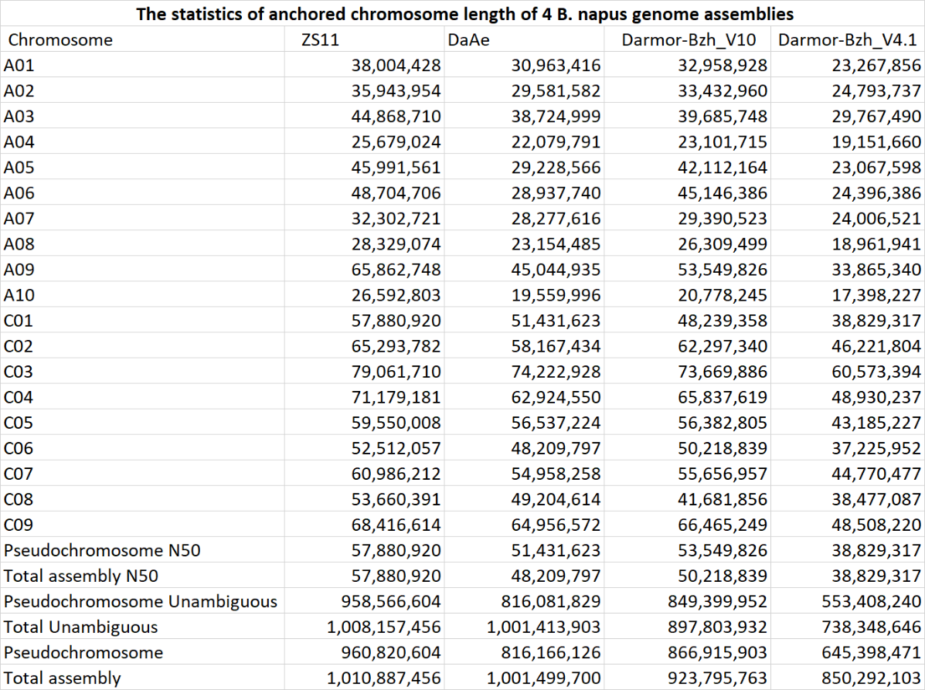

Table Percentages of BUSCOs. BUSCOs percentages were calculated using the brassicales_odb10 dataset which contains 4,596 BUSCOS.



Table Transposable Element content of 3 B. napus assemblies. Calculated using default parameters of repeatmasker v4.1.2-p1 and lib file bnapus.TE-families.fa located at (http://cbi.hzau.edu.cn/rape/download_ext/)

