**Figures**

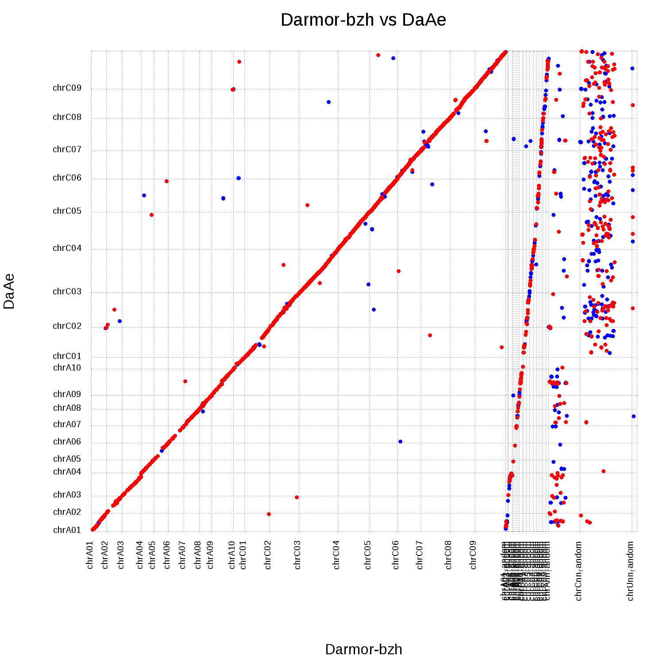

Figure 4 Nucmer plot of the final assembly aligned to the complete *Brassica napus* reference. A total of 19 final assembly pseudomolecules are aligned to 41 reference pseudomolecules. Reference pseudomolecules 1–19 are anchored and orientated sequences, reference pseudomolecules 20–38 contain sequences that could be anchored to a chromosome but could not be confidently positioned, reference pseudomolecules 39 and 40 contain sequences that could only be anchored to a subgenomes, and reference pseudomolecule 41 contains sequences that could not be anchored. Alignments of the final assembly to pseudomolecules 20–41 indicate regions where previously unanchored sequences were able to be placed in the new assembly. Red indicates an alignment in the forward direction and blue indicates an alignment in the reverse direction.

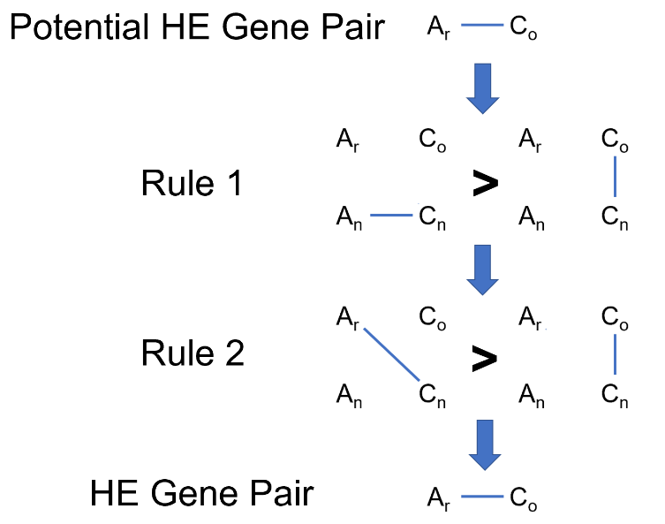

Figure 5 Example of a C gene being converted to an A gene. *B. rapa* = Ar, *B. oleracea* Co, *B. napus* A = An, and *B. napus* C = Cn. A potential homoeologous gene pair must pass two rules. First, the Cn gene of the pair must align better to its homoeolog (An) than it does to its ortholog (Co). Second, the Cn gene must also align better to its homoeolog's ortholog (Ar) than it does to its own ortholog (Co). If both rules are satisfied, the pair is declared a homoeologous gene pair.

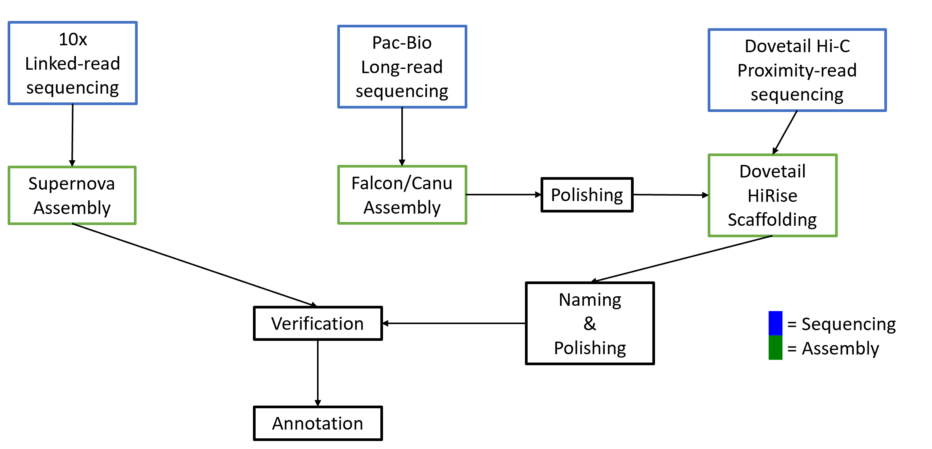

Figure 6 Genome assembly and annotation strategy

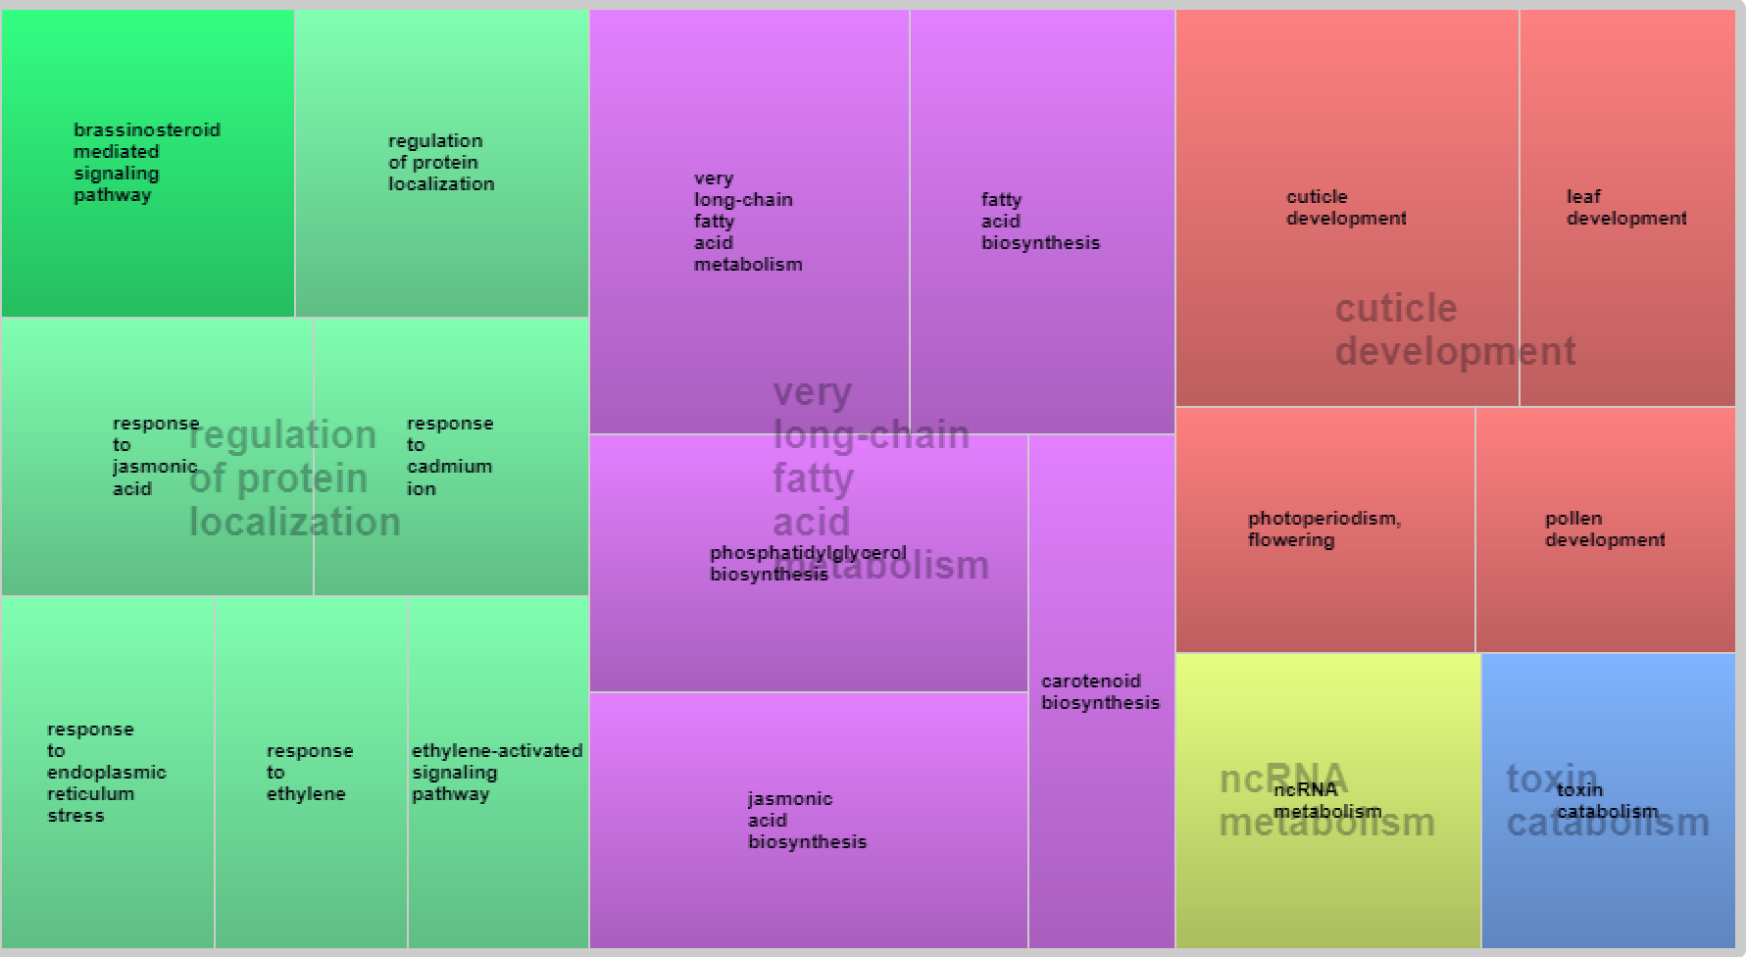

Figure 7 Revigo plot of over-represented GO terms of Brassica Unigene sequences present in the Da-Ae genome but not the Darmor-bzh genome

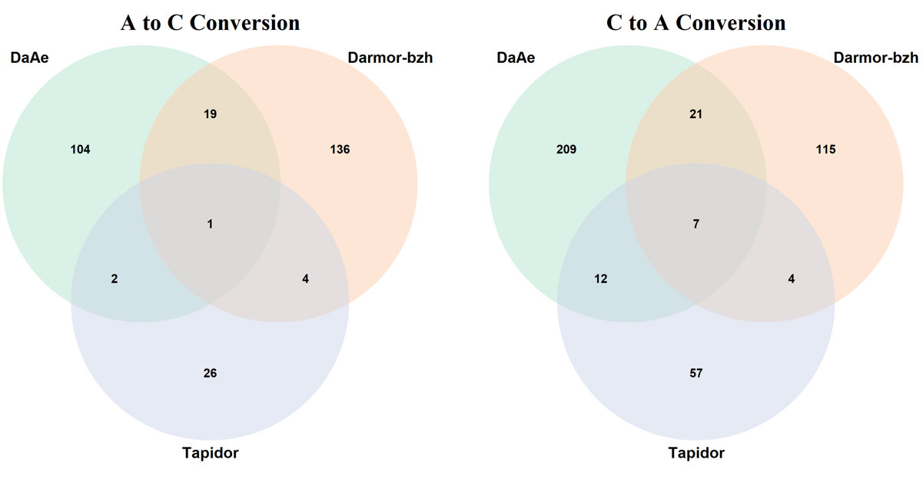

Figure 8 Conserved orthologous gene pairs between Da-Ae, the reference (Darmor-bzh), and Tapidor

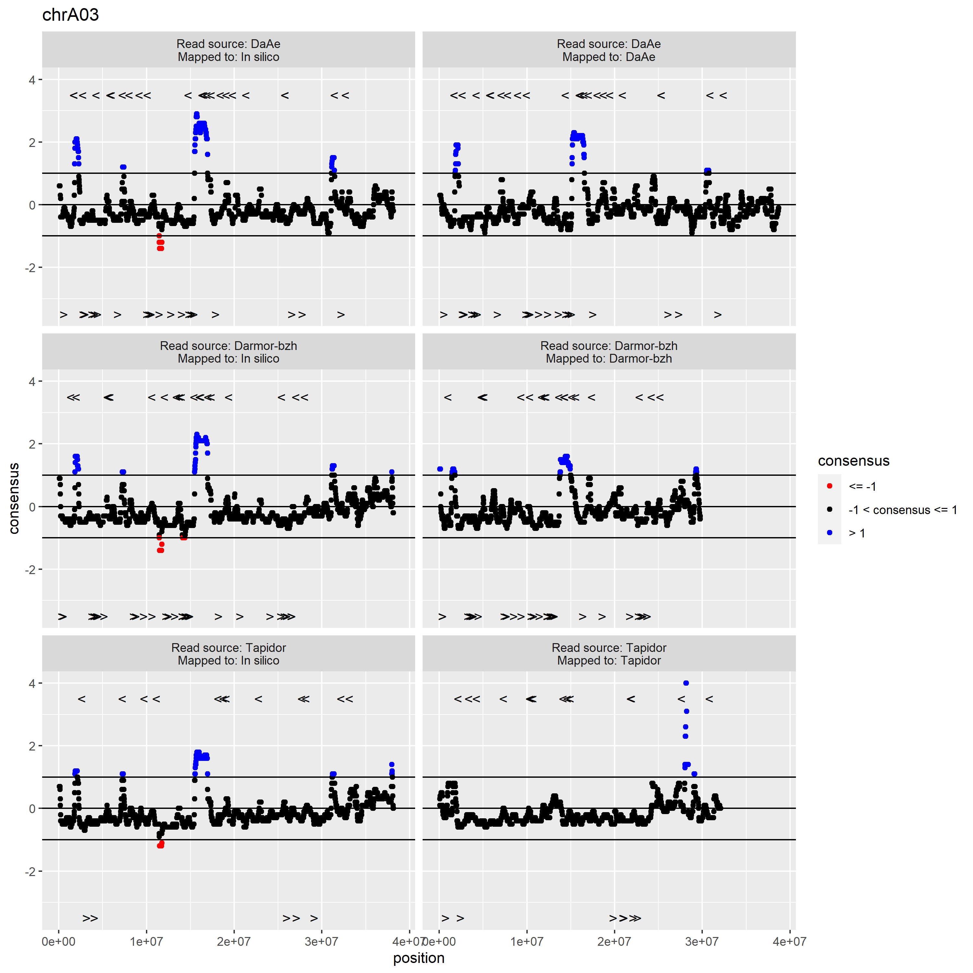

Figure 9 Coverage of each genome. There are three peaks of increased coverage shared among Da-Ae, Reference, and Tapidor, suggesting sites of shared homoeologous exchange. “<” indicates recipient and “>” indicates donor locations of genes suspected to be involved in homoeologous exchange.

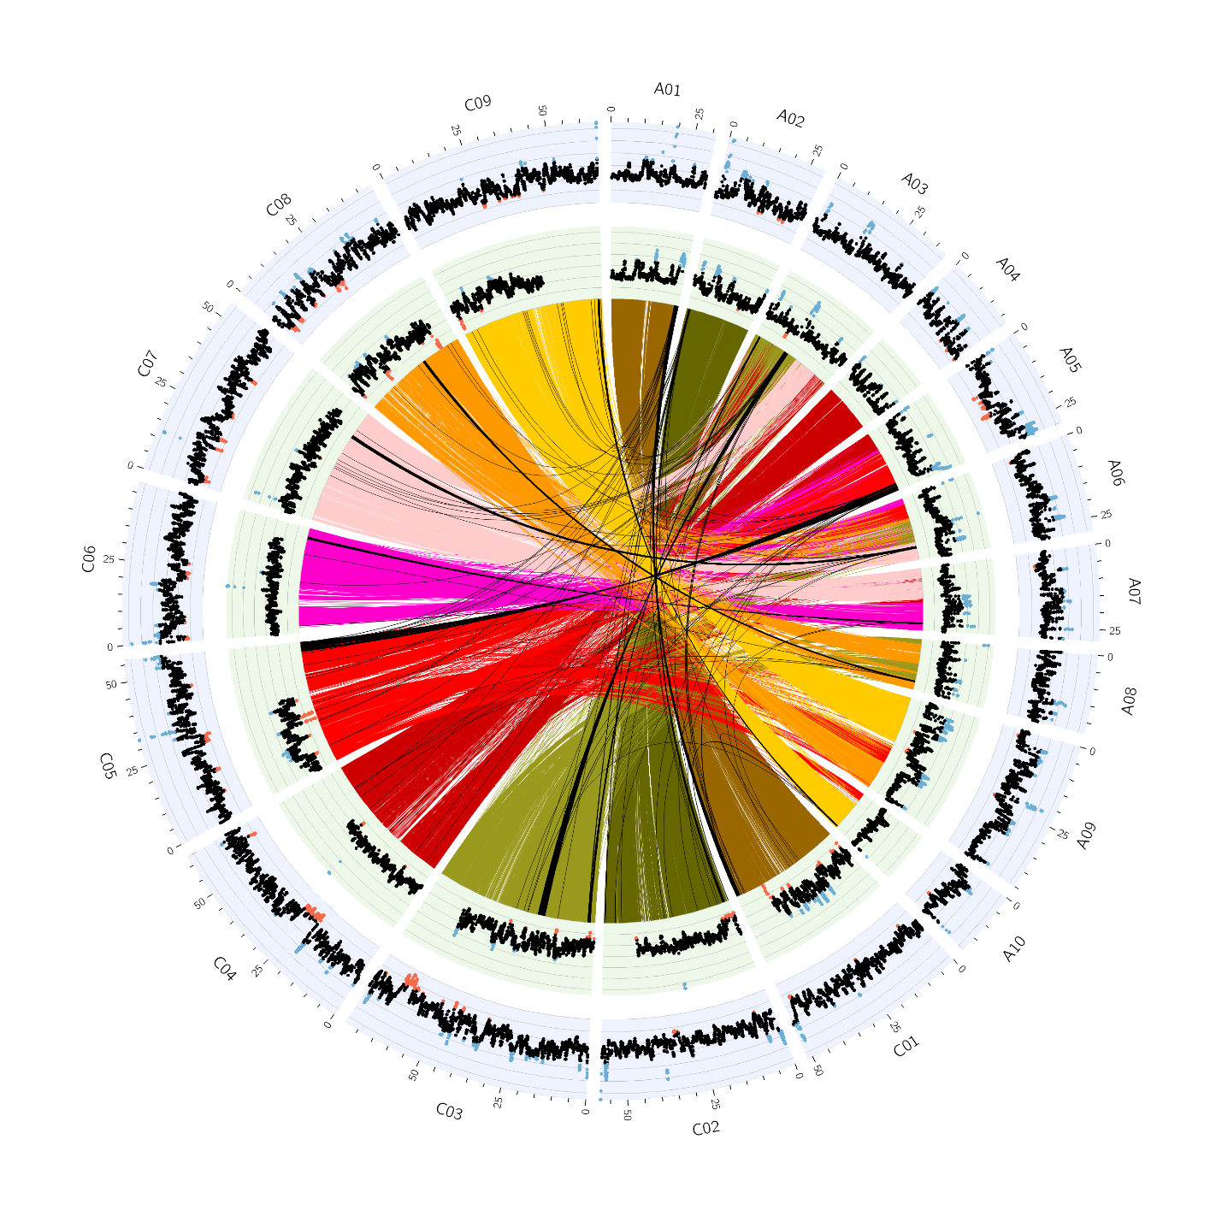

Figure 10 Circos plot of Da-Ae. Outer blue track is read coverage across the Da-Ae genome. Inner green track is read coverage across the *in silico* genome (*B. rapa* + *B. oleracea*). Blue dots indicate standardized coverage greater than 1 and red dots indicate standardized coverage less than -1. Ribbons in the center of the plot indicate regions of homology between the A and C subgenomes. Colors have been assigned based on C subgenome chromosomes. Black ribbons are regions suspected of having undergone homoeologous exchange.