Exam Question – Teddy Bear Factory

Jim is writing a program to calculate the wages of workers in a teddy bear factory.

1. Workers sometimes get a £50 bonus.

Here is the algorithm used to calculate whether a worker should get a bonus:

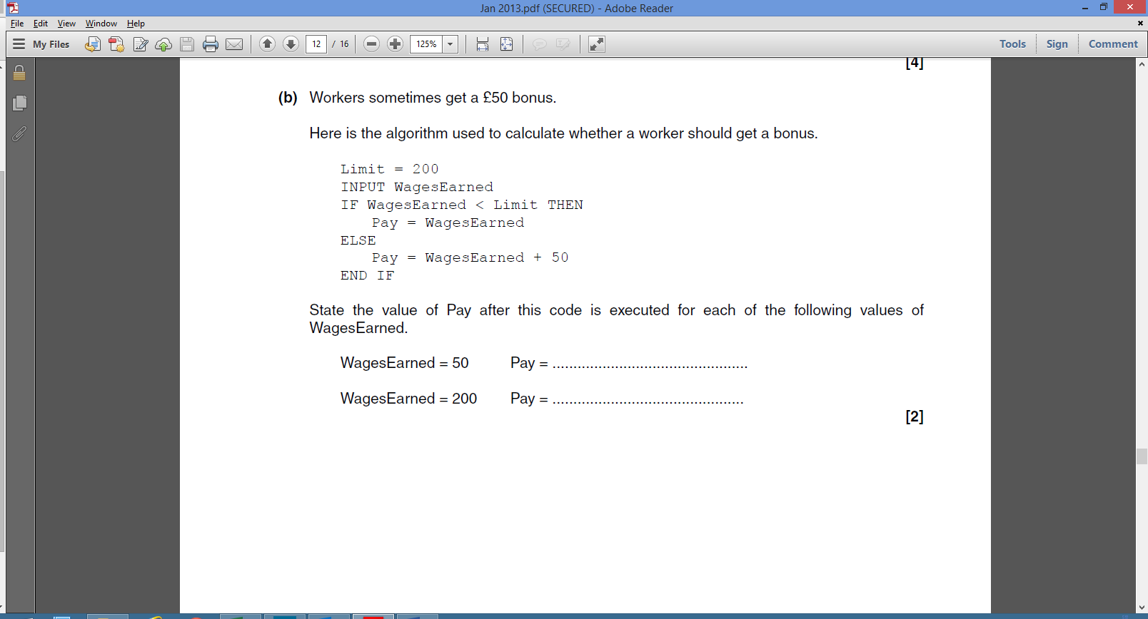

State the value of Pay after this code is executed for each of the following values of WagesEarned:

WagesEarned = 50 Pay = ………………….

WagesEarned = 200 Pay = ………………….

[2]

2. The wages earned by a worker is either £2 for every teddy bear they have made, or £5 for every hour they have worked, whichever is larger.

Write an algorithm that:

* Allows the user to input the number of teddy bears made, and the number of hours worked
* Calculates the wages for the number of teddy bears made
* Calculates the wages for the number of hours worked
* Outputs the larger of the two results.

|  |
| --- |
|  |

[6]