**Q1.**

package Q_01;  
  
import javax.swing.*;  
  
public class Q1 {  
 public static void main(String[] args) {  
 JFrame frame = new JFrame();  
 frame.setSize(800,600);  
 frame.setTitle("Welcome to Java");  
 frame.setVisible(true);  
 }  
}

**output :**

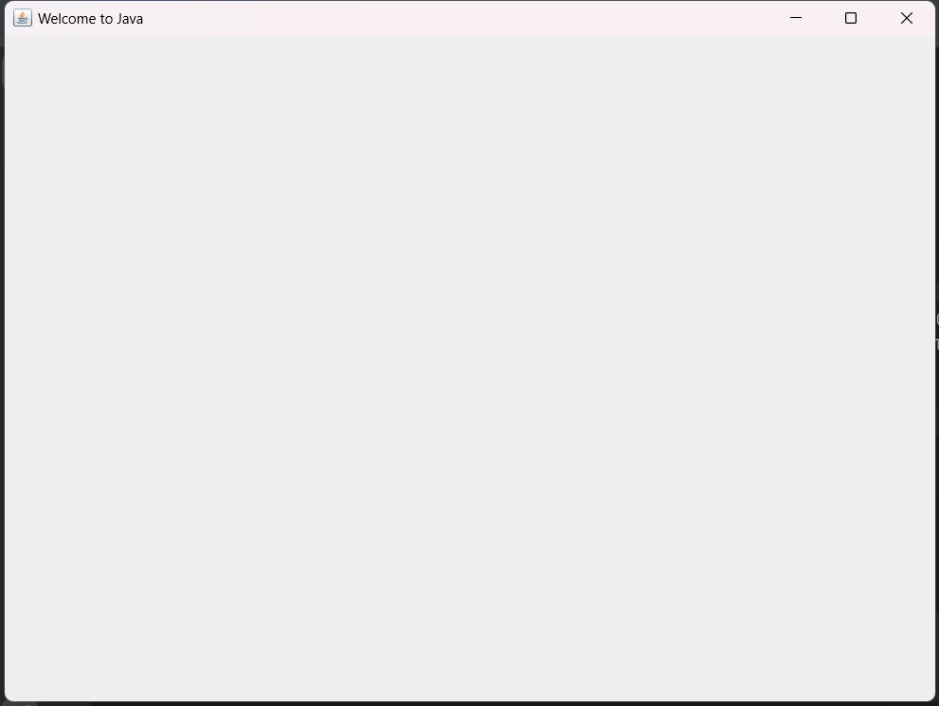

**Q2.**

package Q_02;  
  
import javax.swing.*;  
import java.util.Scanner;  
  
public class Q2 {  
 public static void main(String[] args) {  
 Scanner input = new Scanner(System.*in*);  
  
 System.*out*.println("Enter your first name :");  
 String firstName = input.next();  
  
 System.*out*.println("Enter your last name : ");  
 String lastName = input.next();  
  
 input.close();  
  
 JFrame welcomeframe;  
 JFrame frame = new JFrame();  
 frame.setSize(250,150);  
 frame.setTitle(firstName + " " + lastName);  
 frame.setVisible(true);  
 }  
}

**Output:**

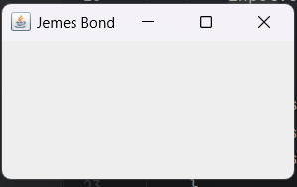

**Q3.**

package Q_03;  
  
import java.util.Scanner;  
  
public class Q3 {  
 public static void main(String[] args) {  
 Scanner input = new Scanner(System.*in*);  
  
 System.*out*.println("Enter first name :");  
 String firstName = input.next();  
  
 System.*out*.println("Enter middle name :");  
 String middleName = input.next();  
  
 System.*out*.println("Enter last name :");  
 String lastName = input.next();  
  
 String initial = middleName.substring(0,1);  
  
 System.*out*.println(firstName + " " + initial + "." + lastName);  
 }  
}

**Output:**

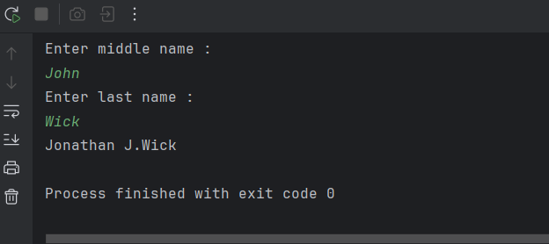

**Q4.**

package Q_04;  
  
import java.text.SimpleDateFormat;  
import java.util.Date;  
  
public class Q4 {  
 public static void main(String[] args) {  
 Date today = new Date();  
 System.*out*.println(today);  
  
 SimpleDateFormat sdf = new SimpleDateFormat("dd MMM yyyy");  
 System.*out*.println(sdf.format(today));  
 }  
}

**Output:**

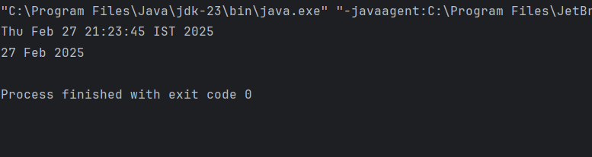

**Q5.**

package Q_05;  
  
import java.text.SimpleDateFormat;  
import java.util.Date;  
  
public class Q5 {  
 public static void main(String[] args) {  
 Date today = new Date();  
 SimpleDateFormat dateFormat = new SimpleDateFormat("EEEE,MMMM d,yyyy");  
 String formattedDate = dateFormat.format(today);  
 System.*out*.println(formattedDate);  
 }  
}

**Output:**

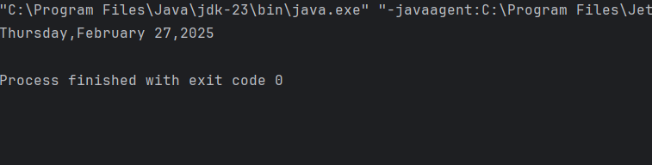

**Q6.**

package Q_06;  
  
import javax.swing.*;  
import java.util.Scanner;  
  
public class Q6 {  
 public static void main(String[] args) {  
 JFrame frame = new JFrame();  
 Scanner Scanner = new Scanner(System.*in*);  
  
 System.*out*.println("Enter the frame width :");  
 int width = Scanner.nextInt();  
  
 System.*out*.println("Enter the frame height");  
 int height = Scanner.nextInt();  
  
 frame.setSize(width,height);  
  
 frame.setVisible(true);  
 }  
}

**Output:**

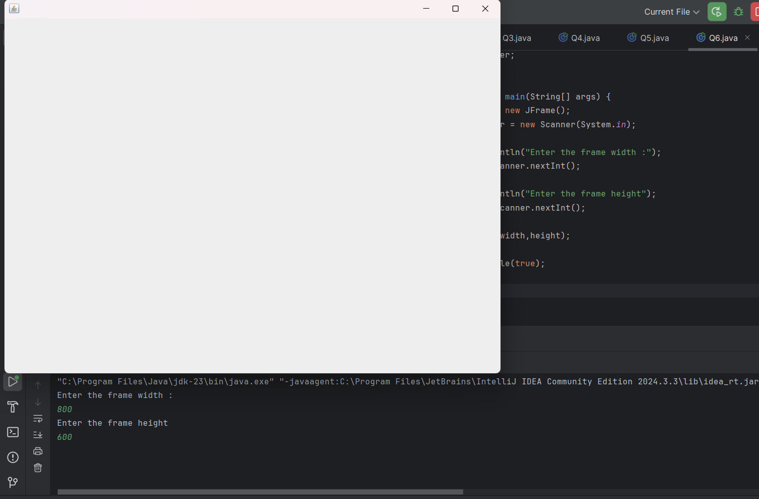

**Q7.**

package Q_07;  
  
import javax.swing.*;  
import java.text.SimpleDateFormat;  
import java.util.Date;  
  
public class Q7 {  
 public static void main(String[] args) {  
 JFrame frame = new JFrame();  
 Date date = new Date();  
 SimpleDateFormat sdf = new SimpleDateFormat("HH:mm:ss a");  
  
 String title = sdf.format(date);  
  
 frame.setSize(600,800);  
 frame.setTitle(title);  
 frame.setVisible(true);  
  
 }  
}

**Output:**

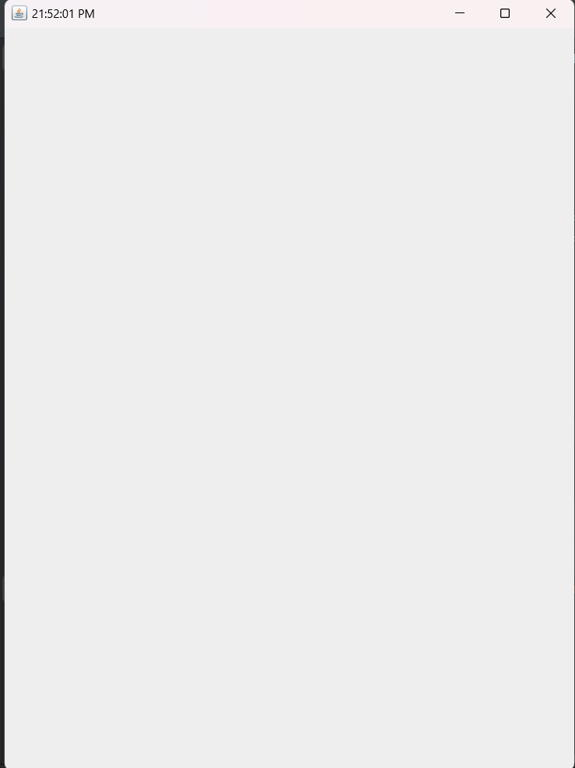

**Q8.**

package Q_08;  
  
import java.util.Scanner;  
  
public class Q8 {  
 public static void main(String[] args) {  
 Scanner scanner = new Scanner(System.*in*);  
  
 System.*out*.println("Enter a string including a single exclamation mark :");  
 String input = scanner.nextLine();  
  
 int exclamationIndex = input.indexOf('!');  
  
 String beforeExclamation = input.substring(0,exclamationIndex);  
 String afterExclamation = input.substring(exclamationIndex + 1);  
  
 System.*out*.println("Before exclamation mark : " + beforeExclamation);  
 System.*out*.println("After exclamation mark :" + afterExclamation);  
  
  
  
  
  
 }  
}

**Output:**

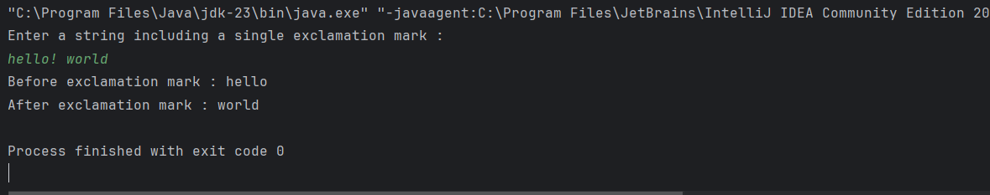

**Q9.**

package Q_09;  
  
import java.util.Scanner;  
  
public class Q9 {  
 public static void main(String[] args) {  
 Scanner scanner = new Scanner(System.*in*);  
  
 System.*out*.println("Enter a string :");  
 String input = scanner.nextLine();  
  
 int length = input.length();  
  
 char firstChar = input.charAt(0);  
 char lastChar = input.charAt(length - 1);  
  
 System.*out*.println("Number of characters : " + length);  
 System.*out*.println("First character :" + firstChar);  
 System.*out*.println("Last character :" + lastChar);  
  
 scanner.close();  
 }  
}

**Output:**

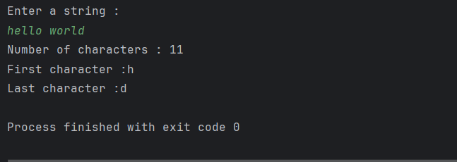

**Q10.**

package Q_10;  
  
import java.util.Scanner;  
  
public class Q10 {  
 public static void main(String[] args) {  
 Scanner scanner = new Scanner(System.*in*);  
  
 System.*out*.println("Enter an odd length word :");  
 String word = scanner.nextLine();  
  
 int length = word.length();  
  
 if (length % 2 == 1) {  
 int middleIndex = length / 2;  
  
 char middleChar = word.charAt(middleIndex);  
  
 System.*out*.println("The middle character is : " + middleChar);  
 }  
 else {  
 System.*out*.println("The word must have an odd length");  
 }  
  
 }  
}

**Output:**

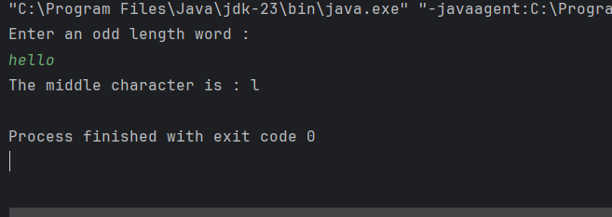

**Q11.**

package Q_11;  
  
import java.util.Scanner;  
  
public class Q11 {  
 public static void main(String[] args) {  
 Scanner Scanner = new Scanner(System.*in*);  
  
 System.*out*.println("Enter your full name(first middle last) :");  
 String fullName = Scanner.nextLine();  
  
 String[] nameParts = fullName.split(" ");  
  
 if (nameParts.length == 3) {  
 String firstName = nameParts[0];  
 String middleName = nameParts[1];  
 String lastName = nameParts[2];  
  
 char middleInitial = middleName.charAt(0);  
  
 String formattedName = lastName + " , " + firstName + " " + middleInitial + " . ";  
  
 System.*out*.println("Formatted name : " + formattedName);  
 }  
 else {  
 System.*out*.println("Invalid input");  
 }  
 }  
}

**Output:**

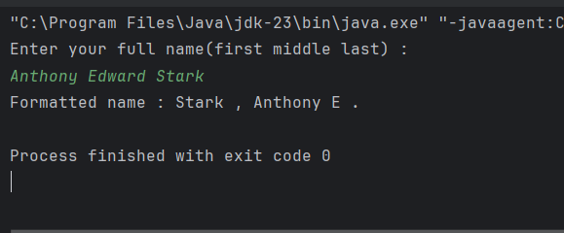

**Q12.**

package Q_12;  
  
import javax.swing.*;  
  
public class Q12 {  
 public static void main(String[] args) {  
 JFrame frame = new JFrame();  
  
 frame.setTitle("My First Frame");  
  
 frame.setSize(300,200);  
  
 frame.setLocation(100,50);  
  
 frame.setDefaultCloseOperation(JFrame.*EXIT_ON_CLOSE*);  
  
 frame.setVisible(true);  
 }  
}

**Output:**

