

Object oriented programming

Lab Work Sheet -2



CT/2021/025

**Q_01:**

package Q_01;  
  
import java.util.Scanner;  
  
public class Q1 {  
 public static void main(String[] args) {  
  
 //part a:  
  
 System.*out*.println("PART a ");  
 Scanner scanner = new Scanner(System.*in*);  
  
 System.*out*.println("Enter value of A:");  
 double A = scanner.nextDouble();  
  
 System.*out*.println("Enter Value of C(C and A should not be equal) :");  
 double C = scanner.nextDouble();  
  
 System.*out*.println("Enter value of B :");  
 double B = scanner.nextDouble();  
  
 double root = Math.*sqrt*((Math.*pow*(B,2)) + 4 * A * C);  
 System.*out*.println("Answer is "+ root);  
  
  
  
 // Part b:  
 System.*out*.println("PART b ");  
  
 System.*out*.println("Enter value of X :");  
 double X = scanner.nextDouble();  
  
 System.*out*.println("Enter value of Y :");  
 double Y = scanner.nextDouble();  
  
 double root2 = Math.*sqrt*(X + (4 * Math.*pow*(Y,3)));  
  
 System.*out*.println("Answer is "+ root2);  
  
 // Part c:  
 System.*out*.println("PART c ");  
 System.*out*.println("Enter value of X :");  
 double x = scanner.nextDouble();  
  
 System.*out*.println("Enter value of Y :");  
 double y = scanner.nextDouble();  
  
 double root3 = Math.*cbrt*(x * y);  
  
 System.*out*.println("Answer is " + root3);  
  
 //Part d:  
 System.*out*.println("PART d ");  
  
 final double PI = 3.14;  
 double area; double radius ;  
  
 System.*out*.println("Enter radius of the circle :");  
 radius = scanner.nextDouble();  
  
 area = PI * Math.*pow*(radius , 2);  
 System.*out*.println("Area of the circle is " + area);  
 }  
}

**Output :**

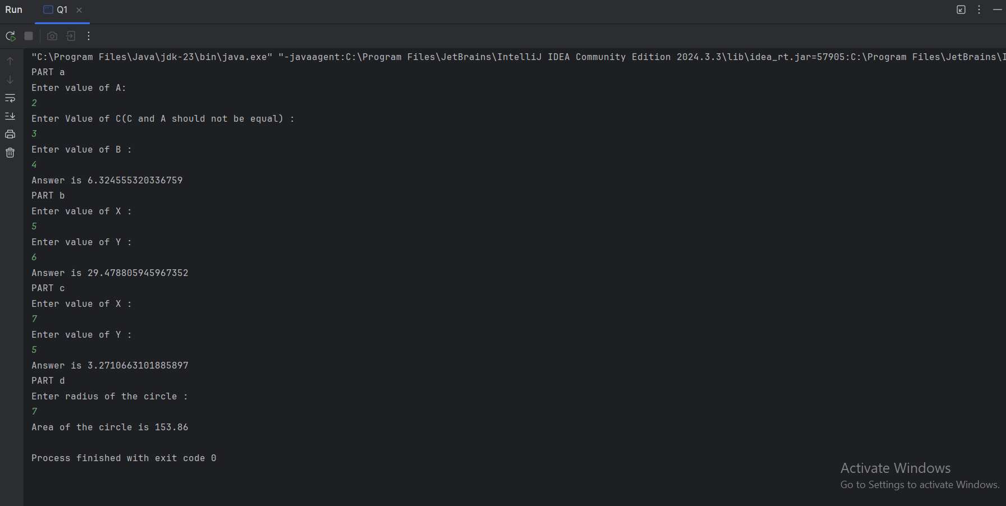

**Q_02:**

package Q_02;  
  
import java.util.Scanner;  
  
public class Q2 {  
 public static void main(String[] args) {  
  
 System.*out*.println("Enter value in centimeter :");  
 Scanner scanner = new Scanner(System.*in*);  
 double Cm = scanner.nextDouble();  
  
 double inch = Cm * (1/2.54);  
 System.*out*.println("Inches : " + inch);  
  
 double feet = Cm * (0.032);  
 System.*out*.println("Feets : " + feet);  
  
 }  
}

**Output:**

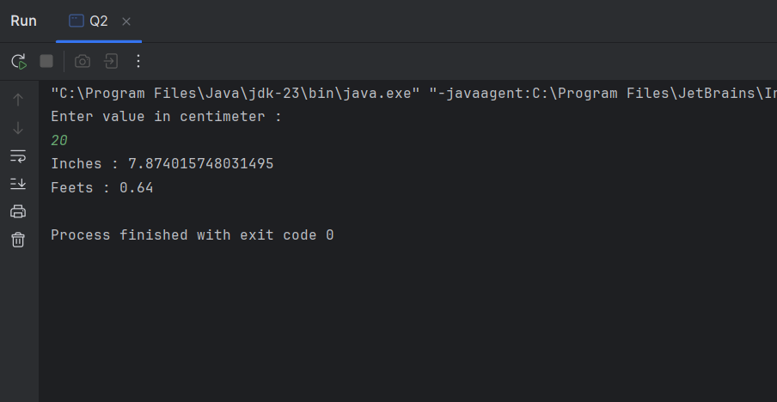

**Q_03:**

package Q_03;  
  
import java.util.Scanner;  
  
public class Q3 {  
 public static void main(String[] args) {  
  
 System.*out*.println("Enter temperature in degree celsius :");  
 Scanner scanner = new Scanner(System.*in*);  
 double cel = scanner.nextDouble();  
  
 double tem = (1.8 * cel) + 32;  
 System.*out*.println("Temperature in Fahrenheit : " +tem );  
  
  
 }  
}

**Output:**

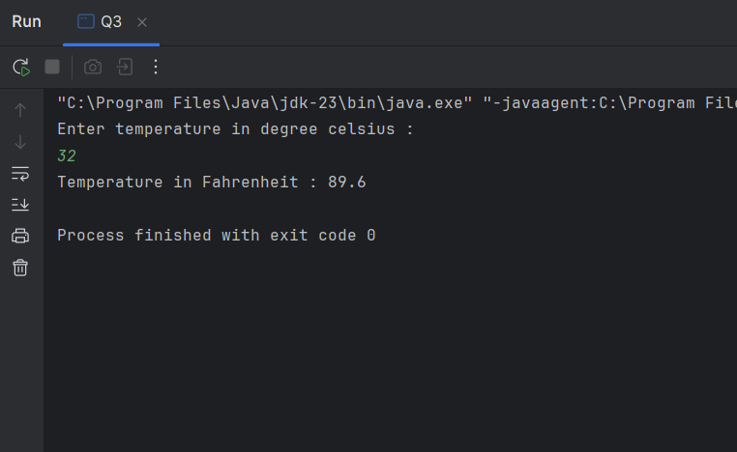

**Q_04:**

package Q_04;  
  
import java.util.Scanner;  
  
public class Q4 {  
 public static void main(String[] args) {  
  
 System.*out*.println("Enter your body weight :");  
 Scanner scanner = new Scanner(System.*in*);  
 double weight = scanner.nextDouble();  
  
 double calories = weight * 19;  
  
 System.*out*.println("Number of calories :" + calories);  
 }  
}

**Output:**

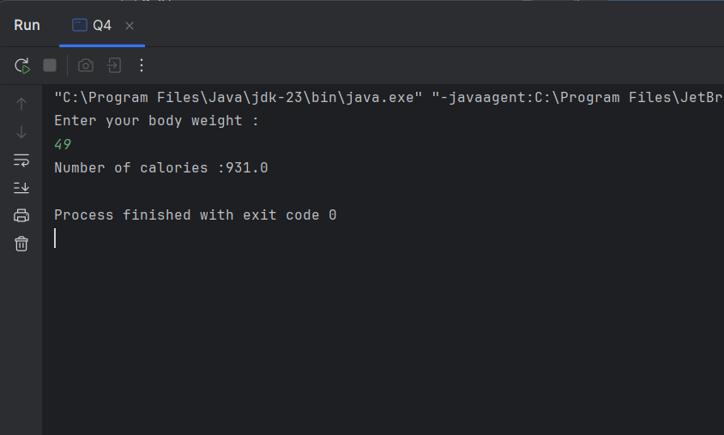

**Q_05:**

package Q_05;  
  
import java.util.Scanner;  
  
public class Q5 {  
 public static void main(String[] args) {  
  
 System.*out*.println("Enter temperature in Fahrenheit :");  
 Scanner scanner = new Scanner(System.*in*);  
 double fahrenheit = scanner.nextDouble();  
  
 double tem = (5.0/9.0) * (fahrenheit - 32);  
 System.*out*.println("Temperature in celsius : " + tem);  
 }  
}

**Output:**

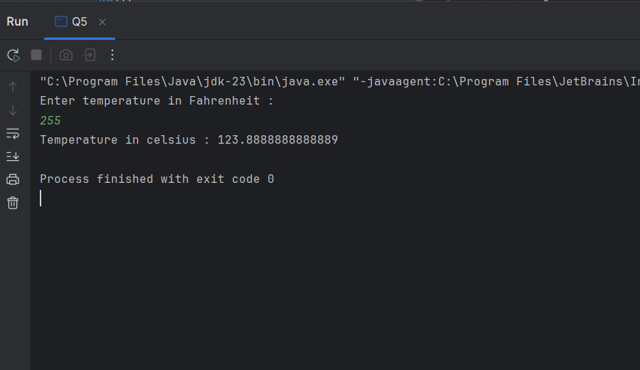

**Q_06:**

package Q_06;  
  
import java.util.Scanner;  
  
public class Q6 {  
 public static void main(String[] args) {  
  
 System.*out*.println("Enter your born year :");  
 Scanner scanner = new Scanner(System.*in*);  
 int year = scanner.nextInt();  
 int currentYear = java.time.Year.*now*().getValue();  
  
 int age = currentYear - year ;  
 System.*out*.println("You were born in " + year +" and will be(are) " + age + " this year.");  
  
 }  
}

**Output:**

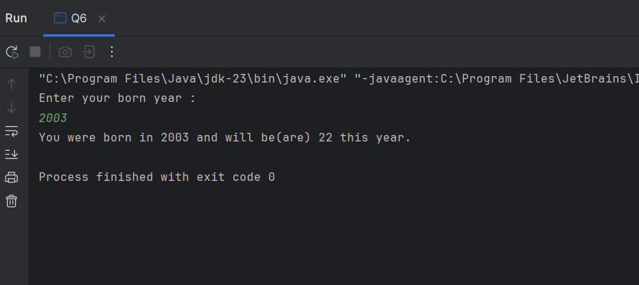

**Q_07:**

package Q_07;  
  
import java.util.Scanner;  
  
public class Q7 {  
 public static void main(String[] args) {  
  
 Scanner scanner = new Scanner(System.*in*);  
  
 System.*out*.println("Enter your body weight in Kg :");  
 double weight = scanner.nextDouble();  
  
 System.*out*.println("Enter your height in Cm :");  
 double height = scanner.nextDouble();  
  
 double BMI = weight / Math.*pow*((height/100.0),2);  
  
 System.*out*.println("Your BMI value : " + BMI);  
  
 if (BMI >20 && BMI <25) {  
 System.*out*.println("Your BMI value is normal");  
 }  
 else {  
 System.*out*.println("Take care of your body health");  
 }

**Output:**

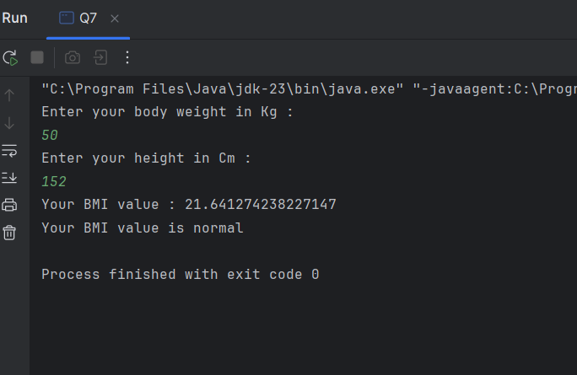

**Q_08:**

package Q_08;  
  
import java.util.Scanner;  
  
public class Q8 {  
 public static void main(String[] args) {  
  
 final double PI = 3.14;  
 System.*out*.println("Enter radius of the sphere in meter :");  
 Scanner scanner = new Scanner(System.*in*);  
 double radius = scanner.nextDouble();  
  
 double volume = (4.0/3.0) * (PI *(Math.*pow*(radius,2)));  
  
 System.*out*.println("Volume of the sphere : " + volume );  
 }  
}

**Output:**

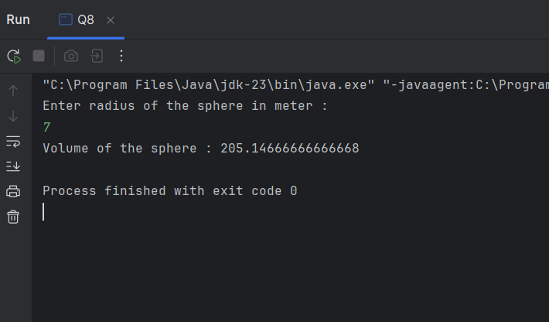

**Q_09:**

package Q_09;  
  
import java.util.Scanner;  
  
public class Q9 {  
 public static void main(String[] args) {  
  
 Scanner scanner = new Scanner(System.*in*);  
 System.*out*.println("Enter the invest money in dollar : ");  
 double P = scanner.nextDouble();  
  
 System.*out*.println("Enter the interest rate : ");  
 double R = scanner.nextDouble();  
  
 System.*out*.println("Enter number of years : ");  
 double N = scanner.nextDouble();  
  
 double investment = P * (Math.*pow*((1 + (R/100)),N));  
  
 System.*out*.println("Amount of money after "+N+ " years : "+ investment);  
  
 }  
}

**Output**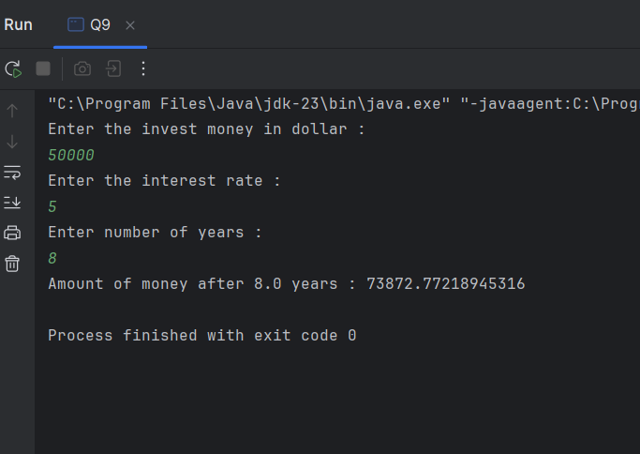

**Q_10:**

package Q_10;  
  
import java.util.Scanner;  
  
public class Q10 {  
 public static void main(String[] args) {  
  
 Scanner scanner = new Scanner(System.*in*);  
 System.*out*.println("Enter loan amount : ");  
 double amount = scanner.nextDouble();  
  
 System.*out*.println("Enter annual interest rate : ");  
 double AnnualRate = scanner.nextDouble();  
  
 System.*out*.println("Enter loan period in months: ");  
 double period = scanner.nextDouble();  
  
 double monthlyInterestRate = (AnnualRate / 100.0 /12);  
  
 double numberOfPayments = period * 12;  
  
 double monthlyPayment = (amount * monthlyInterestRate)/ (1- Math.*pow*((1/(1 + monthlyInterestRate)),numberOfPayments));  
  
 double totalPayment = monthlyPayment * numberOfPayments;  
  
 System.*out*.println("Monthly Payment : " + monthlyPayment);  
 System.*out*.println("Total payment : " + totalPayment);  
  
  
 }  
}

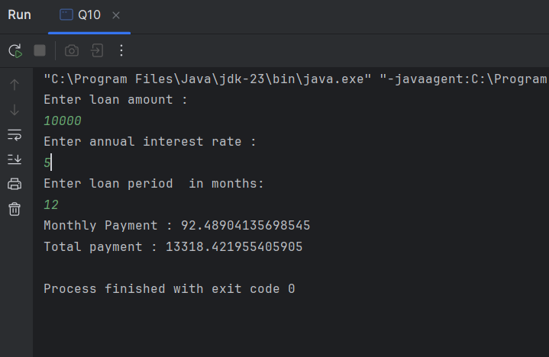**Output :**