**Q_01 :**

**CT_2021_025 – Lab Work Sheet 03**

***package Q_01;  
  
import java.util.Scanner;  
  
public class Temperature {  
  
 private double celsius;  
  
 public Temperature(){  
 this.celsius = 0.0;  
 }  
  
 Temperature(double celsius){  
 this.celsius = celsius;  
 }  
  
 public double toCelsius() {  
 return this.celsius;  
 }***

***public static void main(String[] args) {  
 Scanner scanner = new Scanner(System.in);  
  
 System.out.println("Enter temperature in celsius :");  
 double inputCelsius = scanner.nextDouble();  
  
 Temperature temp = new Temperature((inputCelsius));  
  
 System.out.println("Temperature in Fahrenheit : " + temp.toFahrenheit());  
  
 scanner.close();  
 }  
  
}***

***public double toFahrenheit() {  
 return this.celsius * 9/5 + 32;  
 }  
  
 public void setCelsius(double celsius){  
 this.celsius = celsius;  
 }  
 public void setFahrenheit(double fahrenheit) {  
 this.celsius = (fahrenheit - 32) * 5/9;  
 }***

***}***

**Output :**

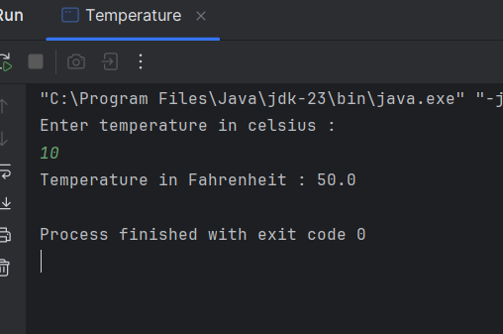

**Q_02:**

***package Q_02;  
  
import Q_01.Temperature;  
  
import java.util.Scanner;  
  
public class TempConverter {  
 public static void main(String[] args) {  
 Scanner scanner = new Scanner(System.in);  
  
 System.out.println("Enter Temperature in Fahrenheit :");  
 double fahrenheit = scanner.nextDouble();  
  
 Temperature temp = new Temperature();  
 temp.setFahrenheit(fahrenheit);  
  
 System.out.println("Temperature in Celsius : " + temp.toCelsius() );  
 }  
}***

**Output: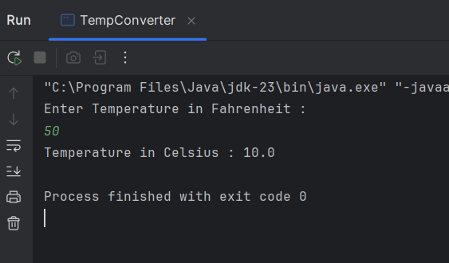Q_03 :**

***package Q_03;  
  
import java.util.Scanner;  
  
public class Area {  
  
 private double radius;  
  
 public Area() {  
 this.radius = 0.0;  
 }  
  
 public Area(double radius) {  
 this.radius = radius;  
 }  
  
 public void setRadius(double radius) {  
 this.radius = radius;  
 }  
  
 public double getRadius() {  
 return radius;  
 }  
  
 public double computeArea() {  
 return Math.PI * radius * radius;  
 }  
  
 public double computeCircumference() {  
 return 2 * Math.PI * radius;  
 }  
  
 public static void main(String[] args) {  
 Scanner scanner = new Scanner(System.in);  
  
 System.out.print("Enter inner radius (ri): ");  
 double ri = scanner.nextDouble();  
  
 System.out.print("Enter outer radius (ro): ");  
 double ro = scanner.nextDouble();  
  
 Area innerCircle = new Area(ri);  
 Area outerCircle = new Area(ro);  
  
 double shadedArea = outerCircle.computeArea() - innerCircle.computeArea();  
  
 System.out.printf("Area of the circular region: %.2f\n", shadedArea);  
  
 scanner.close();  
 }  
}***

**Output :**

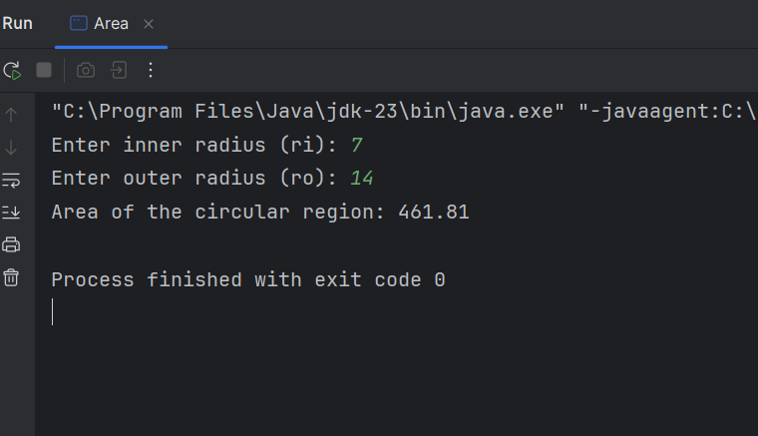

**Q_04:**

* Owner Class:

***package Q_04;  
  
public class Owner {  
 private String ownerName;  
 private String phoneNo;  
  
 public Owner() {  
 this.ownerName = "Unknown";  
 this.phoneNo = "Not Available";  
 }  
  
 public Owner(String ownerName, String phoneNo) {  
 this.ownerName = ownerName;  
 this.phoneNo = phoneNo;  
 }  
  
 public String getOwnerName() {  
 return ownerName;  
 }  
  
 public void setOwnerName(String ownerName) {  
 this.ownerName = ownerName;  
 }  
  
 public String getPhoneNo() {  
 return phoneNo;  
 }  
  
 public void setPhoneNo(String phoneNo) {  
 this.phoneNo = phoneNo;  
 }  
  
 public String toString() {  
 return "Owner Name: " + ownerName + ", Phone No: " + phoneNo;  
 }  
}***

* Bicycle Class:

***package Q_04;  
  
public class Bicycle {  
  
 private Owner owner;  
  
 public Bicycle() {  
 this.owner = new Owner(); // Assign default owner  
 }  
  
 public Bicycle(String name, String num) {  
 this.owner = new Owner(name, num);  
 }  
  
 public Owner getOwner() {  
 return owner;  
 }  
  
 public void setOwner(Owner owner) {  
 this.owner = owner;  
 }  
  
 public void displayBicycleInfo() {  
 System.out.println("Bicycle Details: ");  
 System.out.println(owner.toString());  
 }  
}***

* BicycleTest Class:

***package Q_04;  
  
public class Bicycle {  
  
 private Owner owner;  
  
 public Bicycle() {  
 this.owner = new Owner(); // Assign default owner  
 }  
  
 public Bicycle(String name, String num) {  
 this.owner = new Owner(name, num);  
 }  
  
 public Owner getOwner() {  
 return owner;  
 }  
  
 public void setOwner(Owner owner) {  
 this.owner = owner;  
 }  
  
 public void displayBicycleInfo() {  
 System.out.println("Bicycle Details: ");  
 System.out.println(owner.toString());  
 }  
}***

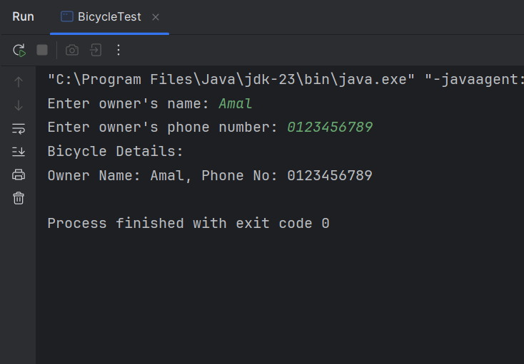**Output :**

**Q_05:**

* Course Class:

***package Q_05;  
  
public class Course {  
 private String courseName;  
 private String courseCode;  
 private Lecturer lecturer; // Has-a relationship with Lecturer  
  
 public Course() {  
 this.courseName = "Unknown";  
 this.courseCode = "None";  
 this.lecturer = new Lecturer();  
 }  
  
 public Course(String courseName, String courseCode, Lecturer lecturer) {  
 this.courseName = courseName;  
 this.courseCode = courseCode;  
 this.lecturer = lecturer;  
 }  
  
 public String getCourseName() {  
 return courseName;  
 }  
  
 public void setCourseName(String courseName) {  
 this.courseName = courseName;  
 }  
  
 public String getCourseCode() {  
 return courseCode;  
 }  
  
 public void setCourseCode(String courseCode) {  
 this.courseCode = courseCode;  
 }  
  
 public Lecturer getLecturer() {  
 return lecturer;  
 }  
  
 public void setLecturer(Lecturer lecturer) {  
 this.lecturer = lecturer;  
 }  
  
 public void displayCourseInfo() {  
 System.out.println("Course Name: " + courseName);  
 System.out.println("Course Code: " + courseCode);  
 lecturer.displayLecturerInfo();  
 }  
}***

* Lecturer Class :

***package Q_05;  
  
public class Lecturer {  
 private String lecturerName;  
 private String courseTeaching;  
  
 public Lecturer() {  
 this.lecturerName = "Unknown";  
 this.courseTeaching = "None";  
 }  
  
 public Lecturer(String lecturerName, String courseTeaching) {  
 this.lecturerName = lecturerName;  
 this.courseTeaching = courseTeaching;  
 }  
  
 public String getLecturerName() {  
 return lecturerName;  
 }  
  
 public void setLecturerName(String lecturerName) {  
 this.lecturerName = lecturerName;  
 }  
  
 public String getCourseTeaching() {  
 return courseTeaching;  
 }  
  
 public void setCourseTeaching(String courseTeaching) {  
 this.courseTeaching = courseTeaching;  
 }  
  
 public void displayLecturerInfo() {  
 System.out.println("Lecturer Name: " + lecturerName);  
 System.out.println("Course Teaching: " + courseTeaching);  
 }  
}***

* Student Class:

***package Q_05;  
  
public class Student {  
 private String studentName;  
 private String degreeName;  
 private String courseFollowing;  
  
 public Student() {  
 this.studentName = "Unknown";  
 this.degreeName = "Unknown";  
 this.courseFollowing = "None";  
 }  
  
 public Student(String studentName, String degreeName, String courseFollowing) {  
 this.studentName = studentName;  
 this.degreeName = degreeName;  
 this.courseFollowing = courseFollowing;  
 }  
  
 public String getStudentName() {  
 return studentName;  
 }  
  
 public void setStudentName(String studentName) {  
 this.studentName = studentName;  
 }  
  
 public String getDegreeName() {  
 return degreeName;  
 }  
  
 public void setDegreeName(String degreeName) {  
 this.degreeName = degreeName;  
 }  
  
 public String getCourseFollowing() {  
 return courseFollowing;  
 }  
  
 public void setCourseFollowing(String courseFollowing) {  
 this.courseFollowing = courseFollowing;  
 }  
  
 public void displayStudentInfo() {  
 System.out.println("Student Name: " + studentName);  
 System.out.println("Degree Program: " + degreeName);  
 System.out.println("Enrolled Course: " + courseFollowing);  
 }  
}***

* Main Class :

***public class Main {  
 public static void main(String[] args) {  
 Scanner scanner = new Scanner(System.in);  
  
 System.out.print("Enter Lecturer's Name: ");  
 String lecturerName = scanner.nextLine();  
 System.out.print("Enter Course Taught by Lecturer: ");  
 String lecturerCourse = scanner.nextLine();  
  
 Lecturer lecturer = new Lecturer(lecturerName, lecturerCourse);  
  
 System.out.print("Enter Course Name: ");  
 String courseName = scanner.nextLine();  
 System.out.print("Enter Course Code: ");  
 String courseCode = scanner.nextLine();  
  
 Course course = new Course(courseName, courseCode, lecturer);  
  
 System.out.print("Enter Student's Name: ");  
 String studentName = scanner.nextLine();  
 System.out.print("Enter Student's Degree Name: ");  
 String degreeName = scanner.nextLine();  
  
 Student student = new Student(studentName, degreeName, courseName);  
  
 System.out.println("\n______Course Information______");  
 course.displayCourseInfo();  
  
 System.out.println("\n______ Student Information______");  
 student.displayStudentInfo();  
  
 scanner.close();  
 }  
}***

**Output:**

